Supporting Information for
Te-Modulated Fe Single-Atom with Synergistic Bidirectional Catalysis for High-Rate and Long-Cycling Lithium-Sulfur Battery
Jian Guo^{1, #}, Lu Chen^{2, #}, Lijun Wang¹, Kangfei Liu³, Ting He^{2,} *, Jia Yu^{4,} *, and Hongbin Zhao^{1,} *
¹Department of Chemistry, College of Sciences, Shanghai University, Shanghai 200444, P. R. China
²School of Chemical Science and Engineering, Tongji University, Shanghai 200092, P. R. China
³School of Chemical Engineering, East China University of Science and Technology, Shanghai 200237, P. R. China
⁴Key Laboratory of Precision and Intelligent Chemistry, University of Science and Technology of China, Hefei 230026, P. R. China
#Jian Guo and Lu Chen contributed equally to this work.
*Corresponding authors. E-mail: heting@tongji.edu.cn (Ting He); jiayu@ustc.edu.cn (Jia Yu); hongbinzhao@shu.edu.cn (Hongbin Zhao)
S1 Supplementary Experimental Section
S1.1 Preparation of Modified Separators
The FeTe/NC and Fe/NC modified separators were prepared using a simple surface coating method. In short, FeTe/NC or Fe/NC, Ketjen black (KB), and polyvinylidene fluoride (PVDF) binder were mixed using N-methyl pyrrolidone (NMP) as a solvent to form a slurry in a weight ratio of 8:1:1. Then, the mixture was coated on commercial Celgard 2400 polypropylene (PP) separator and further dried at 60 °C under vacuum to evaporate the solvent. Finally, the functionalized separator was cut into discs with a diameter of 19 mm and the areal mass loading weight of coating materials was about 0.5 mg cm⁻².
S1.2 Preparation of CNT/S Composite
CNT/S composite was synthesized by a typical melt-diffusion method. In brief, the CNT powder was continuously ground with sublimed sulfur (3:7 in W/W) and then heated in a sealed vial at 155 °C for 12 h.
S1.3 Electrochemical Measurements
The CNT/S, KB, and PVDF were mixed with a mass ratio of 8:1:1 and put into an NMP solution to prepare a slurry. The slurry was cast on the aluminum foil and then vacuum dried at 60 °C for 12 h to serve as a cathode. The sulfur loading on each electrode was weighed to be ∼1.2 mg cm⁻². The aqueous PTFE solution was used to prepare the cathodes of high-sulfur-loading (8.7 mg cm⁻²). The assembled CR2016-type coin cells employed Li foil as the anode, FeTe/NC, Fe/NC modified separators and bare PP as the separator. 1 M LiTFSI in 1,3-dioxolane (DOL)/1,2-dimethoxyethane (DME) (1:1 by volume) with 2.0 wt.% LiNO₃ was used as the electrolyte. The ratio of the electrolyte and sulfur (E/S) was demanded at 15 μL mg⁻¹ for regular batteries. Given high-loading cathodes, the E/S ratio was 4.9 μL mg⁻¹. The electrochemical impedance spectroscopy (EIS) and cyclic voltammetry (CV) experiments were recorded by the CHI760E workstation. Galvanostatic charge-discharge (GCD) tests were conducted on a Land battery test system (Land CT2001, Wuhan) at 25 °C in a potential range between 1.7 and 2.8 V.
S1.3.1 Symmetrical Cell Assembly and Measurements
A 9:1 weight ratio of active materials and PVDF was mixed in NMP solution and the paste was coated on aluminum foil to prepare the electrodes. 0.2 M Li₂S₆ solution as electrolyte and PP as separators. To estimate the electrochemical properties, the CHI760E workstation was employed to test the CV and EIS measurements.
S1.3.2 Li₂S Nucleation and Dissolution Tests
For the liquid-solid conversion kinetics, S and Li₂S (7:1 molar ratio) were mixed in a DOL/DME (v/v=1:1) solution with 1.0 M LiTFSI and 2.0 wt.% LiNO₃, and a 0.2 M Li₂S₈ solution was formed after intense stirring. The active materials were coated on aluminum foil as the working electrode. Lithium metal was used as the counter electrode and PP as the separator. The Li₂S₈ solution was dripped on the working electrode, and the 1 M LiTFSI electrolyte was added on the other side. The cells were discharged to 2.11 V at 0.114 mA and then kept at 2.09 V for Li₂S to nucleate until the current dropped below 10⁻⁵ A. To analyze the Li₂S dissolution, fresh cells were galvanostatically discharged under a current of 0.114 mA until the voltage was reduced to 1.7 V; then, the cells were potentiostatically charged at 2.40 V.
S1.3.3 Theoretical Equations for Current-time Transients of Four Classical Electrochemical Deposition Models [S1]
$2DI:\frac{j}{j_{m}}=\left(\frac{t}{t_{m}}\right)\left\{\exp\left[\frac{t^{2}-{t_{m}}^{2}}{2{t_{m}}^{2}}\right]\right\}$ (S1)
$2DP:\frac{j}{j_{m}}={(\frac{t}{t_{m}})}^{2}\{exp⁡[\frac{-2(t^{3}-{t_{m}}^{3})}{3{t_{m}}^{3}}]\}$ (S2)
$3DI:\frac{j}{j_{m}}={(\frac{1.9542}{t/{t_{m}}})}^{1/2}\{1-exp⁡[1.2564(\frac{t}{t_{m}})]\}$ (S3)
$3DP:\frac{j}{j_{m}}={(\frac{1.2254}{t/{t_{m}}})}^{1/2}\{1-exp⁡[2.3367{(\frac{t}{t_{m}})}^{2}]\}$ (S4)
S1.3.4 Calculation of Difference in Activation Energy [S2]
$E_{a}=E_{a}^{0}-RT/b{}_{cathode}$ (S5)
where $E_{a}^{0}$ is the intrinsic activation energy, $E_{a}$ is the activation energy of discharge and charge process, ${}_{cathode}$ is the irreversible potential during CV test, b is the slope of the Tafel plot.
S1.3.5 Calculation of Li-ion Diffusion Constant
The Li-ion diffusion constant can be estimated using the Randles-Sevcik equation [S3]:
$I_{p}=2.69×{10}^{5}n^{3/2}AD_{Li}^{1/2}v^{1/2}C_{Li}$ (S6)
where $I_{p}$ is the peak current, n represents electron number, A represents electrode area, $D_{Li}$ is the Li-ion diffusion coefficient, $C_{Li}$ is the Li-ion concentration in the electrochemical reaction and v is the scanning rate.
S1.3.6 Calculation of Internal Resistance
The internal resistance (∆R_{internal}) was derived from the following equation [S4]:
$ΔR_{internal}\left(Ω\right)={Δ_{QOCV-OCV}}/{I_{appilied}}$ (S7)
where ∆V denotes the voltage difference between QOCV and OCV, while $I_{applied}$ refers to the applied current, and $∆R_{internal}$ represents the internal resistance of the batteries, normalized overtime during the lithiation/delithiation process.
S1.4 Computational Methods
All calculations were performed in the framework of the spin-polarized density functional theory (DFT) within the Projected Augmented Wave (PAW) method implemented in the Vienna ab initio simulation package (VASP) [S5-S7]. The Perdew-Burke-Ernzerhof (PBE) function was adopted to describe electron exchange and correlation energy as it has been proven to provide a useful trend in calculating the adsorption energy [S8, S9]. The cut-off energy for plane-wave basis was set as 450 eV to ensure the precision of calculations and the total energy convergence criterion for energy is 10⁻⁵ eV, with the force convergence thresholds set at 0.03 eV/Å for geometric optimization. 3×3×1 Monkhorst-Pack grids were used for geometric optimization on all the models. A vacuum layer of at least 15 Å was applied in the z-direction of the slab model to prevent vertical interaction between the slabs. The D3 method of Grimme was employed to describe the van der Waals (vdW) dispersion for calculation [S10]. The binding energy for polysulfide was calculated using the equation:
$∆E=E_{surf+ads}-(E_{surf}+E_{ads})$ (S8)
where $E_{sur+ads}$ is the energy of the absorbed system, $E_{ads}$ is the energy of isolated polysulfides and $E_{surf}$ is the energy of the corresponding surface. The CI-NEB was applied for the calculations of Li₂S decomposition and lithium-ion migration [S11].
S1.5 Materials Characterization
The morphologies of the materials were recorded by using a scanning electron microscope (SEM, Pharos G2, accelerating voltage = 15 kV), high-resolution transmission electron microscopy (HRTEM, JEOL JEM-2100, accelerating voltage = 200 kV) and aberration-corrected high-angle annular darkfield scanning transmission electron microscope (AC-HAADF-STEM, JEOL JEM-ARM200F, operated at 200 kV). The crystalline structures of all the samples were identified by using Bruker D8 advance (Cu Kα source, λ = 1.54056 Å). X-ray photoelectron spectroscopy (XPS) was carried out on Thermo Scientific K-ALPHA. The X-ray absorption fine structure (XAFS) analysis was carried out on beamline 1W1B at the Beijing Synchrotron Radiation Facility (BSRF, Beijing, China).
S2 Supplementary Figures and Tables
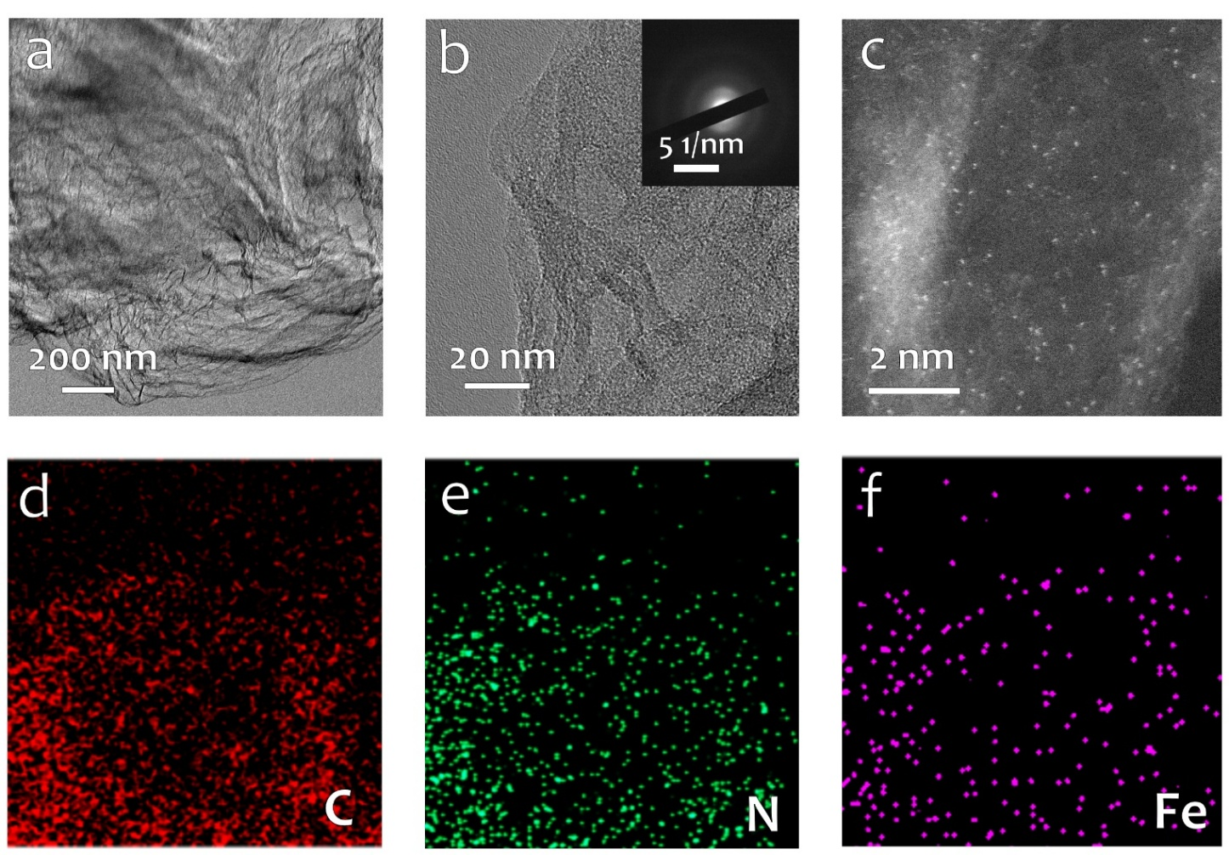
Fig. S1 (a) TEM, (b) HRTEM (inset: SAED pattern), and (c) AC-HAADF-STEM image and (d-f) elemental mappings of Fe/NC

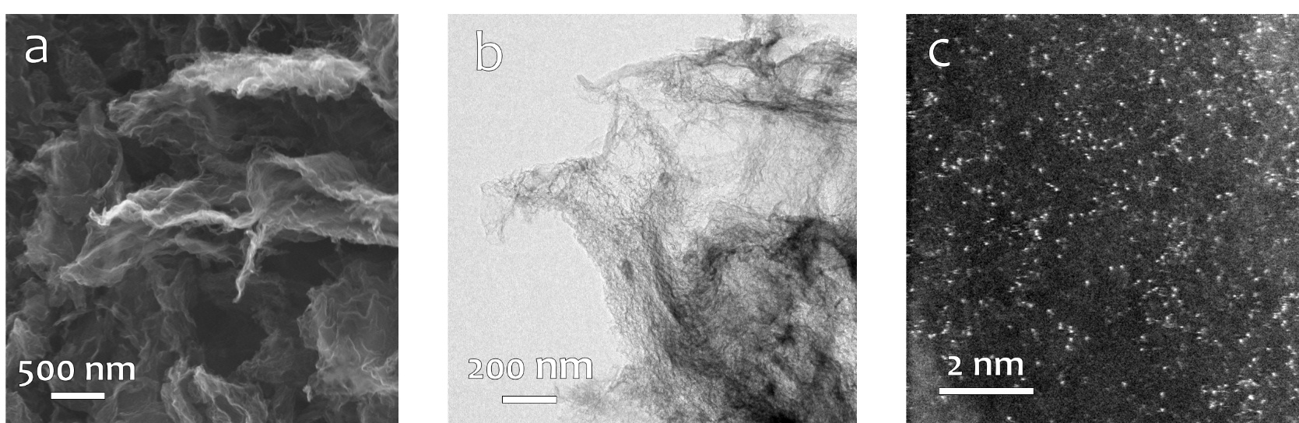
Fig. S2 (a) SEM, (b) TEM, and (c) aberration-corrected STEM image of Te/NC
Fig. S3 (a) N₂ adsorption/desorption isotherms and (b) the corresponding pore size distributions of FeTe/NC and Fe/NC

Fig. S4 XRD patterns of FeTe/NC and Fe/NC

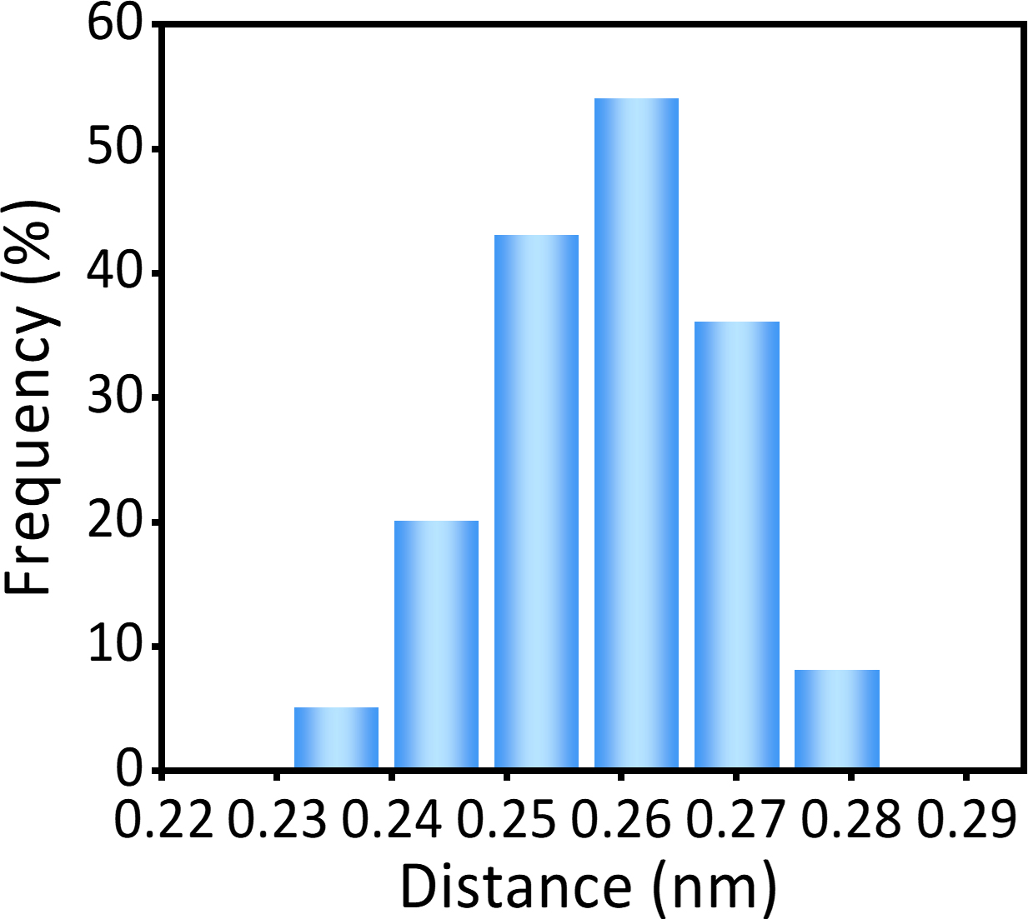
Fig. S5 Statistics on the interatomic distances of the Fe-Te diatomic pairs in the AC-STEM image
Fig. S6 Raman spectra of FeTe/NC and Fe/NC
Fig. S7 XPS surveys of FeTe/NC and Fe/NC
Fig. S8 XPS spectra of (a) Fe 2p, (b) Te 3d, (c) C 1s and (d) N 1s
Note: After the incorporation of Te atoms, the binding energy of C 1s and N 1s shifts to higher energy, which is probably attributed to the Te atom promoting electron transfer from C or N to Te [S12].
Fig. S9 WT k³-weighted EXAFS spectra of (a) Fe₂O₃ and (b) TeO₂
Fig. S10 FT-EXAFS fitting curve in k space of FeTe/NC at the Te K-edge
Fig. S11 Fe K-edge FT-EXAFS analysis of Fe/NC (a) in R space and (b) in k space. Te K-edge FT-EXAFS analysis of Te/NC (c) in R space and (d) in k space
Note: The fitting outcomes revealed that, in Fe/NC, the coordination pattern between the Fe and N atoms was Fe-N₅. The fitting results for Te/NC indicate that the Te-N coordination number is 3, forming a Te-N₃ coordination structure.

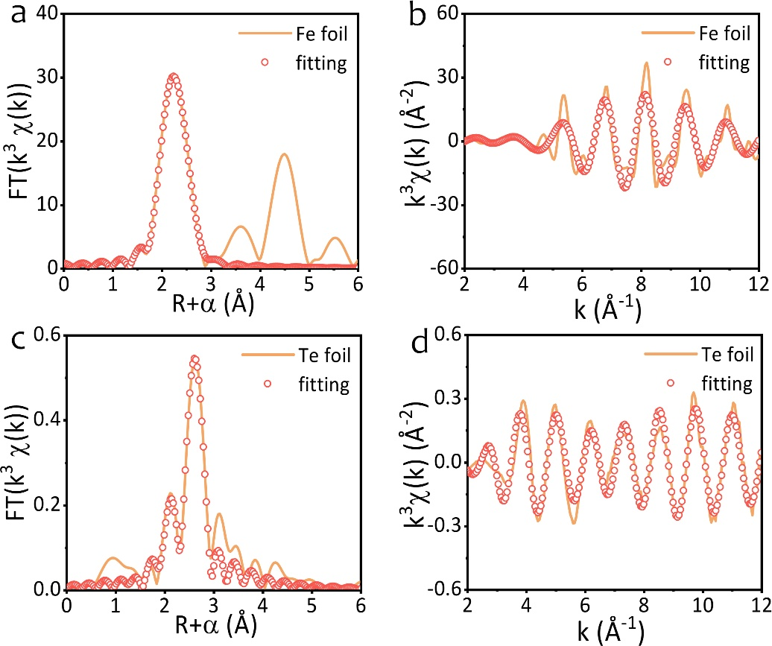
Fig. S12 Fe K-edge FT-EXAFS analysis in R space (a) and (b) k space. Te K-edge FT-EXAFS analysis in R space (c) and (d) k space

Fig. S13 XPS spectra of (a) N 1s, (b) Li 1s, and (c) S 2p
Note: In the N 1s spectrum of FeTe/NC-Li₂S₆ (Fig. S13a), the peak shifts to a higher binding energy. A distinct peak at 56.2 eV can be observed in the Li 1s spectrum (Fig. S13b), ascribed to Li-N bonding between polysulfides and nitrogen in FeTe/NC, indicating strong electrostatic dipole interactions between Li⁺ and electronegative N atoms. As shown in Fig. S13c, The S 2p spectrum following the adsorption test displays four distinct contributions at 162.3/163.2, 163.9/165.1, 167.7/168.8, and 169.1/170.3 eV, corresponding to the terminal sulfur (S_{T}⁻¹), bridged sulfur (S_{B}⁰), and oxidized sulfur species (such as polythionate and thiosulfate), respectively. The observation of an additional peak associated with the Fe-S bond suggests that the active Fe sites facilitate the capture and anchoring of LiPSs [S13].
Fig. S14 CV curves of the Li₂S₆ symmetric cells with FeTe/NC and Fe/NC electrodes

Fig. S15 EIS of the symmetric cells with FeTe/NC and Fe/NC electrodes
Note: Rs: The internal resistance of the electrolyte; Rsei: The internal resistance of the solid electrolyte interface (SEI) film correlated with insoluble Li₂S₂/Li₂S; Rct: The charge-transfer resistance related to the electrode reaction kinetics; CPE1: Capacitance of the electrode bulk in the high-frequency region; CPE2: Capacitance of the charge transfer process at the interface between sulfur and electrolyte; W1: The semi-infinite Warburg diffusion impedance of long-chain LiPSs.

Fig. S16 Potentiostatic charge profiles at 2.4 V for FeTe/NC and Fe/NC electrodes
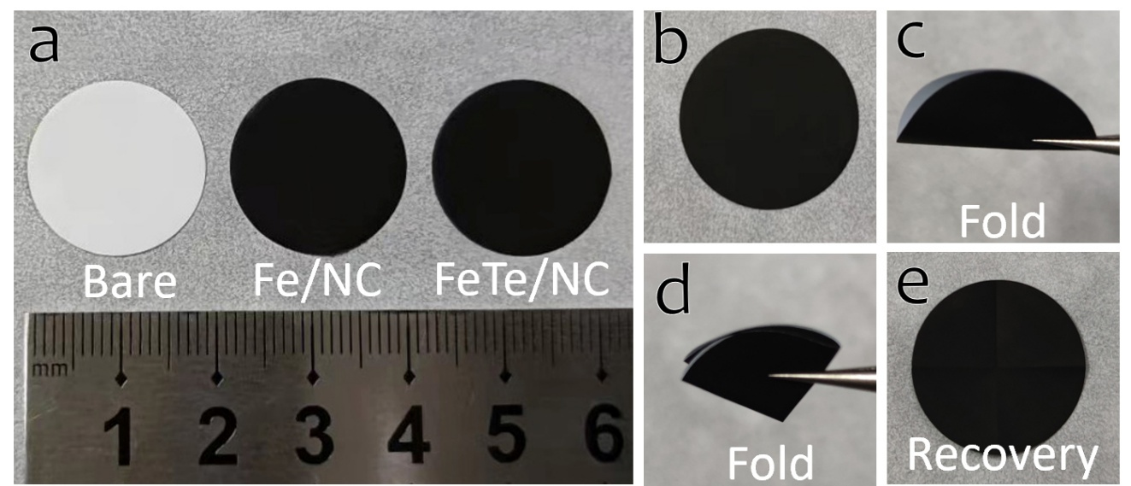
Fig. S17 (a) Photographs of the bare PP, Fe/NC, and FeTe/NC modified separators. (b-e) FeTe/NC modified separator at bending state and after recovery
Note: The prepared separators show robustness; no appreciable delamination and deformation can be detected after the folding or bending test.

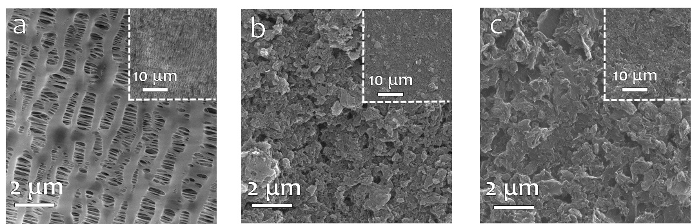
Fig. S18 SEM images of one side of the (a) bare PP, (b) Fe/NC and (c) FeTe/NC modified separators

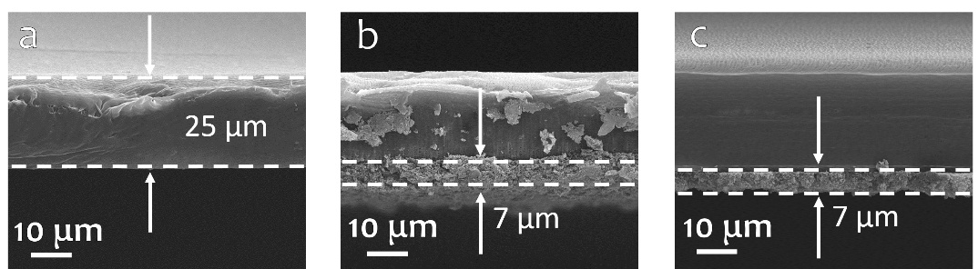
Fig. S19 Cross-sectional SEM images of the (a) bare PP, (b) Fe/NC, and (c) FeTe/NC modified separators
Fig. S20 Cross-sectional SEM image and the corresponding elemental mapping images of (a) Fe/NC and (b) FeTe/NC modified separator
Note: The corresponding EDS mapping shows the uniform distribution of the components in the coating layer.
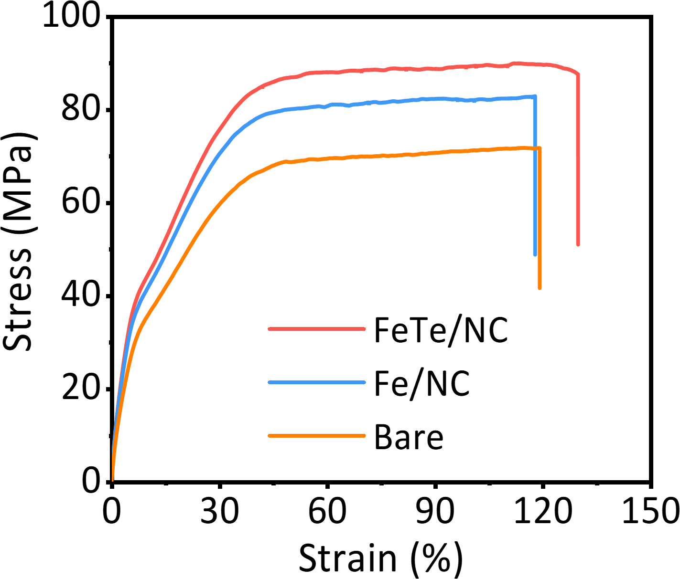
Fig. S21 Stress-strain curves for different separators
Fig. S22 Contact angle measurement of Li-S electrolyte on the surface of the bare PP, Fe/NC, and FeTe/NC modified separators
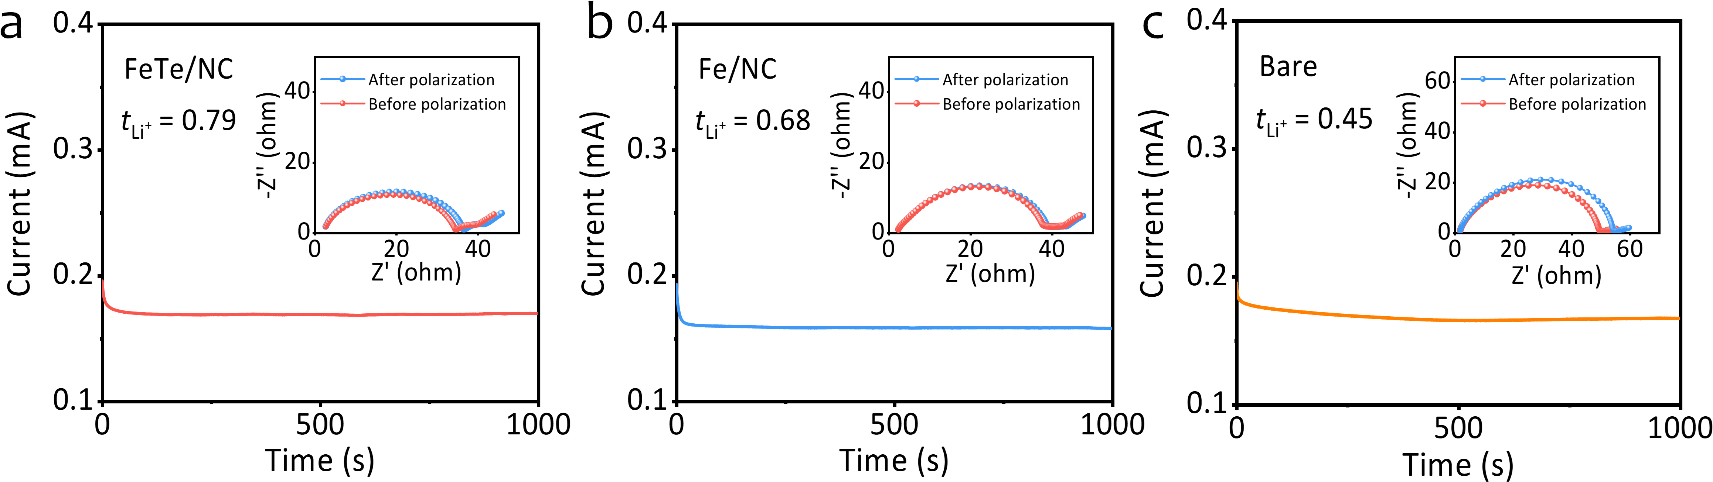
Fig. S23 I-t and EIS curves of the FeTe/NC, Fe/NC and bare PP-based separators
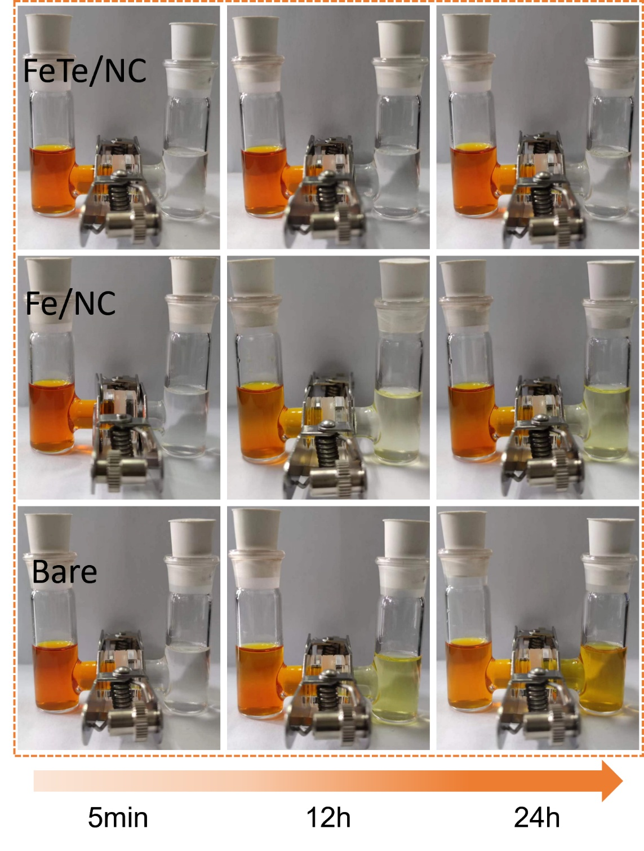
Fig. S24 Diffusion tests of LiPSs with the bare PP, Fe/NC and FeTe/NC modified separators

Fig. S25 TG curve of CNT/S composite under nitrogen atmosphere

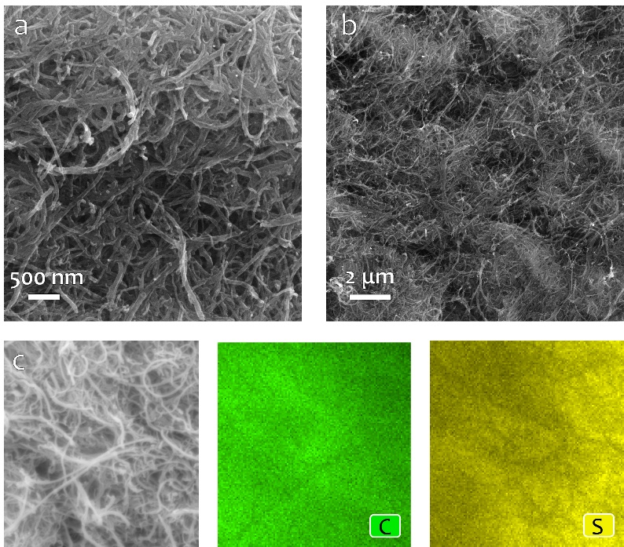
Fig. S26 (a-c) SEM images and elemental mappings of CNT/S
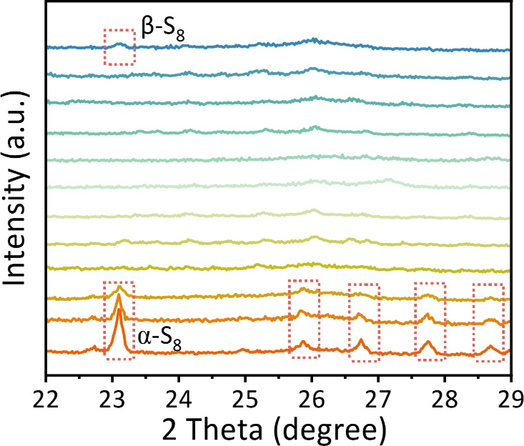
Fig. S27 In-situ XRD patterns of the bare PP-based Li-S cells during the initial cycle
Fig. S28 CV curves of the (a) FeTe/NC, (b) Fe/NC and (c) bare PP-based Li-S cells. The linear fitting results of the peak current as a function of scan rate with different separators at (d) reductive peak A, (e) reductive peak B and (f) oxidative peak C

Fig. S29 Li-ion diffusion coefficient value at peaks A, B, and C

Fig. S30 EIS plots of Li-S cells with different separators

Fig. S31 Discharge/charge profiles of the Li-S cells with (a) Fe/NC and (b) bare PP separators at different rates

Fig. S32 SEM images and the corresponding EDS spectra and elemental mapping images of the anode side of the (a) FeTe/NC, (b) Fe/NC, and (c) bare PP modified separators after 200 cycles at 1 C.
Note: The sulfur concentration of the bare PP separator on the anode side reached 8.28 at%, whereas it decreased to 3.61 at% for the Fe/NC modified separator and further to 2.25 at% for the FeTe/NC modified separator, highlighting the superior capability of the FeTe/NC coating to restrict LiPSs migration.
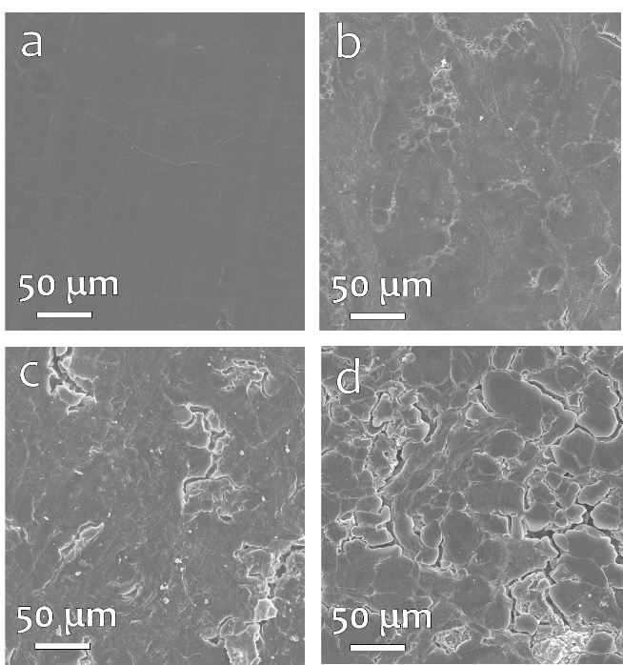
Fig. S33 (a) Top-view morphology of fresh Li anode. Top-view morphology change of dissembled Li anodes after 200 cycles at 1 C in the (b) FeTe/NC, (c) Fe/NC, and (d) bare PP-based Li-S cells.
Note: The lithium anode with the bare PP separator exhibits a rough surface and a considerable amount of “dead” lithium after 200 cycles. In contrast, the anode paired with the FeTe/NC modified separator has a smoother morphology, likely resulting from residue and the decomposition of LiTFSI salt in the electrolyte. This suggests that the FeTe/NC catalyst effectively mitigates the dissolution and shuttling of LiPSs to the lithium metal side.

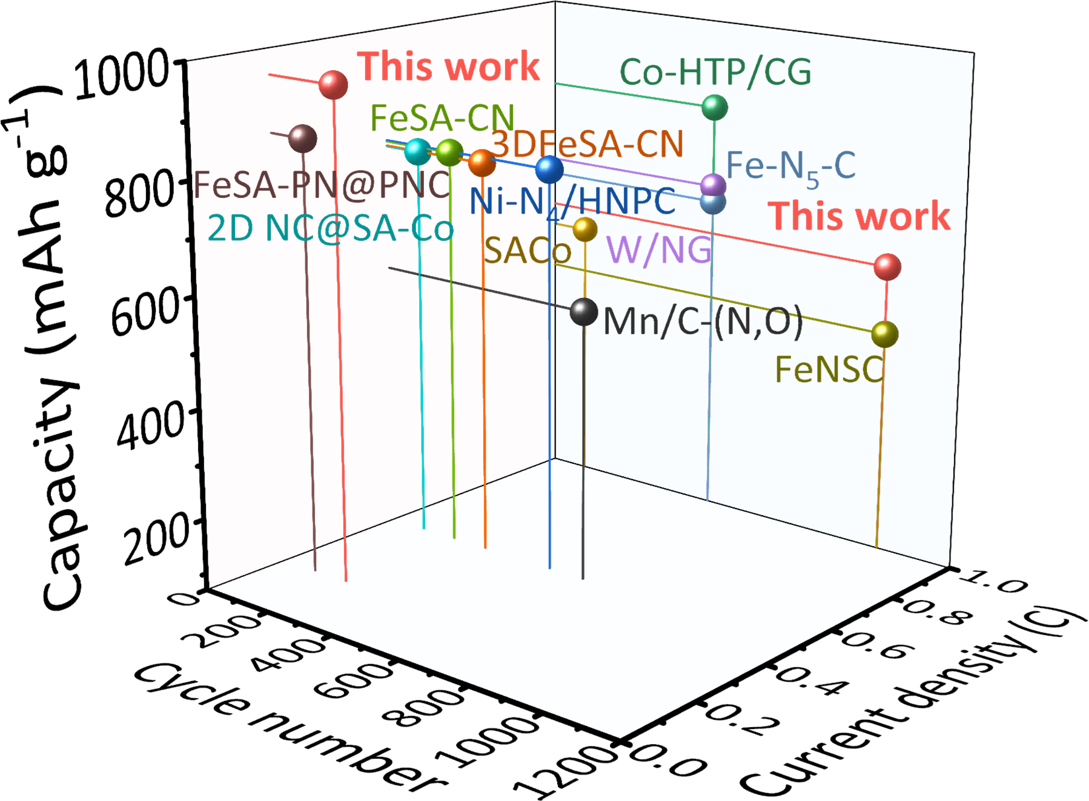
Fig. S34 Performance comparison with reported metal atom-based catalysts in the Li-S battery
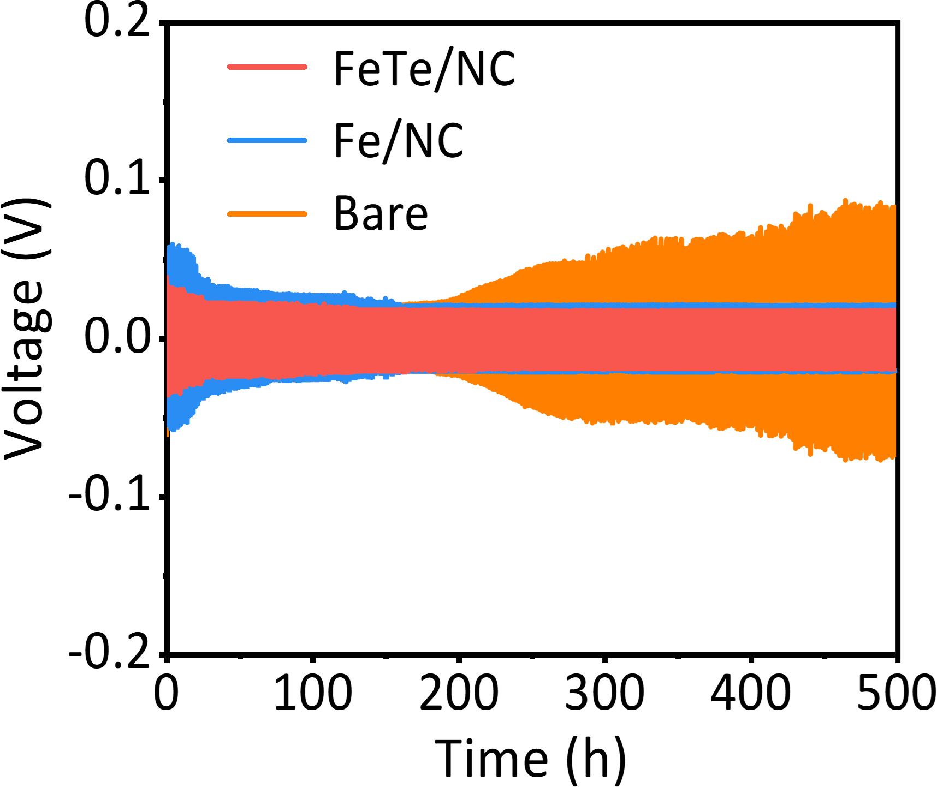
Fig. S35 Cycling performance of Li-Li symmetric cells including FeTe/NC, Fe/NC, or bare PP-based separators at 1 mA cm⁻² current for 1 mAh cm⁻² capacity
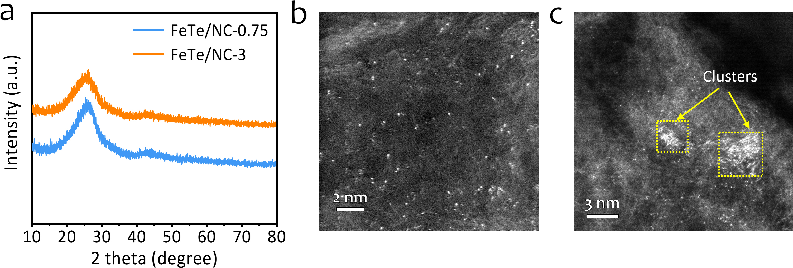
Fig. S36 (a) XRD patterns, AC-HAADF-STEM images of (b) FeTe/NC-0.75 and (c) FeTe/NC-3
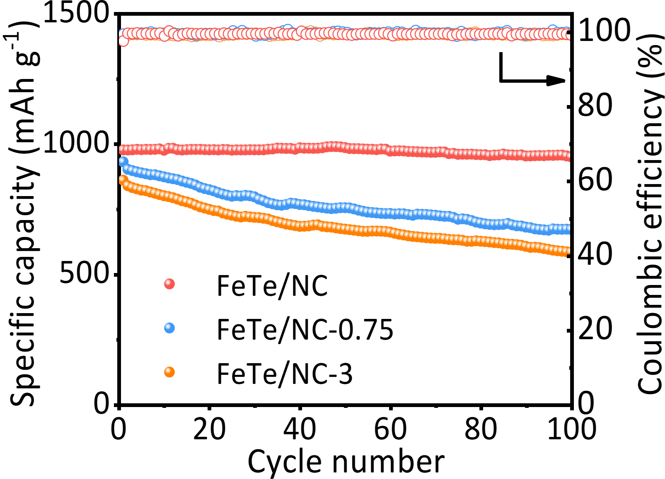
Fig. S37 Cycling performance of FeTe/NC-0.75, FeTe/NC and FeTe/NC-3 based cells at 0.5 C

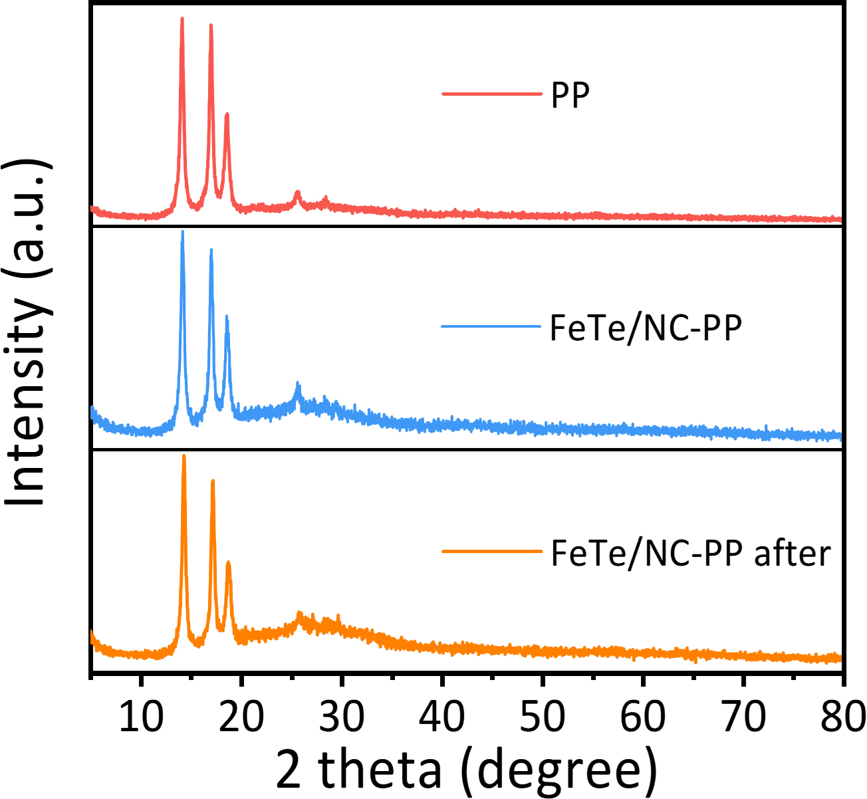
Fig. S38 XRD patterns of pristine PP, FeTe/NC-PP and FeTe/NC-PP after 100 cycles at 0.5 C

Fig. S39 Optimized structures of (a, c) FeTe/NC, (b, d) Fe/NC
Fig. S40 Three-dimensional (3D) charge density difference diagram of (a, c) FeTe/NC, (b, d) Fe/NC and corresponding 2D projection of charge density contour. (red: electron accumulation, blue: electron depletion, isovalue = 0.005 eV/Å³)
Fig. S41 PDOS of Fe-d orbitals for the (a) FeTe/NC and (b) Fe/NC
Note: The d orbitals are divided into four categories: d_{z}², d_{xy}, d_{xz/yz}, and d_{x}²_{-y}². Typically, the d_{z}² and d_{xz/yz} orbitals engage in hybridization with the p orbitals of sulfur atoms in LiPSs, leading to the formation of both bonding (𝜎 and 𝜋) and antibonding (𝜎* and 𝜋*) states. In contrast, the horizontal d orbitals (d_{x}²_{-y}² and d_{xy}) remain inactive and are considered nonbinding.[14] The geometric distortion in FeTe/NC raises the energy levels of the d_{xz/yz} orbitals compared to Fe/NC, which reduces the occupancy of the antibonding states, leading to stronger adsorption of LiPSs.
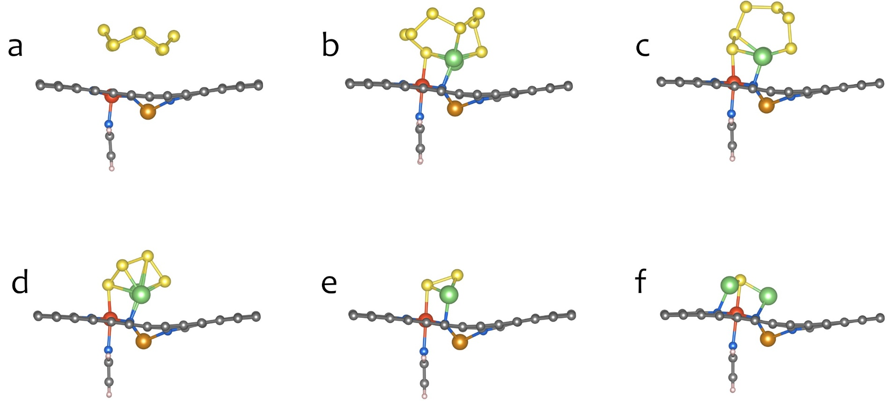
Fig. S42 Optimized structures of (a) S₈, (b) Li₂S₈, (c) Li₂S₆, (d) Li₂S₄, (e) Li₂S₂, (f) Li₂S on FeTe/NC
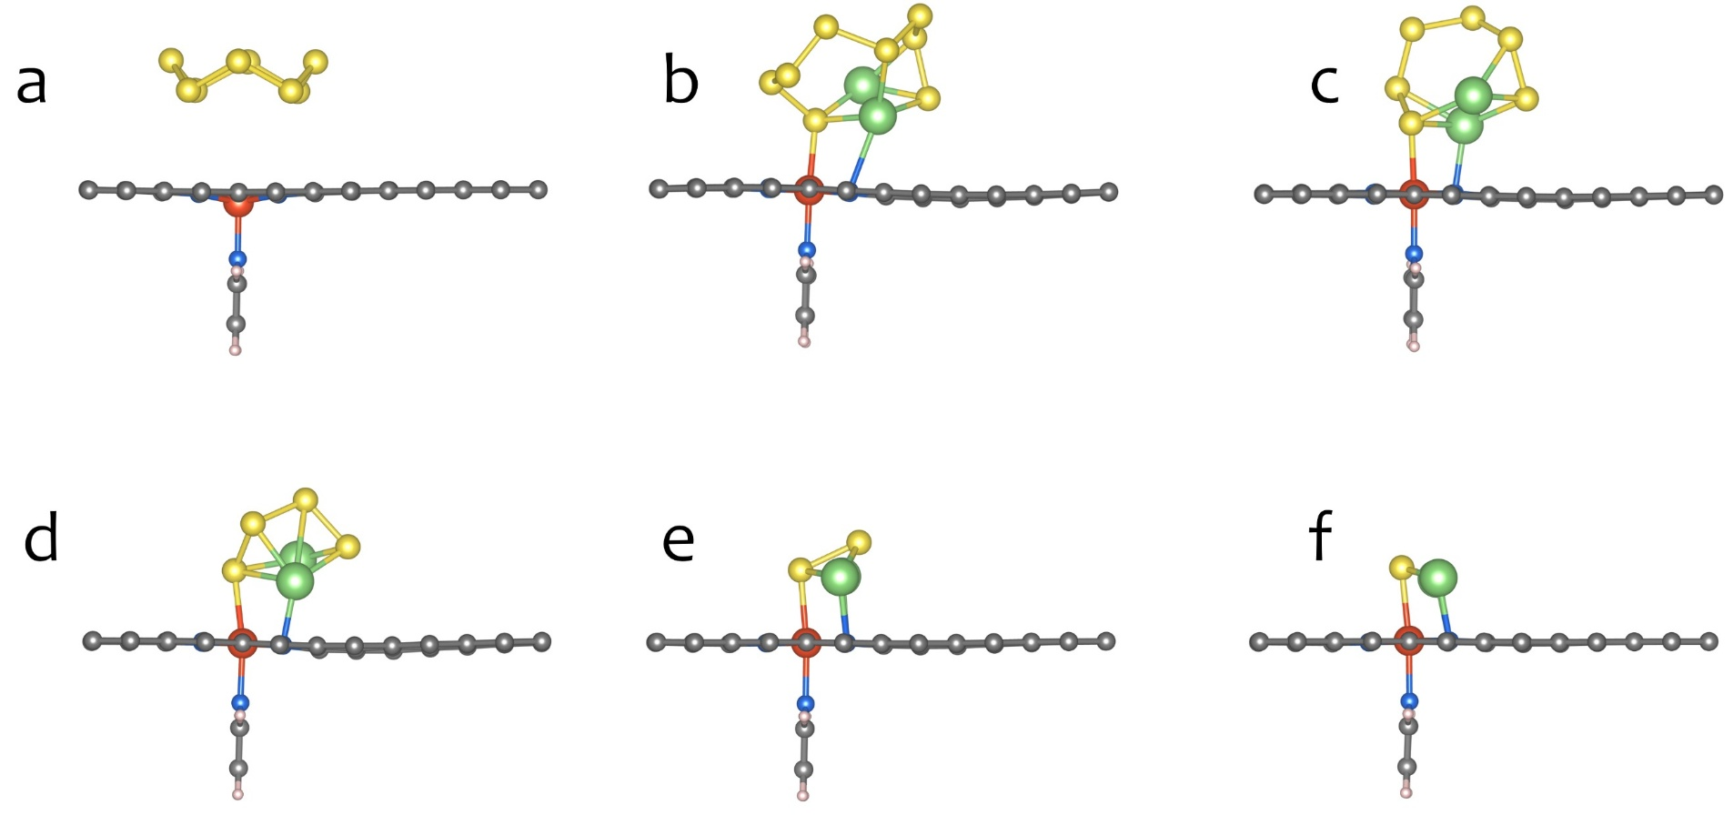

Fig. S43 Optimized structures of (a) S₈, (b) Li₂S₈, (c) Li₂S₆, (d) Li₂S₄, (e) Li₂S₂, (f) Li₂S on Fe/NC

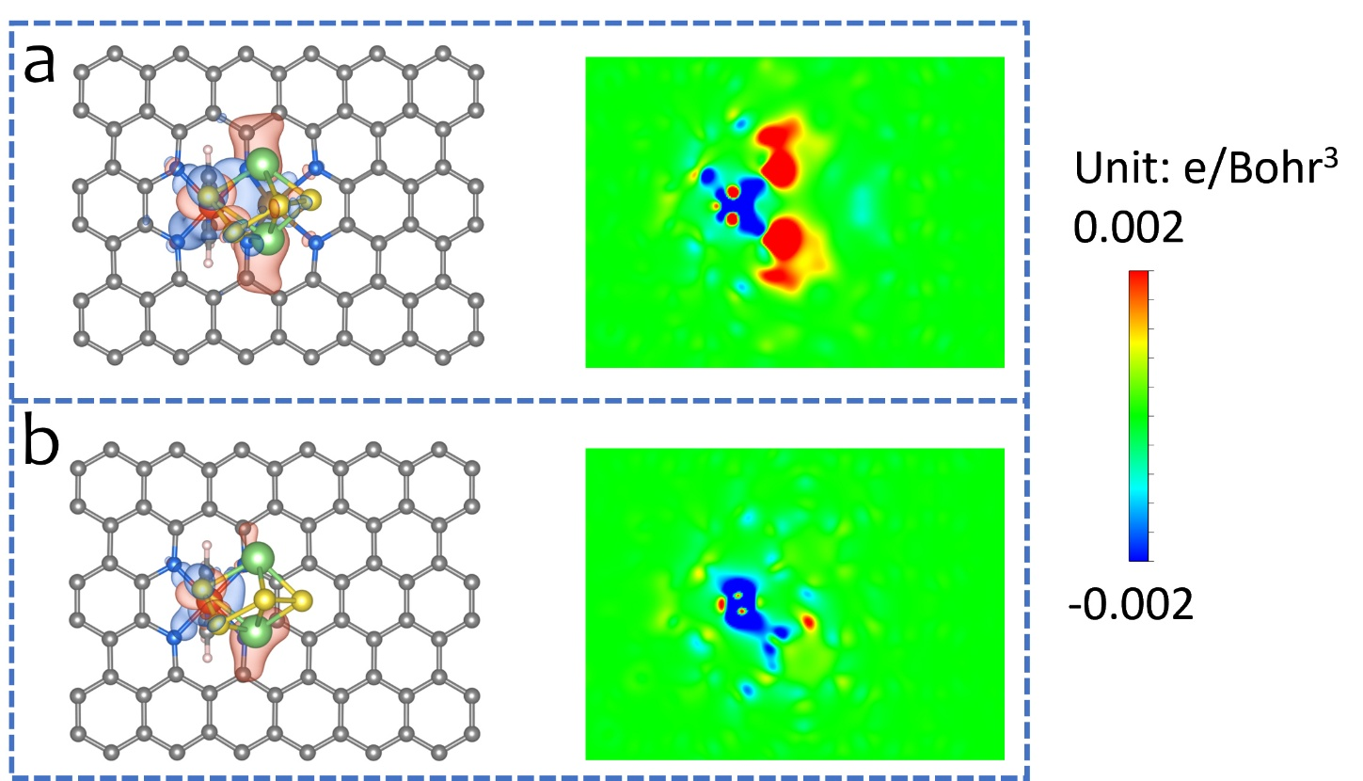
Fig. S44 3D charge density difference of Li₂S₄ adsorption on (a) FeTe/NC, (b) Fe/NC and corresponding 2D projection of charge density contour, the red (blue) distribution corresponds to charge accumulation (depletion)

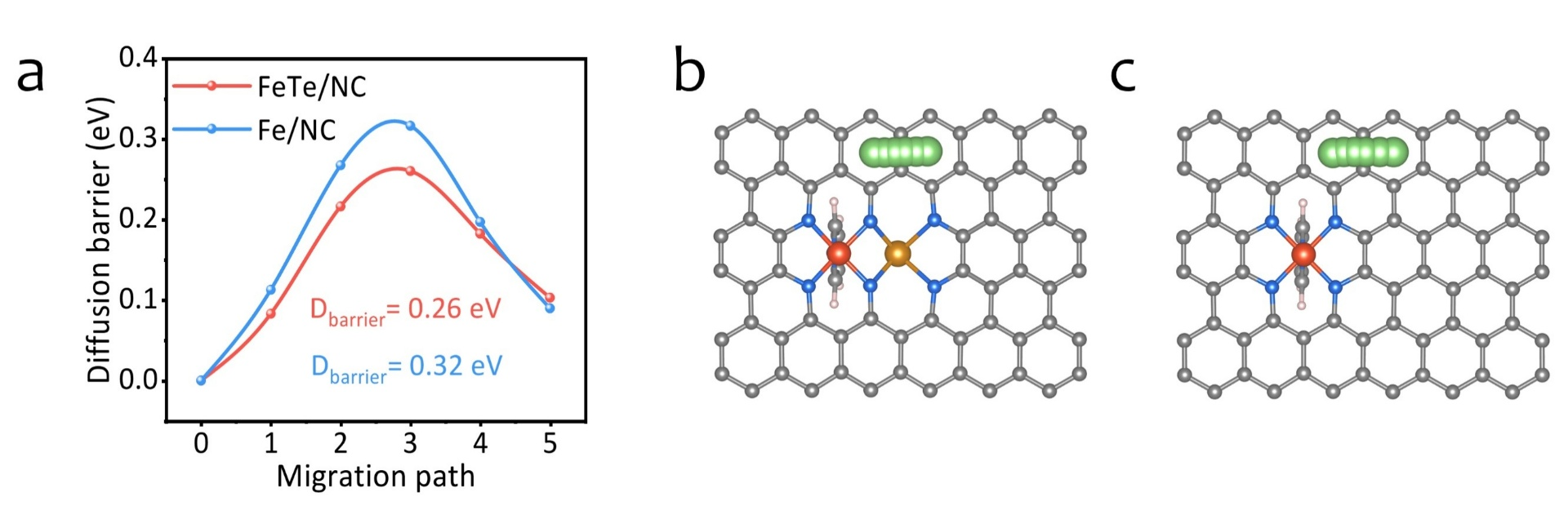
Fig. S45 (a) Energy barrier of Li-ion diffusion on the surface of FeTe/NC and Fe/NC. Geometrical configurations of the minimum energy path of Li-ion diffusion on the surface of (b) FeTe/NC and (c) Fe/NC
Table S1 ICP-OES results of different samples
Samples | Elements | Element content in solution (mg L⁻¹) | Element content in samples (wt%) | Atomic ratio
FeTe/NC-0.75 | Fe | 3.1732 | 1.48% | Fe:Te = 2.2:1
FeTe/NC-0.75 | Te | 3.3650 | 1.57% | Fe:Te = 2.2:1
FeTe/NC | Fe  Te | 3.3025  6.2650 | 1.54%  2.92% | Fe:Te = 1.2:1
FeTe/NC-3 | Fe | 3.4736 | 1.62% | Fe:Te = 1:1.5
FeTe/NC-3 | Te | 12.0921 | 5.64% | Fe:Te = 1:1.5
Fe/NC | Fe | 2.2601 | 1.04%
Table S2 EXAFS fitting parameters at the Fe K-edge and Te K-edge for FeTe/NC, Fe/NC, Te/NC, Fe foil and Te foil samples
Samples | Path | CN | R(Å) | σ²×10³ (Å²) | ΔE₀(eV) | R factor
Fe/NC | Fe-N | 5.1±0.3 | 2.03±0.01 | 11.7±0.8 | 1.51±0.8 | 0.0092
FeTe/NC | Fe-Te | 0.9±0.4 | 2.66±0.02 | 13.7±1.2 | 5.73±1.6 | 0.017
FeTe/NC | Fe-N | 5.0±0.6 | 1.98±0.02 | 6.0±2.0 | 5.73±1.6 | 0.017
Te/NC | Te-N | 2.9±0.5 | 1.91±0.02 | 5.8±1.7 | 4.99±1.6 | 0.015
FeTe/NC | Te-Fe | 1.1±0.3 | 2.65±0.03 | 10.0±1.4 | 5.49±2.3 | 0.012
FeTe/NC | Te-N | 4.0±0.4 | 2.0±0.02 | 6.5±1.5 | 5.49±2.3 | 0.012
Fe-foil | Fe-Fe | 8* | 2.46±0.02 | 4.7±0.7 | 5.73±2.0 | 0.0026
Fe-foil | Fe-Fe | 6* | 2.85±0.01 | 5.8±1.2 | 5.73±2.0 | 0.0026
Te-foil | Te-Te | 2* | 2.83±0.01 | 5.5±1.3 | 7.33±1.2 | 0.014
Note: CN is the coordination number; R is the interatomic distance (the bond length between central atoms and surrounding coordination atoms); σ² is the Debye−Waller factor (a measure of thermal and static disorder in absorber-scatterer distances); ΔE₀ is edge energy shift (the difference between the zero kinetic energy value of the sample and that of the theoretical model). R factor is used to value the goodness of the fitting. * This value was fixed during EXAFS fitting, based on the known structure of Fe and Te. A reasonable range of EXAFS fitting parameters: 0.700 < Ѕ₀² < 1.000; CN > 0; σ² > 0 Å²; |ΔE₀| < 10 eV; R factor < 0.02.
Table S3 Electrode resistances obtained from equivalent circuit fitting of FeTe/NC and Fe/NC symmetric cells.
Samples | R_{s}/Ω | R_{sei}/Ω | R_{ct}/Ω | W_{e}/Ω
FeTe/NC | 3.745 | 3.615 | 5.371 | 1.765
Fe/NC | 3.524 | 6.583 | 5.963 | 2.148
Table S4 The slope of the curve (I_{p}/v^{0.5})
Samples | Peaki | Peakii | Peakiii
FeTe/NC | 0.224 | 0.281 | 0.537
Fe/NC | 0.174 | 0.215 | 0.342
Bare | 0.097 | 0.107 | 0.148
Table S5 Calculated lithium-ion diffusion coefficients (D_{Li}⁺, cm² s⁻¹)
Samples | Peaki | Peakii | Peakiii
FeTe/NC | 6.77×10⁻⁸ | 1.07×10⁻⁷ | 3.89×10⁻⁷
Fe/NC | 4.09×10⁻⁸ | 6.24×10⁻⁸ | 1.58×10⁻⁷
Bare | 1.27×10⁻⁸ | 1.55×10⁻⁸ | 2.96×10⁻⁸
Table S6 Electrode resistances obtained from the equivalent circuit fitting of Li-S cells with the bare PP, Fe/NC and FeTe/NC modified separators.
Samples | R_{s}/Ω | R_{ct}/Ω | W_{e}/Ω
FeTe/NC | 1.42 | 26.81 | 5.09
Fe/NC | 1.14 | 47.47 | 23.29
Bare | 2.91 | 100.80 | 15.52
Table S7 A comprehensive comparison of the electrochemical performance of the FeTe/NC modified separator in this work with metal atom-dispersed catalysts in the literature for advanced Li-S batteries
 | Functional  materials | Coordination  structure | S mass loading  (mg cm⁻²) | Rate  (C) | Reversible Capacity  (mAh g⁻¹) | Capacity  after cycling  (mAh g⁻¹) | Refs.
 | FeTe/NC | FeN₅-TeN₄ | 1.2 | 0.2  1  5 | 1149  974  735 | 954 (200th)  601 (1000th)  - | This work
 | FeSA-CN | Fe-N₄ | 1.4 | 0.2  0.5  4 | 1123  958  - | -  796 (200th)  605 (500th) | [S15]
 | Fe-PNC | Fe-N₄ | 1.3 | 0.1  0.5 | -  - | 427 (300th)  557 (300th) | [S16]
 | Fe-N₅-C | Fe-N₅ | 1.0 | 0.2  1 | 1224  907 | 920 (100th)  662 (500th) | [S17]
 | 3DFeSA-CN | Fe-N₂ | 1.2 | 0.5 | 1114 | 788 (300th) | [S18]
 | FeNSC | Fe-N₃S₁ | 1.0 | 1 | 905 | 477 (1000th) | [S19]
 | FeSA-PN@PNC | Fe-N₃P₁ | 1.5 | 0.2 | 1108 | 853(100th) | [S20]
 | S-SACo  @NG | Co-N₄ | 2.0 | 0.5 | 749 | 551 (400th) | [S21]
 | 2D NC  @SA-Co | Co-N₄ | 1.0 | 0.5 | - | 787 (100th) | [S22]
 | SACo | Co-N₃ | 1.5-2.0 | 1 | 708 | 560 (100th) | [S23]
SA‐Co/BNC |  | Co-B₂N₂ | 1.2 | 0.2  1 | 1257  1006 | 1106 (100th)  684 (1000th) | [S24]
Co-HTP/CG |  | Co-N₄O₁ | 1.2-1.8 | 0.5  1 | 1070  1137 | 862 (200th)  840 (500th) | [S25]
CoSA-N₃PS |  | Co-N₃P₁S₁ | - | 0.5  1  5 | 1098  -  - | 949 (200th)  -  - | [S26]
 | Ni-N₅/  HNPC | Ni-N₅ | 1.3-1.6 | 0.5 | 1086 | 798 (500th) | [S27]
 | Mn/C-  (N, O) | MnN₁O₃ | 1.1 | 0.5 | 1060 | 560 (600th) | [S28]
 | W/NG | W-O₂N₂ | 1.1 | 0.5  1  2 | -  -  - | 986 (200th)  691 (500th)  605 | [S29]
Table S8 Bader charges of FeTe/NC and Fe/NC
FeTe/NC |  | Fe/NC
Atom | Charge | Atom | Charge
N1 | -1.17 | N1 | -1.18
N2 | -1.17 | N2 | -1.17
N3 | -1.16 | N3 | -1.17
N4 | -1.16 | N4 | -1.17
N5 | -1.23 | Fe | +1.21
N6 | -1.23 | - | -
Fe | +1.15 | - | -
Te | +1.84 | - | -
Supplementary References
- B. Wang, L. Wang, D. Ding et al., Zinc-assisted cobalt ditelluride polyhedra inducing lattice strain to endow efficient adsorption-catalysis for high-energy lithium-sulfur batteries. Adv. Mater. 34(50), 2204403 (2022). https://doi.org/10.1002/adma.202204403
- K. Liu, J. Feng, J. Guo et al., (1‐10) facet‐dominated TiB₂ nanosheets with high exposure of dual‐atom‐sites for enhanced polysulfide conversion in Li-S batteries. Adv. Funct. Mater. 34(17), 2314657 (2023). https://doi.org/10.1002/adfm.202314657
- X. B. Wang, C. R. Zhao, B. X. Liu et al., Creating edge sites within the 2D metal-organic framework boosts redox kinetics in lithium-sulfur batteries. Adv. Energy Mater. 12(42), 2201960 (2022). https://doi.org/10.1002/aenm.202201960
- W. Q. Yao, W. Z. Zheng, J. Xu et al., ZnS-SnS@NC heterostructure as robust lithiophilicity and sulfiphilicity mediator toward high-rate and long-life lithium-sulfur batteries. ACS Nano 15(4), 7114-7130 (2021). https://doi.org/10.1021/acsnano.1c00270
- P. E. Blöchl. Projector augmented-wave method. Phys. Rev. B 50(24), 17953-17979 (1994). https://doi.org/10.1103/PhysRevB.50.17953
- G. Kresse, J. Furthmuller. Efficiency of ab-initio total energy calculations for metals and semiconductors using a plane-wave basis set. Comp. Mater. Sci. 6(1), 15-50 (1996). https://doi.org/10.1016/0927-0256(96)00008-0
- G. Kresse, J. Hafner. Ab initiomolecular-dynamics simulation of the liquid-metal–amorphous-semiconductor transition in germanium. Phys. Rev. B 49(20), 14251-14269 (1994). https://doi.org/10.1103/PhysRevB.49.14251
- M. Ernzerhof, G. E. Scuseria. Assessment of the perdew-burke-ernzerhof exchange-correlation functional. J. Chem. Phys. 110(11), 5029-5036 (1999). https://doi.org/10.1063/1.478401
- G. Kresse, D. Joubert. From ultrasoft pseudopotentials to the projector augmented-wave method. Phys. Rev. B 59(3), 1758-1775 (1999). https://doi.org/10.1103/PhysRevB.59.1758
- S. Grimme, S. Ehrlich, L. Goerigk. Effect of the damping function in dispersion corrected density functional theory. J. Comput. Chem. 32(7), 1456-1465 (2011). https://doi.org/10.1002/jcc.21759
- G. Henkelman, B. P. Uberuaga, H. Jónsson. A climbing image nudged elastic band method for finding saddle points and minimum energy paths. J. Chem. Phys. 113(22), 9901-9904 (2000). https://doi.org/10.1063/1.1329672
- Z. Y. Chen, X. Z. Su, J. Ding et al., Boosting oxygen reduction reaction with Fe and Se dual-atom sites supported by nitrogen-doped porous carbon. Appl. Catal. B-Environ. Energy 308(121206 (2022). https://doi.org/10.1016/j.apcatb.2022.121206
- Y. Tian, G. Li, Y. Zhang et al., Low‐bandgap Se‐deficient antimony selenide as a multifunctional polysulfide barrier toward high‐performance lithium–sulfur batteries. Adv. Mater. 32(4), 1904876 (2019). https://doi.org/10.1002/adma.201904876
- Q. Lv, Y. Sun, B. Li et al., Metal–organic frameworks with axial cobalt–oxygen coordination modulate polysulfide redox for lithium–sulfur batteries. Adv. Energy Mater. 15(5), 2403223 (2024). https://doi.org/10.1002/aenm.202403223
- C. G. Wang, H. W. Song, C. C. Yu et al., Iron single-atom catalyst anchored on nitrogen-rich mof-derived carbon nanocage to accelerate polysulfide redox conversion for lithium sulfur batteries. J. Mater. Chem A. 8(6), 3421-3430 (2020). https://doi.org/10.1039/c9ta11680j
- Z. Z. Liu, L. Zhou, Q. Ge et al., Atomic iron catalysis of polysulfide conversion in lithium-sulfur batteries. ACS Appl. Mater. Interfaces 10(23), 19311-19317 (2018). https://doi.org/10.1021/acsami.8b03830
- Y. G. Zhang, J. B. Liu, J. Y. Wang et al., Engineering oversaturated Fe-N multifunctional catalytic sites for durable lithium-sulfur batteries. Angew. Chem. Int. Ed. 60(51), 26622-26629 (2021). https://doi.org/10.1002/anie.202108882
- Y. F. Ding, Q. S. Cheng, J. H. Wu et al., Enhanced dual-directional sulfur redox via a biotemplated single-atomic Fe-N mediator promises durable Li-S batteries. Adv. Mater. 34(28), 2202256 (2022). https://doi.org/10.1002/adma.202202256
- H. Zhao, B. Tian, C. Su, Y. Li. Single-atom iron and doped sulfur improve the catalysis of polysulfide conversion for obtaining high-performance lithium–sulfur batteries. ACS Appl. Mater. Interfaces 13(6), 7171-7177 (2021). https://doi.org/10.1021/acsami.0c20446
- T. Huang, Y. J. Sun, J. H. Wu et al., Altering local chemistry of single-atom coordination boosts bidirectional polysulfide conversion of Li-S batteries. Adv. Funct. Mater. 32(39), 2203902 (2022). https://doi.org/10.1002/adfm.202203902
- G. M. Zhou, S. Y. Wang, T. S. Wang et al., Theoretical calculation guided design of single-atom catalysts toward fast kinetic and long-life Li-S batteries. Nano Lett. 20(2), 1252-1261 (2020). https://doi.org/10.1021/acs.nanolett.9b04719
- Y. J. Li, P. Zhou, H. Li et al., A freestanding flexible single-atom cobalt-based multifunctional interlayer toward reversible and durable lithium-sulfur batteries. Small Methods 4(3), 1900701 (2020). https://doi.org/10.1002/smtd.201900701
- J. Kim, S. J. Kim, E. Jung et al., Atomic structure modification of Fe-N-C catalysts via morphology engineering of graphene for enhanced conversion kinetics of lithium-sulfur batteries. Adv. Funct. Mater. 32(19), 2110857 (2022). https://doi.org/10.1002/adfm.202110857
- Z. Wang, Y. Yan, Y. Zhang et al., Single-atomic Co-B₂N₂ sites anchored on carbon nanotube arrays promote lithium polysulfide conversion in lithium–sulfur batteries. Carbon Energy 5(11), e306 (2023). https://doi.org/10.1002/cey2.306
- Q. L. Lv, Y. J. Sun, B. Li et al., Metal-organic frameworks with axial cobalt-oxygen coordination modulate polysulfide redox for lithium-sulfur batteries. Adv. Energy Mater. 15(5), 2403223 (2024). https://doi.org/10.1002/aenm.202403223
- C. X. Dong, C. N. Ma, C. Zhou et al., Engineering d-p orbital hybridization with P, S co-coordination asymmetric configuration of single atoms toward high-rate and long-cycling lithium-sulfur battery. Adv. Mater. 36(38), 2407070 (2024). https://doi.org/10.1002/adma.202407070
- S. L. Zhang, X. Ao, J. Huang et al., Isolated single-atom Ni-N catalytic site in hollow porous carbon capsules for efficient lithium-sulfur batteries. Nano Lett. 21(22), 9691-9698 (2021). https://doi.org/10.1021/acs.nanolett.1c03499
- Y. N. Liu, Z. Y. Wei, B. Zhong et al., O-, N-coordinated single Mn atoms accelerating polysulfides transformation in lithium-sulfur batteries. Energy Storage Mater. 35(12-18 (2021). https://doi.org/10.1016/j.ensm.2020.11.011
- P. Wang, B. J. Xi, Z. C. Y. Zhang et al., Atomic tungsten on graphene with unique coordination enabling kinetically boosted lithium-sulfur batteries. Angew. Chem. Int. Ed. 60(28), 15563-15571 (2021). https://doi.org/10.1002/anie.202104053

