Supporting Information
Differentiating the 2D Passivation from Amorphous Passivation in perovskite solar cells
Xiaojian Zheng^{1,2,#}, Shehzad Ahmed^{3,#}, Yu Zhang^{1,#}, Guoqiang Xu^{1,2}, Junyu Wang¹, Di Lu¹, Tingshu Shi¹, Jun Tang¹, Lei Yan², Wei Chen⁴, Peigang Han¹, Zhixin Liu^{1,*}, Danish Khan^{1,}*, Xingzhu Wang ^{2,} *, Zeguo Tang^{1 ,} *

¹ College of New Materials and New Energies, Shenzhen Technology University，Lantian Road 3002, Pingshan, Shenzhen 518118, China
² Engineering and Research Center for Integrated New Energy Photovoltaics & Energy Storage Systems of Hunan Province and School of Electrical Engineering, University of South China, Hengyang 421001, Hunan, China
³ China-UK Low Carbon College, Shanghai Jiao Tong University, Lingang, Shanghai 201306, China
⁴ College of Engineering Physics, Shenzhen Technology University, Shenzhen, Guangdong 518118, China
*Corresponding author. E-mail: liuzx@sustech.edu.cn, khandanish@sztu.edu.cn, wangxz@sustech.edu.cn, tangzeguo@sztu.edu.cn
#These authors contributed equally to this work.

Computational Details
All first-principles computations have been performed utilizing the Vienna Ab initio Simulation Package (VASP) grounded in density functional theory (DFT) [1]. The exchange-correlation interactions were characterized using the generalized gradient approximation (GGA) based on the Perdew-Burke-Ernzerh of (PBE) functional [2]. The projector-augmented wave (PAW) approach was utilized to characterize the interaction between core and valence electrons [3]. The PbI₆ monolayer was represented as a periodic two-dimensional slab with an adequately large vacuum zone (~20 Å) in the out-of-plane direction to prevent interactions between periodic imagery. The plane-wave basis set was augmented with an energy cutoff of 550 eV to guarantee convergence. The Brillouin zone was sampled with a Γ-centered Monkhorst-Pack k-point mesh of 3×3×1 for structural relaxations and 5×5×1 for electronic structure computations [3]. Structural optimizations were conducted until the residual forces on each atom fell below 0.001 eV/Å. To examine the adsorption characteristics of the 4TF-BA and 4F-BA molecules on the PbI₆ monolayer, we calculated the formation energy (E _{form}) utilizing the subsequent equation:
E _{form} = E _{adsorbed system} - (E_{PbI6} + E _{molecule})
where E _{adsorbed system} denotes the total energy of the PbI₆ monolayer with the adsorbed molecule, E_{PbI6} represents the energy of the pristine PbI₆ monolayer, and E _{molecule} signifies the energy of the isolated molecule [4]. Charge transfer study was conducted utilizing Bader charge calculations and charge density differential plots to illustrate charge redistribution during adsorption [5]. The charge transfer density (Δρ) was calculated as follows:
Δρ = ρ _{adsorbed system} - (ρ_{PbI6} + ρ _{molecule})
where Δρ denotes the charge density of the corresponding components. To further explore the electronic interactions at the molecule-substrate interface, the crystal orbital Hamilton population (-COHP) and projected crystal orbital Hamilton population (-pCOHP) analyses were conducted. These calculations provided insights into the bonding and antibonding interactions between the molecular orbitals and the PbI₆ substrate. The LOBSTER code was implemented within VASP to compute the -COHP and -pCOHP, enabling a detailed analysis of orbital interactions and bonding characteristics [6]. All calculations were performed with van der Waals (vdW) interactions using DFT-D3 correction scheme to accurately describe the adsorption characteristics of 4TF-BA and 4F-BA on the PbI₆ layer.

The carrier lifetime calculation:
We studied the charge recombination dynamics and used the following formula to fit the TRPL decay curve:
y $=$ y₀ $+$ A₁exp$\left(\frac{-t}{τ_{1}}\right)$ $+$ A₂exp$\left(\frac{-t}{τ_{2}}\right)$
(1)
where A₁ and A₂ are relative amplitudes, and τ₁ and τ₂ represent the lifetimes for fast and slow recombination, respectively. The average lifetime of the nonradiative recombination process can be calculated according to the following formula:
(2)
$τ$_{ave} $=$ $\frac{\sum{A_{i}τ_{i}^{2}}}{\sum{A_{i}τ_{i}}}$

Electrochemical impedance spectroscopy (EIS) and capacitance-voltage spectrum (C-V):
Capacitance- voltage spectrum (C-V) has been studied by electrochemical workstation. The depletion layer capacitance can be approximated as a function of the applied bias-voltage:
C $=\sqrt{\frac{qε_{r}N}{2(V_{bi}-V)}}$
(3)
where q is the element charge, ε_{r} is the relative dielectric constant, N is the charge carrier density, and V_{bi} is the built-in potential.

Space charge limited current (SCLC):
The PCE and SCLC of perovskite solar cells were calculated by recording the current density-voltage (J-V) curves on a solar simulator connected to a Keithley 2400 Digital Source Meter under AM1.5G irradiation in the dark. The light intensity was calibrated with a standard silicon photodiode. The scan rate was fixed at 20 mV s⁻¹ while the delay time was set to 0.01 s. A metal mask defined the active area with a size of 0.06 cm². The trap density (N_{trap}) is calculated by equation:
N_{trap} $=$ $\frac{{2C}_{g}V_{TFL}}{qAL}$
(4)
where C_{g} is the geometrical capacitance of the perovskite layer, which is obtained by the C-V spectra of the corresponding devices, V_{TFL} is the trap-filled limit voltage obtained through the dark J-V curve, q is the elementary charge, A is the active area, and L is the thickness of perovskite film.

Supporting Figures

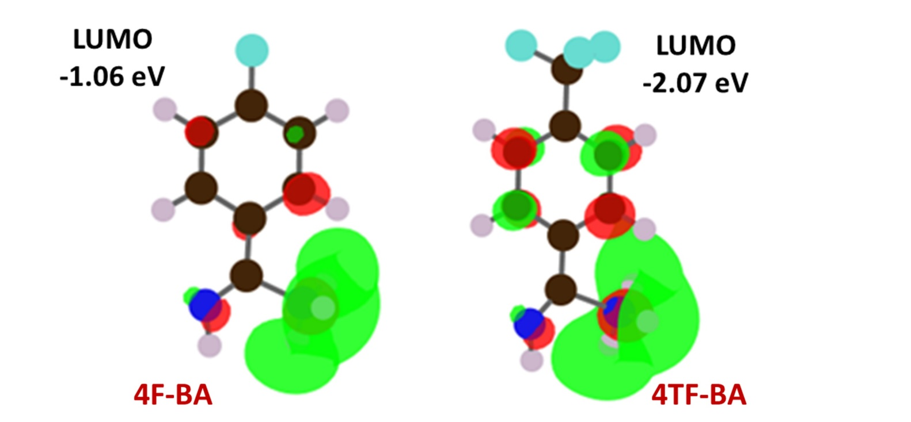
Fig. S1. LUMO isosurfaces and levels of 4F-BA and 4TF-BA.

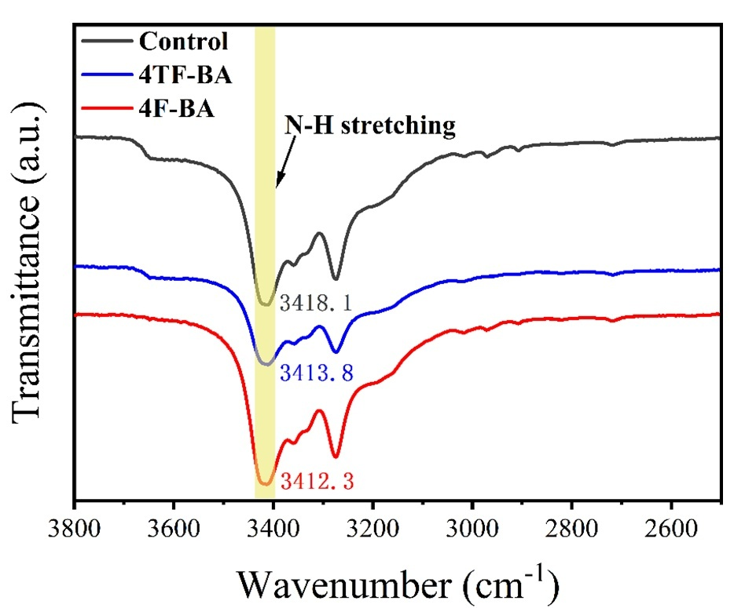
Fig. S2. The FTIR spectra of control, 4TF-BA, and 4F-BA-based films.

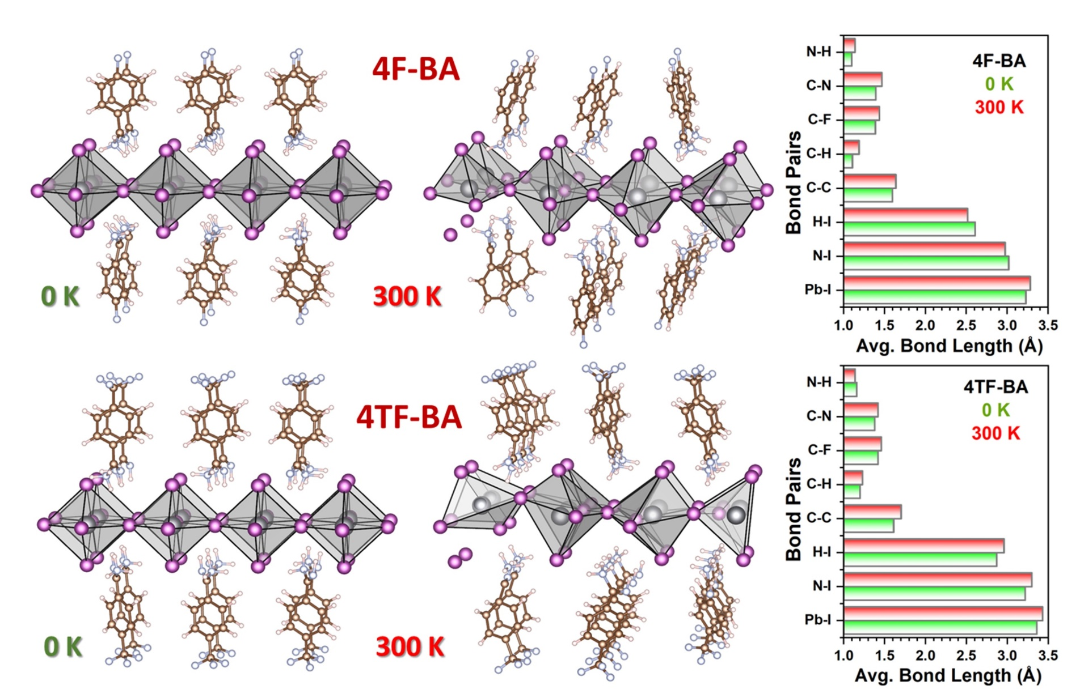
Fig. S3. (a) Structural snapshots before and after AIMD simulations at 300 K, illustrating better thermal stability in 4F-BA. And, the bond length comparison before and after AIMD. 4F-BA exhibits shorter N–I and H–I distances at 300 K, indicating stronger interfacial binding than 4TF-BA.

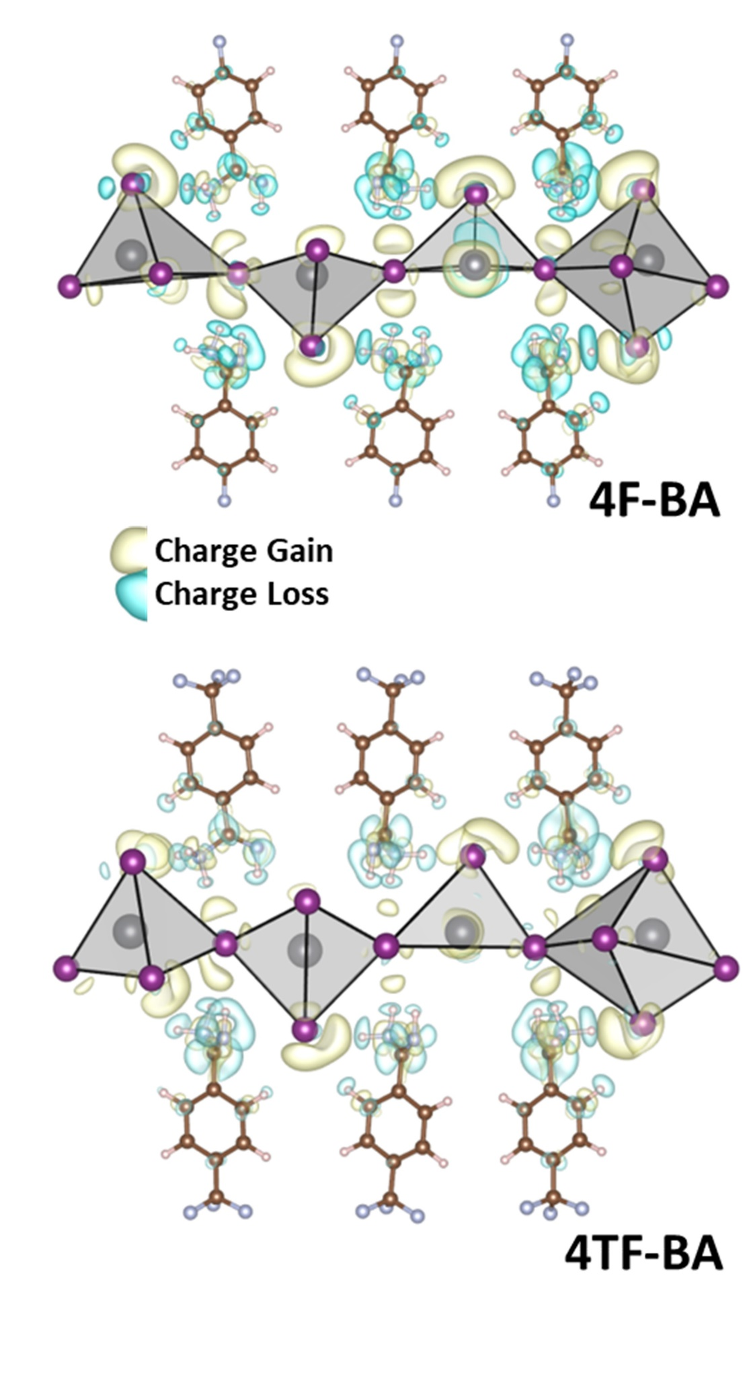
Fig. S4. Charge density difference plots showing greater interfacial charge transfer for 4F-BA than 4TF-BA.
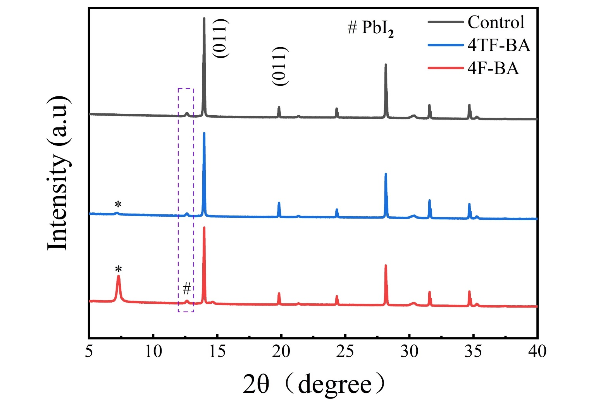
Fig. S5. XRD results of control and modified films via 4TF-BA and 4F-BA.

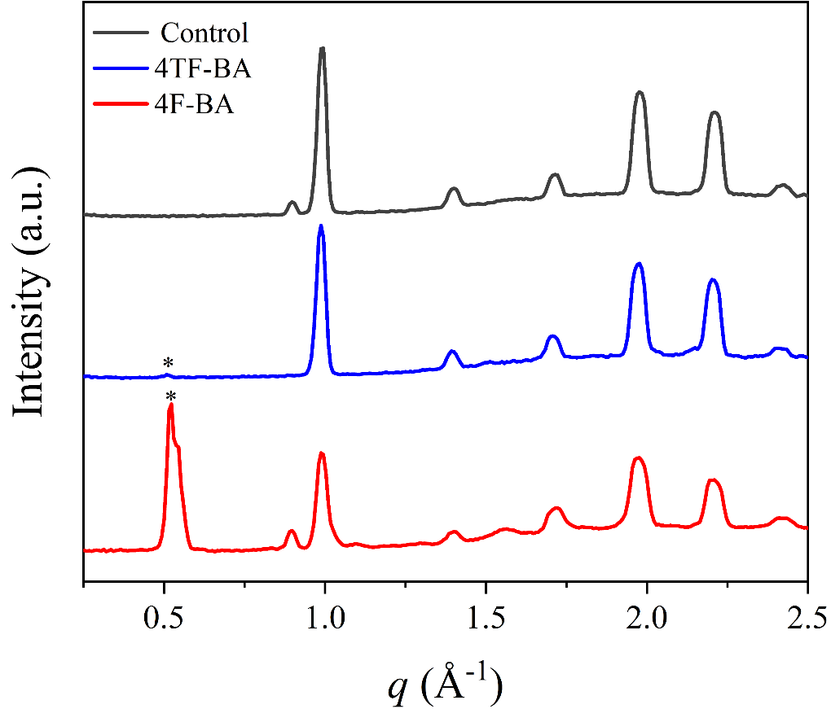
Fig. S6. Intensity profiles along the qz axis of the corresponding perovskite film extracted from GIWAXS data for each case.

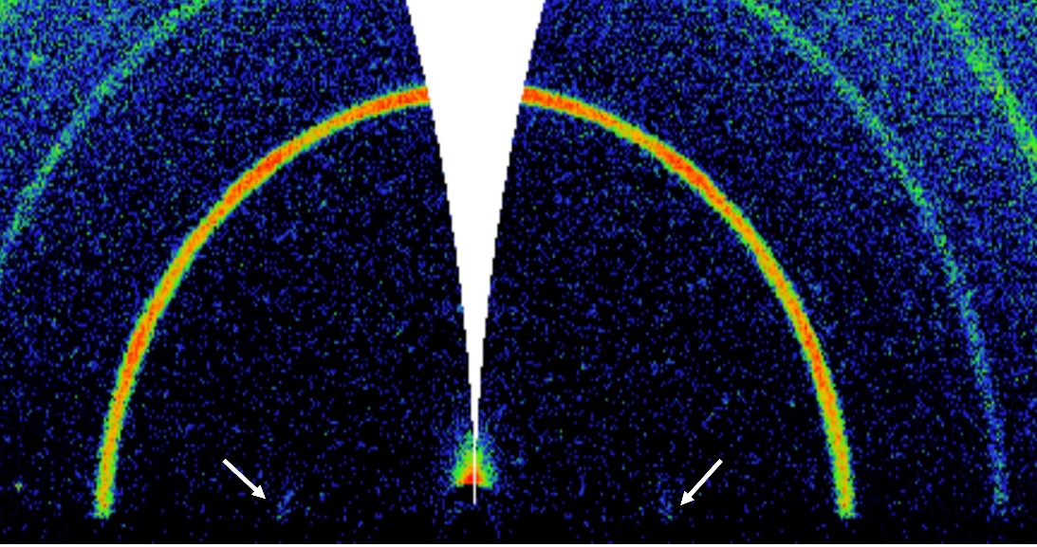
Fig. S7. Zoomed-in version of GIWAXS of 4TF-BA-based perovskite films. Very faint signal as highlighted by white arrows.

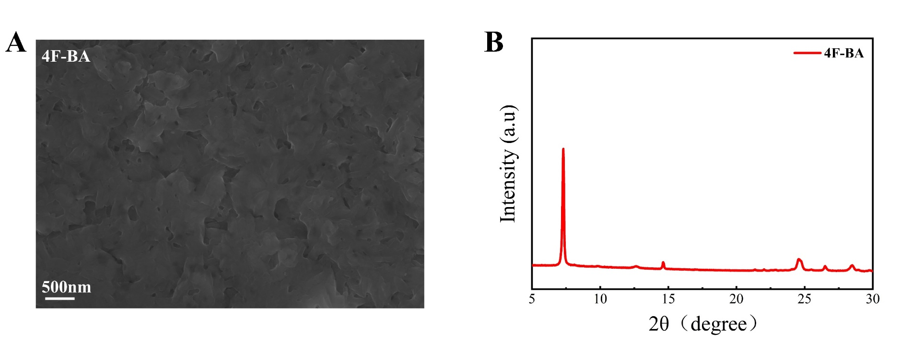
Fig. S8. (A) SEM image and (B) XRD graph of pure 2D Ruddlesden–Popper perovskite film (4F-BA)₂Pb(ICl)₄.
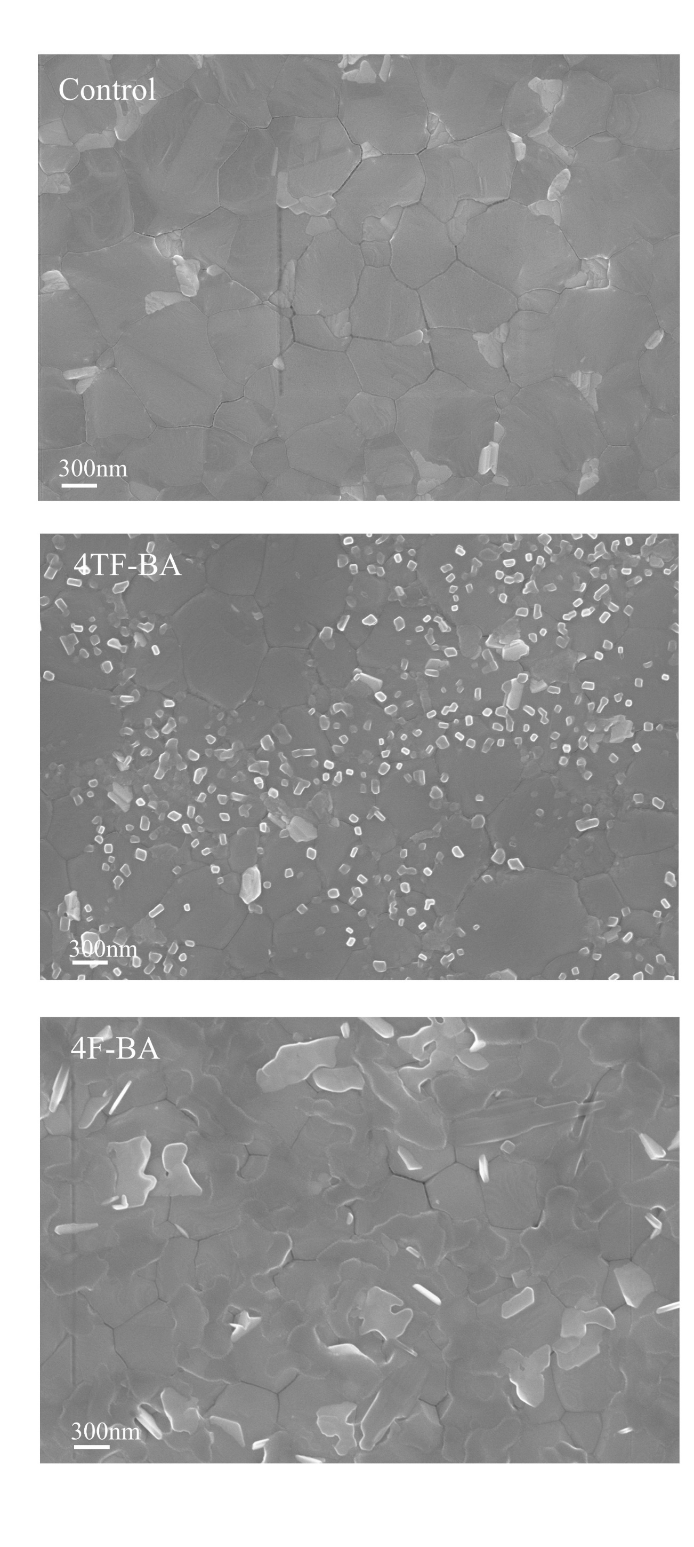
Fig. S9. Top SEM images of the control perovskite and perovskite treated with 4TF-BA and 4F-BA.

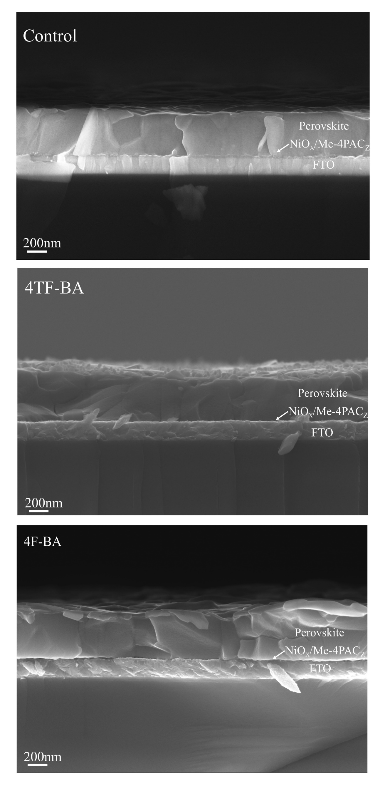

Fig. S10. Cross-sectional SEM images of the control perovskite film and the films treated with 4TF-BA and 4F-BA.

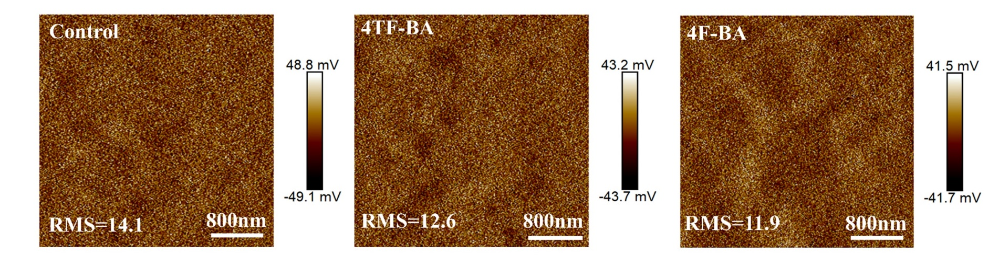
Fig. S11. Surface contact potential difference distribution images, measured by KPFM of perovskite films without or with 4TF-BA and 4F-BA treatments.

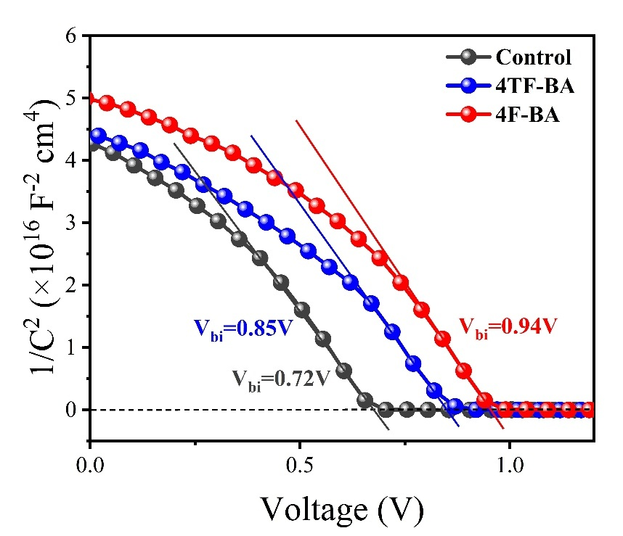
Fig. S12. Mott-Schottky plots of control and modified devices.

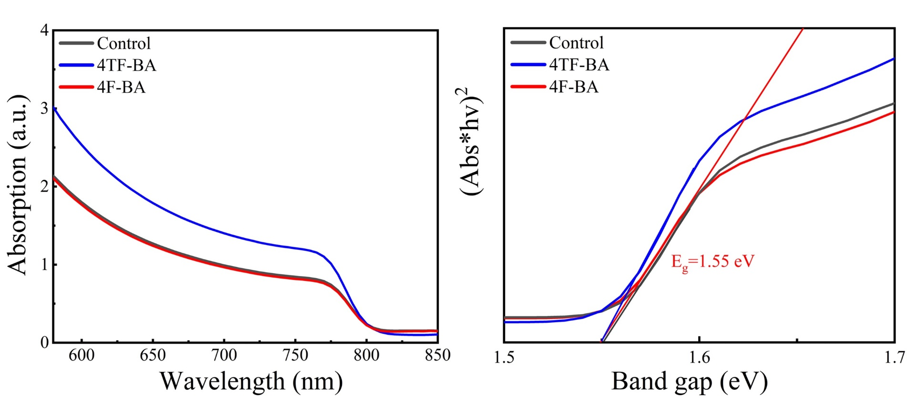
Fig. S13. UV-vis absorption spectra of control and modified films (left panel) and the extracted Tauc plots showing the band gap of 1.55 eV in each case.

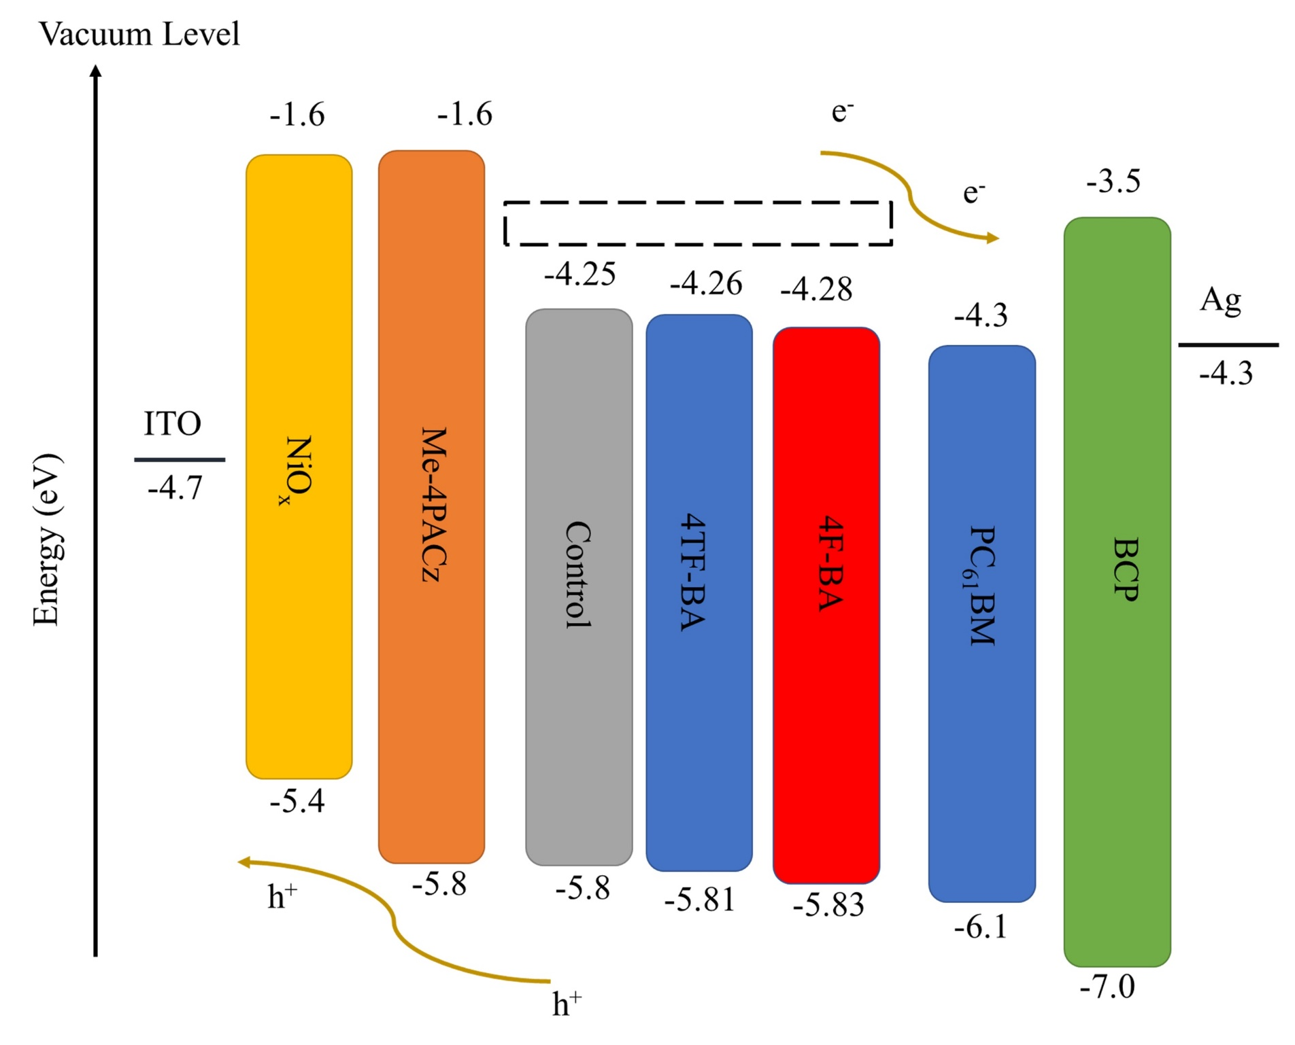
Fig. S14. The energy level diagram of the layers of our as-fabricated p-i-n device.

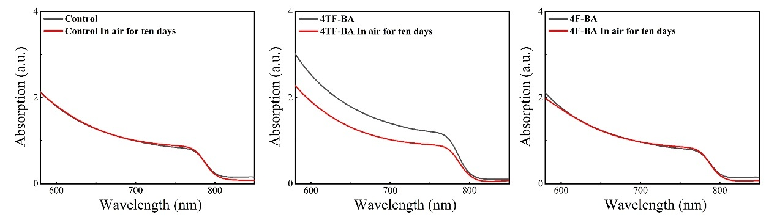
Fig. S15. Absorption comparison before and after aging in ambient air for 10 days, obtained from the UV-vis test.

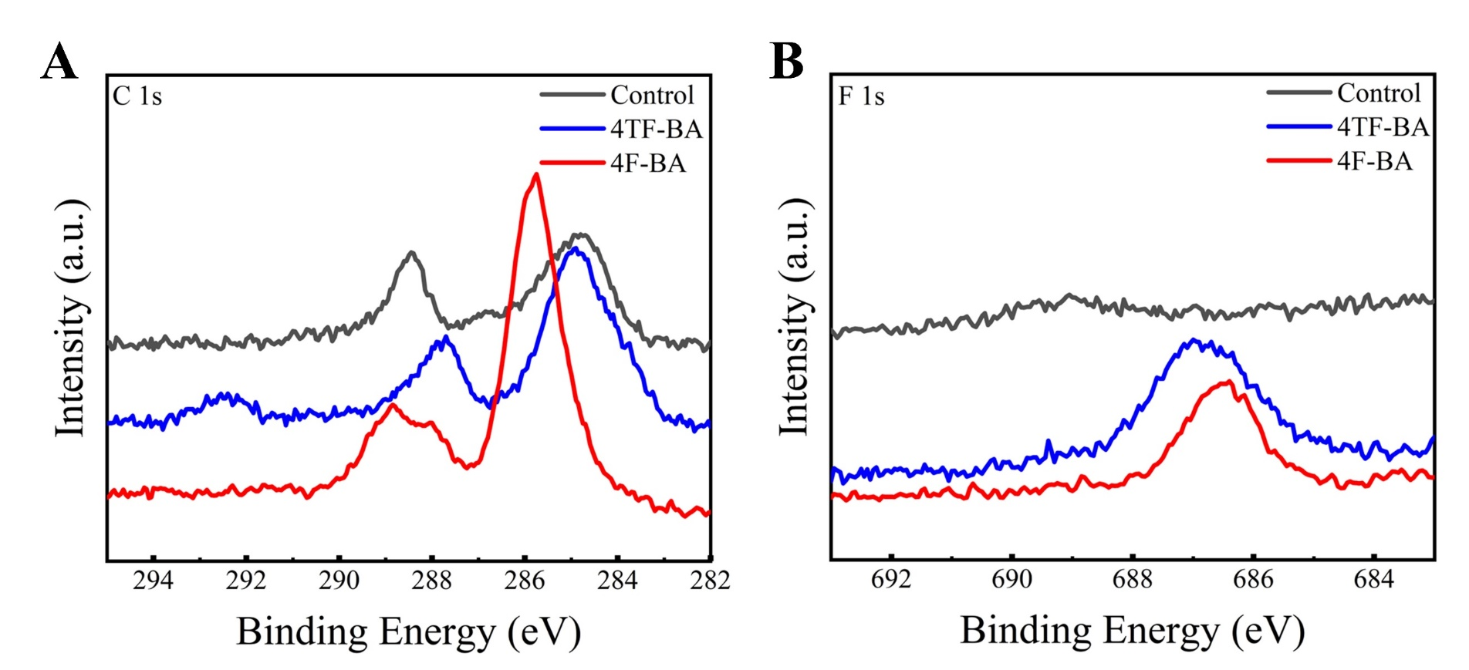
Fig. S16. XPS spectra of (A) C 1s and (B) F1s core levels of control,4TF-BA and 4F-BA treated perovskite films.

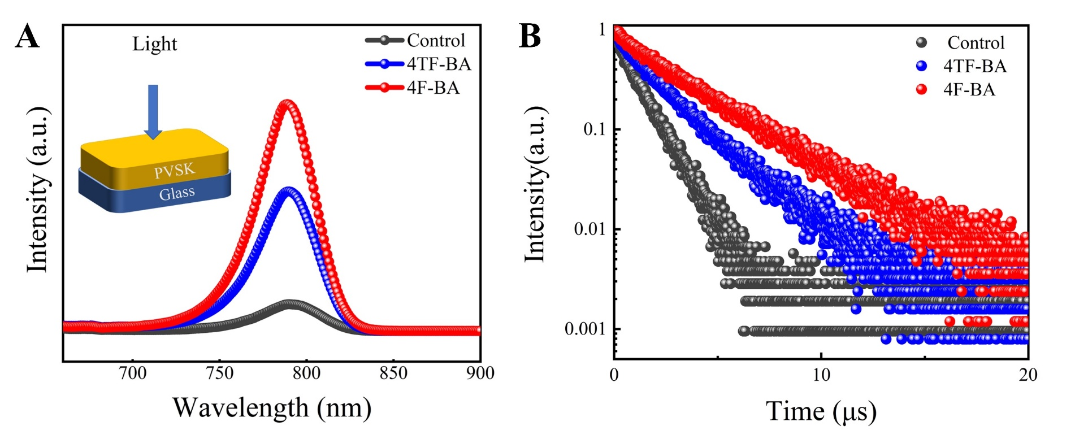
Fig. S17. (A) PL intensity and (B) the corresponding TRPL of the control, 4TF-BA, and 4F.

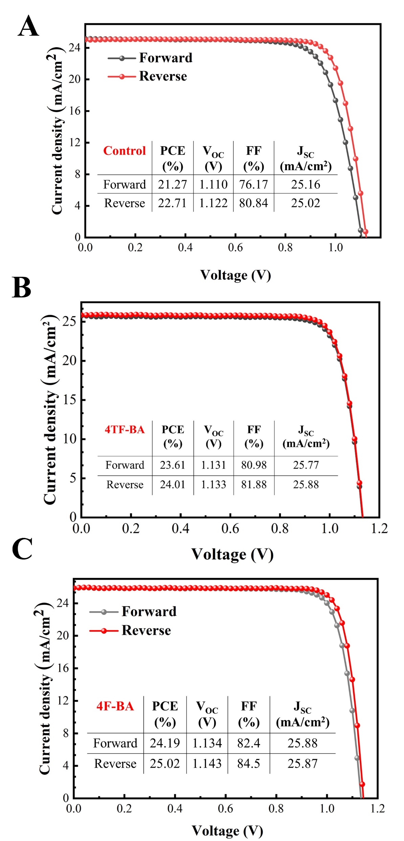
Fig. S18. J-V curves of the best-performing (A) control device, (B) 4TF-BA-based device, and (C) 4F-BA-based device.

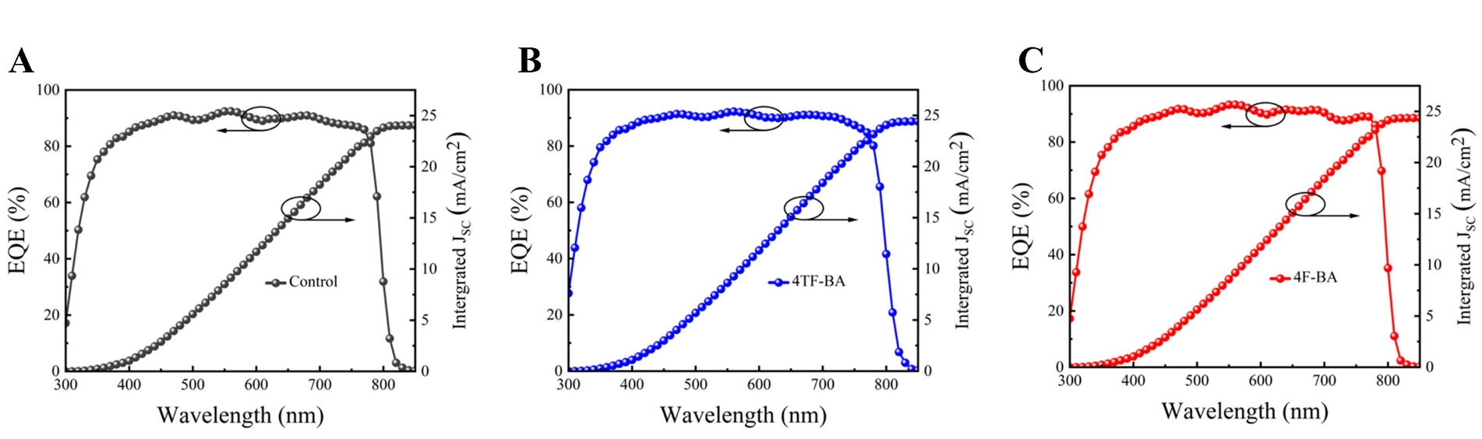
Fig. S19. External quantum efficiency curves and integrated J_{SC} of (A) control, (B) 4TF-BA, and (C) 4F-BA-based device.

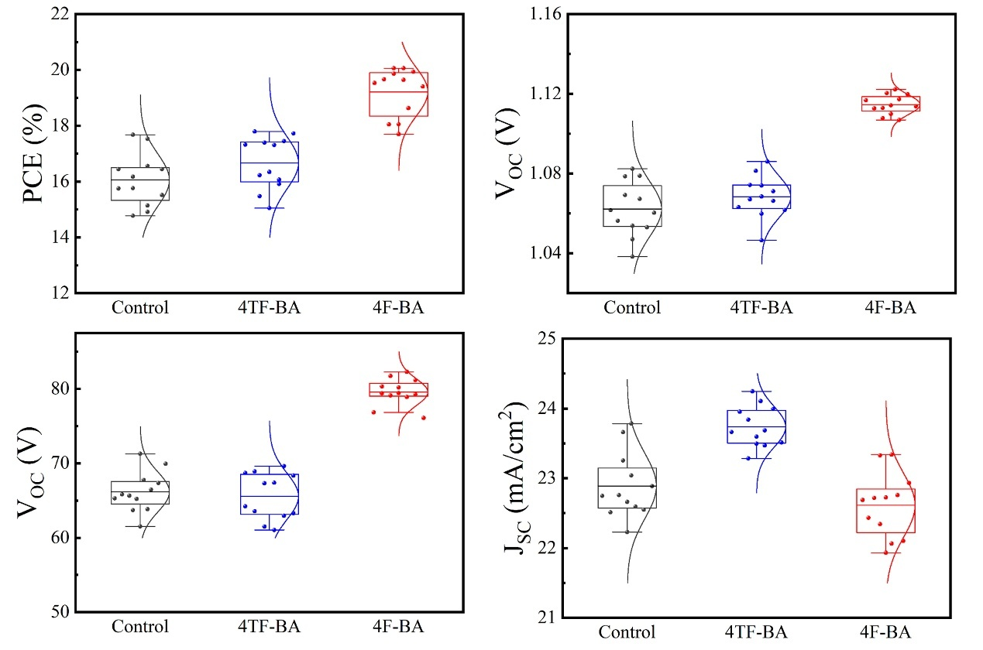
Fig. S20. Photovoltaic performances of the devices based on Cs_{0.05}(FA_{0.95}MA_{0.05})_{0.95}Pb(I_{0.95}Br_{0.05})₃ perovskite in each case.
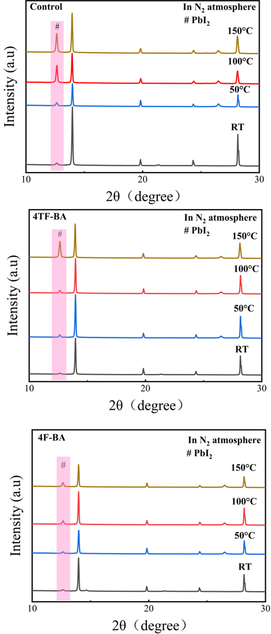
Fig. S21. XRD graphs under different annealing temperature of control, 4TF-BA-based, and 4F-BA-based perovskite films.

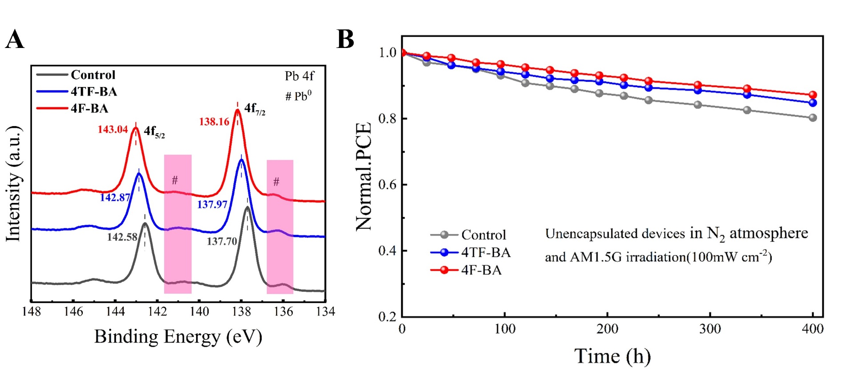
Fig. S22. (A) Pb 4f XPS comparison of the control and modified films after UV light soaking for 7 days. (B) Long-term stability tracking under continuous illumination for 400 hours in an N2 environment.

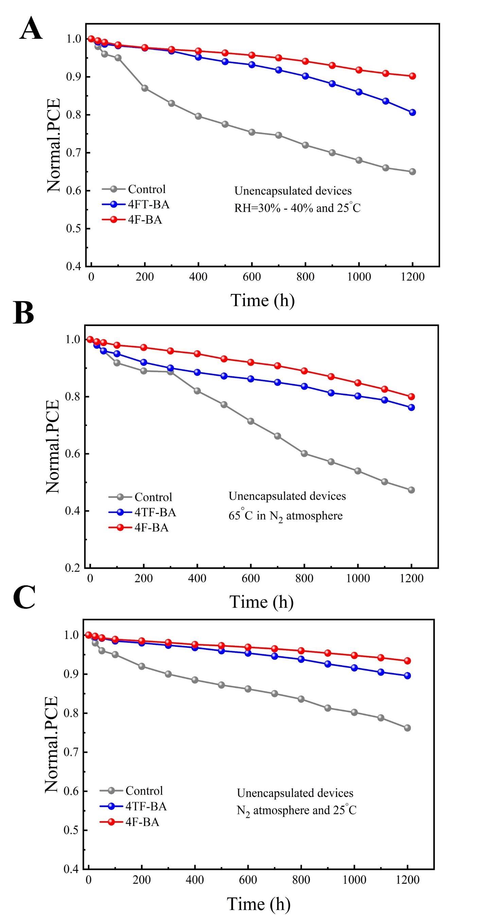
Fig. S23. Long-term stability of unencapsulated devices (A) stored in an N₂ atmosphere at 25°C, (B) stored in an N₂ atmosphere at 65°C, and (C) stored under ambient conditions (25°C, 30–40% relative humidity).

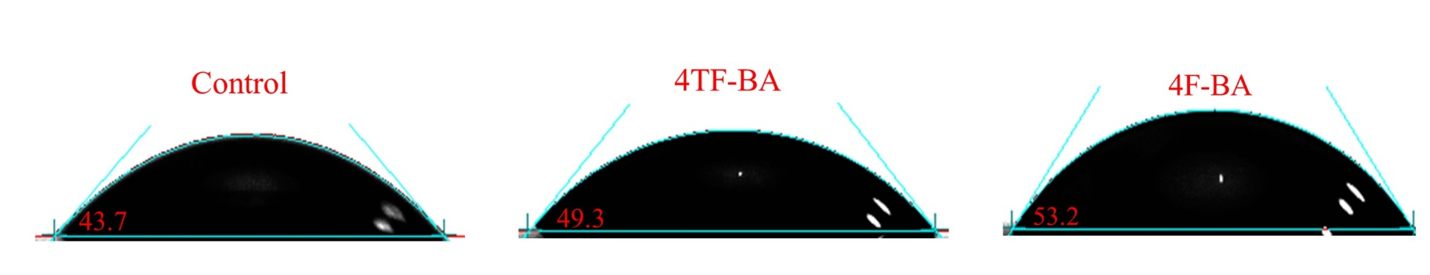
Fig. S24. The water contact angle measurements of the Control, 4TF-BA, and 4F-BA-treated perovskite films.

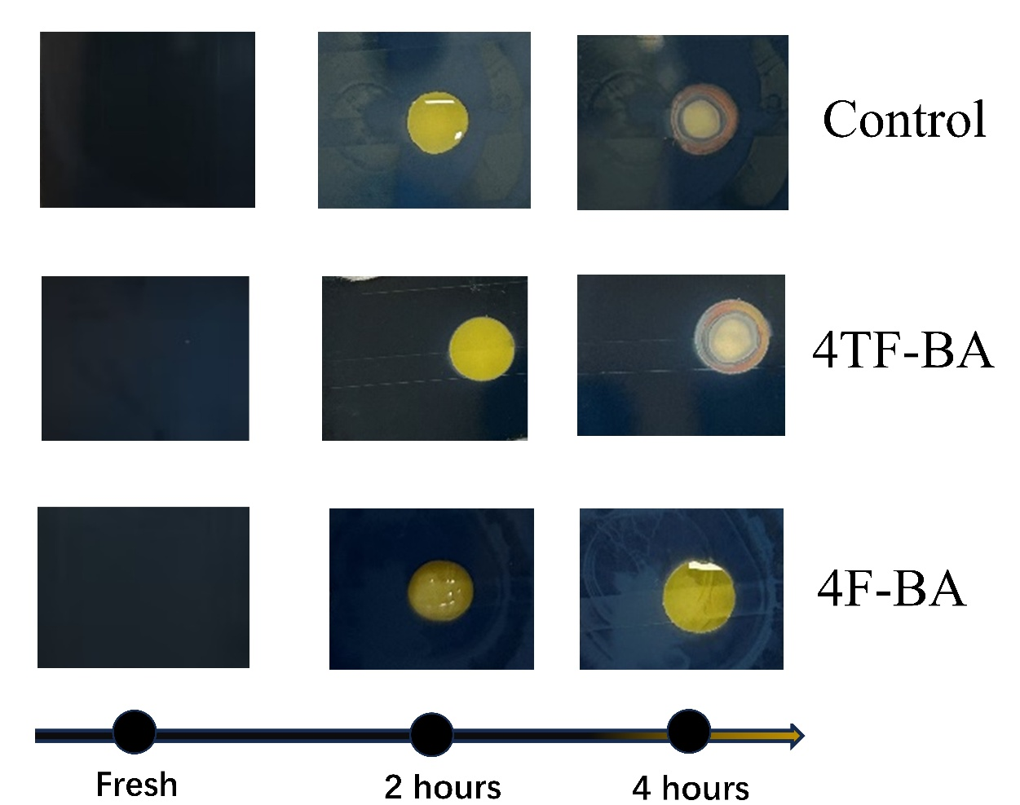
Fig. S25. The images of control and modified perovskite films with prolonged water droplet test after storing in air for 4 hours.

Supporting Tables

Table S1. The fitted carrier lifetime of perovskite films obtained from the TRPL measurements.

Device | A₁ | τ₁(ns) | A₂ | τ₂(ns) | τ_{ave}(ns)
Control | 0.48 | 50.15 | 1.32 | 180.23 | 168.28
4TF-BA | 0.43 | 98.72 | 1.48 | 443.34 | 422.40
4F-BA | 0.32 | 129.22 | 1.64 | 682.92 | 663.21

Table S2. The fitting results of Nyquist impedance by the equivalent circuit.
Device | R_{S} (Ω) | R_{rec} (Ω) | C (nF)
Control | 37.89 | 2853 | 8.63
4TF-BA | 24.71 | 4597 | 7.41
4F-BA | 22.19 | 5462 | 3.04

References
1. J. Hafner, Journal of Computational Chemistry 29, 2044 (2008).
2. Y. Zhao, N. E. Schultz, and D. G. Truhlar, J. Chem. Theory Comput. 2, 364 (2006).
3. G. Kresse and D. Joubert, Phys. Rev. B 59, 1758 (1999).
4. S. Kirklin, J. E. Saal, B. Meredig, A. Thompson, J. W. Doak, M. Aykol, S. Rühl, and C. Wolverton, Npj Computational Materials 1, 15010 (2015).
5. E. Sanville, S. D. Kenny, R. Smith, and G. Henkelman, Journal of Computational Chemistry 28, 899 (2007).
6. S. Maintz, V. L. Deringer, A. L. Tchougréeff, and R. Dronskowski, Journal of Computational Chemistry 37, 1030 (2016).

