Supporting Information for
Boron-Insertion-Induced Lattice Engineering of Rh Nanocrystals towards Enhanced Electrocatalytic Conversion of Nitric Oxide to Ammonia
Peng Han^{1,#}, Xiangou Xu^{2,} #, Weiwei Chen³, Long Zheng¹, Chen Ma¹, Gang Wang¹, Lei Xu¹, Ping Gu¹, Wenbin Wang⁴, Qiyuan He⁴, Zhiyuan Zeng⁵, Jinlan Wang², Dong Su³, Chongyi Ling^{2,}*, Zhengxiang Gu^{6,}*, and Ye Chen^{1,}*
¹ Department of Chemistry, The Chinese University of Hong Kong, Hong Kong, P. R. China
² Key Laboratory of Quantum Materials and Devices of Ministry of Education, School of Physics, Southeast University, Nanjing 211189, P. R. China
³ Beijing National Laboratory for Condensed Matter Physics, Institute of Physics, Chinese Academy of Sciences, Beijing 100190, P. R. China
⁴ Department of Materials Science and Engineering, City University of Hong Kong, Hong Kong, P. R. China
⁵ Department of Materials Science and Engineering, and State Key Laboratory of Marine Pollution, and Center of Super-Diamond and Advanced Films, City University of Hong Kong, Hong Kong, P. R. China
⁶ School of Chemistry and Materials Science, Nanjing Normal University, Nanjing 210023, P. R. China
# Peng Han and Xiangou Xu contributed equally to this work.
*Corresponding authors. E-mail: lingchy@seu.edu.cn (Chongyi Ling); zxgu16@fudan.edu.cn (Zhengxiang Gu); yechen@cuhk.edu.hk (Ye Chen)

S1 Experimental Section

S1.1 Chemicals and reagents
All chemicals were used as received without further purification. L-Ascorbic acid (AA, BioXtra, ≥99.0%, crystalline), potassium bromide (KBr, ≥99.0%), polyvinylpyrrolidone (PVP, powder, M_{W} ~55000), sodium hexachlororhodate(III) (Na₃RhCl₆, 97%), rhodium(III) chloride hydrate (RhCl₃⸱xH₂O, Rh 38-40%) tetrahydrofuran (THF, 99.9%, anhydrous), sodium sulfate (Na₂SO₄, ≥99.0%), sodium citrate tribasic dihydrate (≥99.0%), ammonium chloride (NH₄Cl, ≥99.5%), sodium hydroxide (NaOH, ACS reagent, ≥97.0%), hydrazine hydrate (N₂H₄, reagent grade, 50-60%), potassium hydroxide (KOH, 99.99%), p-dimethylaminobenzaldehyde (C₉H₁₁NO, 99%), dimethylamine borane (DMAB, (CH₃)₂NH·BH₃, 97%), and ethylene glycol (EG, 99.8%, anhydrous) were all purchased from Sigma-Aldrich. Borane–tetrahydrofuran (BH₃-THF, 1 M in THF), sodium nitroferricyanide dihydrate (C₅FeN₆Na₂O·2H₂O), salicylic acid (≥99%), sodium hypochlorite (NaClO, available chlorine ≥30%), and carbon (C, Cabot Vulcan XC-72) were purchased from Macklin. Nafion 115 membrane was purchased from Aladdin. Nafion D-521 dispersion (5% w/w in water and 1-propanol) was purchased from Thermo Scientific Chemicals. Fumasep FBM-bipolar membrane was purchased from Fuel Cell Store. Ethanol (HPLC, 99.9%) and acetone (HPLC, 99.9%), and hydrochloric acid (HCl, AR, 37%) were purchased from RCI Labscan (Thailand). N₂ gas (99.95%) and Ar (99.95%) were provided by Industrial from Linde HKO Limited (Hong Kong). All aqueous solutions are prepared using Milli-Q water with a resistivity of 18.2 MΩ·cm at room temperature.

S1.2 Structural characterizations
The transmission electron microscopy (TEM) images are acquired on an FEI Tecnai Spirit 12 microscope operated at 120 kV. High-resolution TEM (HRTEM) images are carried out on an FEI Tecnai F20 microscope operated at 200 kV. The high-angle annular dark-field scanning transmission electron microscopy (HAADF-STEM) and energy-dispersive X-ray spectroscopy (EDS) elemental mapping images are performed on a JEOL JEM-NeoAEM-200F TEM performed at 200 kV. X-ray diffraction (XRD) patterns are measured by a Rigaku SmartLab diffractometer with Cu Kα radiation (λ=1.5406 Å). X-ray photoelectron spectroscopy (XPS) is conducted on PHI 5000 Versaprobe III system. A Bruker 600 M nuclear magnetic resonance (NMR) instrument with water suppression was used to record the ¹H-NMR spectra. The X-ray absorption fine structures (XAFS) of Rh NCs, a-Rh₄B NPs, hcp RhB NPs, Rh foil and Rh₂O₃ were measured at BL14W1 beamline in Shanghai Synchrotron Radiation Facility (Shanghai, China). The edge energy of the X-ray absorption near edge structure (XANES) spectra were determined from the maximum value in the first derivative of the leading edge of the XANES spectrum. The coordination parameters were obtained by fitting the R-space Fourier transformed data using the least square in Artemis. XAS data normalization and background subtraction were performed using Demeter 0.9.26 software package. The inductively coupled plasma optical emission spectrometry (ICP-OES) is taken on an ICPE 9820 model.

S1.3 Quantification of products concentration
NH₄⁺ quantification. The produced NH₃ was quantitatively determined using the indophenol blue method [S1]. Typically, 5 ml of electrolyte was withdrawn from the reaction cell and diluted to 2 ml. Then, 2 ml of 1 M NaOH solution containing sodium citrate and salicylic acid (stored at 4 °C) together with 1 ml of freshly prepared 0.05 M NaClO were added. The mixed solution was shaken for a few seconds. Finally, 0.2 ml of a 1 wt.% sodium nitroferricyanide solution (stored at 4 °C) was added for the color reaction. After keeping at room temperature for 1 h, the resulting solution was measured using an ultraviolet–visible (UV–Vis) spectrophotometer. The absorbance at ~655 nm was used to determine the concentration of NH₃. To quantify the amount of NH₃, a calibration curve was built using a standard NH₄Cl (≥99.5%) solution in 0.5 M Na₂SO₄. The fitting curve (y = 0.420x − 0.0018, R² = 0.9998) showed a good linear relation of absorbance value with NH₃ concentrations.
N₂H₄ quantification. The N₂H₄ was quantitatively determined by Watt and Chrisp method [S2]. A mixed solution of 1.97 g C₉H₁₁NO, 10 mL concentrated HCl, and 100 mL ethanol was used as a color reagent. The calibration curve was plotted as follow: (i) collecting the electrolyte from the cathode compartment or preparing a series of N₂H₄ solutions of known concentration as standards; (ii) adding 4 mL color reagent into above solutions separately and standing 20 min at room temperature; (iii) measuring the absorbance of the resulting solution at 460 nm in 10 mm glass cuvette by the Ultraviolet-visible (UV-Vis) spectrophotometer. The fitting curve shows a good linear relation of absorbance with N₂H₄ concentration (y = 0.425x + 0.055, R² = 0.9998).
Gas chromatography (Agilent Technologies 7890B) and mass chromatography (Pfeiffer GSD 320 O2) were used to quantify gas products, including H₂, N₂, NO and N₂O.

S1.4 Calculation of Faradaic efficiency (FE) and the NH₃ yield rate
The FE for NH₃ electrosynthesis was defined as the amount of electric charge used for producing NH₃ divided by the total charge passed through the electrodes during electrolysis. The FE was calculated according to the following equation:
FE = n × F × c × V / (M × Q) (S1)
The NH₃ yield was calculated using the following equation:
NH₃ yield = C_{NH3} × V / (17 × t × S) (S2)
where n is the number of electrons needed to produce one product molecule, F is the Faraday constant (96485 C mol^{–1}), C is the measured mass concentration of the product, V is the volume of the cathodic reaction electrolyte (50 mL), M is the relative molecular mass of a specific product, Q is the quantity of applied charge/electricity, t is the duration for applying the potential (1 h), and S is the geometric area of the working electrode (1 cm²).

S1.5 In-situ attenuated total reflection infrared (ATR-IR) spectroscopy measurements
The crystalline Ge substrates were used to increase the reflected signals. The catalyst-loaded gold film supported by crystalline silicon, platinum wire, and Ag/AgCl electrode served as the working electrode, counter electrode, and reference electrode, respectively. NO flow was constantly purged before and during the tests. LSV curves were performed in the range of 0.0 to –0.7 V with a scan rate of 1 mV s⁻¹.

S1.6 Zn-NO battery assembly and measurement
The electrocatalysts were employed as the cathode in a cathodic electrolyte (0.2 M Na₂SO₄). A polished Zn plate was employed in an anodic electrolyte (1.0 M KOH), and a bipolar membrane was used to separate the two electrolytes. During the battery discharge process, NORR occurs at the cathode side, while Zn converts to ZnO at the anode side. The electrochemical reaction on each electrode was described from the following equations:
Cathode: NO + 5H⁺ + 5e– → NH₃ + H₂O (S3)
Anode: Zn + 2OH– → ZnO + H₂O + 2e– (S4)
Overall: 5Zn + 2NO + 3H₂O → 5ZnO + 2NH₃ (S5)
The NH₃ yield was quantified using a colorimetric method. The power density was calculated from the equation (P = U × j) using the polarization results, where U is the voltage and j the current density.

S2 Supplementary Figures
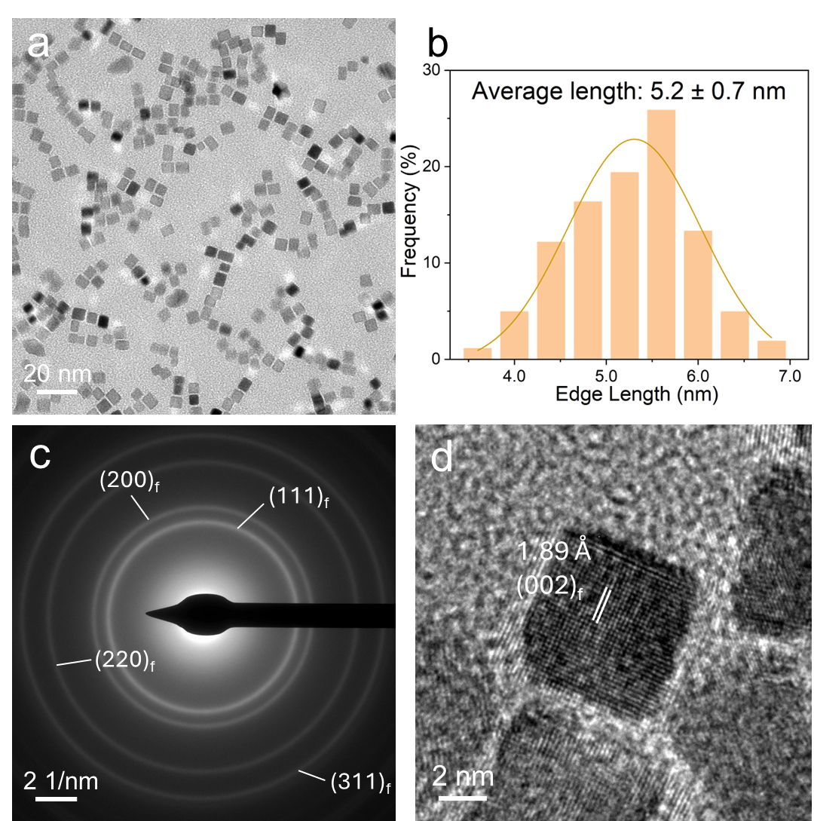
Fig. S1 (a) Low-magnification TEM image with size distribution histogram, (b) Size distribution diagram, (c) Selected area electron diffraction (SAED) pattern, and (d) The HRTEM image of Rh NCs

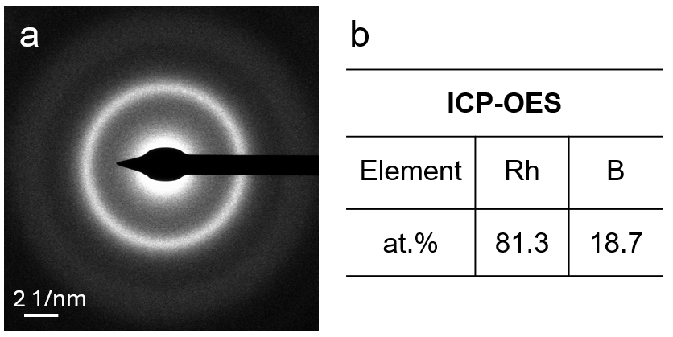
Fig. S2 (a) SAED pattern of a-Rh₄B NPs. (b) Elemental analysis result of a-Rh₄B NPs from ICP-OES
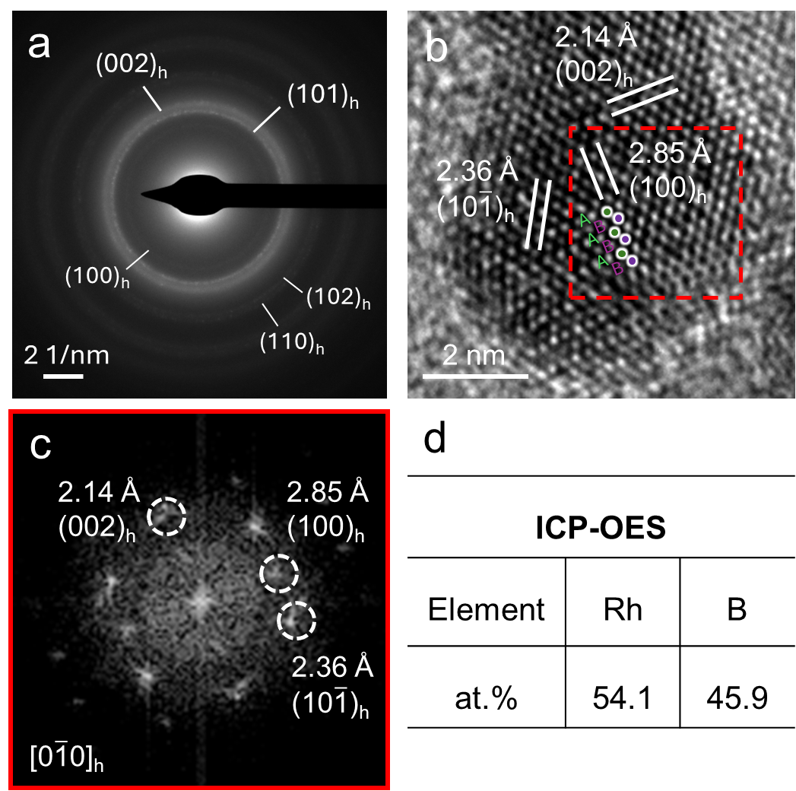
Fig. S3 (a) SAED pattern, (b) HRTEM image (c) The corresponding fast Fourier transform (FFT) pattern of the selected square area marked in (b), and (d) ICP-OES result of hcp RhB NPs. The HRTEM image (Fig. S3b) of a representative hcp RhB NP show the typical atomic stacking mode of a hcp phase: i.e., “ABAB” along the [001]_{h} close-packed direction

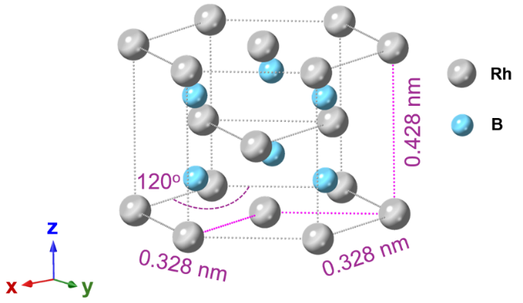
Fig. S4 The crystal structure model of hcp RhB. The lattice parameters are derived from the inter-planer spacing d_{hkl} obtained by the XRD pattern and Bragg’s Law (λ = 2d_{hkl}sinθ).
Note that hcp RhB crystallizes in the hexagonal P6₃/mmc space group. Rh is bonded in a 6-coordinate geometry to six equivalent B atoms. B is bonded in a distorted body-centered cubic geometry to six equivalent Rh and two equivalent B atoms [S3, S4].

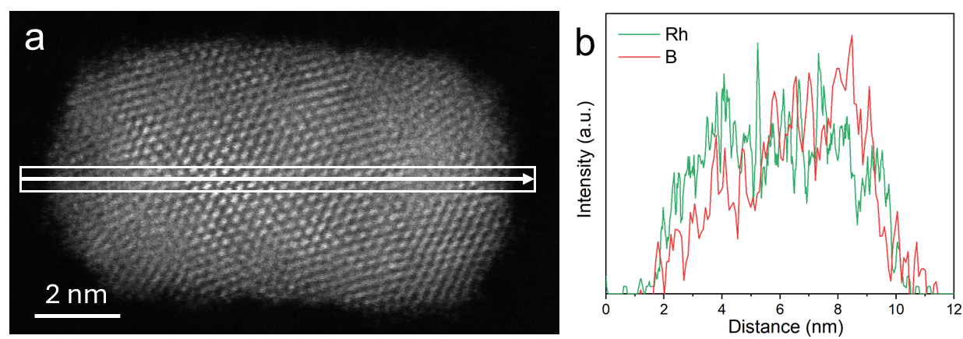
Fig. S5 (a) HAADF-STEM image of one typical hcp RhB NP and (b) the corresponding line-scan STEM-EDS elemental analysis of Rh and EELS elemental analysis of B along the white arrow in (a)

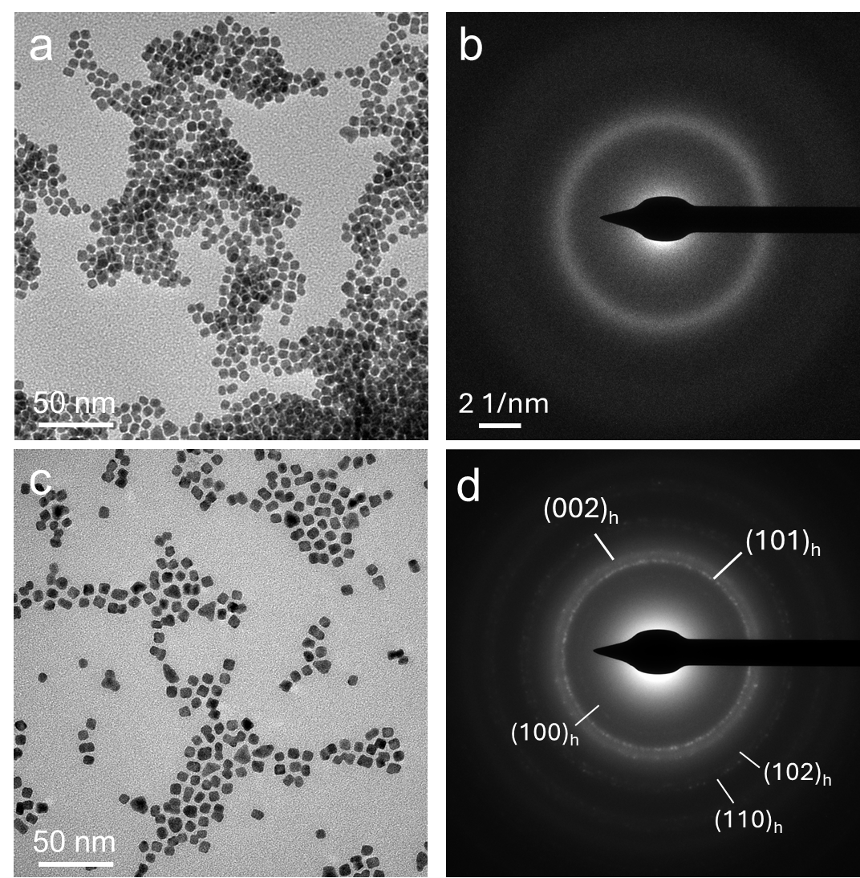
Fig. S6 Structural characterizations of B-inserted Rh nanocrystals obtained using DMAB as an alternative B source. The synthesis temperature is increased, and other conditions are the same as those using BH₃-THF. (a) TEM image and (b) SAED pattern of a-Rh₄B NPs prepared at reaction temperature of 110 ○C. (c) TEM image and (d) SAED pattern of hcp RhB NPs prepared at reaction temperature of 170 ○C

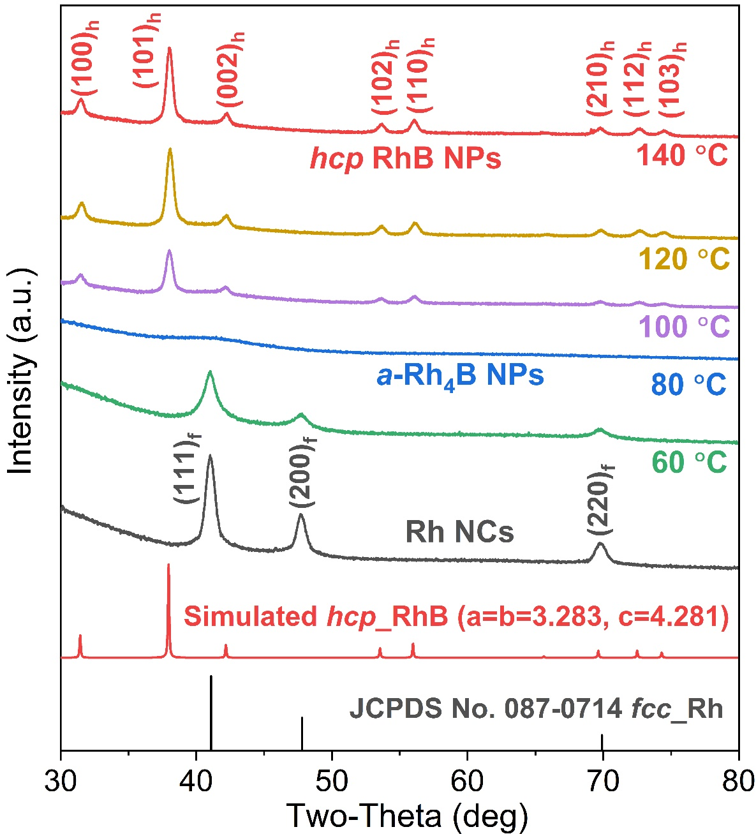
Fig. S7 XRD patterns of B-inserted Rh nanomaterials synthesized at different reaction temperatures while other conditions are unchanged

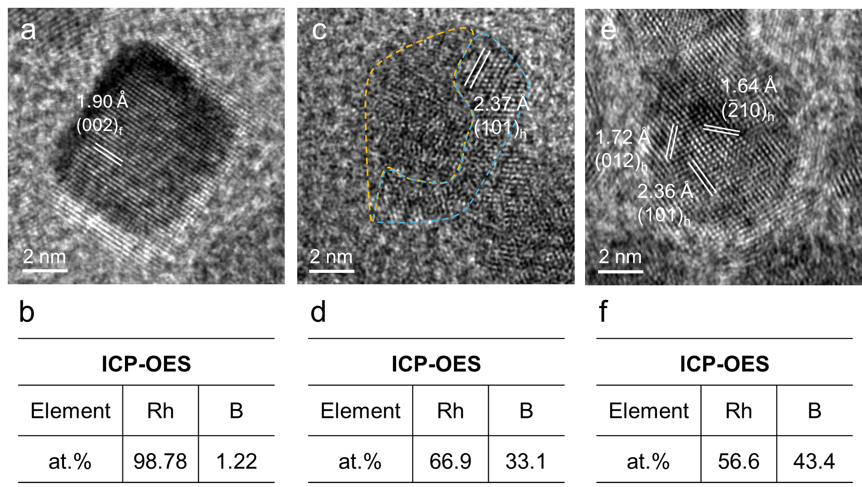

Fig. S8 HRTEM images of B-inserted Rh nanocrystals synthesized at (a) 60 °C, (c) 100 °C, and (e) 120 °C, respectively. ICP-OES results of B-inserted Rh nanocrystals synthesized at (b) 60 °C, (d) 100 °C, and (f) 120 °C, respectively.

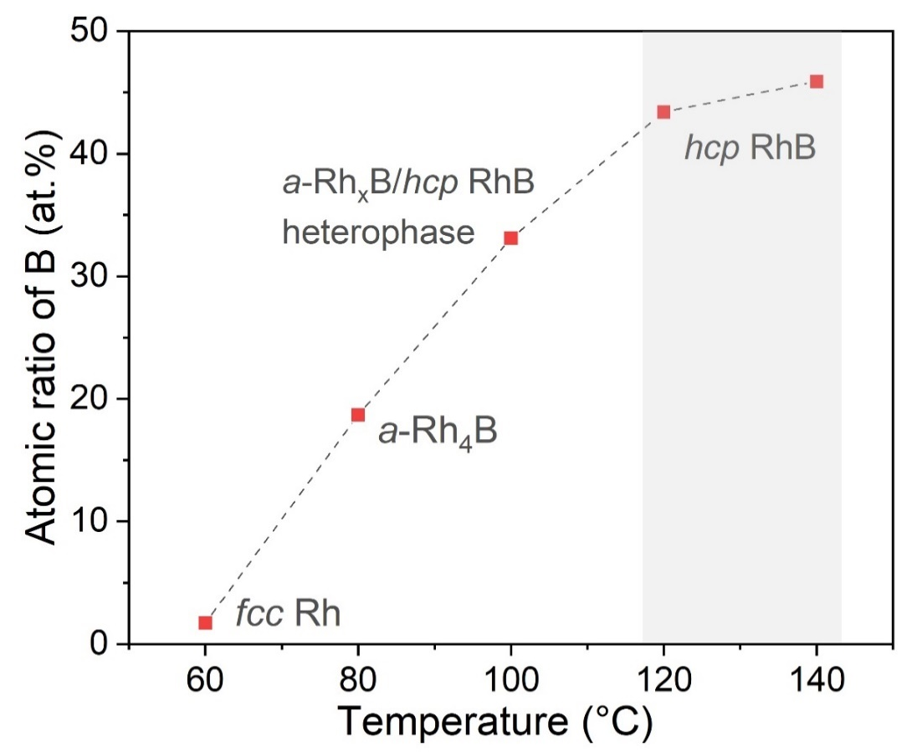
Fig. S9 Temperature-composition correlation analysis of B-inserted Rh nanocrystals synthesized at different reaction temperatures while other conditions are unchanged. At 60 °C, B content was neglectable (1.22 at.%) and the obtained sample maintains the fcc phase, while an fcc-to-amorphous transition initiates between 60-80 °C. The coexistence of a-RhₓB and hcp RhB phases (a-RhₓB/hcp RhB heterophase, 33.1 at.% B) at 100 °C captures the intermediate transition state during B insertion. Furthermore, the complete transformation to phase-pure hcp RhB occurs above 120 °C, as the B content approximately exceeds 43.4 at.%

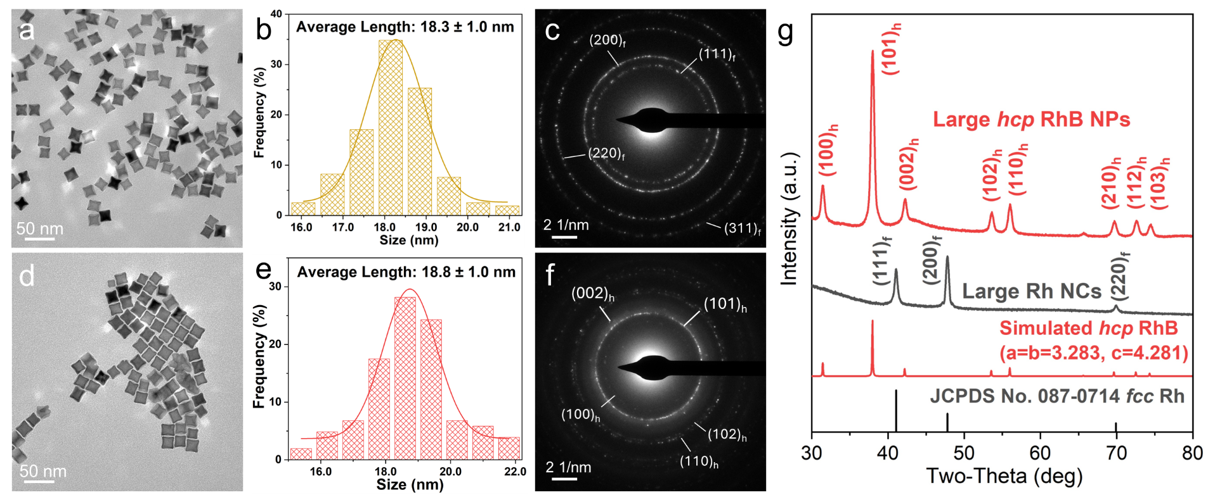
Fig. S10 (a, d) TEM images of large Rh NCs and large hcp RhB NPs. (b, c) Size distribution diagrams of large Rh NCs and large hcp RhB NPs. (e, f) SAED patterns of large Rh NCs and large hcp RhB NPs. (g) XRD patterns of large Rh NCs and large hcp RhB NPs

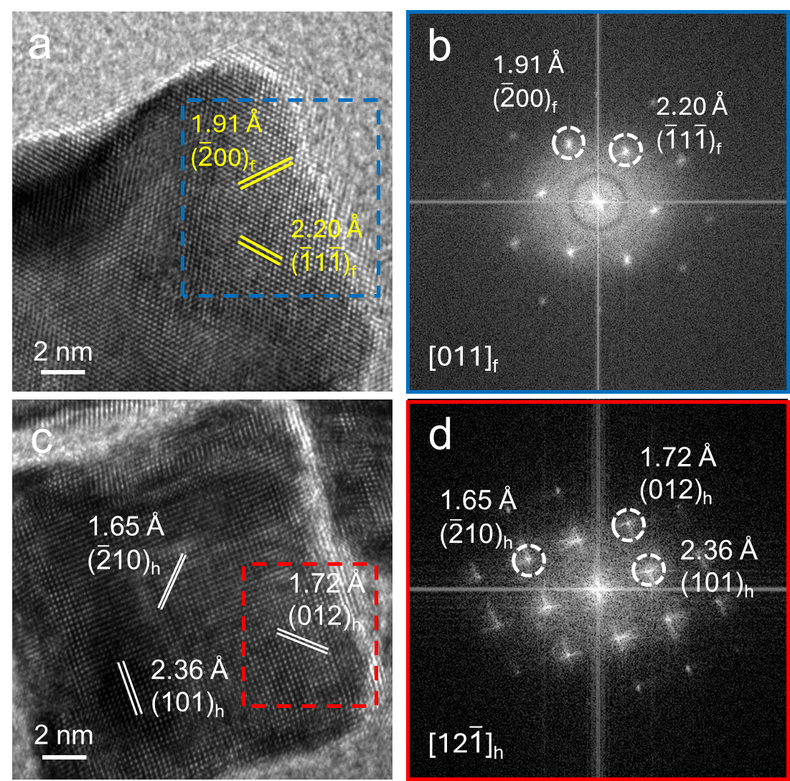
Fig. S11 (a) HRTEM image and (b) The corresponding FFT pattern of the selected square area marked in (a) of large Rh NCs. (c) HRTEM image and (d) The corresponding FFT pattern of the selected square area marked in (c) of large hcp RhB NPs.

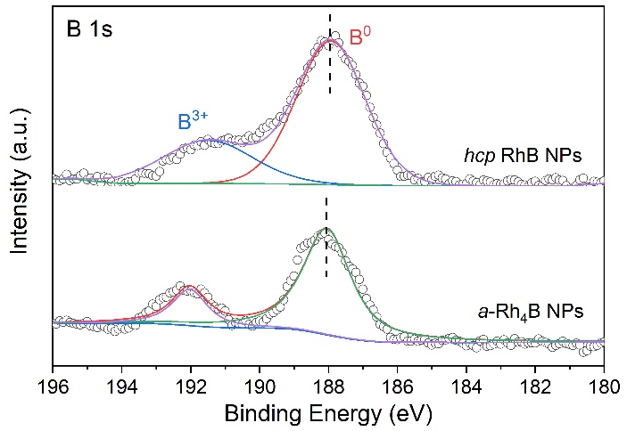
Fig. S12 High-resolution XPS spectra of B 1s of a-Rh₄B NPs and hcp RhB NPs. Note that mild surface B oxidation is commonly observed in B-inserted metal-based nanomaterials and a B oxidation peak is often present in XPS test [S5]

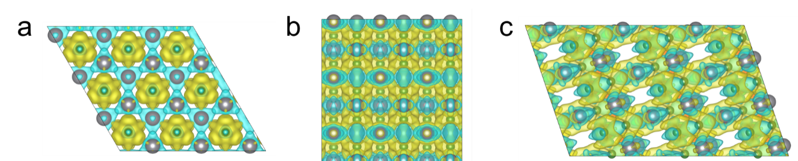
Fig. S13 The differential charge density analysis of RhB(002), RhB(100), and RhB(101) facets (isovalue = 0.008 a.u.)

Fig. S14 EXAFS fitting results of k²-weighted R space (a) Rh foil, (b) Rh₂O₃, (c) Rh NCs, (d) a-Rh₄B NPs and (e) hcp RhB NPs

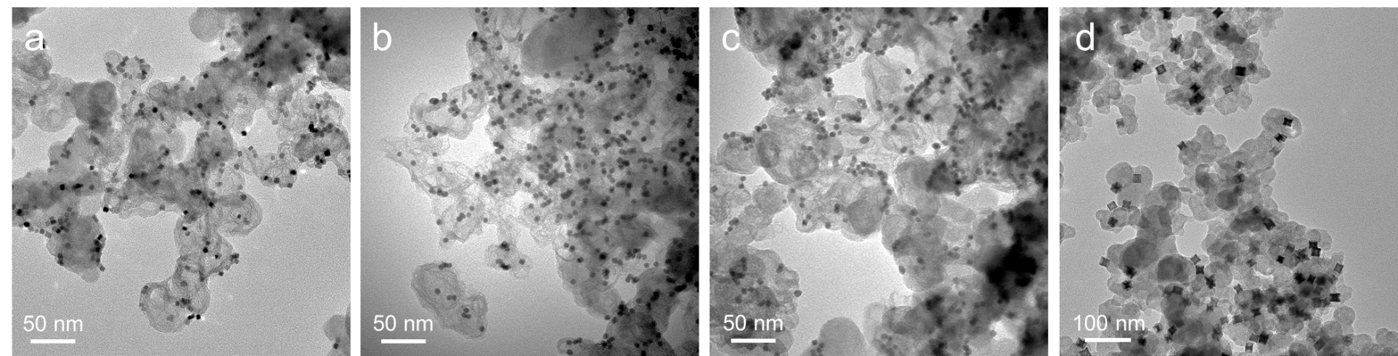
Fig. S15 TEM images of (a) Rh NCs, (b) a-Rh₄B NPs, (c) hcp RhB NPs, (d) large hcp RhB NPs loaded on carbon black

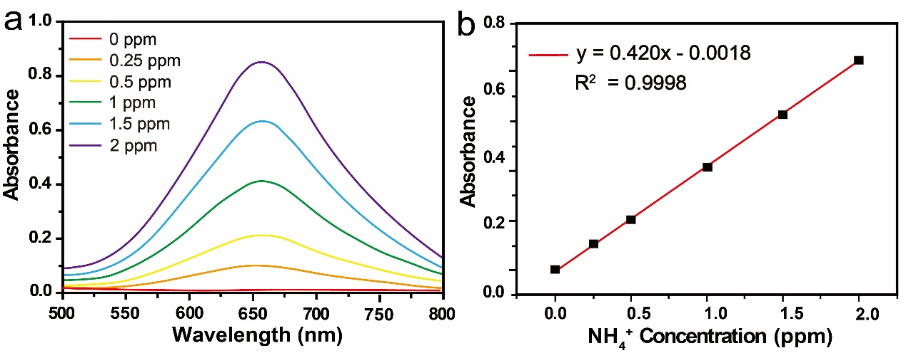
Fig. S16 Quantification of NH₃ using the indophenol blue by colorimetric method. (a) UV−Vis absorption spectra for NH₄⁺ (a detectable amount of NH₃, in the form of NH₄⁺) at various concentrations. (b) A calibration curve for estimating the concentrations of NH₄⁺

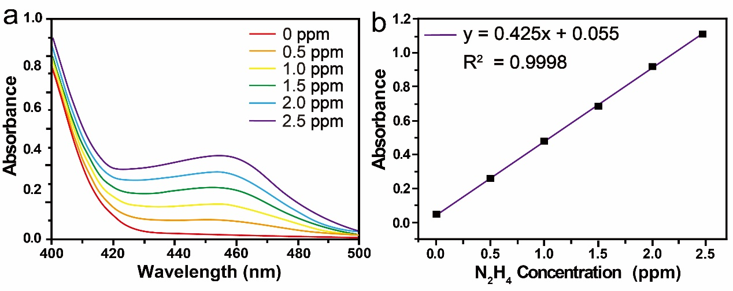
Fig. S17 Quantification of N₂H₄ using colorimetric method. (a) UV-Vis absorption spectra of a series of N₂H₄ solutions at different concentrations after incubated for 20 min at room temperature and corresponding (b) calibration curve used for estimating N₂H₄

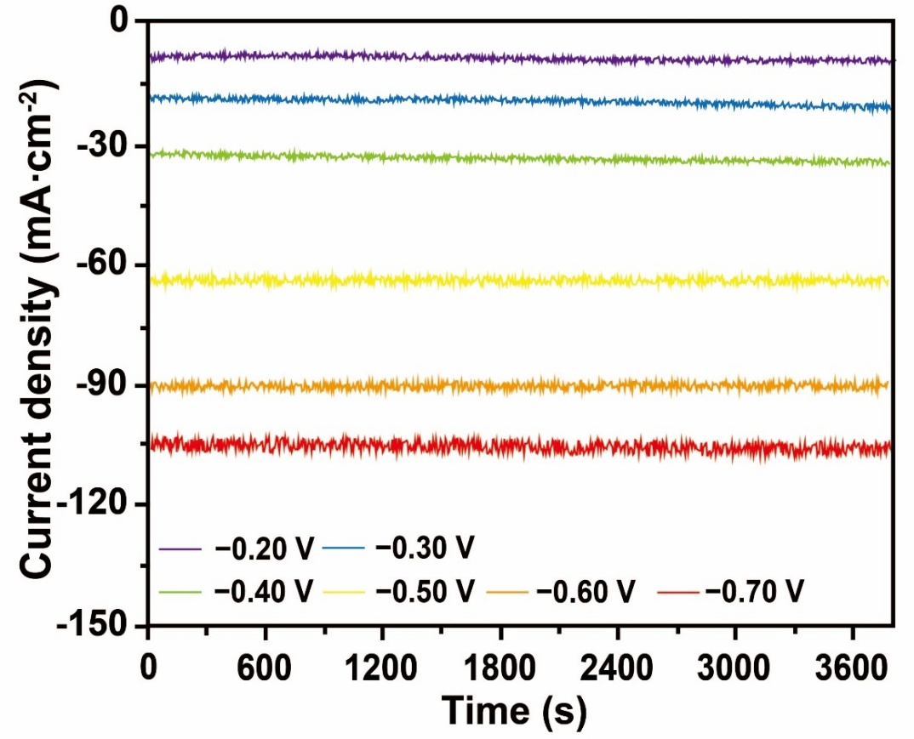
Fig. S18 Chronoamperometry curves for hcp RhB NPs at various potentials in NO (20 vol.%) with 0.5 M Na₂SO₄ electrolyte
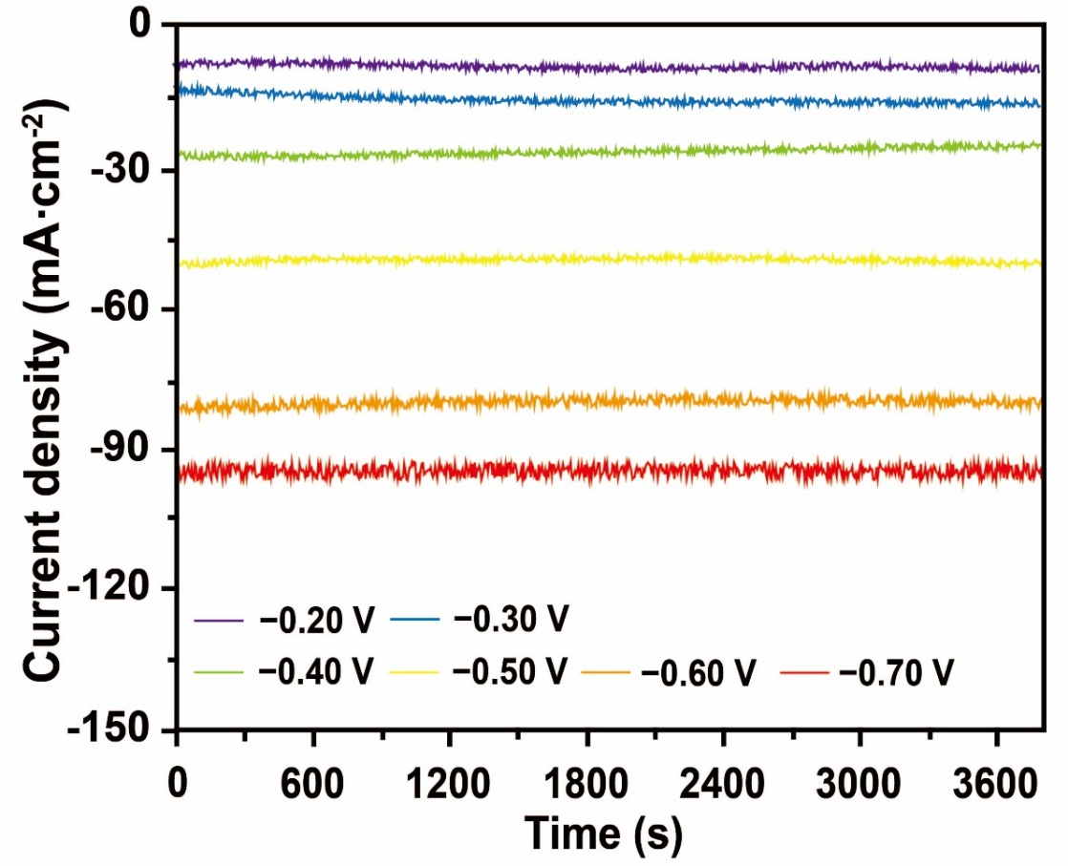
Fig. S19 Chronoamperometry curves for Rh NCs at various potentials in NO (20 vol.%) with 0.5 M Na₂SO₄ electrolyte
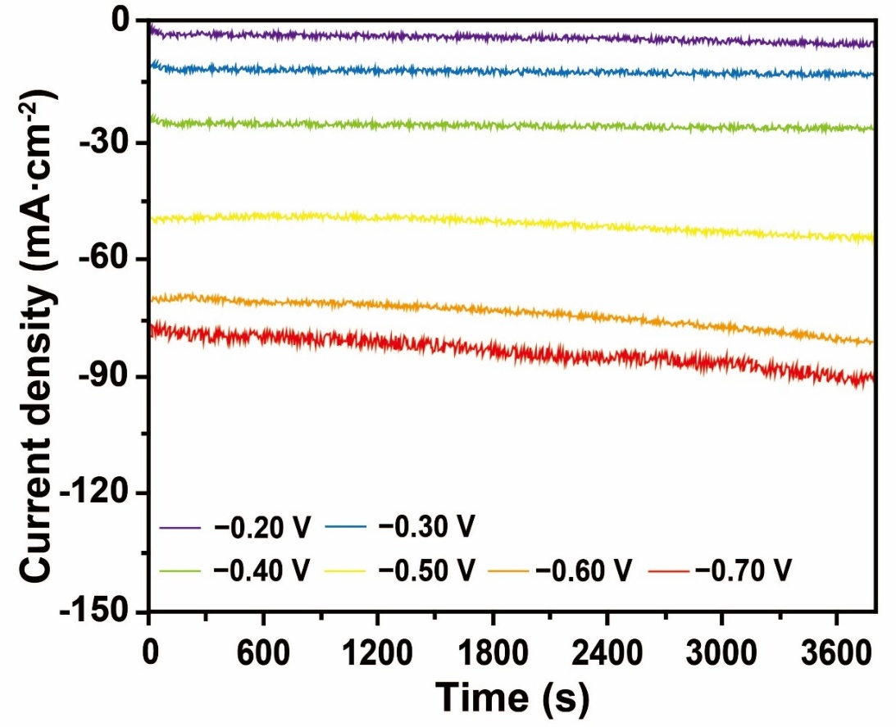
Fig. S20 Chronoamperometry curves for a-Rh₄B NPs at various potentials in NO (20 vol.%) with 0.5 M Na₂SO₄ electrolyte

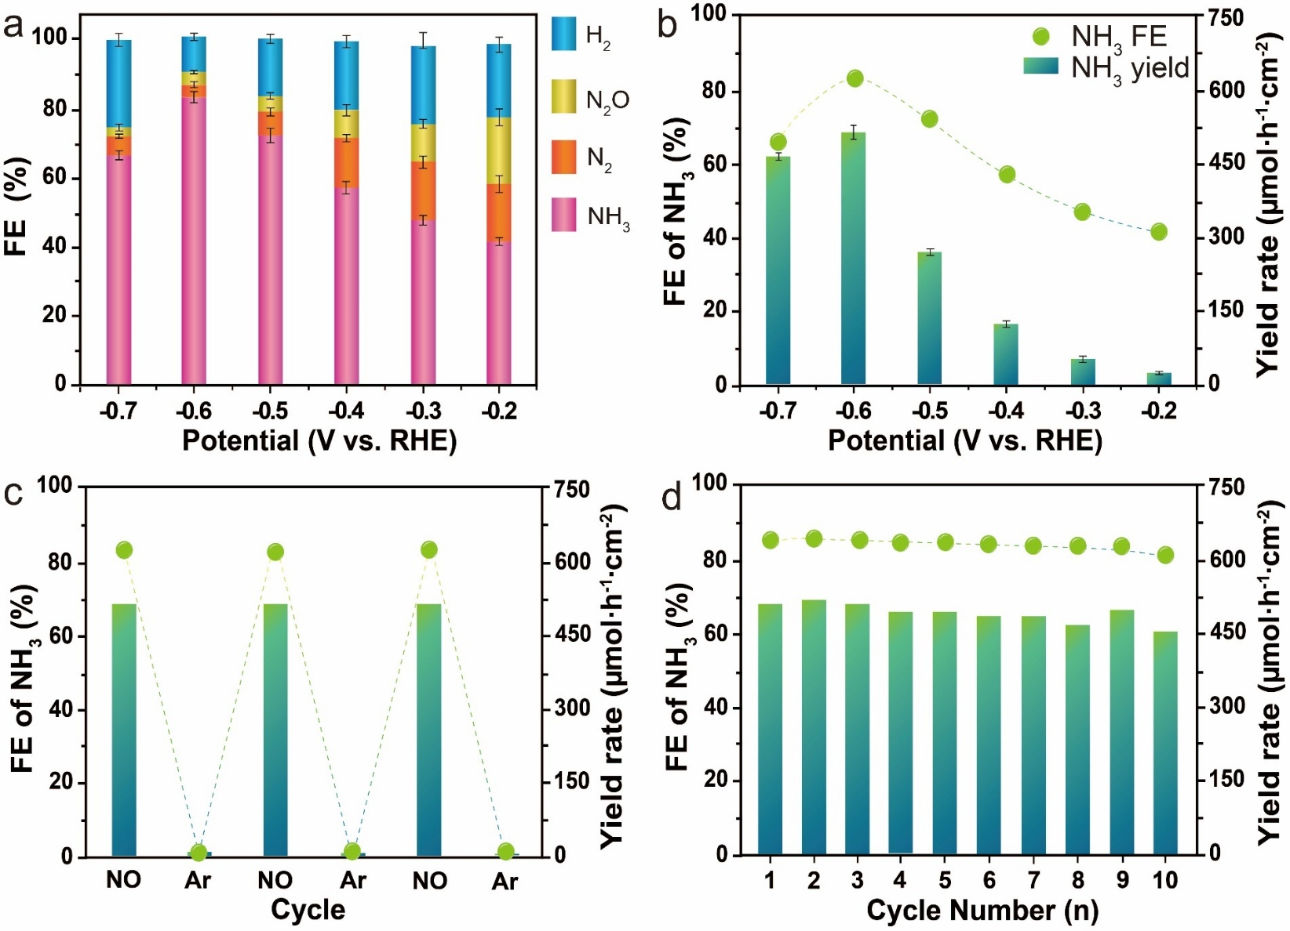
Fig. S21 Electrocatalytic NORR performance of Rh NCs. (a) FEs of all possible products including NH₃, H₂, N₂O and N₂ for Rh NCs at each given potential. (b) NH₃ yield and FE_{NH3} of Rh NCs at different potentials. (c) Alternating electrolysis test of Rh NCs at −0.6 V vs. RHE. (d) FE_{NH3} and NH₃ yield rate in 10 consecutive cycles over Rh NCs for NORR at −0.6 V vs. RHE
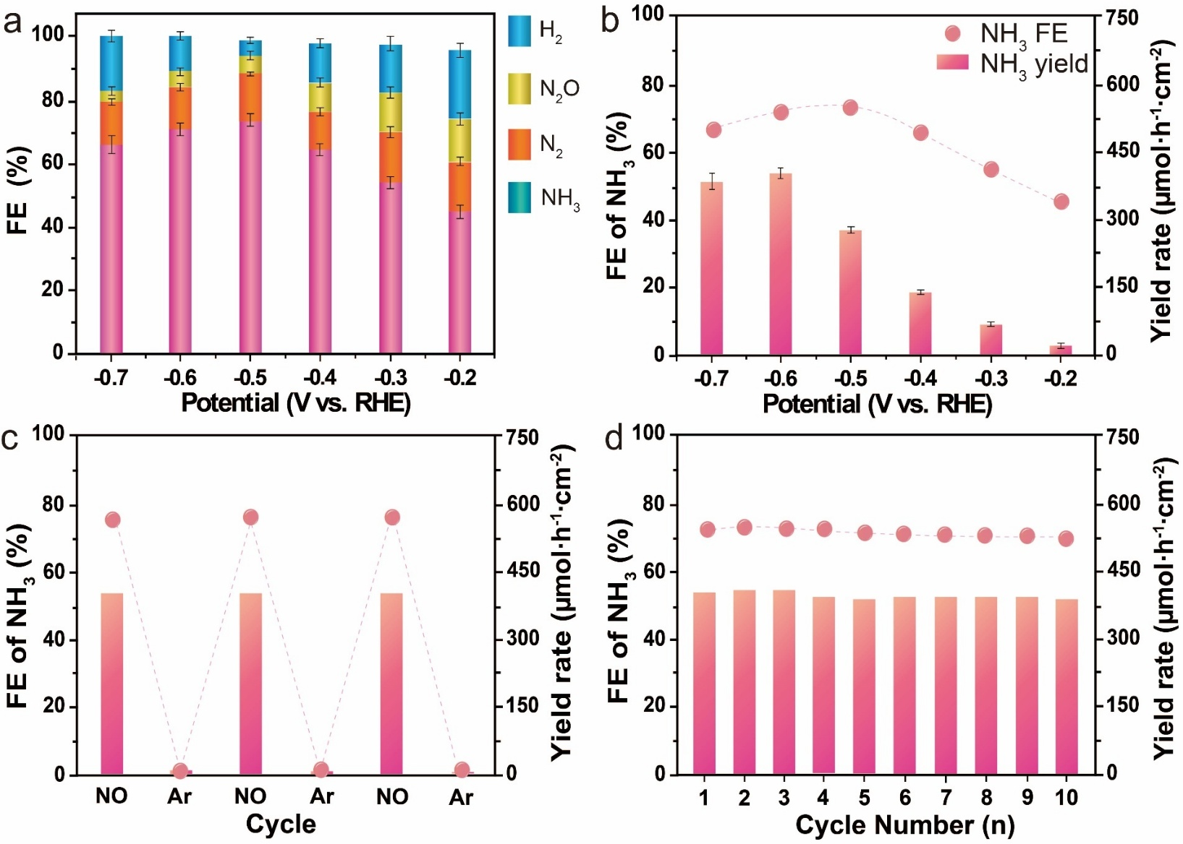
Fig. S22 Electrocatalytic NORR performance of a-Rh₄B NPs. (a) FEs of all possible products including NH₃, H₂, N₂O and N₂ for a-Rh₄B NPs at each given potential. (b) NH₃ yield and FE_{NH3} of a-Rh₄B NPs at different potentials. (c) Alternating electrolysis test of a-Rh₄B NPs at −0.6 V vs. RHE. (d) FE_{NH3} and NH₃ yield rate in 10 consecutive cycles over a-Rh₄B NPs for NORR at −0.6 V vs. RHE

Fig. S23 Electrocatalytic NORR performance of large hcp RhB NPs. (a) FEs of all possible products including NH₃, H₂, N₂O and N₂ at each given potential. (b) NH₃ yield and FE_{NH3} measured at different potentials. (c) Alternating electrolysis test at −0.6 V vs. RHE. (d) FE_{NH3} and NH₃ yield rate in 10 consecutive cycles for NORR at −0.6 V vs. RHE

Fig. S24 Alternating electrolysis test of hcp RhB NPs at −0.6 V vs. RHE by switching between NO-saturated and air-saturated electrolytes

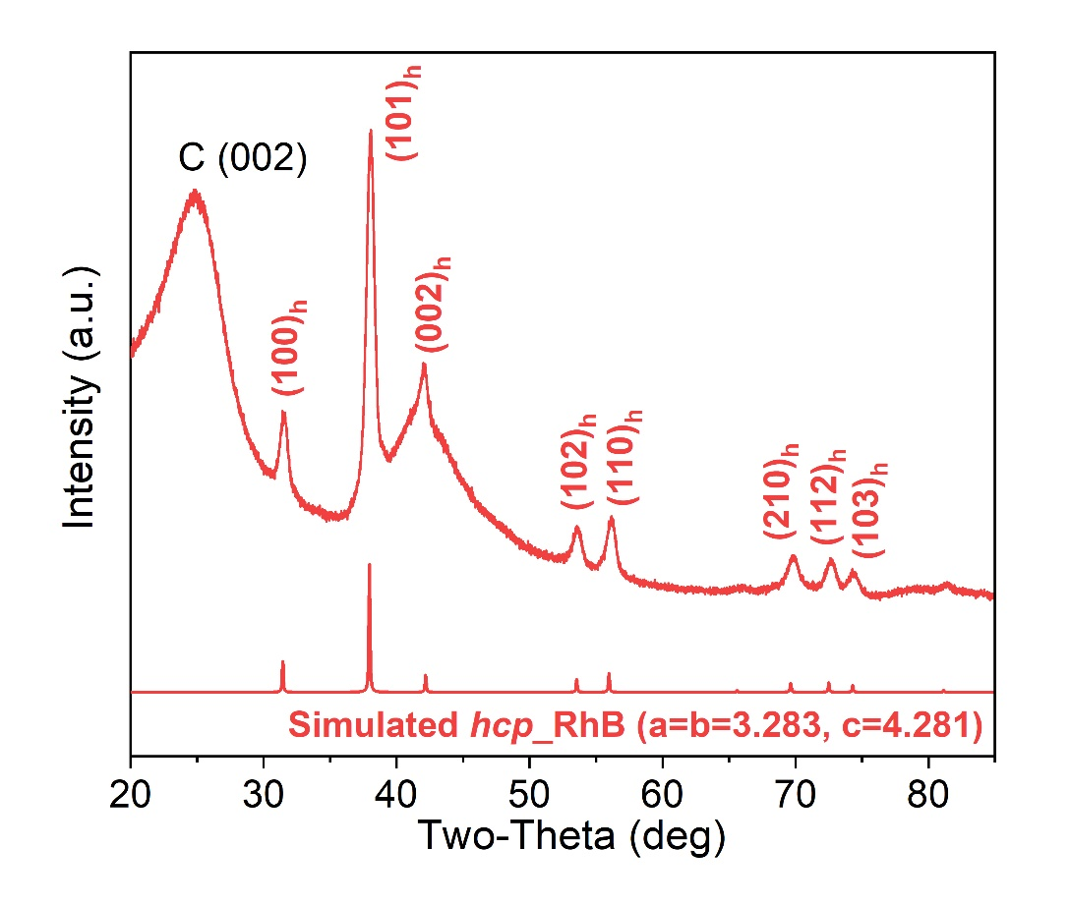
Fig. S25 XRD pattern of hcp RhB NPs/C after the long-term electrocatalytic stability test

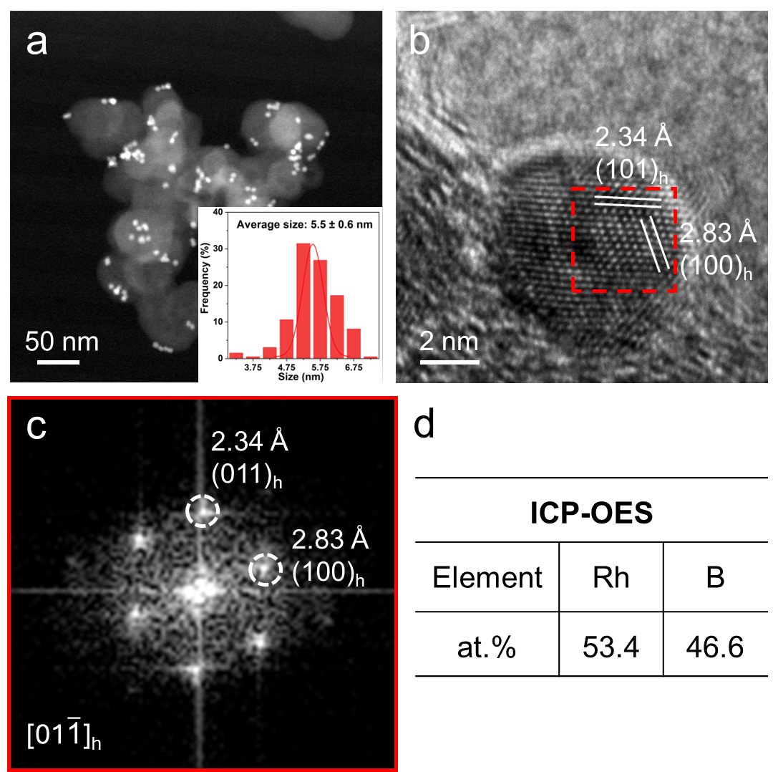
Fig. S26 (a) HAADF-STEM image and the size distribution diagram (inset), (b) HRTEM image, (c) The corresponding FFT pattern of the selected area in (b), and (d) ICP-OES result of the hcp RhB NPs after the long-term electrocatalytic stability test

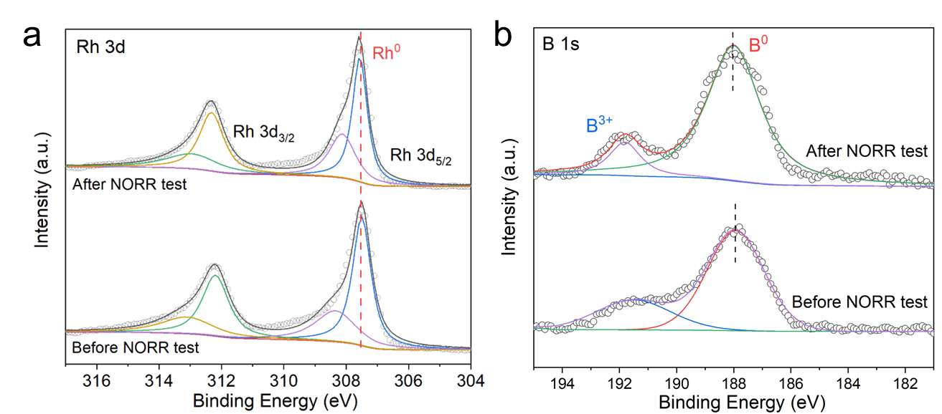
Fig. S27 High-resolution XPS spectra of hcp RhB NPs before and after NORR test in (a) Rh 3d region, and (b) B 1s region

Fig. S28 3D potential-dependent in situ attenuated total reflection infrared spectra of (a) hcp RhB NPs, (b) a-Rh₄B NPs, and (c) Rh NCs for NORR in the range from 0 to −0.7 V vs. RHE

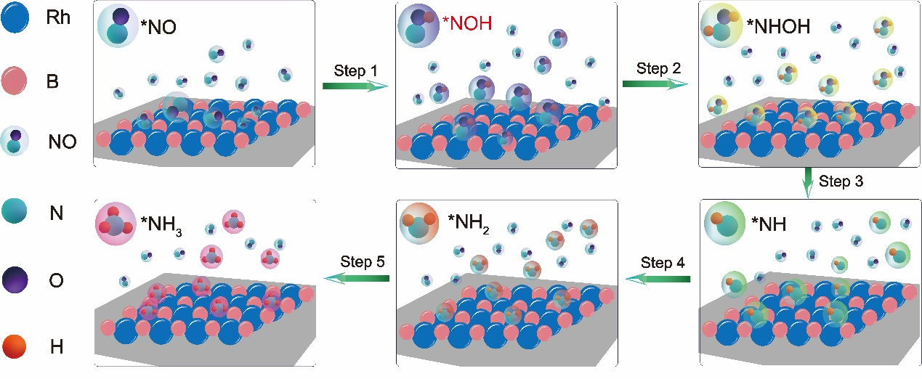
Fig. S29 Schematic illustration of the first possible NORR pathway of “NO → *NO → *NOH → *NHOH → *NH₂OH → *NH₂ → *NH₃”

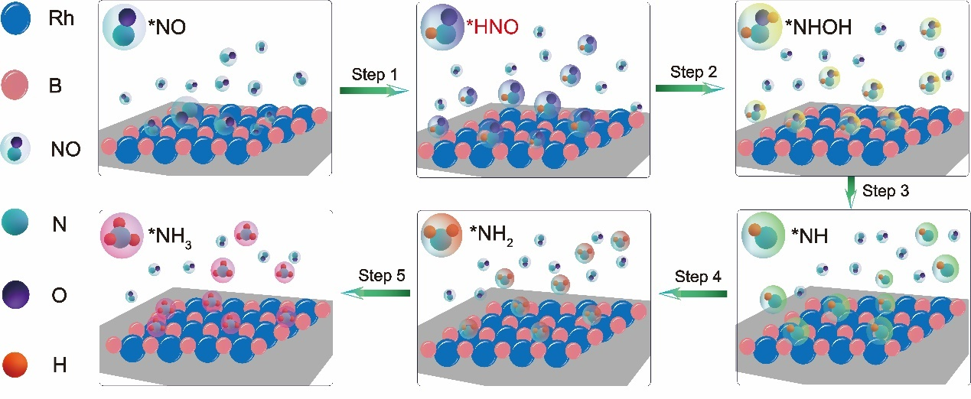
Fig. S30 Schematic illustration of the second possible NORR pathway of “NO → *NO → *HNO → *NHOH → *NH₂OH → *NH₂ → *NH₃”

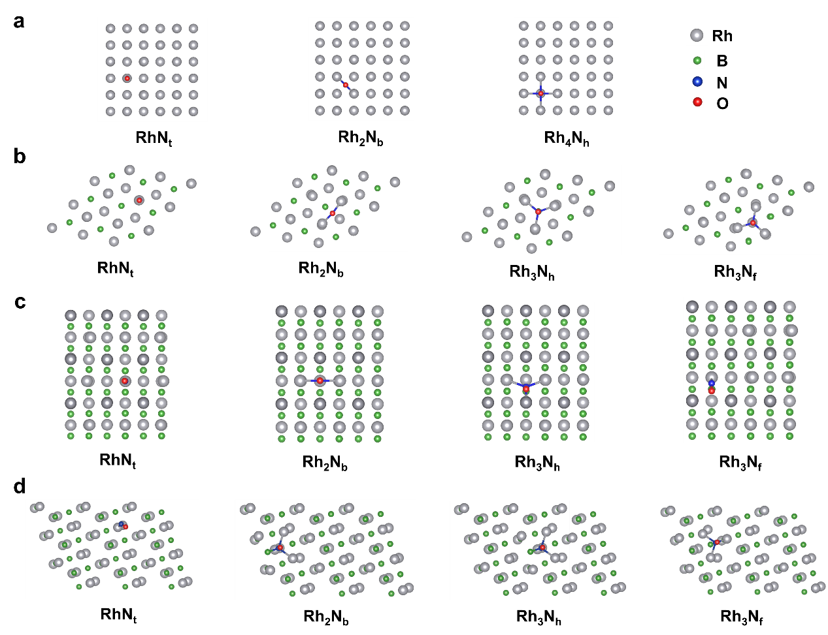
Fig. S31 Top views of the possible adsorption configurations of NO molecules on the surfaces of (a) Rh(100); (b) RhB(002), (c) RhB(100), and (d) RhB(101) facets

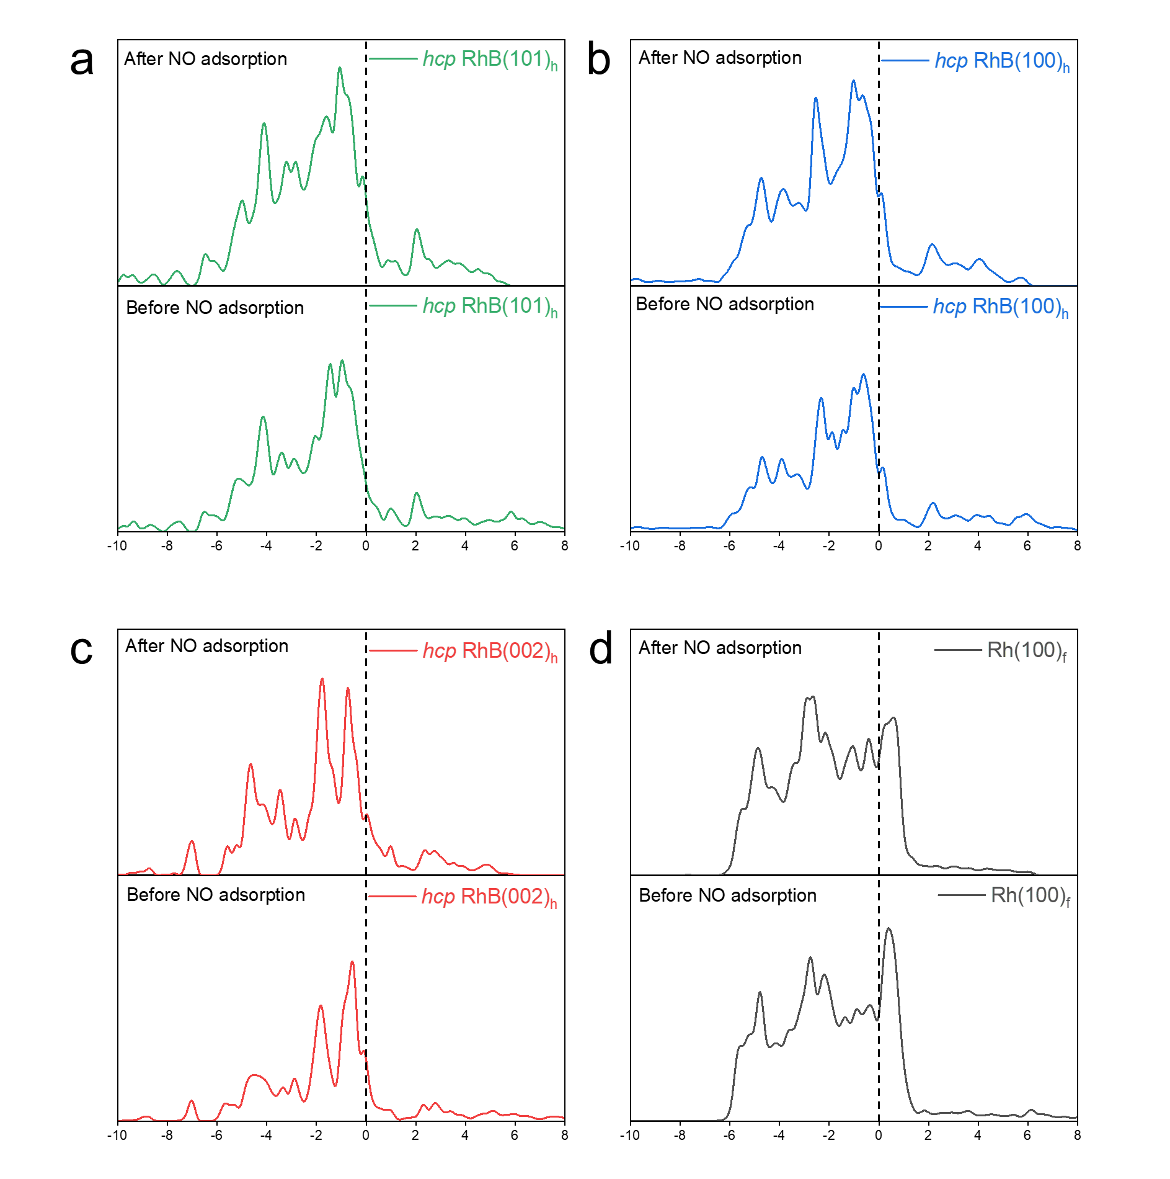
Fig. S32 The PDOSs of Rh sites over (a) hcp RhB(101)_{h}, (b) hcp RhB(100)_{h}, (c) hcp RhB(002)_{h}, and (d) Rh(100)_{f} surfaces before and after NO adsorption

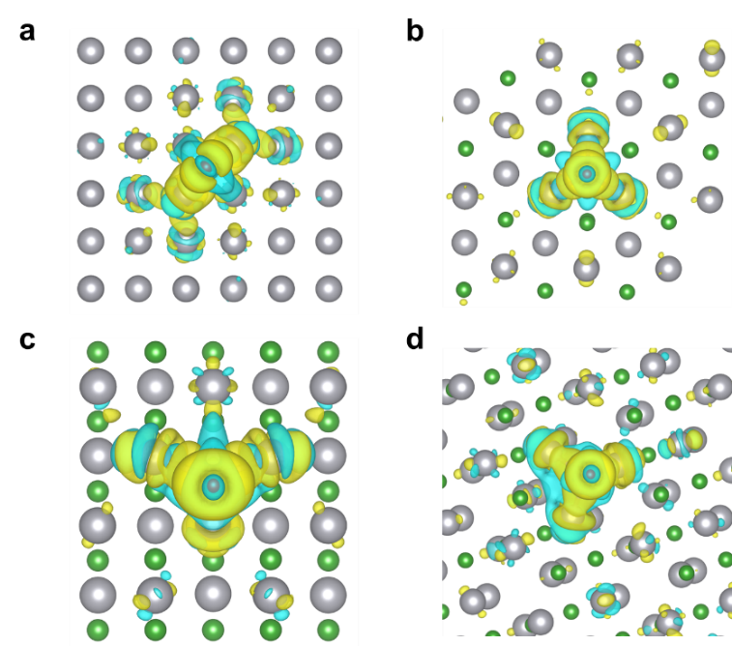
Fig. S33 Top views of calculated Charge of Density and Bader Charge analysis of NO molecules on (a) Rh(100), (b) RhB(002), (c) RhB(100), and (d) RhB(101) facets

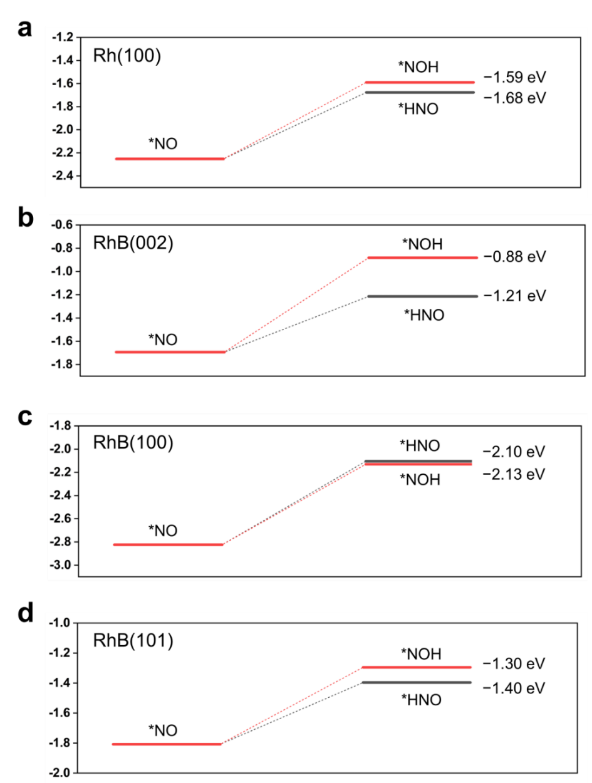
Fig. S34 Reaction Gibbs free energy (G) diagram of “*NO → *HNO” step or “*NO → *NOH” step on (a) Rh(100), (b) RhB(002), (c) RhB(100), and (d) RhB(101) facets

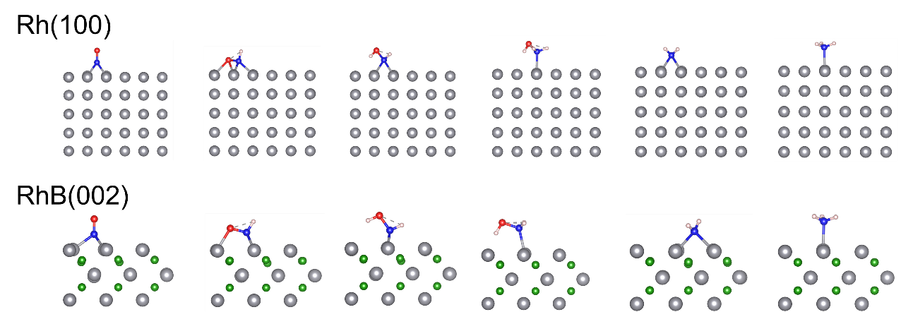
Fig. S35 Side views of adsorption configurations of intermediates along the NORR steps on Rh(100) and RhB (002) facets

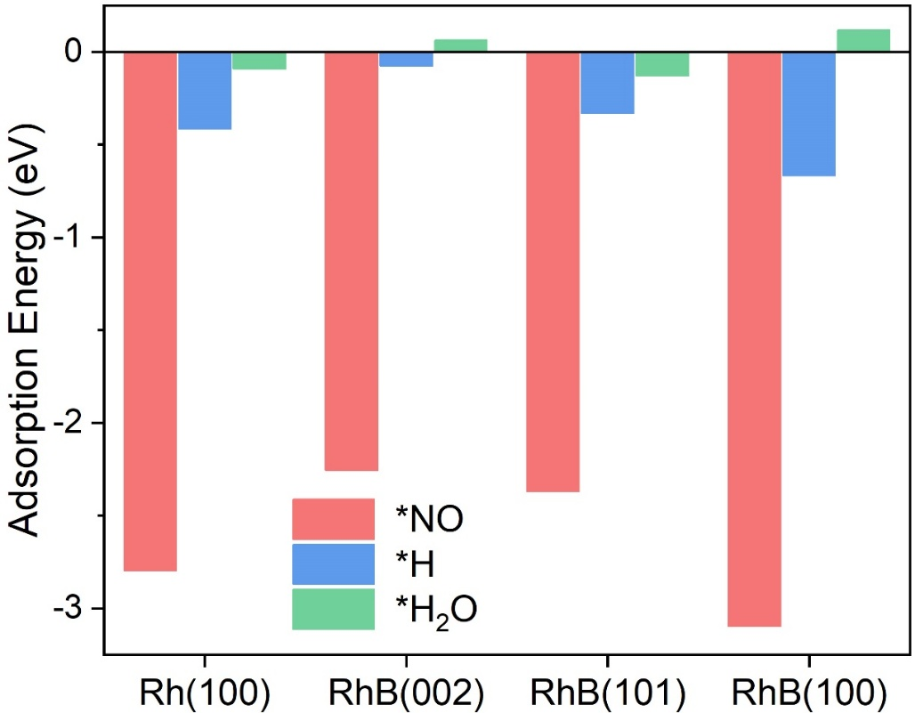
Fig. S36 Calculated adsorption energies of *NO, *H, and *H₂O on Rh(100), RhB(002), RhB(101), and RhB(100) facets
Fig. S37 LSV curves of Rh NCs and hcp RhB NPs in Ar-saturated 0.5 M Na₂SO₄ electrolyte. The hcp RhB NPs exhibit a 38.6 mV higher overpotential than Rh NCs at the current density of −25 mA cm⁻², demonstrating effective suppression of HER activity
Fig. S38 Open circuit voltage (OCV) measurement of the Zn-NO battery with hcp RhB NPs as the cathode

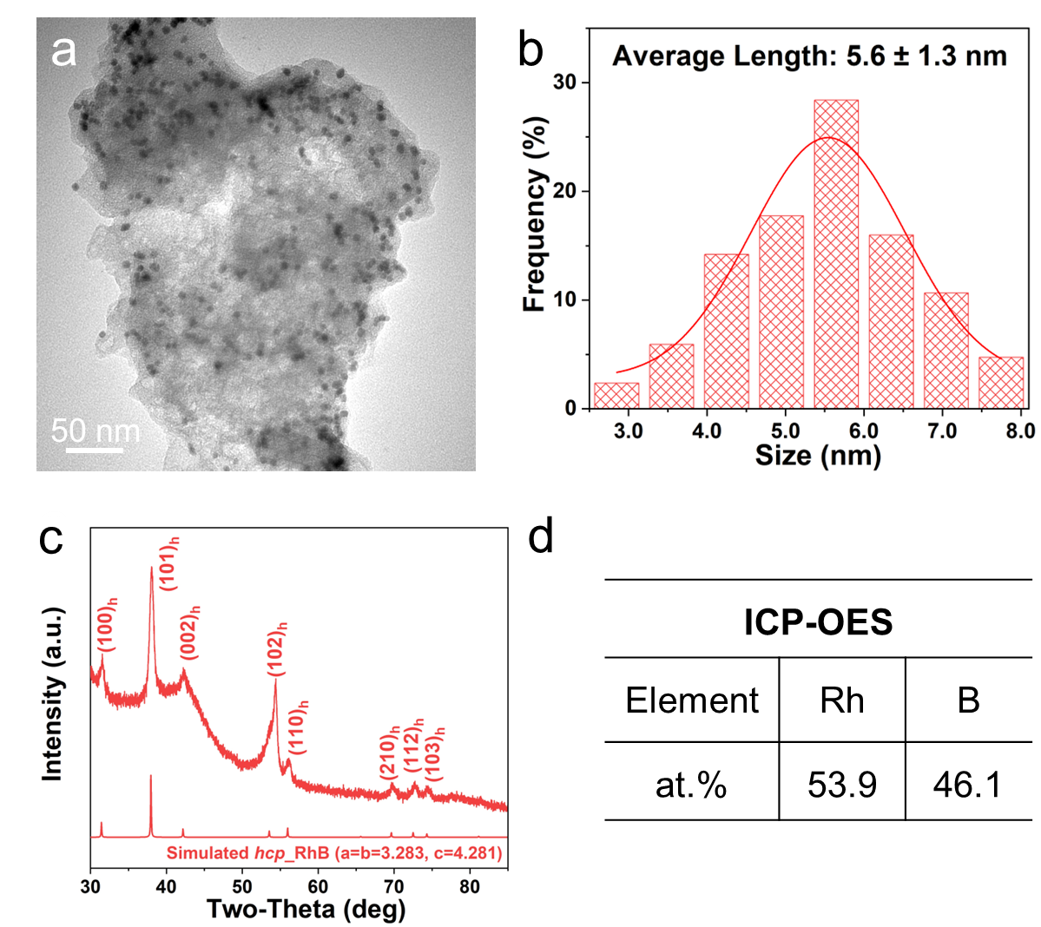
Fig. S39 (a) TEM image, (b) Size distribution diagram, (c) XRD pattern, and (d) ICP-OES result of hcp RhB NPs after the Zn-NO battery test

S3 Supplementary Tables
Sample | Shell | C.N. | R (Å) | σ² (×10⁻³ Å²) | ΔE₀ (eV) | R-factor
Rh foil | Rh-Rh | 12.0* | 2.72 | 3.6 | -8.6 | 0.005
Rh₂O₃ | Rh-O | 6.0 | 2.04 | 4.0 | -3.7 | 0.011
Rh₂O₃ | Rh-Rh | 3.0 | 3.05 | 11.3 | -3.7 | 0.011
hcp RhB NPs | Rh-Rh | 8.7 ± 0.70 | 2.64 ± 0.05 | 7.9 ± 0.26 | -5.5 ± 1.05 | 0.018
hcp RhB NPs | Rh-B | 5.3 ± 0.80 | 1.96 ± 0.04 | 2.0 ± 0.11 | -5.5 ± 1.05 | 0.018
Rh NCs | Rh-Rh | 10.4 ± 0.16 | 2.70 ± 0.03 | 3.8 ± 0.14 | -3.0 ± 0.35 | 0.007
a-Rh₄B NPs | / | / | / | / | / | /
Table S1 A summary of the Rh K-edge EXAFS fitting results of Rh NCs, a-Rh₄B NPs, and hcp RhB NPs in reference to Rh foil and Rh₂O₃.
C.N.: coordination numbers; R: bond distance; σ²: Debye-Waller factors (a measure of thermal and static disorder in absorber-scatterer distances); ΔE₀: the inner potential correction. R-factor: goodness of fit. *These values were fixed during the EXAFS fitting, based on the known structures of Rh foil.

Table S2 Comparison of NH₃ yield rate and FE_{NH3} of our catalysts with the reported nanocatalysts for electrocatalytic NORR performed in H-type electrochemical systems
Catalysts | Electrolyte  (pH value) | C_{NO} | NH₃ yield (µmol h⁻¹ cm⁻²) | FE (%) | Potential  (V vs. RHE) | Ref.
hcp RhB NPs | 0.5 M Na₂SO₄ (pH = 7.0) | 20 vol.% | 629.5 | 92.1 | −0.60/−0.50ª | This work
Rh NCs | 0.5 M Na₂SO₄ (pH = 7.0) | 20 vol.% | 514.7 | 83.2 | −0.60 | This work
a-Rh₄B NPs | 0.5 M Na₂SO₄  (pH = 7.0) | 20 vol.% | 403.8 | 73.7 | −0.60/−0.50 | This work
Defective TiO_{2−x} | 0.2 M PBS  (pH = 7.4) | 10 vol.% | 72.41 | 92.5 | −0.70/−0.40 | Small 2023, 19, 2300291 [S6]
MoC/NCS | 0.1 M HCl + 0.5 mM Fe(II) sodium benzoate (Fe^{II}-SB)  (pH = 1.0) | 99.99 vol.% | 79.27 | 89 | −0.80 | Nano Res. 2022,15, 8890 [S7]
CoB/Co@C | 0.5 M Na₂SO₄  (pH = 7.0) | 99.99 vol.% | 315.4 | 70.3 | −0.60 | Nano Lett. 2023, 23, 7120−7128 [S8]
NiO nanosheet | 0.1 M Na₂SO₄ + 0.5 mM Fe^{II}-EDTA  (pH = 7.0) | 10 vol.% | 125.07 | 90.0 | −0.60 | Chem. Commun. 2021, 57, 13562–13565 [S9]
MoS₂  nanosheet | 0.1 M HCl + 0.5 mM Fe^{II}-SB  (pH = 1.0) | 10 vol.% | 99.6 | 76.6 | −0.70 | Angew. Chem. Int. Ed. 2021, 60, 25263–25268 [S10]
Ni₂P nanosheet | 0.1 M HCl  (pH = 1.0) | 10 vol.% | 33.47 | 76.9 | −0.20 | J. Mater. Chem. A 2021, 9, 24268–24275 [S11]
a-B_{2.6}C@TiO₂ | 0.2 M Na₂SO₄ + Fe^{II}-EDTA  (pH = 7.0) | 10 vol.% | 216.01 | 87.6 | −0.90 | Angew. Chem. Int. Ed. 2022, 61, e202202087 [S12]
Cu foam | 0.25 M Li₂SO₄  (pH = ~7.0) | 99.99 vol.% | 517.1 | 93.5 | −0.90 | Angew. Chem. Int. Ed. 2020, 59, 9711–9718 [S13]
Fe₂O₃ nanorod | 0.1 M Na₂SO₄ + 0.5 mM  Fe^{II}-EDTA  (pH = ~7.0) | 10 vol.% | 78.02 | 86.7 | −0.60/−0.40 | J. Mater. Chem. A 2022, 10, 6454–6462 [S14]
CuFe alloy | 0.1 M PBS  (pH = 7.4) | 95 vol.% NO + 5 vol.%NO₂ | 136.81 | 90.6 | −0.80 | Chem Catal. 2022, 2, 622-638 [S15]
CoP nanowire | 0.2 M Na₂SO₄  (pH = 7.0) | 10 vol.% | 47.22 | 88.3 | −0.20 | Inorg. Chem. Front. 2022, 9, 1366-1372 [S16]
Ru_{0.05}Cu_{0.95} | 0.5 M Na₂SO₄  (pH = 7.0) | 25 vol.% | 17.68 | 64.9 | −0.50 | Sci. China Chem. 2021, 64, 1493 [S17]
Mo₂C nanosheets | 0.5 M Na₂SO₄  (pH = 7.0) | 99.99 vol.% | 122.7 | 86.3 | −0.40 | Inorg. Chem. 2023, 62, 653−658 [S18]
bcc RuGa | 0.1 M K₂SO₄  (pH = 7.0) | 20 vol.% | 160.3 µmol h⁻¹ cm^{-2 b} | 72.3 | −0.20 | Angew. Chem. Int. Ed. 2023, 62, e202213351 [S19]
Cu@Co | 0.1 M Na₂SO₄  (pH = 7.0) | 1.0 vol.% | 36.89 | 76.5 | −0.50 | Adv. Mater. 2023, 36, e2309470 [S20]
Cu nanosheets | 0.1 M K₂SO₄  (pH = 7.0) | 99.99 vol.% | 187.5 | 93.2 | −0.59 | Angew. Chem. Int. Ed. 2024, 63, e202319135 [S21]
FeOCl-V_{Cl} | 0.1 M HCl +  50 mM sodium benzenesulfonate (SB)  (pH = 1.0) | 1.0 vol.% | 26.79 | 91.1 | −0.50 | Angew. Chem. Int. Ed. 2024, 63, e202318792 [S22]
CuFe DS/NC | 0.1 M Na₂SO₄  (pH = 7.0) | 99.99 vol.% | 112.52 | 90.0 | −0.60 | Adv. Mater. 2023, 35, 2304646 [S23]
hcp Co | 0.1 M Na₂SO₄  (pH = 7.0) | 99.99 vol.% | 439.5 | 72.6 | −0.60 | J. Am. Chem. Soc. 2023, 145, 6899−6904 [S24]
hcp Co | 0.1 M Na₂SO₄  + 0.5 mM Fe^{II}-EDTA  (pH = 7.0) | 99.99 vol.% | 463.4 | 75.8 | −0.60 | J. Am. Chem. Soc. 2023, 145, 6899−6904 [S24]
low-coordinated Ru | 0.5 M Na₂SO₄  (pH = 7.0) | 1.0 vol.% | 45.02 | 66.0 | −0.20 | ACS Energy Lett. 2022, 7, 1187−1194 [S25]
MnO_{2-x} nanowire array | 0.2 M Na₂SO₄  (pH = 7.0) | 10 vol.% | 9.90 | 82.8 | −0.70 | Mater. Today Phys. 2022, 22, 100586 [S26]
FeNC | 0.1 M HClO₄  (pH = 1.0) | 10 vol.% | ~20.2 | 5.1 | −0.20 | Nat. Commun. 2021, 12, 1856 [S27]
NiNC@CF | 0.5 M PBS  (pH = 7.4) | 99.99 vol.% | 108 | 87.0 | −0.90/−0.50 | J. Mater. Chem. A 2022, 10, 6470 [S28]
FeB₂ | 0.5 M Na₂SO₄  (pH = 7.0) | 99.9 vol.% | 289.3 | 93.8 | −0.40 | Inorg. Chem. 2023, 62, 8487−8493 [S29]
Cu₁/MoS₂ | 0.5 M Na₂SO₄  (pH = 7.0) | 99.99 vol.% | 337.5 | 90.6 | −0.60 | Nano Res. 2023, 16, 5857–5863 [S30]
Sb₁/MoO₃ | 0.5 M Na₂SO₄  (pH = 7.0) | 99.9 vol.% | 273.5 | 91.7 | −0.60 | ACS Energy Lett. 2023, 8, 1281−1288 [S31]
Pd₁Cu | 0.5 M Na₂SO₄  (pH = 7.0) | 99.99 vol.% | 305.8 | 96.7 | −0.40 | Nano Lett. 2024, 24, 541-548 [S32]
Ir₁/MoO₃ | 0.5 M Na₂SO₄  (pH = 7.0) | 99.9 vol.% | 438.8 | 93.2 | −0.47 | Nano Res. 2023, 16, 8737-8742 [S33]
Fe₁/MoS_{2-x} | 0.5 M Na₂SO₄  (pH = 7.0) | 99.99 vol.% | 288.2 | 82.5 | −0.60 | Appl. Catal., B 2023, 324, 122241 [S34]
W₁/MoO_{3−x} | 0.5 M Na₂SO₄  (pH = 7.0) | 99.99 vol.% | 308.6 | 91.2 | −0.50/−0.40 | Nano Lett. 2023, 23, 1735-1742 [S35]
Cu@Cu/C NWAs | 0.05 M H₂SO₄  (pH = 7.0) | 3.0 vol.% | 69.3 | 93.0 | −0.10 | J. Am. Chem. Soc. 2024, 146, 10044 [S36]
V_{O}-TiO_{2-x} | 1 M KOH +  50 mM SB  (pH = 14.0) | 1.0 vol.% | 37.2 µmol h⁻¹ mg_{cat.}⁻¹ ^{c} | 76.4 | −0.50 | Angew. Chem. Int. Ed. 2024, e202420346 [S37]
a: This catalyst achieves the maximum NH₃ yield rate and FE_{NH3} at different potential.
b: The NH₃ yield rate of bcc RuGa was re-calculated in the unit of µmol h⁻¹ cm⁻².
c: The NH₃ yield rate of V_{O}-TiO_{2-x} was calculated in the unit of µmol h⁻¹ mg_{cat.}⁻¹.
Table S3 The NO adsorption energy (E_{ads}) of different configurations on Rh(100), RhB(002), RhB(100) and RhB(101) facets
Model | Adsorption Site | NO adsorption energy (E_{ads})
Rh(100) | RhN_{t} | -2.429 eV
Rh(100) | Rh₂N_{b} | -2.797 eV
Rh(100) | Rh₄N_{h} | -2.640 eV
RhB(002) | RhN_{t} | -2.136 eV
RhB(002) | Rh₂N_{b} | -2.088 eV
RhB(002) | Rh₃N_{f} | -2.255 eV
RhB(002) | Rh₃N_{h} | -2.088 eV
RhB(101) | RhN_{t} | -2.063 eV
RhB(101) | Rh₂N_{b} | -1.806 eV
RhB(101) | Rh₃N_{h} | -1.806 eV
RhB(101) | Rh₃N_{f} | -2.371 eV
RhB(100) | RhN_{t} | -2.334 eV
RhB(100) | Rh₂N_{b} | -2.988 eV
RhB(100) | Rh₃N_{h} | -3.097 eV
RhB(100) | Rh₃N_{f} | -2.350 eV
Note: The E_{ads} calculation results reveal that NO prefers to adopt Rh₃N_{f} sites on RhB(002) and RhB(101), Rh₃N_{h} site on RhB(100), and Rh₂N_{b} site on Rh(100).

Table S4 Adsorbent charge transfer in Bader analysis (+ represents adsorbate gain electrons from slab, − is the opposite)
System | Rh(100) | RhB(002) | RhB(100) | RhB(101)
Sum electrons | +0.37 e⁻ | +0.47 e⁻ | +0.56 e⁻ | +0.44 e⁻
Table S5 Calculated Gibbs free energies (ΔG) of adsorption species for NORR on Rh(100), RhB(002), RhB(100) and RhB(101) surfaces with respect to the reference NO + * (in eV)
Rh (100) | * | *NO | *HNO | *NHOH | *NH₂OH | *NH₂ | *NH₃
Rh (100) | 0.00 | -2.253 | -1.677 | -1.370 | -1.910 | -4.078 | -4.242
Rh (100) | * | *NO | *NOH
Rh (100) | 0.00 | -2.253 | -1.590
RhB (002) | * | *NO | *HNO | *NHOH | *NH₂OH | *NH₂ | *NH₃
RhB (002) | 0.00 | -1.693 | -1.214 | -1.443 | -1.725 | -3.476 | -4.001
RhB (002) | * | *NO | *NOH
RhB (002) | 0.00 | -1.693 | -0.882
RhB (101) | * | *NO | *HNO | *NHOH | *NH₂OH | *NH₂ | *NH₃
RhB (101) | 0.00 | -1.807 | -1.396 | -1.410 | -1.730 | -3.675 | -4.245
RhB (101) | * | *NO | *NOH
RhB (101) | 0.00 | -1.807 | -1.295
RhB (100) | * | *NO | *HNO
RhB (100) | 0.00 | -2.824 | -2.104
RhB (100) | * | *NO | *NOH | *NHOH | *NH₂OH | *NH₂ | *NH₃
RhB (100) | 0.00 | -2.824 | -2.130 | -1.970 | -1.856 | -4.062 | -4.121
Table S6 Comparison of peak power density of our battery with the reported Zn-NO battery systems
Catalysts | Catholyte | Power density (mW cm⁻²) | Refs.
hcp RhB NPs | 0.2 M Na₂SO₄ | 4.33 | This work
Rh NCs | 0.2 M Na₂SO₄ | 2.91 | This work
a-Rh₄B NPs | 0.2 M Na₂SO₄ | 1.94 | This work
NiO nanosheet | 0.1 M Na₂SO₄ | 0.88 | Chem. Commun. 2021, 57, 13562−13565 [S9]
MoS₂ nanosheet | 0.1 M HCl + 0.5 mM Fe^{II}-SBª | 1.04 | Angew. Chem. Int. Ed. 2021, 60, 25263–25268 [S10]
Fe₂O₃ nanorod | 0.1 M Na₂SO₄ | 1.18 | J. Mater. Chem. A, 2022, 10, 6454–6462 [S14]
Ni₂P nanosheet | 0.1 M HCl | 1.53 | J. Mater. Chem. A, 2021, 9, 24268–24275 [S11]
a-B_{2.6}C@TiO₂ | 0.1 M Na₂SO₄ | 1.7 | Angew. Chem. Int. Ed. 2022, 61, e202202087 [S12]
CuFe DS/NC | 0.1 M Na₂SO₄ | 2.3 | Adv. Mater. 2023, 35, 2304646 [S23]
Cu@Co | 0.1 M Na₂SO₄ | 3.08 | Adv. Mater. 2023, 2309470 [S20]
CoB/Co@C | 0.5 M Na₂SO₄ | 3.68 | Nano Lett. 2023, 23, 7120−7128 [S8]
hcp Co | 0.1 M Na₂SO₄ | 4.66 | J. Am. Chem. Soc. 2023, 145, 6899−6904 [S24]
FeOCl-V_{Cl} | 0.1 M HCl + 50 mM SBª | 6.2 | Angew. Chem. Int. Ed. 2024, e202318792 [S22]
NiFe LDH | 0.1 M HCl + 0.5 mM Fe^{II}-SBª | 1.8 | Chem. Commun. 2022, 58, 8097–8100 [S38]
Bi NDs | 0.1 M Na₂SO₄  + 0.5 mM Fe^{II}-EDTAª | 2.33 | Mater. Today Phys. 2022, 22, 100611 [S39]
Bi NPs@C | 0.1 M Na₂SO₄ | 2.35 | Nano Res. 2022, 151 5032-5037 [S40]
CoP nanowire | 0.2 M Na₂SO₄ | 0.496 | Inorg. Chem. Front. 2022, 9, 1366-1372 [S16]
MoC/NCS | 0.1 M HCl + 0.5 mM Fe^{II}-SBª | 1.8 | Nano Res. 2022,15, 8890-8896 [S7]
CoS_{x} nanosheet | 0.2 M Na₂SO₄ | 2.06 | Inorg. Chem. 2022, 61, 8096−8102 [S41]
a: Fe^{II}-SB, SB, and Fe^{II}-EDTA are electrolyte additives for rapid NO capture [S42, S43].
Supplementary References
- D. Zhu, L. Zhang, R.E. Ruther, R.J. Hamers, Photo-illuminated diamond as a solid-state source of solvated electrons in water for nitrogen reduction. Nat. Mater. 12(9), 836–841 (2013). https://doi.org/10.1038/nmat3696
- G.W. Watt, J.D. Chrisp, Spectrophotometric method for determination of hydrazine. Anal. Chem. 24(12), 2006–2008 (1952). https://doi.org/10.1021/ac60072a044
- B. Aronsson, J. Åselius, E. Stenberg, Borides and silicides of the platinum metals. Nature 183(4671), 1318–1319 (1959). https://doi.org/10.1038/1831318b0
- Z. Li, X. Ai, H. Chen, X. Liang, X. Li et al., Asymmetrically strained hcp rhodium sublattice stabilized by 1D covalent boron chains as an efficient electrocatalyst. Chem. Commun. 57(41), 5075–5078 (2021). https://doi.org/10.1039/D1CC00774B
- D. Chen, R. Yu, H. Zhao, J. Jiao, X. Mu et al., Boron-induced interstitial effects drive water oxidation on ordered Ir−B compounds. Angew. Chem. Int. Ed. 63(35), e202407577 (2024). https://doi.org/10.1002/anie.202407577
- Z. Li, Q. Zhou, J. Liang, L. Zhang, X. Fan et al., Defective TiO₂−x for high-performance electrocatalytic NO reduction toward ambient NH₃ production. Small 19(24), 2300291 (2023). https://doi.org/10.1002/smll.202300291
- G. Meng, M. Jin, T. Wei, Q. Liu, S. Zhang et al., MoC nanocrystals confined in N-doped carbon nanosheets toward highly selective electrocatalytic nitric oxide reduction to ammonia. Nano Res. 15(10), 8890–8896 (2022). https://doi.org/10.1007/s12274-022-4747-y
- B. Wu, L. Huang, L. Yan, H. Gang, Y. Cao et al., Boron-modulated electronic-configuration tuning of cobalt for enhanced nitric oxide fixation to ammonia. Nano Lett. 23(15), 7120–7128 (2023). https://doi.org/10.1021/acs.nanolett.3c01994
- P. Liu, J. Liang, J. Wang, L. Zhang, J. Li et al., High-performance NH₃ production via NO electroreduction over a NiO nanosheet array. Chem. Commun. 57(99), 13562–13565 (2021). https://doi.org/10.1039/D1CC06113E
- L. Zhang, J. Liang, Y. Wang, T. Mou, Y. Lin et al., High-performance electrochemical NO reduction into NH₃ by MoS₂ nanosheet. Angew. Chem. Int. Ed. 60(48), 25263–25268 (2021). https://doi.org/10.1002/anie.202110879
- T. Mou, J. Liang, Z. Ma, L. Zhang, Y. Lin et al., High-efficiency electrohydrogenation of nitric oxide to ammonia on a Ni2P nanoarray under ambient conditions. J. Mater. Chem. A 9(43), 24268–24275 (2021). https://doi.org/10.1039/D1TA07455E
- J. Liang, P. Liu, Q. Li, T. Li, L. Yue et al., Amorphous boron carbide on titanium dioxide nanobelt arrays for high-efficiency electrocatalytic NO reduction to NH₃. Angew. Chem. 134(18), e202202087 (2022). https://doi.org/10.1002/ange.202202087
- J. Long, S. Chen, Y. Zhang, C. Guo, X. Fu et al., Direct electrochemical ammonia synthesis from nitric oxide. Angew. Chem. Int. Ed. 59(24), 9711–9718 (2020). https://doi.org/10.1002/anie.202002337
- J. Liang, H. Chen, T. Mou, L. Zhang, Y. Lin et al., Coupling denitrification and ammonia synthesis via selective electrochemical reduction of nitric oxide over Fe₂O₃ nanorods. J. Mater. Chem. A 10(12), 6454–6462 (2022). https://doi.org/10.1039/D2TA00744D
- R. Hao, L. Tian, C. Wang, L. Wang, Y. Liu et al., Pollution to solution: a universal electrocatalyst for reduction of all NO_{x}-based species to NH₃. Chem Catal. 2(3), 622–638 (2022). https://doi.org/10.1016/j.checat.2022.01.022
- J. Liang, W.-F. Hu, B. Song, T. Mou, L. Zhang et al., Efficient nitric oxide electroreduction toward ambient ammonia synthesis catalyzed by a CoP nanoarray. Inorg. Chem. Front. 9(7), 1366–1372 (2022). https://doi.org/10.1039/D2QI00002D
- J. Shi, C. Wang, R. Yang, F. Chen, N. Meng et al., Promoting nitric oxide electroreduction to ammonia over electron-rich Cu modulated by Ru doping. Sci. China Chem. 64(9), 1493–1497 (2021). https://doi.org/10.1007/s11426-021-1073-5
- K. Chen, P. Shen, N. Zhang, D. Ma, K. Chu, Electrocatalytic NO reduction to NH₃ on Mo₂C nanosheets. Inorg. Chem. 62(2), 653–658 (2023). https://doi.org/10.1021/acs.inorgchem.2c03714
- H. Zhang, Y. Li, C. Cheng, J. Zhou, P. Yin et al., Isolated electron-rich ruthenium atoms in intermetallic compounds for boosting electrochemical nitric oxide reduction to ammonia. Angew. Chem. Int. Ed. 62(4), e202213351 (2023). https://doi.org/10.1002/anie.202213351
- Z. Wu, Y. Liu, D. Wang, Y. Zhang, K. Gu et al., Cu@Co with dilatation strain for high-performance electrocatalytic reduction of low-concentration nitric oxide. Adv. Mater. 36(11), e2309470 (2024). https://doi.org/10.1002/adma.202309470
- L. Xiao, S. Mou, W. Dai, W. Yang, Q. Cheng et al., Identification of Cu(111) as superior active sites for electrocatalytic NO reduction to NH(3) with high single-pass conversion efficiency. Angew. Chem. Int. Ed. 63(11), e202319135 (2024). https://doi.org/10.1002/anie.202319135
- X. Guo, P. Wang, T. Wu, Z. Wang, J. Li et al., Aqueous electroreduction of nitric oxide to ammonia at low concentration via vacancy engineered FeOCl. Angew. Chem. Int. Ed. 63(6), e202318792 (2024). https://doi.org/10.1002/anie.202318792
- D. Wang, X. Zhu, X. Tu, X. Zhang, C. Chen et al., Oxygen-bridged copper–iron atomic pair as dual-metal active sites for boosting electrocatalytic NO reduction. Adv. Mater. 35(39), 2304646 (2023). https://doi.org/10.1002/adma.202304646
- D. Wang, Z.-W. Chen, K. Gu, C. Chen, Y. Liu et al., Hexagonal cobalt nanosheets for high-performance electrocatalytic NO reduction to NH₃. J. Am. Chem. Soc. 145(12), 6899–6904 (2023). https://doi.org/10.1021/jacs.3c00276
- Y. Li, C. Cheng, S. Han, Y. Huang, X. Du et al., Electrocatalytic reduction of low-concentration nitric oxide into ammonia over Ru nanosheets. ACS Energy Lett. 7(3), 1187–1194 (2022). https://doi.org/10.1021/acsenergylett.2c00207
- Z. Li, Z. Ma, J. Liang, Y. Ren, T. Li et al., MnO₂ nanoarray with oxygen vacancies: an efficient catalyst for NO electroreduction to NH₃ at ambient conditions. Mater. Today Phys. 22, 100586 (2022). https://doi.org/10.1016/j.mtphys.2021.100586
- D.H. Kim, S. Ringe, H. Kim, S. Kim, B. Kim et al., Selective electrochemical reduction of nitric oxide to hydroxylamine by atomically dispersed iron catalyst. Nat. Commun. 12(1), 1856 (2021). https://doi.org/10.1038/s41467-021-22147-7
- T. Muthusamy, S. Sethuram Markandaraj, S. Shanmugam, Nickel nanoparticles wrapped in N-doped carbon nanostructures for efficient electrochemical reduction of NO to NH₃. J. Mater. Chem. A 10(12), 6470–6474 (2022). https://doi.org/10.1039/D2TA00623E
- G. Zhang, F. Wang, Y. Wan, Y. Guo, K. Chu, Iron diboride (FeB2) for the electroreduction of NO to NH₃. Inorg. Chem. 62(22), 8487–8493 (2023). https://doi.org/10.1021/acs.inorgchem.3c01207
- K. Chen, G. Zhang, X. Li, X. Zhao, K. Chu, Electrochemical NO reduction to NH₃ on Cu single atom catalyst. Nano Res. 16(4), 5857–5863 (2023). https://doi.org/10.1007/s12274-023-5384-9
- K. Chen, Y. Zhang, J. Xiang, X. Zhao, X. Li et al., P-block antimony single-atom catalysts for nitric oxide electroreduction to ammonia. ACS Energy Lett. 8(3), 1281–1288 (2023). https://doi.org/10.1021/acsenergylett.2c02882
- K. Chen, J. Xiang, Y. Guo, X. Liu, X. Li et al., Pd₁Cu single-atom alloys for high-current-density and durable NO-to-NH₃ electroreduction. Nano Lett. 24(2), 541–548 (2024). https://doi.org/10.1021/acs.nanolett.3c02259
- K. Chen, G. Wang, Y. Guo, D. Ma, K. Chu, Iridium single-atom catalyst for highly efficient NO electroreduction to NH₃. Nano Res. 16(7), 8737–8742 (2023). https://doi.org/10.1007/s12274-023-5556-7
- K. Chen, J. Wang, J. Kang, X. Lu, X. Zhao et al., Atomically Fe-doped MoS_{2−x} with Fe-Mo dual sites for efficient electrocatalytic NO reduction to NH₃. Appl. Catal. B Environ. 324, 122241 (2023). https://doi.org/10.1016/j.apcatb.2022.122241
- K. Chen, J. Wang, H. Zhang, D. Ma, K. Chu, Self-tandem electrocatalytic NO reduction to NH₃ on a W single-atom catalyst. Nano Lett. 23(5), 1735–1742 (2023). https://doi.org/10.1021/acs.nanolett.2c04444
- J. Meng, C. Cheng, Y. Wang, Y. Yu, B. Zhang, Carbon support enhanced mass transfer and metal–support interaction promoted activation for low-concentrated nitric oxide electroreduction to ammonia. J. Am. Chem. Soc. 146(14), 10044–10051 (2024). https://doi.org/10.1021/jacs.4c00898
- X. Guo, T. Wu, H. Li, L. Chai, M. Liu, Enhancing low-concentration electroreduction of NO to NH₃ via potential-controlled active site-intermediate interactions. Angew. Chem. Int. Ed. 64(8), e202420346 (2025). https://doi.org/10.1002/anie.202420346
- G. Meng, T. Wei, W. Liu, W. Li, S. Zhang et al., NiFe layered double hydroxide nanosheet array for high-efficiency electrocatalytic reduction of nitric oxide to ammonia. Chem. Commun. 58(58), 8097–8100 (2022). https://doi.org/10.1039/D2CC02463B
- Y. Lin, J. Liang, H. Li, L. Zhang, T. Mou et al., Bi nanodendrites for highly efficient electrocatalytic NO reduction to NH₃ at ambient conditions. Mater. Today Phys. 22, 100611 (2022). https://doi.org/10.1016/j.mtphys.2022.100611
- Q. Liu, Y. Lin, L. Yue, J. Liang, L. Zhang et al., Bi nanoparticles/carbon nanosheet composite: a high-efficiency electrocatalyst for NO reduction to NH₃. Nano Res. 15(6), 5032–5037 (2022). https://doi.org/10.1007/s12274-022-4283-9
- L. Zhang, Q. Zhou, J. Liang, L. Yue, T. Li et al., Enhancing electrocatalytic NO reduction to NH₃ by the CoS nanosheet with sulfur vacancies. Inorg. Chem. 61(20), 8096–8102 (2022). https://doi.org/10.1021/acs.inorgchem.2c01112
- K. Ogura, H. Ishikawa, Electrochemical conversion of nitrous oxide into ammonia in the presence of iron complexes. J. Chem. Soc., Faraday Trans. 1 80(8), 2243 (1984). https://doi.org/10.1039/f19848002243
- E.K. Pham, S.-G. Chang, Removal of NO from flue gases by absorption to an iron(ii) thiochelate complex and subsequent reduction to ammonia. Nature 369(6476), 139–141 (1994). https://doi.org/10.1038/369139a0

