Supporting Information for
Dynamic Network- and Microcellular Architecture-Driven Biomass Elastomer toward Sustainable and Versatile Soft Electronics
Shanqiu Liu^{1,#,}*, Yi Shen^{1,#}, Yizhen Li², Yunjie Mo¹, Enze Yu¹, Taotao Ge¹, Ping Li³*, Jingguo Li²*
¹Institute for Frontiers and Interdisciplinary Science, Zhejiang University of Technology, Hangzhou 310014, P.R. China
²State Key Laboratory of Advanced Environmental Technology, Department of Environmental Science and Engineering, University of Science and Technology of China, Hefei 230026, P. R. China
³School of Materials Science and Engineering, Xi’an Jiaotong University, Xi’an 710049, P. R. China
#Shanqiu Liu and Yi Shen contributed equally to this work.
*Corresponding authors. E-mail: shanqiuliu@zjut.edu.cn (Shanqiu Liu); pli@xjtu.edu.cn (Ping Li); lijg@ustc.edu.cn (Jingguo Li)
Supplementary Figures and Tables

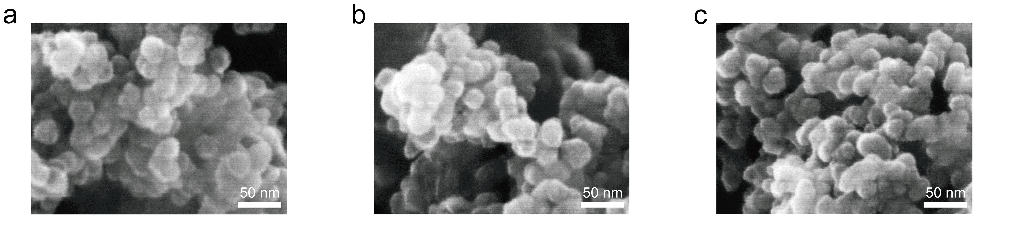
Fig. S1 SEM images of a SiO₂, b SiO₂-NH₂, and c SiO₂-LA

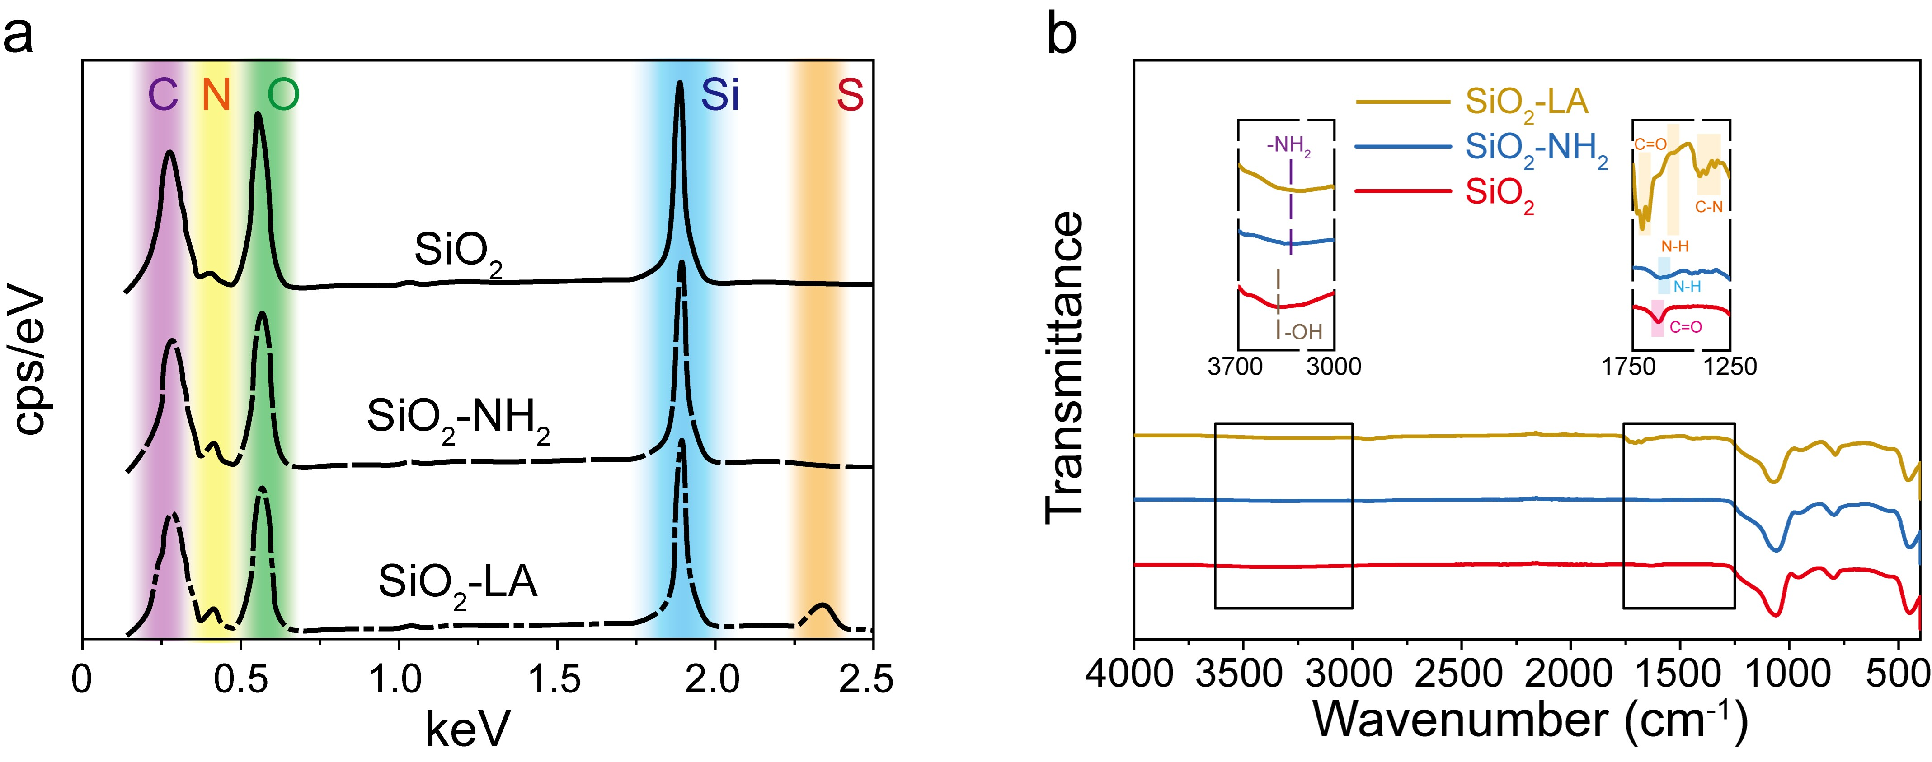
Fig. S2 a EDX spectra and b FT-IR spectra of SiO₂, SiO₂-NH₂ and SiO₂-LA

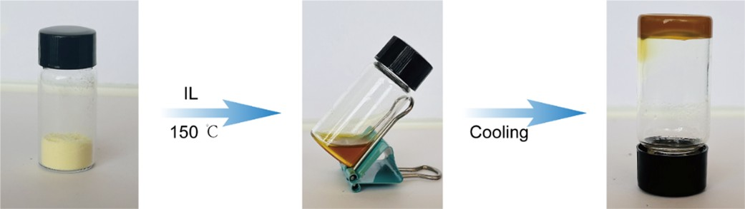
Fig. S3 Digital photos for the preparation of the elastic composite

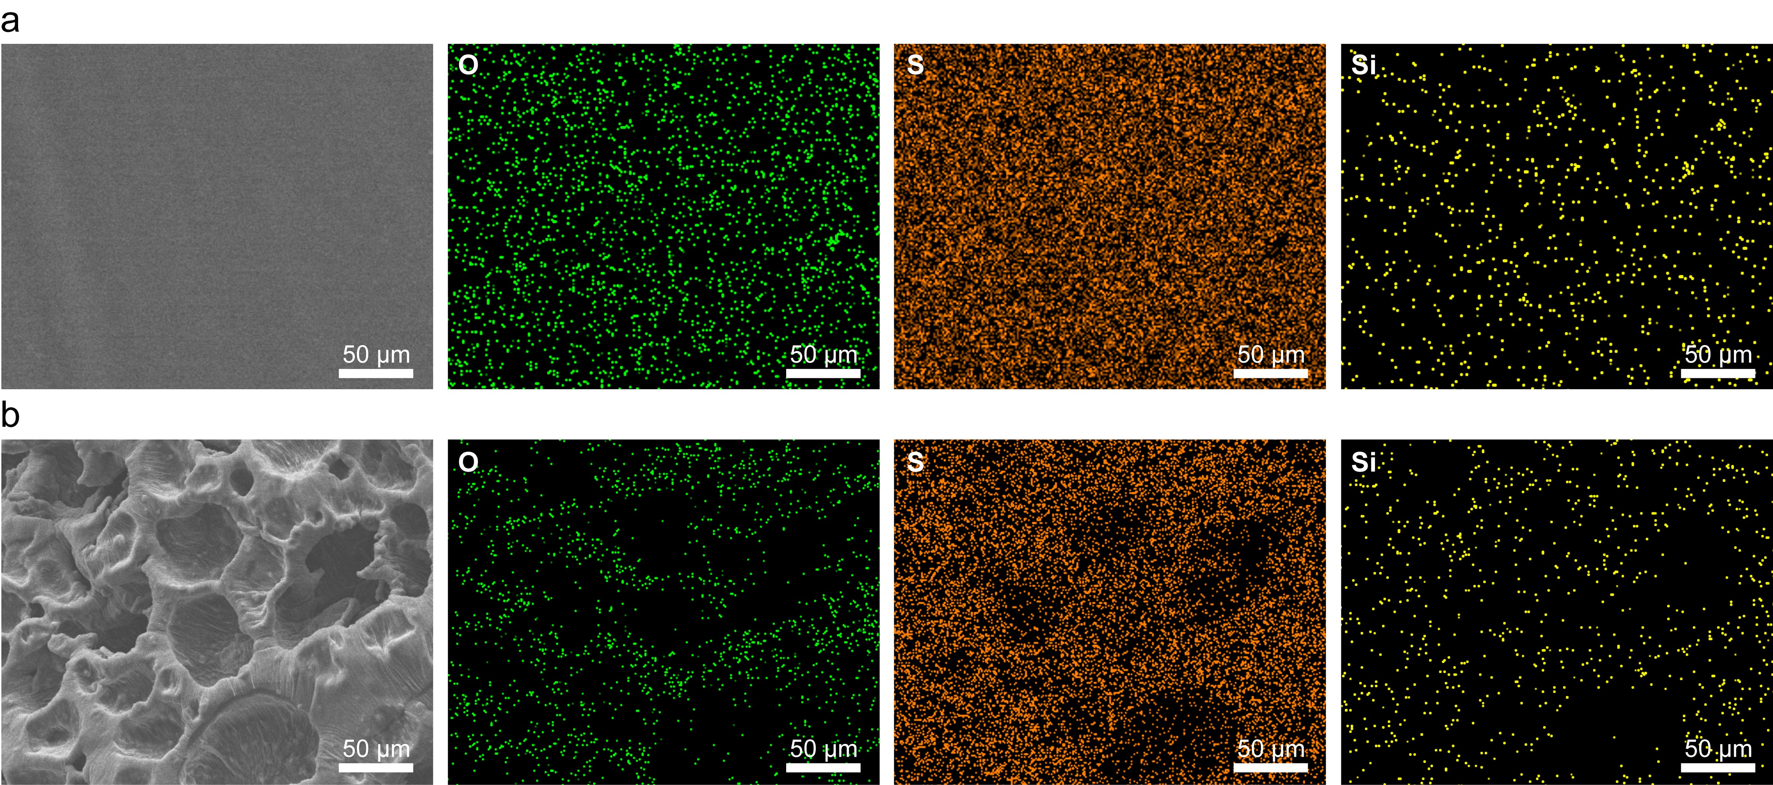
Fig. S4 SEM and EDX spectra of composites containing 1 wt% 20 nm nanoparticles: a before and b after microporous structuring

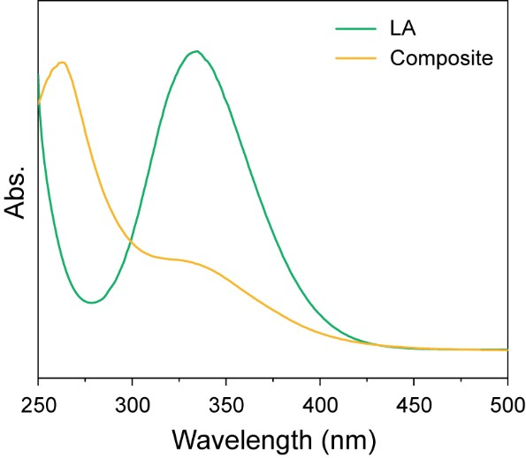
Fig. S5 UV absorption spectra of lipoic acid and the elastic composite

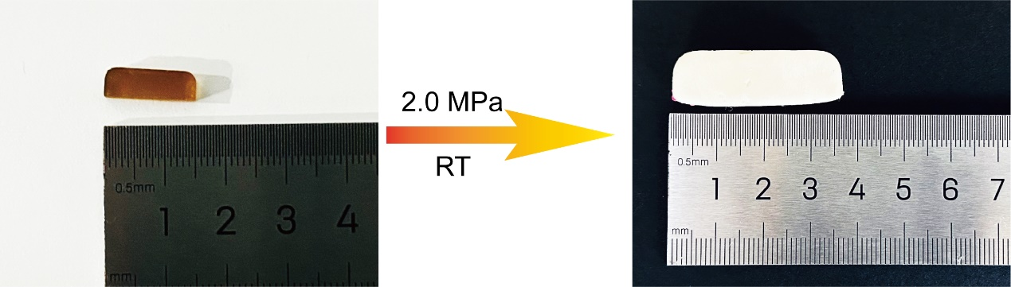
Fig. S6 Digital photographs of the composite before and after microporous structuring
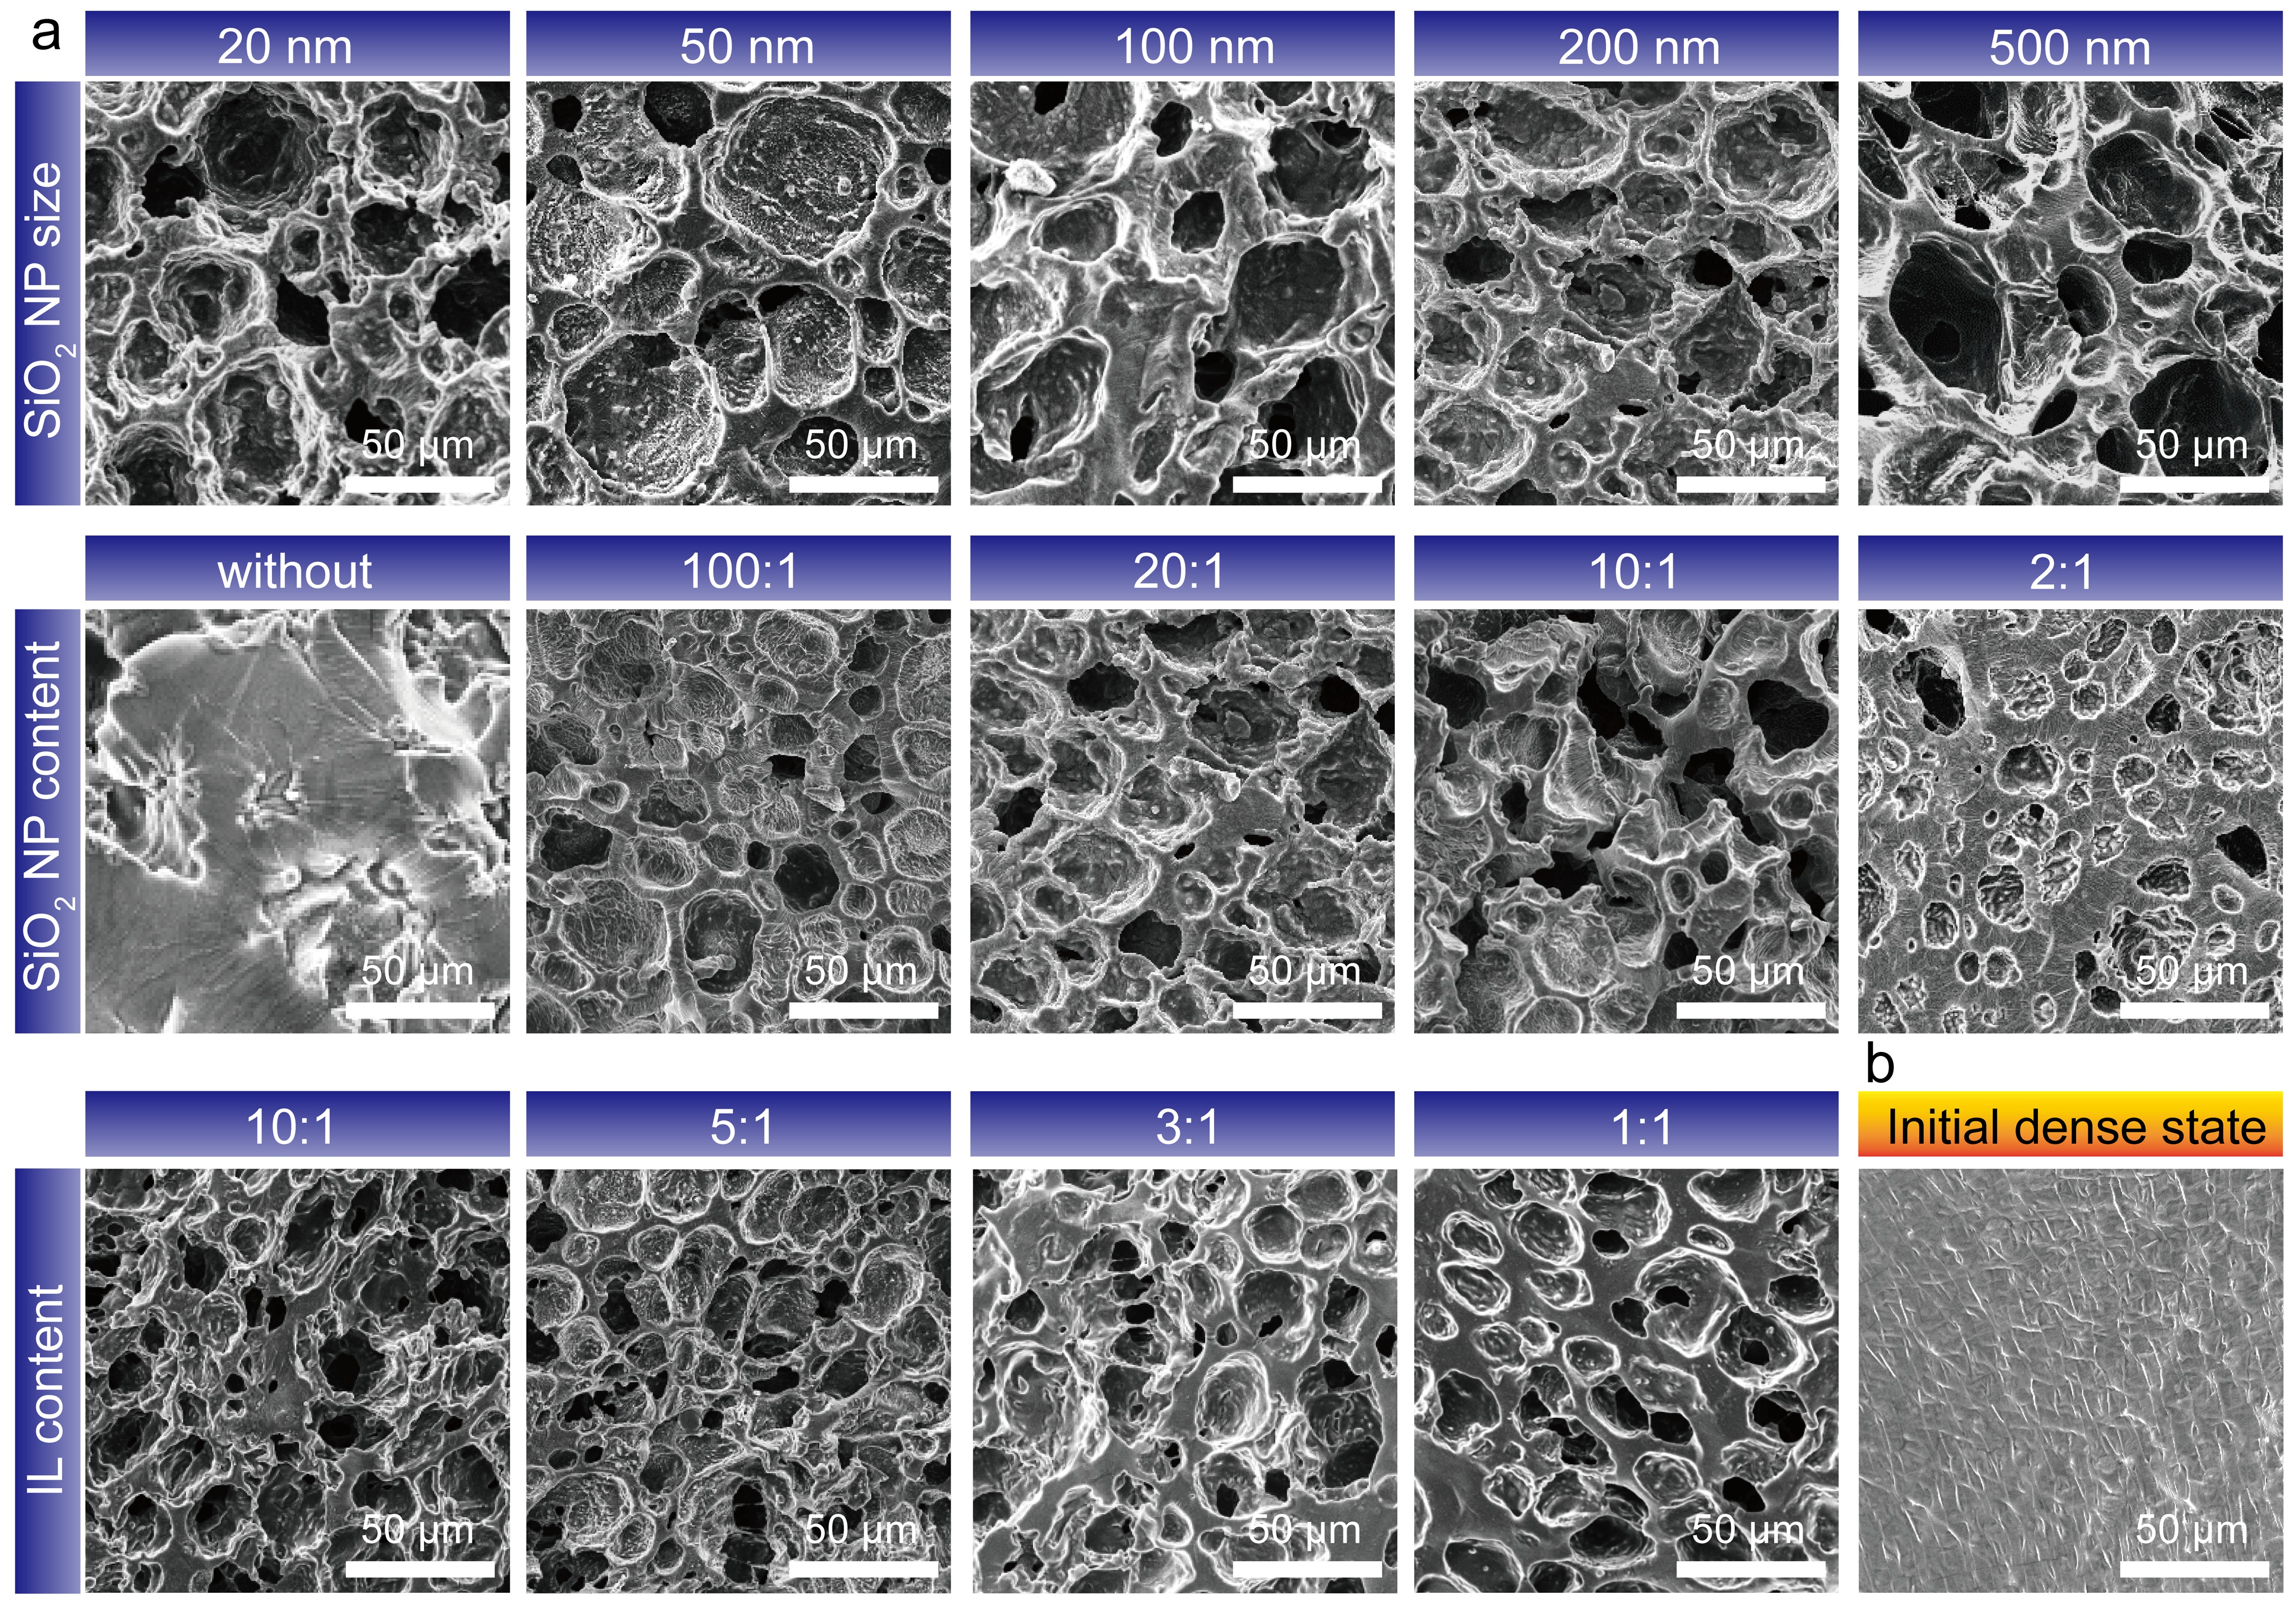
Fig. S7 SEM images showing the microporous morphology of composites with different composition ratios. a After microporous structuring and b in the initial dense state
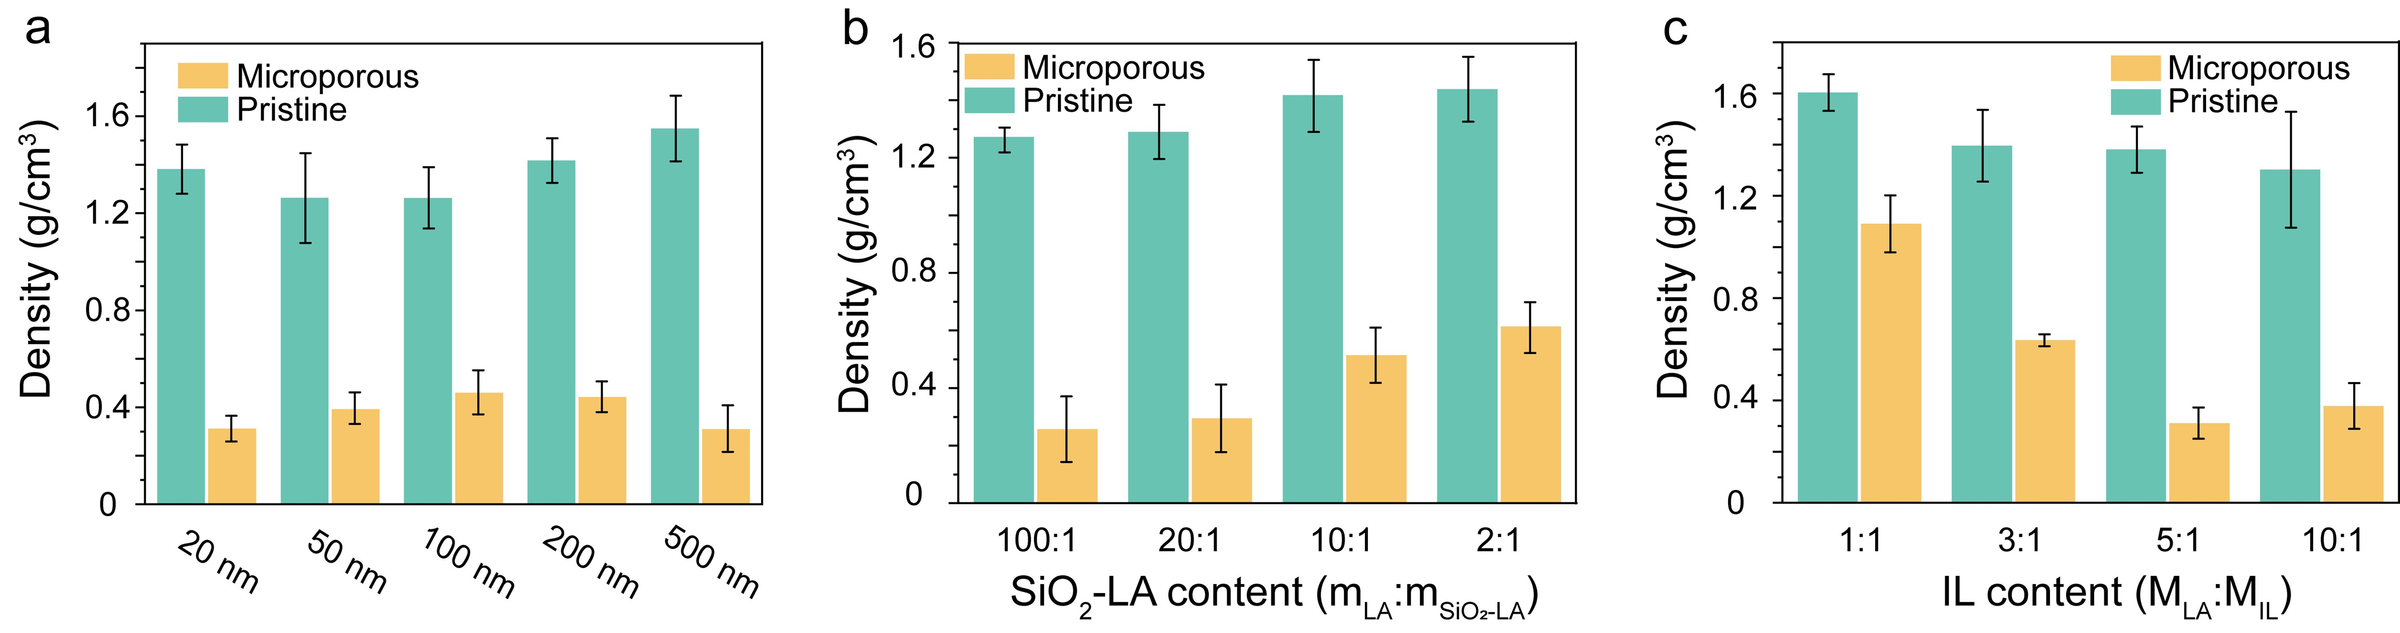
Fig. S8 Density of composites with varying compositions before and after microporous structuring. a Composites containing 1 wt% nanoparticles of different sizes and 20 wt% ionic liquid. b Composites containing varying contents of 20 nm nanoparticles and 20 wt% ionic liquid. c Composites containing 1 wt% 20 nm nanoparticles and varying contents of ionic liquid
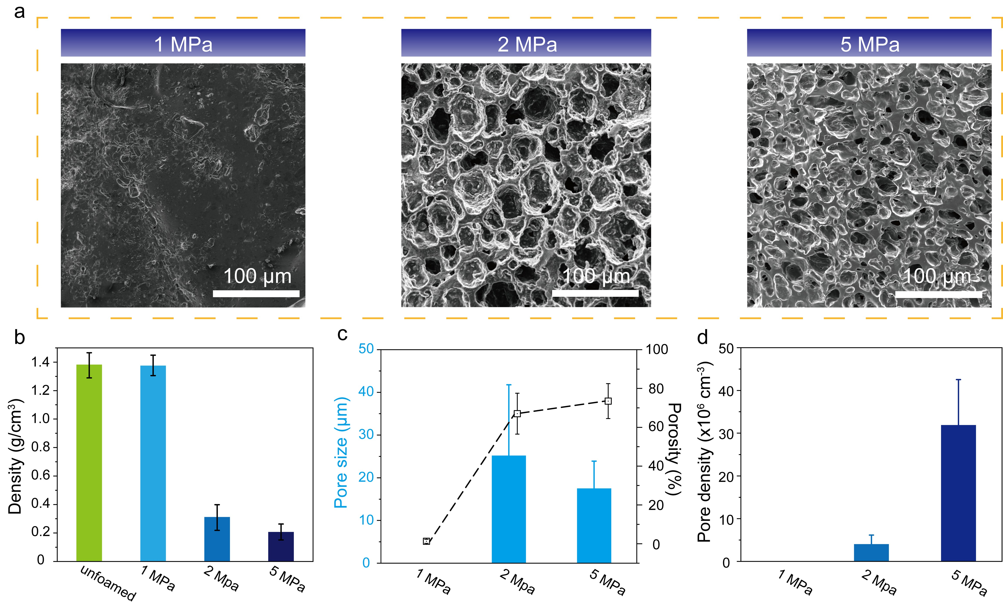
Fig. S9 SEM images and structural parameters of composites with 1 wt% 20 nm nanoparticles and 20 wt% ionic liquid prepared under different CO₂ saturation pressures: a microporous morphology, b density, c average pore size and porosity, and d pore density
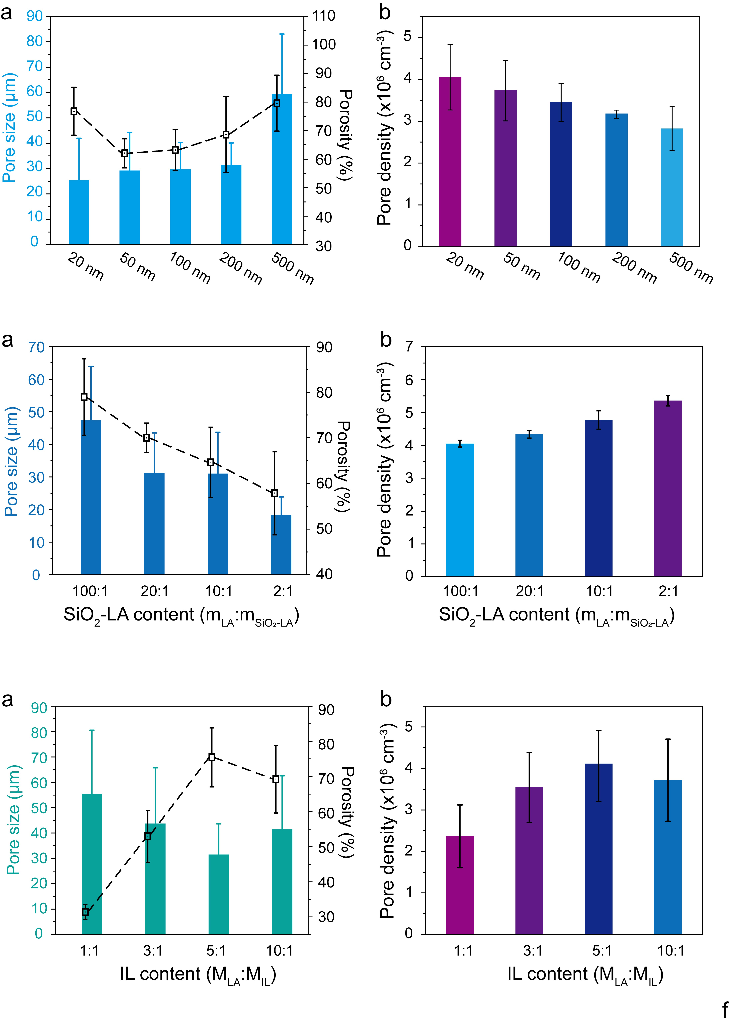
Fig. S10 Microporous composites with 1 wt% SiO₂-LA and 20 wt% ionic liquid: a pore size and porosity, and b pore density as a function of nanoparticle size under CO₂ saturation at 2.0 MPa
Fig. S11 Microporous composites with 20 nm nanoparticles and 20 wt% ionic liquid: a pore size and porosity, and b pore density as a function of nanoparticle content under CO₂ saturation at 2.0 MPa
Fig. S12 Microporous composites with 1 wt% 20 nm nanoparticles: a pore size and porosity, and b pore density as a function of ionic liquid content under CO₂ saturation at 2.0 MPa
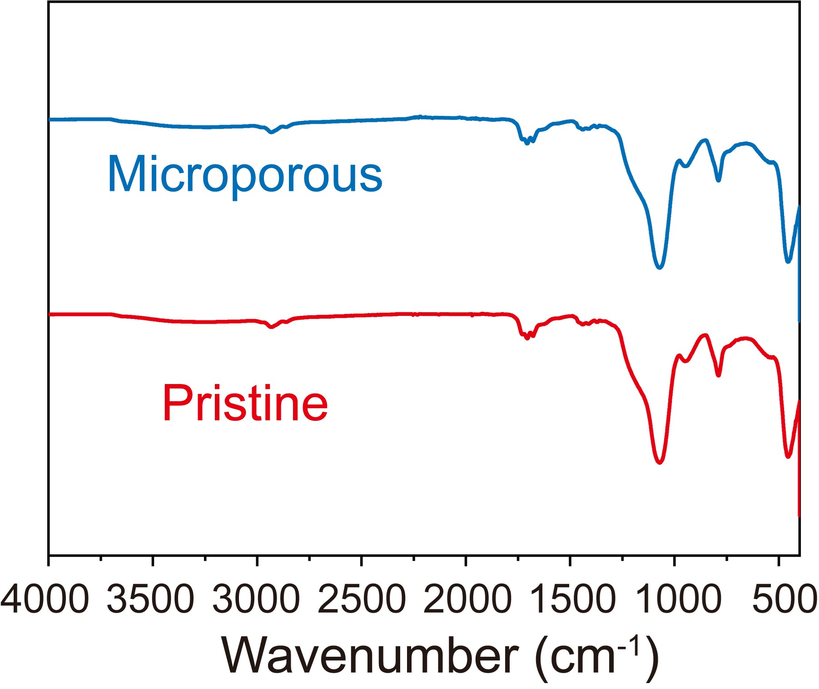
Fig. S13 ATR-FTIR spectra of the composite before and after microporous structuring
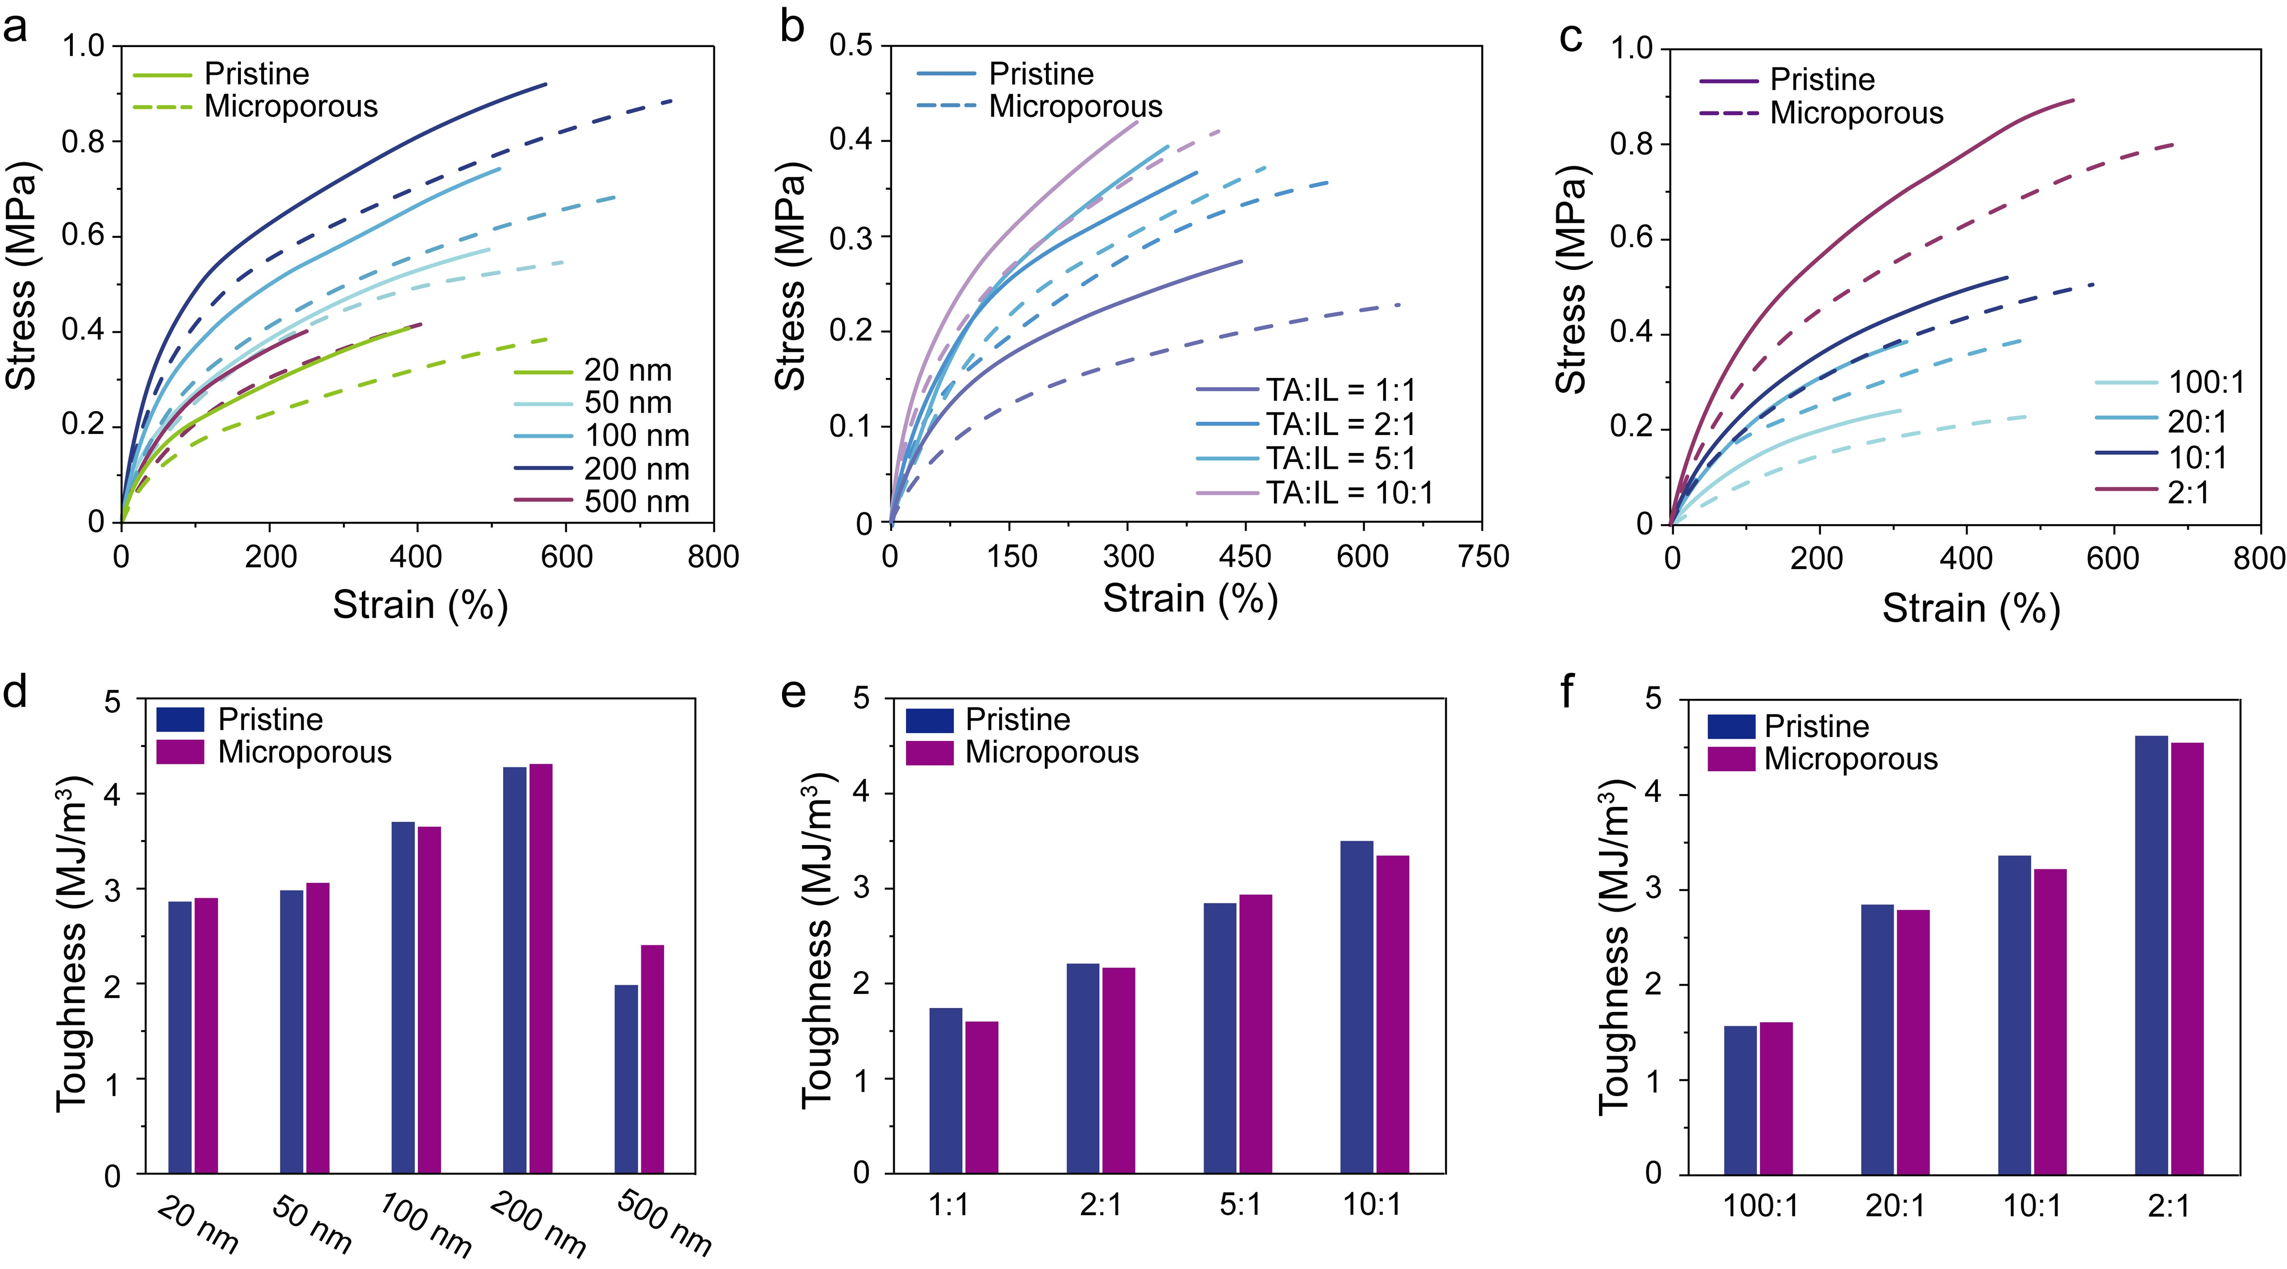
Fig. S14 Stress-strain curves of the composites with a different SiO₂-LA particle size, b different ionic liquid content, and c different SiO₂-LA amount, and d-f their corresponding toughness

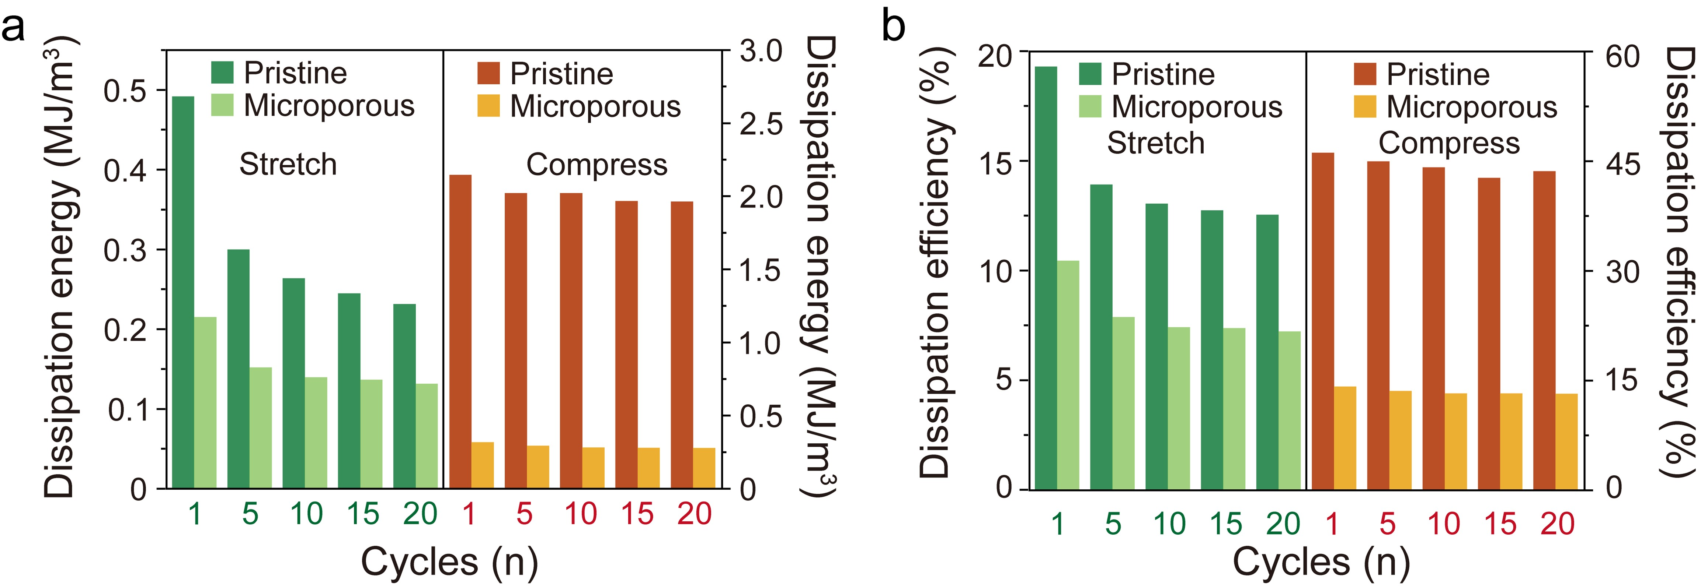
Fig. S15 a Stress dissipation and b dissipation efficiency during 20 cycles of 200% tensile strain and 50% compressive strain

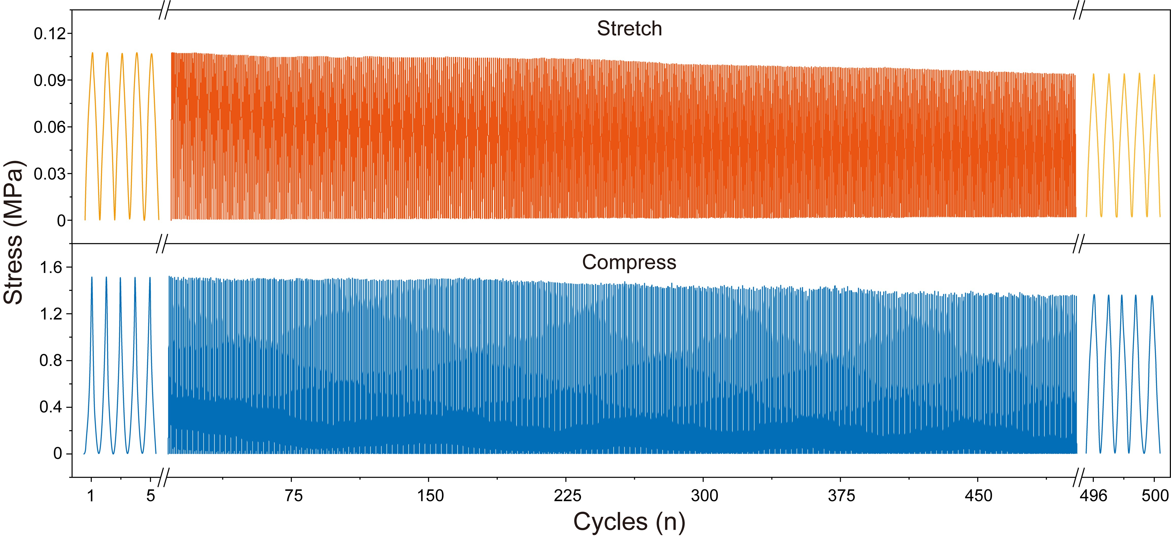
Fig. S16 Stress variation of the composite during 500 cycles at 100% tensile strain and 50% compressive strain

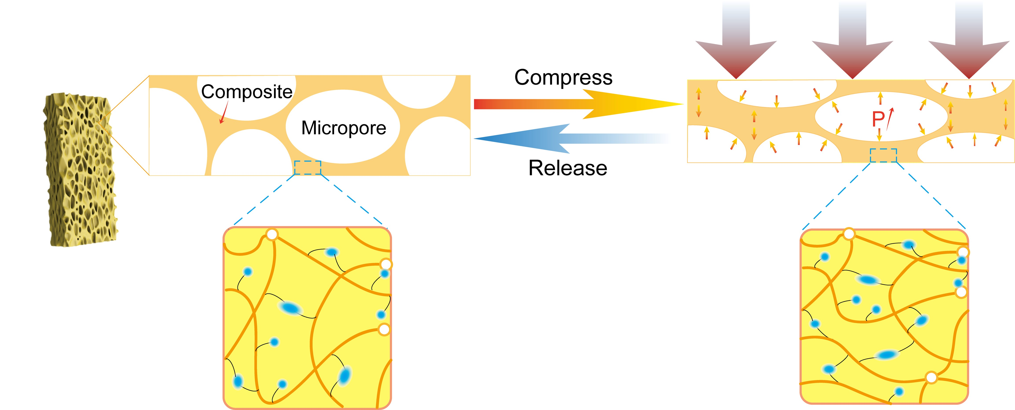
Fig. S17 Schematic representation of the elastic recovery behavior of the microporous composite
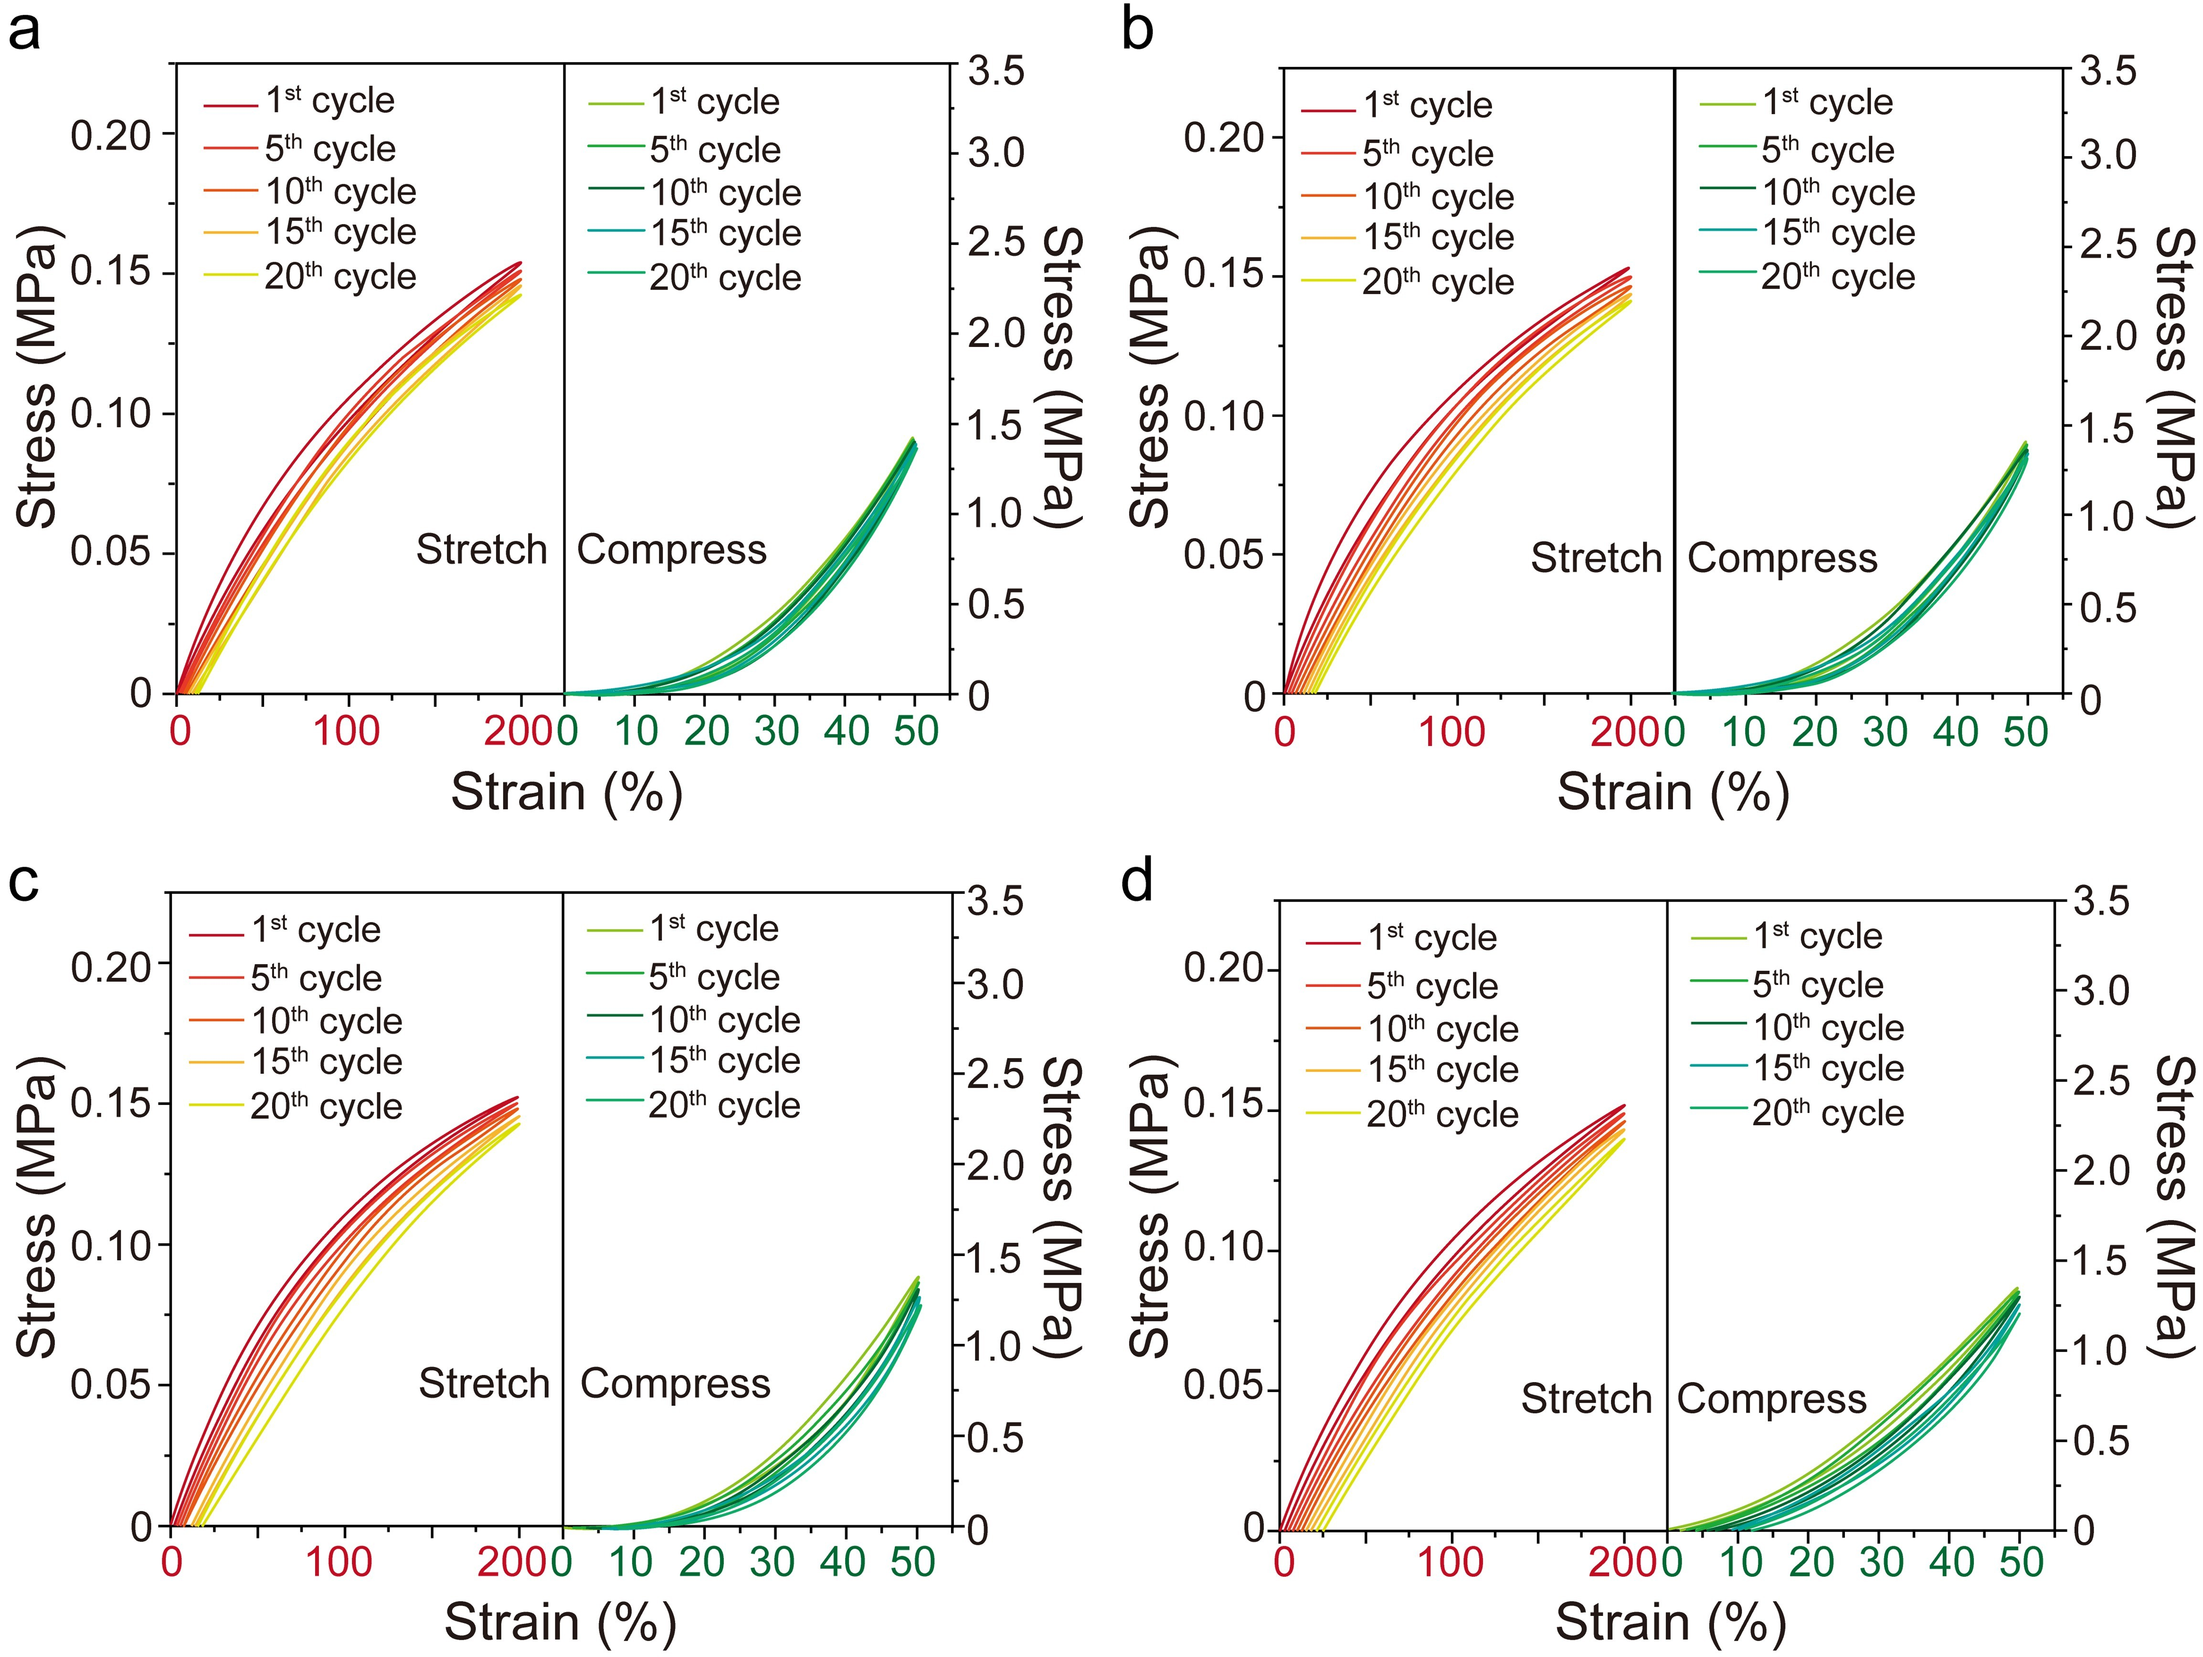
Fig. S18 Stress–strain curves under cyclic loading at 200% tensile strain and 50% compressive strain for dense and microporous composites stored at ambient conditions for a 7, b 15, and c 30 and d 60 days
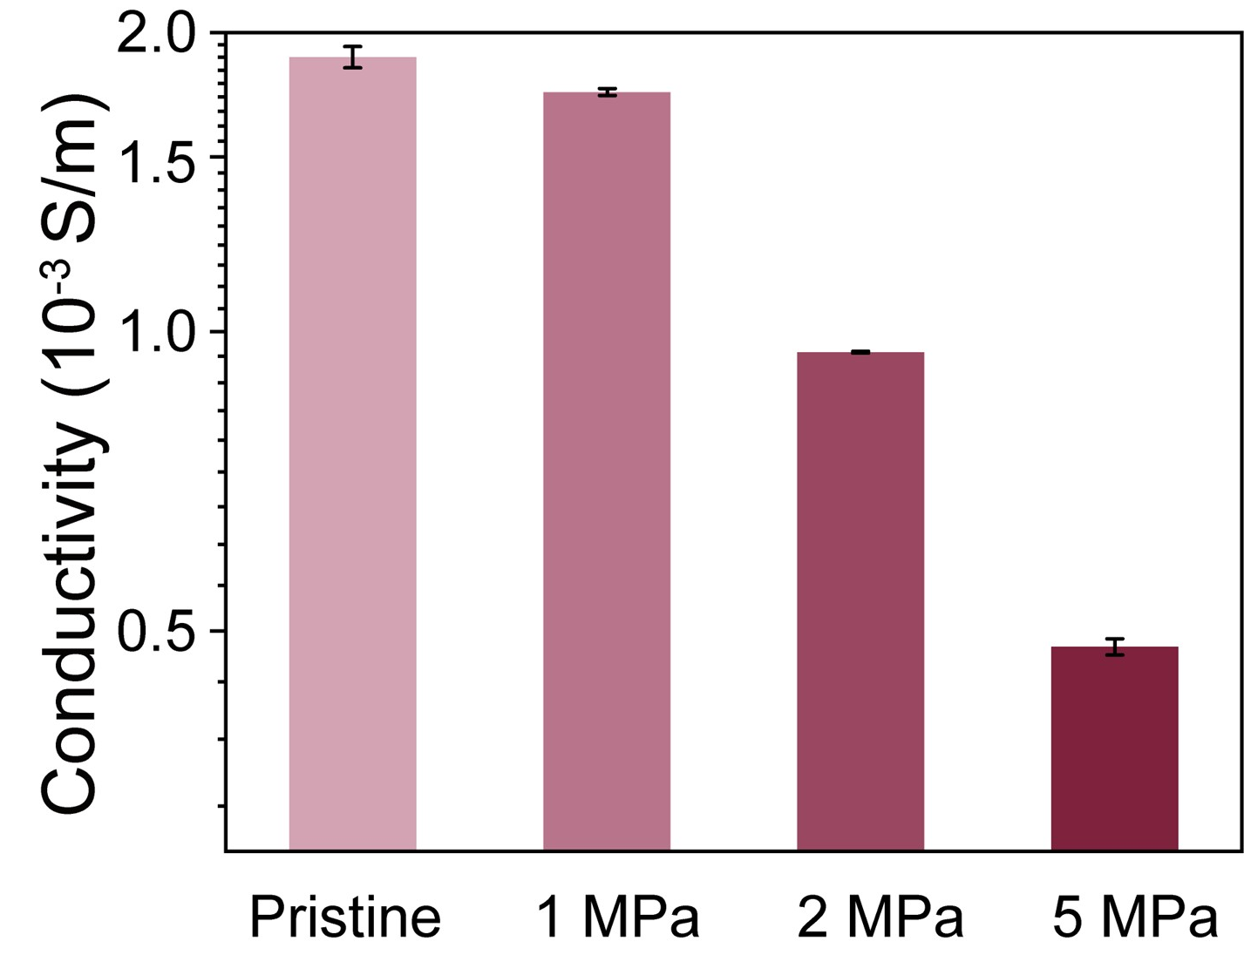
Fig. S19 Conductivity variation of the composites as a function of foaming pressure
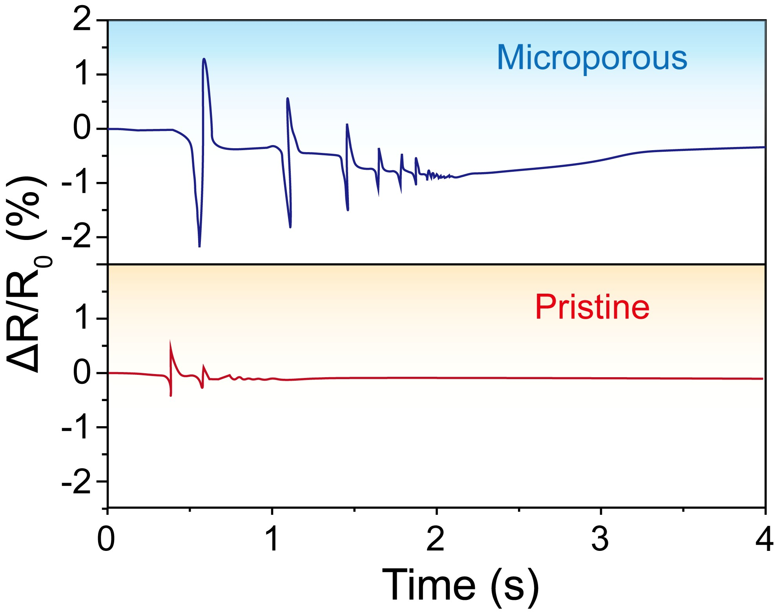
Fig. S20 The relative resistance curves of the microporous and dense composites during the drop of a ping-pong ball

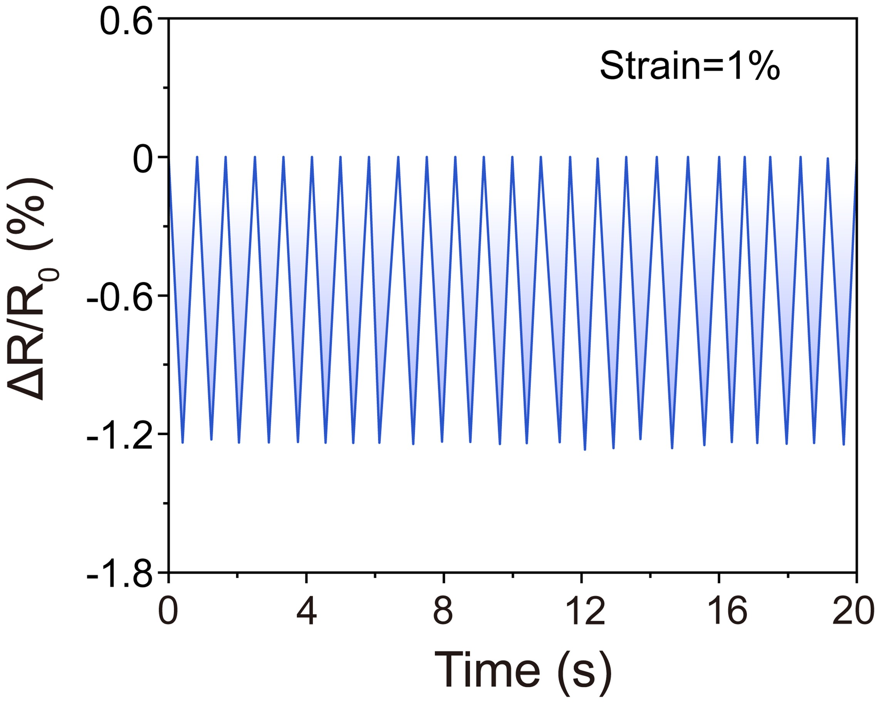
Fig. S21 Relative resistance curves of the microporous composite under repeated 1% compressive strain

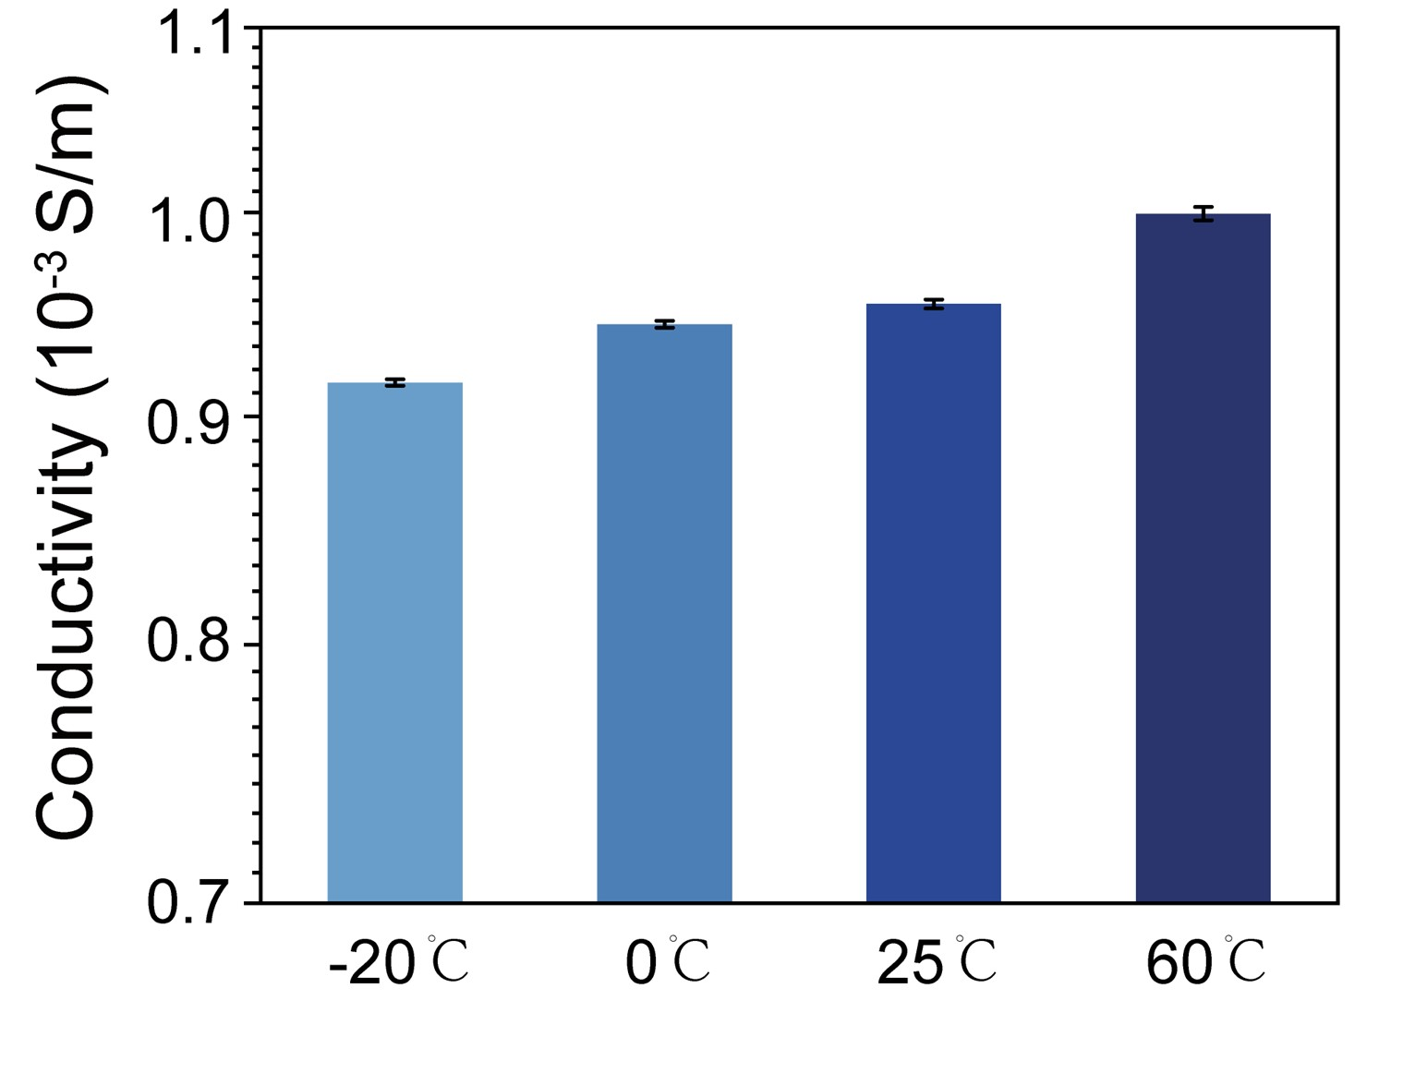
Fig. S22 Variation in conductivity of the microporous composites with temperature

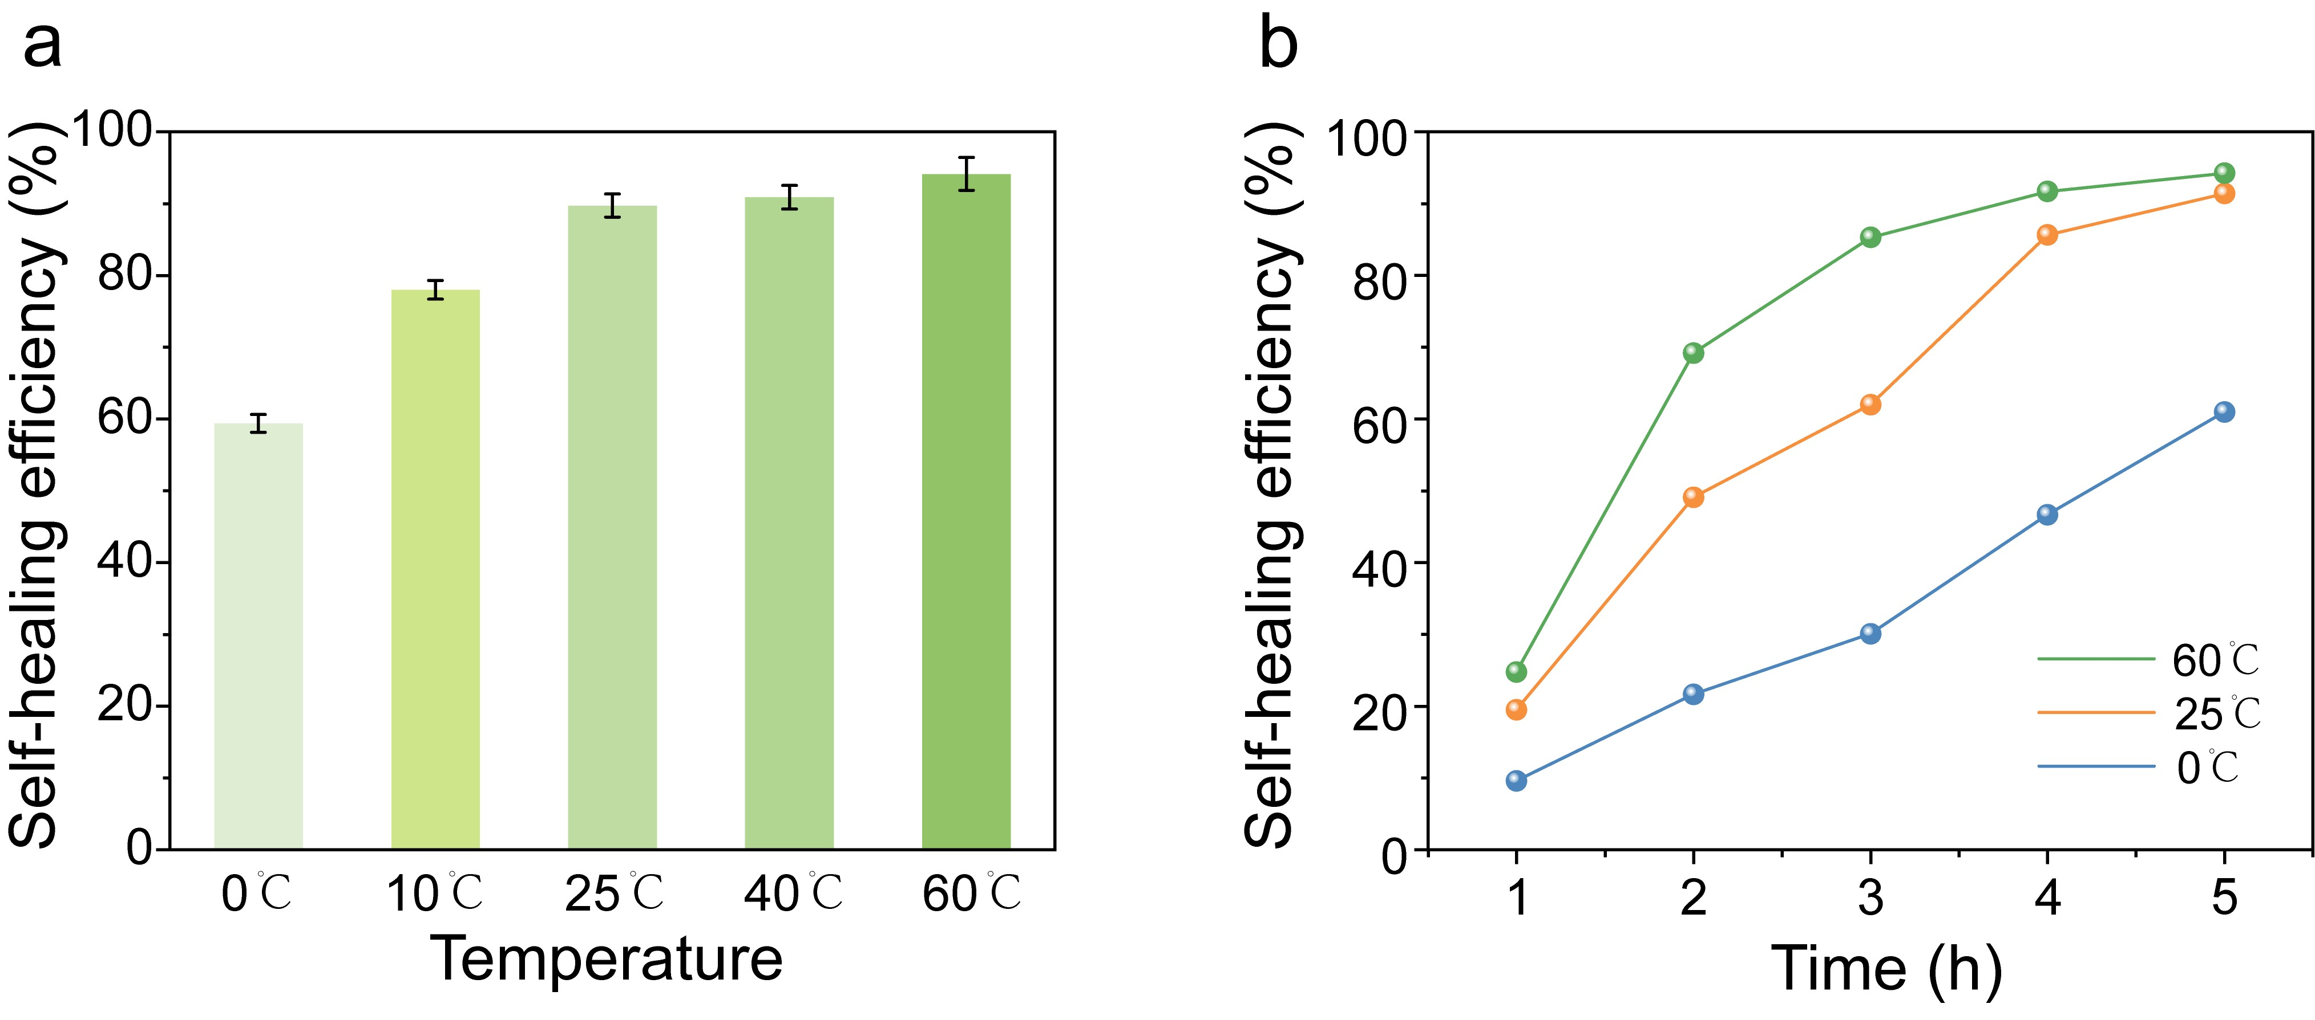
Fig. S23 a Self-healing efficiency of the composites after 5 h as a function of temperature. b Self-healing efficiency over time at different temperatures

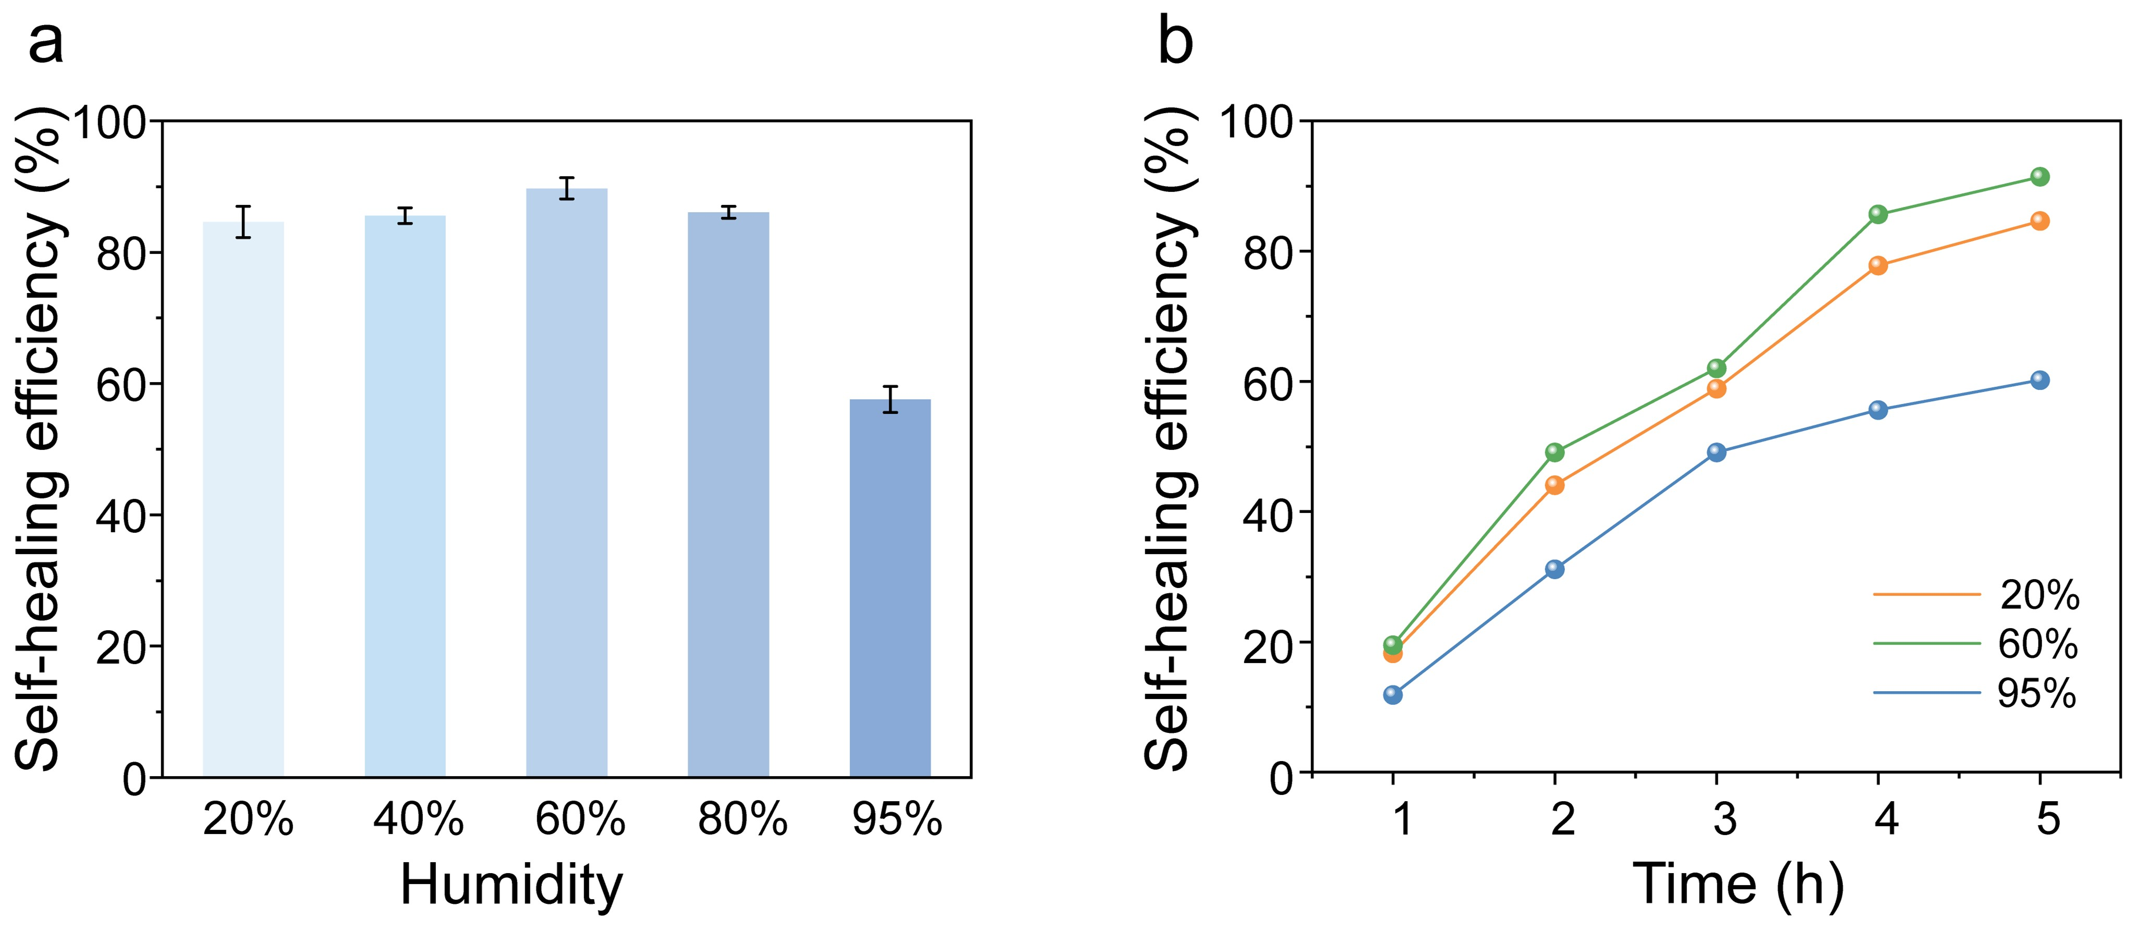
Fig. S24 a Self-healing efficiency of the composites after 5 h as a function of humidity. b Self-healing efficiency of the composites at different humidity levels over time
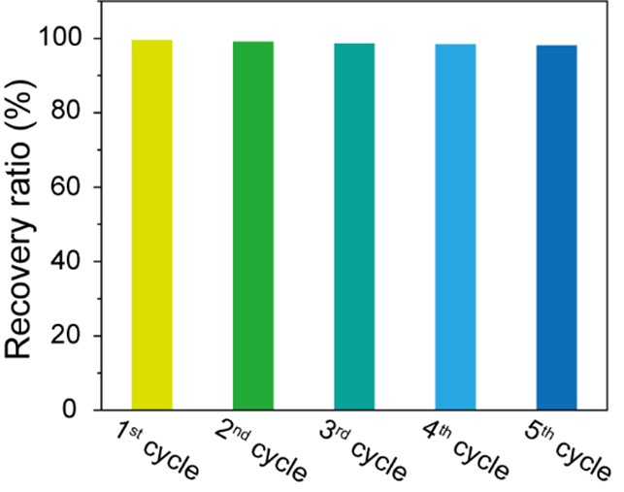
Fig. S25 SiO₂-LA recovery efficiency at different cycle numbers
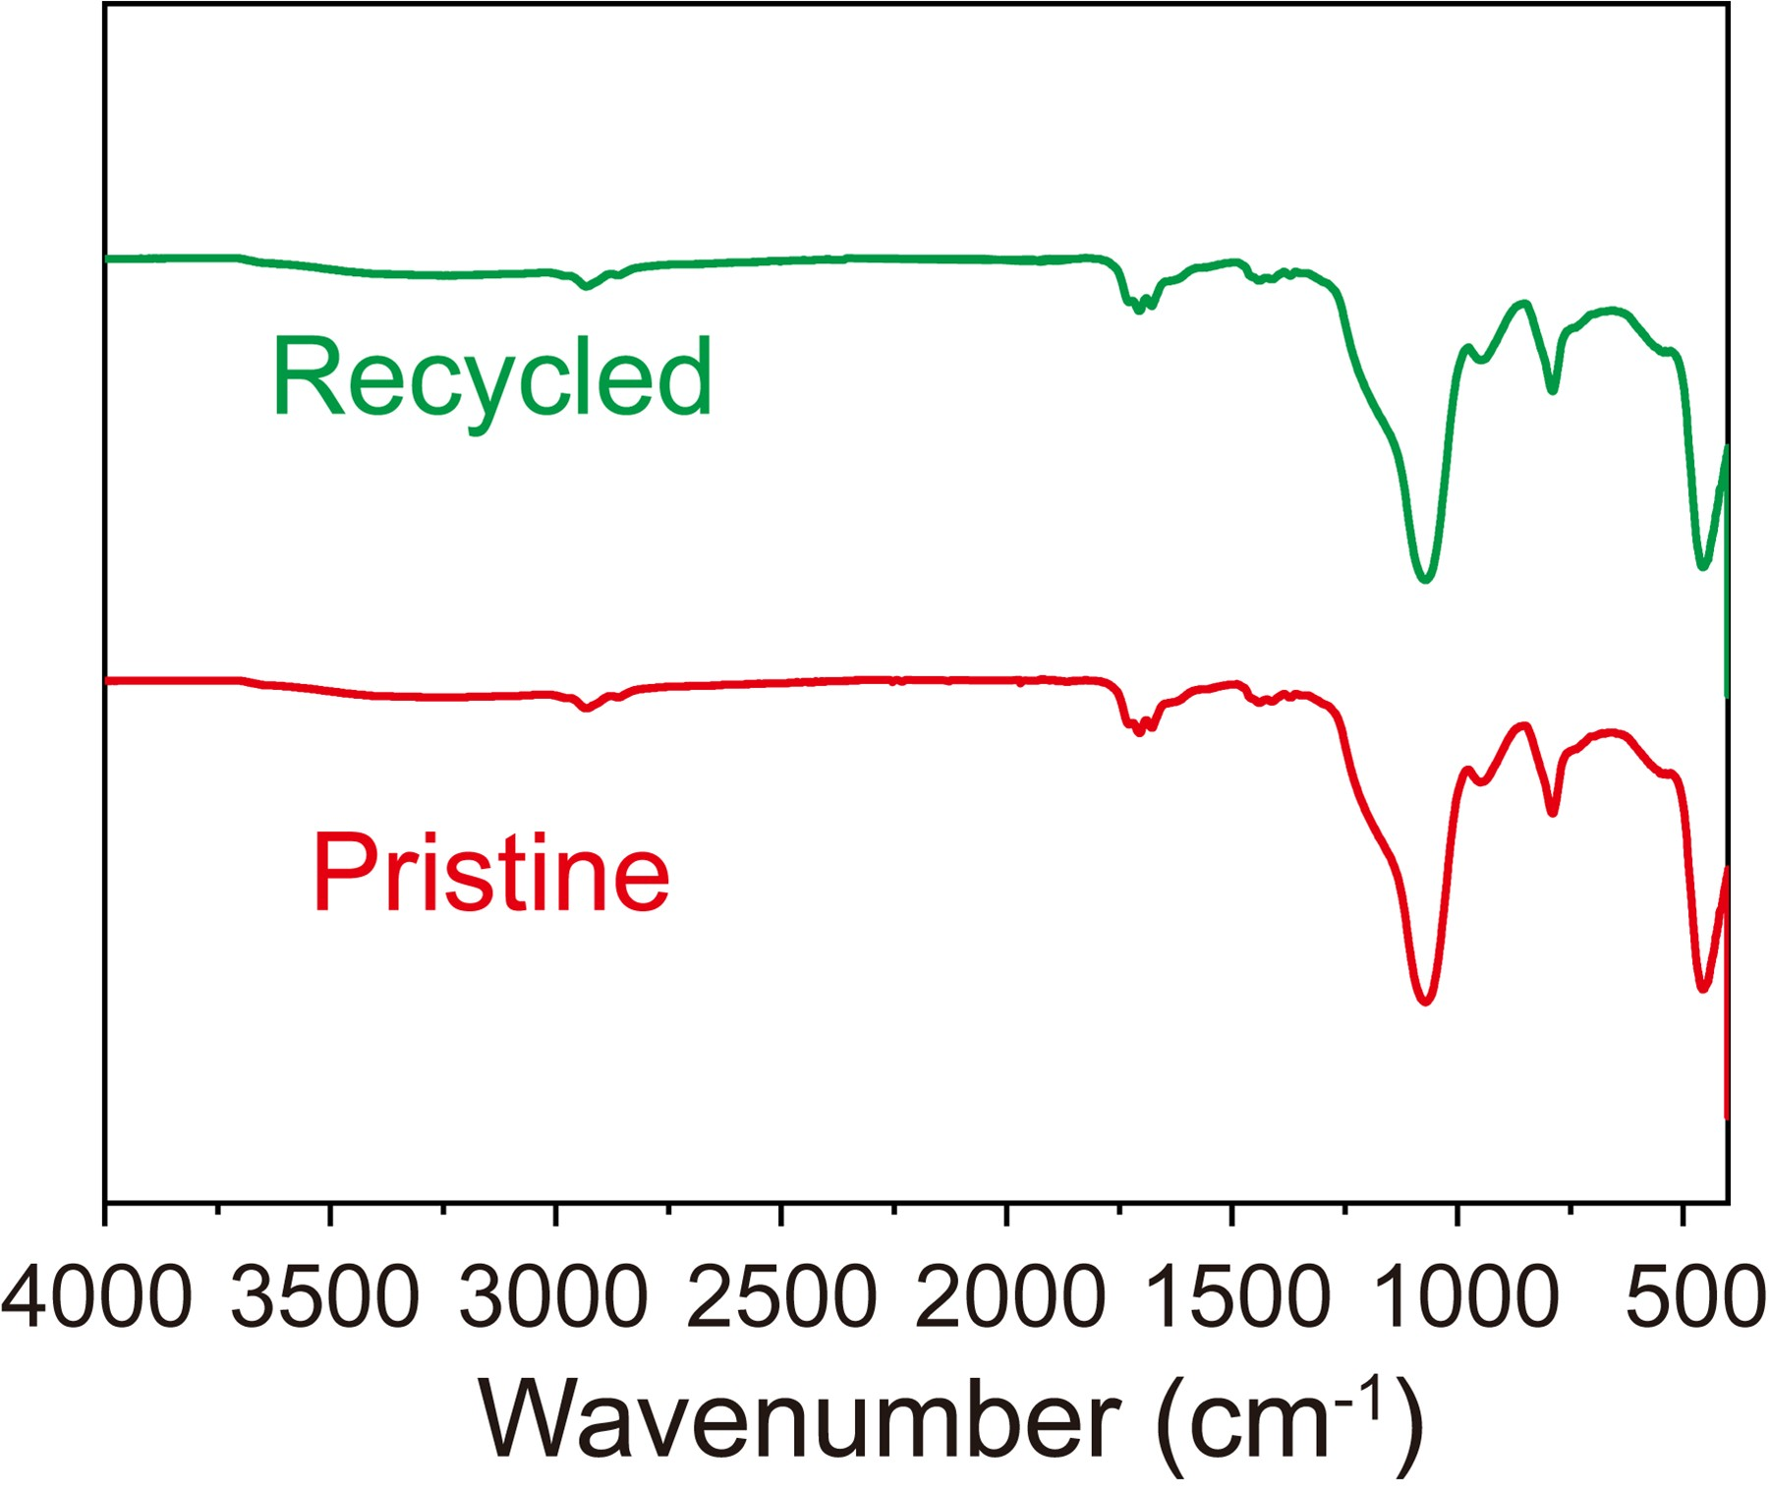
Fig. S26 FTIR spectra of SiO₂-LA before and after five recycling cycles

Table. S1 Performance comparison with peer-reported elastic conductive composites.
Ref | Density  (g/cm³) | Self-healing  Efficiency (%) | GF | Recyclability | Recovery  Rate (%) |  | Porosity(%)
This work | 0.3 | 90 | 4.8 | Yes |  | 99 | 81
[S1] | 1.31 | 86 | 2.81 | No |  | 75 | -
[S2] | 1.27 | 0 | 3.15 | Yes |  | 84 | -
[S3] | 1.33 | 0 | 1.85 | Yes |  | 85 | -
[S4] | 1.46 | 55 | 2.64 | No |  | 60 | -
[S5] | 0.4 | 0 | 2.25 | No |  | - | 77
[S6] | 0.017 | 0 | 1.67 | No |  | - | 96
[S7] | 0.41 | 0 | 2.2 | No |  | - | 87
Supplementary References
C. Dang, M. Wang, J. Yu, Y. Chen, S. Zhou et al., Transparent, highly stretchable, rehealable, sensing, and fully recyclable ionic conductors fabricated by one-step polymerization based on a small biological molecule. Adv. Funct. Mater. 29(30), 1902467 (2019). https://doi.org/10.1002/adfm.201902467
C. Ma, J. Wei, Y. Zhang, X. Chen, C. Liu et al., Highly processable ionogels with mechanical robustness. Adv. Funct. Mater. 33(31), 2211771 (2023). https://doi.org/10.1002/adfm.202211771
K.G. Cho, S. An, D.H. Cho, J.H. Kim, J. Nam et al., Block copolymer-based supramolecular ionogels for accurate on-skin motion monitoring. Adv. Funct. Mater. 31(36), 2102386 (2021). https://doi.org/10.1002/adfm.202102386
X. Zhang, Q. Fu, Y. Wang, H. Zhao, S. Hao et al., Tough liquid-free ionic conductive elastomers with robust adhesion and self-healing properties for ionotronic devices. Adv. Funct. Mater. 34(4), 2307400 (2024). https://doi.org/10.1002/adfm.202307400
P. Ding, J. Wang, Z. Xiao, X. Zhao, Y. Zhao et al., Low-hysteresis, high-fidelity flexible strain sensor with interconnected conductive network design for harsh environments and manipulator control. Chem. Eng. J. 511, 162258 (2025). https://doi.org/10.1016/j.cej.2025.162258
H. Liu, X. Chen, Y. Zheng, D. Zhang, Y. Zhao et al., Lightweight, superelastic, and hydrophobic polyimide nanofiber/MXene composite aerogel for wearable piezoresistive sensor and oil/water separation applications. Adv. Funct. Mater. 31(13), 2008006 (2021). https://doi.org/10.1002/adfm.202008006
X. Wu, Y. Han, X. Zhang, Z. Zhou, C. Lu, Large-area compliant, low-cost, and versatile pressure-sensing platform based on microcrack-designed carbon Black@Polyurethane sponge for human–machine interfacing. Adv. Funct. Mater. 26(34), 6246–6256 (2016). https://doi.org/10.1002/adfm.201601995

全部文献的年份分布参考结果 by 善锋软件(R)_数据清洗与数据清除二合一小程序
序号 | 年份 | 当年条数 | 累计条数 | 当年占比/% | 累计占比/%
1 | 年份空缺 | 1 | 1 | 33 | 33
2 | 年份提取失误 | 1 | 2 | 33 | 67
3 | 年份提取失误 | 1 | 3 | 33 | 100

文中引文序号连续性有误：。

引文数量不同。
文中最大引文序号为： 0 < 3 (文后文献的最大/最后编号)；实际引文数量为： 0 < 3 (文后文献的最大/最后编号，即有未被引用的文献)。

文中施引和文后文献列表概况：
文中施引最末位置 = / 1 页
文中施引的位置数 = 0
文中最大引文序号 = 0
文中实际引用条数 = 0
文后文献最大编号 = 3
文后文献实际条数 = 3
文中未引文献序号 = 1，2，3

文后文献序号连续性无误。

恭喜，未发现重复的文献！

