Supporting Information for
Ultrafast Sulfur Redox Dynamics Enabled by a PPy@N-TiO₂ Z-Scheme Heterojunction Photoelectrode for Photo-assisted Lithium-Sulfur Batteries
Fei Zhao^{1, 2}, Yibo He^{1, 2,} *, Xuhong Li¹, Ke Yang^{1, 2}, Shuo Chen^{1, 2}, Yuanzhi Jiang³, Xue-Sen Wang⁴, Chunyuan Song^{1, 2}, and Xuqing Liu^{1, 2}
¹ State Key Laboratory of Solidification Processing, Center of Advanced Lubrication and Seal Materials, School of Materials Science and Engineering, Northwestern Polytechnical University, Xi’an, Shaanxi 710072, P. R. China
² Research & Development Institute of Northwestern Polytechnical University in Shenzhen, Shenzhen 518063, P. R. China
³ Key Laboratory of Advanced Energy Materials Chemistry (Ministry of Education), Nankai University, Tianjin 300071, P. R. China
⁴ Department of Physics, National University of Singapore, Singapore 117543, Singapore
*Corresponding author. E-mail: heyibo@nwpu.edu.cn (Yibo He)

Supplementary Figures and Table
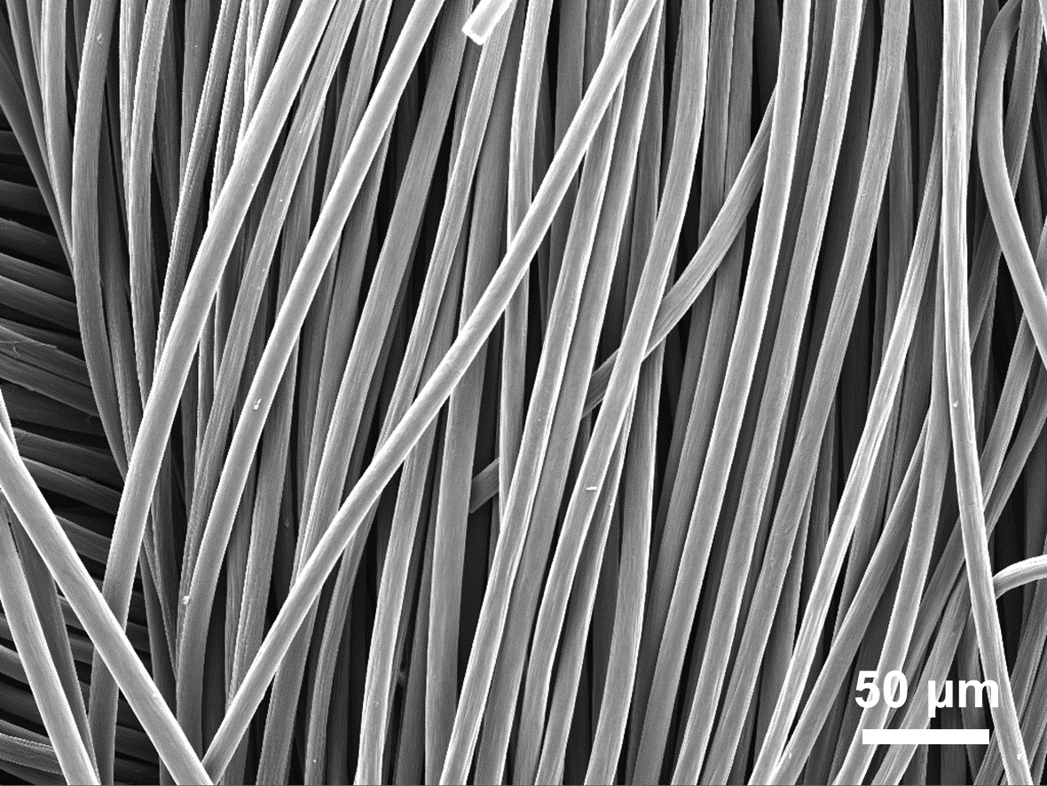
Fig. S1 Low-magnification SEM image of CC
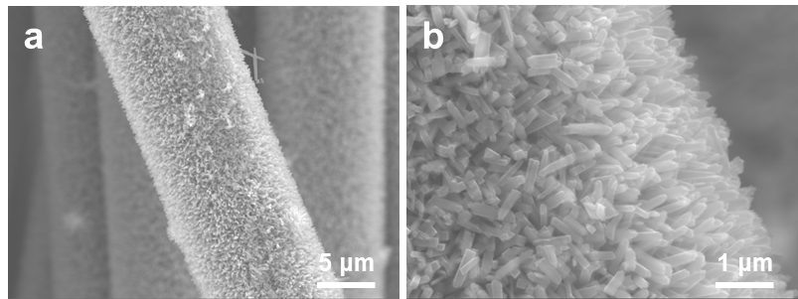
Fig. S2 SEM image of TiO₂/CC
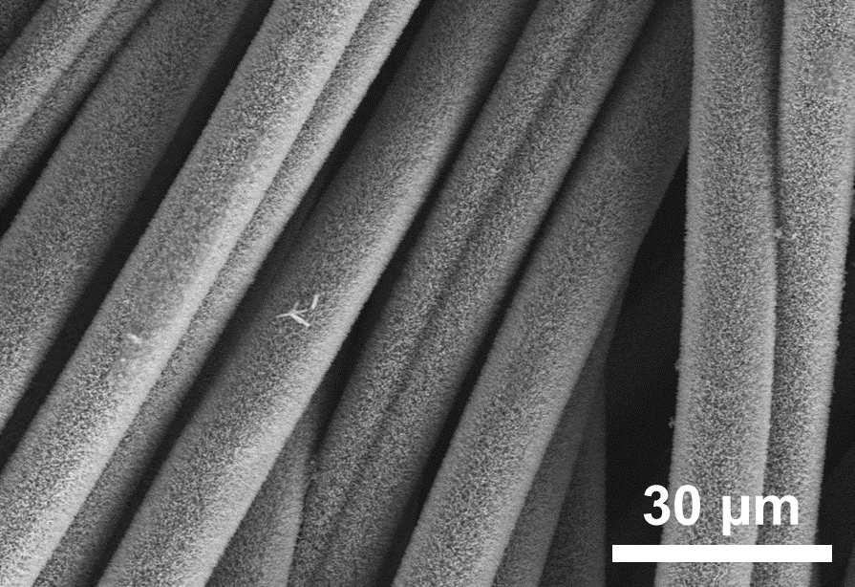
Fig. S3 Low-magnification SEM image of PPy@N-TiO₂/CC

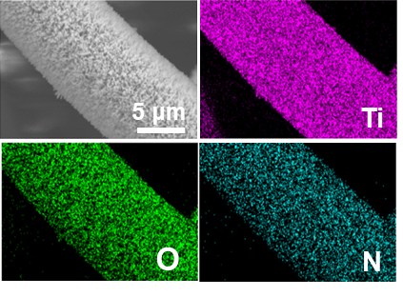
Fig. S4 Element mapping of PPy@N-TiO₂/CC

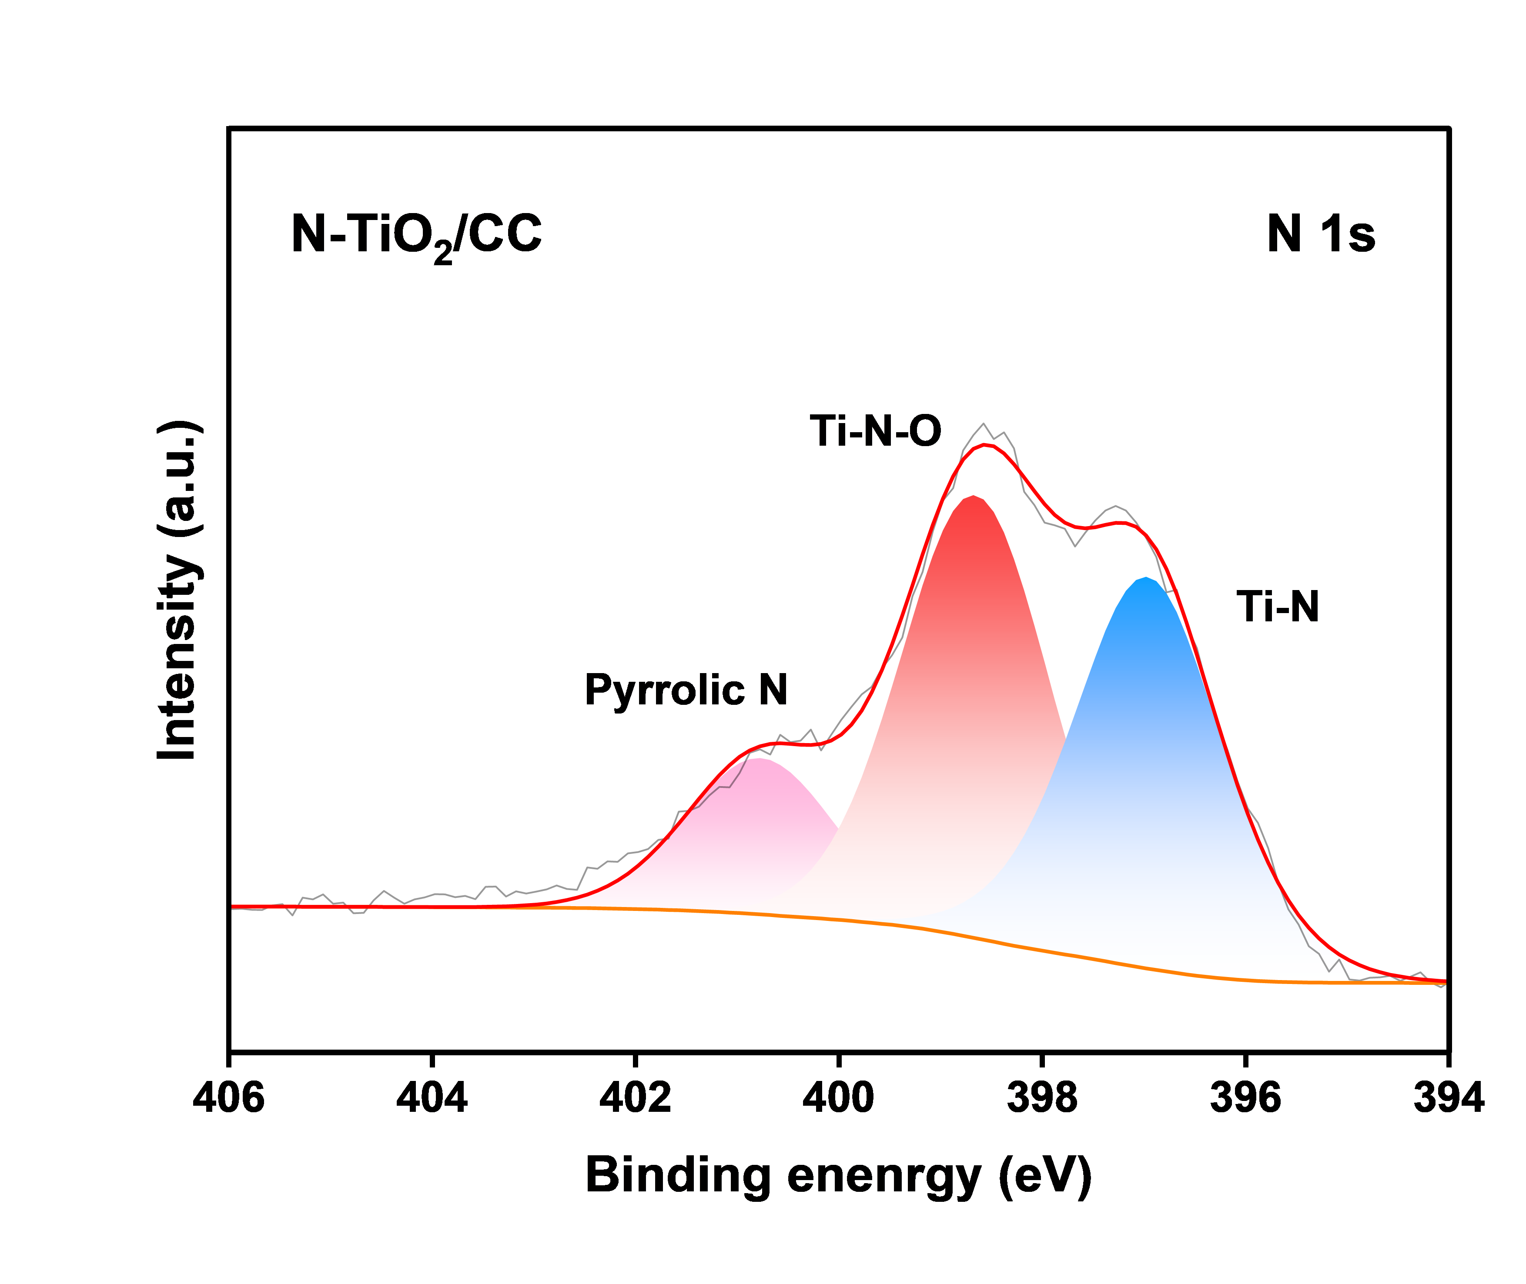
Fig. S5 N 1s XPS spectrum of N-TiO₂/CC
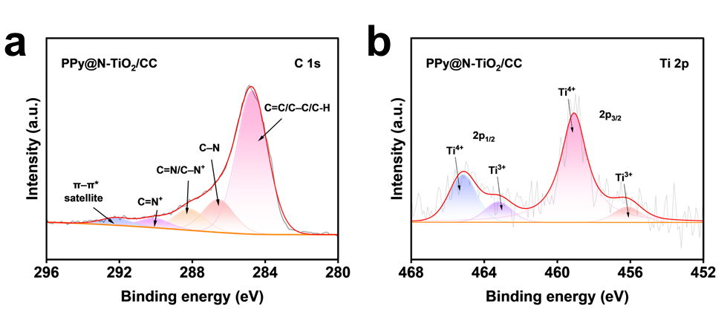
Fig. S6 a C 1s, b Ti 2p XPS spectra of PPy@N-TiO₂/CC

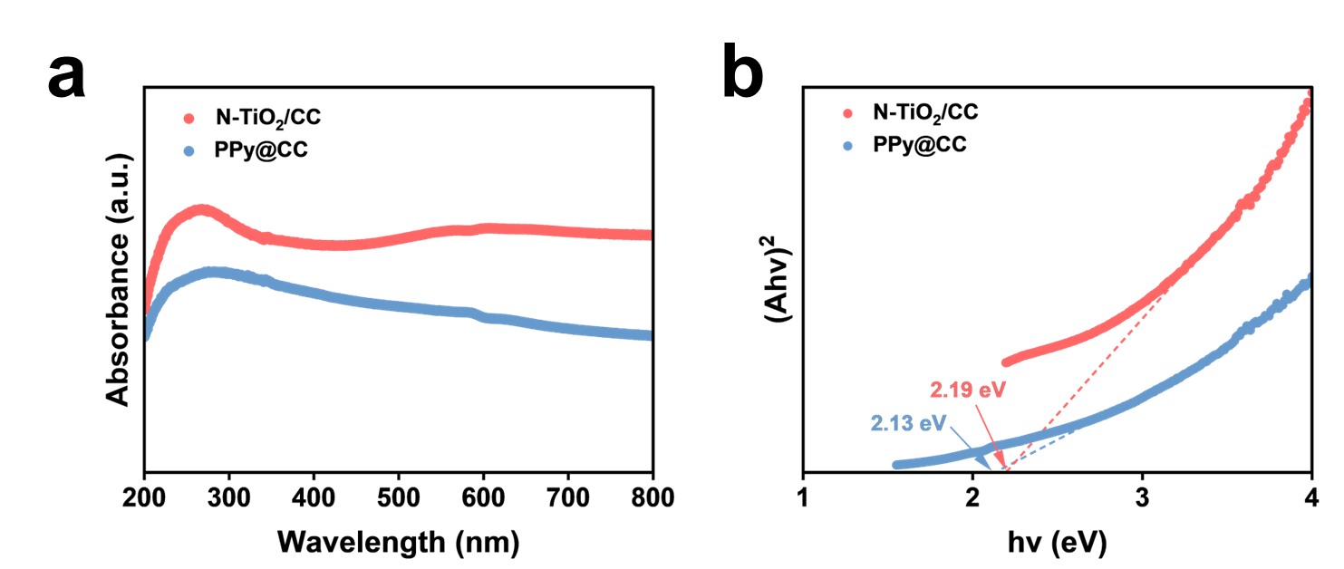
Fig. S7 a UV-vis absorption spectra and b the band gap of N-TiO₂/CC and PPy@CC

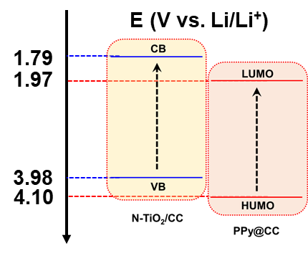
Fig. S8 Band energy diagram of N-TiO₂/CC and PPy@CC vs. Li/Li⁺

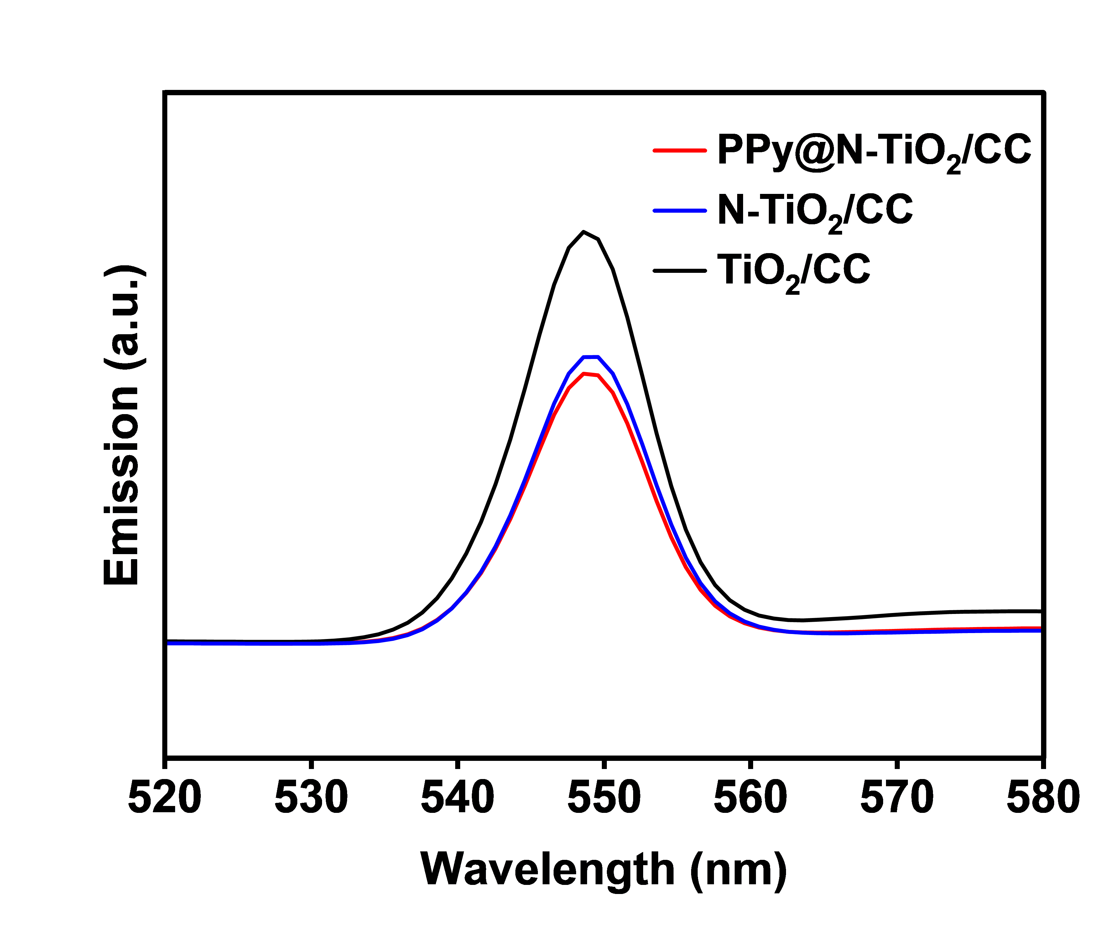
Fig. S9 PL emission spectra of various samples
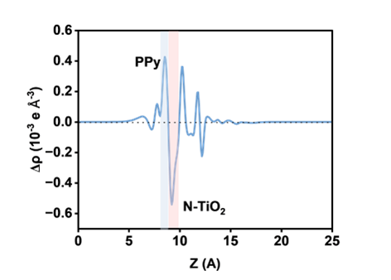
Fig. S10 Average planar electron density difference Δρ(z) for PPy@N-TiO₂

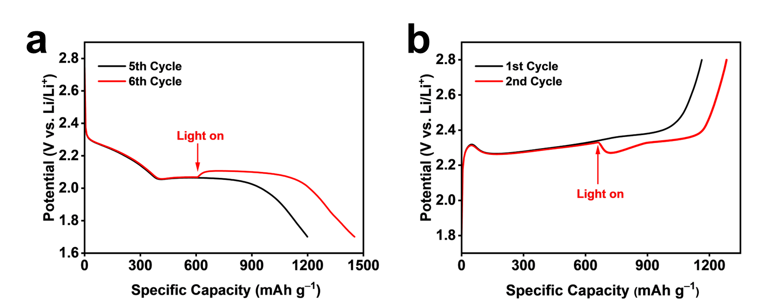
Fig. S11 a Discharge and b charge curves of PPy@N-TiO₂/CC battery at 0.2 C by altering the light on/off
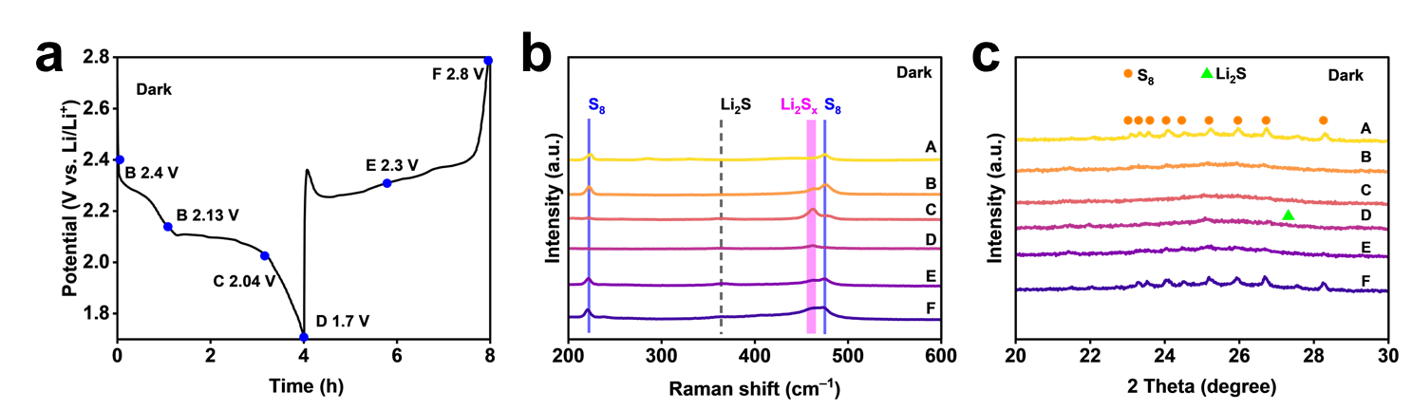
Fig. S12 a GCD curves of PPy@N-TiO₂/CC battery at 0.2 C without the illumination. Corresponding b Raman spectra and c XRD patterns of PPy@N-TiO₂/CC photocathode without the illumination
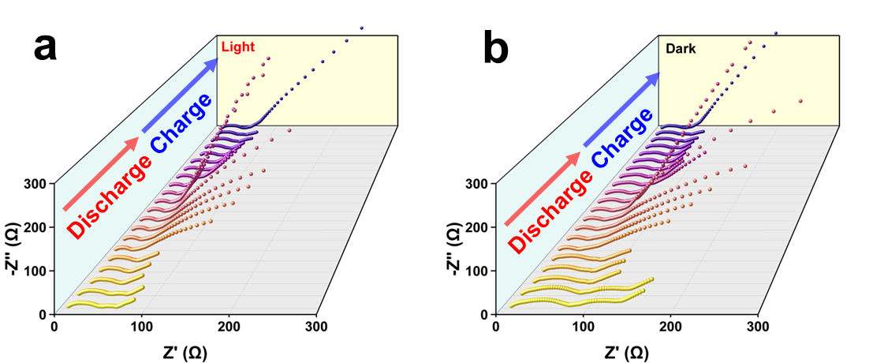
Fig. S13 EIS spectra of the PPy@N-TiO₂ battery at 0.2 C (a) with and (b) without the illumination
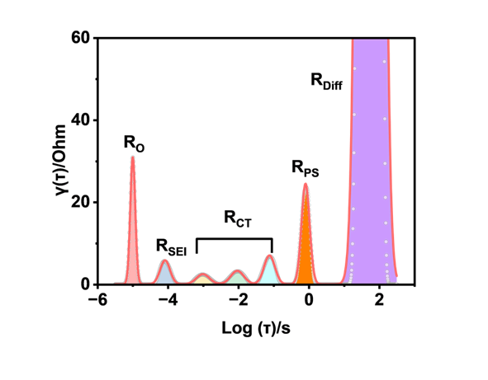
Fig. S14 Schematic diagram of DRT analysis

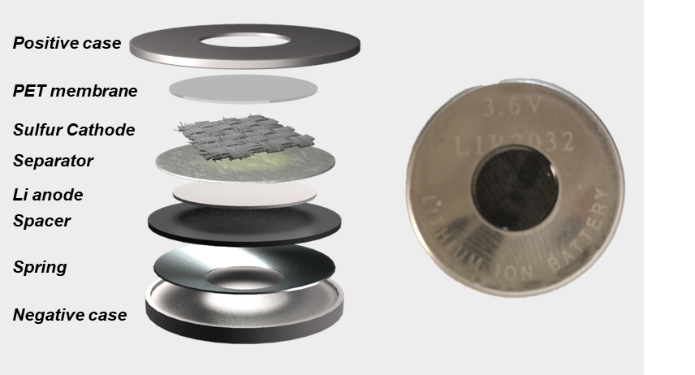
Fig. S15 Schematic diagram and optical photograph of PALSB assembly
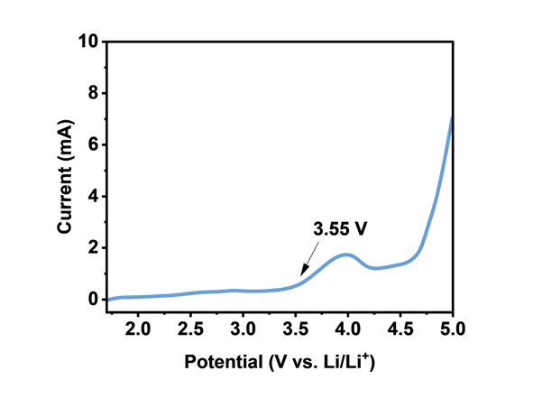
Fig. S16 LSV curves of Li||PPy@N-TiO₂/CC battery with the illumination
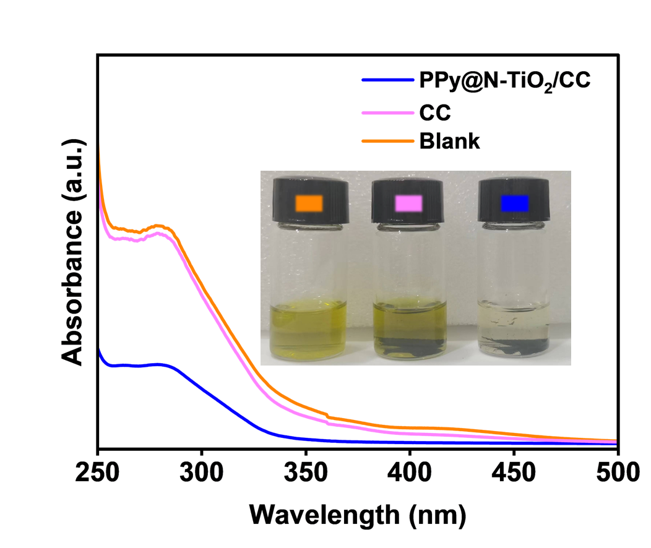
Fig. S17 UV-vis absorption spectra of Li₂S₆ solution with different samples (inset: the digital photo of polysulfides adsorption)

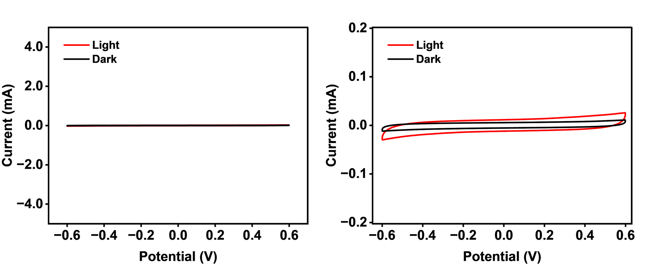
Fig. S18 CV curves of symmetric batteries without Li₂S₆ at 0.5 mV s^{–1} with PPy@N-TiO₂/CC electrode with and without the illumination
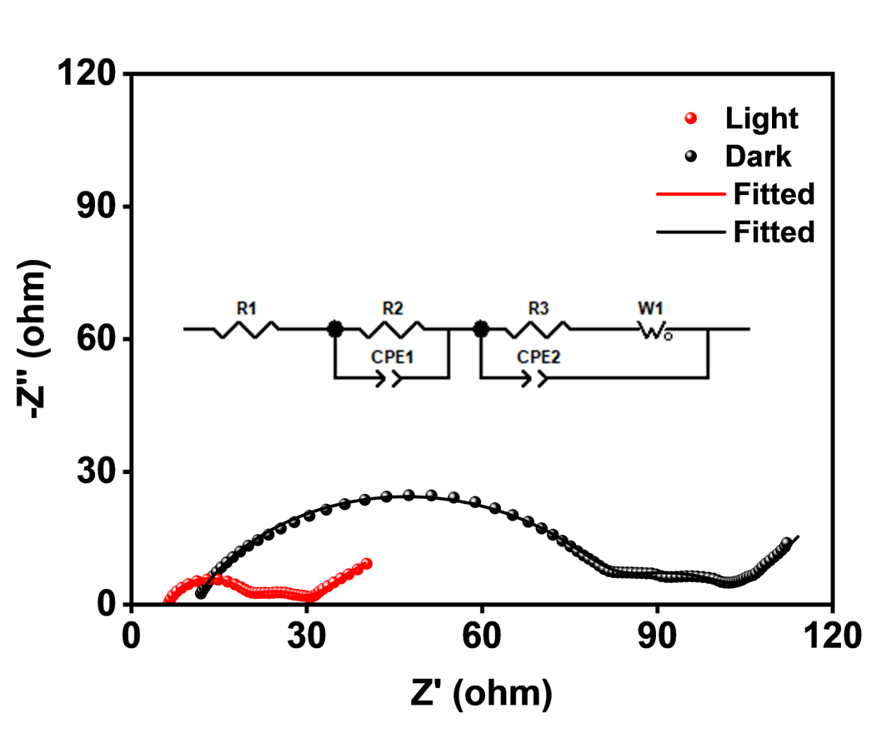
Fig. S19 EIS curves of PPy@N-TiO₂/CC assembled PALSB with and without the illumination
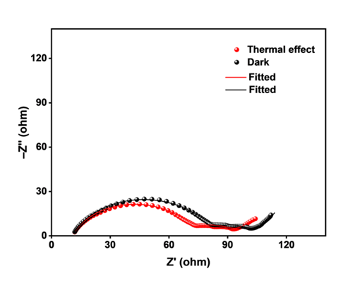
Fig. S20 EIS curves of PPy@N-TiO₂/CC assembled PALSB under photothermal
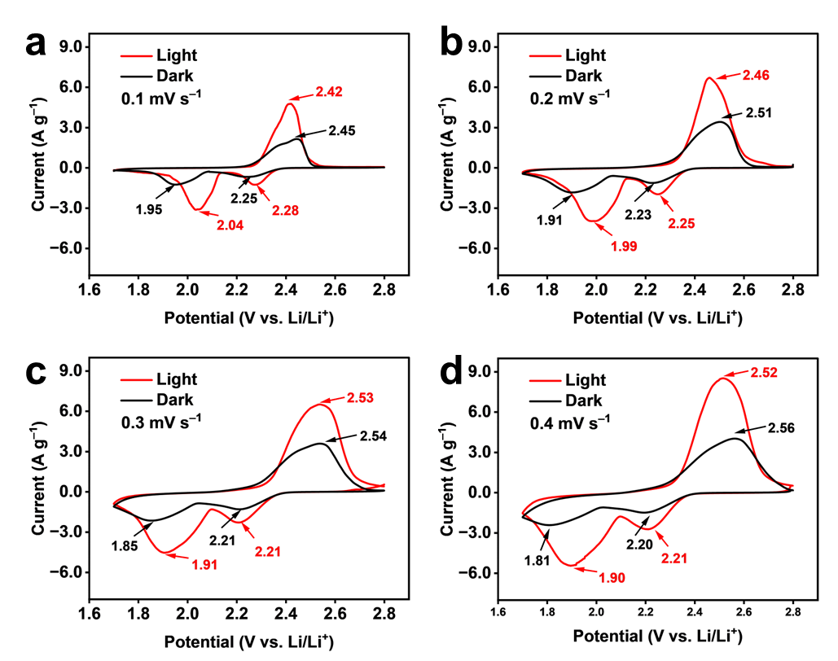
Fig. S21 CV curves of PPy@N-TiO₂/CC battery with and without the illumination at a 0.1 mV s^{–1}, b 0.2 mV s^{–1}, c 0.3 mV s^{–1}, and d 0.4 mV s^{–1}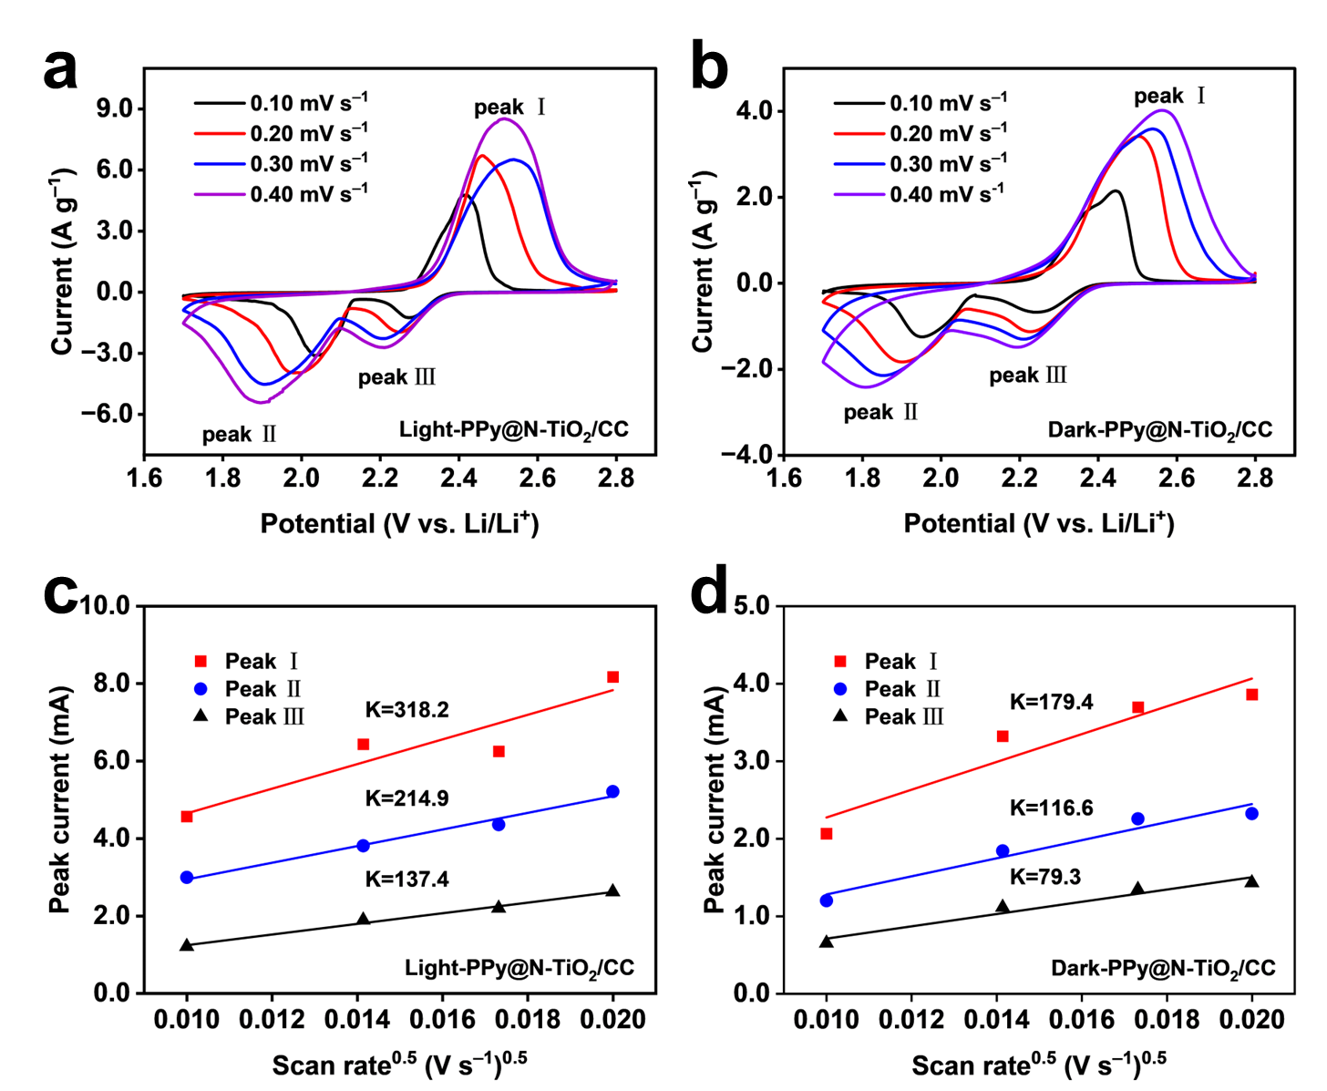
Fig. S22 CV curves of PPy@N-TiO₂/CC battery a with and b without the illumination at different scan rates. Plots of CV peak current versus square root of scan rate c with and d without the illumination
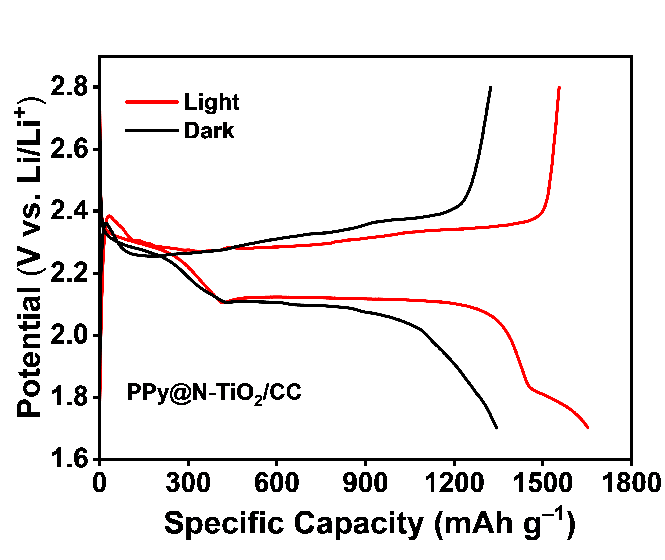
Fig. S23 GCD curves of PPy@N-TiO₂/CC battery at 0.2 C with and without the illumination

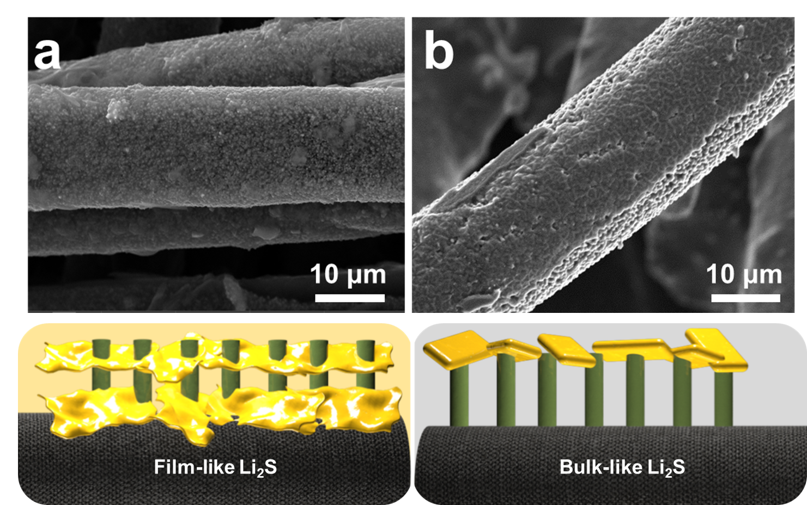
Fig. S24 The SEM images of PPy@N-TiO₂/CC electrode after being initially discharged a with and b without the illumination (Schematic diagram of discharge product morphology with and without the illumination)
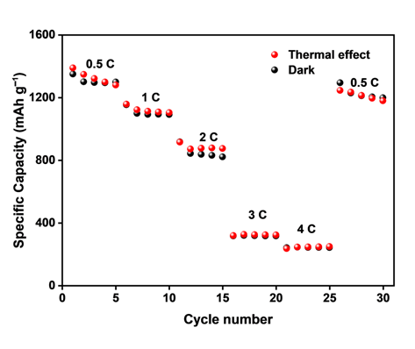
Fig. S25 Rate performance of PPy@N-TiO₂/CC battery under photothermal
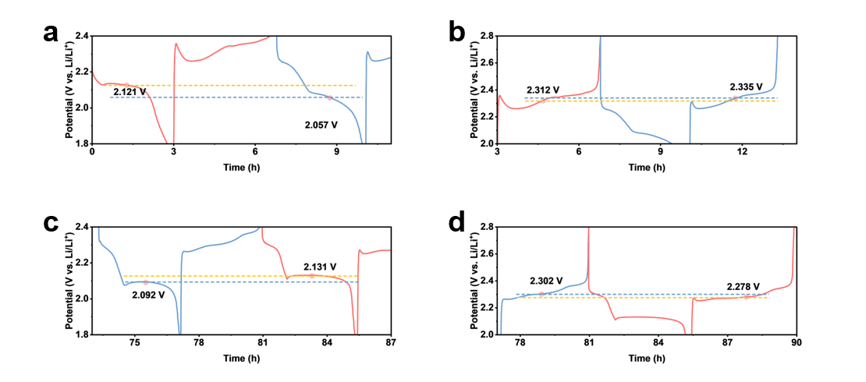
Fig. S26 Partially enlarged GCD curves by altering the illumination periodically: a,b initial cycle, c,d final cycle
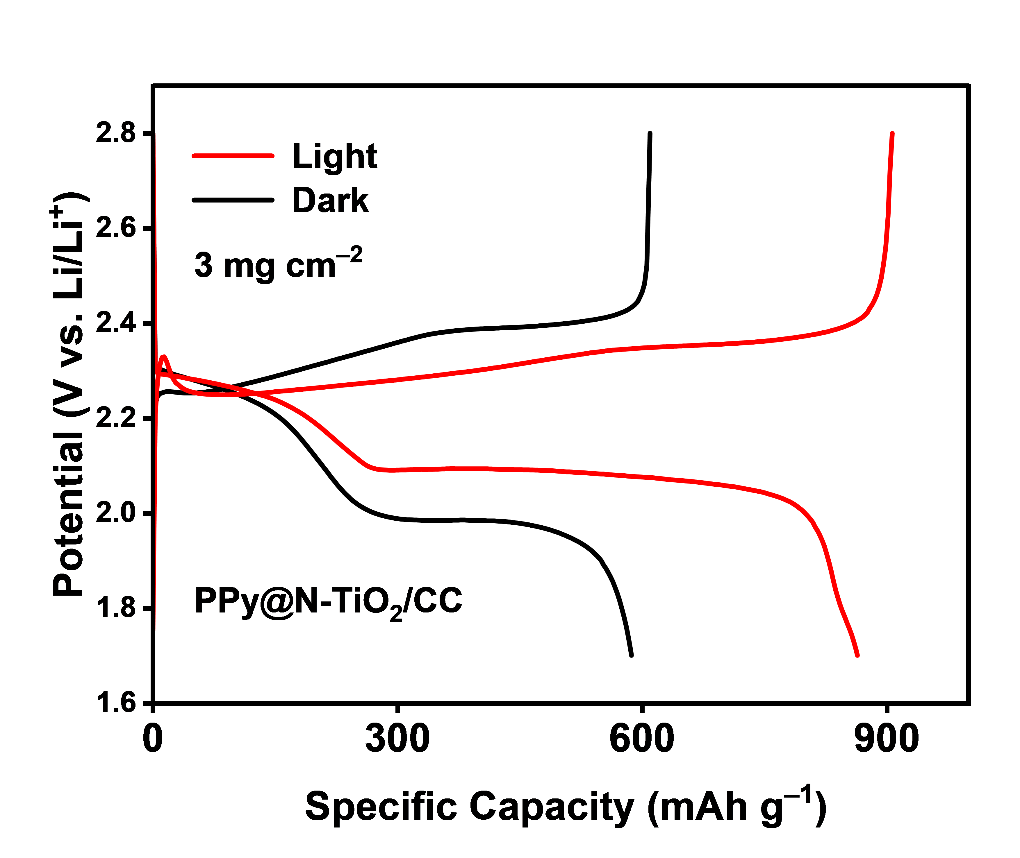
Fig. S27 GCD curves with sulfur loading of 3 mg cm^{–2} at 0.2 C
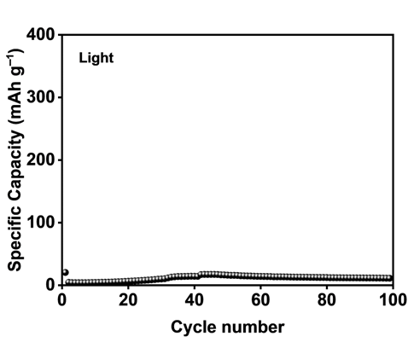

Fig. S28 Cycling performance of PPy@N-TiO₂/CC without the Li₂S₆ solution

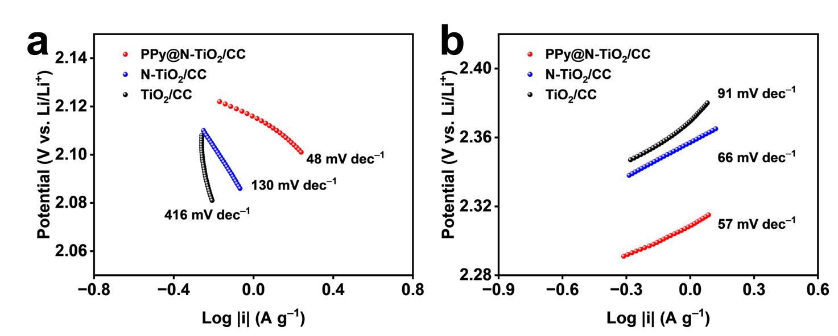
Fig. S29 a, b Tafel curves of PPy@N-TiO₂/CC, N-TiO₂/CC and TiO₂/CC electrodes with the illumination

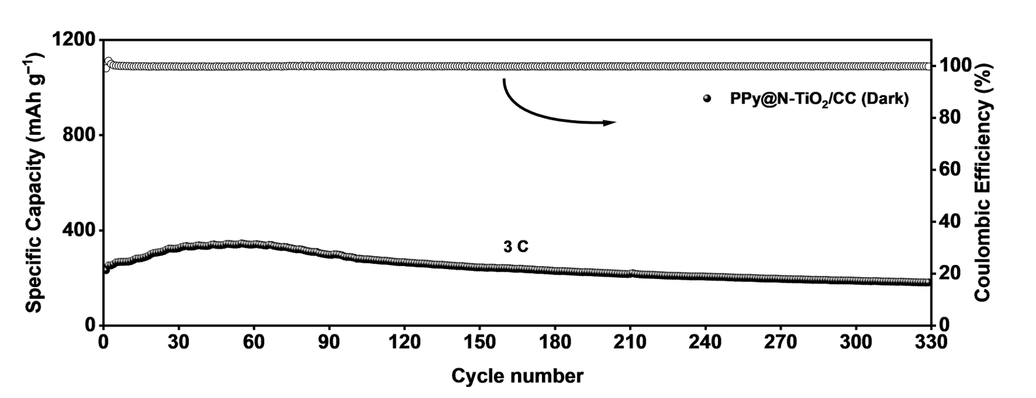
Fig. S30 Cycling performance of PPy@N-TiO₂/CC battery at 3 C without the illumination

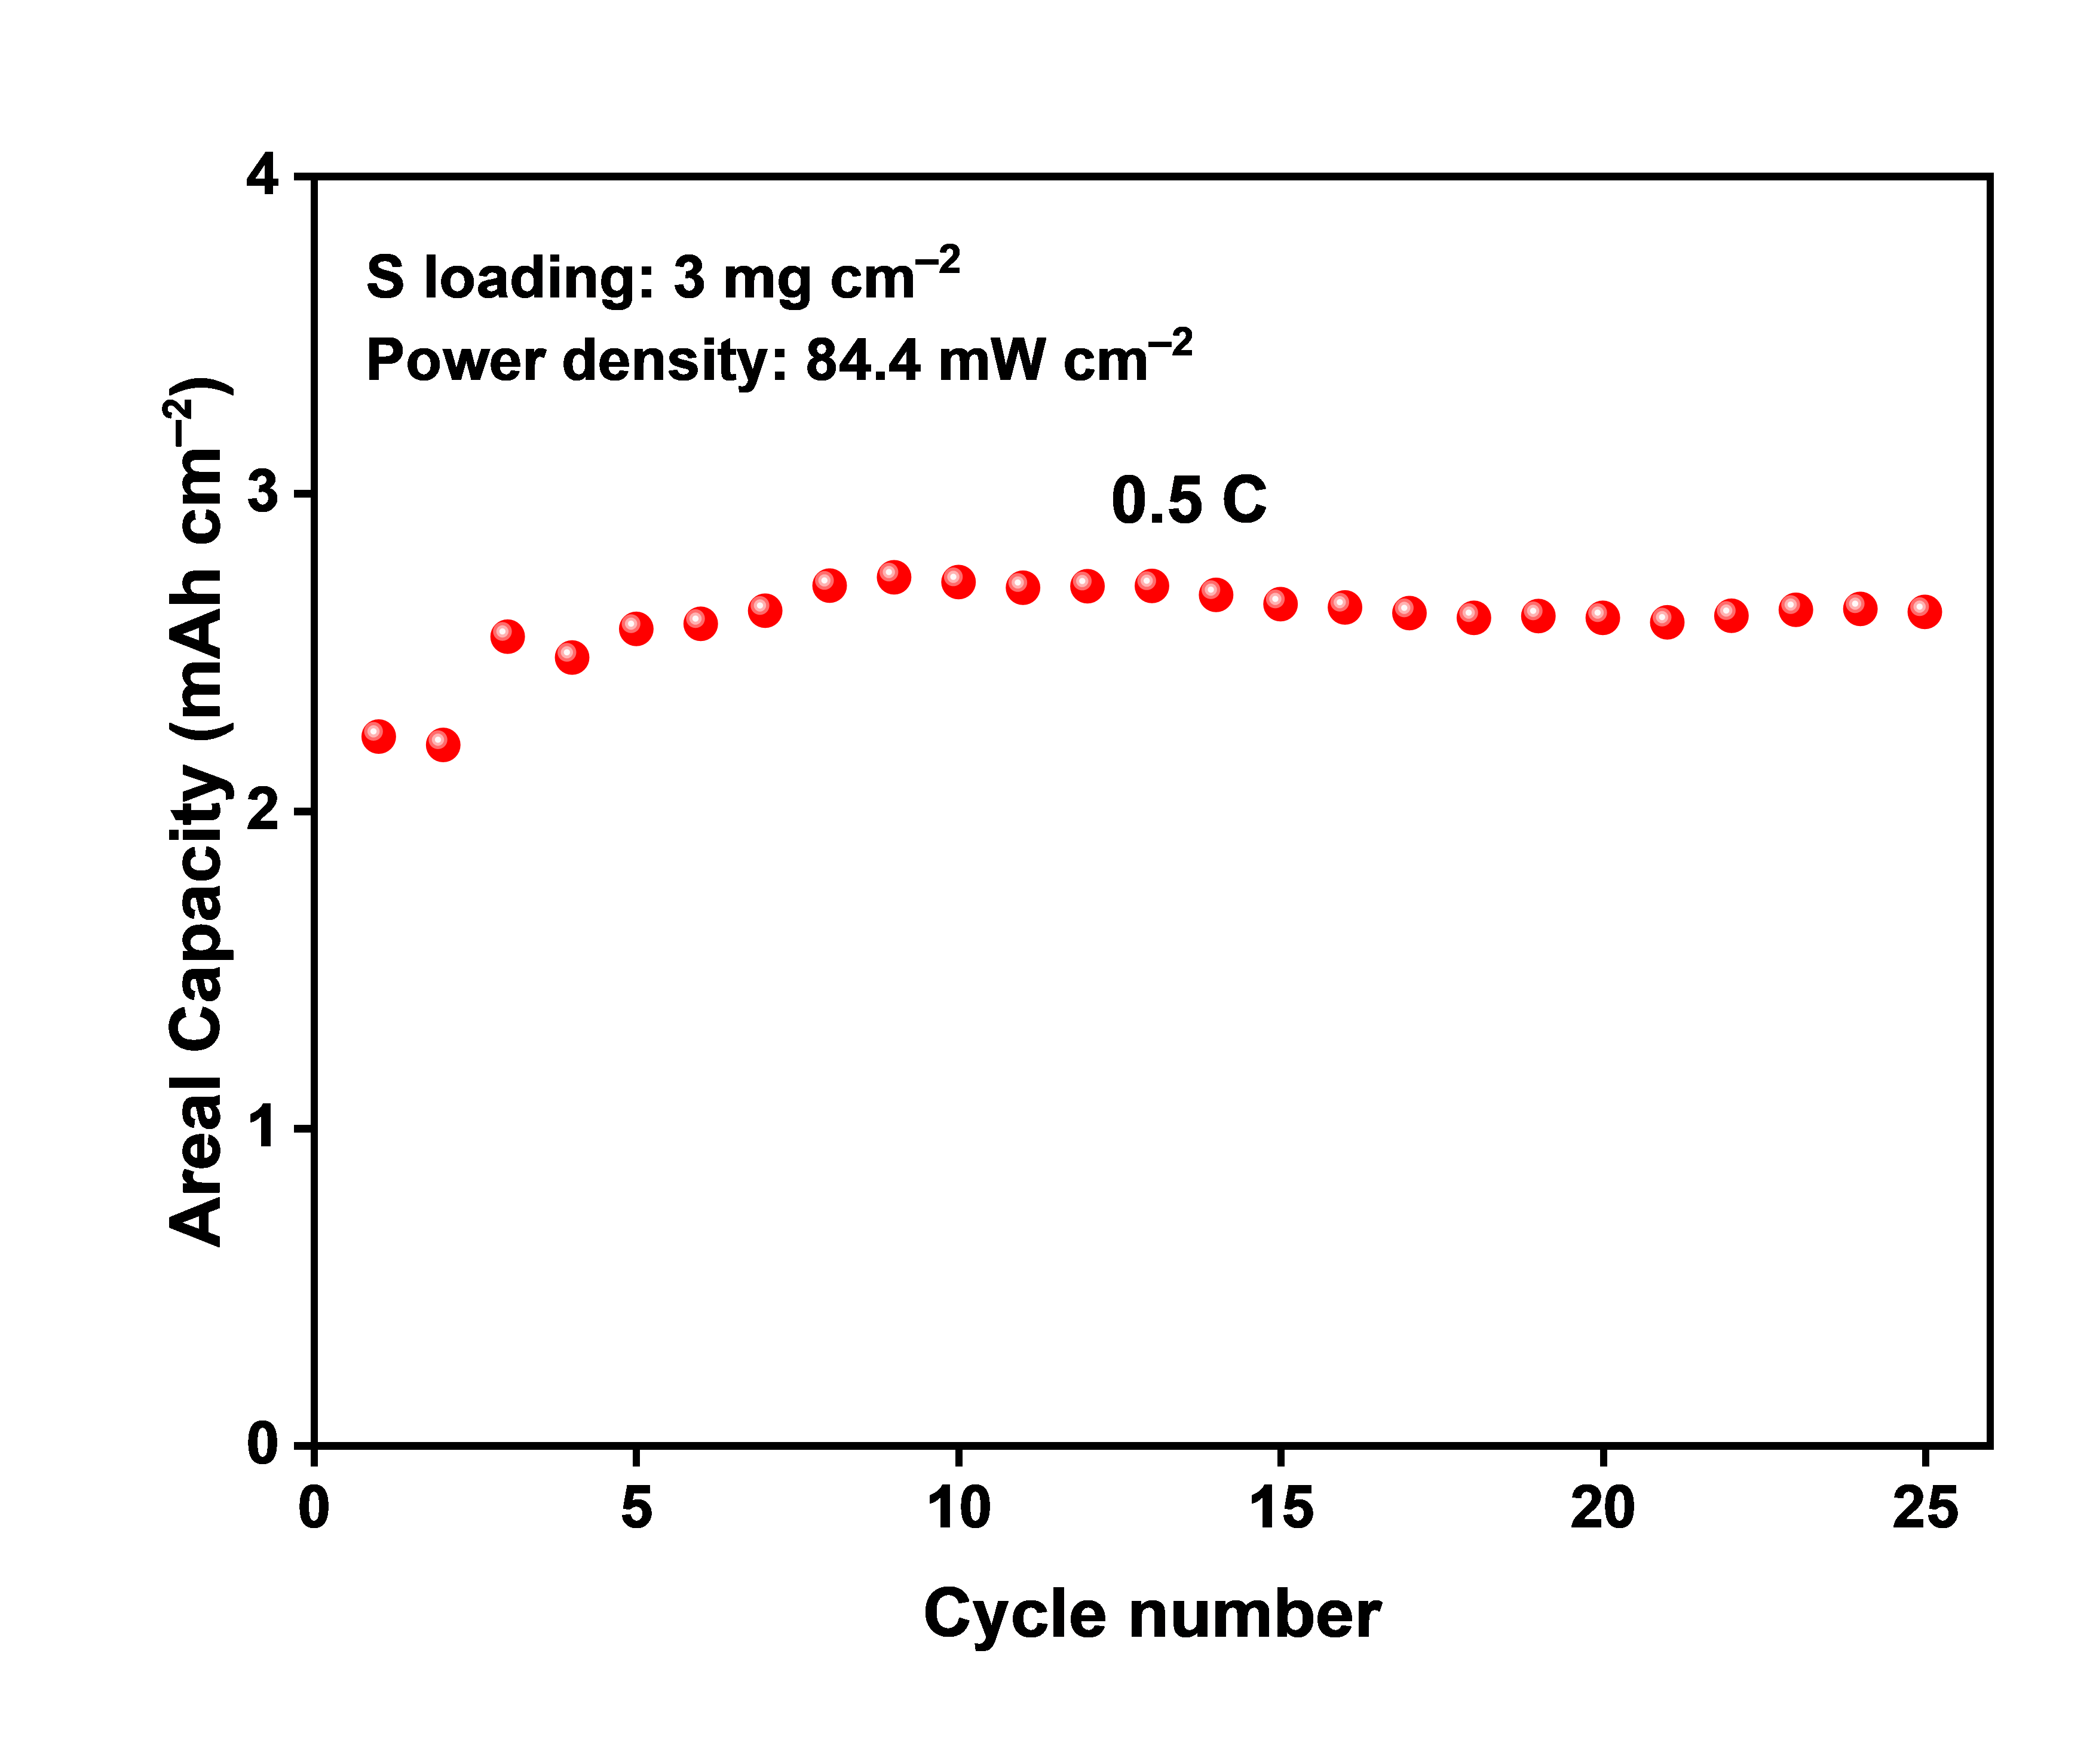
Fig. S31 Cycling performance with a sulfur loading of 3 mg cm^{–2} at 0.5 C

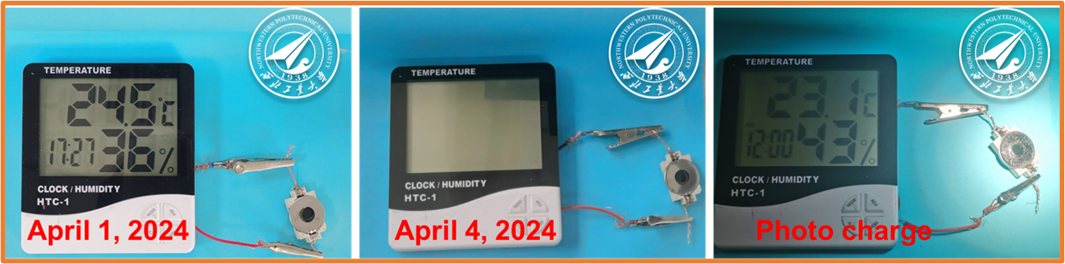
Fig. S32 Evaluation of the practicability of PPy@N-TiO₂/CC assembled PALSB: in series with an electronic thermometer
Tabel S1 The fitted results from EIS analysis
Cathode | Test condition | R₁ (ohm) | R₂ (ohm) | R₃(ohm)
PPy@N-TiO₂/CC | Dark | 10.8 | 71.0 | 23.1
PPy@N-TiO₂/CC | Thermal | 10.7 | 61.6 | 21.7
PPy@N-TiO₂/CC | Light | 6.4 | 12.5 | 11.4
N-TiO₂/CC | Light | 8.37 | 19.9 | 13.8
TiO₂/CC | Light | 9.3 | 18.5 | 26.2

