Supporting Information for
Exposing Zn(002) Texture with Sucralose Additive for Stable and Dendrite-Free Aqueous Zinc-Ion Batteries
Feiyu Tao^{1,4}, Yingke Ren², Li’e Mo³, Yifan Wang³, Yang Huang³, Hong Zhang⁵, Chengwu Shi¹, Zhaoqian Li^{1,3*}, Jiaqin Liu^{1,6}, Lei Chen^{4,*}, Linhua Hu^{3,*}, Yucheng Wu^{1,*}
¹School of New Energy Engineering, Hefei Institute of Technology, Hefei, Anhui, 238076, P. R. China
²College of Science, Hebei University of Science and Technology, Shijiazhuang, Hebei 050018, P. R. China
³Key Laboratory of Photovoltaic and Energy Conservation Materials, CAS, Institute of Solid State Physics, Hefei Institutes of Physical Science, Chinese Academy of Sciences, Hefei, Anhui 230031, P. R. China
⁴School of Environmental and Chemical Engineering, Jiangsu University of Science and Technology, Zhenjiang 212003, P. R. China
⁵Hebei Computational Optical Imaging and Photoelectric Detection Technology Innovation Center, Hebei International Joint Research Center for Computational Optical Imaging and Intelligent Sensing, School of Mathematics and Physics Science and Engineering, Hebei University of Engineering, Handan, Hebei 056038, P. R. China
⁶School of Chemistry, Beijing University of Chemical Technology, Beijing 100029, P. R. China
*Corresponding authors. E-mail: zqli@hfit.edu.cn (Zhaoqian Li); chenlei@just.edu.cn (Lei Chen); lhhu@rntek.cas.cn (Linhua Hu); ycwu@hfut.edu.cn (Yucheng Wu)
Supplementary Figures and Tables
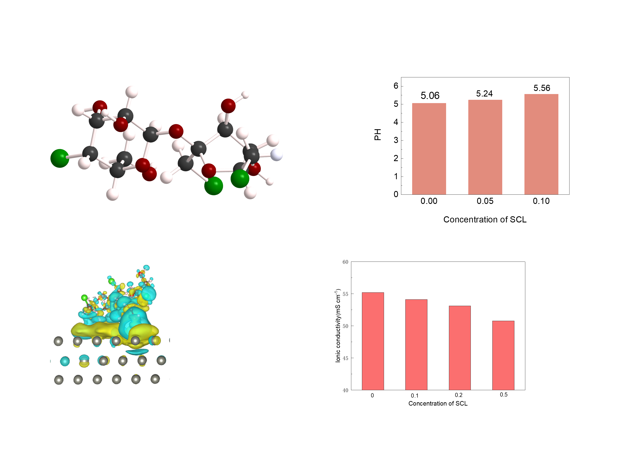
Fig. S1 The molecule structure of SCL
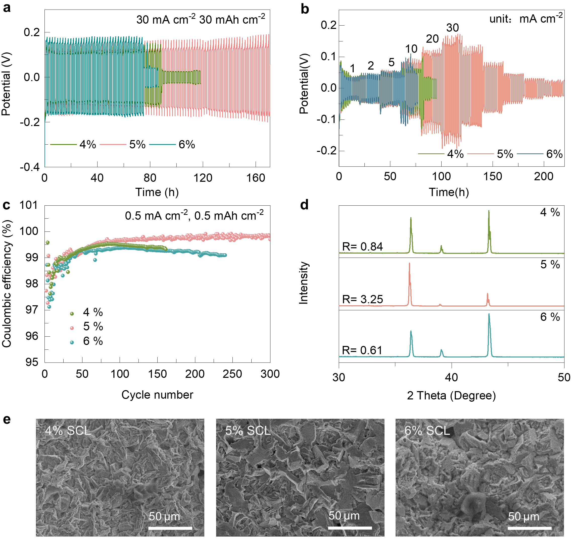
Fig. S2 a The voltage profiles of Zn//Zn batteries with different electrolytes at 30 mA cm⁻² and 30mAh cm⁻². b Rate cycling performance comparison of Zn//Zn symmetric cells under different current densities and areal capacities of 1 mA cm⁻²/1 mAh cm⁻², 2 mA cm⁻²/2 mAh cm⁻², 5 mA cm⁻²/5 mAh cm⁻², 10 mA cm⁻²/10 mAh cm⁻², 20 mA cm⁻²/20 mAh cm⁻² and 30 mA cm⁻²/30 mAh cm⁻². c CEs of Zn plating/stripping on Cu foil in SCL/ Zn(OTF)₂ electrolyte at 0.5 mA cm⁻² with the capacity of 0.5 mAh cm⁻². d The XRD spectra of the deposited Zn plates in different electrolytes. e SEM image of the deposited Zn at a constant current density of 30 mA cm⁻² in different electrolytes
The Zn//Zn symmetric battery results demonstrate that the electrolyte containing 5 wt% SCL exhibits the most extended cycling lifespan and exceptional rate performance, whereas other electrolytes suffer from short circuits after only a few cycles (Figs. S4a, S4b). As depicted in Fig. S4c, the 5 wt% SCL-containing Zn//Cu battery achieves the highest Coulombic efficiency. XRD analysis of Zn deposits formed at 30 mA cm⁻² shows that the (002) diffraction peak is most intense in the 5 wt% SCL electrolyte, indicative of a preferential (002) orientation during Zn deposition. Furthermore, SEM observations (Fig. S4e) reveal that Zn deposited in the 5 wt% SCL-containing electrolyte exhibits a discernibly flat and layered morphology, contrasting sharply with the noticeably non-uniform and disordered structures observed in other tested electrolytes.
Fig. S3 The charge density difference of SCL adsorbed on the Zn (002)

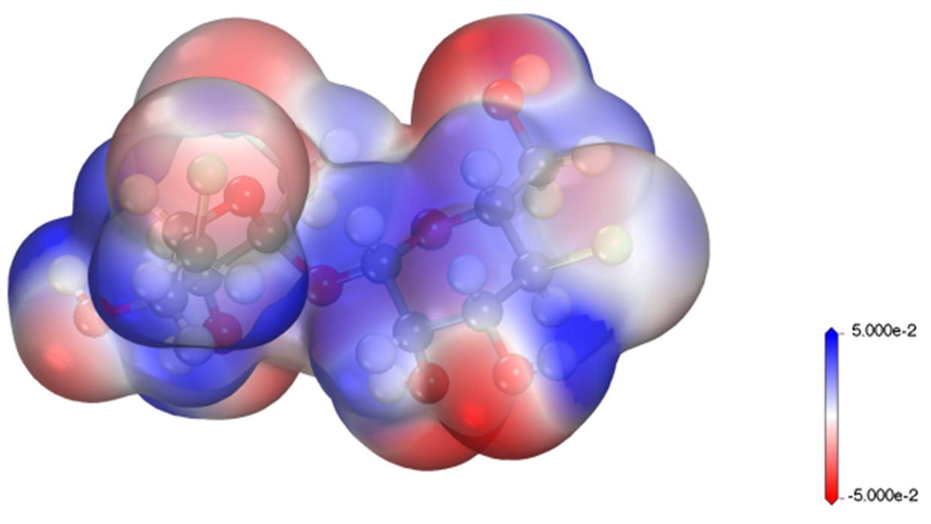
Fig. S4 Electrostatic potential (ESP) mapping of SCL molecule

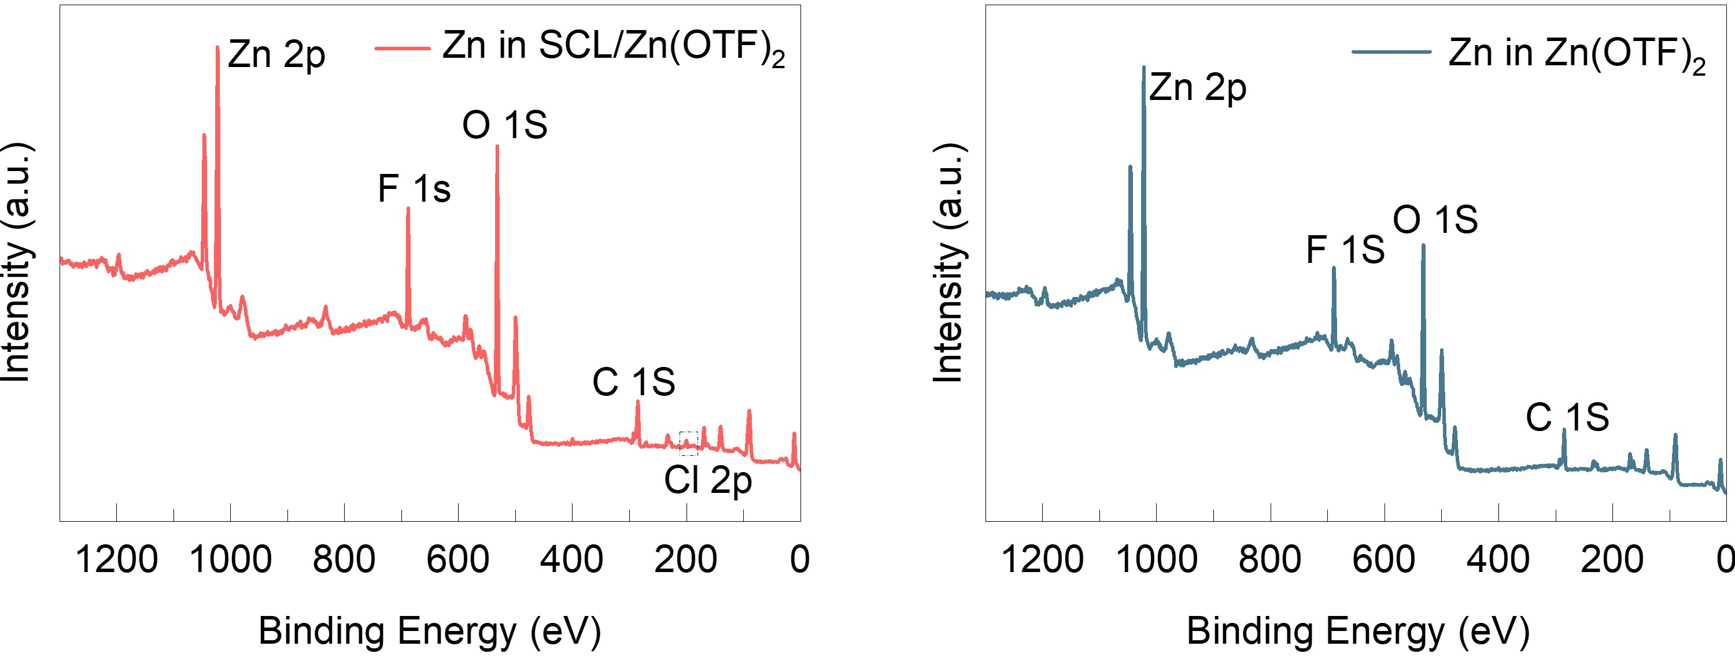
Fig. S5 XPS spectra for Zn foil after soaking in electrolytes with/without the SCL additive for 24 h
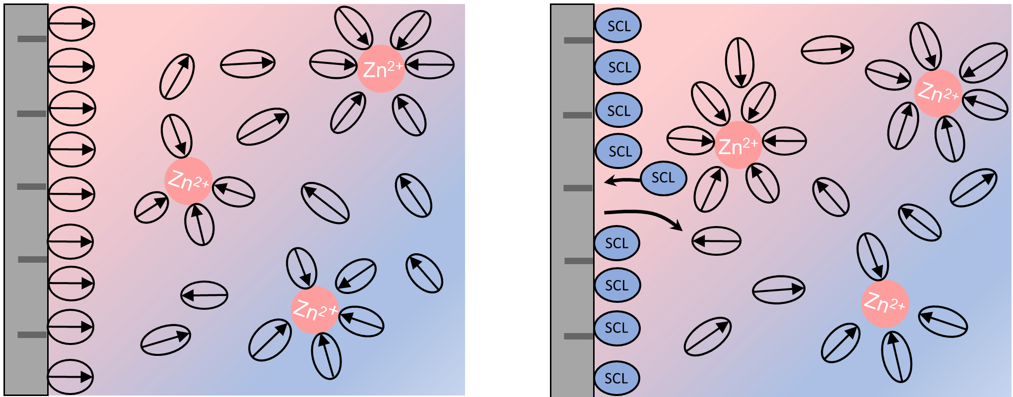
Fig. S6 The schematic descriptions of the interface structure: after (the right) and before (the left) introducing SCL
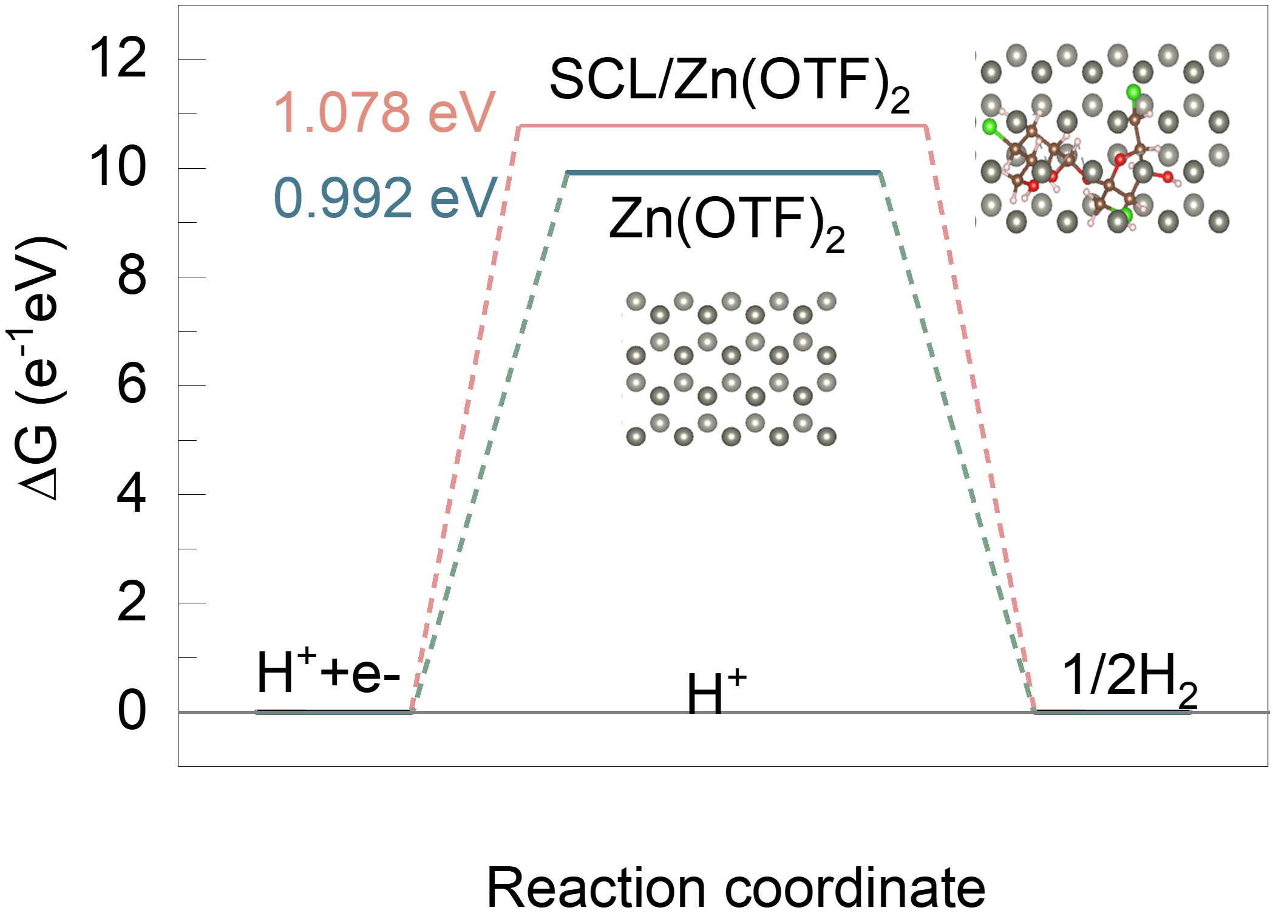
Fig. S7 The hydrogen barrier of pure Zn(OTF)₂ and SCL/Zn(OTF)₂ electrolytes
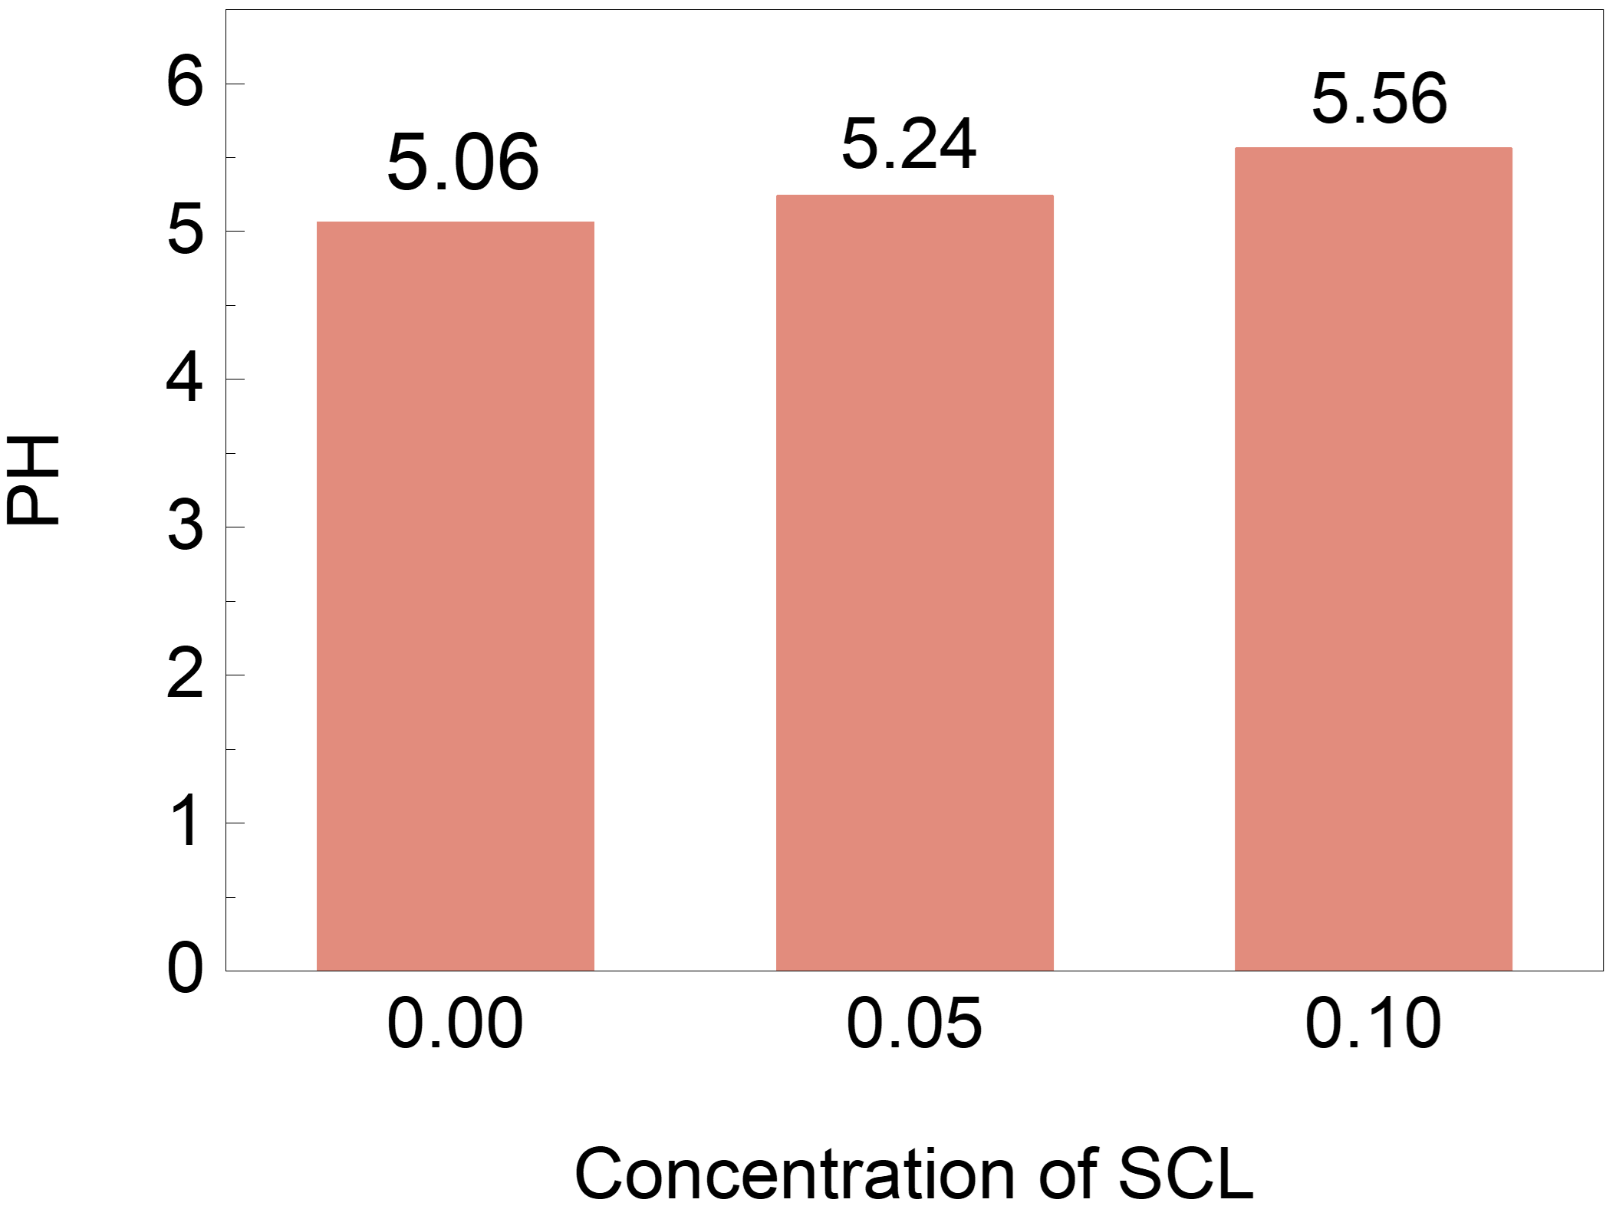
Fig. S8 pH measurement of SCL/Zn(OTF)₂ solution
Fig. S9 The Tafel plots in different electrolytes

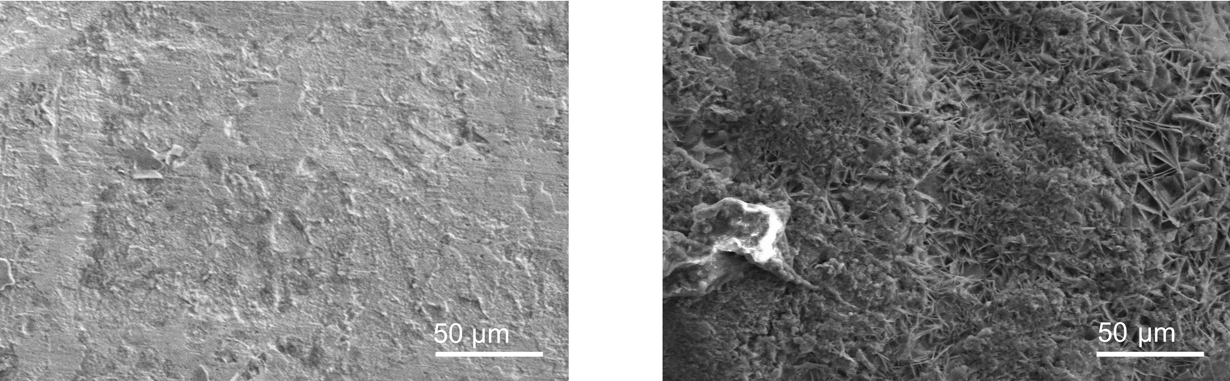
Fig. S10 The SEM images of soaked Zn plated surface in SCL/Zn(OTF)₂ (the left) and Zn(OTF)₂ (the right)

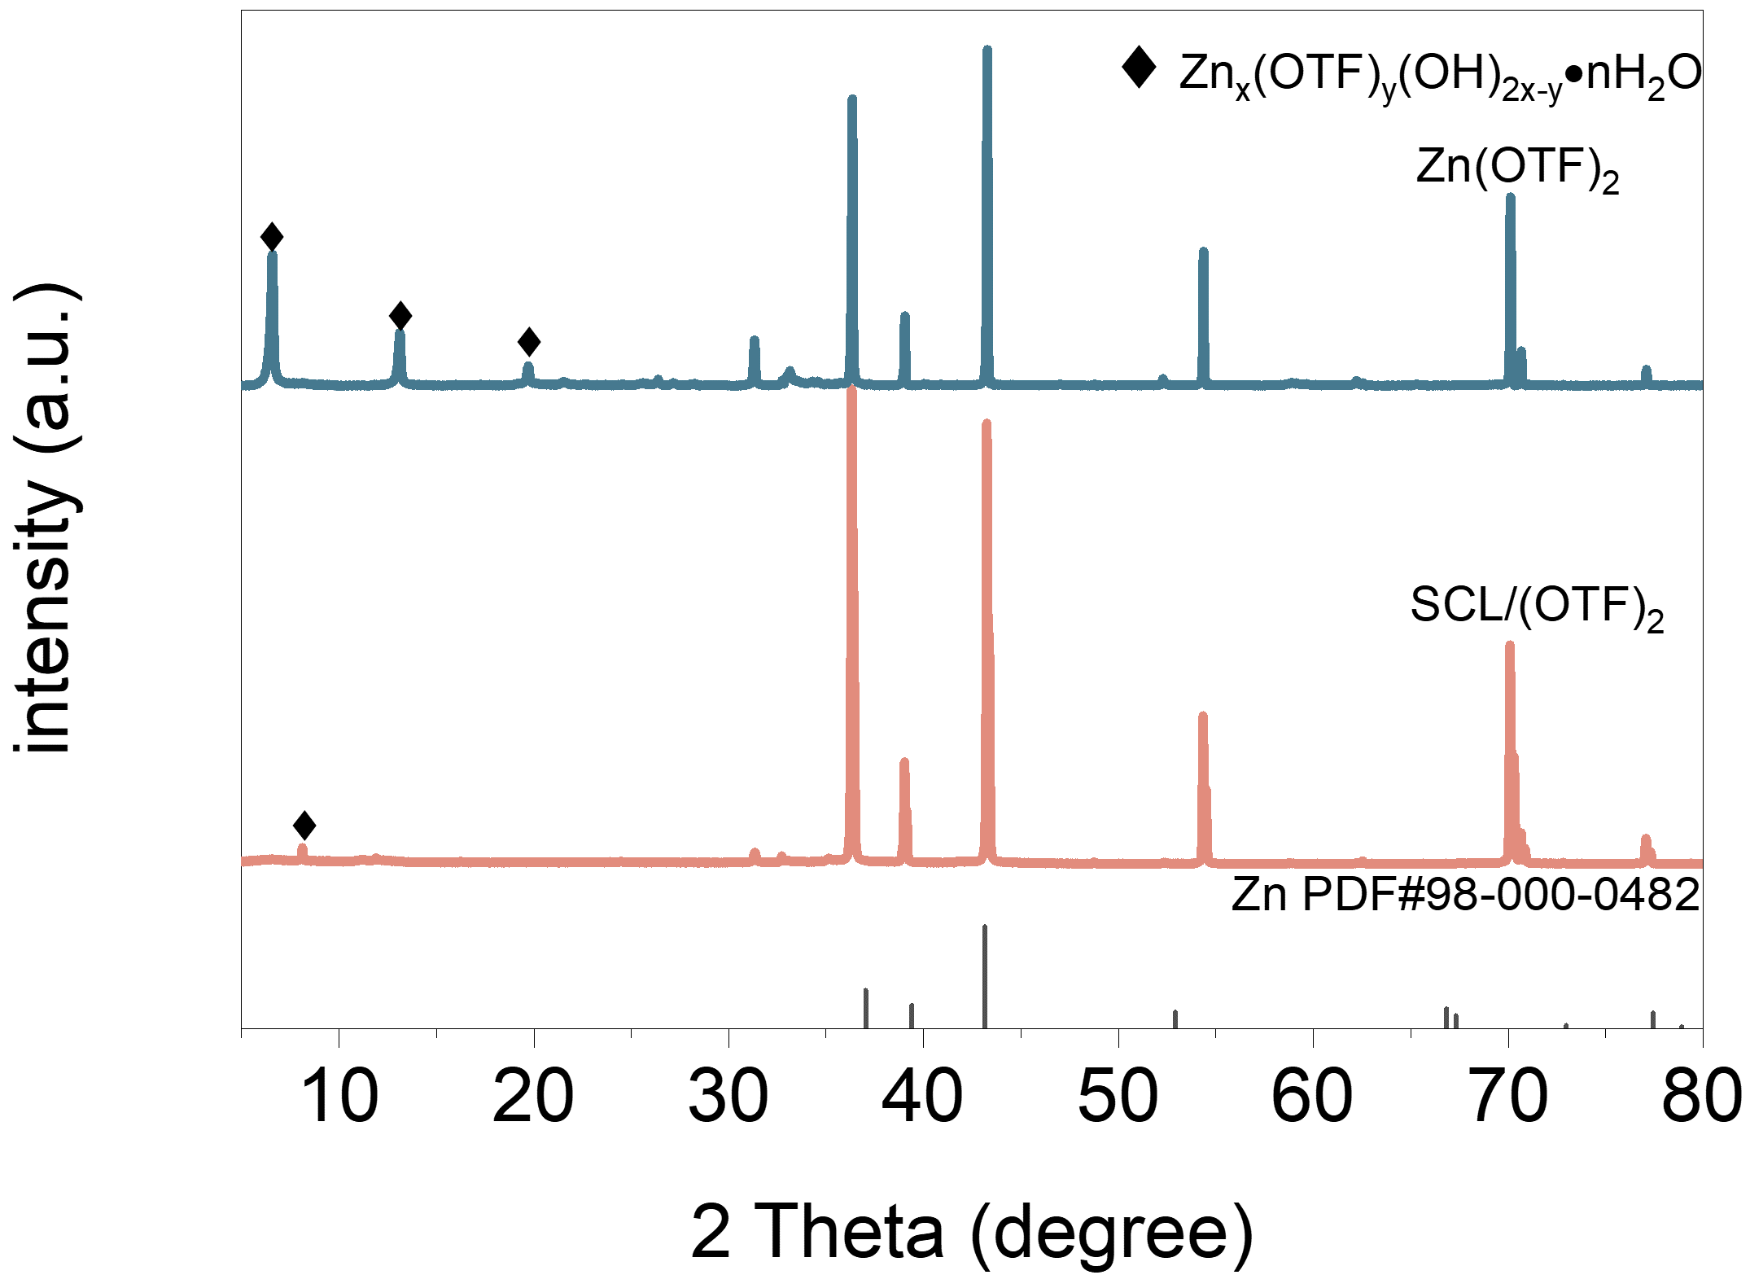
Fig. S11 The XRD curves of Zn anode immersed in SCL/Zn(OTF)₂ and Zn(OTF)₂ electrolyte
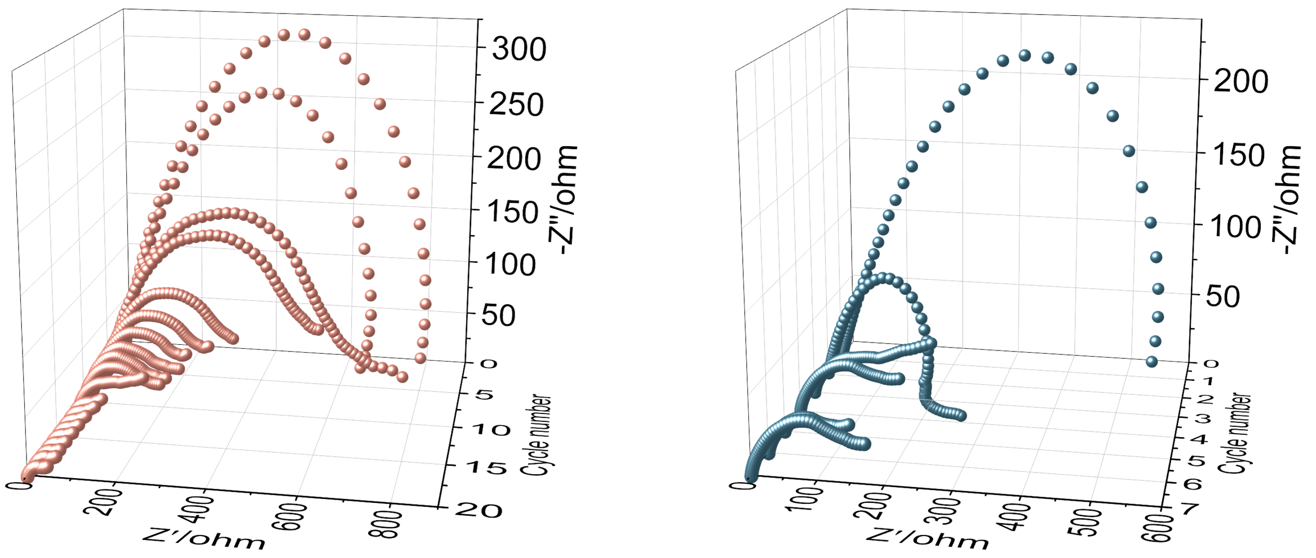
Fig. S12 EIS of Zn//Zn symmetric cells with SCL/Zn(OTF)₂ (left) and Zn(OTF)₂ (right) electrolytes after different cycles

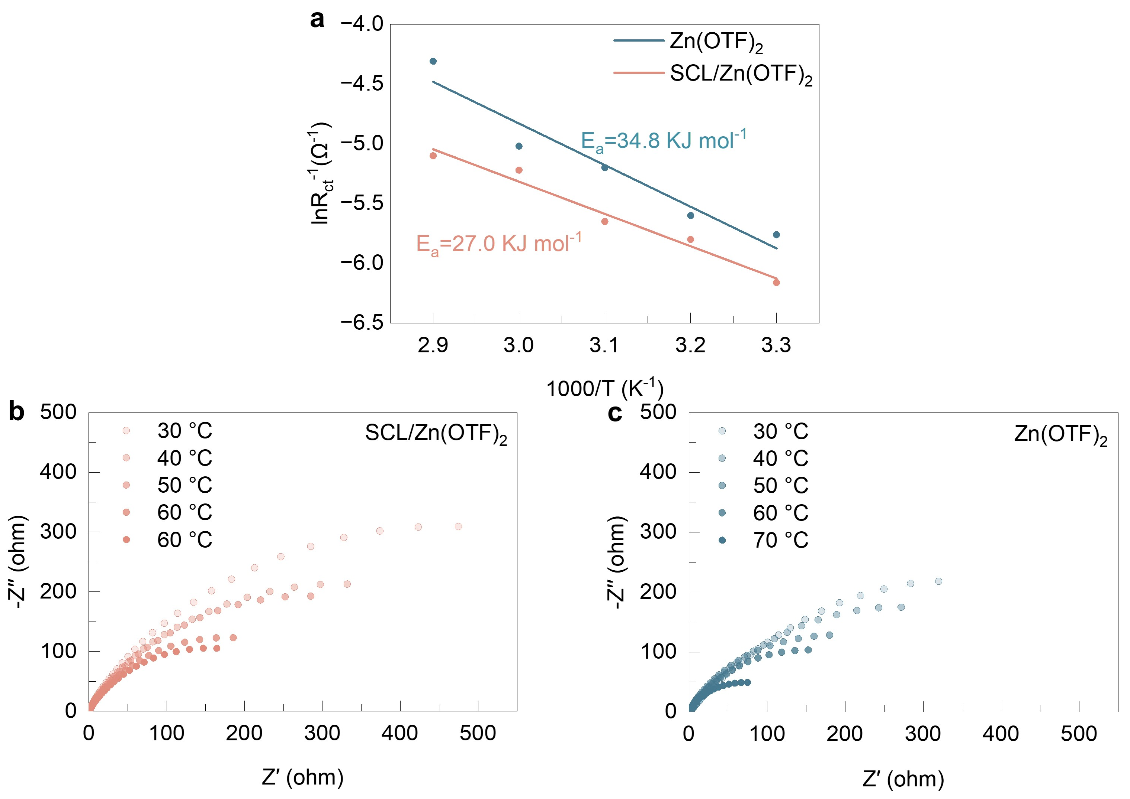
Fig. S13 a Arrhenius curves and activation energy (Ea) value. EIS curves under different temperatures in a SCL/Zn(OTF)₂ and b Zn(OTF)₂ electrolyte
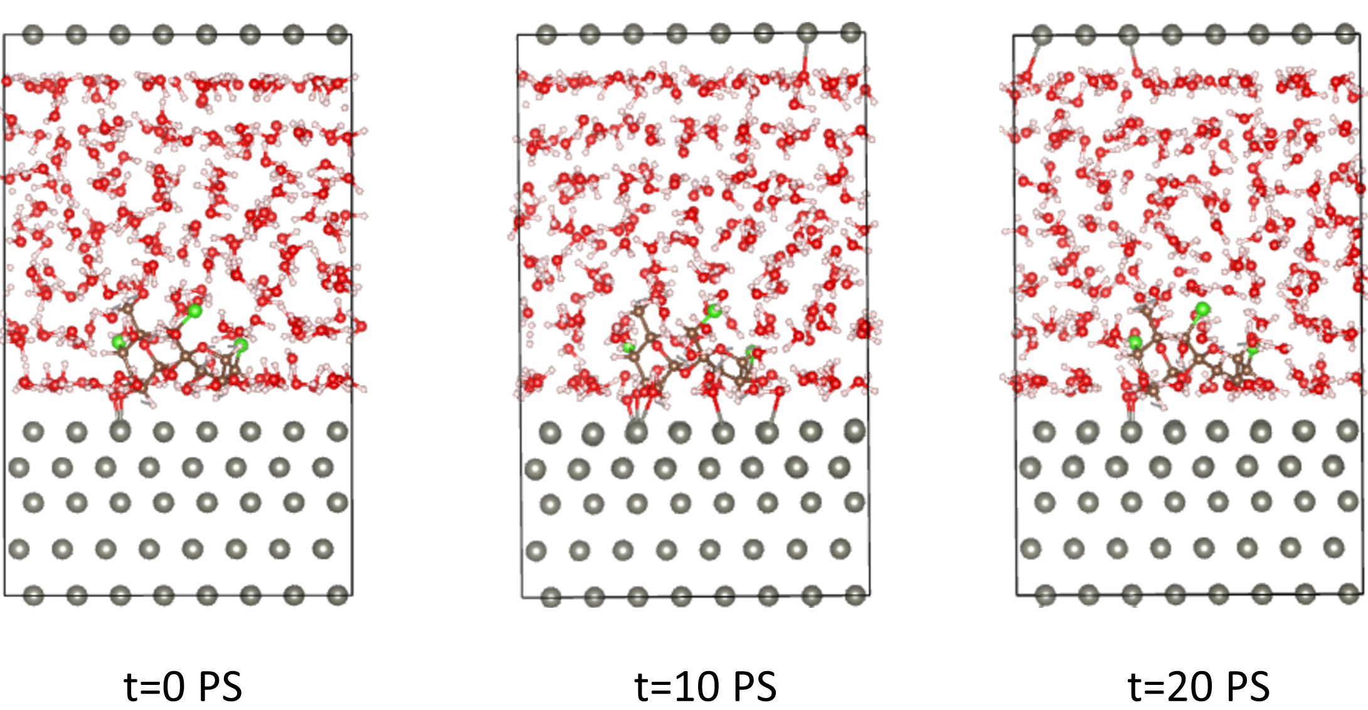
Fig. S14 AIMD simulation for understanding the effect of water environment on SCL/Zn interaction
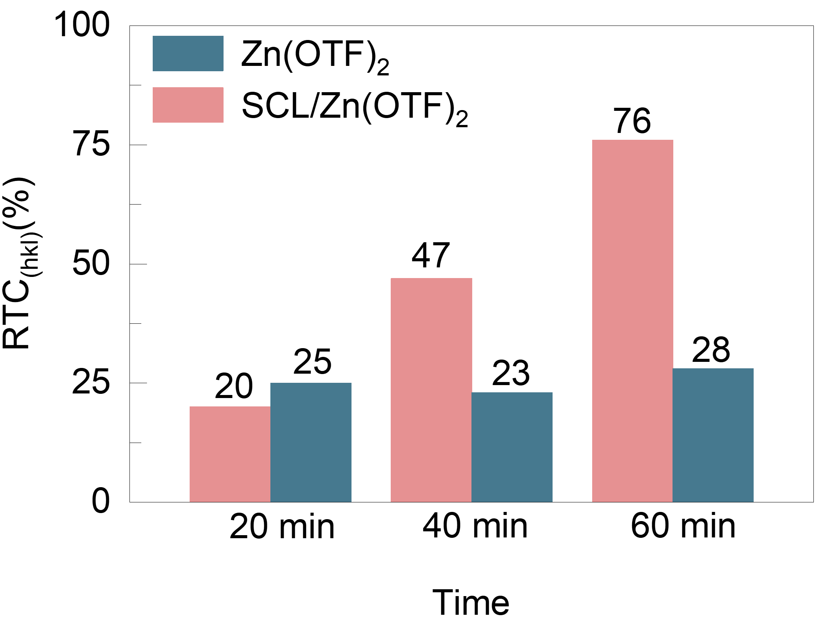
Fig. S15 RTC value of deposited Zn anodes with different electrolytes
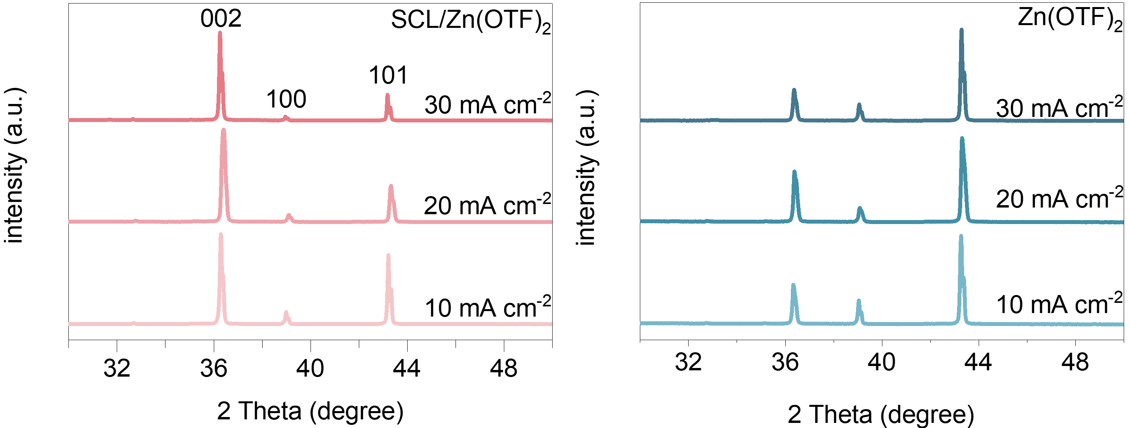
Fig. S16 XRD spectra of the deposited Zn plates in different electrolytes at various current densities for 1h
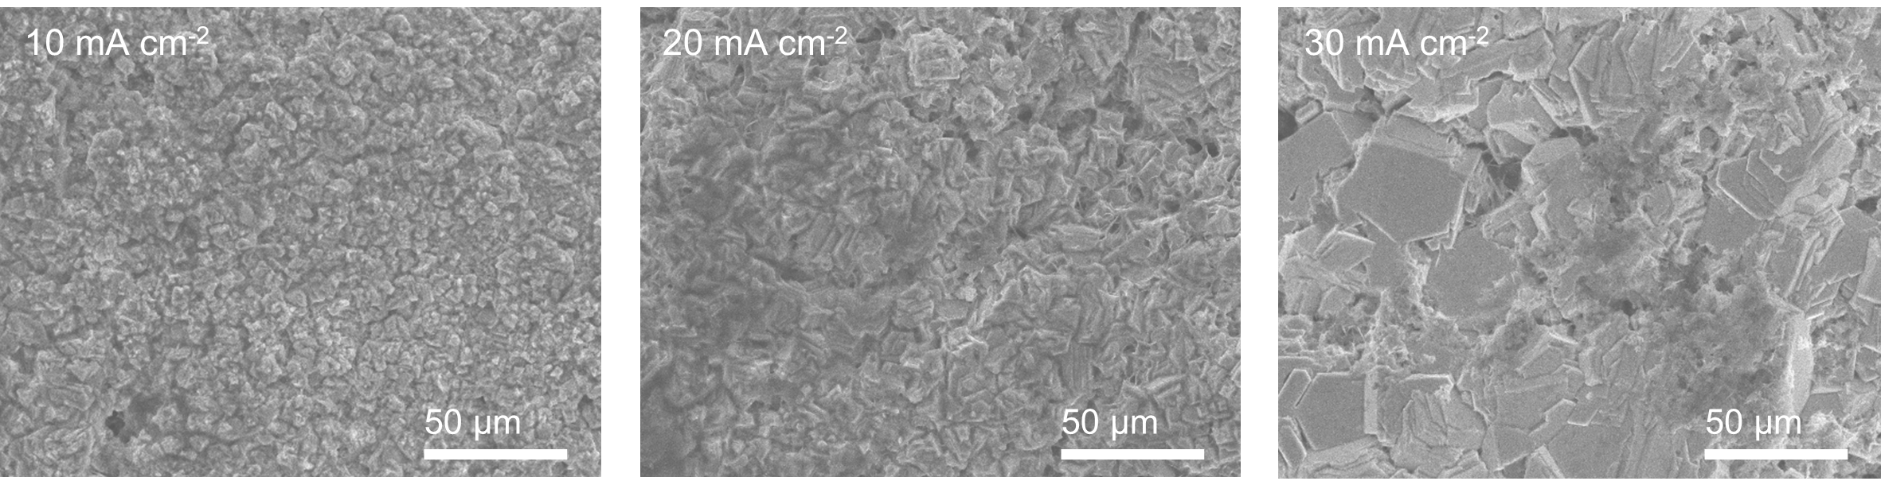
Fig. S17 SEM images of deposited Zn anode under different current densities with fixed areal capacity of 30 mAh cm⁻² in SCL/Zn(OTF)₂

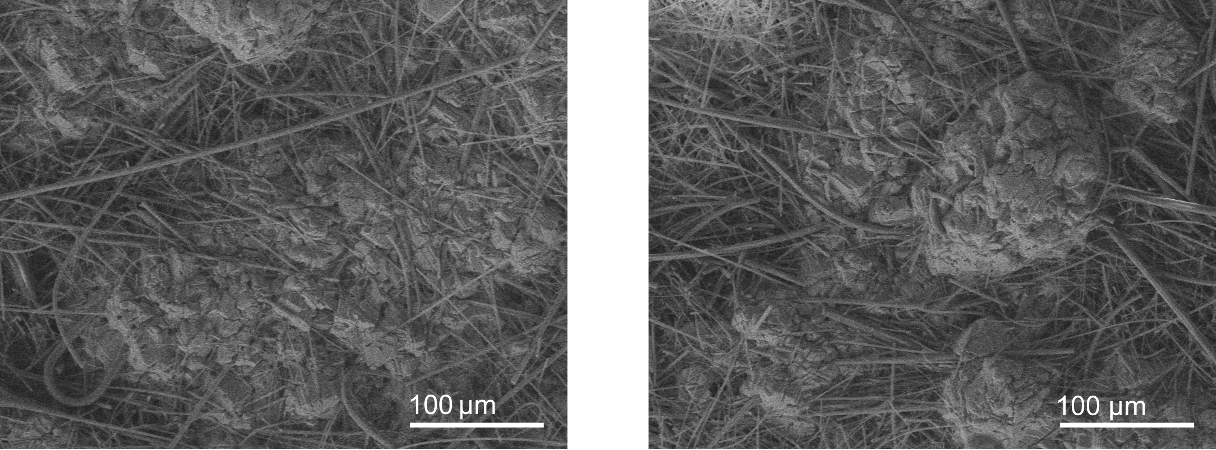
Fig. S18 SEM image of the cycled Zn anode surface in SCL/Zn(OTF)₂ (the left) and Zn(OTF)₂ (the right) electrolytes after 10 cycles at 30 mA cm⁻² and 30 mAh cm⁻²

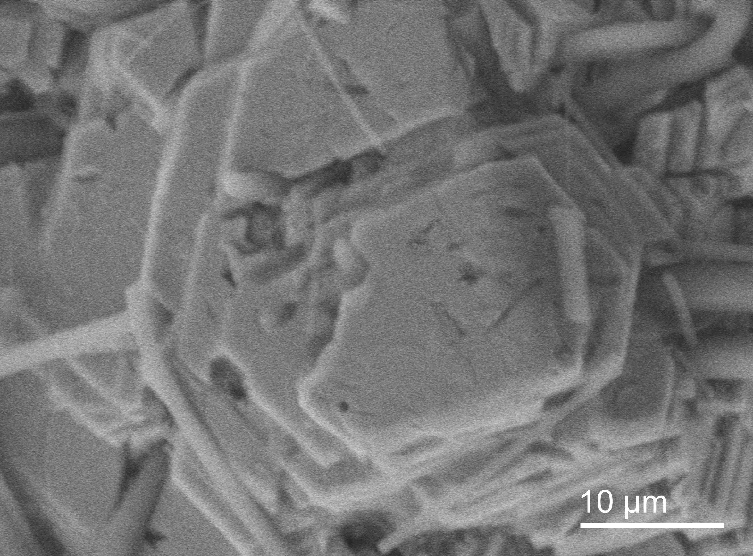
Fig. S19 SEM image of the cycled Zn anode surface in SCL/Zn(OTF)₂ electrolytes after 10 cycles at 30 mA cm⁻² and 30 mAh cm⁻²
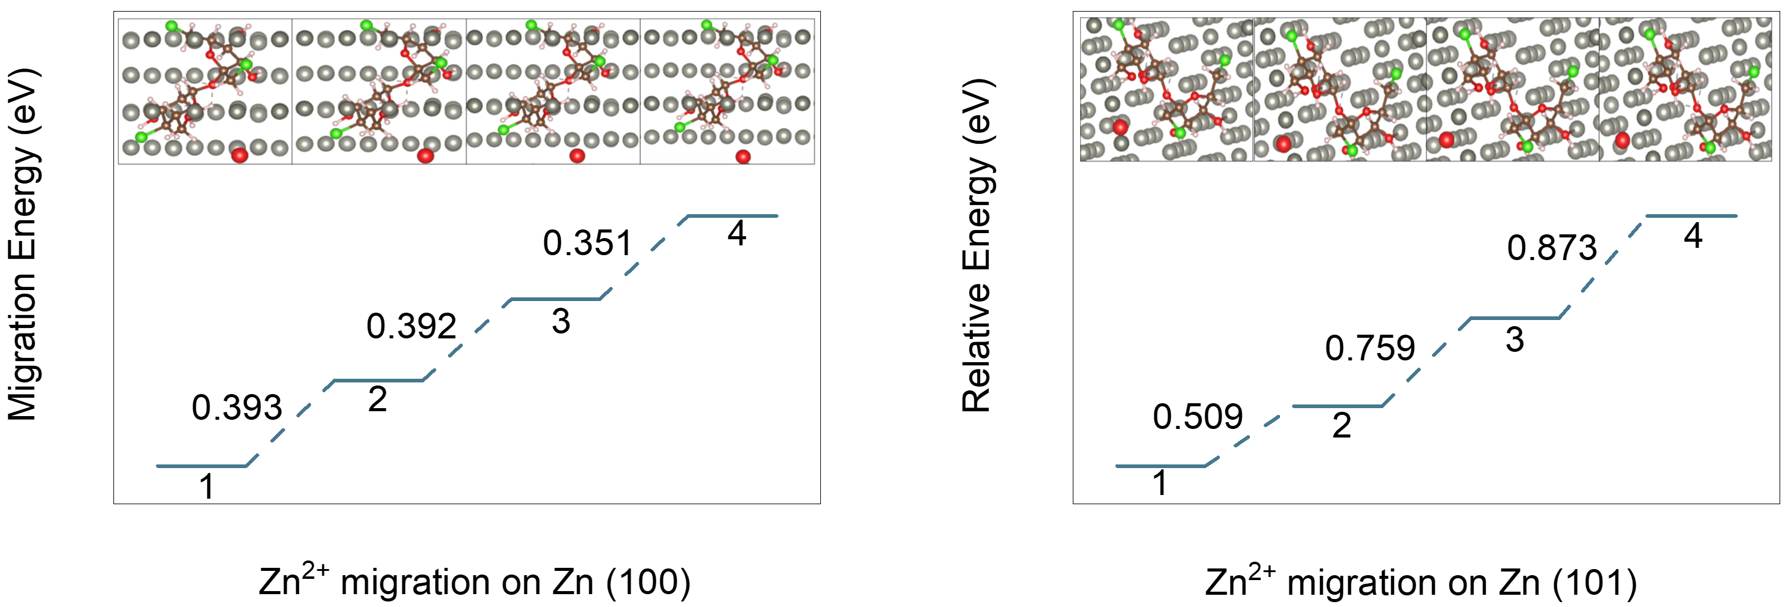
Fig. S20 Zn²⁺ migration energy on Zn (100) and (101) after SCL adsorption, insets show the calculated migration positions
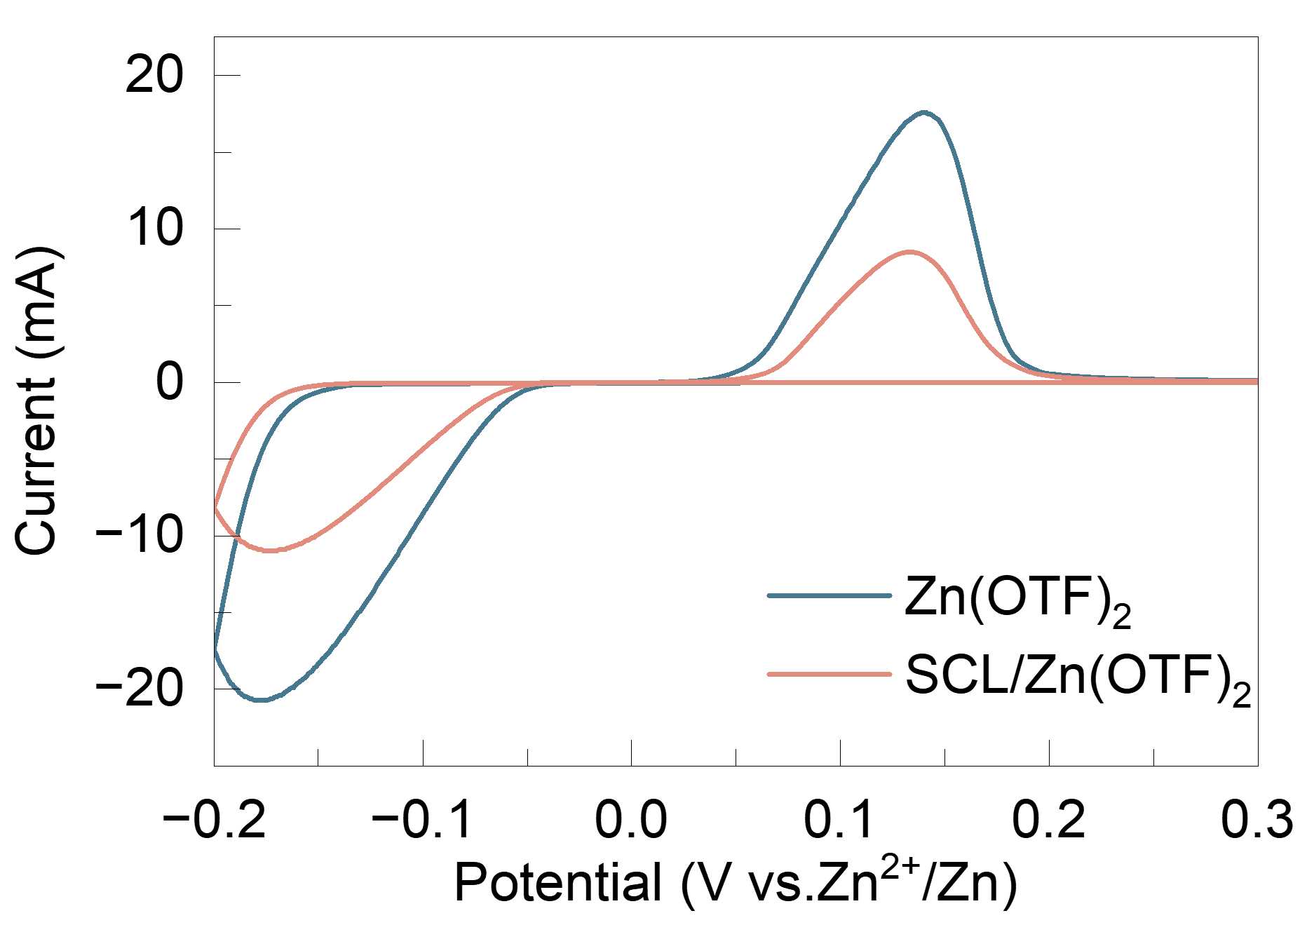
Fig. S21 CV curves of Zn//Cu half batteries in SCL/Zn(OTF)₂ and Zn(OTF)₂ electrlytes
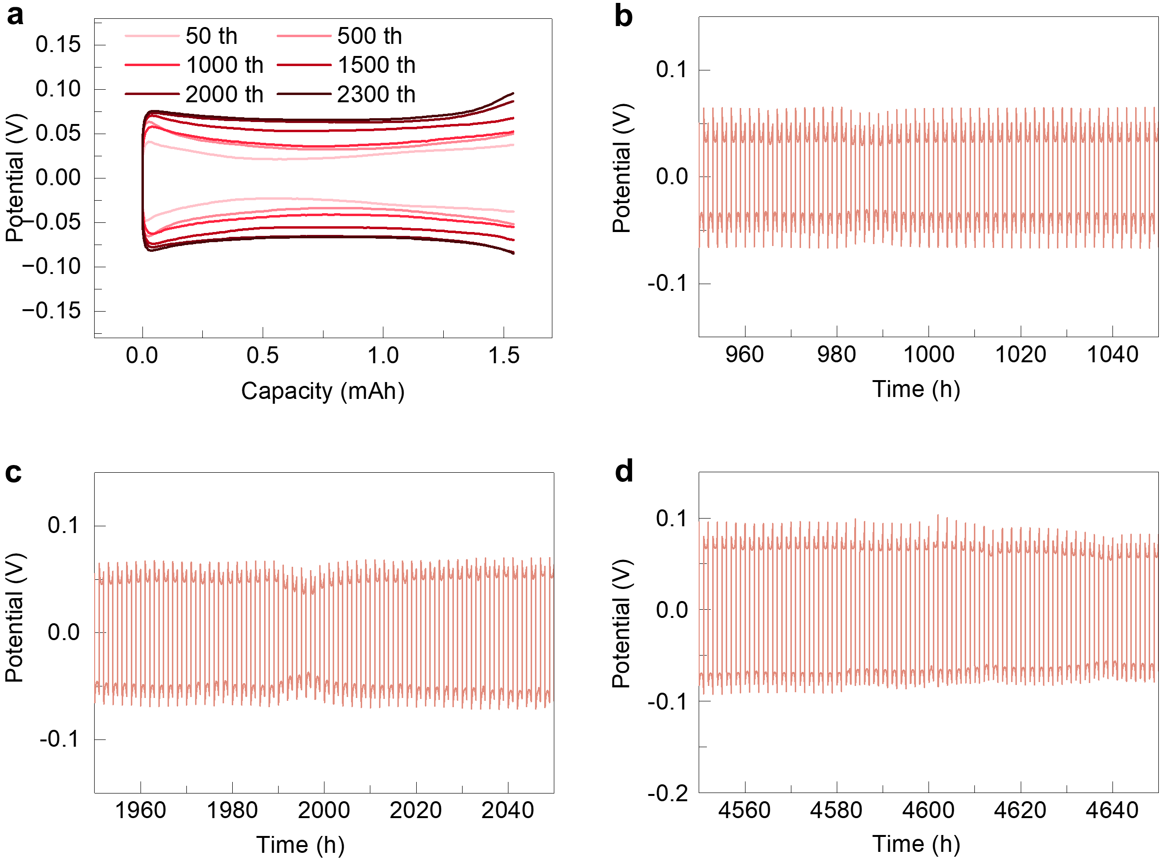
Fig. S22 a Potential profiles during the galvanostatic cycling at 1 mA cm⁻², 1 mAh cm⁻². The enlarged potential-time profiles of Zn//Zn batteries at different cycling time under the current density of 1 mA cm⁻²: b 950-1050 h; c 1950-2050 h; d 4550-4650 h
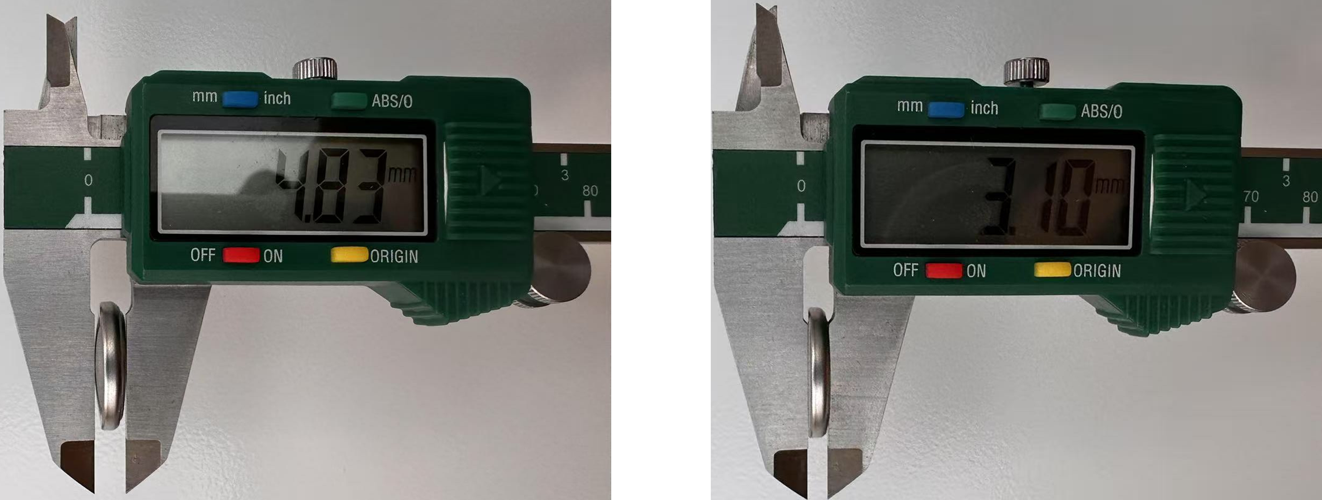
Fig. S23 Digital photos of Zn//Zn symmetric battery operating at 30 mA cm⁻², 30 mAh cm⁻², after 50 cycles with SCL (the left) and after 10 cycles without SCL (the right)
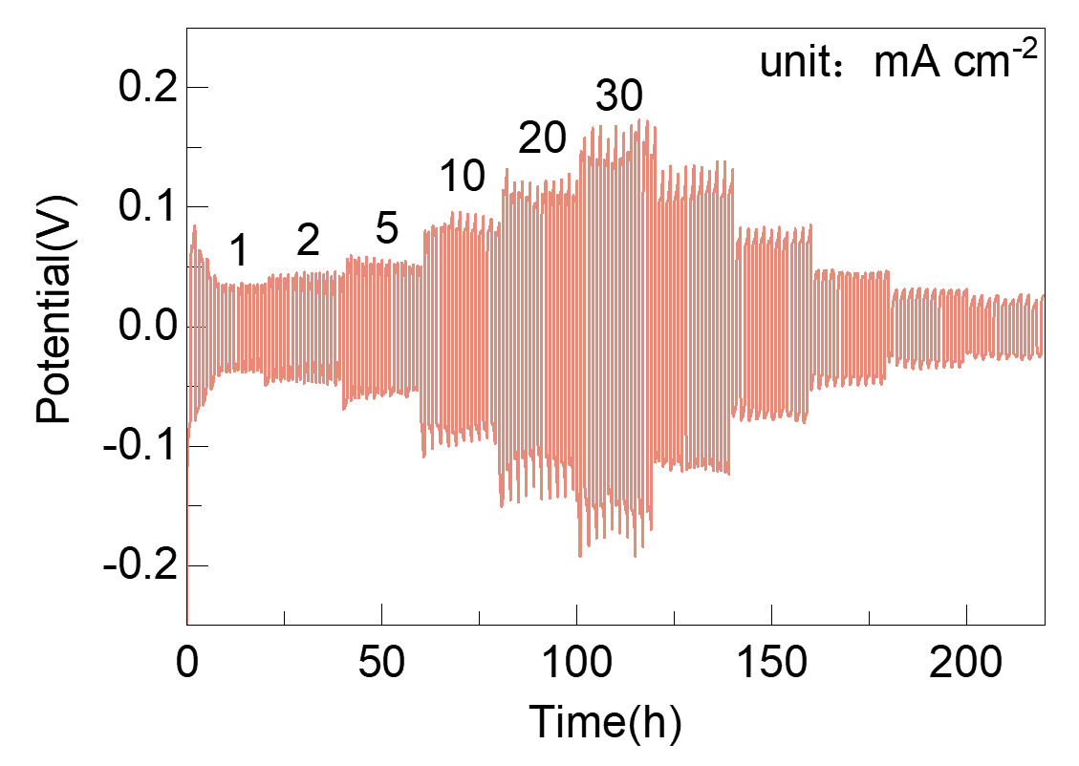
Fig. S24 Rate cycling performance comparison of Zn//Zn symmetric batteries under different current densities and areal capacities of 1 mA cm⁻²/1 mAh cm⁻², 2 mA cm⁻²/2 mAh cm⁻², 5 mA cm⁻²/5 mAh cm⁻², 10 mA cm⁻²/10 mAh cm⁻², 20 mA cm⁻²/20 mAh cm⁻² and 30 mA cm⁻²/30 mAh cm⁻²
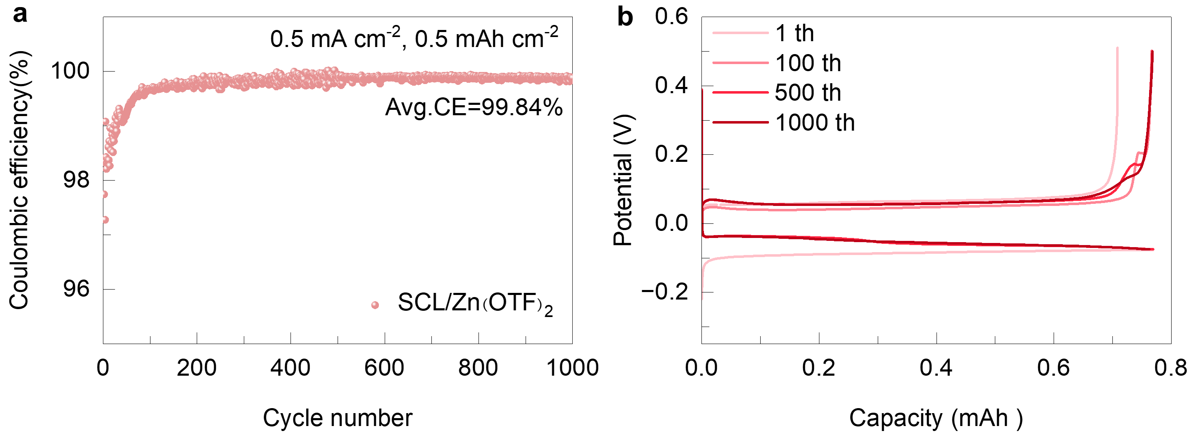
Fig. S25 a CEs of Zn plating/stripping on Cu foil in SCL/ Zn(OTF)₂ electrolyte at 0.5 mA cm⁻² with the capacity of 0.5 mAh cm⁻². b Corresponding potential-capacity profiles at different cycles
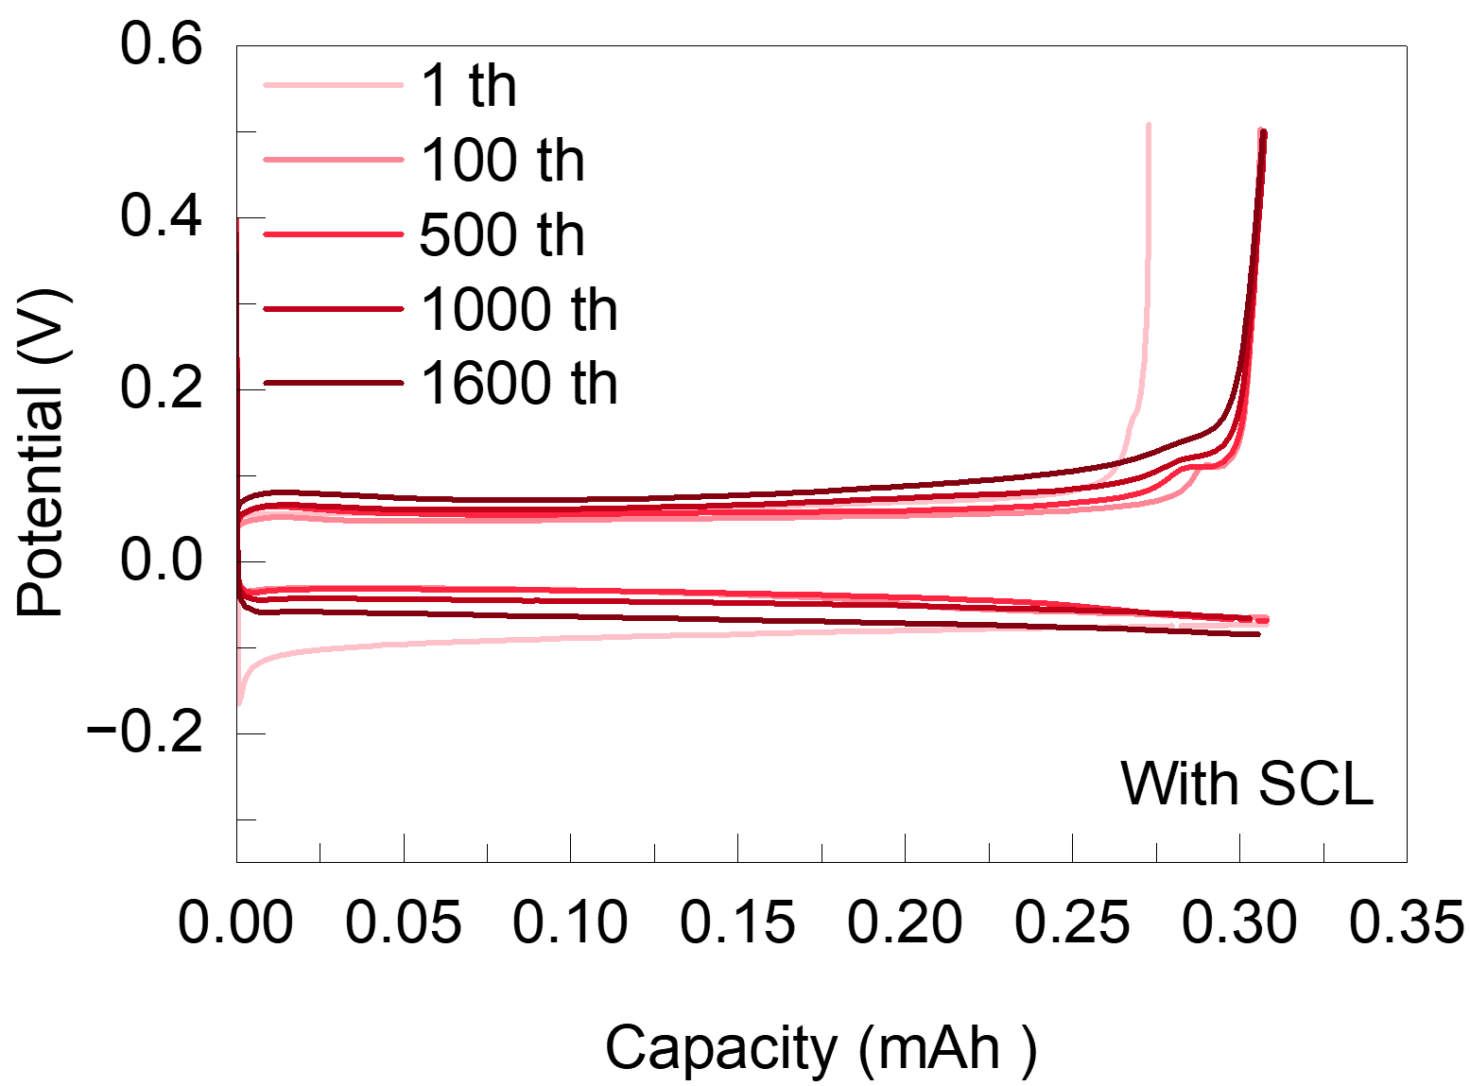
Fig. S26 Potential-capacity profiles at different cycles at 0.2 mA cm⁻² with the capacity of 0.2 mAh cm⁻²
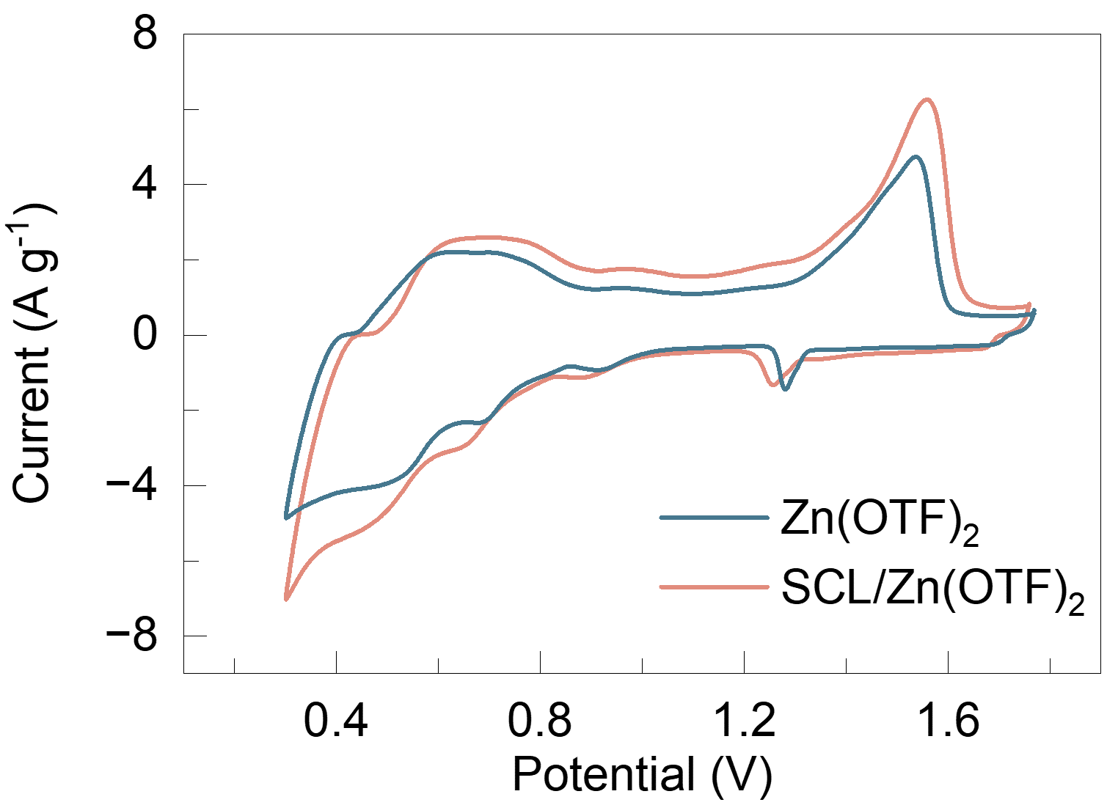
Fig. S27 CV curves of Zn//NH₄V₄O₁₀ full batteries with different electrolyte at 1st cycle
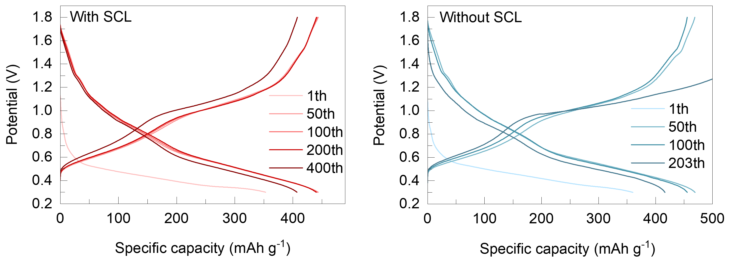
Fig. S28 The voltage- Specific capacity profiles of Zn//NH₄V₄O₁₀ full batteries with different electrolytes
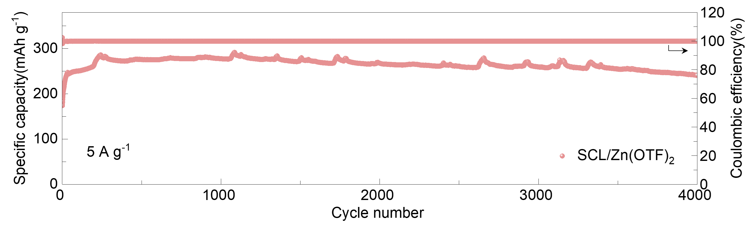
Fig. S29 The performance of Zn//NH₄V₄O₁₀ full battery with SCL/Zn(OTF)₂ eletrolyte at 5 A g⁻¹
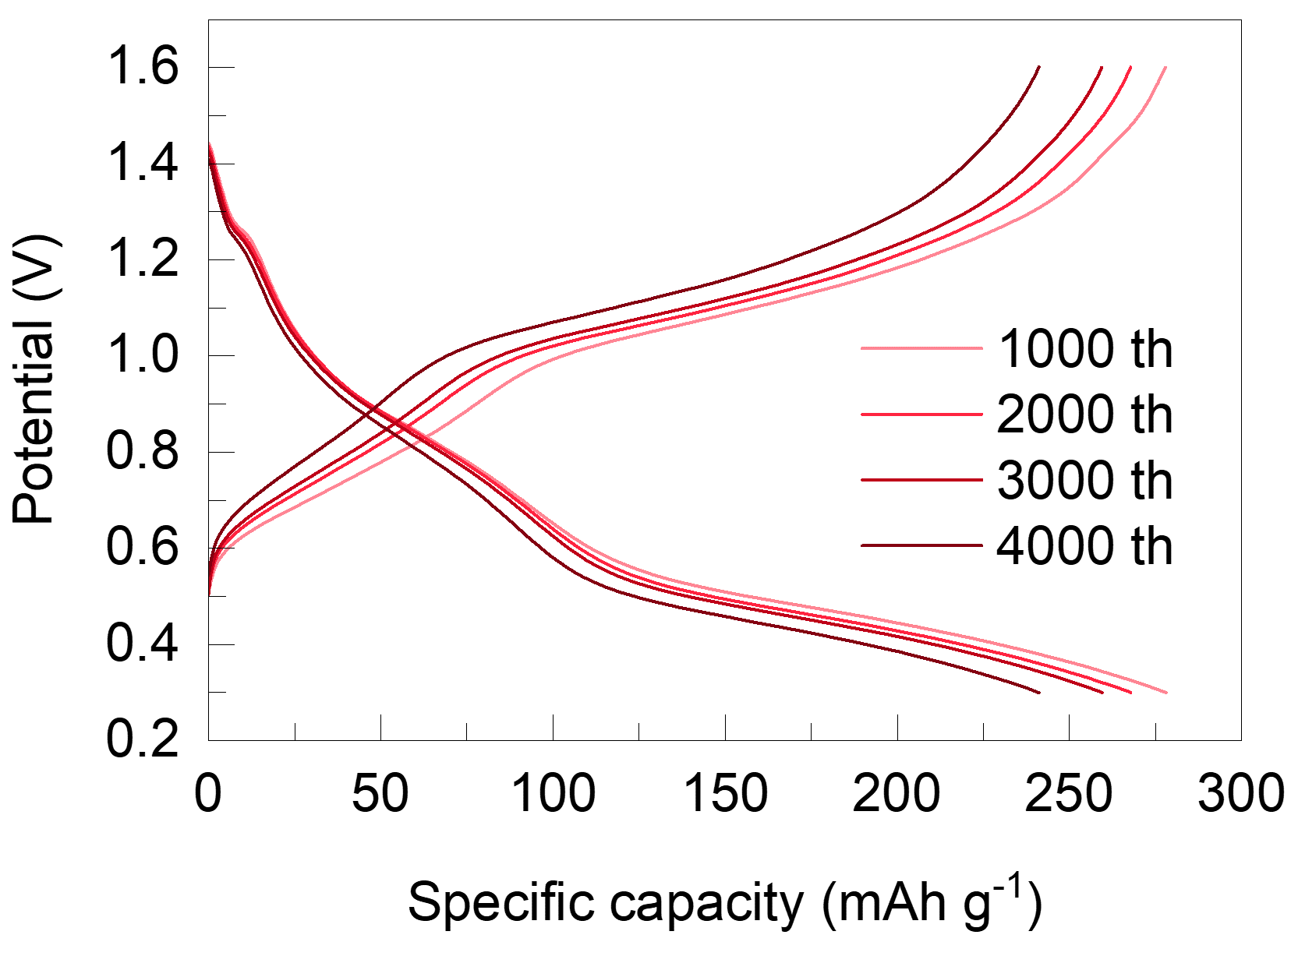
Fig. S30 The voltage- Specific capacity profiles of Zn//NH₄V₄O₁₀ full battery with SCL/Zn(OTF)₂ electrolyte at 5 A g⁻¹
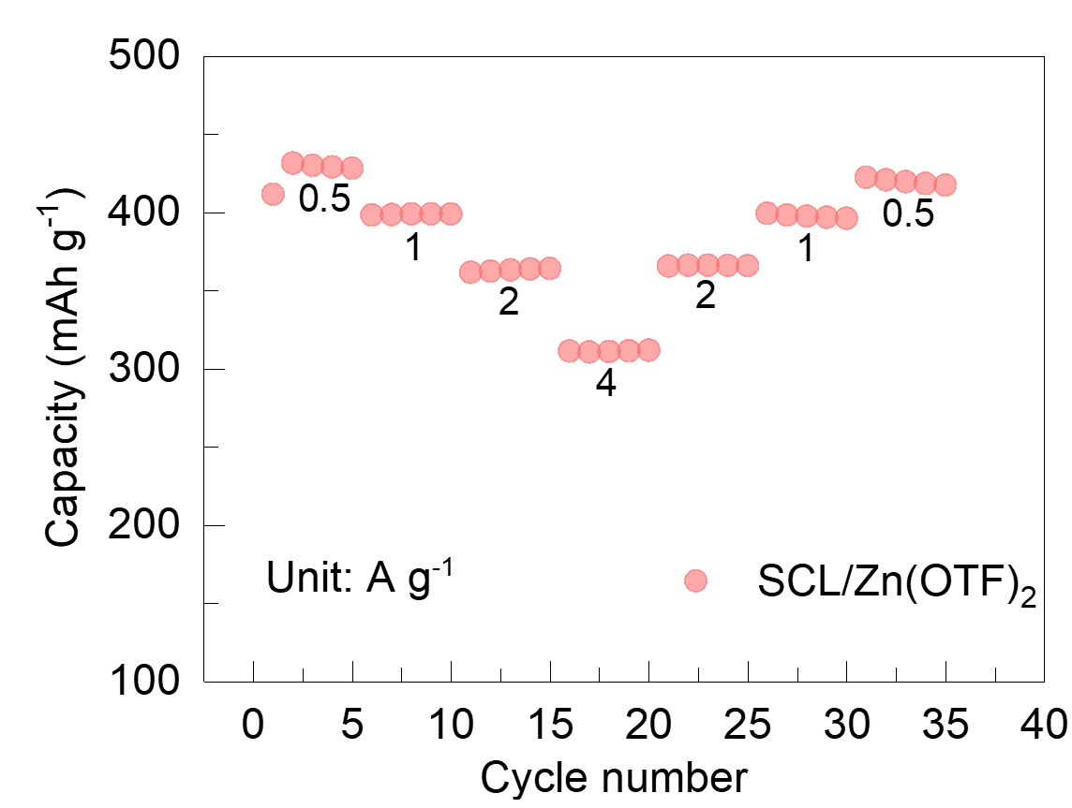
Fig. S31 The rate performance of Zn//NH₄V₄O₁₀ full battery with SCL/Zn(OTF)₂ electrolyte
Table S1 Comparison of the electrochemical stability of Zn metal electrodes
Electrolyte | Current density areal capacity | Lifetime | Depth of discharge | References
SCL/Zn(OTF)₂ | 1 mA cm⁻², 1 mAh cm⁻²  30 mA cm⁻², 30 mAh cm⁻²  30 mA cm⁻², 40 mAh cm⁻² | 4900 h  171 h  98 h | 1.7%  73.3%  97.7% | Our work
LA/ ZnSO₄ | 10 mA cm⁻², 10 mAh cm⁻²  15 mA cm⁻², 15 mAh cm⁻² | 180 h  60 h | 61%  92% | [S1]
LA⁺/ ZnSO₄ | 10 mA cm⁻², 5.9 mAh cm⁻² | 160 h | 80% | [S2]
DMA/ ZnSO₄ | 1 mA cm⁻², 1 mAh cm⁻²  30 mA cm⁻², 30 mAh cm⁻² | 3200 h  120 h | 3.4%  51.3% | [S3]
SL/ ZnSO₄ | 24 mA cm⁻², 24 mAh cm⁻² | 110 h |  | [S4]
PMCNA/Zn(ClO₄)₂ | 1 mA cm⁻², 1 mAh cm⁻² | 4500 h |  | [S5]
ggg/ZnSO₄ | 0.5 mA cm⁻², 0.5 mAh cm⁻² | 4500 h |  | [S6]
PV/ZnSO₄ | 1 mA cm⁻², 1 mAh cm⁻² | 4000 h |  | [S7]
SAA/ ZnSO₄ | 1 mA cm⁻², 1 mAh cm⁻² | 3400 h |  | [S8]
Table S2 The comparison of average CE with other reported works
Electrolyte | Current density areal capacity | Coulombic efficiency | References
SCL/Zn(OTF)₂ | 0.5 mA cm⁻², 0.5 mAh cm⁻²  0.2 mA cm⁻², 0.2 mAh cm⁻² | 99.84%  99.61% | Our work
AS/ZnSO₄ | 1 mA cm⁻², 1 mAh cm⁻² | 99.6% | [S9]
TG/ZnSO₄ | 0.5 mA cm⁻², 0.25 mAh cm⁻² | 99.73% | [S10]
NCAP-Glu/ZnSO₄ | 1 mA cm⁻², 1 mAh cm⁻² | 99.83% | [S11]
AMCA/ZnSO₄ | 0.5 mA cm⁻², 0.5 mAh cm⁻² | 99.53% | [S12]
APM/Zn(OTF)₂ | 0.5 mA cm⁻², 0.5 mAh cm⁻² | 99.16% | [S13]
NMS/ZnSO₄ | 1 mA cm⁻², 0.5 mAh cm⁻² | 99.7% | [S14]
IDS/ZnSO₄ | 1 mA cm⁻², 1 mAh cm⁻² | 99.5% | [S15]
Supplementary References
- M. Shi, C. Lei, H. Wang, P. Jiang, C. Xu et al., Molecule engineering of sugar derivatives as electrolyte additives for deep-reversible Zn metal anode. Angew. Chem. Int. Ed. 63(35), e202407261 (2024). https://doi.org/10.1002/anie.202407261
- R. Zhao, H. Wang, H. Du, Y. Yang, Z. Gao et al., Lanthanum nitrate as aqueous electrolyte additive for favourable zinc metal electrodeposition. Nat. Commun. 13(1), 3252 (2022). https://doi.org/10.1038/s41467-022-30939-8
- T. Wei, H. Zhang, Y. Ren, L.-E. Mo, Y. He et al., Building near-unity stacked (002) texture for high-stable zinc anode. Adv. Funct. Mater. 34(14), 2312506 (2024). https://doi.org/10.1002/adfm.202312506
- M. Wang, J. Ma, Y. Meng, J. Sun, Y. Yuan et al., High-capacity zinc anode with 96 % utilization rate enabled by solvation structure design. Angew. Chem. Int. Ed. 62(3), e202214966 (2023). https://doi.org/10.1002/anie.202214966
- D. Feng, Y. Jiao, P. Wu, Guiding Zn uniform deposition with polymer additives for long-lasting and highly utilized Zn metal anodes. Angew. Chem. Int. Ed. 62(51), e202314456 (2023). https://doi.org/10.1002/anie.202314456
- J. Zhang, Y. Liu, Y. Wang, Z. Zhu, Z. Yang, Zwitterionic organic multifunctional additive stabilizes electrodes for reversible aqueous Zn-ion batteries. Adv. Funct. Mater. 34(34), 2401889 (2024). https://doi.org/10.1002/adfm.202401889
- W. Liang, D. Li, R. Zhong, S. Tao, Y. Zhu et al., Electrolyte engineering strategy with catecholate type additive enabled ultradurable Zn anode. Adv. Funct. Mater. 35(36), 2504195 (2025). https://doi.org/10.1002/adfm.202504195
- K. Liu, M. Sun, Y. Wu, T. Zhang, A. Zhu et al., Binary electrolyte additive-reinforced interfacial molecule adsorption layer for ultra-stable zinc metal anodes. Adv. Mater. 37(18), 2420079 (2025). https://doi.org/10.1002/adma.202420079
- Z. Chen, R. Jiang, Y. Chen, H. Zhu, X. Tang et al., Zincophilic group-rich aminoglycosides for ultra-long life and high-rate zinc batteries. Energy Storage Mater. 74, 103913 (2025). https://doi.org/10.1016/j.ensm.2024.103913
- Z. Liu, R. Wang, Q. Ma, J. Wan, S. Zhang et al., A dual-functional organic electrolyte additive with regulating suitable overpotential for building highly reversible aqueous zinc ion batteries. Adv. Funct. Mater. 34(5), 2214538 (2024). https://doi.org/10.1002/adfm.202214538
- X. Fan, L. Chen, Y. Wang, X. Xu, X. Jiao et al., Selection of negative charged acidic polar additives to regulate electric double layer for stable zinc ion battery. Nanomicro Lett. 16(1), 270 (2024). https://doi.org/10.1007/s40820-024-01475-5
- N. Hu, J. Tao, Y. Tan, H. Song, D. Huang et al., Comprehensive understanding of steric-hindrance effect on the trade-off between zinc ions transfer and reduction kinetics to enable highly reversible and stable Zn anodes. Adv. Energy Mater. 14(46), 2404018 (2024). https://doi.org/10.1002/aenm.202404018
- Y. Liu, L. Miao, H. Shen, Z. Wang, K. Yao et al., Maximizing functional diversity of electrolyte additives through modular molecular engineering to stabilize zinc metal anodes. Adv. Funct. Mater. 35(30), 2501968 (2025). https://doi.org/10.1002/adfm.202501968
- Q. Zong, R. Li, J. Wang, Q. Zhang, A. Pan, Tailoring the whole deposition process from hydrated Zn²⁺ to Zn0 for stable and reversible Zn anode. Angew. Chem. Int. Ed. 63(41), e202409957 (2024). https://doi.org/10.1002/anie.202409957
- J. Yang, R. Zhao, Z. Hu, Y. Wang, K. Zhang et al., Blocking the passivation reaction via localized acidification and cation selective interface towards highly stable zinc anode. Energy Storage Mater. 70, 103449 (2024). https://doi.org/10.1016/j.ensm.2024.103449

