Supporting Information for
Violet Arsenic Phosphorus: Switching p-Type into High Performance n-Type Semiconductor by Arsenic Substitution
Rui Zhai^{1#}, Zhuorui Wen^{1#}, Xuewen Zhao^{2#}, Junyi She¹, Mengyue Gu¹, Fanqi Bu¹, Chang Huang³, Guodong Meng¹, Yonghong Cheng¹, and Jinying Zhang¹*
¹ State Key Laboratory of Electrical Insulation and Power Equipment, Center of Nanomaterials for Renewable Energy, School of Electrical Engineering, Xi’an Jiaotong University, Xi’an, Shaanxi 710049, P. R. China
² State Grid Integrated Energy Service Group Co., Ltd., Beijing 100052, P. R. China
³ Instrumental Analysis Center of Xi'an Jiaotong University, Xi'an Jiaotong University, Xi'an 710049, P. R. China
#Rui Zhai, Zhuorui Wen, and Xuewen Zhao are co-first authors and contributed equally to this work.
*Corresponding author. E-mail: jinying.zhang@mail.xjtu.edu.cn (Jinying Zhang)
First-principles Calculations
Density functional theory (DFT) of bulk VP and P_{20.61}As_{0.39} were implemented in the Vienna Ab Initio Simulation Package (VASP) code. The Perdew-Burke-Ernzerhof (PBE) functional within the generalized gradient approximation (GGA) was adopted to describe electronic exchange-correlation energy. The ionic cores were described with the projector augmented wave (PAW) method. The calculated structures were the periodic boundary conditions. A basis set of plane waves was up to an energy cutoff of 500 eV. For the structure optimization and energy calculations, the K-points were set to be 2 × 2 ×2. All of the calculations were continued until the force and energy have converged to less than 0.01 eV Å⁻¹ and 10⁻⁴ eV, respectively. Calculations of violet phosphorene and P_{20.61}As_{0.39} phosphorene were carried out on the basis of the framework of DFT and the Vienna ab initio simulation package [S1]. The generalzied gradient approximation proposed by Perdew, Burke, and Ernzerhof is selected for the exchange-correlation potential [S2]. The long range van der Waals interaction is described by the DFT-D3 approach [S3]. The cut-off energy for plane wave is set to 550 eV. The energy criterion is set to 10⁻⁶ eV in iterative solution of the Kohn-Sham equation. A vacuum layer of 35 Å is added perpendicular to the sheet to avoid artificial interaction between periodic images. The Brillouin zone integration is performed using a 2×2×1 k-mesh. All the structures are relaxed until the residual forces on the atoms have declined to less than 0.01 eV/Å.
Generally, the carrier mobility, μ_{2D}, of the 2D semi-conductor, with a view to studying the properties of migration of electrons and holes, can be obtained as follows [S4]:
$$μ_{2D}=\frac{eℏ^{3}C_{2D}}{K_{B}Tm_{a}^{*}m_{d}E_{1}^{2}}$$
where e is the electron charge, ℏ is the reduced Planck constant, K_{B} is the Boltzmann constant and T is the temperature (300 K in our calculations). The $m_{a}^{*}$ and $m_{d}=\sqrt{m_{x}^{*}m_{y}^{*}}$ are the effective mass and average effective mass of carriers along the transport direction, respectively. The in-plane stiffness C_{2D} = 2[∂²E/∂(Δl/l₀)²]/S₀, where the E is total energy and S₀ is the area of the xy plane for the supercell, respectively. The E₁ = ΔV/(Δl/l₀) is the deformation potential constant, the ΔV =ΔE_{VBM} or ΔE_{CBM} (strain range from -2% to 2%, calculated using 1% steps), Δl and l₀ are the deformation of the lattice constants along the transport direction and the intrinsic lattice constants, correspondingly.
Photocatalytic Hydrogen Evolution Measurements
10 mg VP-As (P_{83.4}As_{0.6}) single crystals were first ground followed by the addition of 50 mL of deionized water, which was then exfoliated to phosphorene nanosheets using a Ultrasonic Cell Crusher (JYD-250L) at 25 W for 2 h. About 1 wt.% chloroplatinic acid solution was added to the reaction suspension as precursors to obtain Pt co-catalyst. 0.2 M of ascorbic acid was then added as sacrificial agents. The photocatalytic H₂ evolution reactions were carried out under irradiation of a Xe lamp (CEL-PF300-T8, 300W, 350 nm - 780 nm) in a quartz cell connected to a glass closed gas circulation and evacuation system (Labsolar-6a, PERFECTLIGHT, Beijing) for 4 h. The production of H₂ was detected by an online gas chromatography with TCD detector (GC-9790). High pure Argon gas was used as carrier gas.
Supplementary Figures and Tables

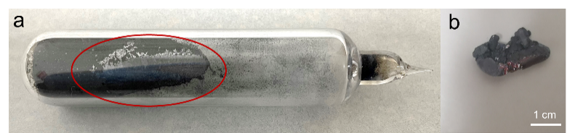
Fig. S1 Optical images of (a) the quartz tube after reaction; (b) the as-produced violet arsenic phosphorus wrapped inside molten lead (from red circle of Fig. S1a)

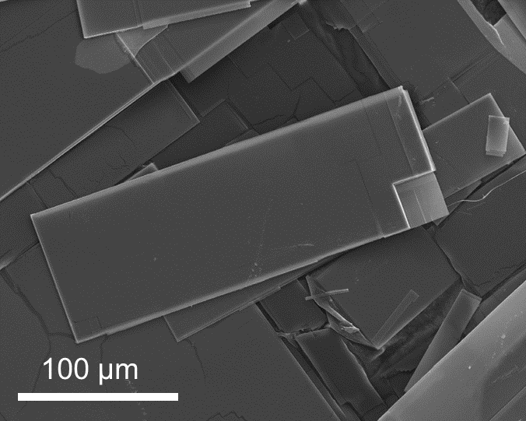
Fig. S2 SEM image of some pieces of bulk violet arsenic phosphorus
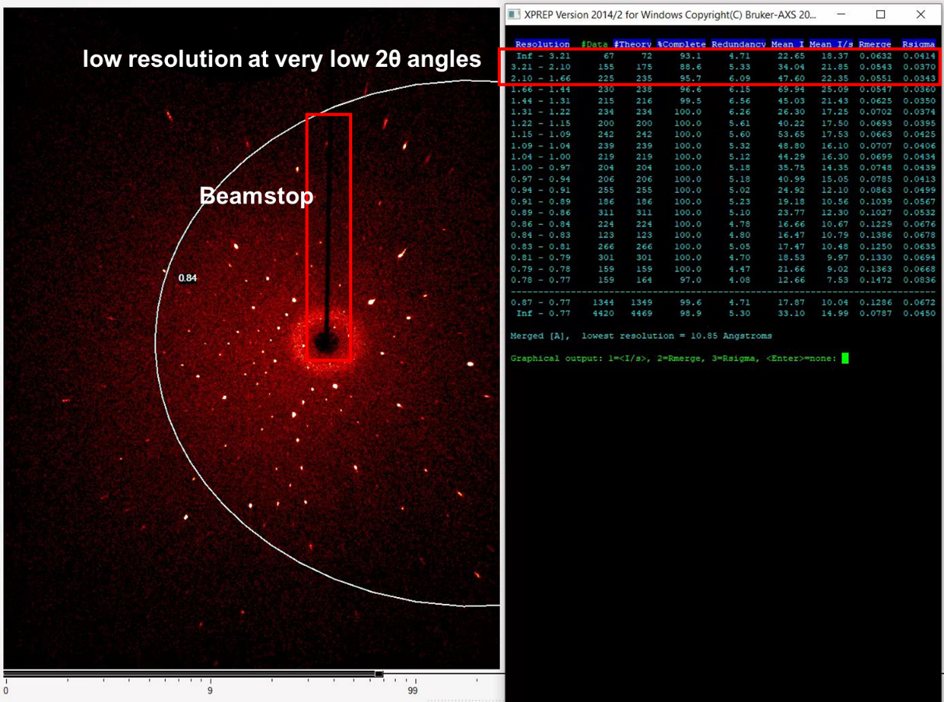
Fig. S3 Detail picture for the single-crystal X-ray diffraction measurements of P_{83.4}As_{0.6}
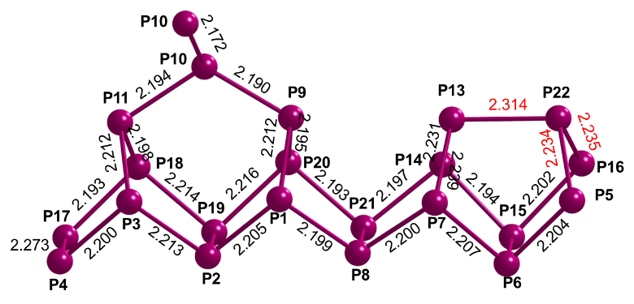
Fig. S4 Tubular substructure with position number and bond lengths of violet phosphorus

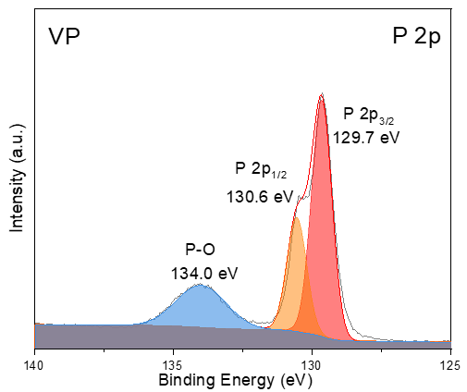
Fig. S5 High-resolution XPS spectra of P2p of VP
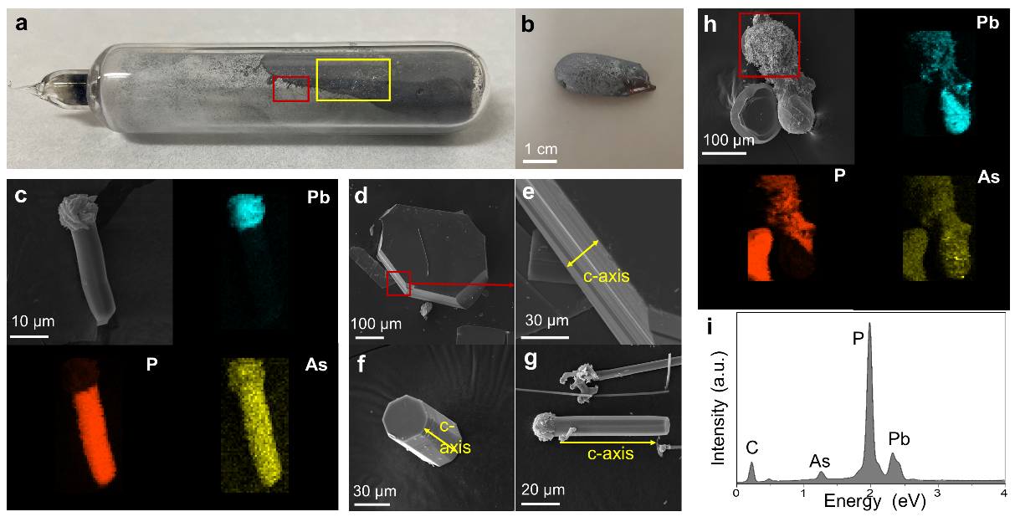
Fig. S6 Optical images of (a) the quartz tube after reaction; (b) the as-produced violet arsenic phosphorus wrapped inside molten lead (from yellow box of Figure S3a). (c) SEM image of the products from the red box of Figure S3a accompanied by corresponding elemental mapping analysis, SEM image of (d) the product from the red box in Figure S3a and (e) enlarged layered structure; (f)-(g) the product from the red box in Figure S3a. (h) SEM image accompanied by corresponding elemental mapping analysis and (i) EDS spectrum of the As–P–Pb product
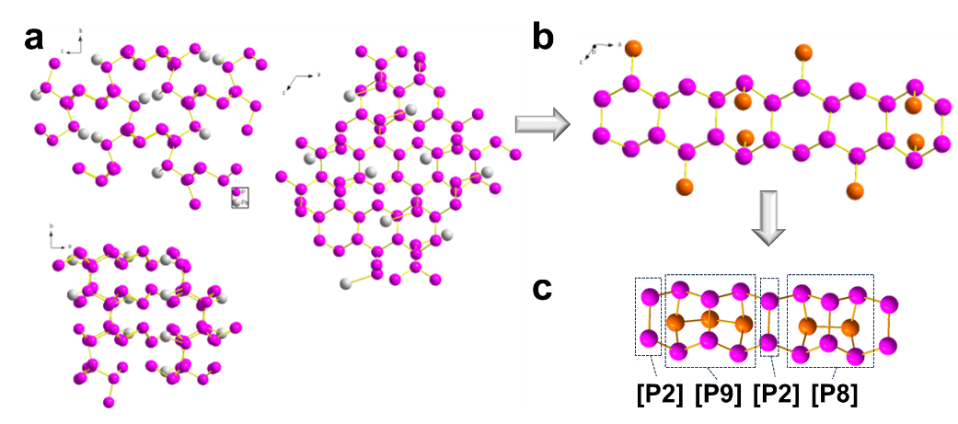
Fig. S7 The nucleation mechanism of violet arsenic phosphorus crystals from lead droplets. (a) Different views of PbP₇ crystal structure. (b) The nearest-neighbor phosphorus structure of PbP₇ crystals, and (c) the corresponding P2[P9]P2[P8] tubular structure of violet phosphorus framework after recombination
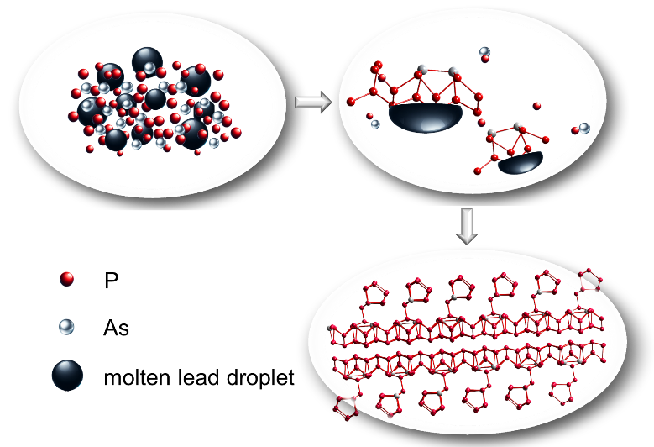
Fig. S8 Schematic illustration of the growth mechanism of violet arsenic phosphorus crystals
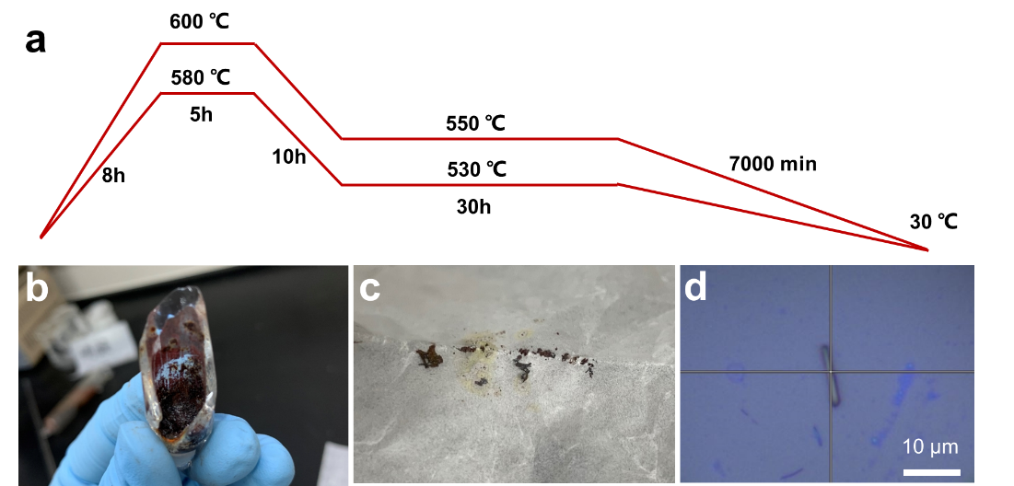
Fig. S9 (a) Synthesis parameters for chemical vapor transport method to produce violet arsenic phosphorus. Optical images of (b) the quartz tube after reaction and (c, d) the as-produced violet arsenic phosphorus crystals

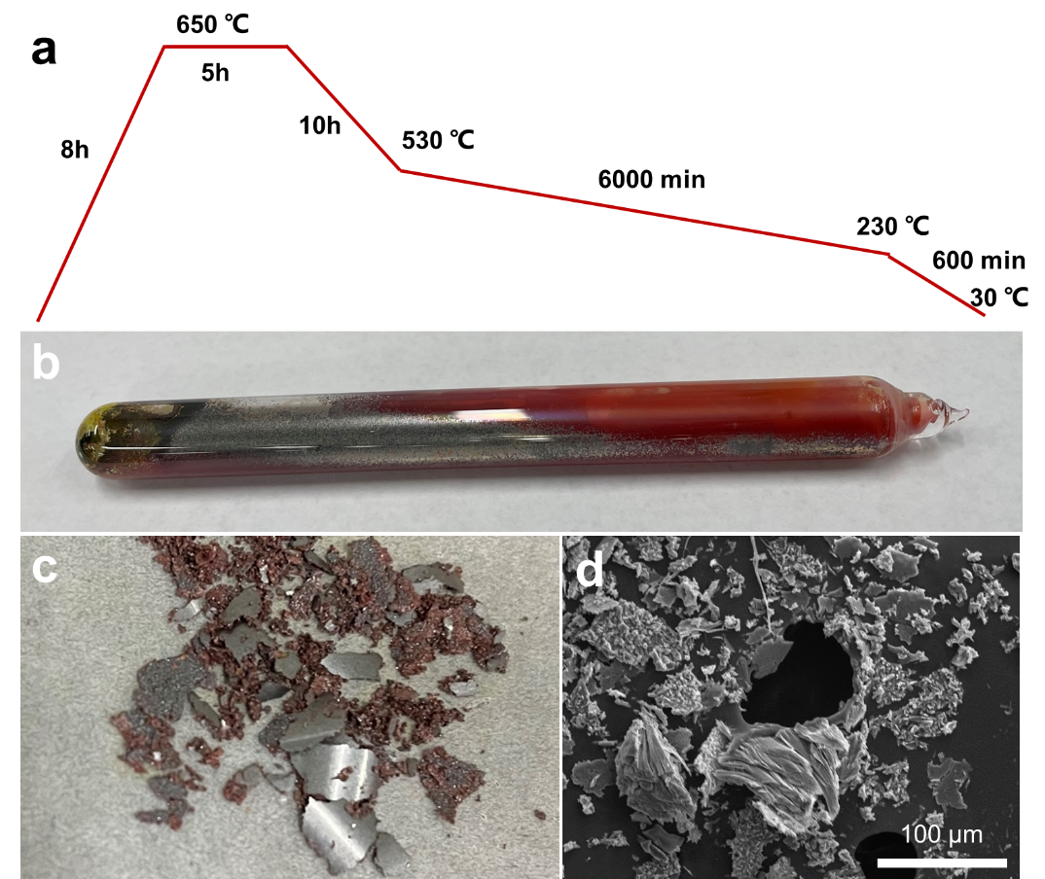
Fig. S10 (a) Synthesis parameters for direct vapor condensation method to produce violet arsenic phosphorus. Optical images of (b) the quartz tube after reaction and (c) the as-produced violet arsenic phosphorus crystals. (d) SEM image of the as-produced violet arsenic phosphorus
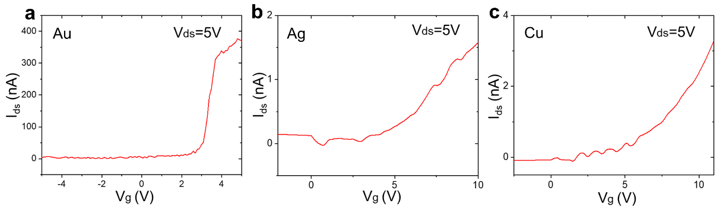
Fig. S11 The corresponding Source–drain current as a function of gate voltage obtained from a FET based on a VP-As (P_{83.4}As_{0.6}) nanosheet (V_{ds} = 5 V) with the individual (a) gold, (b) silver, and (c) copper electrode
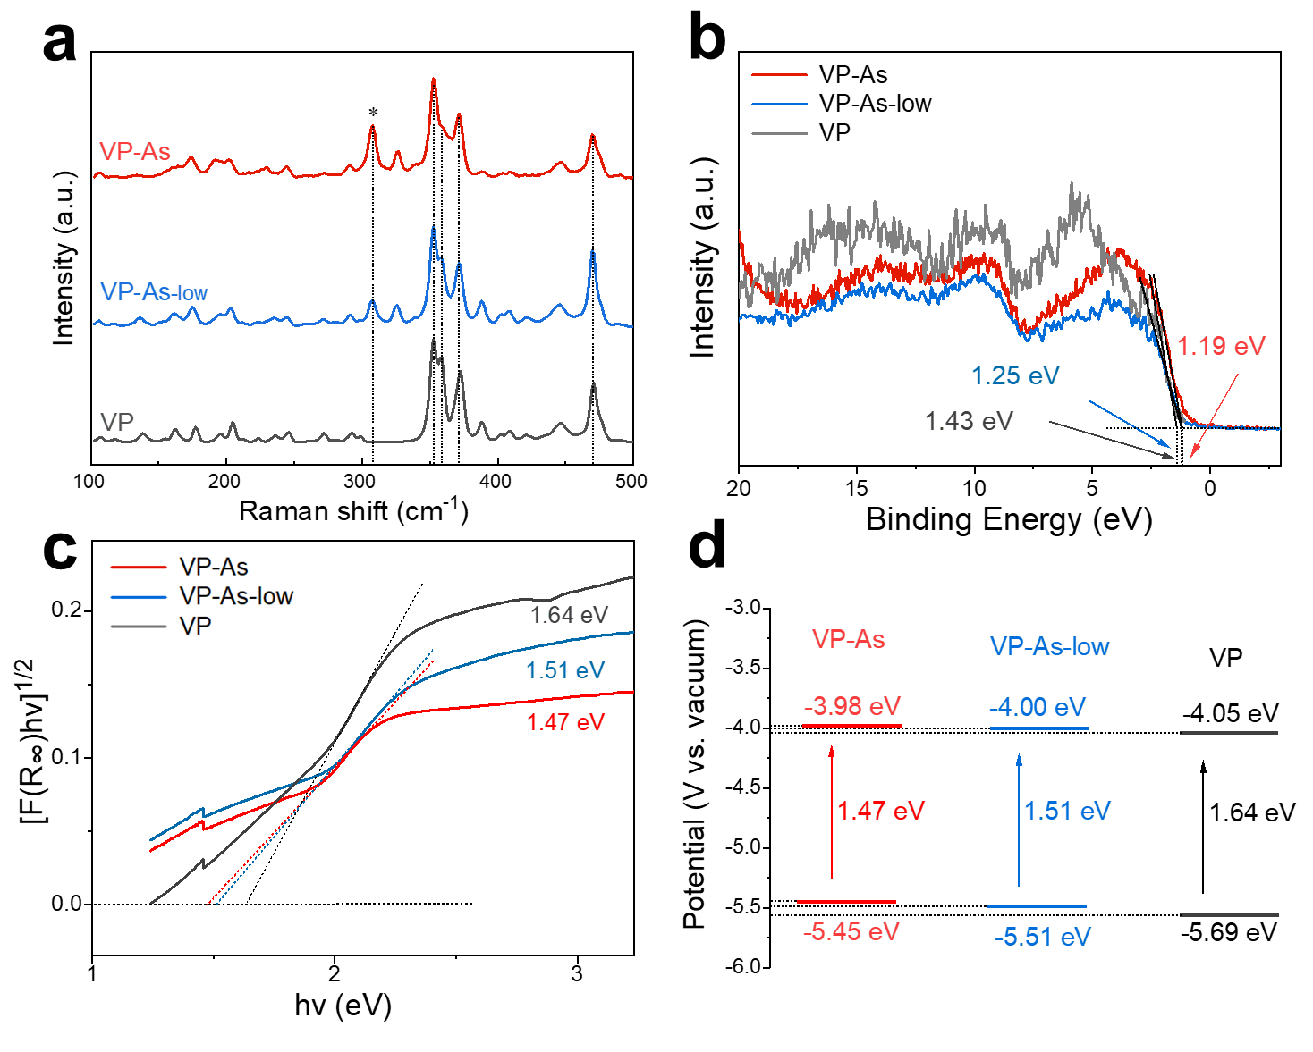
Fig. S12 (a) Raman spectra, (b) valence band XPS, (c) diffuse reflectance spectra and (d) deduced band edges of violet arsenic phosphorus with different substitutional rate of arsenic atoms
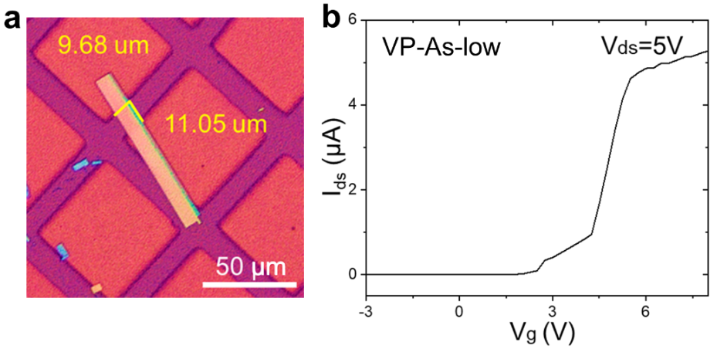
Fig. S13 (a) Optical image and (b) corresponding source–drain current (V_{ds} = 5 V) according to gate voltage obtained from a VP-As-low nanosheet based FET
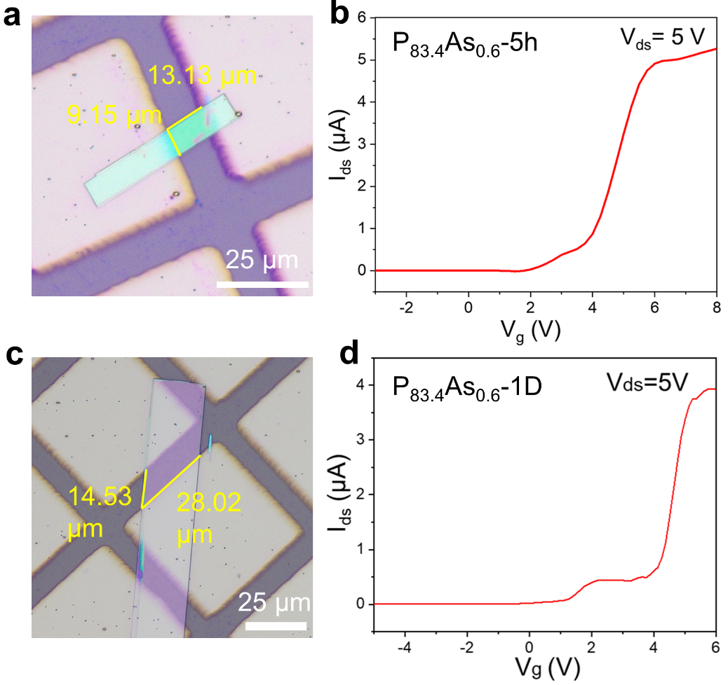
Fig. S14 (a) The optical image and (b) corresponding source–drain current (V_{ds} = 5 V) according to gate voltage of a VP-As (P_{83.4}As_{0.6}) nanosheet based FET after exposure in ambient conditions for 5 hours. (c) The optical image and (d) corresponding source–drain current (V_{ds} = 5 V) according to gate voltage of a VP-As (P_{83.4}As_{0.6}) nanosheet based FET after exposure in ambient conditions for 1 day

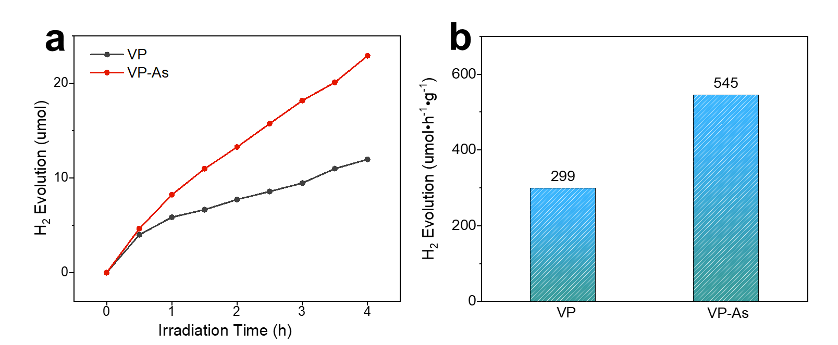
Fig. S15 (a) Photocatalytic H₂ evolution curves and (b) H₂ evolution rates of violet arsenic phosphorene nanosheets and violet phosphorene nanosheets

Table S1 Crystal data and structure refinement for a P_{83.4}As_{0.6} single crystal
empirical formula | P_{83.4}As_{0.6}
Formula weight | 2627.85
temperature /K | 302
crystal system | monoclinic
space group | P 2/n
a /Å | 9.2075(4)
b /Å | 9.1507(4)
c /Å | 21.7698(10)
α/° | 90
β /° | 94.388(2)
γ /° | 90
volume /Å³ | 1828.84(14)
Z | 1
calculated density /g cm⁻³ | 2.386
μ /mm^{‑1} | 2.139
Crystal size/mm³ | 0.2 × 0.15 × 0.1
Radiation | MoKα (λ = 0.71073)
F(000) | 1271
2Θ range for data collection /° | 3.752 to 52.742
Index ranges | -11 ≤ h ≤ 11, -11 ≤ k ≤ 11, -28 ≤ l ≤ 28
Reflections collected | 4155
Independent reflections | 3702
Data/restraints/parameters | 3702/12/199
Goodness-of-fit on F² | 1.095
Final R indexes [I>=2σ(I)] | R₁ = 0.0725, wR₂ = 0.1730
Final R indexes [all data] | R₁ = 0.0794, wR₂ = 0.1769
Largest diff. peak/hole / e Å⁻³ | 2.186/-1.179

Table S2 Atomic coordinates of P_{83.4}As_{0.6} crystal unit cell
 | x | y | z
P1 | 0.08459 | 0.0732 | 0.68148
P2 | 0.99096 | 0.90461 | 0.61651
P3 | 0.83486 | 0.8191 | 0.67997
P4 | 0.74316 | 0.65214 | 0.61517
P5 | 0.5844 | 0.5518 | 0.67364
P6 | 0.50386 | 0.38688 | 0.60477
P7 | 0.35195 | 0.3222 | 0.67396
P8 | 0.24056 | 0.15201 | 0.61659
P9 | -0.067 | 0.2599 | 0.6722
P10 | -0.27997 | 0.19441 | 0.70065
P11 | 0.64679 | 0.9718 | 0.67338
As1/P12 | 0.391/0.3848 | 0.712/0.7011 | 0.6697/0.6704
P13 | 0.20298 | 0.52139 | 0.67047
P14 | 0.1412 | 0.51267 | 0.56776
P15 | 0.3602 | 0.51717 | 0.53376
P16 | 0.37724 | 0.7447 | 0.56629
P17 | 0.60315 | 0.78161 | 0.54336
P18 | 0.625 | 1.01048 | 0.57304
P19 | -0.14991 | 0.03215 | 0.5441
P20 | -0.12117 | 0.26375 | 0.57244
P21 | 0.10178 | 0.28138 | 0.5438

Table S3 The cell parameters and cell volumes of pristine VP, violet arsenic phosphorus and reported violet antimony phosphorus
 | Single-crystal XRD data | Powder XRD data | a (Å) | b (Å) | c (Å) | β (°) | V (Å³)
VP | Yes | Yes | 9.210 | 9.128 | 21.893 | 97.7768 | 1823.5(8)
VP-As (This work, P_{83.4}As_{0.6}) | Yes | Yes | 9.2075 | 9.1507 | 21.7698 | 94.388 | 1828.84(14)
VP-Sb (P_{20.56}Sb_{0.44}) | None | Yes | 9.2345 | 9.1732 | 22.6176 | 106.077 | 1841.01(16)
VP-Sb (P₇₆Sb_{3.27}) | Yes | Yes | 9.2146 | 9.1619 | 21.901 | 97.81 | 1831.82

Table S4 Comparison of FET performance of VP-As to reported phosphorus semiconducting materials
Transistor channel material | Type | Mobility (cm² V⁻¹ s⁻¹) | Refs.
VP | p | 4.07 | This work
VP-As (P_{83.4}As_{0.6}) | n | 137.06 | This work
BP | p | 35 | [S5]
BP/HATCN | p | 69 | [S5]
BP/HATNA | p | 97 | [S5]
exfoliated ultralarge BP with CH₃COOTBA intercalation | p | 76 | [S6]
nonoxidative BP flakes with high crystallinity | p | 60 | [S7]
BP-NMP | ambipolar | 50 | [S8]
amorphous BP ultrathin film | p | 14 | [S9]
BP-C | p | 1995 | [S10]
BP | ambipolar | 38 (electrons),  172 (holes) | [S11]
BP | p | 100 | [S12]

Table S5 Comparison of FET performance of VP-As to reported n-type 2D semiconducting materials
Transistor channel material | Mobility (cm² V⁻¹ s⁻¹) | on/off ratio | subthreshold swing (mV/dec) | Refs.
VP-As (P_{83.4}As_{0.6}) | 137.06 | 664 | 114 | This work
multilayer (ML) MoS₂ islands | 70 | 10⁸ | 150 | [S13]
MoS₂ | 30 | Not mentioned | Not mentioned | [S14]
MoS₂ under tensile strain | 185 | Not mentioned | Not mentioned | [S15]
metal-agglomeration-suppressed MoS₂ films | 59.8 | 10⁵ | 500 | [S16]
MoS₂-PPh₃ | 60 | Not mentioned | Not mentioned | [S17]
MoS₂-ReO₃ | 46.3 | Not mentioned | Not mentioned | [S18]
MoS₂-O₂ | 100 | 10⁹ | 80 | [S19]
MoS₂-NMP | 22.2 | 10⁵ | Not mentioned | [S20]
MoS₂-DMSO | 29.2 | Not mentioned | Not mentioned | [S20]
MoS₂-DMF | 26.6 | Not mentioned | Not mentioned | [S20]
WS₂ | 33 | Not mentioned | Not mentioned | [S14]
WS₂ | 140 | 10⁶ | Not mentioned | [S21]
WS₂ encapsulated in hexagonal BN | 100 | 10⁵ | Not mentioned | [S22]
monolayered triangular WS₂ flakes | 50.5 | 10⁷ | Not mentioned | [S23]
WS₂-Cl | 60 | 4×10⁶ | Not mentioned | [S24]
MoSe₂ | 59.4 | Not mentioned | Not mentioned | [S25]
self-assembled monolayers modified MoSe₂ | 166.5 | Not mentioned | Not mentioned | [S25]
bilayer MoSe₂ | 65 | 10⁵ | Not mentioned | [S26]
WSe₂ with amorphous BN capping layer | 7.42 | 10⁶ | Not mentioned | [S27]
WSe₂-DETA | 25 | Not mentioned | Not mentioned | [S28]
WSe₂-S | 68.2 | Not mentioned | Not mentioned | [S29]
MoTe₂ | ≈ 43 | 10⁶ | Not mentioned | [S30]

Supplementary References
- G. Kresse, D. Joubert, From ultrasoft pseudopotentials to the projector augmented-wave method. Phys. Rev. B 59(3), 1758–1775 (1999). https://doi.org/10.1103/physrevb.59.1758
- J. Perdew, K. Burke, M. Ernzerhof, Generalized gradient approximation made simple. Phys. Rev. Lett. 77(18), 3865–3868 (1996). https://doi.org/10.1103/PhysRevLett.77.3865
- S. Grimme, J. Antony, S. Ehrlich, H. Krieg, A consistent and accurate ab initio parametrization of density functional dispersion correction (DFT-D) for the 94 elements H-Pu. J. Chem. Phys. 132(15), 154104 (2010). https://doi.org/10.1063/1.3382344
- J. Qiao, X. Kong, Z.-X. Hu, F. Yang, W. Ji, High-mobility transport anisotropy and linear dichroism in few-layer black phosphorus. Nat. Commun. 5, 4475 (2014). https://doi.org/10.1038/ncomms5475
- H. Shi, S. Fu, Y. Liu, C. Neumann, M. Wang et al., Molecularly engineered black phosphorus heterostructures with improved ambient stability and enhanced charge carrier mobility. Adv. Mater. 33(48), 2105694 (2021). https://doi.org/10.1002/adma.202105694
- N. Wang, N. Mao, Z. Wang, X. Yang, X. Zhou et al., Electrochemical delamination of ultralarge few-layer black phosphorus with a hydrogen-free intercalation mechanism. Adv. Mater. 33(1), e2005815 (2021). https://doi.org/10.1002/adma.202005815
- J. Li, C. Chen, S. Liu, J. Lu, W.P. Goh et al., Ultrafast electrochemical expansion of black phosphorus toward high-yield synthesis of few-layer phosphorene. Chem. Mater. 30(8), 2742–2749 (2018). https://doi.org/10.1021/acs.chemmater.8b00521
- J. Kang, J.D. Wood, S.A. Wells, J.-H. Lee, X. Liu et al., Solvent exfoliation of electronic-grade, two-dimensional black phosphorus. ACS Nano 9(4), 3596–3604 (2015). https://doi.org/10.1021/acsnano.5b01143
- Z. Yang, J. Hao, S. Yuan, S. Lin, H.M. Yau et al., Field-effect transistors based on amorphous black phosphorus ultrathin films by pulsed laser deposition. Adv. Mater. 27(25), 3748–3754 (2015). https://doi.org/10.1002/adma.201500990
- W.C. Tan, Y. Cai, R.J. Ng, L. Huang, X. Feng et al., Few-layer black phosphorus carbide field-effect transistor via carbon doping. Adv. Mater. 29(24), 1700503 (2017). https://doi.org/10.1002/adma.201700503
- S. Das, M. Demarteau, A. Roelofs, Ambipolar phosphorene field effect transistor. ACS Nano 8(11), 11730–11738 (2014). https://doi.org/10.1021/nn505868h
- A. Kumar, K. Intonti, L. Viscardi, O. Durante, A. Pelella et al., Memory effect and coexistence of negative and positive photoconductivity in black phosphorus field effect transistor for neuromorphic vision sensors. Mater. Horiz. 11(10), 2397–2405 (2024). https://doi.org/10.1039/d4mh00027g
- H. Xu, H. Zhang, Z. Guo, Y. Shan, S. Wu et al., High-performance wafer-scale MoS₂ transistors toward practical application. Small 14(48), e1803465 (2018). https://doi.org/10.1002/smll.201803465
- A. Sebastian, R. Pendurthi, T.H. Choudhury, J.M. Redwing, S. Das, Benchmarking monolayer MoS₂ and WS(2) field-effect transistors. Nat. Commun. 12(1), 693 (2021). https://doi.org/10.1038/s41467-020-20732-w
- X. Liu, B. Erbas, A. Conde-Rubio, N. Rivano, Z. Wang et al., Deterministic grayscale nanotopography to engineer mobilities in strained MoS₂ FETs. Nat. Commun. 15, 6934 (2024). https://doi.org/10.1038/s41467-024-51165-4
- K.H. Jung, S.J. Yun, Y. Choi, J.H. Cho, J.W. Lim et al., Metal-agglomeration-suppressed growth of MoS₂ and MoSe₂ films with small sulfur and selenium molecules for high mobility field effect transistor applications. Nanoscale 10(32), 15213–15221 (2018). https://doi.org/10.1039/C8NR03778G
- D. Lee, J.J. Lee, Y.S. Kim, Y.H. Kim, J.C. Kim et al., Remote modulation doping in van der Waals heterostructure transistors. Nat. Electron. 4(9), 664–670 (2021). https://doi.org/10.1038/s41928-021-00641-6
- X. Ma, J. Zhang, J. Lai, M. Zhang, J. Zheng et al., Gradient rhenium doping enabled tunable anisotropic valleytronic material based on monolayer molybdenum disulfide. 2D Mater. 8(3), 035031 (2021). https://doi.org/10.1088/2053-1583/abf762
- J. Tang, Z. Wei, Q. Wang, Y. Wang, B. Han et al., In situ oxygen doping of monolayer MoS₂ for novel electronics. Small 16(42), 2004276 (2020). https://doi.org/10.1002/smll.202004276
- X.-K. Li, R.-X. Sun, H.-W. Guo, B.-W. Su, D.-K. Li et al., Controllable doping of transition-metal dichalcogenides by organic solvents. Adv. Electron. Mater. 6(3), 1901230 (2020). https://doi.org/10.1002/aelm.201901230
- D. Ovchinnikov, A. Allain, Y.-S. Huang, D. Dumcenco, A. Kis, Electrical transport properties of single-layer WS₂. ACS Nano 8(8), 8174–8181 (2014). https://doi.org/10.1021/nn502362b
- Y. Wang, T. Sohier, K. Watanabe, T. Taniguchi, M.J. Verstraete et al., Electron mobility in monolayer WS₂ encapsulated in hexagonal boron-nitride. Appl. Phys. Lett. 118(10), 102105 (2021). https://doi.org/10.1063/5.0039766
- Y. Yue, J. Chen, Y. Zhang, S. Ding, F. Zhao et al., Two-dimensional high-quality monolayered triangular WS₂ flakes for field-effect transistors. ACS Appl. Mater. Interfaces 10(26), 22435–22444 (2018). https://doi.org/10.1021/acsami.8b05885
- L. Yang, K. Majumdar, H. Liu, Y. Du, H. Wu et al., Chloride molecular doping technique on 2D materials: WS₂ and MoS₂. Nano Lett. 14(11), 6275–6280 (2014). https://doi.org/10.1021/nl502603d
- K. Zhao, D. He, X. Liu, F. Ren, J. Wang et al., Enhance carrier diffusion of monolayer MoSe₂ by interface engineering. ACS Appl. Mater. Interfaces 16(26), 34349–34357 (2024). https://doi.org/10.1021/acsami.4c05143
- Y. Li, K. Zhang, F. Wang, Y. Feng, Y. Li et al., Scalable synthesis of highly crystalline MoSe₂ and its ambipolar behavior. ACS Appl. Mater. Interfaces 9(41), 36009–36016 (2017). https://doi.org/10.1021/acsami.7b10693
- Z. Lu, M. Zhu, G. Zhang, W. Liu, S. Han et al., Electrical characteristics of WSe₂ transistor with amorphous BN capping layer. Results Phys. 38, 105568 (2022). https://doi.org/10.1016/j.rinp.2022.105568
- H.G. Ji, P. Solís-Fernández, D. Yoshimura, M. Maruyama, T. Endo et al., Chemically tuned p- and n-type WSe₂ monolayers with high carrier mobility for advanced electronics. Adv. Mater. 31(42), 1903613 (2019). https://doi.org/10.1002/adma.201903613
- X. Duan, C. Wang, Z. Fan, G. Hao, L. Kou et al., Synthesis of WS_{2x}Se_{2–2x} alloy nanosheets with composition-tunable electronic properties. Nano Lett. 16(1), 264–269 (2016). https://doi.org/10.1021/acs.nanolett.5b03662
- S. Cho, S. Kim, J.H. Kim, J. Zhao, J. Seok et al., DEVICE TECHNOLOGY. Phase patterning for ohmic homojunction contact in MoTe₂. Science 349(6248), 625–628 (2015). https://doi.org/10.1126/science.aab3175

