Supporting Information for
Ferroelectric Optoelectronic Sensor for Intelligent Flame Detection and In-Sensor Motion Perception
Jiayun Wei^{1,#}, Guokun Ma^{1,#}, Runzhi Liang^{1,#}, Wenxiao Wang^{2,#}, Jiewei Chen², Shuang Guan¹, Jiaxing Jiang¹, Ximo Zhu¹, Qian Cheng¹, Yang Shen¹, Qinghai Xia¹, Shiwen Wu¹, Houzhao Wan¹, Longhui Zeng^{3,}*, Mengjiao Li⁴, Yi Wang⁵, Liangping Shen^{1,}*, Wei Han^{1,}*, Hao Wang^{1,}*
¹Institute of Microelectronics and Integrated Circuits, School of Integrated Circuits, Hubei University, Wuhan 430062, P. R. China
²School of Physics, South China Normal University, Guangzhou 510006, P. R. China
³School of Physics and Microelectronics, Key Laboratory of Material Physics Ministry of Education, Zhengzhou University, Zhengzhou 450052, P. R. China
⁴School of Microelectronics, Shanghai University, Jiading, Shanghai 201800, P. R. China
⁵Center for Microscopy and Analysis, Nanjing University of Aeronautics and Astronautics, Nanjing 210016, P. R. China
#Jiayun Wei, Guokun Ma, Runzhi Liang, and Wenxiao Wang contribute equally to this work.
*Corresponding authors. E-mail: wangh@hubu.edu.cn or nanoguy@126.com (Hao Wang); weihan@hubu.edu.cn (Wei Han); lpshen@hubu.edu.cn (Liangping Shen); lhzeng.hfut@gmail.com (Longhui Zeng)
S1 Growth of Ga₂O₃ films and annealing
The synthesis of Ga₂O₃ thin films was achieved through atomic layer deposition (ALD). The specific process involved the introduction of a clean and dry Si substrate, coated with a 300 nm SiO₂ insulating layer, into the chamber of the ALD equipment. The substrate was subjected to oxygen plasma for a period to precondition the surface and remove contaminants from the substrate surface. Trimethylgallium was deposited for 0.1 s, followed by 20 s of argon purging, and then 10 s of oxygen exposure. The typical growth temperature is about 300℃.
S2 Growth of In₂Se₃ films
Approximately 100 mg of In₂Se₃ powder was placed in a quartz boat located at zone 2 of the heating area, evenly spread out. Commercial mica (KMg₃AlSi₃O₁₀F₂) sheets were used as substrates, placed directly above the In₂Se₃ powder, and the vertical distance between the source material and the substrate was controlled within a narrow range (approximately 3 mm). Prior to the reaction, the system was evacuated under preliminary vacuum, followed by maintaining a vacuum level of approximately 0.5 Pa. The target temperature of the heating zone was typically set to 800 °C. After reaching the target temperature, the holding time was typically 30 minutes. The heating rate was typically 33 °C/min. After the reaction, the quartz boat was slowly pulled out of the heating zone using a magnet, and the product cooled down to room temperature in the furnace, resulting in a 2D In₂Se₃ film on the mica substrate.
S3 Transfer method of In₂Se₃ films
First, the surface of mica sheets grown with two-dimensional phase In₂Se₃ films was coated with a layer of PMMA solution using a spin coater at 2000 rpm. Subsequently, the PMMA-coated samples were baked on a hot plate at 80 °C for 5 minutes to evaporate the organic solvent in the PMMA, thereby solidifying it into a film. The samples were then surrounded with tape, immersed in deionized water, and using tweezers, the PMMA film containing the sample was peeled off from the mica due to the surface tension of the water. Next, the PMMA film with the sample was transferred onto a Ga₂O₃ film and baked at 45℃ on a hot plate for 10 minutes to completely evaporate the water. After dissolving the PMMA with acetone solution, the In₂Se₃ film was transferred onto the Ga₂O₃ film.
S4 Materials characterizations
The In₂Se₃/Ga₂O₃ heterojunction was characterized by OM (Ningbo Sunny, CX40M), KPFM and PFM (Oxford Instruments Asylum Research and Cypher S), XPS (Thermo Fisher Scientific K-Alpha) all samples were analyzed using an Al Ka X-ray source (spot size of 400 um) at a constant dwelling time for 100 ms wide scan (single scan, a step size of 1eV) and 300 ms narrow scan (5 scans, a step size of 0.05 eV). The survey spectra and high-resolution single core-level spectra were measured at the pass energies of 150 and 30 eV, respectively. To neutralize the charge on the sample during the experiments, an electron-ion charge compensation system was used. The studies were carried out under ultrahigh vacuum 10⁻⁹ mba at room temperature; in the case of using a sample charge compensation system, the partial pressure of argon in the analytical chamber was 5 × 10⁻⁷ mbar. The experimental data were processed using Thermo Fisher Scientific K-Alpha, the spectrometer sofware (Avantage Thermo Fisher Scientific). The cross-section sample was made by focused-ion beam (FIB, Thermo Fisher Helios5 UX), and the TEM/EDS data was collected by a spherical aberration-corrected TEM (JEOL JEM-ARM200F).
S5 Device fabrication and characterization
Au electrodes were deposited by a thermal evaporation coater by using TEM grids (Zhongjingkeyi) as hard masks. Following the removal of the grids, the Au electrodes were fabricated. All current-voltage (I-V) and current-time (I-t) curves were measured in a vacuum environment in the probe-station (MyProber) using the semiconductor analyzer (Keithley 4200-SCS). The noise current is measured by PDA PXle-FS380 and Keithley 4200A-SCS. The light source used for the measurement was a LED 255 nm whose optical power was measured by a standard silicon photodiode and adjusted by a neutral density optical filter.
S6 Flame detection alarm system
The system comprises an In₂Se₃/Ga₂O₃ heterojunction flame detector, a smoke detector, a detector scanning platform, a detector I-V amplifier circuit, an ESP-Wroom-32 master control circuit, and an NB-IoT communication circuit. The specific operation principle is as follows: When a flame is detected, the flame detector senses it, causing a change in the detector's current. This changed current then passes through the I-V amplifier circuit. The ESP-Wroom-32 master control unit reads the amplified voltage signal and subsequently transmits the information via WiFi or the NB-IoT network.
S7 CNN graded neuron computing
In this study, the lightweight CNN was trained on a custom dataset consisting of four classes of flame spreading motions (upward, downward, leftward, and rightward), containing a total of 1000 images, with each category comprising approximately 250 images. The model architecture consisted of a single convolutional layer with 8 filters of size 2×2 using ReLU activation, followed by max pooling with a 2×2 window, a fully connected layer with 64 units, and a 4-unit softmax output layer. The model was compiled with the Adam optimizer (default learning rate of 0.001) and sparse categorical cross-entropy loss, and trained over 20 epochs with a batch size of 32. The dataset was split using a 70%/30% train-test ratio. Additionally, we conducted a energy consumption analysis focused on software-level computational efficiency. Our results show a total training energy consumption of 154.67 Joules for the software training process across 20 epochs. More significantly for practical deployment scenarios, the inference phase demonstrates remarkable efficiency with 5.13 Joules consumed per inference at a processing time of 0.103 seconds per images. This software-level energy analysis provides valuable insights into the computational efficiency of our algorithm when implemented on standard processing hardware.
The core innovation of our system lies in a system that efficiently couples a graded neuromorphic sensing device with backend neural network processing. Rather than focusing on algorithmic advances in the network structures themselves, our contribution is centered on how the device’s native analog encoding capability simplifies and enhances downstream digital processing. The device continuously captures visual inputs and converts them into spatiotemporally correlated conductance variations, effectively compressing raw temporal sequences into low-dimensional feature representations.
In the context of the CNN-based processing pathway (Figure 5), the device itself does not perform computation within the network, nor does it replace any neural layers or act as a dynamic synapse. The entire CNN, including its convolutional layers, activation functions, and classification layers, is implemented in software. The principal role of the device here is to serve as a sensing-computing integrated sensor that encodes temporal dynamics and spatial contrasts into analog conductance profiles. These profiles are then mapped to grayscale image frames that already incorporate meaningful motion and structural information. As a result, the CNN receives highly preprocessed inputs rather than raw pixel streams, drastically reducing the network’s architectural complexity and computational burden. In this way, the device serves as an encoding front-end rather than a computational element within the CNN.
We further emphasize that the device is solely involved in the inference stage as part of the sensing and encoding front-end. It plays no role in the training process, which means all model parameters are updated via backpropagation executed on a digital computer. To ensure reproducibility and clarify the physical–computational interface, we define the mapping from device conductance to CNN input as follows. The conductance values G, as measured from the device under optical stimuli, are normalized using the following equation.
G_{Norm}=(G−G_{min})/(G_{max}−G_{min})
where G_{min} and G_{max} denote the minimum and maximum conductance values observed across the entire dataset under controlled experimental conditions. This normalized value (G_{Norm}) is subsequently scaled by 255 to generate grayscale pixel intensities.
I_{pixel} = |255⋅G_{Norm}|
where I_{pixel} represents the grayscale pixel intensity value obtained after mapping the normalized conductance value to the standard 0-255 image range. The resulting image is then fed directly into the software-based CNN. This approach provides a transparent and reproducible bridge between the analog device response and digital network processing.
S8 Fabrication and testing of artificial neuron hardware
The high purity Nb₂O₅ target (99.999%) and TiO₂ target (99.999%) were co-sputtered to deposit NbO_{x}:Ti thin films as threshold switch (TS) layer on Si/SiO₂/Ti/Pt substrate by RF sputtering deposition (ULVAC ACS-4000-C4). The used power for Nb₂O₅ and TiO₂ is 55 W and 5 W, respectively. The co-sputtered time is 2400 s. Then, the metal Ti (99.99%) top electrodes were patterned by mask alignment process and were deposited by DC sputtering. The NbO_{x} TS device is connected in series with the output resistor (R_{o}=50 Ω) and the capacitor (C=1 nF) in parallel, and the integrated input resistor (R_{i}=5 kΩ) is then connected in series to construct LIF (leaky integration-and-fire) artificial neuron. Photoelectric artificial neurons were constructed by connecting Fe-OES devices with LIF artificial neurons. The electrical characteristics of the device were measured by Keysight B1500A semiconductor parameter analyzer. During electrical testing, a voltage is applied to the Ti top electrode (TE), and the Pt bottom electrode (BE) is grounded. In neuron test, the Siglent SDS2504X HD digital oscilloscope was used to observe the voltage of each circuit module during neuron behavior test in real time. The signals of input pulse V_{in}, capacitor voltage V_{c} at both ends and output pulse V_{out} are detected by three channels respectively. The output trigger mode is adopted to monitor the status of each unit, access and read the required data.
S9 SNN-based system for optical perception
The threshold switching memristor is connected in series with the output resistor, denoted as R_{o}, then in parallel with a capacitor, and finally in series with the synaptic resistor, denoted as R_{i}. The input signal is converted from external solar-blind ultraviolet light into an electrical signal by the Fe-OES, which is then amplified and converted into a voltage signal by the detection system. An oscilloscope is used to measure the input, capacitor, and output waveforms. Upon applying the input voltage, the capacitor begins to charge. Once the capacitor voltage exceeds the threshold voltage, the TS device transitions from a high-resistance state to a low-resistance state. Simultaneously, the neuron generates a pulse through the output resistor. During the capacitor's discharge through the TS device and R_{o}, any input voltage charging the capacitor is released due to the discharge. When the capacitor voltage drops below the holding voltage, the TS device reverts to its high-resistance state. At this point, the capacitor re-enters the charging state, preparing for the next discharge. The capacitor and output pulses vary according to the intensity of the input ultraviolet light.
S10 Simulation of SNN
First, MNIST data is loaded through Torchvision, and then the image is preprocessed. We then build a custom frequency encoder that converts the input image pixel values into a pulse column that matches the pulse emitting frequency. The encoder calculates the transmission frequency through the exponential attenuation formula, and generates a pulse column within the specified time step (T_steps), which is provided as an input signal to the SNN. Then a SNN model consisting of two fully connected layers (Linear) and two layers of LIF neurons is constructed using the modules provided by SpikingJelly. The mean square error (MSE) is then used as a loss function to quantify the difference between the firing frequency of the output neuron and the true label (One-hot encoding). Adam algorithm is selected by the optimizer, which combines adaptive learning rate and momentum mechanism to improve the stability and convergence speed of the training process. In the training process, training was conducted on a custom dataset comprising 60,000 training images and 10,000 test images. The image data were converted into PyTorch tensors using transforms.ToTensor and normalized to the range [0, 1]. The DataLoader was utilized to load the data in batches, with a batch size of 256. The training set was shuffled to improve generalization, while the test set remained unshuffled to ensure consistent evaluation. The model was trained using the Adam optimizer, which incorporates adaptive learning rate and momentum mechanisms to enhance training stability and convergence speed. The learning rate was set to 0.001, and training proceeded for 30 epochs with a batch size of 256.
S11 Supplementary Figure and Tables
Fig. S1 a, Photograph of Ga₂O₃ thin film prepared by ALD method on four-inch Si substrate. b, Photograph of centimetre-scale In₂Se₃ film grown on mica substrate by CVD method
Fig. S2 The cross-sectional TEM and EDS mapping images at the Ga₂O₃/In₂Se₃ interface
Fig. S3 Images of changes in the binding energies of a, Ga2p_{3/2}, b, Ga2p_{1/2}, c, and Ga3d for pre-annealed and annealed Ga₂O₃ films. Images of d, In3d, e, Se3d, and f, Se3p peaks of In₂Se₃ films
Fig. S4 a, structure of Ga₂O₃ device. b, Optical image of Ga₂O₃ device

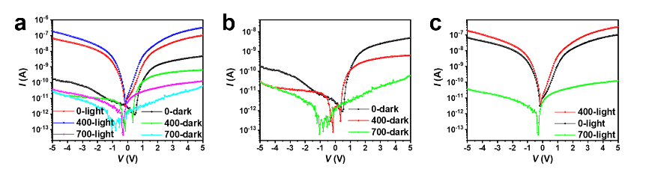
Fig. S5 I-V curves of Ga₂O₃ film devices were prepared without annealing, annealed at 400 ℃ in air, and annealed at 700 ℃ in air. a, Output characteristics of the Ga₂O₃ film devices in the dark and UV illumination. b, Dark current. c, Photocurrent
Fig. S6 Photoelectric performance of unannealed Ga₂O₃ film devices. a, Photoresponse I–V characteristic curves of the device. b, Noise current of the device. c, R and D* of the device on the light intensity. d, EQE
The definition formula is as follows:
$$\begin{aligned}\text{EQE = }\frac{\text{R h c}}{\text{q λ}}\text{\#}\end{aligned}$$
In this formula, h refers to Planck's constant, c is the speed of light, q is the elementary charge, and λ is the wavelength of the irradiated light. A higher EQE value in a photodetector signifies a greater efficiency in converting incoming photons into photo-charge carriers. The external quantum efficiency (EQE) of the non-annealed device, as illustrated in Fig. 6d, is 56498%.

Fig. S7 Photoelectric performance of Ga₂O₃ film device annealed at 400 ℃. a, Photoresponse I–V characteristic curves of the device. b, Noise current of the device. c, R and D* of the device on the light intensity. d, EQE
Fig. S8 Photoelectric performance of Ga₂O₃ film device annealed at 700 ℃. a, Photoresponse I–V characteristic curves of the device. b, Noise current of the device. c, R and D* of the device on the light intensity. d, EQE

Fig. S9 a, OM images of In₂Se₃ film before transfer. b, OM images of Ga₂O₃/In₂Se₃ heterojunction device

Fig. S10 Photoelectric performance of annealed at 400 ℃ Ga₂O₃/In₂Se₃ heterojunction device. a, Photoresponse I–V characteristic curves of the device. b, Noise current of the device. c, R and D* of the device on the light intensity. d, EQE
Fig. S11 Photoelectric performance of unannealed Ga₂O₃/In₂Se₃ heterojunction device. a, Photoresponse I–V characteristic curves of the device. b, Noise current of the device. c, R and D* of the device on the light intensity. d, EQE

Fig. S12 Photoelectric performance of Ga₂O₃ annealed at 700 ℃/In₂Se₃heterojunction device. a, Photoresponse I–V characteristic curves of the device. b, Noise current of the device. c, R and D* of the device on the light intensity. d, EQE

Fig. S13 Band alignment and the photogenerated carrier transport process under a, in initial state condition, and b, in polarization condition. c, Electric field distribution in the initial state simulated using COMSOL Multiphysics. d, Electric field distribution under polarized conditions simulated using COMSOL Multiphysics
Fig. S14 Transfer characteristics of the Ga₂O₃/In₂Se₃ heterojunction under various drain-source voltages

Fig. S15 I_{ds} – V_{ds} curves testing under different gate voltages before and after exposure to 255 nm UV light

Fig. S16 Noise current of the Ga₂O₃/In₂Se₃ heterojunction device at 5 V gate voltage
Fig. S17 a, Stability and reliability characteristics of the Fe-OES after 1200 s. b, Stability and reliability characteristics of the Fe-OES after 12h. c, Response time
Fig. S18 a, Stability and reliability characteristics of the Fe-OES after 10,000 seconds under a gate voltage of 20 V. b, Stability and reliability of the Fe-OES after 10,000 seconds of cyclic gate voltage sweeping between -20 V and 20 V

Fig. S19 Stability testing of the device under high humidity and varying temperature conditions

Fig. S20 a, Photocurrent and dark current at five distinct regions on the Ga₂O₃ film. b, The specific values of the photocurrent and dark current at 5 V on the Ga₂O₃ film. c, Photocurrent and dark current at five distinct regions on the Ga₂O₃/In₂Se₃ film. d, The specific values of the photocurrent and dark current at 5 V on the Ga₂O₃/In₂Se₃ film
Fig. S21 Transfer characteristic curves at five distinct regions on the Ga₂O₃/In₂Se₃ film
Fig. S22 a, Photograph of the as-grown In₂Se₃ thin films. b, Photocurrent and dark current at the edge and central regions of the Ga₂O₃/In₂Se₃ film. c, Transfer characteristic curves in the edge regions of the Ga₂O₃/In₂Se₃ film. d, Transfer characteristic curves in the central regions of the Ga₂O₃/In₂Se₃ film
Fig. S23 a, Optical micrograph of the as-grown In₂Se₃ films (the red box exhibits superior crystallinity, while the film with holes in the blue box shows inferior crystallinity). b, Photocurrent and dark current at different crystallinity of the Ga₂O₃/In₂Se₃ film. c, Transfer characteristic curves in the superior crystallinity regions of the Ga₂O₃/In₂Se₃ film. d, Transfer characteristic curves in the inferior crystallinity regions of the Ga₂O₃/In₂Se₃ film
Fig. S24 Field-effect transistor and hysteresis window at five distinct regions on the Ga₂O₃/In₂Se₃ film
Fig. S25 a, Schematic diagram of the signal processing circuit. b, Schematic diagram of the NB_IOT Communication Module. c, Physical diagram of the flame detection circuits
Fig. S26 Flame detector system based on Fe-OES. Flame alarm system in nighttime conditions. a, Flame alarm system. b, Flame ignition. c, Alarm of flame alarm system. Flame alarm system in daytime conditions. d, Flame alarm system. e, Flame ignition. f, Alarm of flame alarm system

Fig. S27 a, Flame detection system after the flame is extinguished. b, Flame detection system after the flame has been extinguished for 30 s

Fig. S28 Real-world flame tests conducted in an outdoor sunny environment. a, Tissue paper combustion. b, Cotton combustion. c, Branches and leaves combustion
Fig. S29 Distribution of photocurrent and dark current across the 5×5 Ga₂O₃/In₂Se₃ heterojunction array under 255 nm illumination (300 μW/cm²)

Fig. S30 Two-dimensional photocurrent mapping of the 5×5 Ga₂O₃/In₂Se₃ heterojunction array under 255 nm illumination (300 μW/cm²)
Fig. S31 a, PSC when optical pulses (15, 30, 150, and 300 μW/cm², 500 ms pulses) were applied to the device, exhibiting higher photocurrent with increased light intensity. b, PSC when optical pulses with increased illumination time (0.2, 0.5, and 1 s, 15 μW/cm2 pulses) were applied to the device, a more prominent slow response caused by slow traps is observed. c, Excitatory PSC induced by optical pulses (15 μW/cm², 1000 ms duration, 0.5 Hz frequency) under a 1 V bias

Fig. S32 a, Photoelectric synapse under a 200 ms single light pulse stimulation. b, Light response curves of two consecutive 200 ms light pulses, with an interval of 200 ms between the two consecutive light pulses. c, Response currents for photoelectric synapse under a 200 ms four consecutive light pulse stimulations
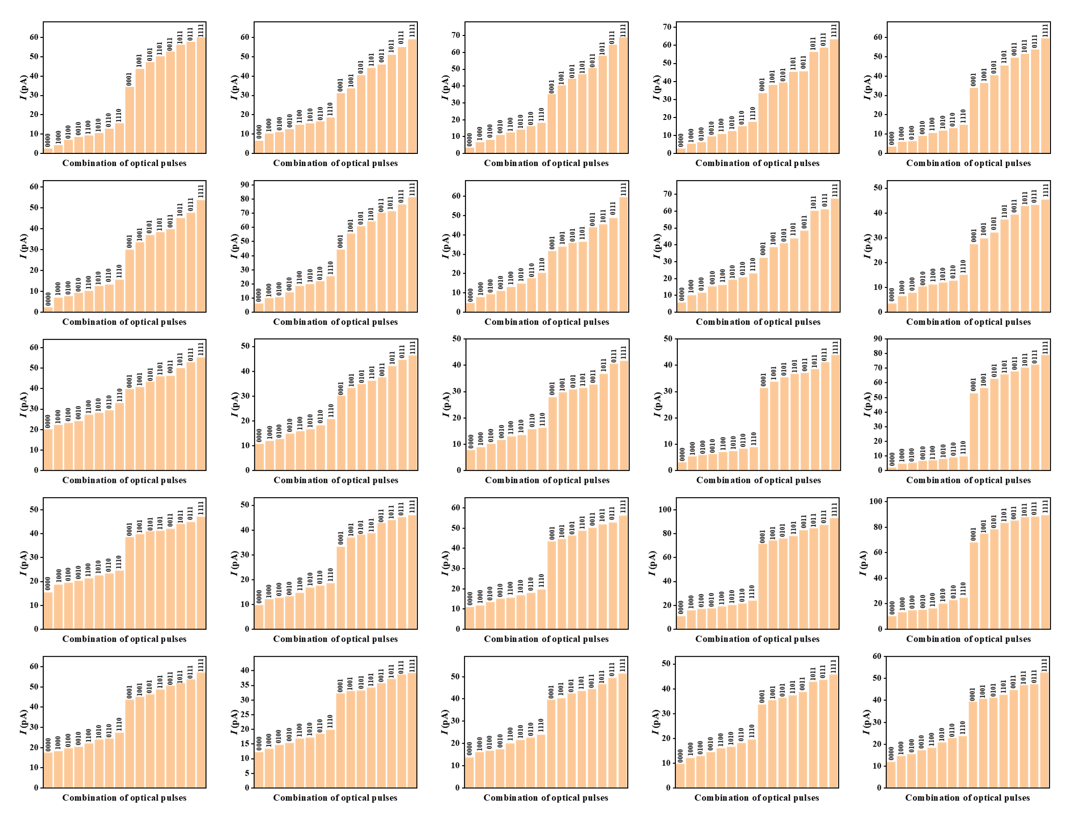
Fig. S33 Response of the 5×5 Ga₂O₃/In₂Se₃ heterojunction array to a four-pulse optical stimulus
Fig. S34 a, Confusion Matrix of Ga₂O₃/In₂Se₃-based sensors. b, Confusion Matrix of Ga₂O₃-based sensors
Fig. S35 Physical hardware implementation of the leaky integrate-and-fire (LIF) neuron
Fig. S36 a, 100 consecutive sweep cycles of the NbOₓ threshold switching device. b, Coefficient of variation (CV) of the switching parameters. c, Distribution of switching resistance over 100 operational cycles

Fig. S37 Schematic of input voltage, capacitance voltage and output voltage at different light intensities

Fig. S38 Schematic of input voltage, capacitor voltage and output voltage details at different light intensities
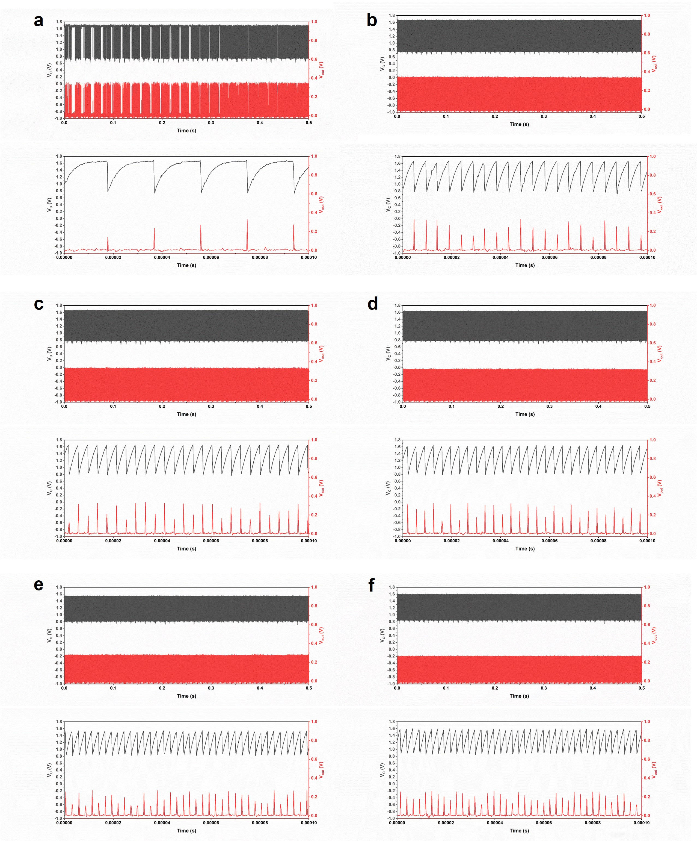
Fig. S39 Long-term stability of VC and Vout of the LIF neuron under different optical intensities (upper: full-range view; lower: magnified view). a, 120 μW/cm². b, 180 μW/cm². c, 240 μW/cm². d, 300 μW/cm². e, 450 μW/cm². f, 600 μW/cm²

Table 1 The specific effects of annealing treatments on Ga₂O₃ photodetectors
Mechanism | Specific effect | Refs.
Enhancement of crystalline quality | Reduction of dark current and enhancement of response speed | [S1]
Modulation of oxygen vacancies | Enhancement of responsivity and response speed | [S2]
Improvement of crystalline quality and reduction of oxygen vacancy defects | Enhancement of response speed with reduction of photocurrent and responsivity | [S3]
Significant suppression of oxygen vacancies | Reduction in responsivity and response speed | [S4]
Reduction of oxygen vacancy concentration | Reduction of dark current and enhancement of response speed | [S5]
Mechanisms of annealing
The trade-off between responsivity and response speed, known as the "Responsivity-Speed Dilemma" [S1], is particularly pronounced in wide-bandgap semiconductors. Ga₂O₃ photodetectors exhibit persistent photoconductivity (PPC) effect, a phenomenon where the conductivity of the detector persists long after the cessation of illumination. This phenomenon is primarily attributed to deep-level defects, such as oxygen vacancies (V_{O}), which trap photo-generated carriers can enhance non-radiative recombination and prolong the conductive state [S2, S3]. Furthermore, these defects contribute to higher dark current and inferior photodetection performance (e.g., low specific detectivity). Conversely, V_{O} can also temporarily trap electrons under illumination, influencing the photocurrent generation and consequently degrading the response speed [S4].
Therefore, modifying the intrinsic crystalline defects in Ga₂O₃ is crucial for enhancing device performance. Annealing engineering serves as a common strategy for this purpose. The specific effects of annealing treatments on Ga₂O₃ photodetectors, as reported in the literature, are summarized in Table 1. High-temperature annealing can effectively suppress intrinsic defects in Ga₂O₃, leading to devices with lower dark current and higher responsivity. This explains the significant performance improvement observed in the device annealed at 400°C. However, although annealing at even higher temperatures (e.g., 700 °C) leads to more pronounced defect suppression, it also results in a substantial reduction in photocurrent. This is because V_{O}, while suppressed, can still act as temporary electron traps under illumination, adversely affecting the overall photoelectronic performance. This mechanism accounts for the performance degradation observed in the sample annealed at 700°C compared to the one annealed at 400 °C.
Table 2 The comparison of responsivity and detectivity between Fe-OES and other reports
Device | I_{dark} (A) | PDCR | R (A/W) | D* (Jones) | LDR (db) | EQE (%) | Refs.
GaO_{X}  Ga₂O₃/MgO/Nb:STO  a-Ga₂O₃  Ga₂O₃/ZnO  TAPC/Ga₂O₃  IGZO-Ga₂O₃  PCDTBT/Ga₂O₃  Ga₂O₃/BFO  GaSe/β-Ga₂O₃  α-Ga₂O₃/polyaniline  α-Ga₂O₃  Ga₂O₃  ε-Ga₂O₃  In₂Se₃/α-Ga₂O₃ | 4.6×10⁻¹⁴(-10V)  2.2×10⁻¹²  3×10⁻¹³ (5V)  2.17×10⁻⁹  2×10⁻¹⁴ (0V)  1×10⁻¹⁰ (10V)  4.8×10⁻¹³  3.78×10⁻¹²  -  2.1×10⁻¹³  -  2×10⁻¹³ (15V)  3.34×10⁻⁹ (20V)  4.74×10⁻¹³ (1V) | 3×10⁸  -  3.9×10⁷  -  5.9×10⁵  -  -  1×10⁵  7.65×10⁴  -  -  1×10⁶  2.22×10⁷  2.63×10⁵ | 66.7  4.46×10⁴  733  2.49  1.4×10⁻³  284  187  0.012  52  8.2×10⁻³  1.65×10⁴  1.3  1.57×10⁴  118473 | 8×10¹⁵  5×10¹⁶  3.9×10¹⁶  1.98×10¹⁴  1.02×10¹³  5.06×10¹⁴  1.3×10¹⁶  6.1×10¹²  2.52×10¹⁴  6.63×10¹³  2.66×10¹⁶  1.46×10¹⁴  1.65×10¹⁶  4.91×10¹⁷ | -  81.9  -  -  -  -  -  -  -  -  -  -  -  100 | -  -  -  -  -  -  3.1×10⁴  0.34  2.54×10⁴  38.4  -  -  -  5.77×10⁷ | [S3]  [S6]  [S7]  [S8]  [S9]  [S10]  [S11]  [S12]  [S13]  [S14]  [S15]  [S16]  [S17]  This work
Table 3 Alarm response times for combustion tests of different materials
Material | Alarm time (s)
Tissue paper  Cotton  Branches/leaves | 6  20  3 | 6  13  3 | 11  5  4 | 24  6  3 | 20  4  5
Supplementary References
- X. Ma, Y. Zhang, P. Tan, X. Feng, Y. Hao et al., Alleviating trade-off between responsivity and response speed of Ga₂O₃ solar-blind photodetector via modulation of carrier redistribution and extraction accessibility. InfoMat 7(9), e70016 (2025). https://doi.org/10.1002/inf2.70016
- L. Luo, H. Huang, L. Yang, R. Hao, X. Hu et al., Ultra-fast gallium oxide solar-blind photodetector with novel thermal pulse treatment. Adv. Mater. 37(12), 2414130 (2025). https://doi.org/10.1002/adma.202414130
- X. Hou, X. Zhao, Y. Zhang, Z. Zhang, Y. Liu et al., High-performance harsh-environment-resistant GaOX solar-blind photodetectors via defect and doping engineering. Adv. Mater. 34(1), 2106923 (2022). https://doi.org/10.1002/adma.202106923
- T. Sheng, X.-Z. Liu, L.-X. Qian, B. Xu, Y.-Y. Zhang, Photoelectric properties of β-Ga₂O₃ thin films annealed at different conditions. Rare Met. 41(4), 1375–1379 (2022). https://doi.org/10.1007/s12598-015-0575-5
- C. Zhou, K. Liu, X. Chen, J. Feng, J. Yang et al., Performance improvement of amorphous Ga₂O₃ ultraviolet photodetector by annealing under oxygen atmosphere. J. Alloys Compd. 840, 155585 (2020). https://doi.org/10.1016/j.jallcom.2020.155585
- Q. Zhang, N. Li, T. Zhang, D. Dong, Y. Yang et al., Enhanced gain and detectivity of unipolar barrier solar blind avalanche photodetector via lattice and band engineering. Nat. Commun. 14(1), 418 (2023). https://doi.org/10.1038/s41467-023-36117-8
- Y. Qin, L.-H. Li, Z. Yu, F. Wu, D. Dong et al., Ultra-high performance amorphous Ga₂O₃ photodetector arrays for solar-blind imaging. Adv. Sci. 8(20), 2101106 (2021). https://doi.org/10.1002/advs.202101106
- H. Wang, J. Ma, H. Chen, L. Wang, P. Li et al., Ferroelectricity enhanced self-powered solar-blind UV photodetector based on Ga₂O₃/ZnO: V heterojunction. Mater. Today Phys. 30, 100929 (2023). https://doi.org/10.1016/j.mtphys.2022.100929
- C. Wu, F. Wu, C. Ma, S. Li, A. Liu et al., A general strategy to ultrasensitive Ga₂O₃ based self-powered solar-blind photodetectors. Mater. Today Phys. 23, 100643 (2022). https://doi.org/10.1016/j.mtphys.2022.100643
- S. Zhou, H. Zhang, X. Peng, H. Liu, H. Li et al., Fully transparent and high-performance ε-Ga₂O₃ photodetector arrays for solar-blind imaging and deep-ultraviolet communication. Adv. Photonics Res. 3(11), 2200192 (2022). https://doi.org/10.1002/adpr.202200192
- Y. Wang, Z. Lin, J. Ma, Y. Wu, H. Yuan et al., Multifunctional solar-blind ultraviolet photodetectors based on p-PCDTBT/n-Ga₂O₃ heterojunction with high photoresponse. InfoMat 6(2), e12503 (2024). https://doi.org/10.1002/inf2.12503
- G. Ma, W. Jiang, W. Sun, Z. Yan, B. Sun et al., A broadband UV-visible photodetector based on a Ga₂O₃/BFO heterojunction. Phys. Scr. 96(12), 125823 (2021). https://doi.org/10.1088/1402-4896/ac2758
- Y. Wang, Y. Tang, H. Li, Z. Yang, Q. Zhang et al., P-GaSe/n-Ga₂O₃ van der Waals heterostructure photodetector at solar-blind wavelengths with ultrahigh responsivity and detectivity. ACS Photonics 8(8), 2256–2264 (2021). https://doi.org/10.1021/acsphotonics.1c00015
- X.Y. Sun, X.H. Chen, J.G. Hao, Z.P. Wang, Y. Xu et al., A self-powered solar-blind photodetector based on polyaniline/α-Ga₂O₃ p–n heterojunction. Appl. Phys. Lett. 119(14), 141601 (2021). https://doi.org/10.1063/5.0059061
- Q. Zhang, D. Dong, T. Zhang, T. Zhou, Y. Yang et al., Over 5 × 103-fold enhancement of responsivity in Ga₂O₃-based solar blind photodetector via acousto–photoelectric coupling. ACS Nano 17(23), 24033–24041 (2023). https://doi.org/10.1021/acsnano.3c08938
- M. Ding, K. Liang, S. Yu, X. Zhao, H. Ren et al., Aqueous-printed Ga₂O₃ films for high-performance flexible and heat-resistant deep ultraviolet photodetector and array. Adv. Opt. Mater. 10(16), 2200512 (2022). https://doi.org/10.1002/adom.202200512
- W. Zhang, W. Wang, J. Wei, S. Xia, J. Zhang et al., Photocarrier transport reconstruction and dramatical performance enhancement in ultrawide-bandgap ε-Ga₂O₃ photodetectors via surface defect passivation. Mater. Today Phys. 38, 101280–101280 (2023). https://doi.org/10.1016/j.mtphys.2023.101280

Appendix
Code for CNN-motion flame
import os
import numpy as np
import tensorflow as tf
from tensorflow.keras import layers, models
import matplotlib.pyplot as plt
from sklearn.model_selection import train_test_split
from sklearn.metrics import confusion_matrix, classification_report
import pandas as pd
import time
import seaborn as sns

data_dir = r'E: \database_Tra_test'

def load_data(data_dir):
categories = ['up', 'down', 'left', 'right']
images = []
labels = []

for label, category in enumerate(categories):
category_path = os.path.join(data_dir, category)
for file in os.listdir(category_path):
img_path = os.path.join(category_path, file)
img = tf.keras.preprocessing.image.load_img(img_path, color_mode='grayscale', target_size=(50, 50))
img_array = tf.keras.preprocessing.image.img_to_array(img)
images.append(img_array)
labels.append(label)

images = np.array(images).reshape(-1, 50, 50, 1)
labels = np.array(labels)

return images, labels

def get_flops(model):
session = tf.compat.v1.Session()
graph = tf.compat.v1.get_default_graph()

with graph.as_default():
with session.as_default():
run_meta = tf.compat.v1.RunMetadata()
opts = tf.compat.v1.profiler.ProfileOptionBuilder.float_operation()

flops = tf.compat.v1.profiler.profile(
graph=graph,
run_meta=run_meta,
cmd='op',
options=opts)

return flops.total_float_ops

def analyze_energy_consumption(model, X_sample, training_time, num_epochs, num_train_samples):
try:
total_flops = get_flops(model)
print(f"ModleFLOPs: {total_flops:.2e}")

inference_flops_per_sample = total_flops

hardware_efficiency = xxx # hardware parameter

training_energy = (total_flops * num_epochs * num_train_samples) / hardware_efficiency

inference_energy_per_sample = inference_flops_per_sample / hardware_efficiency

except Exception as e:
print(f"FLOPs Calculation failed: {e}")
total_flops = None
training_energy = None
inference_energy_per_sample = None

avg_power = 50 # Watts
training_energy_time_based = avg_power * training_time # Joules

start_time = time.time()
model.predict(X_sample[np.newaxis,...])
inference_time = time.time() - start_time
inference_energy_time_based = avg_power * inference_time

return {
"flops": total_flops,
"training_energy_flops": training_energy,
"training_energy_time": training_energy_time_based,
"inference_time": inference_time,
"inference_energy": inference_energy_time_based
}

def plot_and_save_confusion_matrix(y_true, y_pred, classes, save_path):

cm = confusion_matrix(y_true, y_pred)

cm_df = pd.DataFrame(cm, index=classes, columns=classes)

cm_excel_path = os.path.join(save_path, 'confusion_matrix.xlsx')
cm_df.to_excel(cm_excel_path)
print(f" The confusion matrix has been saved to: {cm_excel_path}")

report = classification_report(y_true, y_pred, target_names=classes, output_dict=True)
report_df = pd.DataFrame(report).transpose()

report_path = os.path.join(save_path, 'classification_report.xlsx')
report_df.to_excel(report_path)
print(f" The classification report has been saved to: {report_path}")

plt.Fig.(figsize=(10, 8))
sns.heatmap(cm, annot=True, fmt='d', cmap='Blues',
xticklabels=classes, yticklabels=classes)
plt.title('Confusion Matrix')
plt.ylabel('True Label')
plt.xlabel('Predicted Label')

cm_image_path = os.path.join(save_path, 'confusion_matrix.png')
plt.savefig(cm_image_path, dpi=300, bbox_inches='tight')
print(f" The confusion matrix image has been saved to: {cm_image_path}")
plt.show()

return cm_df, report_df

images, labels = load_data(data_dir)

X_train, X_test, y_train, y_test = train_test_split(images, labels, test_size=0.3, random_state=4)

model = models.Sequential([
layers.Conv2D(8, (2, 2), activation='relu', input_shape=(50, 50, 1)),
layers.MaxPooling2D((2, 2)),
layers.Flatten(),
layers.Dense(64, activation='relu'),
layers.Dense(4, activation='softmax')
])

model.compile(optimizer='adam', loss='sparse_categorical_crossentropy', metrics=['accuracy'])

model.summary()

start_time = time.time()

history = model.fit(X_train, y_train, epochs=20, validation_data=(X_test, y_test))

training_time = time.time() - start_time
print(f" Training time: {training_time:.2f} seconds")

energy_results = analyze_energy_consumption(
model,
X_test[0],
training_time,
num_epochs=20,
num_train_samples=len(X_train)
)

plt.Fig.(figsize=(12, 4))

plt.subplot(1, 2, 1)
plt.plot(history.history['loss'], label='Training Loss')
plt.plot(history.history['val_loss'], label='Validation Loss')
plt.legend()
plt.title('Loss')

plt.subplot(1, 2, 2)
plt.plot(history.history['accuracy'], label='Training Accuracy')
plt.plot(history.history['val_accuracy'], label='Validation Accuracy')
plt.legend()
plt.title('Accuracy')

plt.show()

model.save('E:\\model\\flame_direction_model_conventional.h5')

test_loss, test_acc = model.evaluate(X_test, y_test)
print(f'Test accuracy: {test_acc}')

y_pred = model.predict(X_test)
y_pred_classes = np.argmax(y_pred, axis=1)

class_names = ['up', 'down', 'left', 'right']

results_dir = r'E:\results'
os.makedirs(results_dir, exist_ok=True)

cm_df, report_df = plot_and_save_confusion_matrix(y_test, y_pred_classes, class_names, results_dir)

train_acc = history.history['accuracy']
val_acc = history.history['val_accuracy']

accuracy_data = pd.DataFrame({
'Epoch': range(1, len(train_acc) + 1),
'Training Accuracy': train_acc,
'Validation Accuracy': val_acc
})

energy_data = pd.DataFrame({
'Metric': [
'Training Time',
'Training Energy (Time-based)',
'Inference Time per sample',
'Inference Energy per sample (Time-based)'
],
'Value': [
training_time,
energy_results['training_energy_time'],
energy_results['inference_time'],
energy_results['inference_energy']
],
'Unit': ['Seconds', 'Joules', 'Seconds', 'Joules']
})

if energy_results['flops'] is not None:
flops_data = pd.DataFrame({
'Metric': ['Total FLOPs', 'Training Energy (FLOPs-based)'],
'Value': [energy_results['flops'], energy_results['training_energy_flops']],
'Unit': ['FLOPs', 'Joules']
})
energy_data = pd.concat([energy_data, flops_data], ignore_index=True)

output_path = os.path.join(results_dir, 'accuracy_data.xlsx')
accuracy_data.to_excel(output_path, index=False)

energy_output_path = os.path.join(results_dir, 'energy_analysis.xlsx')
energy_data.to_excel(energy_output_path, index=False)

print(f'Accuracy data successfully saved to {output_path}')
print(f'Energy analysis data successfully saved to {energy_output_path}')

print("\n=== Model Performance Summary ===")
print(f" Test accuracy: {test_acc:.4f}")
print(f" Training time: {training_time:.2f} seconds")
print(f" Single inference time: {energy_results['inference_time']:.6f} seconds")
print(f" Single inference energy consumption: {energy_results['inference_energy']:.6f} Joule")

Code for simulation of SNN
import time
import torch
import torchvision
import torchvision.transforms as transforms
import torch.utils.data
import torch.nn as nn
import torch.nn.functional as F
import torch.optim as optim
import numpy as np
import pandas as pd
from spikingjelly.activation_based import neuron, functional, layer

class CustomFrequencyEncoder(nn.Module):
def __init__(self, A1, t1, y0, T_steps):
super(CustomFrequencyEncoder, self).__init__()
self.A1 = A1
self.t1 = t1
self.y0 = y0
self.T_steps = T_steps

def encode(self, inputs):
inputs_normalized = inputs.view(-1)
frequency = self.A1 * torch.exp(-inputs_normalized / self.t1) + self.y0
frequency = torch.clamp(frequency, min=0.01, max=1.0)
frequency = frequency.view(inputs.shape)
spike_train = torch.rand_like(inputs).le(frequency.unsqueeze(0).expand(self.T_steps, *inputs.shape)).float()
return spike_train

transform = transforms.Compose([transforms.ToTensor()])
trainset = torchvision.datasets.MNIST(root='../mnist', train=True, download=False, transform=transform)
trainloader = torch.utils.data.DataLoader(trainset, batch_size=256, shuffle=True, num_workers=0)
testset = torchvision.datasets.MNIST(root='../mnist', train=False, download=False, transform=transform)
testloader = torch.utils.data.DataLoader(testset, batch_size=256, shuffle=False, num_workers=0)

net = nn.Sequential(
layer.Flatten(start_dim=1),
layer.Linear(28 * 28, 128, bias=False),
neuron.LIFNode(tau=2.0),
layer.Linear(128, 10, bias=False),
neuron.LIFNode(tau=2.0)
)

functional.set_step_mode(net, step_mode='m')

criterion = nn.MSELoss()
optimizer = optim.Adam(net.parameters())
encoder = CustomFrequencyEncoder(A1=-0.53087, t1=0.73155, y0=0.52776, T_steps=50)

epoch_loss = []
train_acc = []
test_acc = []

all_spikes = []
all_labels = []

start = time.time()
for epoch in range(30):
running_loss = 0.0
train_correct = 0
train_total = 0

for i, data in enumerate(trainloader, 0):
inputs, labels = data
labels_onehot = F.one_hot(labels, 10).float()
inputs_spks_Time = encoder.encode(inputs)

optimizer.zero_grad()

outputs_spks_Time = net(inputs_spks_Time)
for t in range(50):
if t == 0:
out_spikes_counter = outputs_spks_Time[0]
else:
out_spikes_counter += outputs_spks_Time[t]
out_spikes_counter_frequency = out_spikes_counter / 50

loss = criterion(out_spikes_counter_frequency, labels_onehot)
loss.backward()
optimizer.step()
functional.reset_net(net)

running_loss += loss.item()
train_correct += (out_spikes_counter_frequency.argmax(-1) == labels).sum().item()
train_total += labels.size(0)

epoch_loss.append(running_loss / len(trainloader))
train_acc.append(train_correct / train_total)

net.eval()
test_correct = 0
test_total = 0
with torch.no_grad():
for inputs, labels in testloader:
labels_onehot = F.one_hot(labels, 10).float()
inputs_spks_Time = encoder.encode(inputs)
outputs_spks_Time = net(inputs_spks_Time)

out_spikes_counter = sum(outputs_spks_Time[t] for t in range(50))
out_spikes_counter_frequency = (out_spikes_counter / 50).cpu().numpy()

test_correct += (out_spikes_counter_frequency.argmax(-1) == labels.numpy()).sum()
test_total += labels.size(0)

all_spikes.append(out_spikes_counter_frequency)
all_labels.append(labels.cpu().numpy())

functional.reset_net(net)
test_acc.append(test_correct / test_total)
net.train()

print(f'Epoch [{epoch+1}/30], Loss: {epoch_loss[-1]:.4f}, Train Acc: {train_acc[-1]:.4f}, Test Acc: {test_acc[-1]:.4f}')

label_spikes_mean = np.zeros((10, 10))
label_counts = np.zeros(10)

for i in range(len(all_labels)):
for label, spikes in zip(all_labels[i], all_spikes[i]):
label_spikes_mean[label] += spikes
label_counts[label] += 1

label_spikes_mean /= label_counts[:, None]

label_spikes_df = pd.DataFrame(label_spikes_mean, columns=[f"Neuron {i}" for i in range(10)])
label_spikes_df.index = [f"Label {i}" for i in range(10)]
label_spikes_df.to_csv("label_spikes_mean.csv", index=True)
print("Saved: label_spikes_mean.csv")

flat_spikes = np.concatenate(all_spikes, axis=0)
flat_labels = np.concatenate(all_labels, axis=0)

spikes_df = pd.DataFrame(flat_spikes, columns=[f"Neuron {i}" for i in range(10)])
spikes_df["Label"] = flat_labels
spikes_df.to_csv("spike_results.csv", index=False)
print("Saved: spike_results.csv")

accuracy_df = pd.DataFrame({
"Epoch": list(range(1, 31)),
"Train Accuracy": train_acc,
"Test Accuracy": test_acc
})
accuracy_df.to_csv("accuracy_results.csv", index=False)
print("Saved: accuracy_results.csv")

