Supporting Information for
Decoding Hydrogen-Bond Network of Electrolyte for Cryogenic Durable Aqueous Zinc-Ion Batteries
Xiyan Wei^{1,2,4}#, Jinpeng Guan^{1,2,4}#, Yongbiao Mu^{1,2}*, Yuhan Zou³, Xianbin Wei⁵, Lin Yang^{1,2}, Quanyan Man^{1,2}, Chao Yang⁴, Limin Zang⁴*, Jingyu Sun³*, and Lin Zeng^{1,2}*
¹Shenzhen Key Laboratory of Advanced Energy Storage, Department of Mechanical and Energy Engineering, Southern University of Science and Technology, Shenzhen 518055, P. R. China
²SUSTech Energy Institute for Carbon Neutrality, Southern University of Science and Technology, Shenzhen 518055, P. R. China
³College of Energy, Soochow Institute for Energy and Materials Innovations, Key Laboratory of Advanced Carbon Materials and Wearable Energy Technologies of Jiangsu Province, Soochow University, Suzhou 215006, P. R. China
⁴MOE Key Laboratory of New Processing Technology for Nonferrous Metal and Materials, Key Laboratory of Natural and Biomedical Polymer Materials (Education Department of Guangxi Zhuang Autonomous Region), College of Materials science and Engineering, Guilin University of Technology, Guilin 541004, P. R. China
⁵Department of Materials Science and Engineering, Southern University of Science and Technology, Shenzhen 518055, P. R. China
# Xiyan Wei and Jinpeng Guan contributed equally to this work.
*Corresponding authors. E-mail: muyb2021@mail.sustech.edu.cn (Yongbiao Mu); 2016034@glut.edu.cn (Limin Zang); sunjy86@suda.edu.cn (Jingyu Sun); zengl3@sustech.edu.cn (Lin Zeng)
S1 Experimental Section
S1.1 Materials
Zinc (Zn) foils (99.99%, 10 µm and 100 µm thickness) and titanium (Ti) foils (99.99%, 10 µm thickness) were purchased from Shenzhen Kejing Star Technology Co., Ltd. N-methyl-2-pyrrolidone (NMP), vanadium dioxide (VO₂), and zinc sulfate heptahydrate (ZnSO₄·7H₂O) were obtained from Shanghai Macklin Biochemical Co., Ltd. Super P conductive carbon black was supplied by Jiangsu Shenzhou Carbon Co., Ltd. Methylsulfonamide (MSA) and glycerol (GL) were procured from Shanghai Aladdin Biochemical Technology Co., Ltd. All chemicals and materials used were of analytical grade and were utilized without any further purification.
S1.2 Electrolyte Preparation
The 2 M ZnSO₄ (ZSO) electrolyte was prepared by dissolving ZnSO₄·7H₂O in deionized water using a 100 mL volumetric flask. The ZW_{a}G_{b}M_{c} electrolytes were formulated by mixing ZnSO₄·7H₂O, deionized water, GL, and MSA. Initially, GL and deionized water were combined in volume ratios of 1:9, 2:8, 3:7, 4:6, and 5:5. Subsequently, ZnSO₄·7H₂O and MSA at various concentrations were added to the mixture, followed by continuous stirring until a homogeneous electrolyte solution was obtained.
S1.3 Materials Characterizations
The morphologies of the samples were examined using a Hitachi SU-8230 field-emission scanning electron microscope (FE-SEM). Transmission electron microscopy (TEM), energy-dispersive X-ray spectroscopy (EDX), and elemental mapping were carried out on a Thermo Fisher Talos microscope operated at an acceleration voltage of 300 kV. X-ray photoelectron spectroscopy (XPS) was conducted using a Thermo Scientific ESCALAB 250Xi system with an Al Kα radiation source (hν=1,486.8 eV). Raman spectra were collected using a HORIBA LabRAM HR Evolution spectrometer with a 532 nm laser as the excitation source. X-ray diffraction (XRD) patterns were recorded on a Bruker D8 Advance diffractometer equipped with a D/Tex Ultra detector and Cu-Kα radiation, operated at a scan rate of 5°/min, to analyze the crystalline structure of the samples.
S1.4 In Situ Optical Microscope Characterization
The cells for in situ optical microscopy observations were assembled using molds purchased from Beijing Scistar Technology Co., Ltd. Both the working and counter electrodes consisted of Zn metal. The electrolytes employed were ZSO and ZW₅G₅M₁ An electrochemical workstation was used to supply the power, with a constant current density of 10 mA/cm² applied during the experiments.
S1.5 Electrochemical Performance Assessment
Zn||Zn symmetric cells were assembled by sandwiching a glass fiber separator (Whatman GF/D) between commercial Zn plates (10 mm in diameter) in CR2025-type coin cells, which were filled with 70 μL of the respective electrolytes. Zn||Ti half-cells were assembled using Zn plates (10 mm in diameter) as the anode, Ti foils (16 mm in diameter) as the cathode, and GF/D glass fiber as separators. These cells were also assembled in CR2025-type coin cells and filled with 70 μL of different electrolytes. Zn||VO₂ full cells were fabricated using Zn plates (14 mm in diameter) as the anode and VO₂ electrodes (12 mm in diameter) as the cathode, with 80 μL of either ZSO or ZW₅G₅M₁ electrolytes. The VO₂ cathode was prepared by mixing VO₂, Super P carbon black, and PVDF binder in a mass ratio of 8:1:1, using NMP as the solvent. The slurry was stirred for 12 h, cast onto Ti foil, and dried at 70℃. The VO₂ loading was ranged from 0.5 mg to 1.5 mg per electrode.
For pouch cell assembly, Zn plates (40 mm × 30 mm) were used as the anode, and VO₂ electrodes (25 mm × 35 mm) were used as the cathode. The pouch cells were filled with 300 μL of ZW₅G₅M₁ electrolyte. Nickel strips were attached to both electrodes using conductive tape. The cell stack, consisting of cathode, separator, and anode, was enclosed in an aluminum-plastic film, which was heat-sealed to ensure proper encapsulation. An additional 300 μL of electrolyte was injected into the sealed cell.
To evaluate the electrochemical performance and coulombic efficiency (CE) of Zn plating/stripping, Zn||Ti asymmetric cells were tested using a Neware battery test system (Shenzhen, China) at 30℃ with ZSO and ZW₅G₅M₁ electrolytes. For CE measurements, 1 mAh/cm² of Zn was plated onto Ti foil and subsequently stripped to 0.6 V in each cycle under current densities of 10 mA/cm².
Cycling stability and voltage hysteresis were evaluated using Zn||Zn symmetric cells tested at various current densities (1-60 mA/cm²) with a fixed Zn deposition capacity of 0.25-5 mAh/cm². Electrochemical impedance spectroscopy (EIS) was performed on a CHI760d electrochemical workstation (CH Instruments, Shanghai, China) over a frequency range of 100 kHz to 100 mHz.
Chronoamperometry (CA) measurements were conducted under a fixed overpotential of 0.15 V. Cyclic voltammetry (CV) tests were performed on Zn||Ti cells in both ZSO and ZW₅G₅M₁ electrolytes over a voltage range of 1 V to -0.3 V at a scan rate of 1 mV/s. Linear sweep voltammetry (LSV) was carried out using Zn||Zn symmetric cells in ZSO and ZW₅G₅M₁ electrolytes at a scan rate of 1 mV/s.
S1.6 Related calculations method
We calculated the ionic conductivity of the electrolyte using Equation S1:
$$\begin{aligned}δ=\frac{L}{R_{S}A}\#\left(S1\right)\end{aligned}$$
where $δ$ represents the ionic conductivity, Rs signifies the electrolyte impedance, A denotes the contact area of the Zn sheet (diameter is 10 mm), and L indicates the distance of the separator (210 μm) immersed in the electrolytes.
Utilizing the Arrhenius equation (Equation S2) to calculate the activation energy:
$$\begin{aligned}\frac{1}{R_{ct}}=Ae^{-\frac{E_{a}}{RT}}\#\left(S2\right)\end{aligned}$$
where Rct, A, R, and T denote the charge transfer impedance, frequency factor, gas constant, and absolute temperature respectively.
The second law of thermodynamics:
$$\begin{aligned}∆G=∆H-T∆S\#(S3)\end{aligned}$$
where ∆H, T, ∆S denote the enthalpy, temperature, and entropy of the system respectively.
The Equation to calculate the configurational entropy (S_{conf}):
$$\begin{aligned}S_{conf}=-R\sum_{i=1}^{n}{x_{i}lnx_{i}}\#（S4）\end{aligned}$$
where R is the ideal gas constant, and x_{i} is the molar fraction of the ith component.
S1.7 DFT and MD calculation method
Classical molecular dynamics (MD) simulations were conducted to investigate the mixed electrolytes at the atomic scale. One bulk model (System1) was constructed for these simulations. System1 comprises 200 Zn²⁺ ions, 200 SO₄²⁻ ions, 100 methylsulfonamide (MSA) molecules, and 431 glycerol (GL) molecules. The initial configuration of the system was generated using the PACKMOL software, with all species randomly placed within a cubic simulation box.
The partial charges of all molecules were calculated using the Gaussian 16 software package, employing the 6-311G (d,p) basis set. Due to the high concentration of zinc sulfate in the system, the charges of the Zn²⁺ and SO₄²⁻ ions were scaled by a factor of 0.8 to account for overestimated electrostatic interactions.
The OPLS-AA force field was applied to describe the interactions of ZnSO₄ and the target organic molecules, while the TIP3P model was used for water molecules. The molecular force field includes both bonded and non-bonded interactions. The non-bonded interactions consist of van der Waals (vdW) forces and electrostatic interactions, which are represented by Equations (S5) and (S6), respectively.
$$\begin{aligned}E_{LJ}\left(r_{ij}\right)=4ε_{ij}\left({\left(\frac{{\text{σ}}_{ij}}{r_{ij}}\right)}^{12}-{\left(\frac{{\text{σ}}_{ij}}{r_{ij}}\right)}^{6}\right)\#\left(S5\right)\end{aligned}$$
$$\begin{aligned}E_{c}\left(r_{ij}\right)=\frac{q_{i}q_{j}}{4πε_{o}ε_{r}r_{ij}}\#\left(S6\right)\end{aligned}$$
In the equation, $q_{i}$、$q_{j}$ are atomic charge, $r_{ij}$is the distance between atoms, $\text{σ}$ is the atomic diameter, $ε$ is the atomic energy parameter.
For different kinds of atoms, the Lorentz-Berthelot mix rules were adopted for vdW interactions, which follows the Equation 4. The cutoff distance of vdW and electronic interactions was set to 1.2 nm, and the PME method was employed to calculate long-range electrostatic interactions.
$$\begin{aligned}σ_{ij}=\frac{1}{2\left(σ_{ii}+σ_{jj}\right)};ε_{ij}={\left(ε_{ii}*ε_{jj}\right)}^{\frac{1}{2}}\#\left(S7\right)\end{aligned}$$
For the MD simulations, energy minimization was first conducted to relax the initial structure of the simulation box. Subsequently, an isothermal-isobaric (NPT) ensemble was employed with a time step of 1.0 fs to further optimize the simulation box, maintaining the temperature at 298.15 K and the pressure at 1.0 atm. Temperature and pressure were regulated using the Nosé-Hoover thermostat and the Parrinello-Rahman barostat, respectively. The duration of the NPT equilibration was set to 20.0 ns, which is sufficient to achieve a stable box size.Throughout all MD simulations, atomic motion was governed by classical Newtonian mechanics, and the equations of motion were integrated using the velocity-Verlet algorithm. All MD simulations were performed using the GROMACS 2021.5 software package.
Density functional theory (DFT) calculations for water, salt, and target molecules were carried out using the Gaussian software. Geometry optimizations were conducted using the PBE1PBE functional. Implicit solvation effects were accounted for using the solvation model based on density (SMD). Molecular structures were visualized with Visual Molecular Dynamics (VMD). The binding energy (𝐸_{Binding}) of the complexes was calculated according to the following equation:
$$\begin{aligned}E_{Binding}=E_{complexe1-complexe2}-E_{complexe1}-E_{complexe2}\#\left(S8\right)\end{aligned}$$
where$E_{complexe1-complexe2}$ represents the total energy of the $complexe1$ interacting $complexe2$. $E_{complexe1}$ is the energy of the $complexe1$, and $E_{complexe2}$ is the energy of the $complexe2$.
S1.8 Vienna ab initio Simulation (VASP) calculation method
Unless otherwise specified, all quantum chemical calculations were performed using the Gaussian 16 A.03 software package. The geometries of all molecules were fully optimized at the B3LYP [S1] level of theory with Grimme’s D3 (BJ) empirical dispersion correction, denoted as B3LYP-D3 (BJ), in conjunction with the 6-311+G** basis set. Frequency analyses were conducted at the same level of theory to confirm the nature of the stationary points and to ensure the absence of imaginary frequencies, thereby validating the optimized structures as true minima. All geometry optimizations were carried out in the aqueous phase using the polarizable continuum model (PCM) without imposing any structural constraints.
Binding energy (ΔE) calculations were performed at the PWPB95-D3(BJ)/def2-QZVPP level using the ORCA 5.0.4 software package, incorporating the solvation model based on solute electron density (SMD) to account for solvent effects in water. Wavefunction analyses were conducted using the Multiwfn program. Selected isosurface maps were visualized with the Visual Molecular Dynamics (VMD) software, based on output files generated by Multiwfn.
Supplementary Figures and Tables
Fig. S1 The electrostatic potential a) MSA and b) GL

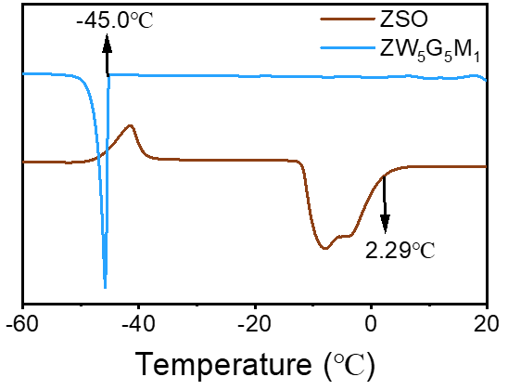
Fig. S2 DSC of different electrolytes
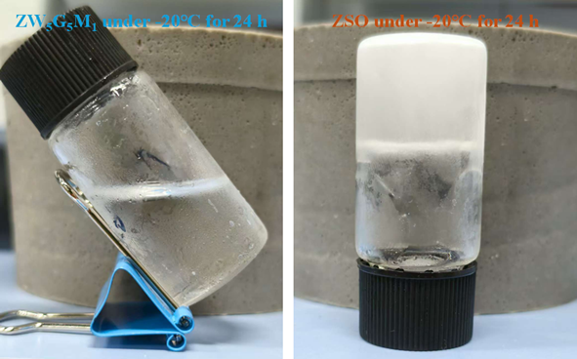
Fig. S3 The optical images of electrolytes after 24 h of standing at -20°C

Fig. S4 Adsorption energies of a) GL, b) MSA, and c) H₂O on the Zn (101) crystal surface

Fig. S5 Coordination numbers of components in the Zn²⁺ solvation structure

Fig. S6 Impedance of SS||SS cells assembled with ZW₅G₅M₁ and ZSO electrolytes at different temperatures

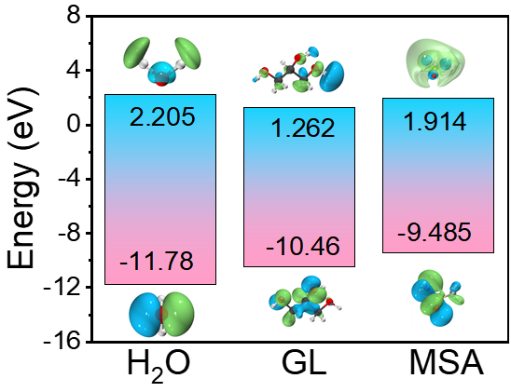
Fig. S7 HOMO and LUMO values of H₂O, GL, and MSA

Fig. S8 Tafel of Zn||Zn symmetric cells assembled with different electrolytes
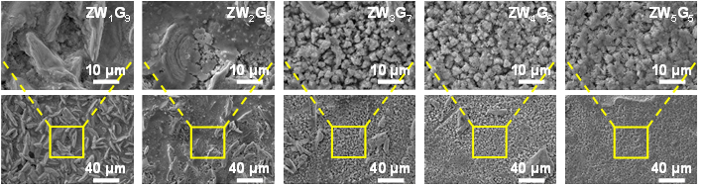
Fig. S9 SEM of Zn deposited in electrolytes with different GL contents
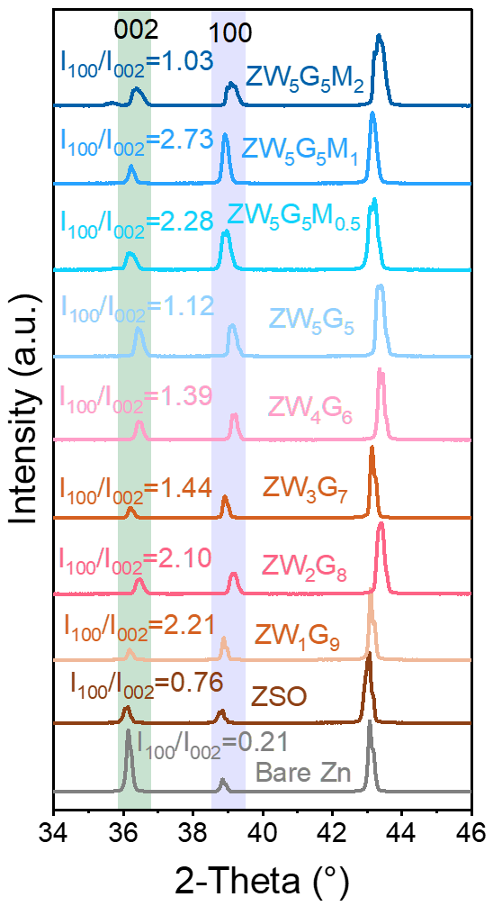
Fig. S10 XRD of Zn anode after cycling with different electrolytes

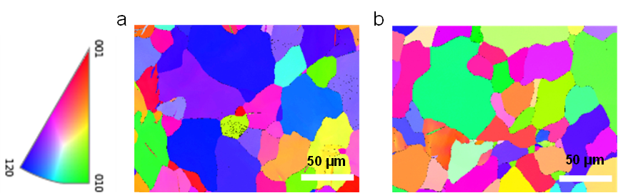
Fig. S11 EBSD image of Zn anode after cycling with (a) ZW₅G₅M₁, (b) ZSO electrolyte

Fig. S12 a) High magnification and b) low magnification SEM of Zn anode deposited for different times in ZW₅G₅M₁ electrolyte
Fig. S13 a) CV curves of Zn||Ti cells assembled with different electrolytes. b) CV curves of Zn||Ti batteries assembled with ZSO and ZW₅G₅M₁ electrolytes
Fig. S14 Rate performance of Zn||Zn symmetric cells assembled with different electrolytes
Fig. S15 Rate performance of Zn||Zn symmetric cells assembled with ZW₅G₅M₁ electrolyte under different temperature

Fig. S16 The long cycle performance of Zn||Zn symmetric cell at -20℃ with current densities of 0.25 mA/cm² and 0.25 mAh/cm²

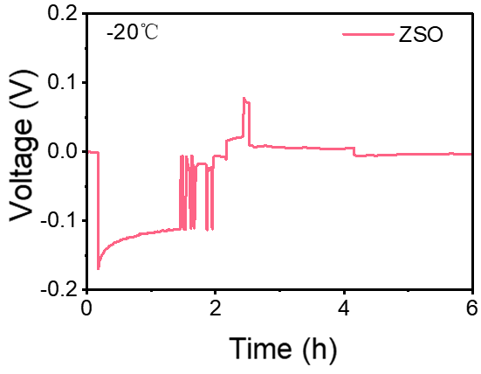
Fig. S17 Zn||Zn symmetric cell assembled with ZSO electrolyte cannot operate at -20 ℃

Fig. S18 CCD test of Zn||Zn symmetric cell with ZW5G5M1 electrolyte at -20 ℃
Fig. S19 a) Coulombic efficiency of Zn||Ti batteries assembled with ZW₅G₅M₁ electrolyte at -20°C. b) Charge-discharge curves of Zn||Ti batteries assembled with ZW₅G₅M₁ electrolyte at -20 °C
Fig. S20 CV curves of Zn||VO₂ batteries assembled with ZSO electrolyte

Fig. S21 Charge-discharge curves of Zn||VO₂ full cells assembled with ZW₅G₅M₁ electrolyte

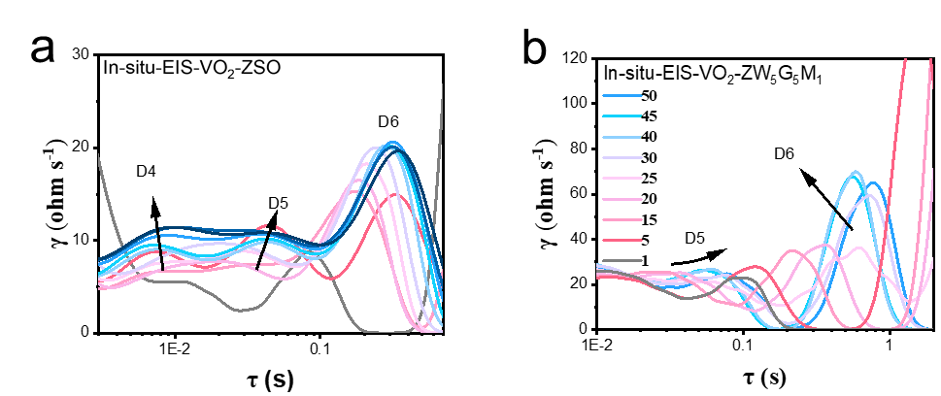
Fig. S22 DRT curves of Zn||VO₂ cells assembled with a-b) ZSO and c-d) ZW₅G₅M₁ electrolytes

Fig. S23 Charge-discharge curves of Zn||VO₂ full cells assembled with a) ZW₅G₅M₁ electrolyte and b) ZSO electrolyte
Fig. S24 Charge-discharge curves of Zn||VO₂ full cells assembled with a) ZSO electrolyte and b) ZW₅G₅M₁ electrolyte
Table S1 Performance comparison of Zn||Zn symmetric cells assembled with different electrolytes
Electrolyte | Temperature (℃) | Current (mA/cm²) | Time (h) | Refs.
ZSO+GL+MSA | 30 | 1 | 4,000 | This work
ZSO+GL+MSA | -20 | 0.5 | 5,400 | This work
L-cysteine+ZSO | -20 | 1 | 4,000 | [S2]
L-cysteine+ZSO | 30 | 5 | 700 | [S2]
ethylene glycol+ZSO | -20 | 2 | 80 | [S3]
ethylene glycol+ZSO | 20 | 2 | 150 | [S3]
γ-valerolactone+Zn(OTf)₂ | 30 | 1 | 2,500 | [S4]
γ-valerolactone+Zn(OTf)₂ | -25 | 0.5 | 1,000 | [S4]
N,N-dimethylformamide+ZSO | 30 | 1 | 2,500 | [S5]
N,N-dimethylformamide+ZSO | -20 | 0.5 | 2,000 | [S5]
Tetrahydrofuran+ Zn(OTf)₂ | 30 | 1 | 2,800 | [S6]
Tetrahydrofuran+ Zn(OTf)₂ | -10 | 1 | 4,000 | [S6]
ZSO+DMSO | 30 | 1 | 2,100 | [S7]
ZSO+DMSO | -20 | 0.5 | 1,200 | [S7]
Zn(OTf)₂+PEGDME | 25 | 1 | 2,000 | [S8]
Zn(OTf)₂+PEGDME | 0 | 1 | 2,000 | [S8]
ZSO+CH₃COONH₄ | 30 | 2 | 2,400 | [S9]
ZSO+CH₃COONH₄ | -10 | 0.5 | 900 | [S9]
Zn(ClO4)₂+ACN | 25 | 1 | 1,000 | [S10]
Zn(ClO4)₂+ACN | -20 | 1 | 1,000 | [S10]
Zn(OTf)₂+PEG | 20 | 1 | 1,000 | [S11]
Zn(OTf)₂+PEG | -20 | 0.2 | 1,000 | [S11]
Zn(OTf)₂/H₂O-AN | -20 | 1 | 500 | [S12]
ZS0+GL+AN | 25 | 0.2 | 3,000 | [S13]
ZS0+GL+AN | -20 | 0.2 | 500 | [S13]
1,3-dioxolane+ ZnCl₂ | 20 | 1 | 800 | [S14]
1,3-dioxolane+ ZnCl₂ | -20 | 5 | 1,000 | [S14]
Supplementary References
- P.J. Stephens, F.J. Devlin, C.F. Chabalowski, M.J. Frisch, Ab initio calculation of vibrational absorption and circular dichroism spectra using density functional force fields. J. Phys. Chem. 98(45), 11623–11627 (1994). https://doi.org/10.1021/j100096a001
- W. Song, X. Xie, L. Deng, A. Pan, G. Cao et al., Reversible uniform and fine deposition stabilizing zinc anode at low temperature. Energy Storage Mater. 70, 103489 (2024). https://doi.org/10.1016/j.ensm.2024.103489
- N. Chang, T. Li, R. Li, S. Wang, Y. Yin et al., An aqueous hybrid electrolyte for low-temperature zinc-based energy storage devices. Energy Environ. Sci. 13(10), 3527–3535 (2020). https://doi.org/10.1039/d0ee01538e
- C. Xie, S. Liu, W. Zhang, H. Ji, S. Chu et al., Robust and wide temperature-range zinc metal batteries with unique electrolyte and substrate design. Angew. Chem. Int. Ed. 62(28), e202304259 (2023). https://doi.org/10.1002/anie.202304259
- P. Xiong, Y. Kang, N. Yao, X. Chen, H. Mao et al., Zn-ion transporting, in situ formed robust solid electrolyte interphase for stable zinc metal anodes over a wide temperature range. ACS Energy Lett. 8(3), 1613–1625 (2023). https://doi.org/10.1021/acsenergylett.3c00154
- S. You, Q. Deng, Z. Wang, Y. Chu, Y. Xu et al., Achieving highly stable Zn metal anodes at low temperature via regulating electrolyte solvation structure. Adv. Mater. 36(26), 2402245 (2024). https://doi.org/10.1002/adma.202402245
- D. Feng, F. Cao, L. Hou, T. Li, Y. Jiao et al., Immunizing aqueous Zn batteries against dendrite formation and side reactions at various temperatures via electrolyte additives. Small 17(42), 2103195 (2021). https://doi.org/10.1002/smll.202103195
- Z. Hou, Z. Lu, Q. Chen, B. Zhang, Realizing wide-temperature Zn metal anodes through concurrent interface stability regulation and solvation structure modulation. Energy Storage Mater. 42, 517–525 (2021). https://doi.org/10.1016/j.ensm.2021.08.011
- C. Lin, X. Yang, P. Xiong, H. Lin, L. He et al., High-rate, large capacity, and long life dendrite-free Zn metal anode enabled by trifunctional electrolyte additive with a wide temperature range. Adv. Sci. 9(21), 2201433 (2022). https://doi.org/10.1002/advs.202201433
- C. Song, Z. Gong, C. Bai, F. Cai, Z. Yuan et al., High performance Zn-I2 battery with acetonitrile electrolyte working at low temperature. Nano Res. 15(4), 3170–3177 (2022). https://doi.org/10.1007/s12274-021-3884-z
- J. Zhou, H. Yuan, J. Li, W. Wei, Y. Li et al., Highly reversible and stable Zn metal anode under wide temperature conditions enabled by modulating electrolyte chemistry. Chem. Eng. J. 442, 136218 (2022). https://doi.org/10.1016/j.cej.2022.136218
- J. Wang, Q. Zhu, F. Li, J. Chen, H. Yuan et al., Low-temperature and high-rate Zn metal batteries enabled by mitigating Zn²⁺ concentration polarization. Chem. Eng. J. 433, 134589 (2022). https://doi.org/10.1016/j.cej.2022.134589
- T. Wei, Y. Ren, Z. Li, X. Zhang, D. Ji et al., Bonding interaction regulation in hydrogel electrolyte enable dendrite-free aqueous zinc-ion batteries from −20 to 60 ℃. Chem. Eng. J. 434, 134646 (2022). https://doi.org/10.1016/j.cej.2022.134646
- X. Lu, Z. Liu, A. Amardeep, Z. Wu, L. Tao et al., Ultra-stable zinc metal anodes at-20 ℃ through eutectic solvation sheath in chlorine-functionalized eutectic electrolytes with 1, 3-dioxolane. Angew. Chem. Int. Ed. 62(33), e202307475 (2023). https://doi.org/10.1002/anie.202307475

