Supporting Information for
COF Scaffold Membrane with Gate-Lane Nanostructure for Efficient Li⁺/Mg²⁺ Separation
Zixuan Zhang^{1,2}, Yan Kong³, Runlai Li⁵, Xiaolin Yue³, Hao Deng^{1,2}, Yu Zheng^{3,4}, Sui Zhang^{2*}, Runnan Zhang^{3,4*}, Zhongyi Jiang^{1,3,4,6*}
¹Joint School of National University of Singapore and Tianjin University, International Campus of Tianjin University, Binhai New City, Fuzhou 350207, P. R. China
²Department of Chemical and Biomolecular Engineering, National University of Singapore, 4 Engineering Drive 4, Singapore 117585, Singapore
³Key Laboratory for Green Chemical Technology of Ministry of Education, School of Chemical Engineering and Technology, Tianjin University, Tianjin 300072, P. R. China
⁴Ningbo Key Laboratory of Green Petrochemical Carbon Emission Reduction Technology and Equipment, Zhejiang Institute of Tianjin University, Ningbo, Zhejiang 315201, P. R. China
⁵College of Polymer Science & Engineering, State Key Laboratory of Polymer Materials Engineering, Sichuan University, Chengdu 610065, P. R. China
⁶State Key Laboratory of Synthetic Biology, Tianjin University, Tianjin 300072, P. R. China
*Corresponding authors. E-mail: zhyjiang@tju.edu.cn (Zhongyi Jiang), runnan.zhang@tju.edu.cn (Runnan Zhang), chezhangsui@nus.edu.sg (Sui Zhang)
S1 Supplementary Experimental Methods
S1.1 Synthesis of 4,4'-((2,5-di(hydrazinecarbonyl)-1,4-phenylene)bis(oxy))bis(N,N,N-trimethylbutan-1-aminium) (DQA) monomer
DQA monomer was synthesized according to our previous study [S1].
diethyl 2,5-bis(4-bromobutoxy)terephthalate (A). 2,5-dihydroxyterephthalic acid diethyl ester (3.05 g, 12.0 mmol), potassium carbonate (8.29 g, 0.06 mol) and potassium iodide (450 mg, 2.7 mmol) were dissolved in 250 mL of acetone, to which 1,4-dibromobutane (10.36 g, 48.0 mmol) was added. Afterwards, the resulting mixture was heated at 70 °C for 27 h under N₂ protection and then cooled to room temperature. After filtration and filtrate evaporation, the crude product was purified by the chromatographic column to obtain A as a white solid (3.63 g, 6.93 mmol, 57.8% yield). ¹H NMR (500 MHz, CDCl₃): δ = 7.34 (s, 1H), 4.37 (q, J = 7.1 Hz, 2H), 4.05 (t, J = 6.0 Hz, 2H), 3.50 (t, J = 6.6 Hz, 2H), 2.15 – 2.06 (m, 1H), 1.97 (p, J = 6.9, 6.3 Hz, 1H), 1.39 (t, J = 7.1 Hz, 3H). ¹³C NMR (101 MHz, CDCl₃): δ = 165.88, 151.76, 124.99, 116.81, 68.90, 61.48, 33.49, 29.53, 28.01, 14.46.
4,4'-((2,5-bis(ethoxycarbonyl)-1,4-phenylene)bis(oxy))bis(N,N,N-trimethylbutan-1-aminium) (B). A (3.63g, 6.93 mmol) was dissolved in 50 mL of ethanol and 15 mL of trimethylamine solution was added. The resulting mixture was refluxed at 50 °C for 36 h. Through solution evaporation, the obtained solid was dissolved in 40 mL of water, to which silver chloride (2.15 g, 15 mmol) was added. The mixture was stirred at 90 °C for 7 h under N₂ protection. After cooling, the mixture was filtered and the filtrate was evaporated to obtain B as a white solid (3.76 g, 6.8 mmol, 98.1% yield). ¹H NMR (500 MHz, DMSO-d₆): δ = 7.34 (s, 1H), 4.29 (q, J = 7.1 Hz, 2H), 4.05 (t, J = 6.0 Hz, 2H), 3.44 – 3.38 (m, 2H), 3.07 (s, 9H), 1.86 (dt, J = 15.7, 7.6 Hz, 2H), 1.73 (p, J = 6.6 Hz, 2H), 1.30 (t, J = 7.1 Hz, 3H). ¹³C NMR (101 MHz, DMSO-d₆): δ = 165.10, 150.51, 124.70, 115.72, 68.48, 64.76, 60.97, 52.05, 25.60, 18.47, 14.10.
4,4'-((2,5-di(hydrazinecarbonyl)-1,4-phenylene)bis(oxy))bis(N,N,N-trimethylbutan-1-aminium) (DQA). B (3.76 g, 6.8 mmol) was dissolved in 60 mL of ethanol and 10 mL of hydrazine hydrate was added. The solution was heated to reflux at 80 °C for 48 h. After cooling, the mixture was evaporated and the product was then vacuum-dried at 45 °C for 12 h to obtain DQA as a faint yellow solid (3.43 g, 6.53 mmol, 96.0% yield). ¹H NMR (500 MHz, DMSO- d₆): δ = 9.33 (s, 1H), 7.27 (s, 1H), 4.56 (s, 2H), 4.08 (t, J = 5.9 Hz, 2H), 3.47 – 3.36 (m, 2H), 3.08 (s, 9H), 1.86 (dt, J = 15.7, 7.1 Hz, 2H), 1.76 (p, J = 7.2, 6.7 Hz, 2H). ¹³C NMR (101 MHz, D₂O): δ = 167.16, 149.96, 126.43, 115.04, 69.11, 66.18, 52.93, 25.27, 19.52.
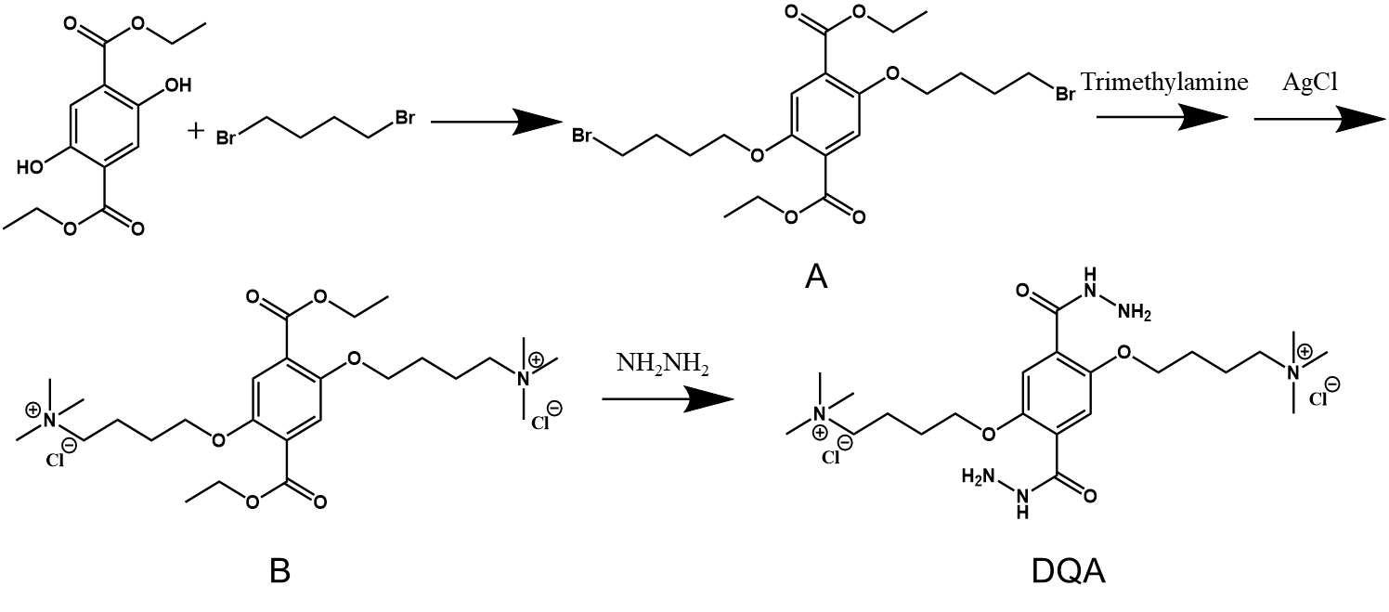
Scheme S1 Synthesis of DQA monomer
S1.2 Determination of MWCO of membranes
The MWCO of membranes was identified by the rejection of 90% for spherical neutral solutes polyethylene glycol (PEG) with a molecular weight of 200, 400, 600, 800, and 1000 Da. The experiments were conducted under the operating conditions of 200 ppm feed solution under 4.0 bar pressure. The rejection of solutes was calculated using Eq. 2 in the main text, where the concentrations of the permeate and feed solution were determined by total organic carbon (TOC) analyzer (ANATAILIN, HTY-CT1000B, China). Additionally, the Stokes radius of PEG molecules was calculated based on Eq. S1:
$r_{s}\text{ = 16.73×}{\text{10}}^{\text{-12}}\text{×}{M_{w}}^{\text{0.557}}$ (S1)
where $M_{w}$ is molecular weight of PEG. The mean pore size of the membranes equals the Stokes radius of the spherical solute with a 50% rejection. The pore size distribution is derived by the following Eq. S2, which was represented by a probability density function:
$\frac{dR(r_{p})}{dr_{p}}=\frac{1}{r_{p}lnσ_{p}\sqrt{2π}}exp\left[-\frac{{(lnr_{p}-lnμ_{p})}^{2}}{{2(lnσ_{p})}^{2}}\right]$ (S2)
where μ_{p} is the mean pore size, σ_{p} equals to the ratio of the solute radius at R =84.13% to R =50.00%, and r_{p} is the Stokes radius of the spherical solute.
S1.3 MD simulations
The MD simulations were performed using the Gromacs 2022.1 program [S2], conducted under constant temperature and pressure conditions with periodic boundary conditions. A single simulation system, which primarily comprises a COF molecular layer and a plane formed by 20 PEI chains with a degree of polymerization of 20 was built. The distance between the COF and PEI was set at 3.0 nm. Subsequently, in addition to Cl⁻ of COF, this system was filled with 173 Cl⁻ ions, 173 Li⁺ ions, and 17,212 water molecules. The molecules were placed within a cuboid box measuring 9.0 nm × 8.0 nm × 8.0 nm. Both the COF and PEI molecules, along with ions, were modeled using the GAFF all-atom force field, and the TIP3P water model was employed to solvate the complex system [S3]. An initial energy minimization of 50,000 steps was conducted using the steepest descent method. The simulations utilized the NPT ensemble, with the Leap-Frog algorithm used to integrate the equations of motion. Long-range electrostatic interactions were treated using the PME method [S4], while van der Waals and Coulomb interactions were truncated at 12 Å and updated every 10 steps. The Lincs algorithm was applied to constrain all bond lengths [S5], with parameters set to lincs_iter = 1 and lincs_order = 4. The system temperature was raised from 0 K to 298.15 K using the V-rescale temperature coupler [S6]. The Parrinello-Rahman method was employed to maintain a constant pressure of 1 bar [S7], ensuring isotropic pressure conditions. Non-bonded interactions were computed using a neighbor grid-based cutoff scheme, with short and long cutoff distances set at 9 Å and 14 Å, respectively. All simulations were initialized with velocities randomly assigned according to the Maxwell-Boltzmann distribution, with a total of 50,000,000 steps simulated at a time step of 1 fs, resulting in a total simulation time of 50 ns, generating 2000 conformations. Visualization of simulation results was achieved using the built-in Gromacs tools and VMD software.
S1.4 DFT calculations
The interaction energies quantitatively reveal the distinct roles of COF nanosheets and PEI. The first principles density-functional theory calculations were carried out using the DMol3 module in Materials Studio. The electron exchange–functional was calculated using Perdew-Burke–Ernzerhof (PBE) described by generalized gradient approximation (GGA). An all electron double numerical atomic orbital augmented by Double Numerical plus polarization (DNP) is used as the basis set and all electrons are included in the calculation. The convergence criteria in total energy, maximum force, and maximum displacement were set at 10⁻⁵ Hartree, 0.002 Hartree/Å, and 0.005 Å, respectively. The electronic self-consistent field (SCF) tolerance was set at 10⁻⁶ Hartree. Accordingly, the interaction energy is defined as follows:
 | E(A-B)=E(total)－E(A)－E(B) | (S3)
where E(A-B) is the interaction energy between Li⁺/Cl⁻ and COF/PEI; E(total) is the energy of Li⁺/Cl⁻ and COF/PEI; E(A) is the energy of Li⁺ or Cl⁻ and E(B) is the energy of COF or PEI, respectively.
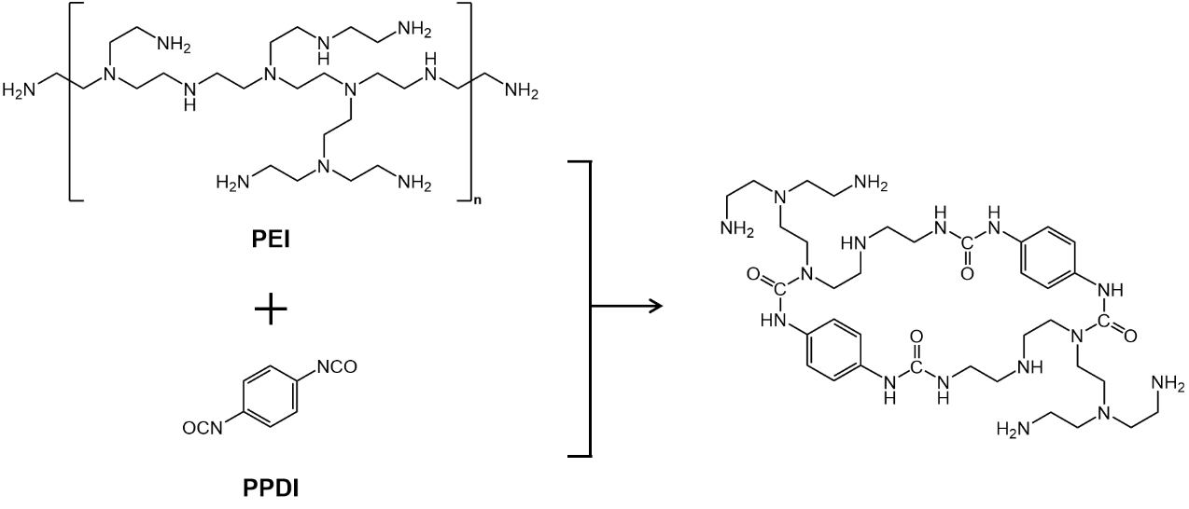
Scheme S2 Schematic illustration of the structure of polyuria
S2 Supplementary Figures and Tables
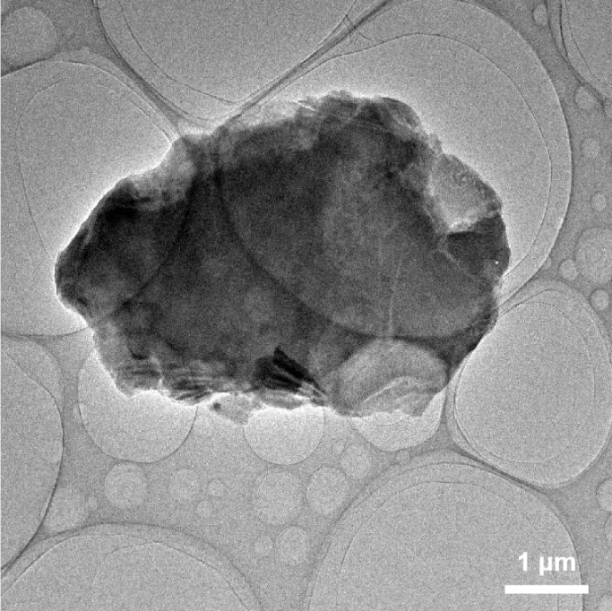
Fig. S1 TEM image of COF nanosheets

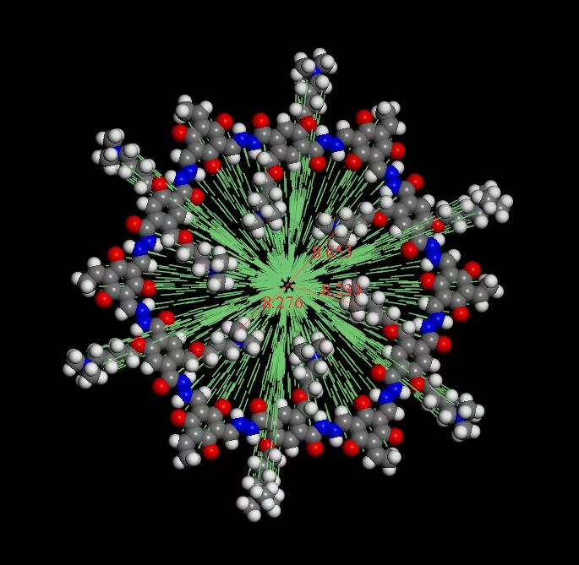
Fig. S2 Pore size of COF
The pore size was simulated via Material Studio.

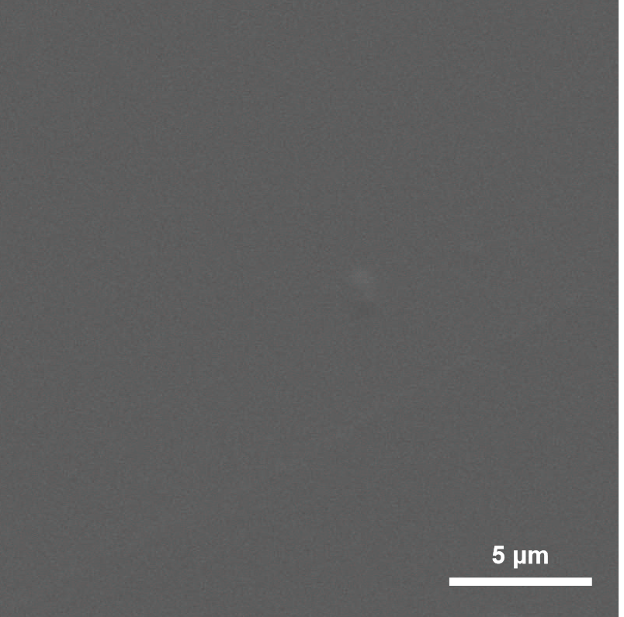
Fig. S3 SEM image of COF scaffold membranes
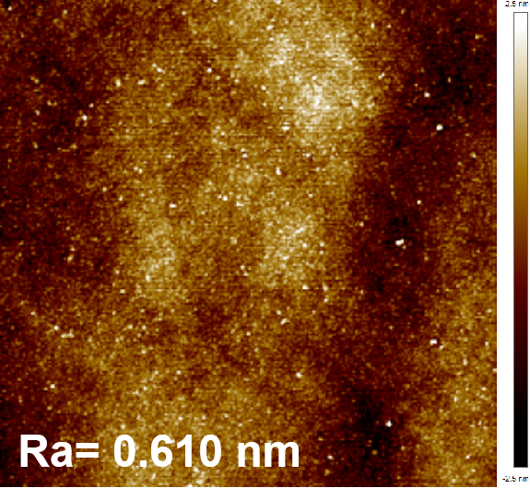
Fig. S4 AFM image of COF scaffold membranes

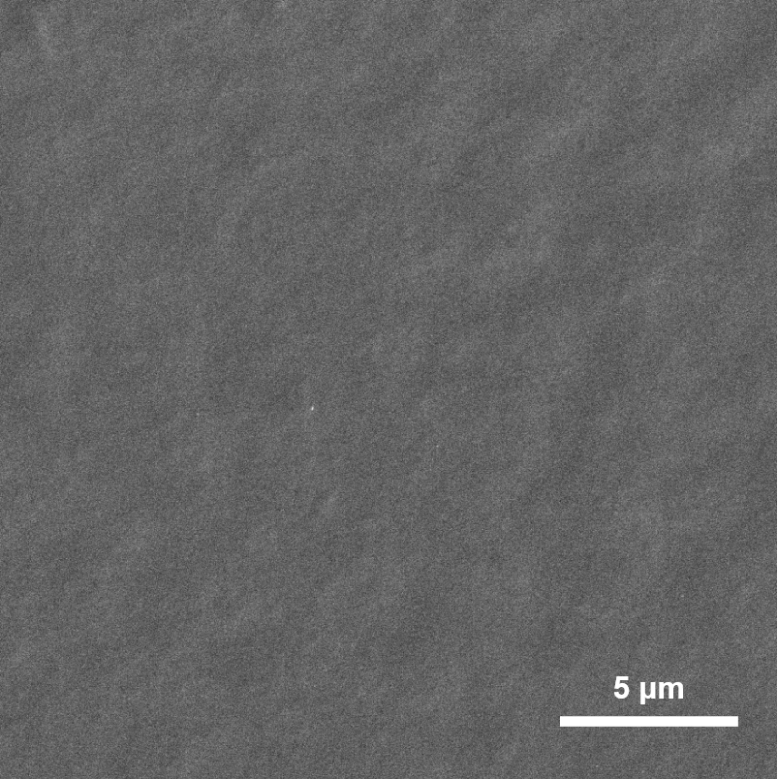
Fig. S5 SEM image of PU membranes
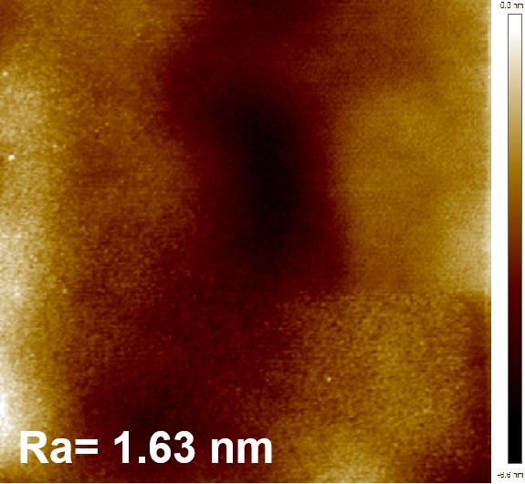
Fig. S6 AFM image of PU membranes

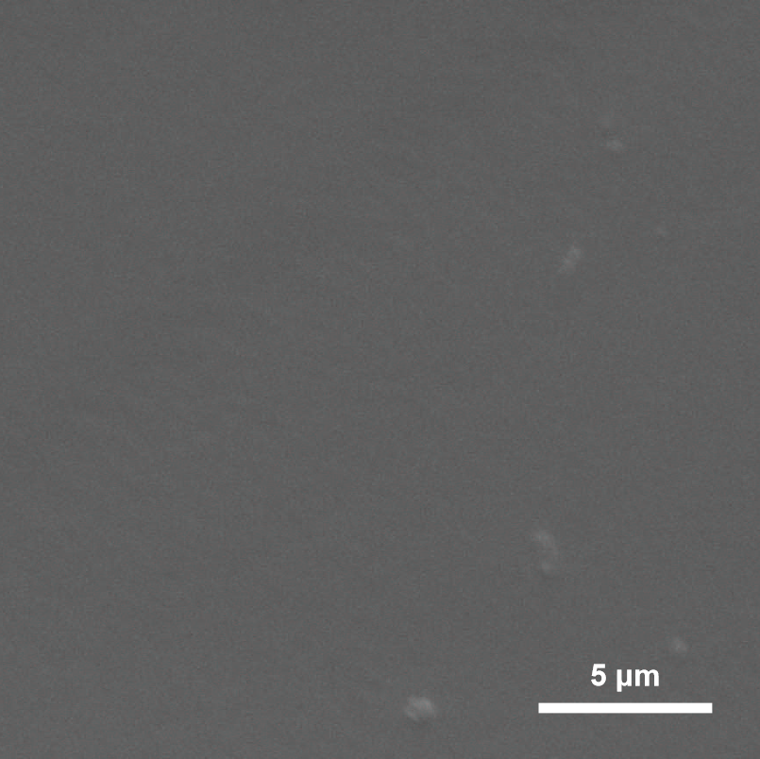
Fig. S7 SEM image of COF hybrid membranes
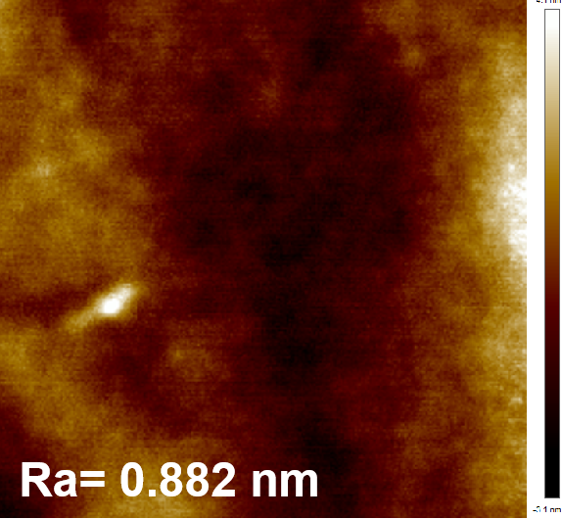
Fig. S8 AFM image of COF hybrid membranes

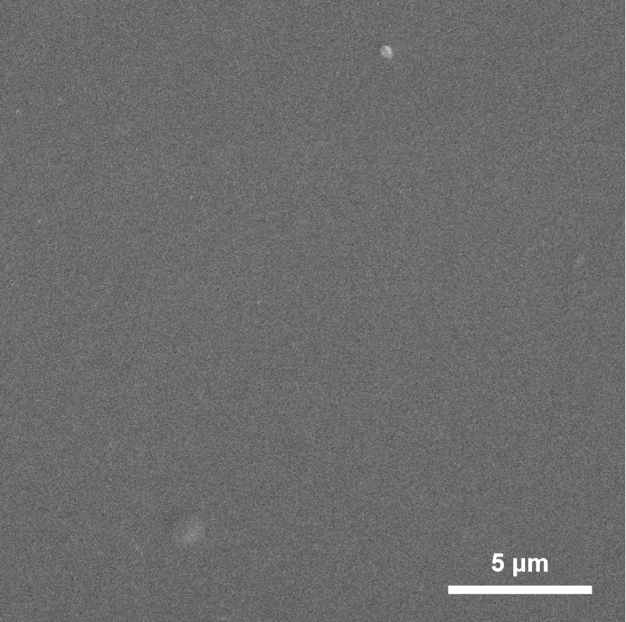
Fig. S9 SEM image of COF membranes
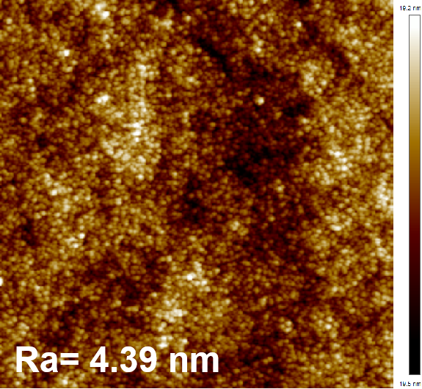
Fig. S10 AFM image of COF membranes

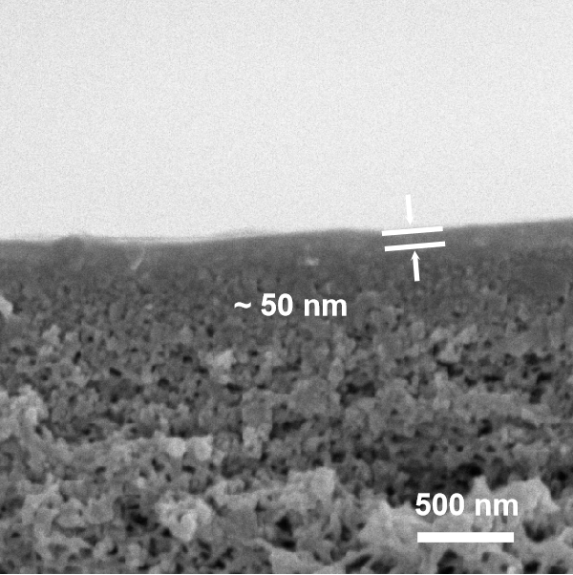
Fig. S11 Cross-sectional SEM image of PU membranes
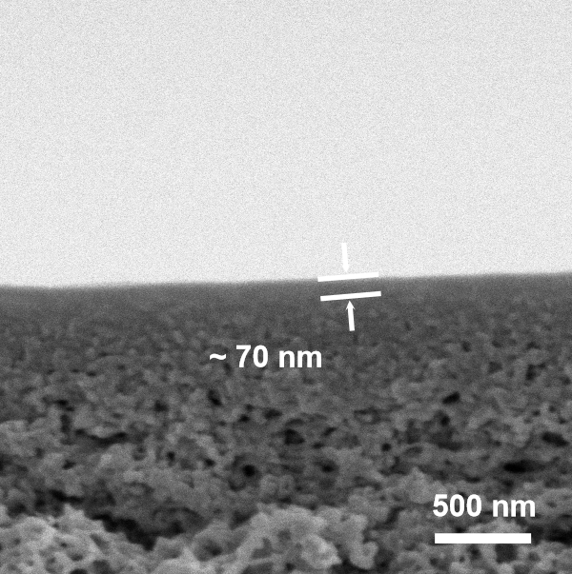
Fig. S12 Cross-sectional SEM image of COF hybrid membranes

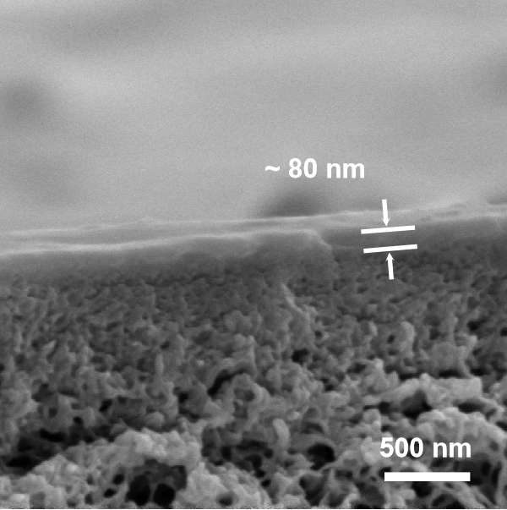
Fig. S13 Cross-sectional SEM image of COF membranes

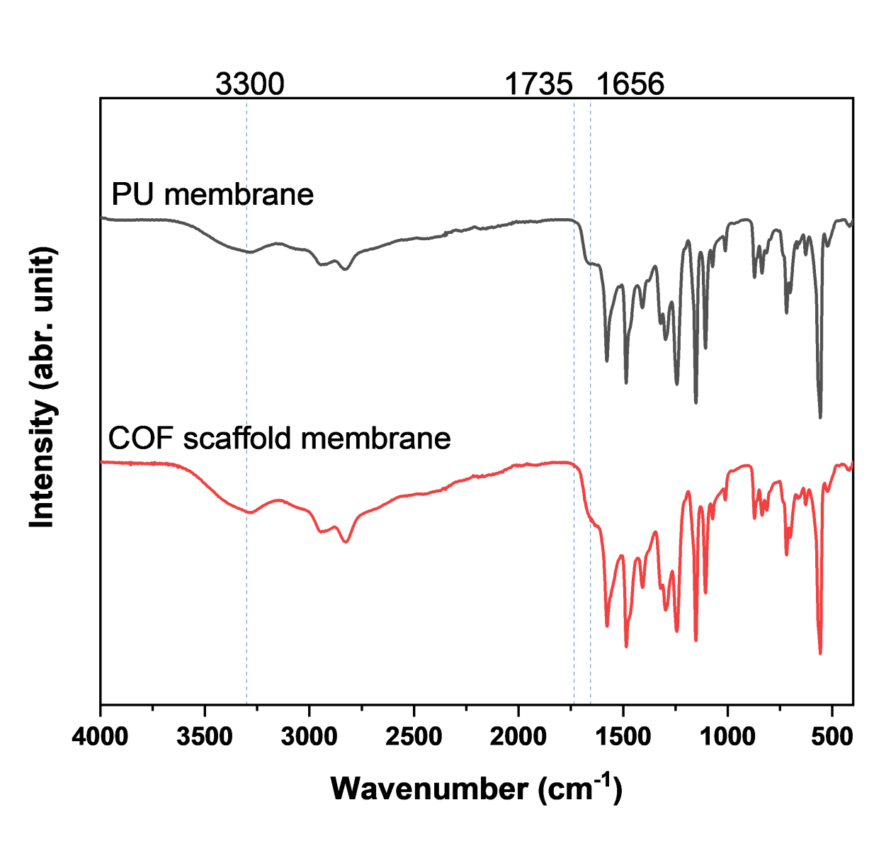
Fig. S14 FTIR spectra of COF scaffold membranes

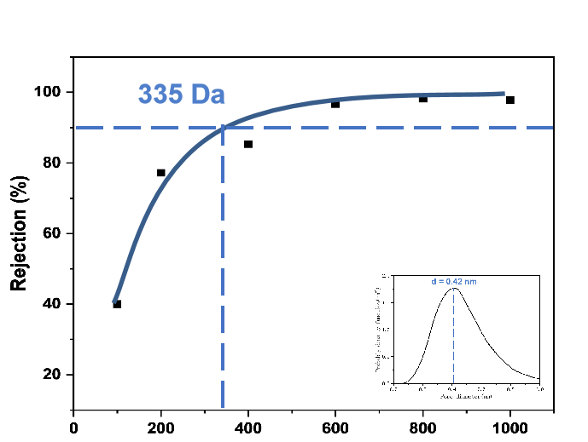
Fig. S15 MWCO of COF scaffold membranes
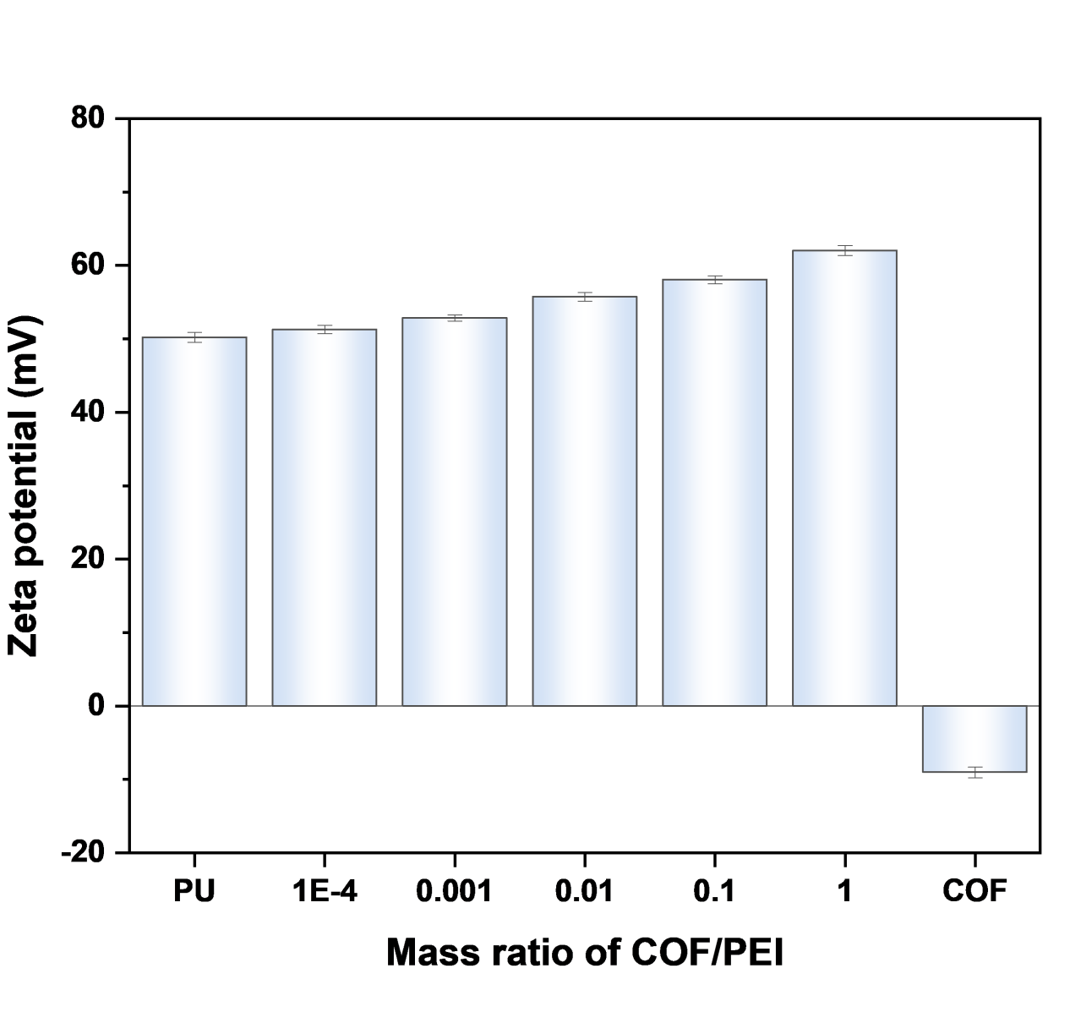
Fig. S16 Effect of mass ratio of COF/PEI on zeta potential of COF scaffold membranes

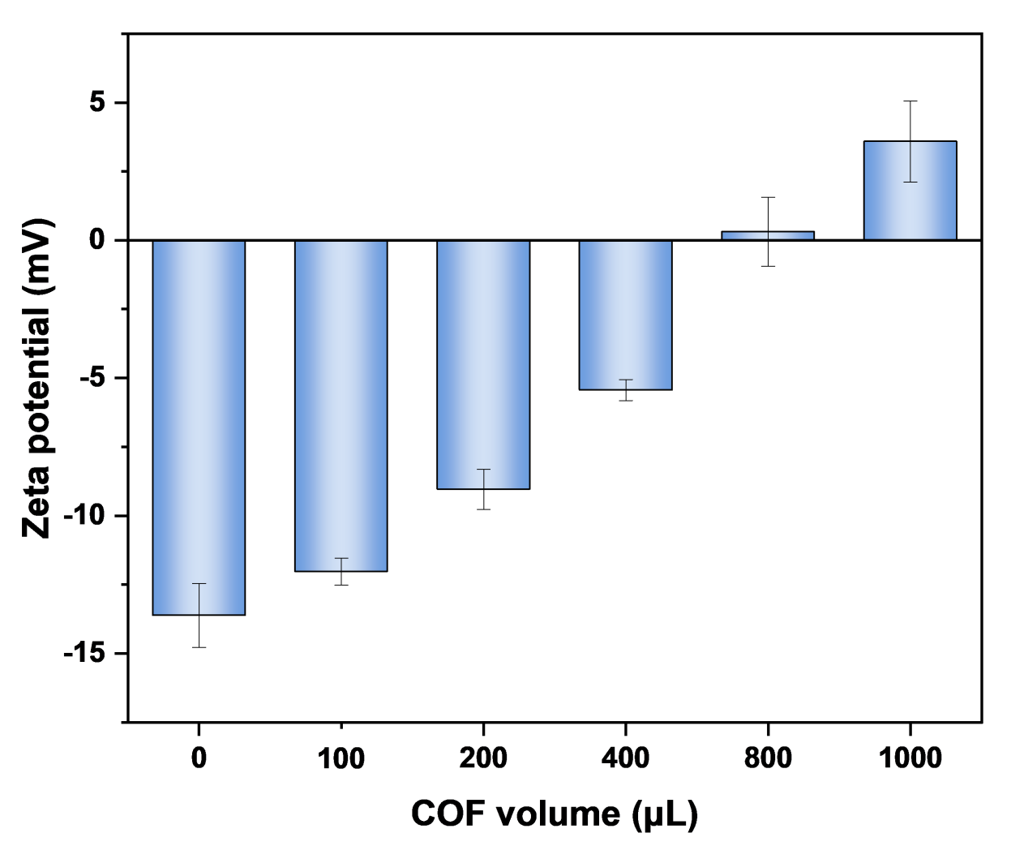
Fig. S17 Effect of COF volume on zeta potential of COF membranes
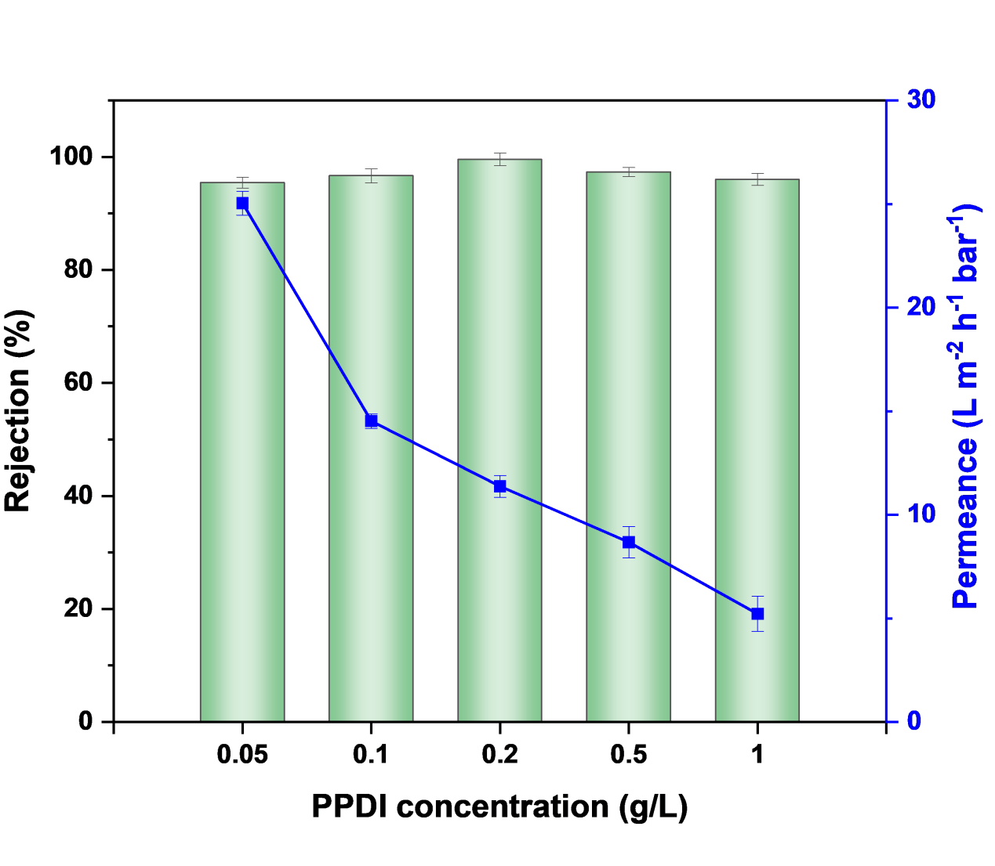
Fig. S18 Effect of PPDI concentration on performance of COF scaffold membranes

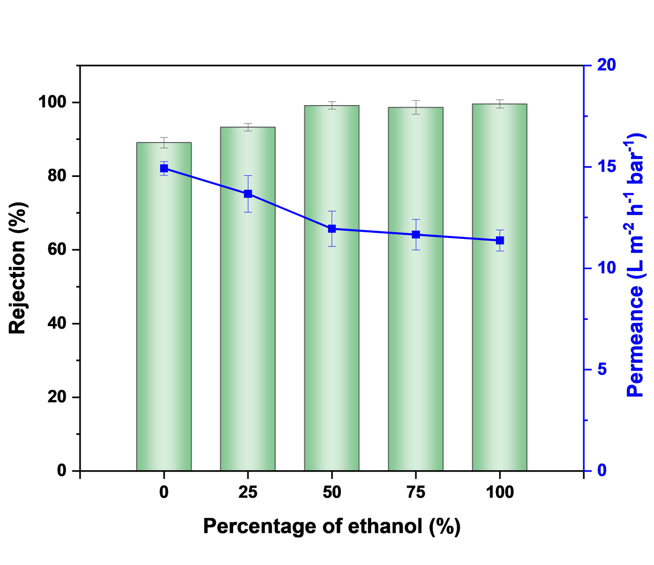
Fig. S19 Effect of volume ratio of water/ethanol on performance of COF scaffold membranes
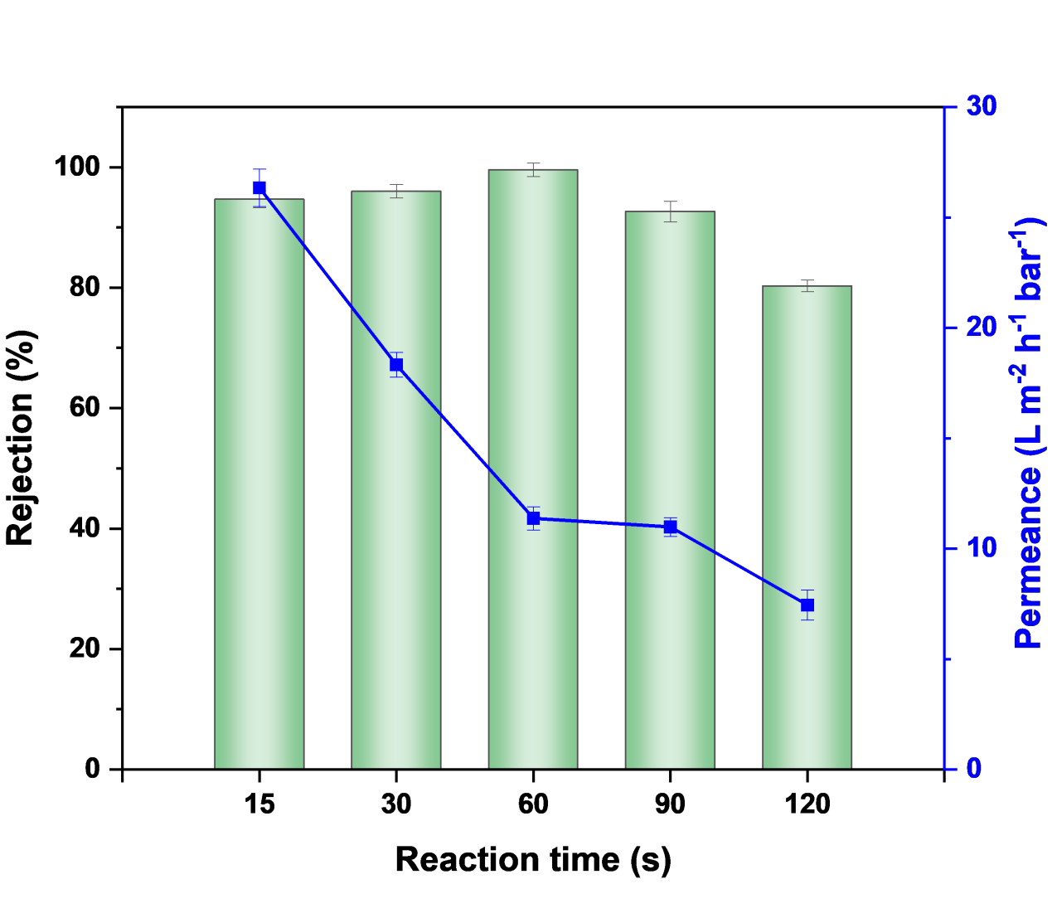
Fig. S20 Effect of reaction time on performance of COF scaffold membranes

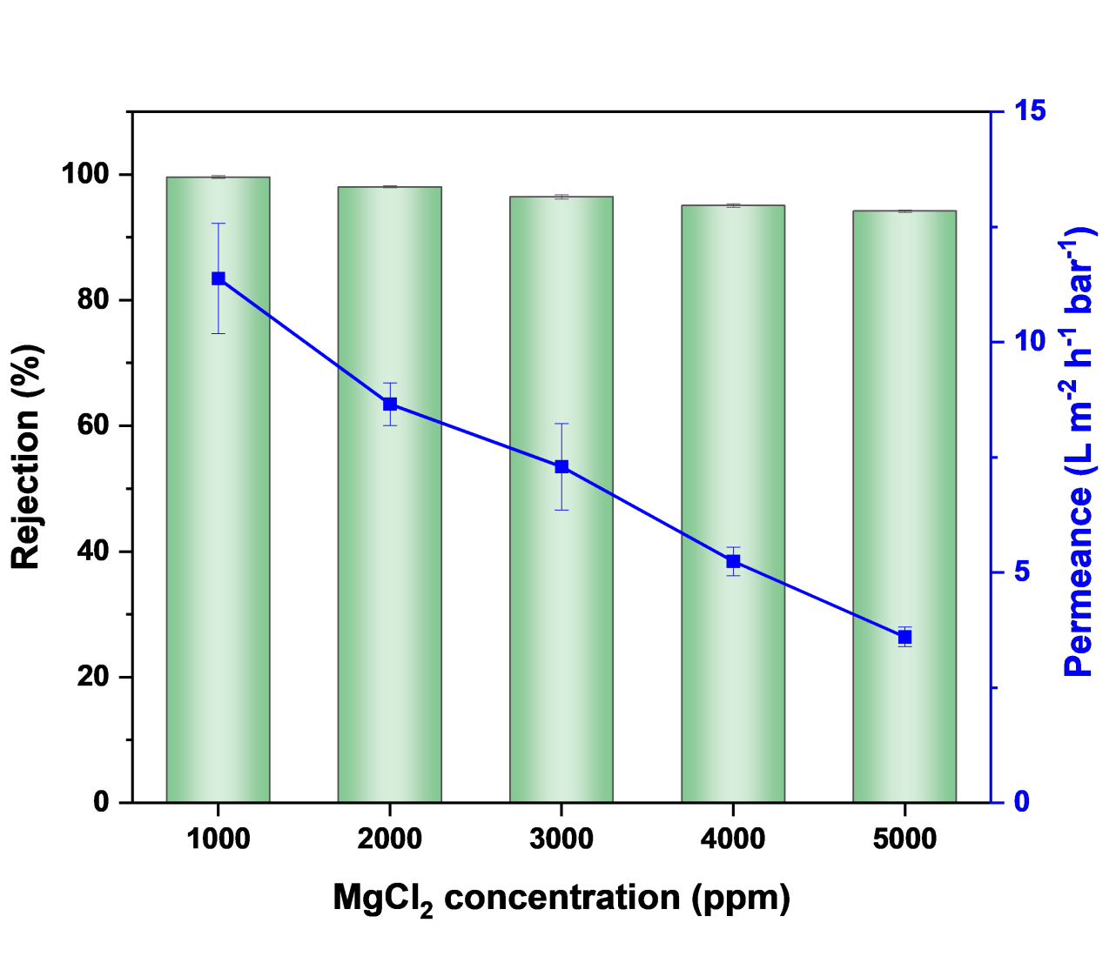
Fig. S21 Rejection and permeance to 1000 ppm MgCl₂ with respect to different feed solution concentration
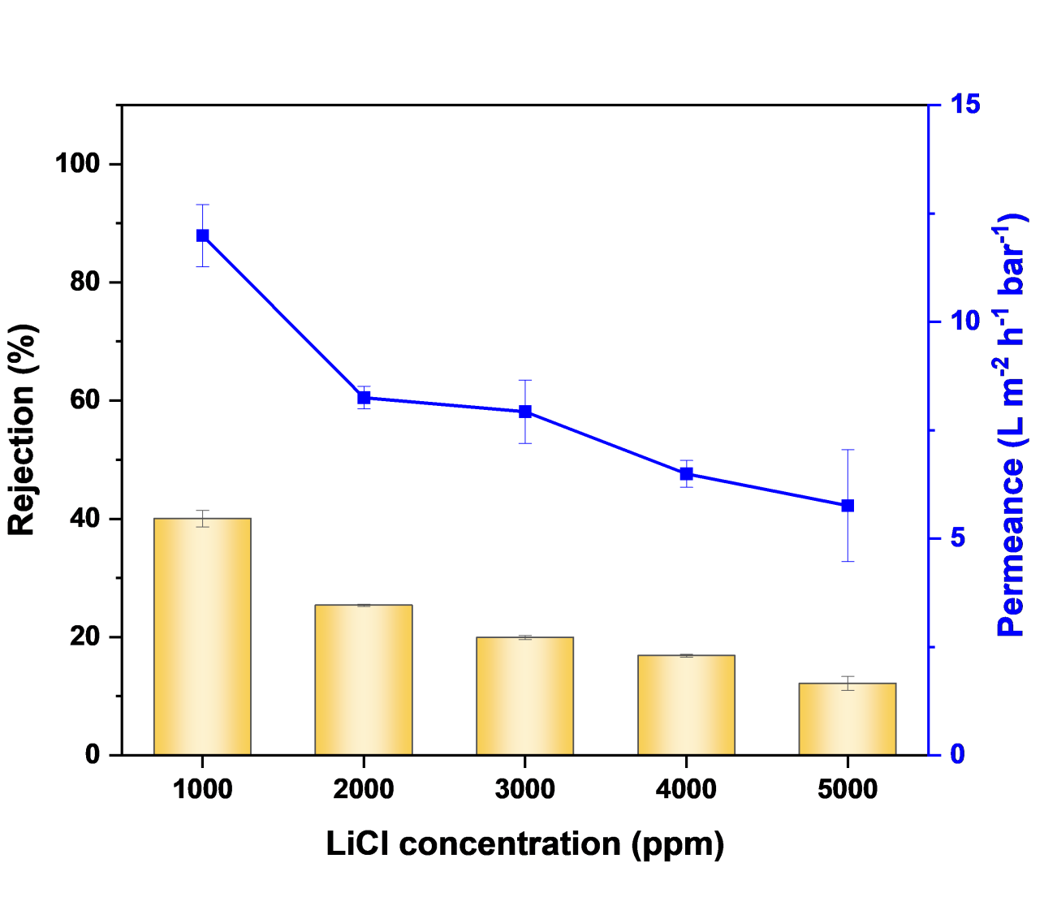
Fig. S22 Rejection and permeance to 1000 ppm LiCl with respect to different feed solution concentration

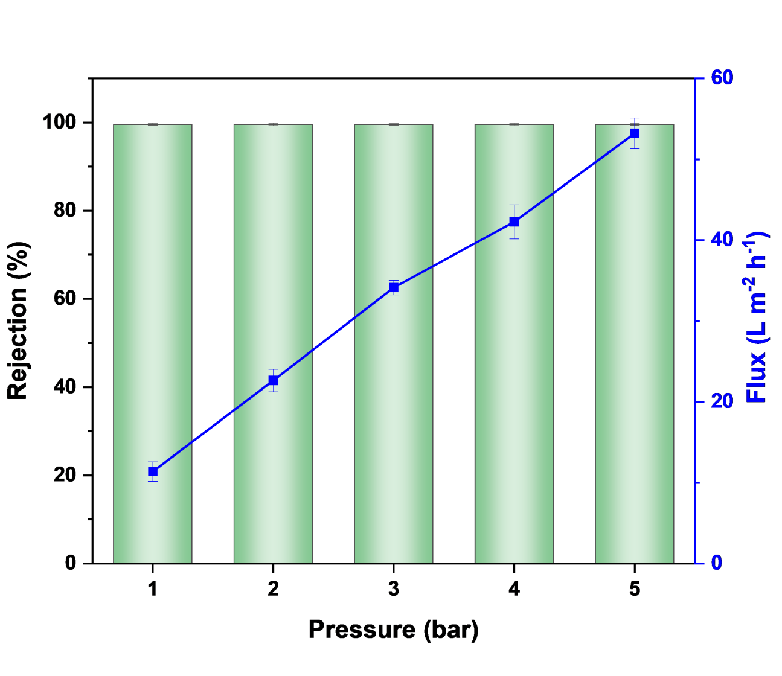
Fig. S23 Rejection to 1000 ppm MgCl₂ with different pressure

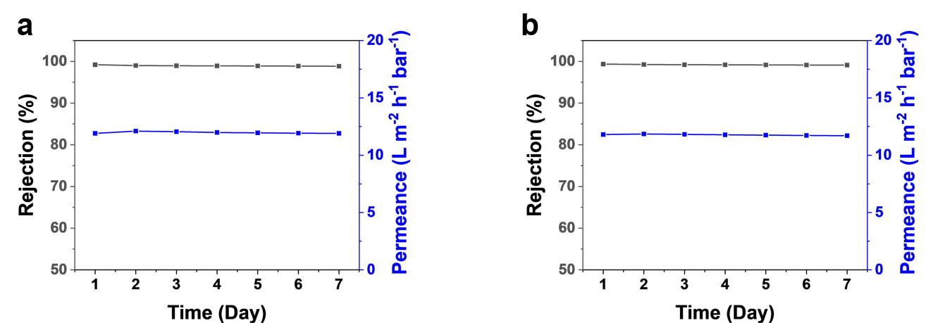
Fig. S24 The COF scaffold membrane resistant to (a) H₂SO₄ (pH=3) and (b) NaOH (pH=11)

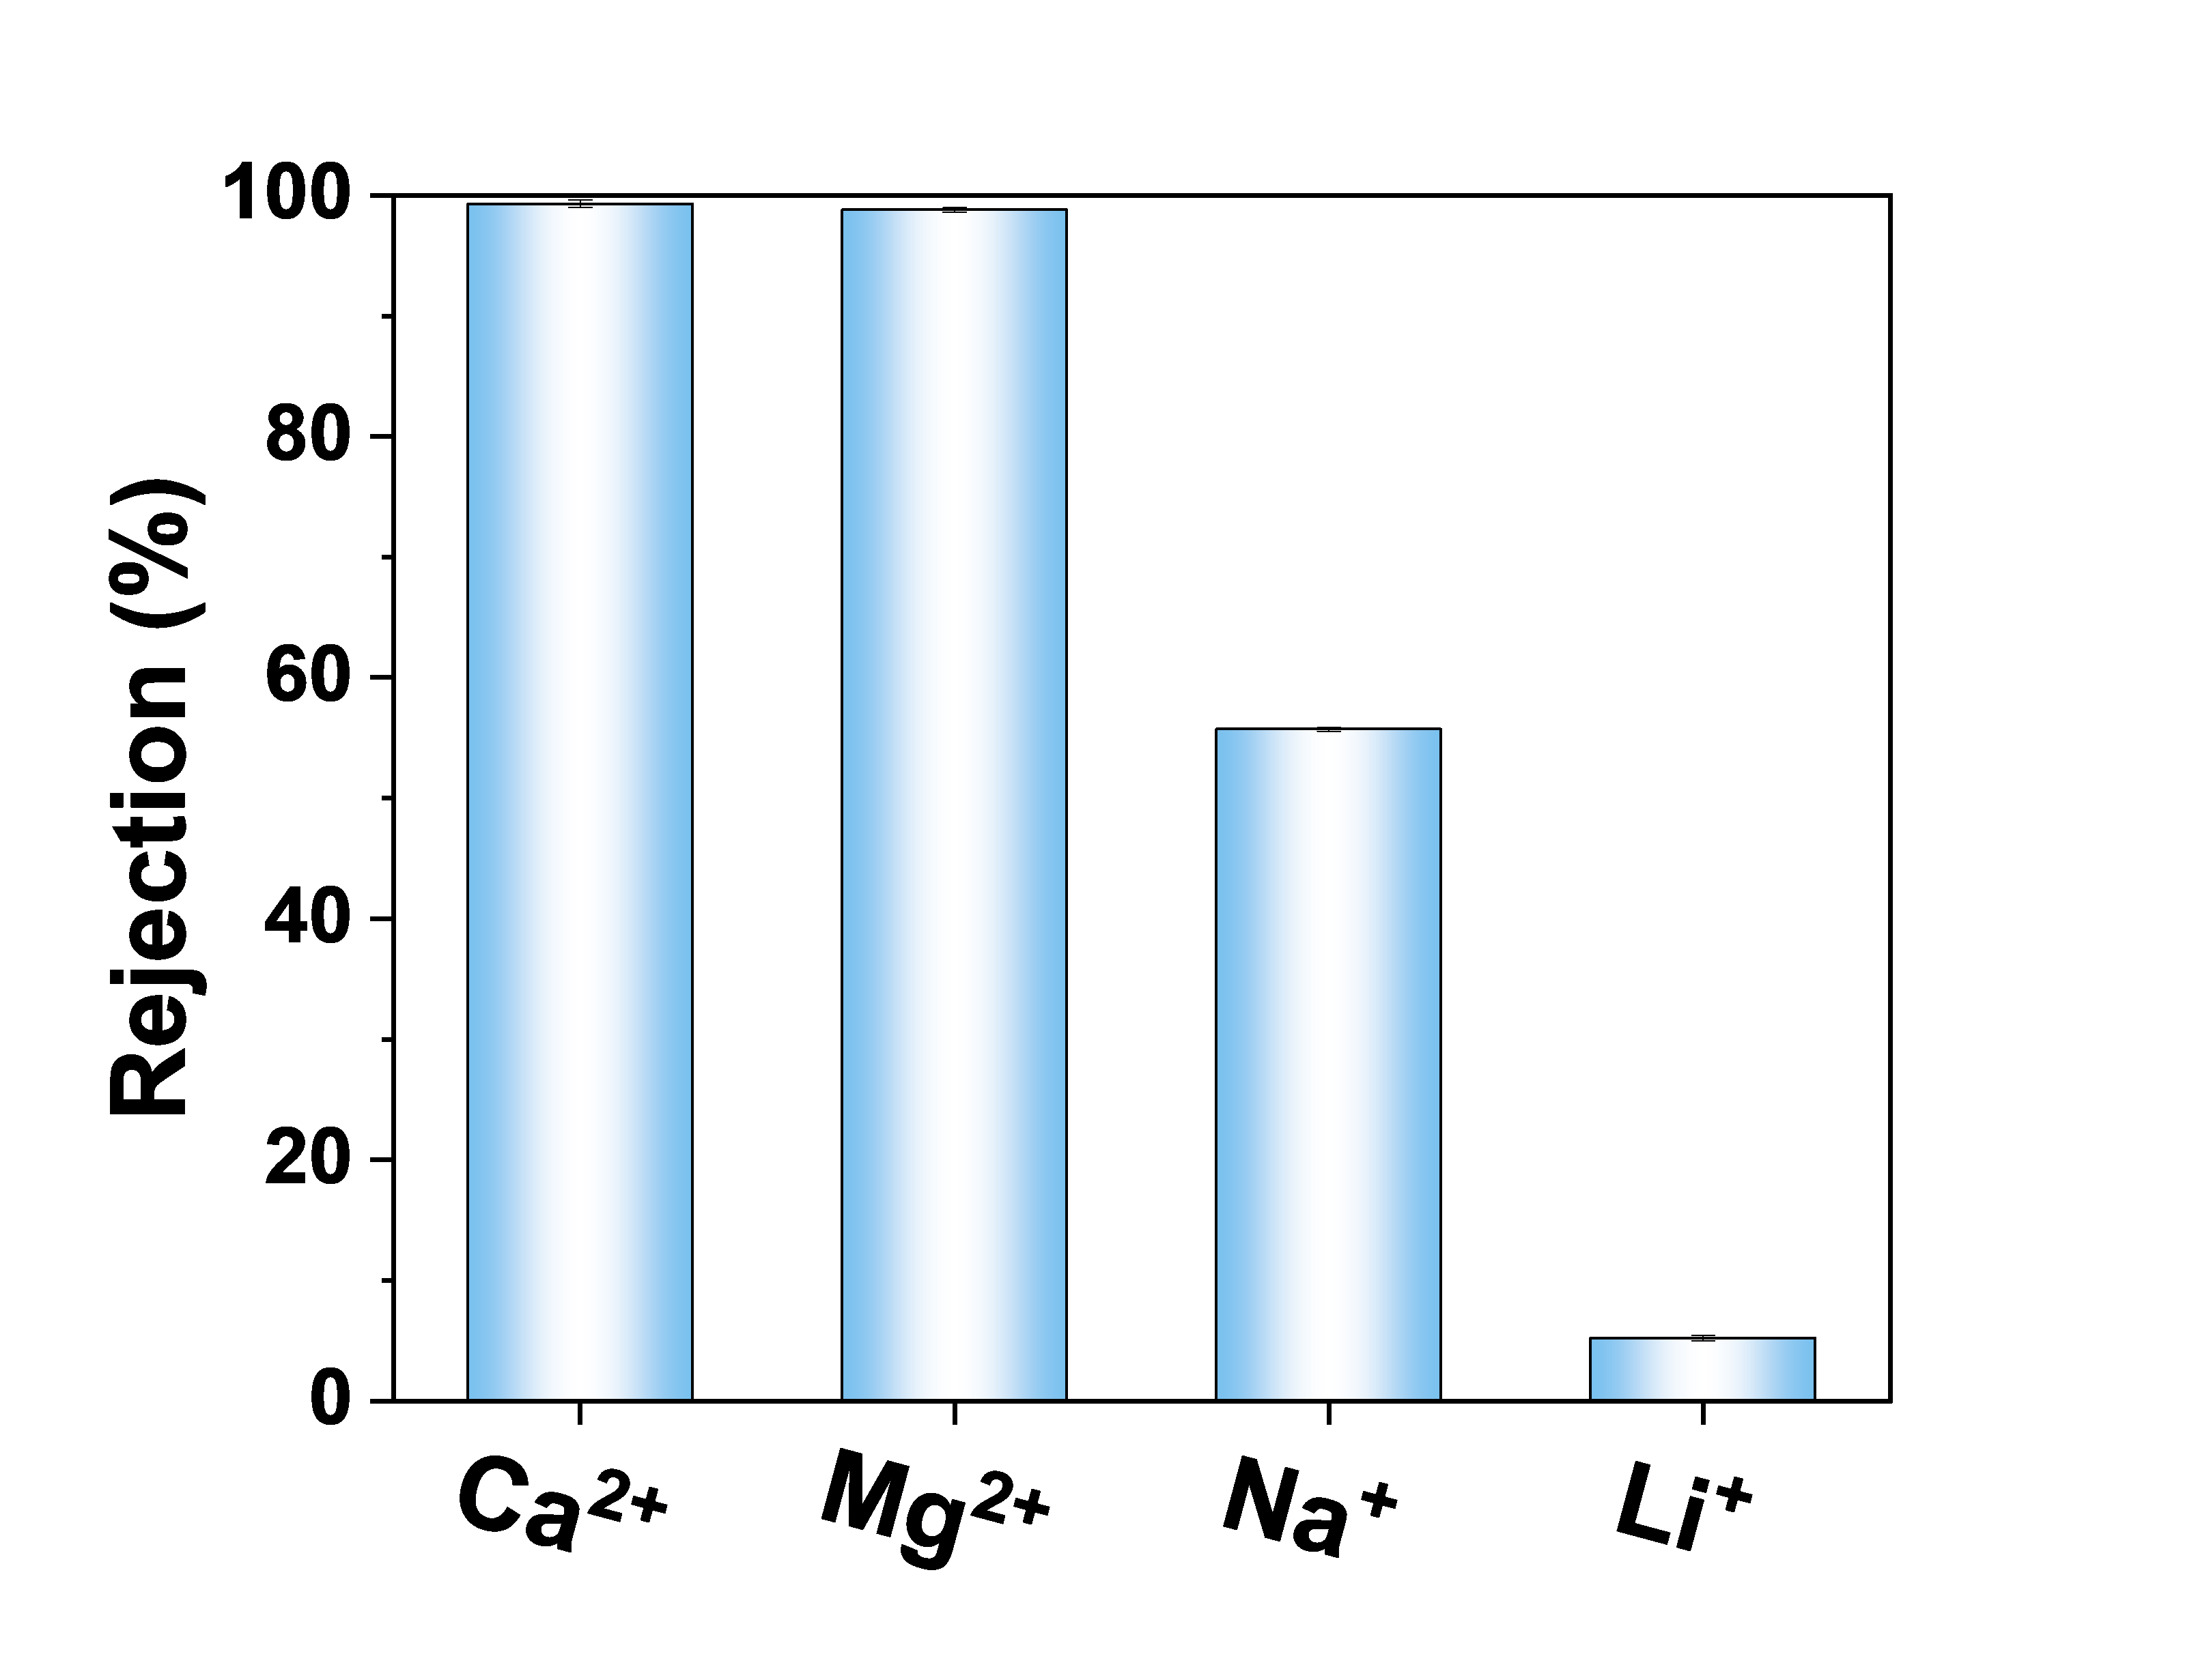
Fig. S25 Rejection to different salts of simulated salt lake brine

Fig. S26 MD model without solvent water molecules

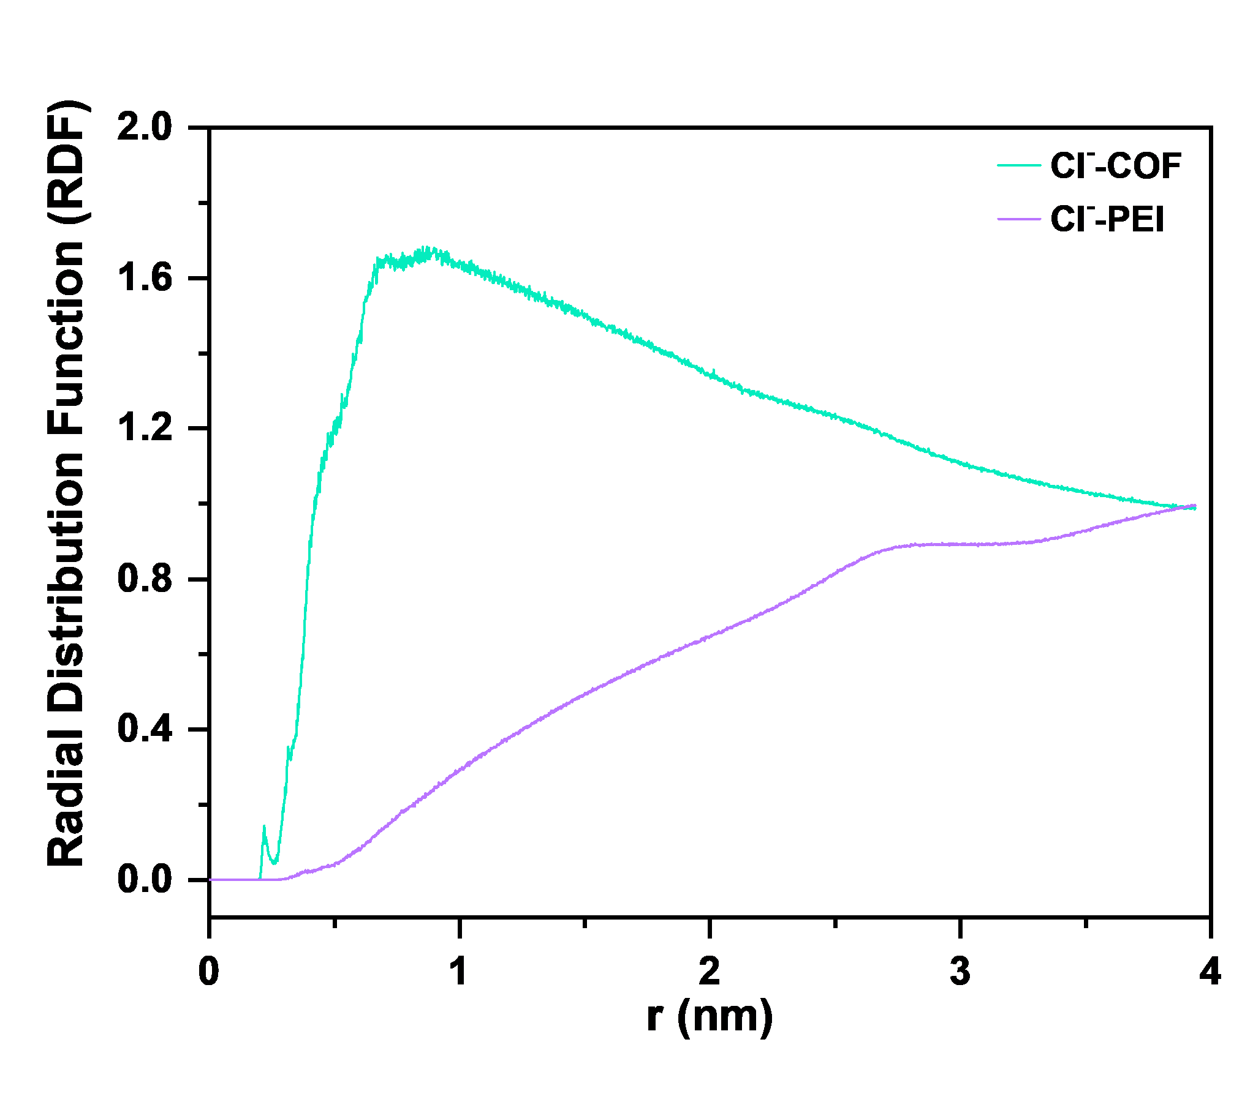
Fig. S27 RDF distribution of Cl⁻ between COF nanosheets and PEI

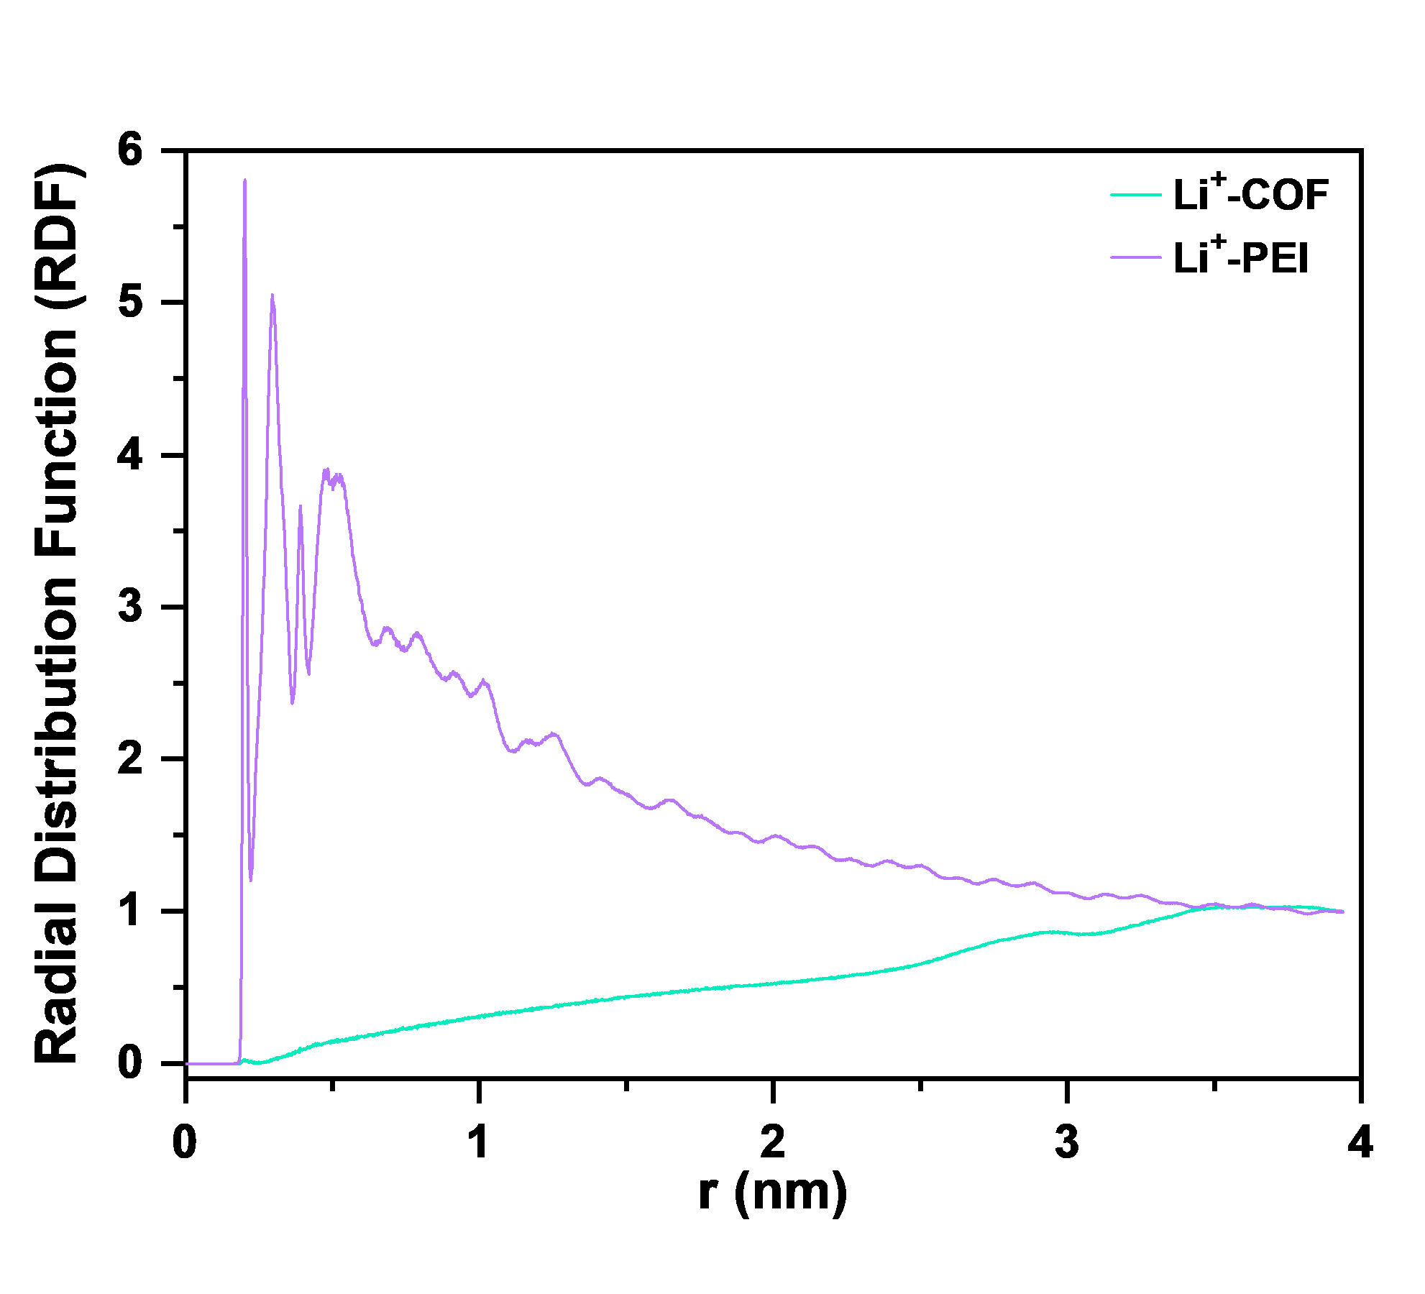
Fig. S28 RDF distribution of Li⁺ between COF nanosheets and PEI
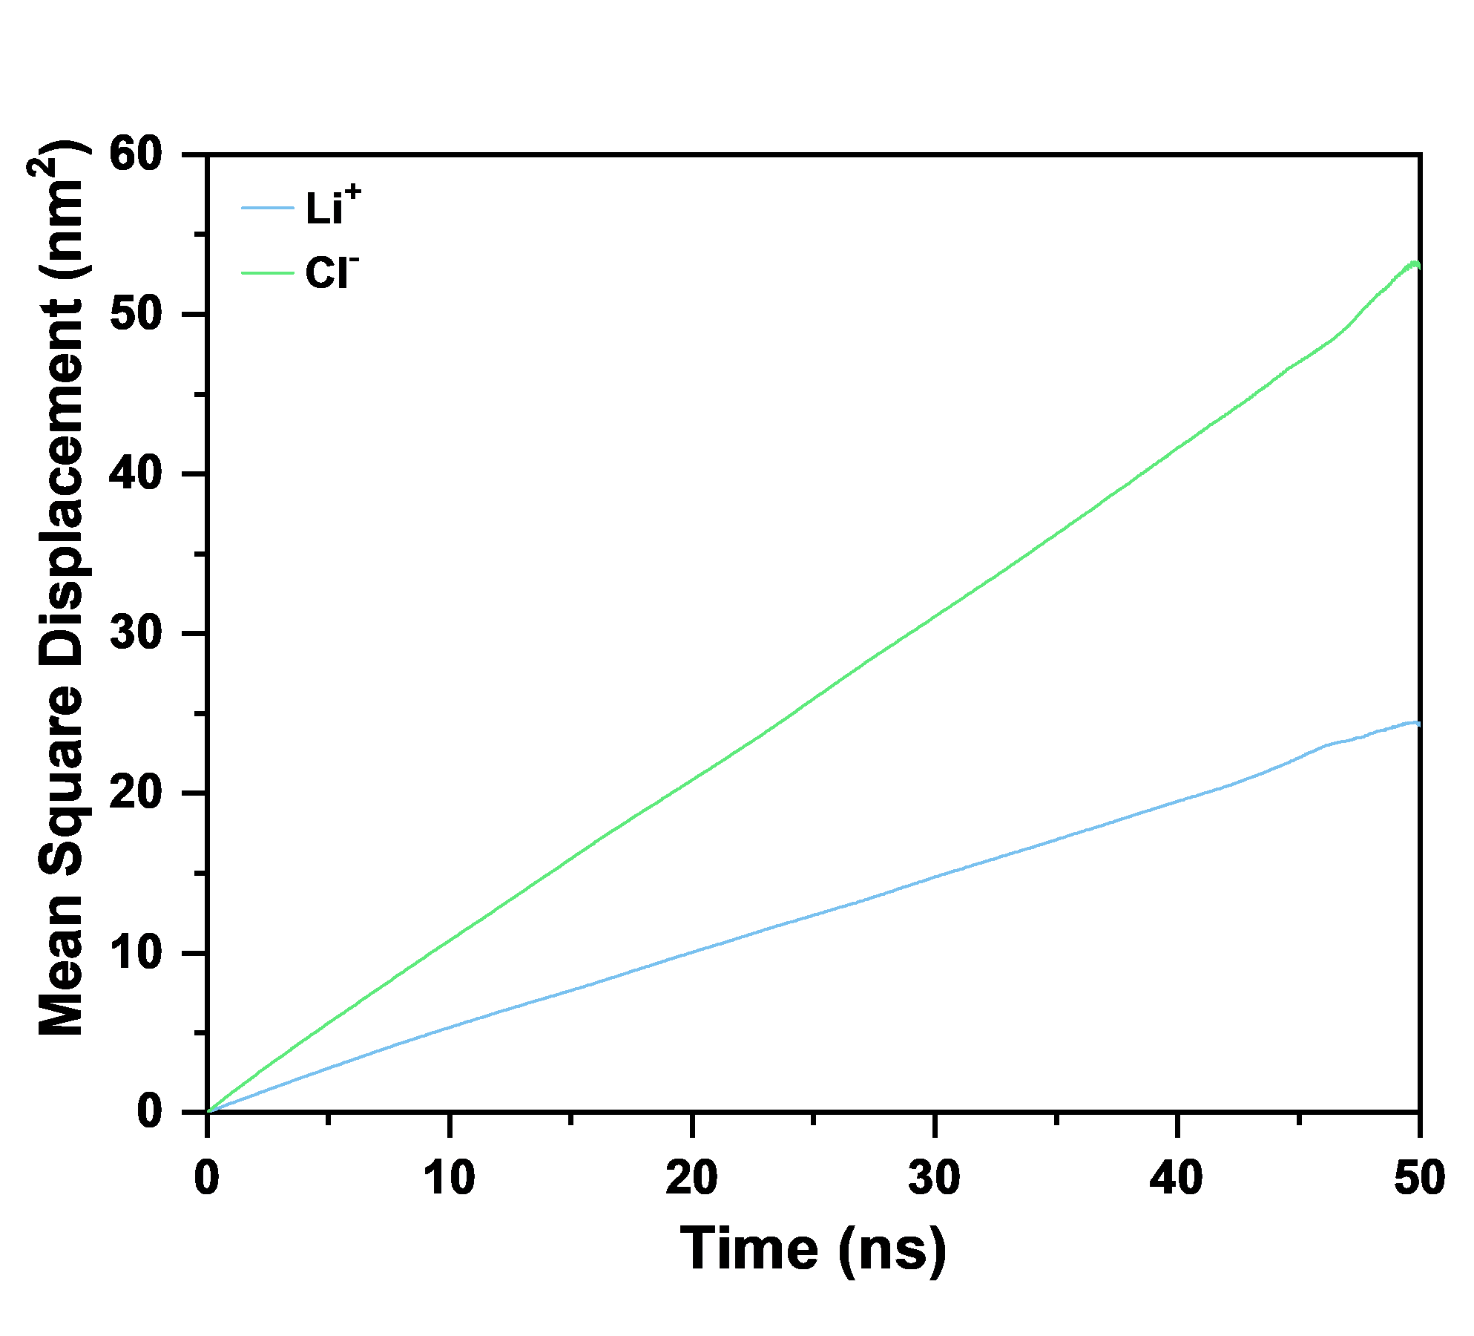
Fig. S29 MSD of Cl⁻ and Li⁺

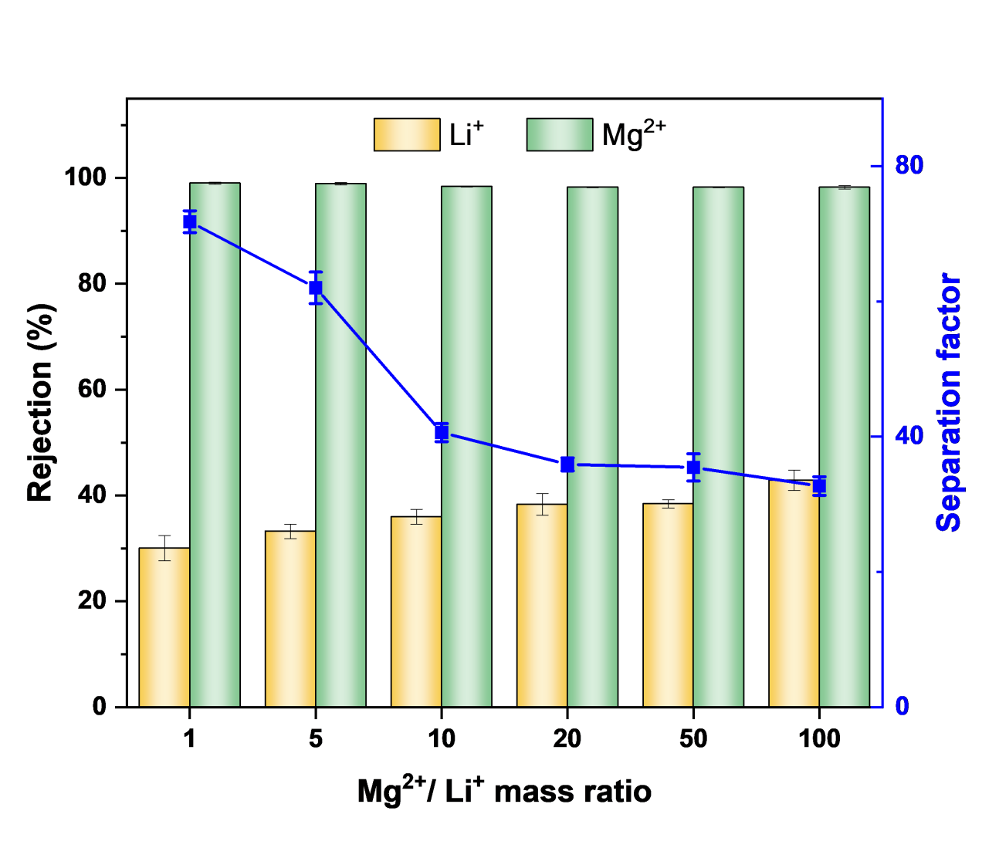
Fig. S30 Rejection and separation factor of COF scaffold membranes in the single-solute system (MgSO₄ and Li₂SO₄)
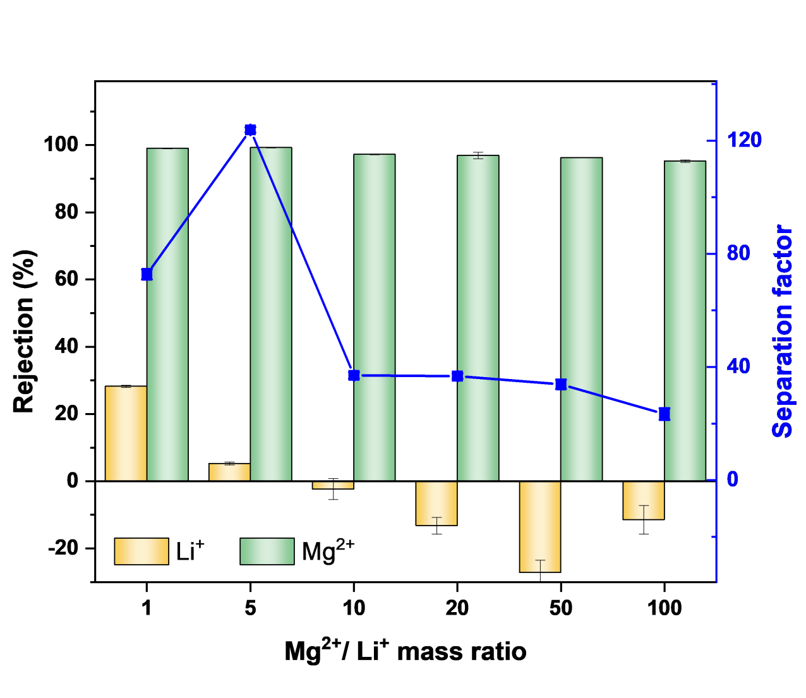
Fig. S31 Rejection and separation factor of COF scaffold membranes in the mixed-solute system (MgSO₄ and Li₂SO₄)
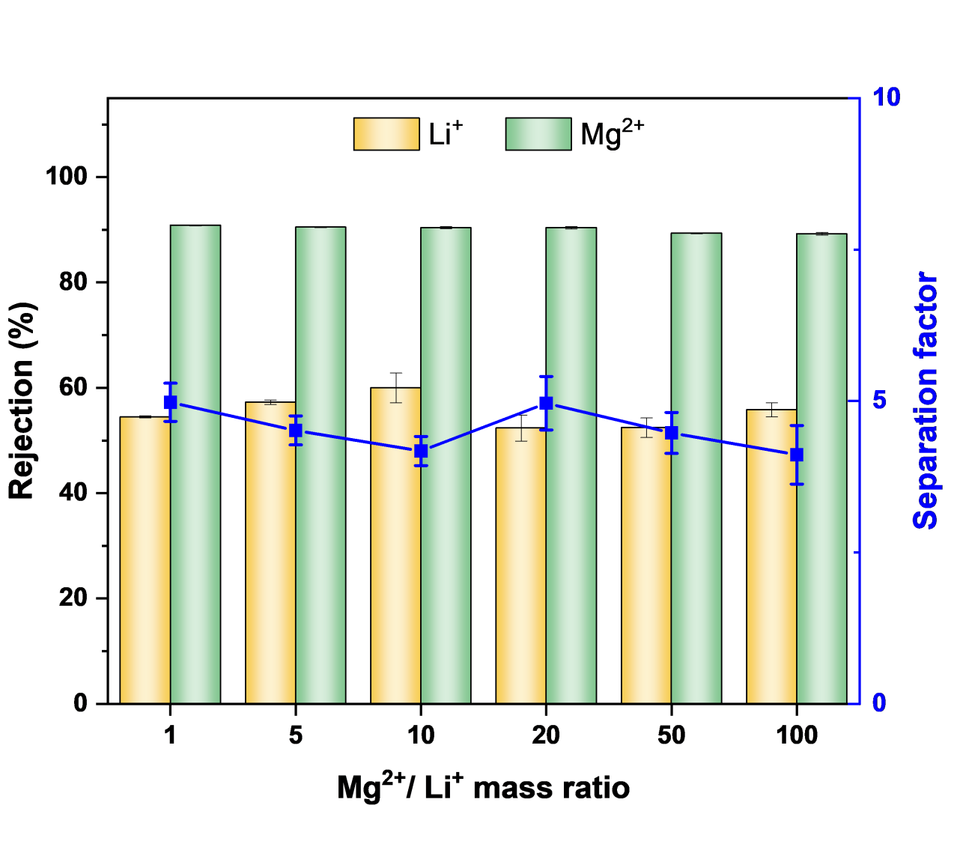
Fig. S32 Rejection and separation factor of PU membranes in the single-solute system (MgSO₄ and Li₂SO₄)
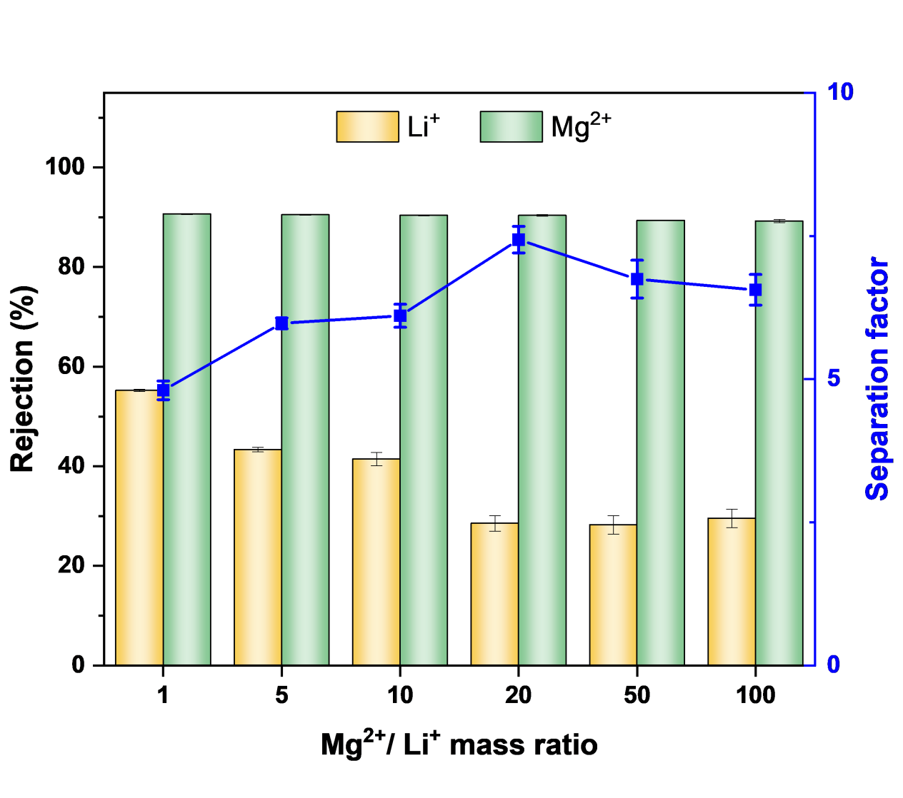
Fig. S33 Rejection and separation factor of PU membranes in the mixed-solute system (MgSO₄ and Li₂SO₄)
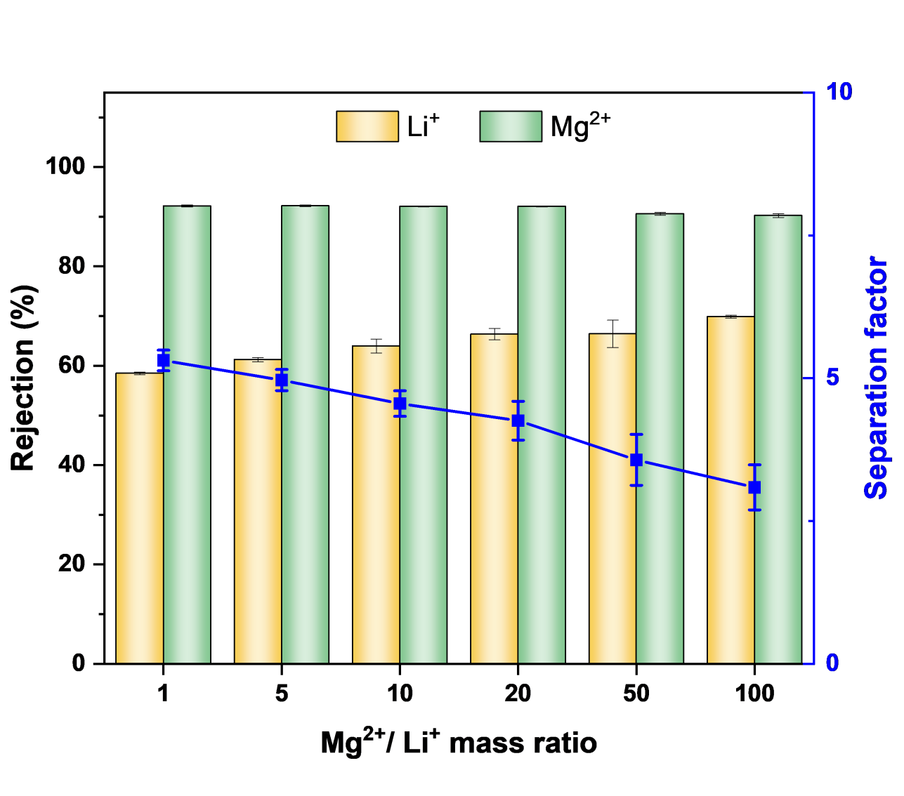
Fig. S34 Rejection and separation factor of COF hybrid membranes in the single-solute system (MgSO₄ and Li₂SO₄)
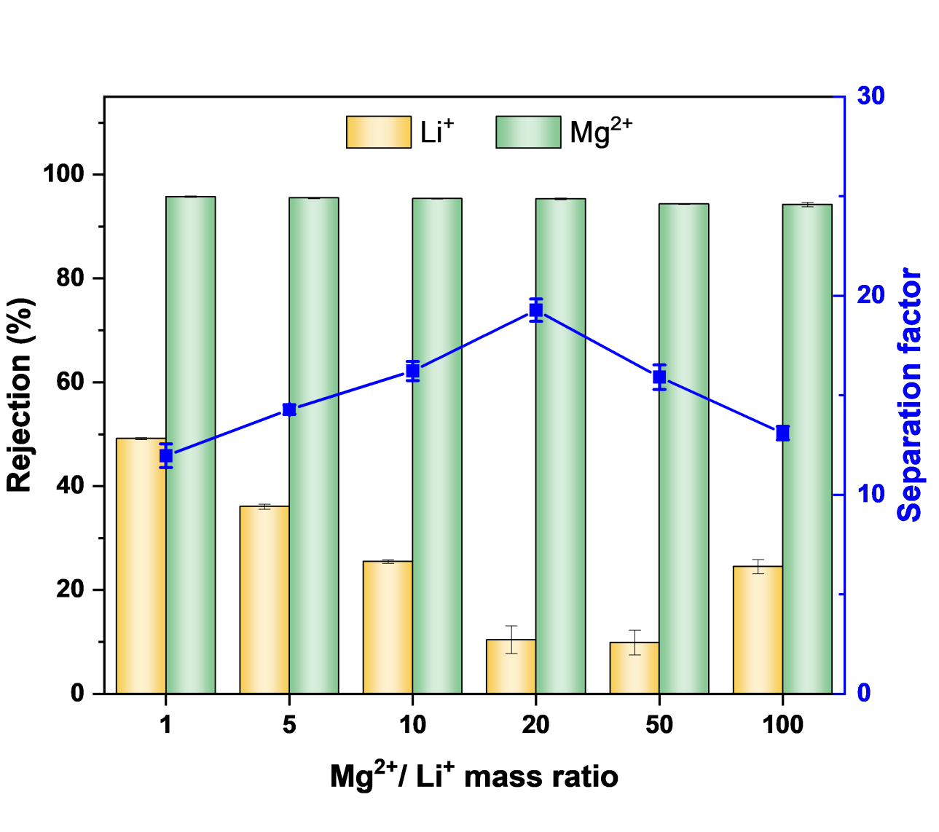
Fig. S35 Rejection and separation factor of COF hybrid membranes in the mixed-solute system (MgSO₄ and Li₂SO₄)
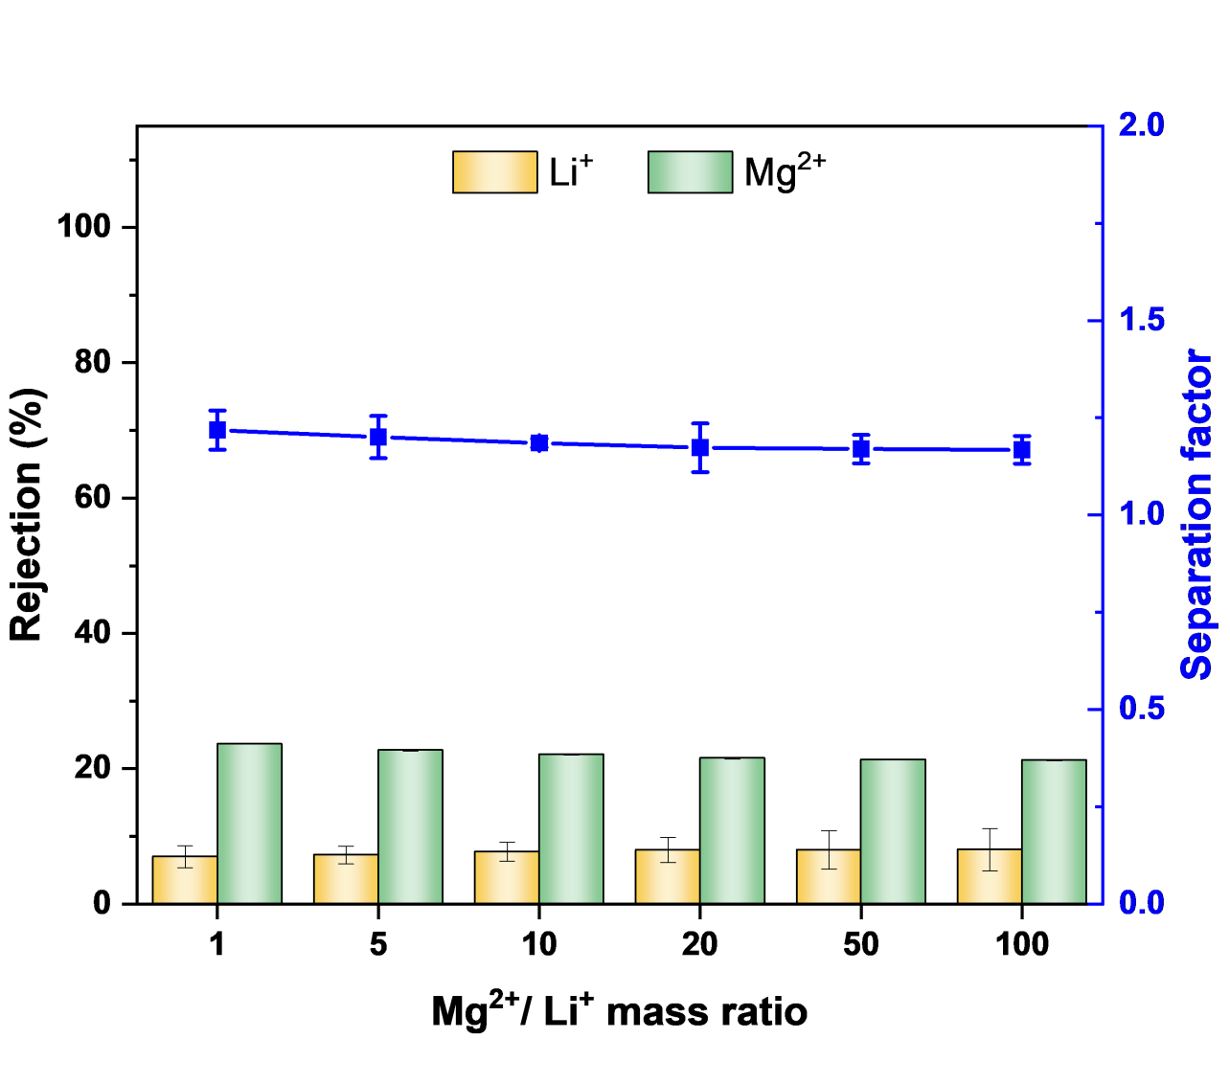
Fig. S36 Rejection and separation factor of COF membranes in the single-solute system (MgSO₄ and Li₂SO₄)
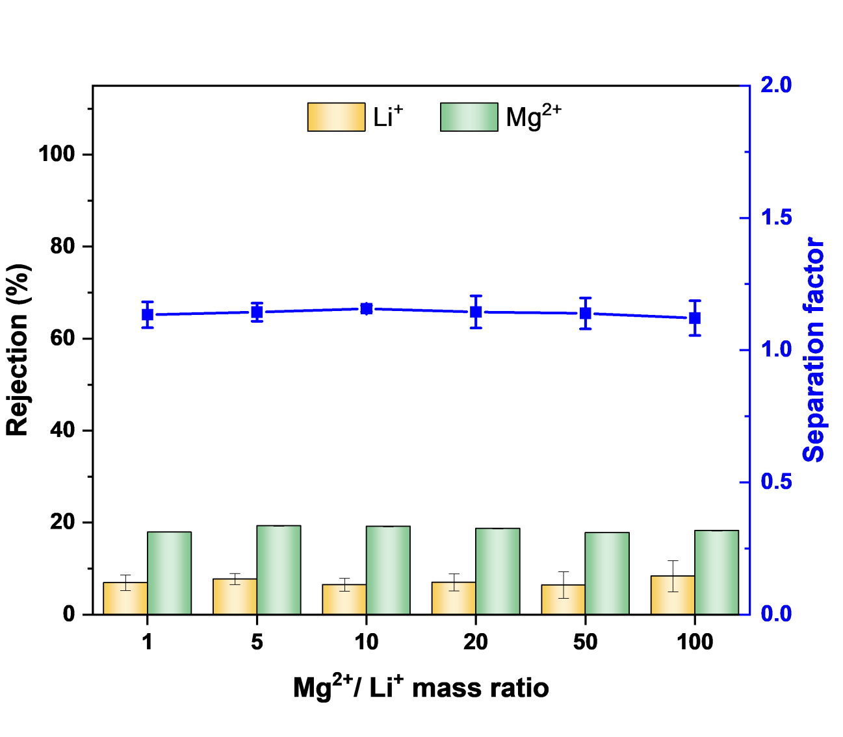
Fig. S37 Rejection and separation factor of COF membranes in the mixed-solute system (MgSO₄ and Li₂SO₄)
Table S1 Mg²⁺/Li⁺ mass ratios in feed and permeate in the mixed-solute system
Mg²⁺/Li⁺ mass ratio
Feed | Permeate
1 | 0.0066
5 | 0.0284
10 | 0.0511
20 | 0.1011
50 | 0.2156
100 | 1.7756
Table S2 The summary of Li⁺/Mg²⁺ separation performance of mixed-solute system of nanofiltration membranes
Membrane | Permeance  (LMH/bar) | Mg²⁺/Li⁺ mass ratio | True selectivity | Testing conditions  (C_{total}, Pressure) | References
TFNPHF | 6.7 | 21.4 | 13.1 | 2000 ppm, 6 bar | [S8]
MBCN | 23 | 73 | 23.9 | 2000 ppm, 4 bar | [S9]
NF-HACC | 15.7 | 21.4 | 13.9 | 2000 ppm, 6 bar | [S10]
PEI-LDH/GA | 6.3 | 10 | 18.7 | 2000 ppm, 5 bar | [S11]
PEI/Cyclen-TMC | 14 | 20 | 8 | 2000 ppm, 5 bar | [S12]
UiO/TFN/PEI | 30.6 | 20 | 33 | 2000 ppm, 4 bar | [S13]
DTES/PEI/TMC | 6.2 | 20 | 12.95 | 2000 ppm, 8 bar | [S14]
SERS | 6.2 | 20 | 15.38 | 2000 ppm, 15 bar | [S15]
SIP | 1.3 | 20 | 7.68 | 2000 ppm, 15 bar | [S15]
PIP-TMC/[MimAP][Tf₂N] | 4.72 | 20 | 8.12 | 2100 ppm, 6 bar | [S16]
PIP-TMC/[MimAP][Tf₂N] | 4.72 | 40 | 6.19 | 4100 ppm, 6 bar | [S16]
CA/PEI | 18.6 | 21.4 | 66.4 | 2000 ppm, 10 bar | [S17]
PAA/TMC | 7.39 | 20 | 82.8 | 2000 ppm, 5 bar | [S18]
PAH/DA/PSS | 21.9 | 35 | 37.8 | 2000 ppm, 2 bar | [S19]
NoriaPG/PEI | 22.5 | 30.9 | 88.6 | 2000 ppm, 10 bar | [S20]
Cu-MPD | 16.2 | 23 | 8 | 2000 ppm, 5 bar | [S21]
PGO | 6.85 | 23 | 23.5 | 5000 ppm, 2 bar | [S22]
PEI-TMC/DAIB | 15.5 | 15.3 | 16.6 | 5500 ppm, 6 bar | [S23]
PEI-TMC/QBPD | 26.11 | 50 | 5.2 | 2000 ppm, 6 bar | [S24]
PEI-TMC/QEDTP | 18.82 | 120 | 15.6 | 2000 ppm, 6 bar | [S25]
PEI-TMC/HMTAB | 16.32 | 50 | 10.1 | 2000 ppm, 6 bar | [S26]
PEI-TMC/TQAIL | 13.26 | 15.3 | 23.17 | 5500 ppm, 6 bar | [S27]
PEI-TMC/QTHIM | 33 | 50 | 10.9 | 2000 ppm, 6 bar | [S28]
PEI-g-PA | 12 | 20 | 33.4 | 2000 ppm, 4 bar | [S29]
PEI-TMC | 5.02 | 20 | 15.38 | 2000 ppm, 8 bar | [S30]
RIP | 22.25 | 20 | 9.22 | 2000 ppm, 15 bar | [S31]
polyamide-TG | 1.4 | 20 | 82.96 | 2000 ppm, 4 bar | [S32]
NF-TC | 8 | 20 | 167 | 2000 ppm, 5 bar | [S33]
COF scaffold membrane | 11.47 | 10 | 195.76 | 2000 ppm, 6 bar | This work
COF scaffold membrane | 11.47 | 20 | 197.75 | 2000 ppm, 6 bar | This work
COF scaffold membrane | 11.47 | 50 | 231.87 | 2000 ppm, 6 bar | This work
COF scaffold membrane | 11.47 | 100 | 56.32 | 2000 ppm, 6 bar | This work
Table S3 The summary of reported diffusion coefficients
Membrane | Ion | Diffusion coefficient  (10⁻⁵ cm² s⁻¹) | References
TpBDMe2 | K⁺ | 0.976 | [S34]
TpBDMe2 | Na⁺ | 0.0865 | [S34]
TpBDMe2 | Li⁺ | 0.0632 | [S34]
TpBDMe2 | Mg²⁺ | 0.0185 | [S34]
TpPa–CO₂H | Rb⁺ | (5.7 ± 0.81) × 10⁻⁴ | [S35]
TpPa–CO₂H | K⁺ | (7.6 ± 1.1) × 10⁻⁴ | [S35]
TpPa–CO₂H | Na⁺ | (6.3 ± 1.8) × 10⁻⁴ | [S35]
TpPa–CO₂H | Li⁺ | (4.2 ± 1.1) × 10⁻⁴ | [S35]
COF-V-60% | K⁺ | 8.92 × 10⁻⁷ | [S36]
COF-V-60% | Na⁺ | 5.25 × 10⁻⁷ | [S36]
TpTag-COF | Cl⁻ | 0.1524 ± 0.0501 | [S37]
COF-170/PAN | Cl⁻ | 0.815 | [S38]
COF-170/PAN | SO₄²⁻ | 0.477 | [S38]
COF scaffold membrane | Li⁺  Cl⁻ | 0.989  2.141 | This work
Supplementary References
- Y. Kong, B. Lyu, C. Fan, Y. Yang, X. Wang et al., Manipulation of cationic group density in covalent organic framework membranes for efficient anion transport. J. Am. Chem. Soc. 145(51), 27984–27992 (2023). https://doi.org/10.1021/jacs.3c07958
- D. Van Der Spoel, E. Lindahl, B. Hess, G. Groenhof, A.E. Mark et al., GROMACS: Fast, flexible, and free. J. Comput. Chem. 26(16), 1701–1718 (2005). https://doi.org/10.1002/jcc.20291
- W.L. Jorgensen, J. Chandrasekhar, J.D. Madura, R.W. Impey, M.L. Klein, Comparison of simple potential functions for simulating liquid water. J. Chem. Phys. 79(2), 926–935 (1983). https://doi.org/10.1063/1.445869
- T. Darden, D. York, L. Pedersen, Particle mesh Ewald: an N⋅log(N) method for Ewald sums in large systems. J. Chem. Phys. 98(12), 10089–10092 (1993). https://doi.org/10.1063/1.464397
- B. Hess, H. Bekker, H.J.C. Berendsen, J.G.E.M. Fraaije, LINCS: a linear constraint solver for molecular simulations. J. Comput. Chem. 18(12), 1463–1472 (1997). https://doi.org/10.1002/(SICI)1096-987X(199709)18:12&lt;1463::AID-JCC4&gt;3.0.CO;2-H
- H.J.C. Berendsen, J.P.M. Postma, W.F. van Gunsteren, A. DiNola, J.R. Haak, Molecular dynamics with coupling to an external bath. J. Chem. Phys. 81(8), 3684–3690 (1984). https://doi.org/10.1063/1.448118
- R. Martoňák, A. Laio, M. Parrinello, Predicting crystal structures: the parrinello-rahman method revisited. Phys. Rev. Lett. 90(7), 075503 (2003). https://doi.org/10.1103/physrevlett.90.075503
- Q. Shen, S.-J. Xu, Z.-L. Xu, H.-Z. Zhang, Z.-Q. Dong, Novel thin-film nanocomposite membrane with water-soluble polyhydroxylated fullerene for the separation of Mg²⁺/Li⁺ aqueous solution. J. Appl. Polym. Sci. 136(41), 48029 (2019). https://doi.org/10.1002/app.48029
- Q. Bi, C. Zhang, J. Liu, X. Liu, S. Xu, Positively charged zwitterion-carbon nitride functionalized nanofiltration membranes with excellent separation performance of Mg²⁺/Li⁺ and good antifouling properties. Sep. Purif. Technol. 257, 117959 (2021). https://doi.org/10.1016/j.seppur.2020.117959
- T. Zhang, Y. Chen, Q. Yu, H. Sun, K. Chen et al., Advanced Mg²⁺/Li⁺ separation nanofiltration membranes by introducing hydroxypropyltrimethyl ammonium chloride chitosan as a co-monomer. Appl. Surf. Sci. 616, 156434 (2023). https://doi.org/10.1016/j.apsusc.2023.156434
- H. Ni, N. Wang, Y. Yang, M. Shen, Q.-F. An, Positively-charged nanofiltration membrane constructed by polyethyleneimine/layered double hydroxide for Mg²⁺/Li⁺ separation. Desalination 548, 116256 (2023). https://doi.org/10.1016/j.desal.2022.116256
- T. Li, X. Zhang, Y. Zhang, J. Wang, Z. Wang et al., Nanofiltration membrane comprising structural regulator Cyclen for efficient Li⁺/Mg²⁺ separation. Desalination 556, 116575 (2023). https://doi.org/10.1016/j.desal.2023.116575
- F. Aghili, A.A. Ghoreyshi, B. Van der Bruggen, A. Rahimpour, A highly permeable UiO-66-NH2/polyethyleneimine thin-film nanocomposite membrane for recovery of valuable metal ions from brackish water. Process. Saf. Environ. Prot. 151, 244–256 (2021). https://doi.org/10.1016/j.psep.2021.05.022
- H. Wu, H. Zhao, Y. Lin, X. Liu, L. Wang et al., Positively-charged PEI/TMC nanofiltration membrane prepared by adding a diamino-silane coupling agent for Li⁺/Mg²⁺ separation. J. Membr. Sci. 672, 121468 (2023). https://doi.org/10.1016/j.memsci.2023.121468
- Y. Li, S. Wang, H. Li, D. Liu, Y. Jin et al., Polyamide nanofiltration membranes with rigid–flexible microstructures for high-efficiency Mg²⁺/Li⁺ separation. Sep. Purif. Technol. 306, 122552 (2023). https://doi.org/10.1016/j.seppur.2022.122552
- H. Wu, Y. Lin, W. Feng, T. Liu, L. Wang et al., A novel nanofiltration membrane with [MimAP] [Tf2N] ionic liquid for utilization of lithium from brines with high Mg²⁺/Li⁺ ratio. J. Membr. Sci. 603, 117997 (2020). https://doi.org/10.1016/j.memsci.2020.117997
- K. Chen, S. Zhao, H. Lan, T. Xie, H. Wang et al., Dual-electric layer nanofiltration membranes based on polyphenol/PEI interlayer for highly efficient Mg²⁺/Li⁺ separation. J. Membr. Sci. 660, 120860 (2022). https://doi.org/10.1016/j.memsci.2022.120860
- P. Xu, R.R. Gonzales, J. Hong, K. Guan, Y.-H. Chiao et al., Fabrication of highly positively charged nanofiltration membranes by novel interfacial polymerization: Accelerating Mg²⁺ removal and Li⁺ enrichment. J. Membr. Sci. 668, 121251 (2023). https://doi.org/10.1016/j.memsci.2022.121251
- Y. Yang, Y. Li, K. Goh, C.H. Tan, R. Wang, Dopamine-intercalated polyelectrolyte multilayered nanofiltration membranes: Toward high permselectivity and ion-ion selectivity. J. Membr. Sci. 648, 120337 (2022). https://doi.org/10.1016/j.memsci.2022.120337
- K. Chen, F. Li, T. Wei, H. Zhou, T. Zhang et al., An interlayer-based positive charge compensation strategy for the preparation of highly selective Mg²⁺/Li⁺ separation nanofiltration membranes. J. Membr. Sci. 684, 121882 (2023). https://doi.org/10.1016/j.memsci.2023.121882
- L. Wang, D. Rehman, P.-F. Sun, A. Deshmukh, L. Zhang et al., Novel positively charged metal-coordinated nanofiltration membrane for lithium recovery. ACS Appl. Mater. Interfaces 13(14), 16906–16915 (2021). https://doi.org/10.1021/acsami.1c02252
- R. Wang, J. Wu, J. Zheng, B. Chen, X. Zhu, Janus membrane with tailored upper and lower surface charges for ion penetration manipulation in high-performance nanofiltration. J. Membr. Sci. 667, 121191 (2023). https://doi.org/10.1016/j.memsci.2022.121191
- H. Peng, Q. Zhao, A nano-heterogeneous membrane for efficient separation of lithium from high magnesium/lithium ratio brine. Adv. Funct. Mater. 31(14), 2009430 (2021). https://doi.org/10.1002/adfm.202009430
- Y. Feng, H. Peng, Q. Zhao, Fabrication of high performance Mg²⁺/Li⁺ nanofiltration membranes by surface grafting of quaternized bipyridine. Sep. Purif. Technol. 280, 119848 (2022). https://doi.org/10.1016/j.seppur.2021.119848
- Y. Xu, H. Peng, H. Luo, Q. Zhang, Z. Liu et al., High performance Mg²⁺/Li⁺ separation membranes modified by a bis-quaternary ammonium salt. Desalination 526, 115519 (2022). https://doi.org/10.1016/j.desal.2021.115519
- H. Luo, H. Peng, Q. Zhao, High flux Mg²⁺/Li⁺ nanofiltration membranes prepared by surface modification of polyethylenimine thin film composite membranes. Appl. Surf. Sci. 579, 152161 (2022). https://doi.org/10.1016/j.apsusc.2021.152161
- F. Soyekwo, H. Wen, D. Liao, C. Liu, Fouling-resistant ionic graft-polyamide nanofiltration membrane with improved permeance for lithium separation from MgCl₂/LiCl mixtures. J. Membr. Sci. 659, 120773 (2022). https://doi.org/10.1016/j.memsci.2022.120773
- X. Liu, Y. Feng, Y. Ni, H. Peng, S. Li et al., High-permeance Mg²⁺/Li⁺ separation nanofiltration membranes intensified by quadruple imidazolium salts. J. Membr. Sci. 667, 121178 (2023). https://doi.org/10.1016/j.memsci.2022.121178
- Z. Yang, W. Fang, Z. Wang, R. Zhang, Y. Zhu et al., Dual-skin layer nanofiltration membranes for highly selective Li⁺/Mg²⁺ separation. J. Membr. Sci. 620, 118862 (2021). https://doi.org/10.1016/j.memsci.2020.118862
- P. Xu, W. Wang, X. Qian, H. Wang, C. Guo et al., Positive charged PEI-TMC composite nanofiltration membrane for separation of Li⁺ and Mg²⁺ from brine with high Mg²⁺/Li⁺ ratio. Desalination 449, 57–68 (2019). https://doi.org/10.1016/j.desal.2018.10.019
- Y. Li, S. Wang, W. Wu, H. Yu, R. Che et al., Fabrication of positively charged nanofiltration membrane with uniform charge distribution by reversed interfacial polymerization for Mg²⁺/Li⁺ separation. J. Membr. Sci. 659, 120809 (2022). https://doi.org/10.1016/j.memsci.2022.120809
- S. Zhang, R. Zhang, R. Li, Z. Zhang, Y. Li et al., Guanidyl-incorporated nanofiltration membranes toward superior Li⁺/Mg²⁺ selectivity under weakly alkaline environment. J. Membr. Sci. 663, 121063 (2022). https://doi.org/10.1016/j.memsci.2022.121063
- G. Zhao, Y. Zhang, Y. Li, G. Pan, Y. Liu, Positively charged nanofiltration membranes for efficient Mg²⁺/Li⁺ separation from high Mg²⁺/Li⁺ ratio brine. Adv. Membr. 3, 100065 (2023). https://doi.org/10.1016/j.advmem.2023.100065
- F. Sheng, B. Wu, X. Li, T. Xu, M.A. Shehzad et al., Efficient ion sieving in covalent organic framework membranes with sub-2-nanometer channels. Adv. Mater. 33(44), 2104404 (2021). https://doi.org/10.1002/adma.202104404
- H. Wang, Y. Zhai, Y. Li, Y. Cao, B. Shi et al., Covalent organic framework membranes for efficient separation of monovalent cations. Nat. Commun. 13, 7123 (2022). https://doi.org/10.1038/s41467-022-34849-7
- L. Cao, I.-C. Chen, Z. Li, X. Liu, M. Mubashir et al., Switchable Na(+) and K(+) selectivity in an amino acid functionalized 2D covalent organic framework membrane. Nat. Commun. 13(1), 7894 (2022). https://doi.org/10.1038/s41467-022-35594-7
- Q.-W. Meng, S. Wu, M. Liu, Q. Guo, W. Xian et al., Guanidinium-based covalent organic framework membrane for single-acid recovery. Sci. Adv. 9(25), eadh0207 (2023). https://doi.org/10.1126/sciadv.adh0207
- Q.-W. Meng, J. Li, Z. Lai, W. Xian, S. Wang et al., Optimizing selectivity via membrane molecular packing manipulation for simultaneous cation and anion screening. Sci. Adv. 10(39), eado8658 (2024). https://doi.org/10.1126/sciadv.ado8658

