Supporting Information for
High-Density 1D Ionic Wire Arrays for Osmotic Energy Conversion
Jinlin Hao^{1, #}, Cuncai Lin^{1, #}, Min Zhao², Yilin Wang¹, Xingteng Ma¹, Lilong Gao^{1,} *, Xin Sui^{1,} *, Longcheng Gao^{2,} *, Kunyan Sui^{1,} *, Lei Jiang³
¹ Key Laboratory of Marine Bio-based Fibers of Shandong Province, Qingdao Application Technology Innovation Center of Advanced Fibers and Composites, College of Materials Science and Engineering, Qingdao University, Qingdao 266071, P. R. China
² Laboratory of Bio-inspired Smart Interfacial Science and Technology of Ministry of Education, School of Chemistry, Beihang University, Beijing 100191, P. R. China
³ Key Laboratory of Bio-inspired Materials and Interfacial Science, Technical Institute of Physics and Chemistry, Chinese Academy of Sciences, Beijing 100190, P. R. China
# Jinlin Hao and Cuncai Lin contributed equally to this work.
*Corresponding authors. E-mail: suixin_1991@126.com (Xin Sui); gaolilong@qdu.edu.cn (Lilong Gao); lcgao@buaa.edu.cn (Longcheng Gao); sky@qdu.edu.cn (Kunyan Sui)
Supplementary Figures
Fig. S1 Synthesis route of PTHLCAM-VI

Fig. S2 ¹H NMR spectra of THLCAM

Fig. S3 ¹H NMR spectra of PTHLCAM-VI

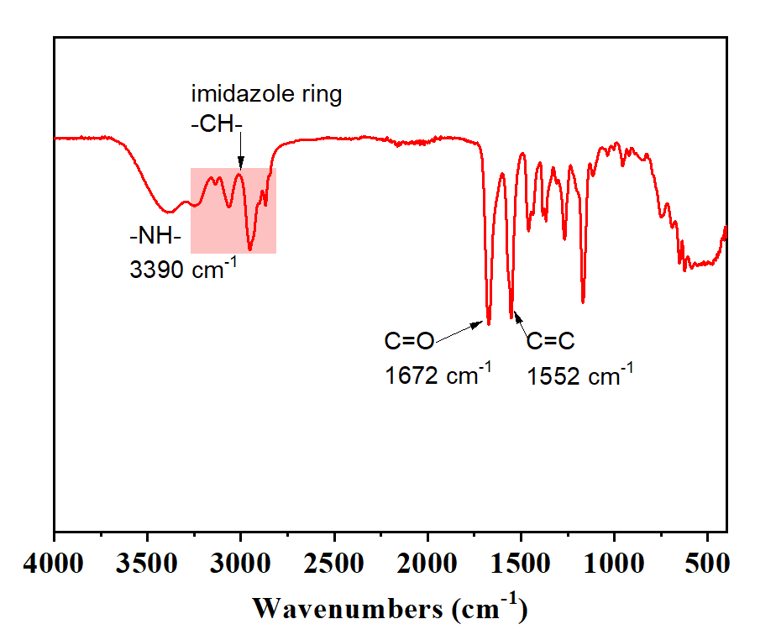
Fig. S4 IR spectra of THLCAM-VI

Fig. S5 ¹H NMR spectra of THLCAM-VI

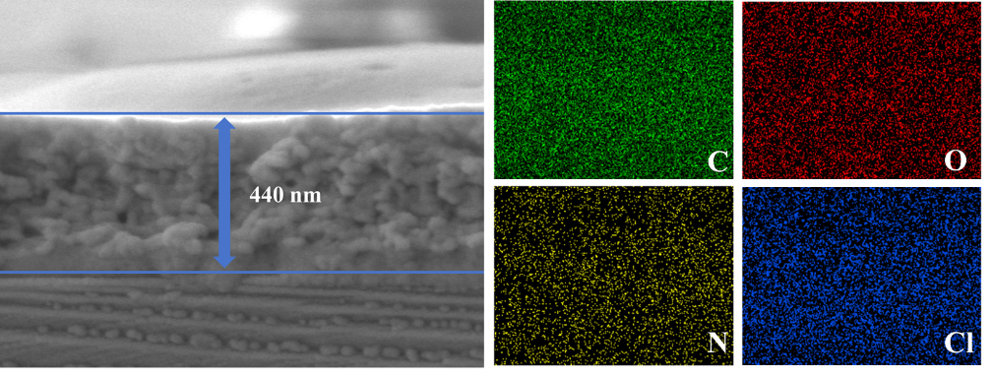
Fig. S6 Cross-sectional SEM image and EDX mapping of the M-PTHLCAM-VI

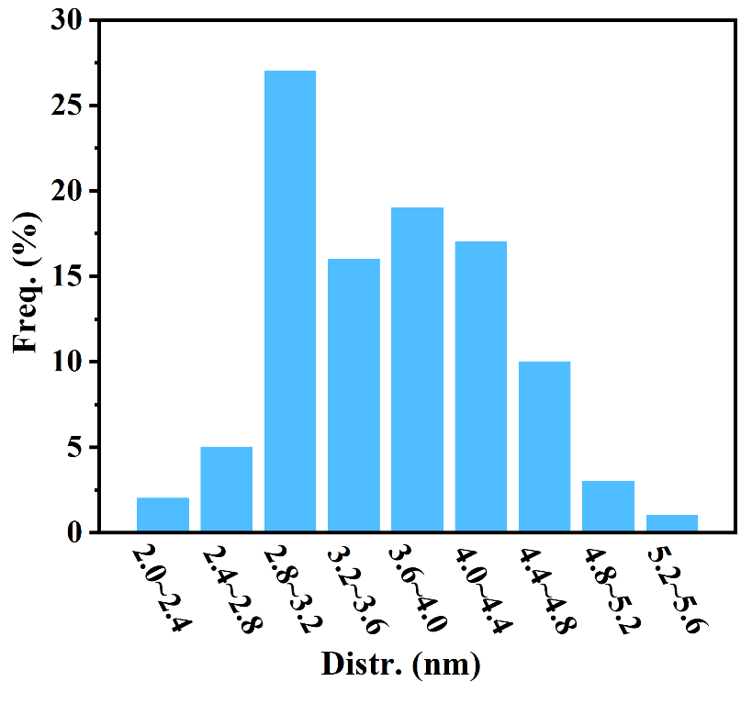
Fig. S7 AFM test pore size distribution statistics

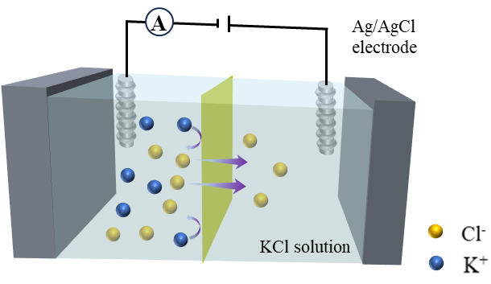
Fig. S8 Schematic of two-chamber electrochemical cell

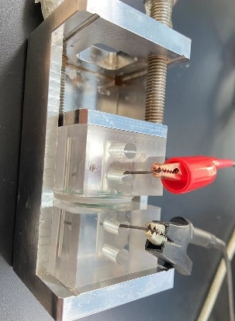
Fig. S9 Optical image of two-chamber cell

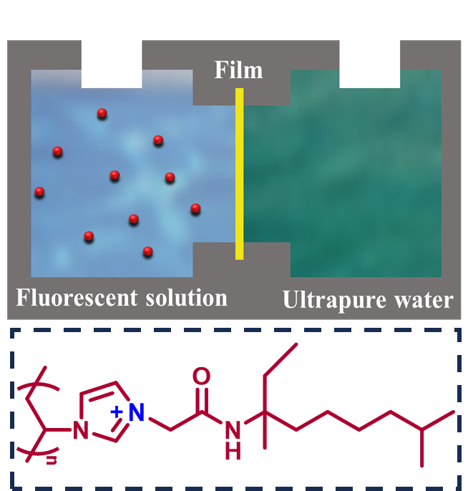
Fig. S10 Image of bespoke two-cell test setup
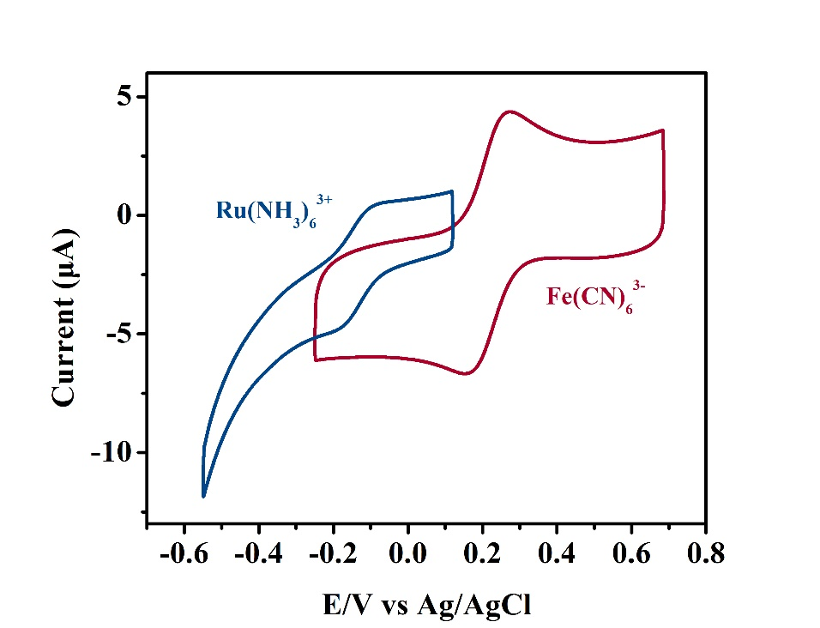
Fig. S11 CV curves of the PTHLCAM-VI membrane when using [Fe(CN)₆]³⁻ as the cationic electroactive probe and [Ru(NH3)₆]³⁺ as the anionic electroactive probe
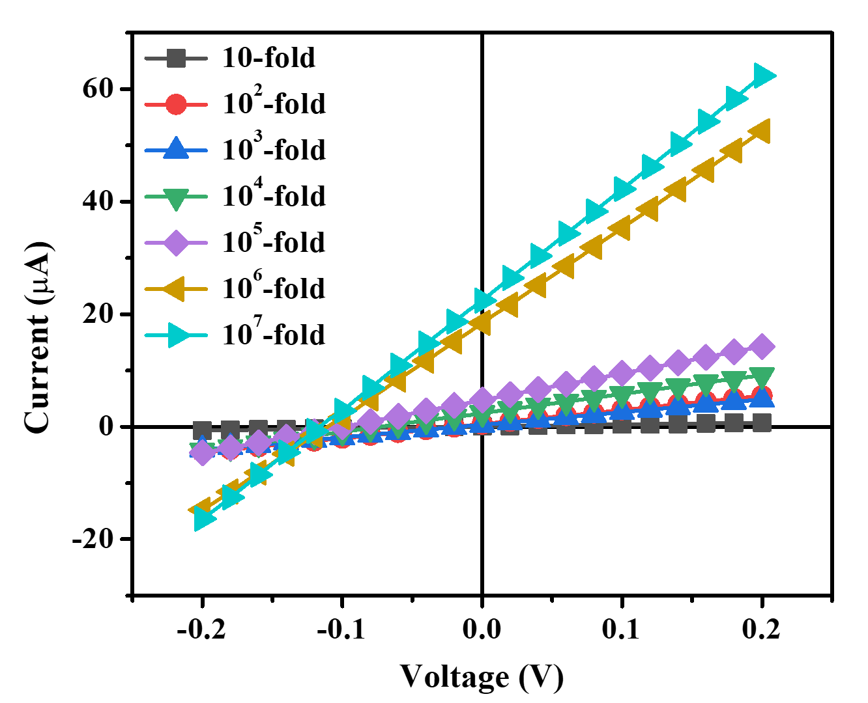
Fig. S12 I-V curves of the M-PTHLCAM-VI in KCl solutions of different concentration gradients

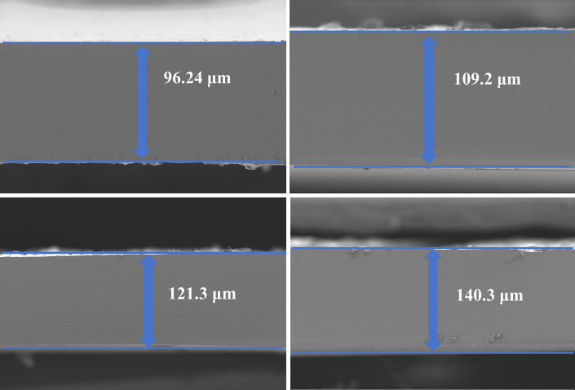
Fig. S13 SEM of PTHLCAM-VI membranes with different thickness

Fig. S14 Power densities of the PTHLCAM-VI membrane under different pH conditions
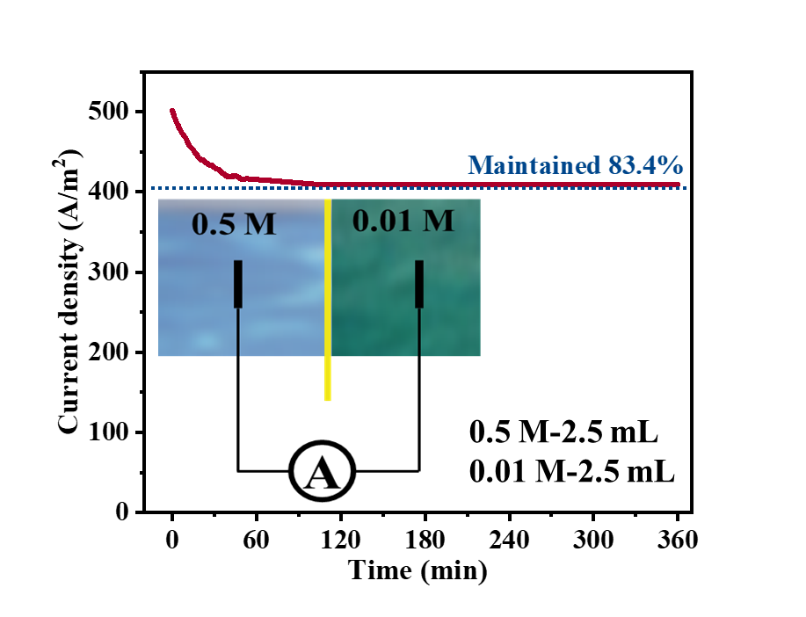
Fig. S15 Current-time curve of system working with no electrolyte replenishing

Fig. S16 The relationship between the power densities and testing area of the PTHLCAM-VI membrane under 0.5 M KCl and 0.01 M KCl
Fig. S17 Power densities of the PTHLCAM-VI membrane in various salt systems

