Supporting Information for
Unlocking Reversible Mn²⁺/MnO₂ Chemistry in Semisolid Slurry Electrodes for High-Performance Aqueous Zn-Mn Batteries
Zefang Yang^{1,2,3}, Qi Zhang¹*, Chao Hu¹, Yougen Tang¹, Jinchi Li², Qi Wang⁴, Wanhai Zhou², Dongliang Chao²*, Haiyan Wang¹*
¹ Hunan Provincial Key Laboratory of Chemical Power Sources, College of Chemistry and Chemical Engineering, Central South University, Changsha 410083, P. R. China
² Laboratory of Advanced Materials, Aqueous Battery Center, State Key Laboratory of Molecular Engineering of Polymers, College of Smart Materials and Future Energy, Fudan University, Shanghai 200433, P. R. China
³ School of Physical and Mathematical Sciences, Nanyang Technological University, Singapore 637371, Singapore
⁴ Nanotechnology Research Laboratory, Faculty of Engineering, University of Sydney, NSW 2006, Australia
*Corresponding authors. E-mail: qzhang1027@csu.edu.cn (Qi Zhang); chaod@fudan.edu.cn (Dongliang Chao); wanghy419@csu.edu.cn (Haiyan Wang)
Supplementary Figures
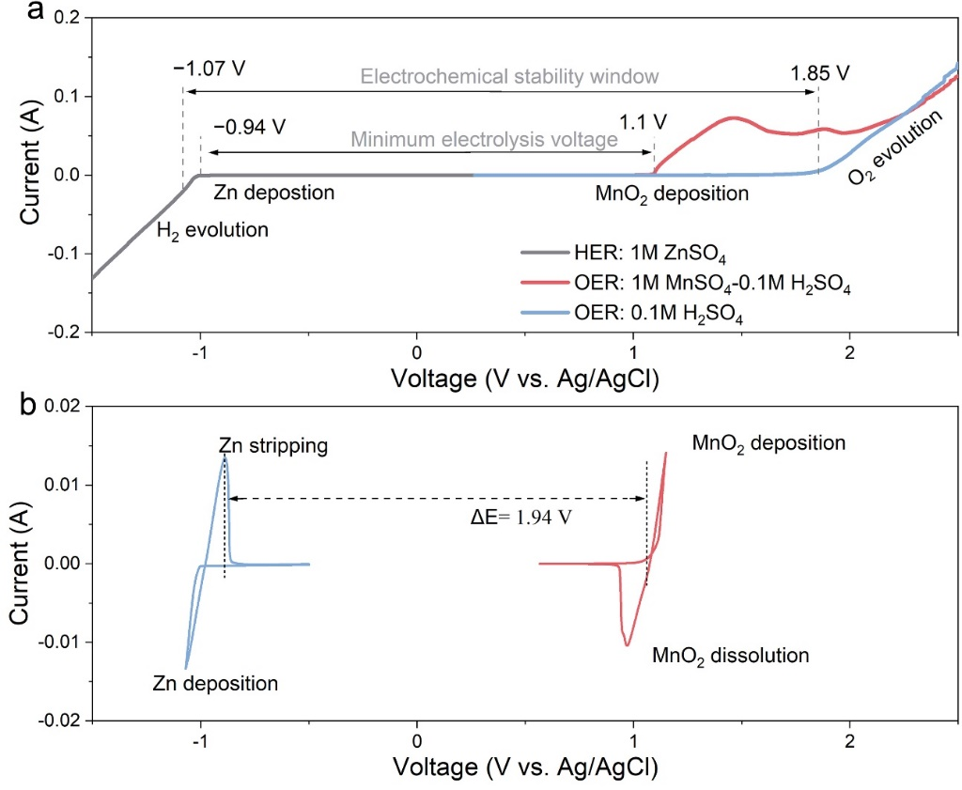
Fig. S1 (a) Cyclic voltammetry curve of MnO₂ and zinc deposition/dissolution with a voltage gap. (b) The electrochemical window of the electrolyte for the slurry electrode
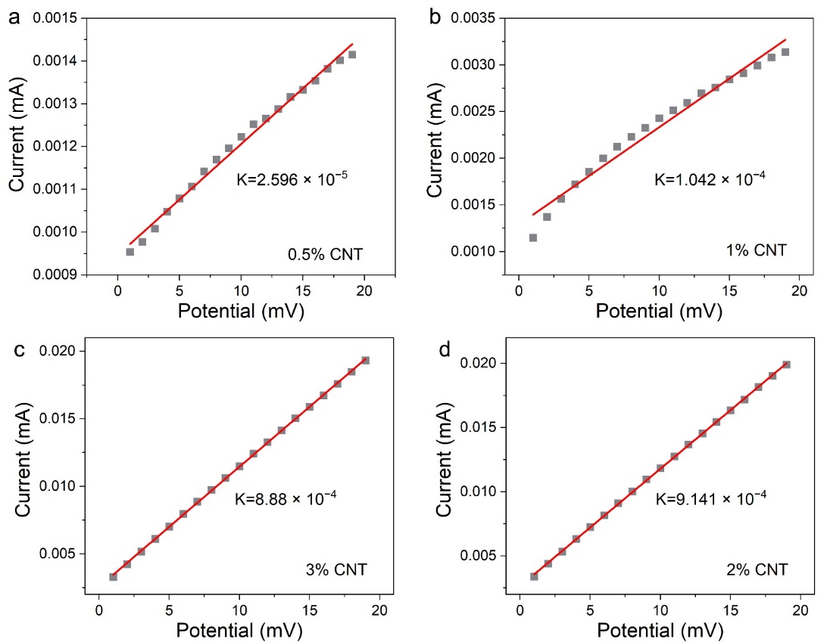
Fig. S2 Voltage-current relationship of the slurry with CNTs concentrations of (a) 0.5%, (b) 1%, (c) 2% and (d) 3%
The resistance of the slurry was calculated using the previous methods. [S1, S2] The electrode slurry is first encapsulated between the graphite plates. The measurement is conducted on the electrochemical workstation at a fixed scan rate of 0.1 mV s⁻¹. The electronic conductivity of slurry can be calculated using the formula below.
R = U/I (S1)
σ = L/RS (S2)
where R, L and S are the slope (1/K) of the voltage-current plot, the thickness of the slurry electrode and the reaction area of the slurry, respectively.
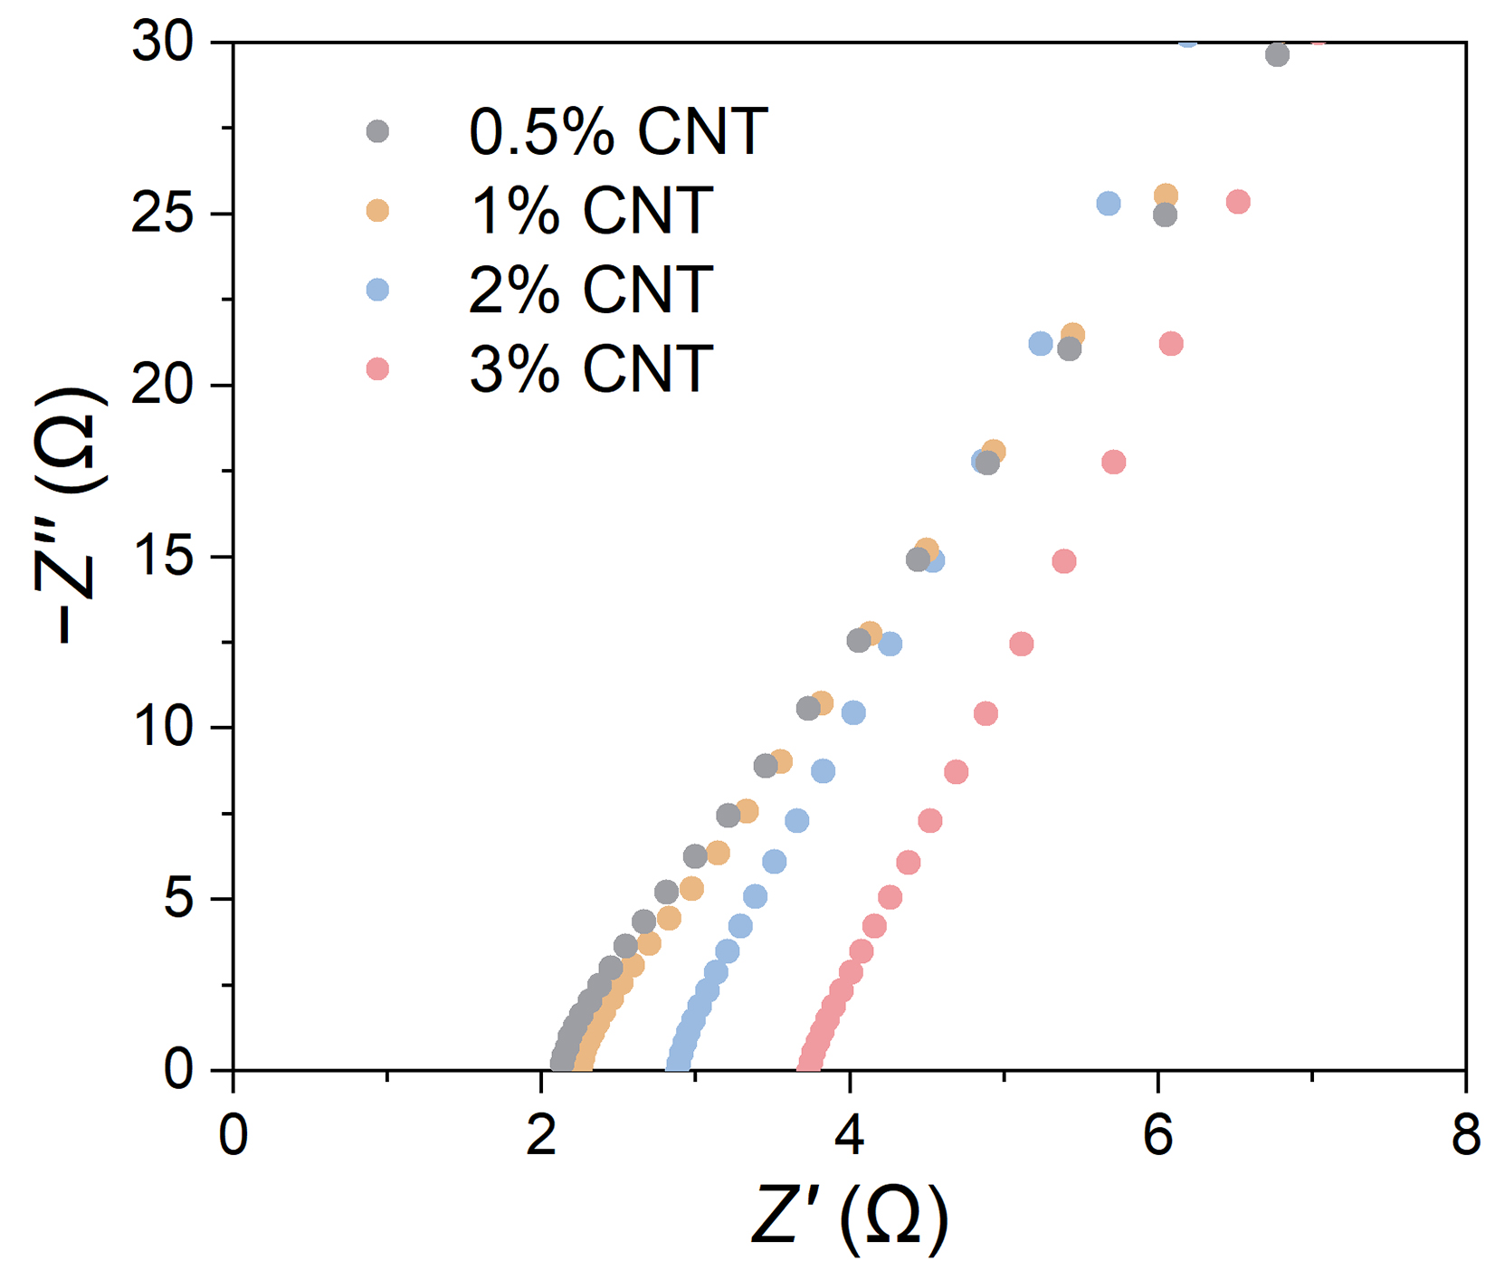
Fig. S3 Nyquist plots of the slurry with different concentrations of CNTs. The measurements are conducted by employing two stainless sheets as work and counter electrodes, respectively
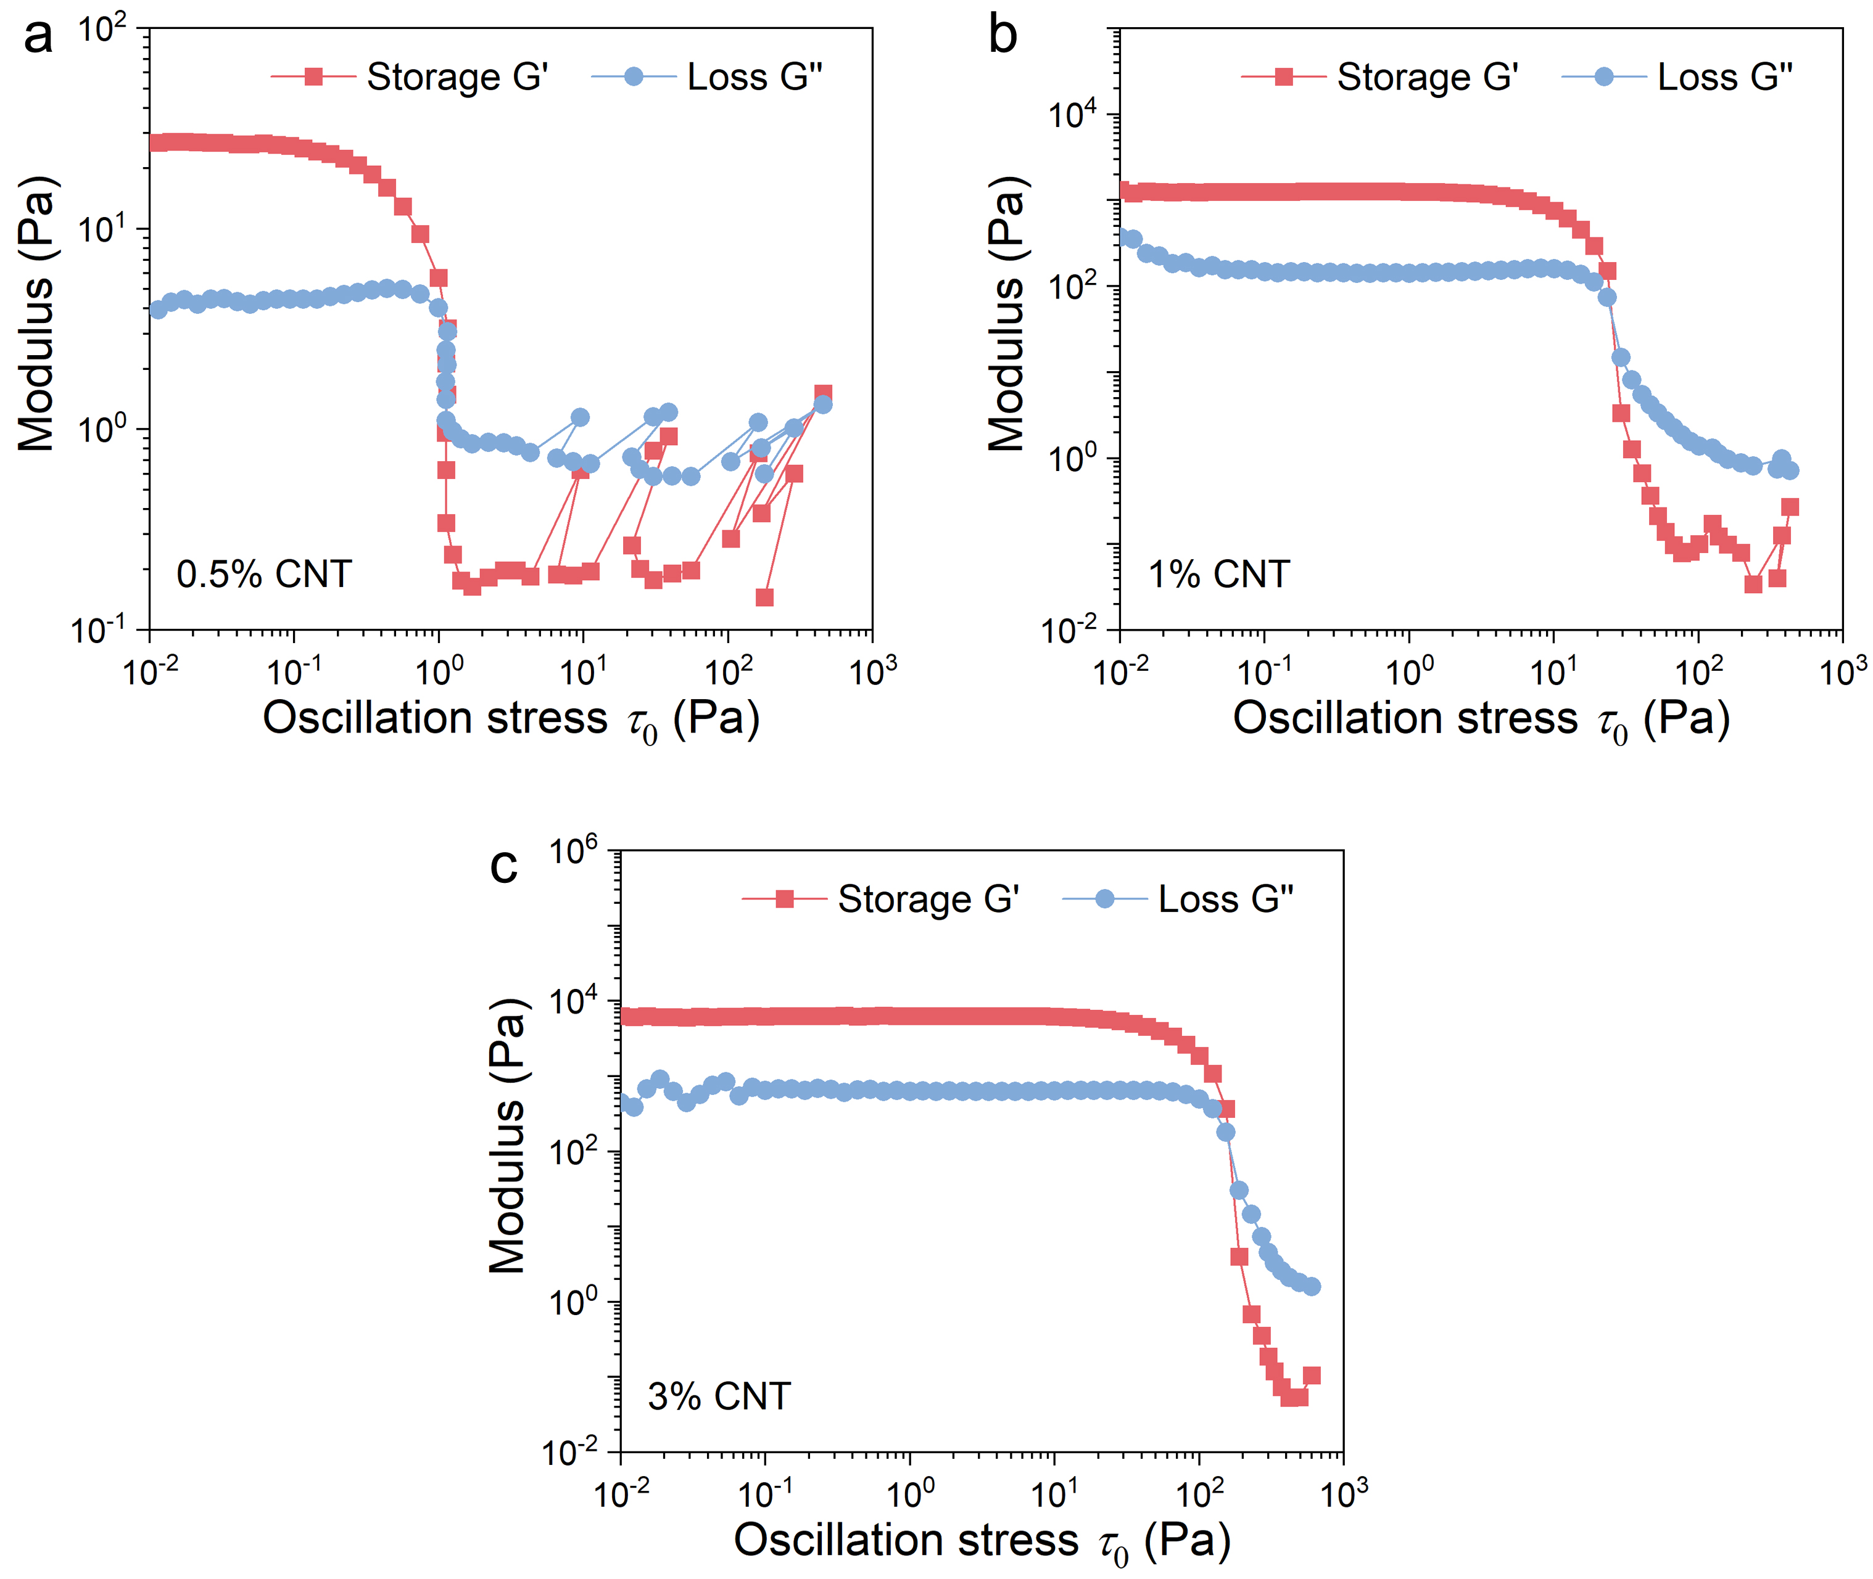
Fig. S4 Rheological property of the slurry with a CNTs concentration of (a) 0.5%, (b) 1% and (c) 3%

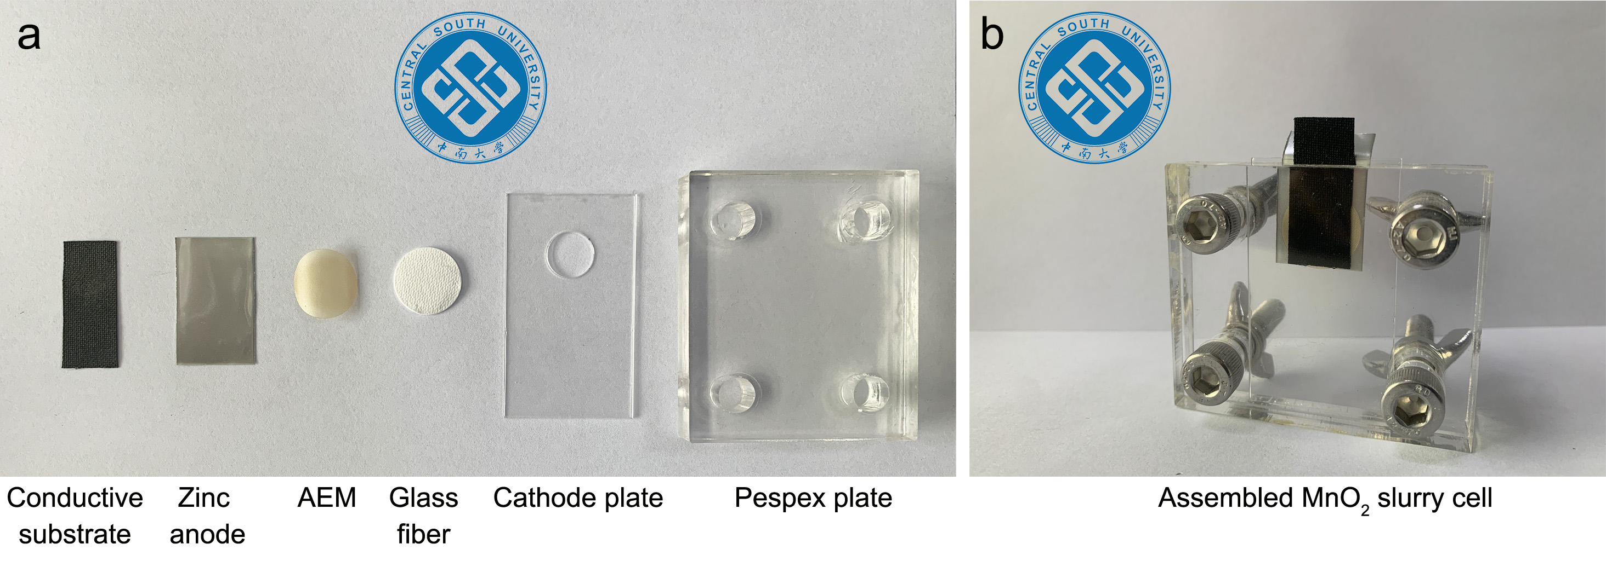
Fig. S5 (a) The units and (b) setup of the Perspex-type MnO₂ slurry cell

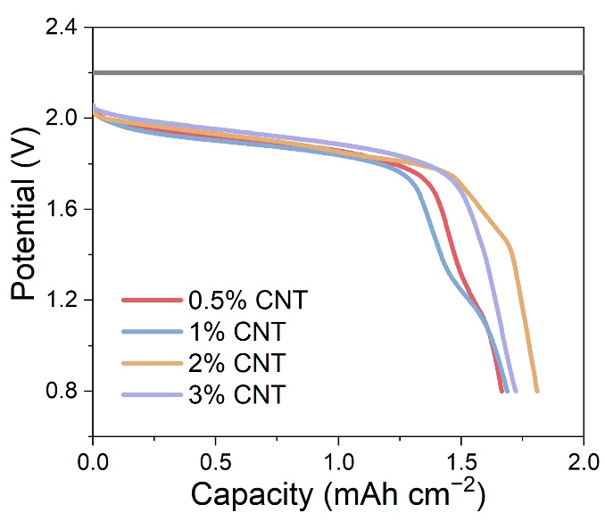
Fig. S6 The constant-voltage charge and galvanostatic discharge curves of the slurry electrodes with different concentrations of CNTs

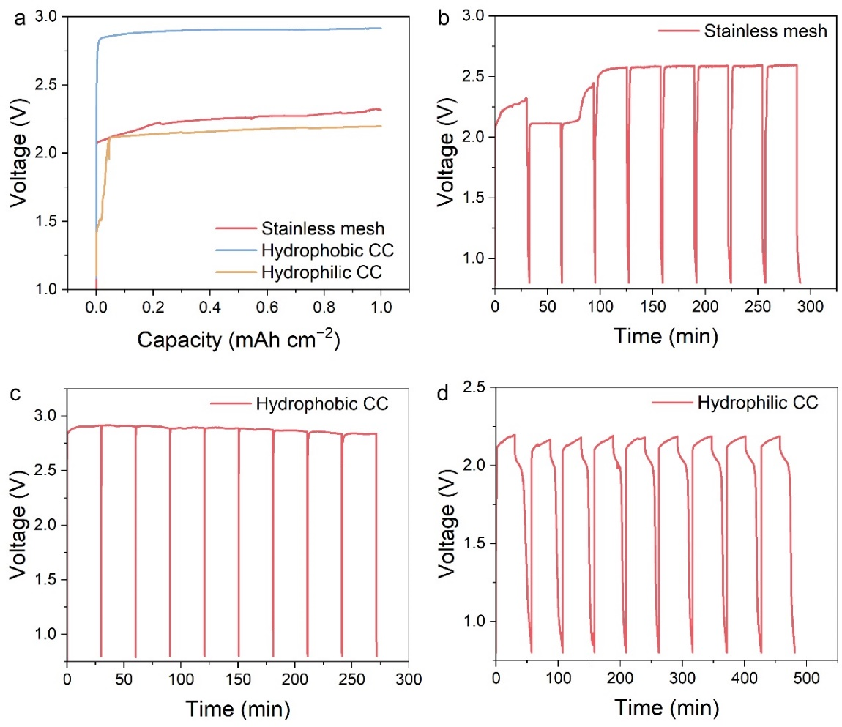
Fig. S7 (a) Voltage curves of MnO₂ deposition on stainless mesh, hydrophobic and hydrophilic CC in the catholyte at a constant current. Cycling curves of MnO₂ deposition/dissolution on (b) stainless mesh, (c) hydrophobic and (d) hydrophilic CC

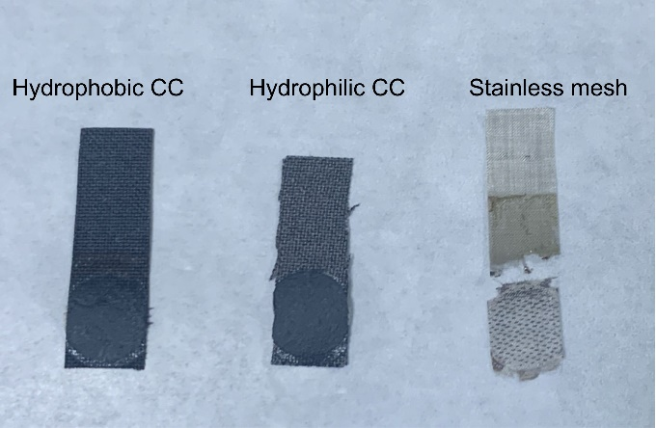
Fig. S8 Digital photographs of stainless mesh, hydrophobic and hydrophilic CC disassembled from electrolytic MnO₂ cell after cycling
MnO₂ deposition/dissolution on stainless mesh, hydrophobic and hydrophilic CC was investigated. Hydrophobic CC exhibits a high MnO₂ deposition overpotential close to electrolytic water, whereas the MnO₂ deposition overpotentials on hydrophilic CC and stainless mesh are 2.19 and 2.32 V, respectively. It can be seen from the voltage profiles of MnO₂ on hydrophobic CC that no MnO₂ dissolution behavior occurs during the cycling period. In addition, only a tiny amount of MnO₂ is separated from the stainless mesh. The fracture on the stainless mesh is observed after repeated MnO₂ deposition/dissolution. Both hydrophilic and hydrophobic CC show no change in integrity and appearance. Note that the current collector for the slurry is supposed to be highly conductive to rapidly transport electrons but inert to MnO₂ to ensure reversible MnO₂ deposition/dissolution on the CNTs in the slurry. Therefore, an optimized hydrophobic CC is chosen as the conductive substrate for the slurry.

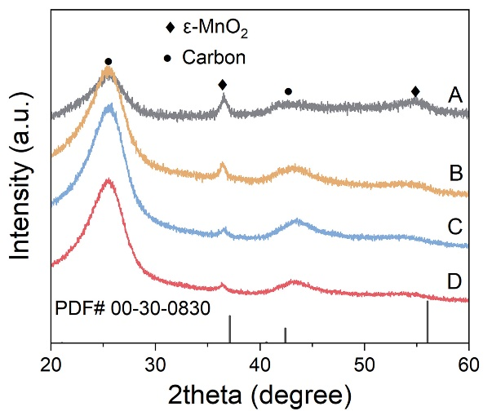
Fig. S9 XRD patterns of MnO₂ deposition/dissolution in CE-MnO₂ cells with AEM

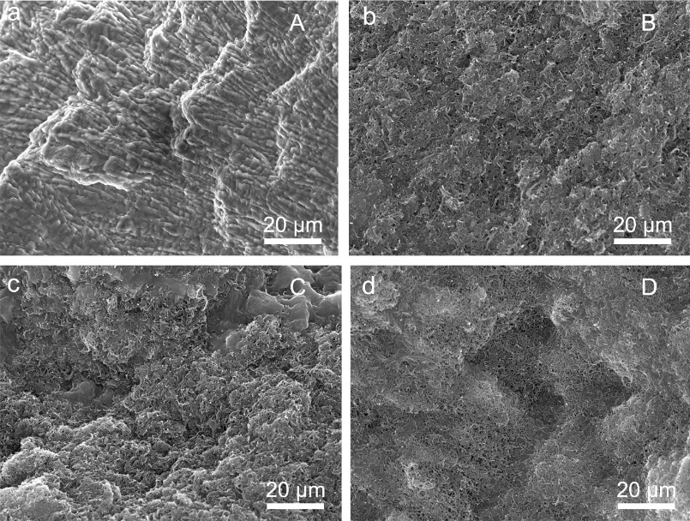
Fig. S10 SEM images of MnO₂ slurry electrode after (a) the charge and (b-d) discharge at different states
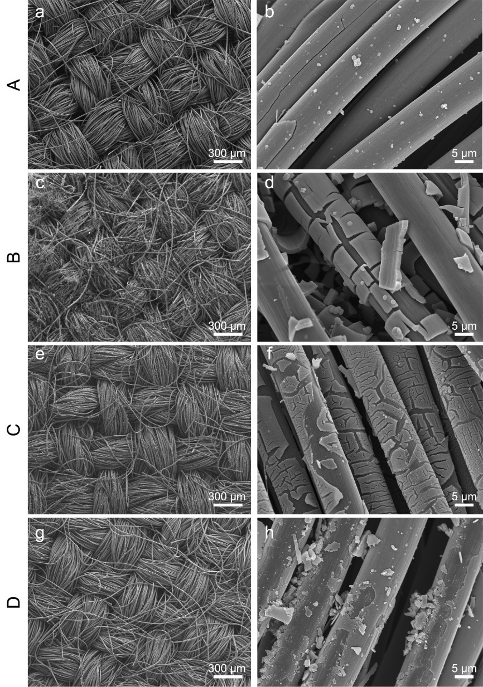
Fig. S11 SEM images of CE-MnO₂ cell without AEM after (a, b) the charge and (c-h) discharge at different states
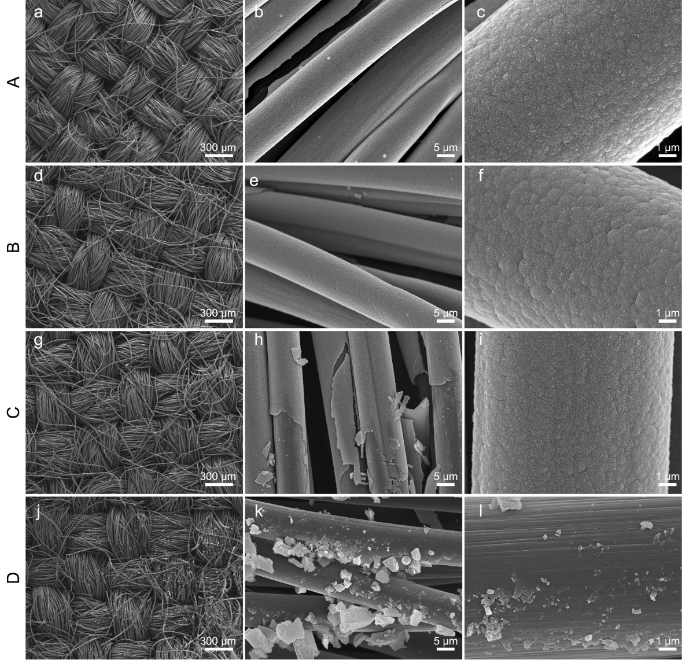
Fig. S12 SEM images of CE-MnO₂ cell with AEM after (a-c) the charge and (d-l) discharge at different states
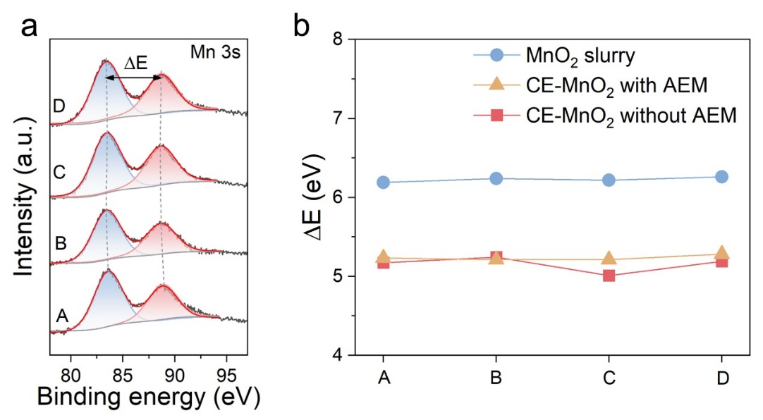
Fig. S13 (a) Mn 3s spectra of CE-MnO₂ cells with AEM. (b) ∆E value of MnO₂ slurry and CE-MnO₂ cells with and without AEM after charge and discharge at different states by single peak fitting

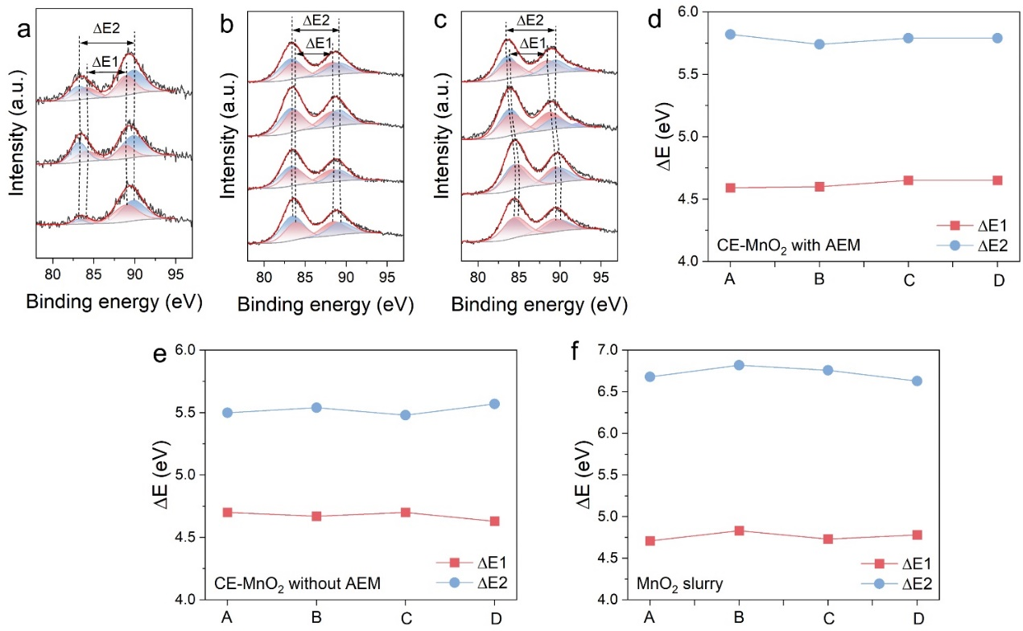
Fig. S14 Mn 3s spectra of CE-MnO₂ cells (a) with and (b) without AEM after charge and discharge at different states by multi-peak fitting. ∆E value of CE-MnO₂ cells (c) with and (d) without AEM and (e) MnO₂ slurry cell by multi-peak fitting

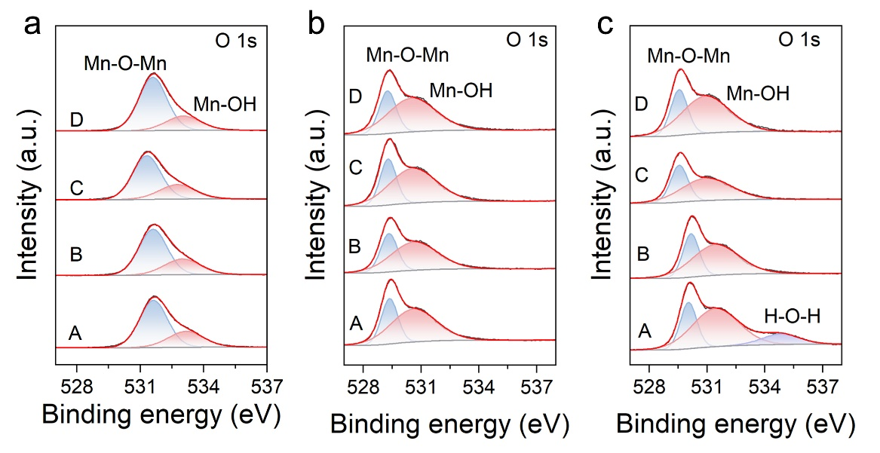
Fig. S15 O 1s spectra of (a) the MnO₂ slurry and CE-MnO₂ cells (b) with and (c) without AEM after charge and discharge at different states

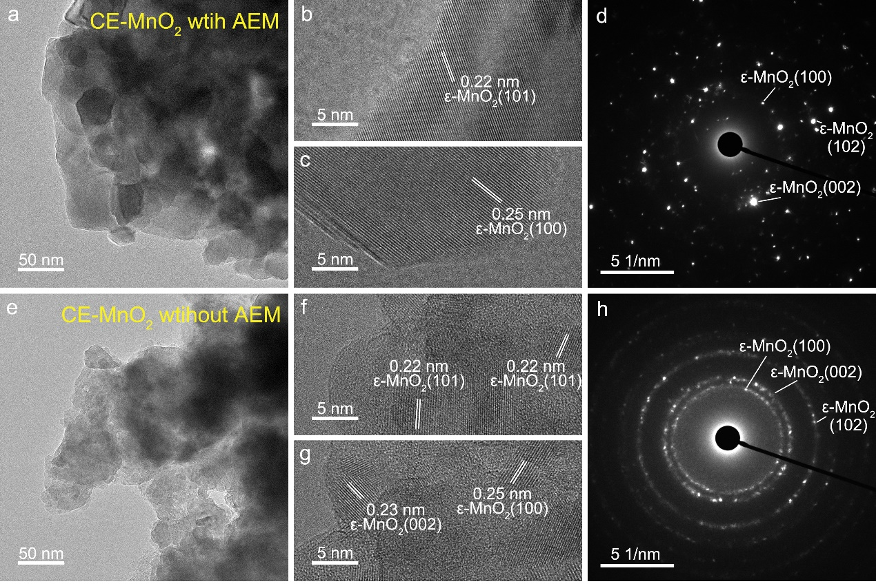
Fig. S16 (a, e) TEM images, (b, c, f, g) high-resolution TEM images and (d, h) the selected area electron diffraction patterns of MnO₂ deposition in CE-MnO₂ cells (a-d) with and (e-h) without AEM

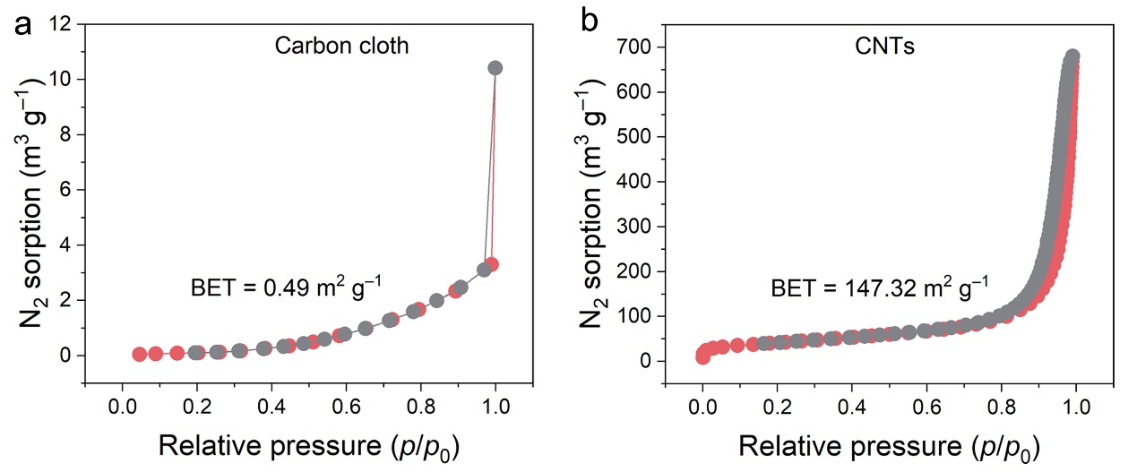
Fig. S17 N₂ adsorption–desorption isotherms of (a) carbon cloth and (b) CNTs
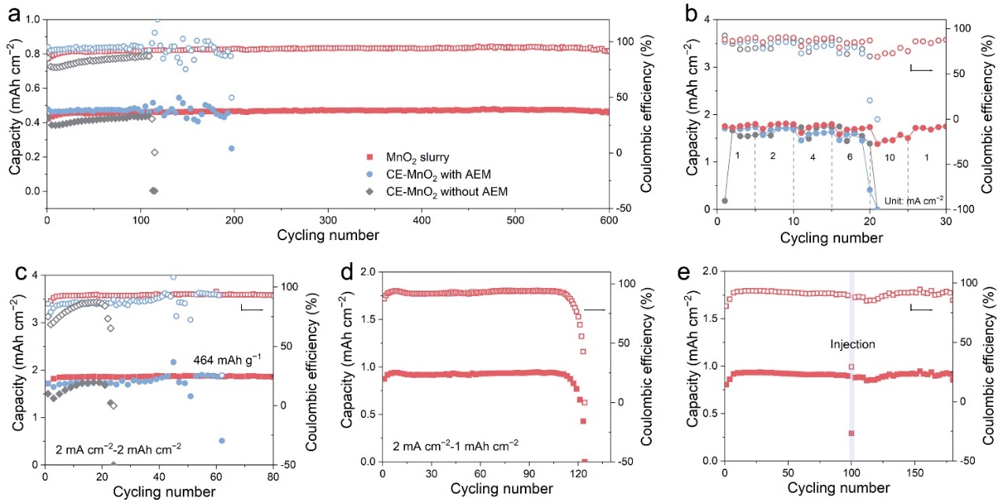
Fig. S18 (a) Cycling stability and (b) rate performance of Zn-MnO₂ slurry and CE-MnO₂ cells with and without AEM. (c) Cycling performance of Zn-MnO₂ slurry and CE-MnO₂ cells with and without AEM at 2 mA cm⁻² and 2 mAh cm⁻². (d) Cycling performance of Zn-MnO₂ slurry cells at 2 mA cm⁻² and 1 mAh cm⁻². (e)The cycling life of the Zn-MnO₂ slurry cell was enhanced by the injection of the catholyte
The charge and discharge conditions are further set to 2 mA cm⁻² and 2 mAh cm⁻². As shown in Fig. S18c, the MnO₂ slurry cell delivers a specific capacity of 464 mAh g⁻¹ (calculated based on the mass loading of active CNTs) and maintains a stable capacity after 80 cycles, whereas the capacity of CE-MnO₂ cells with and without AEM is rapidly degraded after 44 and 21 cycles, respectively. Note that the thick MnO₂ deposition layers are generated in the case of high mass loading, resulting in low dissolution reversibility due to the poor electronic conductivity of ε-MnO₂. To investigate the failure mechanism of the MnO₂ slurry cell, the cycling performance was tested at 2 mA cm⁻² and 1 mAh cm⁻². The MnO₂ slurry cell shows a steady capacity profile within 110 cycles and a subsequent sharp capacity decline (Fig. S18d), which arises from the depletion of the electrolyte in the slurry by H₂ evolution from the zinc anodes. Surprisingly, when the MnO₂ slurry electrode is injected with a small amount of catholyte before failure, the cycle life of the slurry cells can be extended to 180 cycles, suggesting a low-cost regenerative capability of the slurry battery (Fig. S18e).

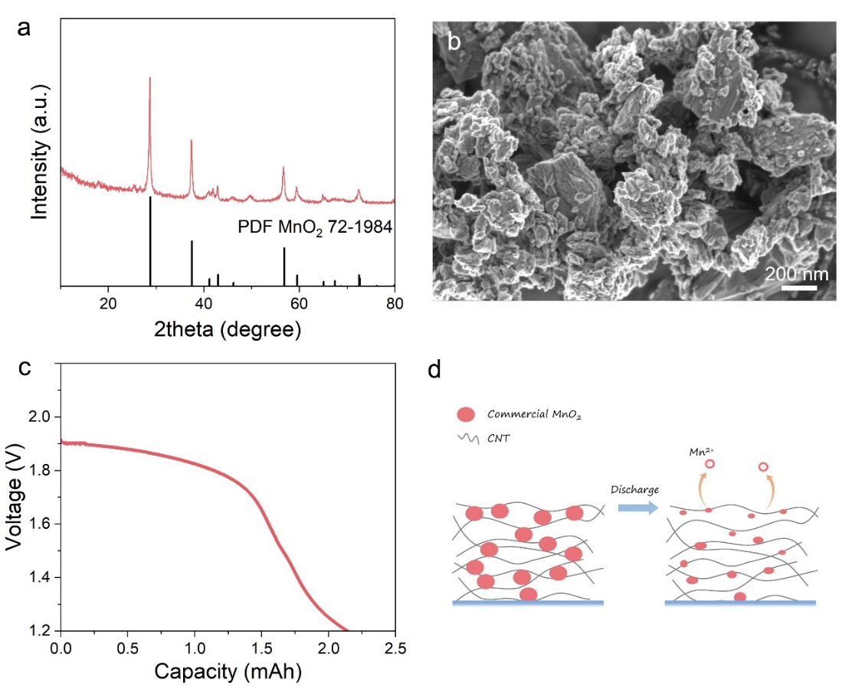
Fig. S19 (a) XRD patterns and (b) SEM images of commercial MnO₂ powder. (c) Discharge curves of slurry with appropriate amounts of commercial MnO₂ powders. (d) Schematic illustration of commercial MnO₂ powders being dissolved during discharge
Commercial MnO₂ powders were added to the catholytes with the CNTs content of 2% to obtain a uniform slurry (Fig. S19a and S19b). When a galvanostatic discharge was applied to the slurry electrode with MnO₂ powders, a distinct discharge curve with a voltage platform of 1.85 V was observed (Fig. S19c). The results indicate that the pre-incorporated MnO₂ in the slurry can be activated by the 3D conductive CNTs network, suggesting the ability of the slurry electrode to revive dead MnO₂ during MnO₂ dissolution (Fig. S19d).
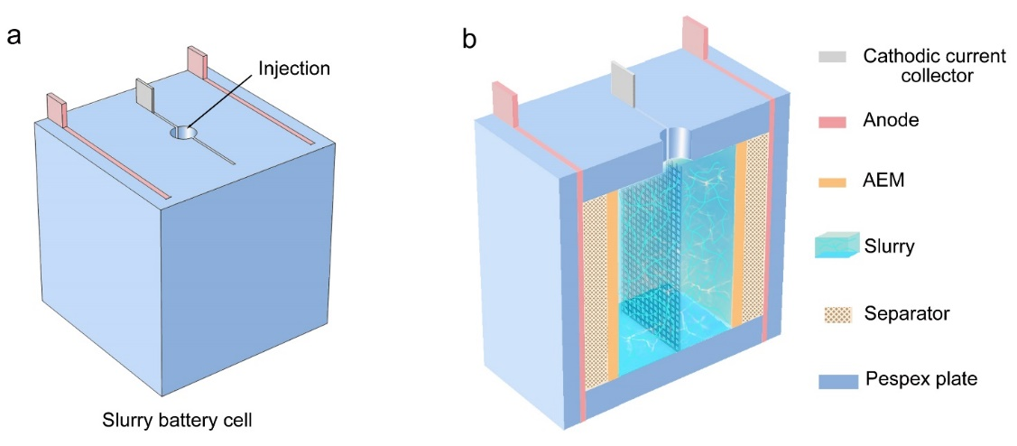
Fig. S20 Schematic illustration of (a) appearance and (b) cross section for the Zn-MnO₂ slurry cells
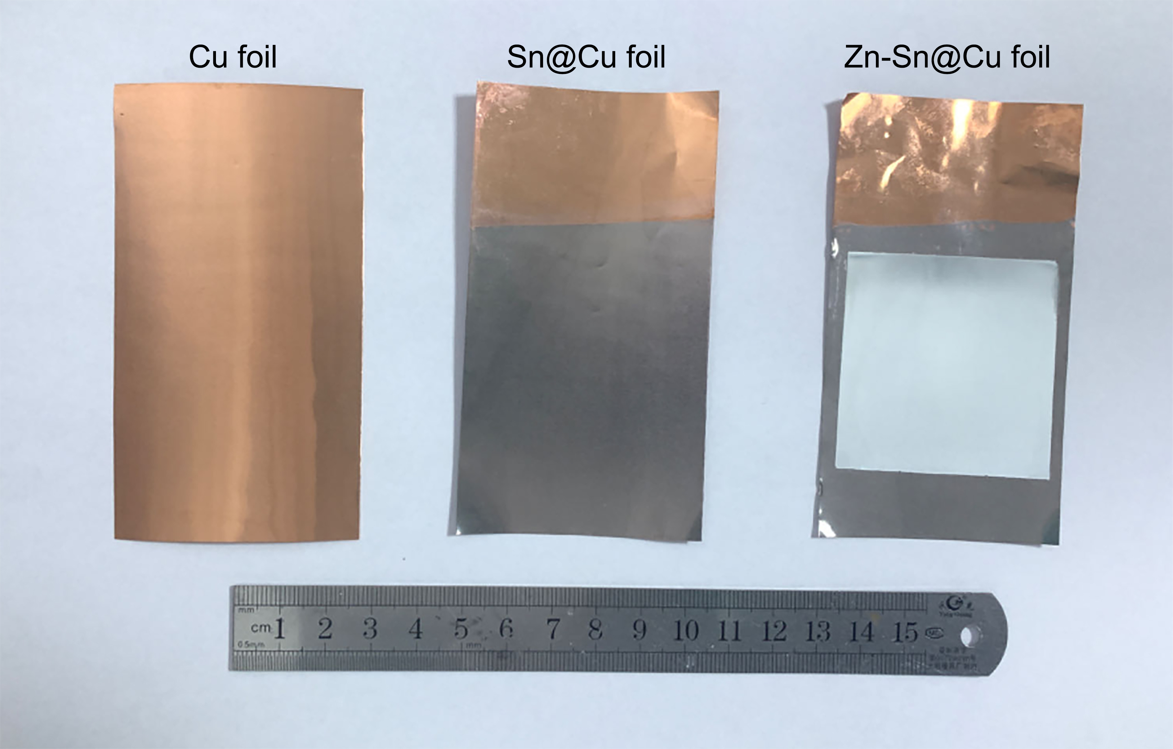
Fig. S21 Digital photographs of copper (Cu) foil, tinned copper (Sn@Cu) foil and pre-plated zinc on Sn@Cu (Zn-Sn@Cu) foil
Fig. S22 The discharge curves of CE-MnO₂ battery with Zn-Sn@Cu anode
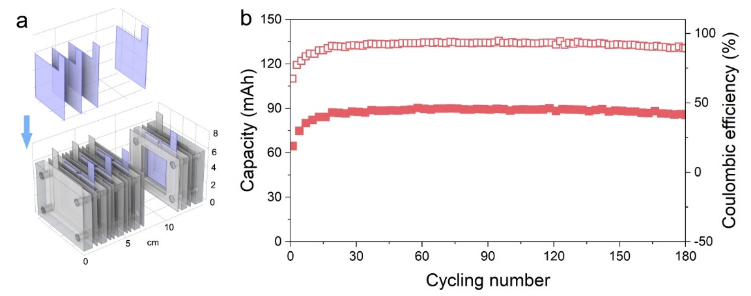
Fig. S23 (a) Schematic illustration of fabrication for multi-layer slurry batteries with high voltage and capacity. (b) Cycling performance of Zn-MnO₂ slurry battery with three slurry electrodes in parallel after charge for 96 mAh and discharge to 0.8 V at 384 mA
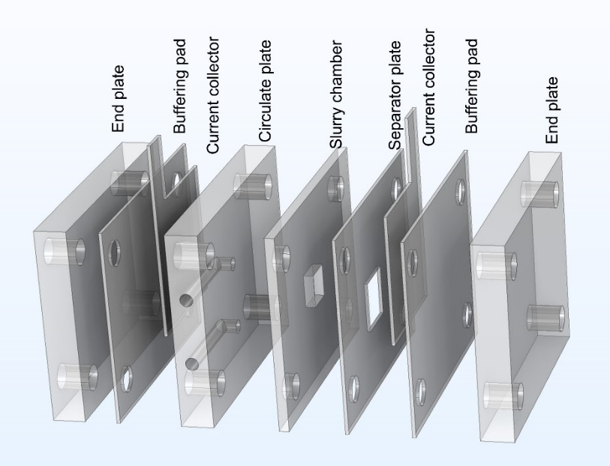
Fig. S24 Schematic illustration of Zn-MnO₂ slurry flow cell
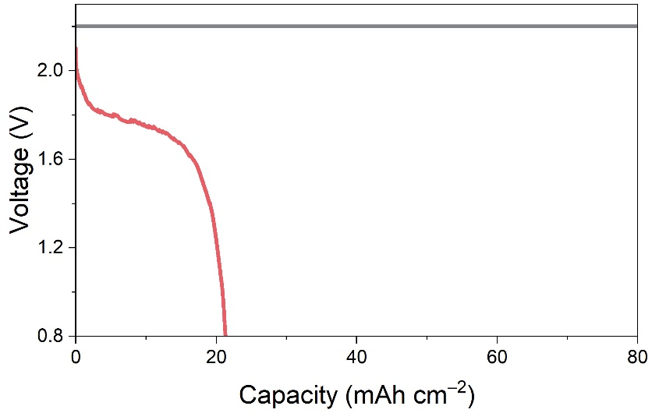
Fig. S25 Charge and discharge curves of CE-MnO₂ flow cell at a discharge current density of 1.5 mA cm⁻²
Fig. S26 Cycling stability of the Zn-MnO₂ slurry flow cell at 1.5 mA cm⁻² and 15 mAh cm⁻², a capacity of 12.5 mAh cm⁻² is retained after 40 cycles with a CE of 83.3%
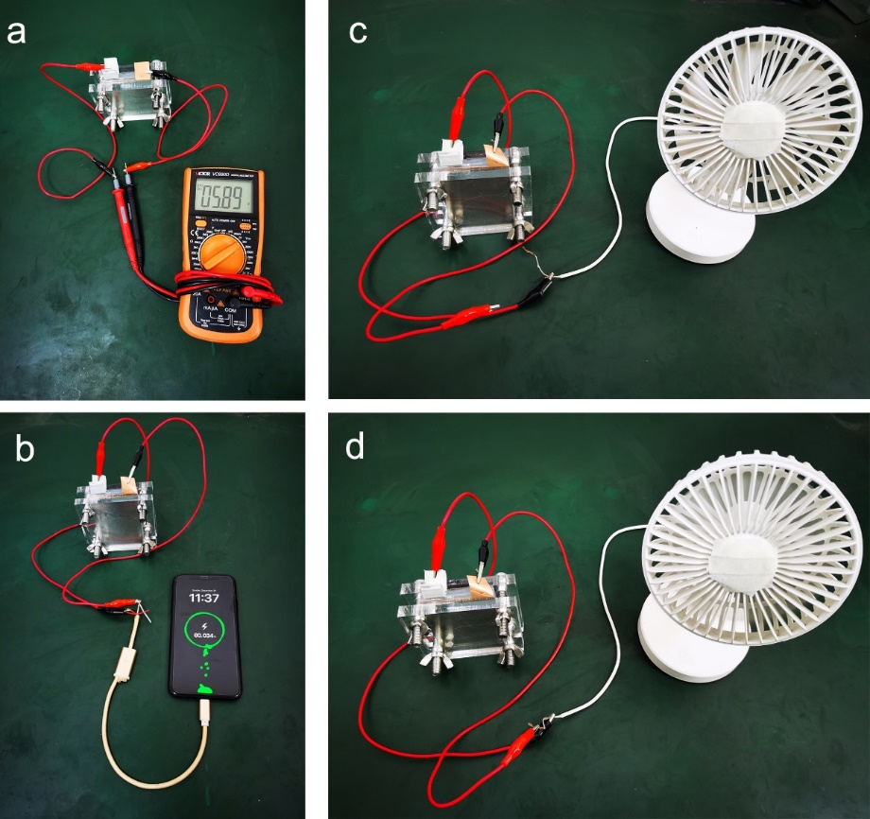
Fig. S27 Digital photographs of (a) open-circuit voltage test, power supply for (b) mobile phone and (c, d) electric fan of the three Zn-MnO2 slurry cells connected in series; (c) disconnect state, (d) work state
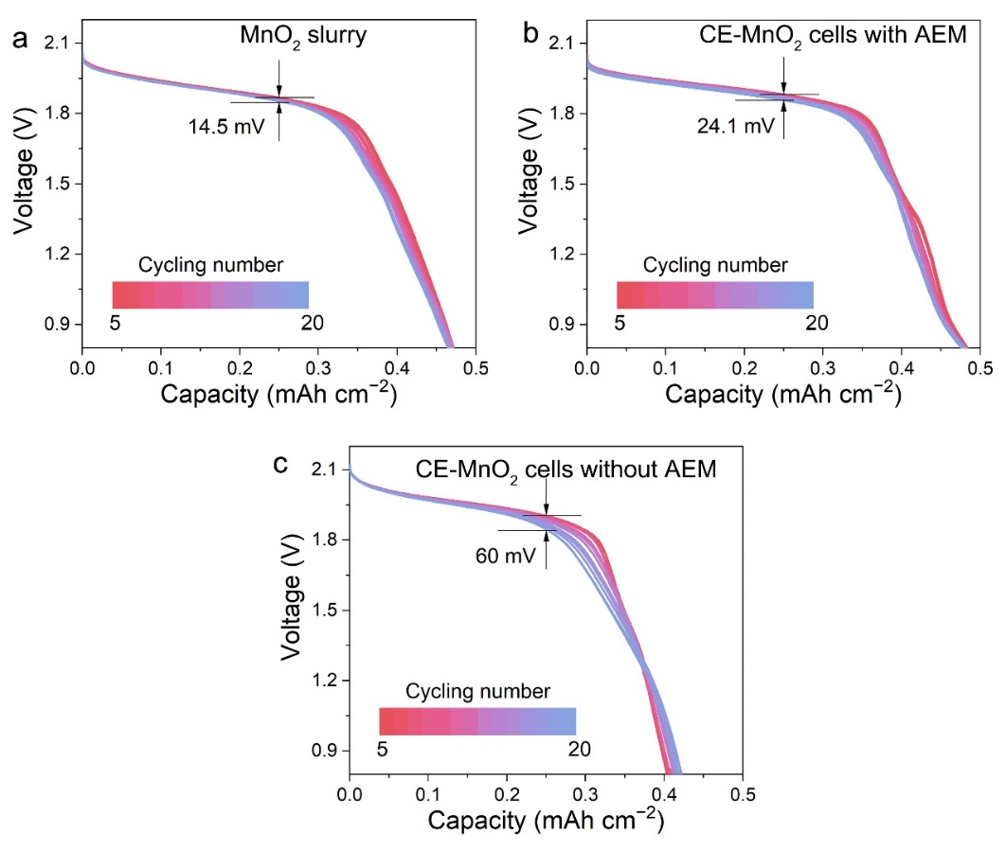
Fig. S28 The discharge curves of (a) MnO₂ slurry and CE-MnO₂ cells (b) with and (c) without AEM in the range of 5th to 20th cycle
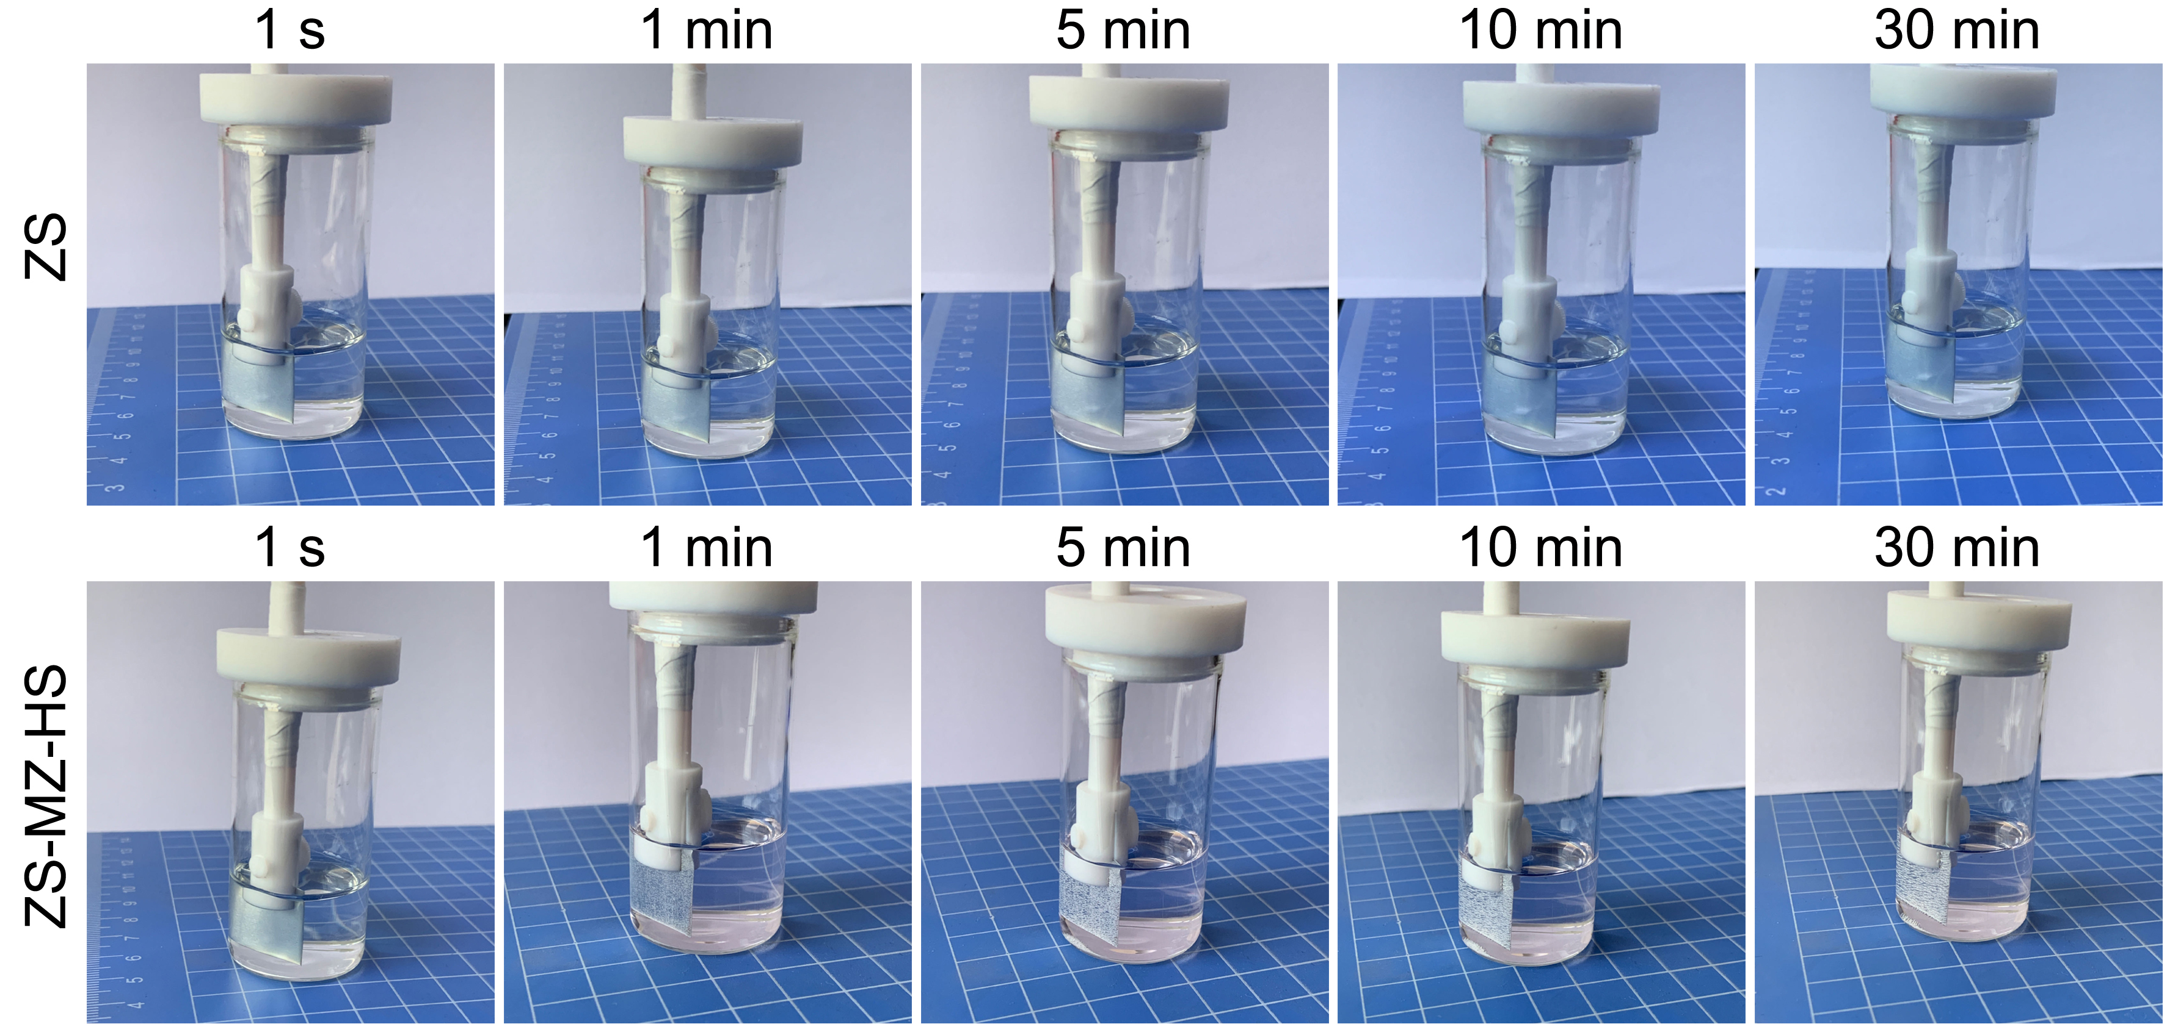
Fig. S29 Digital photograph of zinc foil soaking in 1 M ZnSO₄ (ZS) and 1 M MnSO₄-1M ZnSO₄ electrolytes with 0.1 M H₂SO₄ (ZS-MS-HS) additive for different time

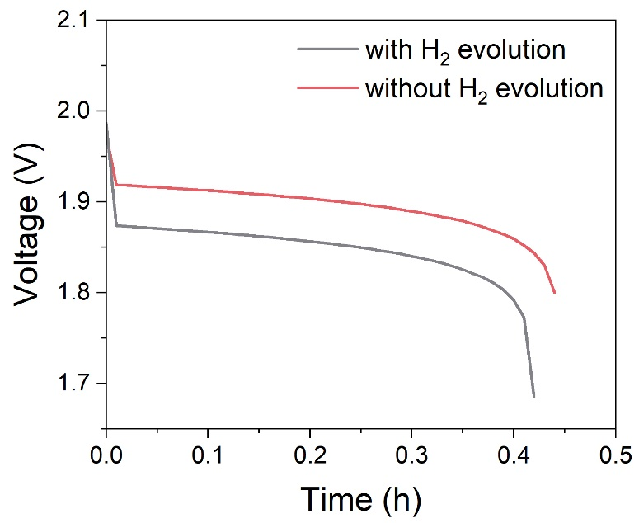
Fig. S30 The simulated discharge curves of Zn-MnO₂ cells with and without H₂ evolution at the anode by FEA
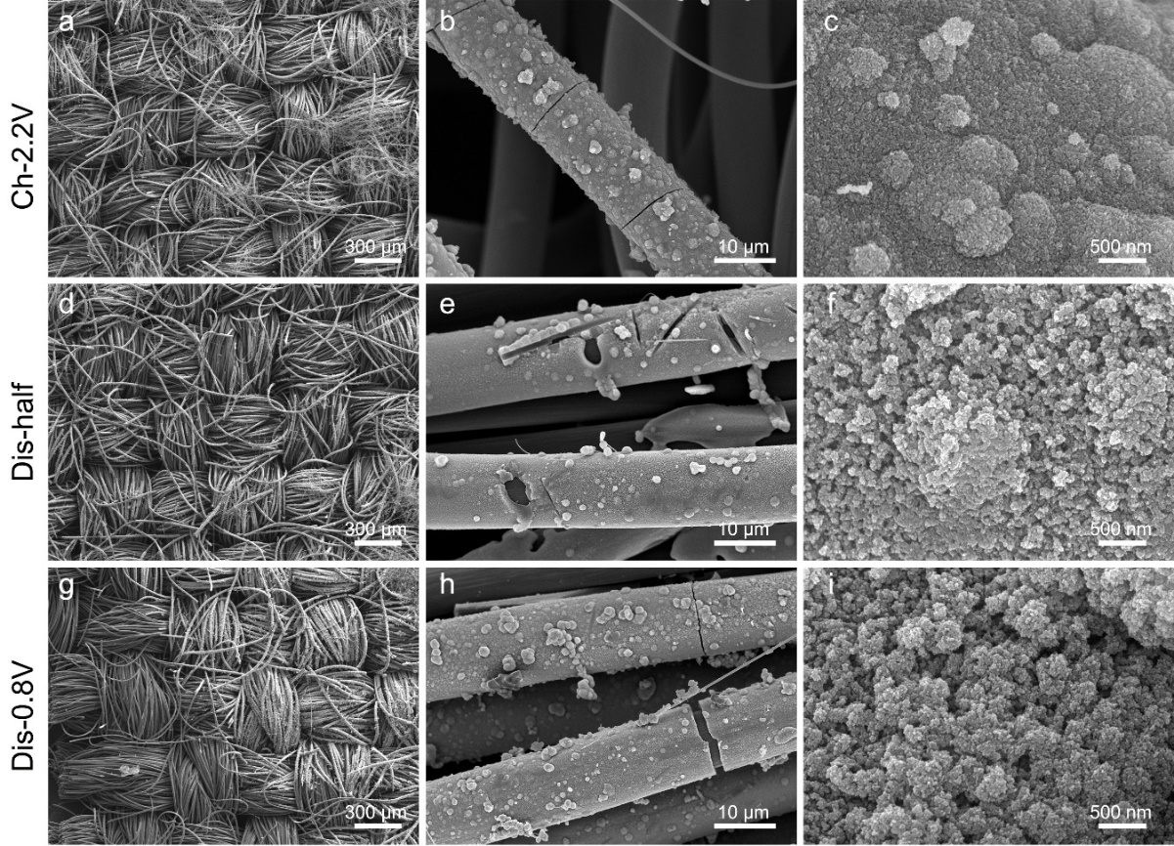
Fig. S31 SEM images of the CE-MnO₂ cell without AEM after 20 cycles at different states. (a-c) Ch-2.2V, (d-f) Dis-half and (g-i) Dis-0.8V represent full charge state, discharge to half depth of discharge and 0.8 V, respectively
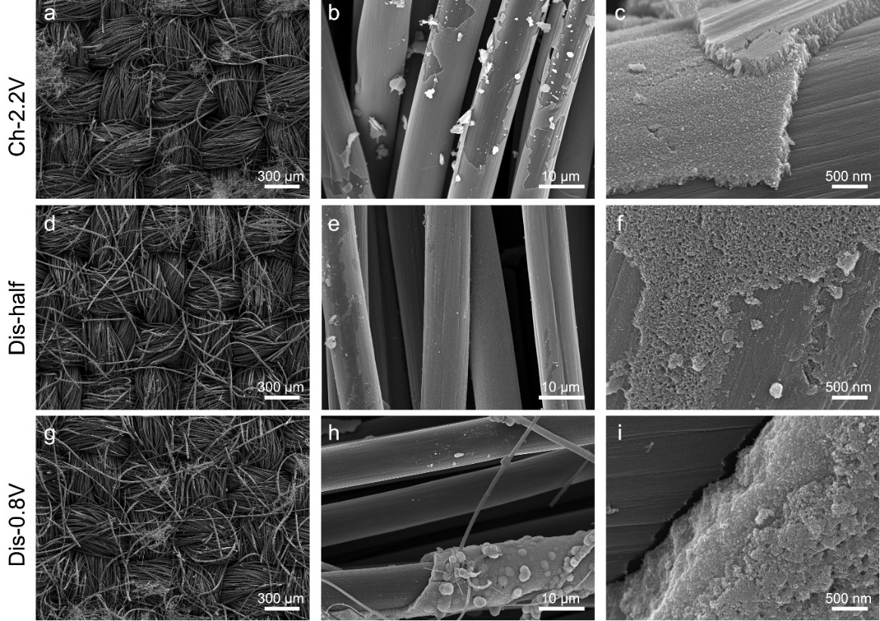
Fig. S32 SEM images of the CE-MnO₂ cell with AEM after 20 cycles at different states. (a-c) Ch-2.2V, (d-f) Dis-half and (g-i) Dis-0.8V

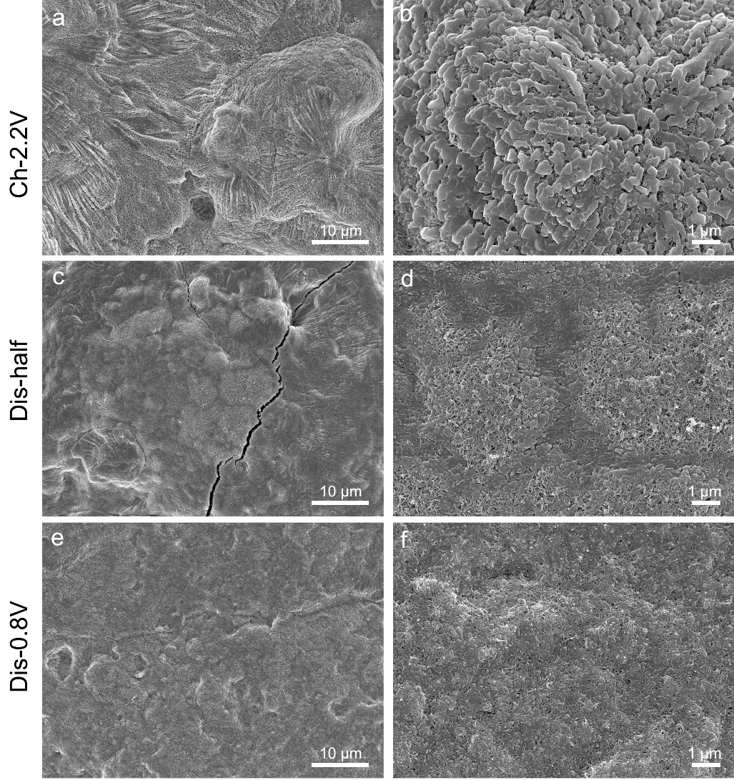
Fig. S33 SEM images of the MnO₂ slurry cell after 20 cycles at different states. (a, b) Ch-2.2V, (c, d) Dis-half and (e, f) Dis-0.8V
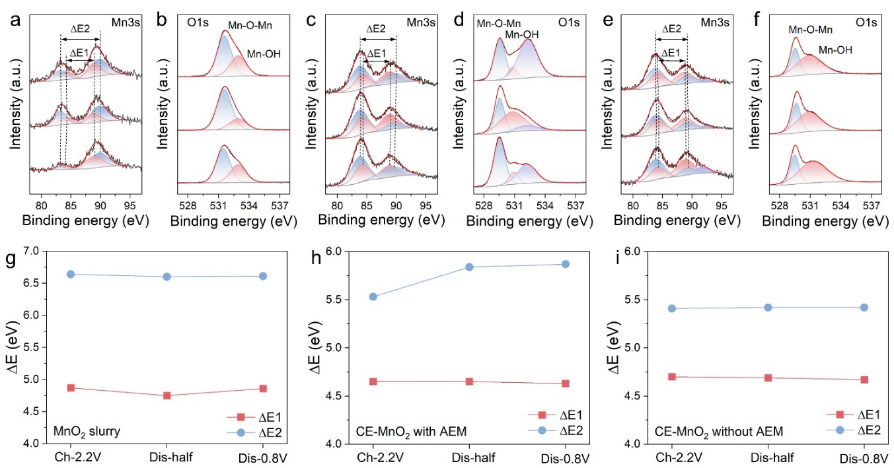
Fig. S34 Mn 3s and O 1s spectra of (a, b) MnO₂ slurry and CE-MnO₂ cell (c, d) with and (e, f) without AEM after 20 cycles at different states. ∆E value of (g) MnO₂ slurry and CE-MnO₂ cells (h) with and (i) without AEM after 20 cycles at different states
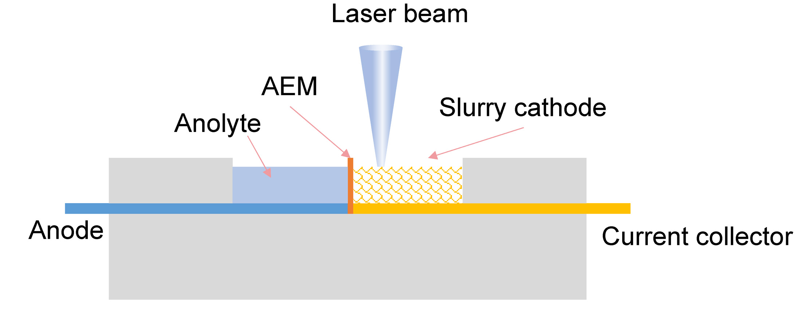
Fig. S35 The schematic diagram of the electrolytic Zn-MnO₂ slurry reaction tank for in-situ Raman spectroscopy record
Fig. S36 Contour map of in-situ Raman spectra and voltage curves of CE-MnO₂ cells with AEM during discharge and charge

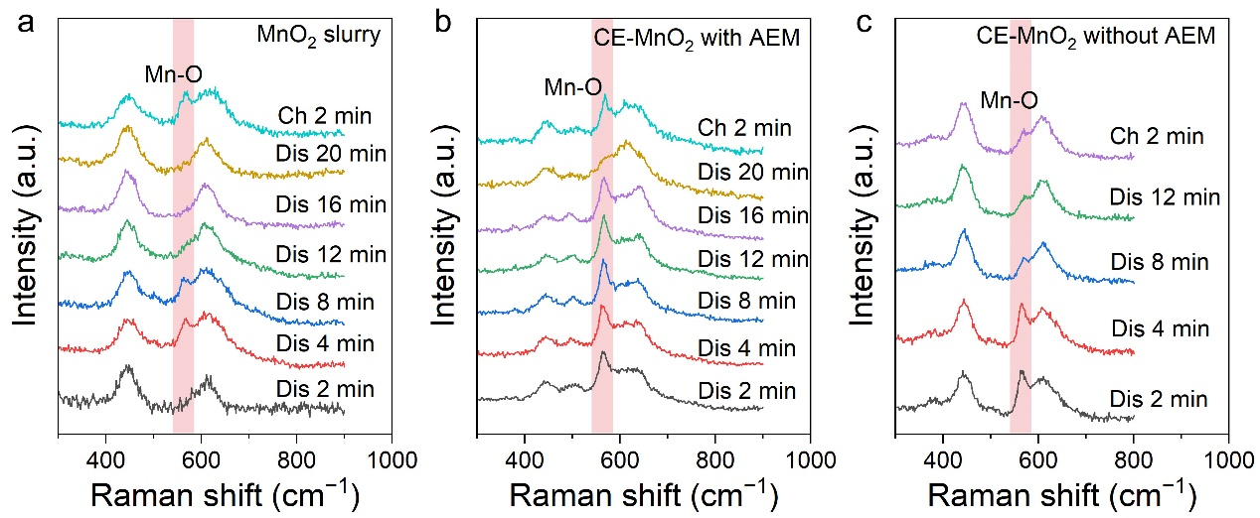
Fig. S37 In-situ Raman spectra of (a) MnO₂ slurry and CE-MnO₂ cells (b) with and (c) without AEM at different charge and discharge states

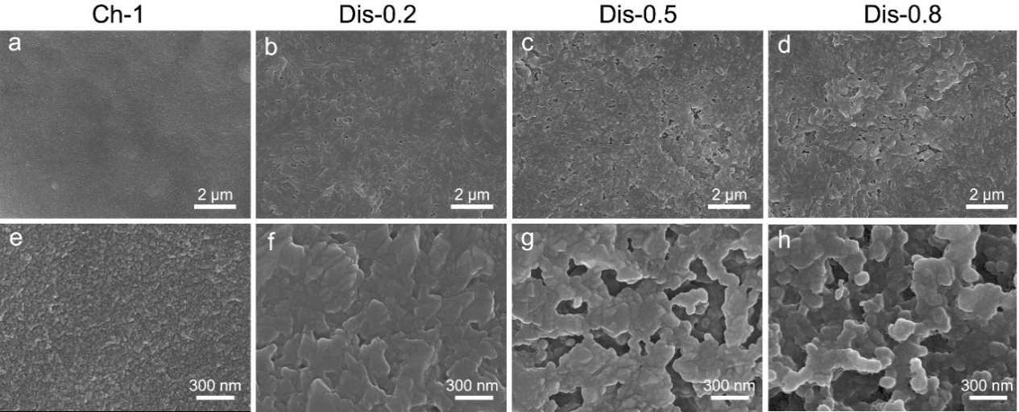
Fig. S38 SEM images of MnO₂ deposition/dissolution on carbon paper at different states. (a, e) Ch-1 represents a charge for a capacity of 1 mAh cm⁻²; (b, f) Dis-0.2, (c, g) Dis-0.5 and (d, h) Dis-0.8 represent discharge for the capacities of 0.2 and 0.5 mAh cm⁻² and to 0.8 V, respectively

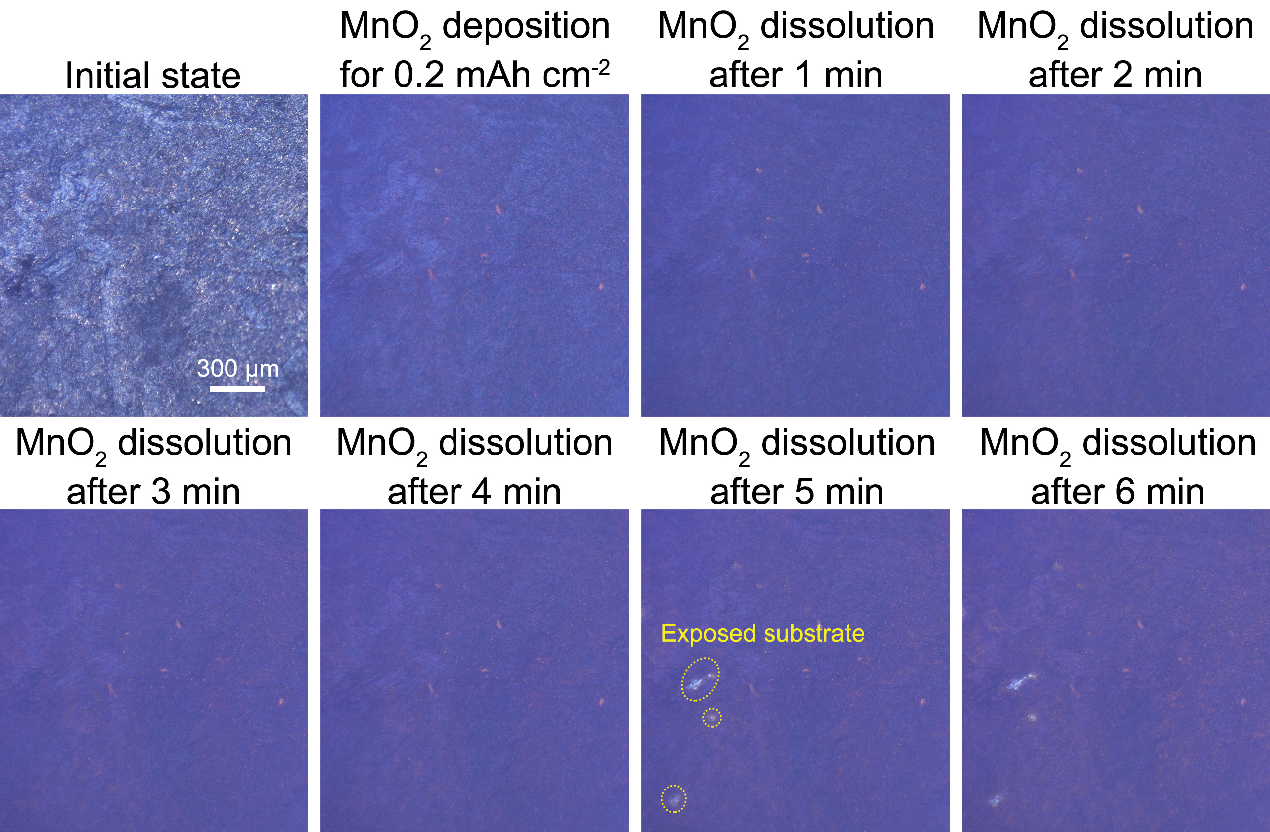

Fig. S39 In-situ optical observations of MnO₂ deposition/dissolution on carbon paper at different states

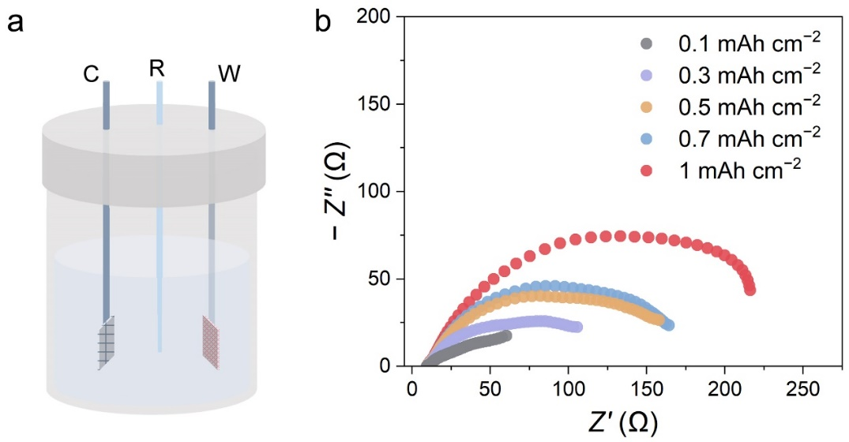
Fig. S40 (a) Three electrode configurations with carbon cloth as working electrode, platinum mesh as a counter electrode and Ag/AgCl as a reference electrode for in-situ EIS measurements of MnO₂ deposition for different capacities. (b) In-situ Nyquist plots of MnO₂ deposition in three electrodes at different capacities
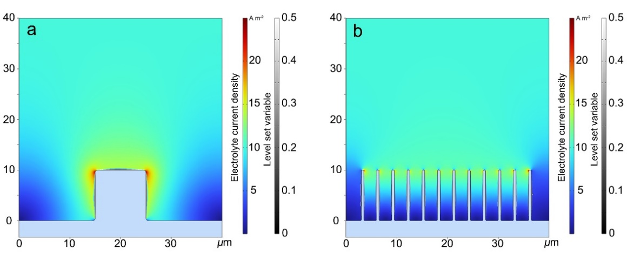
Fig. S41 The electric field simulation of MnO₂ deposition on (a) carbon cloth and (b) CNTs at initial state
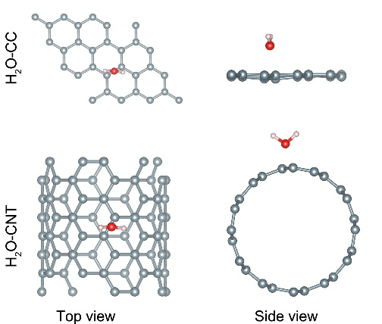
Fig. S42 The structural models water molecules adsorbed on CC and CNTs

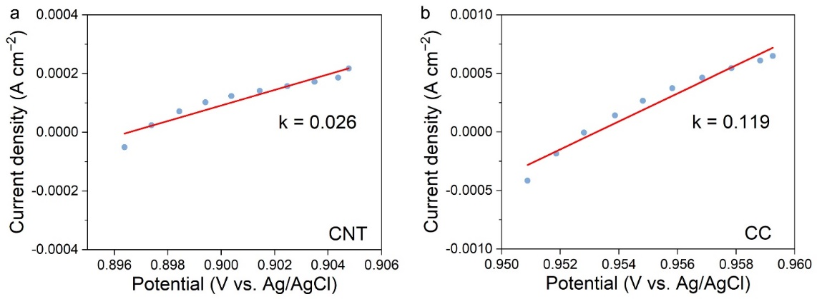
Fig. S43 Linear polarization curves of (a) CNTs and (b) CC electrodes
The exchange current density of CNTs and CC electrodes was determined from the slope of the linear polarization curves according to follow Equation [S3]
$I_{0}=\frac{I_{d}RT}{Fη}$ (S3)
where I_{d}, F, R, T and η represent the applied current density, the Faraday constant (96500 C mol⁻¹), the gas constant (8.314 J mol^{–1} K^{–1}), the temperature (298 K), and the total overpotential (V), respectively.
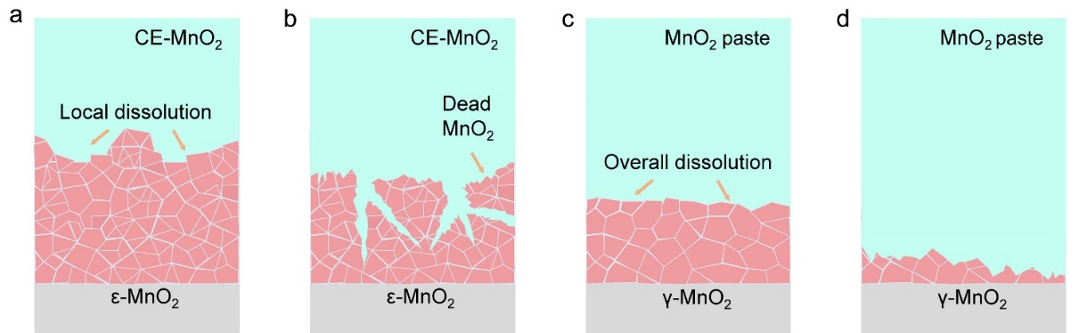
Fig. S44 Schematic illustration of localized dissolution in the (a, b) CE-MnO₂ cells and (c, d) overall dissolution in the MnO₂ slurry cells
Table S1 Parameters of MnO₂ deposition and dissolution simulation in COMSOL
Parameter | Symbol | Value | Unit
Initial Mn concentration | C_{Mn2+,ref} | 2000 | mol m⁻³
Temperature | T₀ | 298 | K
Exchange current density | i₀ | 0.49 | A m⁻²
Equilibrium potential | Eeq | 0 | V
Anode potential | φ_{s_anode} | −1.23 | V
Cathode potential | φ_{s_cathode} | 1.23 | V
Cathode transfer coefficients | α_{c} | 1.5
Anode transfer coefficients | α_{a} | 0.5
Density of MnO₂ | ρ | 0.08693 | kg mol⁻¹
Molar mass of MnO₂ | M | 5.03 | g cm³
Applied current density | appl_i | 1 | mA cm⁻²
Mn²⁺ charge | z_{Mn} | 2
Supplementary References
- C.M. Feng, D.D. Liu, Y.C. Chen, J.J. Du, P. Zhang, Evaluation method of the conductive property of the electrode slurry in semi-solid lithium battery. J. Funct. Mater. 48(5), 5011–5016 (2017). https://doi.org/10.3969/j.issn.1001-9731.2017.05.003
- C. Feng, Y. Chen, D. Liu, P. Zhang, Conductivity and electrochemical performance of LiFePO₄ slurry in the lithium slurry battery. IOP Conf. Ser. Mater. Sci. Eng. 207(1), 012076 (2017). https://doi.org/10.1088/1757-899X/207/1/012076
- P.H.L. Notten, P. Hokkeling, Double-phase hydride forming compounds: a new class of highly electrocatalytic materials. J. Electrochem. Soc. 138(7), 1877–1885 (1991). https://doi.org/10.1149/1.2085893

