Supporting Information for
Atomically Dispersed Pt-Ru Dual-Atom Catalysts for Efficient Low-Temperature CO Oxidation Reaction
Yanan Qi^{1, 2, #}, Hongqiu Chen^{3, #}, Feng Hong^{1,2, #}, Xiangbin Cai^{4, #}, Zhehan Ying⁵, Jiangyong Diao^{1,2}, Zhimin Jia^{1,2}, Jiawei Chen^{1,2}, Ning Wang⁶, Shengling Xiang⁶, Xiaowen Chen^{1,2}, Guodong Wen^{1, 2}, Bo Sun^{1, 2, *}, Geng Sun^{3*}, Hongyang Liu^{1, 2, *}
1 School of Materials Science and Engineering, University of Science and Technology of China, Shenyang 110016, P. R. China
2 Shenyang National Laboratory for Materials Science, Institute of Metal Research, Chinese Academy of Sciences, Shenyang 110016, P. R. China
3 Chongqing Key Laboratory of Chemical Theory and Mechanism, School of Chemistry and Chemical Engineering, Chongqing University, Chongqing 401331, P. R. China
4 Division of Physics and Applied Physics, School of Physical and Mathematical Sciences, Nanyang Technological University, Singapore 637371, Singapore
5 Materials Characterization and Preparation Facility (GZ), The Hong Kong University of Science and Technology (Guangzhou), Guangzhou, P. R. China
6 Department of Physics and Center for Quantum Materials, Hong Kong University of Science and Technology, Kowloon, Hong Kong SAR 999077, P. R. China
# Yanan Qi, Hongqiu Chen, Feng Hong, and Xiangbin Cai contributed equally to this work.
* Corresponding authors. E-mail: bosun@imr.ac.cn (Bo Sun); sungengemail@cqu.edu.cn (Geng Sun); liuhy@imr.ac.cn (Hongyang Liu)

Supplementary Figures and Tables
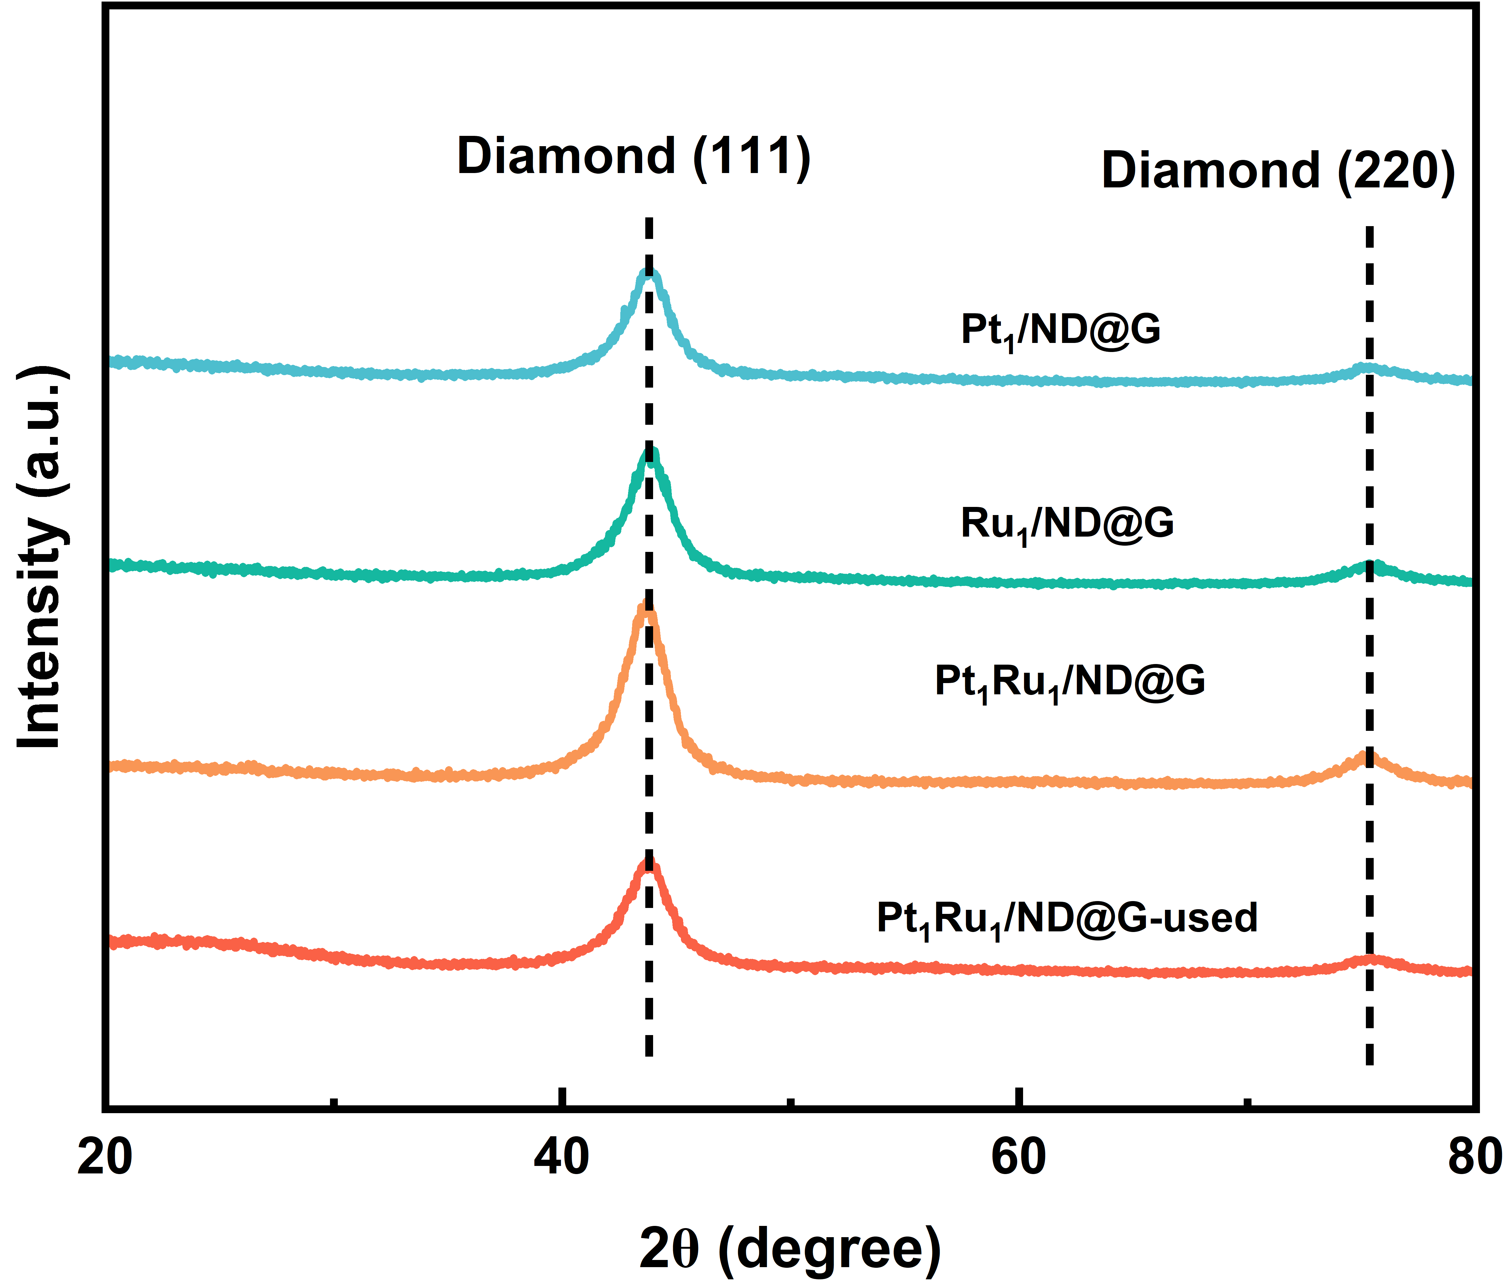
Fig. S1 XRD patterns of Ru₁/ND@G, Pt₁/ND@G, Pt₁Ru₁/ND@G, and Pt₁Ru₁/ND@G-used
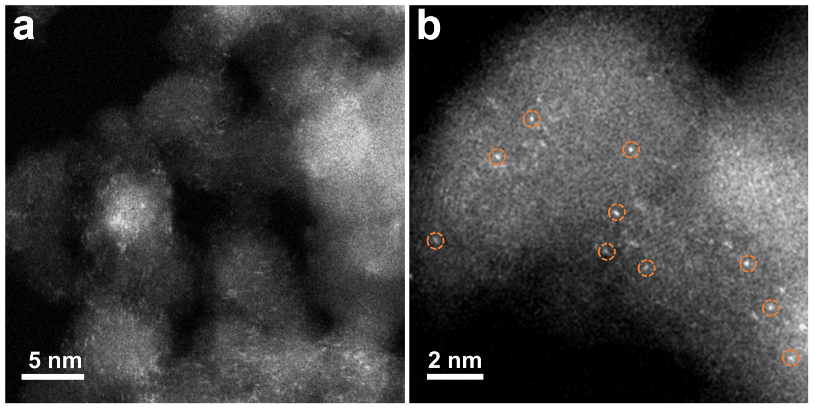
Fig. S2 Additional HAADF-STEM images of Ru₁/ND@G
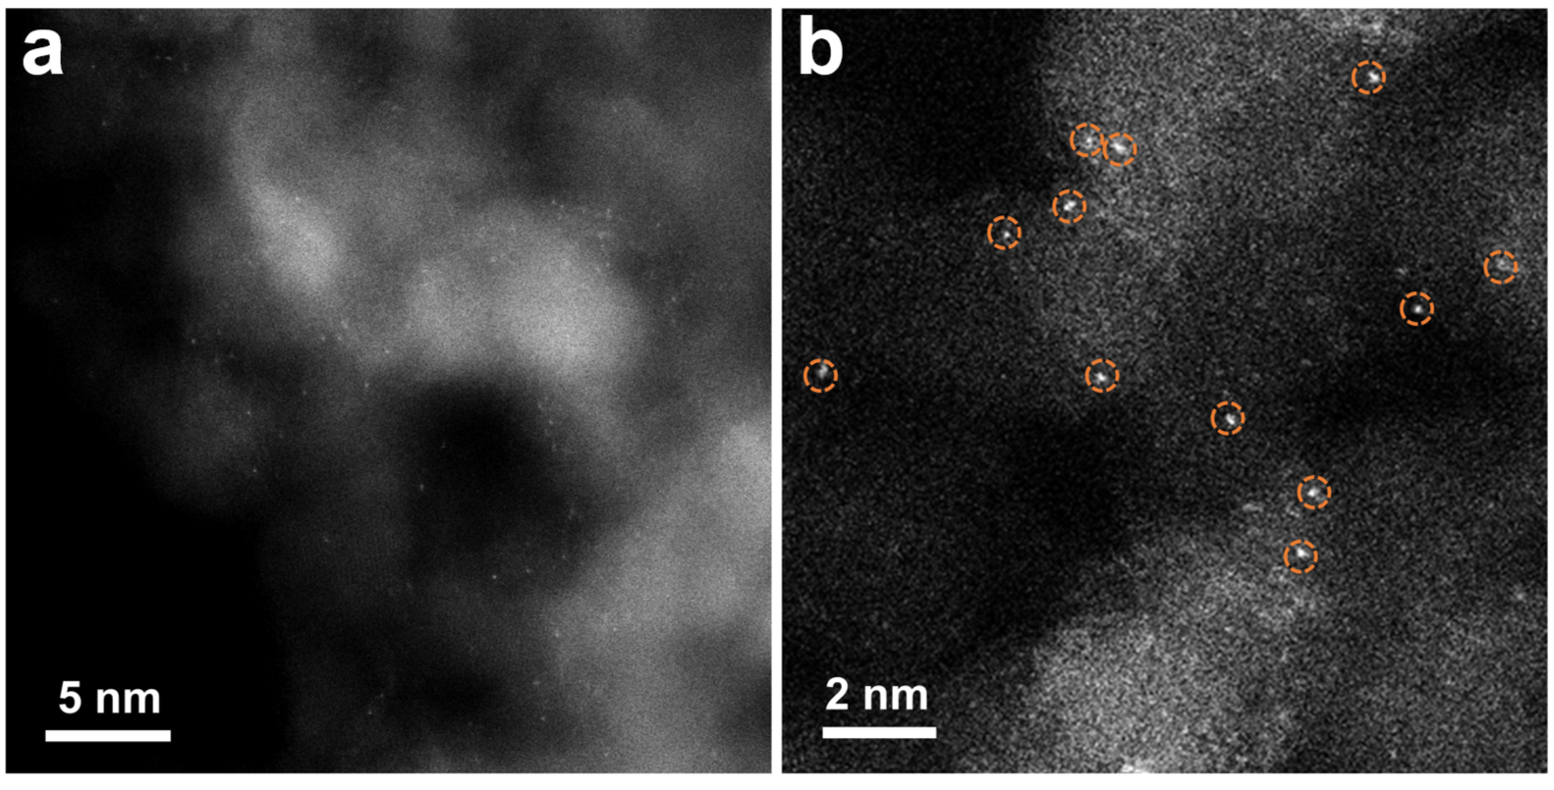
Fig. S3 Additional HAADF-STEM images of Pt₁/ND@G

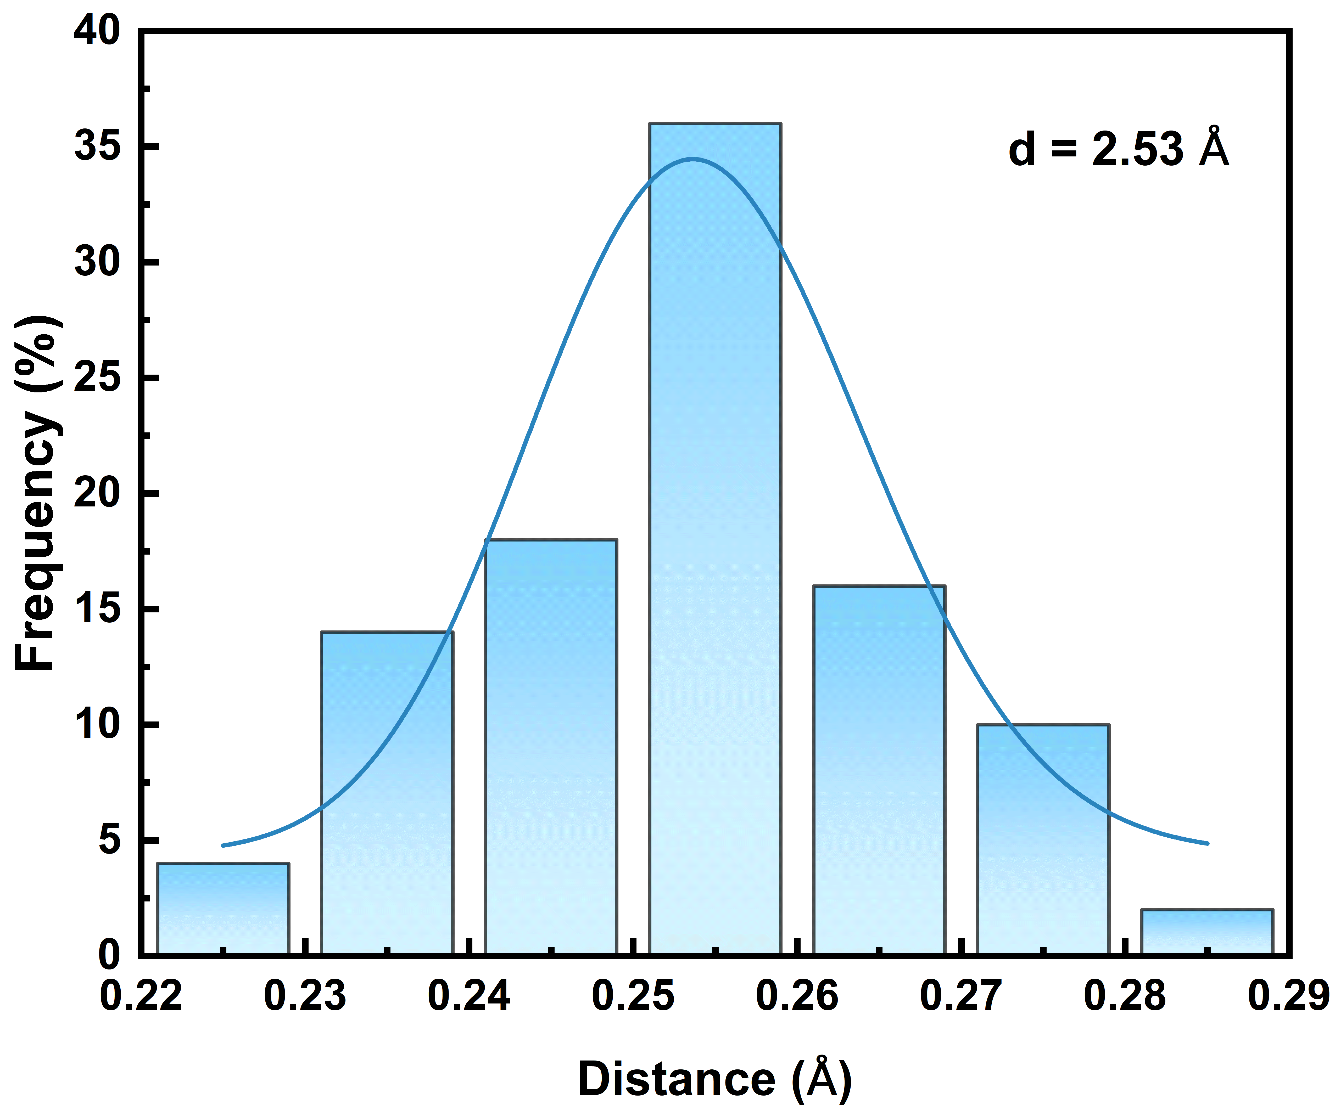
Fig. S4 The distribution of the Pt₁-Ru₁ distances by counting 50 Pt-Ru atom pairs
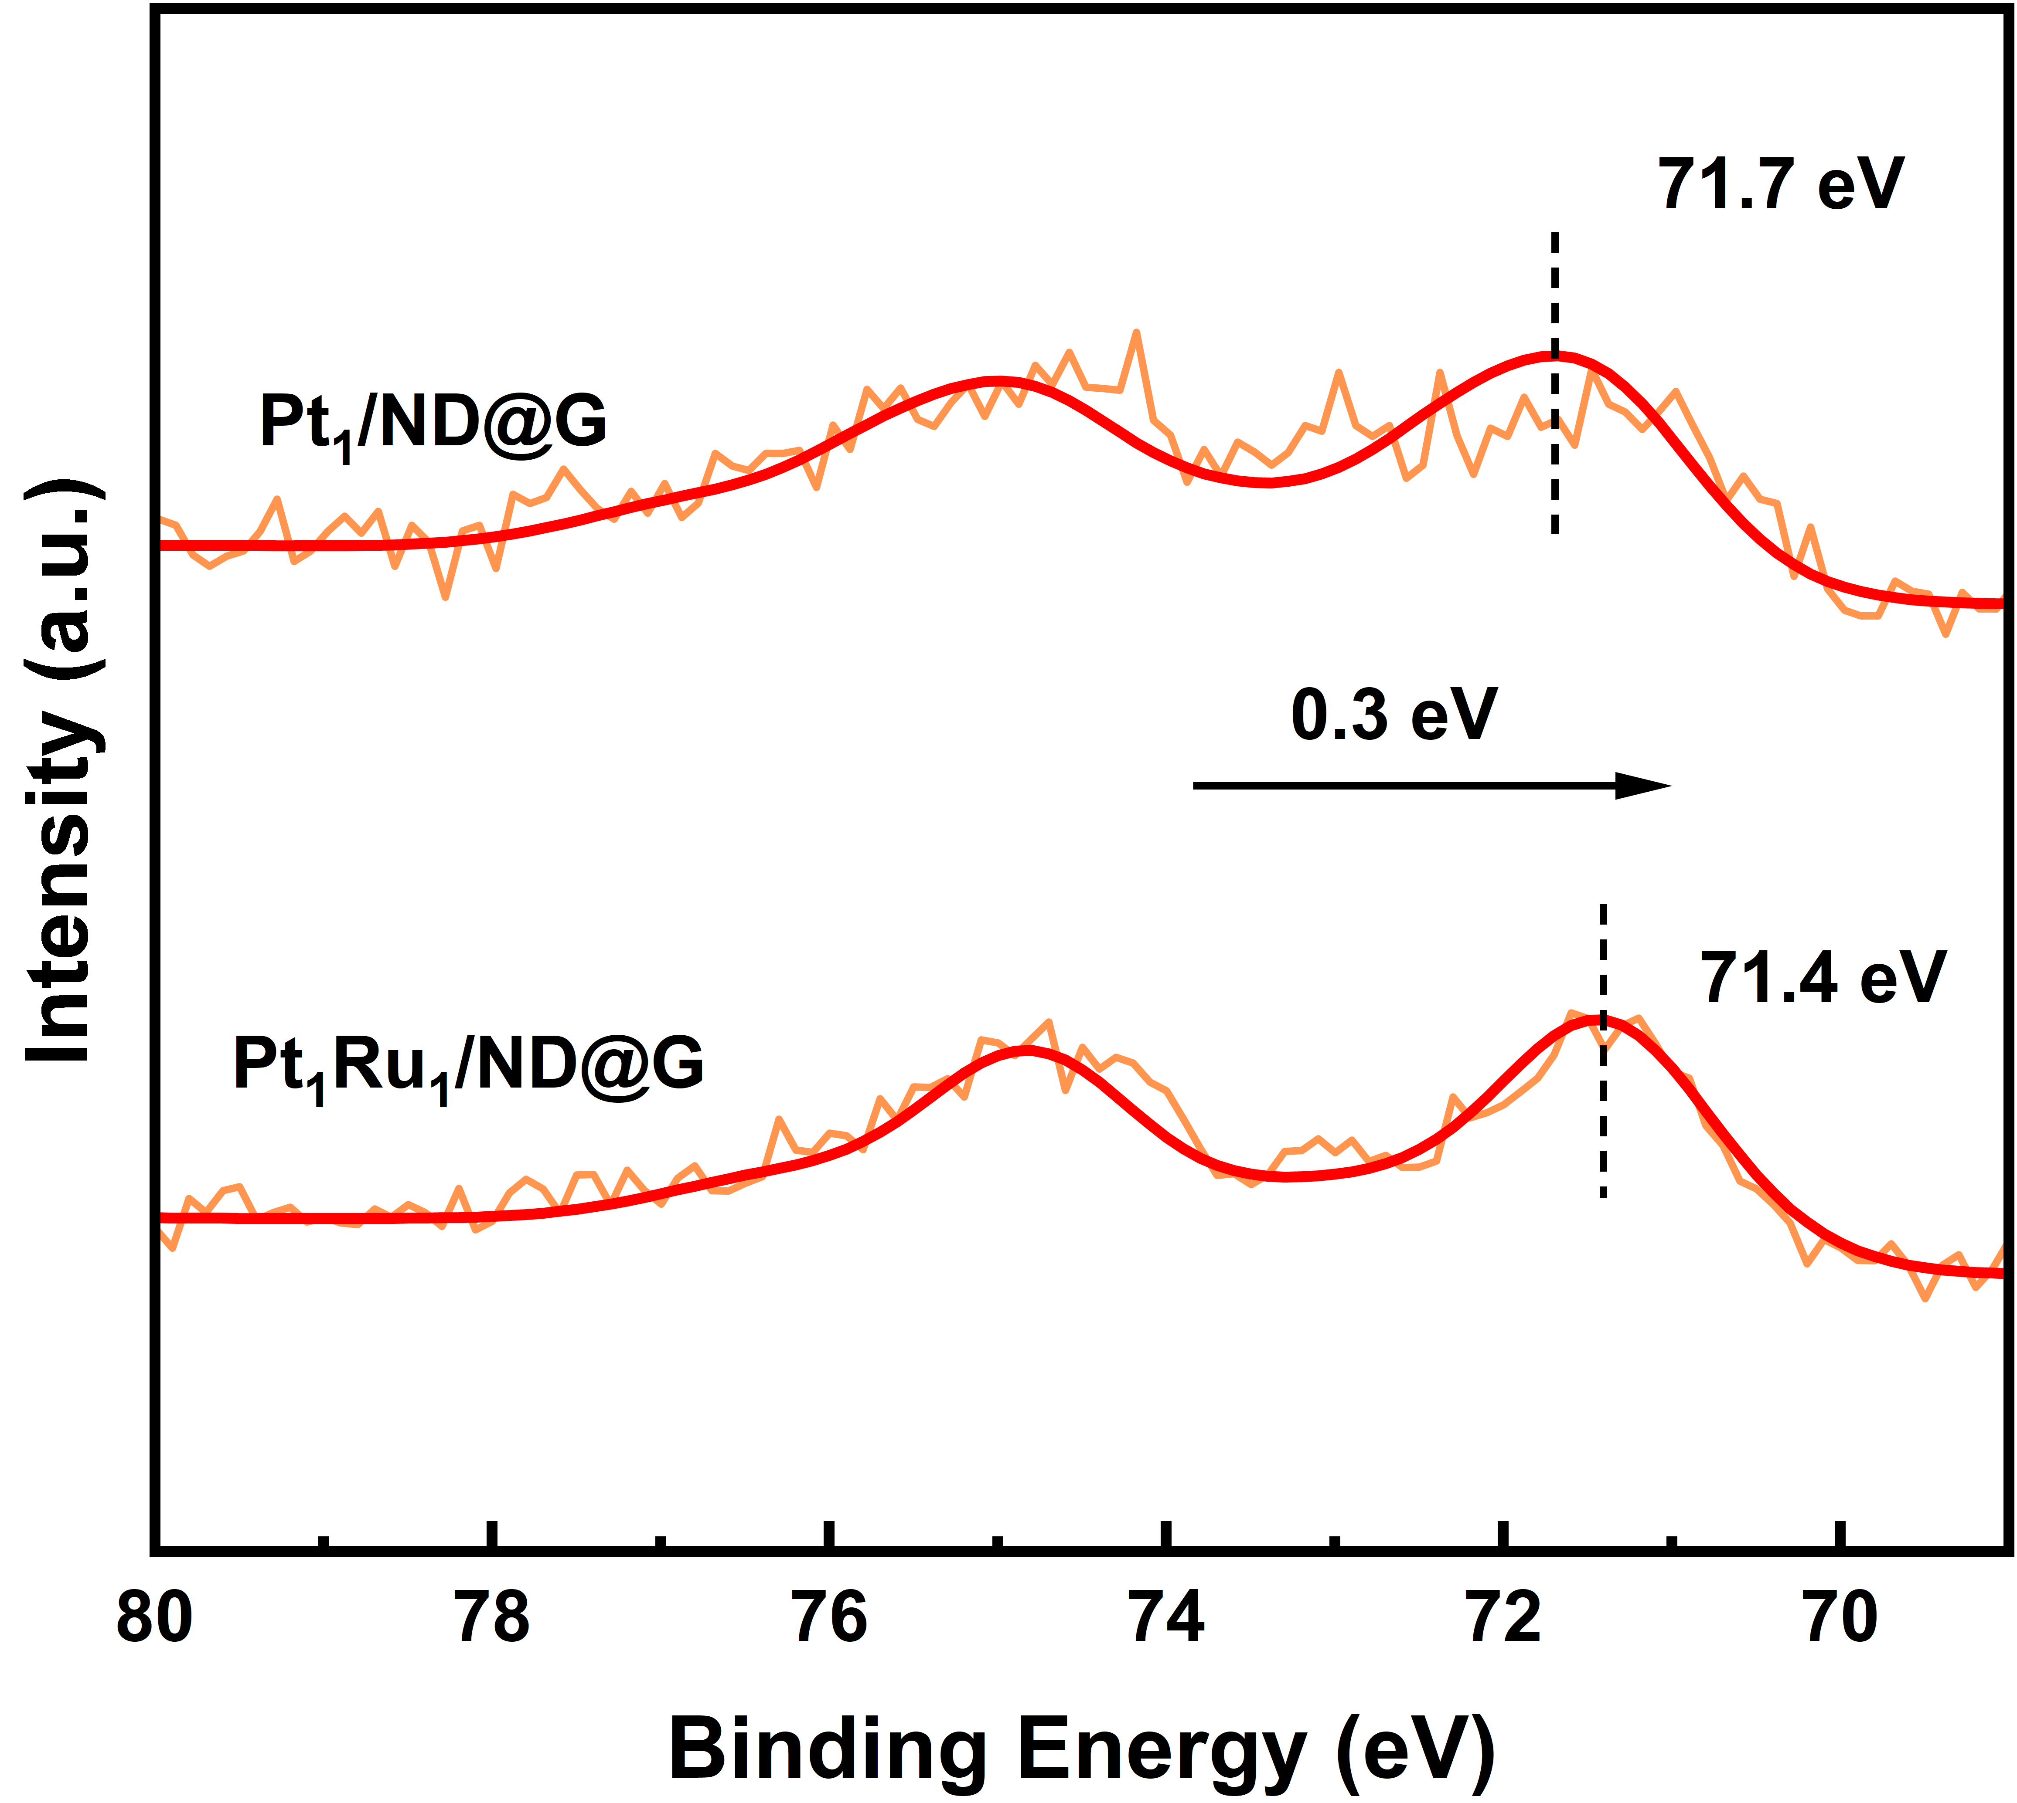
Fig. S5 Pt 4f XPS spectra of Pt₁/ND@G and Pt₁Ru₁/ND@G
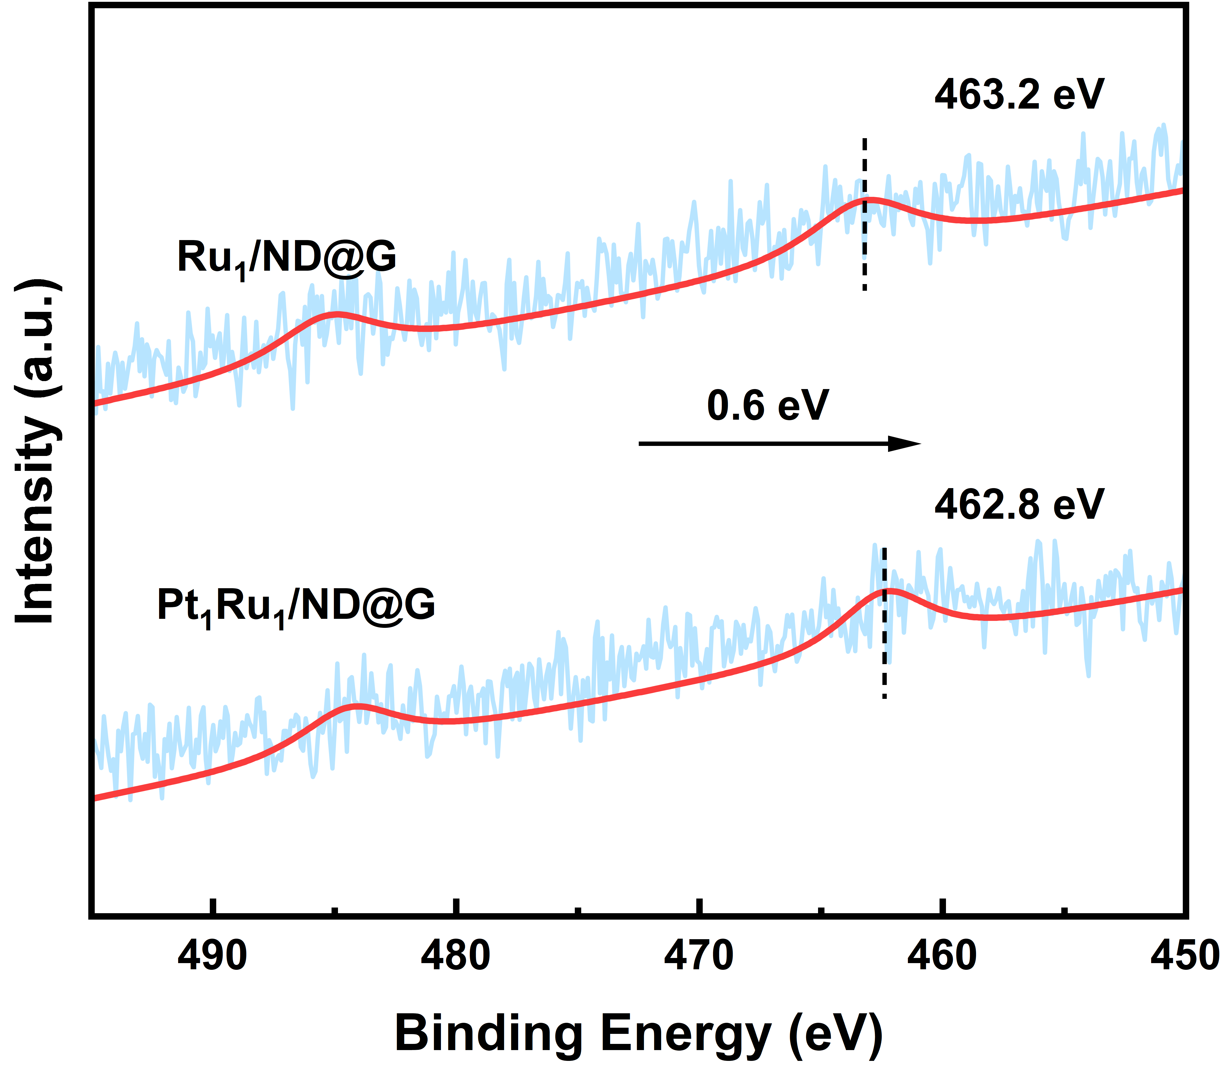
Fig. S6 Ru 3p XPS spectra of Ru₁/ND@G and Pt₁Ru₁/ND@G
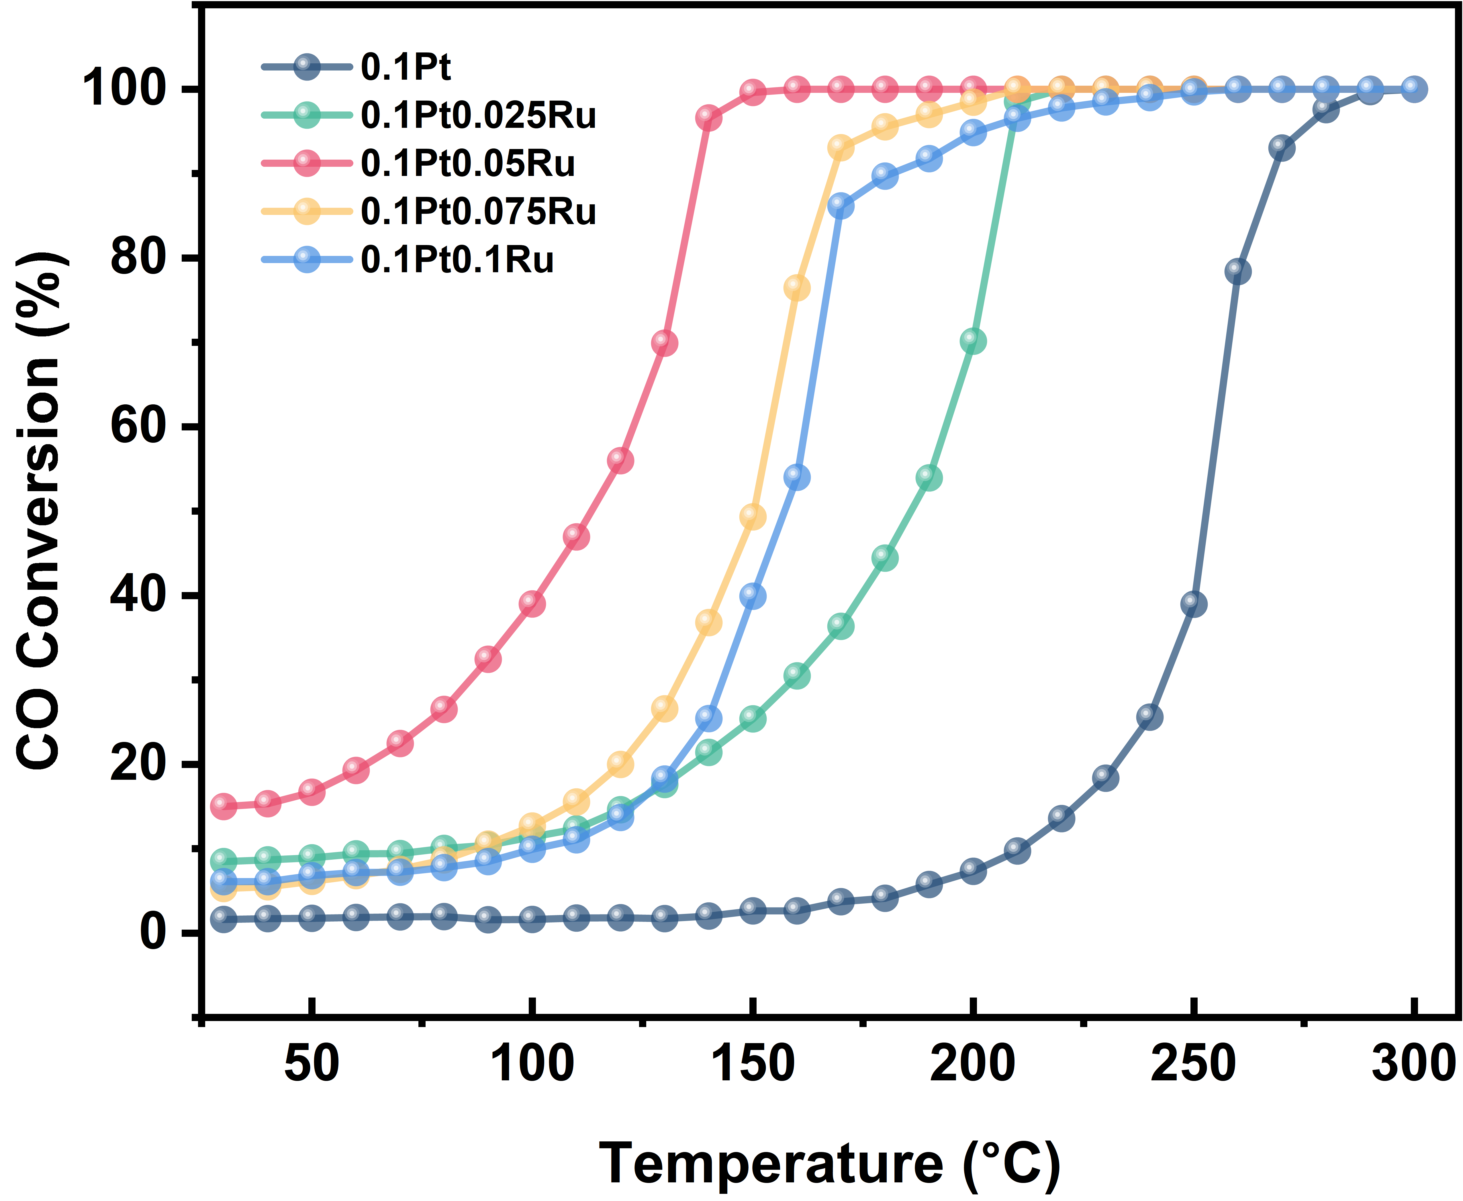
Fig. S7 CO conversion of various PtRu/ND@G catalysts with different Ru loading. Reaction conditions: 1% CO, 1% O₂ balanced in He, GHSV = 48,000 mL·g_{cat}⁻¹·h⁻¹
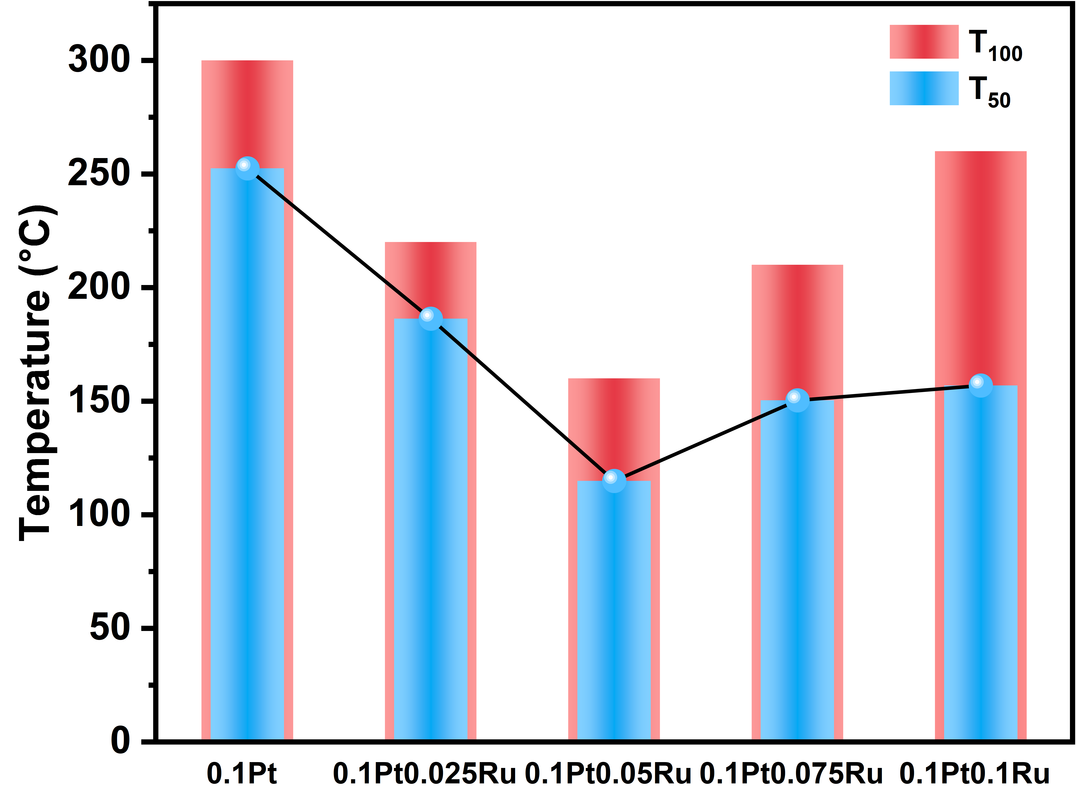
Fig. S8 T₅₀, T₁₀₀ of various PtRu/ND@G catalysts with different Ru loading
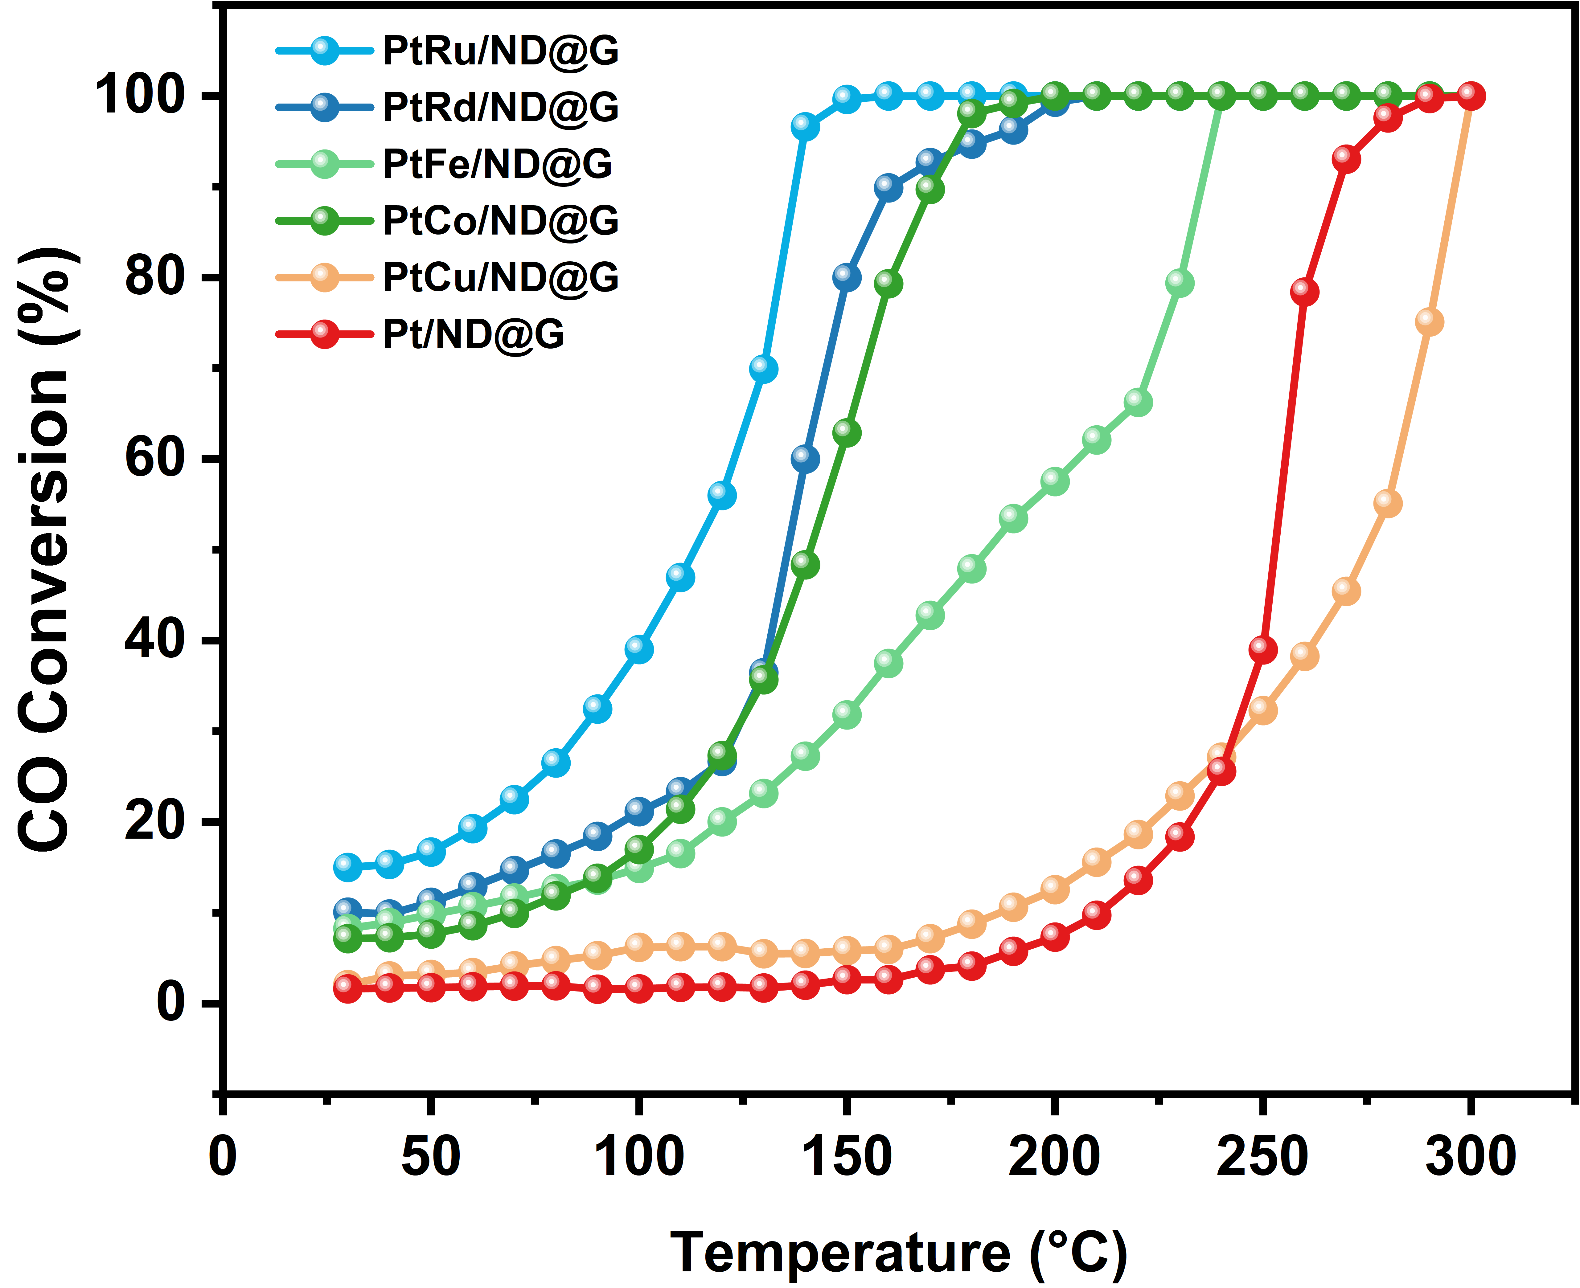
Fig. S9 CO catalytic oxidation performance of different PtM/ND@G catalysts

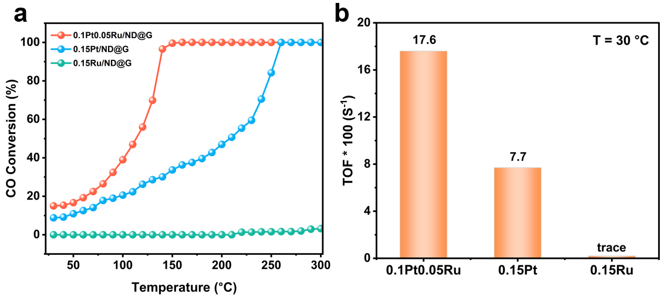
Fig. S10 (a) Catalytic performance and (b) TOF (30°C) of Pt/ND@G, Ru/ND@G, and PtRu/ND@G with the same metal loading (GHSV = 48,000 mL·g_{cat}⁻¹·h⁻¹)

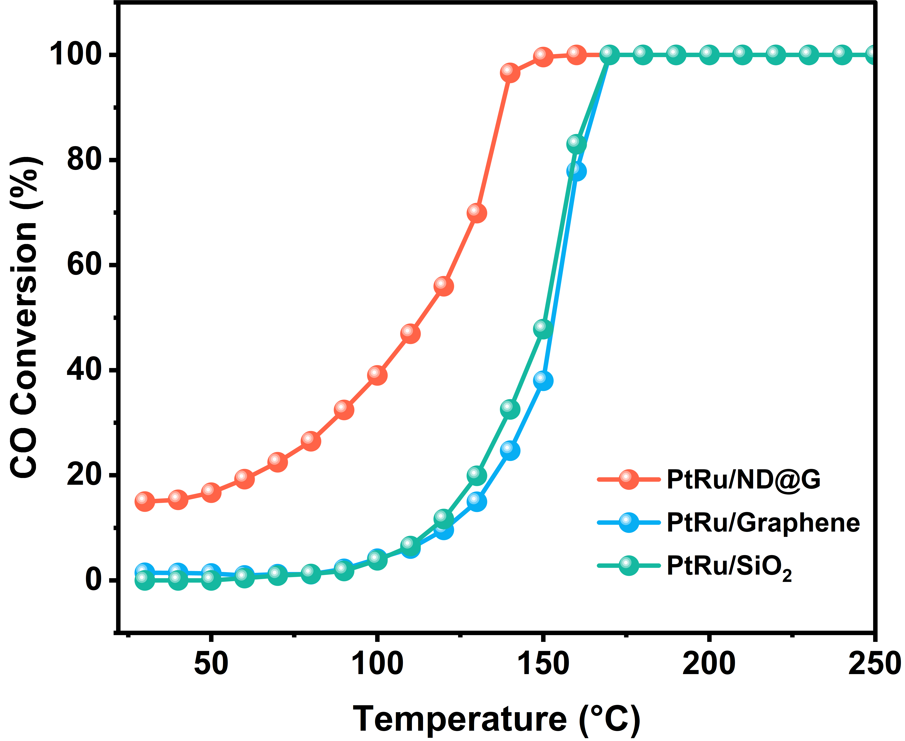

Fig. S11 Catalytic performance of PtRu /ND@G, PtRu /Graphene, and PtRu/ SiO₂ (GHSV = 48,000 mL·g_{cat}⁻¹·h⁻¹)
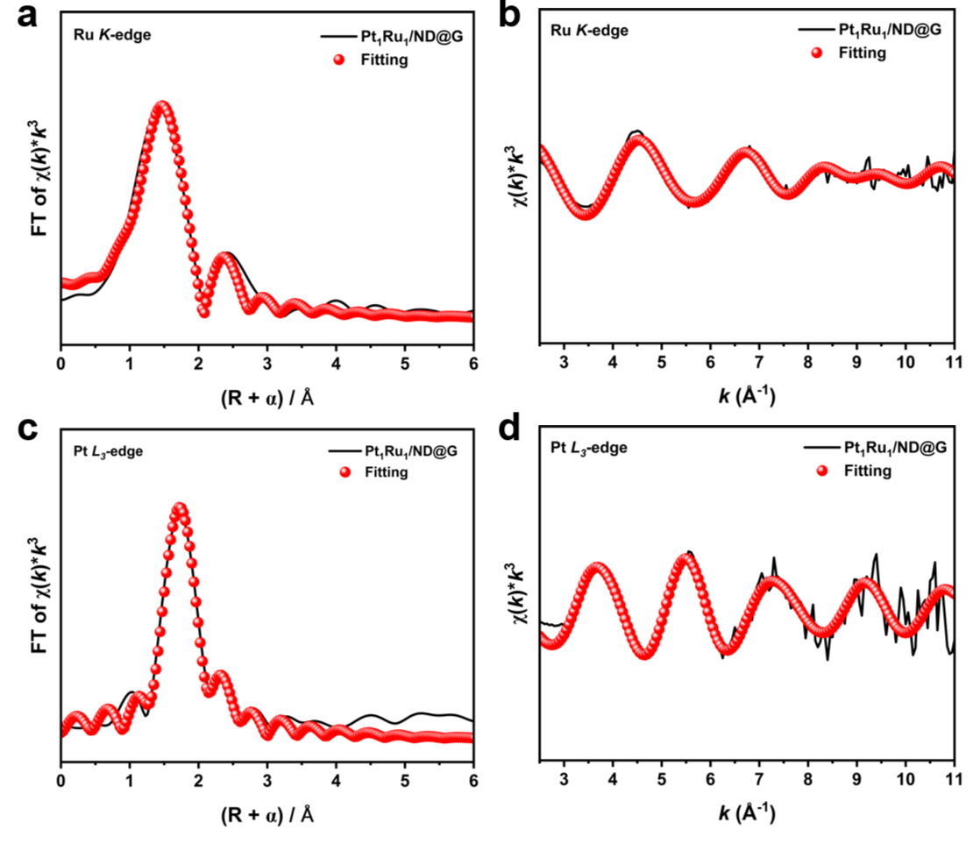
Fig. S12 The experimental Ru (a, b) and Pt (c, d) EXAFS spectra and the fitting curves of Pt₁Ru₁/ND@G

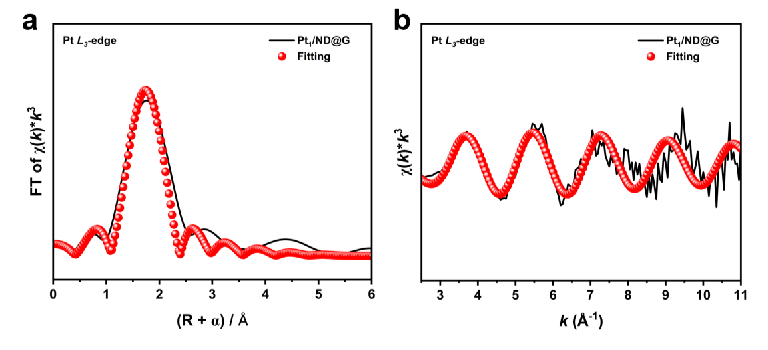
Fig. S13 The EXAFS fitting curves of Pt₁/ND@G at R-space

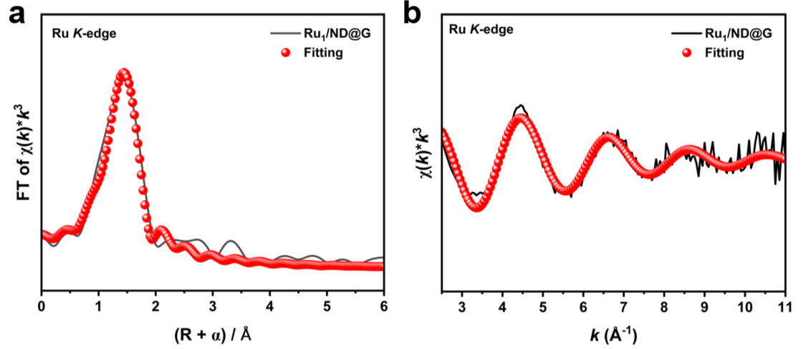
Fig. S14 The EXAFS fitting curves of Ru₁/ND@G at R-space
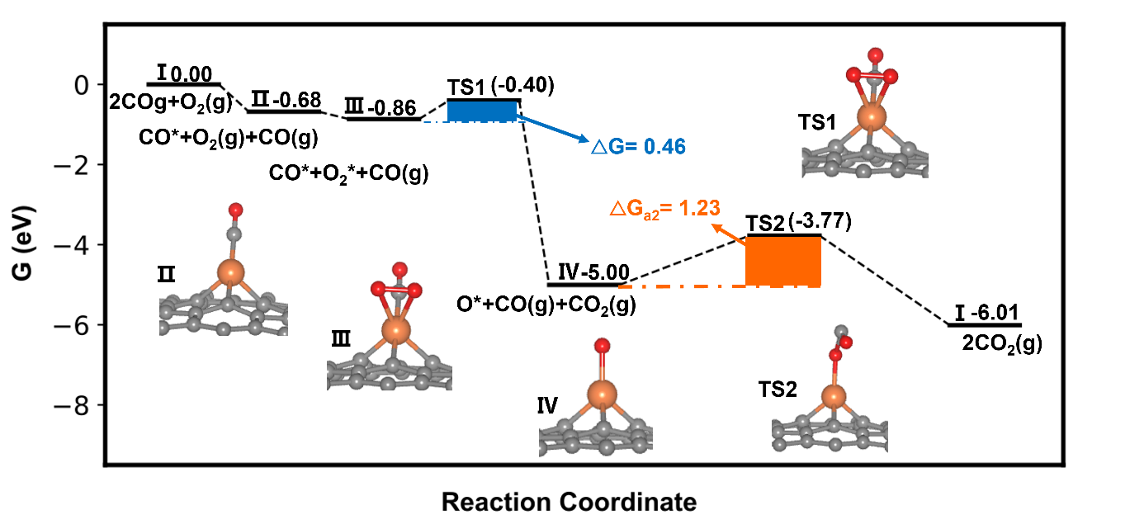
Fig. S15 Free energy profiles for CO oxidation on the Pt₁/ND@G catalyst (x-axis is the reaction coordinate, y-axis is the free energy determined at 50 ℃ and the partial pressure for CO₂, O₂ and CO is 1000, 2000, 1000 Pa, respectively. Color codes: grey, orange and red balls represent carbon, platinum and oxygen, respectively)
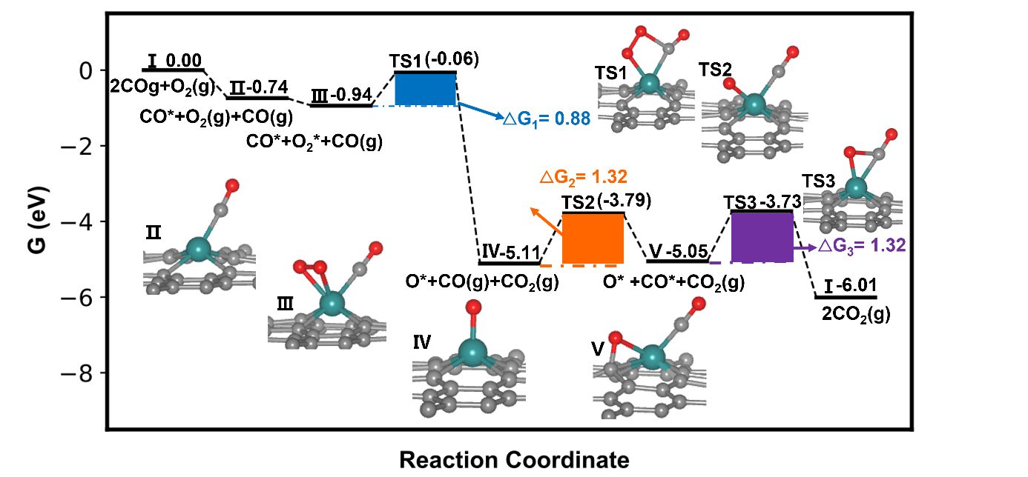
Fig. S16 Free energy profiles for CO oxidation on the Ru₁/ND@G catalyst (x-axis is the reaction coordinate, y-axis is the free energy determined at 50 ℃ and the partial pressure for CO₂, O₂ and CO is 1000, 2000, 1000 Pa, respectively. Color codes: grey, red, and green balls represent carbon, oxygen and ruthenium, respectively)
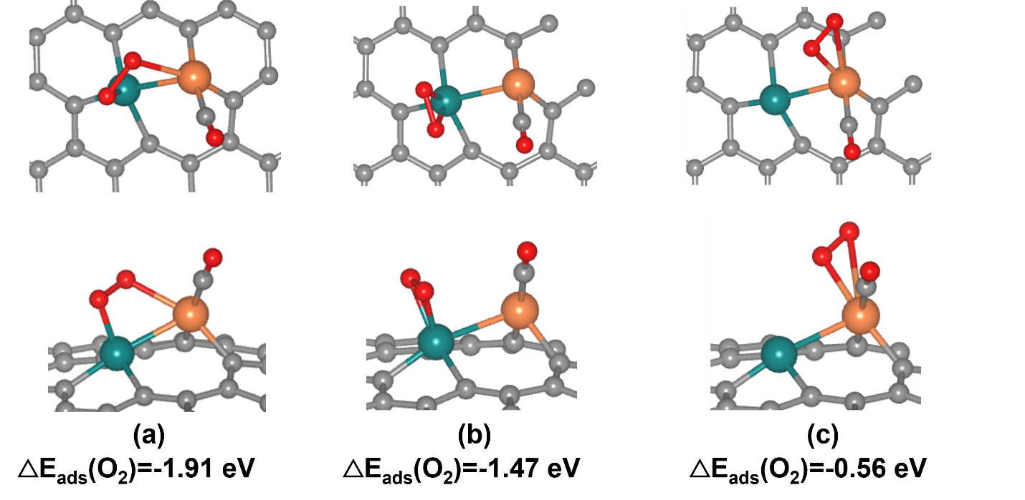
Fig. S17 (a), (b), and (c) are the top and side views of the optimized structures of O₂ adsorbed on the bridge site, Ru site, and Pt site, respectively, along with the adsorption energy of O₂. Color codes: grey, red, orange and green balls are carbon, oxygen, platinum and ruthenium, respectively)
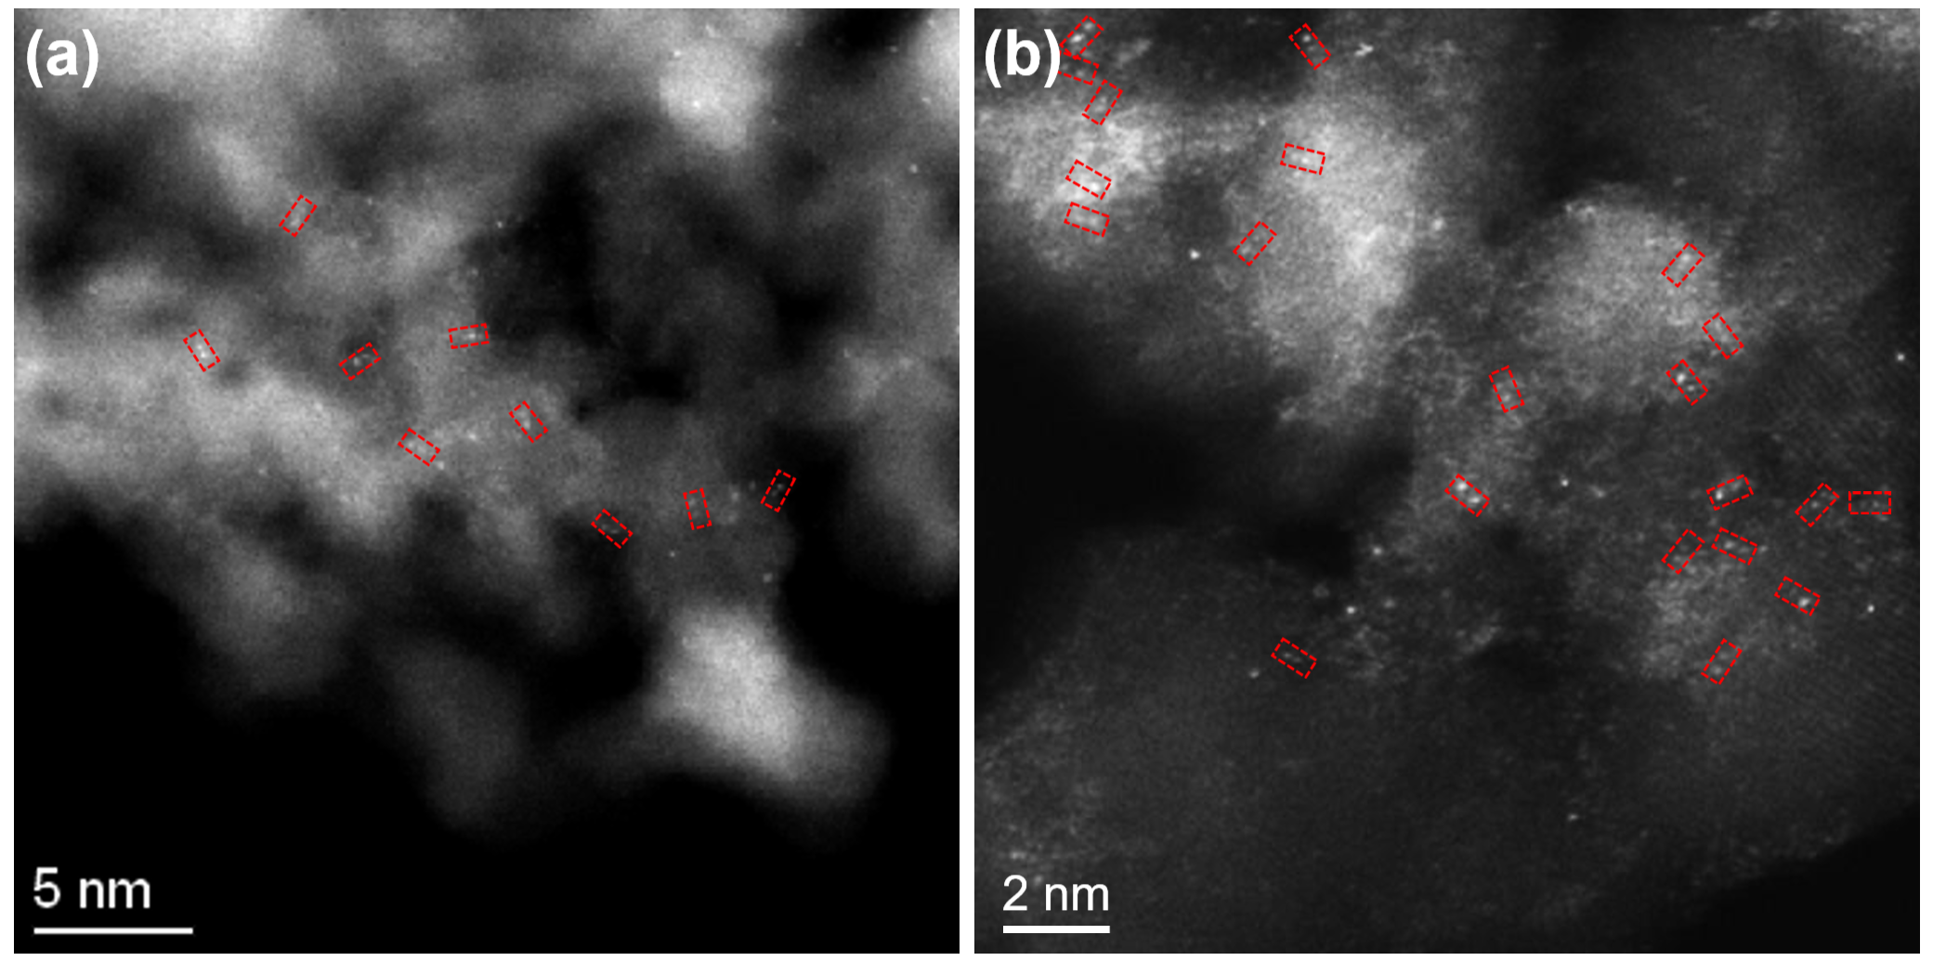
Fig. S18 (a) and (b) HAADF-STEM images of Pt₁Ru₁/ND@G after the stability experiment
Table S1 Comparison of the structure information and catalytic performance over the Pt₁Ru₁/ND@G and SACs
Catalyst | Pt loading  (wt%) | Ru loading  (wt%) | Temp.  (°C) | TOF  *10² (s⁻¹)
Ru₁/ND@G | 0 | 0.04 | 30 | ~0
Pt₁/ND@G | 0.09 | 0 | 30 | 1.5
Pt₁Ru₁/ND@G | 0.09 | 0.04 | 30 | 17.6
Pt₁Ru₁/ND@G-used | 0.10 | 0.05 | 30 | \
Table S2 The peak positions and shifts of platinum and ruthenium in the XPS spectra of the catalyst
catalyst | Pt₁/ND@G | Ru₁/ND@G | Pt₁ Ru₁/ND@G
Peak Position of Pt 4f₇/₂ | 71.7 | \ | 71.4
Peak Position of Ru 3p_{3/2} | \ | 463.8 | 463.2
BE Shift of Pt (eV) | Ref. | \ | - 0.3
BE Shift of Ru (eV) | \ | Ref. | - 0.6
Table S3 The kinetic measurement parameters for catalysts in this work
catalyst | reaction order in CO | reaction orders in O₂ | activation energies (kJ/mol) | pre-exponential factors (h⁻¹) | R² values
Pt₁/ND@G | + 0.71 | + 0.22 | 17.9 ± 0.6 | 221.4 | 0.99
Ru₁/ND@G | \ | \ | 23.4 ± 1.2 | 403.4 | 0.99
Pt₁Ru₁/ND@G | + 0.53 | + 0.12 | 13.2 ± 0.4 | 492.7 | 0.99
Table S4 Fit results for the EXAFS spectra of different catalysts
Sample | Path | R (Å)ª | C.N.^{b} | σ² (Å²)^{c} | ΔE₀(eV)^{d} | R-factor^{e}
Ru foil | Ru-Ru | 2.68(1) | 12 | 0.004 | -3.8(17) | 0.008
RuO₂ | Ru-C/O | 1.97(1) | 6 | 0.002 | -3.2(22) | 0.018
Ru₁/NDG | Ru-C/O | 2.02(2) | 4.5 | 0.008 | -0.3(23) | 0.012
Pt₁Ru₁/NDG | Ru-C/O | 2.02(4) | 3.9 | 0.009 | 1.3(36) | 0.018
 | Ru-Pt | 2.58(4) | 0.9 | 0.003
Pt foil | Pt-Pt | 2.76(1) | 12 | 0.005 | 5.2(4) | 0.003
PtO₂ | Pt-C/O | 2.01(1) | 6 | 0.003 | 9.3(12) | 0.014
Pt₁/NDG | Pt-C/O | 2.01(4) | 2.4 | 0.009 | 9.8(19) | 0.019
 | Pt-Cl | 2.32(3) | 1.5 | 0.009 | 9.8(19) | 0.019
Pt₁Ru₁/NDG | Pt-C/O | 2.02(2) | 1.8 | 0.004 | 9.4(26) | 0.011
 | Pt-Cl | 2.28(3) | 1.2 | 0.004 | 9.4(26) | 0.011
 | Pt-Ru | 2.52(3) | 1.1 | 0.007 | 9.4(26) | 0.011
a: R is the interatomic distance (the bond length between Pt/Ru central atoms and surrounding coordination atoms). b: CN is the coordination number. c: σ² is the Debye-Waller factor (a measure of thermal and static disorder in absorber scatterer distances). d: ΔE₀ is the edge energy shift (the difference between the zero kinetic energy value of the sample and that of the theoretical model). e: R factor is used to value the goodness of the fitting.
Table S5 Catalytic performance over various catalysts reported in literature
Catalyst | Pt loading  (wt%) | Reaction condition | Temp.  (°C) | TOF×10²  (s⁻¹) | Refs.
Pt₁Ru₁/ND@G | 0.1 | 1% CO，1% O₂ | 30 | 17.6 | This work
0.75Pt0.2Fe/ND@G | 0.75 | 1% CO，1% O₂ | 30 | 15.1 | [S1]
0.5Pt_{n}/ND@G | 0.5 | 1% CO，1% O₂ | 30 | 3.5 | [S2]
Pt₁/FeOx | 0.17 | 1% CO，1% O₂ | 27 | 13.6 | [S3]
Pt-SA/A-Fe₂O₃ | 1.2 | 1% CO，1% O₂ | 70 | 6.87 | [S4]
Pt/Sn_{0.2}Ti_{0.8}O₂ | 0.5 | 1% CO，1% O₂ | 80 | 17.2 | [S5]
0.3Pt/TiO₂ | 0.3 | 1% CO，1% O₂ | 40 | 2.15 | [S6]
HO-Pt/TiO₂ | 1 | 1% CO，1% O₂ | 70 | 11 | [S7]
Pt-CC/Al₂O₃ | 5 | 1% CO, 1% O₂ | 120 | 2.8 | [S8]
Pt-CD/Al₂O₃ | 2.2 | 1% CO, 1% O2 | 30 | 14.8 | [S8]
Pt NP/TiO₂ | 1.0 | 0.5% CO, 5% O₂ | 115 | 1.01 | [S9]
Pt/CNT-600 | 1 | 1.0 % CO, 20.0 % O₂ | 100 | 5.55 | [S10]
Co₃O₄/Pt/Al₂O₃ | 3.85 | 1% CO, 10% O₂ | 60 | 2.7 | [S11]
1%wt Pt/TiO₂(B) | 1 | 0.9% CO, 24% O₂ | 100 | 10.9 | [S12]
CeO₂-IMP-Pt | 1.2 | 1% CO, 16%O₂ | 80 | 1.2 | [S13]

Table S6 The structures of optimized Pt₁Ru₁/ND@G, Pt₁/ND@G, and Ru₁/ND@G
catalyst | Optimized structures | Bonds | CNª | R(Å) | Bader charge analaysis
 |  |  |  |  | Pt | Ru
Pt₁/ND@G | 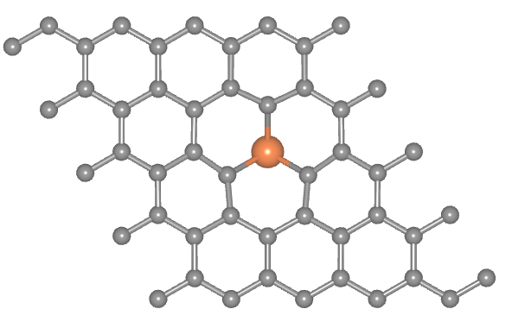  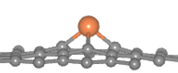 | Pt/C | 3 | 1.93 | +0.22e | \
Ru₁/ND@G | 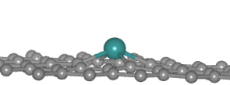  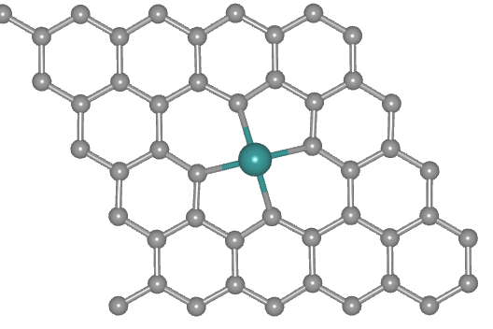 | Ru/C | 4 | 2.02 | \ | +0.62e
Pt₁Ru₁/ND@G | 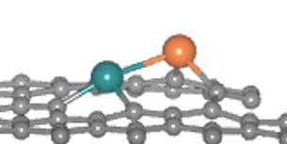  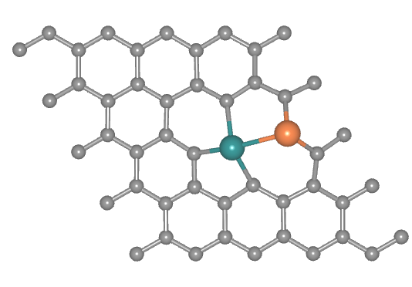 | Ru/C | 3 | 1.98 | +0.05e | +0.54e
Pt₁Ru₁/ND@G |  | Pt/C | 2 | 1.92 | +0.05e
Pt₁Ru₁/ND@G |  | Ru-Pt | 1 | 2.52 | +0.05e
ªCN is the coordination number.

Table S7 The adsorption energies of CO and O₂ on Pt₁Ru₁/ND@G, Pt₁/ND@G, and Ru₁/ND@G
catalyst | Reaction | Eads(eV)
Pt₁Ru₁/ND@G | CO(g)->CO* | -1.74
Pt₁Ru₁/ND@G | CO*+O₂(g)->CO*+O₂* | -1.91
Pt₁/ND@G | CO(g)->CO* | -1.46
Pt₁/ND@G | CO*+O₂(g)->CO*+O₂* | -0.96
Ru₁/ND@G | CO(g)->CO* | -1.52
Ru₁/ND@G | CO*+O₂(g)->CO*+O₂* | -0.98
Supplementary References
- Z. Jia, X. Qin, Y. Chen, X. Cai, Z. Gao et al., Fully-exposed Pt-Fe cluster for efficient preferential oxidation of CO towards hydrogen purification, Nat. Commun. 13, 6798 (2022). https://doi.org/10.1038/s41467-022-34674-y
- Z. Jia, M. Peng, X. Cai, Y. Chen, X. Chen et al., Fully exposed platinum clusters on a nanodiamond/graphene hybrid for efficient low-temperature CO oxidation, ACS Catal. 12, 9602–9610 (2022). https://doi.org/10.1021/acscatal.2c02769
- B. Qiao, A. Wang, X. Yang, L.F. Allard, Z. Jiang et al., Single-atom catalysis of CO oxidation using Pt1/FeOx, Nat. Chem. 3, 634–641 (2011). https://doi.org/10.1038/nchem.1095
- W. Chen, Y. Ma, F. Li, L. Pan, W. Gao et al., Strong electronic interaction of amorphous Fe₂O₃ nanosheets with single‐atom Pt toward enhanced carbon monoxide oxidation, Adv. Funct. Mater. 29, 1904278 (2019). https://doi.org/10.1002/adfm.201904278
- J. Chen, S. Xiong, H. Liu, J. Shi, J. Mi et al., Reverse oxygen spillover triggered by CO adsorption on Sn-doped Pt/TiO2 for low-temperature CO oxidation, Nat. Commun. 14, 3477 (2023). https://doi.org/10.1038/s41467-023-39226-6
- Z. Zhou, W. Guan, X. Pan, A. Wang, T. Zhang, Synthesis of pyrazines from biomass-derived vicinal diols using ammonia over heterogeneous Pt/CeO₂/Al₂O₃ catalysts, ACS Catal. 15, 5664–5673 (2025). https://doi.org/10.1021/acscatal.5c00372
- L. Zhang, X. Cheng, G. Zhang, W. Qiu, H. He et al., High active platinum clusters on titanium dioxide supports toward carbon monoxide oxidation, Appl. Catal. B Environ. 266, 118629 (2020). https://doi.org/10.1016/j.apcatb.2020.118629
- Y. Chen, Y. Feng, L. Li, J. Liu, X. Pan et al., Identification of active sites on high-performance Pt/Al₂O₃ catalyst for cryogenic CO oxidation, ACS Catal. 10, 8815–8824 (2020). https://doi.org/10.1021/acscatal.0c02253
- H. Hojo, M. Gondo, S. Yoshizaki, H. Einaga, Atomic and electronic structure of Pt/TiO₂ catalysts and their relationship to catalytic activity, Nano Lett. 22, 145–150 (2022). https://doi.org/10.1021/acs.nanolett.1c03485
- W. Chen, J. Cao, J. Yang, Y. Cao, H. Zhang et al., Molecular-level insights into the electronic effects in platinum-catalyzed carbon monoxide oxidation, Nat. Commun. 12, 6888 (2021). https://doi.org/10.1038/s41467-021-27238-z
- X. Liu, Q. Zhu, Y. Lang, K. Cao, S. Chu et al., Oxide‐nanotrap‐anchored platinum nanoparticles with high activity and sintering resistance by area‐selective atomic layer deposition, Angew. Chem. Int. Ed. 56, 1648–1652 (2017). https://doi.org/10.1002/anie.201611559
- J. Liu, T. Ding, H. Zhang, G. Li, J. Ca et al., Engineering surface defects and metal–support interactions on Pt/TiO₂(B) nanobelts to boost the catalytic oxidation of CO, Catal. Sci. Technol. 8, 4934–4944 (2018). https://doi.org/10.1039/C8CY01410H
- J. Chen, Y. Wanyan, J. Zeng, H. Fang, Z. Li et al., Surface engineering protocol to obtain an atomically dispersed Pt/CeO₂ catalyst with high activity and stability for CO oxidation, ACS Sustain. Chem. Eng. 6, 14054–14062 (2018). https://doi.org/10.1021/acssuschemeng.8b02613

