Supporting Information for
Ion-Mediated Carbon Microdomain Engineering Boosting Enhanced Plateau Capacity of Carbon Anode under High Rate Towards High-Performance Sodium Dual-Ion Batteries
Bin Tang^{1,2#}, Yuchen Zhang^{1,2#}, Bifa Ji^{1#}, Geng Yu^{1,4}, Yongping Zheng¹, Xiaolong Zhou^{1,2}, Nuntaporn Kamonsutthipaijit³, Pornsuwan Buangam³, Sarayut Tunmee³, Hideki Nakajima³, Ukit Rittihong³, Qingguang Pan^{1,2}*, Fan Zhang^{1,2}*, and Yongbing Tang^{1,2}*
¹ Advanced Energy Storage Technology Research Center, Shenzhen Institutes of Advanced Technology, Chinese Academy of Sciences, Shenzhen 518055, P. R. China
² University of Chinese Academy of Sciences, Beijing 100049, P. R. China
³ Synchrotron Light Research Institute (Public Organization), 111 University Avenue, Muang District, Nakhon Ratchasima 30000, Thailand
⁴ Southern University of Science and Technology, Shenzhen 518055, P. R. China
#Bin Tang, Yuchen Zhang, and Bifa Ji contributed equally to this work.
*Corresponding authors. E-mail: fan.zhang1@siat.ac.cn (Fan Zhang); qg.pan@siat.ac.cn (Qingguang Pan); tangyb@siat.ac.cn (Qingguang Pan)
S1 Fitting and analysis of SAXS
The background was deducted by the SAXSIT code developed by the Synchrotron light research institute - SLRI BL1.3L to obtain the 1D scattering profile of the sample as function of azimuthal angle. The pore structure information was obtained by fitting the scattering intensity (Q)-scattering intensity curve. Modified porous equation is given as [S1]:
I(q)=$I\left(q\right)=\frac{A}{q^{a}}+\frac{B^{'}a_{1}^{6}Δρ^{2}}{{(1+a_{1}^{2}Q^{2})}^{2}}+\frac{C}{{(1+a_{2}^{2}Q^{2})}^{2}}+D$ （S1）
Here, A and B are the pore specific surface area parameters; A and B are proportional to the total surface area of the large and small pores, respectively. a is the slope of the initial drop of the intensity in the logarithmic plot. $a_{1}$ is characteristic length over which the scattering power changes. Based on the assumption that the pore structure was spherical with the radius of a spherical pore volume by $R=a_{1}\sqrt{10}$. Δρ is the electron density contrast, sensitive to changes in the electron density of the pores. $a_{2}$ is characteristic length of an additional intermediate pore size. C is proportional to the surface area of the pores with the intermediate size. D is a constant background term.
Assuming that the pore structure was spherical, the average pore size $a_{1}\sqrt{10}$ and the specific surface area parameter B of the small pores were calculated by the equation S1 in the case of a small number of open pores. The closed-pore volume parameter ($V$) was defined, which can be calculated by S2~S3:
$k∙B=4π{\left(a_{1}\sqrt{10}\right)}^{2}∙x$ (S2)
$V=\frac{4}{3}π∙{\left(a_{1}\sqrt{10}\right)}^{3}∙x=\frac{\sqrt{10}}{3}a_{1}∙B$ (S3)
Here, $k$ is the specific surface area factor of the pores, and the specific surface area of the pores is $k∙B$. $x$ represents the number of pores.
S2 Electrochemical kinetic analysis
Cyclic voltammetry (CV) cures were used to measure the electrochemical reaction and kinetics of MECs in half-cell structure at different scan rates of 0.1, 0.3, 0.5, 1.0, 3.0, and 5.0 mV s⁻¹. According to the power law, the current response at a fixed potential has a linear or exponential relationship with the applied scan rate [S2]:
$i=a∙v^{b}$ (S4)
Here, $v$ (mV s⁻¹) is the scan rate, $i$ (mA) is the response current measured at a fixed potential using a specific scan rate, a and b are variable parameters.
S3 The energy density and power density
The energy density and power density of MEC₃ || EG were calculated on the basis of the active materials of both electrodes. The medium discharge voltage ($\overline{V}$) at different current densities was obtained from the galvanostatic charge–discharge profiles. The MEC₃ anode had a diameter of 12 mm (corresponding to an area S₁=0.36π cm²) with a mass loading of approximately 1 mg cm⁻², while the EG cathode had a diameter of 10 mm (corresponding to an area S₂=0.25π cm²) with a mass loading of approximately 2 mg cm⁻². Accordingly, the gravimetric energy density (ED) and power density (PD) normalized to the total active mass of both electrodes were calculated according to Equations (S5) and (S6).
$E=\frac{C∙\overline{V}∙S_{2}∙L_{2}}{S_{1}∙L_{1}+S_{2}∙L_{2}}$ （S5）
$P=\frac{C∙\overline{V}∙S_{2}∙L_{2}}{\left(S_{1}∙L_{1}+S_{2}∙L_{2}\right)∙t}$ （S6）
Herein, C and t denote the specific capacity of the cathode at a given current density and the corresponding discharge time, respectively. L₁ and L₂ are corresponding to the areal mass loadings of the active materials in the MEC₃ anode and the EG cathode, respectively. Based on these parameters, the energy density and power density of MEC₀ and MEC₃ were calculated under various current densities, and the results were systematically compared with those reported in recent literature.
Supplementary Tables
Table S1 Comparison of different carbon microstructure regulation strategies in terms of structural features, capacity and rate performance
Ref.MS/SI | Structural Regulation Strategy | Performance
[30]/ [S3] | The free radical–induced strategy by controlled delignification regulating radical release to promote closed pore formation in hard carbon | Capacity of 350 mAh g⁻¹@20 mA g⁻¹; plateau capacity of 241 mAh g⁻¹@20 mA g⁻¹
[31]/ [S4] | Converting open pores into closed ones via waste mask–derived carbon deposition for enhanced sodium storage | Capacity of 335.5 mAh g⁻¹@20 mA g⁻¹; plateau capacity of 180 mAh g⁻¹@300 mA g⁻¹
[32]/ [S5] | Activated carbon micropores filled with graphitic-like domains via self-catalyzed chemical vapor deposition | Capacity of 435.5 mAh g⁻¹@20 mA g⁻¹; plateau capacity of 200 mAh g⁻¹@300 mA g⁻¹
[33]/ [S6] | Steric hindrance in polymer precursor to promote closed-pore formation | Capacity of 340.3 mAh g⁻¹@ 30 mA g⁻¹; plateau capacity of 200 mAh g⁻¹@300 mA g⁻¹
[37]/ [S7] | One-step Zn-gluconate pyrolysis to form closed pores by ZnO etching carbon materials | Capacity of 481.5 mAh g⁻¹@20 mA g⁻¹; plateau capacity of 180 mAh g⁻¹@200 mA g⁻¹
[15]/ [S8] | Pre-desolvation by extending the aging time to generate a highly aggregated electrolyte configuration inside the nanopore | Capacity of 319.7 mAh g⁻¹@20 mA g⁻¹; plateau capacity of 250 mAh g⁻¹@100 mA g⁻¹
[34]/ [S9] | The structural regulation strategy combines self-templating, high-temperature reconstruction, and soft-carbon coating to tailor pore architecture and optimize graphene nanodomains in hard carbon. | Capacity of 414 mAh g⁻¹@20 mA g⁻¹; plateau capacity of 200 mAh g⁻¹@200 mA g⁻¹
[36]/ [S10] | Zinc-assisted cross-linking and etching precisely regulate epoxy-resin-derived hard carbon to form semi-closed ultramicropores for rapid Na⁺ storage | Capacity of 408 mAh g⁻¹@30 mA g⁻¹; plateau capacity of 256.2 mAh g⁻¹@30 mA g⁻¹
This work | Ion-mediated microdomain engineering to build molecular-scale closed pores and enrich oxidized-N sites | Capacity of 427 mAh g⁻¹@30 mA g⁻¹; high plateau capacity of 253 mAh g⁻¹@300 mA g⁻¹
Table S2 The specific surface area and pore diameter distribution for MEC₀~MEC₄
Samples | BET Surface Area  (m² g⁻¹) | t-Plot micropore volume  (cm³ g⁻¹)
MEC₀ | 8.69 | 0.002
MEC₁ | 13.26 | 0.005
MEC₂ | 18.95 | 0.004
MEC₃ | 39.13 | 0.009
MEC₄ | 229.73 | 0.071
Table S3 The fitted FWHM of (002) and (100) peaks in XRD patterns
Samples / FWHM | peak (002) | peak (100)
MEC₀ | 7.090 | 4.104
MEC₁ | 6.420 | 4.010
MEC₂ | 6.300 | 3.928
MEC₃ | 6.108 | 3.001
MEC₄ | 6.850 | 3.958
Table S4 Each parameter after SAXS fitting
Samples / parameter | A | a | B | $$a_{1}$$ | V
MEC₀ | 13.391 | 4.196 | 22860.693 | 0.339 | 8161.327
MEC₁ | 14.789 | 4.008 | 48199.254 | 0.316 | 16077.822
MEC₂ | 89.930 | 3.778 | 76643.527 | 0.327 | 26397.306
MEC₃ | 122.572 | 3.313 | 79320.162 | 0.411 | 34395.214
MEC₄ | 206.430 | 2.926 | 23488.288 | 0.442 | 10953.631
(MEC₃-Discharge-0.0001V) | 102.405 | 3.881 | 21545.206 | 0.392 | 8902.571
Table S5 ICP results of element contents of Zn and N in MEC₀ and MEC₃
Samples | N (wt%) | Zn (wt%)
MEC₀ | 0.97 | 0
MEC₃ | 1.154 | 0.00155

Table S6 Comparison of the key testing parameters of sodium-half cell (Corresponding to Fig. 2e)
Half-cell  Na || carbon materials | Electrolyte | Loading  （mg cm⁻²） | Charge–discharge voltage range（V) | Ref.MS/SI
MEC₃ | 1 M NaClO₄ in EC/DMC (1:1 v/v) | 1 – 1.5 | 0.0001 – 2.0 | This work
HG1300 | 1 M NaClO₄ in EC/DMC (1:1 v/v) | 1.5 – 2.0 | 0.001 – 2.5 | [46]/ [S2]
HC | 1 M NaClO₄ in EC/DEC (1:1 v/v) with 2 vol% FEC | 0.8 – 1.1 | 0.002 – 3.0 | [37]/ [S7]
HC | 1 M NaPF₆ in EC/DEC/EMC (1:1:1 v/v/v) with 5 vol% FEC | ~1.0 | 0.01 – 3.0 | [15]/ [S8]
4S-HCNs | 1 M NaClO₄ in EC/DEC (1:1 v/v) with 5 vol% FEC | / | 0.001 – 2.0 | [47]/ [S11]
CPs | 1 M NaClO₄ in PC with 5 vol% FEC | / | 0.01 – 3.0 | [48]/ [S12]
FP-MP | 1 M NaClO₄ in EC/DMC (1:1 v/v) | 1.5 – 2.0 | 0 – 2.5 | [49]/ [S13]
HC-1300 | 1 M NaClO₄ in EC/DEC (1:1 v/v) with 5 vol% FEC | ~2.5 | 0.001 – 2.0 | [50]/ [S14]
HC | 1 M NaClO₄ in EC/PC (1:1 v/v) | 1.0 – 2.3 | 0.02 – 3.0 | [51]/ [S15]
HCS | 1 M NaPF₆ in EC/DEC (1:1 v/v) | ~2.0 | 0.01 – 1.5 | [52]/ [S16]

Table S7 The physical parameters of each component in the EIS equivalent circuit diagram of MEC₀ and MEC₃ at 25 °C
Sample | MEC₀ (Ω) | MEC₃ (Ω)
R_{s} | 2.67 | 2.11
R_{ct1} | 56.16 | 29.45
R_{ct2} | 70.44 | 14.66

Table S8 Comparison of the key testing parameters of SDIBs (Corresponding to Fig. 5e)
Cell configuration  Anode || Cathode | Electrolyte | Loading  （mg cm⁻²） | Charge–discharge voltage range（V) | Ref.MS/SI
HC || EG | 1 M NaPF₆ in EC/DMC/EMC (1:1:1) | 2 | 2.0 – 4.8 | This work
HC || Graphite | 0.8 M NaPF₆ in PC | / | 1.5 – 4.8 | [65]/ [S17]
SC || Graphite | 1 M NaPF₆ in EC/DEC | / | / | [66]/ [S18]
Cu₃P@PC || EG | 1 M NaPF₆ in EC/EMC/DMC (1:1:1) | 0.5 | 2.0 – 5.0 | [67]/ [S19]
MoS₂NS@N || EG | 1 M NaPF₆ in EC/EMC/DMC (1:1:1) | / | 1.0 – 4.0 | [68]/ [S20]
Sn || Graphite | / | / | 2.0 – 4.8 | [73]/ [S21]
WSe₂/CS || Graphite | 1 M NaPF₆ in EC/EMC/DMC (1:1:1) | 1.0 – 4.5 | 0 – 4.0 | [69]/ [S22]
LCSG || Graphite | 1 M NaPF₆ in EC/EMC (1:1) | / | 2.0 – 5.0 | [70]/ [S23]
CuTCNQ || Graphite | 2 M NaPF₆ in EC/DMC (1:1) | 0.6 | 2.0 – 4.8 | [71]/ [S24]
SnP₂O₇@N || KS₆ | 1 M NaPF₆ in EC/DMC/EMC (4:3:2) | / | 1.0 – 4.0 | [72]/ [S25]
Table S9 Comparison of energy density and the corresponding power density of different sodium storage systems (based on the active materials of both electrodes)
Cell configuration  Anode || Cathode | Energy density  (Wh kg⁻¹) | Power density  (W kg⁻¹) | Medium  Voltage (V) | Ref.MS/SI
HC || EG | 222 | 383 | 4.05 | This work
HC || EG | 203 | 1560 | 4.03 | This work
HC || EG | 200 | 1997 | 4.01 | This work
HC || EG | 188 | 2804 | 3.96 | This work
HC || EG | 177 | 3530 | 3.89 | This work
HC || Na₃V₂(PO₄)₃ | 209 | 19 | ~3.35 | [75]/ [S26]
HC || Na₃V₂(PO₄)₃ | 182 | 2172 | / | [75]/ [S26]
HC || Na₃V₂(PO₄)₃ | 157 | 3800 | ~3.10 | [74]/ [S27]
HC || Na₃V₂(PO₄)₃ | 181 | / | / | [76]/ [S28]
HC || Na₃V₂(PO₄)₃ | 266 | / | ~3.25 | [62]/ [S29]
HC || Na₃V₂(PO₄)₃ | 278 | / | ~3.20 | [31]/ [S4]

Supplementary Figures
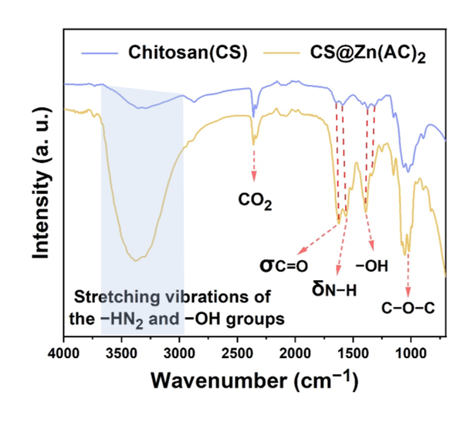
Fig. S1 FTIR Spectra of chitosan and CS@Zn(AC)₂
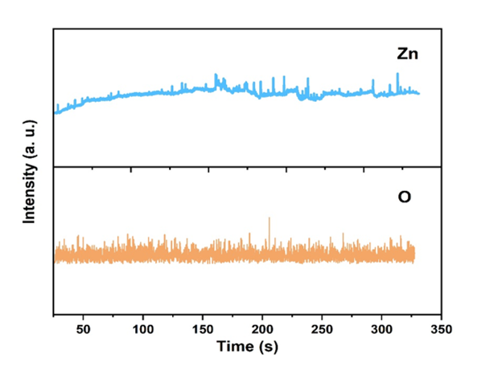
Fig. S2 GDOES spectra of zinc and oxygen in CS@Zn(AC)₂
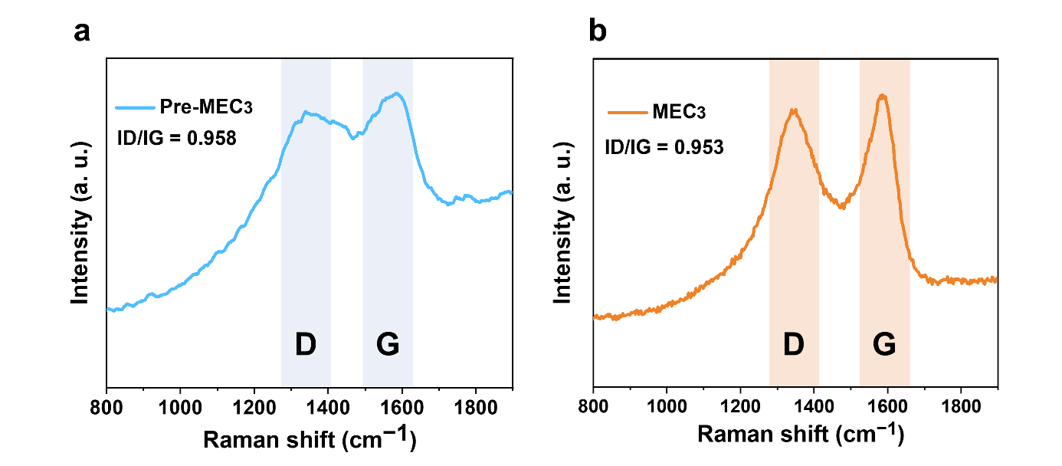
Fig. S3 Raman spectra of the CS@Zn(AC)₂ pre-carbonized product and MEC₃

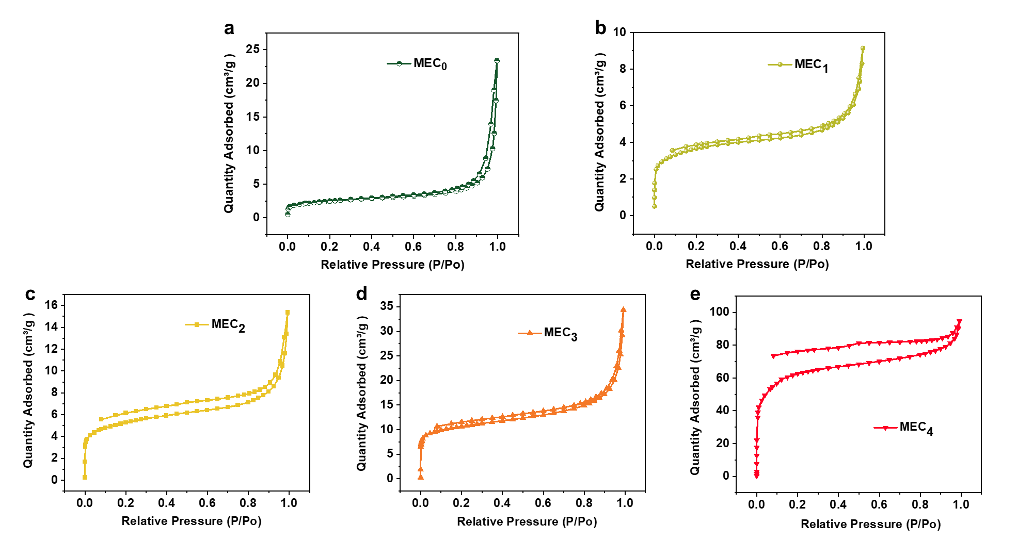
Fig. S4 BET data of MEC₀ ~ MEC₄

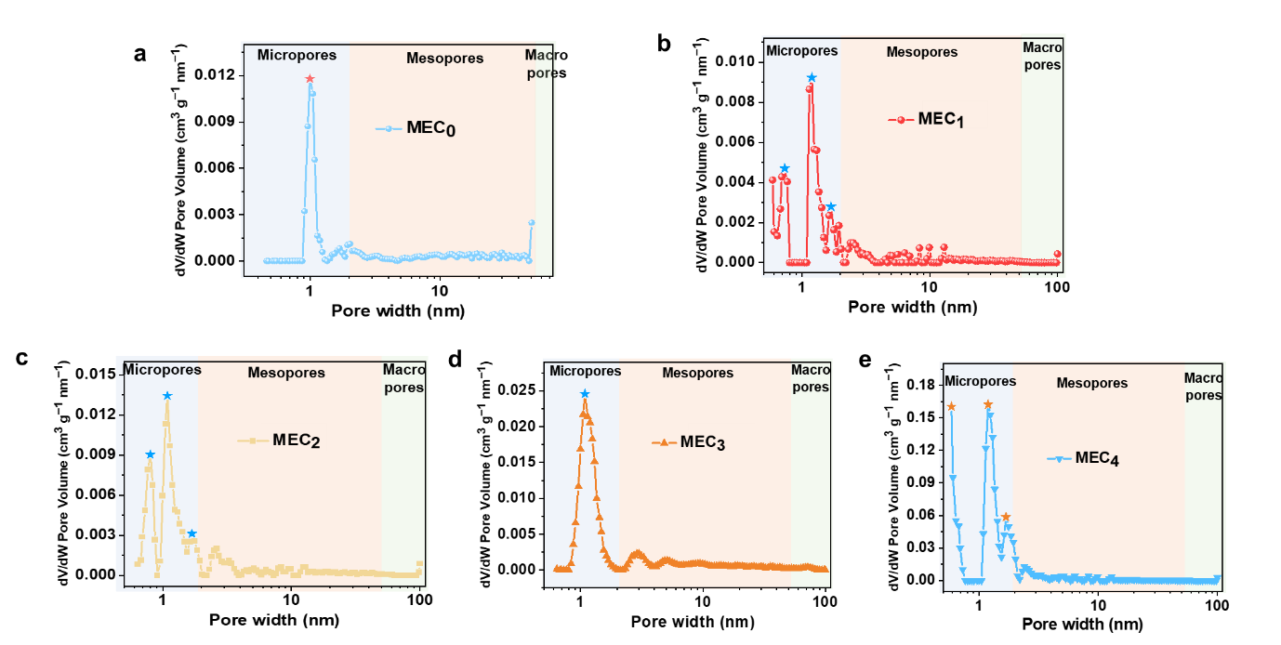
Fig. S5 The pore diameter distribution curves of MEC₀~ MEC₄

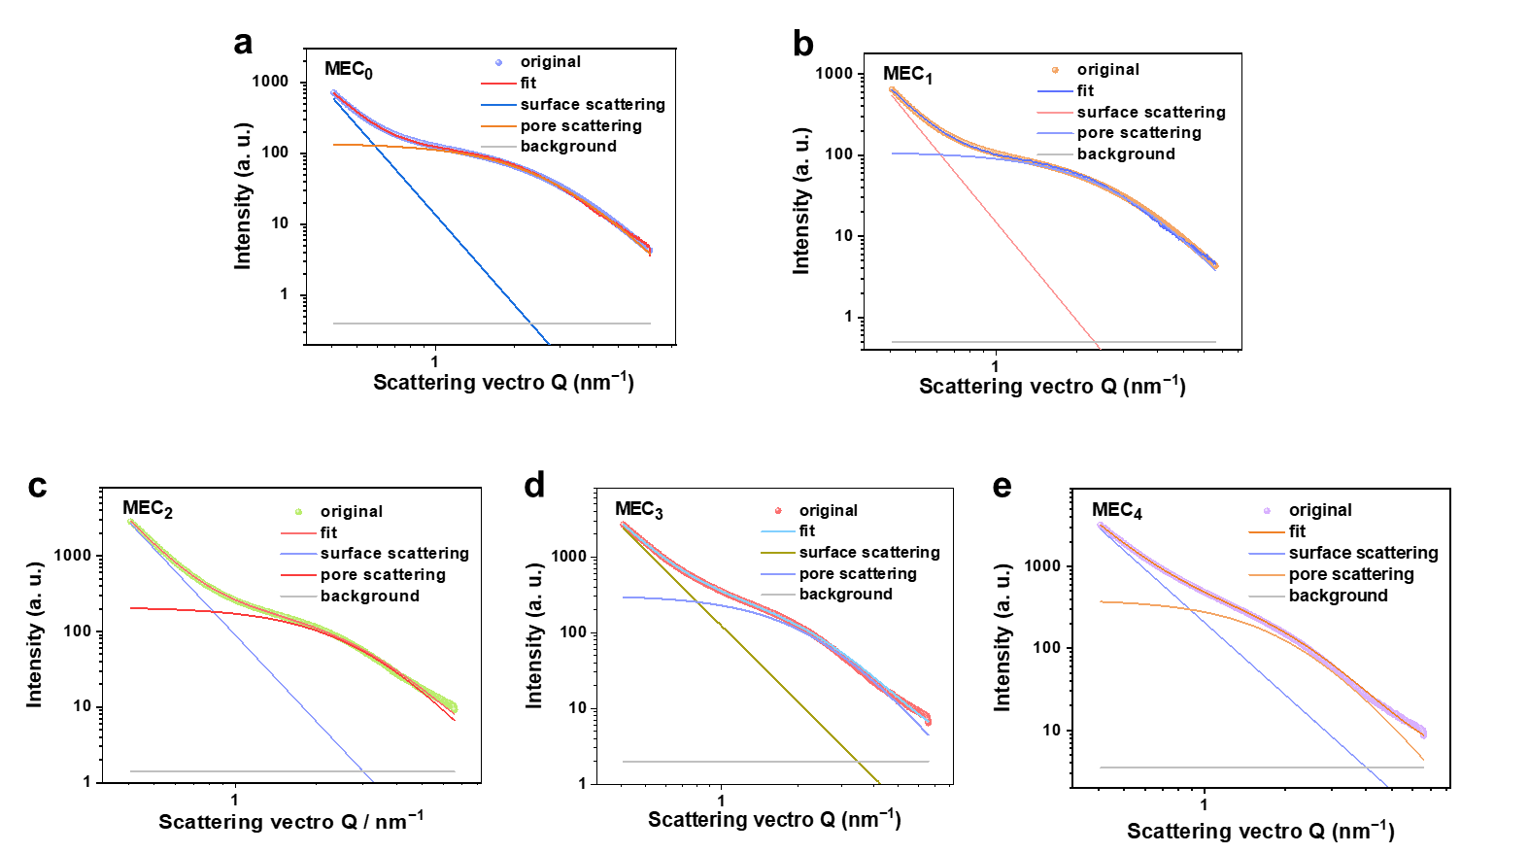
Fig. S6 The fitted SAXS patterns of MEC₀~ MEC₄
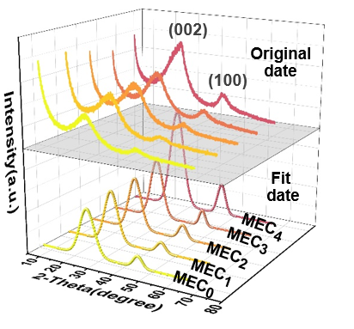
Fig. S7 XRD patterns for MEC₀ ~ MEC₄
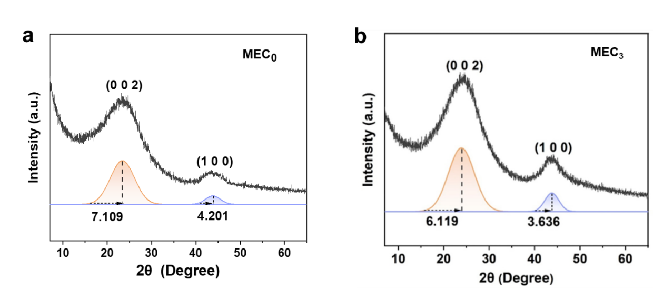
Fig. S8 The fitted XRD patterns of MEC₀ and MEC₃
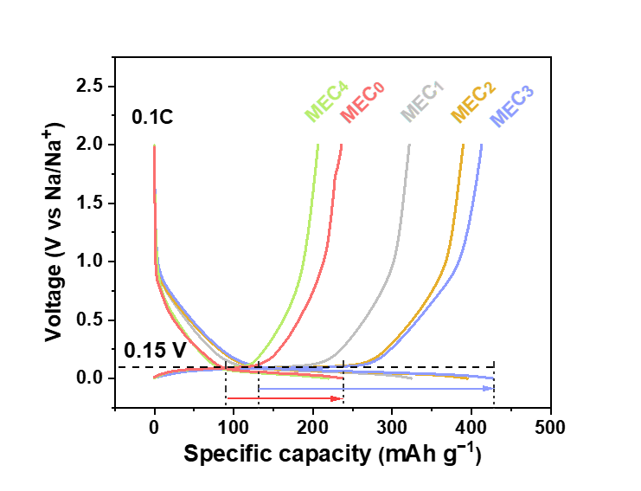
Fig. S9 The galvanostatic charge and discharge curves for MEC₀ ~ MEC₄ at 0.1 C
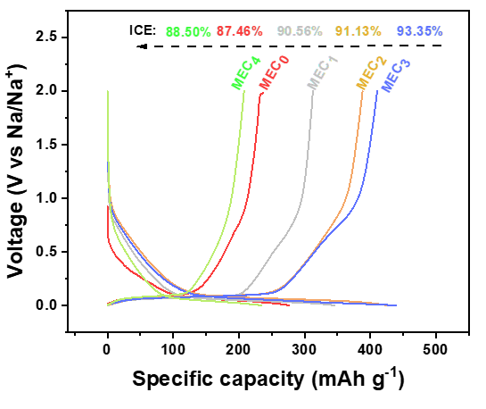
Fig. S10 The galvanostatic charge and discharge curves and initial Coulombic efficiency during the first cycle for MEC₀ ~ MEC₄ at 0.1 C
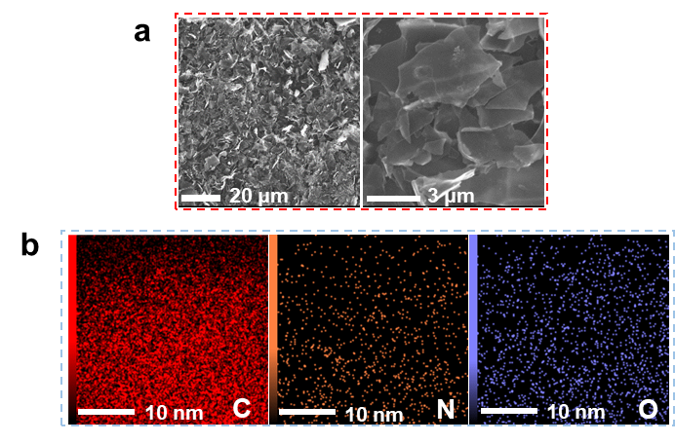
Fig. S11 a SEM images of MEC₃ and b corresponding EDS mapping images
Fig. S12 XPS spectrum of Zn 2p for MEC₃

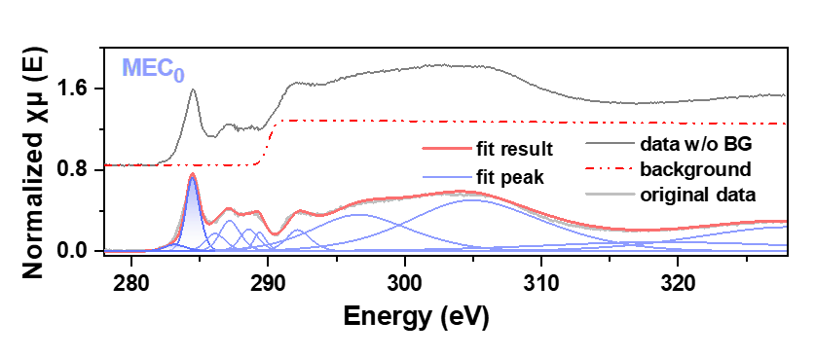
Fig. S13 The carbon K-edge NEXAFS spectra of MEC₀ in the energy range of 275~335 eV
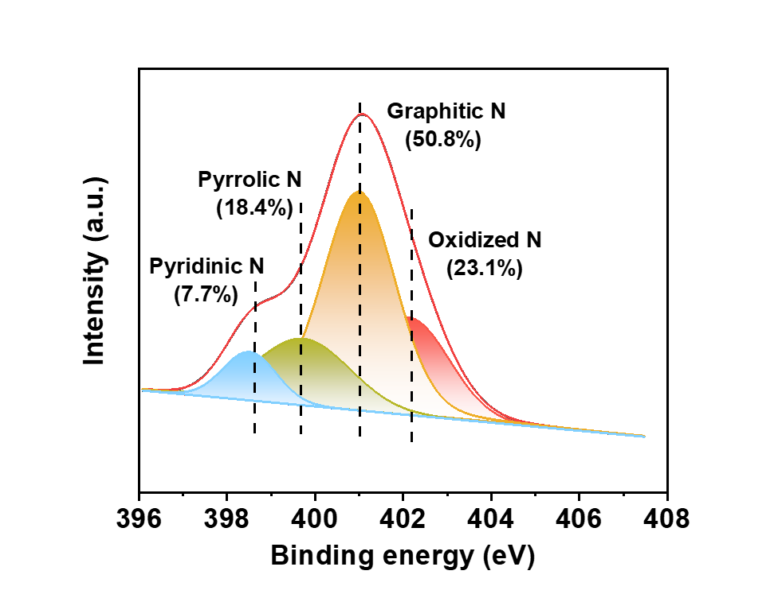
Fig. S14 XPS spectra of N 1s for MEC₀

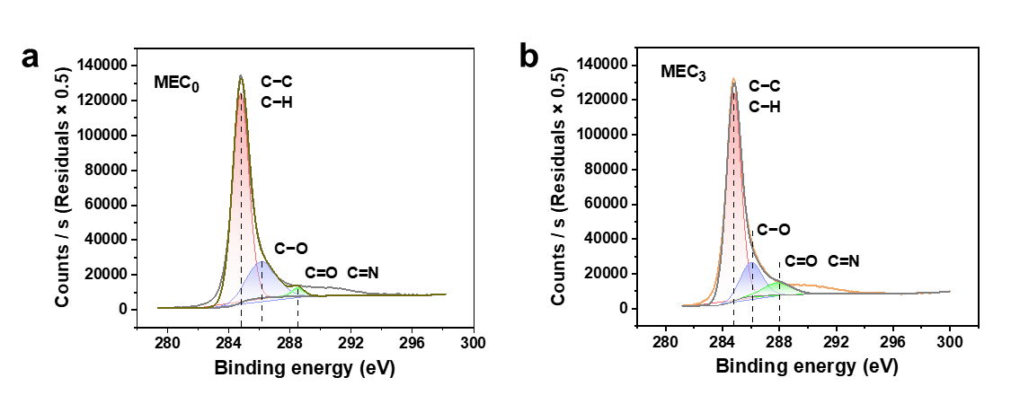
Fig. S15 XPS spectra of C 1s for a MEC₀ and b MEC₃
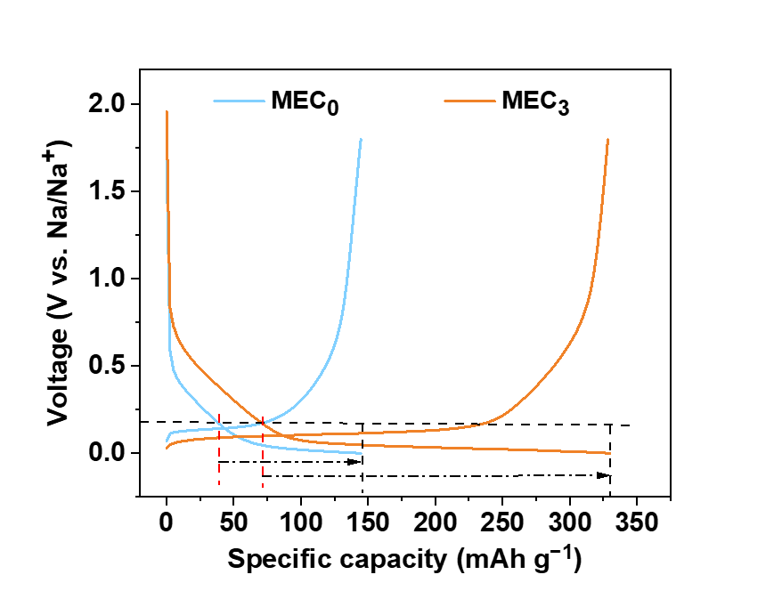
Fig. S16 Comparison of GCD curves and plateau capacity of MEC₀ and MEC₃ at 1 C
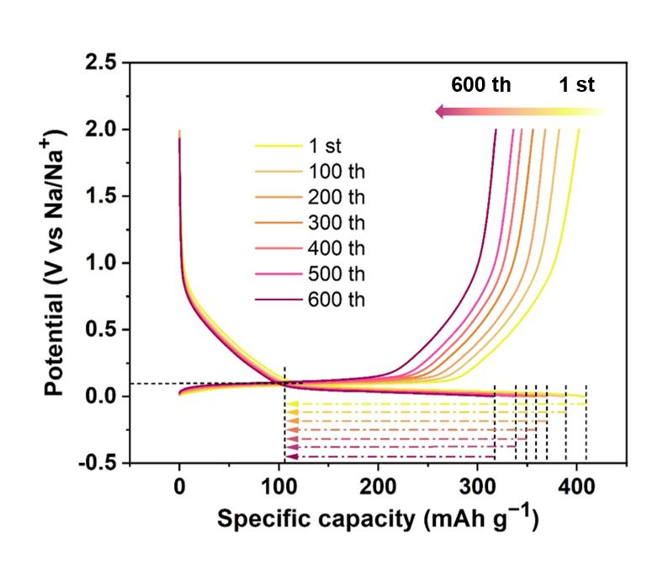
Fig. S17 The GCD curves of MEC₃ at 0.2 C under 1~600 cycles. Before the 0.2 C long-term cycling, the half-cell underwent activation through 2 cycles at 0.1 C
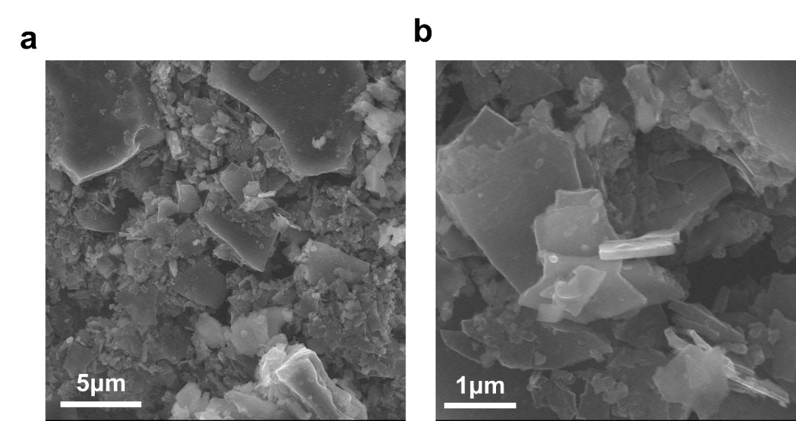
Fig. S18 SEM images of MEC₃ after 100 cycles

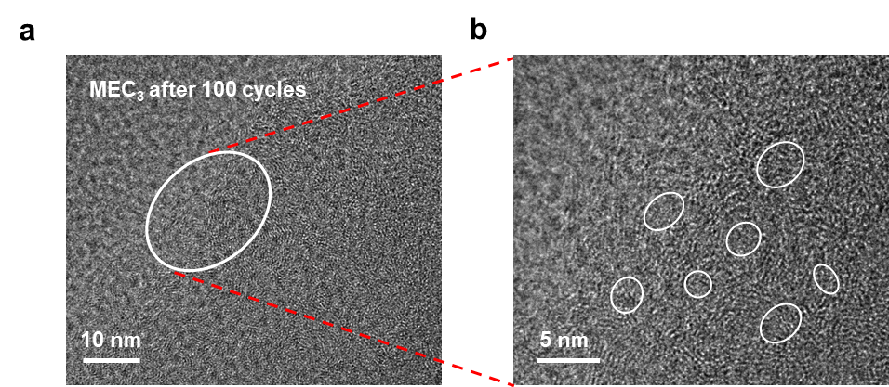
Fig. S19 HR-TEM images of MEC₃ after 100 cycles

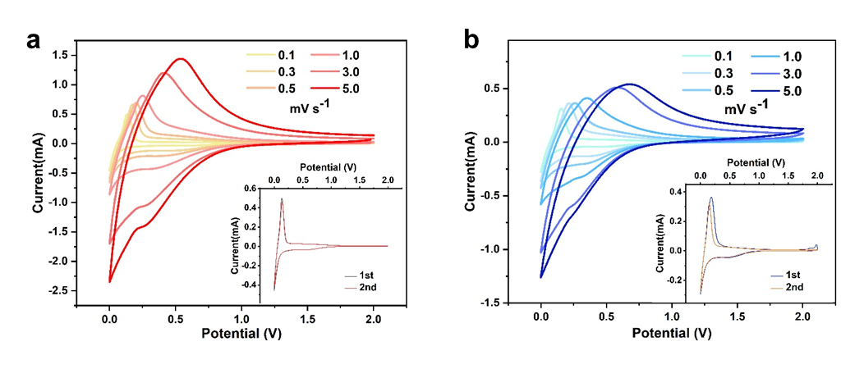
Fig. S20 CV curves of a MEC₃ and b MEC₀ at scan rates of 0.1~5 mV s⁻¹

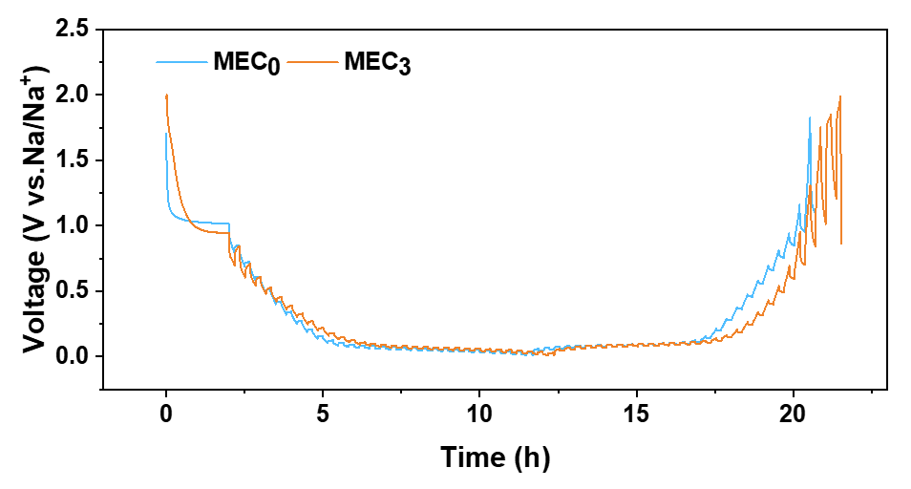
Fig. S21 The GITT potential profiles of MEC₃ and MEC₀
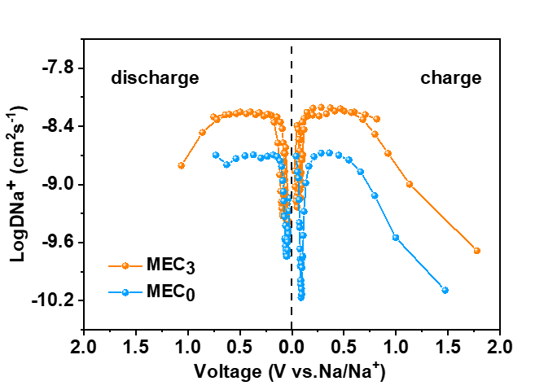
Fig. S22 Na⁺ diffusion coefficients of MEC₃ and MEC₀ derived from GITT measurements
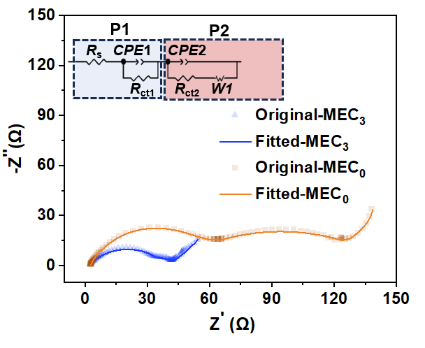
Fig. S23 Nyquist curves and equivalent circuit diagrams of MEC₃ and MEC₀ at 25 °C

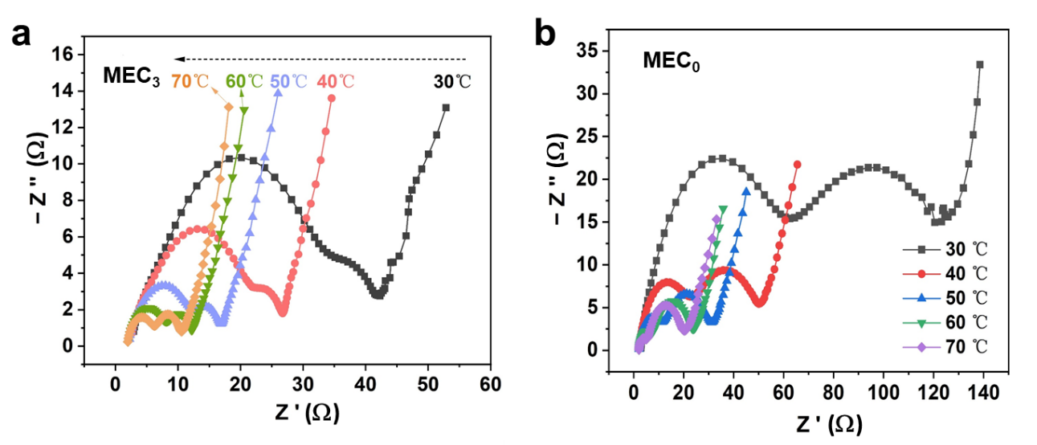
Fig. S24 Nyquist curves and equivalent circuit diagrams of a MEC₃ and b MEC₀ at 30 °C, 40 °C, 50 °C, 60 °C, and 70 °C
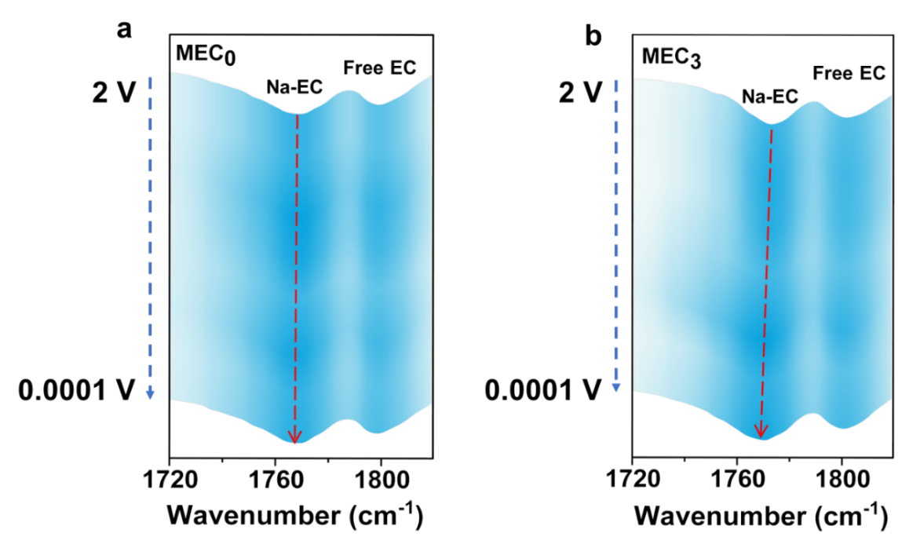
Fig. S25 In-situ FT-IR spectra for a MEC₀ and b MEC₃ during the discharge process
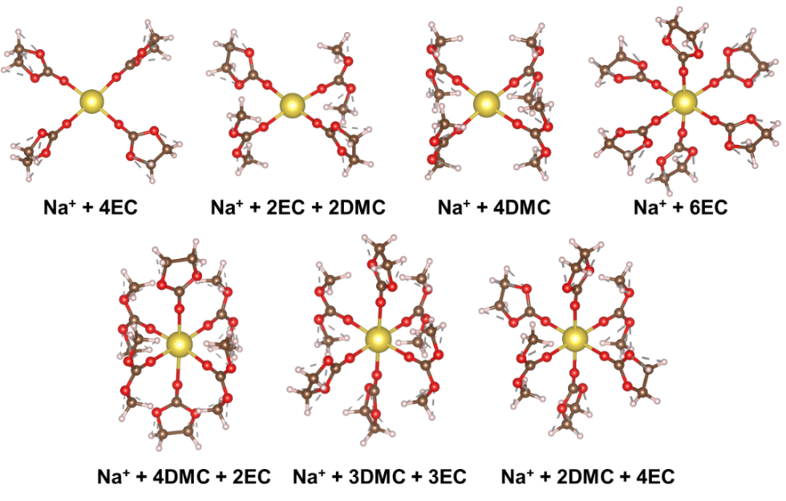
Fig. S26 Different tetrahedral and hexahedral coordination structures of Na⁺ ions with EC, DMC, and their mixed solvents

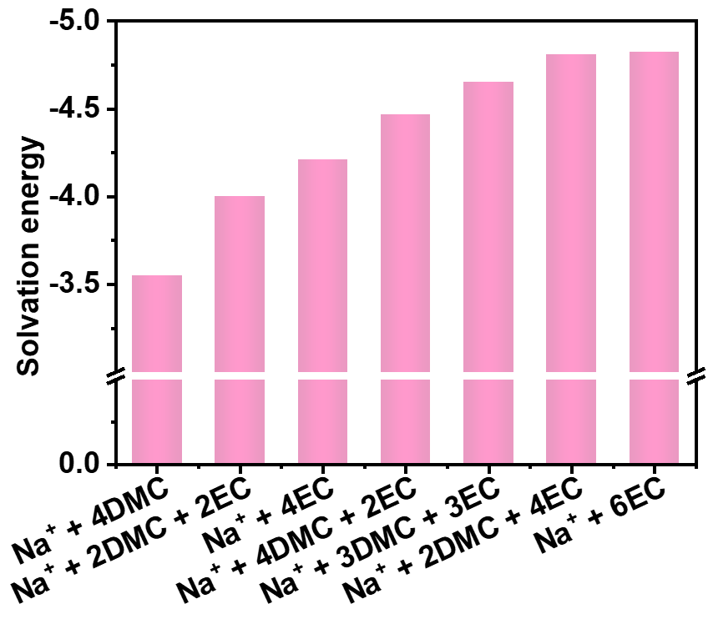
Fig. S27 Solvation energy of different tetrahedral and hexahedral coordination structures of Na⁺ ions with EC, DMC, and their mixed solvents

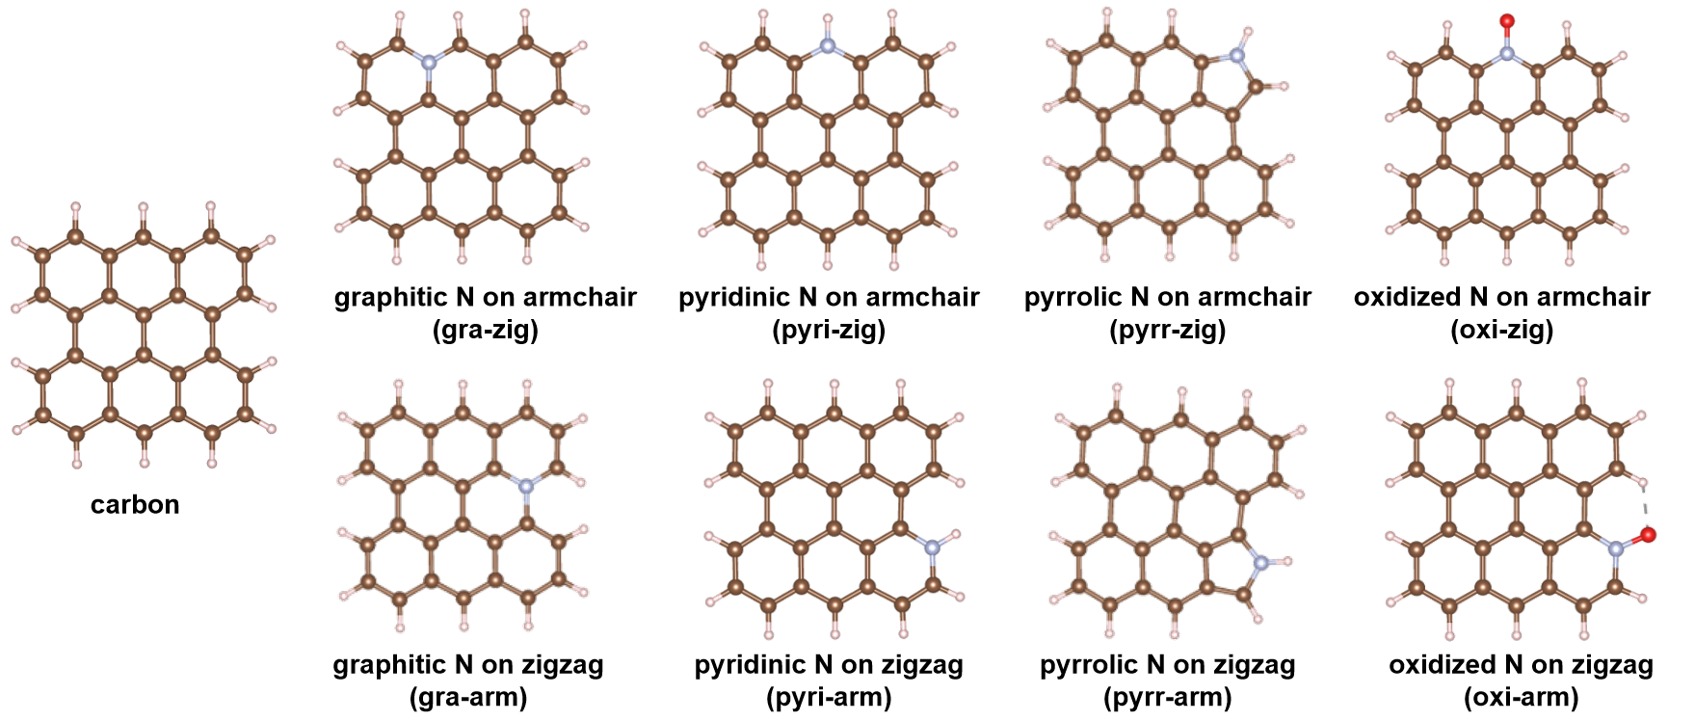
Fig. S28 Carbon structures doped with different N species including pristine carbon, pyridinic N, pyrrolic N, graphitic N, and oxidized N featuring zigzag and armchair configurations
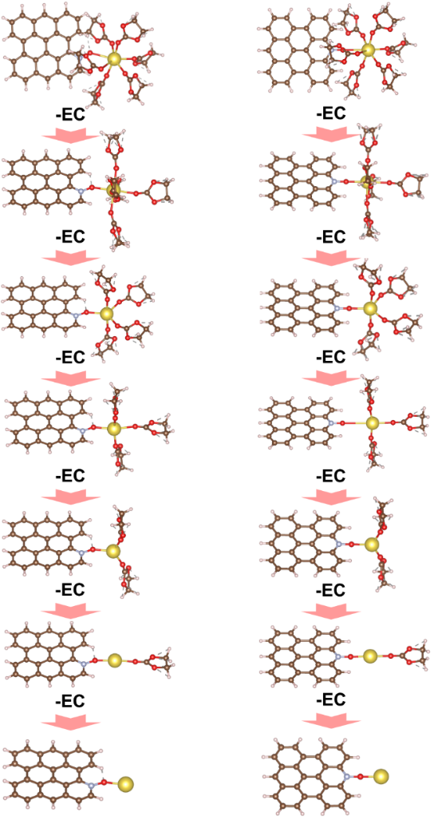
Fig. S29 Step-wise desolvation process for the carbon structures with zigzag and armchair oxidized N
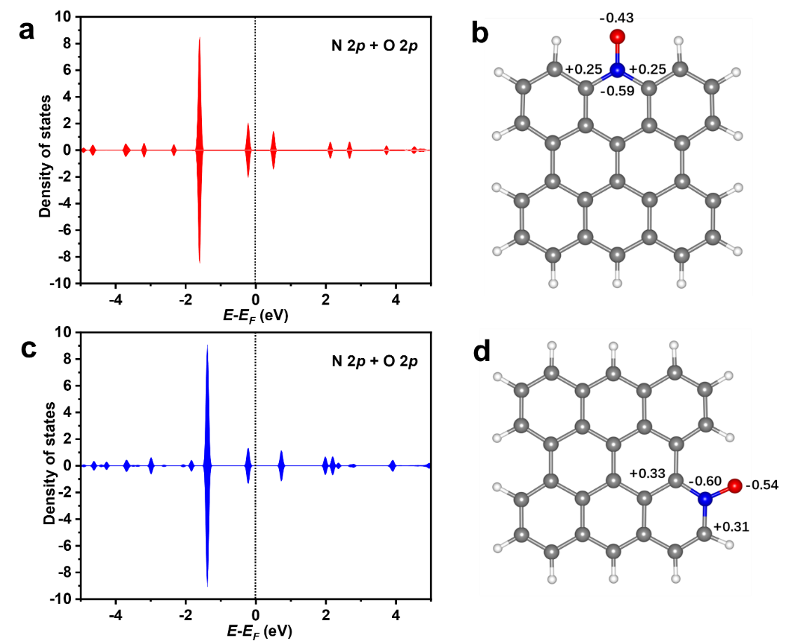
Fig. S30 Partial density of states (pDOS) projecting on N 2p and O 2p orbitals and Bader charge analysis for oxidized N featuring a, c zigzag and b, d armchair configurations
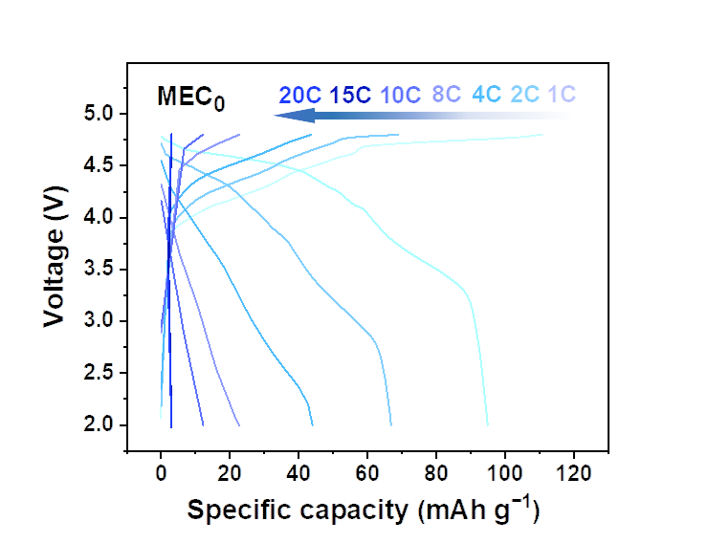
Fig. S31 Charge/discharge curves of the MEC₀ | | EG dual-ion battery at 1 C, 2 C, 4 C, 8 C, 10 C, 15 C, and 20 C
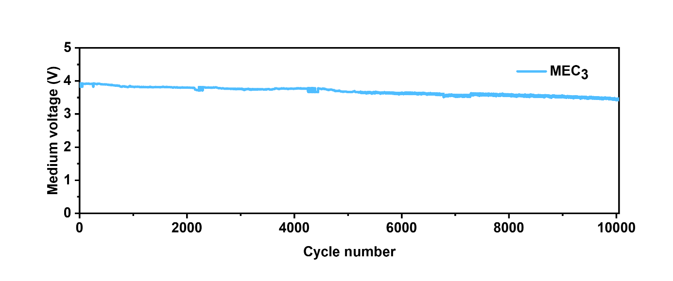
Fig. S32 The medium voltage of The MEC₃ | | EG cycle at 10 C
Supplementary References
- F. Xie, Z. Xu, A.C.S. Jensen, F. Ding, H. Au et al., Unveiling the role of hydrothermal carbon dots as anodes in sodium-ion batteries with ultrahigh initial coulombic efficiency. J. Mater. Chem. A 7(48), 27567–27575 (2019). https://doi.org/10.1039/C9TA11369J
- Z. Xu, J. Wang, Z. Guo, F. Xie, H. Liu et al., The role of hydrothermal carbonization in sustainable sodium-ion battery anodes. Adv. Energy Mater. 12(18), 2200208 (2022). https://doi.org/10.1002/aenm.202200208
- Y. Wang, Z. Yi, L. Xie, Y. Mao, W. Ji et al., Releasing free radicals in precursor triggers the formation of closed pores in hard carbon for sodium-ion batteries. Adv. Mater. 36(26), 2401249 (2024). https://doi.org/10.1002/adma.202401249
- S. Zhang, N. Sun, X. Li, R. Ali Soomro, B. Xu, Closed pore engineering of activated carbon enabled by waste mask for superior sodium storage. Energy Storage Mater. 66, 103183 (2024). https://doi.org/10.1016/j.ensm.2024.103183
- X. Chen, N. Sawut, K. Chen, H. Li, J. Zhang et al., Filling carbon: a microstructure-engineered hard carbon for efficient alkali metal ion storage. Energy Environ. Sci. 16(9), 4041–4053 (2023). https://doi.org/10.1021/acsnano.4c02046
- J. Lin, Q. Zhou, Z. Liao, Y. Chen, Y. Liu et al., Steric hindrance engineering to modulate the closed pores formation of polymer-derived hard carbon for high-performance sodium-ion batteries. Angew. Chem. Int. Ed. 63(39), e202409906 (2024). https://doi.org/10.1002/anie.202409906
- C. Qiu, A. Li, D. Qiu, Y. Wu, Z. Jiang et al., One-step construction of closed pores enabling high plateau capacity hard carbon anodes for sodium-ion batteries: closed-pore formation and energy storage mechanisms. ACS Nano 18(18), 11941–11954 (2024). https://doi.org/10.1021/acsnano.4c02046
- Z. Lu, H. Yang, Y. Guo, H. Lin, P. Shan et al., Consummating ion desolvation in hard carbon anodes for reversible sodium storage. Nat. Commun. 15(1), 3497 (2024). https://doi.org/10.1038/s41467-024-47522-y
- W. Jian, X. Qiu, H. Chen, J. Yin, W. Yin et al., Elucidation of the sodium-ion storage behaviors in hard carbon anodes through pore architecture engineering. ACS Nano 19(24), 22201–22216 (2025). https://doi.org/10.1021/acsnano.5c03700
- J. Duan, Z. Xu, M. Li, P. Yang, H. Hu et al., Structure regulation of hard carbon with enriched semi-closed ultramicropores for enhanced rapid sodium storage. Adv. Funct. Mater. 2508822 (2025). https://doi.org/10.1002/adfm.202508822
- D.-S. Bin, Y. Li, Y.-G. Sun, S.-Y. Duan, Y. Lu et al., Structural engineering of multishelled hollow carbon nanostructures for high-performance Na-ion battery anode. Adv. Energy Mater. 8(26), 1800855 (2018). https://doi.org/10.1002/aenm.201800855
- Z. Jian, Z. Xing, C. Bommier, Z. Li, X. Ji, Hard carbon microspheres: potassium-ion anode versus sodium-ion anode. Adv. Energy Mater. 6(3), 1501874 (2016). https://doi.org/10.1002/aenm.201501874
- Z. Zhu, F. Liang, Z. Zhou, X. Zeng, D. Wang et al., Expanded biomass-derived hard carbon with ultra-stable performance in sodium-ion batteries. J. Mater. Chem. A 6(4), 1513–1522 (2018). https://doi.org/10.1039/c7ta07951f
- F. Xie, Z. Xu, A.C.S. Jensen, H. Au, Y. Lu et al., Hard–soft carbon composite anodes with synergistic sodium storage performance. Adv. Funct. Mater. 29(24), 1901072 (2019). https://doi.org/10.1002/adfm.201901072
- S. Qiu, L. Xiao, M.L. Sushko, K.S. Han, Y. Shao et al., Manipulating adsorption–insertion mechanisms in nanostructured carbon materials for high-efficiency sodium ion storage. Adv. Energy Mater. 7(17), 1700403 (2017). https://doi.org/10.1002/aenm.201700403
- F. Chen, Y. Di, Q. Su, D. Xu, Y. Zhang et al., Vanadium-modified hard carbon spheres with sufficient pseudographitic domains as high-performance anode for sodium-ion batteries. Carbon Energy 5(2), e191 (2023). https://doi.org/10.1002/cey2.191
- Z. Hu, Q. Liu, K. Zhang, L. Zhou, L. Li et al., All carbon dual ion batteries. ACS Appl. Mater. Interfaces 10(42), 35978–35983 (2018). https://doi.org/10.1021/acsami.8b11824
- L. Fan, Q. Liu, S. Chen, Z. Xu, B. Lu, Soft carbon as anode for high-performance sodium-based dual ion full battery. Adv. Energy Mater. 7(14), 1602778 (2017). https://doi.org/10.1002/aenm.201602778
- X. Zhang, L. Zhang, W. Zhang, S. Xue, Y. Tang, A fast and stable sodium-based dual-ion battery achieved by Cu₃P@P-doped carbon matrix anode. J. Power Sources 518, 230741 (2022). https://doi.org/10.1016/j.jpowsour.2021.230741
- Y. Liu, X. Hu, G. Zhong, J. Chen, H. Zhan et al., Layer-by-layer stacked nanohybrids of N, S-co-doped carbon film modified atomic MoS₂ nanosheets for advanced sodium dual-ion batteries. J. Mater. Chem. A 7(42), 24271–24280 (2019). https://doi.org/10.1039/C9TA09636A
- M. Sheng, F. Zhang, B. Ji, X. Tong, Y. Tang, A novel tin-graphite dual-ion battery based on sodium-ion electrolyte with high energy density. Adv. Energy Mater. 7(7), 1601963 (2017). https://doi.org/10.1002/aenm.201601963
- G. Zhang, X. Ou, J. Yang, Y. Tang, Molecular coupling and self-assembly strategy toward WSe₂/carbon micro–nano hierarchical structure for elevated sodium-ion storage. Small Meth. 5(8), 2100374 (2021). https://doi.org/10.1002/smtd.202100374
- X. Hou, W. Li, Y. Wang, S. Li, Y. Meng et al., Sodium-based dual-ion batteries via coupling high-capacity selenium/graphene anode with high-voltage graphite cathode. Chin. Chem. Lett. 31(9), 2314–2318 (2020). https://doi.org/10.1016/j.cclet.2020.04.021
- H. Wang, Q. Wu, Y. Wang, X. Lv, H.-G. Wang, A redox-active metal–organic compound for lithium/sodium-based dual-ion batteries. J. Colloid Interface Sci. 606, 1024–1030 (2022). https://doi.org/10.1016/j.jcis.2021.08.113
- S. Mu, Q. Liu, P. Kidkhunthod, X. Zhou, W. Wang et al., Molecular grafting towards high-fraction active nanodots implanted in N-doped carbon for sodium dual-ion batteries. Natl. Sci. Rev. 8(7), nwaa178 (2020). https://doi.org/10.1093/nsr/nwaa178
- Z. Guo, Z. Xu, F. Xie, J. Jiang, K. Zheng et al., Investigating the superior performance of hard carbon anodes in sodium-ion compared with lithium- and potassium-ion batteries. Adv. Mater. 35(42), 2304091 (2023). https://doi.org/10.1002/adma.202304091
- N. Jiang, L. Chen, H. Jiang, Y. Hu, C. Li, Introducing the solvent co-intercalation mechanism for hard carbon with ultrafast sodium storage. Small 18(15), 2108092 (2022). https://doi.org/10.1002/smll.202108092
- W. Li, X. Guo, K. Song, J. Chen, J. Zhang et al., Binder-induced ultrathin SEI for defect-passivated hard carbon enables highly reversible sodium-ion storage. Adv. Energy Mater. 13(22), 2300648 (2023). https://doi.org/10.1002/aenm.202300648
- Z. Wen, R. Zhao, T. Tian, T. Zhang, X. Wang et al., Molecular stitching in polysaccharide precursor for fabricating hard carbon with ultra-high plateau capacity of sodium storage. Adv. Mater. 37(18), 2420251 (2025). https://doi.org/10.1002/adma.202420251

