Supporting Information for
Temperature-Dependent Infrared Engineering for Extreme Environments: All-Dielectric Thermal Photonic Metamaterials Stable at 1873 K in Air
Yang Liu^{1#}, He Lin^{1,2,3#}, Yunxia Zhou^{1#}, Liming Yuan¹, Yanqin Wang^{1,2}, Xiaoliang Ma^{1,2}, Cheng Huang^{1,2}, Xiangang Luo^{1,2}
¹State Key Laboratory of Optical Field Manipulation Science and Technology, Institute of Optics and Electronics, Chinese Academy of Sciences, Chengdu 610209, P. R. China
²College of Materials Sciences and Opto-Electronic Technology, University of Chinese Academy of Sciences, Beijing 100049, P. R. China
³School of Automation Engineering, University of Electronic Science and Technology of China, Chengdu 611731, P. R. China
#Yang Liu, He Lin, and Yunxia Zhou contributed equally to this work.
*Corresponding authors. E-mail: maxl@ioe.ac.cn (Xiaoliang Ma); huangc@ioe.ac.cn (Cheng Huang); lxg@ioe.ac.cn (Xiangang Luo)
Supplementary Figures and Tables
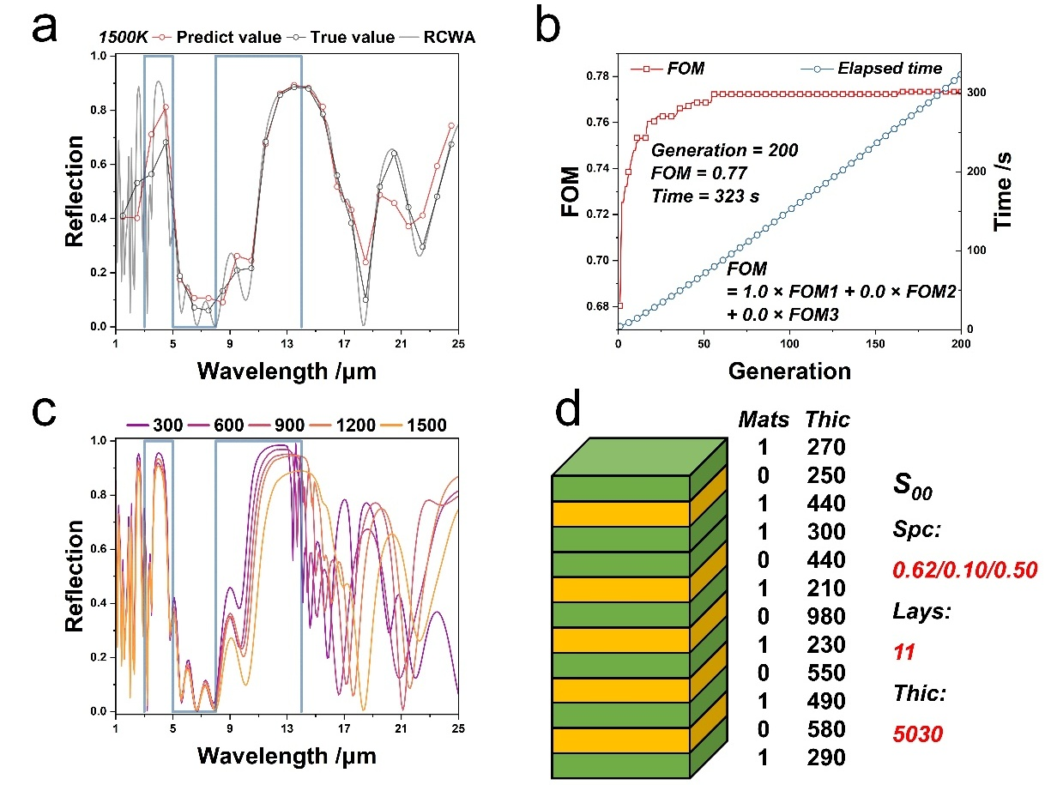
Fig. S1 Detailed data for solution S₀₀. a) Predicted values, true values, and RCWA value from the neural network at 1500 K; b) Evolution of FOM and elapsed time; c) Infrared spectrum across 300–1500 K; d) TPM layer architecture and spectral performance

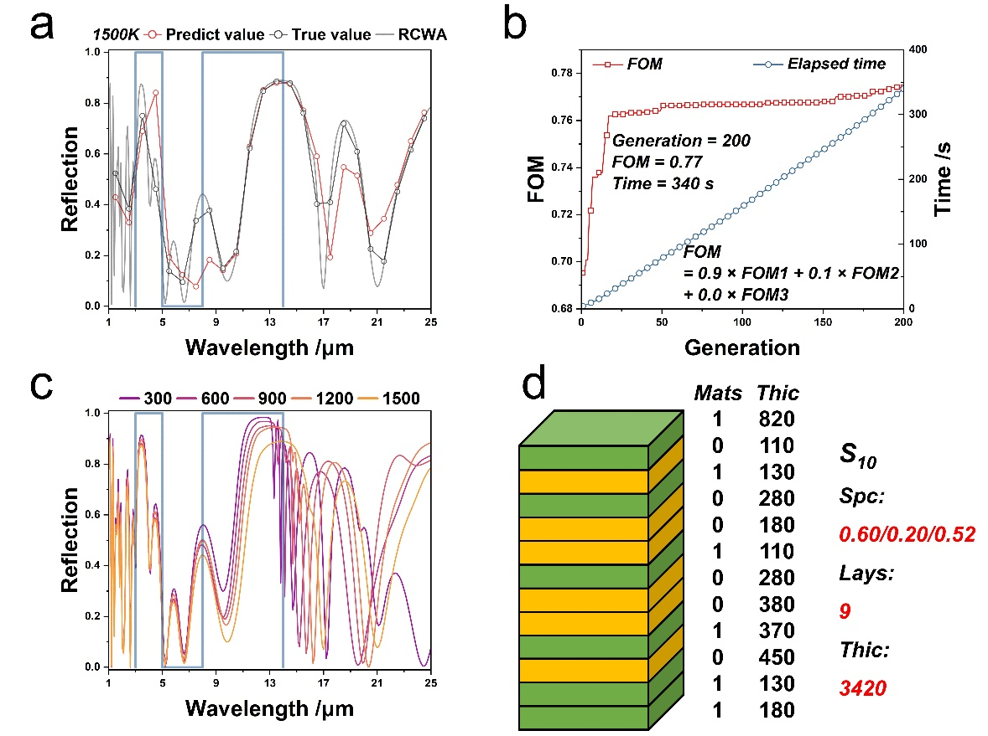
Fig. S2 Detailed data for solution S₁₀. a) Predicted values, true values, and RCWA value from the neural network at 1500 K; b) Evolution of FOM and elapsed time; c) Infrared spectrum across 300–1500 K; d) TPM layer architecture and spectral performance
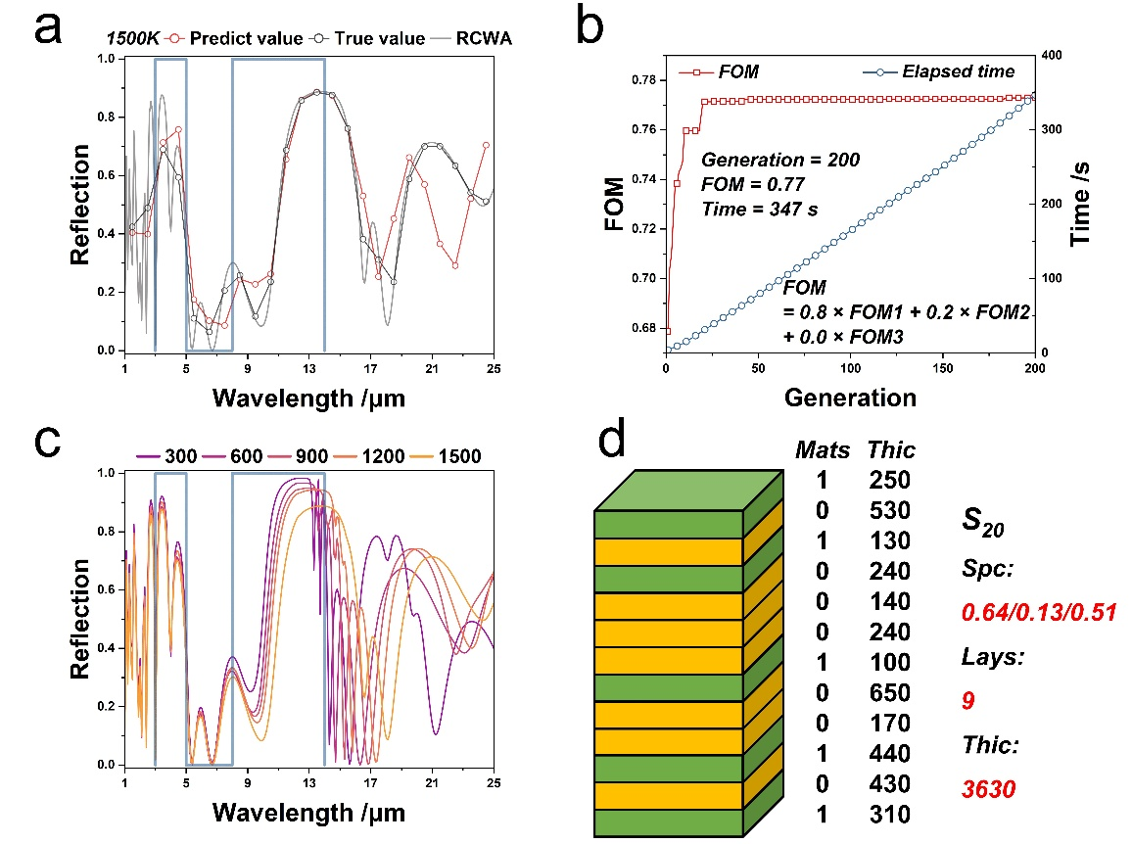
Fig. S3 Detailed data for solution S₂₀. a) Predicted values, true values, and RCWA value from the neural network at 1500 K; b) Evolution of FOM and elapsed time; c) Infrared spectrum across 300–1500 K; d) TPM layer architecture and spectral performance
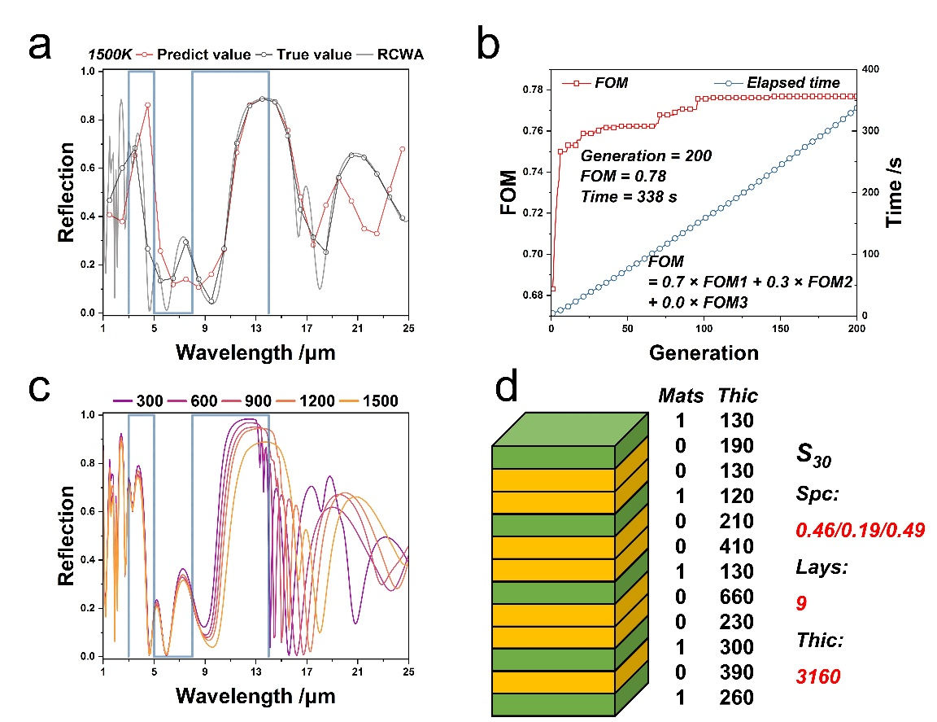
Fig. S4 Detailed data for solution S₃₀. a) Predicted values, true values, and RCWA value from the neural network at 1500 K; b) Evolution of FOM and elapsed time; c) Infrared spectrum across 300–1500 K; d) TPM layer architecture and spectral performance
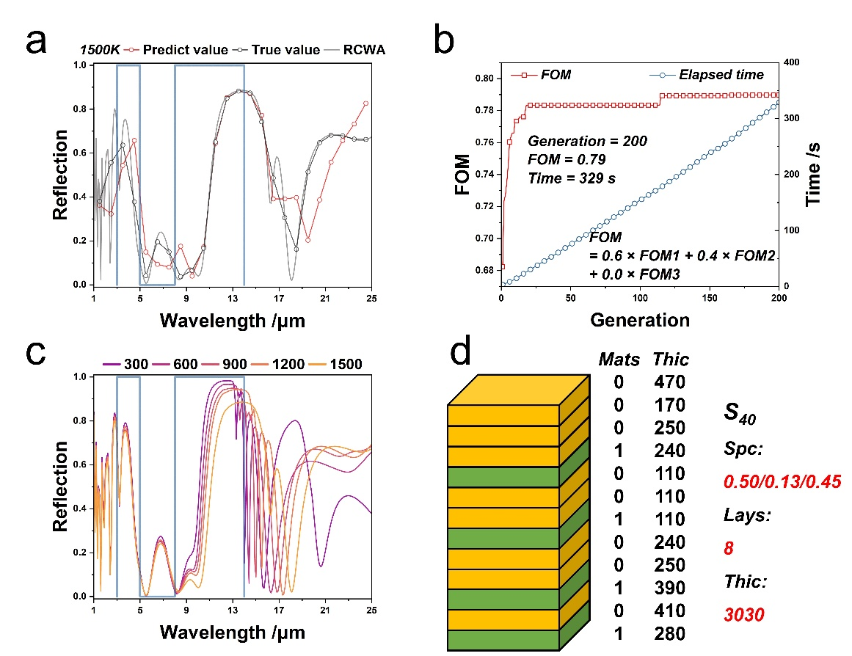
Fig. S5 Detailed data for solution S₄₀. a) Predicted values, true values, and RCWA value from the neural network at 1500 K; b) Evolution of FOM and elapsed time; c) Infrared spectrum across 300–1500 K; d) TPM layer architecture and spectral performance
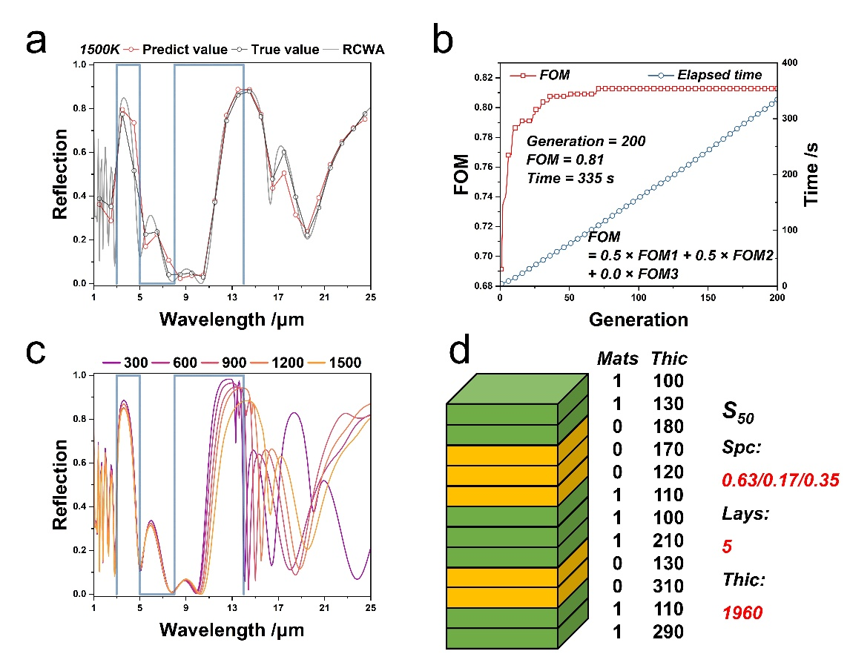
Fig. S6 Detailed data for solution S₅₀. a) Predicted values, true values, and RCWA value from the neural network at 1500 K; b) Evolution of FOM and elapsed time; c) Infrared spectrum across 300–1500 K; d) TPM layer architecture and spectral performance
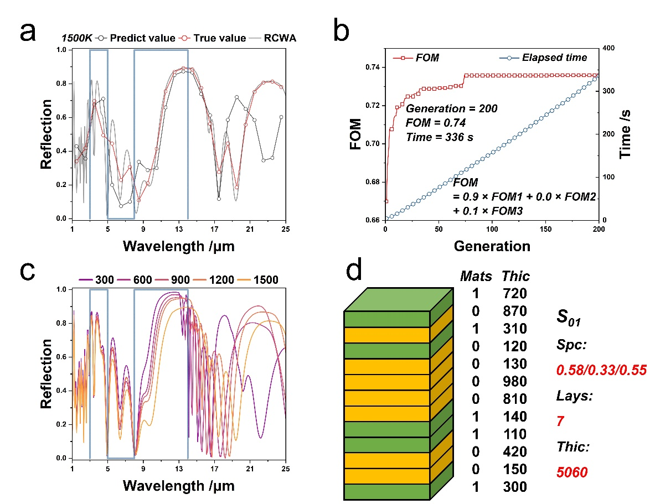
Fig. S7 Detailed data for solution S₀₁. a) Predicted values, true values, and RCWA value from the neural network at 1500 K; b) Evolution of FOM and elapsed time; c) Infrared spectrum across 300–1500 K; d) TPM layer architecture and spectral performance
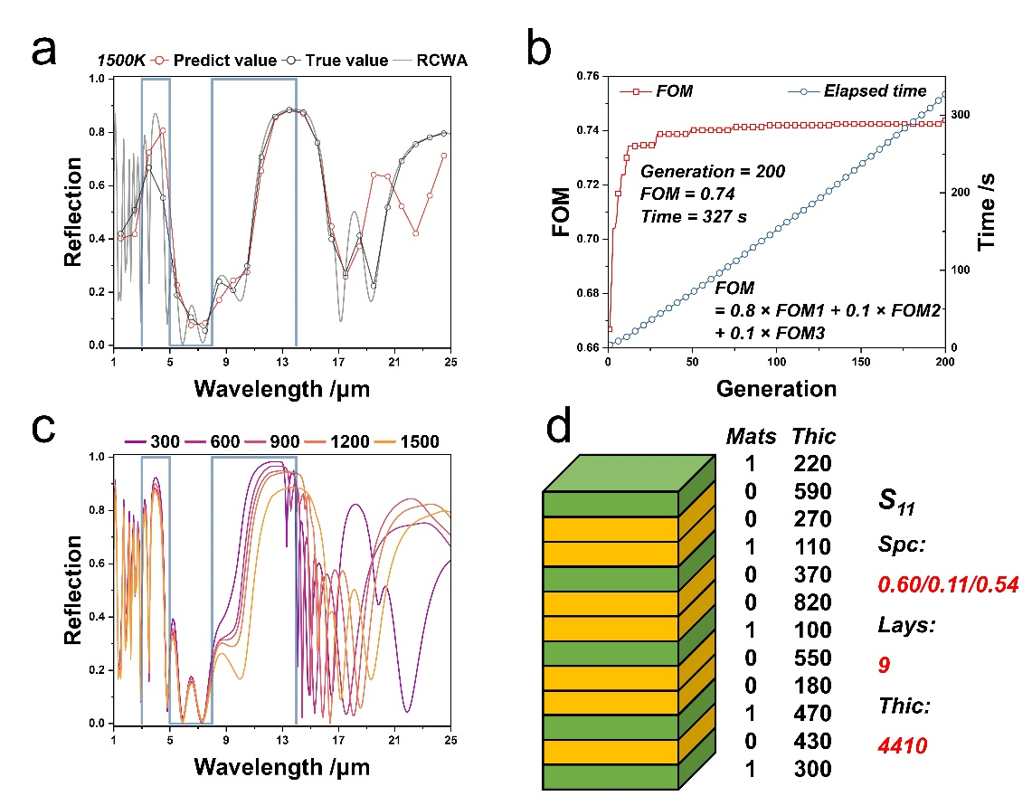
Fig. S8 Detailed data for solution S₁₁. a) Predicted values, true values, and RCWA value from the neural network at 1500 K; b) Evolution of FOM and elapsed time; c) Infrared spectrum across 300–1500 K; d) TPM layer architecture and spectral performance
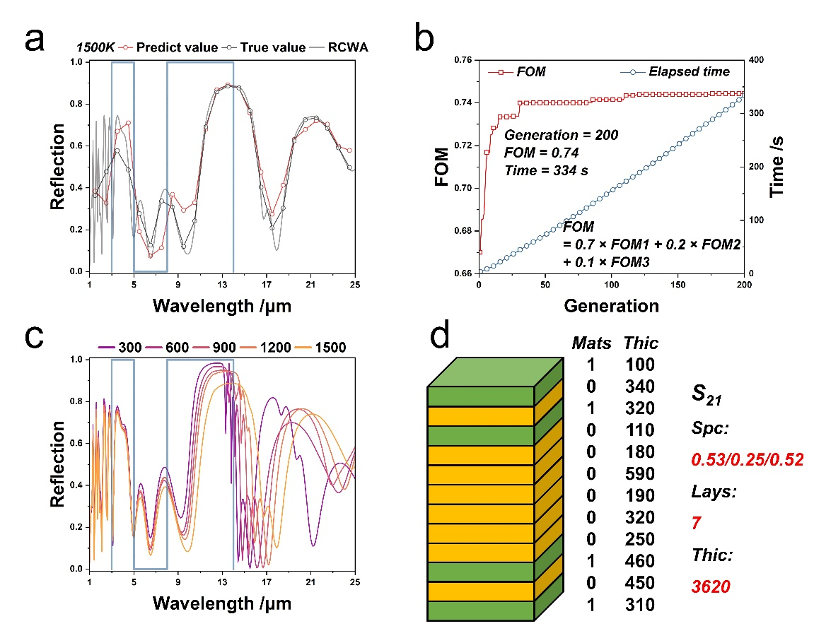
Fig. S9 Detailed data for solution S₂₁. a) Predicted values, true values, and RCWA value from the neural network at 1500 K; b) Evolution of FOM and elapsed time; c) Infrared spectrum across 300–1500 K; d) TPM layer architecture and spectral performance
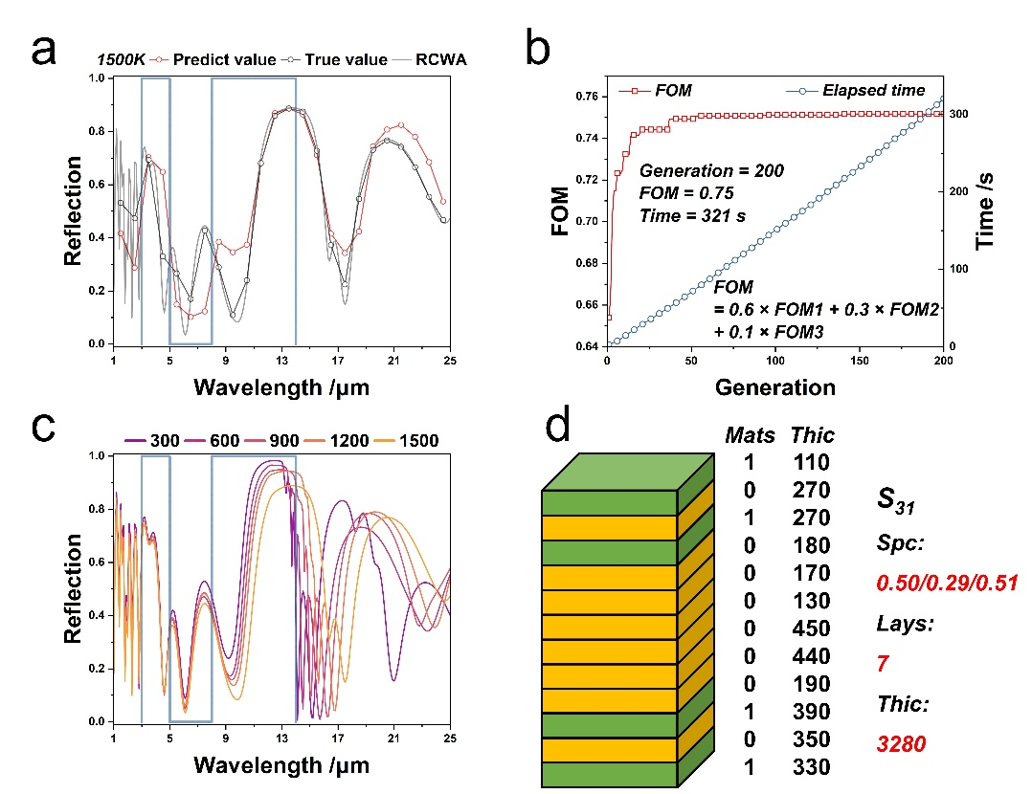
Fig. S10 Detailed data for solution S₃₁. a) Predicted values, true values, and RCWA value from the neural network at 1500 K; b) Evolution of FOM and elapsed time; c) Infrared spectrum across 300–1500 K; d) TPM layer architecture and spectral performance
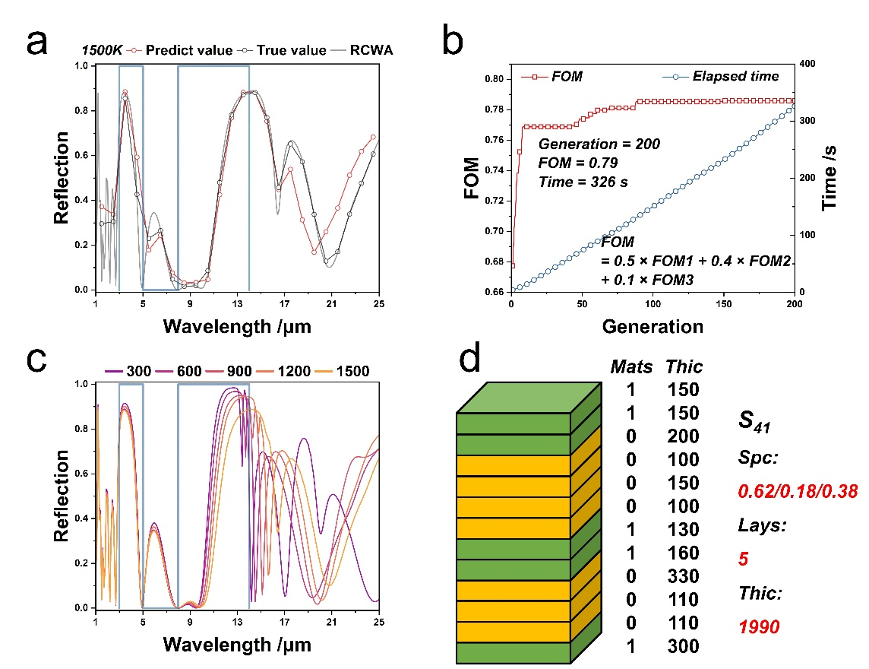
Fig. S11 Detailed data for solution S₄₁. a) Predicted values, true values, and RCWA value from the neural network at 1500 K; b) Evolution of FOM and elapsed time; c) Infrared spectrum across 300–1500 K; d) TPM layer architecture and spectral performance
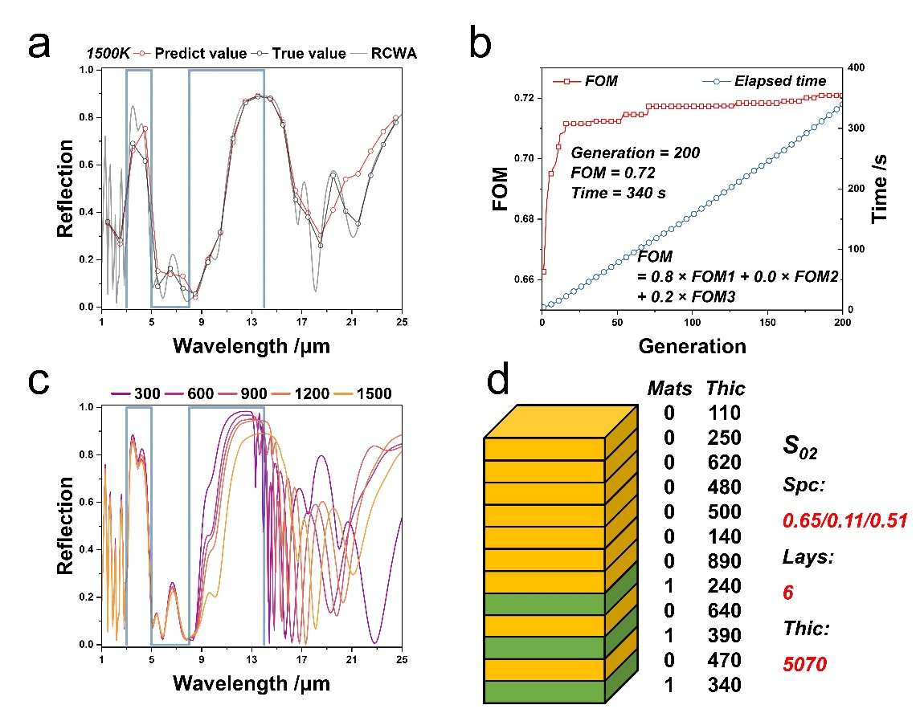
Fig. S12 Detailed data for solution S₀₂. a) Predicted values, true values, and RCWA value from the neural network at 1500 K; b) Evolution of FOM and elapsed time; c) Infrared spectrum across 300–1500 K; d) TPM layer architecture and spectral performance
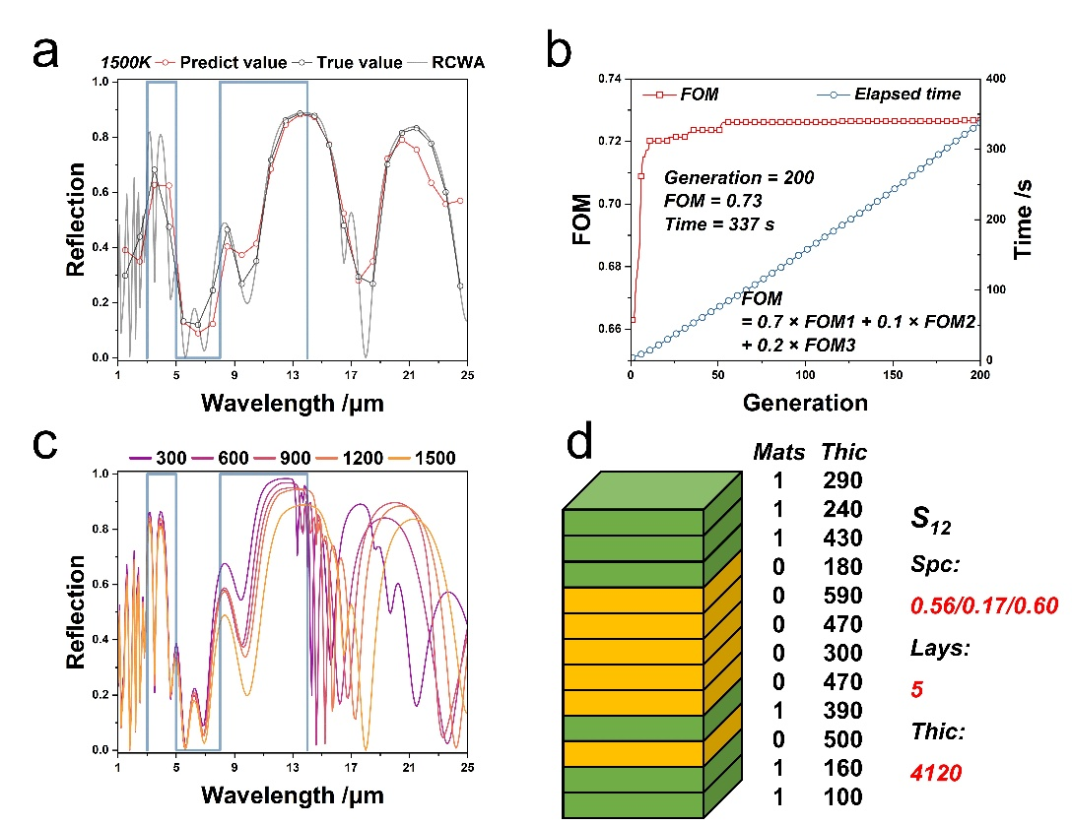
Fig. S13 Detailed data for solution S₁₂. a) Predicted values, true values, and RCWA value from the neural network at 1500 K; b) Evolution of FOM and elapsed time; c) Infrared spectrum across 300–1500 K; d) TPM layer architecture and spectral performance
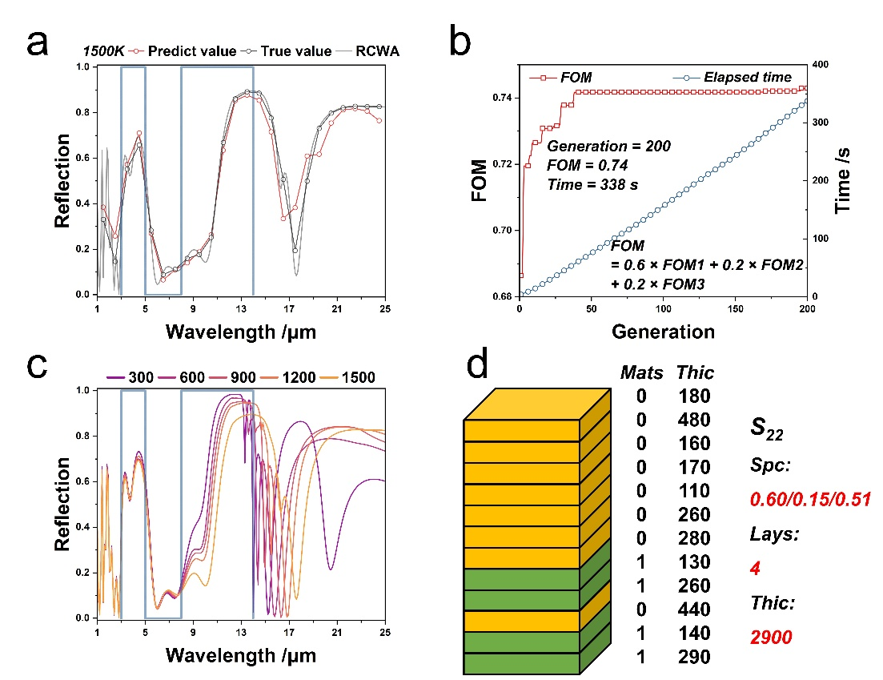
Fig. S14 Detailed data for solution S₂₂. a) Predicted values, true values, and RCWA value from the neural network at 1500 K; b) Evolution of FOM and elapsed time; c) Infrared spectrum across 300–1500 K; d) TPM layer architecture and spectral performance
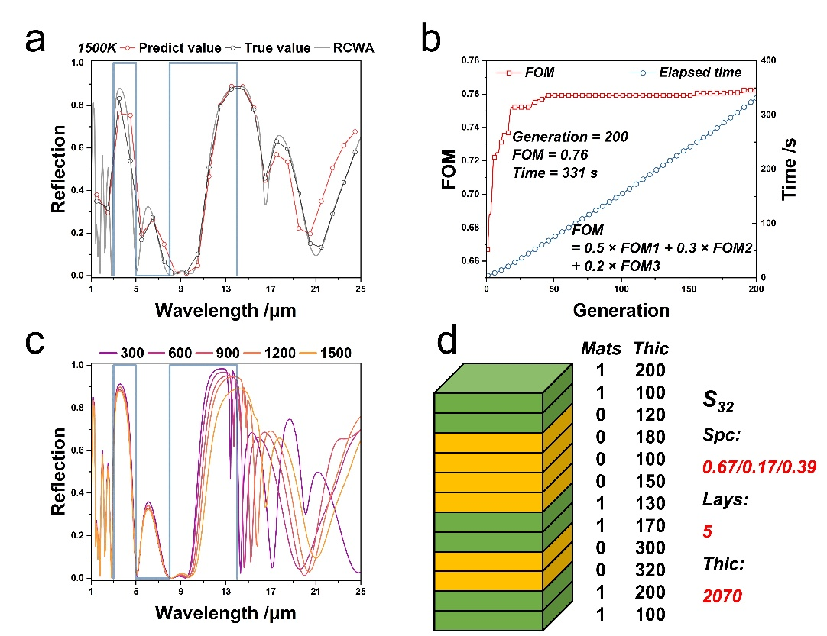
Fig. S15 Detailed data for solution S₃₂. a) Predicted values, true values, and RCWA value from the neural network at 1500 K; b) Evolution of FOM and elapsed time; c) Infrared spectrum across 300–1500 K; d) TPM layer architecture and spectral performance
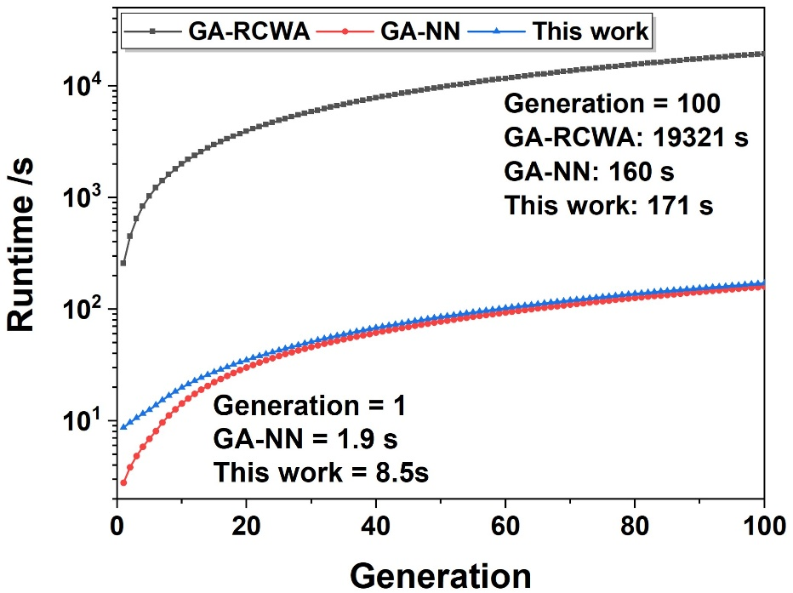
Fig. S16 Runtime of the GA‑RCWA, GA‑NN, and multi‑objective algorithms

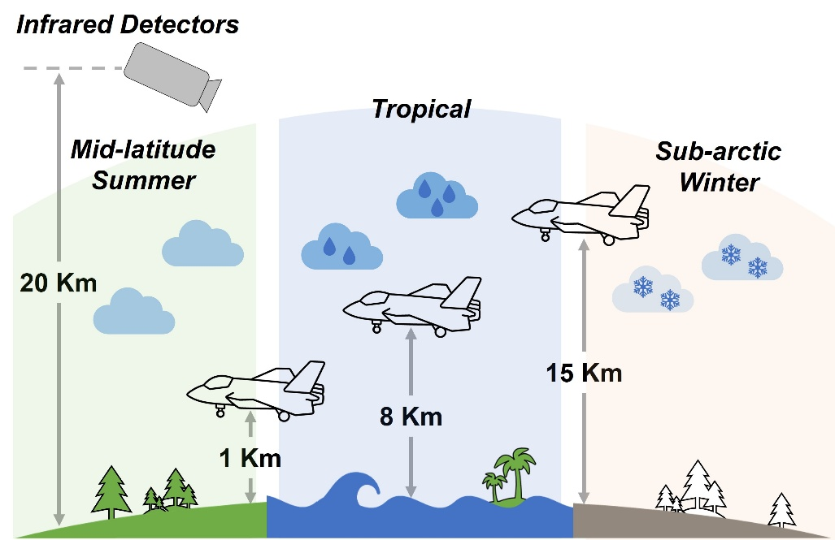
Fig. S17 Schematic of the atmospheric transmission model

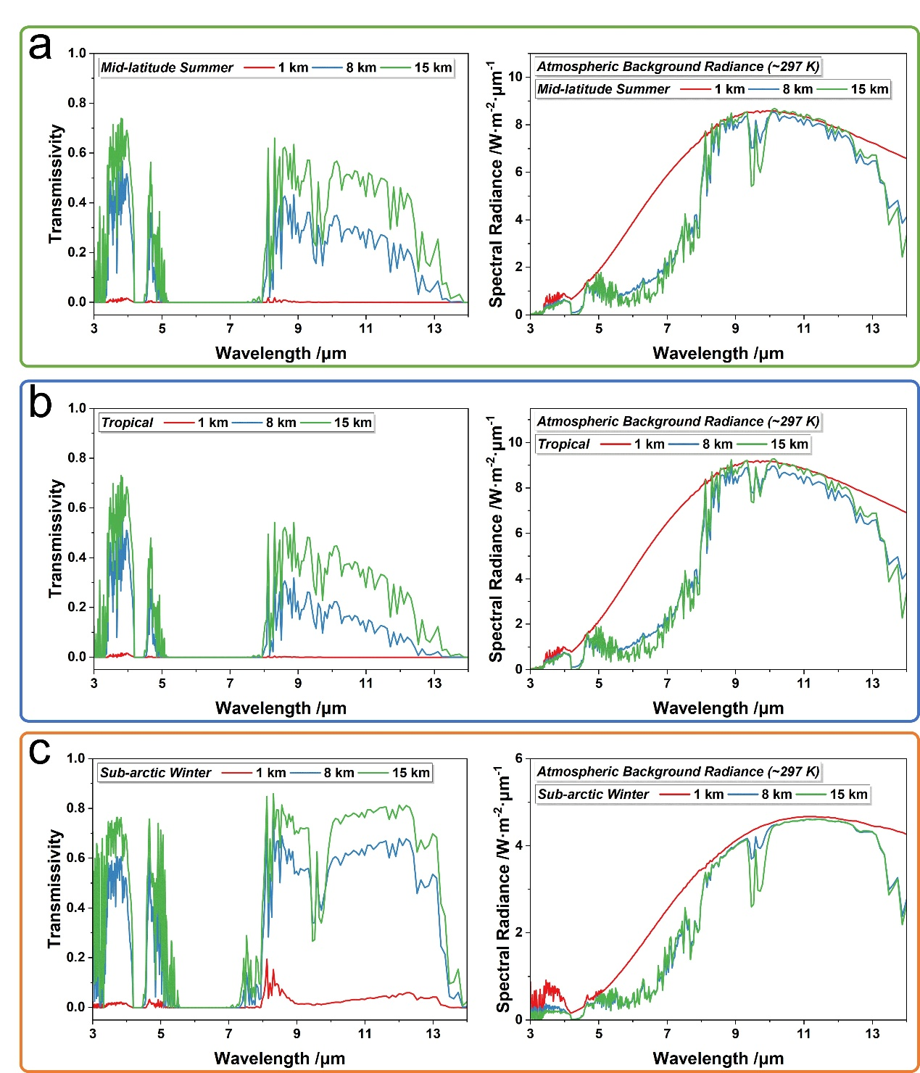
Fig. S18 Atmospheric transmittance and background radiance
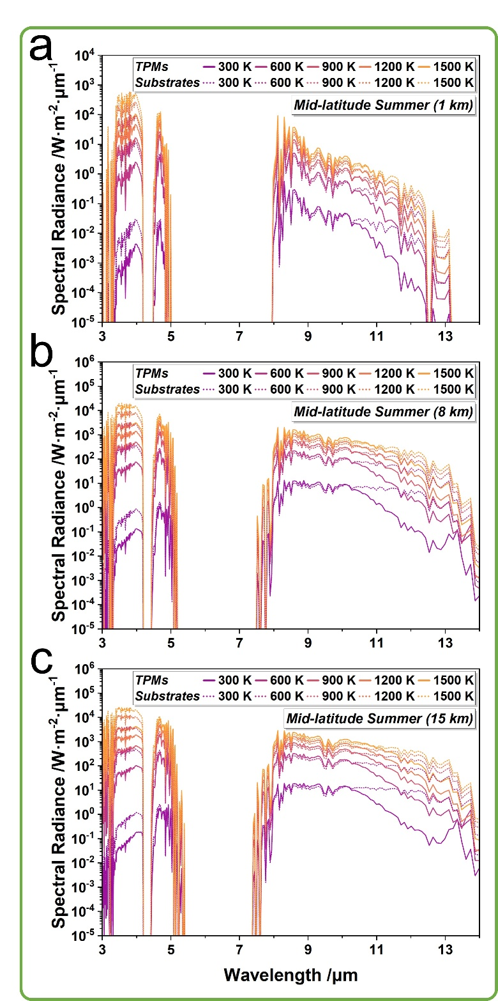
Fig. S19 Spectral radiance of sample S32 vs. metal oxide substrates under the mid-latitude summer model

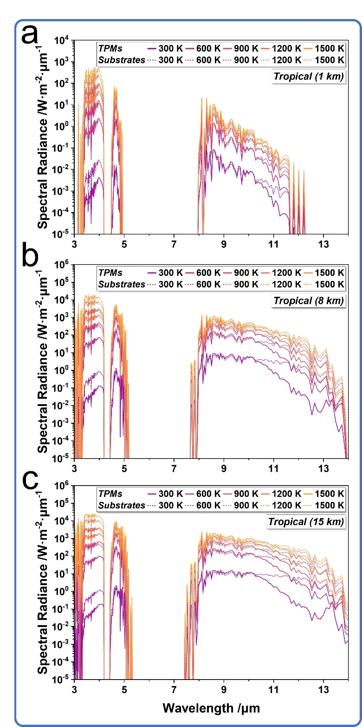
Fig. S20 Spectral radiance of sample S32 vs. metal oxide substrates under the tropical model

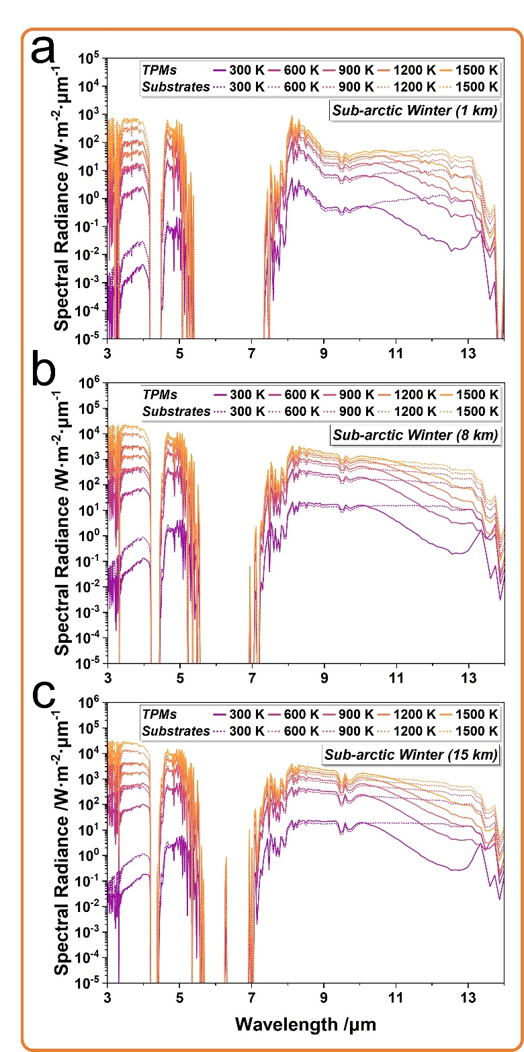
Fig. S21 Spectral radiance of sample S32 vs. metal oxide substrates under the sub-arctic winter model

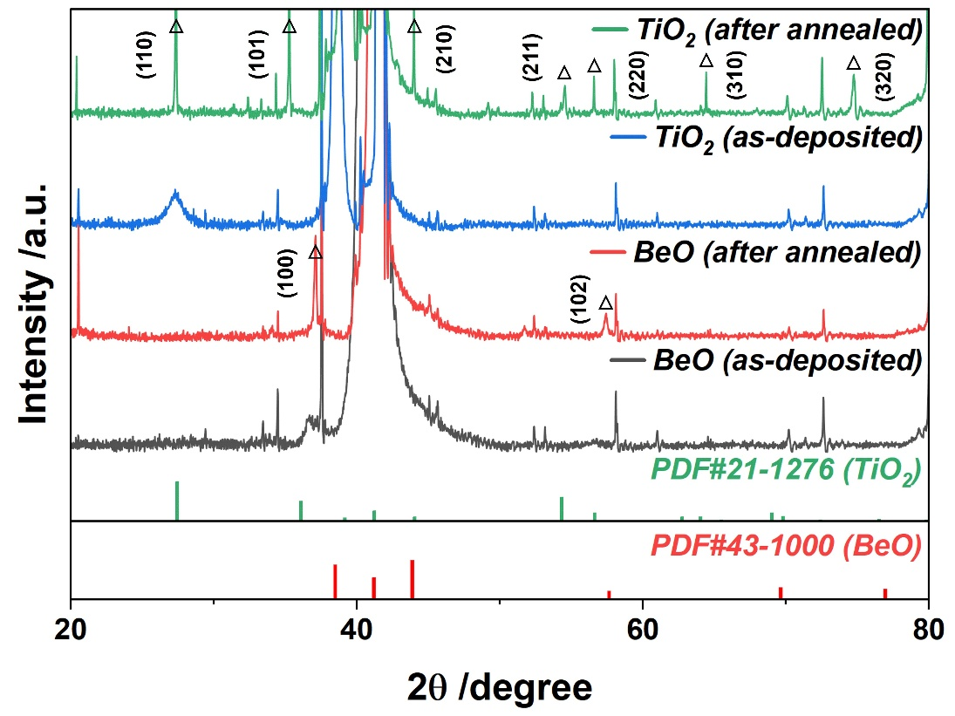
Fig. S22 X-ray diffraction patterns of BeO and TiO₂ before and after annealing

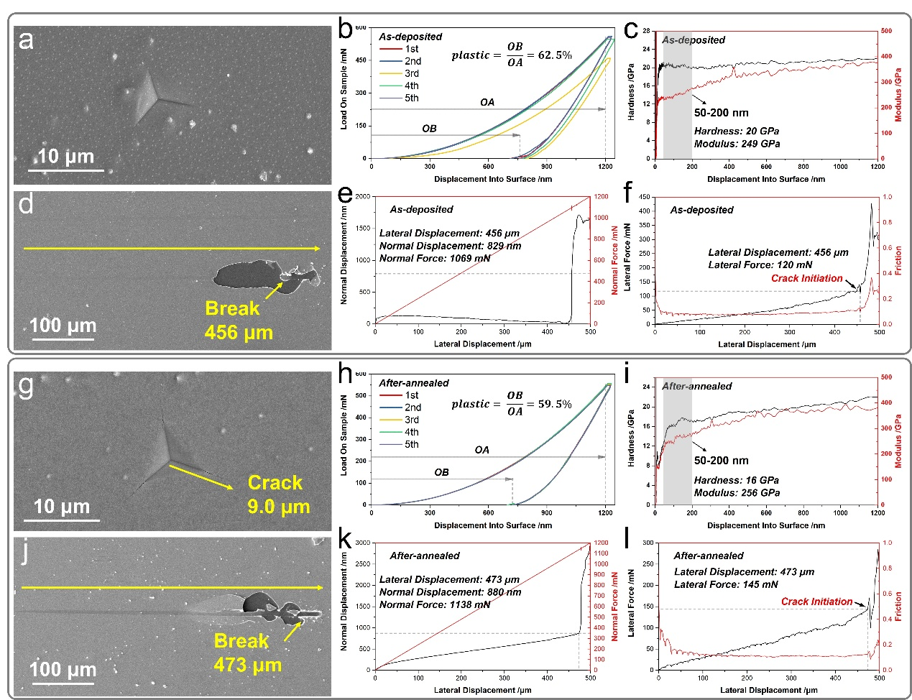
Fig. S23 Mechanical properties of 2-μm YSZ. a-c) Nano-indentation testing before annealing; d-f) Nano-scratch testing before annealing; g-i) Nano-indentation after annealing; j-l) Nano-scratch testing after annealing
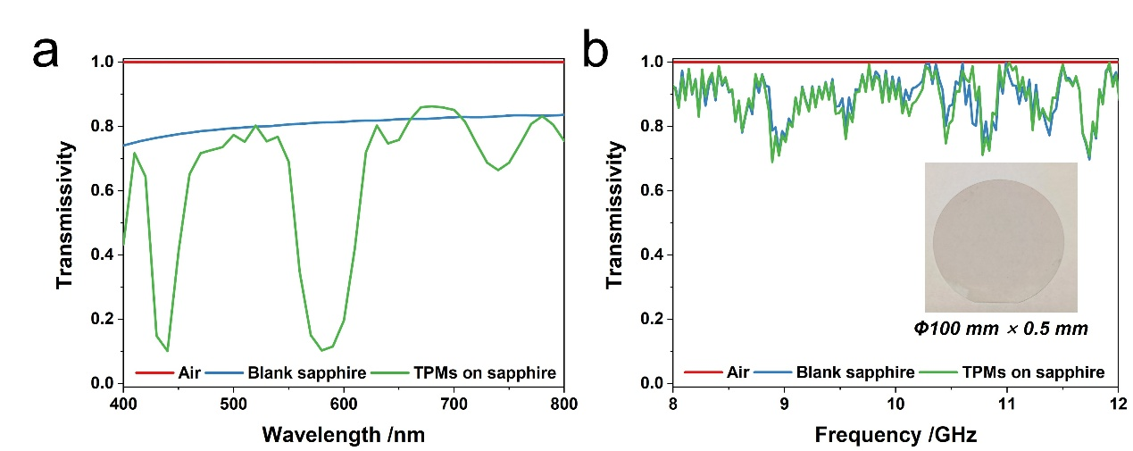
Fig. S24 Comparative transmittance spectra of air, blank sapphire, and TPMs on sapphire in a) visible and b) microwave bands
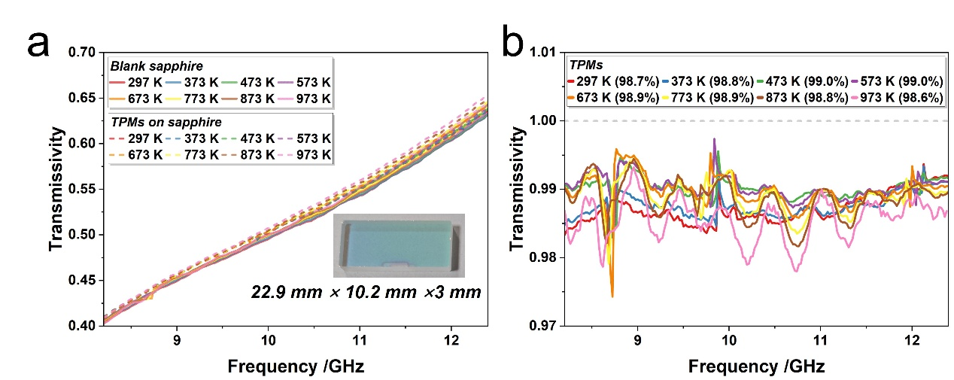
Fig. S25 Comparative transmittance spectra of blank sapphire and TPMs on sapphire in microwave bands across 300 to 1000 K
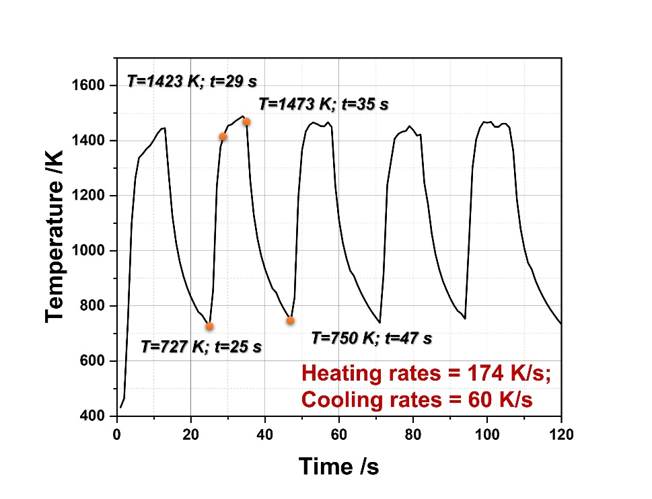
Fig. S26 Temperature-time curve of the thermal shock test
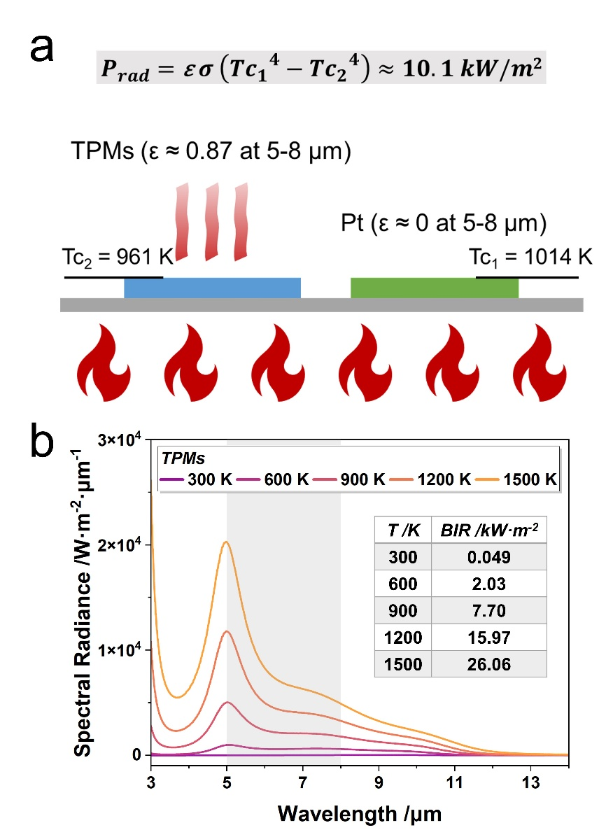
Fig. S27 Radiative cooling performance of the TPMs. a) Measured radiative cooling power (P_{rad}) within the 5-8 μm spectral band at 1014 K. b) Theoretical radiative cooling power (BIR, band-integrated radiance) within the 5-8 μm band across the 300-1500 K temperature range

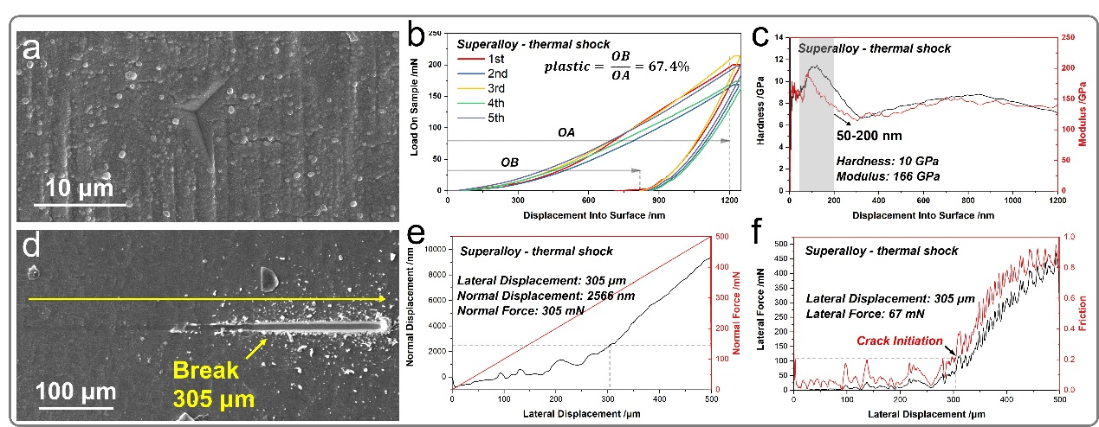
Fig. S28 Mechanical properties of TPM on superalloy substrate. a-c) Nano-indentation and d-f) Nano-scratch testing after thermal shock testing
Table S1 Material‑property trade‑offs for high‑temperature dielectric layers
Materials | n (mid‑IR) | Melting point  /K | CTE  /×10⁻⁶· K⁻¹ | Stability | Reflectivity  (8-14 μm, 300 K)
BeO | ~1.7-1.9 | ~2,800 | ~9 | Excellent | ~0.7
TiO₂ | ~2.4-2.6 | ~2,130 | ~9 | Excellent | ~0.1
Al₂O₃ | ~1.7-1.8 | ~2,323 | ~8 | Excellent | ~0.3
MgF₂ | ~1.3-1.4 | ~1,536 | ~13-15 | Good | ~0
SrTiO₃ | ~2.3-2.5 | ~2,350 | ~10-12 | Good | ~0.2

Table S2 RMSE between the GA-NN and RCWA methods
Solution | 300 K | 600 K | 900 K | 1200 K | 1500 K
S₀₀ | 0.113 | 0.066 | 0.083 | 0.082 | 0.066
S₁₀ | 0.147 | 0.178 | 0.18 | 0.186 | 0.153
S₂₀ | 0.115 | 0.087 | 0.088 | 0.092 | 0.075
S₃₀ | 0.176 | 0.13 | 0.135 | 0.131 | 0.193
S₄₀ | 0.132 | 0.095 | 0.094 | 0.077 | 0.189
S₅₀ | 0.061 | 0.042 | 0.081 | 0.078 | 0.073
S₀₁ | 0.181 | 0.167 | 0.177 | 0.177 | 0.152
S₁₁ | 0.104 | 0.079 | 0.092 | 0.088 | 0.085
S₂₁ | 0.164 | 0.147 | 0.142 | 0.147 | 0.121
S₃₁ | 0.129 | 0.116 | 0.11 | 0.113 | 0.164
S₄₁ | 0.078 | 0.032 | 0.037 | 0.064 | 0.059
S₀₂ | 0.089 | 0.062 | 0.059 | 0.052 | 0.05
S₁₂ | 0.12 | 0.08 | 0.082 | 0.084 | 0.075
S₂₂ | 0.133 | 0.041 | 0.029 | 0.033 | 0.023
S₃₂ | 0.036 | 0.044 | 0.046 | 0.041 | 0.076

Table S3 RMSE between the temperature-dependent infrared engineering model and the baseline model
Solution | 300 K | 600 K | 900 K | 1200 K | 1500 K
S₀₀ | 0 | 0.088 | 0.104 | 0.134 | 0.217
S₁₀ | 0 | 0.093 | 0.11 | 0.137 | 0.201
S₂₀ | 0 | 0.081 | 0.105 | 0.135 | 0.212
S₃₀ | 0 | 0.06 | 0.097 | 0.131 | 0.204
S₄₀ | 0 | 0.064 | 0.099 | 0.134 | 0.21
S₅₀ | 0 | 0.066 | 0.097 | 0.13 | 0.187
S₀₁ | 0 | 0.093 | 0.103 | 0.131 | 0.231
S₁₁ | 0 | 0.083 | 0.1 | 0.128 | 0.219
S₂₁ | 0 | 0.087 | 0.11 | 0.139 | 0.214
S₃₁ | 0 | 0.073 | 0.101 | 0.131 | 0.206
S₄₁ | 0 | 0.065 | 0.092 | 0.126 | 0.185
S₀₂ | 0 | 0.098 | 0.116 | 0.145 | 0.239
S₁₂ | 0 | 0.083 | 0.096 | 0.123 | 0.215
S₂₂ | 0 | 0.077 | 0.1 | 0.13 | 0.211
S₃₂ | 0 | 0.074 | 0.097 | 0.129 | 0.187

Table S4 The solution set of calculation results
Solution | FOM₁ | FOM₂ | FOM₃ | FOM
S₀₀ | 0.726149 | 0.724382 | 0.39985 | 0.726149
S₁₀ | 0.700473 | 0.803136 | 0.472367 | 0.677662
S₂₀ | 0.728331 | 0.792397 | 0.472367 | 0.677138
S₃₀ | 0.65116 | 0.816634 | 0.472367 | 0.597522
S₄₀ | 0.670991 | 0.823468 | 0.513417 | 0.607961
S₅₀ | 0.693503 | 0.881931 | 0.659241 | 0.676372
S₀₁ | 0.670991 | 0.722991 | 0.558035 | 0.676191
S₁₁ | 0.722527 | 0.753752 | 0.472367 | 0.700634
S₂₁ | 0.66631 | 0.792905 | 0.558035 | 0.657315
S₃₁ | 0.647265 | 0.810376 | 0.558035 | 0.636807
S₄₁ | 0.692117 | 0.880237 | 0.659241 | 0.697779
S₀₂ | 0.736387 | 0.722527 | 0.606531 | 0.733615
S₁₂ | 0.703984 | 0.767895 | 0.659241 | 0.712292
S₂₂ | 0.709638 | 0.830359 | 0.716531 | 0.735161
S₃₂ | 0.713195 | 0.875735 | 0.659241 | 0.729517
Table S5 Band-integrated radiance of S32 and oxide substrates in 3-5 µm
T /K  BIR  /W·m⁻²  Cases | 300 K | 600 K | 900 K | 1200 K | 1500 K
T /K  BIR  /W·m⁻²  Cases | TPMs/Subs | TPMs/Subs | TPMs/Subs | TPMs/Subs | TPMs/Subs
MS-1km | 0.0037/0.013 | 1.35/5.53 | 8.92/44.43 | 24.81/129.82 | 54.43/253.32
MS-8km | 0.29/0.68 | 79.45/259.26 | 504.51/2074.53 | 1375.58/6083.57 | 2923.89/11913.37
MS-15km | 0.57/1.2 | 14.21/41.34 | 888.25/3282.59 | 2402.24/9624.43 | 5034.31/18864.51
Tp-1km | 0.0023/0.010 | 1.02/4.65 | 6.98/37.51 | 19.42/109.65 | 43.31/213.94
Tp-1km | 0.21/0.57 | 63.73/229.40 | 411.51/1844.07 | 1132.49/5407.40 | 2440.97/10582.25
Tp-1km | 0.45/1.01 | 119.66/374.53 | 754.74/2980.03 | 2050.75/8726.08 | 4336.86/17080.21
SW-1km | 0.034/0.049 | 6.71/13.71 | 39.84/104.59 | 104.43/303.84 | 208.78/594.17
SW-8km | 0.83/1.29 | 174.33/411.56 | 1078.50/3290.34 | 2908.18/9765.39 | 5979.95/19322.46
SW-15km | 1.20/1.87 | 253.00/589.33 | 1572.07/4721.80 | 4254.71/14050.00 | 8763.18/27854.49

Table S6 Radiation suppression efficiency and radiation attenuation values of S32 and oxide substrates
Cases | 300 K |  | 600 K |  | 900 K |  | 1200 K |  | 1500 K
Cases | η /% | I_{dB} /dB | η /% | I_{dB} /dB | η /% | I_{dB} /dB | η /% | I_{dB} /dB | η /% | I_{dB} /dB
MS-1km | 72% | -5.5 | 76% | -6.2 | 80% | -7.0 | 81% | -7.2 | 79% | -6.8
MS-8km | 58% | -3.8 | 69% | -5.1 | 76% | -6.2 | 77% | -6.4 | 75% | -6.0
MS-15km | 51% | -3.1 | 64% | -4.7 | 73% | -5.7 | 75% | -6.0 | 73% | -5.7
Tp-1km | 78% | -6.6 | 78% | -6.6 | 81% | -7.2 | 82% | -7.4 | 80% | -7.0
Tp-8km | 64% | -4.4 | 72% | -5.5 | 78% | -6.6 | 79% | -6.8 | 77% | -6.4
Tp-15km | 56% | -3.6 | 68% | -4.9 | 75% | -6.0 | 77% | -6.4 | 77% | -6.0
SW-1km | 30% | -1.5 | 51% | -3.1 | 62% | -4.2 | 66% | -4.7 | 65% | -4.6
SW-8km | 36% | -1.9 | 58% | -3.8 | 67% | -4.8 | 70% | -5.2 | 69% | -5.1
SW-15km | 36% | -1.9 | 57% | -3.7 | 67% | -4.8 | 70% | -5.2 | 69% | -5.1

