Supporting Information for
Dual Chloride Confinement in Noble Metal‐Doped NiV LDH Catalysts Enables Stable Industrial-Level Seawater Electrolysis
Kai Liu¹, Yaohai Cai¹, Xiaotian Wei¹, Lihang Qu¹, Jianxi Lu¹, Yingwei Qi¹, Zhenbo Wang^{2,*}, Dong Liu^{1,*}
¹ Guangdong Provincial Key Laboratory of New Energy Materials Service Safety, College of Materials Science and Engineering, Shenzhen University, Shenzhen 518060, P. R. China
² State Key Laboratory of Space Power-Sources, MIIT Key Laboratory of Critical Materials Technology for New Energy Conversion and Storage, MOE Engineering Research Center for Electrochemical Energy Storage and Carbon Neutrality in Cold Regions, School of Chemistry and Chemical Engineering, Harbin Institute of Technology, Harbin 150001, P. R. China
*Corresponding authors. E-mail: dongliu@szu.edu.cn (Dong Liu); wangzhb@hit.edu.cn (Zhenbo Wang)
S1 Experiment Sections
S1.1 Materials
Nickel foam (NF), nickel nitrate (Ni(NO₃)₂·6H₂O; purity ≥98%), vanadium chloride (VCl₃; purity ≥98%), iridium chloride hydrate (IrCl₃·xH₂O; purity ≥98%), ruthenium chloride hydrate (RuCl₃·xH₂O; purity ≥98%), osmium chloride (OsCl₃; purity ≥98%), chloroplatinic acid (H₂PtCl₆; purity ≥98%), urea (CN₂H₄O; purity ≥98%), potassium hydroxide (KOH; purity ≥98%), commercial RuO₂, and commercial Pt/C (20%). Hydrochloric acid, acetone, absolute alcohol, and deionized water with a resistivity of 18.2 MΩ were utilized in all experiments. Additionally, seawater was sourced from the South China Sea (Shenzhen Bay).
S1.2 Electrochemical measurements
Electrochemical evaluations of all samples were performed using CHI660E, CHI760E DH7006A-2, and DH7006B-2 stations in an alkaline seawater electrolyte, prepared by adding 1 M KOH to natural, unpurified seawater collected from the South China Sea. A Hg/HgO electrode and a graphite rod served as the reference and counter electrodes, respectively, for the oxygen evolution reaction (OER) and hydrogen evolution reaction (HER). All the prepared samples were utilized as working electrodes. Potentials in these experiments were adjusted to the reversible hydrogen electrode (RHE) standard using the formula: E_{RHE}= E + 0.098 V + 0.059 × pH. The electrocatalytic performance was assessed in various electrolytes: 1.0 M KOH and 1.0 M KOH seawater solution. Linear sweep voltammetry (LSV) with a scan rate of 5 mV s⁻¹ was employed to evaluate the OER and HER activities. Tafel slopes were determined from the linear regions of the Tafel plots using the Tafel equation upon LSV curves with iR compensation. Cyclic voltammetry (CV) tests were performed at varying scan rates (20, 40, 60, 80, and 100 mV s⁻¹) to determine the double-layer capacitance (C_{dl}) of the catalysts. Electrochemical impedance spectroscopy (EIS) was conducted across a frequency range of 0.01 kHz to 10000 kHz. Long-term stability was assessed via chronopotentiometry at room temperature. The synthesized sample, Ag/AgCl electrode and Pt wire were used as working electrode, reference electrode and counter electrode, respectively. The measurement was carried out in 1 M potassium hydroxide with a potential range from 0.1 V to 0.6 V (vs. Ag/AgCl). After 15 s of testing, data were collected.
S1.3 Calculations of AEM electrolyzer efficiency (6 M KOH seawater)
These calculations only considered the electricity costs, based on the method proposed by literature:
H₂ production rate @ 0.1 A cm⁻²
= (j A cm⁻²) (1 e⁻/1.602 × 10⁻¹⁹ C) (1 H₂/2 e⁻)
= 0.1 A cm⁻² / (1.602 × 10⁻¹⁹ C × 2) = 5.1828 × 10⁻⁷ mol H₂ cm⁻² s⁻¹

LHV of H₂
= 120 kJ g⁻¹ H₂ = 2.42 × 10⁵ J mol⁻¹ H₂

H₂ power out
= (5.1828 × 10⁻⁷ mol cm⁻² s⁻¹) × (2.42 × 10⁵ J mol⁻¹) = 0.1254 W cm⁻²

Electrolyzer Power @ 0.1 A cm⁻² (6 M KOH seawater)
= (0.1 A cm⁻²) (1.698V) = 0.1715 W cm⁻²

Efficiency of AEM
= (H₂ Power Out) / (Electrolyzer Power) = 0.1254 W cm⁻²/ 0.1698W cm⁻² = 73.9%
S1.4 DFT calculation
All the DFT calculations were conducted based on the Vienna Ab-inito Simulation Package (VASP). The exchange-correlation effects were described by the Perdew-Burke-Ernzerhof (PBE) functional within the generalized gradient approximation (GGA) method. The core-valence interactions were accounted by the projected augmented wave (PAW) method. The energy cutoff for plane wave expansions was set to 400 eV, and the 3×3×1 Monkhorst-Pack grid k-points were selected to sample the Brillouin zone integration. The structural optimization was completed for energy and force convergence set at 1.0×10⁻⁴ eV and 0.05 eV Å⁻¹, respectively.
The adsorption energies (E_{ads}) of Cl are calculated by:
E_{ads} = E_{*Cl}–E_{Cl}–E_{Sub}
where E_{Cl} and E_{*Cl} represent the energies before and after the adsorption of Cl on the substrates, respectively. E_{sub} is the energy of NiOOH and Ir-NiOOH surfaces.
The Gibbs free energy change (ΔG) of each step is calculated using the following formula:
∆G = ∆E + ∆ZPE - T∆S
where ΔE is the electronic energy difference directly obtained from DFT calculations, ΔZPE is the zero point energy difference, T is the room temperature (298.15 K) and ΔS is the entropy change. ZPE could be obtained after frequency calculation by:
ZPE =$\frac{1}{2} \sum{hvi}$
And the TS values of adsorbed species are calculated according to the vibrational frequencies:
$$TS = k_{B}T [\sum_{k}{ln⁡(\frac{1}{1-e^{-hv/k_{B}T}}})+ \sum_{k}{\frac{hv}{k_{B}T}} \frac{1}{{(e}^{hv/k_{B}T}-1)}+1]$$
Supplementary Figures and Tables
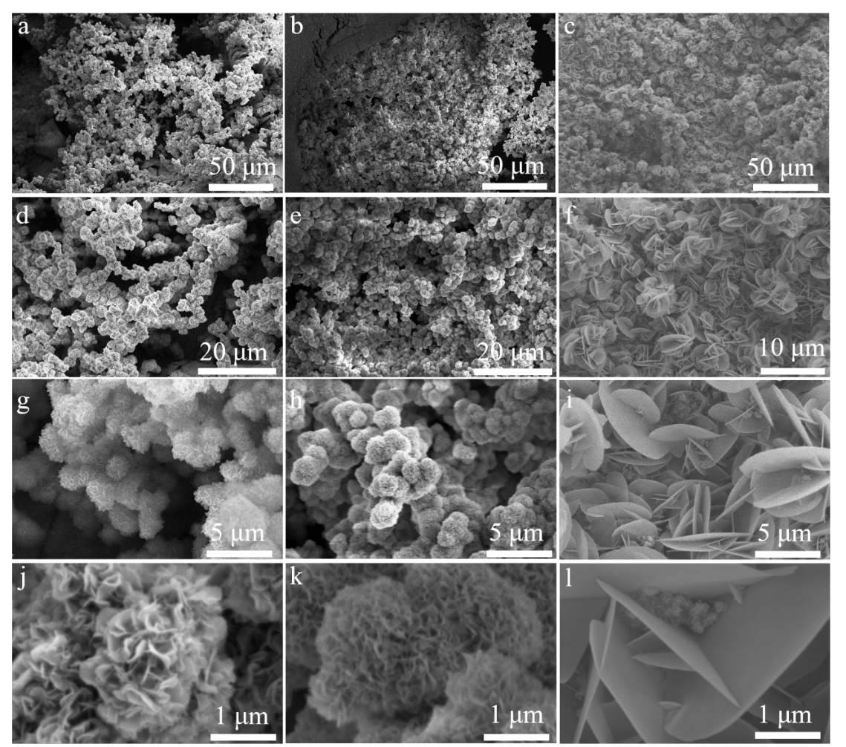
Fig. S1 SEM images of (a, d, g, j) NiV LDH, (b, e, h, k) Ru-NiV LDH, and (c, f, i, l) Ir-NiV LDH at different magnifications. Scale bars: 50 μm (a-c), 20 μm (d-f), 5 μm (g-i), and 1 μm (j-l)
Fig. S2 TEM images of a) NiV LDH, c) Ru-NiV LDH, and e) Ir-NiV LDH, SAED pattern of b) NiV LDH, d) Ru-NiV LDH, and f) Ir-NiV LDH

Fig. S3 a-c) Corresponding line intensity file taken from the selected areas of Fig. 1b,1c, and 1d, respectively
Fig. S4 TEM-EDX results of a) NiV LDH, b) Ru-NiV LDH, and c) Ir-NiV LDH

Fig. S5 TEM image for NiV LDH with elemental mapping images for C, O, Ni, and V elements
Fig. S6 TEM image for Ru-NiV LDH with elemental mapping images for C, O, Ni, V, and Ru elements
Fig. S7 TEM image for Ir-NiV LDH with elemental mapping images for C, O, Ni, V, and Ir elements

Fig. S8 a) XRD of NiV LDH, Ru-NiV LDH, and Ir-NiV LDH, b) the corresponding Fig. S8a enlarges the XRD pattern
Fig. S9 XPS survey of a) NiV LDH, b) Ru-NiV LDH, and c) Ir-NiV LDH

Fig. S10 a) Ru 3p XPS spectra of of Ru-NiV LDH, b) Ir 4f XPS spectra of of Ir-NiV LDH

Fig. S11 EPR of NiV LDH, Ru-NiV LDH, and Ir-NiV LDH(g=2.002)

Fig. S12 The geographical location for the source of natural seawater
Fig. S13 HER catalytic performance. a) The overpotentials of the catalyst at 10 mA cm⁻², 100 mA cm⁻², 500mA cm⁻², and 1000 mA cm⁻² were measured, b) Nyquist plots (insert of equivalent circuit model), and c) the double-layer capacitance of NF, NiV LDH, Os-NiV LDH, Ru-NiV LDH, Ir-NiV LDH, and Pt-NiV LDH, d-i) cyclic voltammograms of NF, NiV LDH, Os-NiV LDH, Ru-NiV LDH, Ir-NiV LDH, and Pt-NiV LDH at scan rates in the range of 20-100 mV s⁻¹, respectively
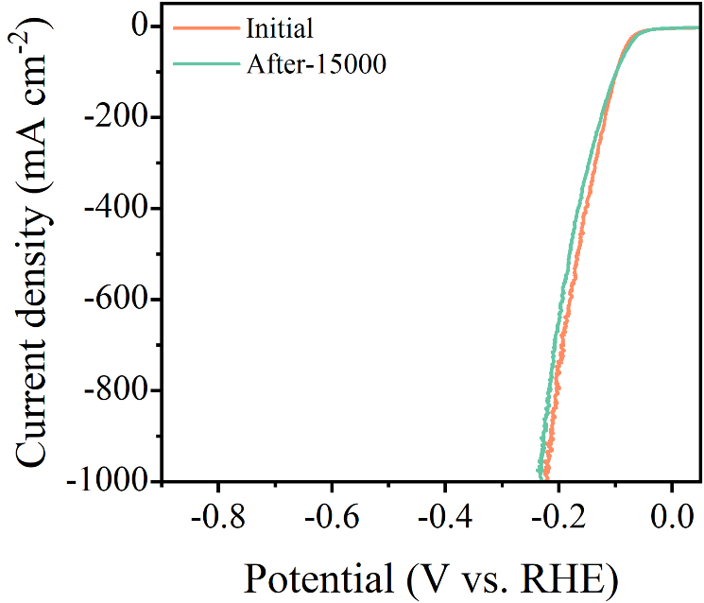
Fig. S14 Comparison of HER polarization curves before and after 15000 CV cycles

Fig. S15 SEM images of Ru-NiV LDH after long-term stability for HER

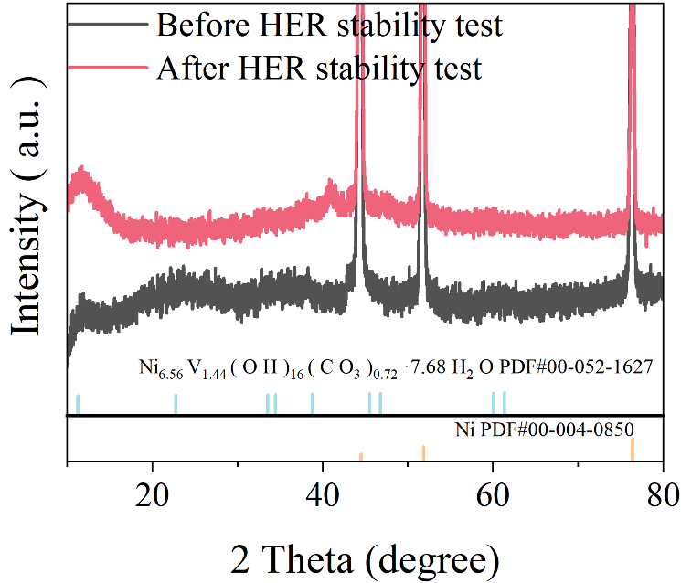
Fig. S16 XRD pattern of Ru-NiV LDH after long-term stability for HER

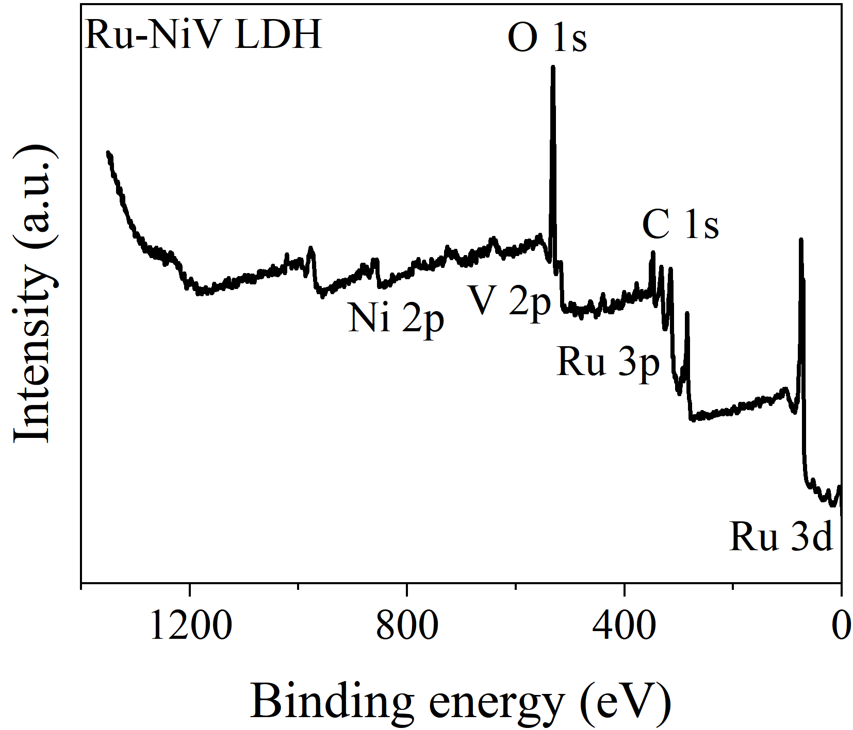
Fig. S17 XPS survey of Ru-NiV LDH after long-term stability for HER

Fig. S18 a) Ni 2p, b) V 2p, c) O 1s, and d) Ru 3p of XPS spectra of Ru-NiV LDH after long-term stability for HER

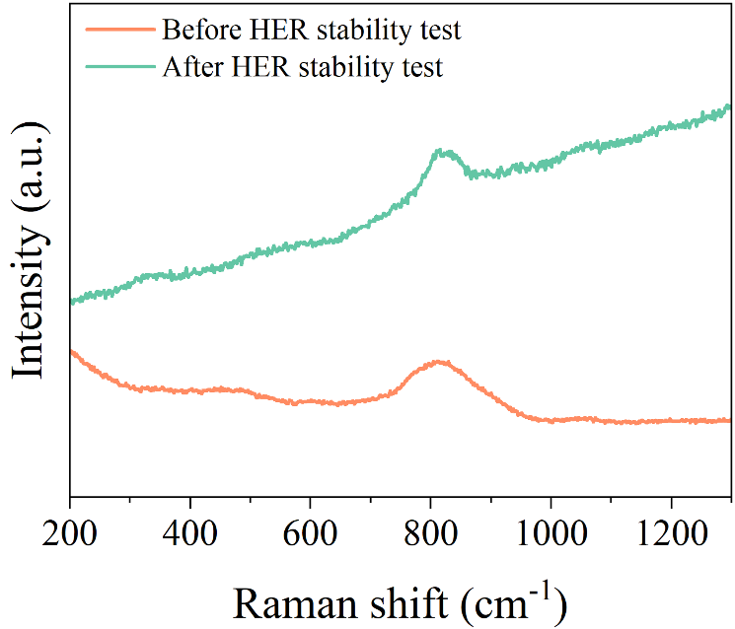
Fig. S19 Comparison of Raman spectra results for Ru-NiV LDH before and after long-term HER stability testing
Fig. S20 Experimental and theoretical gaseous products (H₂ and O₂) by the two-electrode electrolyzer at a constant current density of 200 mA cm⁻², optical images of drainage method. Experimental and theoretical gaseous products (H₂) by the two-electrode electrolyzer
Fig. S21 OER catalytic performance. a) The overpotentials of the catalyst at 10 mA cm⁻², 100 mA cm⁻², 500mA cm⁻², and 1000 mA cm⁻² were measured, b) Nyquist plots (insert of equivalent circuit model), and c) the double-layer capacitance of NF, NiV LDH, Os-NiV LDH, Ru-NiV LDH, Ir-NiV LDH, and Pt-NiV LDH, d-i) cyclic voltammograms of NF, NiV LDH, Os-NiV LDH, Ru-NiV LDH, Ir-NiV LDH, and Pt-NiV LDH at scan rates in the range of 20-100 mV s⁻¹, respectively
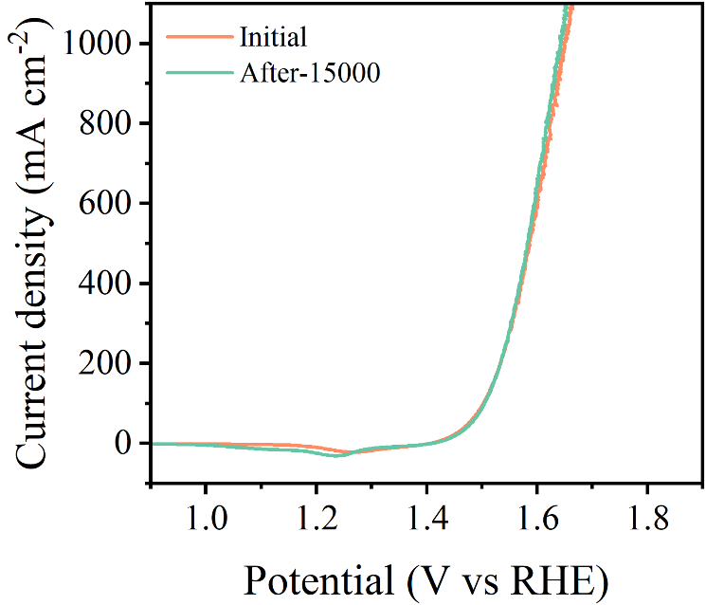
Fig. S22 Comparison of OER polarization curves before and after 15000 CV cycles
Fig. S23 SEM images of Ir-NiV LDH after long-term stability for OER

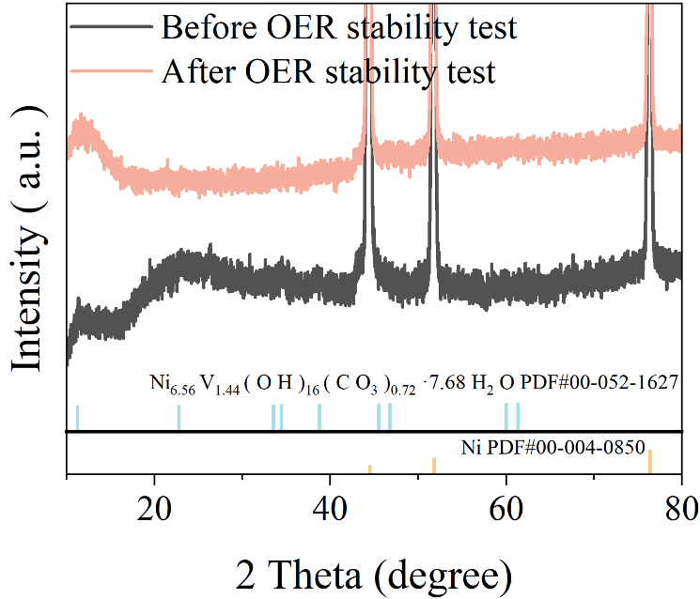
Fig. S24 XRD pattern of Ir-NiV LDH after long-term stability for OER
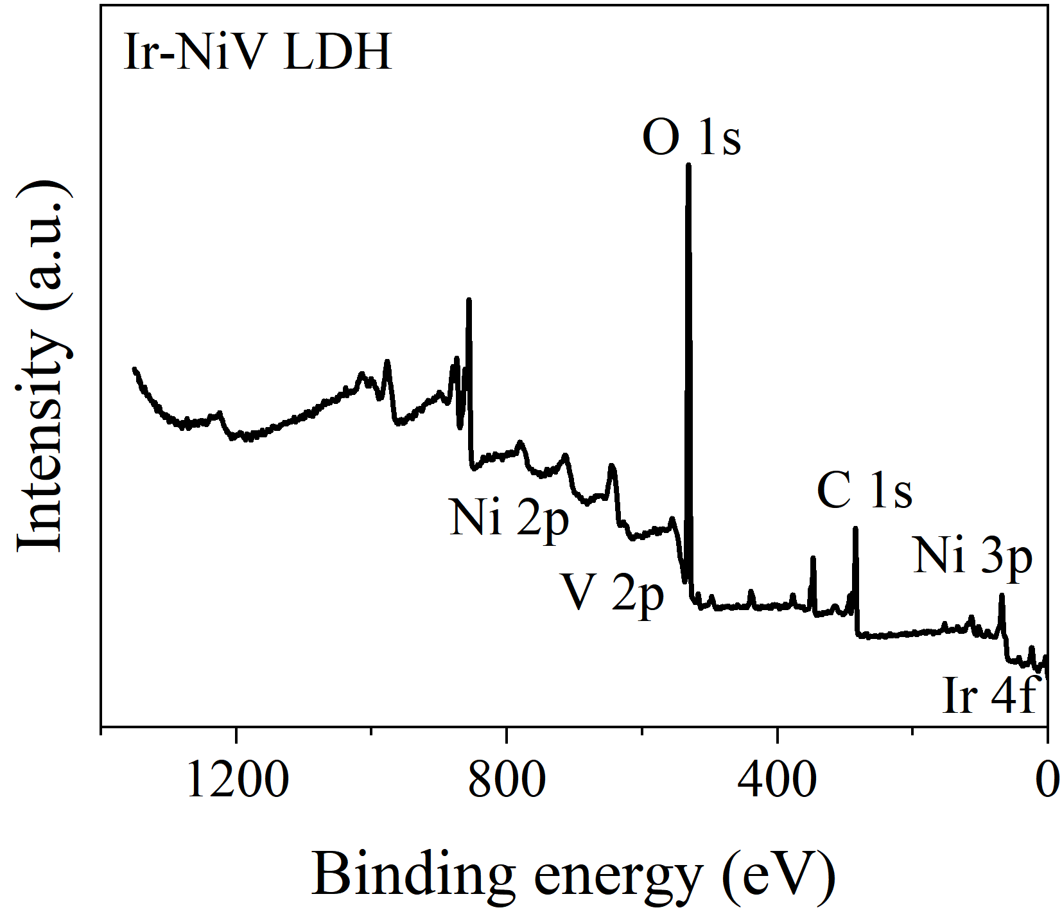
Fig. S25 XPS survey of Ir-NiV LDH after long-term stability for OER

Fig. S26 a) Ni 2p, b) O 1s, and c) Ir 4f of XPS spectra of Ir-NiV LDH after long-term stability for OER
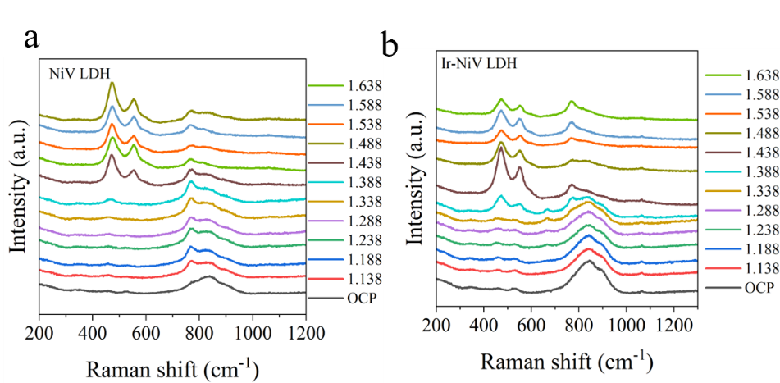
Fig. S27 a-b) In-situ Raman spectrum of NiVLDH and Ir-NiVLDH in 1 M KOH, respectively

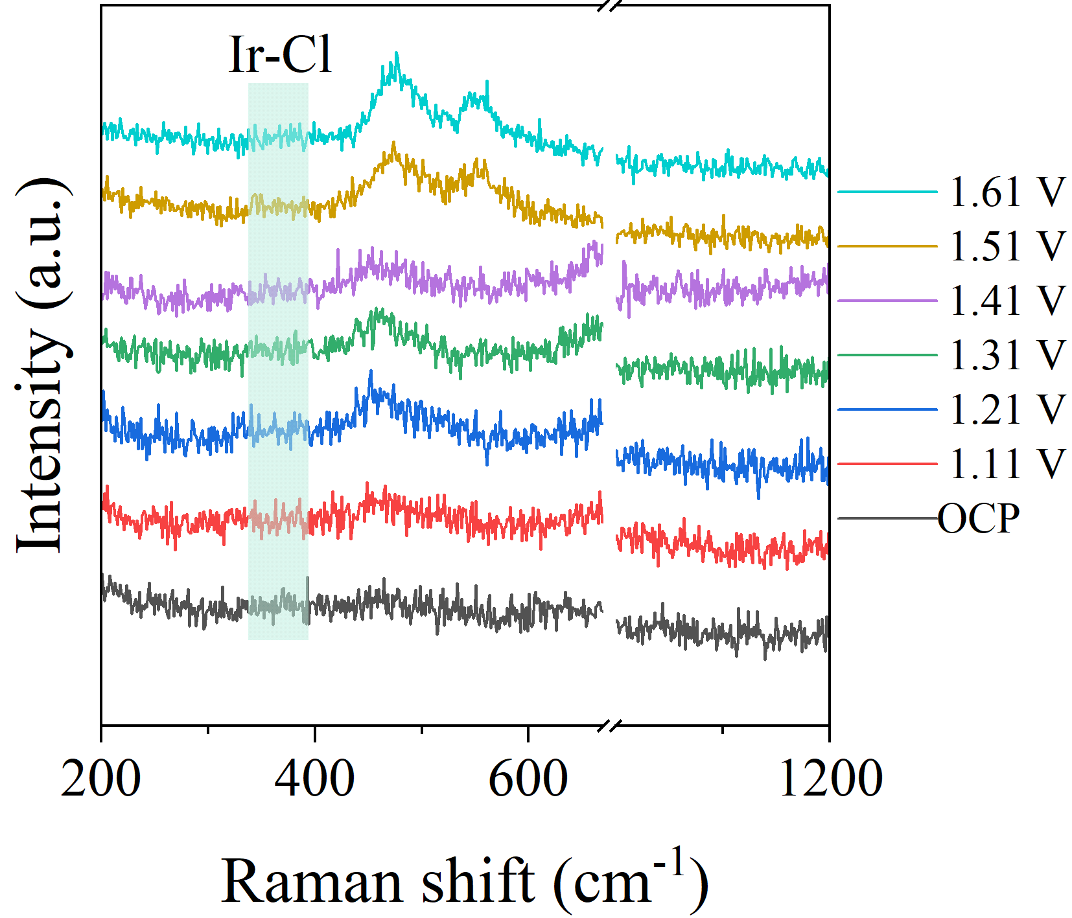
Fig. S28 In-situ Raman spectrum of Ir-NiVLDH in 1 M KOH + 0.5 M NaCl
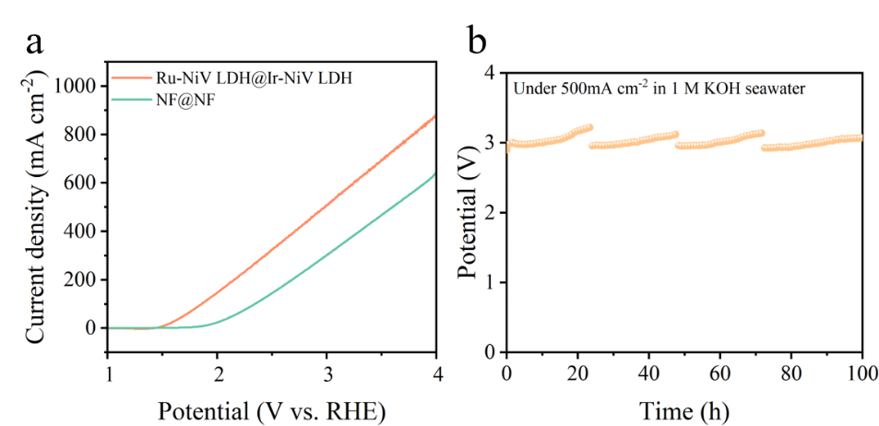
Fig. S29 The total water splitting performance (without iR compensation) of the two-electrode system in alkaline seawater electrolyte. a) Polarization curve, and b) durability test at an industrial-grade current density of 500 mA cm⁻²

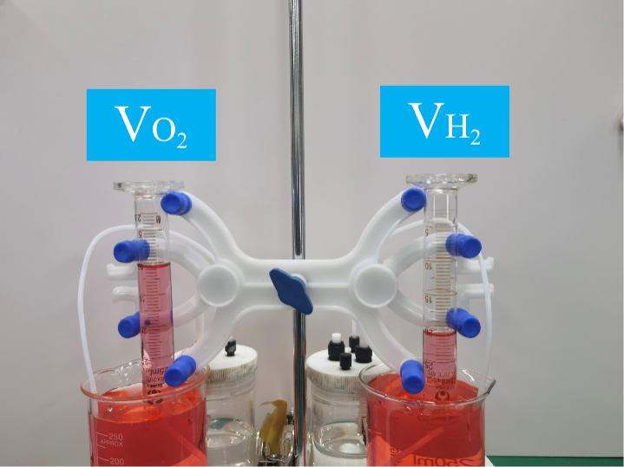
Fig. S30 Experimental and theoretical gaseous products (H₂ and O₂) by the two-electrode electrolyzer at a constant current density of 200 mA cm⁻², optical images of drainage method. Photographs of collected hydrogen and oxygen
Fig. S31 O-tolidine test for NiV LDH (a), Ru-NiV LDH (b), and Ir-NiV LDH (c). Photographs of the testing solutions

Fig. S32 a) Photographs of the NiV LDH (1) and Ir-NiV LDH (2) catalysts after the chronoamperometry (i-t) test in a 1 M KOH + 0.5 M NaCl electrolyte; b) Corresponding images of ClO⁻ detection in an o-phenylenediamine solution

Fig. S33 Water contact angles of a) NiV LDH, b) Ru-NiV LDH, and c) Ir-NiV LDH

Fig. S34 a) The projected density of states of NiOOH, b) the projected density of states of NiV LDH
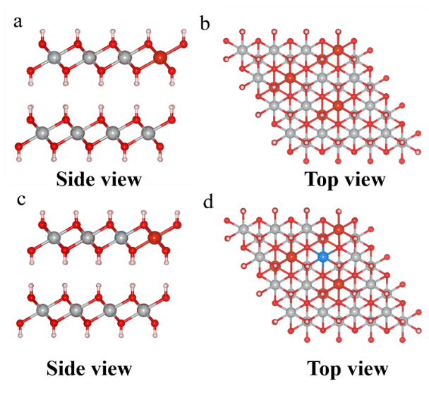
Fig. S35 Theoretical models of NiV LDH and Ru-NiV LDH. a) Side view of NiV LDH models, b) top view of NiV LDH models, c) side view of Ru-NiV LDH models, d) top view of Ru-NiV LDH models
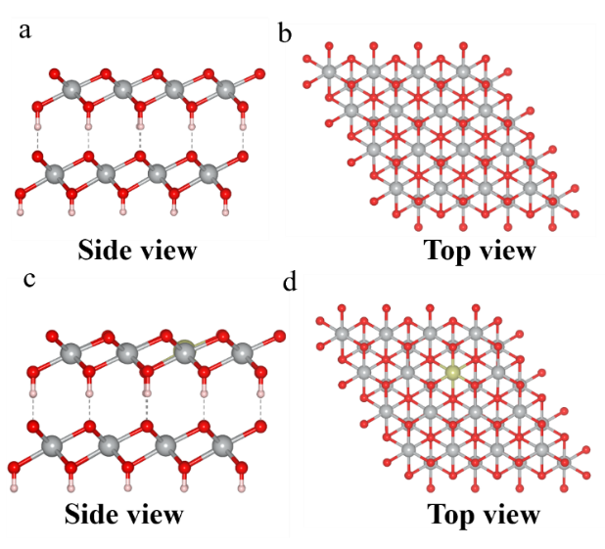
Fig. S36 Theoretical models of NiOOH and Ir-NiOOH. a) Side view of NiOOH models, b) top view of NiOOH models, c) side view of Ir-NiOOH models, d) top view of Ir-NiOOH models
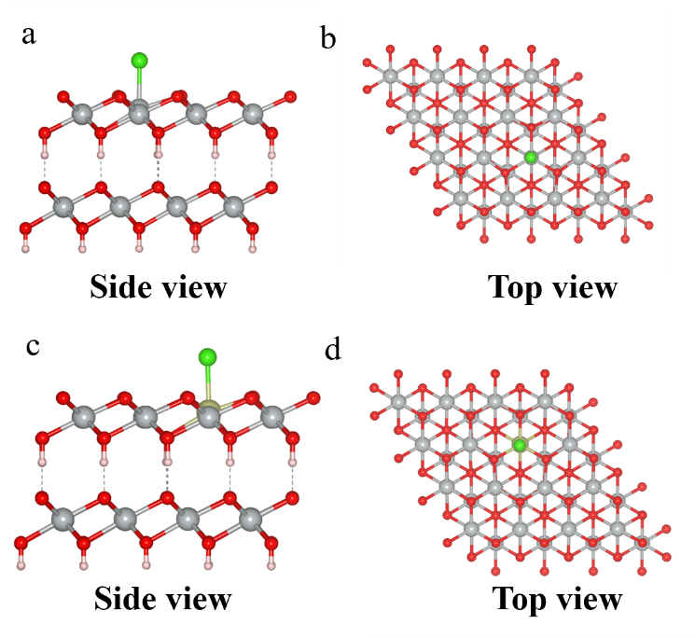
Fig. S37 The theoretical model of Cl⁻ adsorption on NiOOH and Ir-NiOOH. a) The side view of Cl⁻ adsorbed by NiOOH model, b) top view of Cl⁻ adsorption on NiOOH model, c) Ir-NiOOH model adsorption Cl⁻ side view, d) Ir-NiOOH mode adsorption Cl⁻ type top view
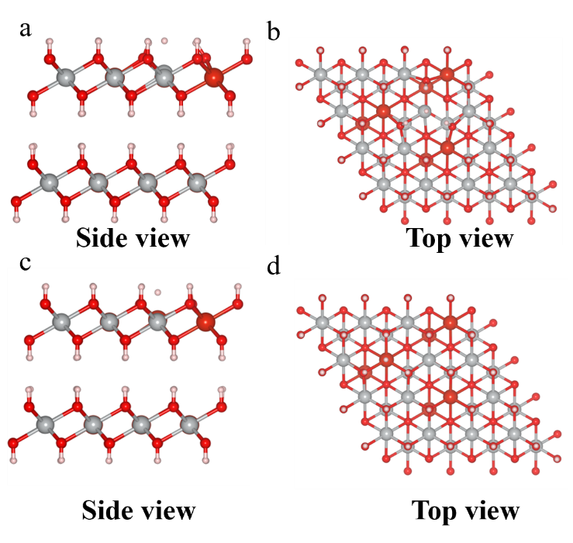
Fig. S38 a) Ni site side view, b) Ni site top view, c) V site side view, d) V site top view of NiV LDH and the possible adsorption H * configuration

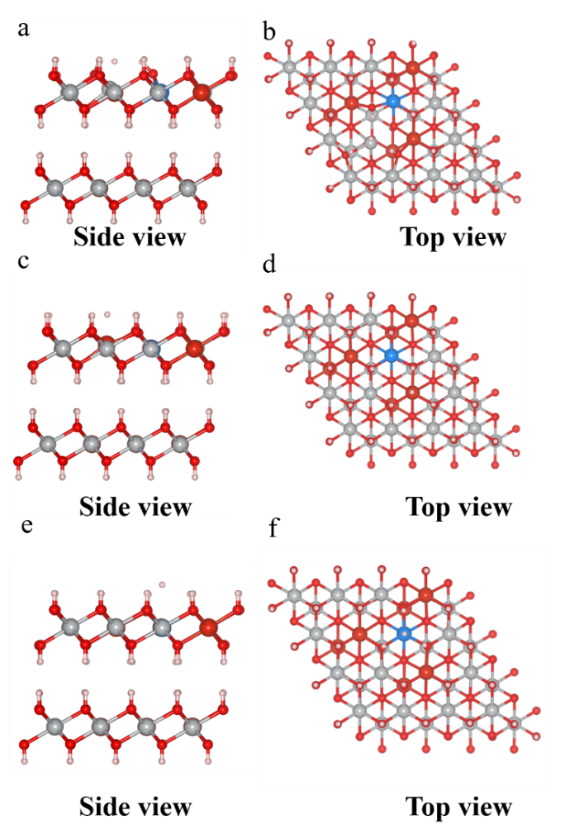
Fig. S39 a) Ni site side view, b) Ni site top view, c) V site side view, d) V site top view, e) Ru site side view, f) Ru site top view of Ru-NiV LDH and the possible adsorption H * configuration

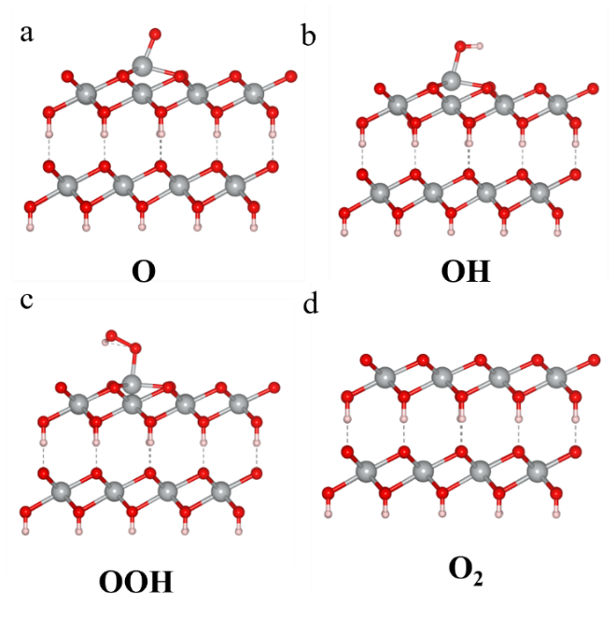
Fig. S34 Reaction pathway for OER on NiOOH of Ni site. a) O* process, b) OH* process, c) OOH* process, d) O₂ process
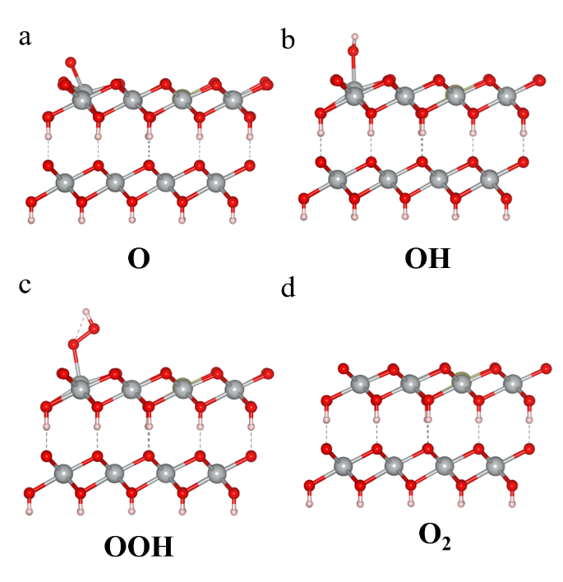
Fig. S41 Reaction pathway for OER on Ir-NiOOH of Ni site. a) O* process, b) OH* process, c) OOH* process, d) O₂ process

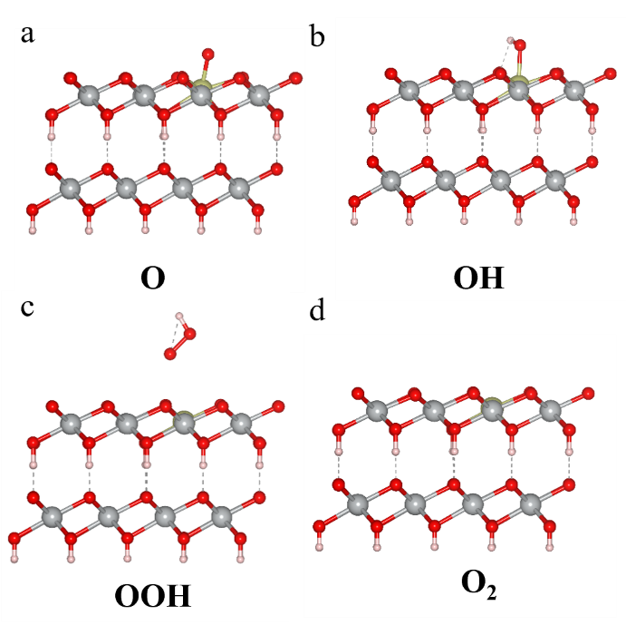
Fig. S42 Reaction pathway for OER on Ir-NiOOH of Ir site. a) O* process, b) OH* process, c) OOH* process, d) O₂ process

Fig. S43 Oxygen production results. a) The results of DEMS for 18O-labeled NiV LDH, b) The results of DEMS for 18O-labeled Ir-NiV LDH
Table S1 ICP-OES results of pristine NiV LDH, Ru-NiV LDH and Ir-NiV LDH
 | Element | Mass Fraction
NiV LDH | Ni | 85.69%
NiV LDH | V | 3.62 %
Ru-NiV LDH | Ni | 93.93 %
Ru-NiV LDH | V | 1.73 %
Ru-NiV LDH | Ru | 0.23 %
Ir-NiV LDH | Ni | 88.03%
Ir-NiV LDH | V | 1.75 %
Ir-NiV LDH | Ir | 0.68 %
Table S2 ICP-OES for untested liquids, HER stability test liquids and OER stability test results
 | Element | Element content  （mg/L)
1M KOH+Seawater | K | 29795.40
1M KOH+Seawater | Na | 1093.19
1M KOH+Seawater | V | <0.2
HER Stability Test  1M KOH+Seawater | K | 54190.40
HER Stability Test  1M KOH+Seawater | Na | 4025.87
HER Stability Test  1M KOH+Seawater | V | 1.69
OER Stability Test  1M KOH+Seawater | K | 53953.40
OER Stability Test  1M KOH+Seawater | Na | 4109.17
OER Stability Test  1M KOH+Seawater | V | 1.67
Table S3 The stability current density and stability time of Ru-NiV LDH and the most advanced HER catalyst in alkaline seawater were compared
Electrocatalysts | Current density (mA cm⁻²) | Time (h) | References
Ru-NiV LDH | 500 | 2350 | This work
Fe₃Se₄/NiSe₂@MXene | 500 | 140 | Adv. Funct. Mater. 2025, 35, 2424718
caMo-NiFePO/NMF | 500 | 480 | Adv. Funct. Mater. 2025, 35, 2504862
Ru-Ni₂P/Fe₂P | 500 | 100 | Adv. Funct. Mater. 2024, 34, 2400734
Pt@Ni₂P_{v}/NF | 1000 | 1200 | Adv. Funct. Mater. 2025, e14592
NiP₂@CoP | 400 | 400 | Nano Research, 2025, 18, 9490706
Fe-Ni₂Pv | 100 | 100 | Adv. Mater. 2024, 36, 2307395
Ru@NMoC | 500 | 500 | Angew. Chem. Int. Ed. 2025, 64, e202505031
HW-NiMoN | 500 | 100 | Nano-Micro Lett. 15, 2023, 157
Ni-MoN | 500 | 100 | Adv. Mater. 2022, 34, 2201774
MnCo/NiSe | 500 | 200 | Appl. Catal. B Environ. 2023, 325, 122355
Fe₄N/Co₃N/MoO₂ | 500 | 200 | Adv. Mater. 2024, 36, 2405852
RuMo/Cu₂O@C | 500 | 300 | Adv. Mater. 2025, 37, 2416658
Am-NiMoB | 500 | 350 | Appl. Catal. B Environ. 2025, 365, 124928
D-Ni₃Mo/NF | 500 | 100 | Chem. Eng. J.2024, 485, 150044
Pt-SAs/ac-NiFe LDH | 500 | 100 | J. Energy Chem. 2025,107, 427–439

Table S4 The stability current density and stability time of Ir-NiV LDH and the most advanced OER catalyst in alkaline seawater were compared
Electrocatalysts | Current density (mA cm⁻²) | Time (h) | References
Ir-NiV LDH | 500 | 2750 | This work
Fe₃Se₄/NiSe₂@MXene | 500 | 130 | Adv. Funct. Mater. 2025, 35, 2424718
caMo-NiFePO/NMF | 500 | 480 | Adv. Funct. Mater. 2025, 35, 2504862
Ru-Ni₂P/Fe₂P | 500 | 100 | Adv. Funct. Mater. 2024, 34, 2400734
CeNiFe@CuO | 500 | 300 | Adv. Funct. Mater. 2025, 35, 2508539
BZ-NiFe-LDH/CC | 500 | 100 | Nano Research Energy 2022, 1, e9120028
Cr-NiFeLDH | 100 | 100 | Appl. Catal. B Environ. 2026, 383, 126109
NiP₂@CoP | 400 | 400 | Nano Research, 2025, 18, 9490706
Fe-Ni₂Pv | 100 | 100 | Adv. Mater. 2024, 36, 2307395
Ni_{0.10}-Fe₃N@NCPs | 500 | 200 | Adv. Funct. Mater. 2024, 34, 2404470
MnCo/NiSe | 500 | 200 | Appl. Catal. B Environ. 2023, 325, 122355
Fe₄N/Co₃N/MoO₂ | 500 | 200 | Adv. Mater. 2024, 36, 2405852
HEA-Mo₂C | 500 | 1000 | Adv. Funct. Mater. 2025, e17862
MCF-LDH | 500 | 600 | Adv. Energy Mater. 2025, 15, e03465
NiFe LDH_CO₃²⁻ | 500 | 1000 | Adv. Energy Mater. 2024, 14, 2400053
Ce(OH)₃@NiFe LDH | 1000 | 1000 | Small 2025, 21, 2505219

