Supporting Information for
Integrated Performance Metrics of Porous Carbon Toward Practical Supercapacitor Devices
Yuting Song¹, Sicheng Fan¹, Zerui Yan¹, Dafu Tang¹, Xiang Gao¹, Jiawei Guo¹, Yunlong Zhao², Qiulong Wei^{1,}*
¹State Key Laboratory of Physical Chemistry of Solid Surface, Fujian Key Laboratory of Surface and Interface Engineering for High Performance Materials, College of Materials, Xiamen University, Xiamen 361005, P. R. China
²Dyson School of Design Engineering, Imperial College London, London SW72BX, UK
*Corresponding author. E-mail: qlwei@xmu.edu.cn (Qiulong Wei)
S1 Calculation of the volume of electrolyte for supercapacitor pouch cells
S1.1 Volume of electrolyte based on the porosity of activated carbon (AC) electrodes
The mass loading of the electrode was 13 mg cm⁻² and a thickness of 200 μm (double sides, as measured by the cross-sectional SEM image in Fig. S3, except for the thickness of the Al foil). Thus, the ρ_{electrode} is 0.65 $\text{g }{\text{cm}}^{-\text{3}}$ (13 mg cm⁻²/200 μm).
The electrode area was 24 cm² for each piece. The total volume of the electrodes: ${\text{V}}_{\text{electrode}}\text{=24×200×}{\text{10}}^{-\text{4}}\text{×} \text{(10+11) =} \text{10.08 }\text{mL}$.
The true density (${\text{ρ}}_{\text{AC}}$) of the electrode powder was 1.94 g cm⁻³.
Porosity of the electrode: ${\text{P}}_{\text{electrode}}\text{ = (1}-\frac{{\text{ρ}}_{\text{electrode}}}{{\text{ρ}}_{\text{AC}}}\text{)×100\%} \text{=} （\text{1}-\frac{\text{0.65}}{\text{1.94}}）\text{×100\%} \text{=} \text{66.5\%}$.
Hence, the pore volume of the electrode:
V_{AC}+V_{P}$\text{=}{\text{ V}}_{\text{electrode}}{\text{×P}}_{\text{electrode}}\text{ = 10.08×66.5\% = 6.7 }\text{mL}$.
The accumulative pore volume of the activated carbon is 0.65 mL g⁻¹. The pore volume of AC material: V_{AC} = 0.65 mL g⁻¹×(6.5 mg cm⁻²×24 cm²×2×21×95%)/1000 = 4.04 mL.
The stacking pore volume of the electrode is V_{P} = (V_{AC}+V_{P}) −V_{AC}=6.7−4.04 = 2.66 mL.
The porosity of the stacking pore volume corresponds to V_{P}/V_{electrode} = (2.66/10.08)×100 = 26.4%.
The separator also exhibits electrolyte absorption, which must be accounted for in total volume calculations. The total length of the separator is 103.2 cm. The volume of the separator is ${\text{V}}_{\text{Separator}}\text{ = 103.2}\text{×}\text{6}\text{×}\text{30}\text{×}{\text{10}}^{-\text{4}}\text{ = 1.86 mL}$, and the pore volume of the separator is
${\text{V}}_{\text{S}}\text{ = }{\text{V}}_{\text{separator}}\text{×}\text{73\% = 1.8576}\text{×}\text{73\% = 1.36 }\text{mL}$.
${\text{V}}_{\text{pore }}\text{ = }{\text{V}}_{\text{AC}}\text{+}{\text{V}}_{\text{P}}\text{+}{\text{V}}_{\text{S}}\text{ = 6.7+1.36 = 8.06 }\text{mL}$.
S1.2 Volume of electrolyte is based on the Q of the device
The voltage window of the supercapacitor is 0-2.7 V.
The rated capacitance of the supercapacitor is 137 F.
The Q of the device is ${\text{Q}}_{\text{theo}}\text{=}$137 F$\text{×}$2.7 V = 370 C, and related volume of electrolyte (1 M Net₄BF₄ in ACN) is [(370C)/(96485 C mol⁻¹)$]\text{/}$(1 mol mL⁻¹)$≈$3.8 mL.
V_{Q} = 3.8 mL.
S2 Prediction of E_{device} based on 43 AC samples
The mass loading of the AC electrode is 13 mg cm⁻² (double sides, AC: conductive carbon: binder=95:3:2). Furthermore, the area of electrodes in soft-packaged pouch supercapacitors is 24 cm². Furthermore, the electrolyte is 1 M Net₄BF₄ in ACN and separator is NKK TF4030 cellulose separators. The porosity of stacking pore in electrode is considered about 26%. The true density of different AC is assumed as 2 g cm⁻³.
The volume of AC (V_{carbon}), V_{carbon} = m_{AC}/$\text{ρ}$_{ture}.
The pore volume of AC (V_{AC}), V_{AC} = m_{AC}*P_{AC}
The volume of electrode, V_{electrode} = (V_{AC}+V_{carbon})/ (1−26%).
The stacking pore volume (V_{P}), V_{P} = V_{electrode}*26%.
S3 Calculation of descriptor ($\text{η}$)
E_{device}$=\frac{\frac{1}{8}C_{S}V^{2}*m_{AC}}{3.6M_{total}}$
$$M_{total}=m_{AC}+m_{electrolyte}+m_{inactive}$$
$$m_{incative }=m_{S}+m_{Al}+(m_{conductive crabon}+m_{binder})+m_{P}$$
The mass ratio between AC and other components can help simplify this equation. Because the current collector and separator exhibit approximately equal areas to the electrode, the mass ratio can simplify to the ratio of their respective area densities. The density of Al is well-established as ~2.7 g cm⁻³ with the Al foil thickness of 12 μm, the area density is calculated to be 3.24 mg cm⁻². According to Table S1, the area density of separator is 1.263 mg cm⁻². Assuming an AC mass loading of m_{a} mg cm⁻², the mass ratio between components becomes $m_{AC}$: $m_{Al}$: $m_{S}=$ m_{a}: 3.24: 1.263. So, $m_{Al}=\frac{3.24}{m_{a}}*m_{AC}$, $m_{S}=\frac{1.263}{m_{a}}*m_{AC}$. Furthermore, the masses of conductive carbon and binder are determined by their respective ratios in the electrode slurry composition. We defined the electrode containing 95 wt.% AC powder, 3 wt.% conductive carbon, and 2 wt.% binder. Hence ($m_{conductive crabon}+m_{binder}$) =$\frac{\text{3\%+2\%}}{\text{95\%}}*m_{AC}$ = 0.053$m_{AC}$.
$$m_{electrolyte}=ρ_{e}V_{electrolyte}=ρ_{e}*\left(V_{AC}+V_{P}+V_{S}\right)=ρ_{e}*\left[m_{AC}*P_{AC}+26\%*\left(\frac{\frac{m_{AC}}{ρ_{true}}+V_{AC}}{1-26\%}\right)+P_{S}*\frac{m_{S}}{ρ_{S}}\right]=ρ_{e}m_{AC}*(1.35P_{AC}+\frac{0.35}{ρ_{true}}+\frac{0.125P_{S}}{m_{a}})$$
$$M_{total}=m_{AC}+\left[ρ_{e}m_{AC}*\left(1.35P_{AC}+\frac{0.35}{ρ_{true}}+\frac{3P_{S}}{m_{a}}\right)\right]+\left[\left(\frac{1.263}{m_{a}}*m_{AC}\right)+\left(\frac{3.24}{m_{a}}*m_{AC}\right)+\left(0.053m_{AC}\right)+m_{P}\right]=m_{AC}\left[1.053+ρ_{e}*\left(1.35P_{AC}+\frac{0.35}{ρ_{true}}+\frac{3P_{S}}{m_{a}}\right)+\frac{4.503}{m_{a}}\right]+m_{P}$$
Because the density of commercial electrolyte (1 M Net₄BF₄ in ACN) is 0.8639 g mL⁻¹, $P_{S}=73\%$ (Table S1), and ${\text{ρ}}_{\text{true}}\text{≈}\text{2 g }$cm⁻³, so the equation can continue simplify to:
$M_{total}$=$m_{AC}\left(1.166P_{AC}+\frac{6.4}{m_{a}}+1.2\right)+m_{P}$
The E_{device}:
$$E_{device}=\frac{\frac{1}{8}C_{S}V^{2}}{3.6*(1.166P_{AC}+\frac{6.4}{m_{a}}+1.2+ζ)}$$
$$η=\frac{C_{S}}{(1.166P_{AC}+\frac{6.4}{m_{a}}+1.2)}$$
where $ζ$ is the correction coefficient from the mass of package ($ζ=\frac{m_{P}}{m_{AC}})$.
S4 Supplementary Figures and Tables
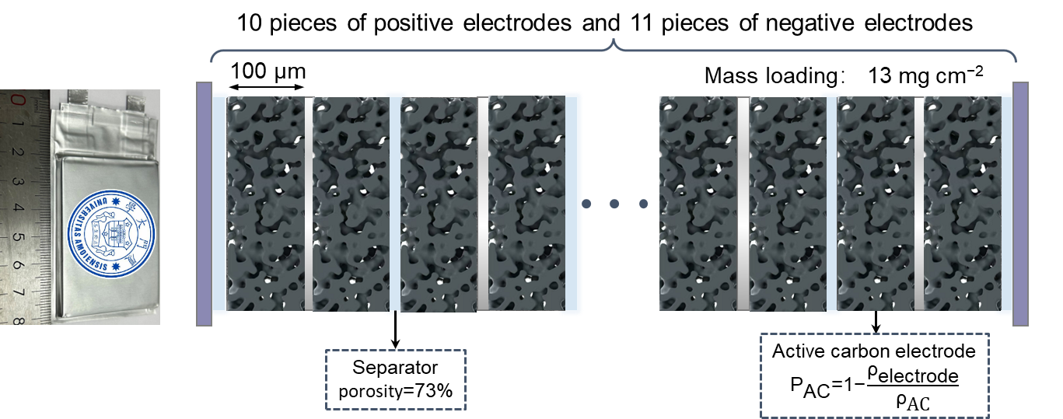
Fig. S1 The design and assemble of supercapacitor pouch cell. This pouch cell is composed of 10 pieces of positive electrode and 11 pieces of negative electrode
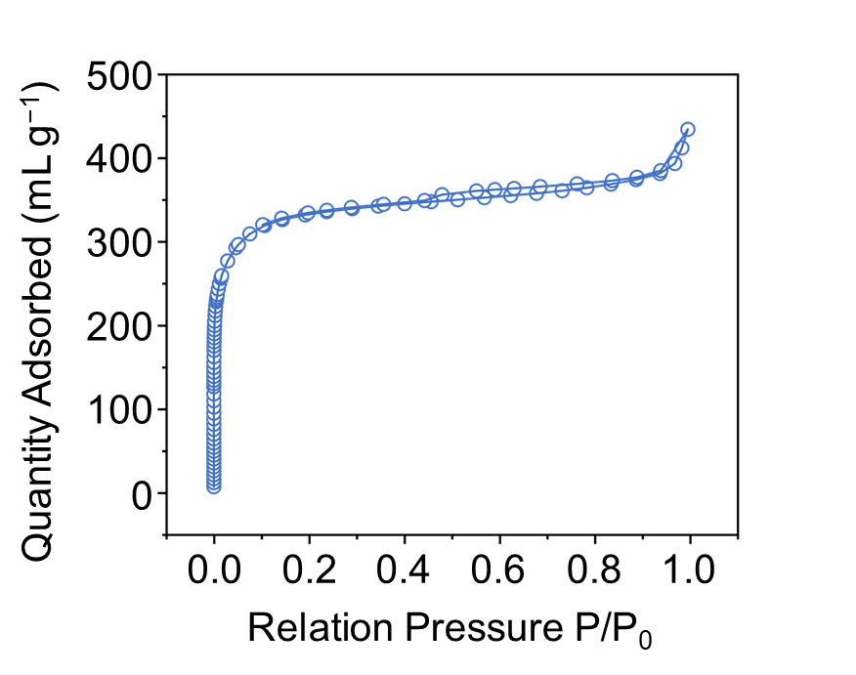
Fig. S2 N₂ adsorption‒desorption isotherms of the AC materials

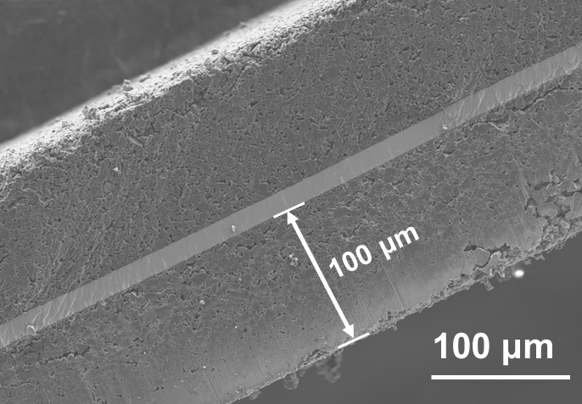
Fig. S3 Cross‒sectional SEM images of the AC electrode (double-side coating)
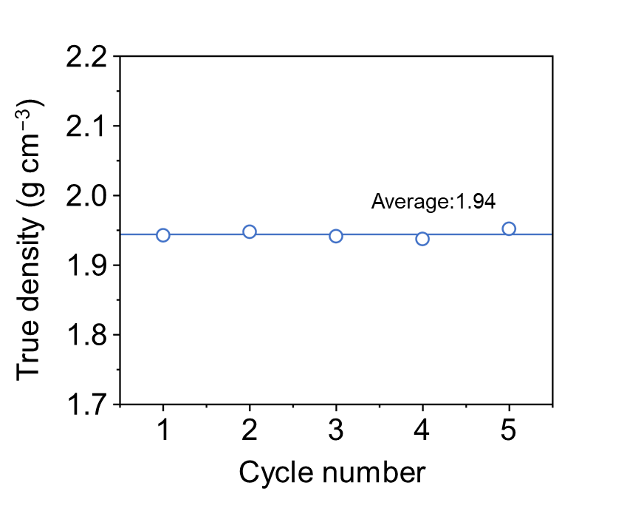
Fig. S4 The true density of the AC materials
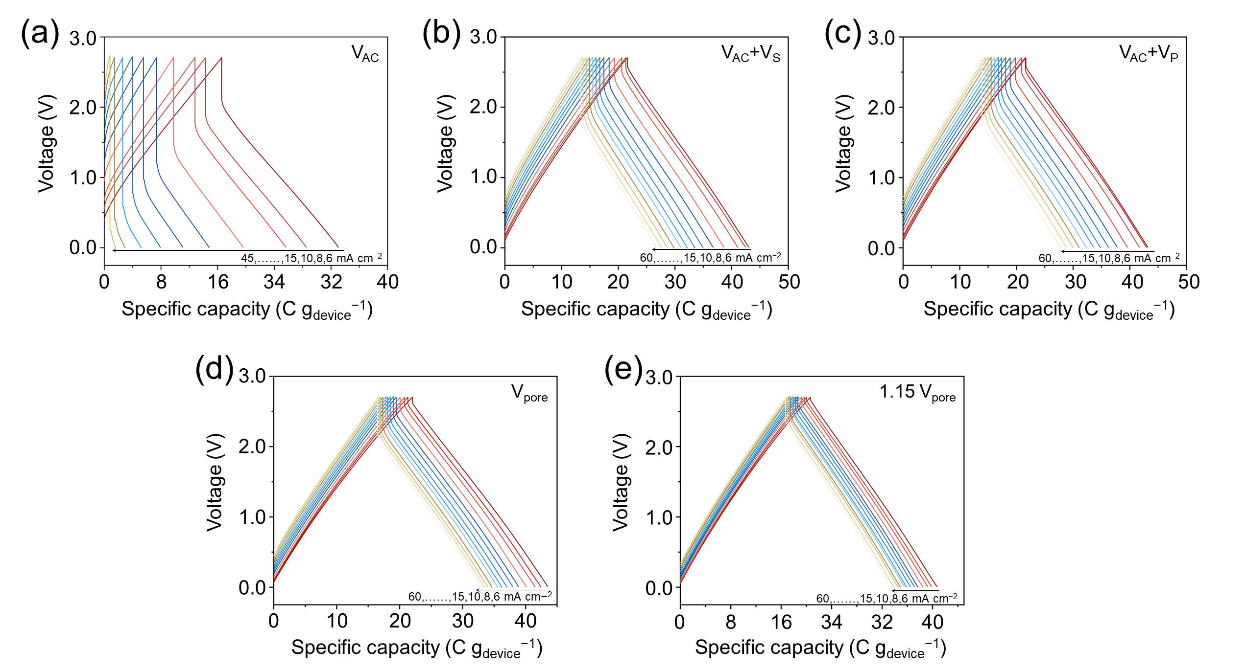
Fig. S5 Charging and discharging curves at different current densities of supercapacitor pouch cell with volumes of electrolyte: a V_{AC}, b V_{AC}+V_{S}, c V_{AC}+V_{P}, d V_{pore} and e 1.15 V_{pore}
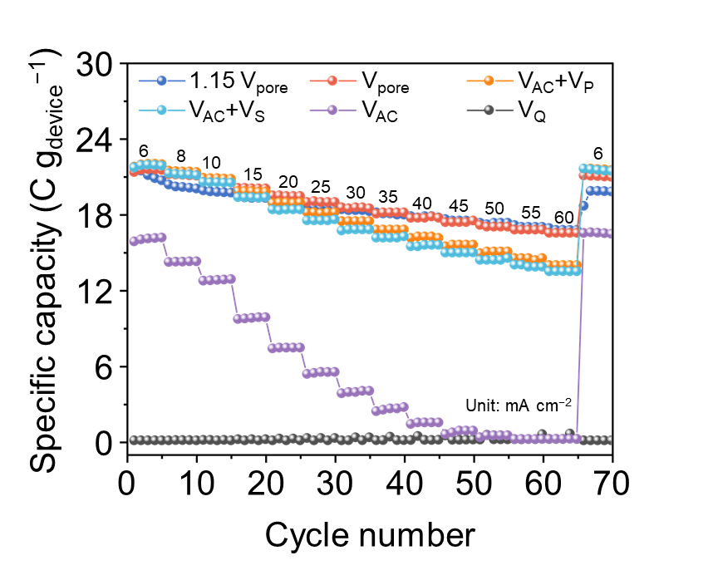
Fig. S6 Rate performance of supercapacitor pouch cells with different volumes of electrolyte
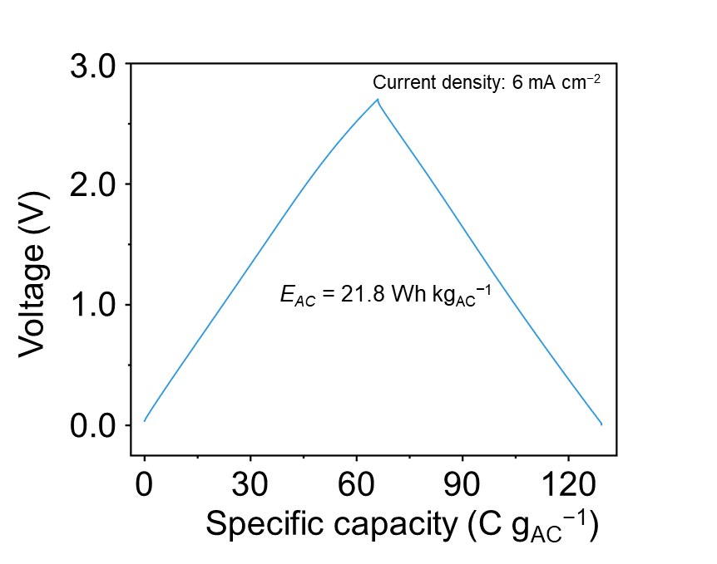
Fig. S7 Charging and discharging curves of the supercapacitor measured by coin cell
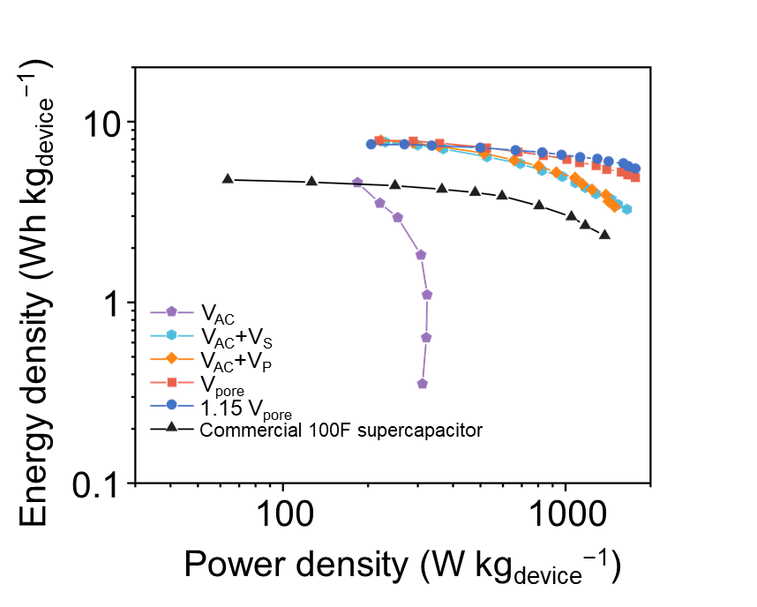
Fig. S8 Ragon plots of as-assembled supercapacitor pouch cells with different volumes and commercial 100 F cylindrical supercapacitors

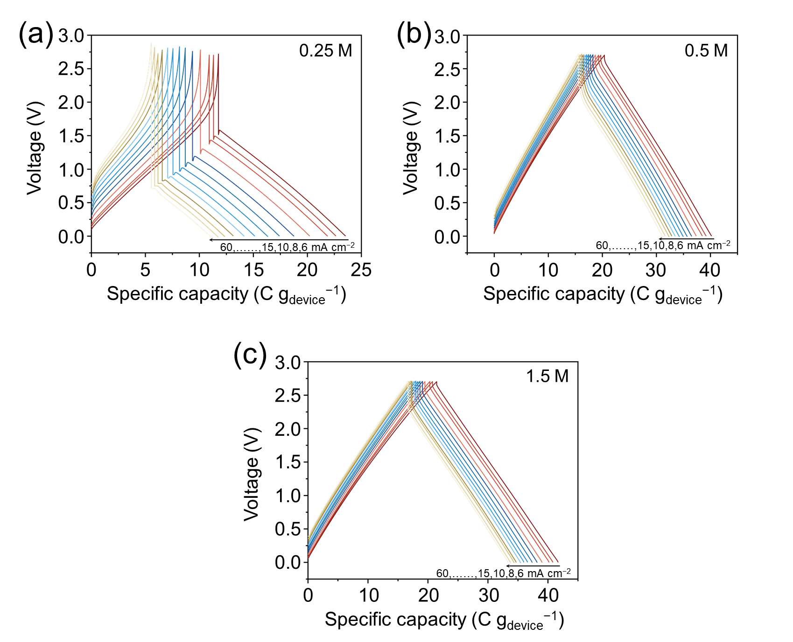
Fig. S9 Charging and discharging curves of supercapacitor pouch cells with different electrolyte concentrations: a 0.25 M, b 0.5 M and c 1.5 M. The added electrolyte volume is consistent in 7.9$±$0.1 mL
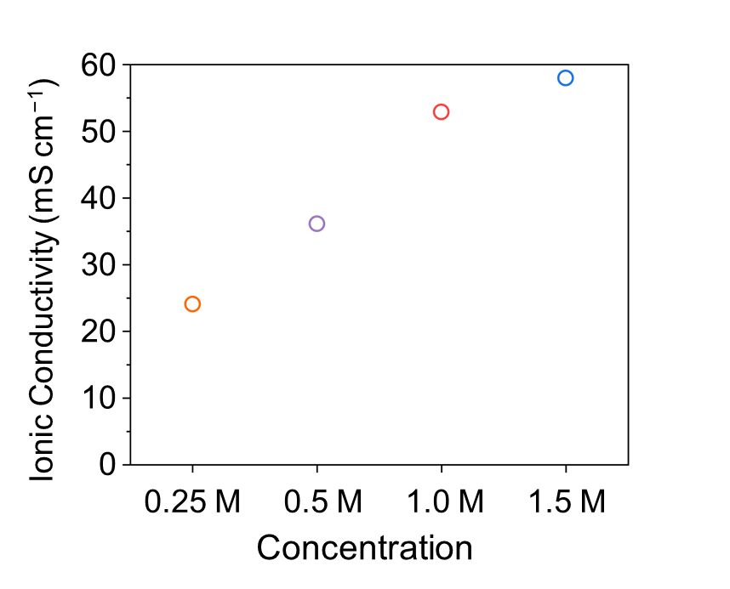
Fig. S10 The ionic conductivities of electrolytes with different concentrations
The ionic conductivities of electrolytes with different concentrations were tested based the formula of $σ=L/RS$ [S1] at room tempreture, where $σ$ is ionic conductivity, R is the impedance, L is the distance between two parallel electrode and S is the area of the electrode. The L and S are constants for the same equipment. Additionally, the 0.01 M KCl ($σ_{KCL}=1.41$mS cm⁻¹) was as nominal solution, and the ionic conductivities of electrolytes is calculated by following equation, $σ_{electrolyte}=\frac{R_{KCl}}{R_{electrolyte}}×σ_{KCl}$. Thus, the ionic conductivities are calculated by the measured impendences of specific electrolyte.
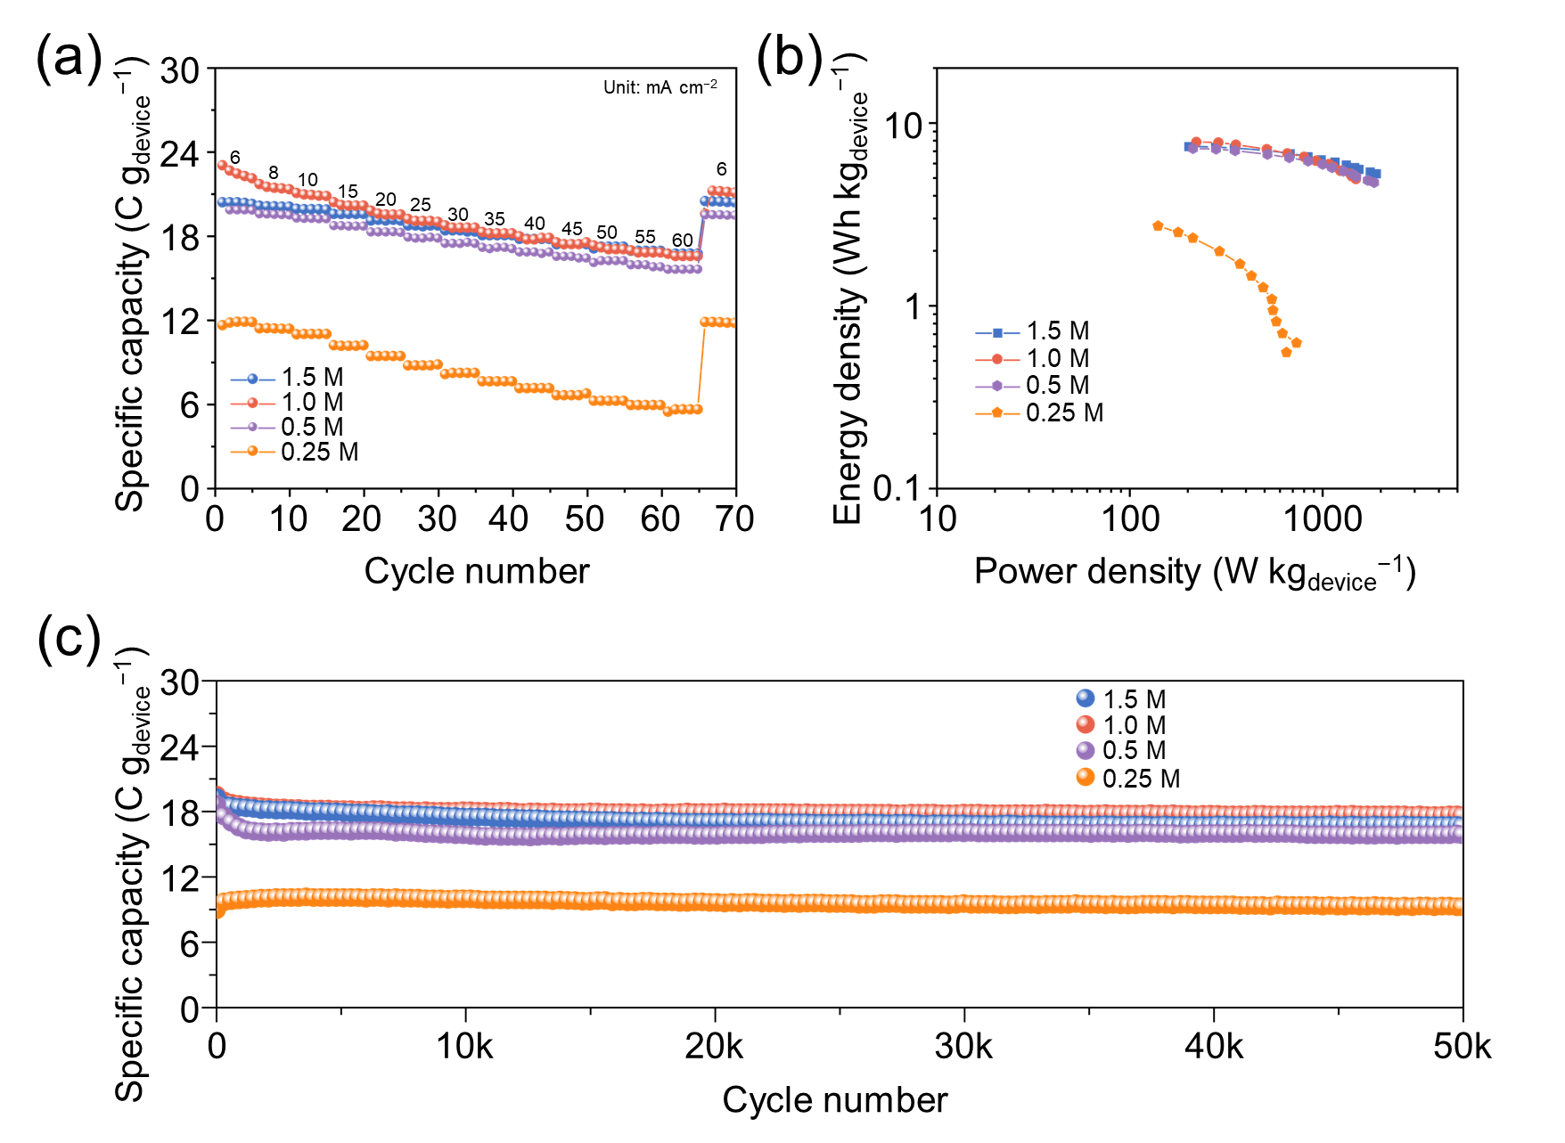
Fig. S11 a Rate performance. b Ragone plots and c Cycling performance of supercapacitor pouch cells with different electrolyte concentrations
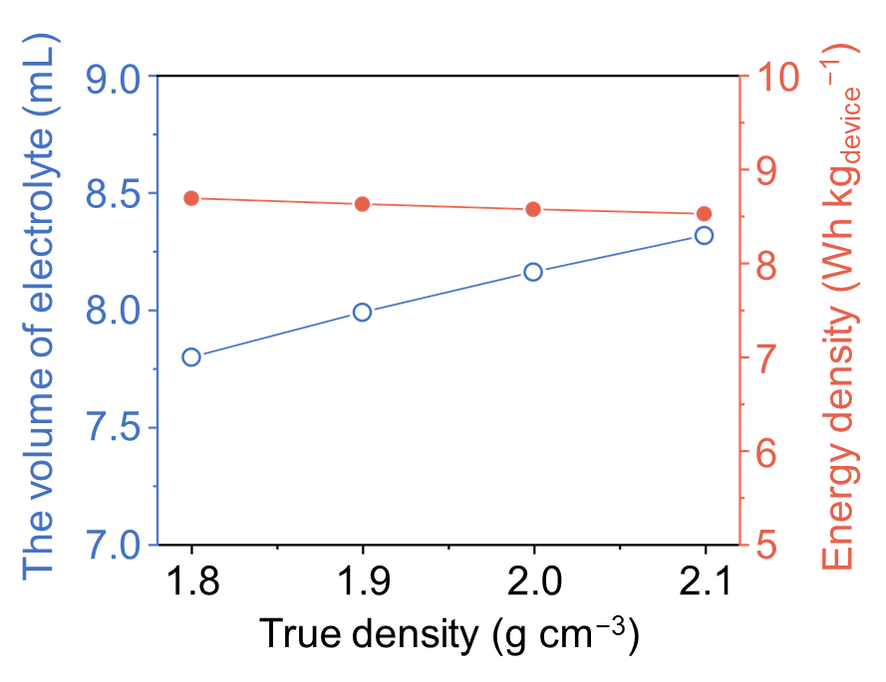
Fig. S12 Required volume of electrolyte and E_{device} of supercapacitors using AC materials with different true densities
For true density of ACs in between 1.8 and 2.1 g cm⁻³, the simulated E_{device} revealed minimal variation. Therefore, a true density of 2.0 g cm⁻³ was adopted for the 43 AC materials form literature in the subsequent analyses.

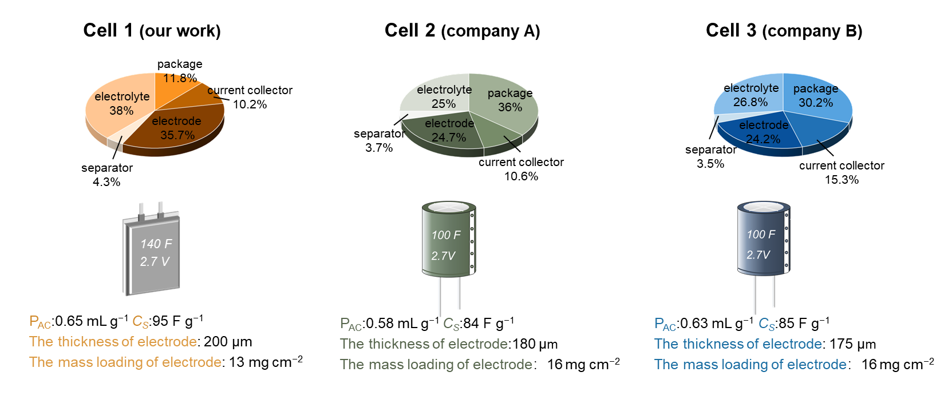
Fig. S13 Mass distributions of the components in supercapacitor and the key parameters of AC materials and electrodes. Commercial supercapacitors were disassembled to analyze their mass distribution and properties of AC materials
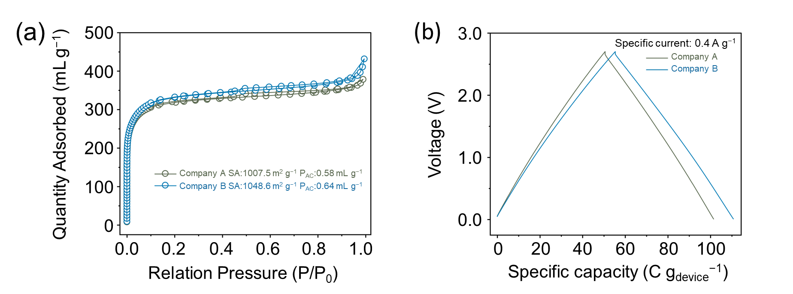
Fig. S14 a N₂ adsorption‒desorption isotherms of the AC materials of different cylindrical supercapacitors. b Charging and discharging curves of cylindrical supercapacitors
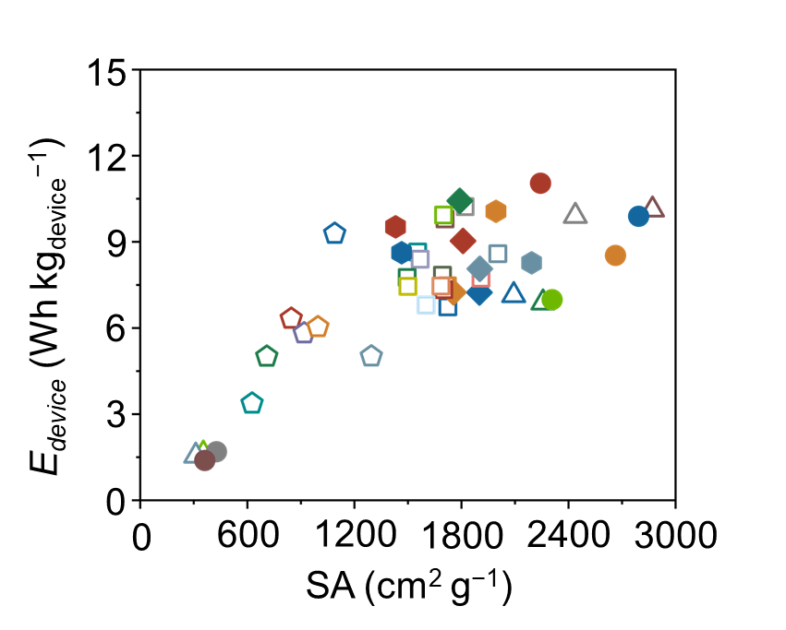
Fig. S15 The plot of E_{devicce} vs. specific surface area of AC materials
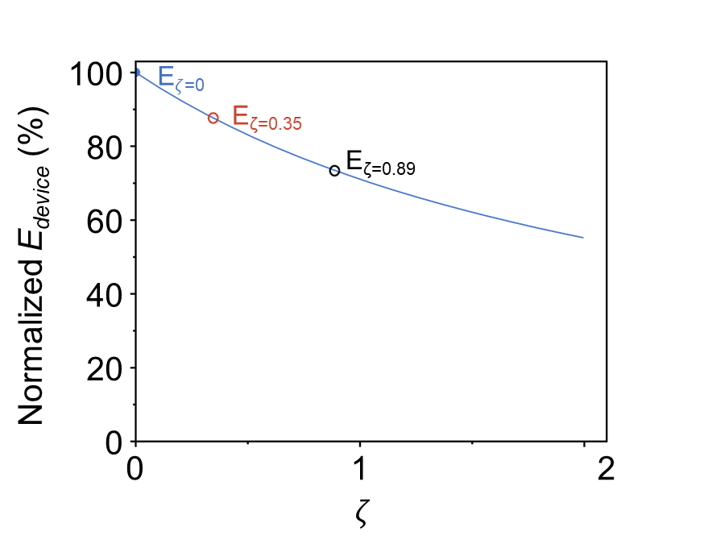
Fig. S16 The influence of correction coefficient ($ζ$) on E_{device}
Using C_{S} = 95 F g⁻¹, P_{AC} = 0.65 mL g⁻¹, and m_{a} = 13 mg cm⁻², the influence of the packaging factor $ζ$ on the E_{device} is investigated. For a ~140 F supercapacitor cells, the $ζ$ of pouch package and cylindrical package is 0.35 and 0.89, respectively, corresponding to 87% and 73% of normalized E_{device} (when $ζ$ = 0). Usually, when larger supercapacitor cell is assembled, the influence of $ζ$ would be decrease.
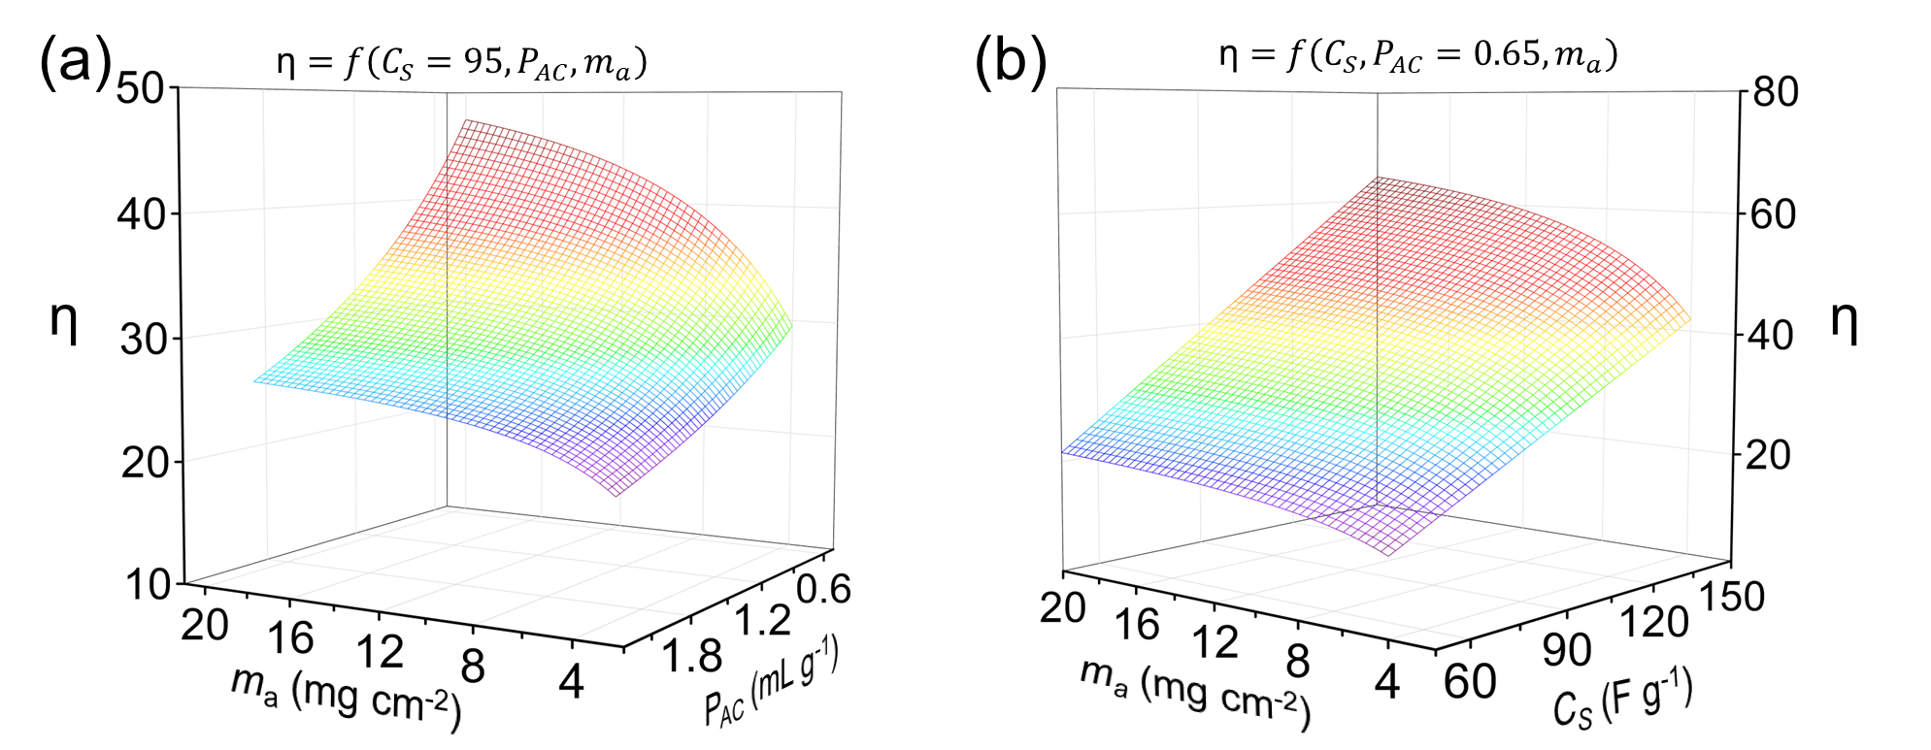
Fig. S17 a The 3D function relation plots of (a) m_{a} (mg cm⁻²) and P_{AC} (mL g⁻¹) with respect to η, where C_{S} = 95 F g⁻¹. b m_{a} (mg cm⁻²) and C_{S} (mL g⁻¹) to η, fixing the P_{AC} = 0.65 mL g⁻¹
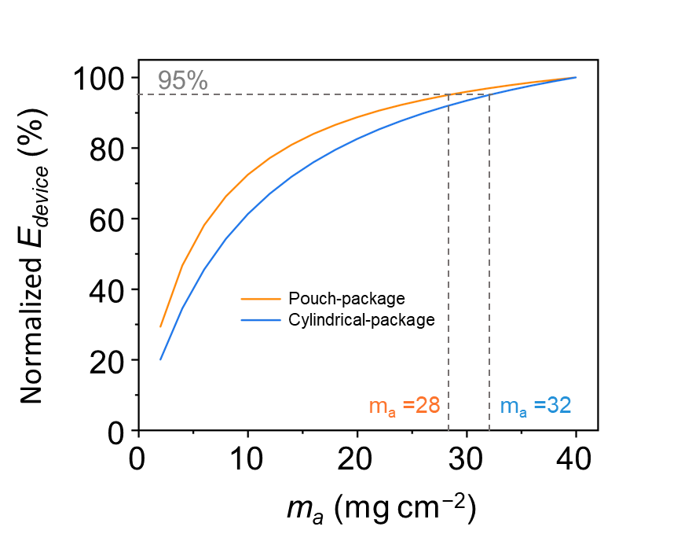
Fig. S18 The E_{device} of AC (C_{S} = 95 F g⁻¹, P_{AC} = 0.65 mL g⁻¹) across varying mass loadings (ranging from 2 to 40 mg cm⁻², double-side coating)
Table S1 The parameter specification of separators
NKK TF4030 cellulose separators
thickness | 30$\text{μm}$
width | 60$\text{ mm}$
density | 0.421 g cm⁻³
porosity | 73$\%$
strength | $≥$7.8 $\text{N/}$15$\text{mm}$
pH | 5.5-8.0

Table S2 Characterization of the AC electrode
The parameters of commercial activated carbon electrode
mass loading (mg cm⁻²) | 6.5
mass ratio of electrode  (AC: conductive carbon: binder) | 95:3:2
thickness of the electrode ($\text{μm}$) | 100
true density (g cm⁻³) | 1.94
accumulative pore volume (mL g⁻¹) | 0.65
specific surface area (m² g⁻¹) | 1051
the volume ratio of stacked pores to the electrode | 26.7%
V_{pore} (mL) | 8.15
V_{AC} (mL) | 4.04
V_{P} (mL) | 2.67
Vs (mL) | 1.36

Table S3 The densities and ionic conductivities of electrolytes
Concentrations | Density (g mL⁻¹) | Ionic conductivity (mS cm⁻¹)
0.25 M Net₄BF₄ in ACN | 0.807 | 24.07
0.5 M Net₄BF₄ in ACN | 0.825 | 36.13
1.0 M Net₄BF₄ in ACN | 0.864 | 52.9
1.5 M Net₄BF₄ in ACN | 0.898 | 58

Table S4 The accumulative pore volume, specific capacitance, BET surface area, electrolyte and predicted E_{device} for 43 AC materials from literature
Carbon Sample | Accumulative pore volume (mL g⁻¹) | Specific capacitance (F g⁻¹) | BET surface area  (m² g⁻¹) | Electrolyte | #E_{device}  (Wh ${\text{kg}}_{\text{device}}^{-\text{1}}$) | Refs.
YP-50F  YP-80F  PW-400  SC-1800  ACS-PC  EL-104  EL-106  ACC-10  ACC-15  ACC-20  APC-700-1  APC-700-2  APC-800  APC-950  APC-1000  APC-1050  APC-1100  AEL-1000  AEL-1100  AEL-1200 | 0.70  1.10  0.80  0.80  0.90  0.80  0.90  0.40  0.50  0.80  0.80  0.80  0.90  0.80  0.80  0.80  0.90  0.80  0.70  0.70 | 94.3  95.7  84.3  128  135.3  93.5  93.7  98  105.1  107.5  122.6  124.3  117.1  108.2  105.1  97.1  93.8  91.8  89.8  81.8 | 1694  2264  1724  1821  1796  1721  1907  1094  1436  2004  1708  1700  1815  1555  1569  1496  1761  1701  1685  1602 | 1 M Net₄BF₄ in ACN | 7.84  6.85  6.73  10.22  10.40  7.47  7.21  9.26  9.50  8.59  9.79  9.93  9.01  8.64  8.40  7.76  7.21  7.33  7.46  6.80 | [S2]
PICA A  PICA B  PICA C | 1.63  1.12  0.71 | 115  100  90 | 2315  2100  1500 | 1.7 M N(C₂H₅)₄CH₃SO₃ in ACN | 6.95  7.11  7.45 | [S3]
CDC-700 | 1.4 | 170 | 2250 | 1 M Net₄BF₄ in ACN | 11.02 | [S4]
ND 1300-AR  ND 1300-VAC  ND 1700-AR  ND 1700-VAC | 1.11  1.11  1.23  1.30 | 22  21  24  20 | 356  314  430  364 | 1 M  Net₄BF₄  in ACN | 1.57  1.50  1.64  1.34 | [S5]
Hurd-a-1  Hurd-a-3  Hurd-a-5  Hurd-b-5  Bast-a-5  Bast-b-5 | 0.73  1.16  1.71  1.06  1.76  0.86 | 94  144  167  136  146  103 | 1910  2879  2801  2446  2671  1909 | 1.8 M Net₄BF₄ in PC | 7.73  10.09  9.87  9.87  8.50  8.03 | [S6]
CPr48  CS48  CP48  CPr15  CS15  CP15  CPr15T  CSU  CPrU | 0.25  0.58  0.29  0.21  0.45  0.25  0.2  0.57  0.28 | 62  115  50  48  93  57  32  94  60 | 850  2000  1300  713  1470  923  630  2200  1000 | 1 M Net₄BF₄ in ACN | 6.29  10.04  4.98  4.97  8.59  5.78  3.33  8.24  6.00 | [S7]
Note: #Energy density is simulated via the provided E-tool.
S5 E-tool for supercapacitor
Input information of materials
Electrode properties |  | Sepatator
active material | activated carbon (AC) | NKK TF4030
accumulative pore volume of activated carbon (mL/g) | 0.65 | porosity (%) | 73%
true density (g/cm³) | 2 | thickness (μm) | 30
porosity of stacking pores | 26% | width (cm) | 6
double-side mass loading (m_{a}, mg/cm²) | 13 | density (g/cm³) | 0.421
content of active material (wt.%) | 95% | Electrolyte
specific capacitance (F/g) | 95 | 1 M Net₄BF₄ in ACN
width (cm) | 4.3 | density (g/mL) | 0.8639
length (cm) | 5.6 | Cuerrent collector
area of single electrode (cm²) | 24.08 | areal density of 12 μm Al foil (mg/cm²) | 3.24
positive pieces | 10 | Operating voltage of supercapacitor
negative pieces | 11 | voltage window (V) | 2.7
Supercapacitor device
mass of AC (m_{AC}, g) | 6.57 | mass of electrolyte (V_{total}) (g) | 6.91
volume of AC (cm³) | 3.29 | mass of separator (g) | 0.78
V_{AC} (cm³) | 4.06 | mass of current collector (Al foil) (g) | 1.64
total volume of electrode (cm³) | 9.93 | mass of package (g) | 2.17
V_{P} (cm³) | 2.58 | mass of binder and conductive carbon (g) | 0.35
V_{pore} (cm³) | 6.64 | total mass of device (M_{total}, g) | 18.42
Vs (cm³) | 1.36 | rated capacitance (F) | 141
Output results of supercapacitor cell
E_{AC} (Wh/kg) | 22.90 | conversion factor (f) | 0.34
E_{device} (Wh/kg) | 7.77
NOTE: ¹V_{AC} is the volume of pore in AC; V_{P} is the volume of stacking pore; Vs is the volume of pore in separator;
²The cacluating equation of energy density : E_{AC}=1/2*C*V²/m_{AC}; E_{device}=1/2*C*V²/M_{total}
Supplementary References
- S. Wang, L. Yu, S. Wang, L. Zhang, L. Chen et al., Strong, tough, ionic conductive, and freezing-tolerant all-natural hydrogel enabled by cellulose-bentonite coordination interactions. Nat. Commun. 13(1), 3408 (2022). https://doi.org/10.1038/s41467-022-30224-8
- X. Liu, D. Lyu, C. Merlet, M.J.A. Leesmith, X. Hua et al., Structural disorder determines capacitance in nanoporous carbons. Science 384(6693), 321-325 (2024). https://doi.org/ 10.1126/science.adn6242
- J. Gamby, P.L. Taberna, P. Simon, J.F. Fauvarque, M. Chesneau, Studies and characterisations of various activated carbons used for carbon/carbon supercapacitors. J. Power Sources 101(1), 109-116 (2001). https://doi.org/10.1016/S0378-7753(01)00707-8
- Y. Korenblit, M. Rose, E. Kockrick, L. Borchardt, A. Kvit et al., High-rate electrochemical capacitors based on ordered mesoporous silicon carbide-derived carbon. ACS Nano 4(3), 1337-1344 (2010). https://doi.org/10.1021/nn901825y
- M. Zeiger, N. Jäckel, D. Weingarth, V. Presser, Vacuum or flowing argon: What is the best synthesis atmosphere for nanodiamond-derived carbon onions for supercapacitor electrodes? Carbon. 94(507-517 (2015). https://doi.org /10.1016/j.carbon.2015.07.028
- W. Sun, S.M. Lipka, C. Swartz, D. Williams, F. Yang, Hemp-derived activated carbons for supercapacitors. Carbon 103, 181-192 (2016). https://doi.org/ 10.1016/j.carbon.2016.02.090
- C. Vix-Guterl, E. Frackowiak, K. Jurewicz, M. Friebe, J. Parmentier et al., Electrochemical energy storage in ordered porous carbon materials. Carbon 43(6), 1293-1302 (2005). https://doi.org/ 10.1016/j.carbon.2004.12.028

