Supporting Information for

Laser-Driven Single-Step Synthesis of Monolithic Prelithiated Silicon-Graphene Anodes for Ultrahigh-Performance Zero-Decay Lithium-Ion Batteries
Avinash Kothuru^{1†}, Gil Daffan^{2†}, Fernando Patolsky^{1,2,3 *}
¹ School of Chemistry, Faculty of Exact Sciences, Tel Aviv University, Tel Aviv 69978, Israel
² Department of Materials Science and Engineering, Faculty of Engineering, Tel Aviv University, Tel Aviv 69978, Israel
³ Tel Aviv University Center for Nanoscience and Nanotechnology, Tel Aviv University, Tel Aviv 69978, Israel
† Avinash Kothuru and Gil Daffan contributed equally to this work.
*Corresponding author. Email: fernando@tauex.tau.ac.il (Fernando Patolsky)
Supplementary Figures and Tables
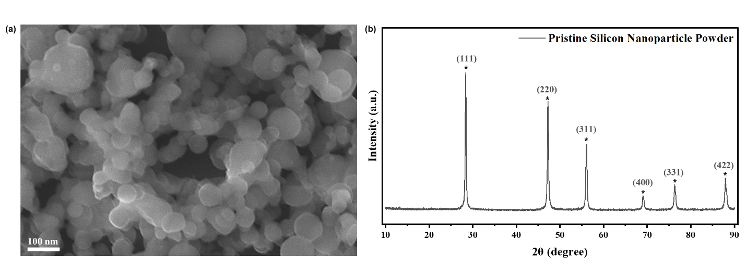
Fig. S1 (a) High-resolution scanning electron microscopy (HR-SEM) image of pristine SiNPs, showing uniform nanoparticle morphology and surface texture prior to anode fabrication. (b) XRD analysis of the pristine SiNPs, showing high crystallinity before the lasing process
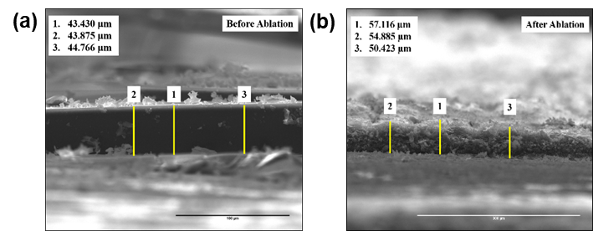
Fig. S2 HR-SEM imaging of the prelithiated SiNP/LIG electrode cross-section, depicting electrode thickness before (a) and after (b) laser irradiation
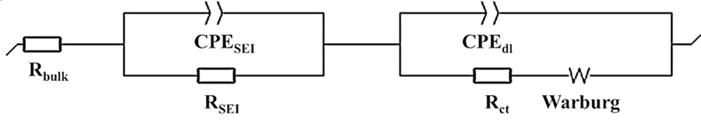
Fig. S3 The equivalent circuit used for fitting the electrical impedance spectroscopy (EIS) data includes several components. The bulk resistance of the cell, referred to as R_{Bulk}, corresponds to the high-frequency intercept of the first semicircle in the Nyquist plot. The solid electrolyte interphase (SEI) is modeled with a resistance (R_{SEI}) and a constant phase element (CPE_{SEI}). The interface between the electrode and the electrolyte is characterized by the charge transfer resistance (R_{CT}) and the double-layer constant phase element (CPE_{dl}). At low frequencies, impedance caused by diffusion limitations—known as Warburg impedance—appears as a line with an approximately 45-degree slope in the Nyquist plot [S1]
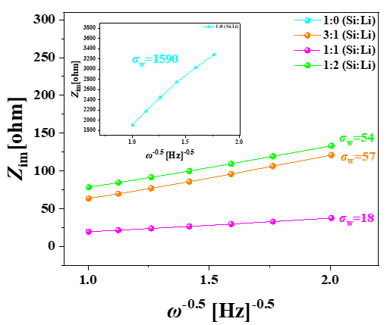
Fig. S4 Slopes extracted from the low-frequency region of the EIS Nyquist plots in Fig. 4a of the manuscript, corresponding to the Warburg impedance, were calculated using equation (3) in the Methods section to analyze lithium-ion diffusion characteristics in prelithiated SiNP/LIG anodes with varying Si:LiOH ratios

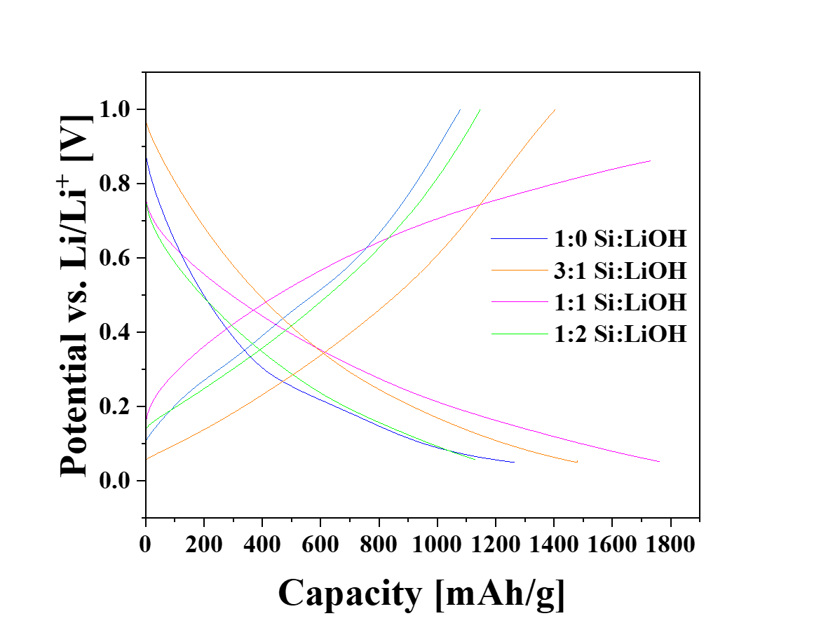
Fig. S5 Voltage profiles from the initial cycles of SiNP/LIG anodes prepared with different Si:LiOH precursor ratios. The Li-free sample (1:0) exhibits an ICE of 83%, whereas all Li-containing samples show markedly higher values—94% (3:1), 97% (1:2), and 97% (1:1)—highlighting the beneficial effect of Li addition on first-cycle efficiency
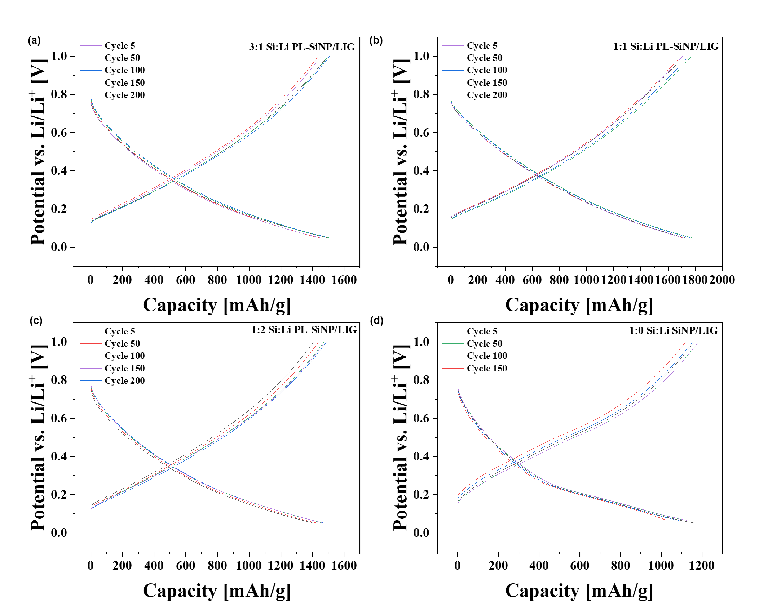
Fig. S6. Voltage profiles at selected cycles for prelithiated SiNP/LIG anodes prepared with different Si:LiOH precursor ratios, showing standard voltage–capacity behavior for Si-based anodes in Li-ion half-cells [S2, S3]
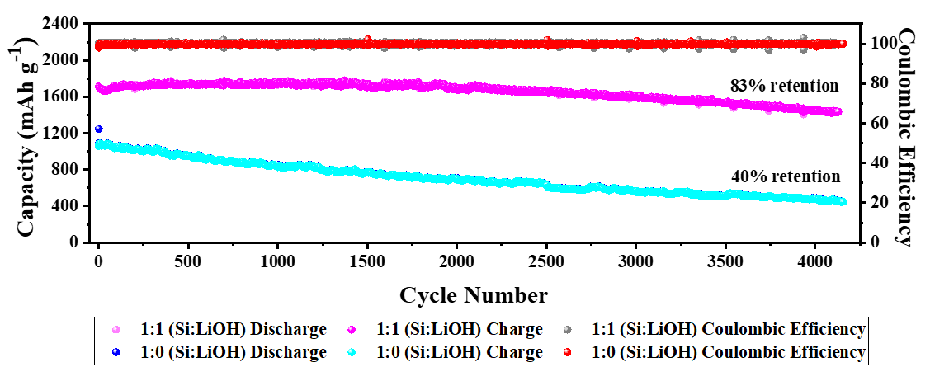
Fig. S7 Galvanostatic cycling performance of non-prelithiated (turquoise) and prelithiated (magenta) SiNP/LIG anodes in lithium half-cells at a current density of 5 A/g over 4150 cycles. The prelithiated anode demonstrates exceptional long-term stability, retaining 98% of its capacity after more than 2000 cycles and 83% after 4150 cycles. In contrast, the non-prelithiated anode exhibits significant capacity degradation, retaining only ~40% of its initial capacity after 4150 cycles

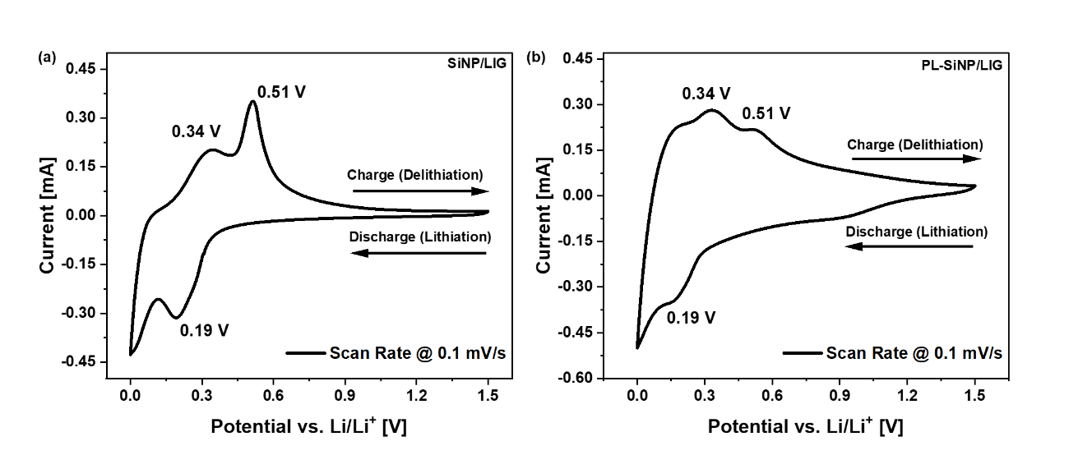
Fig. S8. Cyclic voltammetry (CV) of (a) non-prelithiated and (b) prelithiated SiNP/LIG anodes versus lithium metal in coin cells, measured between 0 and 1.5 V vs. Li/Li⁺, showing standard lithiation/delithiation peaks for silicon-based anodes in LIB half-cells [S4]

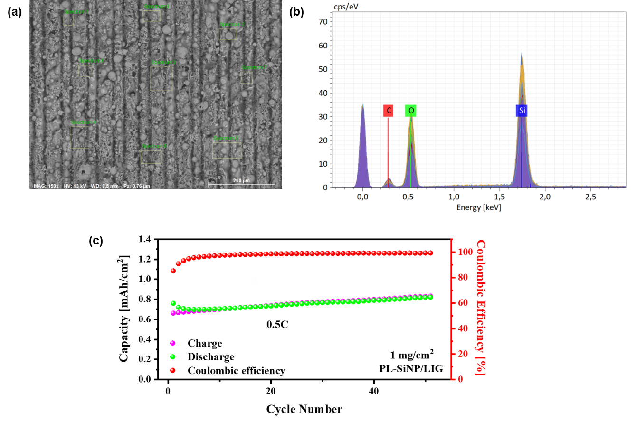
Fig. S9 (a) HRSEM imaging of a prelithiated SiNP/LIG anode, showing selected areas (green) analyzed by energy dispersive X-ray spectroscopy (EDS) elemental analysis. (b) EDS spectrums of the selected areas. (c) Galvanostatic cycling of a prelithiated SiNP/LIG anode with a silicon loading of ~1 mg/cm² for 50 cycles at a 0.5C rate. The anode demonstrates high areal capacity and stable performance at high cycling rates with no observable degradation

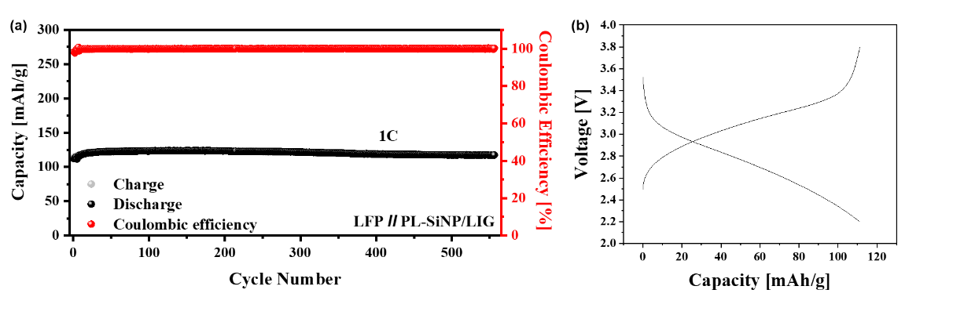
Fig. S10 (a) Long-term galvanostatic cycling of a full cell comprising a 1 mg/cm⁻² LiFePO₄ (LFP) cathode and a prelithiated SiNP/LIG anode, cycled at a 1C rate between 2.8 and 3.8 V for over 500 cycles, showing stable capacity retention with no observable degradation. (b) Initial charge–discharge voltage profile typical of LFP-based full cells

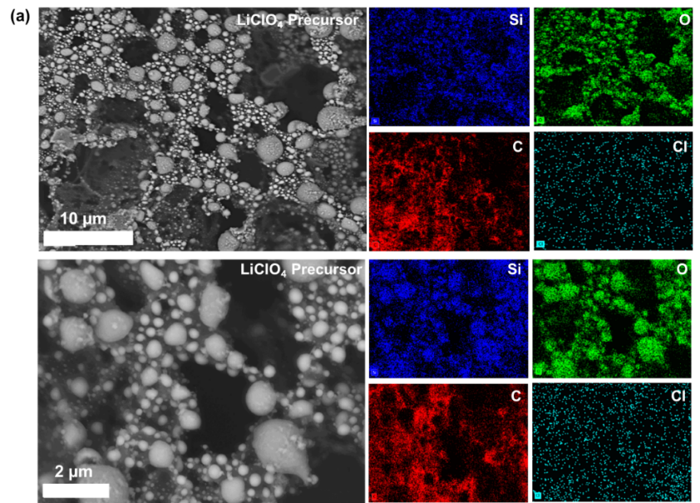
Fig. S11 HRSEM and EDS elemental mapping of a prelithiated SiNP/LIG anode prepared using lithium perchlorate (LiClO₄) as the lithium salt precursor
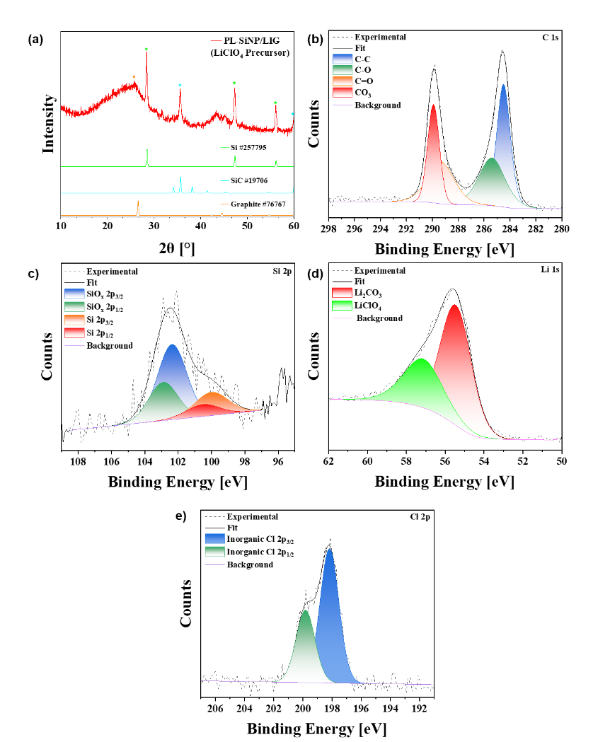
Fig. S12 XRD (a) and XPS (b-e) analysis of a prelithiated SiNP/LIG anode prepared using lithium perchlorate (LiClO₄) as the lithium salt precursor. XRD reference spectra were obtained from the ICSD database and indexed accordingly. XPS peak assignments for C 1s [S5, S6], Si 2p [S7], Li 1s [S6], and Cl 2p [S8] were performed using the NIST XPS database and cited accordingly
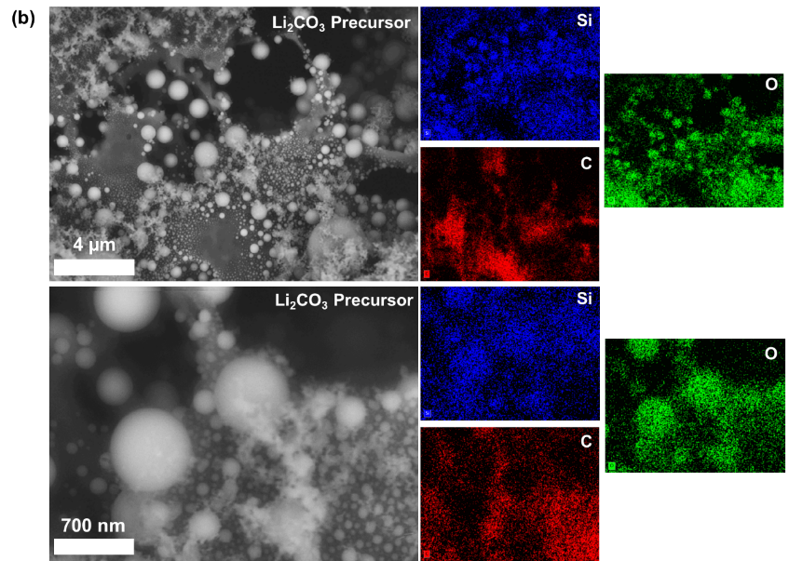
Fig. S13 HRSEM and EDS imaging and elemental distribution mapping of a prelithiated SiNP/LIG anode prepared using lithium carbonate (Li₂CO₃) as the lithium salt precursor.
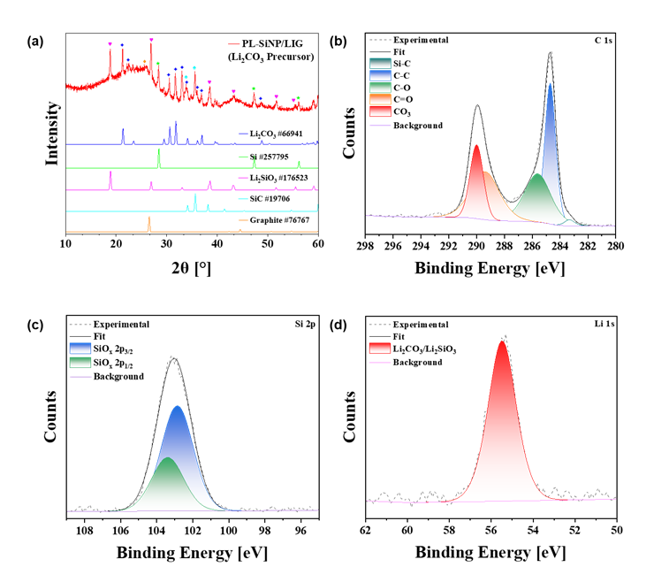
Fig. S14 XRD (a) and XPS (b-e) analysis of a prelithiated SiNP/LIG anode prepared using lithium carbonate (Li₂CO₃) as the lithium salt precursor. XRD reference spectra were obtained from the ICSD database and indexed accordingly. XPS peak assignments for C 1s [S5, S6], Si 2p [S9], and Li 1s [S6, S10] were performed using the NIST XPS database and cited accordingly
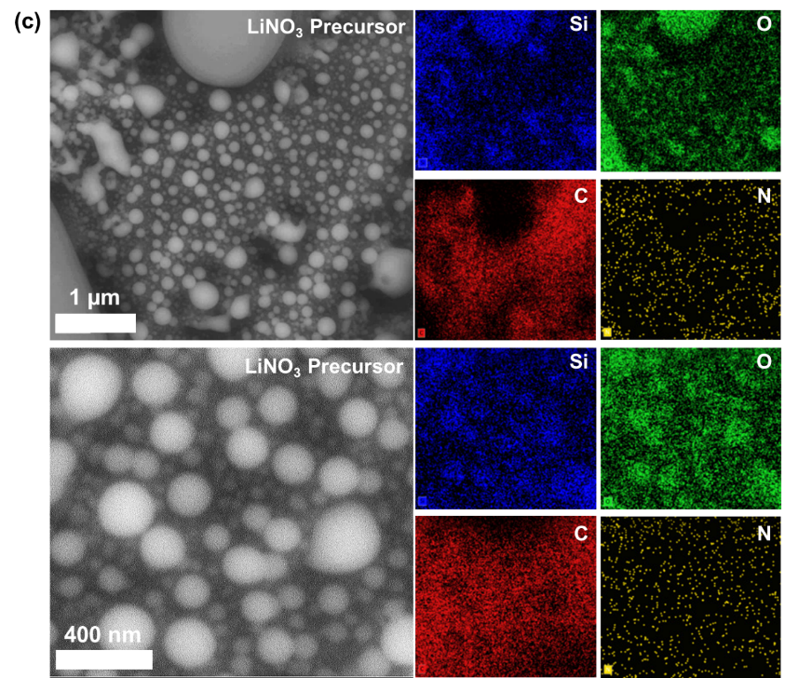
Fig. S15 HRSEM and EDS imaging and elemental distribution mapping of a prelithiated SiNP/LIG anode prepared using lithium nitrate (LiNO₃) as the lithium salt precursor
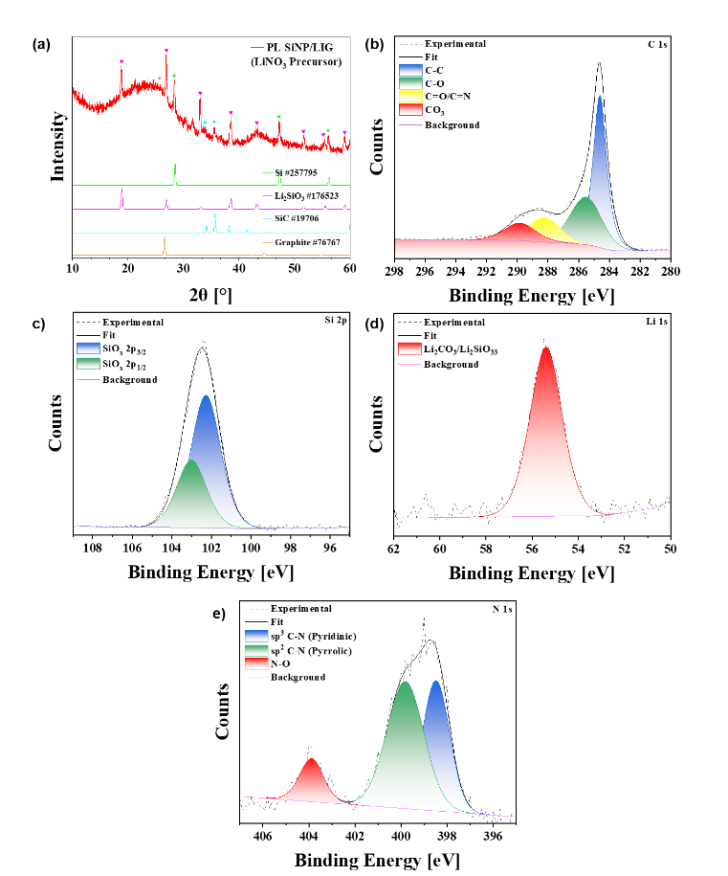
Fig. S16 XRD (a) and XPS (b-e) analysis of a prelithiated SiNP/LIG anode prepared using lithium nitrate (LiNO₃) as the lithium salt precursor. XRD reference spectra were obtained from the ICSD database and indexed accordingly. XPS peak assignments for C 1s [S5, S6], Si 2p [S9], Li 1s [S6, S10], and N 1s [S11]were performed using the NIST XPS database and cited accordingly
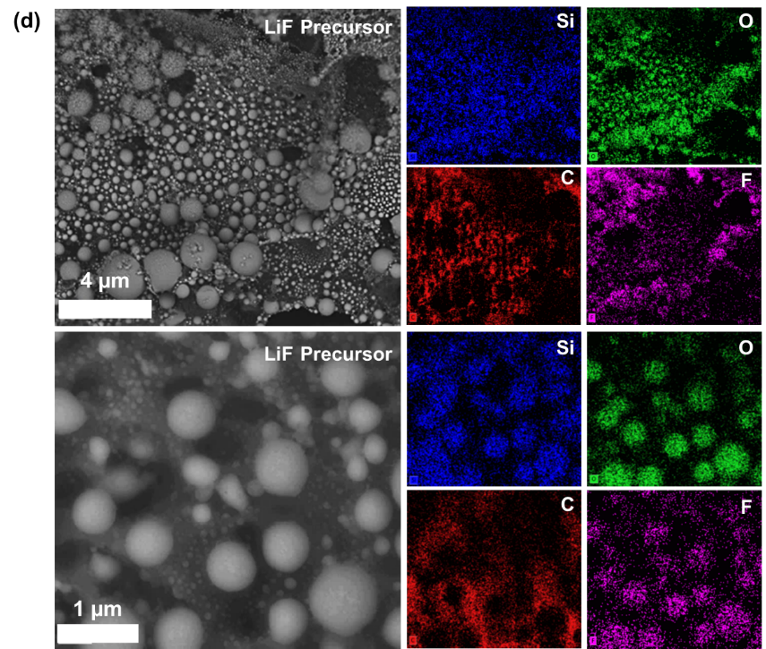
Fig. S17 HRSEM and EDS imaging and elemental distribution mapping of a prelithiated SiNP/LIG anode prepared using lithium fluoride (LiF) as the lithium salt precursor
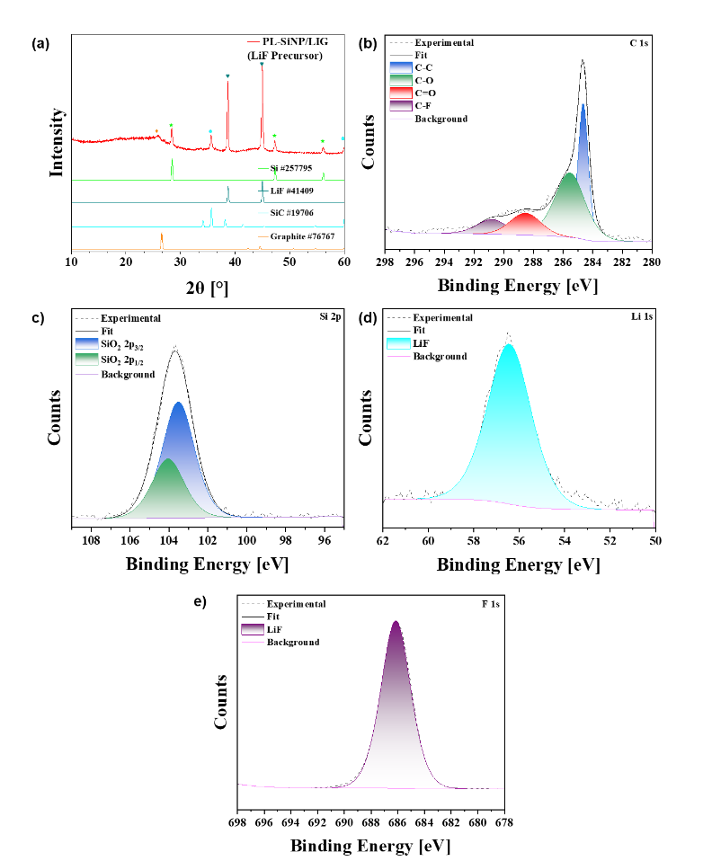
Fig. S18 XRD (a) and XPS (b-e) analysis of a prelithiated SiNP/LIG anode prepared using lithium fluoride (LiF) as the lithium salt precursor. XRD reference spectra were obtained from the ICSD database and indexed accordingly. XPS peak assignments for C 1s [S5, S12], Si 2p [S9], Li 1s [S13], and F 1s [S13]were performed using the NIST XPS database and cited accordingly
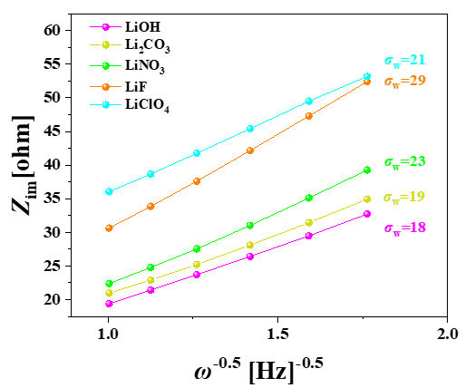
Fig. S19 Slopes extracted from the low-frequency region of the EIS Nyquist plots in Fig. 5a of the manuscript, corresponding to the Warburg impedance, were calculated using equation (3) in the Methods section to analyze lithium-ion diffusion characteristics in prelithiated SiNP/LIG anodes with varying types of Li precursors

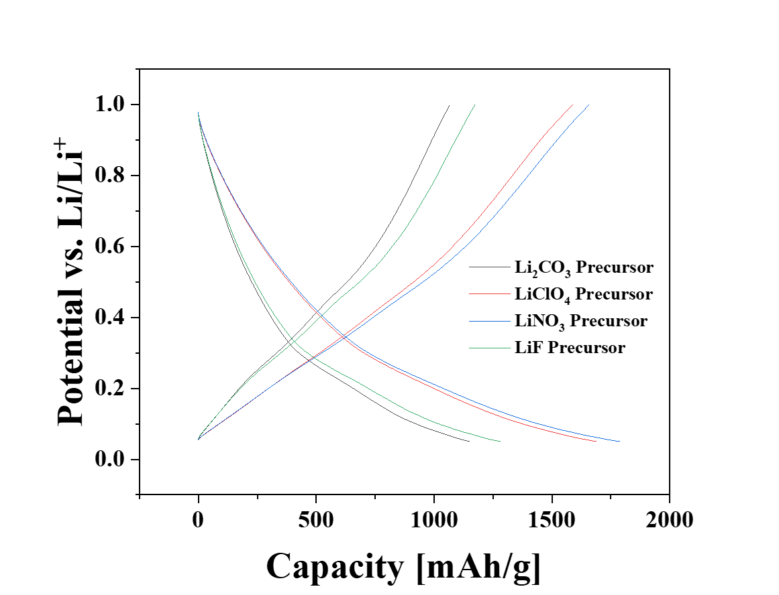
Fig. S20 Voltage–capacity profiles during the initial cycles of prelithiated SiNP/LIG anodes prepared using different lithium salt precursors, showing ICEs of 92% for the carbonate precursor, 94% for the perchlorate precursor, 92% for the nitrate precursor, and 91% for the fluoride precursor

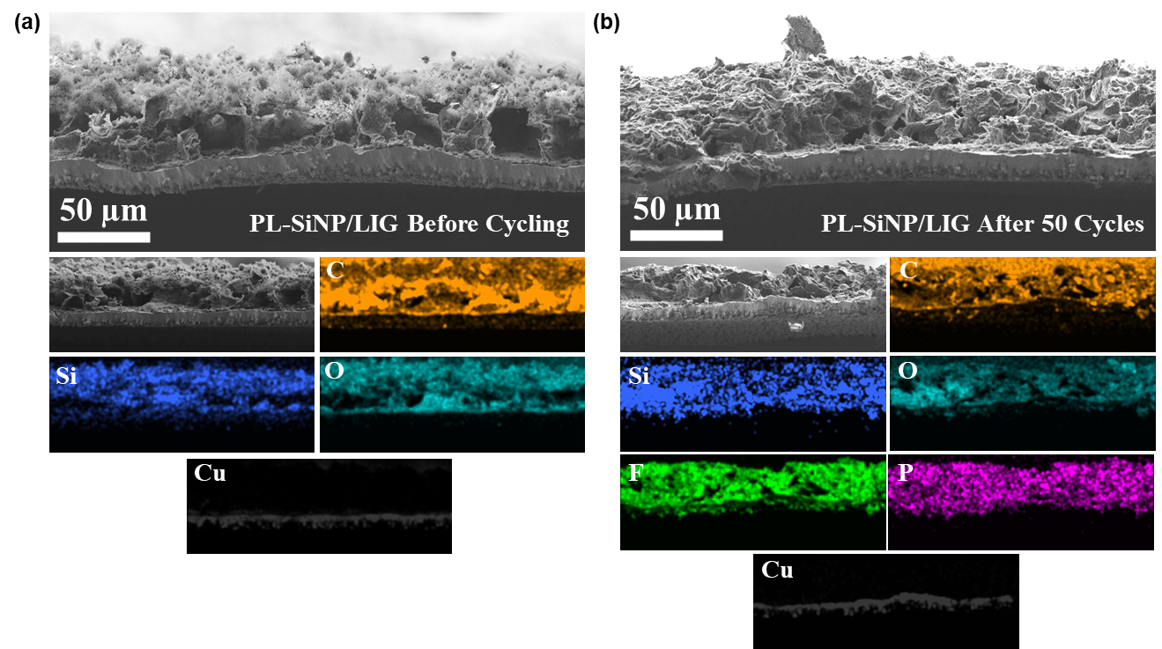
Fig. S21 Cross-sectional HRSEM and EDS analysis of PL-SiNP/LIG anodes prepared using a 1:1 Si:LiOH precursor ratio before cycling (a) and after 50 cycles (delithiated) (b), showing excellent mechanical stability with no delamination, minimal volume change (∼50 µm thickness before and after cycling), and limited SEI formation
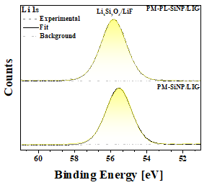
Fig. S22 High-resolution X-ray photoelectron spectroscopy (XPS) spectra of the Li 1s region in post-mortem (PM) samples of non-prelithiated and prelithiated (PL) SiNP/LIG anodes after cycling, complementing the XPS data shown in Fig. 6e–g of the manuscript [S9, S13]
Supplementary References
- L.A. Middlemiss, A.J.R. Rennie, R. Sayers, A.R. West, Characterisation of batteries by electrochemical impedance spectroscopy. Energy Rep. 6, 232–241 (2020). https://doi.org/10.1016/j.egyr.2020.03.029
- Y. Ha, T.R. Martin, S. Frisco, L. Rynearson, M.C. Schulze et al., Evaluating the effect of electrolyte additive functionalities on NMC622/Si cell performance. J. Electrochem. Soc. 169(7), 070515 (2022). https://doi.org/10.1149/1945-7111/ac7e75
- T. Vorauer, P. Kumar, C.L. Berhaut, F.F. Chamasemani, P.-H. Jouneau et al., Multi-scale quantification and modeling of aged nanostructured silicon-based composite anodes. Commun. Chem. 3, 141 (2020). https://doi.org/10.1038/s42004-020-00386-x
- B. Jerliu, E. Hüger, L. Dörrer, B.K. Seidlhofer, R. Steitz et al., Lithium insertion into silicon electrodes studied by cyclic voltammetry and operando neutron reflectometry. Phys. Chem. Chem. Phys. 20(36), 23480–23491 (2018). https://doi.org/10.1039/C8CP03540G
- B. Rui, M. Yang, L. Zhang, Y. Jia, Y. Shi et al., Reduced graphene oxide-modified biochar electrodes via electrophoretic deposition with high rate capability for supercapacitors. J. Appl. Electrochem. 50(4), 407–420 (2020). https://doi.org/10.1007/s10800-020-01397-1
- N. Hornsveld, B. Put, W.M.M. Kessels, P.M. Vereecken, M. Creatore, Plasma-assisted and thermal atomic layer deposition of electrochemically active Li₂CO₃. RSC Adv. 7(66), 41359–41368 (2017). https://doi.org/10.1039/c7ra07722j
- J.A.L. López, J.C. López, D.E.V. Valerdi, G.G. Salgado, T. Díaz-Becerril et al., Morphological, compositional, structural, and optical properties of Si-nc embedded in SiOx films. Nanoscale Res. Lett. 7(1), 604 (2012). https://doi.org/10.1186/1556-276X-7-604
- W.E. Morgan, J.R. Van Wazer, W.J. Stec, Inner-orbital photoelectron spectroscopy of the alkali metal halides, perchlorates, phosphates, and pyrophosphates. J. Am. Chem. Soc. 95(3), 751–755 (1973). https://doi.org/10.1021/ja00784a018
- K.-J. Jeong, S. Hossen, M.T. Rahman, J.S. Shim, D.-H. Lee et al., Enhancing charging efficiency with lithium silicate in silicon composite anode materials through lithiothermic reduction reaction synthesis. Adv. Mater. Technol. 9(14), 2302055 (2024). https://doi.org/10.1002/admt.202302055
- Chengxu Shenab, Rusheng Fua, Yonggao XiaORCID logo*a and Zhaoping Liu, New perspective to understand the effect of electrochemical prelithiation behaviors on silicon monoxide. RSC Adv. 8, 14473-14478 (2018). https://doi.org/10.1039/C8RA01917G
- C. Xie, L. Lin, L. Huang, Z. Wang, Z. Jiang et al., Zn-N(x) sites on N-doped carbon for aerobic oxidative cleavage and esterification of C(CO)-C bonds. Nat. Commun. 12(1), 4823 (2021). https://doi.org/10.1038/s41467-021-25118-0
- M.R. Busche, M. Weiss, T. Leichtweiss, C. Fiedler, T. Drossel et al., The Formation of the solid/liquid electrolyte interphase (SLEI) on NASICON-type glass ceramics and LiPON. Adv. Mater. Interfaces 7(19), 2000380 (2020). https://doi.org/10.1002/admi.202000380
- T. Yu, T. Zhao, N. Zhang, T. Xue, Y. Chen et al., Spatially confined LiF nanoparticles in an aligned polymer matrix as the artificial SEI layer for lithium metal anodes. Nano Lett. 23(1), 276–282 (2023). https://doi.org/10.1021/acs.nanolett.2c04242

