Supporting Information for
Aggregation-Induced-Emission Luminogens Functionalized MXene Nanosheets for Stimuli-Responsive Hydrogel in Pyroptosis-Mediated Choroidal Melanoma Therapy
Yingni Xu¹, Fei Wang¹, Wenfang Liu², Ruibin Lin², Cheng Liu¹, Qi Zhao², Guokang He¹, Guiping Yuan¹, Weidong Yin¹, Fei Yu³, Jianwei Sun¹, Ryan T. K. Kwok^{1,} *, Jacky W. Y. Lam¹, Li Ren ^{2,} *, Xuan Zhao ^{4,} *, Jin Yuan ^{4,} *, and Benzhong Tang ^{1, 5,} *
¹ Department of Chemistry, The Hong Kong Branch of Chinese National Engineering Research Center for Tissue Restoration and Reconstruction, Department of Chemical and Biological Engineering, Division of Life Science and State Key Laboratory of Molecular Neuroscience, The Hong Kong University of Science and Technology, Clear Water Bay, Kowloon, Hong Kong 999077, P. R. China
² School of Materials Science and Engineering, South China University of Technology, Guangzhou 510006, P. R. China
³ Sun Yat-sen Memorial Hospital, Sun Yat-Sen University, Guangzhou 510020, P. R. China
⁴ Beijing Tongren Eye Center, Beijing Tongren Hospital, Capital Medical University, Beijing Key Laboratory of Ophthalmology & Visual Sciences, Beijing, 100730, P. R. China
⁵ Guangdong Basic Research Center of Excellence for Aggregate Science, School of Science and Engineering, Shenzhen Institute of Aggregate Science and Technology, The Chinese University of Hong Kong, Shenzhen (CUHK-Shenzhen), Guangdong 518172, P. R. China
*Corresponding authors. E-mail: chryan@ust.hk (Ryan T. K. Kwok); psliren@scut.edu.cn (Li Ren); zhaox229@mail.sysu.edu.cn (Xuan Zhao); yuanjincornea@126.com (Jin Yuan); tangbenz@cuhk.edu.cn (Benzhong Tang)

S1 Experimental Procedures

S1.1 Main Materials
The Nb₂AlC ceramic powder was purchased from Xinxi Technologies (Guangzhou, China). 4-bromo-N, N-bis(4-Methoxyphenyl) aniline, 5-Formyl-2-thiopheneboronic acid, Pd(dppf)Cl₂, p-toluenesulfonic acid, 4-methylpyridine were purchased from TCI Chemicals (Shanghai, China). Br-PEG-NH₂ was purchased from Tanshui Technologies (Guangzhou, China). Agarose (low gelling temperature) was purchased from Macklin (China). 3-[N, N″-dimethyl-2-(2-methylprop-2-benzyloxy)ethylammonium]propane-1-sulfonate inner salt (purity 98%) (SBMA), ammonium persulfate (APS) (purity > 99.0%), tetramethylethylenediamine (TEMED) (purity 99%), were all obtained from J&K (China). Phosphate buffered saline (PBS), (DMEM) medium, fetal bovine serum (FBS), penicillin/streptomycin, LysoTracker Green, and MitoTracker Green were purchased from Thermo Fisher Scientific. 3,4-dihydro-2,3-dimethyl-2H-pyrrole 1-oxide (DMPO), 2,2,6,6-Tetramethyl-4-piperidone hydrochloride (TEMP) were obtained from Dojindo (Japan). 2',7'-dichlorodihydrofluorescein diacetate (DCFH-DA), 3'-(p-hydroxyphenyl) fluorescein (HPF), 9,10-anthracenediyl-bis(methylene) dimalonic acid (ABDA), dihydrorhodamine (DHR) were purchased from Sigma-Aldrich. Chlorin e6 (Ce6) was purchased from Frontier Scientific. Reactive oxygen species (ROS) detection kit, MTT Cell Proliferation Assay Kit Calcein-AM and D-Luciferin potassium salt were purchased from Beyotime Biotech (Shanghai, China). Anti-GSDMD antibody and anti-cleaved N-terminal GSDMD antibody were obtained from Abcam (UK). MUM-2B cells were purchased from BNCC (China). S. aureus and E. coli were obtained from China General Microbiological Culture Collection Center. All other chemicals were of analytical grade and were used as received without further purification. Ultrapure water was supplied by Mill-Q Plus System (Millipore Corporation, USA).

S1.2 Synthetic of PEG-MeoTTPy
The synthetic route of PEG-MeoTTPy is shown in Scheme S1, and the detailed experimental procedures including three steps are given below.
Scheme S1 Synthesis route of PEG-MeoTTPy
Synthesis of 5-(4-(diphenylamino) phenyl) thiophene-2-carbaldehyde (1). A solution of 4-bromo-N, N-bis(4-Methoxyphenyl) aniline (1.9 g, 5 mmol), 5-Formyl-2-thiopheneboronic acid (1.01 g, 6.5 mmol), Pd(dppf)Cl₂ (366 mg, 0.5 mmol) and K₂CO₃ (3.45 g, 25 mmol) was refluxed under nitrogen in dry methanol and toluene mixture (1:1 v/v) at 75 ℃ for 24 h. After cooling to room temperature, the solvent was removed and the residue was extracted with dichloromethane (DCM) and water. The crude product was purified by a silica gel column chromatography using petroleum hexane/DCM (2:1 v/v) as eluent to give a white powder of 1. Yield: 90%. ¹H NMR (400 MHz, DMSO-d₆) δ: 9.83 (s, 1H), 7.97 (d, J = 4.0 Hz, 1H), 7.60 (d, J = 8.8 Hz, 2H), 7.53 (d, J = 4.0 Hz, 1H), 7.10 (d, J = 8.9 Hz, 4H), 6.95 (d, J = 8.9 Hz, 4H), 6.74 (d, J = 8.8 Hz, 2H), 3.75 (s, 6H).
Synthesis of 2. A solution of compound 1 (1 g, 3 mmol) and p-toluenesulfonic acid (1.725 g,9 mmol) was refluxed under nitrogen in dry DMF (20 mL) at 150 ℃. Afterward, 4-methylpyridine (0.88 mL,9 mmol) was added via syringe and reaction for 24 h. Afterwards, the mixture was then cooled to room temperature and extracted with DCM and water. The crude product was purified by a silica gel column chromatography using DCM/methanol (99:1 v/v) as eluent to get a bright yellow powder of 2. Y Yield: 75%. ¹H NMR (400 MHz, DMSO-d₆) δ: 8.50 (d, J = 6.1 Hz, 2H), 7.71 (d, J = 16.1 Hz, 2H), 7.52 (d, J = 6.3 Hz, 2H), 7.49 (d, J = 8.8 Hz, 2H), 7.32 (d, J = 3.8 Hz, 1H), 7.26 (d, J = 3.9 Hz, 1H), 7.07 (d, J = 8.9 Hz, 4H), 6.94 (d, J = 9.0 Hz, 4H), 6.86 (d, J = 16.1 Hz, 2H), 6.77 (d, J = 8.8 Hz, 2H), 3.75 (s, 6H). ¹³C NMR (100 MHz, DMSO-d₆) δ: 155.9, 149.8, 148.2, 144.1, 143.8, 139.4, 139.0, 130.1, 126.9, 126.3, 126.1, 124.6, 124.0, 122.6, 120.3, 118.7, 114.9, 55.1.
Synthesis of PEG-MeoTTPy (3). A solution of Br-PEG-NH₂ (50 mg, about 0.025 mmol) and 2 (85.86 mg, 0.175 mmol) was refluxed under nitrogen in dry acetonitrile (20 mL) at 80 ℃ for 24 h. After cooling to room temperature, the mixture was added into 200 mL of ice-cold diethyl ether with vigorous stirring. The precipitates were separated by centrifugation and washed three times with diethyl ether and dried in vacuum at 40 ℃ to a constant weight. Eventually, PEG-MeoTTPy was obtained as magenta powder in 80% yield.

S1.3 DFT Calculations
PEG-MeoTTPy was fully optimized with the density functional theory (DFT) method by using B3LYP density functional and 6-31G (d, p) basis set. Analytical frequency calculations were also performed at the same level of theory to confirm that the optimized structures were at a minimum point. Above quantum chemical calculations were carried out by using Gaussian 16 program. The electron cloud distribution maps were also displayed using VMD software package.

S1.4 Preparation of Nb₂C Nanosheets (MXene)
2D Nb₂C nanosheets were synthesized by using an in situ HF method. In a typical synthesis, LiF (1.7 g) was dissolved in HCl (20 mL, 9 M), followed by the addition of Nb₂AlC powders (1.0 g), and etched for 48 h at 40 ℃. Then, dilute HCl and deionized water were used to wash the acidic mixture solution via centrifugation for multiple cycles until a pH of 6-7 was achieved. Finally, bath sonication was adopted to exfoliate well-dispersed clay-like solid suspension (aqueous solution) for 4 h (Power: 200 W, On/Off cycle: 30 min/20 min), the colloidal dispersion of Nb₂C nanosheets was obtained after centrifugation at 4000 rpm.

S1.5 Nanosheets Characterization
TEM images were performed on transmission electron microscope (JEM-F200, Japan). SEM images and EDS mapping of MX@PEG-MeoTTPy nanosheets were taken on scanning electron microscopy (FEI APREO S, USA). High-resolution mass spectra (HRMS) were recorded on a Finnegan MAT TSQ 7000 Mass Spectrometer System operating in a MALDI-TOF mode. X-ray photoelectron spectroscopy (XPS) was carried out using an X-ray photoelectron spectroscopy (Thermo Scientific K-Alpha, USA). Raman spectra were obtained on high-resolution confocal Raman microscope (Renishaw inVia- Reflex, UK) equipped with 532 nm laser as the excitation source. Fourier transform infrared (FT-IR) was carried out on a Thermo Scientific Nicolet 6700 spectrometer. Size and Zeta potential of samples were determined by a DLS instrument (Malvern Mastersizer 2000, Zeta-sizer Nano ZS90, UK). The UV-vis absorbance and fluorescence intensity of samples were measured by UV-vis spectrophotometer (PerkinElmer Lambda 950, USA) and fluorescent spectrophotometer (Edinburgh Instruments FS5, UK), respectively. The temperature variation and infrared thermal images were recorded by an infrared thermal imaging camera (FLIR-E6, USA). The NIR-I laser was produced using an 808 nm high-power multimode pump laser (Shanghai Connect Fiber Optics Co.). The AIE property of PEG-MeoTTPy was demonstrated by studying its fluorescence behavior in a mixture of MeOH and ether with different volume ratios. Each group contained 10 μM AIEgens and the FL spectra were collected under 510 nm excitation.

S1.6 Photothermal Performance of MX@PEG-MeoTTPy Nanosheets
Photothermal performance of MX@PEG-MeoTTPy nanosheets was obtained and analyzed by irradiating a 1.5 mL EP tube containing a dispersion of nanosheets. The photothermal heating curves were obtained by monitoring the temperature changes of different samples (MXene nanosheets and MX@PEG-MeoTTPy nanosheets) at desired concentrations upon irradiation, and the corresponding temperatures and infrared thermal images were recorded by an infrared thermal imaging camera. The optical sources were provided by an 808 nm NIR laser or white light. The influence of power density on the photothermal properties was also investigated. A heating-cooling cycle assay was applied to study the photothermal stability of MX@PEG-MeoTTPy nanosheets dispersion (containing 100 μg mL⁻¹ MXene nanosheets and 50 μM PEG-MeoTTPy) by laser on (5 min) and following laser off (5 min) for five cycles with an 808 nm NIR laser (0.8 W cm⁻²).

S1.7 ROS Detection and EPR Analysis
The fluorescent probe DCFH-DA was applied as indicator to detect the ROS generation efficiency. The fluorescence intensity of DCFH-DA enhanced after reaction with ROS. In brief, the activated DCFH-DA (10⁻⁵ M) solution was mixed separately with different samples, and the final concentrations were as follow: 10⁻⁵ M PEG-MeoTTPy, MXene nanosheets (20 µg mL⁻¹), MX@PEG-MeoTTPy (containing 20 µg mL⁻¹ MXene nanosheets and 10⁻⁵ M PEG-MeoTTPy), and10⁻⁵ M Ce6. Then the mixture was irradiated with 808 nm NIR laser irradiation (NIR, 0.8 W cm⁻²) and/or white light (WL, 20 mW cm⁻²), and determined via fluorescent spectrophotometer (excitation wavelength: 488 nm and emission wavelength: 525 nm). The ROS generation efficiency (I/I₀) was calculated using the maximal fluorescence intensity (I) after desired time of irradiation and the initial fluorescence intensity (I₀) without irradiation.
In order to further distinguish the types of ROS generated by MX@PEG-MeoTTPy nanosheets, ABDA, HPF and DHR were used as the specific indicator to evaluate the ¹O₂,
•OH and •O₂⁻ generation ability. In brief, ABDA (5 × 10⁻⁵ M) solution was mixed separately with different samples as above, and then exposed to light irradiation. The absorbance decrease of ABDA at 378 nm was recorded at various irradiation time. HPF solution of 5 × 10⁻⁶ M was added with samples and then subjected to the same light irradiation condition. The fluorescence signal of indicator was monitored in a range of 500-600 nm with the excitation wavelength at 490 nm. The fluorescence intensity at 515 nm was recorded to indicate the •OH generation rate. DHR of 1 × 10⁻⁵ M was added with samples under light irradiation, the fluorescence signal of indicator was monitored in a range of 510-600 nm with the excitation wavelength at 525 nm. The fluorescence intensity at 525 nm was recorded to indicate the •O₂⁻ generation rate. EPR analysis was determined the formation of ¹O₂ and •OH by using 2,2,6,6-Tetramethyl-4-piperidone hydrochloride (TEMP) and 5,5-dimethyl-1-pyrrolidine-N-oxide (DMPO) as spin-trapping agents as a spin trap agent.

S1.8 Cell Culture
MUM-2B cells, mouse myoblast C2C12 cells were cultured in medium containing Dulbecco's Modified Eagle’s Medium (DMEM), 10% FBS and antibiotics (100 units mL⁻¹ penicillin and 100 µg mL⁻¹ streptomycin) in a 5 % CO₂ humility incubator at 37 ℃.

S1.9 Intracellular of ROS Generation
The generation of intracellular ROS was evaluated in MUM-2B cells using DCFH-DA as indicator. Cells were seeded into confocal plates and incubated for 12 h. The culture mediums were replaced with 1 mL fresh medium containing MXene nanosheets (100 µg mL⁻¹), PEG-MeoTTPy (50 µM) and MX@PEG-MeoTTPy nanosheets (containing 100 µg mL⁻¹ MXene nanosheets and 50 µM PEG-MeoTTPy), and the cells were incubated for another 4 h at 37 ℃. Then the cells were washed with PBS and incubated with 1 mL fresh medium containing 5 × 10⁻⁶ M DCFH-DA for additional 20 min at 37 ℃. The cells were washed with PBS and irradiated by 808 nm NIR laser (0.8 W cm⁻², 5 min) or/and white light (20 mW cm⁻², 10 min). After that, the fluorescence images of cells were captured by CLSM. The exciting wavelength of DCFH-DA were 488 nm. Following this, cells were washed, trypsinized and the DCF fluorescence intensity of the cells was measured with microplate reader.

S1.10 In vitro Cytotoxicity Study
To determine the cytotoxicity of MX@PEG-MeoTTPy nanosheets under different treatment, MUM-2B cells were used for MTT assay. Typically, MUM-2B cells were seeded in 96-well plates and cultured overnight. Then the medium was replaced with 200 μL fresh medium containing various MX@PEG-MeoTTPy concentrations (MXene concentration was from 0 - 100 µg mL⁻¹, and the corresponding PEG-MeoTTPy concentration was from 0 - 50 µM). After incubation for 4 h, the cells were irradiated by an 808 nm NIR laser at a power density of 0.8 W cm⁻² for 5 min and/or white light at a power density of 20 mW cm⁻² for 10 min. The area of each well was fully covered by the laser spot. After being illuminated, the cells were incubated for another 24 h before the MTT assay. The cell viability was normalized to the control group without any treatment. Besides, in order to prove Type-I ROS generation of nanosheets, an intracellular hypoxic microenvironment was set up using oxygen-sparing bag (MGC AnaeroPack), and cells were treated under a hypoxic atmosphere (< 2% O₂) with the same above steps.
The cytotoxicity of MXene nanosheets and PEG-MeoTTPy alone were also evaluated. MUM-2B cells were selected as a model cancer cells. Briefly, MUM-2B cells cultured in 96-well plates as described above were incubated with MXene nanosheets or PEG-MeoTTPy at various concentrations for 4 h. Subsequently, the cells were irradiated or not by an 808 nm NIR laser at a power density of 0.8 W cm⁻² for 10 min or white light at a power density of 20 mW cm⁻² for 30 min. After incubation for another 24 h, the cell viability was determined by MTT assay and normalized to the control group without any treatment.
As for selective cell killing, MUM-2B (cancer cells) and C2C12 (normal cells) were used. MUM-2B and C2C12 cells cultured in 96-well plates as described above were incubated with MX@PEG-MeoTTPy nanosheets at various concentrations for 4 h. Then the cells were irradiated by an 808 nm NIR laser at a power density of 0.8 W cm⁻² for 10 min and white light at a power density of 20 mW cm⁻² for 30 min. After incubation for another 24 h, the cell viability was determined by MTT assay and normalized to the control group without any treatment.
To evaluate different inhibitors on cell death induced by MX@PEG-MeoTTPy nanosheets, cells were pretreated with the inhibitors (3-MA: 0.5 mM; Z-VAD-fmk: 50 μM; ferr-1: 10 μM; Lip-1: 200 nM; NSA: 10 μM; Nec-1: 100 μM; Disulfiram: 3 μM for 1 h, then incubated with MX@PEG-MeoTTPy nanosheets, the next procedures were the same as above illustrated.

S1.11 RNA-Seq Analysis
RNA was isolated using TRIzol reagent (Invitrogen). After RNA extraction and purification, library construction and sequencing were performed at Personalbio Corporation (Shanghai, China) to conduct next-generation sequencing based on the Illumina sequencing platform (USA). To further assess the integrin-based pathway, gene set enrichment analysis (GSEA) was used to analyze the differentially expressed genes of NOD-like receptor signaling pathway.

S1.12 Gene Expression Analysis
MUM-2B cells treated with MX@PEG-MeoTTPy nanosheets (containing 100μg mL⁻¹ MXene nanosheets and 50 μM PEG-MeoTTPy) under different conditions were collected for gene expression analysis, including cells under PBS, nanosheets under dark, nanosheets under NIR, nanosheets under white light and nanosheets under NIR+white light. Then the cells were collected and lysed using TRIzol reagent (Invitrogen) to extract RNA using a HiPure Total RNA Micro Kit (Magen). The RNA quality and concentration were determined using a NanoDrop 2000 spectrophotometer (Thermo Scientific,USA). A PrimeScript RT reagent kit with gDNA Eraser (TaKaRa Biotechnology, Japan) was used to reverse transcribe the same amount of RNA into cDNA according to the manufacturer’s protocol. The primers for the target gene were listed in Table S2 (Supporting Information). Real-time PCR detection was performed using SYBR Green reagents (GeneCopoeia) on an RT-PCR instrument (QuantStudio 6 Flex, Life Technologies) with 40 amplification cycles. Cells cultured on flat structures were used as a reference for comparison. GAPDH was used as an endogenous control for normalization of the expression levels of genes using the ΔΔCt method¹.

S1.13 Intracellular IL-18/IL-1β Assay
MUM-2B cells were seeded in 6-well plates for 12 h. After that, the cells were treated with MX@PEG-MeoTTPy nanosheets (containing 100 μg mL⁻¹ MXene nanosheets and 50 μM PEG-MeoTTPy) for 4 h. Then, the cells in irradiation groups were exposed to 808 nm NIR laser at a power density of 0.8 W cm⁻² for 3 min and white light at a power density of 20 mW cm⁻² for 5 min. The LDH amount was detected using IL-18/IL-1β assay kit.

S1.14 Western Blotting Analysis
MUM-2B cells were seeded in 6-well plate and incubated at 37 °C. After the cell confluence reached of 80%. The cells were harvested by trypsinization, the resulting cells were treated with different conditions for 4 h, including nanosheets under dark, nanosheets under NIR, nanosheets under white light and nanosheets under NIR plus white light, followed by 808 nm NIR laser at a power density of 0.8 W cm⁻² for 3 min and white light at a power density of 20 mW cm⁻² for 5 min. When the treatment was done, the cells were centrifuged for lysis. The cell lysates were collected to determine the protein content using BCA protein assay kit. Protein extracts were separated by SDS-PAGE (15% acrylamide) and then transferred to PVDF membrane. The membrane was blocked with 5% skim milk for 1 h, following by incubating with primary antibodies of anti-mGSDMD and anti-cleaved N-mGSDMD at 4 °C overnight. The membrane was washed with TBST buffer and incubated with horseradish peroxidase labeled goat anti rabbit or mouse antibodies (1:1000) at room temperature for 1 h. After washing by TBST buffer, the membrane was visualized by chemiluminescence detection reagent. The labelled bands were scanned by Tanon Fine Do X6+ Multi. Protein expression levels were analyzed using GIS 1D analyzing software.

S1.15 Characterization of GNSs
The internal cavity micromorphology of GNSs was observed using a scanning electron microscope (SEM, Merlin, Germany) at a voltage of 20 kV, and the samples were frozen in liquid nitrogen and quickly fractured before being treated by spraying gold. Photothermal performance of GNSs was as mentioned above in the photothermal performance of MX@PEG-MeoTTPy nanosheets section.

S1.16 Light Controlled Release Behavior of GNSs
To study the NIR light-triggered MX@PEG-MeoTTPy nanosheets release profile, 0.5 mL GNSs (containing 300 μg mL⁻¹ MXene nanosheets and 150 μM PEG-MeoTTPy) was added into 2.5 mL of PBS (pH = 7.4) and exposed to an NIR laser (808 nm, 0.8 W⋅cm⁻²) for 5 min followed by an interval of 5 min, and the procedure was repeated four times. Notably, the control sample did not accept any irradiation during the whole release procedure. To determine the concentration of the released MX@PEG-MeoTTPy nanosheets, the release media was removed at predetermined time intervals for UV-vis-NIR measurement and replaced with a fresh medium.

S1.17 In vitro Cytotoxicity of GNSs
MUM-2B were seeded into 96-well plates at a density of 5000 cells per well and the cytotoxicity of the NIR-irradiated GNSs was tested. In brief, GNSs (1 mL, containing 300 μg mL⁻¹ MXene nanosheets and 150 μM PEG-MeoTTPy) was put in the DMEM (3 mL) and irradiated under NIR light for 10 min to trigger the MX@PEG-MeoTTPy nanosheets release. The supernatant was collected and 500 μL of the supernatant was added to the MUM-2B cell cultured in 96-well plates. After incubated for 4 h, cells were exposed under an 808 nm NIR laser at a power density of 0.8 W cm⁻² for 5 min and white light at a power density of 20 mW cm⁻² for 10 min, then it was incubated for another 24 h before MTT assay.

S1.18 In vitro Antibacterial Efficacy
S. aureus and E. coli were severed as model bacteria to evaluate antibacterial efficacy of GNSs. GNSs (100 μL, containing 300 μg mL⁻¹ MXene nanosheets and 150 μM PEG-MeoTTPy) were soaked in the bacteria suspension (200 μL), and then they were exposed under dark or NIR light (0.8 W cm⁻², 5 min). After that, the bacteria were incubated for another 30 min and then irradiated with/without white light at a power density of 20 mW cm⁻² for 20 min. Subsequently, the bacteria suspension was diluted 200 times and 100 μL of diluted bacterial suspension was evenly coated on sterilized LB agar plates and incubated at 37 °C for 24 h. The bacterial colonies in plates were photographed, and the survival rate of bacterial was measured.

S1.19 Photothermal Effect Measurements in vivo
To investigate the photothermal effect of the GNSs in vivo, 2 μL of GNSs hydrogel was injected into the eyeballs of BALB/c nude mice (female, 5 weeks old) through the sclera using a Hamilton syringe (Hamilton company, Reno, NV, USA). Then, the temperature change in the eyeballs under 0.8 W cm⁻² NIR irradiation for 4 min was recorded.

S1.20 Histological and Immunohistochemical Analysis
Eight days post treatments, all mice were photographed and sacrificed, and the eyeballs were collected. Eyeballs were collected and fixed in 4% paraformaldehyde solution, embedded in paraffin, and cut into sections (5 μm thick). Then, the tissue sections were stained with H&E and imaged by light microscopy (DM 4000). The pyroptosis level of tumor cells was examined by using TUNEL and GSDMD-N staining.
Monoclonal antibody Ki67 response was performed to detect proliferation activity of tumor cells.

S1.21 In Vivo Biosafety Evaluation
The blood samples of the mice were collected into blood collection tubes immediately by enucleation of mouse eyes before being sacrificed. The main hematological markers and serum biochemical parameters were further tested. Meanwhile, the major organs (heart, liver, spleen, lung, and kidney) were also dissected from the mice for further H&E analysis. As noted, the blood sample and major organs from the untreated mice were used as a control group to compare the biosecurity.

S1.22 Evaluation of Eyeball Function
Slit lamp biomicroscopy (Topcon system) was performed at day 8 postoperative to evaluate the corneal epithelium, corneal transparency and other pathological changes. The corneal epithelial defects were assessed using fluorescein staining under cobalt blue light. Cross-sectional images of corneal tissue were obtained by spectral-domain AS-OCT (TowardPai) to evaluate the corneal structure.

S1.23 Statistical Analysis
The data presented herein are expressed as mean ± standard deviation (SD) unless stated otherwise. Each experiment was repeated at least three times using biologically independent samples. Statistical analysis was performed using one-way ANOVA with multiple comparison analysis using Tukey’s post hoc test, and p-values < 0.05 were considered statistically significant (*p < 0.05; **p < 0.01; ***p < 0.001). All statistical tests and graphs were generated using Origin 9.0 software.

S2 Supplementary Figures

Fig. S1 ¹H NMR spectrum of 1 in DMSO-d₆
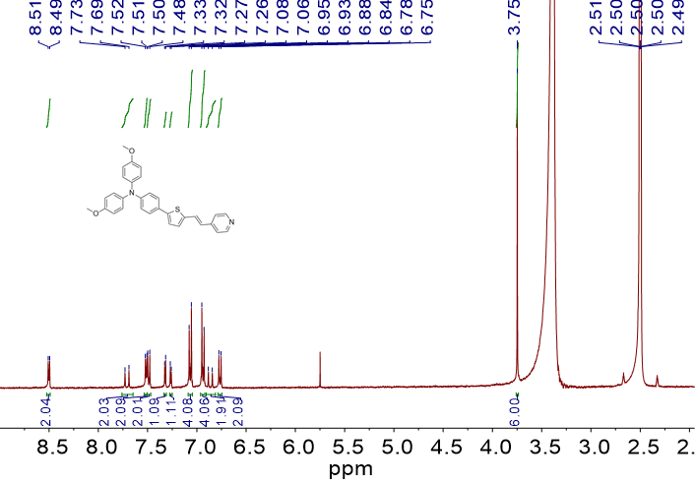
Fig. S2 ¹H NMR spectrum of 2 in DMSO-d₆

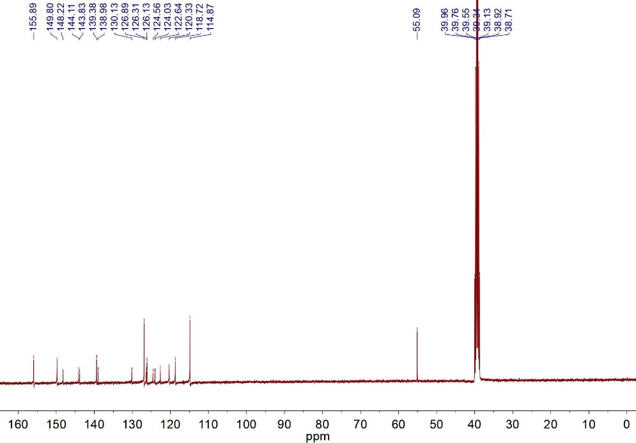
Fig. S3 ¹³C NMR spectrum of 2 in DMSO-d₆

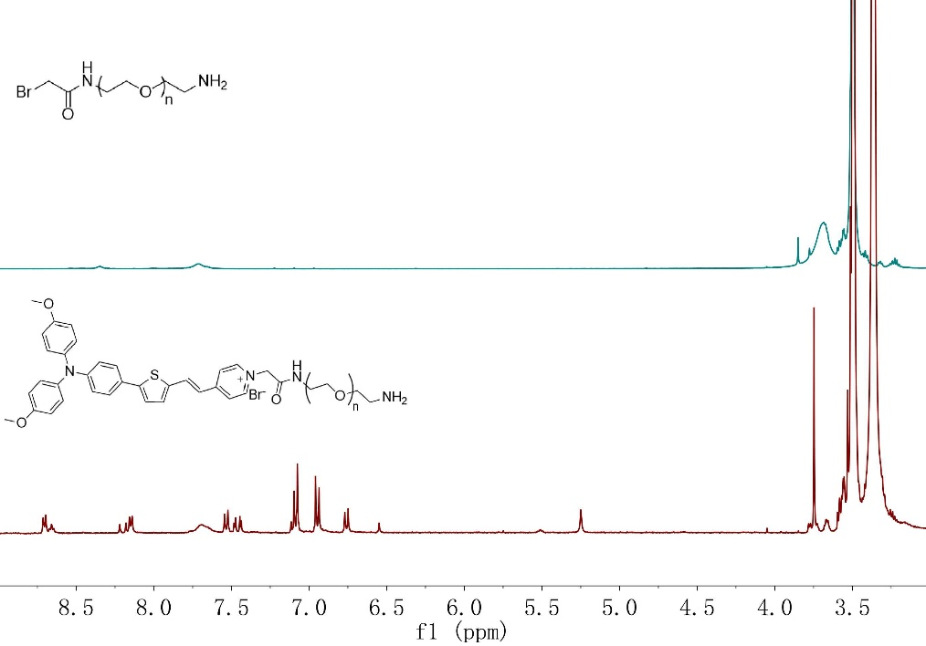
Fig. S4 ¹H NMR spectrum of 3 in DMSO-d₆

Fig. S5 HRMS spectrum of 3

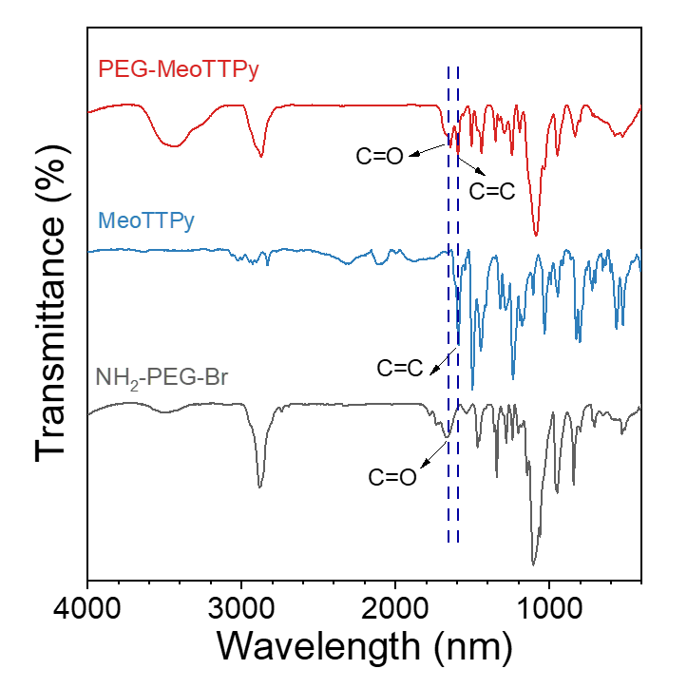
Fig. S6 FT-IR spectra of samples

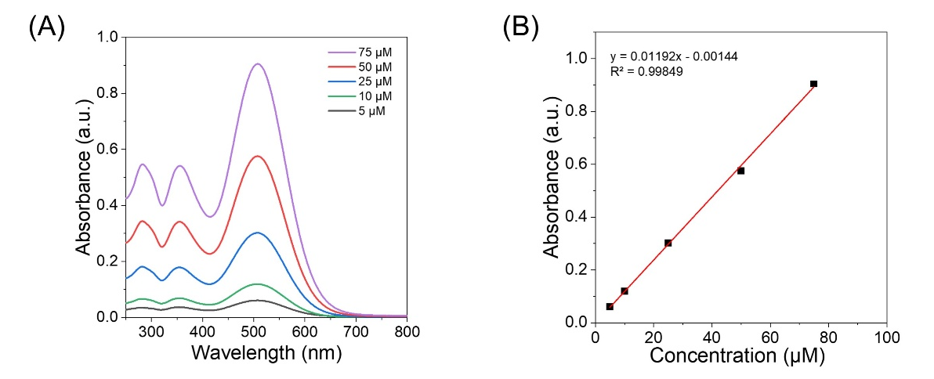
Fig. S7 UV–vis–NIR spectra of 3 with different concentrations (A) and the corresponding standard curve (B)

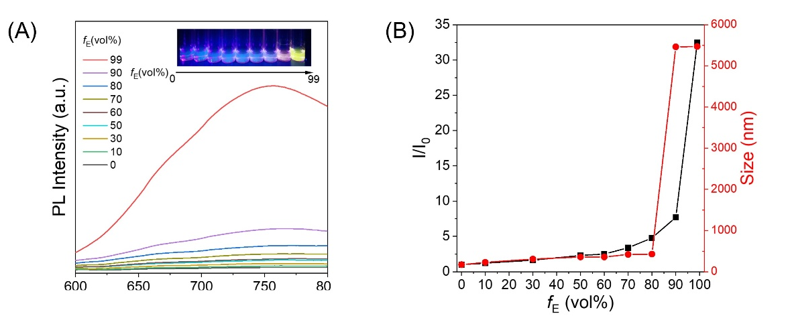
Fig. S8 (A) Fluorescence spectra of 3 (10 μM) in MeOH/ether mixtures with different ether content (f_{E}). Inset: photograph of 3 in MeOH/ether mixtures with f_{E} of 0 to 99% under 365 nm UV light. (B) Plots of I/I₀ and size versus f_{E} for different PSs. I₀ represents the fluorescence intensity in MeOH solution

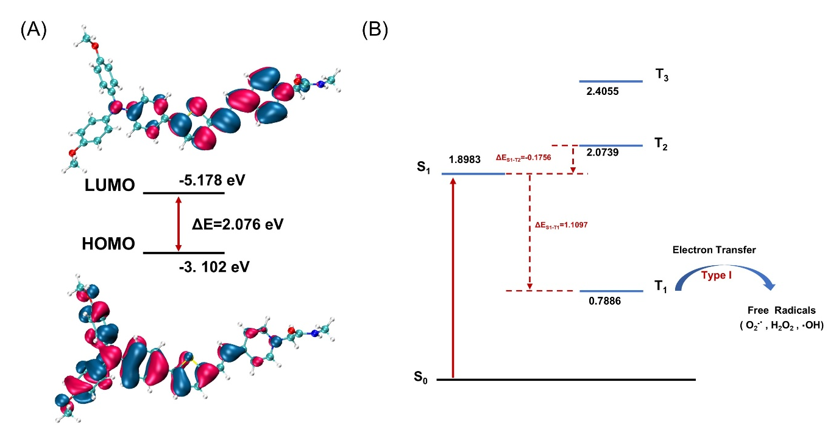
Fig. S9 (A) HOMO and LUMO wave functions in the geometrical structure of 3 optimized by B3LYP/6-311G(d). (B) Singlet and triplet energy levels and ΔEST values of 3 calculated by use of the TD-B3LYP/6-311G(d) level of the theory

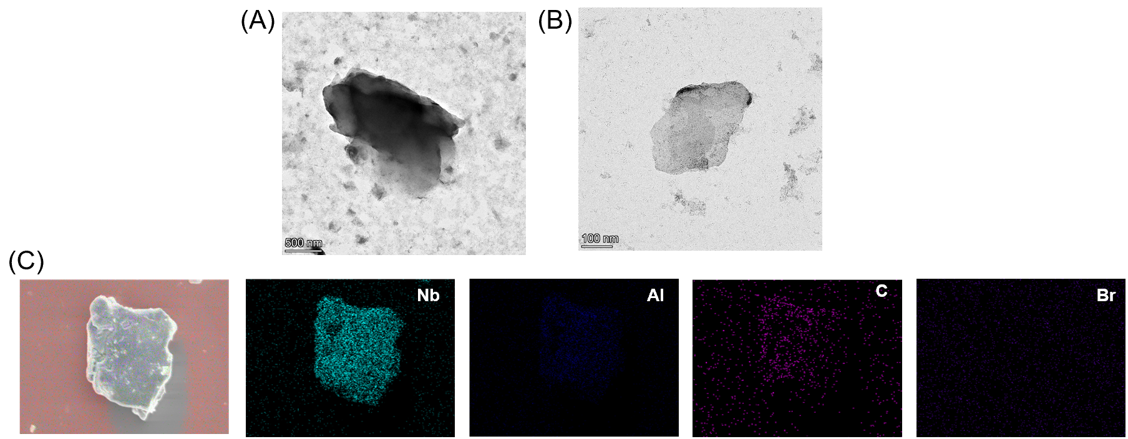
Fig. S10 TEM images of Nb₂AlC (A) and single-layer Nb₂C (MXene) (B). (C) Elemental mapping for MXene by SEM-EDS
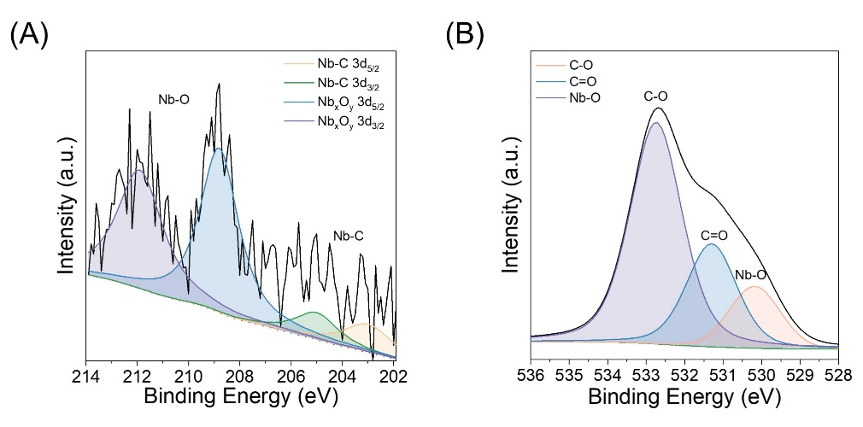
Fig. S11 High-resolution spectra of MX@PEG-MeoTTPy including (A) Nb 3d and (B) O 2s

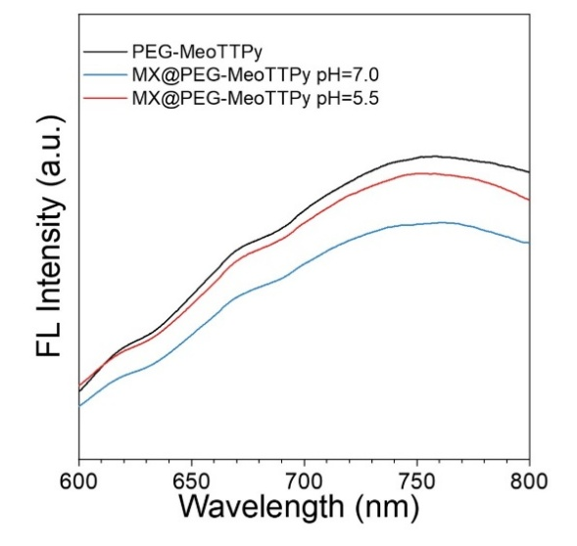
Fig. S12 Fluorescence spectra of samples under different pH

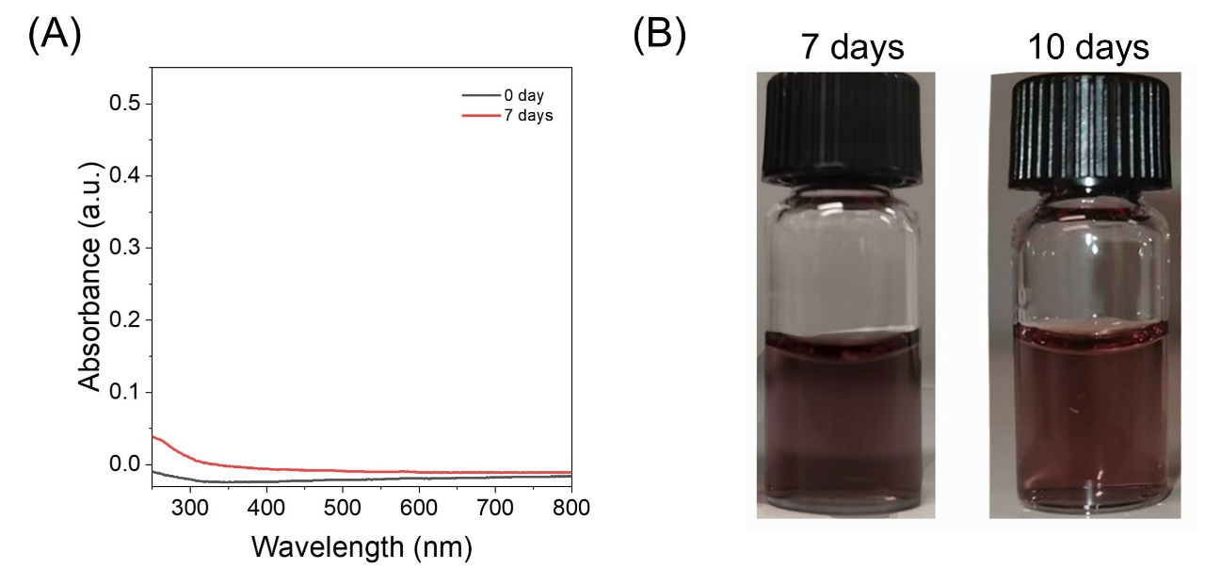
Fig. S13 MX@PEG-MeoTTPy release profiles in PBS. (A) UV-vis-NIR spectra of MX@PEG-MeoTTPy solution after being filtered by ultrafiltration tube on day 0 and day 7. (B) Digital images of MX@PEG-MeoTTPy on day 7 and day 10

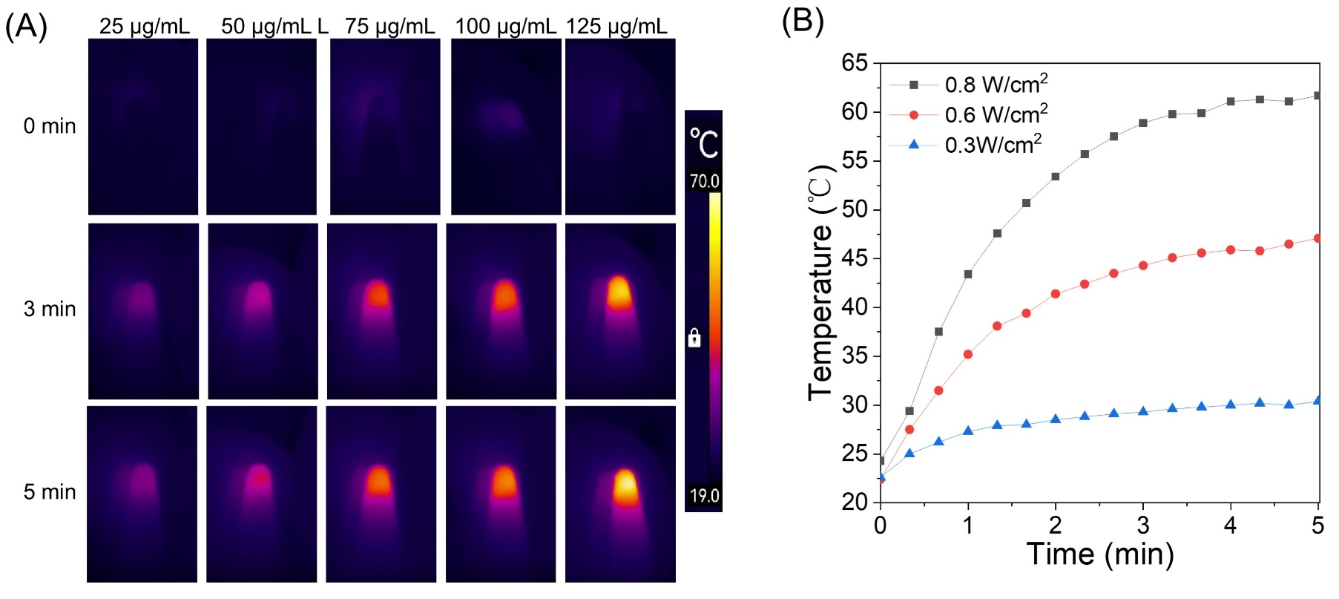
Fig. S14 Photothermal properties of MX/PEG-MeoTTPy suspension. (A)The corresponding infrared thermography of nanosheets suspensions under 808 nm laser irradiation (0.8 W cm⁻²) with different concentrations. (B) Temperature evaluation curves of nanosheets suspensions under 808 nm laser irradiation at different power densities

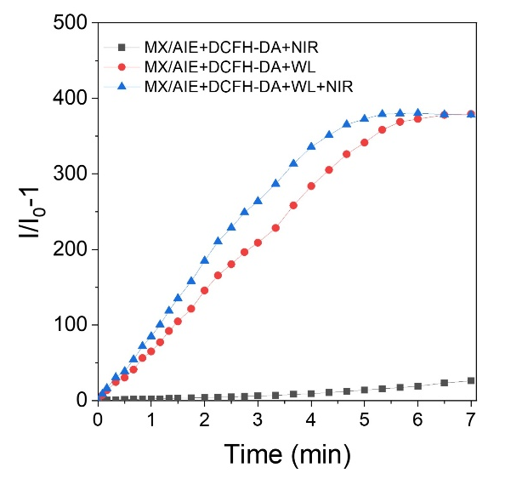
Fig. S15 Plots of I/I₀ versus light irradiation times in the presence of different samples under DCFH-DA before and after 808 nm NIR laser (NIR, 0.8 W cm⁻²) and/or white light (WL, 20 mW cm⁻²)

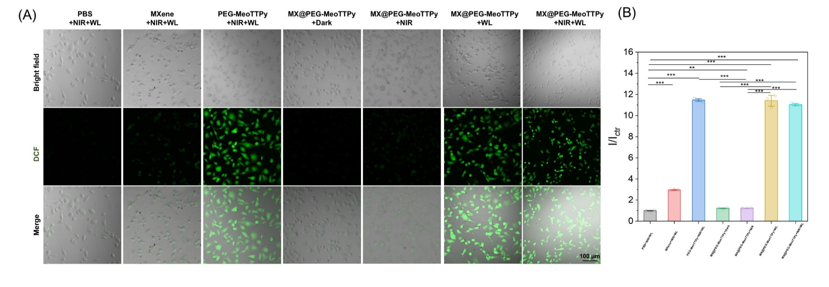
Fig. S16 Intracellular ROS detection by CLSM after MUM-2B cells were incubated under different conditions (A) and corresponding fluorescent intensity (B) at normoxia, I_{ctr} means the florescence intensity of PBS+NIR+WL groups. Scale bar: 100 μm

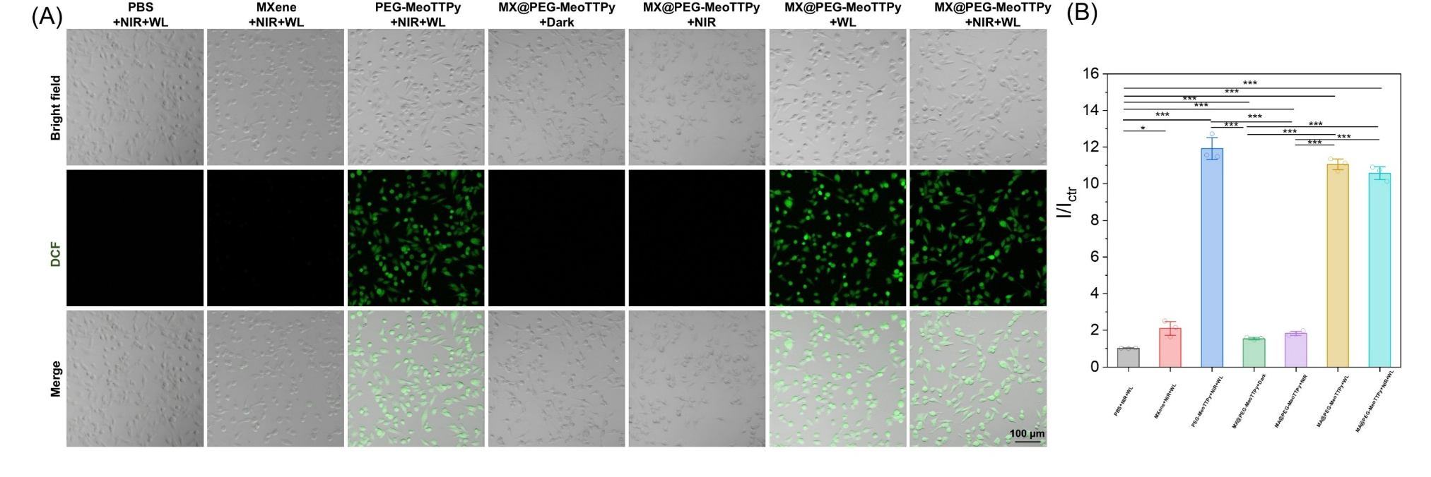
Fig. S17 Intracellular ROS detection by CLSM after MUM-2B cells were incubated under different conditions (A) and corresponding fluorescent intensity (B) at hypoxia, I_{ctr} means the florescence intensity of PBS+NIR+WL groups. Scale bar: 100 μm.
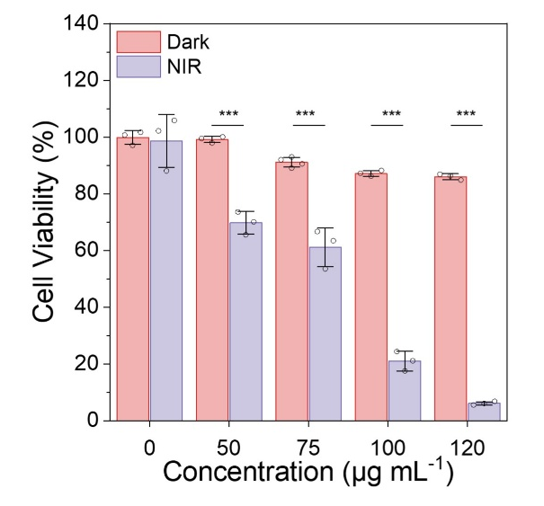
Fig. S18 Cell viability of MUM-2B cells after treated with Mxene nanosheets at different concentrations under 808 nm NIR laser irradiation (NIR, 0.8 W cm⁻², 10 min)

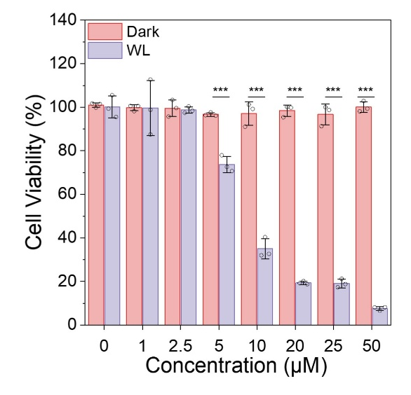
Fig. S19 Cell viability of MUM-2B cells after treated with PEG-MeoTTPy at different concentrations under white light irradiation (WL, 20 mW cm⁻², 30 min)
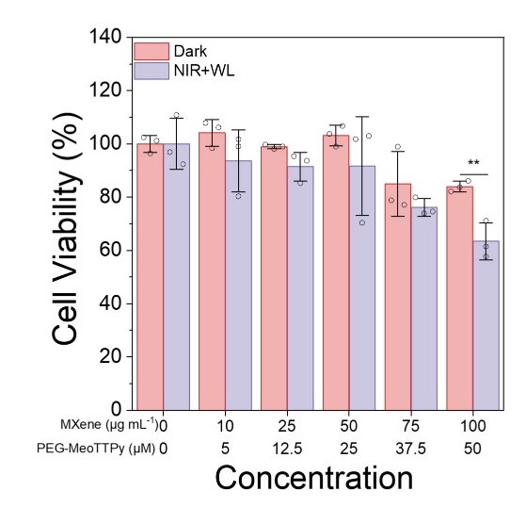
Fig. S20 Cell viability of C2C12 cells after treated with MX@PEG-MeoTTPy at different concentrations with or without 808 nm NIR laser irradiation (NIR, 0.8 W cm⁻², 5 min) and white light irradiation (WL, 20 m mW cm⁻², 10 min)

Fig. S21 CLSM imaging of normal cells (C2C12) after co-staining with MX@PEG-MeoTTPy nanosheets, LysoTracker (green) and MitoTracker (green) at prearranged time intervals, respectively. Scale bar: 20 μm

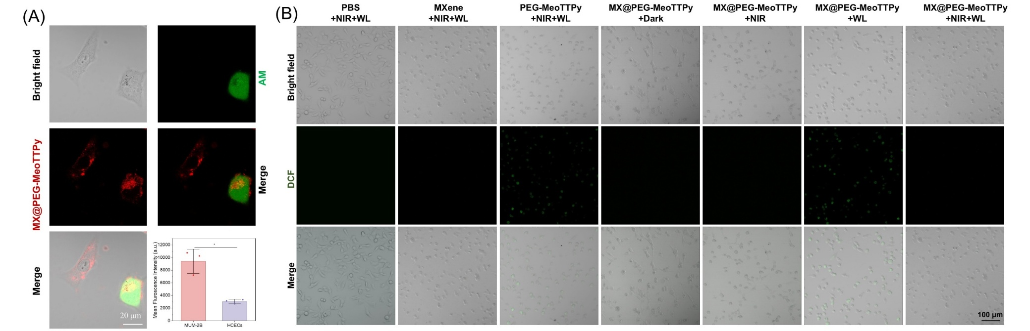
Fig. S22 (A) CLSM images of mixed MUM-2B (pre-stained with calcein AM) and HCECs cells incubated with MX@PEG-MeoTTPy nanosheets (Mxene concentration: 100 μg mL-1 and PEG-MeoTTPy concentration: 50 μM) for 4 h. Scale bar: 20 μm. (B) Intracellular ROS detection by CLSM after HCECs cells were incubated under different conditions. Light irradiation condition was 808 nm NIR laser (NIR, 0.8 W cm⁻² for 5 min) and white light (WL, 20 mW cm⁻² for 10 min). Scale bar: 100 μm

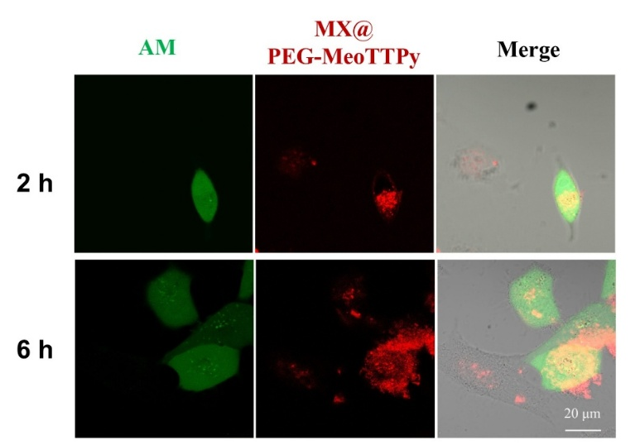
Fig. S23 CLSM images of mixed MUM-2B (pre-stained with calcein AM) and C2C12 cells incubated with MX@PEG-MeoTTPy nanosheets (Mxene concentration: 100 μg mL⁻¹ and PEG-MeoTTPy concentration: 50 μM) for 2 h and 6 h. Scale bar: 20 μm

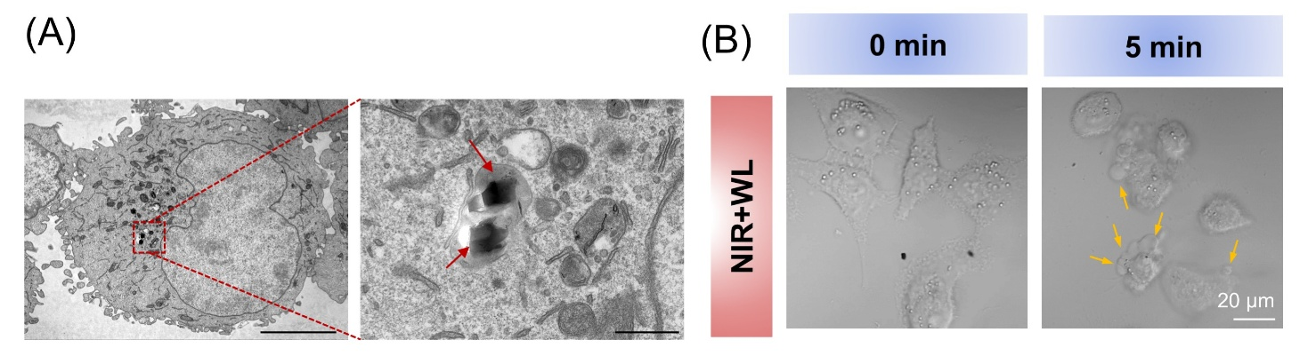
Fig. S24 (A) TEM characterization of nanosheet internalization in MUM-2B cells, arrows indicated nanosheets, scale bar of 5 μm (left) and 500 nm (right). (B) Real-time observation of MX@PEG-MeoTTPy nanosheets-treated cell membrane expansion and content release in pyroptosis by CLSM, scale bar of 20 μm
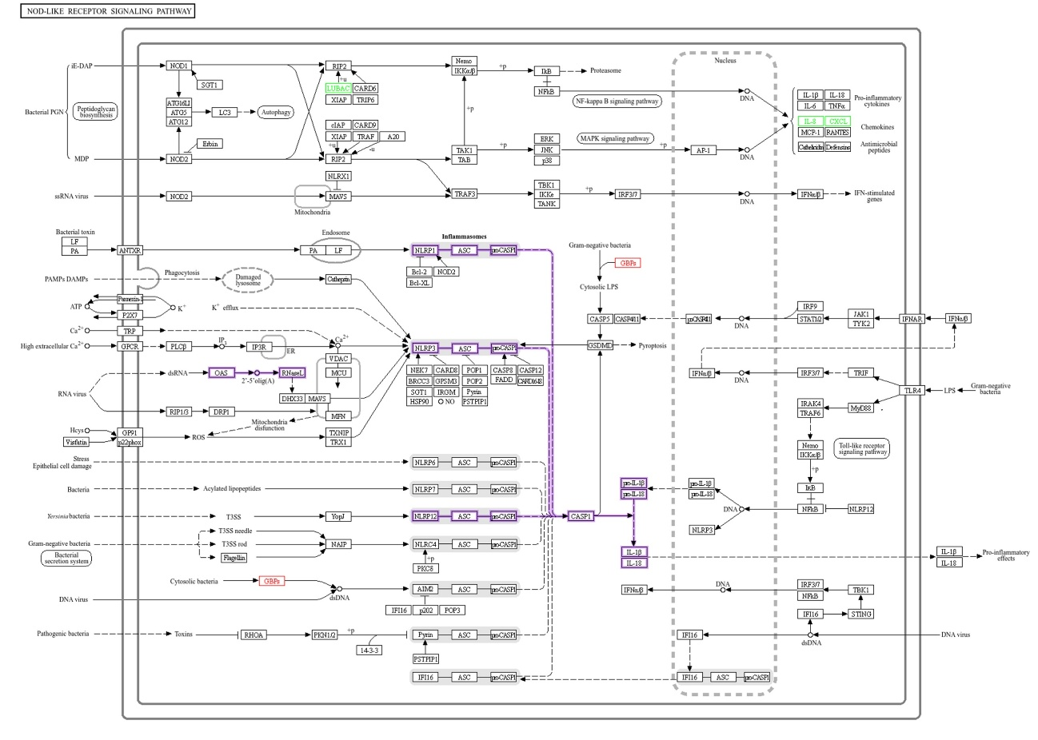
Fig. S25 NOD-like receptor signaling pathway associated with cellular pyroptosis. The signaling pathway is from KEGG PATHWAY: NOD-like receptor signaling pathway - Reference pathway

Fig. S26 The effects of different inhibitors on cell death induced by MX@PEG-MeoTTPy. MUM-2B cells were treated with control or MX@PEG-MeoTTPy with or without pretreatment of 3-MA (500 μM), z-VAD-fmk (50 μM), Ferr-1 (10 μM), Lip-1 (0.2 μM), Nec-1 (100 μM), NSA (10 μM), or Disulfiram (3 μM) for 1 h. Cell viability was measured by MTT assay
Fig. S27 Temperature-dependent sol-gel transition of the Agar/PSBMA and GNSs

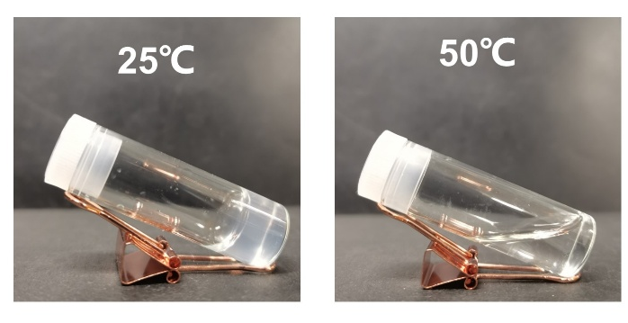
Fig. S28 Digital images of Agar/PSBMA hydrogel under different temperature

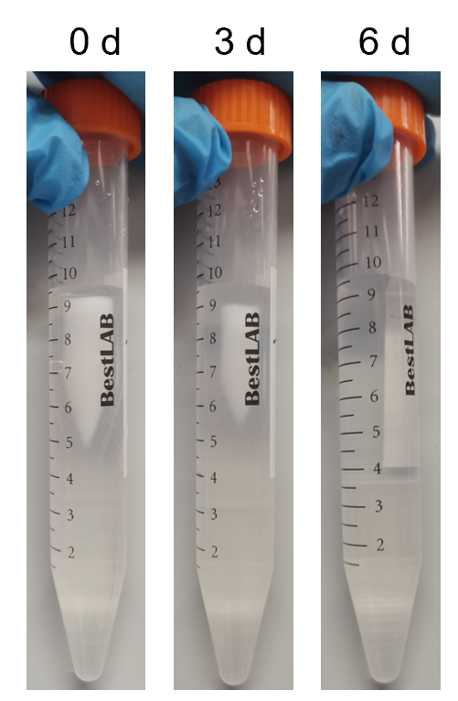
Fig. S29 The degradation images of GNSs in normal saline solution for 6 days
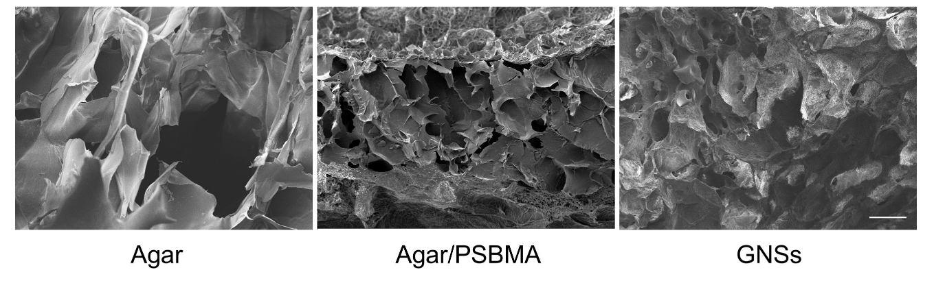
Fig. S30 SEM images of Agar, Agar/PSBMA and GNSs. Scale bar: 100 μm

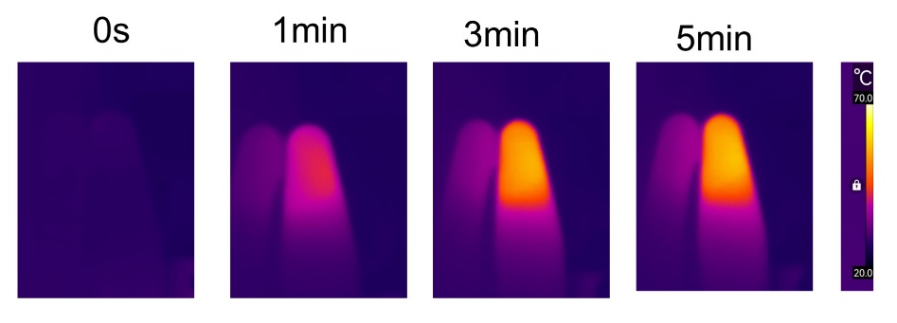
Fig. S31 Infrared thermography of GNSs under 808 nm laser irradiation (0.8 W cm⁻²)

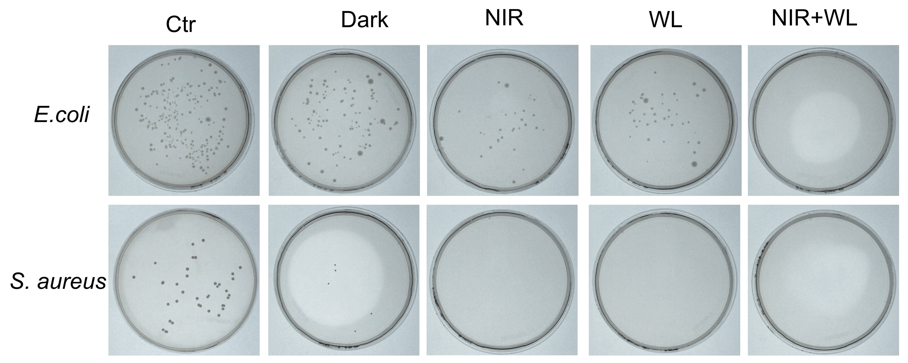
Fig. S32 Photographs of the agar plates reduction of E. coli and S. aureus of GNSs with or without 808 nm NIR laser (NIR, 0.8 W cm⁻² for 5 min) and/or white light (WL, 20 mW cm⁻² for 20 min)

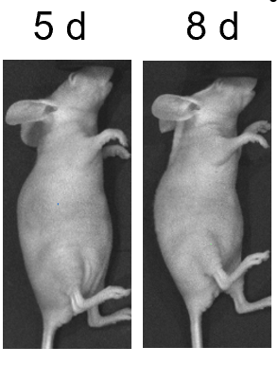
Fig. S33 Fluorescence imaging depicting the retention of GNSs in the eye on day 5and 8 post-injection

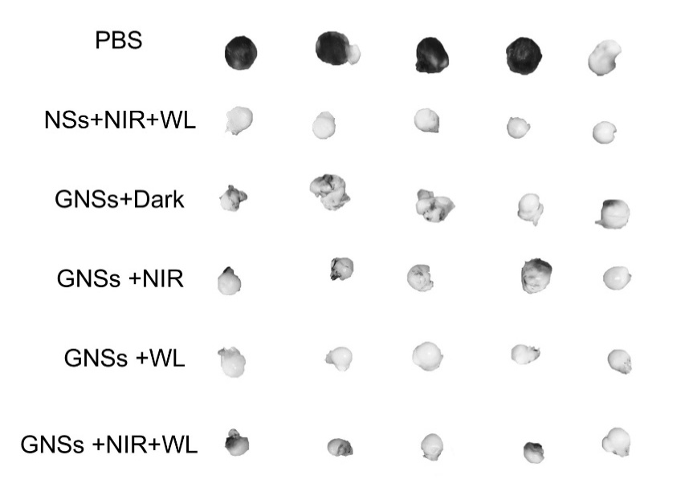
Fig. S34 Digital photos of eyeballs removed from the sacrificed mice in all groups on day 8

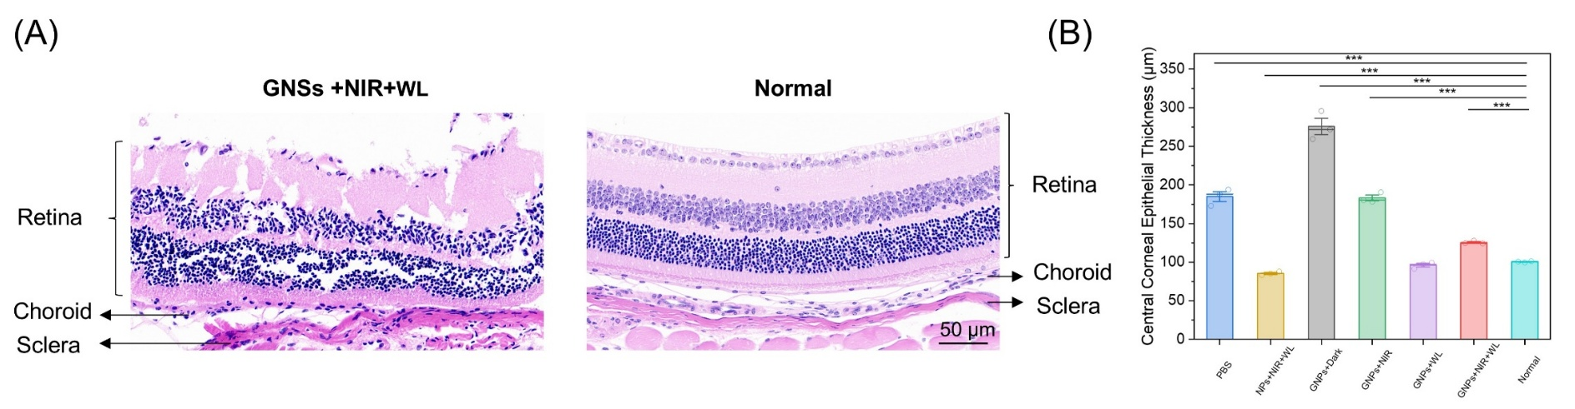
Fig. S35 (A) H&E analysis of the sclera, choroid, and retina between GNSs+NIR+WL and normal group. (B) Measurement of central corneal epithelial thickness

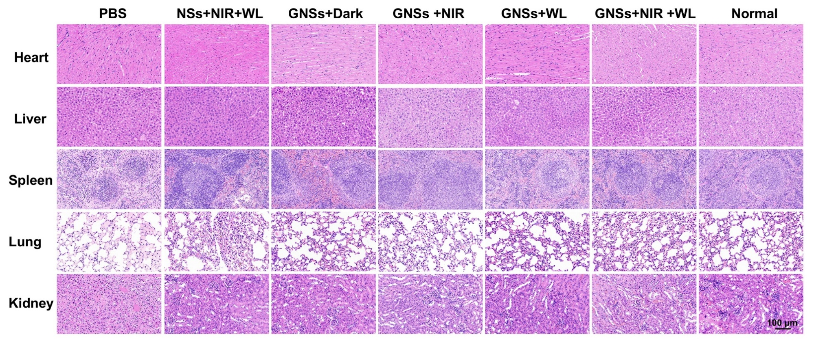
Fig. S36 Representative H&E stained images of major organs collected from different groups of mice at 8th day post-treatment. Scale bar: 100 μm

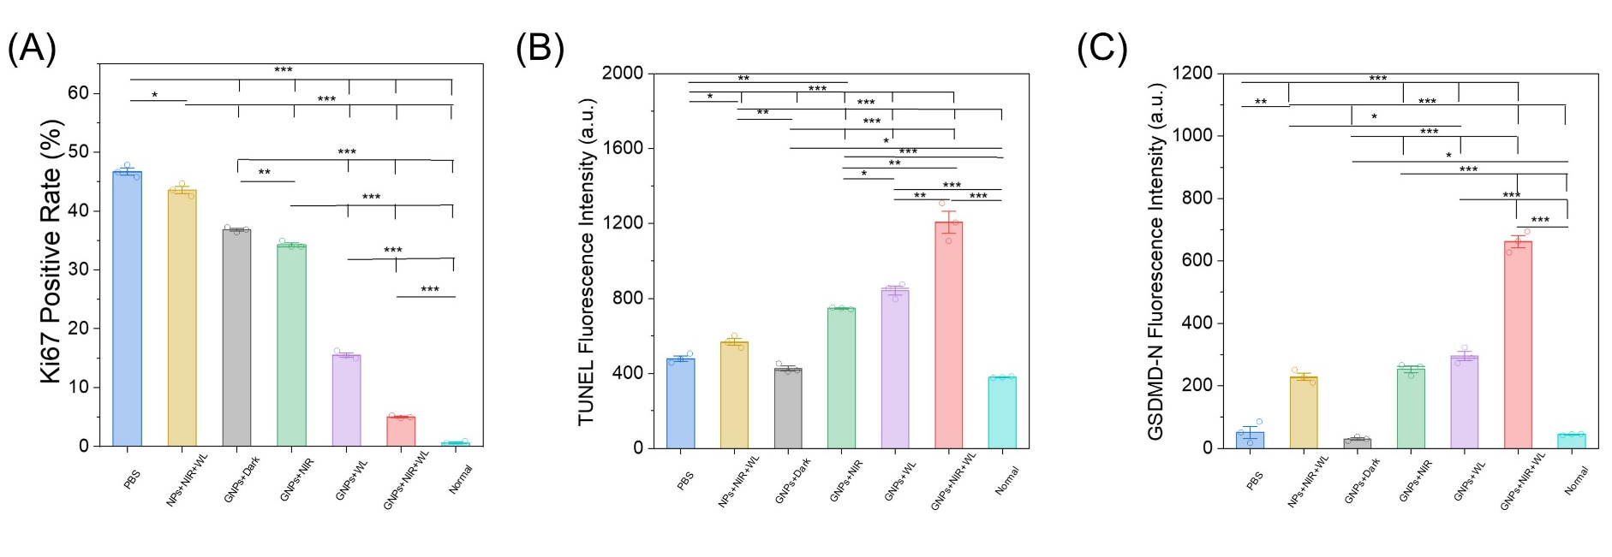
Fig. S37 Statical analysis of Ki67 (A), TUNEL (B) staining and GSDMD-N staining (C)
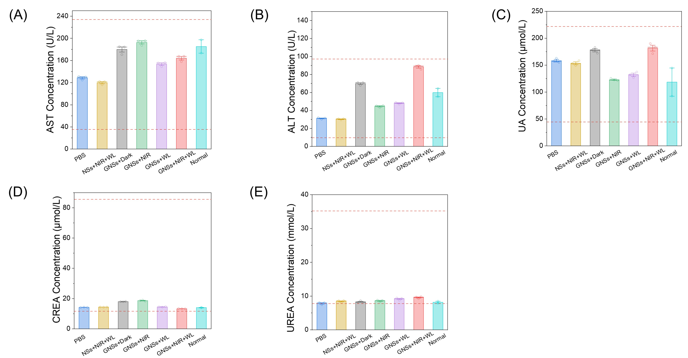
Fig. S38 Biochemical tests in mice at the end of treatments. Abbreviation: Aspartate aminotransferase (AST), alanine aminotransferase (ALT), urine acid (UA), creatinine (CREA) and urea (UREA). The areas framed by the red dotted line in the figures show the normal reference ranges of hematology data of male BALB/c nude mice

S3 Supplementary Tables
Table S1 IC50 and Chou-Talalay combination index (CI) synergy analysis
 | IC₅₀ values |  | CI values
 | Mxene concentration in MX@PEG-MeoTTPy (μg mL⁻¹) | PEG-MeoTTPy concentration in MX@PEG-MeoTTPy (μM) | CI values
Only under NIR | 63.72 | / | /
Only under white light | / | 48.26 | /
NIR plus white light | 48.24 | 24.12 | 0.87
Table S2 qPCR primer sequences
Gene | Sequence 5’-3’
CASP1-F | CACATCCTCAGGCTCAGA
CASP1-R | CGGCTTGACTTGTCCATT
GSDMD-F | CTCCAGCACCTCAATGAA
GSDMD-R | ACTTCCACCTCCTTCTGT
NLRP3-F | CTCGGTGACTTCGGAATC
NLRP3-R | ATGGCTGGTGCTCAATAC
IL18-F | GACCAAGTTCTCTTCATTGAC
IL18-R | GATAGTTACAGCCATACCTCTA

Supplementary References
- Livak, K. J.; Schmittgen, T. D. Analysis of relative gene expression data using real-time quantitative PCR and the 2(-Delta Delta C(T)) Method. Methods. 25 (4), 402-408 (2001). https://doi.org/10.1006/meth.2001.1262

