Supporting Information for
Dipole-Driven Charge Trapping in Monolayer Janus MoSSe for Ultrathin Nonvolatile Memory Devices
Eun Bee Ko^{1†}, Junho Sung^{2†}, Seon Yeon Choi¹, Yasir Hassan³, Jeong-Ju Bae³, Jongseok Kim³, Hyun You Kim³, Eunho Lee², Min Sup Choi³*, Hyun Ho Kim^{1,4}*
¹ School of Materials Science and Engineering, Kumoh National Institute of Technology, Gumi 39177, Republic of Korea
² Department of Chemical and Biomolecular Engineering, Seoul National University of Science and Technology, Seoul 01811, Republic of Korea
³ Department of Materials Science and Engineering, Chungnam National University, Daejeon 34134, Republic of Korea
⁴ School of Materials Science and Engineering, Gwangju Institute of Science and Technology, Gwangju 61005, Republic of Korea
*Corresponding authors. E-mail: kimhh@gist.ac.kr (Hyun Ho Kim); goodcms@cnu.ac.kr (Min Sup Choi)
Supplementary Figures
Fig. S1 a Schematic illustration of the APCVD process used for the growth of monolayer MoSe₂. b Plasma-assisted sulfurization using PECVD to convert the as-grown MoSe₂ into Janus MoSSe. c Optical microscopy (OM) image of the synthesized Janus MoSSe flakes. d AFM profile showing a thickness of ~0.8 nm. e Raman spectra of MoSe₂ and Janus MoSSe. f Raman mapping of A_{1g} peak in Janus MoSSe. g PL spectra of MoSe₂ and Janus MoSSe. h Transfer curve of a Janus MoSSe transistor, measured at a drain voltage of V_{DS} = 5 V.
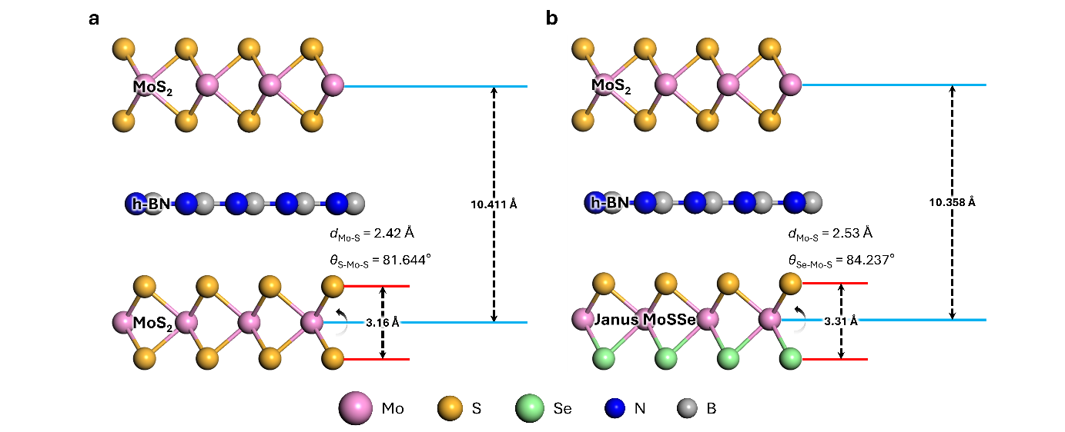
Fig. S2 Atomistic models and key structural parameters of a MoS₂/h-BN/MoS₂ and b MoS₂/h-BN/Janus MoSSe heterostructures. Interlayer distances, bond lengths (𝑑_{Mo−S}​), and bond angles (𝜃_{S−Mo−S}, 𝜃_{Se−Mo−S}​) are indicated for each configuration, highlighting the structural modifications induced by the incorporation of the Janus layer.

Fig. S3 Inverted MoS₂/h-BN/Janus MoSSe. Yellow and blue regions represent the area where electrons are localized and depleted, respectively

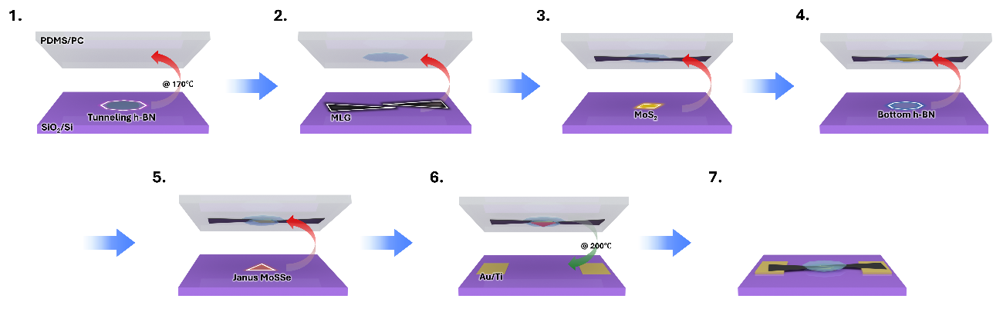
Fig. S4 Schematic illustration of the fabrication process for the Janus MoSSe memory device. The constituent materials, including tunneling h-BN, multilayer graphene (MLG), MoS₂, bottom h-BN, and Janus MoSSe, are sequentially picked up and transferred onto a substrate with pre-patterned Au/Ti electrodes

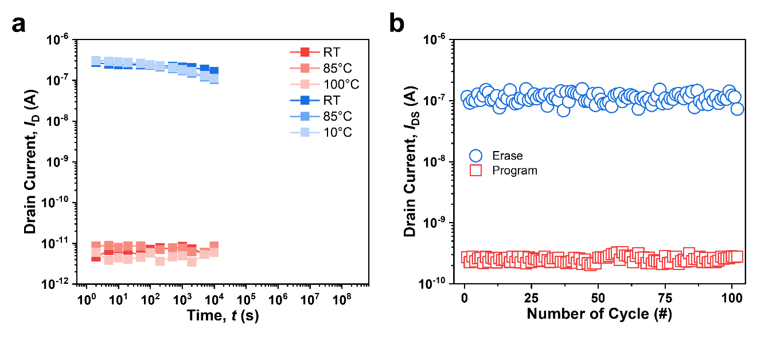
Fig. S5 a Retention characteristics of the Janus MoSSe floating-gate memory device measured at room temperature, 85 °C, and 100 °C. b Endurance characteristics of the Janus MoSSe floating-gate memory device measured with 500 ns program/erase pulses for over 100 cycles

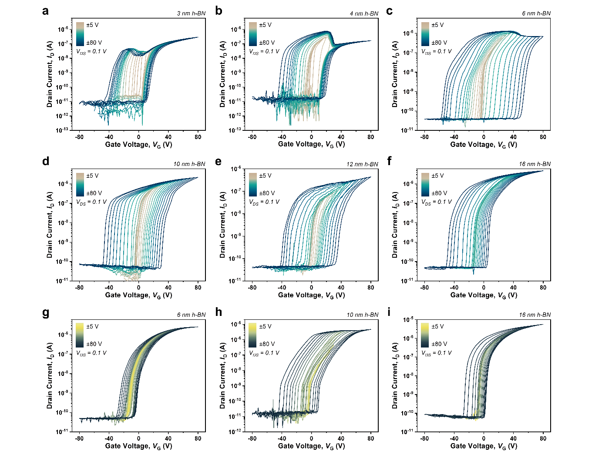
Fig. S6 Transfer characteristics (𝐼_{D}–𝑉_{G}​) of memory devices with varying h-BN tunneling layer thicknesses. a–f Janus MoSSe floating-gate devices with h-BN thicknesses of 3, 4, 6, 10, 12, and 16 nm. g–i MoSe₂ floating-gate devices with h-BN thicknesses of 6, 10, and 16 nm
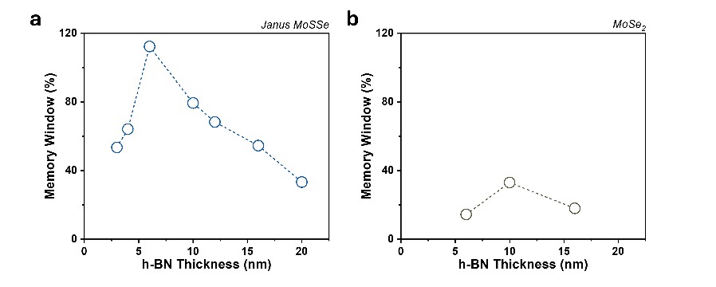
Fig. S7 Summary of memory window variation as a function of h-BN thickness (2~20 nm) for both a Janus MoSSe and b MoSe₂ devices

Table S1 Benchmark table for comparing characteristics such as memory window and endurance based on floating gate, channel, and h-BN thickness
Floating gate | Channel | Tunneling barrier | h-BN thickness (nm) | Memory window (%) | Long-term stability | Endurance | References
Janus MoSSe | MoS₂ | h-BN | 6 | 70 | 10⁴ s | 10000 cycles | This work
MLG | MoS₂ | h-BN | 4.6 | 13 | - | - | [6]
MLG | ReS₂ | h-BN | 6 | 63 | 10⁴ s | 1000 cycles | [16]
MLG | MoS₂ | h-BN | 6.1 | 28 | - | - | [6]
MLG | MoS₂ | h-BN | 7.5 | 55 | - | 1000 cycles | [6]
MLG | MoS₂ | h-BN | 8.4 | 36 | 1500 s | 1000 cycles | [10]
MLG | MoS₂ | h-BN | 10 | 36 | 8000 s | 4200 cycles | [17]
MLG | SnSe₂ | h-BN | 10 | 65 | 2000 s | 500 cycles | [S1]
MLG | InSe | h-BN | 10 | 65 | 16.5 d | 2000 cycles | [7]
MLG | MoS₂ | h-BN | 10 | 60 | 1400 s | 110 cycles | [13]
MLG | MoS₂ | h-BN | 11.7 | 84 | 3800 s | 1000 cycles | [6]
MLG | MoTe₂ | h-BN | 13.3 | 82 | 300 s | 40 cycles | [S2]
MLG | Bi₂O₂Se | h-BN | 13.7 | 79 | 1000 s | 500 cycles | [S3]
MLG | MoS₂ | h-BN | 13.8 | 64 | 10⁴ s | - | [S4]
MLG | ReS₂ | h-BN | 14.8 | 80 | 1000 s | 1000 cycles | [S5]
GaSe | InSe | h-BN | ~7 | 63 | 3 d | - | [S6]
MoTe₂ | WSe₂ | h-BN | 10.8 | 83 | 2000 s | 2000 cycles | [S7]
MoTe₂ | MoS₂ | h-BN | 8.8 | 86 | 3000 s | 1200 cycles | [S8]
Au | SnS₂ | h-BN | 23 | 66 | > 10³ | 15000 cycles | [S9]

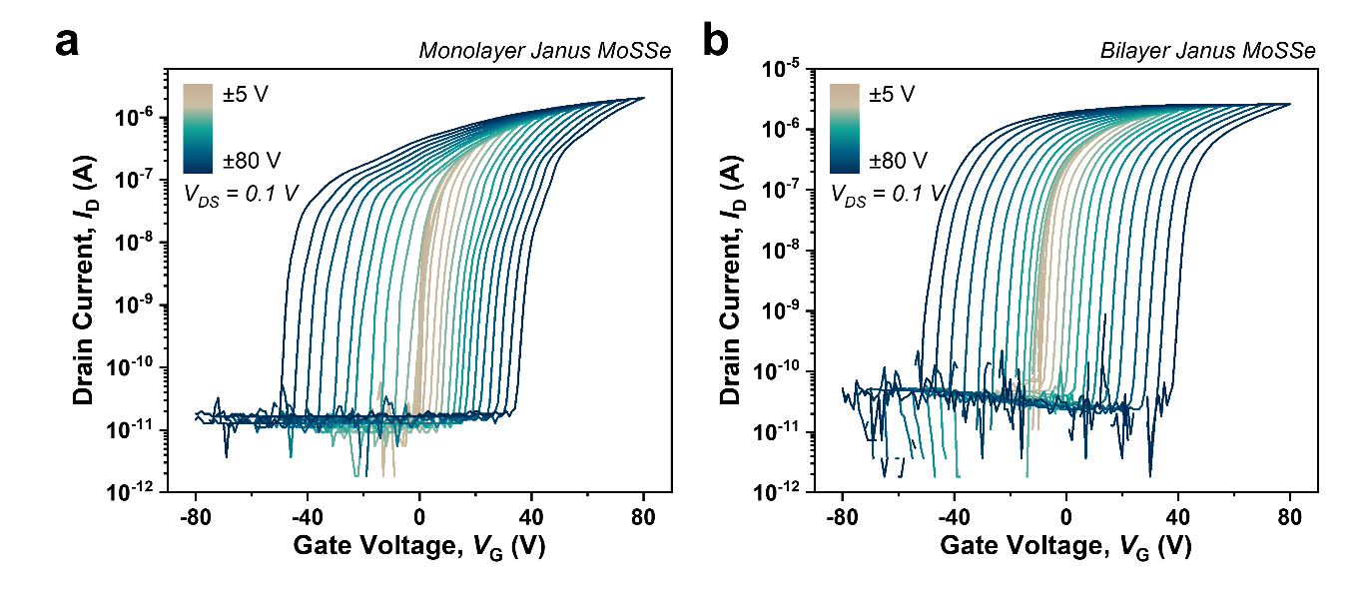
Fig. S8 Transfer characteristics of floating-gate memory devices using a monolayer Janus MoSSe and b bilayer Janus MoSSe as the charge-trapping layer

Fig. S9 AFM height images of a MoS₂ channel and b, c h-BN tunneling layers with thicknesses of 6 nm and 10 nm, respectively

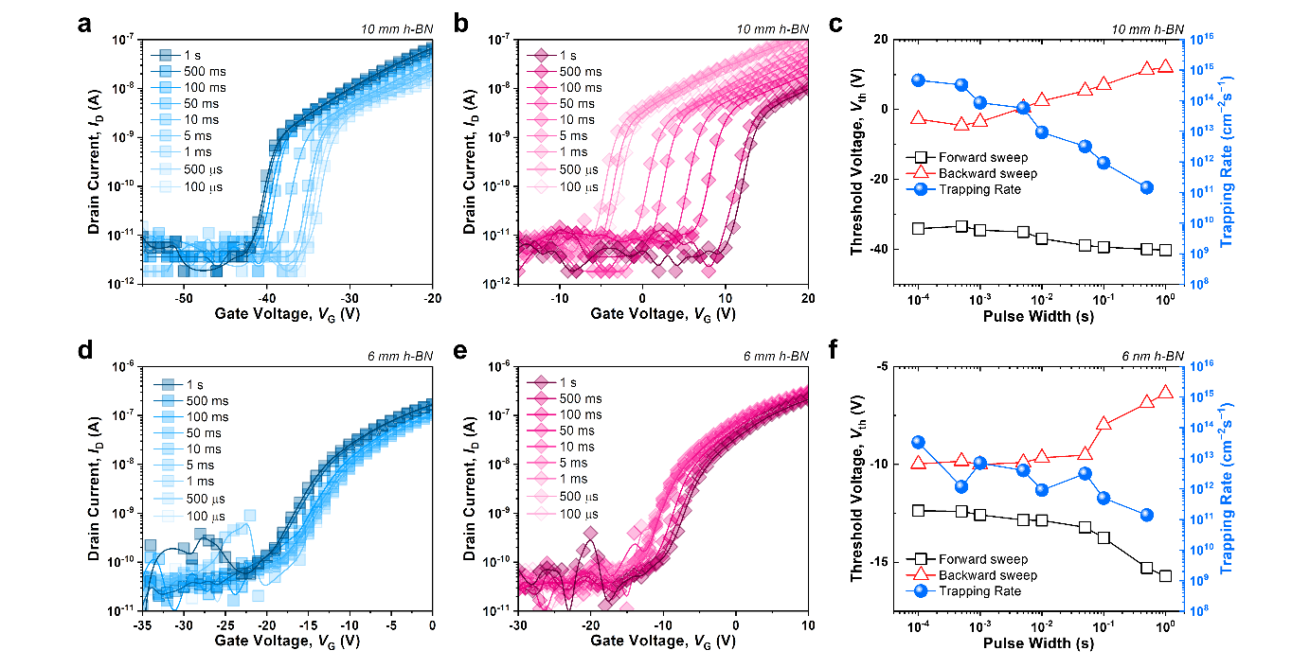
Fig. S10 Pulse-width dependent transfer characteristics of MoSe₂ floating-gate memory devices with different h-BN tunneling layer thicknesses: a–c device with 10 nm h-BN and d–f device with 6 nm h-BN. a, d Forward sweep; b, e backward sweep for various pulse widths; c, f extracted threshold voltage and charge trapping rate as a function of pulse width

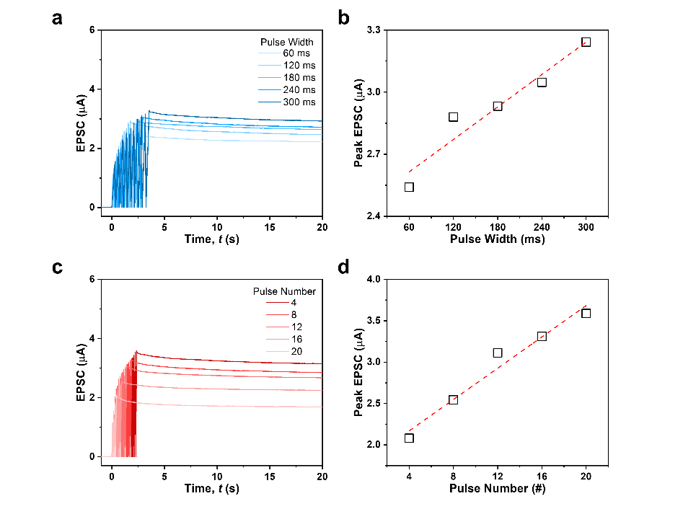
Fig. S11 Changes in LTP characteristics as a function of a width and c number of pulses applied to Janus MoSSe devices. Variation of peak EPSC as a function of b pulse width and d number

Fig. S12 a Curves as a function of NL value used in the fitting of the LTP/D characteristic. b The change in normalized conductance measured in the Janus MoSSe device (symbol) and the curve fitted to the decreasing-increasing trend (line)
Fig. S13 a LTP/D curve obtained by applying 6400 pulses to a Janus MoSSe device over 100 cycles. b Changes in NL_{LTP/D}, G_{max}/G_{min}, and NS_{eff} values during 100 cycles of LTP/D measurements. c Variation of the conductance range defined as G_{max} − G_{min} for 100 cycles of LTP/D
Fig. S14 a LTP/D properties obtained from five different devices. b Variation of the characteristic parameters across devices
Fig. S15 a Schematic of a convolutional neural network with VGG-8 structure for CIFAR-10 data recognition simulation. b Recognition accuracy trend and c highest accuracy for ideal device, Janus MoSSe device and variation considered Janus MoSSe device over 256 epochs of training and inference
Supplementary References
- G. Dastgeer, S. Nisar, A. Rasheed, K. Akbar, V. D. Chavan et al., Atomically engineered, high-speed non-volatile flash memory device exhibiting multibit data storage operations. Nano Energy. 119(109106 (2024). https://doi.org/10.1016/j.nanoen.2023.109106
- Y. Zhang, L. Wang, Z. Huang, W. Deng, X. Yan et al., Nonvolatile memory and neuromorphic devices based on the MoTe₂/h-BN/graphene floating gate transistor. Appl. Mater. Today. 46(102908 (2025). https://doi.org/10.1016/j.apmt.2025.102908
- L. Sun, Y. Xu, G. Huo, Y. Hou, W. Li et al., Multifunctional neuromorphic optoelectronic computing using all 2D floating-gate transistors. Nano Energy. 143(111311 (2025). /https://doi.org/10.1016/j.nanoen.2025.111311
- W. Huang, L. Yin, F. Wang, R. Cheng, Z. Wang et al., Multibit optoelectronic memory in top-floating-gated van der waals heterostructures. Adv. Funct. Mater. 29(36), 1902890 (2019). https://doi.org/10.1002/adfm.201902890
- W. Li, J. Li, T. Mu, J. Li, P. Sun et al., The nonvolatile memory and neuromorphic simulation of ReS₂/h-BN/graphene floating gate devices under photoelectrical hybrid modulations. Small. 20(30), 2311630 (2024). https://doi.org/10.1002/smll.202311630
- X. Gong, Y. Zhou, J. Xia, L. Zhang, L. Zhang et al., Tunable non-volatile memories based on 2D InSe/h-BN/GaSe heterostructures towards potential multifunctionality. Nanoscale. 15(35), 14448-14457 (2023). https://doi.org/10.1039/D3NR02995F
- C. Yao, G. Wu, M. Huang, W. Wang, C. Zhang et al., Reconfigurable artificial synapse based on ambipolar floating gate memory. ACS Appl. Mater. Interfaces.15(19), 23573-23582 (2023). https://doi.org/10.1021/acsami.3c00063
- Y. Xia, J. Zha, H. Huang, H. Wang, P. Yang et al., Uncovering the role of crystal phase in determining nonvolatile flash memory device performance fabricated from MoTe₂-based 2D van der waals heterostructures. ACS Appl. Mater. Interfaces. 15(29), 35196-35205 (2023). https://doi.org/10.1021/acsami.3c06316
- M.A. Khan, S. Yim, S. Rehman, F. Ghafoor, H. Kim et al., Two-dimensional materials memory devices with floating metal gate for neuromorphic applications. Mater. Today Adv. 20(100438 (2023). https://doi.org/10.1016/j.mtadv.2023.100438

