Supporting Information for
Spin Balance over Janus Ir-Co Magnetic Atoms for Efficient Acidic Water Oxidation
Na Li¹, Weiren Cheng^{2,} *, Yuying Liu¹, Ruiqi Liu¹, Sihua Feng¹, Huijuan Wang³, Liyang Lv¹, Chenglong Liu¹, Jin Ma¹, Chao Wang^{1,} *, Wensheng Yan^{1,} *
¹ National Synchrotron Radiation Laboratory, University of Science and Technology of China, Hefei, Anhui 230029, People’s Republic of China
² Key Laboratory of Precision and Intelligent Chemistry, Department of Materials Science and Engineering, University of Science and Technology of China, Hefei, Anhui 230026, People’s Republic of China
³ Material Test and Analysis Lab, Energy and Materials Science Experiment Center, University of Science and Technology of China, Hefei, Anhui 230029, People’s Republic of China
*Corresponding authors. E-mail: : weiren@ustc.edu.cn (Weiren Cheng); chaowng@ustc.edu.cn (Chao Wang); ywsh2000@ustc.edu.cn (Wensheng Yan)
Supplementary Figures and Tables
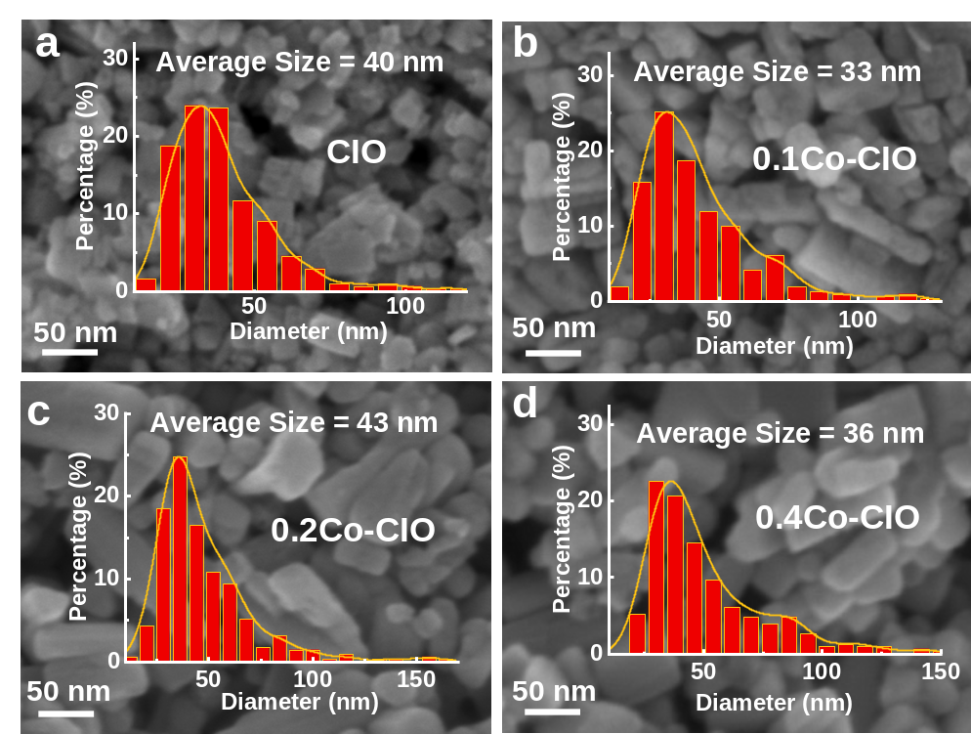
Fig. S1 SEM images and particle distribution for a CIO, b 0.1Co-, c 0.2Co- and d 0.4Co-CIO

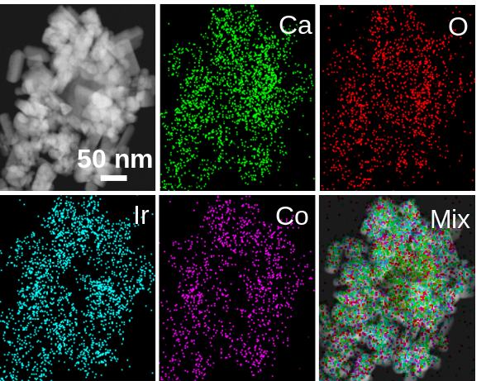
Fig. S2 EDX maps of 0.2Co-CIO. Ca, iridium, oxygen, and cobalt are displayed in green, light blue, red, and magenta, respectively
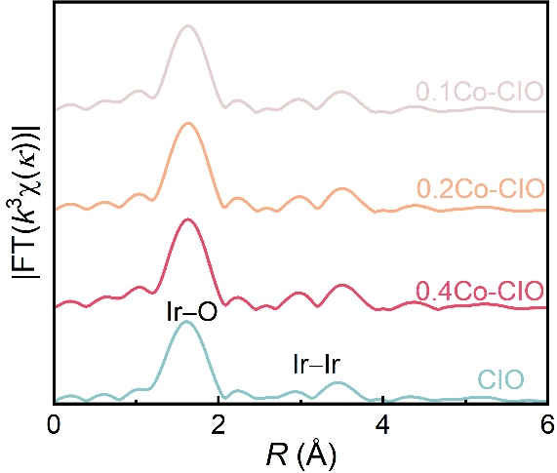
Fig. S3 Ir L₃-edge FT-EXAFS spectra of 0.1Co-, 0.2Co-, 0.4Co-CIO and CIO
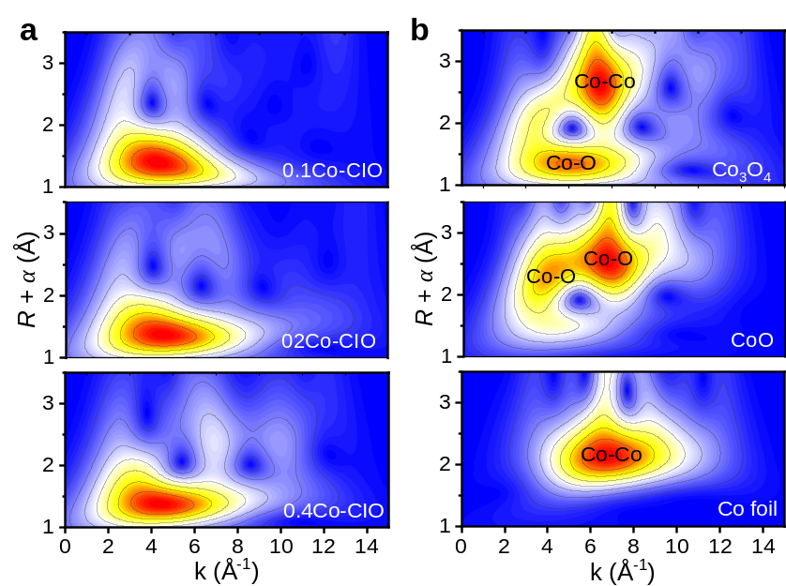
Fig. S4 WT for the k²-weighted EXAFS signal

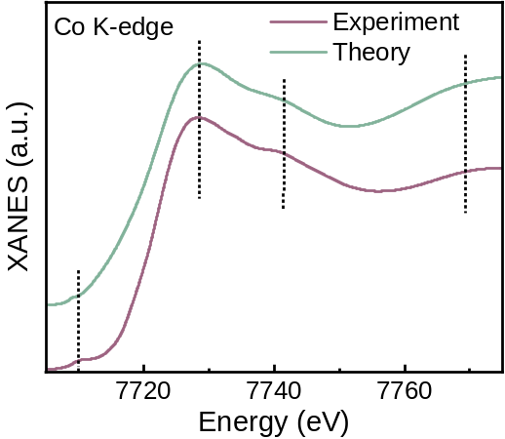
Fig. S5 Comparison between the simulated and the experimental absorption spectrum for 0.2Co-CIrO with a random distribution. The dotted vertical lines indicate the positions of three main absorption peaks with a weak pre-edge peak. The illustration of constructed supercell model can be found in the inset of Fig. 1b
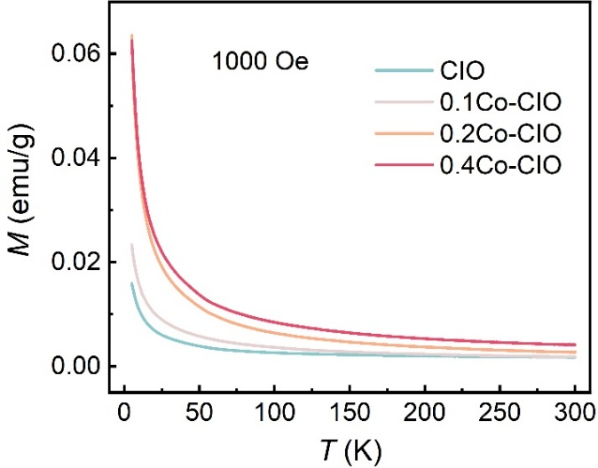
Fig. S6 The Comparison of FC magnetization curve for CIO, 0.1Co-CIO, 0.2Co-CIO and 0.4Co-CIO at an applied field of 1000 Oe

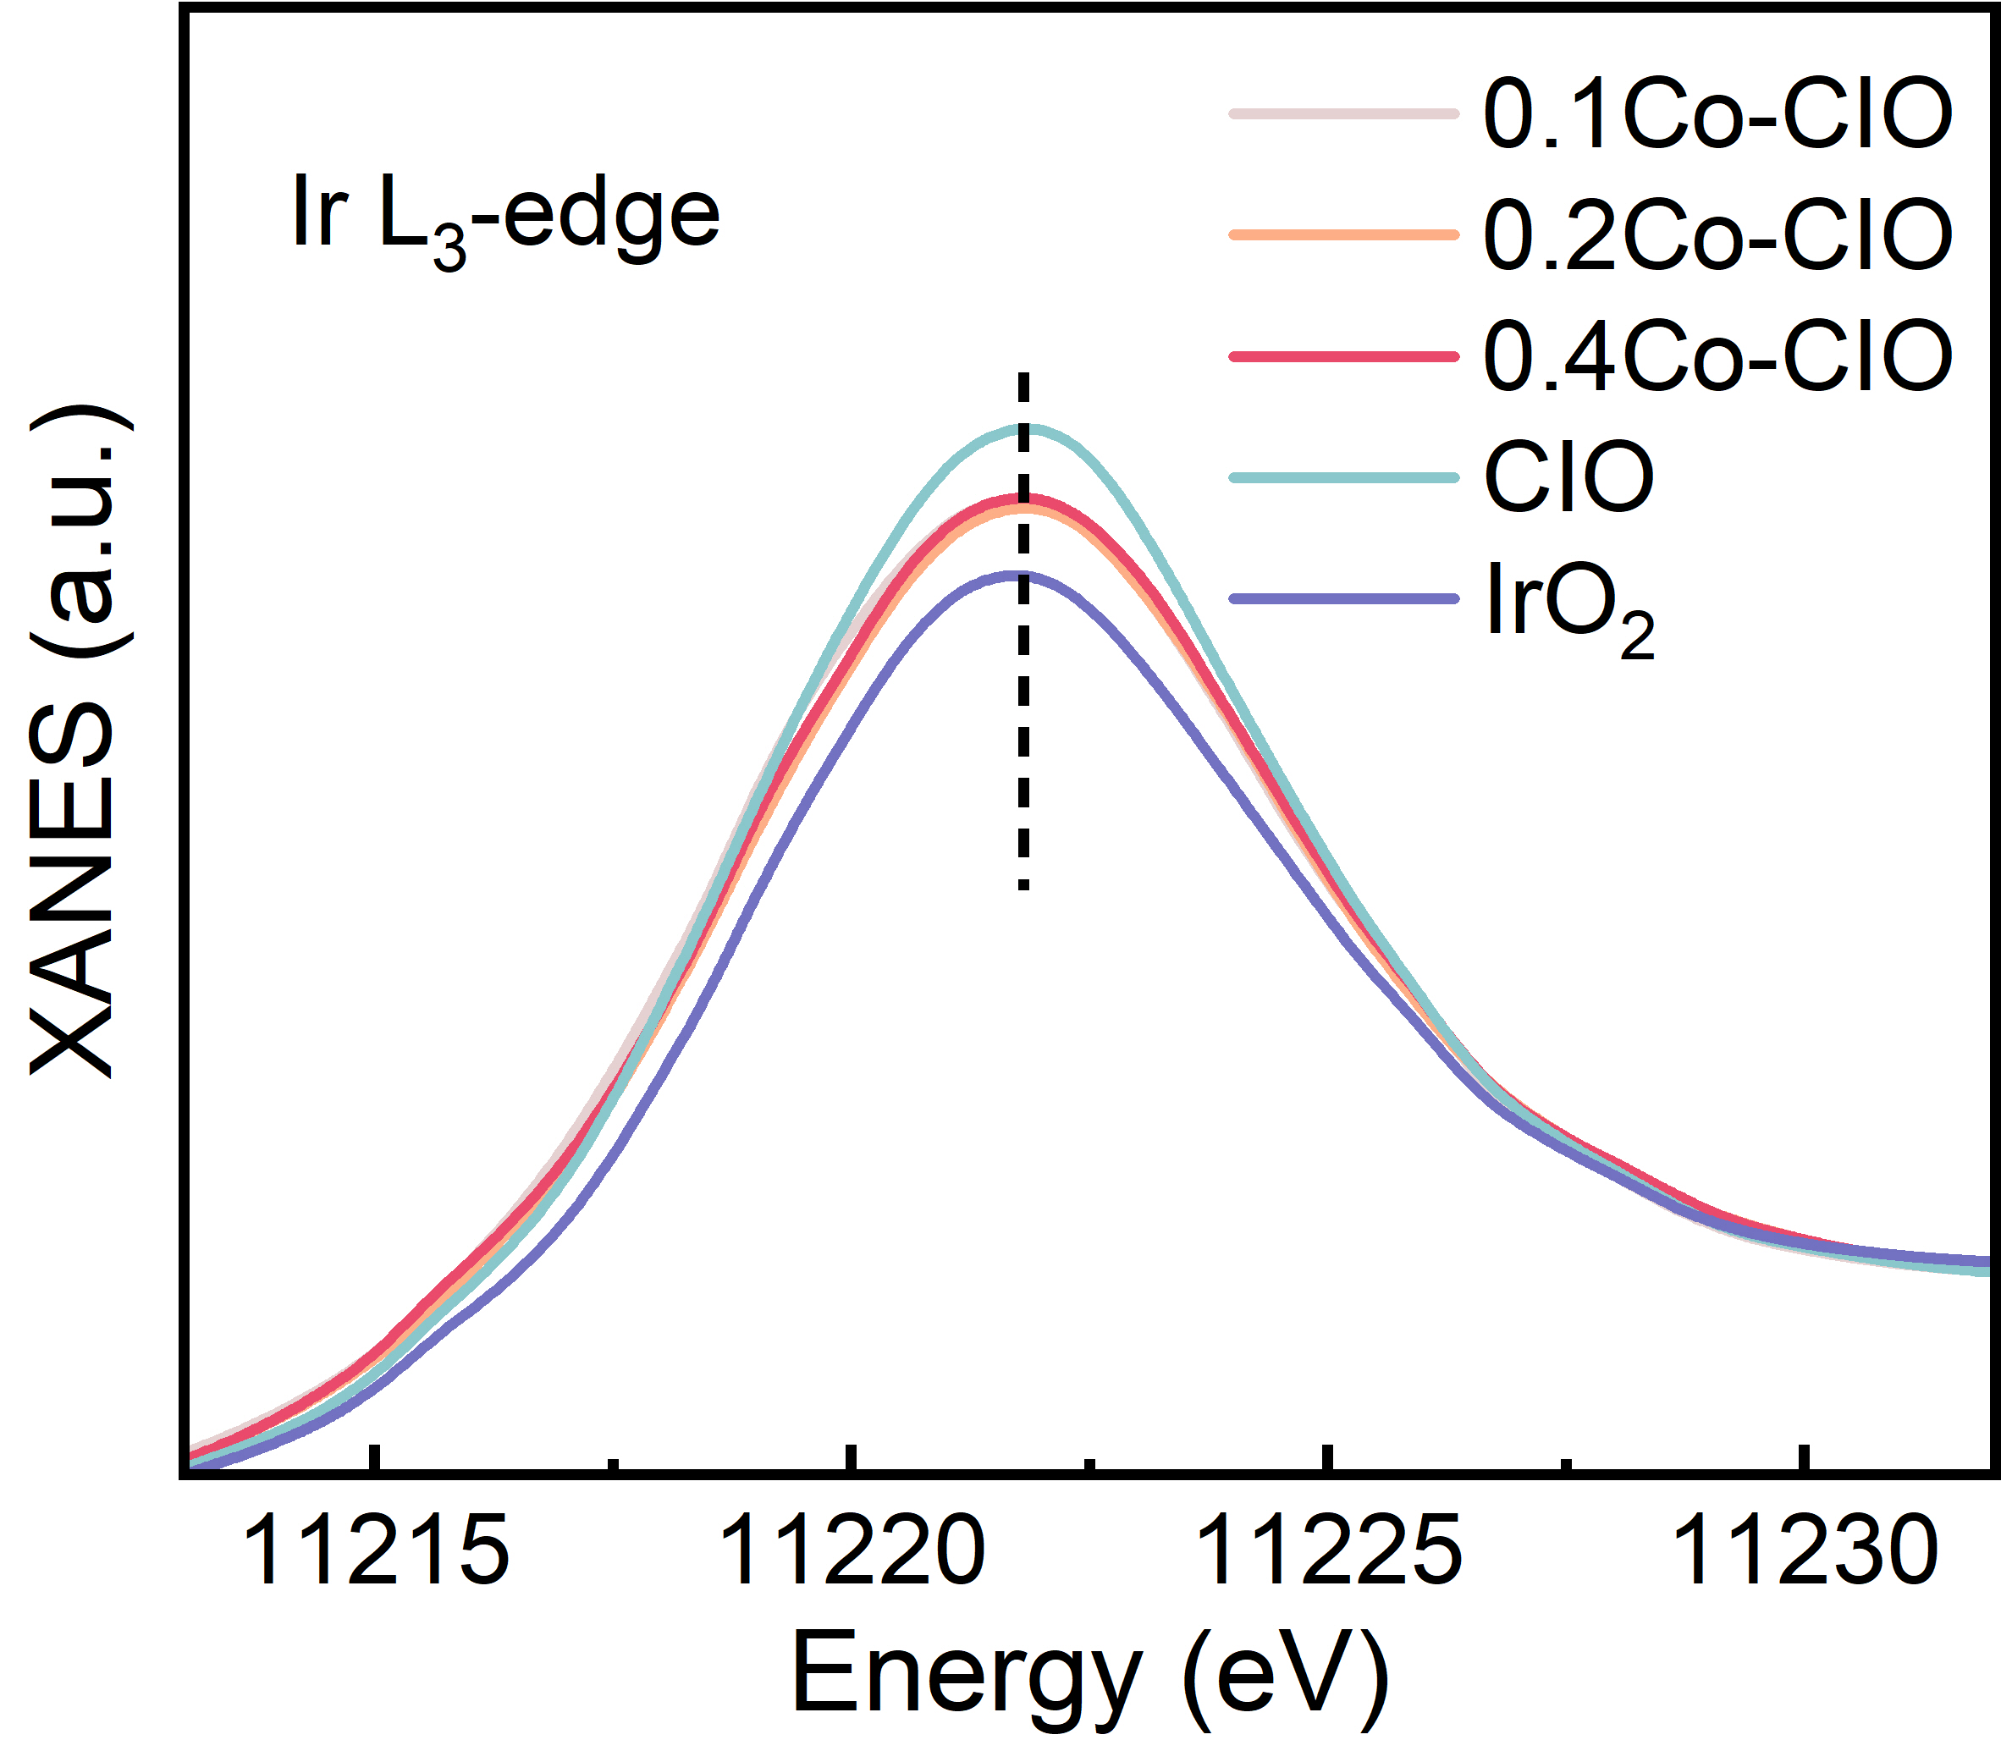
Fig. S7 Ir L₃-edge XANES region for 0.1Co-, 0.2Co-, 0.4Co-CIO, CIO and IrO₂

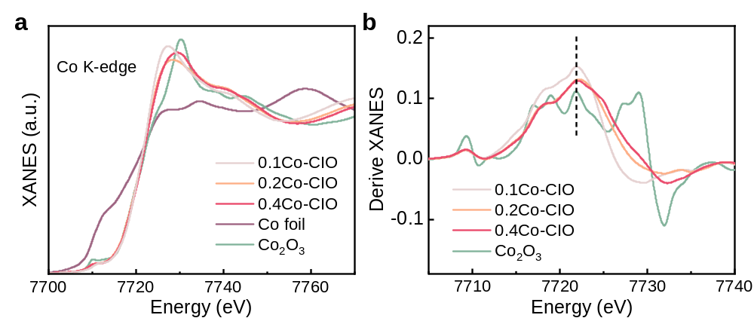
Fig. S8 a Co K-edge XANES region of 0.1Co-, 0.2Co-, 0.4Co-CIO, Co foil and Co₂O₃. b First derivatives of Co K-edge XANES spectra

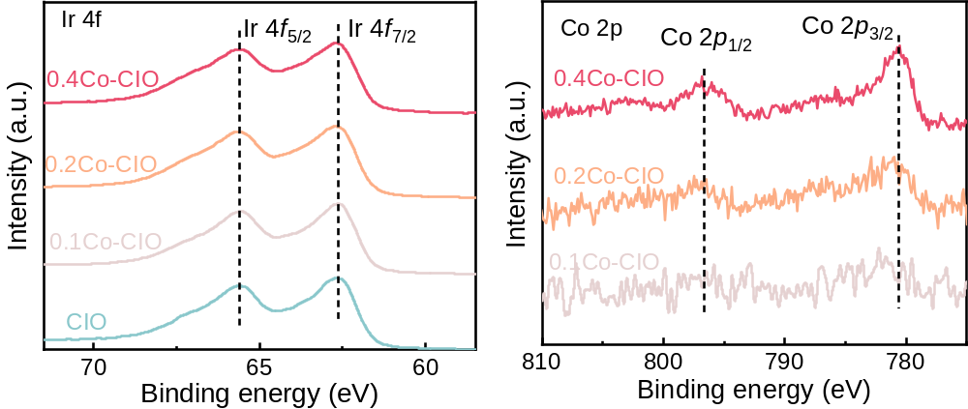
Fig. S9 a Co 2p XPS spectra of 0.1Co-, 0.2Co-, 0.4Co-CIO. b Ir 4f XPS spectra of 0.1Co-, 0.2Co-, 0.4Co-CIO and CIO

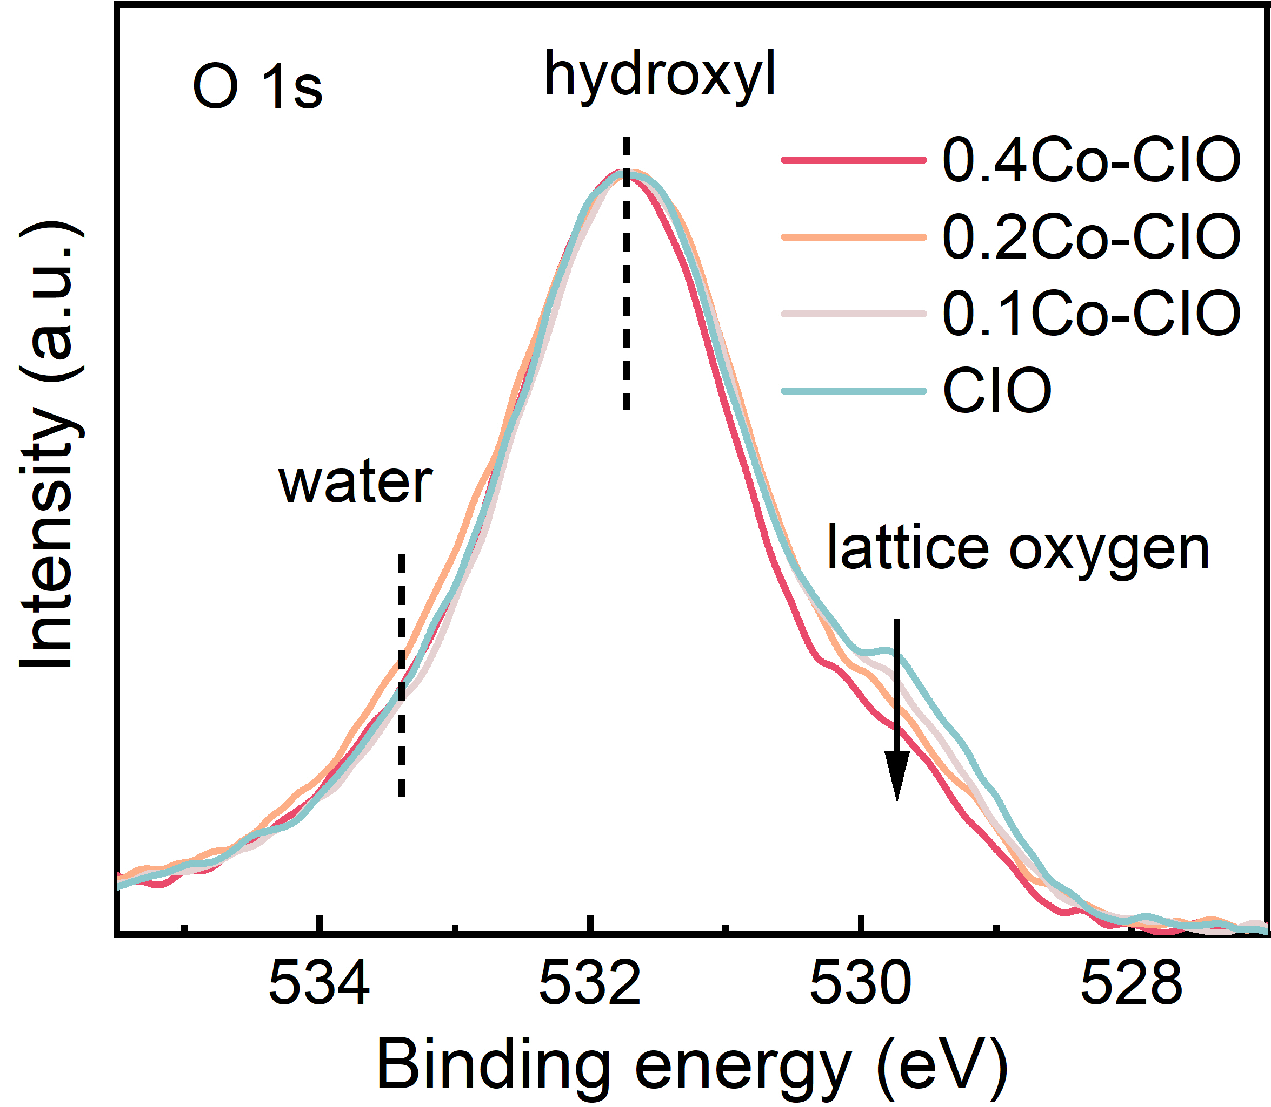
Fig. S10 O 1s XPS spectra of 0.1Co-, 0.2Co-, 0.4Co-CIO and CIO

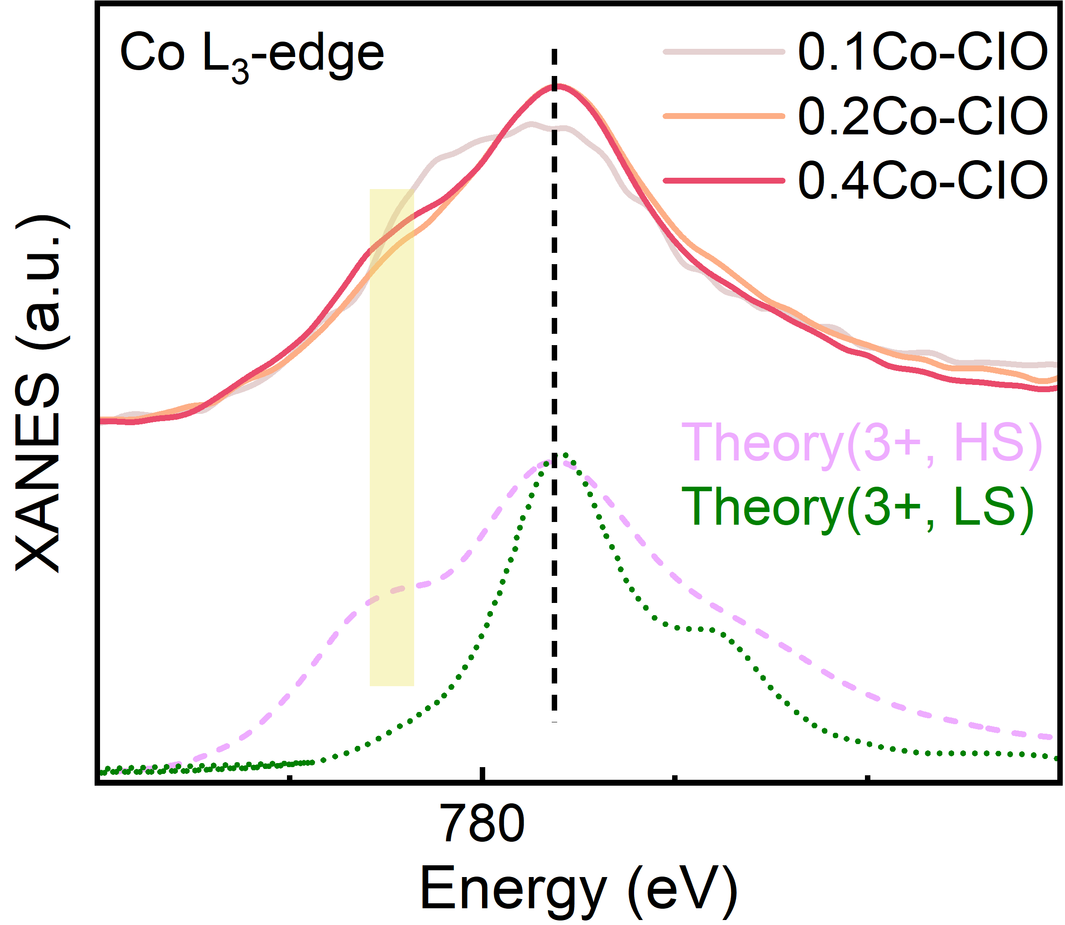
Fig. S11 Comparison of Co L₃-edge XAS spectra between Co-CIO and simulation for a Co³⁺ ion with LS and HS state in octahedral coordination

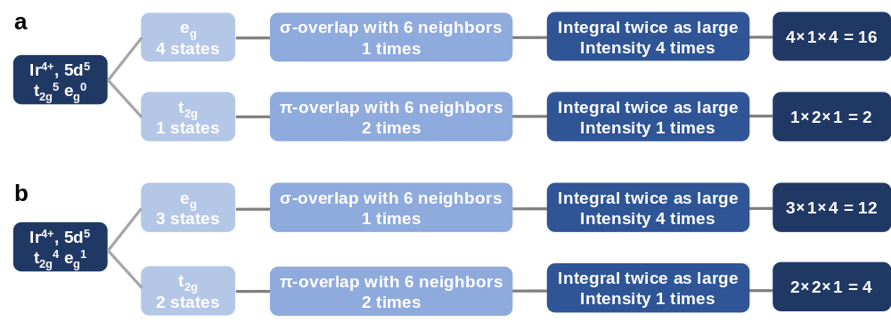
Fig. S12 Intensity of the t_{2g} and e_{g} peaks of a LS state and b IS state Ir⁴⁺ due to the exchange splitting, degeneracy, the number of overlaps, and the overlap strengths
In the case of LS state Ir⁴⁺, there are one vacancy t_{2g} state and four vacancy e_{g} states. Besides, the t_{2g} state points in between the O atoms, and the eg states point directly to the O atoms and have σ overlap with the O 2p states. Effectively, this yields a difference in the hopping terms of 2:1. Additionally, the π bonding overlap with two O 2p orbitals and σ overlap with one O 2p orbital, which implies a difference in hybridization of 1:4 for each O 2p−Ir 5d overlap. The total (relative) intensity ratio for the t_{2g}/e_{g} band is 1/4 × 2/1 × 1/4 = 2/16. Therefore, the expected t_{2g}/e_{g} band ratio is 0.125 for LS state Ir⁴⁺. Similarly, the expected t_{2g}/e_{g} band ratio in IS state Ir⁴⁺ is 2/3 × 2/1 × 1/4 = 4/12.

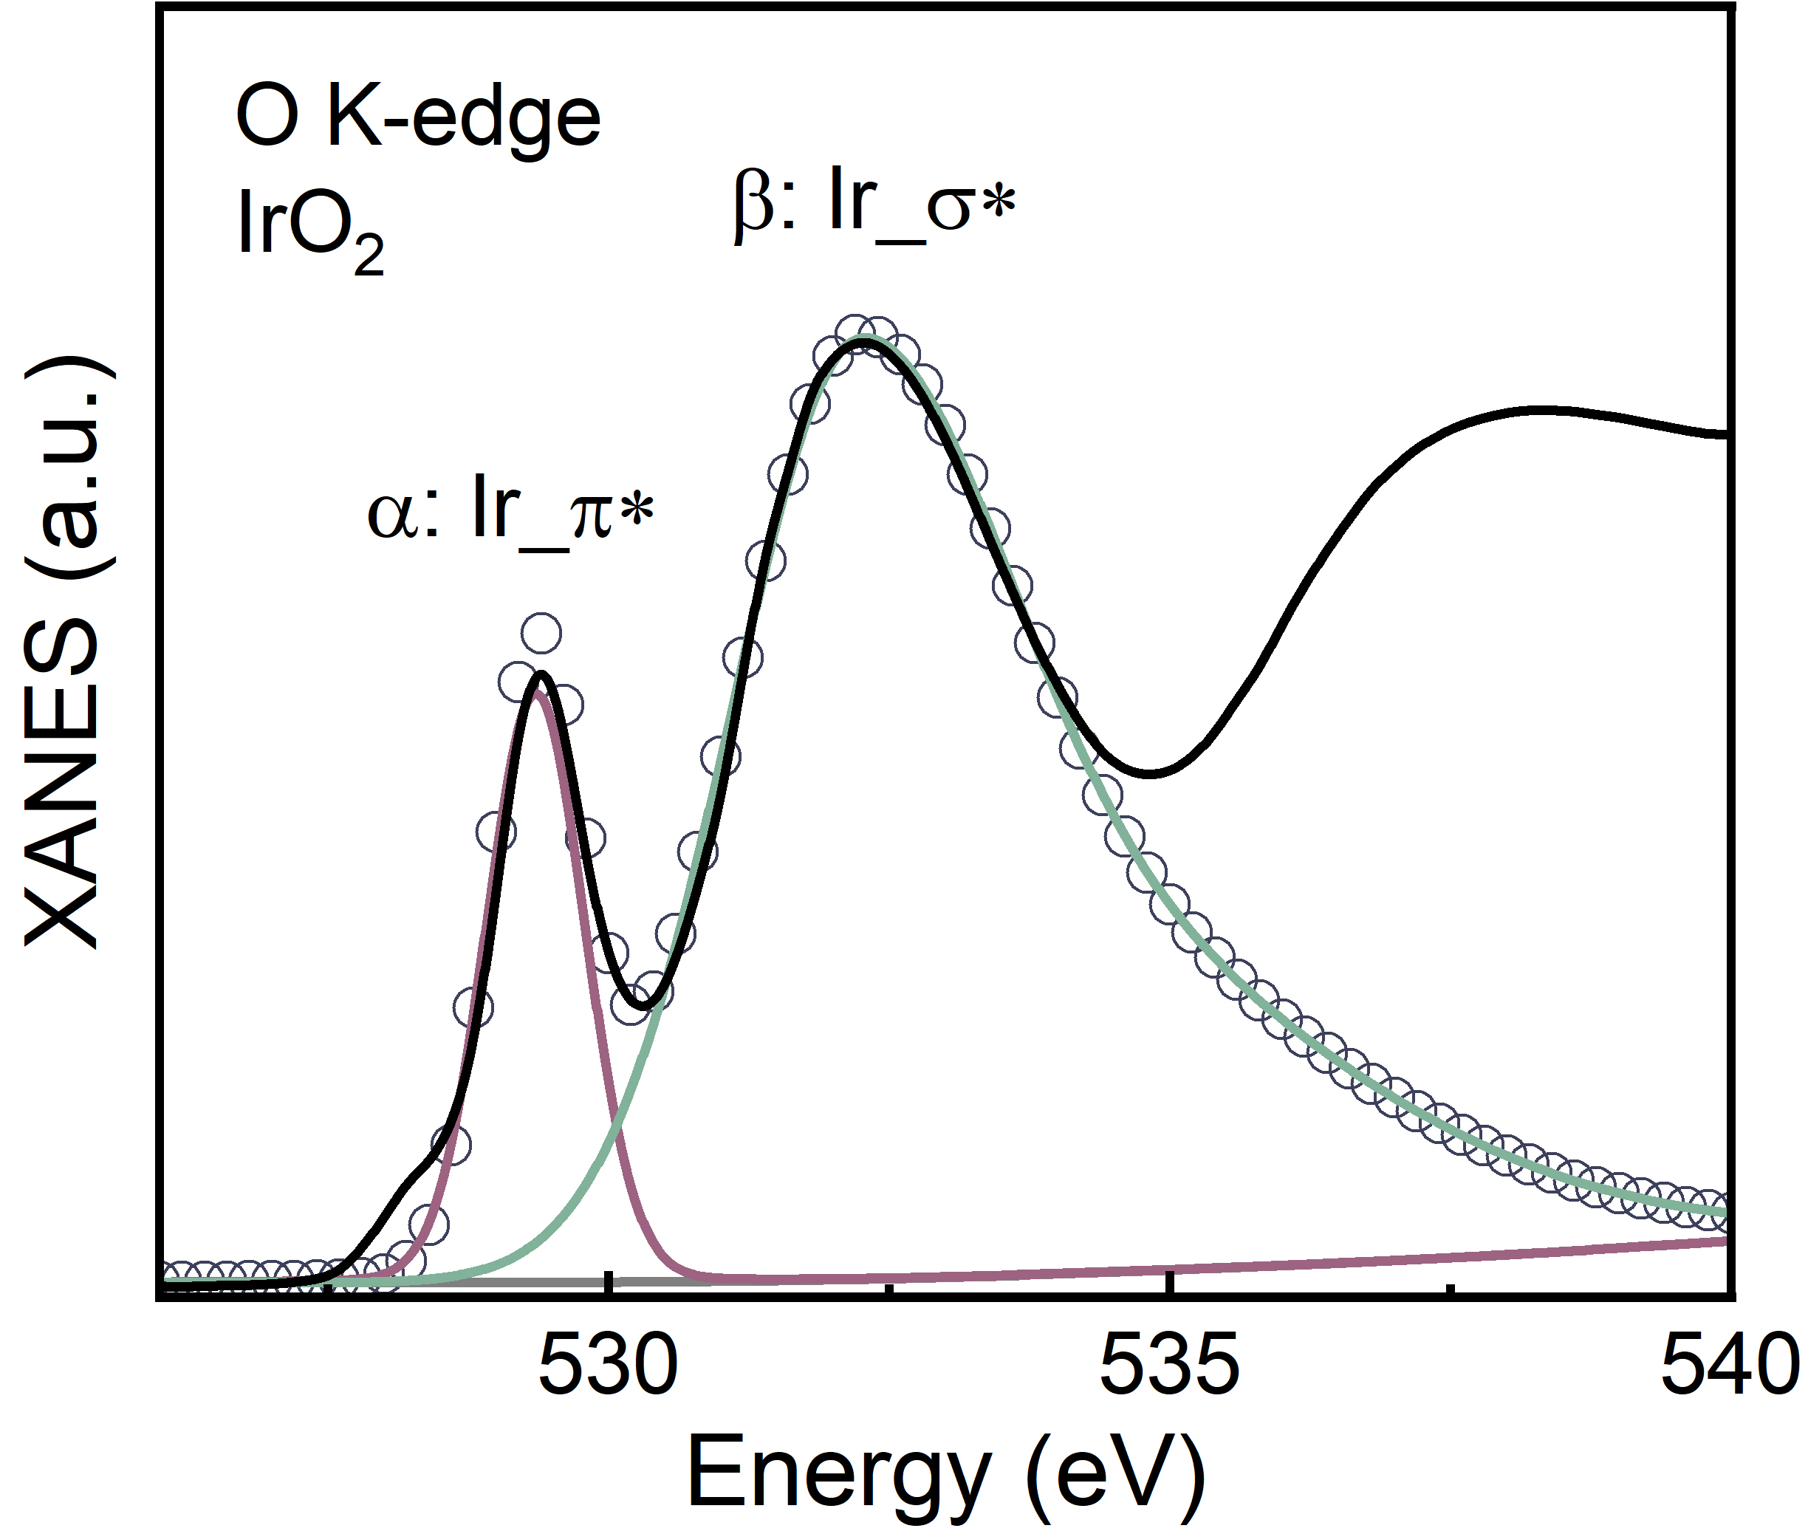
Fig. S13 The fitting results of peak α and β in the O K-edge XANES for commercial IrO₂
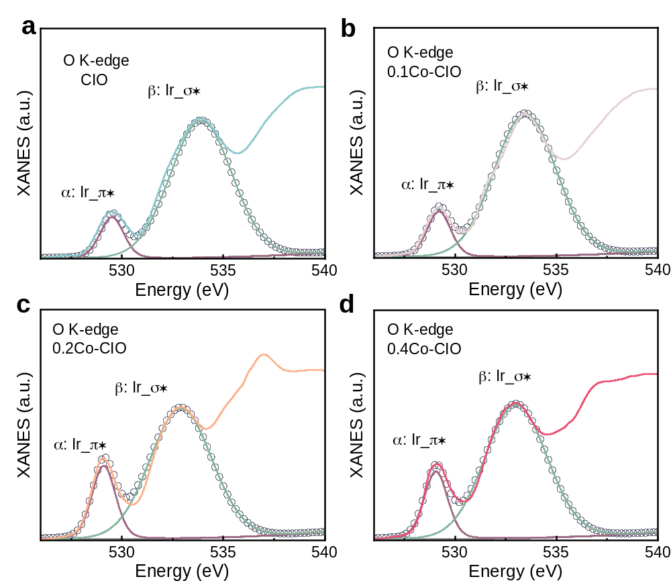
Fig. S14 The fitting results of peak α and β in the O K-edge XANES for a CIO, b 0.1Co-CIO, c 0.2Co-CIO, and d 0.4Co-CIO
The detailed fitting results with 0.126 for IrO₂ and 0.123 for CIO are close to the theoretical value of 0.125, validating the expected estimation of Ir spin state through the I_{t2g}/I_{eg} ratio method although the fit parameters are somewhat different due to the different crystal symmetry.

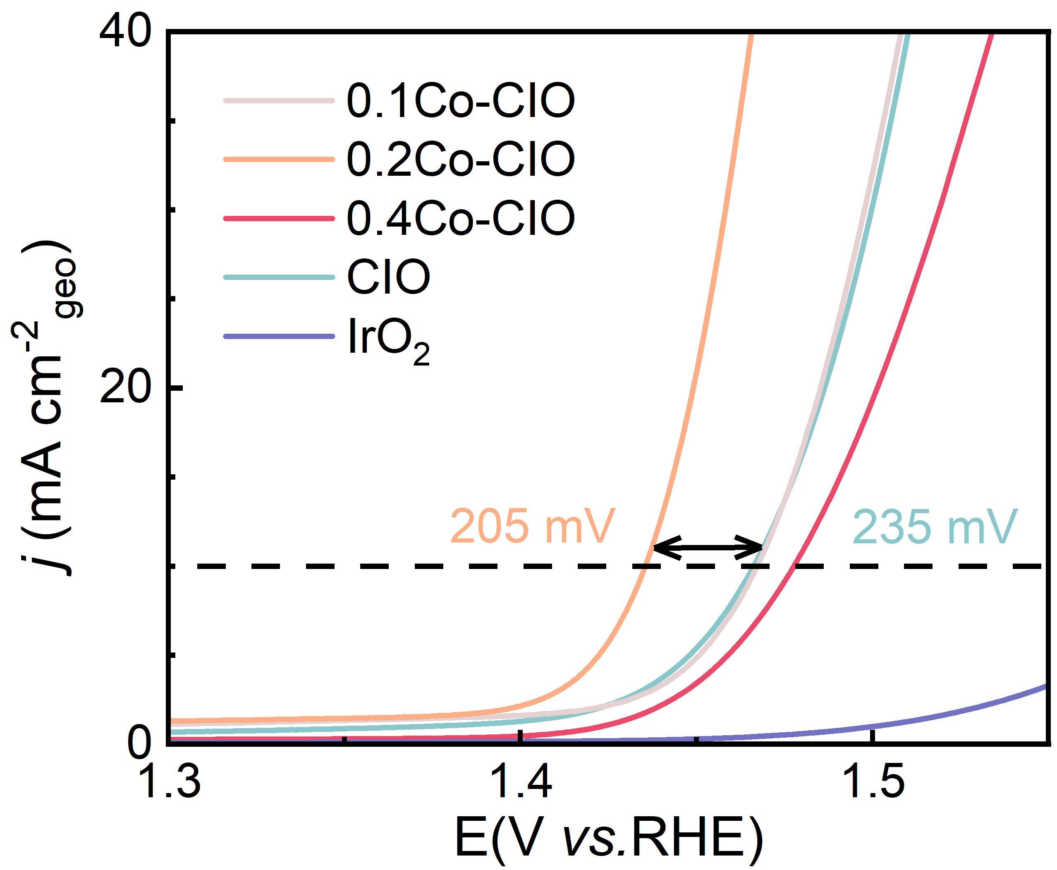
Fig. S15 LSV polarization curves
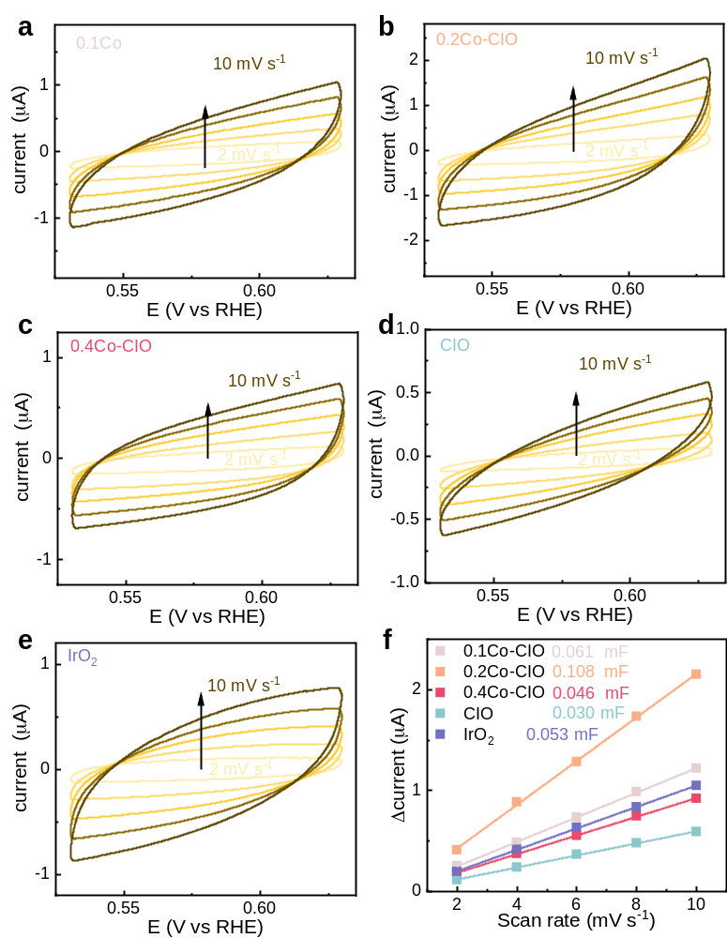
Fig. S16 Double-layer capacitance measurements. CVs were conducted in a non-Faradaic region of voltammogram at the following scan rate: 2, 4, 6, 8, 10 mV s⁻¹. The difference in charging currents variation at an underpotential plotted against scan rate for estimation of double-layer capacitance (C_{dl})

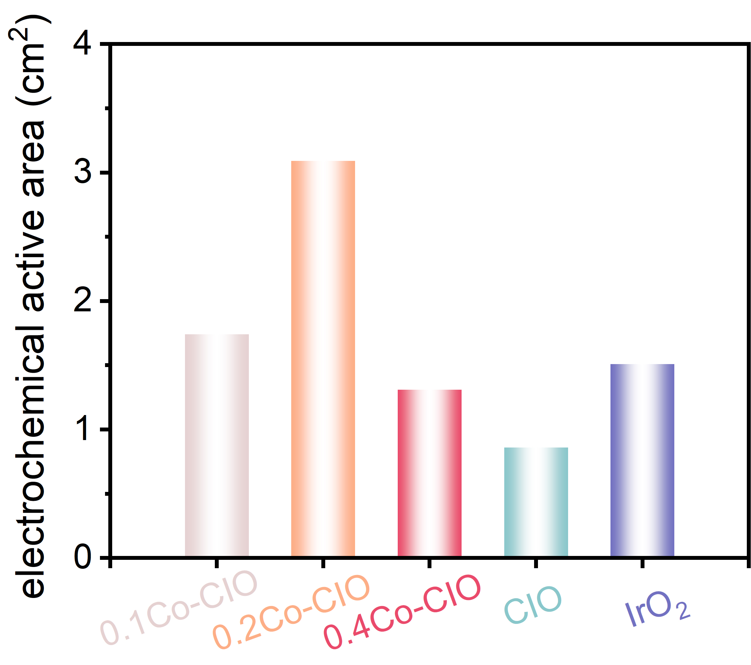
Fig. S17 Comparison of ECSA

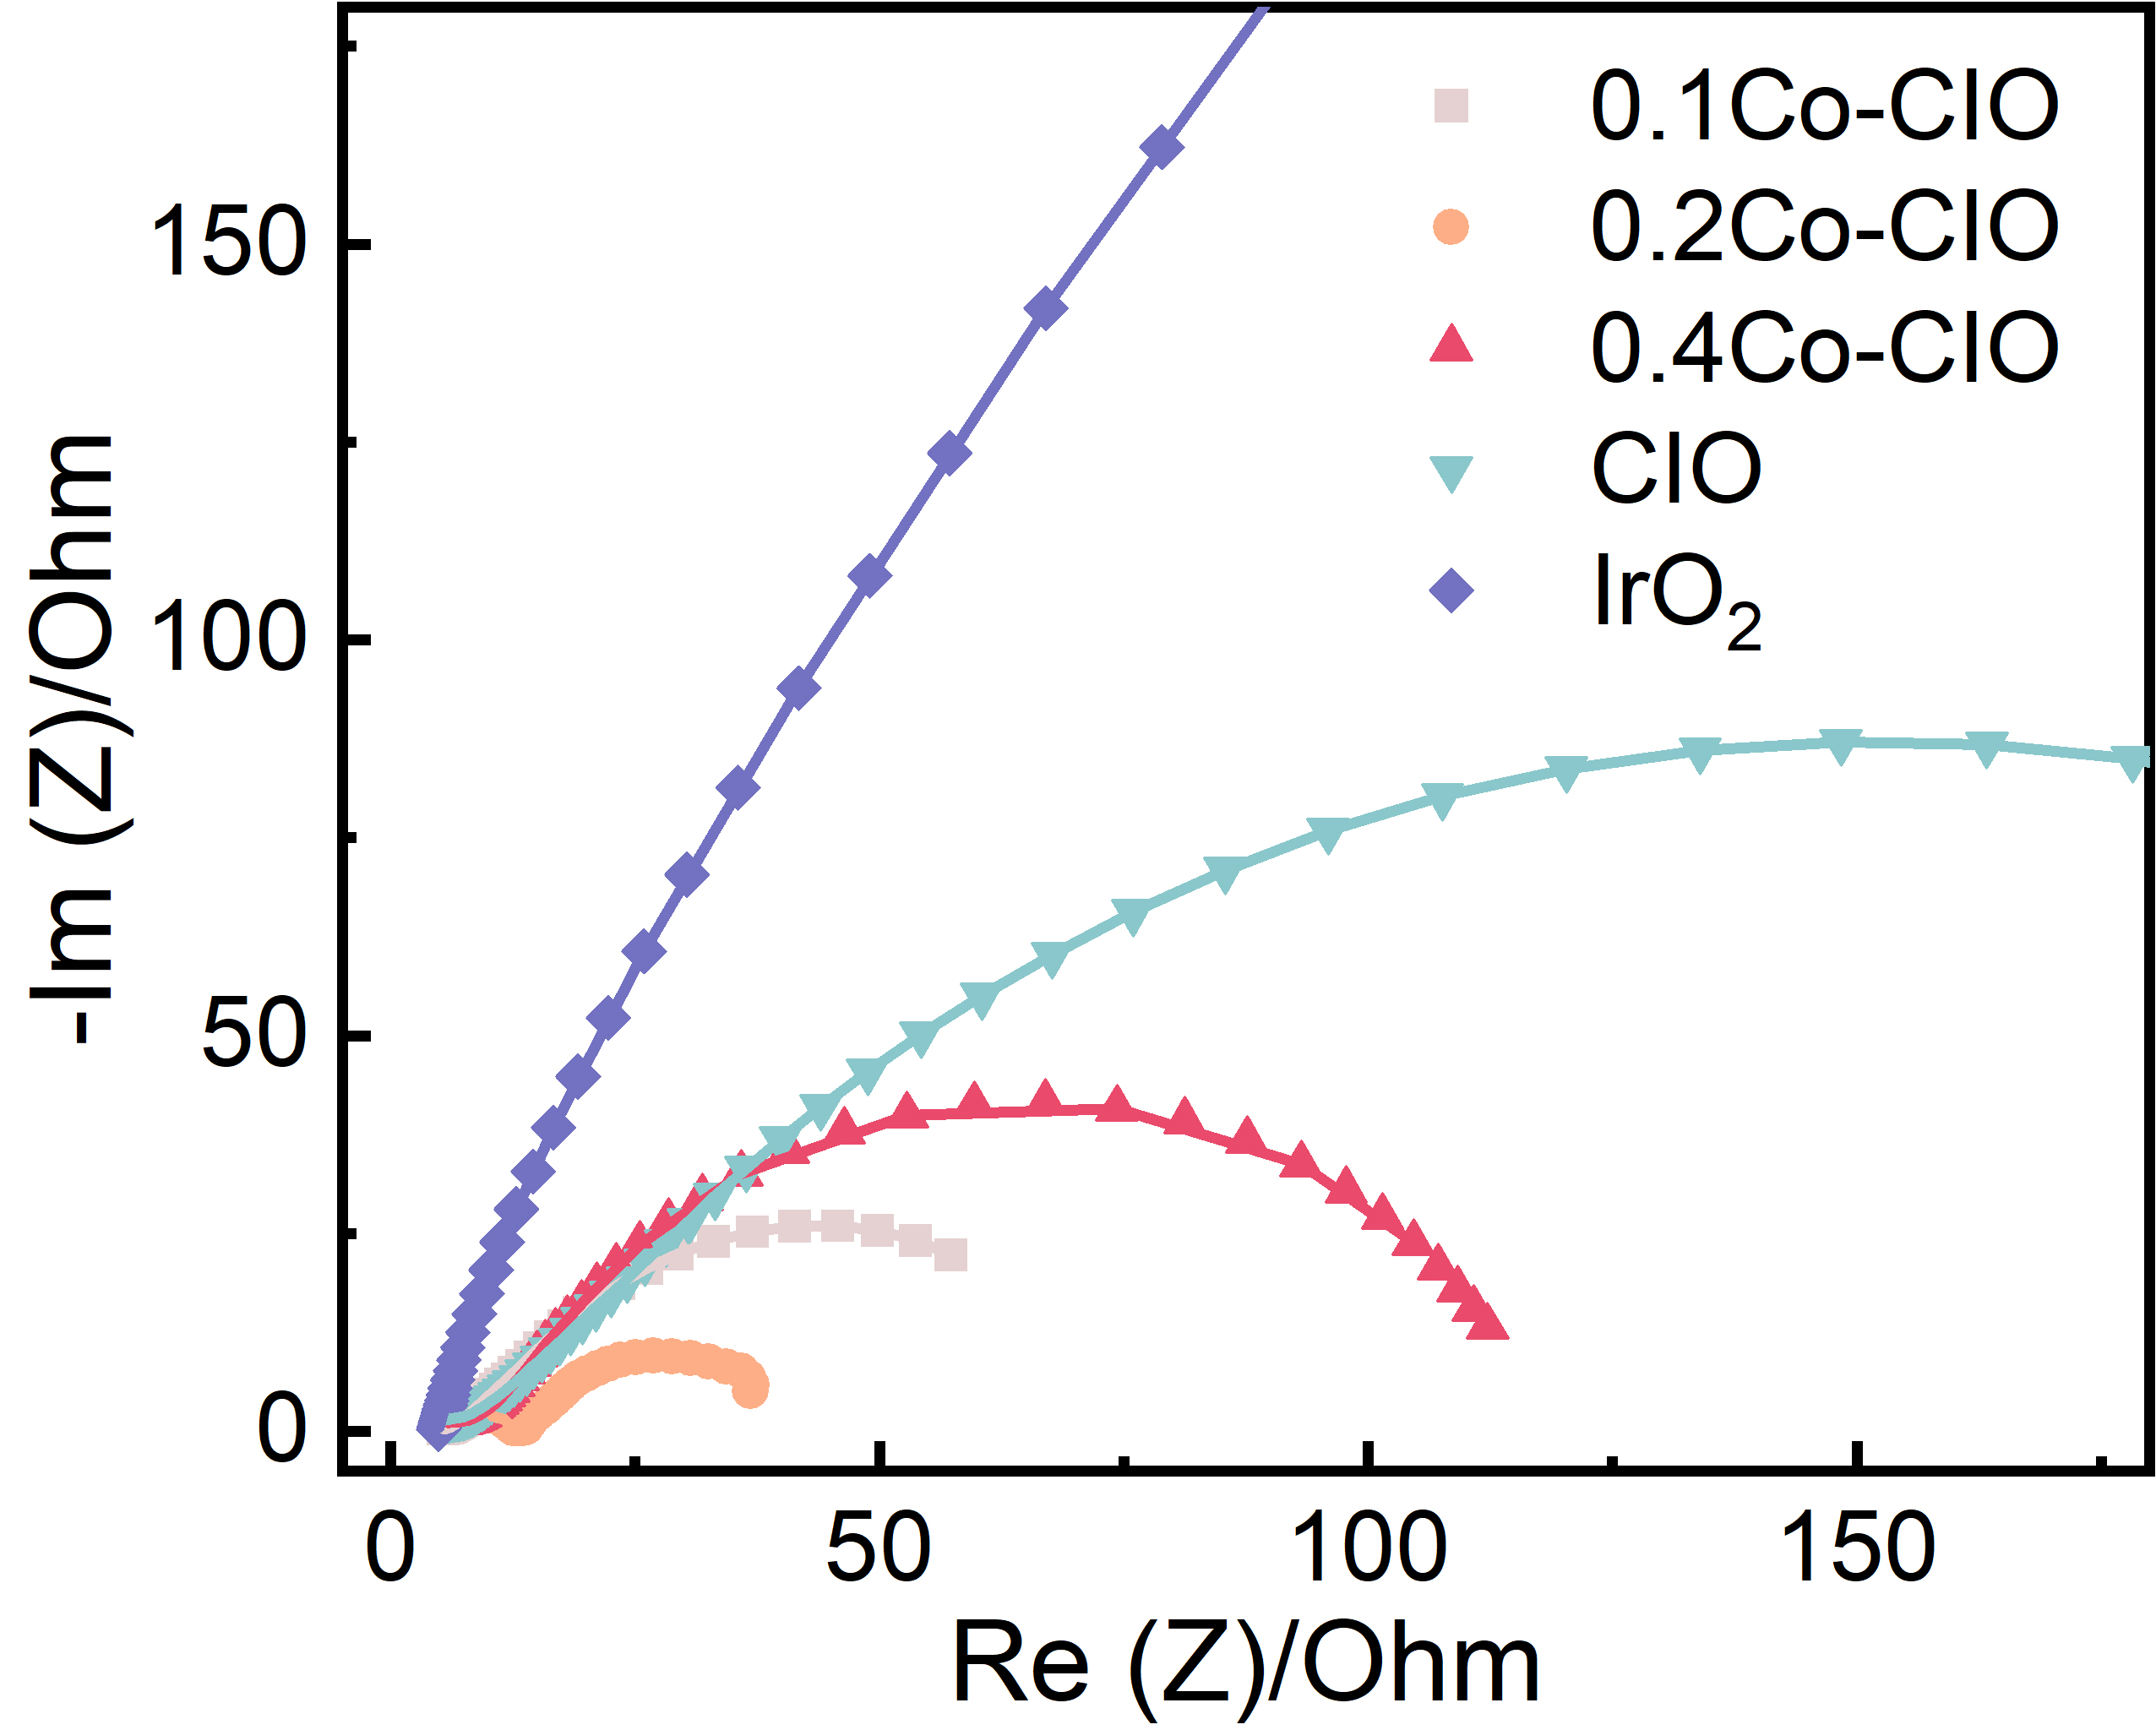
Fig. S18 Electrochemical impedance spectra at 1.53 V (set potential)

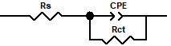
Fig. S19 The equivalent circuit. R_{s}: series resistance; R_{ct}: charge-transfer resistance; CPE: the constant phase element

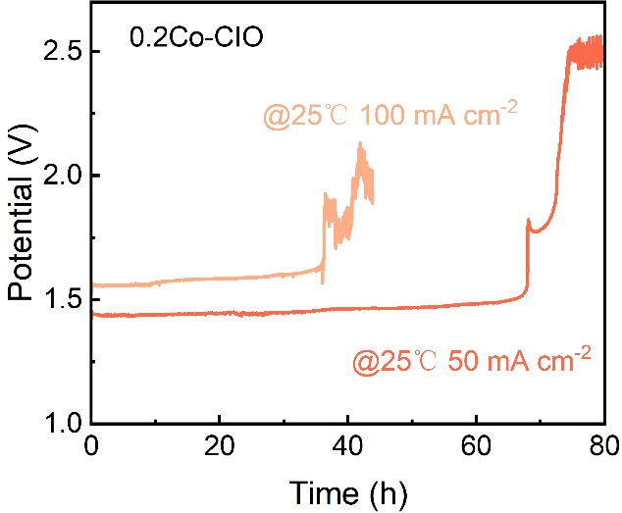.
Fig. S20 Chronopotentiometry curves of 0.2Co-CIO at a constant current density of 50 and 100 mA cm⁻² (with IR compensations)
The instantaneous deactivation may be related to the fact that surface charge accumulation makes a large local potential to drive irreversible structural reorganization.

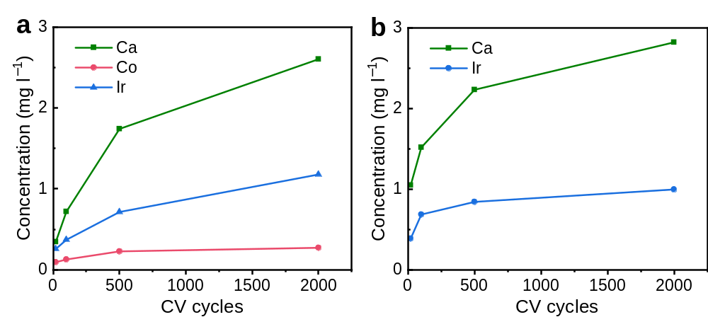
Fig. S21 Elemental leaching was assessed by ICP-OES after cycled voltage tests of a 0.2Co-CIO and b CIO after 20, 100, 500, 2000 cycles

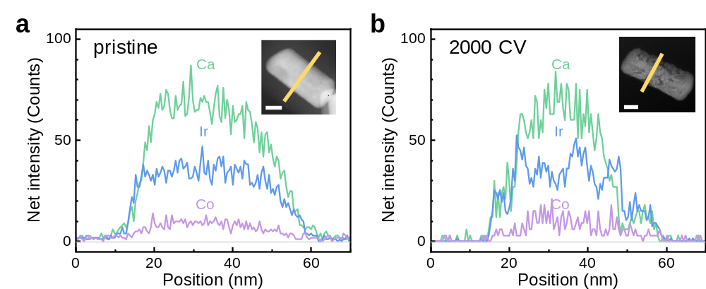
Fig. S22 EDS linear scan analysis of 0.2Co-CIO (scale bar is 20 nm) as pristine and after 2000 CV cycles

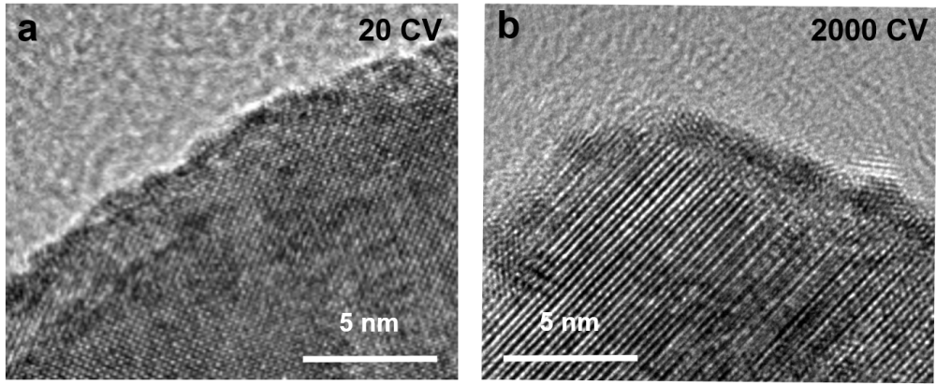
Fig. S23 TEM images of 0.2Co-CIO as a activated after 20 CV cycles and b aged after 2000 CV cycles
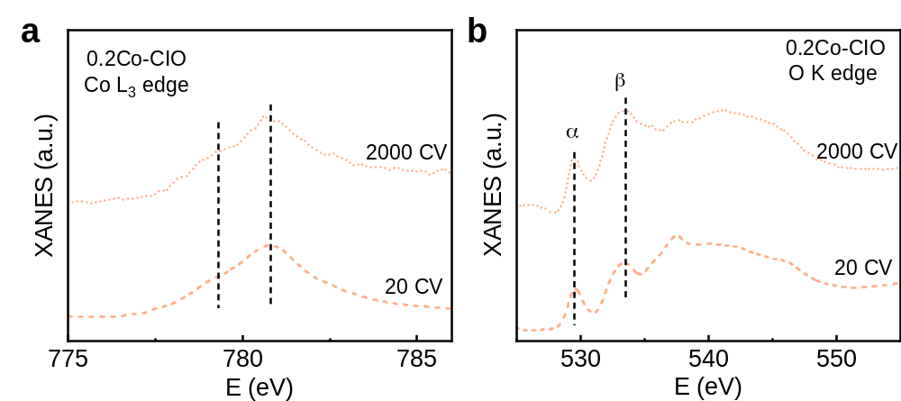
Fig. S24 Comparisons of XANES at a Co L edge, and b O K edge for 0.2Co-CIO as pristine, as activated after 20 CV cycles and as aged by 2000 CV cycles

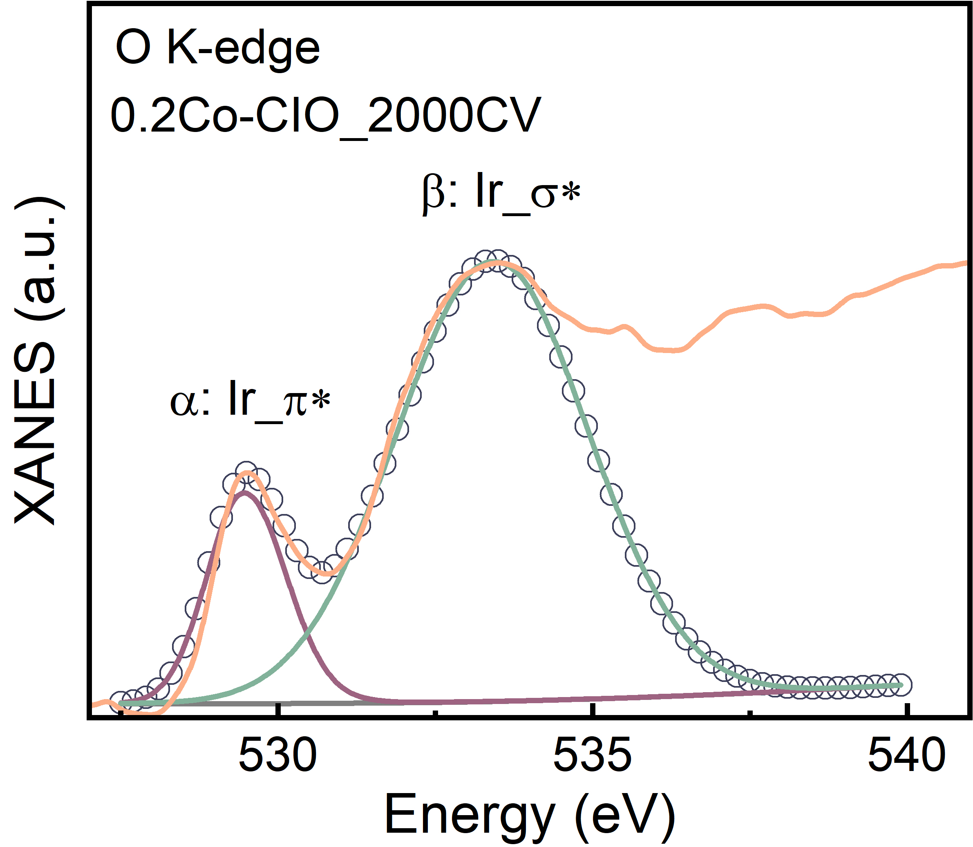
Fig. S25 The fitting results of peak α and β in the O K-edge XANES for 0.2Co-CIO after aged by 2000 CV cycles
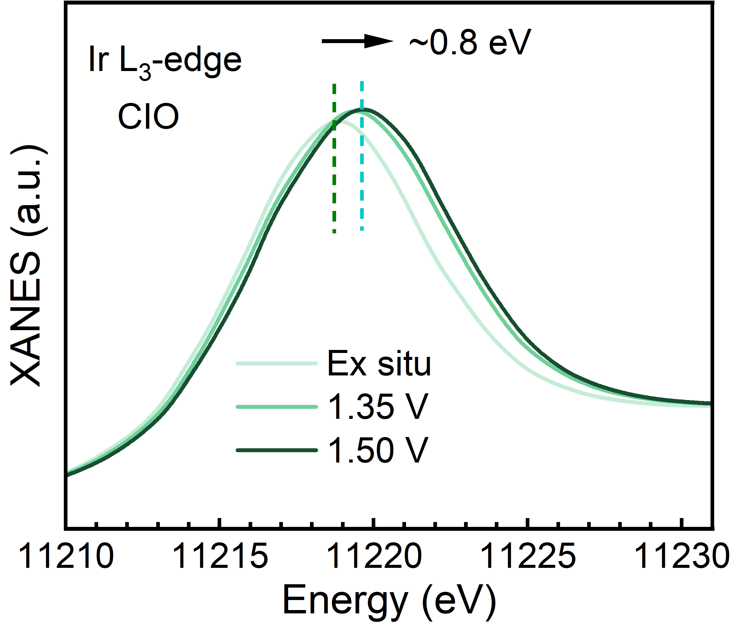
Fig. S26 The first derivative of absorption in the XANES region of Co K-edge for CIO during OER process
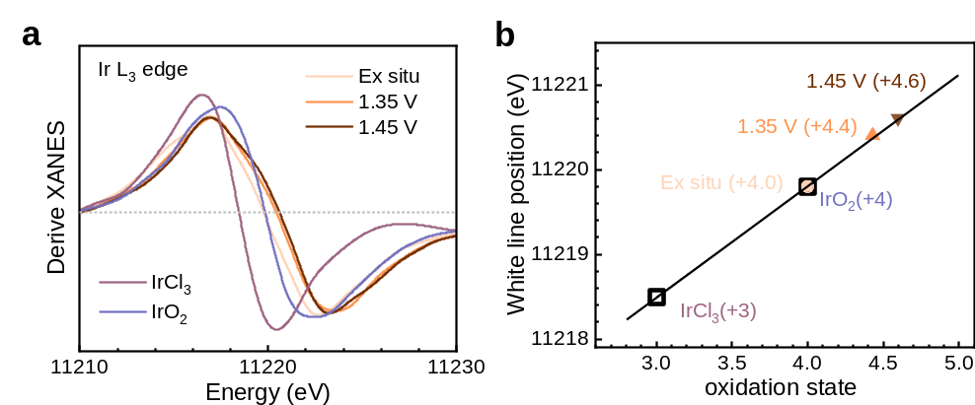
Fig. S27 a The first derivative of absorption in the XANES region of Ir L₃-edge during OER process. b Ir L₃ white line positions of 0.2Co-CIO at different potentials as a function of oxidation state. White line position and oxidation state of IrCl₃ and IrO₂ are shown as references, respectively. All potentials are normalized to RHE
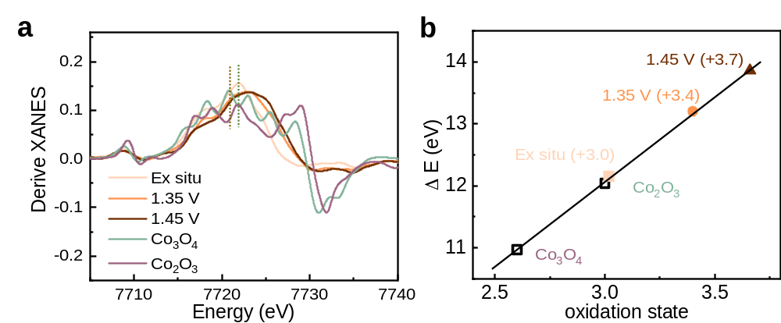
Fig. S28 a The first derivative of absorption in the XANES region of Co K-edge during OER process. b Co K-edge positions of 0.2Co-CIO at different potentials as a function of oxidation state. Absorption edge position and oxidation state of Co₃O₄ and Co₂O₃ are shown as references, respectively. All potentials are normalized to RHE
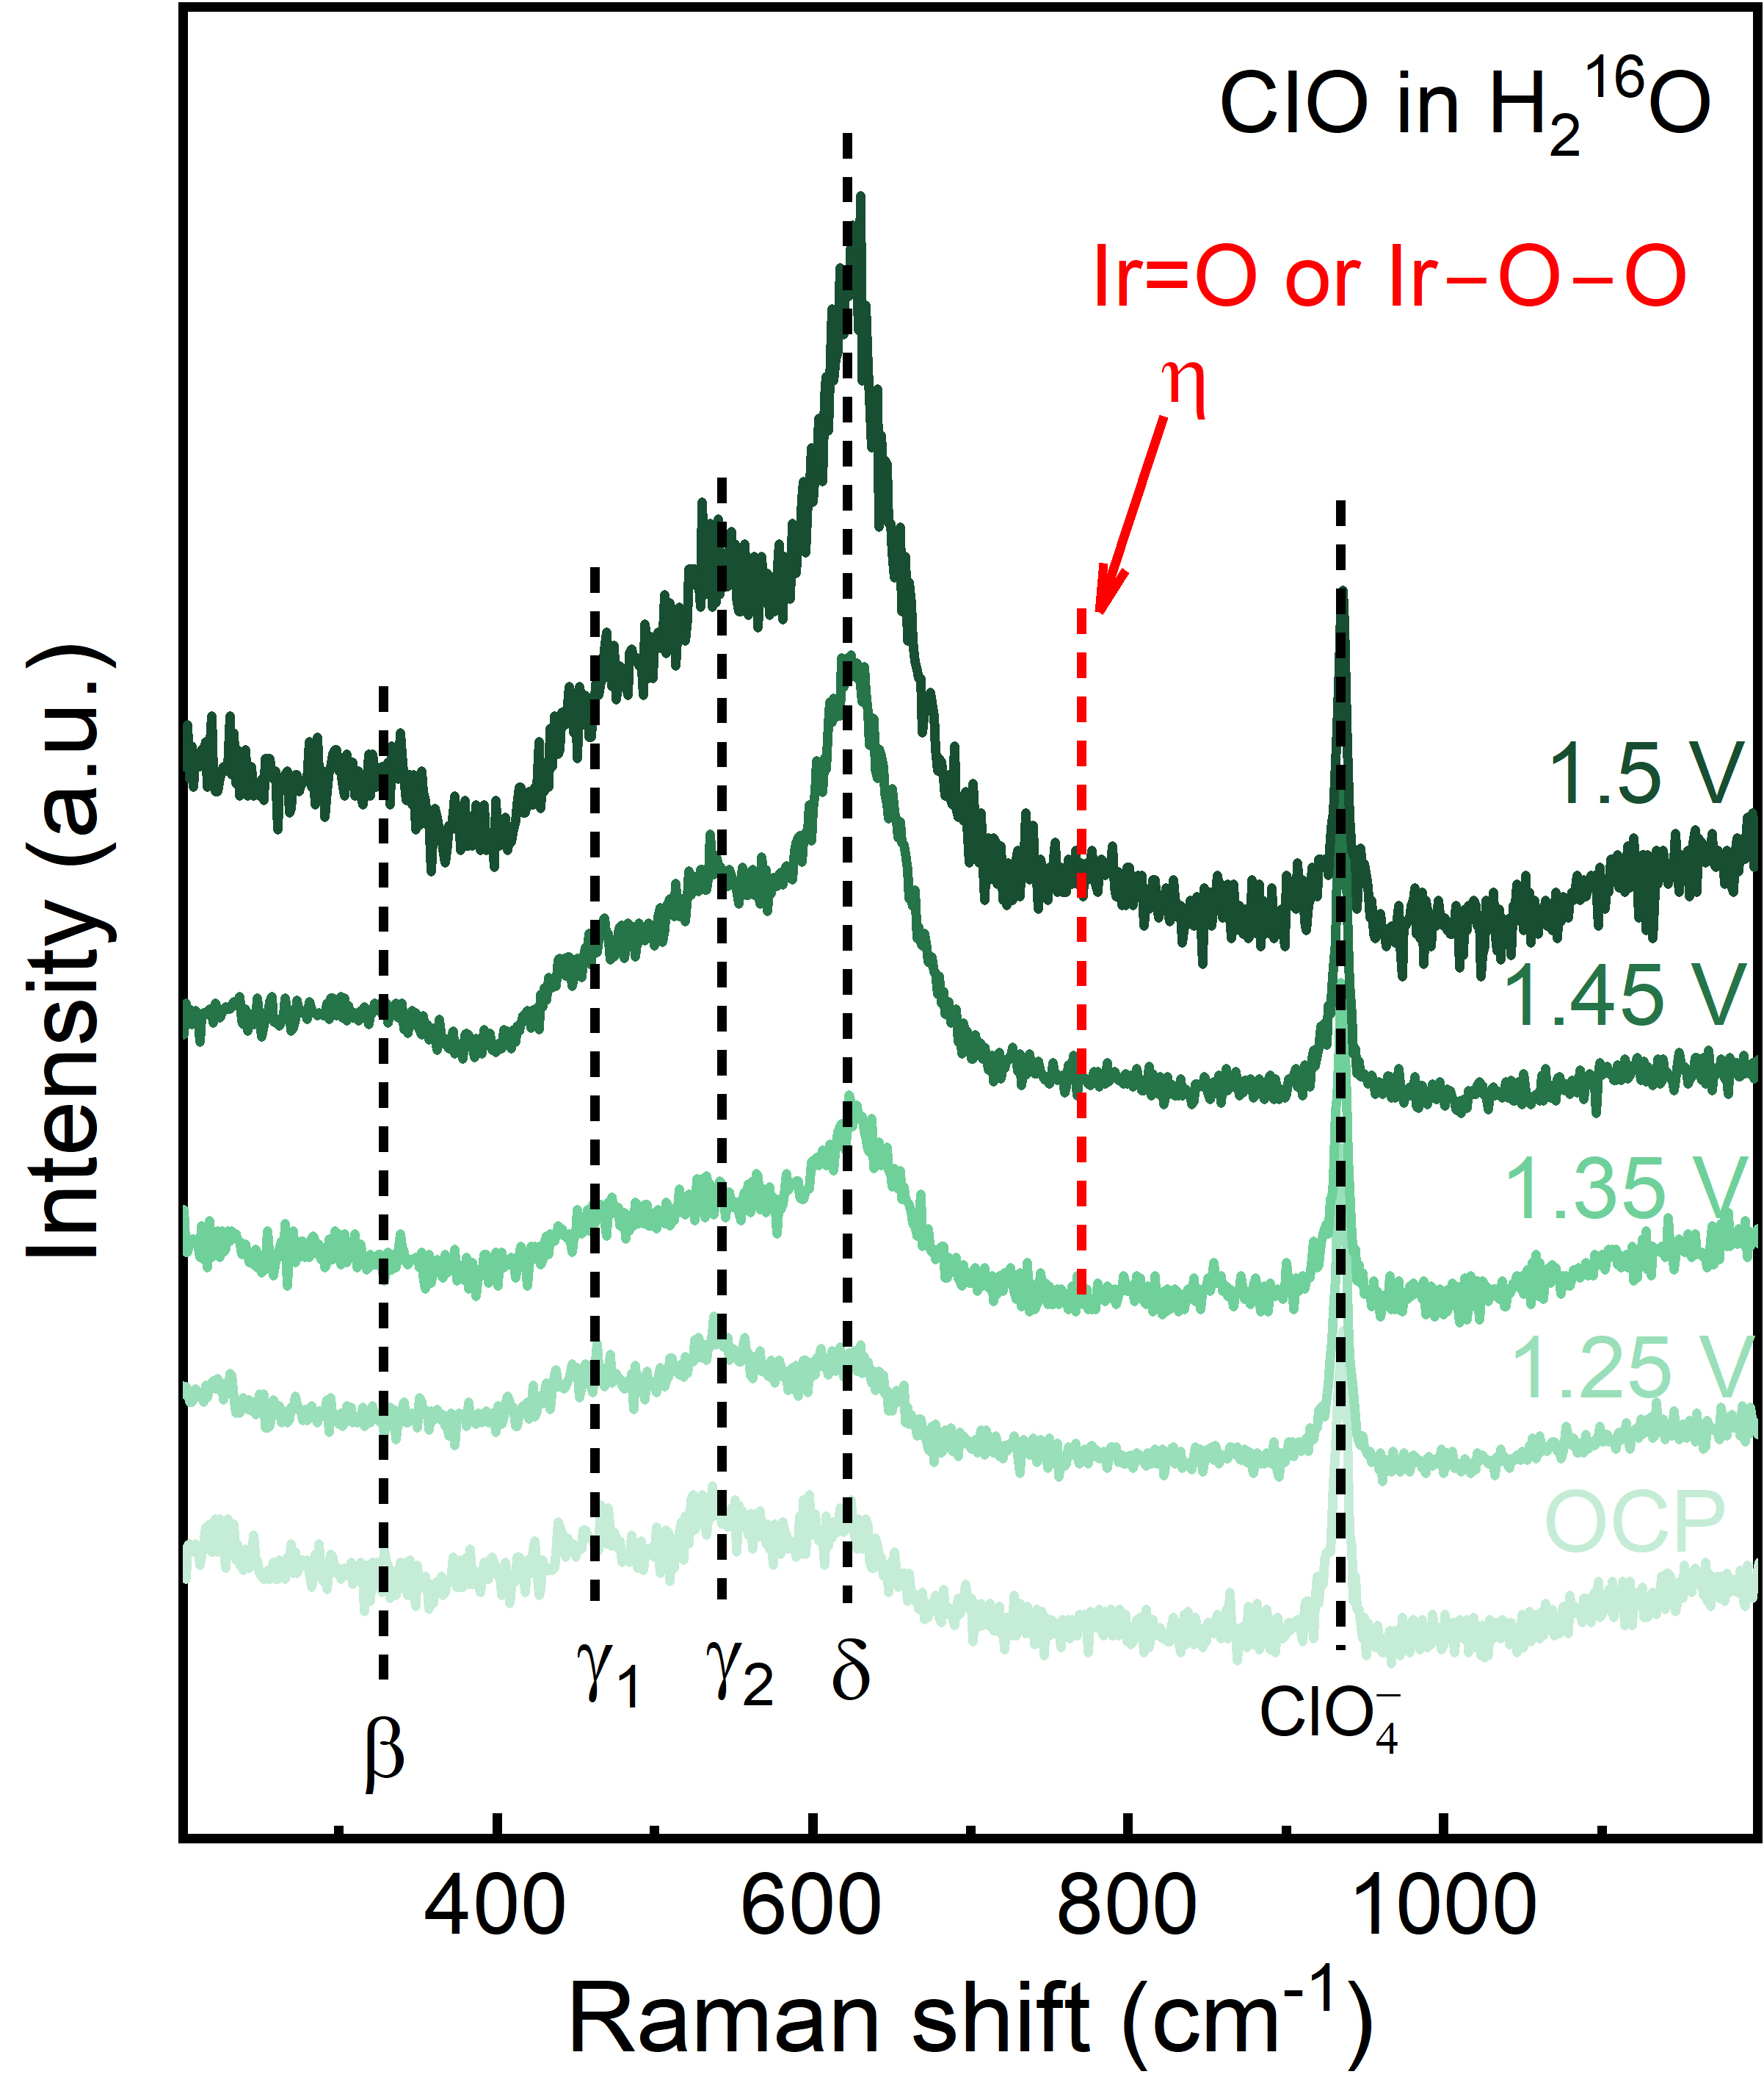
Fig. S29 In situ Raman spectra of CIO catalyst in 1 M HClO₄

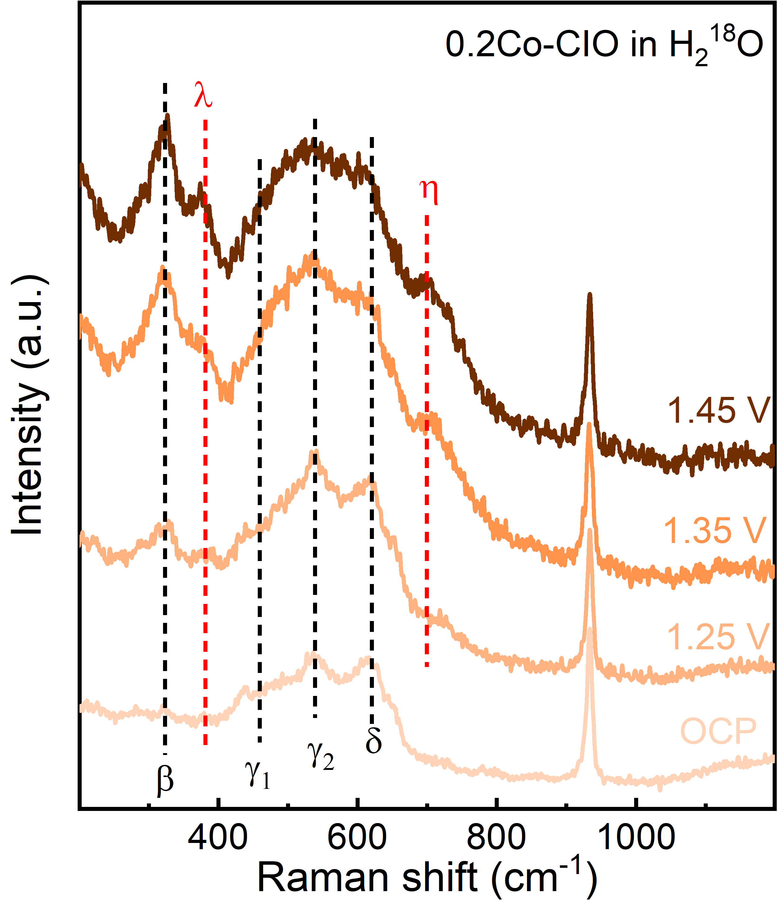
Fig. S30 In situ Raman spectra of 0.2Co-CIO catalyst in 1 M HClO₄+H₂¹⁸O

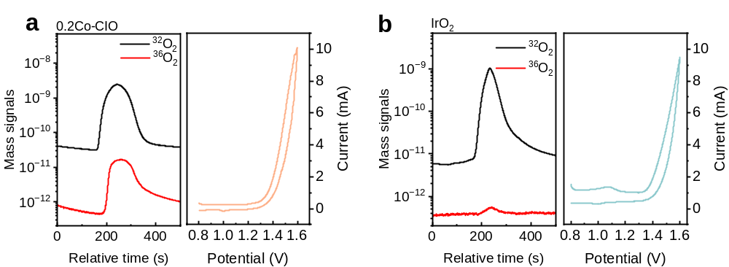
Fig. S31 DEMS signals of ³²O₂ (¹⁶O¹⁶O) and ³⁶O₂ (¹⁸O¹⁸O) from the reaction products for ¹⁸O-labeled 0.2Co-CIO and IrO₂ catalysts in H₂¹⁶O aqueous perchloric acid electrolyte and corresponding CV cycles
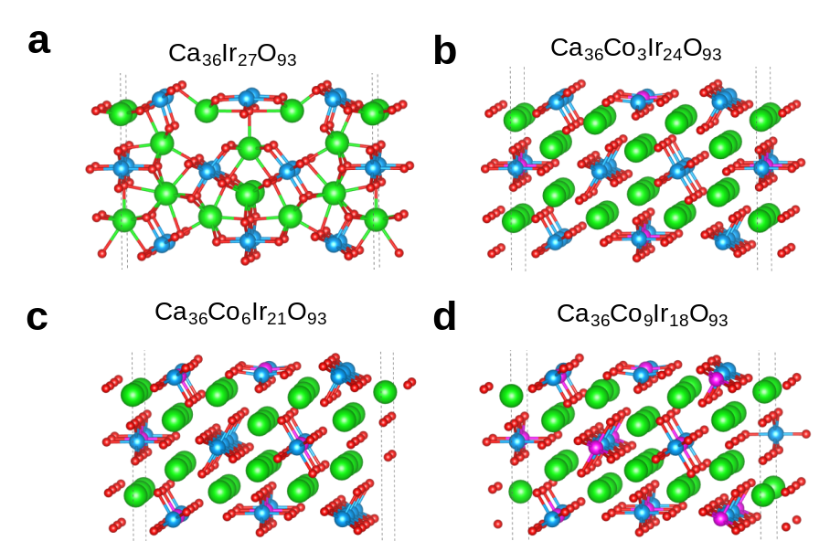
Fig. S32 Slab models of a CIO, b Co1-CIO, c Co2-CIO, d Co3-CIO
DFT results indicated that Co–O–Co structure appears when Co: Ir reaches higher than that in Co3-CIO (Co: Co+Ir = 1/3), which can not effectively regulate the Ir spin state as observed for 0.4Co-CIO (Co: Co+Ir with 2/5). Therefore, higher Co concentration than that in Co3-CIO is not included.
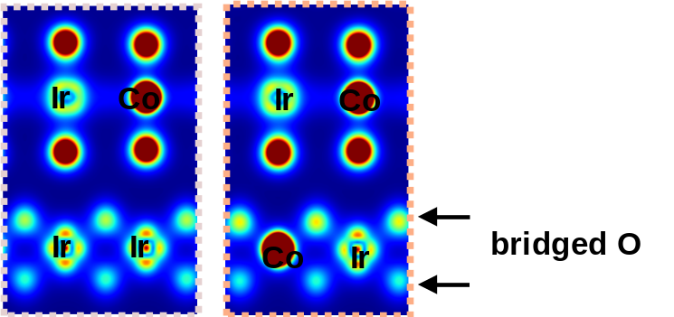
Fig. S33 The electron density of Co1-CIO (left) and Co2-CIO (right)
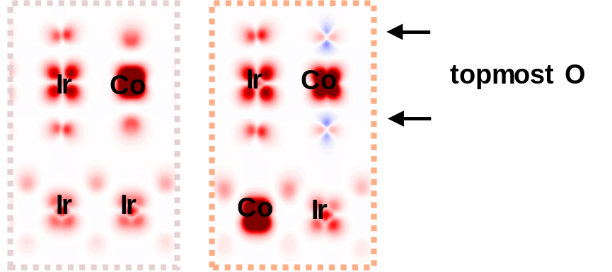
Fig. S34 The electron spin density of Co1-CIO (left) and Co2-CIO (right)
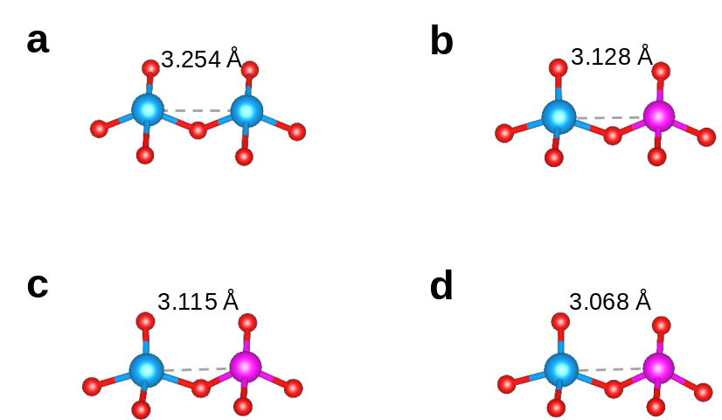
Fig. S35 The atomic distance of surface Ir‒Ir or Ir‒Co in a CIO, b Co1-CIO, c Co2-CIO, d Co3-CIO
The Co‒Ir atomic distance slightly reduces from 3.25 Å to 3.13 Å, 3.12 Å, and 3.07 Å as the Co amounts increase for CIO, Co1-CIO, Co2-CIO, and Co3-CIO, while the bond angle reduces from ~102° and ~108° of Ir‒O‒Ir to ~100° and ~107° of Ir‒O‒Co, respectively. The evolution of local Ir‒O‒Ir structure indicate the gradually enhanced interaction between Co and Ir atoms.
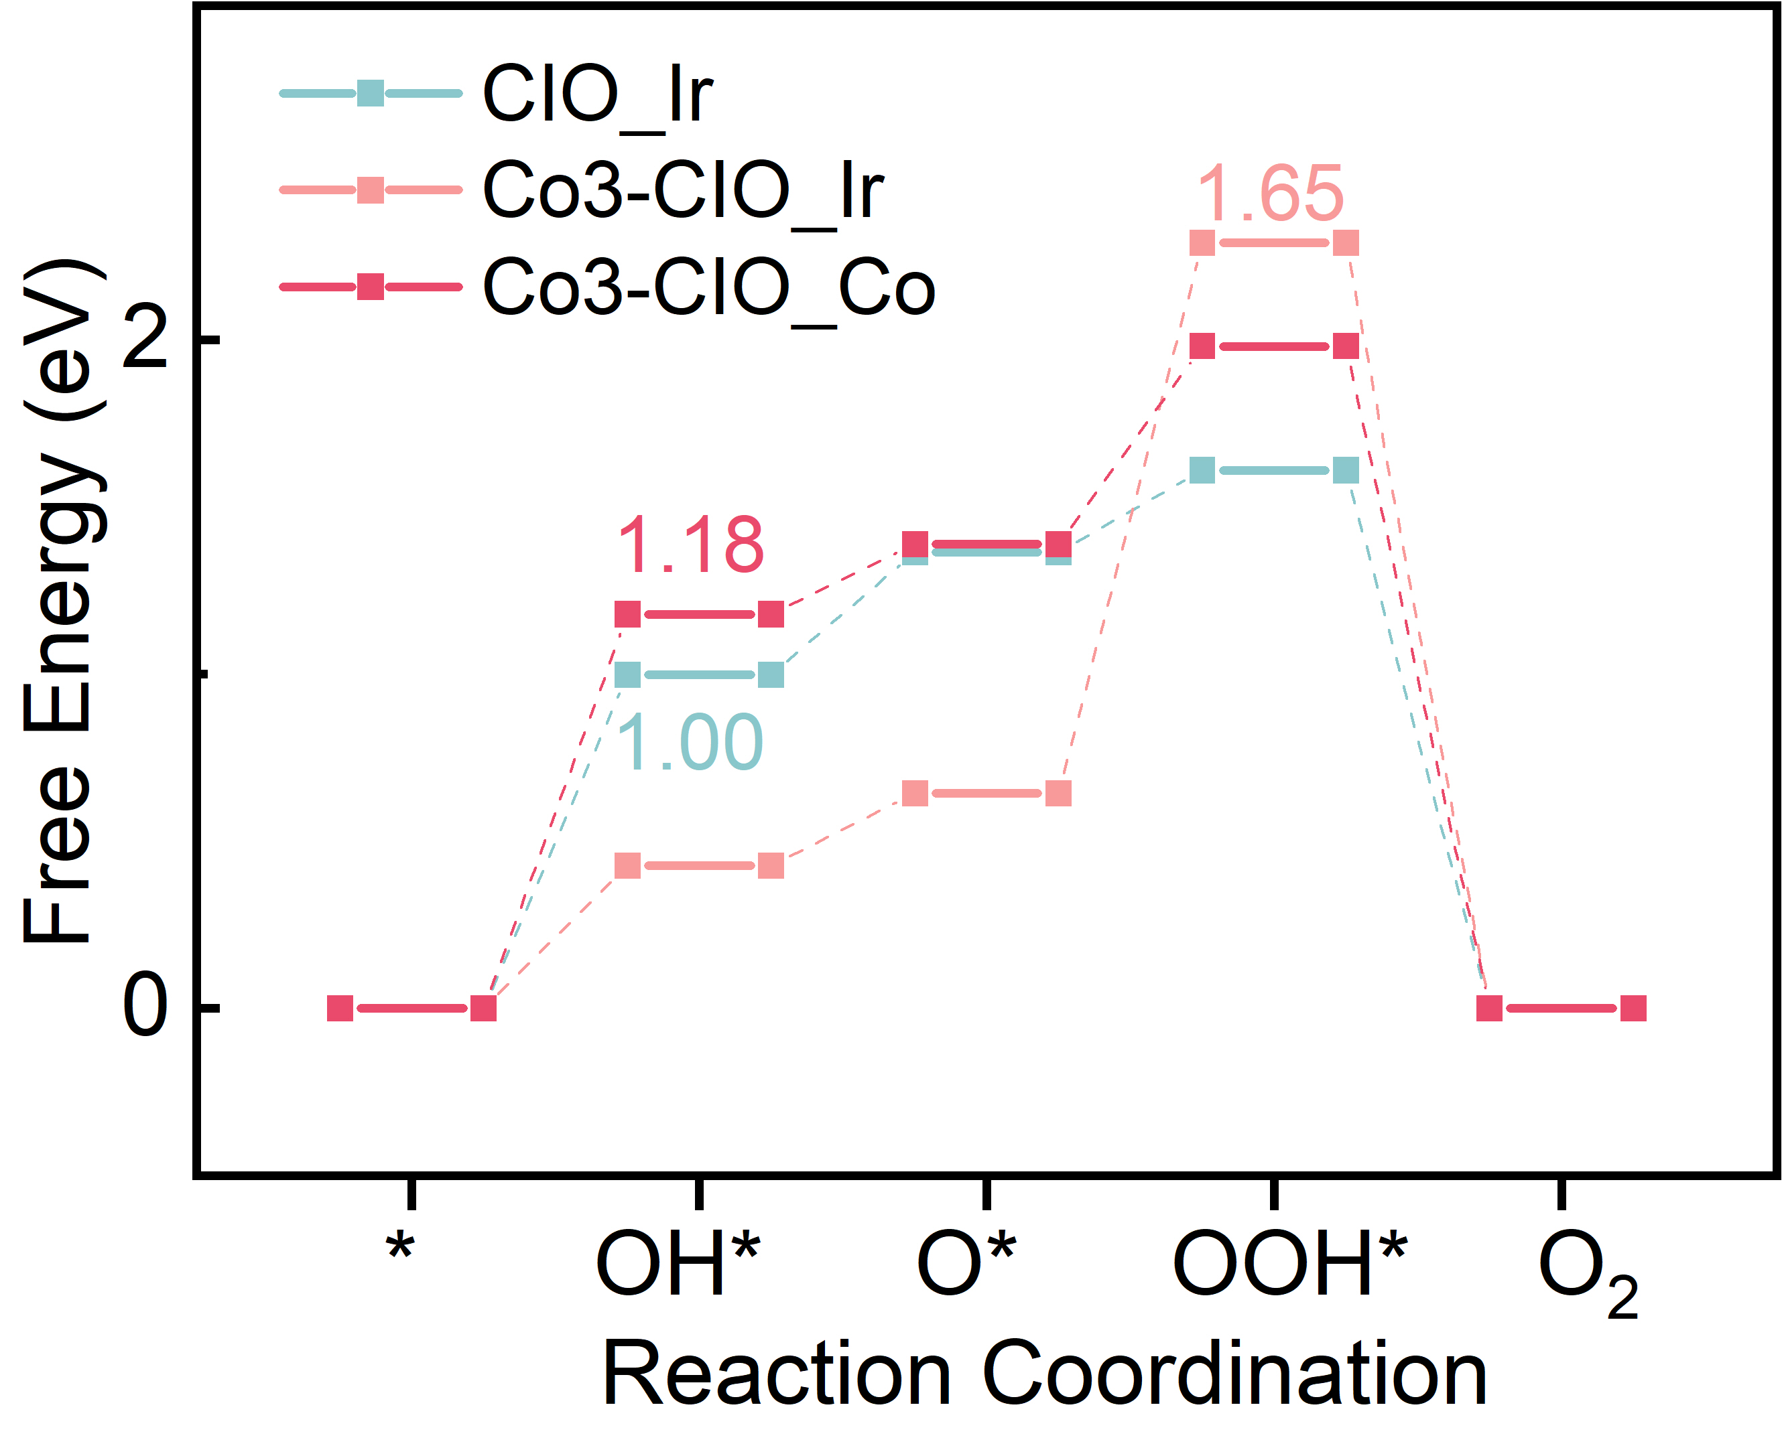
Fig. S36 Free energy profile at 1.23 V for the AEM pathway on the Ir site of CIO and the Ir or Co site of Co3-CIO
Table S1 Fit parameters of peak α and β in O K-edge XANES spectra
catalysts | IrO₂ |  |  | CIO |  |  | 0.1Co-CIO |  |  |  | 0.2Co-CIO |  |  | 0.4Co-CIO |  |  | 0.2Co-CIO_2000CV
Peak | t_{2g} | e_{g} | t_{2g} |  | e_{g} | t_{2g} |  | e_{g} |  | t_{2g} |  | e_{g} | t_{2g} |  | e_{g} | t_{2g} |  | e_{g}
Position | 529.4 | 533.0 | 529.5 |  | 533.9 | 529.2 |  | 533.5 |  | 529.1 |  | 532.9 | 529.0 |  | 533.0 | 529.5 |  | 533.4
FWHM | 1.0 | 2.7 | 1.35 |  | 3.6 | 1.35 |  |  | 3.6 | 1.35 |  | 3.6 | 1.35 |  | 3.6 | 1.35 |  | 3.6
Area | 1.02 | 8.1 | 0.95 |  | 7.70 | 1.05 |  |  | 8.02 | 1.69 |  | 7.33 | 1.56 |  | 7.56 | 1.94 |  | 9.02
Area ratio | 0.126 |  | 0.123 |  |  | 0.130 |  |  |  | 0.230 |  |  | 0.206 |  |  | 0.215
IS (vol%) | 0 |  | 0 |  |  | 2% |  |  |  | 50% |  |  | 40% |  |  | 44%
IS (mole fraction) | 0 |  | 0 |  |  | 0.18 |  |  |  | 0.40 |  |  | 0.24 |  |  | 0.35

The same energy range of ~18 eV from 522-544 eV is carefully fitted aiming at peak α and β with different position. For quantitative studies, the Touggard background was added to remove the background signals. Other parameters including FWHM 1.35 and 3.6, as well as Lorentzian/Gaussian ratio 20% and 5% keep the same for peak α and β, respectively, based on the different spectral shape.
The fitting result of O K edge XANES spectra after 2000 CV cycles indicate a slight reduction of IS Ir atom from pristine 0.4 mole to 0.35 mole, probably due to the dissolution of surface Co atoms in acid. These similar IS Ir ratio before and after the durability test confirmed the relatively stability of Janus Co−Ir structure on surface for the long durability under 10 mA cm^{‒2} of 0.2Co-CIO for 100 h in acid.

Table S2 Comparison of the acidic OER performances of 0.2Co-CIO with other state-of-the-art Ir-based electrocatalyst improved by transition metal doping reported recently
catalysts | electrolytes | E/V@10  mA cm⁻²_{geo} | j (A g⁻¹) | Refs.
0.2Co-CIO | 1 M HClO₄ | 1.435 | 73@1.525 V | This work
Commercial IrO₂ | 1 M HClO₄ | 1.616 | 8 @ 1.53 V | This work
Sr₂CoIrO₆ | 0.1 M HClO₄ | 1.535 | 73 @ 1.525 V | [S1]
Sr₂NiIrO₆ | 0.1 M HClO₄ | 1.525 | 115 @ 1.525 V | [S2]
Sr₂Co_{0.9}Ir_{0.1}O_{3-δ} | 0.1 M HClO₄ | 1.55 | ———— | [S3]
SrIr_{0.8}Zn_{0.2}O₃ | 0.1 M HClO₄ | 1.55 | 110 @ 1.550 V | [S4]
Sr₂ZnIrO₆ | 0.1 M HClO₄ | 1.48 | 139 @1.525 V | [S2]
IrCo_ae | 0.5 M H₂SO₄ | 1.513 | 139 @1.575 V | [S5]
5Ir-Co₃O₄-bilayer | 0.1 M HClO₄ | 1.54 | 1056.2 @1.54 V | [S6]
IrO_{x}/V_{O}-TiO₂ | 0.5 M H₂SO₄ | 1.48 | 120.21 @1.55 V | [S7]
IrNiO_{x}-575 | 0.05 M H₂SO₄ | 1.555 | 100 @1.535 V | [S8]
dh-IrO_{X}-230 | 0.1 M HClO₄ | 1.51 | 72 @1.51 V | [S9]
IrO_{X}/TiO_{x} | 0.5 M H₂SO₄ | 1.463 | 730.8 @ 1.53 V | [S10]
T-0.24Ni/IrO₂ | 0.1 M HClO₄ | 1.42 | 1110.5 @1.58 V | [S11]

Table S3 Parameters resolved from Nyquist Plots
Sample | R_{s}/Ω | R_{ct}/Ω
0.1Co-CIO | 8.954 | 72
0.2Co-CIO | 13.9 | 27.04
0.4Co-CIO | 10.55 | 111.7
CIO | 11.28 | 293.4
IrO₂ | 4.385 | 4629
Supplementary References
- R. Zhang, N. Dubouis, M. Ben Osman, W. Yin, M.T. Sougrati et al., A dissolution/precipitation equilibrium on the surface of iridium-based perovskites controls their activity as oxygen evolution reaction catalysts in acidic media. Angew. Chem. Int. Ed. 58(14), 4571–4575 (2019). https://doi.org/10.1002/anie.201814075
- M. Retuerto, L. Pascual, O. Piqué, P. Kayser, M. Abdel Salam et al., How oxidation state and lattice distortion influence the oxygen evolution activity in acid of iridium double perovskites. J. Mater. Chem. A 9(5), 2980–2990 (2021). https://doi.org/10.1039/d0ta10316k
- Y. Chen, H. Li, J. Wang, Y. Du, S. Xi et al., Exceptionally active iridium evolved from a pseudo-cubic perovskite for oxygen evolution in acid. Nat. Commun. 10, 572 (2019). https://doi.org/10.1038/s41467-019-08532-3
- M. Retuerto, L. Pascual, J. Torrero, M. Abdel Salam, Á. Tolosana-Moranchel et al., Highly active and stable OER electrocatalysts derived from Sr₂MIrO₆ for proton exchange membrane water electrolyzers. Nat. Commun. 13, 7935 (2022). https://doi.org/10.1038/s41467-022-35631-5
- M.F. Labata, N. Kakati, G. Li, V. Altoe, P.A. Chuang, Exploring the structure–function relationship in iridium–cobalt oxide catalyst for oxygen evolution reaction across different electrolyte media. ACS Catal. 15(3), 1715–1726 (2025). https://doi.org/10.1021/acscatal.4c06814
- G. Li, A. Priyadarsini, Z. Xie, S. Kang, Y. Liu et al., Achieving higher activity of acidic oxygen evolution reaction using an atomically thin layer of IrO_{x} over Co₃O₄. J. Am. Chem. Soc. 147(8), 7008–7016 (2025). https://doi.org/10.1021/jacs.4c17915
- Q. Chu, Y. Niu, H. Tao, H. Liu, Q. Li et al., Optimizing the electronic structure of IrO_{x} sub-2 nm clusters via tunable metal support interaction for acidic oxygen evolution reaction. ACS Catal. 15(3), 1942–1951 (2025). https://doi.org/10.1021/acscatal.4c06411
- S.S. Jeon, H. Jeon, J. Lee, R. Haaring, W. Lee et al., Highly active and durable iridium nickel oxide platelets for a proton exchange membrane water electrolyzer with low iridium loading. ACS Catal. 15(6), 4963–4974 (2025). https://doi.org/10.1021/acscatal.5c00014
- K. Sun, X. Liang, X. Wang, Y.A. Wu, S. Jana et al., Highly efficient and durable anode catalyst layer constructed with deformable hollow IrO_{x} nanospheres in low-iridium PEM water electrolyzer. Angew. Chem. 137(21), e202504531 (2025). https://doi.org/10.1002/ange.202504531
- Y. Qin, Y. Huang, Q. Ye, J. Wang, M. Endo et al., In situ construction of IrO_{x} Nanofilm on TiOx for boosting low-Ir catalysis in practical PEM electrolyze. Adv. Energy Mater. 15(21), 2405636 (2025). https://doi.org/10.1002/aenm.202405636
- Liu, X. Zhong, X. Chen, D. Wu, C. Yang et al., Unraveling compressive strain and oxygen vacancy effect of iridium oxide for proton-exchange membrane water electrolyzers. Adv. Mater. 37(16), 2501179 (2025). https://doi.org/10.1002/adma.202501179

