Supporting Information for
Bioinspired Injection Therapy for Spent LiFePO₄ Batteries: A Non-Invasive Strategy for Capacity Regeneration and Longevity Enhancement
Peng Wang ¹, Jian Wang ¹, Longwei Bai ¹, Na Li ^{1,} *, Chuangcong Zhou ^{2, 5}, Mingyang Chen ², Jialiang Zhang ^{3,} *, Zhenyue Xing ², Zaowen Zhao ², Wei Zhang ^{4,} *, Xiaodong Shi ^{2,} *
¹ Hebei Key Laboratory of Flexible Functional Materials, School of Materials Science and Engineering, Hebei University of Science and Technology, Shijiazhuang 050018, P. R. China
² State Key Laboratory of Tropic Ocean Engineering Materials and Materials Evaluation, School of Materials Science and Engineering, Hainan University, Haikou 570228, P. R. China
³ State Key Laboratory of Advanced Metallurgy, University of Science and Technology Beijing, No. 30 Xueyuan Road, Haidian District, Beijing 100083, P. R. China
⁴ Christopher Ingold Laboratory, Department of Chemistry, University College London, London WC1H 0AJ, UK
⁵ College of Physics and Electronic Engineering, Nanyang Normal University, Nanyang 473061, P. R. China
* Corresponding authors. E-mail: nali90@hebust.edu.cn (Na Li); jialiangzhang@ustb.edu.cn (Jialiang Zhang); wei.zhang.21@ucl.ac.uk (Wei Zhang); shixiaodong@hainanu.edu.cn (Xiaodong Shi)
Supplementary Figures and Tables
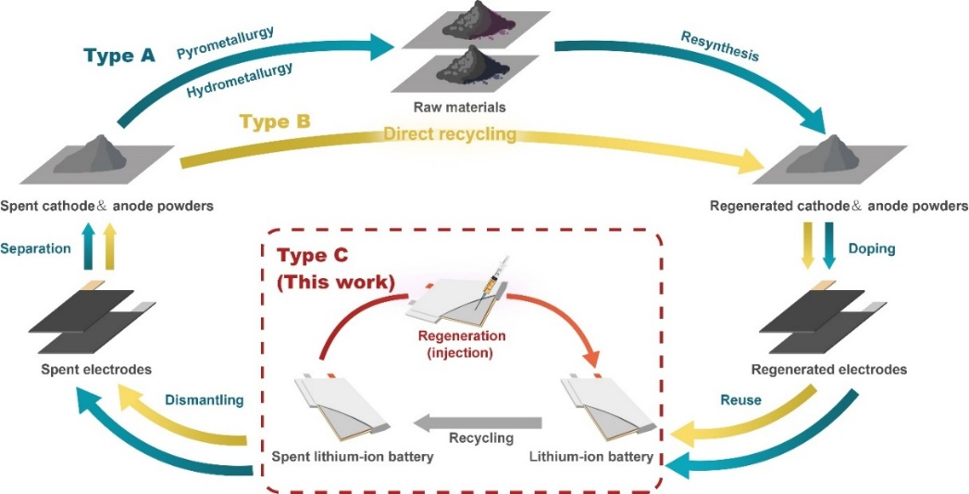
Fig. S1 Schematic comparison of LFP battery recycling processes, highlighting conventional methods and the proposed strategy, where the direct recycling (Type C) eliminates the necessity to dismantling and separating processes and significantly reduces resource and energy use consumption and environmental impact.

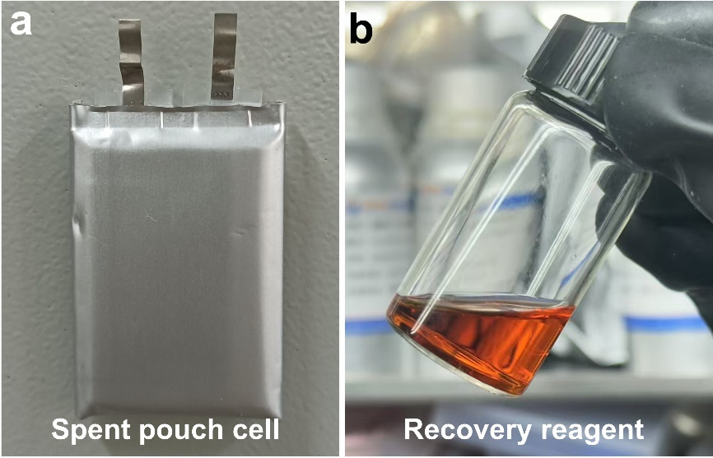
Fig. S2 Digital photo of (a) spent LiFePO₄/graphite (LFP/Gra) pouch cells and (b) the as-prepared I₂-containing recovery reagent

Fig. S3 Cycling performances of spent LFP/Gra pouch cells in I₂-containing electrolyte with different I₂ molar concentrations (0-0.02 M)

Fig. S4 Cycling performances of spent LFP/Gra pouch cells in I₂-containing electrolyte with different injection volumes

Fig. S5 Cycling performances of fresh LFP pouch cells at 1C without the injection treatment of I₂-containing recovery reagent

Fig. S6 CV curves of spent LFP/Gra pouch cells in iodine-free electrolyte within 2.5-4.2 V at 0.1 mV s⁻¹

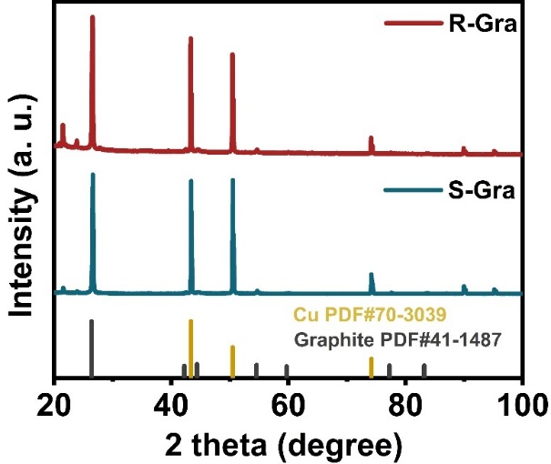
Fig. S7 XRD patterns of S-Gra and R-Gra anodes

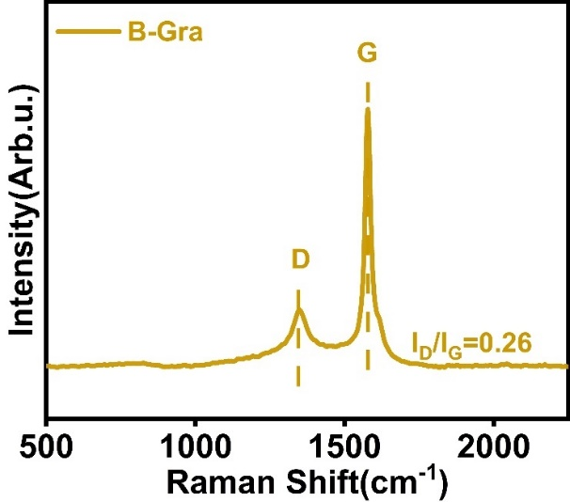
Fig. S8 Raman spectra of B-Gra anode

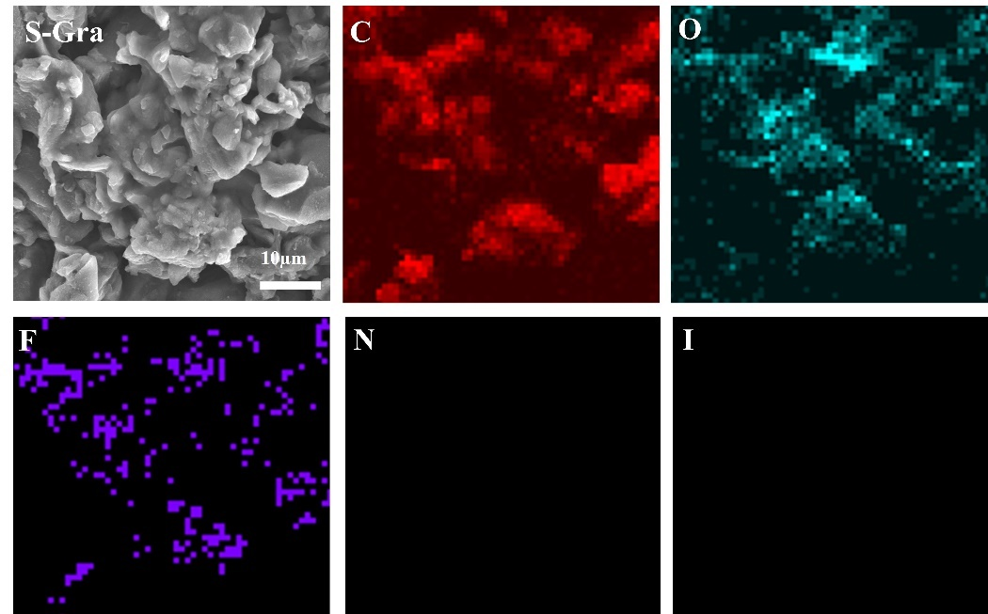
Fig. S9 SEM images and EDS mapping images of S-Gra anode

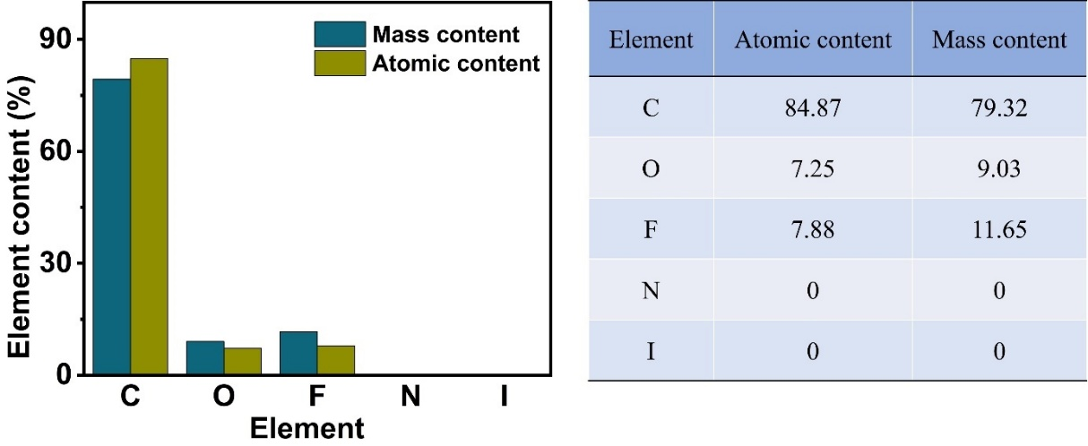
Fig. S10 Atomic and mass content of C, O, F, N and I in S-Gra anode
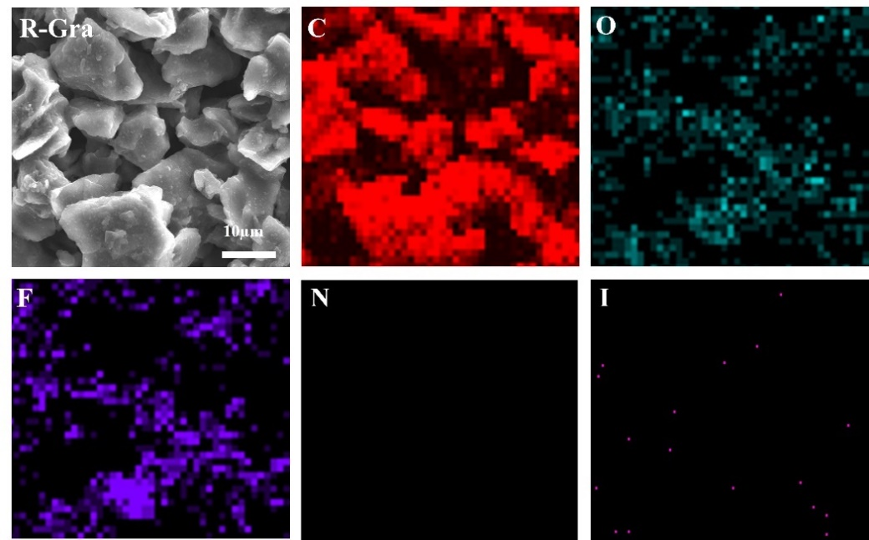
Fig. S11 SEM images and EDS mapping images of R-Gra anode

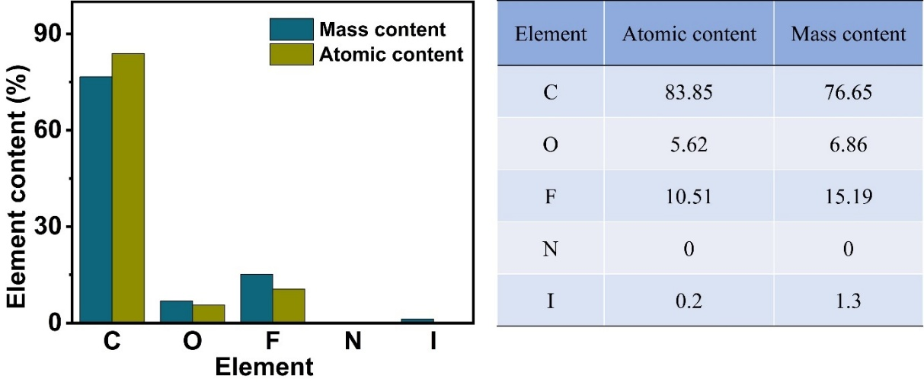
Fig. S12 Atomic and mass content of C, O, F, N and I in R-Gra anode

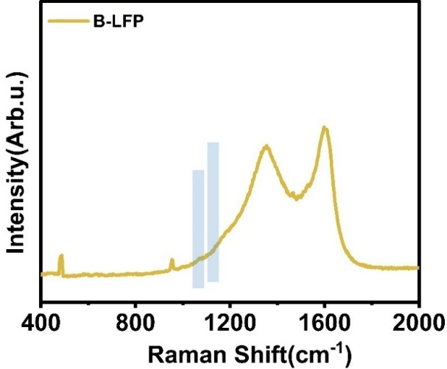
Fig. S13 Raman spectra of B-LFP cathode

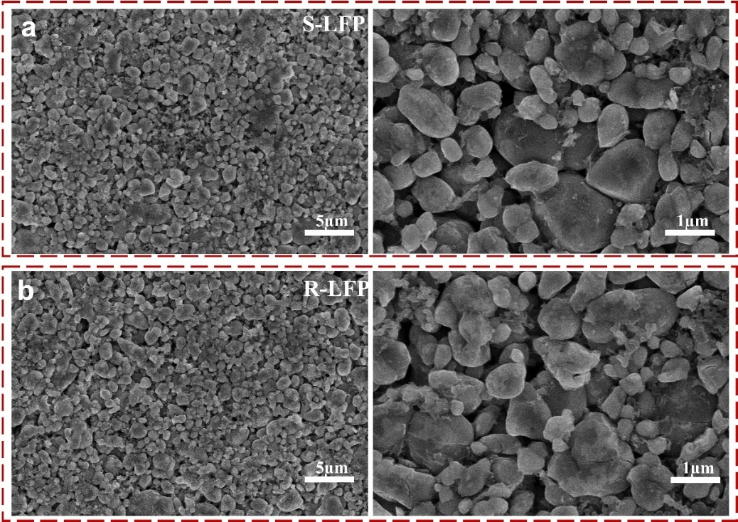
Fig. S14 SEM images of (a) S-LFP and (b) R-LFP cathodes

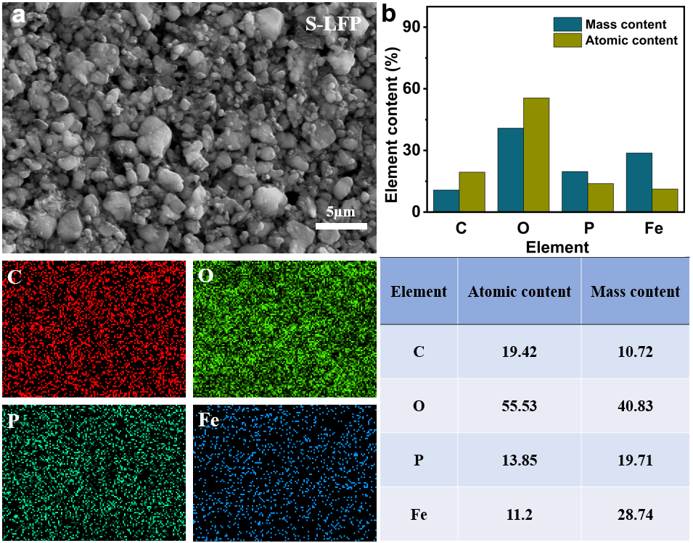
Fig. S15 (a) SEM images and EDS mapping images of S-LFP cathode; (b) Atomic and mass content of C, O, P and Fe in S-LFP cathode

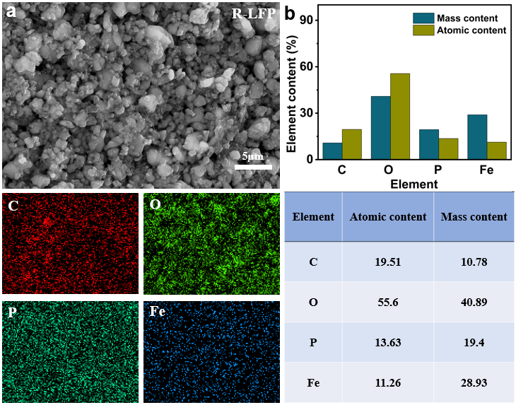
Fig. S16 (a) SEM images and EDS mapping images of R-LFP cathode; (b) Atomic and mass content of C, O, P and Fe in R-LFP cathode

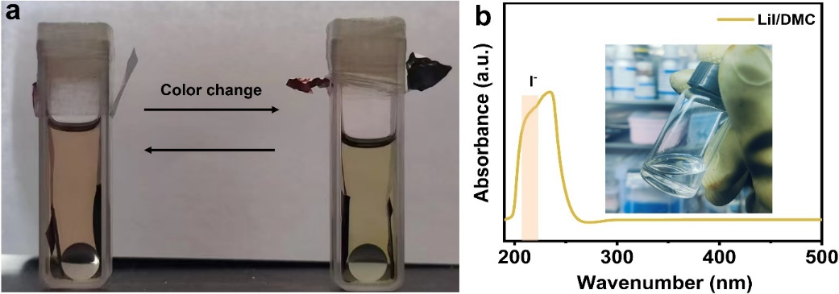
Fig. S17 (a) Color change of the I₂-DMC solution in homemade-cuvette cells containing the S-LFP and S-Gra electrodes; (b) UV-vis spectra and the digital photo of the LiI-DMC solution
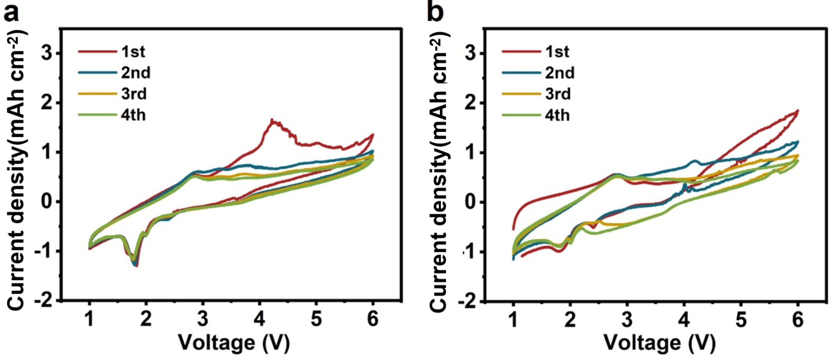
Fig. S18 CV curves of Li||Al cells in (a) LiPF₆ and (b) I₂-containing electrolytes at 1 mV s⁻¹

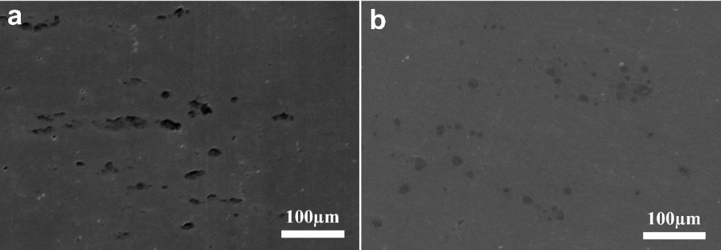
Fig. S19 SEM images of Al foil in Li||Al cells after CV test in (a) LiPF₆ and (b) I₂-containing electrolytes

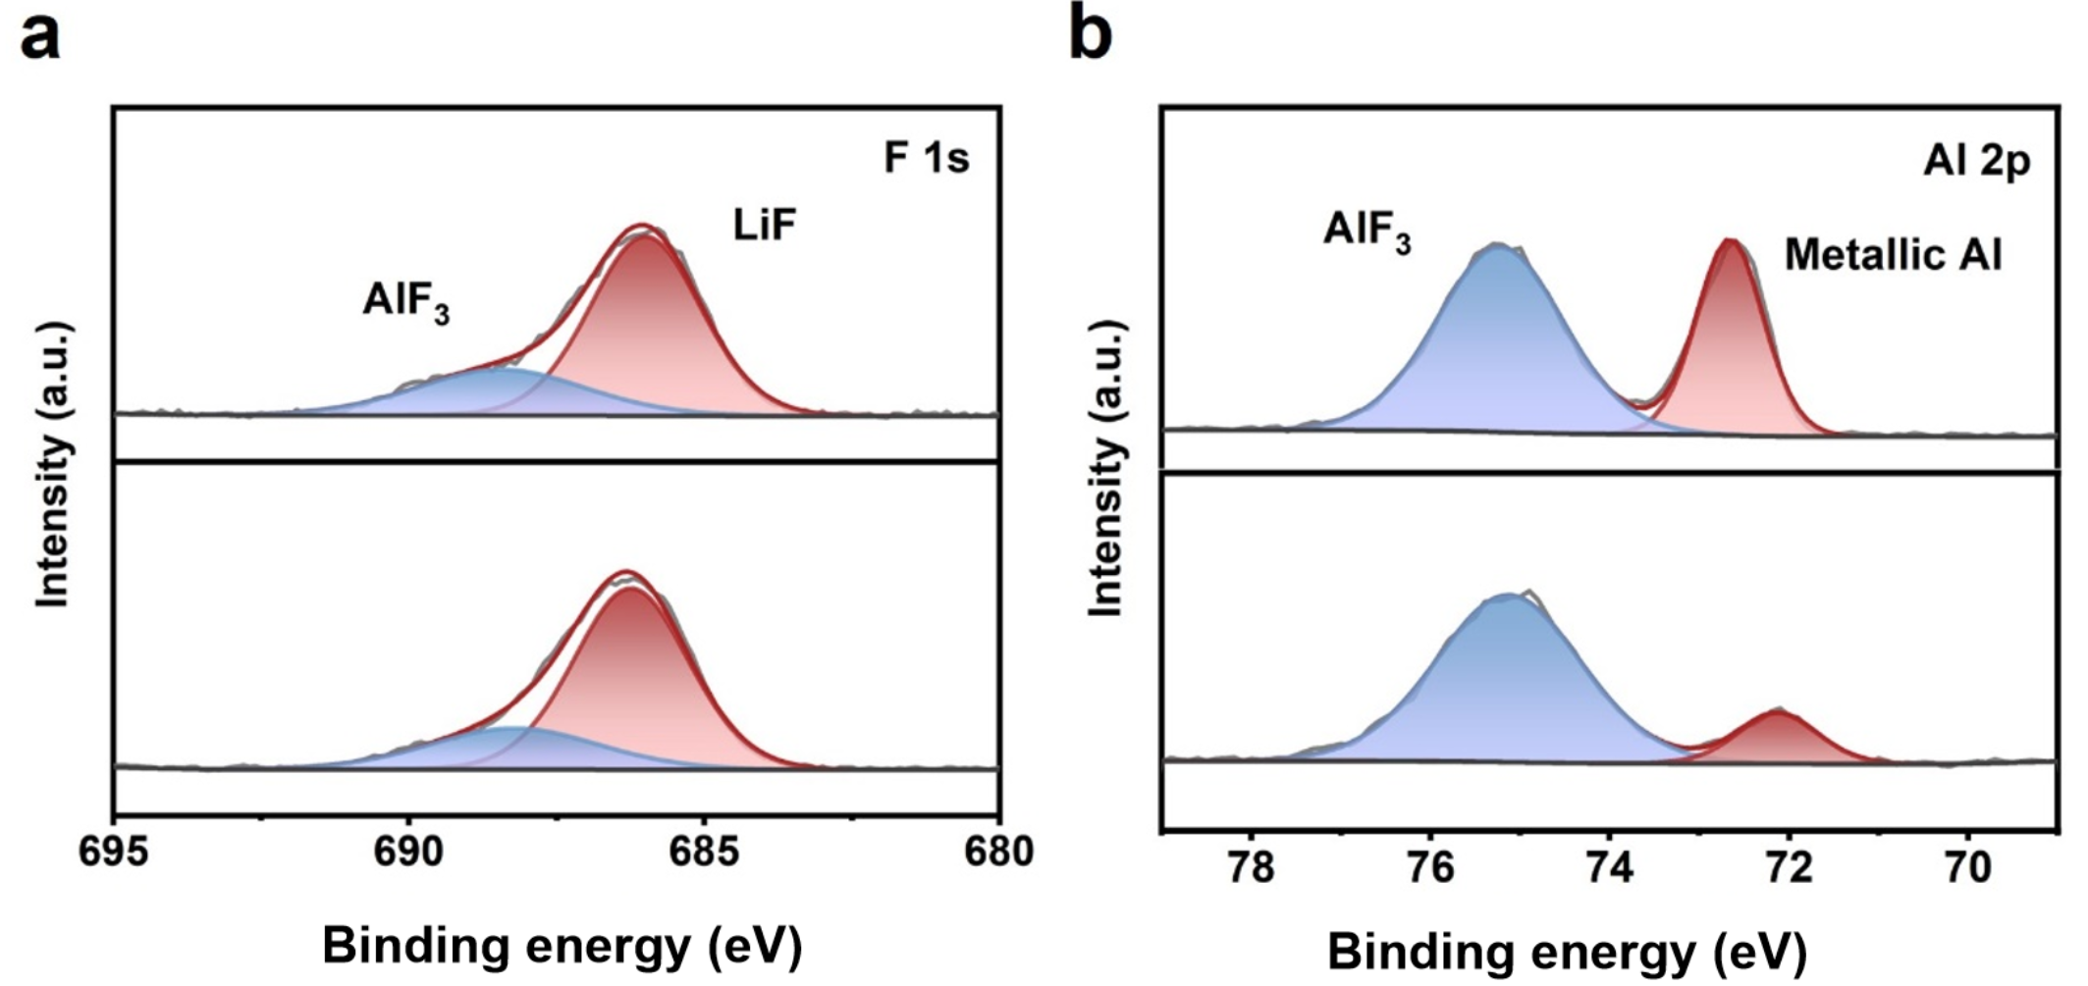
Fig. S20 High resolution (a) F 1s and (b) Al 2p spectra of Al foil in Li||Al cells after CV test in LiPF₆ and I₂-containing electrolytes

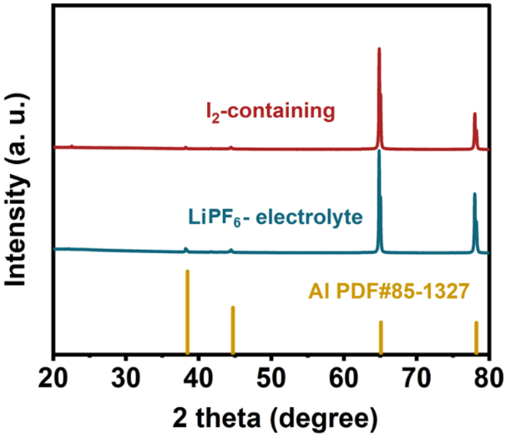
Fig. S21 XRD patterns of Al foil in Li||Al cells after CV test in LiPF₆ and I₂-containing electrolytes

Fig. S22 SEM images of Cu foil after soaking in (a) LiPF₆ and (b) I₂-containing electrolyte for 24 h

Fig. S23 The appearance of LFP pouch cell without pinhole (left one) and the tape sealed post-injection LFP pouch cell (right one) cycling after 500 cycles

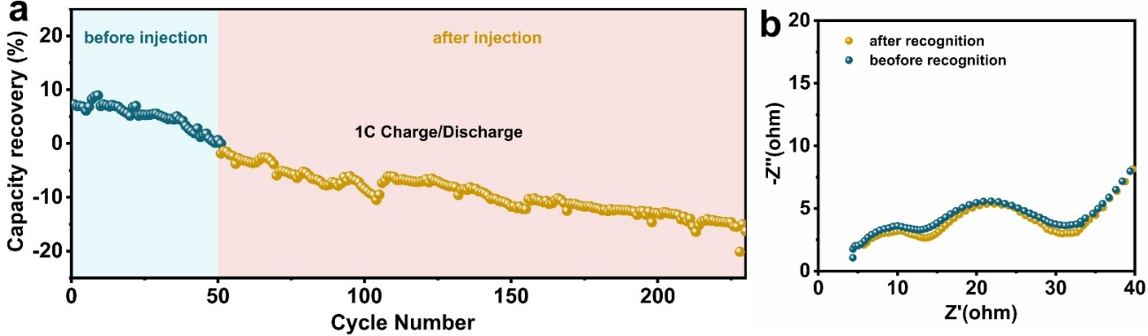
Fig. S24 (a) Capacity recovery ratio and (b) EIS spectra of spent pouch cells before and after injecting commercial LiPF₆ electrolyte without iodine species

Fig. S25 Resistance evolution of R_{D}, R_{ct} and R_{SEI}

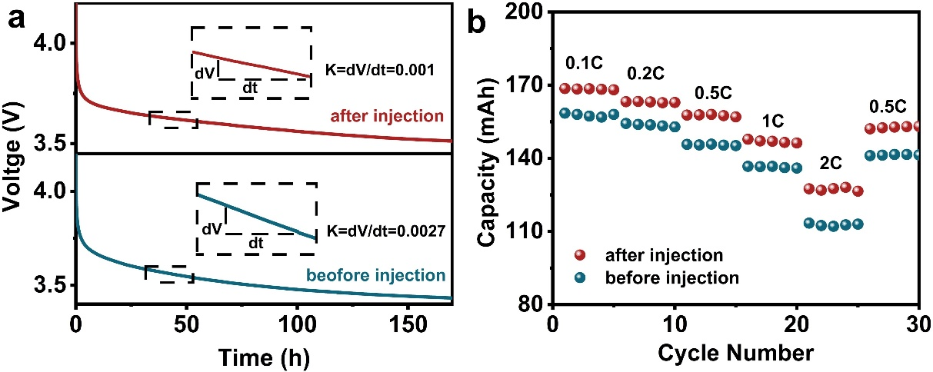
Fig. S26 (a) Self-discharge behavior and (b) rate performance of pouch cells before and after injection

Fig. S27 Cycling performances of LFP pouch cells in raw LiPF₆ electrolyte and I₂-containing LiPF₆ electrolyte

Fig. S28 (a) EIS spectra and (b) the corresponding DRT spectra of pouch cells in raw LiPF₆ electrolyte and I₂-containing LiPF₆ electrolyte

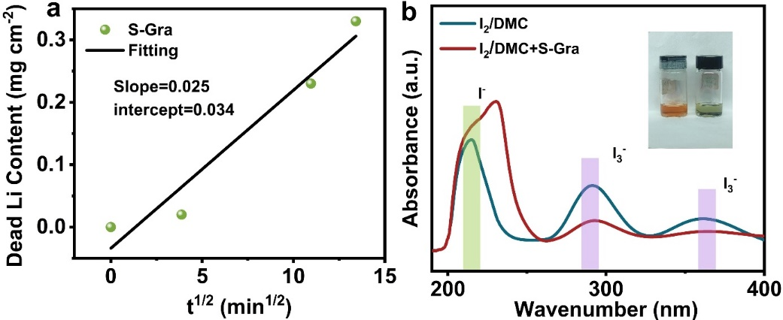
Fig. S29 (a) Variation of dead Li content in S-Gra anode over time and the corresponding linear fitting result; (b) UV-vis spectra of raw I₂-DMC solution and the S-Gra immersed I₂-DMC solution

Table S1 Comparison of cycling stability different regeneration techniques cathodes for LiFePO₄ batteries
Regeneration method | Cycling performances | Capacity retention ratio | Refs.
Solid-state regeneration | after 400 cycles at 1C | 87% | [S1]
Solid-state regeneration | after 300 cycles at 0.5C | 87.94% | [S2]
Solid-state regeneration | after 400 cycles at 5C | 88% | [S3]
Solid-state regeneration | after 300 cycles at 1C | 82% | [S4]
Ex-situ regeneration | after 350 cycles at 1C | 81.6% | [S5]
Ex-situ regeneration | after 500 cycles at 2C | 68.1% | [S6]
Chemical relithiation | after 500 cycles at 0.5C | 90% | [S7]
Electrochemical | after 300 cycles at 1C | 85.5% | [S8]
Photocatalytic | after 500 cycles at 1C | 86.63% | [S9]
Injection recovery | after 300 cycles at 1C | 77.4% | [S10]
Injection recovery | after 300 cycles at 1C | 91.2% | This work

Table S2 Elemental composition content and molar ratios of R-LFP and S-LFP samples based on ICP-OES analysis
 | Element content (wt%) |  |  | Molar ratio
 | Li | P | Fe | Li/P | Li/Fe
S-LFP | 2.64 | 14.89 | 26.82 | 0.79 | 0.79
R-LFP | 3.44 | 14.82 | 26.62 | 1.03 | 1.04

Table S3 Rietveld refinement results of the XRD pattern of S-LFP
Phase 1 LiFePO₄ |  |  |  |  |  | Phase 2 FePO₄
Atom | Site | Wyckoff positions |  |  | Occupancy |  | Site |  | Wyckoff positions |  |  | Occupancy
Li 1 | 4a | 0 | 0 | 0 | 0.981 | NA
Fe 1 | 4c | 0.2859 | 0.25 | 0.9614 | 0.981 | 4c |  | 0.2731 |  | 0.25 | 0.930 | 1
P | 4c | 0.0923 | 0.25 | 0.4073 | 1 | 4c |  | 0.070 |  | 0.25 | 0.397 | 1
O | 4c | 0.1028 | 0.25 | 0.7018 | 1 | 4c |  | 0.126 |  | 0.25 | 0.636 | 1
O | 4c | 0.4650 | 0.25 | 0.1986 | 1 | 4c |  | 0.20 |  | 0.25 | -0.19 | 1
O | 8d | 0.1657 | 0.0317 | 0.2515 | 1 | 8d |  | 0.155 |  | 0.140 | 0.126 | 1
Li 2 | 4c | 0.2859 | 0.25 | 0.9614 | 0.019 | NA
Fe 2 | 4a | 0 | 0 | 0 | 0.019 | NA
Phase 1 LiFePO₄: Space group: Pnma, Rp = 5.57%, Rwp = 4.11%, a= 10.2526, b=5.9460, c=4.6626;
Phase 2 FePO₄: Space group: Pnma, a=9.7434, b= 5.7504, c=4.7142.

Table S4 Rietveld refinement results of the XRD pattern of R-LFP
Phase LiFePO₄
Atom | Site | Wyckoff positions |  |  | Occupancy
Li 1 | 4a | 0 | 0 | 0 | 0.989
Fe 1 | 4c | 0.2837 | 0.25 | 0.9748 | 0.989
P | 4c | 0.0950 | 0.25 | 0.4233 | 1
O | 4c | 0.0912 | 0.25 | 0.7486 | 1
O | 4c | 0.4667 | 0.25 | 0.1979 | 1
O | 8d | 0.1649 | 0.0485 | 0.2883 | 1
Li 2 | 4c | 0.2837 | 0.25 | 0.9748 | 0.011
Fe 2 | 4a | 0 | 0 | 0 | 0.011
LiFePO₄: Space group: Pnma, Rp = 3.97%, Rwp = 3.18%, a= 10.3191 b=6.0019, c=4.6897.

Table S5 Electrochemical performances of pouch cells at different degraded states before/after injection
 |  | Capacity  (mAh) | Capacity recovery  (%) | Overvoltage  (V) | DCIR  (mΩ)
Cell-A | S | 145.8 | 3.38 | 0.19 | 22.23
Cell-A | R | 151.19 | 3.38 | 0.18 | 21.07
Cell-B | S | 128.4 | 7.25 | 0.3 | 26.96
Cell-B | R | 139.86 | 7.25 | 0.21 | 23.49
Cell-C | S | 113.6 | 10.75 | 0.43 | 44.66
Cell-C | R | 130.8 | 10.75 | 0.21 | 24.18
Cell-D | S | 99.8 | 21.64 | 0.5 | 61.20
Cell-D | R | 133.99 | 21.64 | 0.22 | 23.81

The calculation method of capacity recovery ratio (%):
Capacity recovery ratio (%) = (A-B)/C * 100%
Taking the data of Cell-D as an example, A represents the recovered discharge capacity of pouch cells after injection treatment; B is the remaining discharge capacity of spent pouch cells before injection treatment; C is the reversible discharge capacity of this fresh pouch cells without injection treatment. In this table, the values of A, B, C are 133.99, 99.8, and 158 mAh, respectively, i.e., 21.64%=(133.99-99.8)/158*100%.

Table S6 Quantitative analysis of inactive lithium content in pouch cells at different degraded states
Inactive Lithium Content  (mg/g) |  |  | Capacity  (mAh)
Cell-A | S | 9.013 | 145.8
Cell-A | R | / | 151.19
Cell-B | S | 12.192 | 128.4
Cell-B | R | / | 139.86
Cell-C | S | 14.577 | 113.6
Cell-C | R | / | 130.8
Cell-D | S | 23.484 | 99.8
Cell-D | R | / | 133.99

Table S7 Recycling cost ($/kg cell) comparison for different battery recycling technologies
Components | Pyro | Hydro | Direct
Materials | 1.44 | 1.44 | 1.44
Reagent | 0.09 | 0.15 | 0.14
Labor | 0.19 | 0.28 | 0.05
Electricity & Equipment | 0.1 | 0.4 | 0.05
Depreciation | 0.48 | 0.39 | 0
Sewage treatment | 0 | 0.01 | 0

Table S8 Recycling revenue ($/kg cell) comparison for different battery recycling technologies
Components | Pyro | Hydro | Direct
Regenerated cell | 0 | 0 | 13.4
Li₂CO₃ | 0 | 1.83 | 0
FePO₄ | 0 | 0.5 | 0
Graphite | 0 | 1.54 | 0
Aluminum | 0 | 0.52 | 0
Copper | 0.56 | 0.56 | 0

Table S9 Recycling profit ($/kg cell) comparison for different battery recycling technologies
Components | Pyro | Hydro | Direct
Cost | 2.30 | 2.67 | 1.68
Revenue | 0.56 | 4.95 | 13.4
Profit | -1.74 | 2.28 | 11.72

Table S10 Greenhouse gas (GHG) emissions (kg CO₂-eq/kg cell) and energy consumption (kJ/kg cell) for different battery recycling technologies
Components | Pyro | Hydro | Direct
GHGs | 1.53 | 2.765 | 0
Energy consumption | 18.72 | 16.85 | 0

Supplementary References
- M. Xiao, X. Fu, M. Chen, M. Ye, C. Zhu et al., Constructing a homogeneous medium layer to promote the direct regeneration of spent lithium iron phosphate. ACS Appl. Mater. Interfaces 17(8), 12199–12207 (2025). https://doi.org/10.1021/acsami.4c20621
- L. Song, C. Qi, S. Wang, X. Zhu, T. Zhang et al., Direct regeneration of waste LiFePO₄ cathode materials with a solid-phase method promoted by activated CNTs. Waste Manag. 157, 141–148 (2023). https://doi.org/10.1016/j.wasman.2022.12.002
- G. Ji, J. Wang, Z. Liang, K. Jia, J. Ma et al., Direct regeneration of degraded lithium-ion battery cathodes with a multifunctional organic lithium salt. Nat. Commun. 14(1), 584 (2023). https://doi.org/10.1038/s41467-023-36197-6
- [4] T. Wang, C. Gao, Z. Zheng, W. Yu, M. Wang et al., N-doped carbon layer construction and targeted defect repair enables direct regeneration of spent LiFePO₄ cathodes. Adv. Funct. Mater. 35(40), 2502930 (2025). https://doi.org/10.1002/adfm.202502930
- W. Wang, X. Zeng, H. Hu, T. Yang, Z. Ma et al., 1, 2, 3, 4-tetrakis(2-cyanoethoxy)butane (TCEB)-assisted construction of self-repair electrode interface films to improve the performance of 4.5 V pouch LiCoO₂/artificial graphite full cells operating at 45 ℃. ACS Appl. Mater. Interfaces 13(50), 59925–59936 (2021). https://doi.org/10.1021/acsami.1c18252
- S. He, S. Huang, X. Liu, X. Zeng, H. Chen et al., Interfacial self-healing polymer electrolytes for Long-Cycle silicon anodes in High-Performance solid-state lithium batteries. J. Colloid Interface Sci. 665, 299–312 (2024). https://doi.org/10.1016/j.jcis.2024.03.118
- W. Liu, L. Peng, M. Liu, J. Peng, Z. Zeng et al., Versatile chemical repair strategy for direct regeneration of cathode materials from retired lithium-ion battery. Energy Storage Mater. 78, 104227 (2025). https://doi.org/10.1016/j.ensm.2025.104227
- S. Zhou, J. Du, X. Xiong, L. Liu, J. Wang et al., Direct recovery of scrapped LiFePO₄ by a green and low-cost electrochemical re-lithiation method. Green Chem. 24(16), 6278–6286 (2022). https://doi.org/10.1039/D2GC01640K
- X. Lv, J. Lin, X. Sun, Q. Huang, X. Zhang et al., Direct recycling of spent LiFePO₄ cathodes through photocatalytic correction of anti-site defects. Adv. Mater. 37(26), e2503398 (2025). https://doi.org/10.1002/adma.202503398
- Y. Gao, H.-M. Zhang, J. Sun, In-situ capacity regeneration of degraded lithium-ion batteries using remanufacturing remediator. Energy Storage Mater. 78, 104248 (2025). https://doi.org/10.1016/j.ensm.2025.104248

