Supporting Information for
Quantitative Defect–Property Correlations in Ti₃C₂T_{x} MXenes via Precursor-Controlled Defect-Engineering
Tufail Hassan^{1†}, Doyeon Lee^{2†}, Shabbir Madad Naqvi¹, Myungjae Kim³, Jung-Min Oh⁴, Sang Woon Park⁴, Aamir Iqbal⁵, Soo Yeong Cho¹, Zhiwang Hao¹, Noushad Hussain¹, Zubair Khalid¹, Shakir Zaman¹, Xiangmeng Kong¹, Ki-Min Roh⁶, Hanjung Kwon²*, Chong Min Koo^{1,7}*
¹School of Advanced Materials Science and Engineering, Sungkyunkwan University, Seobu-ro 2066, Jangan-gu, Suwon-si, Gyeonggi-do, 16419, Republic of Korea
²Division of Advanced Materials Engineering, College of Engineering, Jeonbuk National University, Jeonju 54896, Republic of Korea
³Hydrogen technology research team, Hyundai-Steel, Bukbusneop-ro, Songak-eup, Dangjin-si, Chungnam, 31719, Republic of Korea
⁴R&D center, INNOMXENE Co., Ltd., Daejeon 34365, Republic of Korea
⁵Swiss Federal Laboratories for Materials Science and Technology, Empa, Dubendorf 8600, Switzerland
⁶Resources Utilization Research Division, Korea Institute of Geoscience & Mineral Resources, Daejeon 34132, Republic of Korea
⁷School of Chemical Engineering, Sungkyunkwan University, Seobu-ro 2066, Jangan-gu, Suwon-si, Gyeonggi-do 16419, Republic of Korea
† Tufail Hassan and Doyeon Lee contributed equally to this work
*Corresponding authors. E-mail: hjkwon@jbnu.ac.kr (Hanjung Kwon); chongminkoo@skku.edu (Chong Min Koo)
Note S1 Synthesis of TiC precursors
To examine precursor-driven defect engineering in MAX phases and MXenes, TiC precursors were synthesized from TiO₂ using a high-energy ball milling-assisted carbothermal reduction approach [S1]. In this process, the TiO₂/graphite powders mixture were subjected to high-energy milling in a planetary mill (Pulverisette 5, Fritsch, Germany) with tungsten carbide-cobalt (WC-Co) balls (6 mm diameter) in a stainless-steel bowl at a ball-to-powder weight ratio of 40:1, operating at 200 rpm for 20 hours. During high-energy milling, powders undergo continuous and intense mechanical impacts caused by high-speed rotation and frequent collisions between milling balls. This process is critical for grain refinement and facilitating solid-state reactions. Subsequently, the milled powders were subjected to heat treatment at 1500 °C for 3 hours under vacuum (6.7 × 10⁻³ Pa) to facilitate carbide formation via carbothermal reduction, resulting in the production of TiC precursor powders (Fig. S1). The carbothermal reduction occurs through multiple intermediate phases (Equations S1a-e), ultimately leading to the production of sub-stoichiometric TiC (Equation S1):
4TiO_{2 (s)} + C_{(s)} → Ti₄O_{7(s)} + CO_{(g)} (S1a)
3Ti₄O_{7(s)} + C_{(s)} → 4Ti₃O_{5(s)} + CO_{(g)} (S1b)
2Ti₃O_{5(s)} + C_{(s)} → 3Ti₂O_{3(s)} + CO_{(g)} (S1c)
Ti₂O_{3(s)} + C_{(s)} → 2TiO_{(s)} + CO_{(g)} (S1d)
TiO_{(s)} + (2-2x-y)C_{(s)} → Ti(C_{1-x-y}O_{x}□_{y})_{(s)} + (1-x)CO_{(g)} (x, y<1) (S1e)
----------------------------------------------------------------------------------------
TiO₂ + (3-2x-y)C → Ti(C_{1-x-y}O_{x}□_{y})_{(s)} + (2-x)CO_{(g)} (x, y<1) (S1)
Graphite acts both as a reducing agent and as the carbon source in the synthesis of TiC. If the reduction is incomplete, Ti(C_{1-x-y}O_{x}□_{y}) containing substitutional oxygen (S_{O}), carbon vacancies (V_{C}), and titanium vacancies (V_{Ti}) is formed. Achieving optimal contact between TiO₂ and graphite powders is essential to reduce activation energy and limit the formation of these defects. High-energy ball milling for 20 hours effectively reduces particle size, enables uniform carbon coating, and supports the synthesis of defect-minimized TiC (Fig. S1).
High-energy ball milling induces severe plastic deformation in the crystal lattices of TiO₂ and graphite powder mixtures, leading to amorphization. This structural disorder facilitates the release of oxygen ions from TiO₂ and activates carbon diffusion pathways, thereby lowering the activation energy of the overall carbothermal reduction reaction. As a result, an environment favorable for oxygen removal at lower temperatures can be achieved.
During the high-energy ball milling process, the particle size of the powders is significantly reduced, and graphite becomes uniformly coated on the surface of TiO₂ particles, enhancing the interfacial contact between TiO₂ and carbon. This microstructural interaction improves reaction homogeneity, enabling the synthesis of defect-suppressed TiC without residual carbon. Furthermore, by controlling the amount of carbon introduced, the defect density within the TiC lattice can be effectively controlled.
Carbon content was systematically varied by controlling the TiO₂:graphite weight ratios to 1:2.4 (TiC–1), 1:2.7 (TiC–2), and 1:3.1 (TiC–3), corresponding to carbon-deficient to C-rich conditions (Table S1). The theoretical stoichiometric ratio for TiC synthesis from TiO₂ and graphite is 1:3 (Equation S1). While excess carbon is effective in minimizing oxygen incorporation, a deficiency in carbon promotes the formation of S_{O} and V_{C} defects.
The prepared mixtures were subjected to ball milling in a planetary mill (Pulverisette 5, Fritsch, Germany) at 200 rpm for 20 hours under an inert atmosphere. This was followed by carbothermal reduction at 1500 °C for 3 hours under vacuum (6.7 × 10⁻³ Pa), resulting in the production of TiC precursor powders (Figs. 1b and S1) [S2].
XRD measurements verified the rock salt structure for all samples, with (111), (200), and (220) diffraction peaks corresponding to JCPDS No. 31-1383. Importantly, the (200) peak was observed to shift towards lower 2θ angles with increasing carbon content, indicating expansion of lattice parameters and enhanced stoichiometry due to reduced oxygen substitution (inset of Fig. 1b, Table S1).

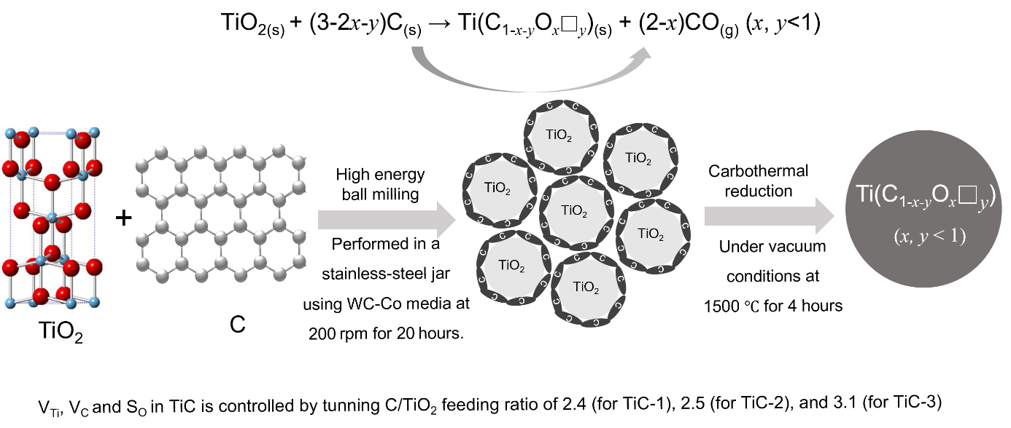 Fig. S1 Schematic illustration displaying TiC synthesis by high-energy milling-assisted carbothermal reduction

Table S1 Synthesis parameters and defect features of TiC precursors
Sample | Reactant feeding ratio |  | Atomic composition formulae | Lattice constant | Defects
 | TiO₂ | C |  | a (Å)* | V_{C}  (%) | S_{O}  (%) | V_{Ti}  (%) | Lattice strain (ε) (%)†
TiC-1 | 1 | 2.4 | Ti(C_{0.662}O_{0.116}□_{0.222}) | 4.3078 | 11.1 ± 0.12 | 5.8 ± 0.17 | 0.48 ± 0.31 | -0.51
TiC-2 | 1 | 2.7 | Ti(C_{0.870}O_{0.028}□_{0.102}) | 4.3133 | 5.1 ± 0.21 | 1.4 ± 0.11 | 0.37 ± 0.23 | -0.39
TiC-3 | 1 | 3.1 | Ti(C_{0.904}O_{0.023}□_{0.073}) | 4.3213 | 3.65 ± 0.10 | 1.15 ± 0.08 | 0.09 ± 0.03 | -0.20
The lattice constant values were calculated from *XRD data, and † The negative value indicates compressive lattice strain

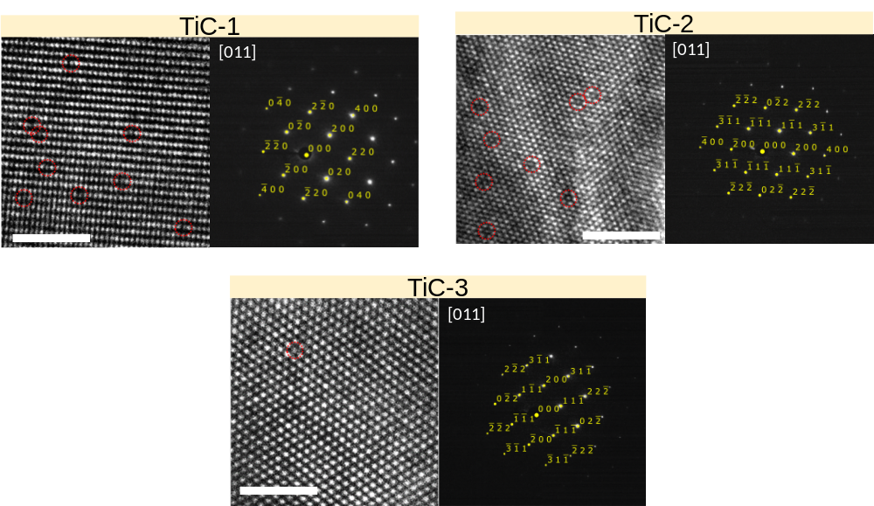
Fig. S2 HAADF-STEM and Fast Fourier Transform (FFT) pattern for synthesized TiC-1, TiC-2, and TiC-3. Titanium vacancies are marked by red circles (Scale bars 2 nm)
Note S2 Synthesis of Ti₃AlC₂ MAX phases
Ti₃AlC₂ MAX phases with different defect levels (Ti₃AlC₂–1/2/3) were synthesized by utilizing TiC precursors (TiC–1/2/3) with controlled defects. The formation of the MAX phase proceeds according to the reaction:
$2TiC + Ti + Al→{Ti}_{3}{AlC}_{2}$ (S2)
For synthesizing Ti₃AlC₂–1/2/3, TiC–1, –2, or –3 was combined with Ti and Al at a molar ratio of 2:1:1 (Table S2). To further reduce the defect concentration, Ti₃AlC₂–4 was produced using TiC-3 precursor with excess Al in a 2:1:2.2 molar ratio, in which molten aluminum facilitates enhanced atomic diffusion during sintering and inhibits the formation of vacancy and oxygen substitution defects, resulting in a product with greater crystallinity [S3]. In contrast, Ti₃AlC₂-5 MAX phase was synthesized from the most defective TiC-1 under the same excess Al condition (TiC:Ti:Al = 2:1:2.2). This sample exhibited a low yield (57.3%) due to the formation of significant Al₂O₃ and intermetallic TiAl₃, and showed significantly higher lattice strain (ε = -0.62 along the c axis, and -0.15 along a axis) compared to Ti₃AlC₂-4 (Fig. S5). These results suggest that a high defect density in the TiC precursor hampers the formation of high-quality MAX phase, even under Al-rich conditions. Therefore, both a high-quality TiC precursor and excess aluminum are critical for achieving a well-crystallized high-quality MAX phase.
The precursor powders were ball-milled for 12 hours at 100 rpm, compacted into Ø50 mm disks (4000 psi), and sintered at 1450 °C for 3 hours in an argon atmosphere. The resultant MAX phase blocks were then crushed and sieved (270-mesh, 53 µm pore size) to acquire fine MAX powders. XRD analysis confirmed successful synthesis of Ti₃AlC₂ MAX phases as evidenced by the presence of characteristic peaks [(002), (004), (101), (103), (104), (105), (106), (107), (108), (109), (110), and (1011), etc.], consistent with JCPDS file No. 52-0875 (Fig. 1c) [S4].
For Ti₃AlC₂-4, TiC-3 was used where the 3.1 mol of carbon was introduced under carbon-rich conditions, corresponding to an excess carbon content of approximately 1.0 wt.%. Despite this carbon-rich environment, the measured free carbon content in the resulting TiC precursor was below 0.02 wt.%. Likewise, the synthesized Ti₃AlC₂ contained less than 0.03 wt.% free carbon. These results confirm that residual carbon is negligible and does not contribute meaningfully to the observed structural or property variations.
The synthesized MAX phases were washed in 9M HCl for 4 h. After acid washing, Ti₃AlC₂/HCl mixture was neutralized and purified with deionized water until a neutral pH was reached. The neutralized MAX powder was then dried in a vacuum oven at 80 °C for 6 h and subsequently sieved through a 400 mesh (40 μm) sieve. The washed, dried and sieved Ti₃AlC₂ MAX phase was subjected to etching to obtain the corresponding MXenes [S3].
Fig. S3 SEM images of MAX phases: (a) Ti₃AlC₂–1, (b) Ti₃AlC₂–2, (c) Ti₃AlC₂–3, and (d) Ti₃AlC₂–4
Table S2 Synthesis parameters and defect characteristics of Ti₃AlC₂ MAX phases
Designation | TiC utilized | Molar feed ratio of reactants |  |  | Atomic composition formulas |  | Structural defects
 |  | TiC | Ti | Al |  | Lattice constants a, c (Å)* | V_{C}  (%) | S_{O}  (%) | V_{Ti}  (%) | Lattice strain (ε) (%)†
Ti₃AlC₂-1 | TiC-1 | 2 | 1 | 1 | Ti₃Al(C_{1.345}O_{0.378}□_{0.277}) | a:3.0607  c:18.4991 | 4.61 ± 0.18 | 6.3 ± 0.36 | 0.54 ± 0.2 | a:-0.30  c:-0.65
Ti₃AlC₂-2 | TiC-2 | 2 | 1 | 1 | Ti₃Al(C_{1.638}O_{0.160}□_{0.202}) | a:3.0637  c:18.5518 | 3.36 ± 0.11 | 2.67 ± 0.11 | 0.39 ± 0.17 | a:-0.21  c:-0.37
Ti₃AlC₂-3 | TiC-3 | 2 | 1 | 1 | Ti₃Al(C_{1.750}O_{0.076}□_{0.174}) | a:3.0673  c:18.5651 | 2.9 ± 0.09 | 1.27 ± 0.07 | 0.22 ± 0.12 | a:-0.08  c:-0.29
Ti₃AlC₂-4 | TiC-3 | 2 | 1 | 2.2 | Ti₃Al(C_{1.797}O_{0.036}□_{0.167}) | a:3.0673  c:18.5931 | 2.78 ± 0.07 | 0.6 ± 0.02 | 0.06 ± 0.03 | a:-0.08  c:-0.14
Ti₃AlC₂-5 | TiC-1 | 2 | 1 | 2.2 | NA | a:3.0653  c:18.5039 | NA | NA | NA | a: -0.15  c:-0.62
*The lattice constant values are determined from XRD analysis.
†The negative sign denotes compressive lattice strain.
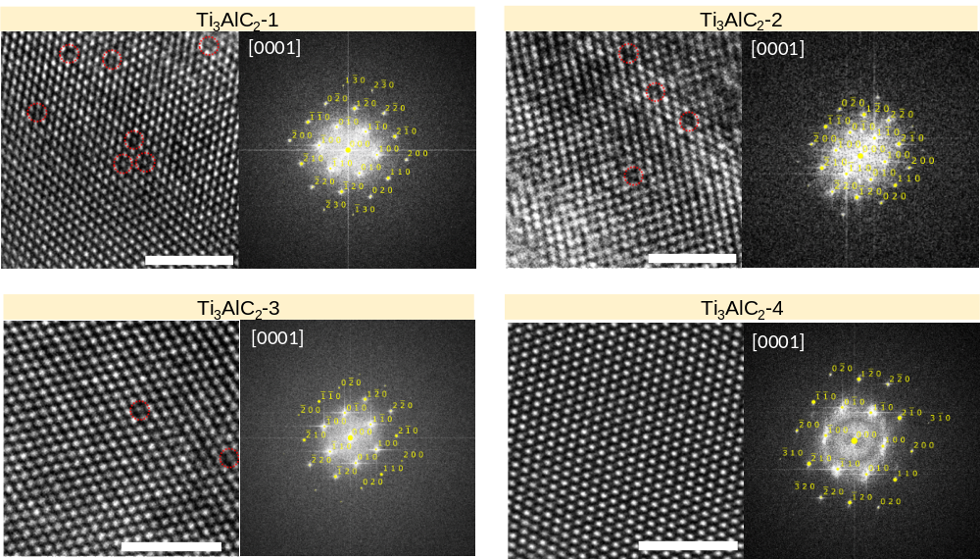
Fig. S4 HAADF-STEM images, and Fast Fourier Transform (FFT) pattern for synthesized (a) Ti₃AlC₂–1, (b) Ti₃AlC₂–2, (c) Ti₃AlC₂–3, and (d) Ti₃AlC₂–4 (Scale bars 2 nm). Titanium vacancies are indicated by red circles

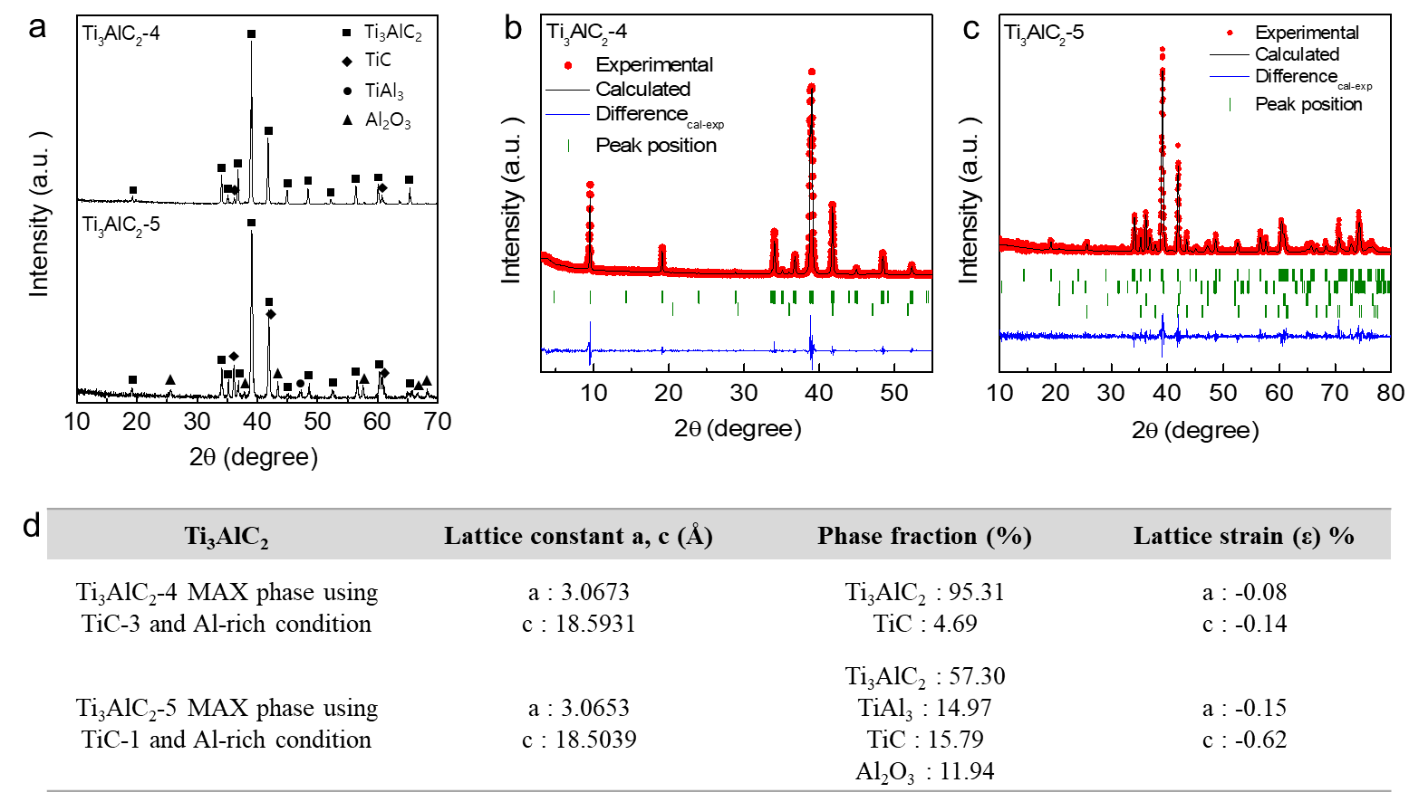
Fig. S5 (a) XRD spectra of Ti₃AlC₂–4, and Ti₃AlC₂–5 MAX phases. Rietveld refinement of XRD spectra of (b) Ti₃AlC₂–4, and (c) Ti₃AlC₂–5. (d) Extracted lattice constants and phase fractions of Ti₃AlC₂–4, and Ti₃AlC₂–5 MAX phases. The most defective TiC, and excess Al conditions was used for synthesis of Ti₃AlC₂–5. Ti₃AlC₂–5 was synthesized using a highly defective TiC–1 precursor and excess Al. Rietveld refinement reveals that this sample contains substantial impurity phases, including TiAl₃, TiC, and Al₂O₃, with the Ti₃AlC phase accounting for only 57.3%. Despite the use of excess Al, the lattice strain in Ti₃AlC₂–5 remains comparable to that of Ti₃AlC₂–1 synthesized from the same defective TiC–1 precursor under stoichiometric Al conditions, indicating that excess Al does not effectively mitigate lattice defects when the TiC precursor exhibits a high defect density. This limited effectiveness is attributed to the preferential reaction of excess Al with oxygen associated with the defective TiC precursor, leading to the formation of a significant amount of Al₂O₃ and thereby reducing the Al available for MAX phase formation. As a result, a higher fraction of unreacted TiC remains, which contributes to increased lattice defects in the Ti₃AlC₂ phase. These results highlight that a low-defect TiC precursor is essential—even under Al-rich conditions—for the synthesis of high-purity, low-defect MAX phases.
Note S3 Synthesis of Ti₃C₂T_{x} MXenes
Ti₃C₂T_{x}–1/2/3/4 MXenes were synthesized using a modified minimally intensive layer delamination (MILD) method [S5], involving the selective removal of aluminum from the parent Ti₃AlC₂ MAX phase. In a typical procedure, 1.6 g of LiF was dissolved in 20 mL of 9 M HCl, followed by the addition of 2 mL of HF. The introduction of a small amount of HF into the LiF–HCl etching system was intended to enhance etching efficiency and increase the yield of single- to few-layer MXene. Specifically, the addition of HF (2 mL per 1 g of MAX phase) accelerates Al removal, resulting in an approximately 10% increase in MXene yield while maintaining controlled etching conditions. Subsequently, 1 g of Ti₃AlC₂ MAX powder was slowly added to the etchant under continuous stirring, and the reaction was carried out at 35 °C for 24 h. After etching, the resulting dispersion was repeatedly washed and centrifuged (5000 rpm, 7 min) with deionized water until the supernatant reached a pH of 5–6, ensuring effective removal of residual acids and reaction by-products. Prior to the final collection step, a brief vortex-shaking treatment (90 s) was applied before the last centrifugation cycle to gently disrupt restacked flakes. This mild mechanical agitation facilitated the conversion of some multilayered particles into single- and few-layer MXene without the need for bath sonication. Single-layer Ti₃C₂T_{x} flakes were then collected by a final centrifugation step (5000 rpm, 5 min) for subsequent characterization. This procedure yields high-quality Ti₃C₂T_{x} MXene with minimal impurity content and a well-preserved layered structure. The synthesis yields of Ti₃C₂T_{x}–1/2/3/4 were approximately 56%, 60%, 53%, and 45%, respectively.
Note S4 Calculation of lattice parameters and lattice strain of TiC precursors, Ti₃AlC₂ MAX phases, and Ti₃C₂T_{x} MXenes
The crystal structures of TiC precursors, Ti₃AlC₂ MAX phases, and Ti₃C₂T_{x} MXenes were analyzed by XRD using a SmartLab instrument (9 kW, Rigaku, Japan) with monochromatic Cu-Kα radiation (λ = 1.5418 Å). Si powder (SRM640D, NIST, USA) was employed as an external standard. The measurements were performed in step-scan mode (0.01° step, 5 s per step), and lattice parameters were extracted by Rietveld refinement using the FullProf program integrated with WinPLOTR. A pseudo-Voigt function was applied to refine the scale factor, zero shift, unit cell, and profile parameters [S6].
For TiC with a rock-salt-type structure (Fm–3m), the lattice parameter (a) and lattice strain (ε) were evaluated from the (002) plane as follows:
$d_{002}=\frac{λ}{2sinθ}$, $\frac{1}{{d_{002}}^{2}}=\frac{0^{2}+0^{2}+2^{2}}{a^{2}}$ , $ϵ=\frac{a-a_{°}}{a_{°}}$ (S3)
$$a_{°}:lattice parameter of perfect crystal of TiC (a_{°}: 4.3274 Å)$$
For Ti₃AlC₂ with hexagonal P6₃/mmc symmetry, lattice parameters (a and c) and respective lattice strains (ε₁ and ε₂) were determined from the (002) and (104) planes as follows:
$d_{002}=\frac{λ}{2sinθ}$, $\frac{1}{{d_{002}}^{2}}=\frac{4}{3}∙\frac{0^{2}+0∙0+ 0^{2}}{{a_{1}}^{2}}+\frac{2^{2}}{c^{2}}$ (S4)
$d_{104}=\frac{λ}{2sinθ}$, $\frac{1}{{d_{104}}^{2}}=\frac{4}{3}∙\frac{1^{2}+1∙0+ 0^{2}}{{a_{2}}^{2}}+\frac{4^{2}}{c^{2}}$ (S5)
$ϵ_{1}=\frac{\overline{a}-a_{°}}{a_{°}}$ $ϵ_{2}=\frac{\overline{c}-c_{°}}{c_{°}}$ (S6)
$\overline{a} and \overline{c}:average values of a_{1}and a_{2}$, $c_{1}and c_{2}$ $a_{°} and c_{°}:lattice parameters of perfect crystal of {Ti}_{3}AlC_{2} (a_{°}: 3.07 Å and c_{°}: 18.62 Å)$
For Ti₃C₂T_{x} MXenes, the lattice parameter (a) and lattice strain (ε) were deduced from SAED patterns using the (200) and (110) planes as follows:
$d_{200}=\frac{λ}{2sinθ},a_{1}=\frac{1}{{d_{200}}^{2}}=\frac{4}{3}∙\frac{2^{2}+2∙0+ 0^{2}}{a^{2}}+\frac{0^{2}}{c^{2}}$ (S7)
$d_{110}=\frac{λ}{2sinθ},a_{2}=\frac{1}{{d_{110}}^{2}}=\frac{4}{3}∙\frac{1^{2}+1∙1+ 1^{2}}{a^{2}}+\frac{0^{2}}{c^{2}}$ (S8)
$ϵ=\frac{\overline{a}-a_{°}}{a_{°}}$ (S9)
$\overline{a}:average value of a_{1},and a_{2}$, and $a_{°}:lattice parameter of perfect crystal of {Ti}_{3}C_{2}T_{x} (a_{°}: 3.07 Å )$
Note S5 Quantification of V_{C}, S_{O}, and V_{Ti} in-plane defects
In-plane lattice defects, including carbon vacancies (V_{C}) and oxygen substitutions (S_{O}), in non-stoichiometric TiC and Ti₃AlC₂ were quantified using carbon elemental analysis, and oxygen elemental analysis respectively. Molar quantities were normalized to 1 mol of Ti for TiC and 3 mol of Ti for Ti₃AlC₂, according to their ideal stoichiometries.
For TiC (ideal Ti:C = 1:1), carbon and oxygen contents measured in wt.% were converted to molar quantities ($n_{C}$ and $n_{O}$), which were then used to calculate defect concentrations as follows:
Oxygen substitution ($S_{O}$): $S_{O} \%=\frac{number of O atoms (n_{O}×1)}{number of total atoms (2)}×100$ (S10)
Carbon Vacancy ($V_{c}$): $V_{c }\%=\frac{number of C vacancies ((1-n_{c}-n_{O})×1)}{number of total atoms (2)}×100$ (S11)

For Ti₃AlC₂ (Ideal Ti:Al:C = 3:1:2), with measured $n_{C}$ and $n_{O}$:
Oxygen substitution ($S_{O}$): $S_{O} \%=\frac{number of O atoms (n_{O}×2)}{number of total atoms (6)}×100$ (S12)
Carbon Vacancy ($V_{c}$): $V_{c} \%=\frac{number of C vacancies ((2-n_{c}-n_{O})×2)}{number of total atoms (6)}×100$ (S13)

Titanium vacancies (V_{Ti}) were quantified via atomic resolution HAADF-STEM. The numbers of Ti atoms and absent Ti lattice sites were assessed across multiple images for statistical reliability. The V_{Ti} concentration is defined as the in-plane defect and was calculated as follows:
$V_{Ti} \%=\frac{Total number of missing Ti sites}{Total number of atomic sites (Ti+C) }×100$ (S14)
For comparative analysis, Ti edge defects (edge-site Ti dangling atoms) in Ti₃C₂T_{x} MXene were estimated based on flake geometry. Edge Ti atoms are recognized as the predominant lattice defects and serve as active sites for oxidative degradation. By assuming a circular flake geometry and employing an average lateral size (diameter d), the number of Ti edge atoms per layer was estimated as:
$Edge Ti atoms=\frac{πd}{Diameter of Ti atom (0.294 nm) }×3$ (S15)
Total Ti atoms per flake were calculated by dividing the flake area by the area attributed to a single Ti atom and multiplying by 3 (for three layers). The percentage of Ti edge atoms was subsequently determined as:
$Ti edge defect \%=\frac{Edge Ti atoms}{Total number of atomic sites (Ti +C) }×100$ (S16)
The Ti edge defect percentage was consistently minimal (~0.01%) for all samples, independent of MXene type, which is attributed to the comparable lateral dimensions of the MXene flakes that measured approximately 3 to 5 µm (Fig. 1k).

Fig. S6 SEM images and particle size distribution for MXene flakes: (a-b) Ti₃C₂T_{x}–1, (c-d) Ti₃C₂T_{x}–2, (e-f) Ti₃C₂T_{x}–3, and (g-h) Ti₃C₂T_{x}–4
SEM images were evaluated using Nano Measurer 2.1 software. The mean flake sizes were 4.02 ± 2.5, 3.91 ± 2.1, 3.75 ± 2.3, and 5.5 ± 2.5 µm for Ti₃C₂T_{x}–1, –2, –3 and –4, respectively. Based on flake diameters, the concentration of edge Ti atoms (active edge sites) was estimated to be 0.013%, 0.0147%, 0.0143%, and 0.01% for Ti₃C₂T_{x}–1 through –4, respectively, signifying a lower density of edge sites in Ti₃C₂T_{x}–4 due to its greater lateral size. Previous etching methods using HF typically yielded smaller flakes (<1 µm) with more edge sites, which have been assumed to promote oxidation; however, the current MILD synthesis method generates larger flakes (~3–5 µm), thereby lessening the impact of edge-site-driven effects. This demonstrates a more substantial role of in-plane Ti vacancies (V_{Ti}), which significantly outnumber edge sites and have a pronounced influence on MXene stability and functional properties, although they are frequently underrepresented in existing studies [S7-S9]. Importantly, the concentrations of edge sites in all samples remained close to ~0.01% (Fig. 1k, green spectra), attributed to the comparable lateral dimensions of these flakes.

Fig. S7 Transmission electron microscopy (TEM) images of freshly prepared (a) Ti₃C₂T_{x}–1, (b) Ti₃C₂T_{x}–2, (c) Ti₃C₂T_{x}–3, and (d) Ti₃C₂T_{x}–4 MXene flakes, along with corresponding SAED patterns presented in the insets. The observations confirm that all samples are monolayer structures, exhibiting smooth surfaces, distinct edges, and a well-resolved hexagonal lattice (Scale bars in SAED pattern is 10 nm⁻¹)
Table S3 Synthesis parameters and defect characteristics of Ti₃C₂T_{x} MXenes
Name | TiC Utilized | MAX Phase Utilized | Lattice parameter a, (Å)# | V_{Ti}  (%)# | Lattice strain (ε) %† | Electrical conductivity  (S cm⁻¹)
Ti₃C₂T_{x}-1 | TiC-1 | Ti₃AlC₂-1 | a:2.9397 | 3.06 ± 0.8 | a:-4.24 | 7550
Ti₃C₂T_{x}-2 | TiC-2 | Ti₃AlC₂-2 | a:2.9613 | 1.26 ± 0.62 | a:-3.54 | 10200
Ti₃C₂T_{x}-3 | TiC-3 | Ti₃AlC₂-3 | a:3.0066 | 0.90 ± 0.15 | a:-2.07 | 13120
Ti₃C₂T_{x}-4 | TiC-3 | Ti₃AlC₂-4 | a:3.0649 | 0.12 ± 0.10 | a:-0.17 | 26000
#The Ti vacancies and lattice constants are determined using HAADF-STEM and SAED pattern analysis.
† The negative sign indicates the presence of compressive lattice strain.

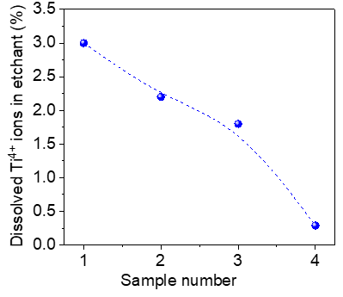

Fig. S8 ICP analysis results indicating the concentration of dissolved Ti ions in the etching solution utilized for Ti₃C₂T_{x}–1/2/3/4

Fig. S9 Raman spectra illustrating I_{D}/I_{G} ratio—a metric associated with carbon disorder—was reduced from 0.83 (for Ti₃C₂T_{x}–1) to 0.26 (for Ti₃C₂T_{x}–4), indicating a decrease in V_{C} and S_{O} concentrations

Note S6 Theoretical analysis of carrier characteristics and electrical conductivity in TiC and Ti₃AlC₂
Carrier density, effective mass, mobility, and electrical conductivity were determined utilizing Density Functional Theory (DFT) with the Vienna Ab initio Simulation Package (VASP) [S10]. The computational methodology was based on the Perdew-Burke-Ernzerhof (PBE) exchange-correlation functional within the Generalized Gradient Approximation (GGA), along with Projector Augmented Wave (PAW) pseudopotentials [S11, S12]. The Brillouin zone was sampled with a 12 × 12 × 12 k-point mesh constructed using the Monkhorst-Pack scheme [S13]. Structural relaxation proceeded iteratively until the energy change between steps was below 10⁻⁶ eV and atomic forces were less than 0.01 eV/Å.
Where applicable, Van der Waals corrections were introduced. The carrier density $n_{e}(T)$ was evaluated by integrating the product of the density of states $g(E)$ with the Fermi-Dirac distribution function $f(E, E_{F}, T)$ within the defined energy interval ${[-E}_{c}$,+$E_{v}$] over the temperature range of 300 ~ 2000 K, where $E_{c}$​ and $E_{v}$​ correspond to the conduction band minimum and the valence band maximum, respectively:
$n_{e}​=\int_{E_{min}​}^{E_{max}}{g(E)f(E,E_{F}​,T)dE}$ (S17)
The Fermi-Dirac function used for the calculations was:
$f(E,E_{F}​,T)=e(E-E_{F}​)/(k​_{B}T)+1​$ (S18)
where $E_{F}$ is the Fermi energy, $T$ the temperature, and $k_{B}$​ the Boltzmann constant ($8.617×{10}^{-5} eV/K$).
The effective mass $m^{*}$ was computed from the second derivative of the energy band edge by applying finite difference methods:
$m^{*}=\frac{ℏ^{2}}{\frac{∂^{2}E}{{∂k}^{2}}}≈\frac{ℏ^{2}}{\frac{E_{i+1}​-{2E}_{i}+E_{i-1}}{{Δk}^{2}}}​$ (S19)
where $ℏ$ is the reduced Planck’s constant ($1.054×{10}^{-34} J·s$), $E(k)$ represents the energy dispersion relation, and $\frac{∂^{2}E}{{∂k}^{2}}$ denotes the second derivative of energy relative to the wave vector $k$. $E_{i-1},$ $E_{i}$, and $E_{i+1}$ are the energy values at adjacent k-points, while $Δk$ is the separation between these points in reciprocal space.
The carrier mobility ($μ$) was estimated using the following equation:
$μ=\frac{eτ}{m^{*}}​$ (S20)
where $e$ denotes the elementary electron charge ($1.6×{10}^{-19} C$), and $τ$ refers to the scattering time. We determined that τ = 3.0 × ${10}^{-14}$ s for Ti₃AlC₂ and $τ = 1.0 × {10}^{-16}$ s for TiC, respectively [S14-S16].
Electronic structures and total energies were evaluated for defect models incorporating both Ti and C vacancies (□) as well as oxygen substitutions (O) in TiC and Ti₃AlC₂: (Ti_{1-x}□_{x})C, Ti(C_{1-x}□_{x}), Ti(C_{1-x}O_{x}), (Ti_{3-x}□_{x})AlC₂, Ti₃Al(C_{2-x}□_{x}), and Ti₃Al(C_{2-x}O_{x}) for x=0, 1%, 2%, 3%, and 5%. The simulations employed 72- and 144-atom supercells to provide a statistical representation. The geometry optimization process involved complete relaxation of both lattice parameters and atomic positions at 0 K and 0 Pa.
Electrical conductivity tensor components ($σ$) were evaluated using the BoltzTrap code [S17], which numerically solves the semi-classical Boltzmann transport equation within the constant-relaxation-time approximation. Electrical conductivity was defined as follows [S17, S18].
$σ\left(ε\right)=\frac{e^{2}}{NΩ}\int{dε}\left(\frac{∂f_{0}}{∂_{ε}}\right)\sum_{n,k}{τ_{n,k}{\vec{ν}}_{n,k}{\vec{ν}}_{n,k}δ\left(ε-ε_{n,k}\right)}$ (S21)
where $e$ represents the carrier charge, $N$ denotes the number of k-points, $Ω$ indicates the unit cell volume, $ε$ is the band energy, $f_{0}$ represents the Fermi–Dirac distribution function, $τ$ refers to the relaxation time, $ν$ is the group velocity of the charges, and $δ$ corresponds to the delta function. Since the electrical conductivity is calculated as $σ/τ_{0}$ in the BoltzTrap code ($τ_{0}$ = 1 fs), it was necessary to adjust the results using the relaxation time $(τ)$ in order to derive a more realistic value $(σ_{τ}/τ_{0}$). [19] τ values of$3.0 × {10}^{-14} s$ were determined for Ti₃AlC₂ [S14-S16, S20]. For models containing defects, identical τ values were applied due to the absence of experimental data.
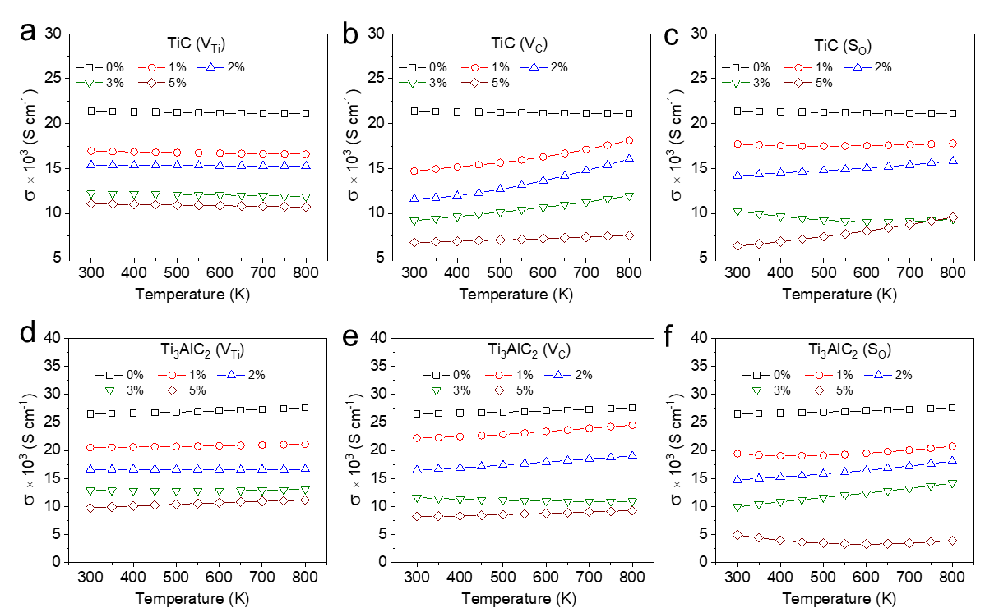
Fig. S10 DFT calculated electrical conductivity of (a–c) TiC, and (d–f) Ti₃AlC₂ as a function of temperature for varying V_{Ti}, V_{C}, S_{O} concentrations (0–5%)

Table S4 Theoretically calculated electronic properties of TiC precursors with varying defect concentrations
 | Carrier density (cm⁻³) |  |  | Carrier mobility (cm² V⁻¹ s⁻¹)
Defect | V_{Ti} | V_{C} | S_{o} | V_{Ti} | V_{C} | S_{o}
0% | 1.7675E+20 | 1.7675E+20 | 1.7675E+20 | 96.51669 | 96.51669 | 96.51669
1% | 9.0506E+19 | 1.7143E+20 | 1.6378E+20 | 81.66353 | 87.09237 | 91.07950
2% | 7.8055E+19 | 1.671E+20 | 1.581E+20 | 51.75870 | 60.90093 | 78.07064
3% | 7.4634E+19 | 1.6285E+20 | 1.5221E+20 | 50.78927 | 60.66491 | 77.06494
5% | 5.7675E+19 | 1.5042E+20 | 1.4316E+20 | 42.06526 | 56.58127 | 72.06216

Table S5 Theoretically calculated electronic properties of Ti₃AlC₂ MAX phases with varying defect concentrations
 | Carrier density (cm⁻³) |  |  | Mobility (cm² V⁻¹ s⁻¹)
Defect | V_{Ti} | V_{C} | S_{o} | V_{Ti} | V_{C} | S_{o}
0% | 1.2851E+20 | 1.2851E+20 | 1.2851E+20 | 46.34353 | 46.34353 | 46.34353
1% | 1.0001E+20 | 1.2628E+20 | 1.07E+20 | 42.43804 | 46.50757 | 39.06688
2% | 9.915E+19 | 1.2373E+20 | 7.1449E+19 | 33.79761 | 44.76265 | 13.38399
3% | 9.5405E+19 | 1.1608E+20 | 7.0361E+19 | 5.987098 | 9.987525 | 6.834274
5% | 8.9675E+19 | 9.4466E+19 | 5.8472E+19 | 3.371191 | 5.764634 | 2.478029

Table S6 DFT-predicted electrical conductivities of TiC and Ti₃AlC₂ MAX phases with varying concentrations of V_{Ti}, V_{C}, and S_{O} defects
 | Calculated conductivity of TiC  (S cm⁻¹) |  |  | Calculated conductivity of Ti₃AlC₂  (S cm⁻¹)
Defect | V_{Ti} | V_{C} | S_{o} | V_{Ti} | V_{C} | S_{o}
0% | 21408.66 | 21408.66 | 21408.66 | 26540.02 | 26540.02 | 26540.02
1% | 16930.89 | 14701.7 | 17717.38 | 20487.61 | 22192.81 | 19395.53
2% | 15374.69 | 11608.07 | 14183.72 | 16581.14 | 16487.89 | 14739.76
3% | 12203.04 | 9201.153 | 10262.98 | 12865.58 | 11606.33 | 9925.309
5% | 11046.89 | 6786.222 | 6360.599 | 9752.791 | 8217.759 | 4952.256
Note S7 Thermal conductivity measurement
Thermal diffusivity ($α$) was evaluated at room temperature by means of a laser flash apparatus (LFA67). Thermal conductivity ($κ$) was computed using the following relationship:
$κ=ρ Cp α$ (S22)
Where ρ denotes the bulk density of the MXene film and C_{p} represents the specific heat capacity, determined via differential scanning calorimetry (DSC 0214).

Table S7 Thermal diffusivity and thermal conductivity data of Ti₃C₂T_{x} MXenes
 | Thickness (mm) | Density  (g cm⁻³) | Heat capacity  (J g⁻¹ K⁻¹) | In-plane thermal diffusivity  (mm² sec⁻¹) | In-plane thermal conductivity  (W m⁻¹ K⁻¹)
Ti₃C₂T_{x}–1 | 0.008 | 2.99± 0.18 | 0.83± 0.15 | 13.31± 1.00 | 33.07
Ti₃C₂T_{x}–2 | 0.009 | 2.81± 0.23 | 0.93± 0.1 | 16.46± 0.80 | 43.01
Ti₃C₂T_{x}–3 | 0.009 | 2.95± 0.25 | 0.89± 0.09 | 17.24± 1.08 | 45.29
Ti₃C₂T_{x}–4 | 0.010 | 3.06 ± 0.13 | 0.90± 0.12 | 20.70± 1.25 | 57.0

Note S8 Infrared emissivity measurement
Emissivity (ε) was determined in accordance with Kirchhoff’s law:
$ε=1 - R$ (S23)
Where, R corresponds to reflectivity, which was quantified by FTIR spectrometry (JASCO-4700, Japan) using MXene films in the range of 2.5–15 µm at room temperature.
Infrared imaging and temperature data were measured using an IR camera (FLIR A310, FLIR, Sweden). In accordance with the Stefan–Boltzmann law:
P = εσT⁴ (S24)
where P denotes the radiation power per unit area (W m⁻²), σ is the Stefan–Boltzmann constant (5.67×10⁻⁸ W m⁻² K⁻⁴), and T is the surface temperature (K).
The relationship between emissivity and electrical conductivity (or resistivity) is described by the modified Hagen–Rubens relation [S21]:
$ε ∝\sqrt{\frac{ρ}{λ}} ∝\sqrt{\frac{1}{λ}}$(S25)

where ρ represents resistivity, σ is conductivity, and λ is the IR wavelength. Consequently, higher conductivity leads to lower emissivity.

Fig. S11 Infrared emissivity of Ti₃C₂T_{x}–1, –2, –3, and –4 MXene films
Note S9 EMI shielding measurement
EMI shielding effectiveness was determined using a two-port network analyzer (ENA5071C, Agilent Technologies, USA) equipped with a rectangular WR-90 waveguide operating in the X-band (8.2–12.4 GHz). Reflection (R), transmission (T), and shielding effectiveness (SE) were calculated based on measured scattering parameters (S_{11,} S_{22,} S₂₁, and S₁₂):
$S_{12}=\frac{V_{1(output)}}{V_{2(input)}}=\frac{E_{1(output)}}{E_{2(input)}}$ (S26)
$R=\frac{P_{r}}{P_{i}}={\left|S_{11}\right|}^{2}={\left|S_{22}\right|}^{2}$ (S27)
$T=\frac{P_{t}}{P_{i}}={\left|S_{12}\right|}^{2}={\left|S_{21}\right|}^{2}$ (S28)
${SE}_{T}=10\log{\frac{1}{T}}$ (S29)
${SE}_{R}=10\log{\frac{1}{1-R}}$ (S30)
${SE}_{A}=10\log{\frac{1-R}{T}}$ (S31)
Here, V and E denote voltage and electric field, respectively. P_{r} and P_{i} refer to the reflected and incident power of the electric field for electromagnetic waves. The total shielding effectiveness (SE_{T}) at a given single impedance is evaluated by combining the contributions of reflection (${SE}_{R})$ and absorption (${SE}_{A})$.
${SE}_{T}={SE}_{R}+{SE}_{A}$ (S32)
As described by Simon’s formulae, total shielding effectiveness is also dependent on electrical conductivity (σ), frequency (f), and film thickness (d):
${SE}_{T}=50+10 log \left(\frac{σ}{f}\right)+1.7 d \sqrt{σf}$ (S33)
This relationship suggests that both the reflection shielding component (SE_{R}) and the absorption shielding component (SE_{A}) increase as electrical conductivity increases.

Fig. S12 (a-d) EMI SE_{T,} SE_{R,} SE_{A} values of Ti₃C₂T_{x}–1/2/3/4 in the X-band frequency
Note S10 Joule heating measurement
Joule heating behavior was assessed using 1.5 × 2 cm² MXene films attached to copper electrodes. A DC power supply (TOYOTECH-TL305T) supplied voltage to the films while the temperature rise was tracked by a K-type thermocouple connected to a Compact DAQ Chassis (CDAQ-9171, National Instruments) using FlexLogger software (National Instruments) for in situ temperature monitoring.
The heating power density (P, W cm⁻²) was determined according to Joule’s law:
P = VI (S34)
where V and I represent the applied voltage and current, respectively.
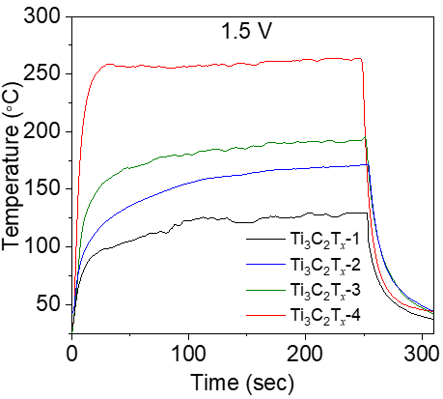

Fig. S13 Steady-state surface temperature of Ti₃C₂T_{x}–1, –2, –3, and –4 MXene films subjected to a constant applied voltage of 1.5 V during Joule heating
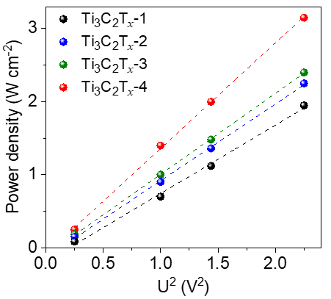
Fig. S14 Correlation between the square of voltage and power density of Ti₃C₂T_{x}–1/2/3/4 MXene films
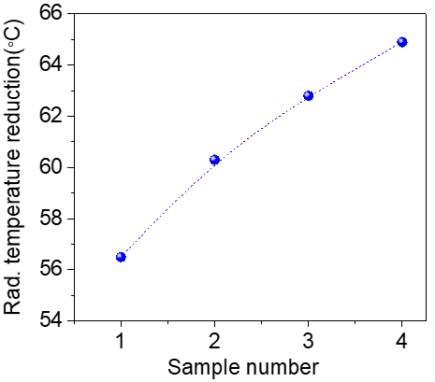
Fig. S15 Radiation temperature reductions relative to a 100 °C background, illustrating the IR camouflage effectiveness of Ti₃C₂T_{x} films. Higher the radiation temperature reduction higher will be thermal camouflage capability
Table S8 Comparison of the electrical conductivity of Ti₃C₂T_{x}–4 MXene with Ti₃C₂T_{x} literature reported values
Year | Name | Synthesis conditions | Conductivity (S cm⁻¹) | Refs.
2014 | Ti₃C₂T_{x} | 10 ml of 50.0 wt.% HF 18 h at RT | 2402.4 | [S22]
2016 | Ti₃C₂T_{x} | 1.6 g LiF + 20 ml 9.0M HCl, 30 h at 50 °C (MILD) | 4665 | [S23]
2017 | Ti₃C₂T_{x} | 1.0 g LiF + 20 ml 9.0M HCl, 24 h at 35°C | 9980 | [S24]
2020 | Ti₃C₂T_{x} | 1.6 g LiF + 20 ml 9.0M HCl, 36 h at RT | 10400 | [S25]
2021 | Ti₃C₂T_{x} | HCl, DI water, HF (6:3:1), 24 h at 35°C, Used Al-Ti₃AlC₂ with excess Al in MAX phase synthesis | 20000 | [S3]
2021 | Ti₃C₂T_{x} | 1.0 g LiF + 20 ml 9.0M HCl, 24 h at 40°C/continuous N₂ flow | 24000 | [S26]
2023 | Ti₃C₂T_{x}  (1.25Ti:2.2Al:2TiC) | HF-HCl method | 21000 | [S27]
2025 | Defect control Ti₃C₂T_{x} | 3ml HF + 1.6 g LiF + 20 ml 9.0M HCl, 24 h at 35°C (Excess C involved during TiC and surplus Al in MAX synthesis) | 26000 | This work

Table S9 Comparison of the thermal conductivity of Ti₃C₂T_{x}–4 MXene with previously reported values in the literature
 | Name | Thickness  (mm) | In-plane thermal conductivity (W m⁻¹ K⁻¹) | Refs.
MXenes | Ti₃C₂T_{x} | 0.029 | 17.55 | [S28]
MXenes | Ti₃C₂T_{x} | 3 | 55.8 | [S29]
MXenes | Ti₃C₂T_{x} film | 0.04 | 2.45 | [S30]
MXenes | Ti₃C₂T_{x} film | - | 13.6 | [S31]
MXenes | Ti₃C₂T_{x} film | 0.02 | 2.84 | [S32]
MXene Composites | MXene/CNF 20% | 0.029 | 7.63 | [S28]
MXene Composites | MXene/CNF 40% | 0.029 | 12.53 | [S28]
MXene Composites | MXene/CNF 60% | 0.029 | 14.93 | [S28]
MXene Composites | MXene/Epoxy | 0.8 | 0.587 | [S33]
MXene Composites | MXene/TPU | 0.4 | 0.148 | [S34]
MXene Composites | MXene/PVA | 0.027 | 4.57 | [S35]
MXene Composites | MXene/PDMS (1.07%) | 0.2 | 3.89 | [S36]
MXene Composites | MXene/CNF (50%) | 0.017 | 11.57 | [S37]
MXene Composites | Ti₃C₂T_{x} MXene/PVA | 3 | 47.6 | [S29]
MXene Composites | Ti₃C₂T_{x} MXene (30%)/ANF | - | 15.5 | [S38]
MXene Composites | Ti₃C₂T_{x} MXene (30%)/CNF | - | 8.84 | [S39]
This work | Defect Control Ti₃C₂T_{x} MXene | 0.01 | 57.50
Table S10 Comparison of the IR emissivity of Ti₃C₂T_{x}–4 MXene with established literature values
System | Name Material | Thickness (um) | Emissivity | Refs.
Graphene & CNTs | Graphene | - | 0.32 | [S40]
Graphene & CNTs | GO | - | 0.85 | [S40]
Graphene & CNTs | CNTs | - | 0.76 | [S40]
Graphene & CNTs | Multilayer graphene | 50 | 0.32 | [S41]
Graphene & CNTs | Graphene fabric | 100 | 0.35 | [S42]
Metals | Ag | - | 0.049 | [S40]
Metals | Cu | - | 0.11 | [S40]
Metals | Al | - | 0.072 | [S40]
Metals | Stainless steel | - | 0.14 | [S40]
Metals | Al-SiO2 | 0.172 | 0.12 | [S43]
Metals | Ag/Ge | - | 0.31 | [S44]
Metals | Germanium | 0.953 | 0.31 | [S44]
MXene | MXene film | 13 | 0.19 | [S45]
MXene | MXene film | 29 | 0.19 | [S45]
MXene | MXene film | 45 | 0.19 | [S45]
MXene | Ti₃C₂T_{x} | 0.2 | 0.047 | [S46]
MXene | Ti₃CNT_{x} | 0.2 | 0.12 | [S46]
MXene | Ti₃C₂T_{x} | 10 | 0.05 | [S47]
MXene | Ti₃C₂T_{x} | 15 | 0.17 | [S48]
MXene | Ti₃C₂T_{x} | 7 | 0.09 | [S49]
This work | Defect control Ti₃C₂T_{x} | 10 | 0.05

Table S11 Comparison of EMI shielding effectiveness (SE_{T}) and electrical conductivity of Ti₃C₂T_{x}–1/2/3/4 MXene with previously reported values in the literature
Category | Materials | Thickness (mm) | Conductivity (S cm⁻¹) | EMI SE (dB) | Refs
MXene | Ti₃C₂T_{x} | 0.014 | 14000 | 70 | [S50]
MXene | Ti₃CNT_{x} | 0.01 | 2700 | 55 | [S50]
MXene | Ti₃C₂T_{x} | 0.04 | 4600 | 87 | [S23]
MXene | Ti₃C₂T_{x} | 0.0215 | 4600 | 78 | [S23]
MXene | Ti₃C₂T_{x} | 0.0112 | 4600 | 68 | [S23]
MXene | Ti₃C₂T_{x} | 0.045 | 4600 | 92 | [S23]
MXene | Ti₃C₂T_{x} pristine | 0.04 | 4500 | 83.5 | [S51]
MXene | Ti₃C₂T_{x} Heat treated | 0.04 | 5225 | 93 | [S51]
MXene | Ti₃CNT_{x} pristine | 0.04 | 1125 | 61.4 | [S51]
MXene | Ti₃CNT_{x} Heat treated | 0.04 | 2475 | 116.2 | [S51]
Metals | Stainless steel | 4 |  | 89 | [S52]
Metals | Copper | 3.1 |  | 90 | [S52]
Metals | Cu foil | 0.01 | 8.0 x 105 | 70 | [S23]
Metals | Al foil | 0.008 | 2.8 x 105 | 66 | [S23]
Graphene | B,N-doped rGO | 1.2 | 124 | 42 | [S53]
Graphene | S-doped rGO | 0.15 | 3100 | 35.8 | [S54]
Graphene | Graphene film | 0.25 |  | 17 | [S55]
Graphene | Graphene film | 0.05 | 1130 | 60 | [S56]
Graphene | Graphene film | 0.008 | 10³ | 20 | [S57]
Graphene | Graphene film | 0.015 | 2400 | 20.2 | [S58]
This work | Defect control Ti₃C₂T_{x} | 0.002 | 26000 | 62.3
This work | Defect control Ti₃C₂T_{x} | 0.004 | 26000 | 69.9
This work | Defect control Ti₃C₂T_{x} | 0.006 | 26000 | 76.3
This work | Defect control Ti₃C₂T_{x} | 0.01 | 26000 | 90.57

Table S12 Comparison of Joule heating saturation temperature of Ti₃C₂T_{x}–4 MXene with values reported in previous studies
Structure | Sample Name | Voltage (V) | Temperature (°C) | Refs.
CNTs and Graphene | Graphene paper | 1.5 | 28 | [S59]
CNTs and Graphene | Graphene paper | 2.1 | 32.5 | [S59]
CNTs and Graphene | Graphene paper | 2.5 | 37.5 | [S59]
CNTs and Graphene | Graphene paper | 3.2 | 43 | [S59]
CNTs and Graphene | CNT paper | 1 | 29 | This work
CNTs and Graphene | CNT paper | 2 | 54.9 | This work
CNTs and Graphene | CNT paper | 3 | 105 | This work
AgNWs | AgNWs network | 4 | 55 | [S60]
AgNWs | AgNWs film | 7 | 100 | [S61]
AgNWs | AgNWs meshes | 7 | 100 | [S62]
MXene | Thermocouple values | 0.5 | 48 | [S40]
MXene | Thermocouple values | 1 | 108 | [S40]
MXene | Thermocouple values | 1.5 | 201 | [S40]
MXene | IR Camera values | 0.5 | 28.9 | [S40]
MXene | IR Camera values | 1 | 44.5 | [S40]
MXene | IR Camera values | 1.5 | 75.5 | [S40]
This work | Defect Controlled Ti₃C₂T_{x} MXene | 0.5 | 59.5 | This work
This work | Defect Controlled Ti₃C₂T_{x} MXene | 1 | 138.3 | This work
This work | Defect Controlled Ti₃C₂T_{x} MXene | 1.4 | 224 | This work
This work | Defect Controlled Ti₃C₂T_{x} MXene | 1.5 | 263 | This work
Note S11 Oxidation Kinetics of Ti₃C₂T_{x} MXenes
UV-vis absorbance spectra of dilute Ti₃C₂T_{x}–1/2/3/4 aqueous dispersions (0.02 mg mL⁻¹) were measured over time at 3 °C, 20 °C, and 35 °C (Figs. S16–S18). Fresh Ti₃C₂T_{x} dispersions displayed peaks at 250, 320, and 780 nm, while fully oxidized samples showed a pronounced 250 nm peak, indicating TiO₂ formation. As oxidation advanced, the 250 nm peak became more intense and the peaks at 320/780 nm weakened [S63-S66]. Among these, Ti₃C₂T_{x}–4 samples maintained a dark green appearance as a result of high crystallinity, whereas the other dispersions became whitish, indicating extensive oxidation and TiO₂ formation (Fig. 4a) [S67].
To assess oxidation kinetics, absorbance at 780 nm was continuously measured and normalized to I/I_{o}, where I_{o} is the initial absorbance and I is the absorbance at each time point.
Exponential decay was observed for all samples, which matched first-order kinetic behavior (Figs. 4c and S19a, b) [S68, S69]:
I=I_{o} e^{-t/τ} =I_{o} e^{-kt} (S35)
Here, t denotes time, τ is the decay time constant, and k is the rate constant. The rate constants for oxidation were higher with increasing temperature and defect concentration (Table S13), [70] supporting the conclusion that lattice defects serve as reactive centers that enhance Ti oxidation and TiO₂ formation [S71-S73].
Activation energies (E_{a}) for Ti₃C₂T_{x}–1/2/3/4 were estimated by plotting ln k against 1/T in Arrhenius coordinates, with linear fitting resulting in the following slopes (Fig. 4d,e):
ln k = ln A – E_{a}/RT (S36)
where A represents the pre-exponential factor, R is the gas constant, and T is the absolute temperature [S70].
Fig. S16 UV-vis absorbance spectra for (a) Ti₃C₂T_{x}–1, (b) Ti₃C₂T_{x}–2, (c) Ti₃C₂T_{x}–3, and (d) Ti₃C₂T_{x}–4 monitored over time at 3 °C
Fig. S17 UV-vis absorbance spectra of (a) Ti₃C₂T_{x}–1, (b) Ti₃C₂T_{x}–2, (c) Ti₃C₂T_{x}–3, and (d) Ti₃C₂T_{x}–4 tracked over time at 20 °C
Fig. S18 UV-vis absorbance spectra for (a) Ti₃C₂T_{x}–1, (b) Ti₃C₂T_{x}–2, (c) Ti₃C₂T_{x}–3, and (d) Ti₃C₂T_{x}–4 recorded at different time points at 35 °C

Fig. S19 Normalized absorbance intensity at 780 nm for Ti₃C₂T_{x}–1, –2, –3, and –4 MXene aqueous dispersions at (a) 20 °C and (b) 35 °C. Dashed lines indicate fitting to a first-order exponential decay model
Table S13 Oxidation rate constants for Ti₃C₂T_{x}–1/2/3/4 MXene aqueous dispersions measured at different temperatures
Summary of rate constants
Temperature  (°C) | Ti₃C₂T_{x}-1 | Ti₃C₂T_{x}-2 | Ti₃C₂T_{x}-3 | Ti₃C₂T_{x}-4
Temperature  (°C) | k (day ⁻¹) | k (day ⁻¹) | k (day ⁻¹) | k (day ⁻¹)
3 | 0.07032 | 0.015048 | 0.00517 | 0.000217
20 | 0.2516 | 0.04139 | 0.0168 | 0.000850
35 | 0.6601 | 0.07203 | 0.0481 | 0.00530
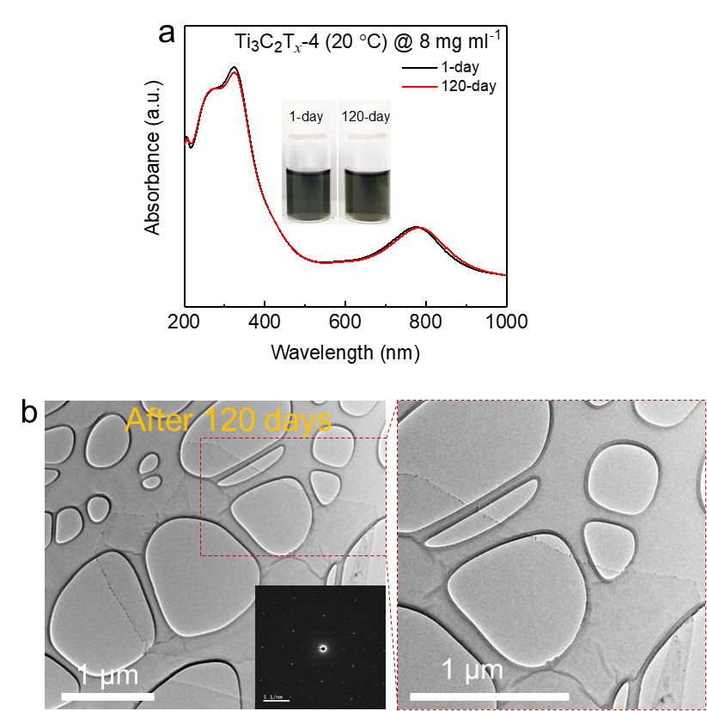
Fig. S20 (a) UV–vis spectra of concentrated Ti₃C₂T_{x}–4 MXene dispersions (8 mg mL⁻¹) in both fresh and aged forms after 120 days of ambient storage. Inset: Images of fresh and aged dispersions. (b) TEM micrograph of Ti₃C₂T_{x}–4 flakes after 120 days of aging and their respective high-resolution image indicating that TiO₂ nanoparticles are sparsely formed and are hardly observed even after 120 days of storage underscoring its excellent oxidation resistance of the Ti₃C₂T_{x}–4 MXene samples
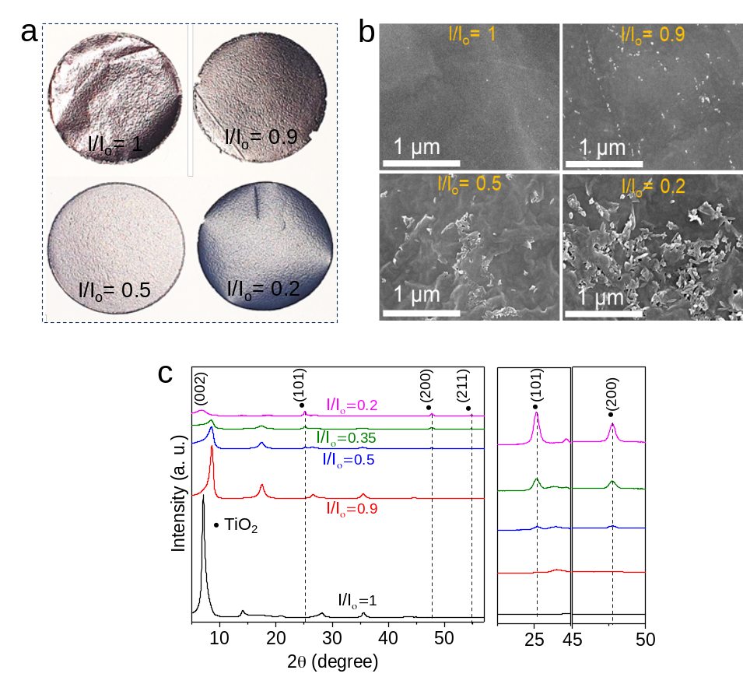
Fig. S21 (a) Digital photos, (b) SEM micrographs, and (c) XRD patterns of MXene films synthesized from the dispersion at varying normalized 780 nm peak intensities (I/I_{o}), reflecting different stages of oxidation. With increasing oxidation, the (002) MXene peak diminishes and TiO₂ (101) and (200) peaks become more pronounced
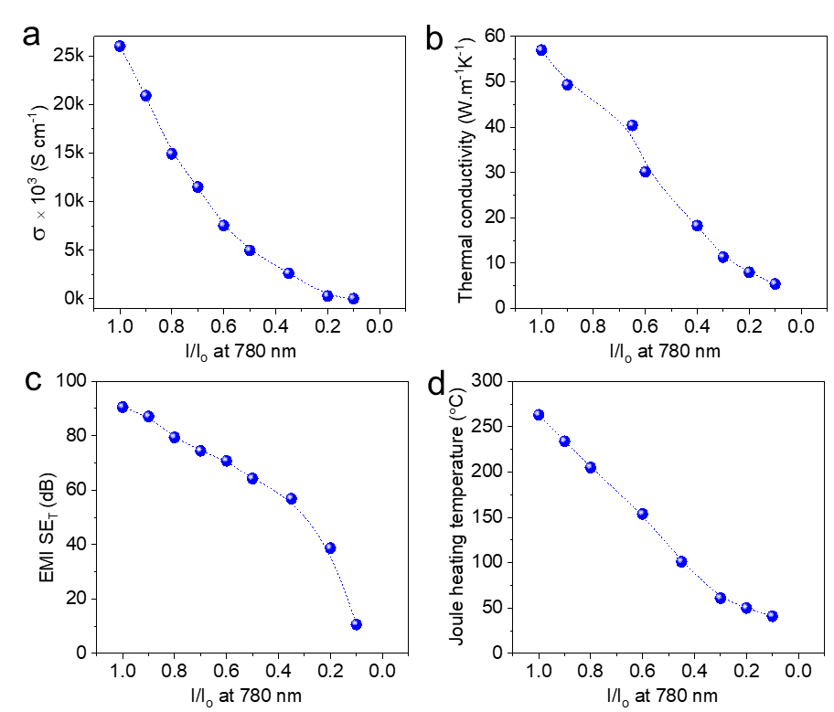
Fig. S22 (a) Electrical conductivity, (b) thermal conductivity, (c) EMI shielding, and (d) Joule heating saturation temperature of MXene films as functions of normalized 780 nm peak intensity (I/I_{o})
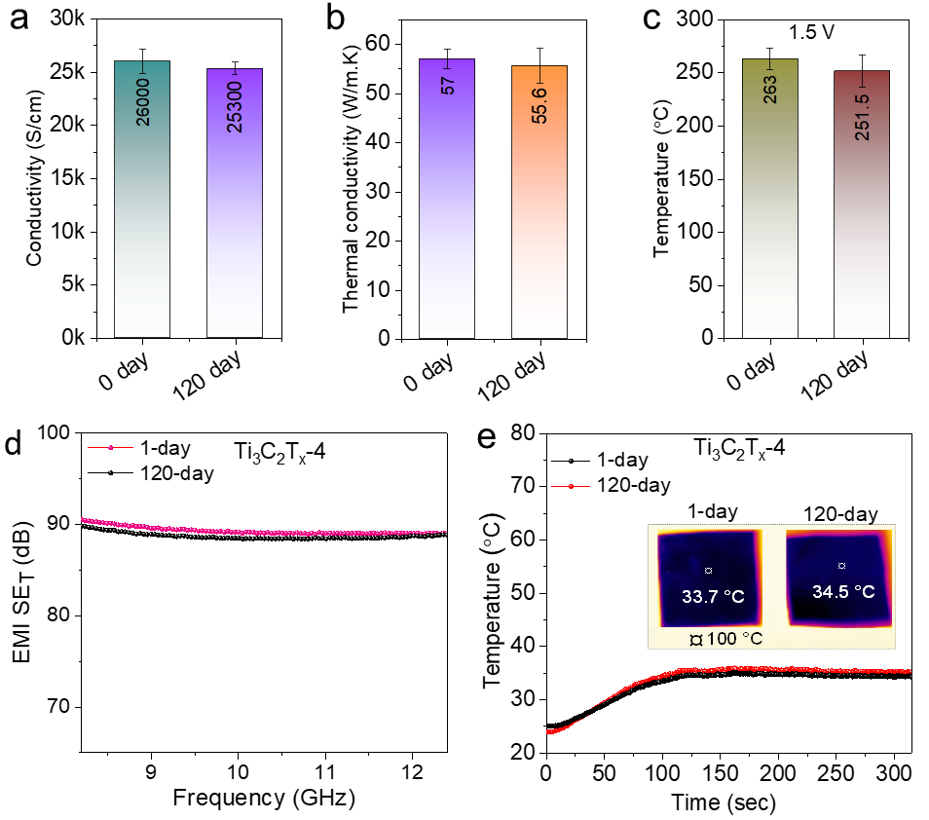
Fig. S23 (a) Electrical conductivity, (b) thermal conductivity, (c) Joule heating temperature, (d) EMI shielding effectiveness, and (e) IR shielding efficiency of films produced from both fresh and 120-day-aged concentrated (8 mg mL⁻¹) Ti₃C₂T_{x}–4 dispersions stored at room temperature. The aged films maintain >97% of electrical conductivity, >95% of thermal conductivity, >93% of Joule heating, 98% of EMI shielding, and 98% of IR shielding, confirming outstanding long-term performance.
Supplementary References
- A.W. Weimer, K.J. Nilsen, G.A. Cochran, R.P. Roach, Kinetics of carbothermal reduction synthesis of beta silicon carbide. AlChE. J. 39(3), 493–503 (1993). https://doi.org/10.1002/aic.690390311
- A. Iqbal, H. Kim, J.-M. Oh, J. Chae, J. Kim et al., Effect of substitutional oxygen on properties of Ti₃C₂T_{x} MXene produced using recycled TiO₂ source. Small Methods 7(8), e2201715 (2023). https://doi.org/10.1002/smtd.202201715
- T.S. Mathis, K. Maleski, A. Goad, A. Sarycheva, M. Anayee et al., Modified MAX phase synthesis for environmentally stable and highly conductive Ti₃C₂ MXene. ACS Nano 15(4), 6420–6429 (2021). https://doi.org/10.1021/acsnano.0c08357
- S. Kajiyama, L. Szabova, K. Sodeyama, H. Iinuma, R. Morita et al., Sodium-ion intercalation mechanism in MXene nanosheets. ACS Nano 10(3), 3334–3341 (2016). https://doi.org/10.1021/acsnano.5b06958
- N. Anjum, M.M. Rahman, A. Elattar, A. Sijuade, E.E. Kalu et al., High-yield MILD synthesis of Ti₃C₂T_{x} MXene: characterization and application in developing energy storage device. Adv. Sustain. Syst. 9(8), 2500402 (2025). https://doi.org/10.1002/adsu.202500402
- J. Rodríquez-Carvajal, Magnetic structure determination from powder diffraction symmetry analysis and simulated annealing. Mater. Sci. Forum 378, 268-273 https://doi.org/10.4028/www.scientific.net/MSF.378-381.268
- M. Ghidiu, M.R. Lukatskaya, M.-Q. Zhao, Y. Gogotsi, M.W. Barsoum, Conductive two-dimensional titanium carbide ‘clay’ with high volumetric capacitance. Nature 516(7529), 78–81 (2014). https://doi.org/10.1038/nature13970
- M. Anayee, N. Kurra, M. Alhabeb, M. Seredych, M.N. Hedhili et al., Role of acid mixtures etching on the surface chemistry and sodium ion storage in Ti₃C₂T_{x} MXene. Chem. Commun. 56(45), 6090–6093 (2020). https://doi.org/10.1039/D0CC01042A
- M. Shekhirev, J. Busa, C.E. Shuck, A. Torres, S. Bagheri et al., Ultralarge flakes of Ti₃C₂T_{x} MXene via soft delamination. ACS Nano 16(9), 13695–13703 (2022). https://doi.org/10.1021/acsnano.2c04506
- J. Hafner, Ab-initio simulations of materials using VASP: Density-functional theory and beyond. J. Comput. Chem. 29(13), 2044–2078 (2008). https://doi.org/10.1002/jcc.21057
- J.P. Perdew, K. Burke, M. Ernzerhof, Generalized gradient approximation made simple. Phys. Rev. Lett. 77(18), 3865–3868 (1996). https://doi.org/10.1103/physrevlett.77.3865
- G. Kresse, D. Joubert, From ultrasoft pseudopotentials to the projector augmented-wave method. Phys. Rev. B 59(3), 1758–1775 (1999). https://doi.org/10.1103/physrevb.59.1758
- P. Wisesa, K.A. McGill, T. Mueller, Efficient generation of generalized Monkhorst-Pack grids through the use of informatics. Phys. Rev. B 93(15), 155109 (2016). https://doi.org/10.1103/physrevb.93.155109
- J. Gertzen, P. Levecque, T. Rampai, T. van Heerden, DFT study of MAX phase surfaces for electrocatalyst support materials in hydrogen fuel cells. Materials 14(1), 77 (2020). https://doi.org/10.3390/ma14010077
- L. Gao, H. Chen, F. Zhang, S. Mei, Y. Zhang et al., Ultrafast relaxation dynamics and nonlinear response of few-layer niobium carbide MXene. Small Meth. 4(8), 2000250 (2020). https://doi.org/10.1002/smtd.202000250
- C.-S. Lue, J. Lin, B. Xie, NMR study of the ternary carbides M₂AlC (M= Ti, V, Cr). Phys. Rev. B 73(3), 035125 (2006). https://doi.org/10.1103/PhysRevB.73.035125
- G.K.H. Madsen, D.J. Singh, BoltzTraP. A code for calculating band-structure dependent quantities. Comput. Phys. Commun. 175(1), 67–71 (2006). https://doi.org/10.1016/j.cpc.2006.03.007
- B. Ryu, M.-W. Oh, Computational simulations of thermoelectric transport properties. J. Korean Ceram. Soc 53(3), 273–281 (2016). https://doi.org/10.4191/kcers.2016.53.3.273
- M.J. Rice, Electron-electron scattering in transition metals. Phys. Rev. Lett. 20(25), 1439–1441 (1968). https://doi.org/10.1103/physrevlett.20.1439
- A.T. Paxton, M. van Schilfgaarde, M. MacKenzie, A.J. Craven, The near-edge structure in energy-loss spectroscopy: many-electron and magnetic effects in transition metal nitrides and carbides. J. Phys.: Condens. Matter 12(5), 729–750 (2000). https://doi.org/10.1088/0953-8984/12/5/319
- B.C. Wyatt, Y. Yang, P.P. Michałowski, T. Parker, Y. Morency et al., Order-to-disorder transition due to entropy in layered and 2D carbides. Science 389(6764), 1054–1058 (2025). https://doi.org/10.1126/science.adv4415
- Z. Ling, C.E. Ren, M.-Q. Zhao, J. Yang, J.M. Giammarco et al., Flexible and conductive MXene films and nanocomposites with high capacitance. Proc. Natl. Acad. Sci. U. S. A. 111(47), 16676–16681 (2014). https://doi.org/10.1073/pnas.1414215111
- F. Shahzad, M. Alhabeb, C.B. Hatter, B. Anasori, S. Man Hong et al., Electromagnetic interference shielding with 2D transition metal carbides (MXenes). Science 353(6304), 1137–1140 (2016). https://doi.org/10.1126/science.aag2421
- Y. Zhang, M. Qiu, Y. Yu, B. Wen, L. Cheng, A novel polyaniline-coated bagasse fiber composite with core–shell heterostructure provides effective electromagnetic shielding performance. ACS Appl. Mater. Interfaces 9(1), 809–818 (2017). https://doi.org/10.1021/acsami.6b11989
- H. Chen, Y. Wen, Y. Qi, Q. Zhao, L. Qu et al., Pristine titanium carbide MXene films with environmentally stable conductivity and superior mechanical strength. Adv. Funct. Mater. 30(5), 1906996 (2020). https://doi.org/10.1002/adfm.201906996
- A. Shayesteh Zeraati, S.A. Mirkhani, P. Sun, M. Naguib, P.V. Braun et al., Improved synthesis of Ti₃C₂T_{x} MXenes resulting in exceptional electrical conductivity, high synthesis yield, and enhanced capacitance. Nanoscale 13(6), 3572–3580 (2021). https://doi.org/10.1039/D0NR06671K
- A. Thakur, N.Chandran B.S., K. Davidson, A. Bedford, H. Fang et al., Step-by-step guide for synthesis and delamination of Ti₃C₂T_{x} MXene. Small Meth. 7(8), 2300030 (2023). https://doi.org/10.1002/smtd.202300030
- E. Jiao, K. Wu, Y. Liu, M. Lu, Z. Hu et al., Ultrarobust MXene-based laminated paper with excellent thermal conductivity and flame retardancy. Compos. Part A Appl. Sci. Manuf. 146, 106417 (2021). https://doi.org/10.1016/j.compositesa.2021.106417
- R. Liu, W. Li, High-thermal-stability and high-thermal-conductivity Ti₃C₂T_{x} MXene/poly(vinyl alcohol) (PVA) composites. ACS Omega 3(3), 2609–2617 (2018). https://doi.org/10.1021/acsomega.7b02001
- H. Wu, J. Gu, Z. Li, W. Liu, H. Bao et al., Characterization of phonon thermal transport of Ti₃C₂T_{x} MXene thin film. J. Phys.: Condens. Matter 34(15), 155704 (2022). https://doi.org/10.1088/1361-648x/ac4f1c
- V.P. Nguyen, M. Lim, K.-S. Kim, J.-H. Kim, J.S. Park et al., Drastically increased electrical and thermal conductivities of Pt-infiltrated MXenes. J. Mater. Chem. A 9(17), 10739–10746 (2021). https://doi.org/10.1039/d1ta00331c
- L. Chen, X. Shi, N. Yu, X. Zhang, X. Du et al., Measurement and analysis of thermal conductivity of Ti₃C₂Tx MXene films. Materials 11(9), 1701 (2018). https://doi.org/10.3390/ma11091701
- R. Kang, Z. Zhang, L. Guo, J. Cui, Y. Chen et al., Enhanced thermal conductivity of epoxy composites filled with 2D transition metal carbides (MXenes) with ultralow loading. Sci. Rep. 9(1), 9135 (2019). https://doi.org/10.1038/s41598-019-45664-4
- X. Wang, L. Wang, Y. He, M. Wu, A. Zhou, The effect of two-dimensional d-Ti3C2 on the mechanical and thermal conductivity properties of thermoplastic polyurethane composites. Polym. Compos. 41(1), 350–359 (2020). https://doi.org/10.1002/pc.25374
- X. Jin, J. Wang, L. Dai, X. Liu, L. Li et al., Flame-retardant poly(vinyl alcohol)/MXene multilayered films with outstanding electromagnetic interference shielding and thermal conductive performances. Chem. Eng. J. 380, 122475 (2020). https://doi.org/10.1016/j.cej.2019.122475
- D. Hu, X. Huang, S. Li, P. Jiang, Flexible and durable cellulose/MXene nanocomposite paper for efficient electromagnetic interference shielding. Compos. Sci. Technol. 188, 107995 (2020). https://doi.org/10.1016/j.compscitech.2020.107995
- G. Song, R. Kang, L. Guo, Z. Ali, X. Chen et al., Highly flexible few-layer Ti₃C₂ MXene/cellulose nanofiber heat-spreader films with enhanced thermal conductivity. New J. Chem. 44(17), 7186–7193 (2020). https://doi.org/10.1039/d0nj00672f
- Y. Zhan, X. Zheng, B. Nan, M. Lu, J. Shi et al., Flexible MXene/aramid nanofiber nanocomposite film with high thermal conductivity and flame retardancy. Eur. Polym. J. 186, 111847 (2023). https://doi.org/10.1016/j.eurpolymj.2023.111847
- E. Jiao, K. Wu, Y. Liu, M. Lu, H. Zhang et al., Robust bioinspired MXene-based flexible films with excellent thermal conductivity and photothermal properties. Compos. Part A Appl. Sci. Manuf. 143, 106290 (2021). https://doi.org/10.1016/j.compositesa.2021.106290
- M. Shen, J. Ni, Y. Cao, Y. Yang, W. Wang et al., Low infrared emitter from Ti₃C₂T_{x} MXene towards highly-efficient electric/solar and passive radiative heating. J. Mater. Sci. Technol. 133, 32–40 (2023). https://doi.org/10.1016/j.jmst.2022.04.059
- O. Salihoglu, H.B. Uzlu, O. Yakar, S. Aas, O. Balci et al., Graphene-based adaptive thermal camouflage. Nano Lett. 18(7), 4541–4548 (2018). https://doi.org/10.1021/acs.nanolett.8b01746
- M.S. Ergoktas, G. Bakan, P. Steiner, C. Bartlam, Y. Malevich et al., Graphene-enabled adaptive infrared textiles. Nano Lett. 20(7), 5346–5352 (2020). https://doi.org/10.1021/acs.nanolett.0c01694
- L. Chen, Z. Ren, X. Liu, K. Wang, Q. Wang, Infrared–visible compatible stealth based on Al-SiO₂ nanoparticle composite film. Opt. Commun. 482, 126608 (2021). https://doi.org/10.1016/j.optcom.2020.126608
- L. Peng, D. Liu, H. Cheng, S. Zhou, M. Zu, A multilayer film based selective thermal emitter for infrared stealth technology. Adv. Opt. Mater. 6(23), 1801006 (2018). https://doi.org/10.1002/adom.201801006
- L. Li, M. Shi, X. Liu, X. Jin, Y. Cao et al., Ultrathin titanium carbide (MXene) films for high-temperature thermal camouflage. Adv. Funct. Mater. 31(35), 2101381 (2021). https://doi.org/10.1002/adfm.202101381
- M. Han, D. Zhang, A. Singh, T. Hryhorchuk, C. Eugene Shuck et al., Versatility of infrared properties of MXenes. Mater. Today 64, 31–39 (2023). https://doi.org/10.1016/j.mattod.2023.02.024
- T. Hassan, A. Iqbal, B. Yoo, J.Y. Jo, N. Cakmakci et al., Multifunctional MXene/carbon nanotube Janus film for electromagnetic shielding and infrared shielding/detection in harsh environments. Nano-Micro Lett. 16(1), 216 (2024). https://doi.org/10.1007/s40820-024-01431-3
- Y. Li, C. Xiong, H. Huang, X. Peng, D. Mei et al., 2D Ti₃C₂T_{x} MXenes: visible black but infrared white materials. Adv. Mater. 33(41), 2103054 (2021). https://doi.org/10.1002/adma.202103054
- Y. Zhang, L. Li, Y. Cao, Y. Yang, W. Wang et al., High-strength, low infrared-emission nonmetallic films for highly efficient Joule/solar heating, electromagnetic interference shielding and thermal camouflage. Mater. Horiz. 10(1), 235–247 (2023). https://doi.org/10.1039/D2MH01073A
- M. Han, C.E. Shuck, R. Rakhmanov, D. Parchment, B. Anasori et al., Beyond Ti₃C₂T_{x} MXene: Mxenes for electromagnetic interference shielding. ACS Nano 14(4), 5008-5016 (2020). https://doi.org/10.1021/acsnano.0c01312
- A. Iqbal, F. Shahzad, K. Hantanasirisakul, M.-K. Kim, J. Kwon et al., Anomalous absorption of electromagnetic waves by 2D transition metal carbonitride Ti₃CNT_{x} (MXene). Science 369(6502), 446–450 (2020). https://doi.org/10.1126/science.aba7977
- X. Shui, D.D.L. Chung, Nickel filament polymer-matrix composites with low surface impedance and high electromagnetic interference shielding effectiveness. J. Electron. Mater. 26(8), 928–934 (1997). https://doi.org/10.1007/s11664-997-0276-4
- S. Umrao, T.K. Gupta, S. Kumar, V.K. Singh, M.K. Sultania et al., Microwave-assisted synthesis of boron and nitrogen Co-doped reduced graphene oxide for the protection of electromagnetic radiation in ku-band. ACS Appl. Mater. Interfaces 7(35), 19831–19842 (2015). https://doi.org/10.1021/acsami.5b05890
- F. Shahzad, P. Kumar, Y.-H. Kim, S.M. Hong, C.M. Koo, Biomass-derived thermally annealed interconnected sulfur-doped graphene as a shield against electromagnetic interference. ACS Appl. Mater. Interfaces 8(14), 9361–9369 (2016). https://doi.org/10.1021/acsami.6b00418
- P. Tripathi, C.R. Prakash Patel, A. Dixit, A.P. Singh, P. Kumar et al., High yield synthesis of electrolyte heating assisted electrochemically exfoliated graphene for electromagnetic interference shielding applications. RSC Adv. 5(25), 19074–19081 (2015). https://doi.org/10.1039/C4RA17230B
- L. Zhang, N.T. Alvarez, M. Zhang, M. Haase, R. Malik et al., Preparation and characterization of graphene paper for electromagnetic interference shielding. Carbon 82, 353–359 (2015). https://doi.org/10.1016/j.carbon.2014.10.080
- B. Shen, W. Zhai, W. Zheng, Ultrathin flexible graphene film: an excellent thermal conducting material with efficient EMI shielding. Adv. Funct. Mater. 24(28), 4542–4548 (2014). https://doi.org/10.1002/adfm.201400079
- P. Kumar, F. Shahzad, S. Yu, S.M. Hong, Y.-H. Kim et al., Large-area reduced graphene oxide thin film with excellent thermal conductivity and electromagnetic interference shielding effectiveness. Carbon 94, 494–500 (2015). https://doi.org/10.1016/j.carbon.2015.07.032
- Y. Guo, C. Dun, J. Xu, J. Mu, P. Li et al., Ultrathin, washable, and large-area graphene papers for personal thermal management. Small 13(44), 1702645 (2017). https://doi.org/10.1002/smll.201702645
- O. Ergun, S. Coskun, Y. Yusufoglu, H.E. Unalan, High-performance, bare silver nanowire network transparent heaters. Nanotechnology 27(44), 445708 (2016). https://doi.org/10.1088/0957-4484/27/44/445708
- T. Kim, Y.W. Kim, H.S. Lee, H. Kim, W.S. Yang et al., Uniformly interconnected silver-nanowire networks for transparent film heaters. Adv. Funct. Mater. 23(10), 1250–1255 (2013). https://doi.org/10.1002/adfm.201202013
- P. Li, J.G. Ma, H.Y. Xu, D. Lin, X.D. Xue et al., Flexible transparent heaters based on silver nanotrough meshes. J. Alloys Compd. 664, 764–769 (2016). https://doi.org/10.1016/j.jallcom.2015.12.216
- G. Li, K. Jiang, S. Zaman, J. Xuan, Z. Wang et al., Ti₃C₂ sheets with an adjustable surface and feature sizes to regulate the chemical stability. Inorg. Chem. 58(14), 9397–9403 (2019). https://doi.org/10.1021/acs.inorgchem.9b01180
- C.J. Zhang, S. Pinilla, N. McEvoy, C.P. Cullen, B. Anasori et al., Oxidation stability of colloidal two-dimensional titanium carbides (MXenes). Chem. Mater. 29(11), 4848–4856 (2017). https://doi.org/10.1021/acs.chemmater.7b00745
- J. Li, R. Qin, L. Yan, Z. Chi, Z. Yu et al., Plasmonic light illumination creates a channel to achieve fast degradation of Ti₃C₂T_{x} nanosheets. Inorg. Chem. 58(11), 7285–7294 (2019). https://doi.org/10.1021/acs.inorgchem.9b00329
- T.Y. Ko, D. Kim, S.J. Kim, H. Kim, A.S. Nissimagoudar et al., Universal ligands for dispersion of two-dimensional MXene in organic solvents. ACS Nano 17, 1112–1119 (2023). https://doi.org/10.1021/acsnano.2c08209
- D. Kim, T.Y. Ko, H. Kim, G.H. Lee, S. Cho et al., Nonpolar organic dispersion of 2D Ti₃C₂T_{x} MXene flakes via simultaneous interfacial chemical grafting and phase transfer method. ACS Nano 13(12), 13818–13828 (2019). https://doi.org/10.1021/acsnano.9b04088
- J. Halim, K.M. Cook, M. Naguib, P. Eklund, Y. Gogotsi et al., X-ray photoelectron spectroscopy of select multi-layered transition metal carbides (MXenes). Appl. Surf. Sci. 362, 406–417 (2016). https://doi.org/10.1016/j.apsusc.2015.11.089
- W. Yuan, L. Cheng, Y. Zhang, H. Wu, S. Lv et al., Hydrogen evolution: 2D-layered carbon/TiO₂ hybrids derived from Ti₃C₂ MXenes for photocatalytic hydrogen evolution under visible light irradiation. Adv. Mater. Interfaces 4(20), admi.201770103 (2017). https://doi.org/10.1002/admi.201770103
- S. Doo, A. Chae, D. Kim, T. Oh, T.Y. Ko et al., Mechanism and kinetics of oxidation reaction of aqueous Ti₃C₂T_{x} suspensions at different pHs and temperatures. ACS Appl. Mater. Interfaces 13(19), 22855–22865 (2021). https://doi.org/10.1021/acsami.1c04663
- X. Sang, Y. Xie, M.-W. Lin, M. Alhabeb, K.L. Van Aken et al., Atomic defects in monolayer titanium carbide (Ti₃C₂T_{x}) MXene. ACS Nano 10(10), 9193–9200 (2016). https://doi.org/10.1021/acsnano.6b05240
- A. Iqbal, J. Hong, T.Y. Ko, C.M. Koo, Improving oxidation stability of 2D MXenes: synthesis, storage media, and conditions. Nano Converg. 8(1), 9 (2021). https://doi.org/10.1186/s40580-021-00259-6
- F. Xia, J. Lao, R. Yu, X. Sang, J. Luo et al., Ambient oxidation of Ti₃C₂ MXene initialized by atomic defects. Nanoscale 11(48), 23330–23337 (2019). https://doi.org/10.1039/c9nr07236e

