Supporting Information for
Modulation of the Spin State of Atomic Fe-N₄ Sites with Interlayer-Adjacent Ir-N₄ for Superior ORR Activity
Yan Tan¹, Aoshuang Li¹, Yijie Wang¹, Xiucai Jiang¹, Yiwen Cheng¹, Dongliang Chao^{2,}*, Yuzhong Zhang^{1,}*, Chuanwei Cheng^{1,}*
¹School of Physics Science and Engineering, Tongji University, Shanghai 200092, P. R. China
²Laboratory of Advanced Materials, Aqueous Battery Center, Shanghai Key Laboratory of Molecular Catalysis and Innovative Materials, Electron Microscope Center of Fudan University, Faculty of Chemistry and Materials, Fudan University, Shanghai 200433, P. R. China
* Corresponding authors. Email: cwcheng@tongji.edu.cn (Chuanwei Cheng); yzzhang@tongji.edu.cn (Yuzhong Zhang); chaod@fudan.edu.cn (Dongliang Chao)
S1 Electrochemical measurements
A platinum wire electrode in a hydrogen-filled chamber was used to simulate the reversible hydrogen electrode (RHE) as the working electrode, with a graphite rod as the counter electrode and an Hg/HgO electrode as the reference electrode. The open-circuit potential-time curve was measured over 2000 seconds in 0.1 M KOH solution using this three-electrode system, and the average open-circuit potential obtained was used as the potential correction value for Hg/HgO relative to RHE.
The observed potential and Hg/HgO can be transformed into RHE using the following formula: E(RHE) = E(Hg/HgO) + 0.880 V.
The K-L equation was used to determine the number of electron transfers ($n$) that occurred during ORR：
$$\frac{1}{j}=\frac{1}{j_{k}}+\frac{1}{j_{dl}}=\frac{1}{nFkC_{O_{2}}}+\frac{1}{0.62nFC_{O_{2}}D_{O_{2}}^{2/3}ν^{-1/6}ω^{1/2}}$$
Where, respectively, $j$, $j_{k}$, and $j_{dl}$ represent the measured current density, kinetic current, and diffusion-limiting current density. $k$ (cm s⁻¹) is the heterogeneous rate constant for electron transfer. $F$ stands for the Faraday constant (96485 C mol⁻¹), and $ν$ for the kinetic viscosity of electrolyte (1.0 × 10⁻² cm² s⁻¹). The oxygen concentration in 0.1 M KOH (1.2 × 10⁻⁶ mol cm⁻³) is donated as $C_{O_{2}}$. The diffusion coefficient of oxygen is donated as $D_{O_{2}}$ (1.9 × 10⁻⁵ cm² s⁻¹).
In accordance with previous studies [S1], a carbon paper integrated with a gas diffusion layer supported on nickel foam was employed as the substrate for the gas diffusion electrode half-cell tests. To achieve a homogeneous catalyst loading, 5 mg of the as-prepared catalyst was dispersed into a mixed solution of 10 µL of 5 wt% Nafion solution containing 500 µL ethanol, followed by sonication for 0.5 hours. Subsequently, 100 µL of the catalyst ink was uniformly drop-cast onto the gas diffusion electrode. The catalyst-coated electrode was then transferred to a vacuum oven and dried at 40 °C for 30 minutes. After complete drying, the electrode was assembled into an in-situ electrochemical reaction cell for performance evaluation. During the tests, an Ag/AgCl electrode and a Pt wire were used as the reference electrode and counter electrode, respectively. Pure oxygen was continuously purged into the bottom chamber of the cell. Polarization curves of all catalysts were measured in 1.0 M KOH electrolyte until stable cyclic voltammetry profiles were observed. All potentials were converted to the reversible hydrogen electrode scale.
The TOF of catalysts was obtained by following equations:
$$TOF = \frac{I}{4nF}$$
Where I is the reduction current (A) recorded in GDE measurements, n is the molar number of atomic Fe sites obtained from ICP, and F is the Faraday constant.
S2 Finite element multi-physics field simulation
A three-dimensional electrochemistry module in COMSOL Multiphysics 6.2 was called to simulate the concentration distribution of the electrolyte at the electrolyte/electrode surface. The 3D nanoparticle was determined to be a regular decahedron with a side length of 1.2 μm. The 3DOM nanoparticle was determined to be a regular decahedron with a side length of 1.2 μm and a pore diameter of 0.2 μm. The conductivity of the IrFe-SACs was set to be 3 × 10⁵ S m⁻¹. The ionic conductivity of the electrolyte was determined to be 65 S m^{–1}. The diffusion coefficient of oxygen in electrolyte was set to be 1 × 10⁻¹² m² s⁻¹. An overpotential of 1.0 V was to excite the oxygen transport process.
S3 DFT calculation details
The models of IrFe-SACs, CoFe-SACs, NiFe-SACs, PtFe-SACs, RuFe-SACs, MnFe-SACs, MnFe-SACs, CuFe-SACs, Ir-SACs and Fe-SACs were built in the hexagonal cell with lattice constants of 14.76 Å, 14.76 Å, and 35.00 Å. The interaction between neighboring crystal cells can be significantly reduced by the vacuum layer of 35.00 Å. The massive carbon nanosheet substrate was simulated using a 6×6 graphene supercell carbon layer, which was partly substituted by M-N₄ (M = Co, Fe, Ni, Ru, Cu, Mn, Zn, Pt, Ir) sites.
In our calculations, the cutoff energy of plane wave expansion was employed at 400 eV and 450 eV for structural optimization and derivation of Gibbs free energy, respectively. The Brillouin zone was sampled using a 4×4×1 k mesh by Gamma-centered scheme. The electronic ground-state energy converged to lower than 10⁻⁴ eV for structural optimization and 10⁻⁵ eV for total energy calculation, and the crystal structure was relaxed to a Hellmann Feynman force of less than 0.01 eV Å⁻¹.
The computational hydrogen electrode (CHE) model was used to determine the Gibbs free energy of each elementary reaction in ORR processes. The four electronic reaction routes listed below can be used to characterize the entire ORR process:
$$\begin{aligned}{*+O}_{2}(g)+H_{2}O(l)+e^{-}→{HOO}^{*}+{OH}^{-} \\ {HOO}^{*}+e^{-}→O^{*}+{OH}^{-} \\ O^{*}+H_{2}O(l)+e^{-}→{HO}^{*}+{OH}^{-} \\ {HO}^{*}+e^{-}→{OH}^{-}+*\end{aligned}$$
ORR electrocatalytic properties are commonly described by Gibbs free energy change, which is calculated as: $ΔG=ΔE+ΔZPE-TΔS-neU$
where ΔE is characterized as the total energy change of system; n is electron transfer number in a certain state; ΔZPE and ΔS stand for the zero-point energy change and entropy change, respectively, which are based on the calculated vibration frequency of the reactants and products by DS-PAW or the standard table. The Gibbs free energy of O₂ was calculated as $G_{O_{2}}=2G_{H_{2}O}-2G_{H_{2}}-4.92 eV$ to prevent improper description of the O₂ triplet state in DFT calculations. The theoretical overpotential (η_{ORR} or η_{OER}) of a reaction was determined as the difference between the voltage needed to convert all free energy steps and the minimal potential (1.23 V) needed for ORR/OER in theory:
$$η_{ORR}=\frac{max(ΔG_{1-4})+1.23eV}{e}$$
The calculation formula of total density of states center${ E}_{c}$ is as follows:
$$E_{c}=\frac{\int_{-∞}^{+∞}{Eρ\left(E\right)dE}}{\int_{-∞}^{+∞}{ρ\left(E\right)dE}}$$
where $ρ\left(E\right)$ is the total density of states, and $E$ is corresponding energy eigenvalue.
Supplementary Figures and Tables
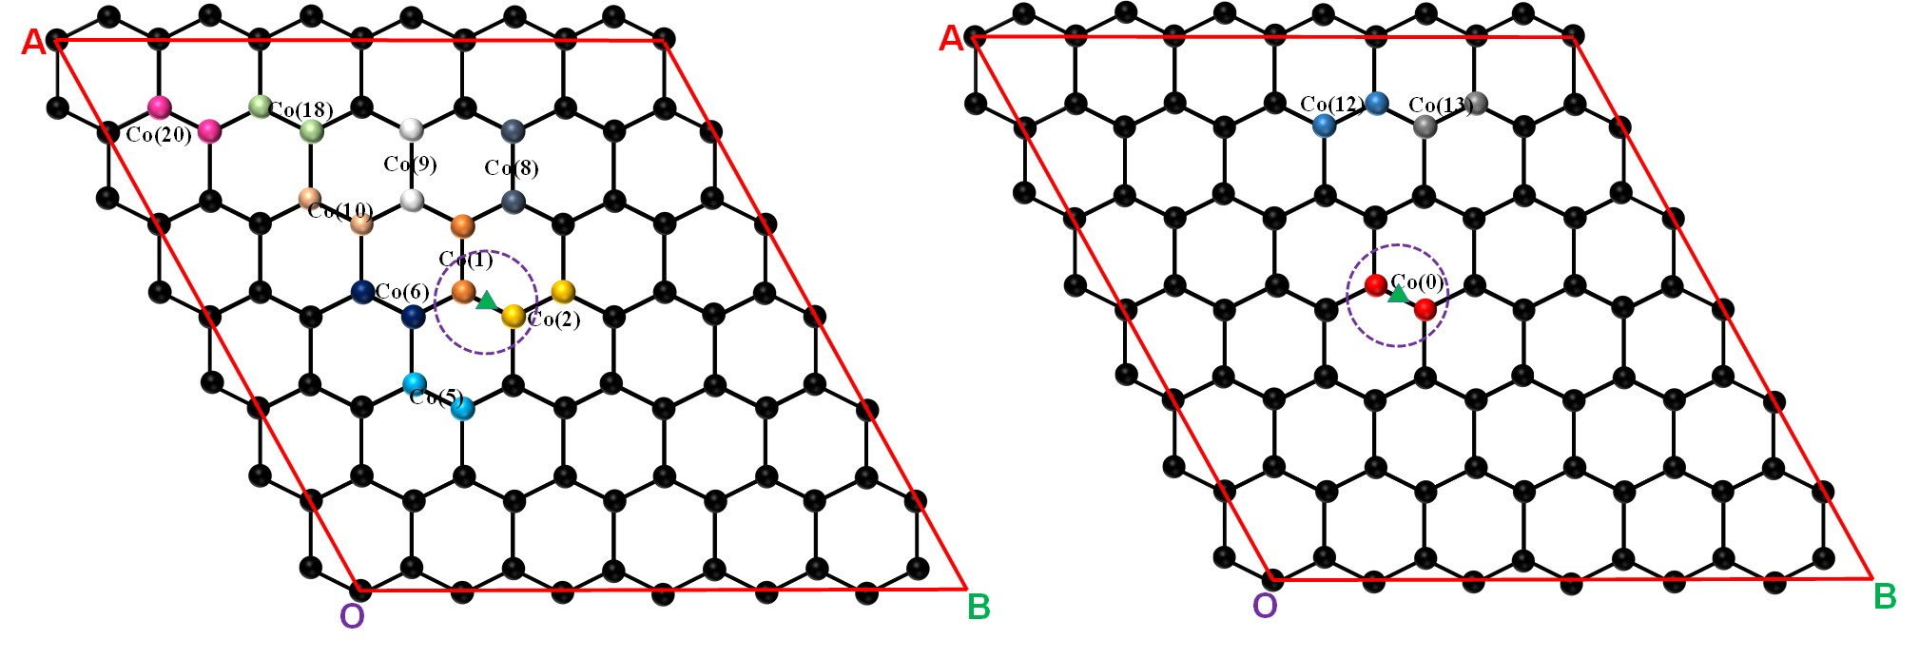
Fig. S1 Partial possible bilayer bimetallic atomic catalyst configurations
Table S1 Ground state energies (E) and diatomic metal spacings (d) for various atomic configurations based on DS-PAW
Models | d (Å) | E (eV) | Models | d (Å) | E(eV)
Co(1) | 3.044 | -30201.122 | Co(11) | 5.709 | -30201.327
Co(2) | 2.727 | -30201.663 | Co(12) | 5.860 | -30201.335
Co(3) | 4.018 | -30201.292 | Co(13) | 5.808 | -30201.321
Co(4) | 3.212 | -30201.060 | Co(14) | 6.229 | -30201.261
Co(5) | 3.193 | -30201.337 | Co(15) | 6.275 | -30201.322
Co(6) | 3.812 | -30201.301 | Co(16) | 6.497 | -30201.048
Co(7) | 4.592 | -30200.612 | Co(17) | 6.806 | -30201.344
Co(8) | 4.749 | -30201.032 | Co(18) | 7.580 | -30201.331
Co(9) | 5.213 | -30201.056 | Co(19) | 8.400 | -30201.328
Co(10) | 5.505 | -30201.323 | Co(20) | 9.337 | -30201.312
Co(0) | 2.511 | -30201.963

Table S2 The calculated results of various oxygen intermediates for different atomic configurations. "G" refers to the total Gibbs free energy of the whole system (oxygen intermediate + small molecular species) in certain reaction step
Items |  | Models |  | *(+H₂+O₂) |  | *OOH |  | *O |  | *OH |  | *(+H₂O)
E/eV |  | CoFe-SACs |  | -1309.0965 |  | -1323.8386 |  | -1314.7630 |  | -1319.3238 |  | -1309.0965
ZPE/eV |  |  |  | 0.0000 |  | 0.4286 |  | 0.0697 |  | 0.3523 |  | 0.0000
TS/eV |  |  |  | 0.0000 |  | 0.1892 |  | 0.0624 |  | 0.0903 |  | 0.0000
G/eV |  |  |  | -1332.6165 |  | -1333.7993 |  | -1335.7757 |  | -1336.6818 |  | -1337.5365
ΔG/eV |  |  |  | 4.9200 |  | 3.7372 |  | 1.7608 |  | 0.8547 |  | 0.0000
U=1.23 V |  |  |  | 0.0000 |  | 0.0472 |  | -0.6992 |  | -0.3753 |  | 0.0000
E/eV |  | NiFe-SACs |  | -1307.4708 |  | -1322.5558 |  | -1313.5079 |  | -1318.0237 |  | -1307.4708
ZPE/eV |  |  |  | 0.0000 |  | 0.4294 |  | 0.0690 |  | 0.3548 |  | 0.0000
TS/eV |  |  |  | 0.0000 |  | 0.1853 |  | 0.0657 |  | 0.0908 |  | 0.0000
G/eV |  |  |  | -1330.9908 |  | -1332.5117 |  | -1334.5246 |  | -1335.3797 |  | -1335.9108
ΔG/eV |  |  |  | 4.9200 |  | 3.3991 |  | 1.3862 |  | 0.5311 |  | 0.0000
U=1.23 V |  |  |  | 0.0000 |  | -0.2909 |  | -1.0738 |  | -0.6989 |  | 0.0000
E/eV |  | MnFe-SACs |  | -1311.0771 |  | -1325.2287 |  | -1316.1794 |  | -1320.7829 |  | -1311.0771
ZPE/eV |  |  |  | 0.0000 |  | 0.4286 |  | 0.0675 |  | 0.3412 |  | 0.0000
TS/eV |  |  |  | 0.0000 |  | 0.1911 |  | 0.0581 |  | 0.1016 |  | 0.0000
G/eV |  |  |  | -1334.5971 |  | -1335.1913 |  | -1337.1901 |  | -1338.1632 |  | -1339.5171
ΔG/eV |  |  |  | 4.9200 |  | 4.3258 |  | 2.3270 |  | 1.3539 |  | 0.0000
U=1.23 V |  |  |  | 0.0000 |  | 0.6358 |  | -0.1330 |  | 0.1239 |  | 0.0000
E/eV |  | CuFe-SACs |  | -1304.4016 |  | -1319.5540 |  | -1310.5284 |  | -1315.0305 |  | -1304.4016
ZPE/eV |  |  |  | 0.0000 |  | 0.4280 |  | 0.0685 |  | 0.3537 |  | 0.0000
TS/eV |  |  |  | 0.0000 |  | 0.1866 |  | 0.0664 |  | 0.0917 |  | 0.0000
G/eV |  |  |  | -1327.9216 |  | -1329.5126 |  | -1331.5464 |  | -1332.3886 |  | -1332.8416
ΔG/eV |  |  |  | 4.9200 |  | 3.3290 |  | 1.2952 |  | 0.4530 |  | 0.0000
U=1.23 V |  |  |  | 0.0000 |  | -0.3610 |  | -1.1648 |  | -0.7770 |  | 0.0000
E/eV |  | RuFe-SACs |  | -1310.1918 |  | -1324.5461 |  | -1314.9766 |  | -1320.0661 |  | -1310.1918
ZPE/eV |  |  |  | 0.0000 |  | 0.4382 |  | 0.0679 |  | 0.3391 |  | 0.0000
TS/eV |  |  |  | 0.0000 |  | 0.1756 |  | 0.0584 |  | 0.1125 |  | 0.0000
G/eV |  |  |  | -1333.7118 |  | -1334.4835 |  | -1335.9871 |  | -1337.4595 |  | -1338.6318
ΔG/eV |  |  |  | 4.9200 |  | 4.1483 |  | 2.6447 |  | 1.1723 |  | 0.0000
U=1.23 V |  |  |  | 0.0000 |  | 0.4583 |  | 0.1847 |  | -0.0577 |  | 0.0000
E/eV |  | PtFe-SACs |  | -1307.8772 |  | -1322.9869 |  | -1313.9419 |  | -1318.4528 |  | -1307.8772
ZPE/eV |  |  |  | 0.0000 |  | 0.4282 |  | 0.0689 |  | 0.3550 |  | 0.0000
TS/eV |  |  |  | 0.0000 |  | 0.1891 |  | 0.0661 |  | 0.0892 |  | 0.0000
G/eV |  |  |  | -1331.3972 |  | -1332.9478 |  | -1334.9591 |  | -1335.8071 |  | -1336.3172
ΔG/eV |  |  |  | 4.9200 |  | 3.3694 |  | 1.3581 |  | 0.5101 |  | 0.0000
U=1.23 V |  |  |  | 0.0000 |  | -0.3206 |  | -1.1019 |  | -0.7199 |  | 0.0000
E/eV |  | IrFe-SACs |  | -1310.2555 |  | -1324.9336 |  | -1315.7519 |  | -1320.4409 |  | -1310.2555
ZPE/eV |  |  |  | 0.0000 |  | 0.4348 |  | 0.0707 |  | 0.3528 |  | 0.0000
TS/eV |  |  |  | 0.0000 |  | 0.1795 |  | 0.0598 |  | 0.0899 |  | 0.0000
G/eV |  |  |  | -1333.7755 |  | -1334.8784 |  | -1336.7611 |  | -1337.7979 |  | -1338.6955
ΔG/eV |  |  |  | 4.9200 |  | 3.8171 |  | 1.9344 |  | 0.8976 |  | 0.0000
U=1.23 V |  |  |  | 0.0000 |  | 0.1271 |  | -0.5256 |  | -0.3324 |  | 0.0000
E/eV |  | ZnFe-SACs |  | -1302.6257 |  | -1317.6007 |  | -1308.5112 |  | -1313.0738 |  | -1302.6257
ZPE/eV |  |  |  | 0.0000 |  | 0.4285 |  | 0.0674 |  | 0.3524 |  | 0.0000
TS/eV |  |  |  | 0.0000 |  | 0.1878 |  | 0.0688 |  | 0.0939 |  | 0.0000
G/eV |  |  |  | -1326.1457 |  | -1327.5599 |  | -1329.5326 |  | -1330.4353 |  | -1331.0657
ΔG/eV |  |  |  | 4.9200 |  | 3.5058 |  | 1.5331 |  | 0.6304 |  | 0.0000
U=1.23 V |  |  |  | 0.0000 |  | -0.1842 |  | -0.9269 |  | -0.5996 |  | 0.0000
Items | Models |  | * |  | *OOH |  | *O |  | *OH |  | *
E/eV | Pt-111 |  | -324.6554 |  | -340.5743 |  | -329.9436 |  | -335.1102 |  | -324.6554
ZPE/eV |  |  | 0.0000 |  | 0.4050 |  | 0.0562 |  | 0.3332 |  | 0.0000
TS/eV |  |  | 0.0000 |  | 0.1575 |  | 0.0628 |  | 0.1105 |  | 0.0000
G/eV |  |  | -348.1754 |  | -350.3693 |  | -350.9074 |  | -352.3970 |  | -353.0954
ΔG/eV |  |  | 4.9200 |  | 2.7261 |  | 2.1880 |  | 0.6984 |  | 0.0000
U=1.23 V |  |  | 0.0000 |  | -0.9639 |  | -0.2720 |  | -0.5316 |  | 0.0000
E/eV | Ir-SACs |  | -1,317.0225 |  | -1,332.6671 |  | -1,323.4089 |  | -1,328.5056 |  | -1,317.0225
ZPE/eV |  |  | 0.0000 |  | 0.4577 |  | 0.0892 |  | 0.3840 |  | 0.0000
TS/eV |  |  | 0.0000 |  | 0.1216 |  | 0.0311 |  | 0.0396 |  | 0.0000
G/eV |  |  | -1,340.5425 |  | -1,342.5310 |  | -1,344.3708 |  | -1,345.7812 |  | -1,345.4625
ΔG/eV |  |  | 4.9200 |  | 2.9315 |  | 1.0917 |  | -0.3187 |  | 0.0000
U=1.23 V |  |  | 0.0000 |  | -0.7585 |  | -1.3683 |  | -1.5487 |  | 0.0000
E/eV | Fe-SACs |  | -1,317.8284 |  | -1,332.3122 |  | -1,323.2953 |  | -1,327.7780 |  | -1,317.8284
ZPE/eV |  |  | 0.0000 |  | 0.4163 |  | 0.0679 |  | 0.3408 |  | 0.0000
TS/eV |  |  | 0.0000 |  | 0.1658 |  | 0.0659 |  | 0.1211 |  | 0.0000
G/eV |  |  | -1,341.3484 |  | -1,342.2617 |  | -1,344.31 |  | -1,345.1783 |  | -1,346.2684
ΔG/eV |  |  | 4.9200 |  | 4.0067 |  | 1.9552 |  | 1.0901 |  | 0.0000
U=1.23 V |  |  | 0.0000 |  | 0.3167 |  | -0.5048 |  | -0.1399 |  | 0.0000

Table S3 The calculated results of various oxygen intermediates for different atomic configurations. "G" refers to the total Gibbs free energy of the whole system (oxygen intermediate + small molecular species) in certain reaction step
Items | Models | *(+H₂+O₂) | *OOH | *O | *OH | *(+H₂O)
E/eV | FeN₄C₁₂ | -776.6109 | -791.0873 | -782.4278 | -786.8327 | -776.6109
ZPE/eV | FeN₄C₁₂ | 0.0000 | 0.4194 | 0.0710 | 0.3414 | 0.0000
TS/eV | FeN₄C₁₂ | 0.0000 | 0.1650 | 0.0660 | 0.1098 | 0.0000
G/eV | FeN₄C₁₂ | -800.1309 | -801.0329 | -803.4427 | -804.2211 | -805.0509
ΔG/eV | FeN₄C₁₂ | 4.9200 | 4.0180 | 1.6081 | 0.8298 | 0.0000
U=1.23 V | FeN₄C₁₂ | 0.0000 | 0.3280 | -0.8519 | -0.4002 | 0.0000
E/eV | IrFeN₆ | -634.3242 | -651.8147 | -641.4821 | -645.2968 | -634.3242
ZPE/eV | IrFeN₆ | 0.0000 | 0.4488 | 0.0862 | 0.3801 | 0.0000
TS/eV | IrFeN₆ | 0.0000 | 0.1397 | 0.0371 | 0.0638 | 0.0000
G/eV | IrFeN₆ | -657.8442 | -661.7056 | -662.4530 | -662.6005 | -662.7642
ΔG/eV | IrFeN₆ | 4.9200 | 1.0586 | 0.3112 | 0.1637 | 0.0000
U=1.23 V | IrFeN₆ | 0.0000 | -2.6314 | -2.1488 | -1.0663 | 0.0000
E/eV | (Ir)N₄  FeN₄ | -632.9697 | -647.3669 | -638.0711 | -642.9731 | -632.9697
ZPE/eV | (Ir)N₄  FeN₄ | 0.0000 | 0.4336 | 0.0596 | 0.3458 | 0.0000
TS/eV | (Ir)N₄  FeN₄ | 0.0000 | 0.1401 | 0.0809 | 0.1293 | 0.0000
G/eV | (Ir)N₄  FeN₄ | -656.4897 | -657.2733 | -659.1124 | -660.3767 | -661.4097
ΔG/eV | (Ir)N₄  FeN₄ | 4.9200 | 4.1363 | 2.2972 | 1.0330 | 0.0000
U=1.23 V | (Ir)N₄  FeN₄ | 0.0000 | 0.4463 | -0.1628 | -0.1970 | 0.0000
E/eV | IrN₄  (Fe)N₄ | -632.9697 | -647.9507 | -639.0275 | -643.4613 | -632.9697
ZPE/eV | IrN₄  (Fe)N₄ | 0.0000 | 0.4320 | 0.0667 | 0.3258 | 0.0000
TS/eV | IrN₄  (Fe)N₄ | 0.0000 | 0.1776 | 0.0689 | 0.1312 | 0.0000
G/eV | IrN₄  (Fe)N₄ | -656.4897 | -657.8963 | -660.0497 | -660.8867 | -661.4097
ΔG/eV | IrN₄  (Fe)N₄ | 4.9200 | 3.5133 | 1.3600 | 0.5229 | 0.0000
U=1.23 V | IrN₄  (Fe)N₄ | 0.0000 | -0.1767 | -1.1000 | -0.7071 | 0.0000
E/eV | (Ir)Fe-SACs | -1293.4728 | -1308.2833 | -1299.1433 | -1303.8073 | -1293.4728
ZPE/eV | (Ir)Fe-SACs | 0.0000 | 0.4328 | 0.0718 | 0.3561 | 0.0000
TS/eV | (Ir)Fe-SACs | 0.0000 | 0.1979 | 0.0584 | 0.0870 | 0.0000
G/eV | (Ir)Fe-SACs | -1316.9928 | -1318.2484 | -1320.1499 | -1321.1582 | -1321.9128
ΔG/eV | (Ir)Fe-SACs | 4.9200 | 3.6644 | 1.7629 | 0.7546 | 0.0000
U=1.23 V | (Ir)Fe-SACs | 0.0000 | -0.0256 | -0.6971 | -0.4754 | 0.0000
E/eV | Ir(Fe)-SACs | -1294.3531 | -1308.9473 | -1299.7478 | -1304.5580 | -1294.3531
ZPE/eV | Ir(Fe)-SACs | 0.0000 | 0.4383 | 0.0725 | 0.3581 | 0.0000
TS/eV | Ir(Fe)-SACs | 0.0000 | 0.1813 | 0.0559 | 0.0840 | 0.0000
G/eV | Ir(Fe)-SACs | -1317.8731 | -1318.8904 | -1320.7512 | -1321.9039 | -1322.7931
ΔG/eV | Ir(Fe)-SACs | 4.9200 | 3.9027 | 2.0419 | 0.8892 | 0.0000
U=1.23 V | Ir(Fe)-SACs | 0.0000 | 0.2127 | -0.4181 | -0.3408 | 0.0000
E/eV | (IrFe)-SACs | -1,277.5261 | -1,292.1958 | -1,283.0426 | -1,287.7440 | -1,277.5261
ZPE/eV | (IrFe)-SACs | 0.0000 | 0.4506 | 0.0718 | 0.3596 | 0.0000
TS/eV | (IrFe)-SACs | 0.0000 | 0.1661 | 0.0578 | 0.0840 | 0.0000
G/eV | (IrFe)-SACs | -1,301.0461 | -1,302.1113 | -1,304.0485 | -1,305.0883 | -1,305.9661
ΔG/eV | (IrFe)-SACs | 4.9200 | 3.8548 | 1.9176 | 0.8778 | 0.0000
U=1.23 V | (IrFe)-SACs | 0.0000 | 0.1648 | -0.5424 | -0.3522 | 0.0000
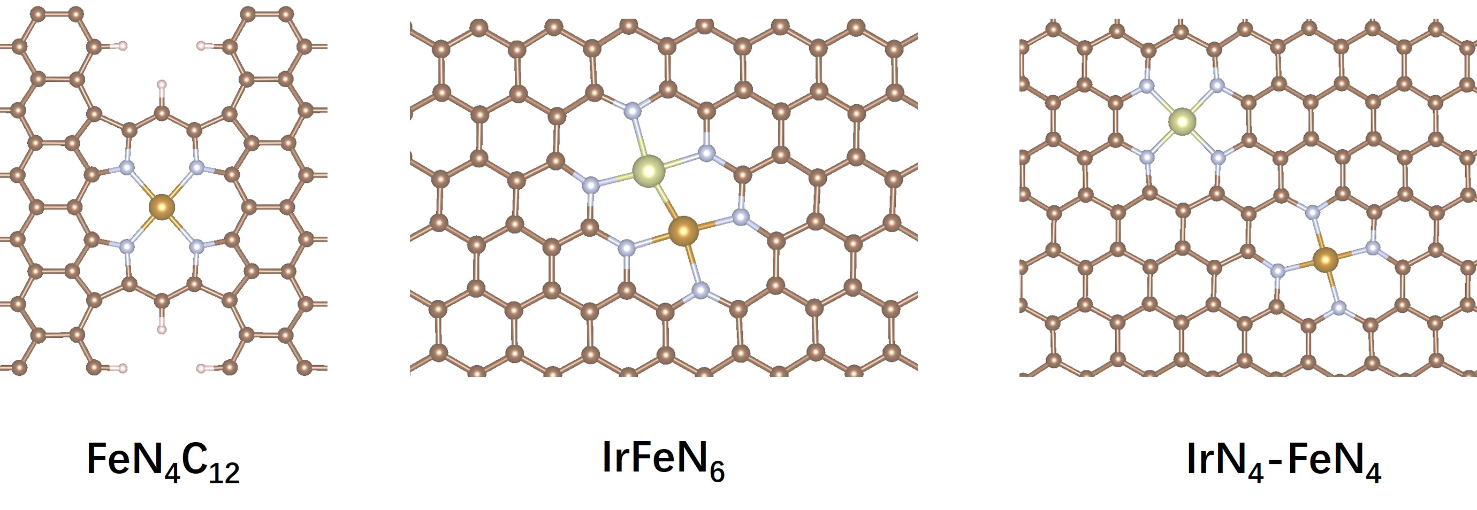
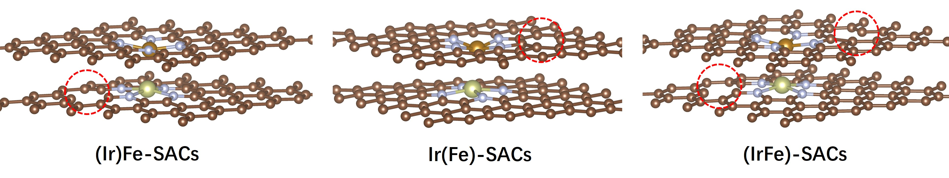
Fig. S2 Structural diagrams of FeN₄C₁₂, IrFeN₆, IrN₄FeN₄, (Ir)Fe-SACs, Ir(Fe)-SACs and (IrFe)-SACs

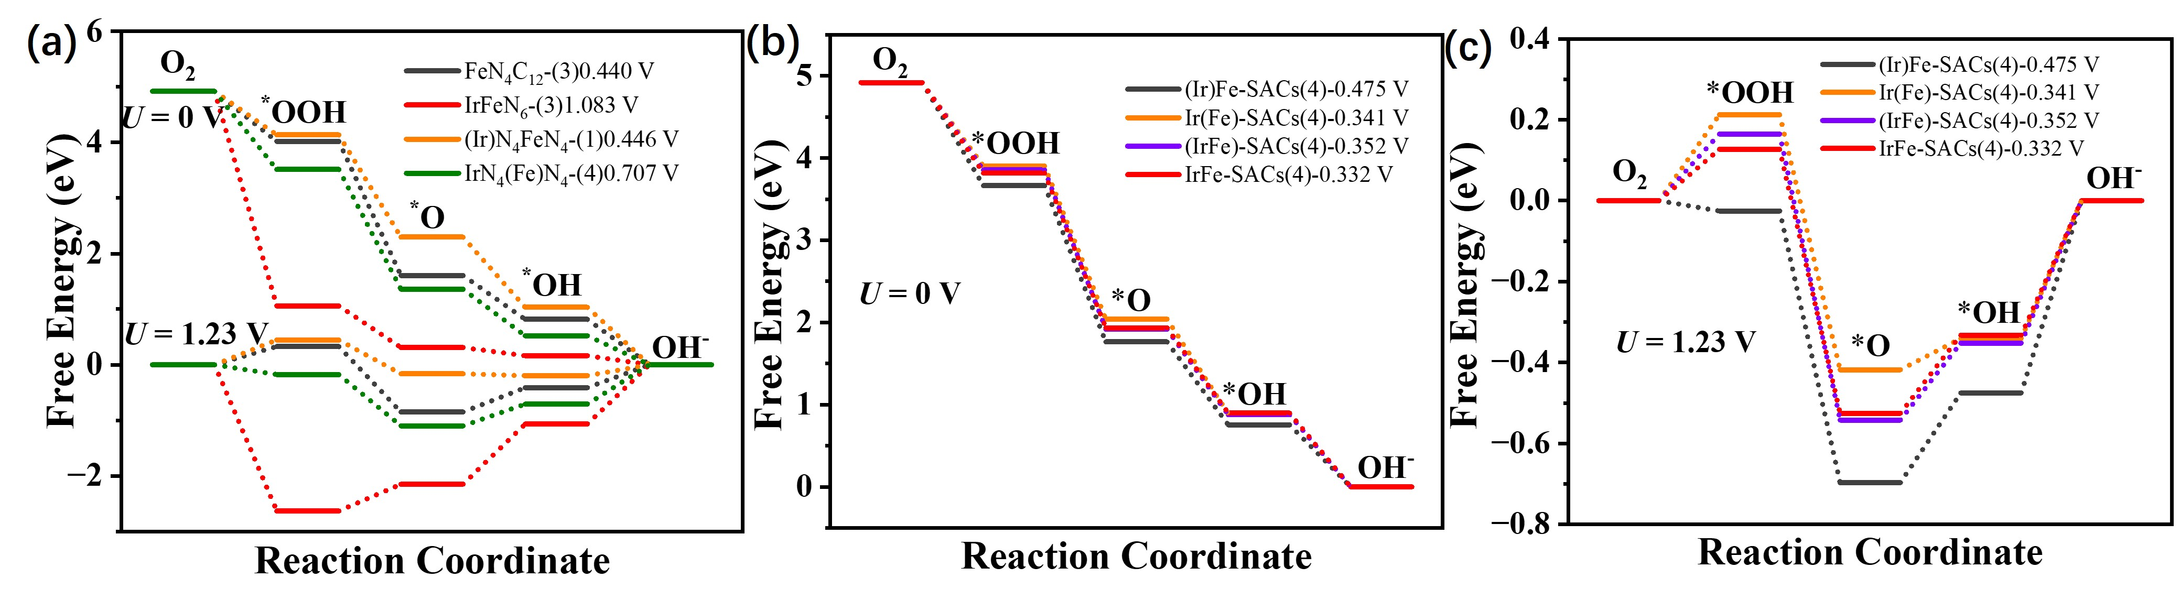
Fig. S3 ORR path Gibbs free energy step of FeN₄C₁₂, IrFeN₆, (Ir)N₄FeN₄ (The active center is the atomic Ir), IrN₄(Fe)N₄ (The active center is the atomic Fe), (Ir)Fe-SACs, Ir(Fe)-SACs and (IrFe)-SACs

Table S4 ICOHP for different atomic configurations
Spin State | Models | O* | HO* | HOO*
1 | IrFe-SACs | -1.9102 | -1.4807 | -1.2780
2 | IrFe-SACs | -3.5731 | -1.0821 | -1.6895
1 | RuFe-SACs | -1.6668 | -0.9573 | -0.9500
2 | RuFe-SACs | -3.0606 | -1.1996 | -1.1152
1 | PtFe-SACs | -3.0753 | -4.0312 | -1.5122
2 | PtFe-SACs | -3.0802 | -4.0300 | -2.0255
1 | NiFe-SACs | -2.1302 | -1.2268 | -1.5092
2 | NiFe-SACs | -3.7579 | -1.7413 | -2.0431
1 | MnFe-SACs | -1.7247 | -0.9932 | -0.6533
2 | MnFe-SACs | -3.1381 | -0.7523 | -0.9395
1 | CuFe-SACs | -2.0149 | -1.1944 | -1.4718
2 | CuFe-SACs | -3.7351 | -1.7381 | -2.0315
1 | CoFe-SACs | -1.9923 | -1.5796 | -1.3350
2 | CoFe-SACs | -3.6618 | -1.1384 | -1.9136
1 | ZnFe-SACs | -2.0331 | -1.1327 | -2.0303
2 | ZnFe-SACs | -3.7104 | -1.6999 | -1.4426
1 | Fe-SACs | -1.95703 | -1.7825 | -2.12297
2 | Fe-SACs | -3.67461 | -1.21039 | -1.53651
1 | Ir-SACs | -3.98811 | -5.40549 | -5.00848
2 | Ir-SACs | -3.9878 | -5.40551 | -5.00845

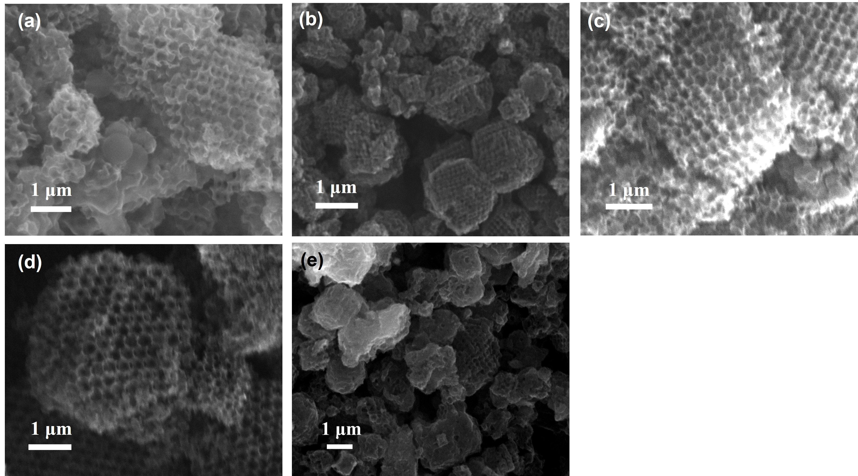
Fig. S4 SEM images of (a) NiFe-SACs, (b) CoFe-SACs, (c) MnFe-SACs, (d) RuFe-SACs and (e) CuFe-SACs

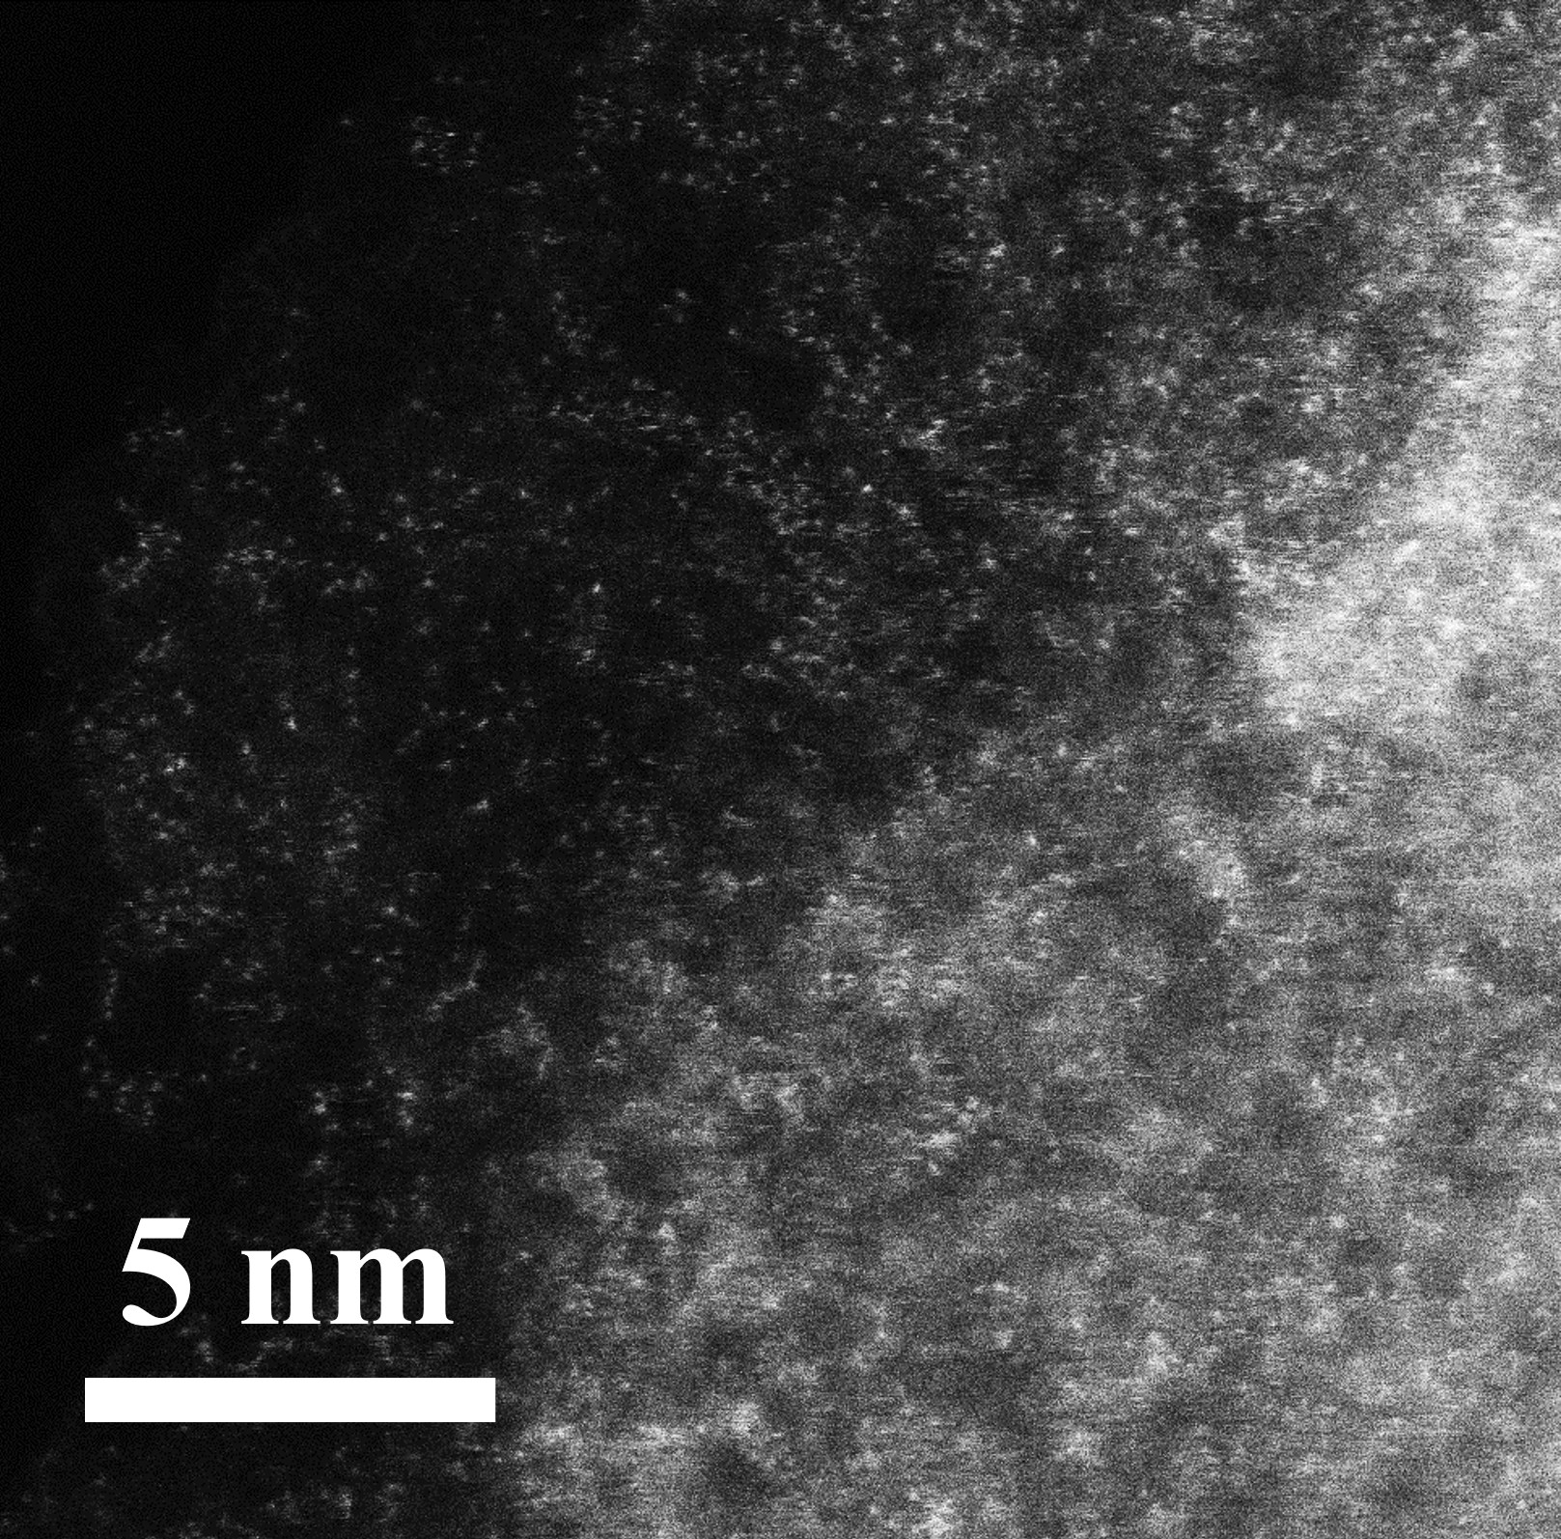
Fig. S5 HAADF-STEM images of IrFe-SACs
Table S5 EDS table of IrFe-SACs
Z | Element | Family | Atomic Fraction (%) | Mass Fraction (%)
6 | C | K | 91.84 | 89.20
7 | N | K | 4.20 | 4.75
8 | O | K | 3.76 | 4.87
26 | Fe | K | 0.17 | 1.79
77 | Ir | M | 0.02 | 0.39
Table S6 ICP results of IrFe-SACs
Samples | Mass  /g | Volume  /mL | Element | Readout  /mg L⁻¹ | Content  /mg kg⁻¹ | wt.%
IrFe-SACs | 0.0104 | 25 | Fe | 8.5941 | 20658.9 | 2.0659%
IrFe-SACs | 0.0104 | 25 | Ir | 1.8775 | 4513.2 | 0.4513%
Fig. S6 XRD pattern of IrFe-SACs

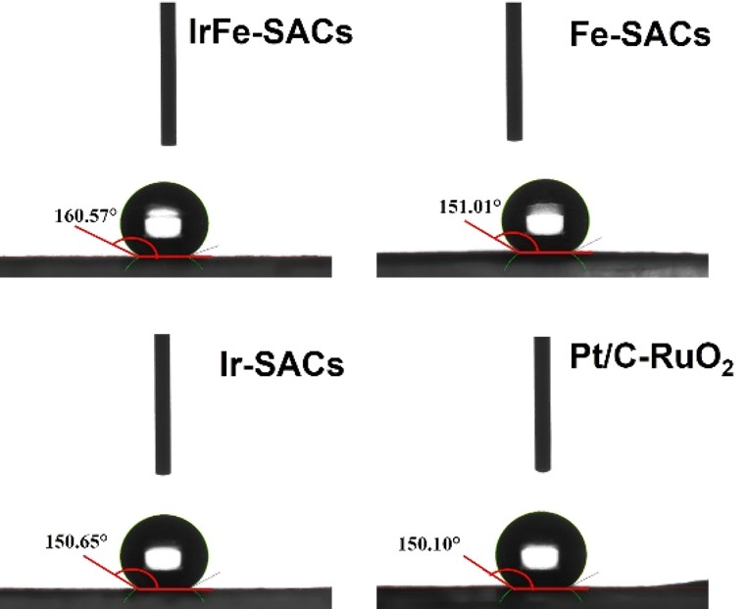
Fig. S7 Surface contact angles measured at IrFe-SACs, Fe-SACs, Ir-SACs and Pt/C-RuO₂ electrodes

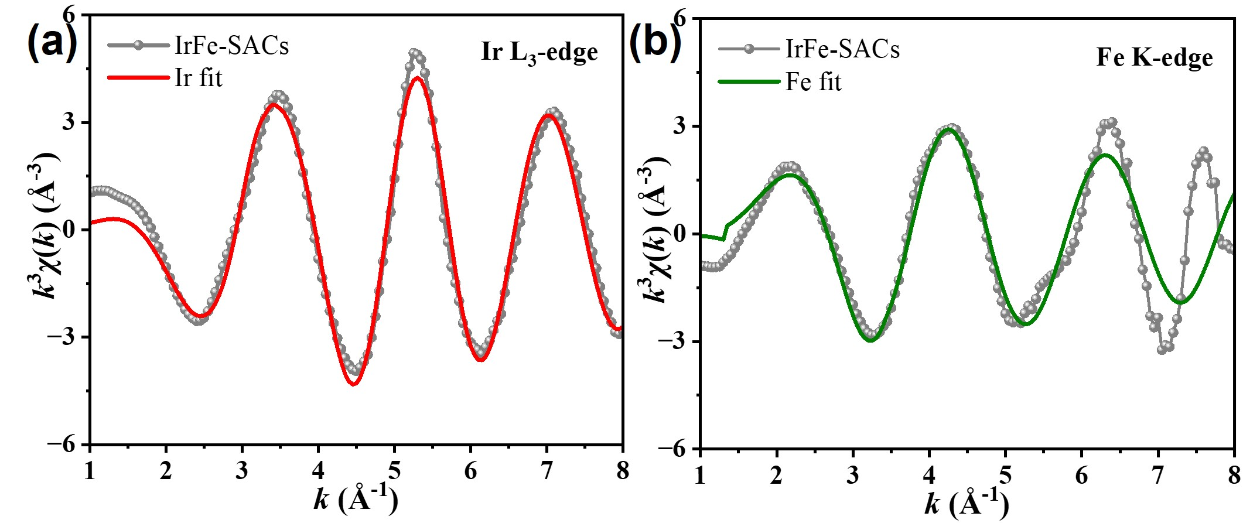
Fig. S8 Fourier-transformed k³-weighted EXAFS fitting results for IrFe-SACs at k space
Table S7 Parameters obtained for the best EXAFS fitting of IrFe-SACs
Edges | Paths | N | R(Å) | σ² (10⁻³ Å²) | Happiness | R-factor
Ir L₃-edge | Ir-N | 3.61±0.05 | 1.95±0.062 | 0.004 | 90.76 | 0.009
Ir L₃-edge | Ir-Fe | 0.95±0.14 | 2.48±0.013 | 0.034 | 90.76 | 0.009
Fe K-edge | Fe-N | 3.76±0.01 | 1.89±0.017 | 0.001 | 95.13 | 0.021
Fe K-edge | Fe-Ir | 1.01±0.05 | 2.48±0.028 | 0.013 | 95.13 | 0.021
Where N is the coordination number; R is the distance between absorber and backscatter atoms; σ²
is the Debye-Waller factor (a measure of thermal and static disorder in absorber-scatterer distances);
R-factor is used to value the goodness of the fitting.
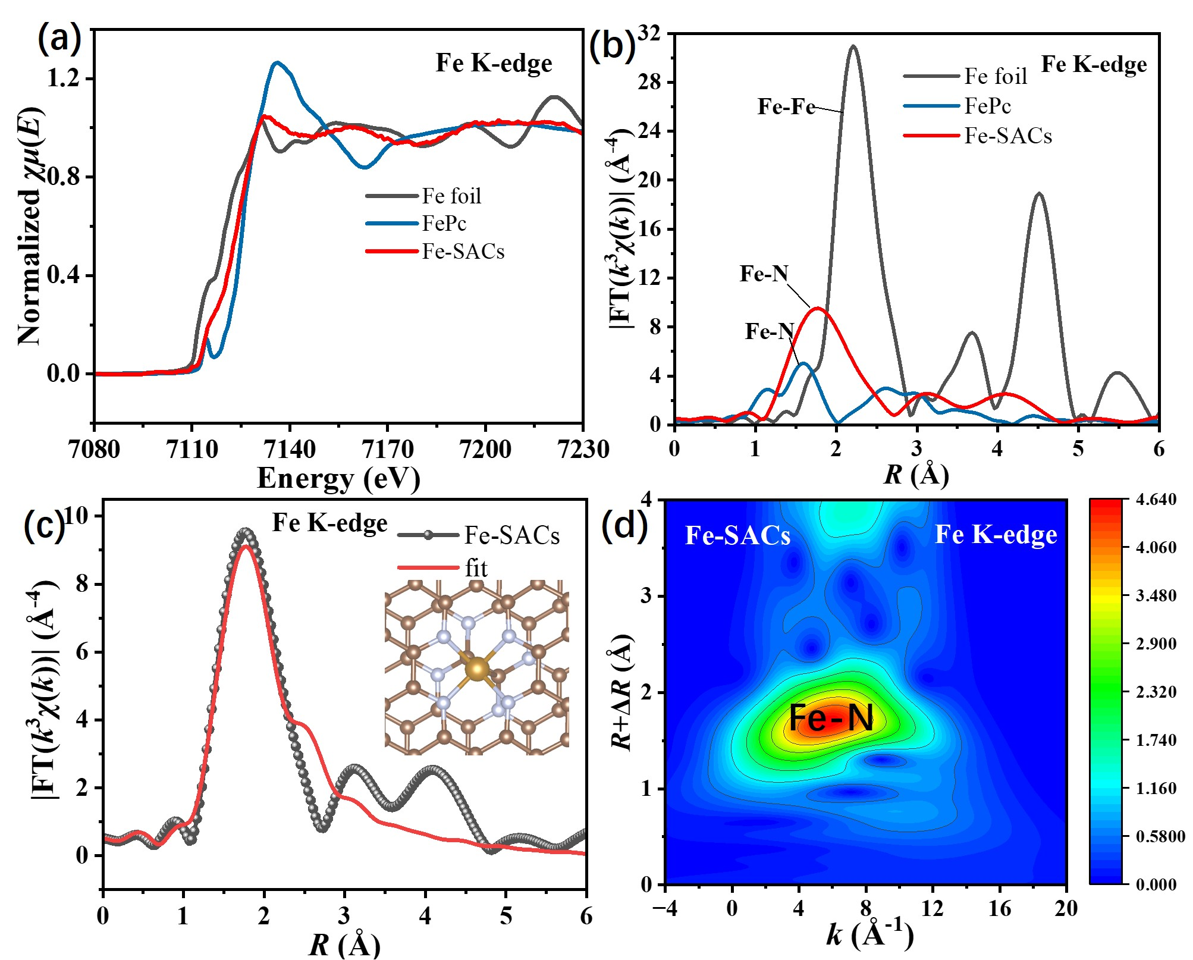
Fig. S9 (a) Normalized XANES spectra, (b) Fourier transforms of EXAFS spectra Fe K-edge of IrFe-SACs and the reference materials at R space. XAFS curves represent fitted data based on (c) Fe K-edge experimental data, with the fitted curves of Fe-SACs at the insets. (d) Wavelet transform of Fe K-edge EXAFS spectra for Fe-SACs
Table S8 Parameters obtained for the best EXAFS fitting of Fe-SACs
Edges | Paths | N | R(Å) | σ² (10⁻³ Å²) | Happiness | R-factor
Fe K-edge | Fe-N | 4.09±0.03 | 2.02±0.021 | 0.006 | 86.52 | 0.011
Fe K-edge | Fe-C | 0.98±0.02 | 2.58±0.018 | 0.015 | 86.52 | 0.011
Where N is the coordination number; R is the distance between absorber and backscatter atoms; σ²
is the Debye-Waller factor (a measure of thermal and static disorder in absorber-scatterer distances);
R-factor is used to value the goodness of the fitting.

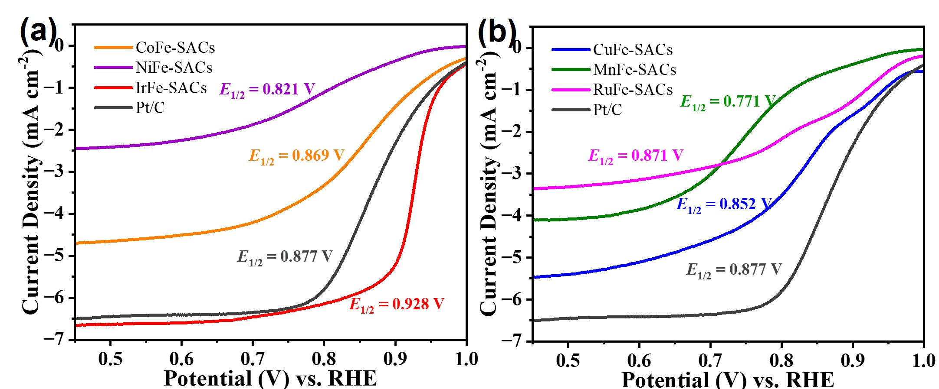
Fig. S10 ORR LSV curves of CuFe-SACs, MnFe-SACs, RuFe-SACs, CoFe-SACs, NiFe-SACs, IrFe-SACs and Pt/C
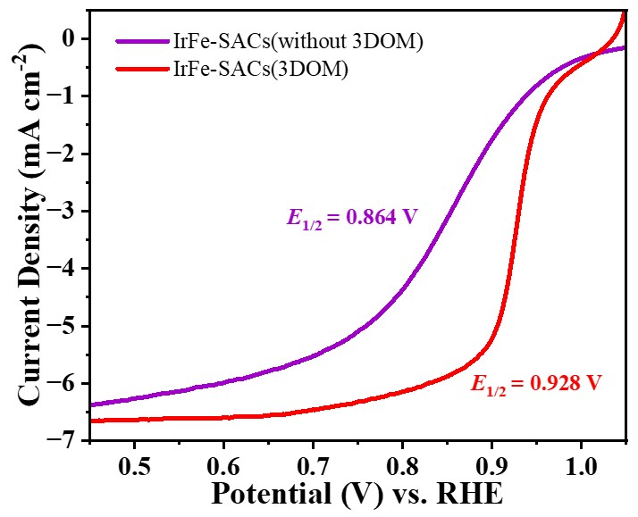
Fig. S11 ORR LSV curves of 3DOM IrFe-SACs and IrFe-SACs without 3DOM structures
Fig. S12 EIS spectrum of various bimetallic atomic catalysts
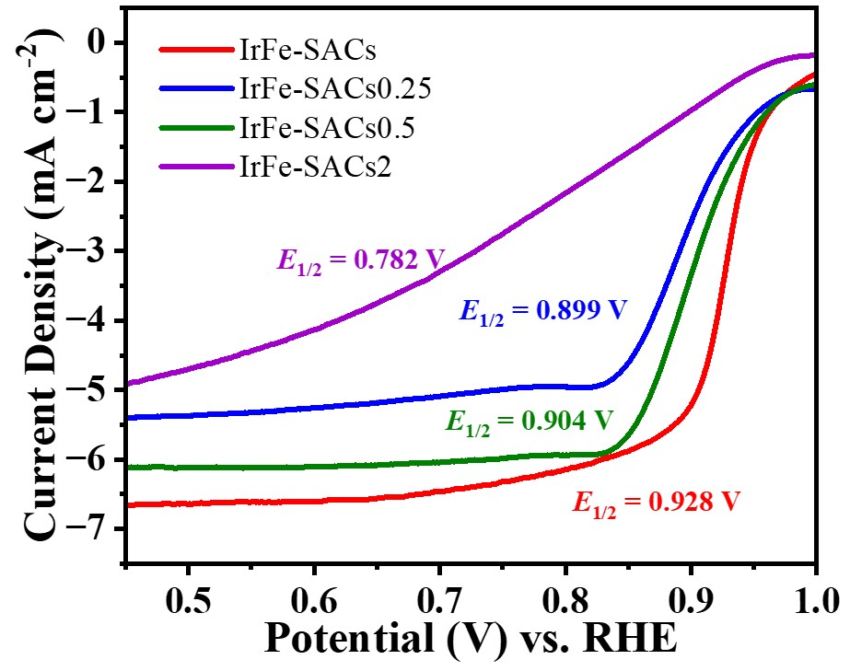
Fig. S13 ORR LSV curves of IrFe-SACs with different Ir loadings. Here, the "x" in "IrFe-SACsx" denotes the feeding ratio of iridium acetylacetonate during the sample preparation, relative to that used for IrFe-SACs
Table S9 Comparison the ORR activity of IrFe-SACs with the reported other transition metal atomic electrocatalysts
Catalysts | E_{onset} (V vs. RHE) |  | E_{1/2} (V vs. RHE) |  | References
IrFe-SACs | 0.961 | 0.928 |  | This work
Co/CoMn-NC | 0.99 | 0.89 |  | [S2]
Co-SAs@NC | 0.96 | 0.82 |  | [S3]
Fe_{SA}-N-C | 1.00 | 0.892 |  | [S4]
Co/Ni-NC | 0.951 | 0.89 |  | [S5]
FeNi/NC@NG | 0.949 | 0.858 |  | [S6]
IrNi@Co/N-C | 0.973 | 0.898 |  | [S7]
FeCo-DACs | 0.915 | 0.89 |  | [S8]
Fe₂DAC | 1.00 | 0.898 |  | [S9]
FeCo-NCH | 0.995 | 0.889 |  | [S10]

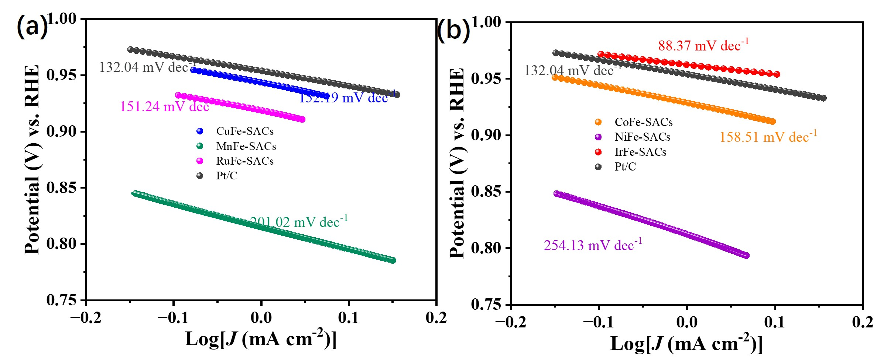
Fig. S14 Tafel curves of CuFe-SACs, MnFe-SACs, RuFe-SACs, CoFe-SACs, NiFe-SACs, IrFe-SACs and Pt/C during ORR tests

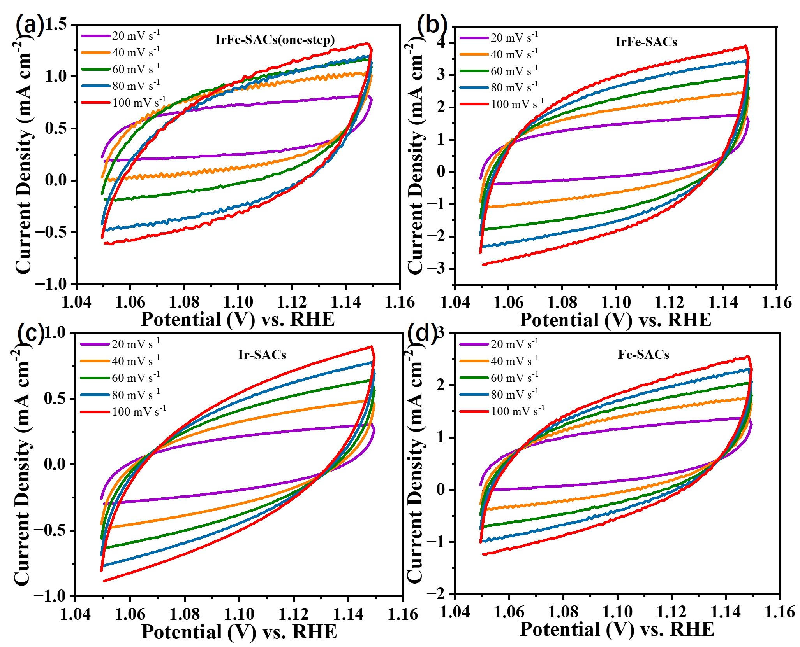
Fig. S15 Cyclic voltammograms from 1.05 V to 1.15 V vs. RHE in 0.1 M KOH at scan rates of 20, 40, 60, 80 and 100 mV s⁻¹ for (a) one-step synthesized IrFe-SACs, (b) IrFe-SACs, (c) Ir-SACs and (d) Fe-SACs, respectively

Table S10 ICP results of IrFe-SACs(one-step)
Samples | Mass  /g | Volume  /mL | Element | Readout  /mg L⁻¹ | Content  /mg kg⁻¹ | wt.%
IrFe-SACs  (one-step) | 0.0218 | 20 | Fe | 35.5268 | 32593.4 | 3.2593%
IrFe-SACs  (one-step) | 0.0218 | 20 | Ir | 7.9954 | 7335.2 | 0.7335%

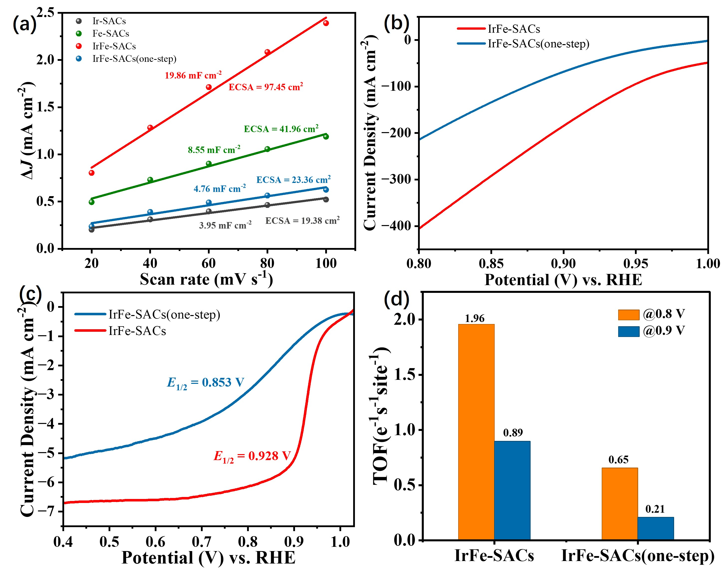
Fig. S16 (a) Relations between current density and scanning rate of CV curves between 1.05 and 1.15 V of one-step synthesized IrFe-SACs, IrFe-SACs, Ir-SACs and Fe-SACs. ORR LSV polarization curves in (b) 1.0 M KOH with GDEs and (c) 0.1 M KOH with RDEs, (d) TOF for one-step synthesized IrFe-SACs and IrFe-SACs

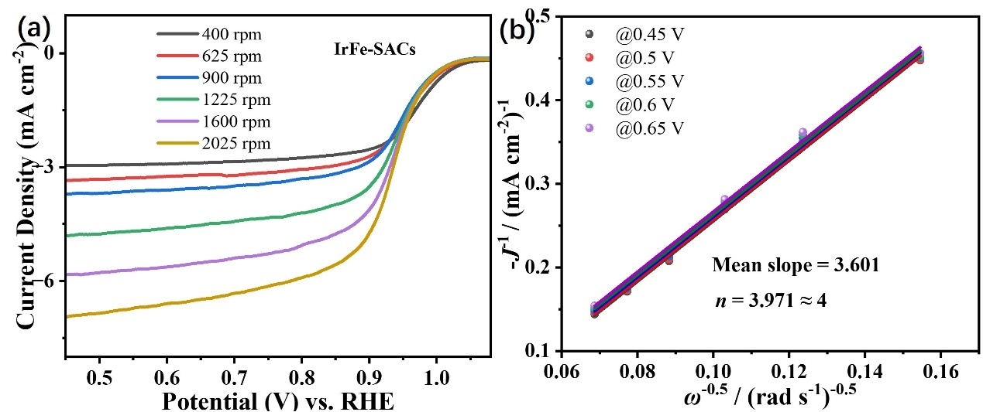
Fig. S17 (a) ORR LSV curves and (b) Koutecký-Levich diagrams of IrFe-SACs at different rotation speeds and potentials for ORR tests
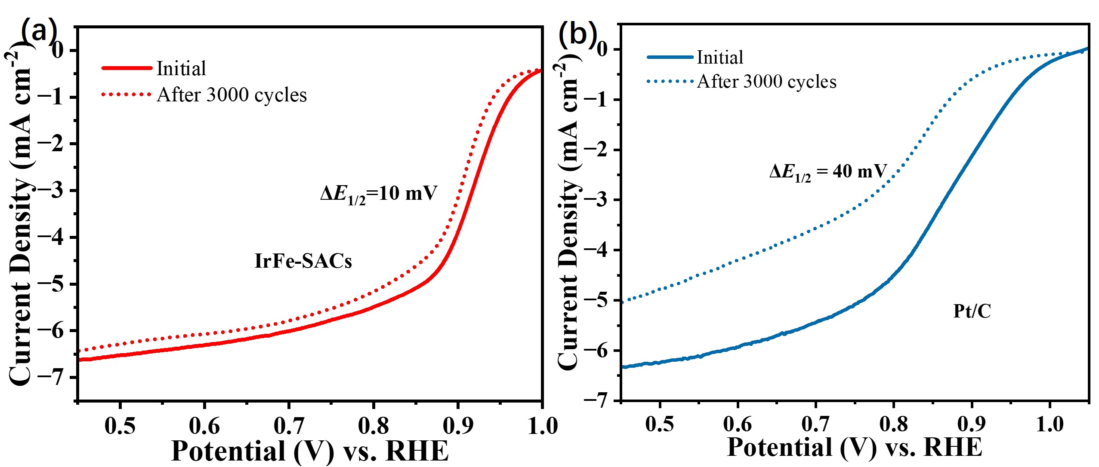
Fig. S18 ORR polarization curves of (a) IrFe-SACs and (b) Pt/C before and after 3000 CV cycles
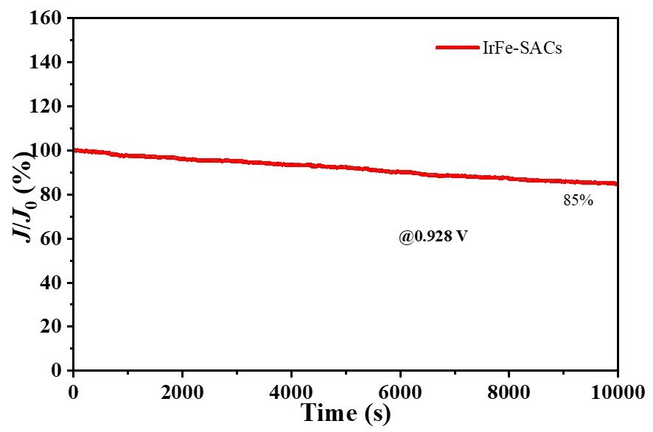
Fig. S19 I-t stability measurements curve of IrFe-SACs
Table S11 ICP results of IrFe-SACs after cycling stability tests
Samples | Mass  /g | Volume  /mL | Element | Readout  /mg L⁻¹ | Content  /mg kg⁻¹ | wt.%
IrFe-SACs | 0.0263 | 20 | Fe | 29.0271 | 22073.8 | 2.2074%
IrFe-SACs | 0.0263 | 20 | Ir | 5.5024 | 4184.3 | 0.4184%

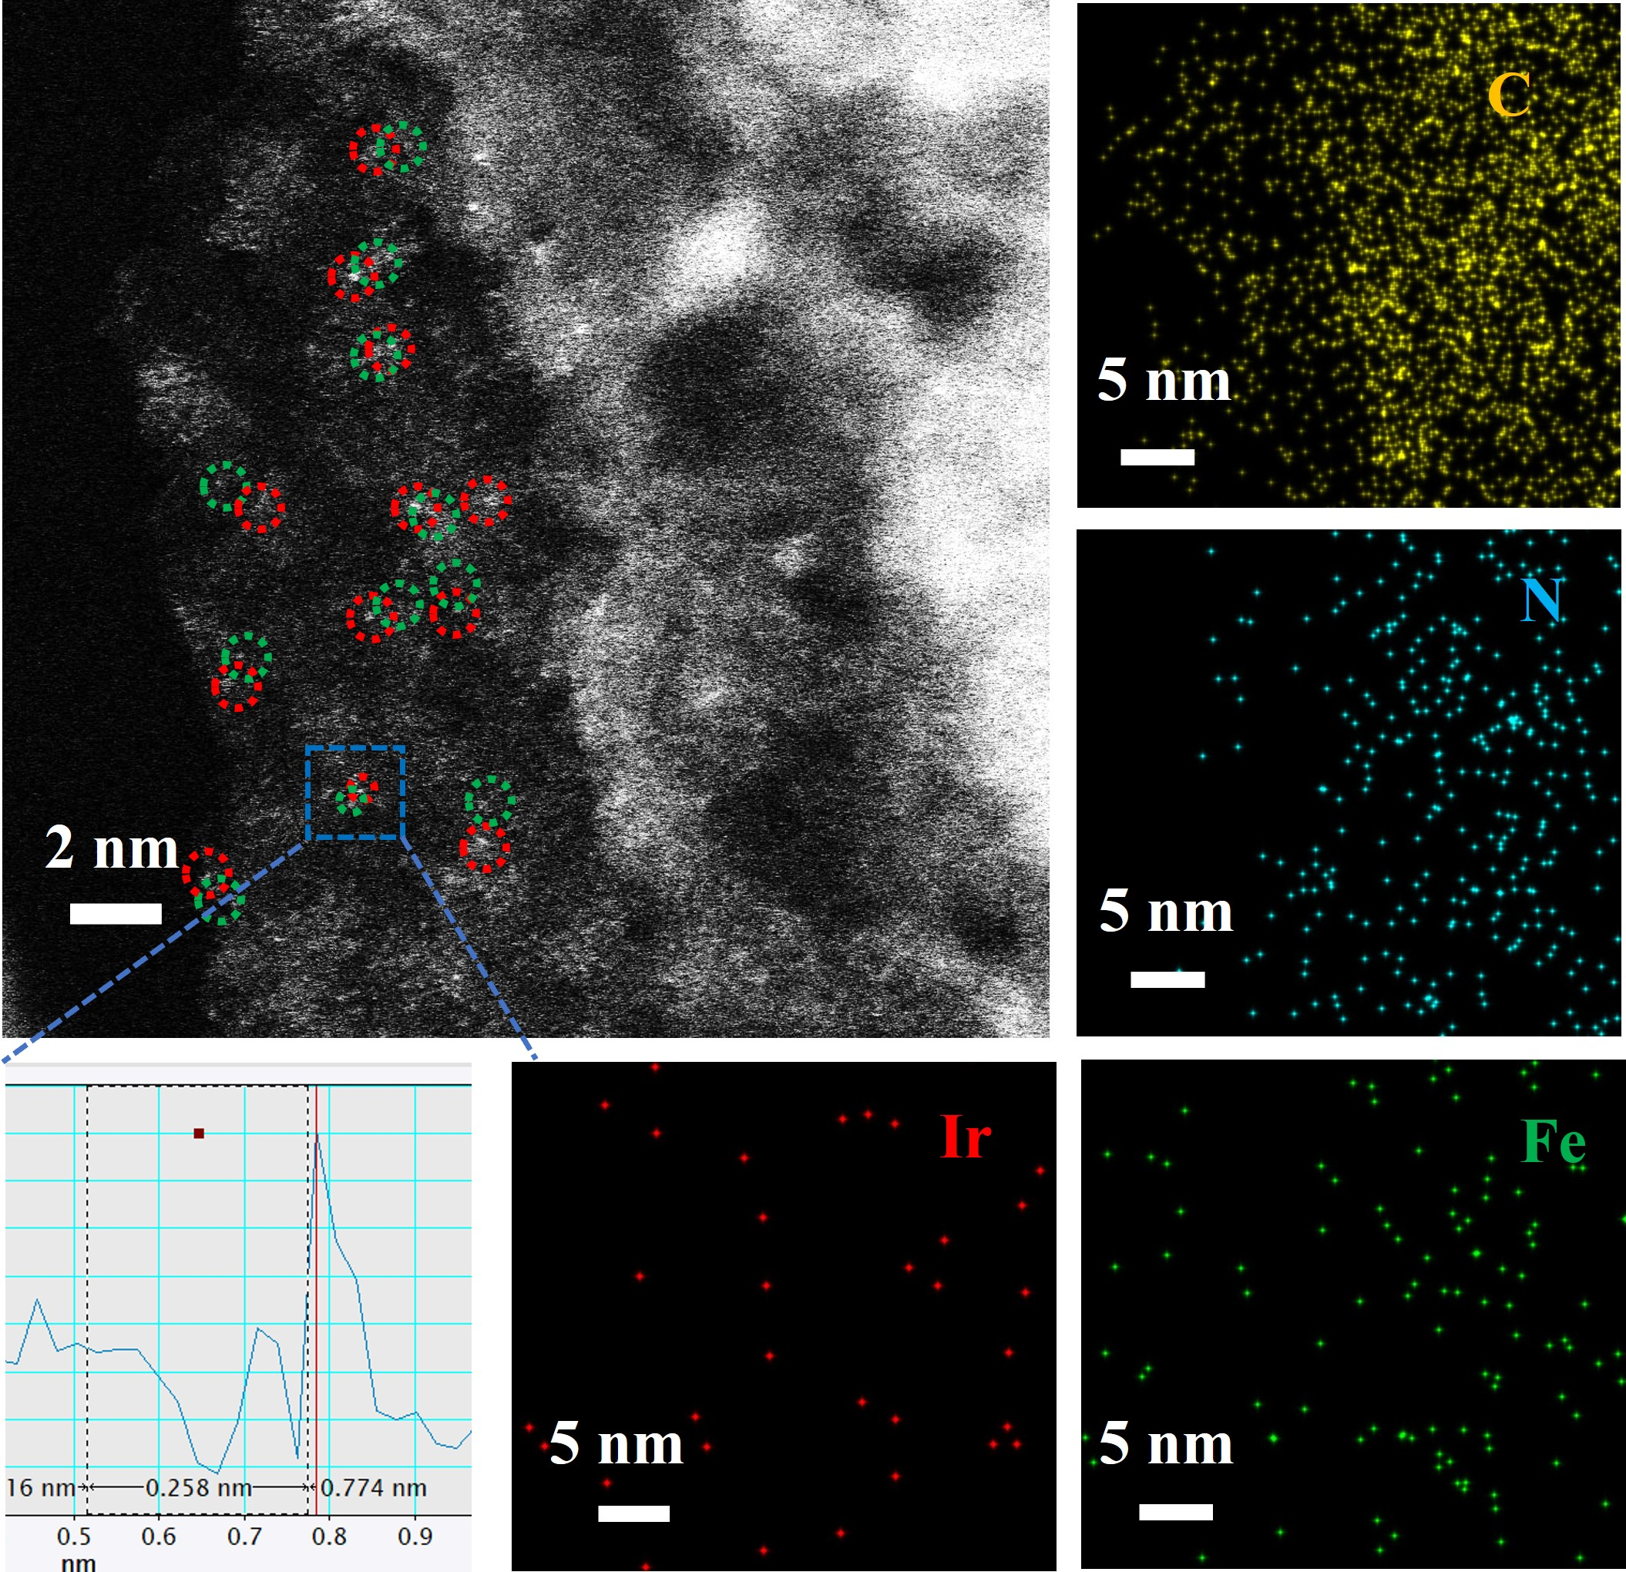
Fig. S20 HAADF-STEM images, element mapping and the intensity profiles of IrFe-SACs after 3000 CV stability tests

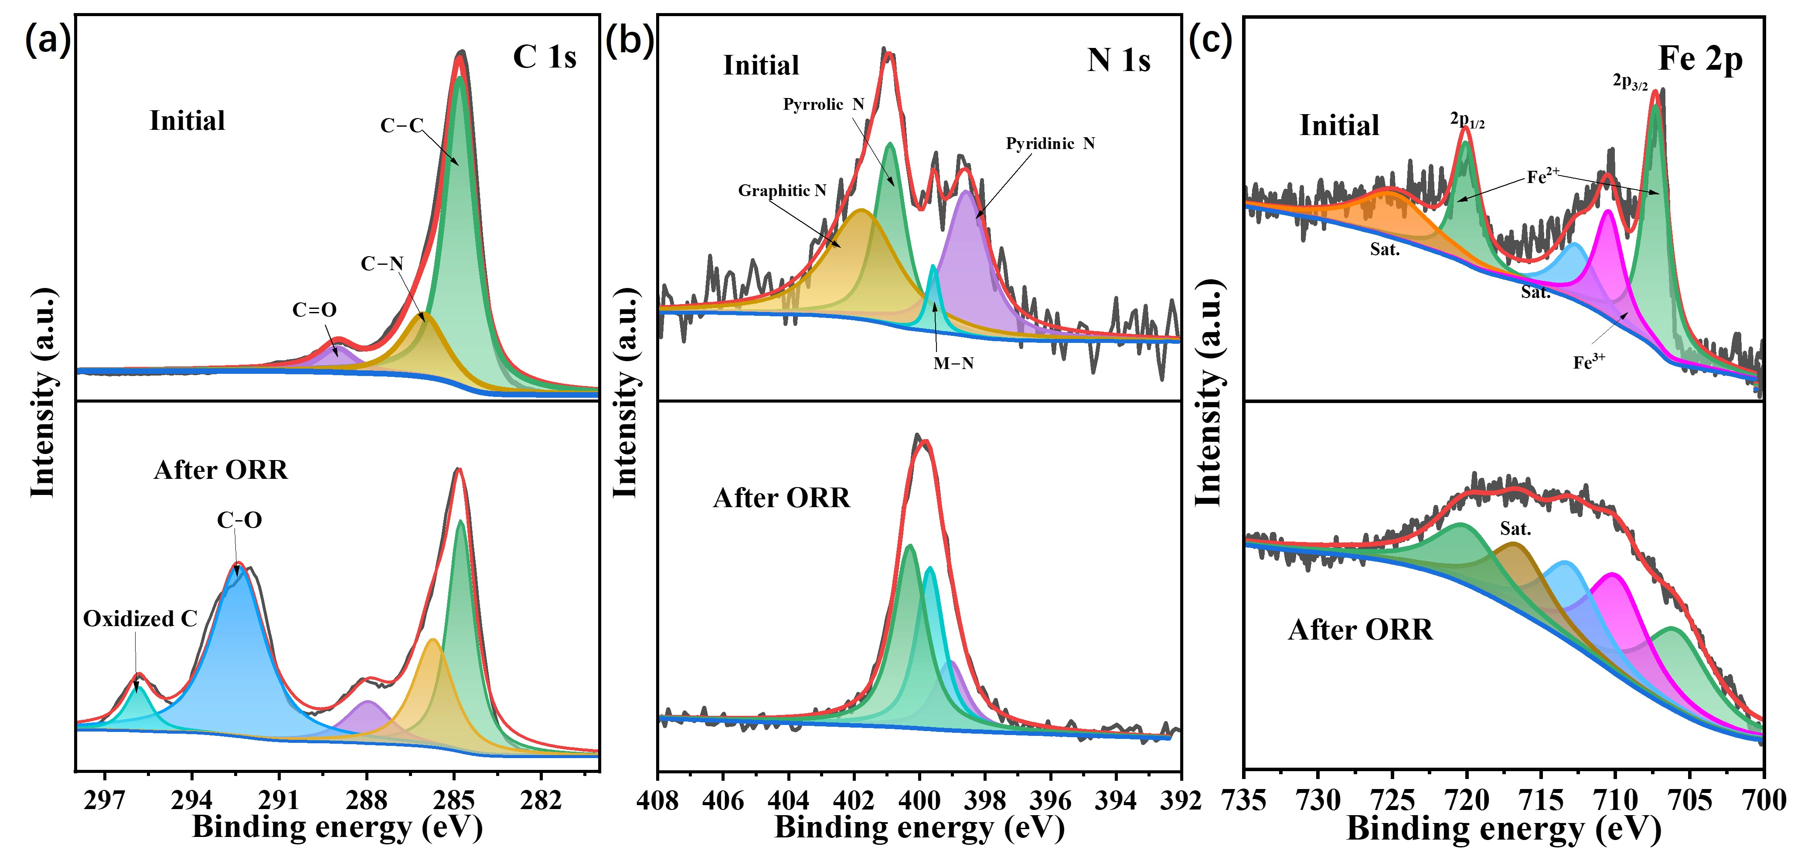
Fig. S21 High-resolution scans of (a) C 1s, (b) N 1s and (c) Fe 2p for IrFe-SACs before and after ORR stability tests
Fig. S22 Open circuit voltage curves of liquid ZABs based on IrFe-SACs and Pt/C-RuO₂ air cathode
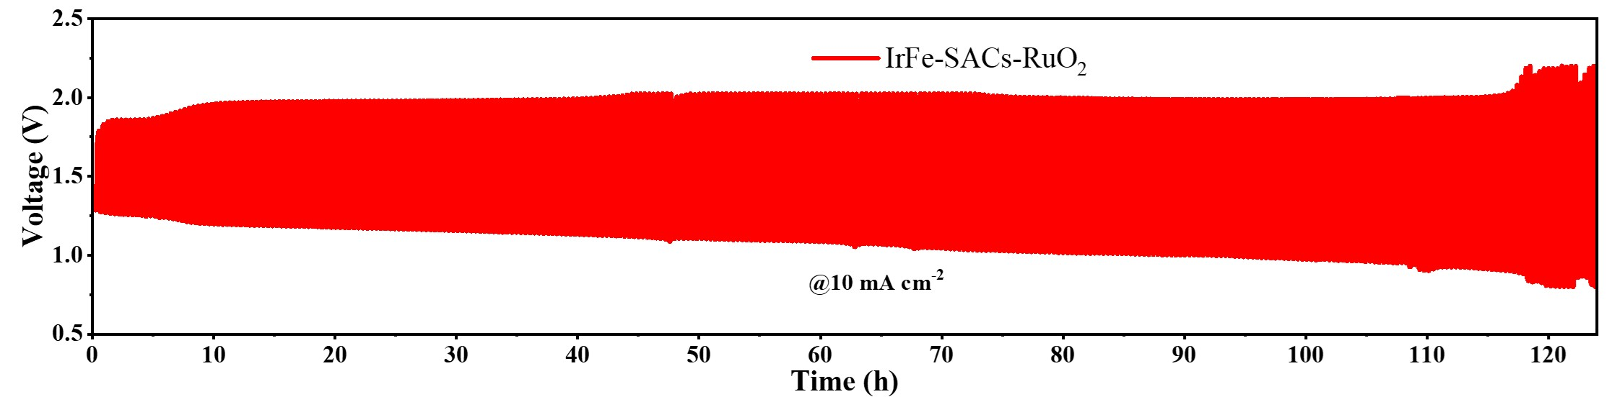
Fig. S23 Galvanostatic charge-discharge cycling curves at 10 mA cm⁻² of liquid ZABs based on IrFe-SACs-RuO₂ air cathode
Table S12 Performance of liquid ZABs based on recently reported oxygen electrocatalysts (-- not mentioned)
Catalysts | Power density  /(mW cm⁻²) | Specific capacity | Cycling stability | References
IrFe-SACs | 314 | 815.1 mAh g⁻¹  @5 mA cm⁻² | 20 min/cycle  1650 cycles  @5 mA cm⁻² | This work
Fe₃Co₇-NC | 133 | 747 mAh g⁻¹  @2 mA cm⁻² | 20 min/cycle  600 cycles  5 mA cm⁻² | [S11]
Fe-N₂-Fe | 170 | 776.7 mAh g⁻¹  @2 mA cm⁻² | 20 min/cycle  1200 cycles  10 mA cm⁻² | [S12]
FeCo-N-C-700 | 150 | 518.0 mAh g⁻¹  @10 mA cm⁻² | 10 min/cycle  252 cycles  5 mA cm⁻² | [S13]
SS-Co-SAC | 195 | 714.2 mAh g⁻¹  @5 mA cm⁻² | 20 min/cycle  100 cycles  10 mA cm⁻² | [S14]
Fe, Co, N−C | 198 | 726.0 mAh g⁻¹  @2 mA cm⁻² | 4 min/cycle  765 cycles  5 mA cm⁻² | [S15]
CoFe−N−C | 142 | -- | 60 min/cycle  200 cycles  5 mA cm⁻² | [S16]
meso/micro-FeCo-N_{x}-CN-30 | 150 | -- | 20 min/cycle  120 cycles  5 mA cm⁻² | [S17]
IrCo-N-C | 139 | 818.0 mAh g⁻¹  @50 mA cm⁻² | 30 min/cycle  450 cycles  5 mA cm⁻² | [S18]
Ni,Fe-DSAs/NCs | 217 | 780.1 mAh g⁻¹  @40 mA cm⁻² | 240 min/cycle  125 cycles  5 mA cm⁻² | [S19]

Table S13 The calculated partial atomic (Ir, Fe, O, H) mean magnetic moments of various oxygen intermediates for IrFe-SACs and Fe-SACs before and after O/OH adsorption (${μ_{B}=eℏ}/{2m_{e}=}$ 5.7884×10⁻⁵ eV T⁻¹)
Items | Models | IrFe-SACs | Fe-SACs
m_{O}/μ_{B} | O* | -0.603 | 0.574
m_{Ir}/μ_{B} | O* | 0.050 | --
m_{Fe}/μ_{B} | O* | -1.178 | 1.229
m_{O}/μ_{B} | HO* | 0.090 | 0.106
m_{Ir}/μ_{B} | HO* | -0.047 | --
m_{Fe}/μ_{B} | HO* | 0.929 | 1.052
m_{H}/μ_{B} | HO* | 0.000 | 0.001
m_{Ir}/μ_{B} | * | 0.143 | --
m_{Fe}/μ_{B} | * | 1.337 | 0.000
Table S14 The calculated partial atomic (Ir, Fe, O, H) mean charge of various oxygen intermediates for IrFe-SACs and Fe-SACs before and after O/OH adsorption (e = 1.6022×10⁻¹⁹ C)
Items | Models | IrFe-SACs | Fe-SACs
Q_{O}/e | O* | 4.873 | 4.872
Q_{Ir}/e | O* | 8.823 | --
Q_{Fe}/e | O* | 7.854 | 7.757
Q_{O}/e | HO* | 5.045 | 5.051
Q_{Ir}/e | HO* | 8.823 | --
Q_{Fe}/e | HO* | 7.604 | 7.628
Q_{H}/e | HO* | 0.736 | 0.740
Q_{Ir}/e | * | 8.859 | --
Q_{Fe}/e | * | 7.541 | 7.632
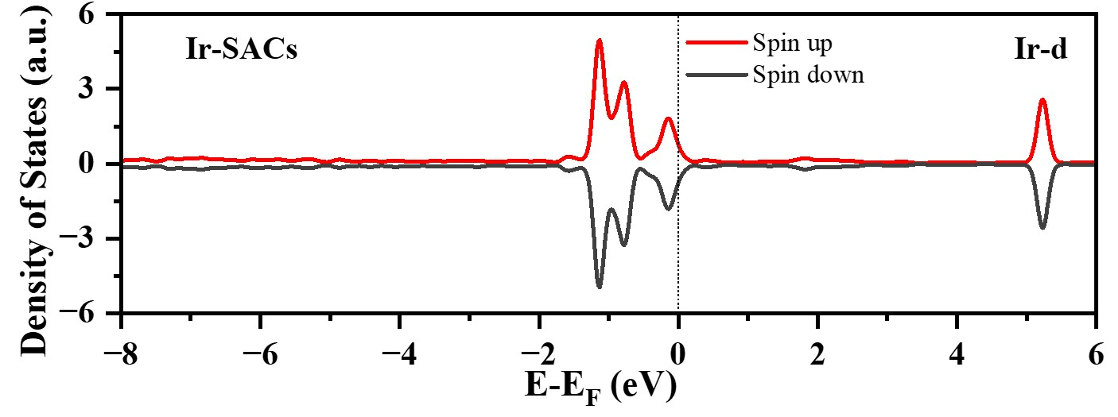
Fig. S24 PDOS of Ir-d for Ir-SACs
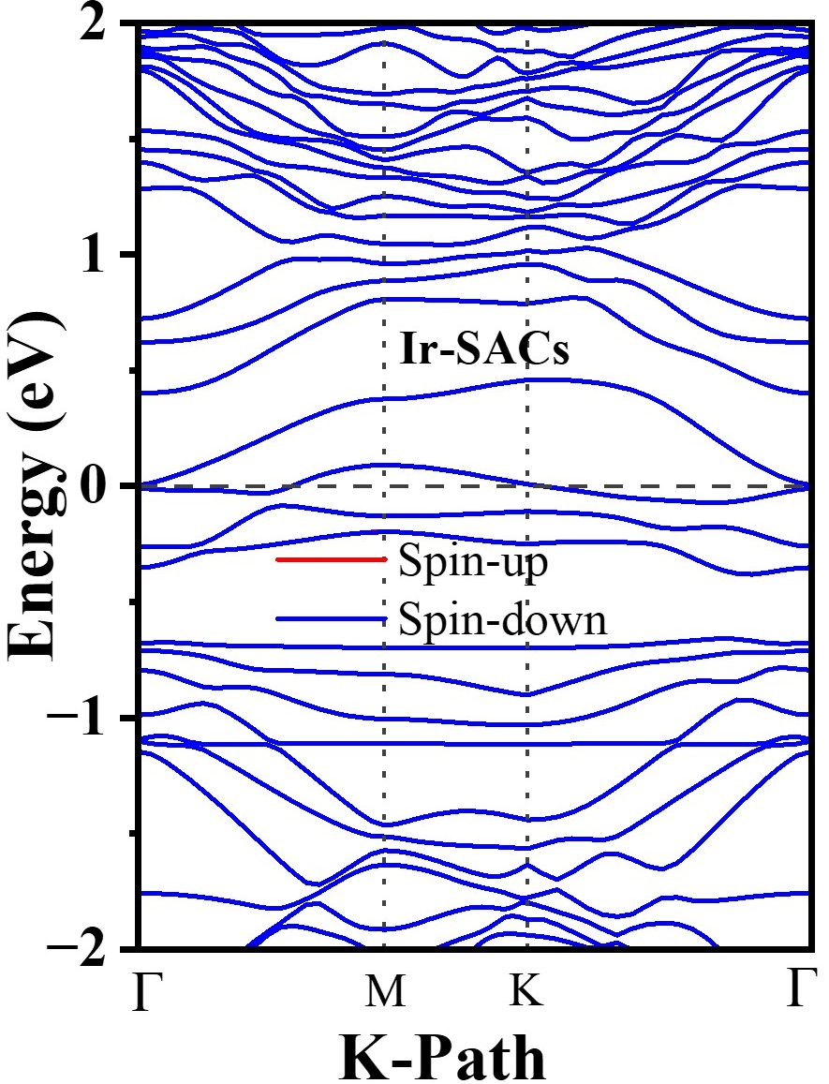
Fig. S25 Band structure of Ir-SACs
Table S15 The HOO(ΔE₁), O (ΔE₂) and HO (ΔE₃) adsorption energy of Ir-SACs, Fe-SACs and IrFe-SACs
Models | Ir-SACs | Fe-SACs | IrFe-SACs
E_{HOO}/eV | -13.0239 | -13.0239 | -13.0239
E*/eV | -1317.0225 | -1317.8284 | -1310.2555
E_{HOO*}/eV | -1332.6671 | -1332.3122 | -1324.9336
E₁/eV | -2.6207 | -1.4599 | -1.6542
E_{O}/eV | -1.5739 | -1.5739 | -1.5739
E*/eV | -1317.0225 | -1317.8284 | -1310.2555
E_{O*}/eV | -1323.4089 | -1323.2953 | -1315.7519
E₂/eV | -4.8125 | -3.8930 | -3.9225
E_{HO}/eV | -7.5614 | -7.5614 | -7.5614
E*/eV | -1317.0225 | -1317.8284 | -1310.2555
E_{HO*}/eV | -1328.5056 | -1327.7780 | -1320.4409
E₃/eV | -3.9217 | -2.3882 | -2.6240
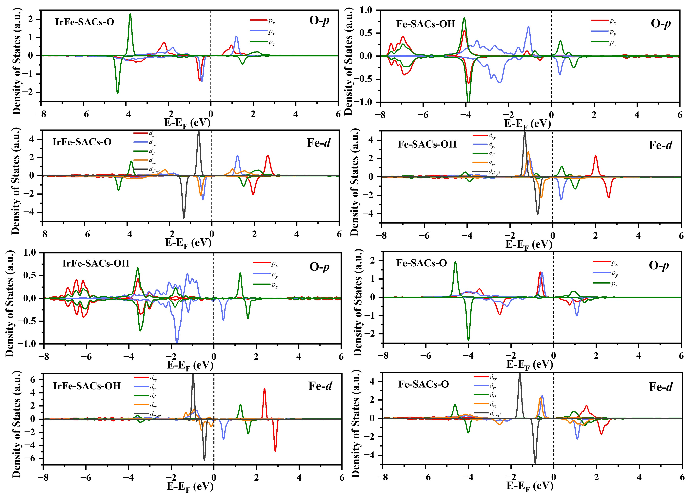
Fig. S26 Fe-d and O-p orbital PDOS diagrams of IrFe-SACs-O/OH and Ir-SACs-O/OH
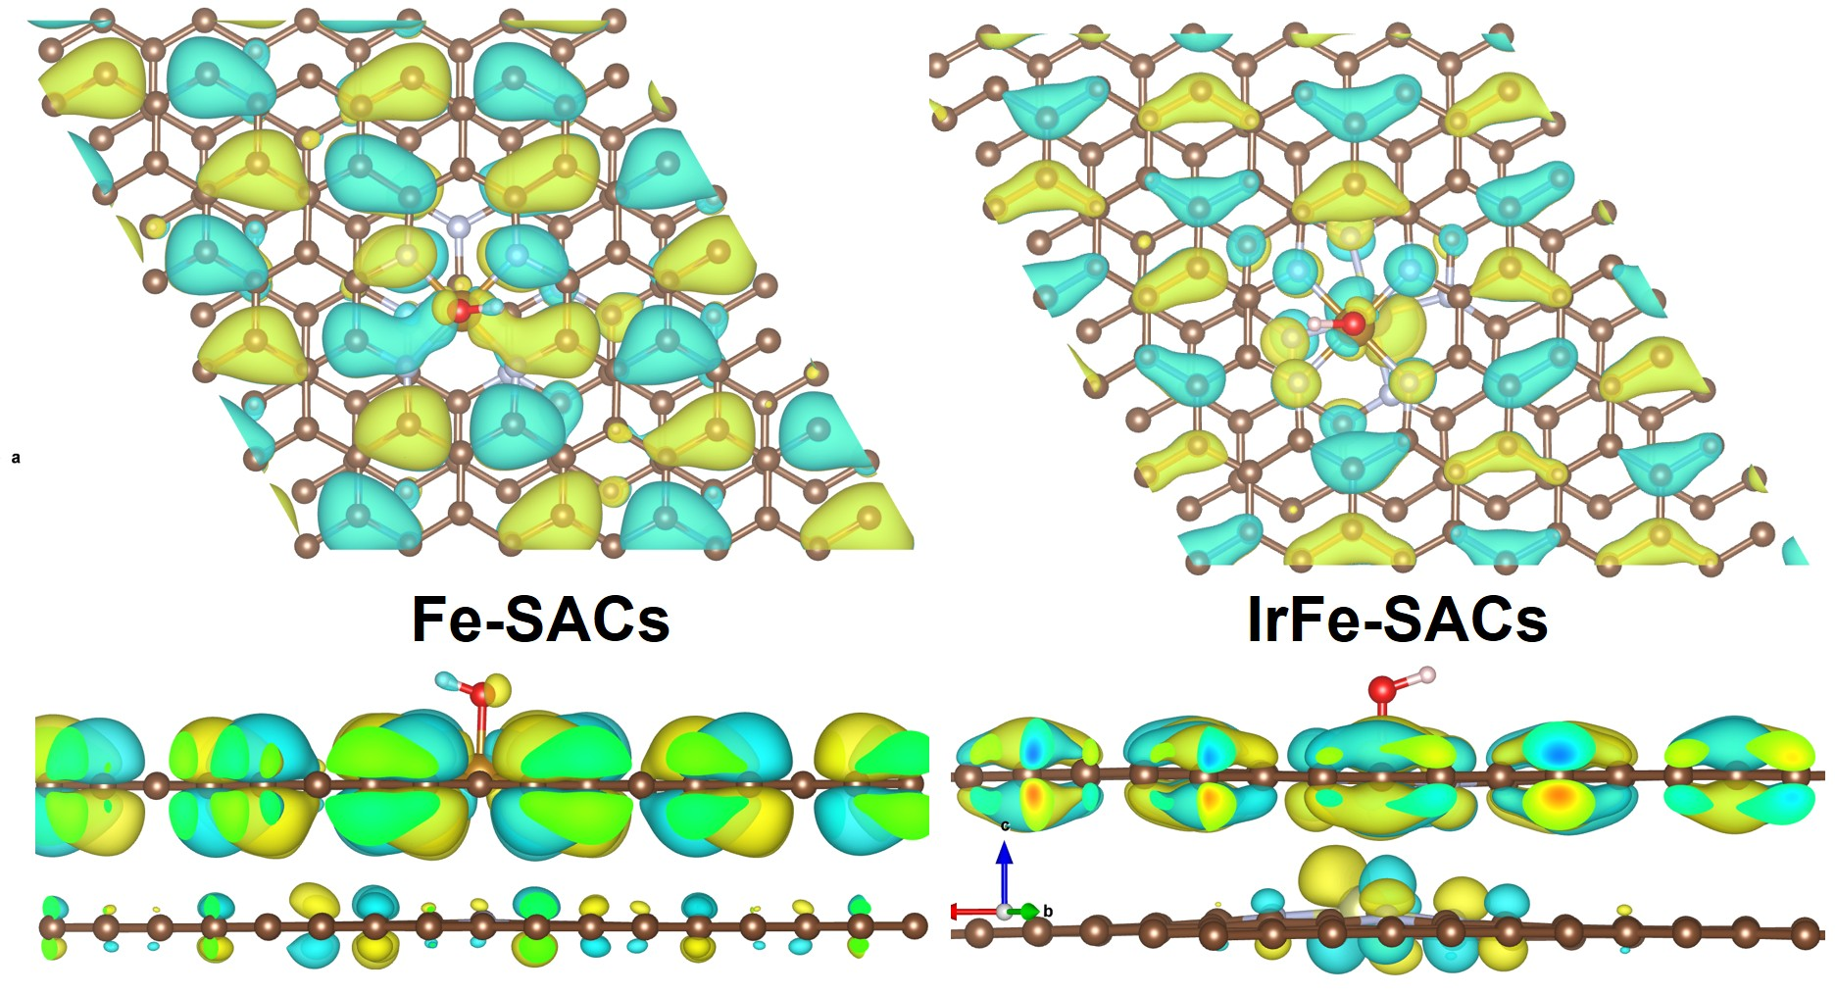
Fig. S27 HOMO molecular orbital diagrams of Fe-SACs-OH and IrFe-SACs-OH
Supplementary References
- P. Zhang, H.-C. Chen, H. Zhu, K. Chen, T. Li et al., Inter-site structural heterogeneity induction of single atom Fe catalysts for robust oxygen reduction. Nat. Commun. 15(1), 2062 (2024). https://doi.org/10.1038/s41467-024-46389-3
- B. Sun, S. Zhang, H. Yang, T. Zhang, Q. Dong et al., Revealing the active sites in atomically dispersed multi-metal–nitrogen–carbon catalysts. Adv. Funct. Mater. 34(29), 2315862 (2024). https://doi.org/10.1002/adfm.202315862
- X. Han, X. Ling, Y. Wang, T. Ma, C. Zhong et al., Generation of nanoparticle, atomic-cluster, and single-atom cobalt catalysts from zeolitic imidazole frameworks by spatial isolation and their use in zinc-air batteries. Angew. Chem. Int. Ed. 58(16), 5359–5364 (2019). https://doi.org/10.1002/anie.201901109
- L. Jiao, G. Wan, R. Zhang, H. Zhou, S.-H. Yu et al., From metal–organic frameworks to single-atom Fe implanted N-doped porous carbons: efficient oxygen reduction in both alkaline and acidic media. Angew. Chem. Int. Ed. 57(28), 8525–8529 (2018). https://doi.org/10.1002/anie.201803262
- Y. Yang, B. Li, Y. Liang, W. Ni, X. Li et al., Hetero-diatomic CoN₄‐NiN₄ site pairs with long-range coupling as efficient bifunctional catalyst for rechargeable Zn-air batteries. Adv. Sci. 11(22), 2310231 (2024). https://doi.org/10.1002/advs.202310231
- Q. Jing, Z. Mei, X. Sheng, X. Zou, Q. Xu et al., Tuning the bonding behavior of d-p orbitals to enhance oxygen reduction through push–pull electronic effects. Adv. Funct. Mater. 34(3), 2307002 (2024). https://doi.org/10.1002/adfm.202307002
- G. Wang, M. Zhang, G. Zhang, Z. Wang, X. Chen et al., Novel approach of diffusion-controlled sequential reduction to synthesize dual-atomic-site alloy for enhanced bifunctional electrocatalysis in acidic and alkaline media. Adv. Funct. Mater. 34(6), 2308876 (2024). https://doi.org/10.1002/adfm.202308876
- J. Qiao, Y. You, L. Kong, W. Feng, H. Zhang et al., Precisely constructing orbital-coupled Fe─Co dual-atom sites for high-energy-efficiency Zn–air/iodide hybrid batteries. Adv. Mater. 36(32), 2405533 (2024). https://doi.org/10.1002/adma.202405533
- H. Liu, L. Jiang, J. Khan, X. Wang, J. Xiao et al., Decorating single-atomic Mn sites with FeMn clusters to boost oxygen reduction reaction. Angew. Chem. Int. Ed. 62(3), e202214988 (2023). https://doi.org/10.1002/anie.202214988
- Z. Jiang, X. Liu, X.-Z. Liu, S. Huang, Y. Liu et al., Interfacial assembly of binary atomic metal-N(x) sites for high-performance energy devices. Nat. Commun. 14(1), 1822 (2023). https://doi.org/10.1038/s41467-023-37529-2
- T. Gu, D. Zhang, Y. Yang, C. Peng, D. Xue et al., Dual-sites coordination engineering of single atom catalysts for full-temperature adaptive flexible ultralong-life solid-state Zn−Air batteries. Adv. Funct. Mater. 33(8), 2212299 (2023). https://doi.org/10.1002/adfm.202212299
- S. Zhao, M. Liu, Z. Qu, Y. Yan, Z. Zhang et al., Cascade synthesis of Fe- N₂-Fe dual-atom catalysts for superior oxygen catalysis. Angew. Chem. Int. Ed. 63(40), e202408914 (2024). https://doi.org/10.1002/anie.202408914
- X. Duan, S. Ren, N. Pan, M. Zhang, H. Zheng, MOF-derived Fe, Co@N–C bifunctional oxygen electrocatalysts for Zn–air batteries. J. Mater. Chem. A 8(18), 9355–9363 (2020). https://doi.org/10.1039/d0ta02825h
- W. Xie, Y. Song, S. Li, J. Li, Y. Yang et al., Single-atomic-co electrocatalysts with self-supported architecture toward oxygen-involved reaction. Adv. Funct. Mater. 29(50), 1906477 (2019). https://doi.org/10.1002/adfm.201906477
- S. Sarkar, A. Biswas, E.E. Siddharthan, R. Thapa, R.S. Dey, Strategic modulation of target-specific isolated Fe, Co single-atom active sites for oxygen electrocatalysis impacting high power Zn-air battery. ACS Nano 16(5), 7890–7903 (2022). https://doi.org/10.1021/acsnano.2c00547
- X. Zhou, J. Gao, Y. Hu, Z. Jin, K. Hu et al., Theoretically revealed and experimentally demonstrated synergistic electronic interaction of CoFe dual-metal sites on N-doped carbon for boosting both oxygen reduction and evolution reactions. Nano Lett. 22(8), 3392–3399 (2022). https://doi.org/10.1021/acs.nanolett.2c00658
- S. Li, C. Cheng, X. Zhao, J. Schmidt, A. Thomas, Active salt/silica-templated 2D mesoporous FeCo-nx-carbon as bifunctional oxygen electrodes for zinc–air batteries. Angew. Chem. Int. Ed. 57(7), 1856–1862 (2018). https://doi.org/10.1002/anie.201710852
- M. Xiao, J. Zhu, S. Li, G. Li, W. Liu et al., 3d-orbital occupancy regulated Ir-co atomic pair toward superior bifunctional oxygen electrocatalysis. ACS Catal. 11(14), 8837–8846 (2021). https://doi.org/10.1021/acscatal.1c02165
- Z. Wang, X. Jin, R. Xu, Z. Yang, S. Ma et al., Cooperation between dual metal atoms and nanoclusters enhances activity and stability for oxygen reduction and evolution. ACS Nano 17(9), 8622–8633 (2023). https://doi.org/10.1021/acsnano.3c01287

