Supporting Information for
Graphene Aerogel-Based Flexible Pressure Sensor for Physiological Signal Detection and Human-Machine Interaction
Zihan Wang¹, Zeshang Zhao¹, Qiyang Tu¹, Chengpeng Yao², Zhao Liu², Chengzhi Zhou¹, Luxiang Xu¹, Shijie Guo¹, Chuizhou Meng^{3,} *, Gaofeng Shao^{4,} *, Huanyu Cheng^{5,} *, Li Yang^{2,} *
¹ State Key Laboratory for Reliability and Intelligence of Electrical Equipment, Hebei Key Laboratory of Smart Sensing and Human-Robot Interaction, School of Mechanical Engineering, Hebei University of Technology, Tianjin 300401, P. R. China
² State Key Laboratory of Reliability and Intelligence of Electrical Equipment, School of Health Sciences and Biomedical Engineering, Hebei University of Technology, Tianjin 300130, P. R. China
³ Research Institute of Wearable Electronic Materials and Devices, School of Materials Science & Engineering, Zhejiang Sci-Tech University, Hangzhou 310018, P. R. China
⁴ School of Chemistry and Materials Science, Nanjing University of Information Science & Technology, Nanjing, 210044, P. R. China
⁵ Department of Engineering Science and Mechanics, The Pennsylvania State University, University Park, 16802, USA
*Corresponding authors. E-mail: 2018108@hebut.edu.cn (Chuizhou Meng); gfshao@nuist.edu.cn (Gaofeng Shao); huanyu.cheng@psu.edu (Huanyu Cheng); yangli5781@126.com (Li Yang)
Supplementary Figures and Tables
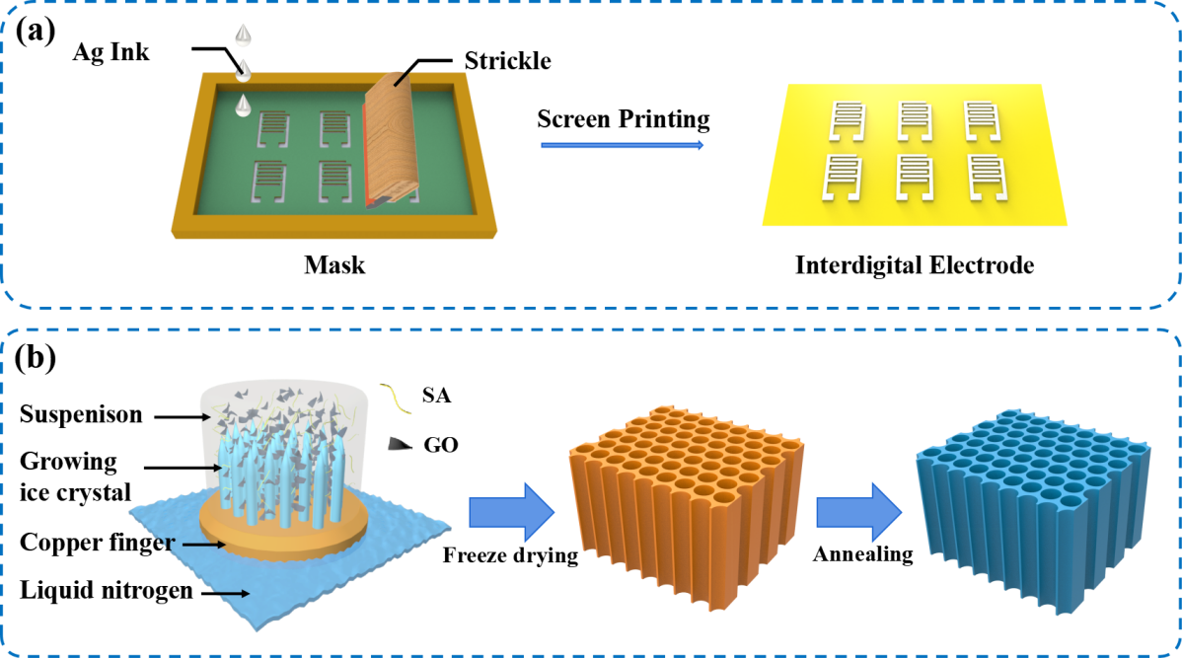
Fig. S1 Schematic diagram of the preparation process of (a) Ag interdigital electrode and (b) rGO aerogel
Fig. S2 Optical images of ultralight rGOA placed on setaria viridis

Fig. S3 Photographs of rGOA during compression and after release

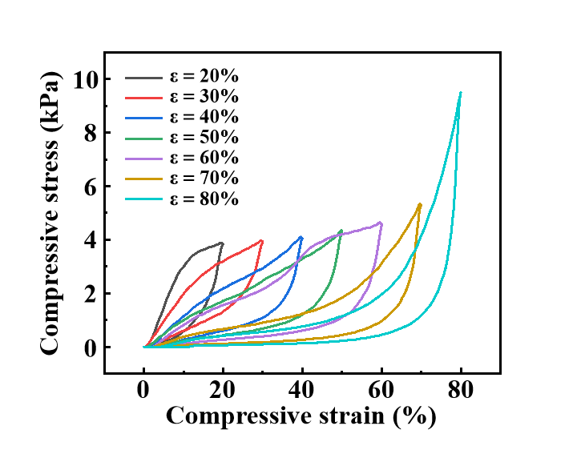
Fig. S4 Compressive stress-strain curves of the rGOA under the applied strain from 20% to 80% along the Y-direction
Fig. S5 Cycling stability of rGOA measured during 100 cycles for a compressive strain of up to 80%
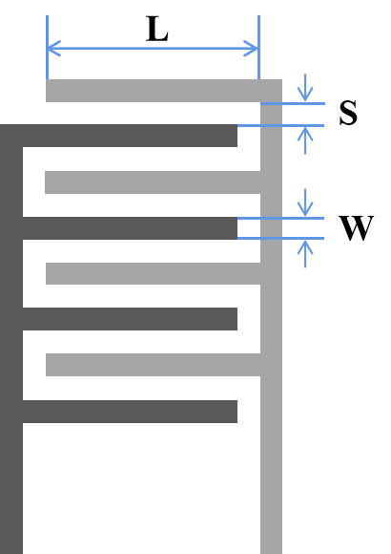
Fig. S6 Rectangular interdigital electrode structure, with finger length (L), finger spacing (S), and finger width (W) labeled

Fig. S7 Schematic showing the interdigital electrode with different design parameters

Fig. S8 Comparison in the current response between the rGOA-based pressure sensors with five different interdigital electrodes
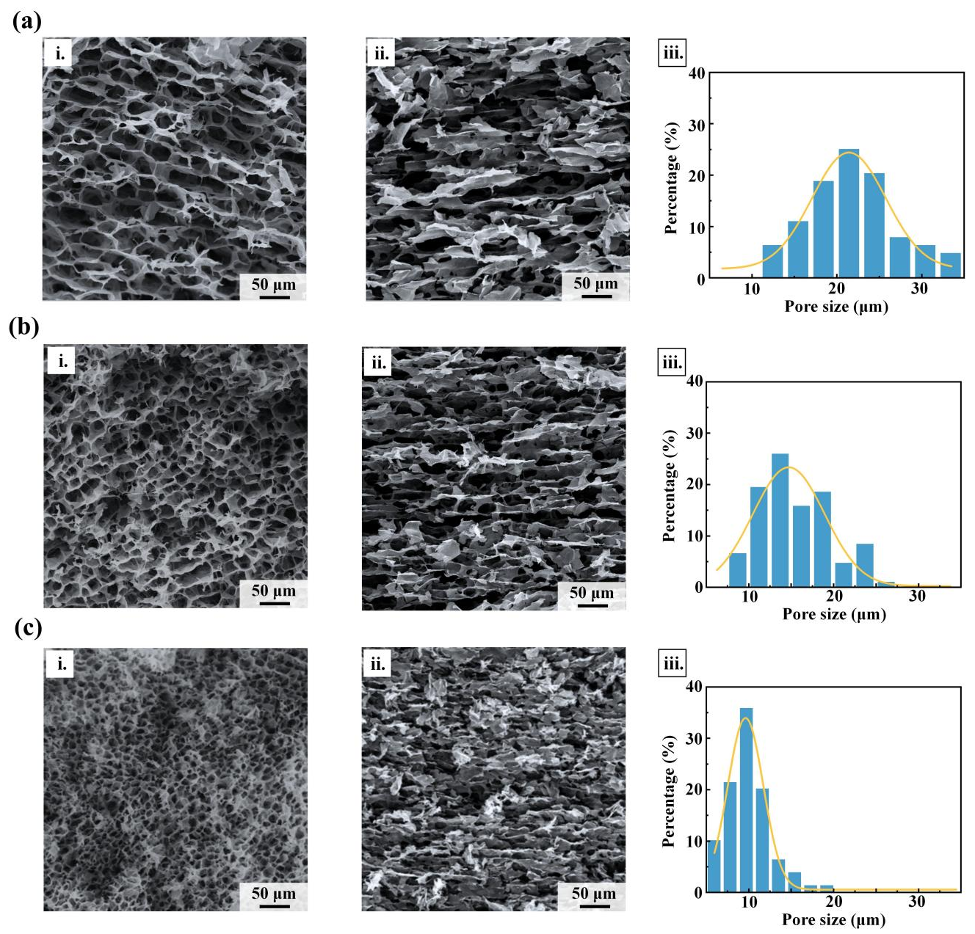
Fig. S9 rGOA prepared at cooling rates of (a) 2 ℃/min, (b) 8 ℃/min, and (c) 15 ℃/min, along with their respective (i) XZ cross-section, (ii) YZ cross-section SEM images, and (iii) pore size distributions
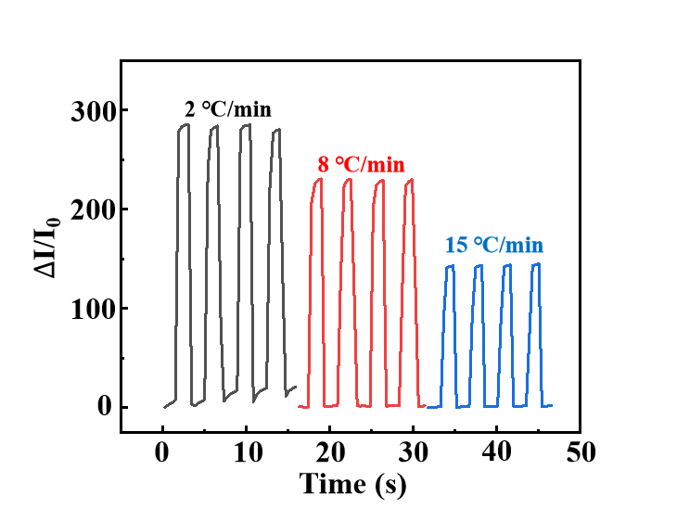
Fig. S10 Current responses of rGOA-based pressure sensors prepared at different cooling rates (i.e., 2, 8, and 15℃/min) under SA:GO=2:3 and a pressure load of 1 kPa
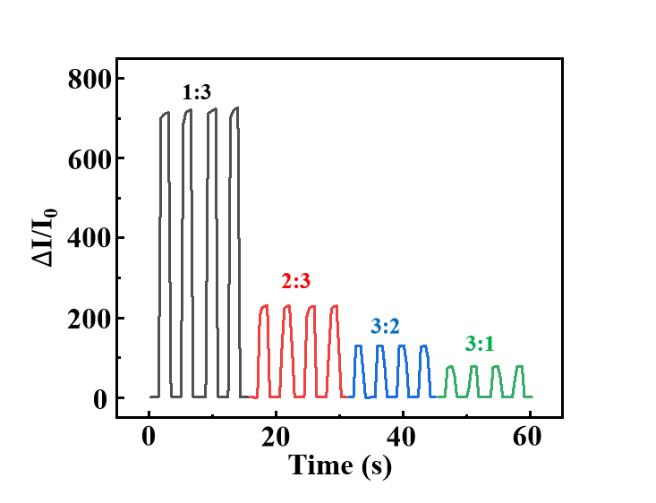
Fig. S11 Current responses of rGOA-based pressure sensors with different SA:GO ratios (1:3, 2:3, 3:2, 3:1) under a pressure load of 1 kPa and a cooling rate of 8℃/mi
Fig. S12 (a) The preparation process and (b) optical image of the transparent PDMS film
Fig. S13 Comparison in the current response of the rGOA-based pressure sensors encapsulated by PDMS with different thicknesses

Fig. S14 Demonstration of the pressure sensing near the LOD for the rGOA-based pressure sensors encapsulated by PDMS with different thicknesses: (a) 50, (b) 100, (c) 150, and (d) 200 μm
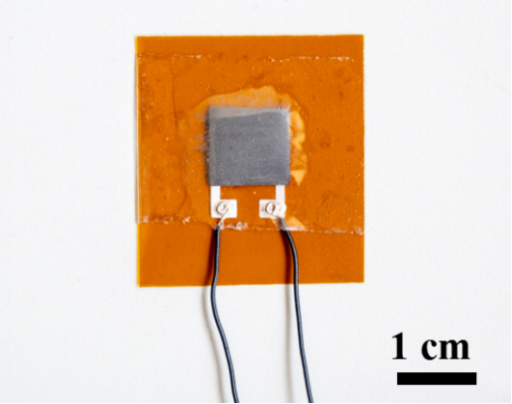
Fig. S15 Photograph of the rGOA-based pressure sensor
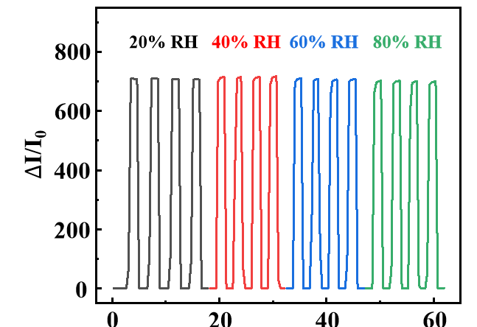
Fig. S16 The current response of the rGOA-based pressure sensor in the RH ranging from 20% to 80%

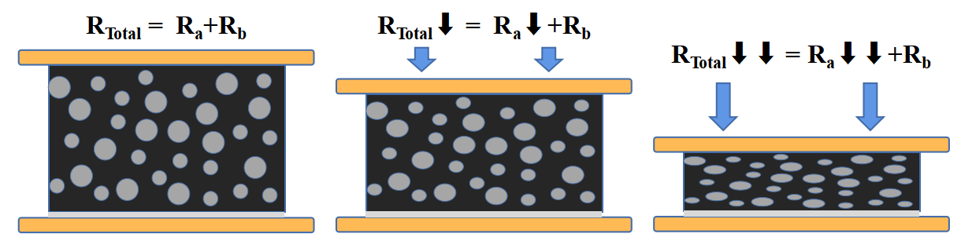
Fig. S17 Schematic diagram of the working principle of the rGOA-based pressure sensor

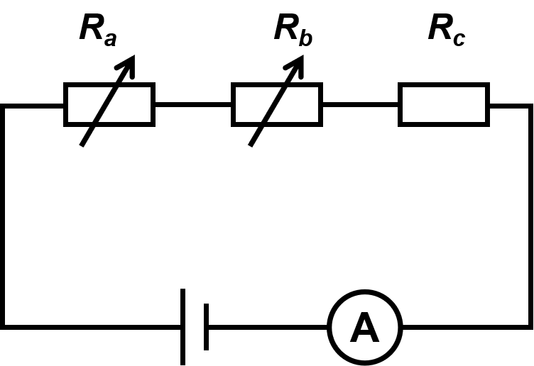
Fig. S18 The equivalent circuit diagram of the rGOA-based pressure sensor

Fig. S19 Photographs showing the increased brightness of the LED with the increasing pressure load

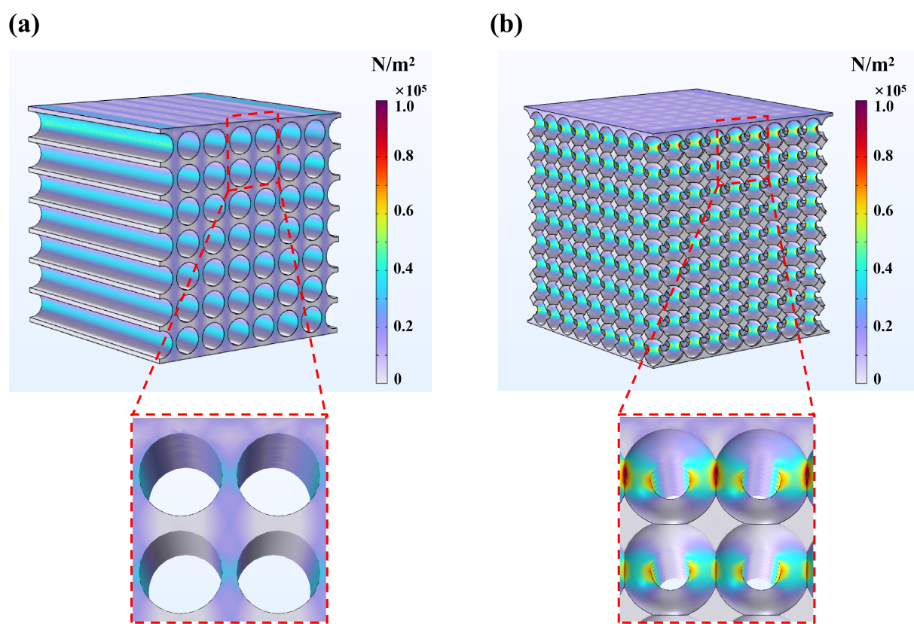
Fig. S20 Comparison of simulated stress distribution between (a) anisotropic and (b) isotropic structures (with uniformly distributed spherical pores in the interior) under 5 kPa. The lower peak stress from the anisotropic structure indicates more uniform load distribution and reduced stress concentration
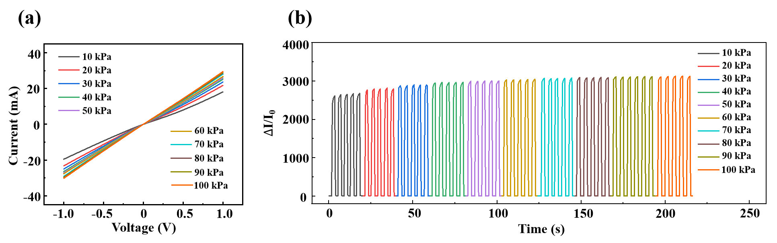
Fig. S21 (a) I−V curves and (b) normalized relative current changes of the rGOA-based pressure sensor under varying pressure loads from 10 to 100 kPa
Fig. S22 Comparison of the current response curves of the rGOA-based pressure sensor under varied (a) frequency from 0.03 to 0.1 Hz (at compression rates of 3, 5, 7, and 10 mm/min) and (b) compression rate from 5 to 50 mm/min to 5 kPa
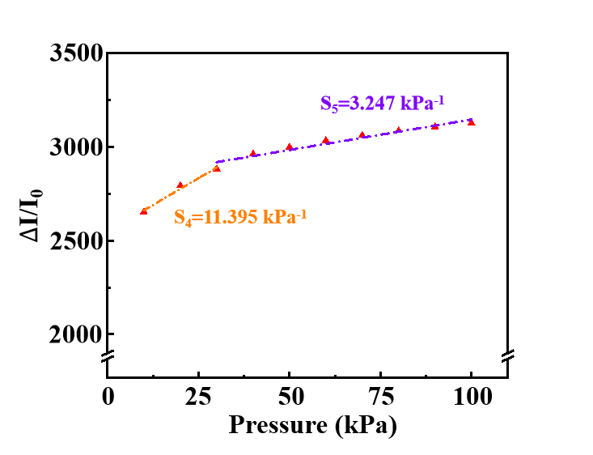
Fig. S23 The sensitivity calibration curves of the rGOA-based pressure sensor under pressure loads ranging from 10 to 100 kPa

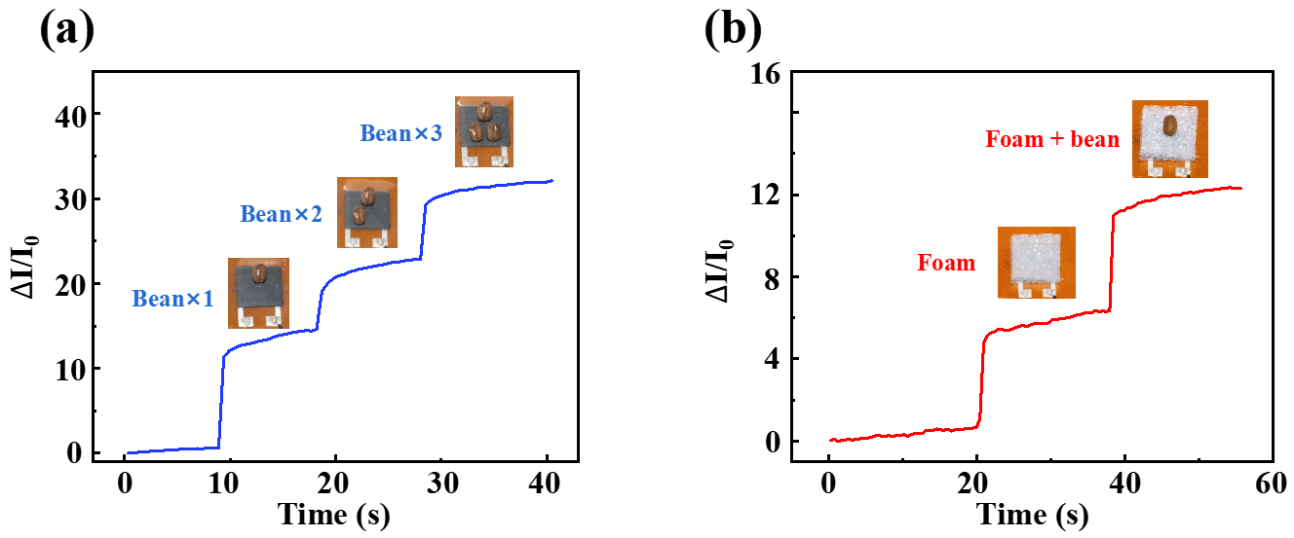
Fig. S24 The response of the rGOA-based pressure sensor to tiny pressures from (a) one, two, and three beans, and (b) foam and bean

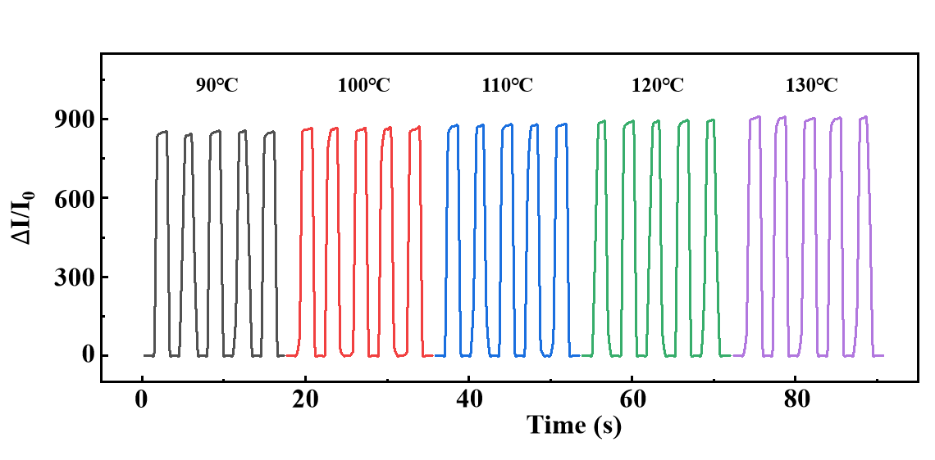
Fig. S25 Current responses of the rGOA-based pressure sensor in the temperature range from 90 to 130℃

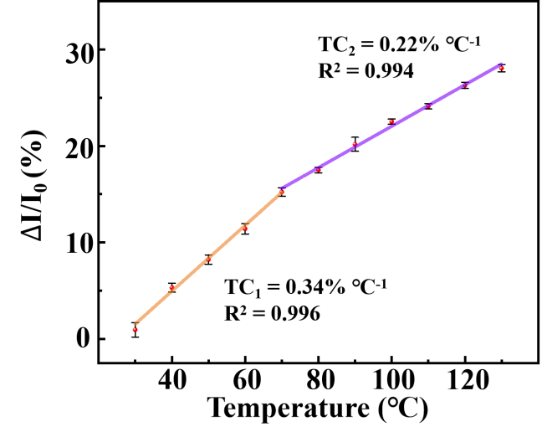
Fig. S26 Temperature-dependent normalized current variation of the rGOA-based pressure sensor in the range from 30 to 130℃. Linear fit reveals two temperature coefficients of 0.34% ℃⁻¹ (30-70℃) and 0.22% ℃⁻¹ (70-130℃)

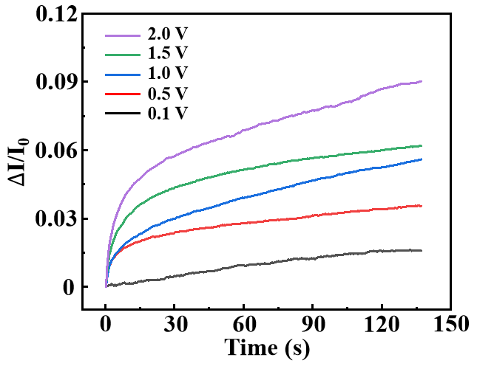
Fig. S27 The current response of the rGOA-based pressure sensor under applied voltages ranging from 0.1 V to 2 V in the absence of an external load
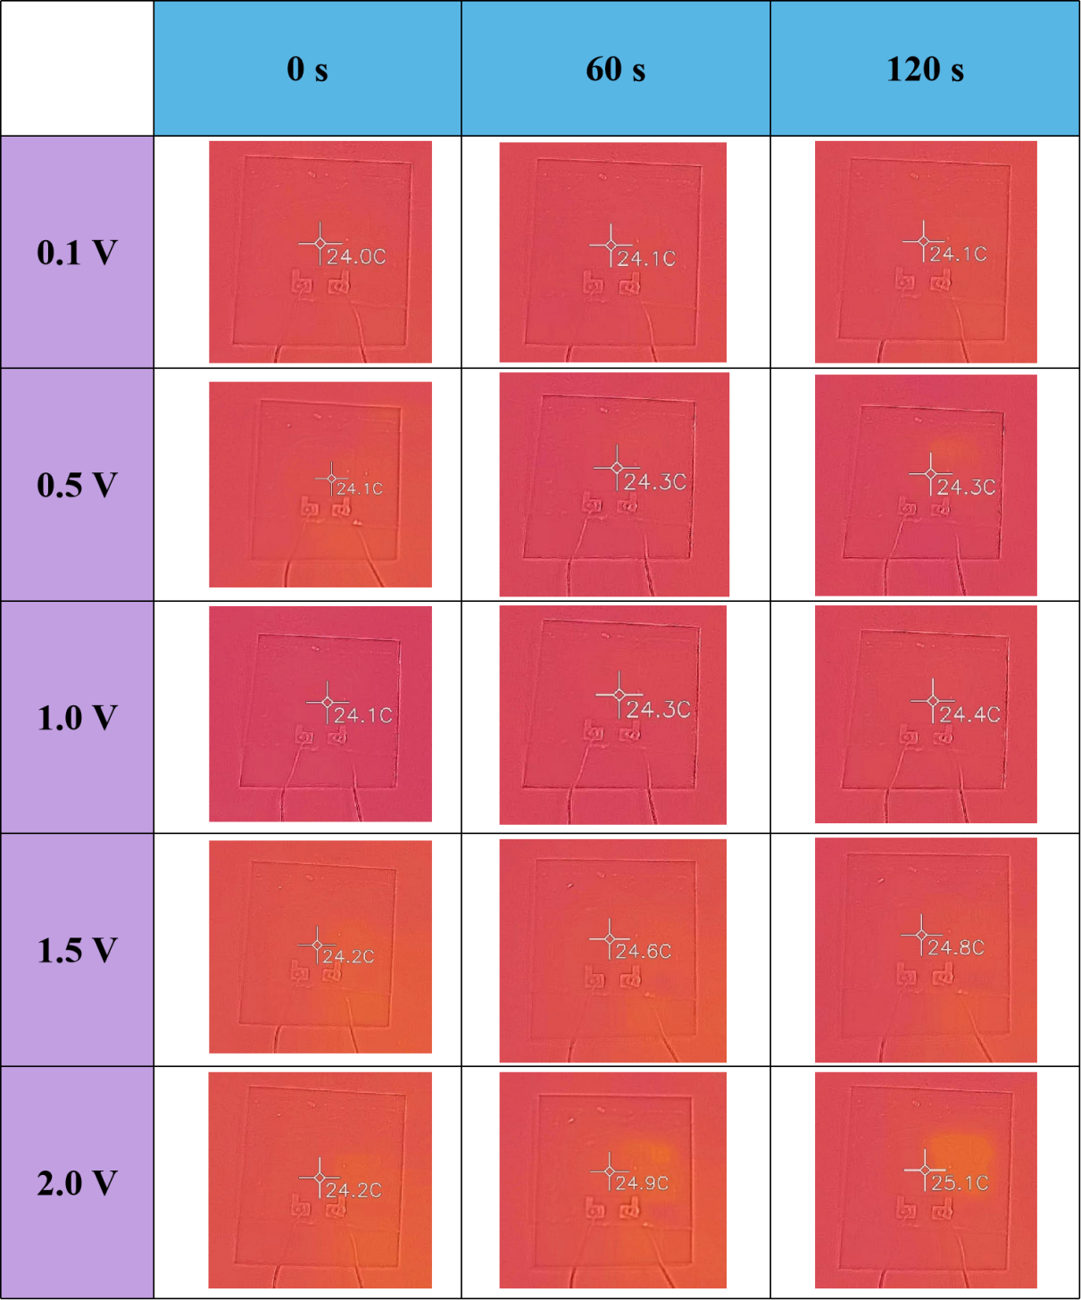
Fig. S28 Infrared images of the rGOA-based pressure sensor showing temperature variation over time under applied voltages ranging from 0.1 V to 2 V

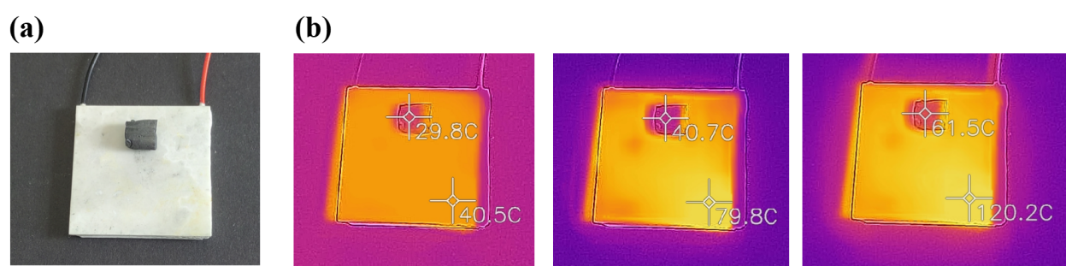
Fig. S29 (a) The rGOA placed on the surface of Peltier and (b) the temperature difference was detected using an infrared thermometer

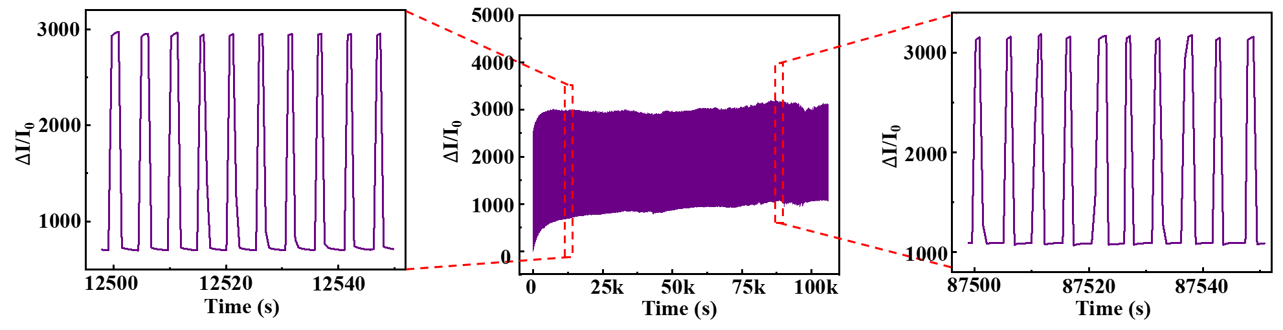
Fig. S30 Repeatability test of the rGOA-based sensor over 20,000 loading/ unloading cycles (10 kPa), with the baseline drift increased by approximately 1.6× between 200 and 20,000 cycles

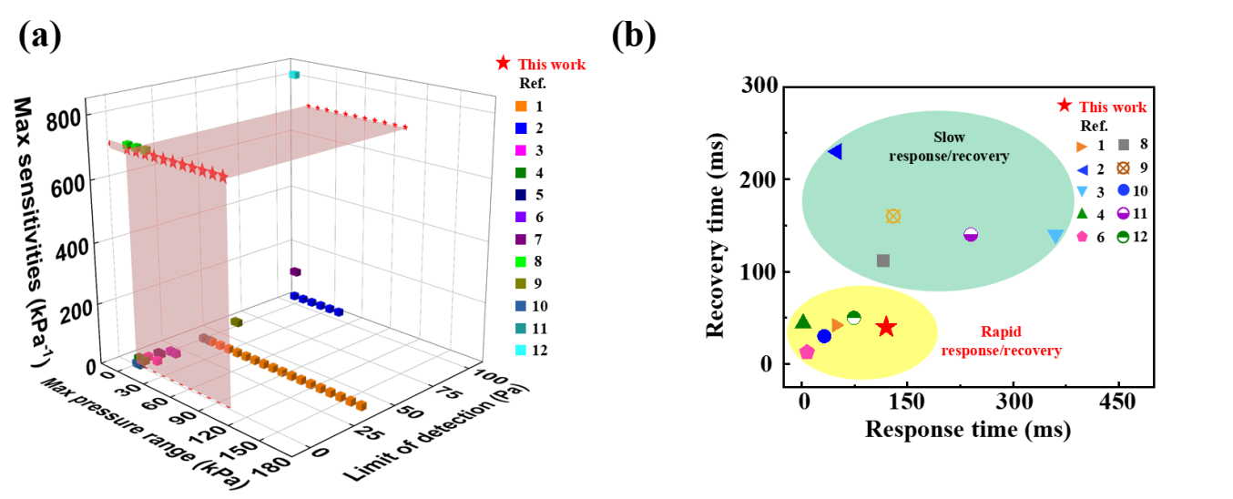
Fig. S31 Comparison between the rGOA-based and other aerogel-based flexible pressure sensors in terms of (a) maximum sensitivity, limit of detection, maximum pressure range, and (b) response/recovery time

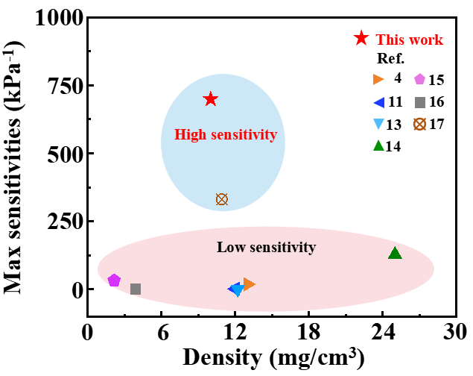
Fig. S32 Comparison between the rGOA-based pressure sensor and other aerogel-based flexible pressure sensors in terms of maximum sensitivity and density

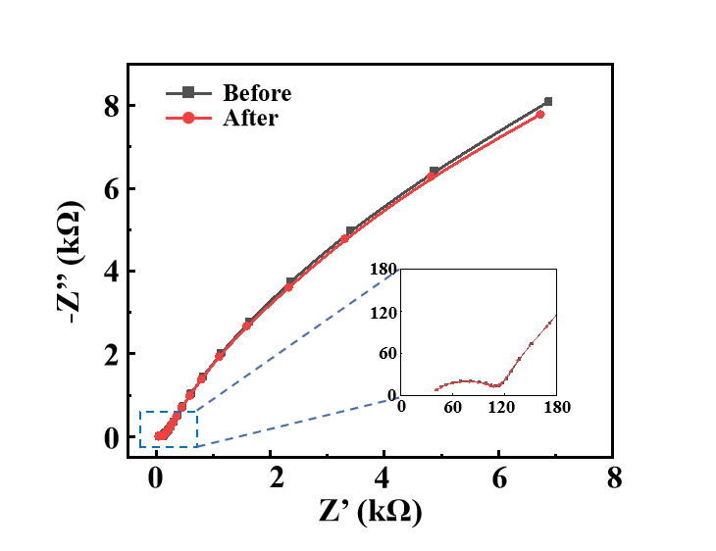
Fig. S33 EIS spectra of the rGOA before and after 5,000 loading/unloading cycles to 250 Pa

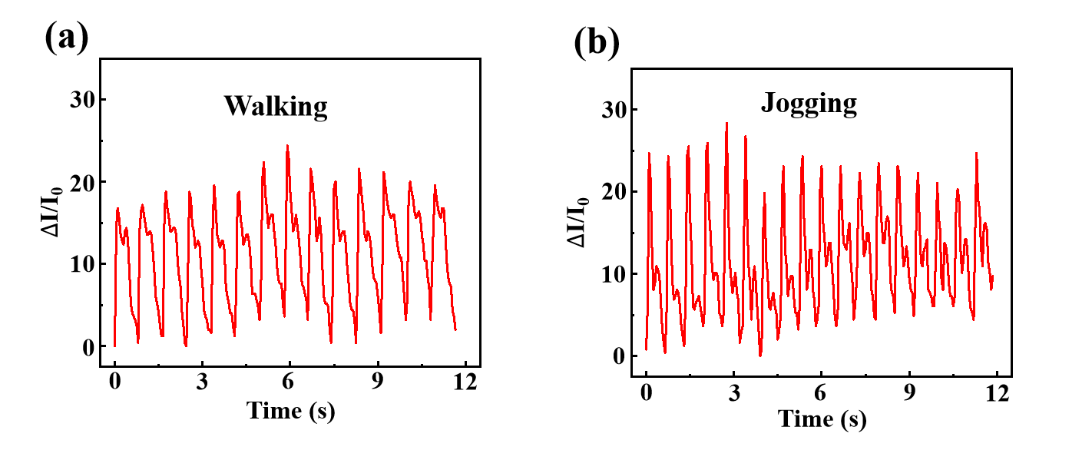
Fig. S34 Periodic pulse signals measured from the radial artery of the wrist during (a) walking and (b) jogging

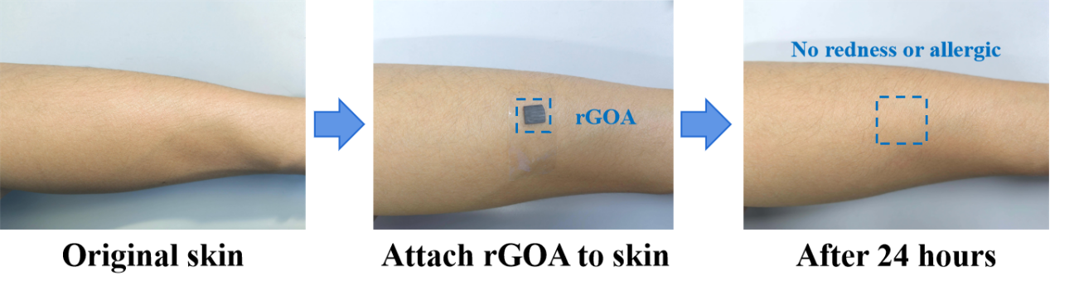
Fig. S35 Optical images of the skin before and after attaching the rGOA (in the blue dashed box region) for 24 hours

Fig. S36 Circuit design diagram of the 4 × 4 pressure sensor array
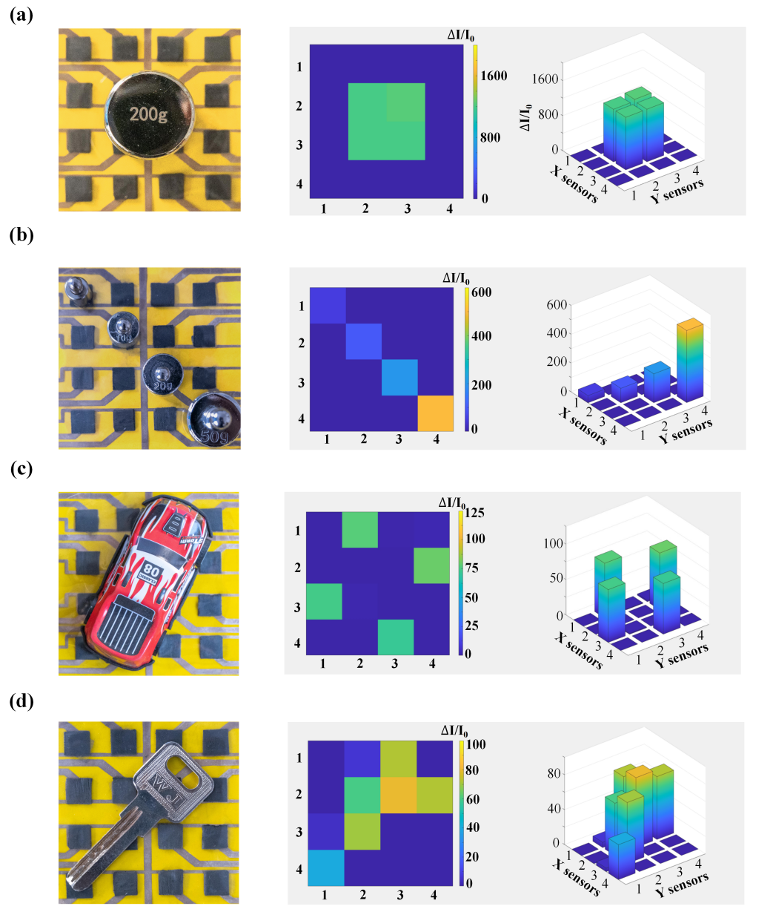
Fig. S37 Images (left), color contrast map (middle), and 3D bar graph (right) of the sensor array to detect (a) one (200 g), (b) four (5 g, 10 g, 20 g, 50 g) weights, (c) an irregular key (d) and a toy car placed on top
Fig. S38 Circuit diagram of the pressure sensor array for battery monitoring
Fig. S39 (a) Design and (b) photograph of the simulated battery case
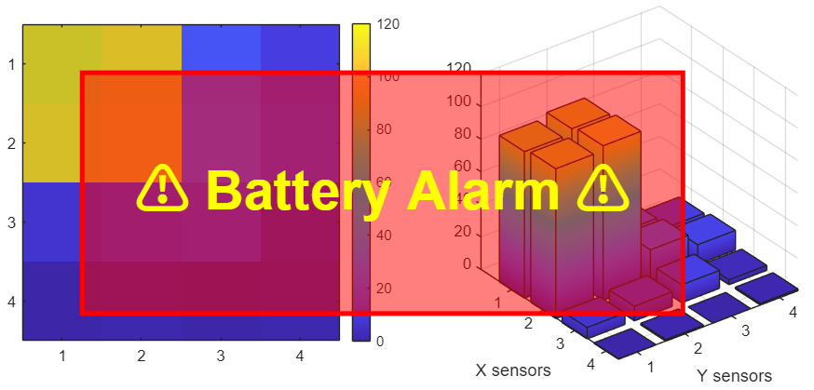
Fig. S40 MATLAB-based alert interface activated upon reaching the warning threshold during battery swelling monitoring
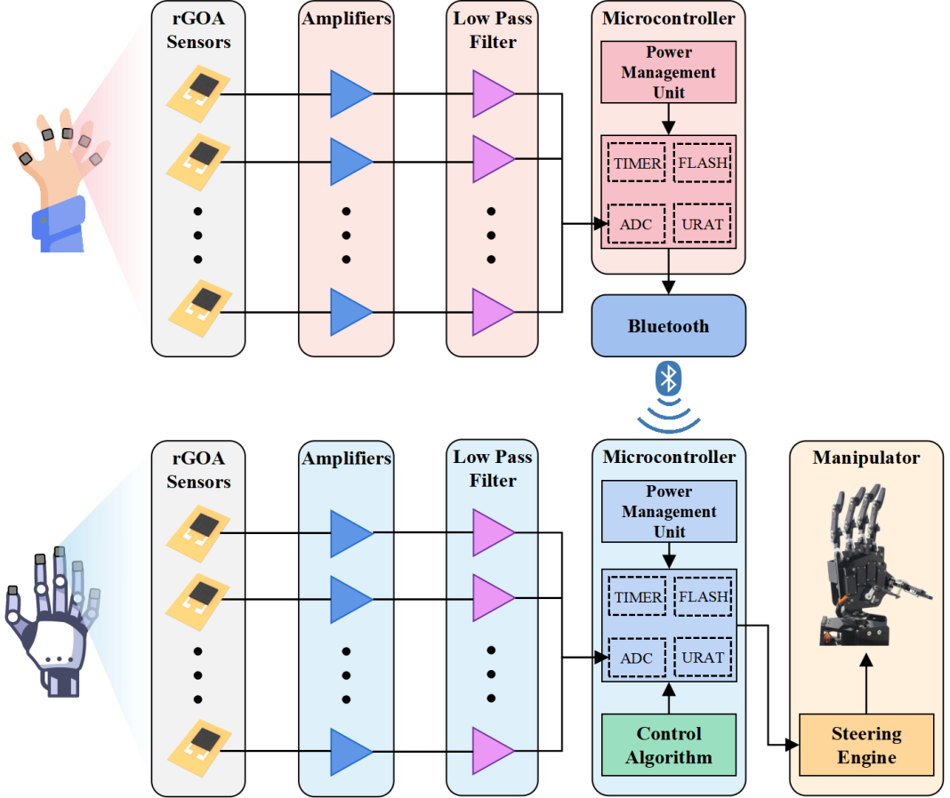
Fig. S41 Schematic diagram showing the control circuit of the manipulator for teleoperation based on force feedback
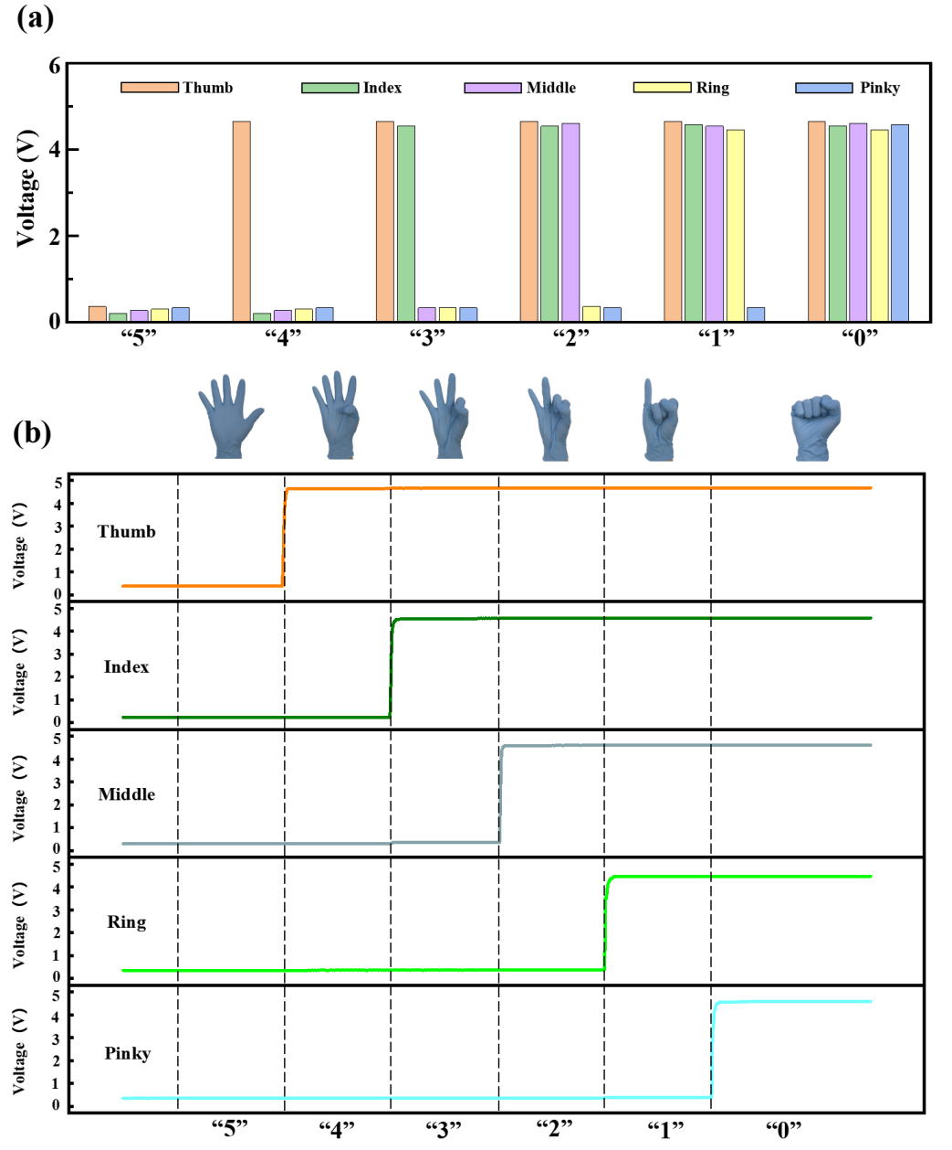
Fig. S42 Voltage responses from the rGOA-based pressure sensors to six gestures: “5”, “4”, “3”, “2”, “1”, and “0”

Fig. S43 Photographs of the PDMS finger pulp
Fig. S44 Comparison between the rGOA-based pressure sensors (a) without and (b) with the finger pulp

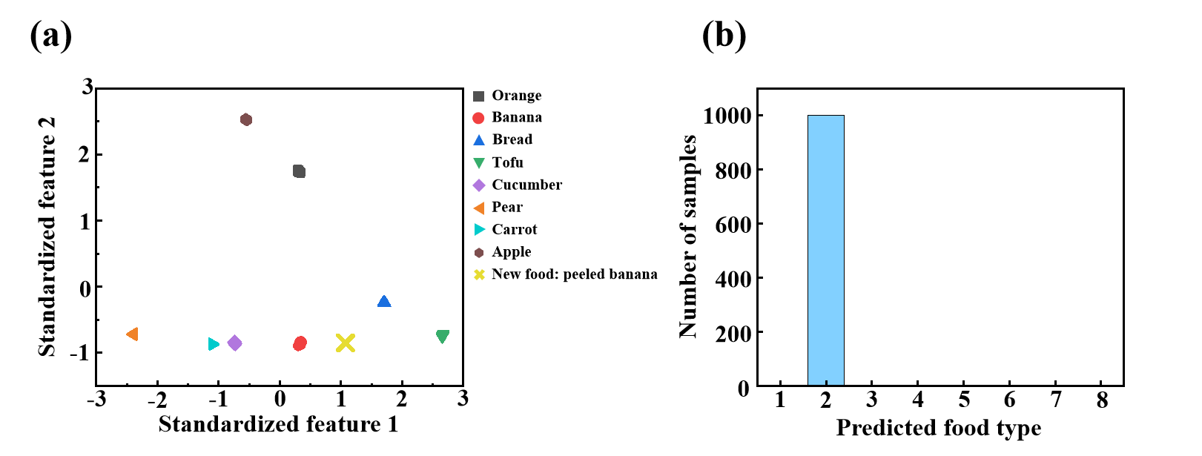
Fig. S45 (a) Two-dimensional visualization of the eight trained food classes and the new unseen food sample of peeled banana in the feature space. Each trained class forms a well-separated cluster. (b) Prediction distribution of the new sample to banana

Table S1 Performance comparison between the rGOA-based and other aerogel-based flexible pressure sensors
Aerogel materials | Sensitivity (kPa⁻¹) | LOD (Pa) | Response/Recovery time (ms) | Cycling performance | Refs.
Poly(ethylene glycol) diacrylate  /amino-functionalized carbon  nanotubes/MXene | 1.42 (0-0.2 kPa)  0.71 (0.12-8.69 kPa)  0.008 (8.69-164.15 kPa) | 40 | 49/42 | 3500 cycles  1 kPa | [S1]
Gradient graphene-aerogel | 19.9 (0.1-1 kPa)  16.3 (1-30 kPa)  29.6 (30-50 kPa) | 100 | 50/230 | 525 cycles  10 kPa | [S2]
Carbonized cotton aerogelelastomer hybrid porous material | 10.25 (0-1 kPa)  8.89 (1-10.53 kPa) | 7.3 | 360/140 | 10000 cycles  50% compression | [S3]
Cotton-like 3D graphene fiber aerogel | 18.55 (0-0.38 kPa)  2.73 (0.38-4 kPa)  0.42 (4-7 kPa) | 2 | 2/44 | 3000 cycles  50% compression | [S4]
Reduced graphene  oxide cross-linked by sustainable-macromolecule-derived carbon | 10.2 (0.75-2.75 kPa) | 13 | -/- | 1000 cycles  2.75 kPa | [S5]
Cellulose sub-micron fibers/carbon black | 0.234 (0-2 kPa)  0.101 (2-3.8 kPa)  0.047 (3.8-6.5 kPa) | 20 | 7.7/12.8 | 1000 cycles  1.5 kPa | [S6]
Anisotropic cross-linked chitosan  and reduced graphene oxide | 9.23 (0-0.5 kPa)  21.36 (0.5-1 kPa)  38.76 (1-2.5 kPa) | 100 | 60/- | 20000 cycles  50% compression | [S7]
3D chitosan/MXene | 709.38 (0-1 kPa)  252.37 (1-20 kPa) | 1.41 | 116/112 | 10000 cycles  1 kPa | [S8]
Cellulose nanofiber/graphene oxide/acrylonitrile  butadiene styrene-derived carbon aerogel | 17.65 (0-0.36 kPa)  3.4 (1.5-3.2 kPa) | 60 | 130/160 | 500 cycles  60% compression | [S9]
Tannic acid/cellulose fibers | 4 (0-0.15 kPa)  1.6 (0.15-1 kPa)  0.6 (1-4 kPa) | 0.8 | 32/30 | 3000 cycles  0.5 kPa | [S10]
Graphene/aramid nanofiber/  polyaniline nanotube | 1.73 (0-0.7 kPa)  0.3 (0.7-7 kPa) | 40 | 240/140 | 3000 cycles  10% compression | [S11]
Cellulose nanofiber/carbon  nanotube/MXene | 817.3 (0-0.2 kPa)  234.9 (0.2-1.5 kPa) | 100 | 74/50 | 2000 cycles  30% compression | [S12]
Graphene oxide/dopamine/polyaniline/nitrogen-doped | 0.10 (0-11.58 kPa) | 0 | -/- | 150 cycles  45% compression | [S13]
1D nanofiber-reinforced 2D pyrrole-reduced graphene oxide | 32.39 (0-30.5 kPa)  12.36 (30.5-65.3 kPa) | - | 280/50 | 10000 cycles  20% compression | [S14]
Graphene oxide/bacterial cellulose | 51.4 (0-3 kPa)  27.8 (3-12 kPa)  5.4 (12-30 kPa) | 20 | ~300/~300 | 200 cycles  18 kPa | [S15]
Graphene-multiwalled carbon nanotubes/polyurethane | 0.1 (0-10 kPa)  0.0035 (10-50 kPa) | 200 | 720/770 | 1000 cycles  10 kPa | [S16]
Reduced graphene oxide aerogel  (rGOA) | 609.960 (0-1 kPa)  238.117 (1-3 kPa)  132.301 (7-10 kPa)  11.395 (10-30 kPa)  3.247 (30-100 kPa) | 1 | 120/40 | 20000 cycles  10 kPa | This work

Table S2 Comparison of the density and max sensitivity between rGOA-based and other aerogel-based flexible pressure sensors.
Density (mg/cm³) | Max sensitivity (kPa⁻¹) | Refs.
13 | 18.55 | [S4]
12 | 1.73 | [S11]
12.2 | 0.1 | [S13]
25 | 128 | [S17]
2.14 | 32.85 | [S18]
3.88 | 0.83 | [S19]
10.9 | 331 | [S20]
10 | 698.96 | This work

Table S3 Performance comparison between the rGOA-based and other flexible piezoresistive sensors
Materials | Sensitivity (kPa⁻¹) | LOD (Pa) | Response/Recovery time (ms) | Cycling performance | Refs.
MXene/cellulose nanofibers (CNFs) | 6.023 (0.11-8.267 kPa)  21.457 (8.267-11.022 kPa)  2.223 (11.022-110.22 kPa) | 110 | 41.84/20.82 | 6000 cycles  16.534 kPa | [S21]
MXene/dot-structured cellulose paper | 39.58 (0-1.01 kPa)  11.95 (1.01-60 kPa) | 2.8 | 93/69 | 10000 cycles  5 kPa | [S22]
MXene/cotton soft tissue | 36.87 (0-1.3 kPa)  11.39 (1.3-60 kPa)  1.25 (60-79 kPa) | 3.7 | 113/81 | 10000 cycles  1.45 kPa | [S23]
MXene/CNFs | 145.5 (0-18 kPa)  25.7 (18-50 kPa) | 320 | 68/40 | 10000 cycles  35.71 kPa | [S24]
Polydimethylsiloxane (PDMS)/carbon nanotube (CNT)/thermoplastic polyurethane /MXene | 82.17 (0-25 kPa) | - | 100/100 | 2000 cycles  ~10 kPa | [S25]
Ag@waffle-structured MXene | 3.04 (0-120 kPa)  1.52 (120-180 kPa)  0.365 (180-300 kPa) | - | 45/30 | 2000 cycles  210 kPa | [S26]
CNTs/carbon black/PDMS conductive sponge | 7.10 (0-25 kPa)  2.96 (25-135 kPa)  1.09 (135-350 kPa) | 10 | 175/165 | 2000 cycles  ~30 kPa | [S27]
CNTs/graphene nanoparticles /PDMS | 38.28 (0-1.5 kPa)  5.75 (1.5-5.8 kPa)  0.79 (5.8-20 kPa) | - | 100/200 | 2000 cycles  ~5 kPa | [S28]
Reduced graphene oxide aerogel  (rGOA) | 609.960 (0-1 kPa)  238.117 (1-3 kPa)  132.301 (7-10 kPa)  11.395 (10-30 kPa)  3.247 (30-100 kPa) | 1 | 120/40 | 20000 cycles  10 kPa | This work

Supplementary References
- J. Huang, H. Liu, Q. Chen, H. Xie, S. Zhou, Shape-programmable lamellar aerogel enabling 3D wireless point-of-care electronics for assistance in pressure injury prevention. Adv. Funct. Mater. 35(13), 2418037 (2025). https://doi.org/10.1002/adfm.202418037
- J. Liu, W. Li, J. Li, K. Wang, Y. Wen et al., Graphene aerogel-based pressure sensors with gradient structure for subtle physiological signals and motion monitoring. Adv. Mater. Technol. 9(10), 2302169 (2024). https://doi.org/10.1002/admt.202302169
- Y. Liu, Z. Zhong, C. Liang, F. Wang, H. Xu et al., Highly compressive aerogel-elastomer hybrid porous material with redistributed strain for high-sensitive soft pressure sensors. Chem. Eng. J. 496, 154069 (2024). https://doi.org/10.1016/j.cej.2024.154069
- T. Yang, C. Ma, C. Lin, J. Wang, W. Qiao et al., Innovative fabrication of ultrasensitive and durable graphene fiber aerogel for flexible pressure sensors. Carbon 229, 119484 (2024). https://doi.org/10.1016/j.carbon.2024.119484
- Z. Zeng, N. Wu, W. Yang, H. Xu, Y. Liao et al., Sustainable-macromolecule-assisted preparation of cross-linked, ultralight, flexible graphene aerogel sensors toward low-frequency strain/pressure to high-frequency vibration sensing. Small 18(24), 2202047 (2022). https://doi.org/10.1002/smll.202202047
- Y. Zhang, P. Zhu, H. Sun, X. Sun, Y. Ye et al., Superelastic cellulose sub-micron fibers/carbon black aerogel for highly sensitive pressure sensing. Small 20(13), e2310038 (2024). https://doi.org/10.1002/smll.202310038
- Y. Wang, Z. Qin, D. Wang, D. Liu, Z. Wang et al., Microstructure-reconfigured graphene oxide aerogel metamaterials for ultrarobust directional sensing at human–machine interfaces. Nano Lett. 24(38), 12000–12009 (2024). https://doi.org/10.1021/acs.nanolett.4c03706
- C. Shang, X. He, X. Li, Z. Liu, Y. Song et al., One 3D aerogel wearable pressure sensor with ultrahigh sensitivity, wide working range, low detection limit for voice recognition and physiological signal monitoring. Sci. China Mater. 66(5), 1911–1922 (2023). https://doi.org/10.1007/s40843-022-2307-6
- D. Liao, Y. Wang, P. Xie, C. Zhang, M. Li et al., A resilient and lightweight cellulose/graphene oxide/polymer-derived multifunctional carbon aerogel generated from Pickering emulsion toward a wearable pressure sensor. J. Colloid Interface Sci. 628(Pt A), 574–587 (2022). https://doi.org/10.1016/j.jcis.2022.07.188
- G. Wang, X. Liu, Z. Song, D. Yu, G. Li et al., Multifunctional flexible pressure sensor based on a cellulose fiber-derived hierarchical carbon aerogel. ACS Appl. Electron. Mater. 5(3), 1581–1591 (2023).
- Y. Zou, Z. Chen, X. Guo, Z. Peng, C. Yu et al., Mechanically robust and elastic graphene/aramid nanofiber/polyaniline nanotube aerogels for pressure sensors. ACS Appl. Mater. Interfaces 14(15), 17858–17868 (2022). https://doi.org/10.1021/acsami.2c02538
- T. Xu, Q. Song, K. Liu, H. Liu, J. Pan et al., Nanocellulose-assisted construction of multifunctional MXene-based aerogels with engineering biomimetic texture for pressure sensor and compressible electrode. Nano-Micro Lett. 15(1), 98 (2023). https://doi.org/10.1007/s40820-023-01073-x
- Z. Deng, C. Gao, S. Feng, H. Zhang, Y. Liu et al., Highly Compressible, Light-Weight and robust Nitrogen-Doped graphene composite aerogel for sensitive pressure sensors. Chem. Eng. J. 471, 144790 (2023). https://doi.org/10.1016/j.cej.2023.144790
- Z. Qin, Z. Wang, D. Li, B. Zhao, Y. Lv et al., Lightweight nanofiber-reinforced pyrrole-reduced graphene oxide aerogel for pressure sensor and oil/water separation material. Adv. Mater. Technol. 8(23), 2300739 (2023). https://doi.org/10.1002/admt.202300739
- J. Sun, K. Xiu, Z. Wang, N. Hu, L. Zhao et al., Multifunctional wearable humidity and pressure sensors based on biocompatible graphene/bacterial cellulose bioaerogel for wireless monitoring and early warning of sleep apnea syndrome. Nano Energy 108, 108215 (2023). https://doi.org/10.1016/j.nanoen.2023.108215
- X.-H. Chen, Z. Tang, F.-M. Li, H.-Q. Li, S.-F. Li et al., Smart and low-cost flexible strain sensor based on graphene-MWCNT porous elastic sponge for home control and object grasping recognition using machine learning. ACS Appl. Electron. Mater. 7(18), 8516–8527 (2025). https://doi.org/10.1021/acsaelm.5c01275
- L. Wang, M. Zhang, B. Yang, J. Tan, X. Ding, Highly compressible, thermally stable, light-weight, and robust aramid nanofibers/Ti(3)AlC(2) MXene composite aerogel for sensitive pressure sensor. ACS Nano 14(8), 10633–10647 (2020). https://doi.org/10.1021/acsnano.0c04888
- Z. Wang, Z. Qin, B. Zhao, H. Zhu, K. Pan, Lightweight, superelastic, and temperature-resistant rGO/polysulfoneamide-based nanofiber composite aerogel for wearable piezoresistive sensors. J. Mater. Chem. C 11(42), 14641–14651 (2023). https://doi.org/10.1039/d3tc02496b
- G. Yang, X. Qin, T. Chen, J. Wang, L. Ma et al., Ultralight, superelastic pure graphene aerogel for piezoresistive sensing application. J. Mater. Sci. 58(2), 850–863 (2023). https://doi.org/10.1007/s10853-022-08113-8
- F. Niu, Z. Qin, L. Min, B. Zhao, Y. Lv et al., Ultralight and hyperelastic nanofiber-reinforced MXene–graphene aerogel for high-performance piezoresistive sensor. Adv. Mater. Technol. 6(11), 2100394 (2021). https://doi.org/10.1002/admt.202100394
- X. Zhang, Y. Wang, L. Zhang, X. Zhang, Y. Guo et al., Facile preparation of porous MXene/cellulose nanofiber composite for highly-sensitive flexible piezoresistive sensors in e-skin. Chem. Eng. J. 505, 159369 (2025). https://doi.org/10.1016/j.cej.2025.159369
- A. Li, J. Xu, S. Zhou, Z. Zhang, D. Cao et al., All-paper-based, flexible, and bio-degradable pressure sensor with high moisture tolerance and breathability through conformally surface coating. Adv. Funct. Mater. 34(52), 2410762 (2024). https://doi.org/10.1002/adfm.202410762
- Li, J. Xu, D. Xu, Z. Zhang, D. Cao et al., High-performance, breathable, and degradable fully cellulose-based sensor for multifunctional human activity monitoring. Chem. Eng. J. 505, 159564 (2025). https://doi.org/10.1016/j.cej.2025.159564
- Y. Cheng, M. Wang, N. Ma, R. Zhang, Z. Cai et al., Nanoscale interlayer engineering enhances MXene-based flexible pressure sensor. Nano Lett. 25(31), 11782–11789 (2025). https://doi.org/10.1021/acs.nanolett.5c01464
- M. Wang, G. Wang, M. Zheng, L. Liu, C. Xu et al., High-performance flexible piezoresistive pressure sensor based on multi-layer interlocking microstructures. J. Mater. Chem. A 12(34), 22931–22944 (2024). https://doi.org/10.1039/D4TA03758H
- H.-W. Zhang, X. Xu, D.-W. Jiang, J. Lu, Y.-S. Wang et al., MXene-integrated printed piezoresistive flexible sensors: a breakthrough in real-time monitoring for medical and smart applications. Adv. Sci. 12(40), e10894 (2025). https://doi.org/10.1002/advs.202510894
- X. Zhao, J. Yang, Y. Zhao, W. Zhai, K. Zhou et al., Flexible pressure sensor based on CNTs/CB/PDMS sponge with porous and microdome structures for sitting posture discrimination. Chem. Eng. J. 502, 157878 (2024). https://doi.org/10.1016/j.cej.2024.157878
- M. Wang, G. Wang, M. Zheng, W. Liu, W. Lv et al., High-performance flexible pressure sensor based on synergistic enhancement of magnetic field oriented carbon Nanotube/Graphene and microdome array structure. Chem. Eng. J. 511, 162053 (2025). https://doi.org/10.1016/j.cej.2025.162053

