Supporting Information for
High Performance Zn-Mn Cement Batteries for the Next Generation of Buildings
Zhaolong Liu¹, Pan Feng^{1,*}, Long Yuan¹, Ruidan Liu¹, Xiangyu Meng¹, Guanghui Tao¹, Jian Chen¹, Zaiping Guo^{2,*} and Changwen Miao^{1,*}
¹ State Key Laboratory of Engineering Materials for Major Infrastructure, Southeast University, Nanjing 210008, P. R. China
² School of Chemical Engineering and Advanced Materials, The University of Adelaid, SA 5005, Australia
*Corresponding authors. E-mail: pan.feng@seu.edu.cn (Pan Feng); zaiping.guo@adelaide.edu.au (Zaiping Guo); mcw@cnjsjk.cn (Changwen Miao)

S1 Supplementary materials and methods

S1.1 Materials
Polyvinylidene difluoride (PVDF) was purchased from AKEMA. Acetylene black was purchased from 3A. N-methylpyrrolidone (NMP) and manganese sulfate (MnSO₄) were purchased from Macklin. Zinc sulfate heptahydrate (ZnSO₄·7H₂O) and sodium dodecyl sulfate (SDS) were purchased from Aladdin. All chemicals were of analytical grade and directly used without further purification.
Zn metal foil with a thickness of 100 μm was purchased from Shanghai Weidi Metal Material Co., Ltd. Aluminum powder (AP) with reactive aluminum content at around 90 wt.% was purchased from LIGUANHUAGONG. The cement used in this study was reference cement (P.Ⅰ 42.5) purchased from Qufu Zhonglian Cement Co., Ltd. The sand was ISO standard sand purchased from Xiamen Aisiou Standard Sand Co., Ltd. Ultrapure water was used in all experiments.

S1.2 Preparation of α-MnO₂ by hydrothermal method
First, 30 mL of 0.1M KMnO₄ solution and 30 mL of 0.15 M MnSO₄ solution were prepared separately and stirred for 1 hour using a magnetic stirrer. The well-stirred KMnO₄ solution was then added dropwise into the MnSO₄ solution under continuous stirring, and the mixture was further stirred for another hour. The resulting solution was transferred into a container, sealed in a hydrothermal reactor, and subjected to hydrothermal treatment at 160 ℃ for 12 hours. The MnO₂ precipitate was collected, thoroughly washed several times with deionized water and anhydrous ethanol, and then dried in an oven at 80 ℃ for 12 hours. Finally, the dried MnO₂ powder was placed in a tube furnace and calcined at 300 ℃ for 1 hour to obtain α-MnO₂ powder.

S1.3 Preparation of α-MnO₂@SSM cathode
First, 0.35 g of α-MnO₂, 0.10 g of acetylene black and 0.05 g of PVDF were weighed and thoroughly ground in a mortar. Next, 1.6 mL of NMP was added, and the mixture was stirred continuously for at least 2 minutes to form a uniform slurry. The slurry was then drop-coated onto a stainless steel mesh (SSM, #304 with a mesh size of 74 μm) to form a film with a thickness of approximately 20 μm. The coated mesh was dried in an oven at 60 ℃ for 12 hours, yielding the α-MnO₂ cathode with an average mass loading of ~1.12 mg cm⁻².

S1.4 Preparation of cement-based separators
First, 140 g of ultrapure water was weighed, and 0.03 g of SDS was dissolved in it by continuous stirring. Meanwhile, 200 g of cement and 200 g of sand were blended in a mixing pot. The SDS solution was then added to the dry mixture and stirred slowly for 30 s, followed by rapid mixing for 1.5 min. Subsequently, 0.2 g of AP (0.1 wt% of cement) was added to the slurry and mixed rapidly for an additional 1.5 min.
A portion of the resulting slurry was poured into cubic stainless steel molds (20 mm × 20 mm × 20 mm) for specimens intended for mechanical property testing. The remaining slurry was cast into cylindrical PTFE molds (radius: 12 mm, depth: 4 mm) for electrochemical testing. All specimens with molds were cured for 24 h at 20 ℃ and 90% relative humidity. After curing, excess mortar was trimmed with a knife to ensure a smooth surface.
The specimens were then demolded and dried in a vacuum oven at 45 ℃ for 3 days. Following drying, the specimens were immersed in an electrolyte solution at a liquid-to-solid ratio of 50:1, then subjected to vacuum impregnation. The electrolyte after soaking was subsequently used for electrochemical testing, ensuring consistency between the impregnated ACS and the testing electrolyte.

S1.5 Measurement of compressive strength
To enhance the efficiency and uniformity of vacuum electrolyte impregnation, specimens with dimensions of 20 mm × 20 mm × 20 mm were used for compressive strength testing after soaking in the electrolyte. Tests were conducted using UTM5105 microcomputer-controlled electronic universal testing machine at a loading rate of 0.5 mm min⁻¹. The maximum load P_{max} was recorded and used to calculate the compressive strength CS (MPa) according to:
$$CS=\frac{P_{max}}{A_{cub}}$$
where P_{max} is the maximum load applied during the test (N), and A_{cub} is the loaded surface area of the specimen (mm²). In this study, A_{cub} =40 mm². Each test was repeated three times per group, and the reported compressive strength is the average of the three measurements.

S1.6 Measurement of ionic conductivity
Cylinder mortar specimens were used to measure ionic conductivity. Before testing, the cement-based specimen (served as a separator) was positioned between two stainless steel foils, each 20 μm thick. Electrochemical impedance spectroscopy (EIS) measurements were conducted on the assembled device under open-circuit voltage conditions. The recorded data were used to calculate the ionic conductivity IC (mS cm⁻¹) using the equation:
$$IC=\frac{1000d_{cy}}{R_{s}A_{ss}}$$
where d_{cy} is the thickness of the cement-based separator (cm), R_{s} is the solution resistance (Ω), and A_{ss} is the surface area of the stainless steel foil (cm²). In this study, d_{cy}=0.4 cm and A_{ss} =1.13 cm². Each test was repeated three times per group, and the reported values represent the average of the three measurements.

S1.7 Fabrication of structural energy storage devices
First, the zinc foil anode and α-MnO₂@SSM cathode were each connected to tabs using conductive tape. A cement-based separator was placed between the two electrodes, after which the assembled electrodes and separator were hermetically sealed in an acrylic enclosure with the pre-soaked electrolyte at a liquid-to-solid ratio of 50:1.

S1.8 Preparation of 100 cm² energy storage devices
An 11 cm × 11 cm × 0.5 cm cement-based separator containing 0.1 wt.% AP was prepared following the same procedure mentioned above. Both the α-MnO₂@SSM cathode and zinc foil anode had an effective area of 10 cm × 10 cm, with extended sections serving as current tabs. For visual observation, the assembled device was sealed in a 12 cm × 12 cm × 0.8 cm acrylic enclosure using self-adhesive silicone waterstop. Alternatively, for experiments requiring direct force transmission, the pre-assembled device was encapsulated in polyolefin shrink film using a heat-sealing process.

S1.9 Preparation of energy storage bricks
An in-situ cast aerated cement-based brick (24 cm × 12 cm × 7 cm) was prepared following the procedure mentioned above. The electrodes were identical to those in Section S1. 8. After positioning and fixing the electrodes, fresh aerated cement mortar was poured into the mold, filling the spaces between electrodes. The assembled energy storage brick was then sealed with epoxy resin on all sides except the upper surface, allowing for electrolyte infiltration. Following a 14-day vacuum curing in electrolyte, the upper surface was finally sealed by anti-salt glue.

S2 Supplementary Figures
Fig. S1 Ionic conductivity and pH of 2M ZnSO₄ solution with different MnSO₄ concentrations
Fig. S2 Element components for different groups via XRF

Fig. S3 XRD patterns of cement-based separators soaked in ZnSO₄ solutions with varying MnSO₄ concentrations

Fig. S4 Semi-quantitative XRD analysis results of the “M0-7d” and “M20-7d” groups
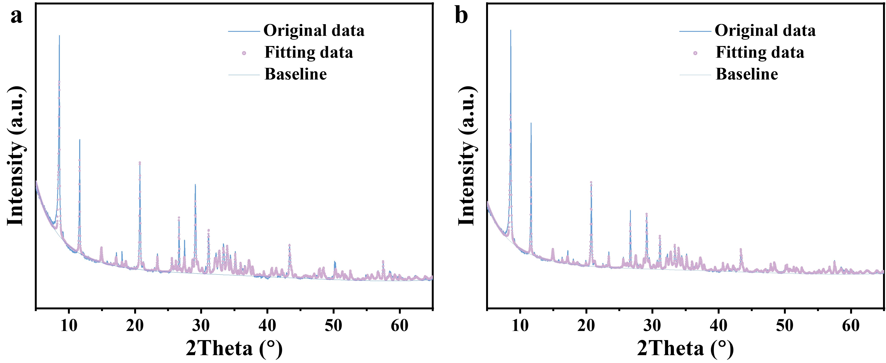
Fig. S5 XRD fitting profiles of a the “M0-7d” group and b the “M20-7d” group

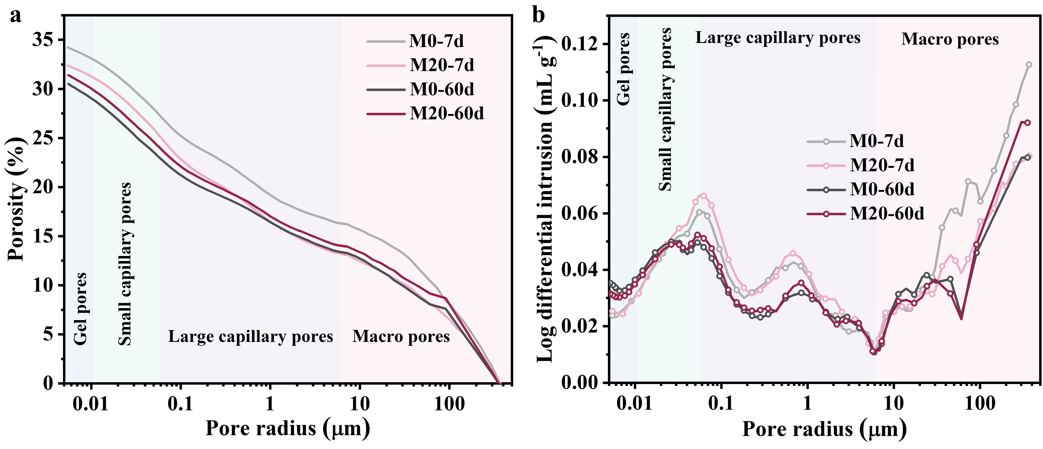
Fig. S6 Pore size distribution of various groups measured by MIP. a Cumulative porosity curves. b Log-differential intrusion curves. Pores are categorized as gel pores (0.005-0.01μm), small capillary pores (0.01-0.05μm), large capillary pores (0.05-5μm) and macro pores (>5μm)

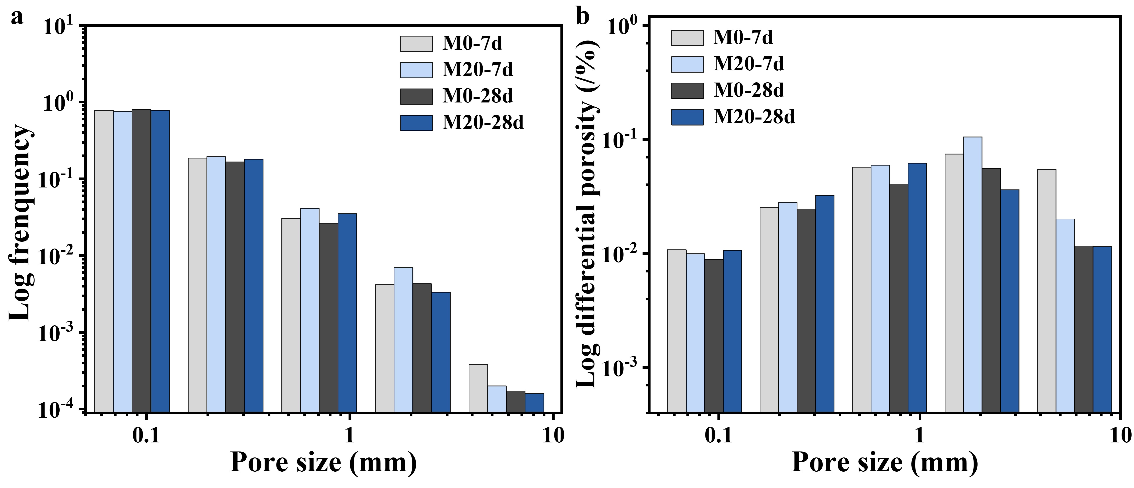
Fig. S7 Statistical analysis of pore size distribution in various groups via X-CT. a Frequency distribution of pore sizes. b Porosity distribution of different pore sizes
Fig. S8 Evolution of electrolyte pH with soaking time

Fig. S9 Synthesis process of α-MnO₂ via hydrothermal method

Fig. S10 XRD pattern of the synthesized α-MnO₂
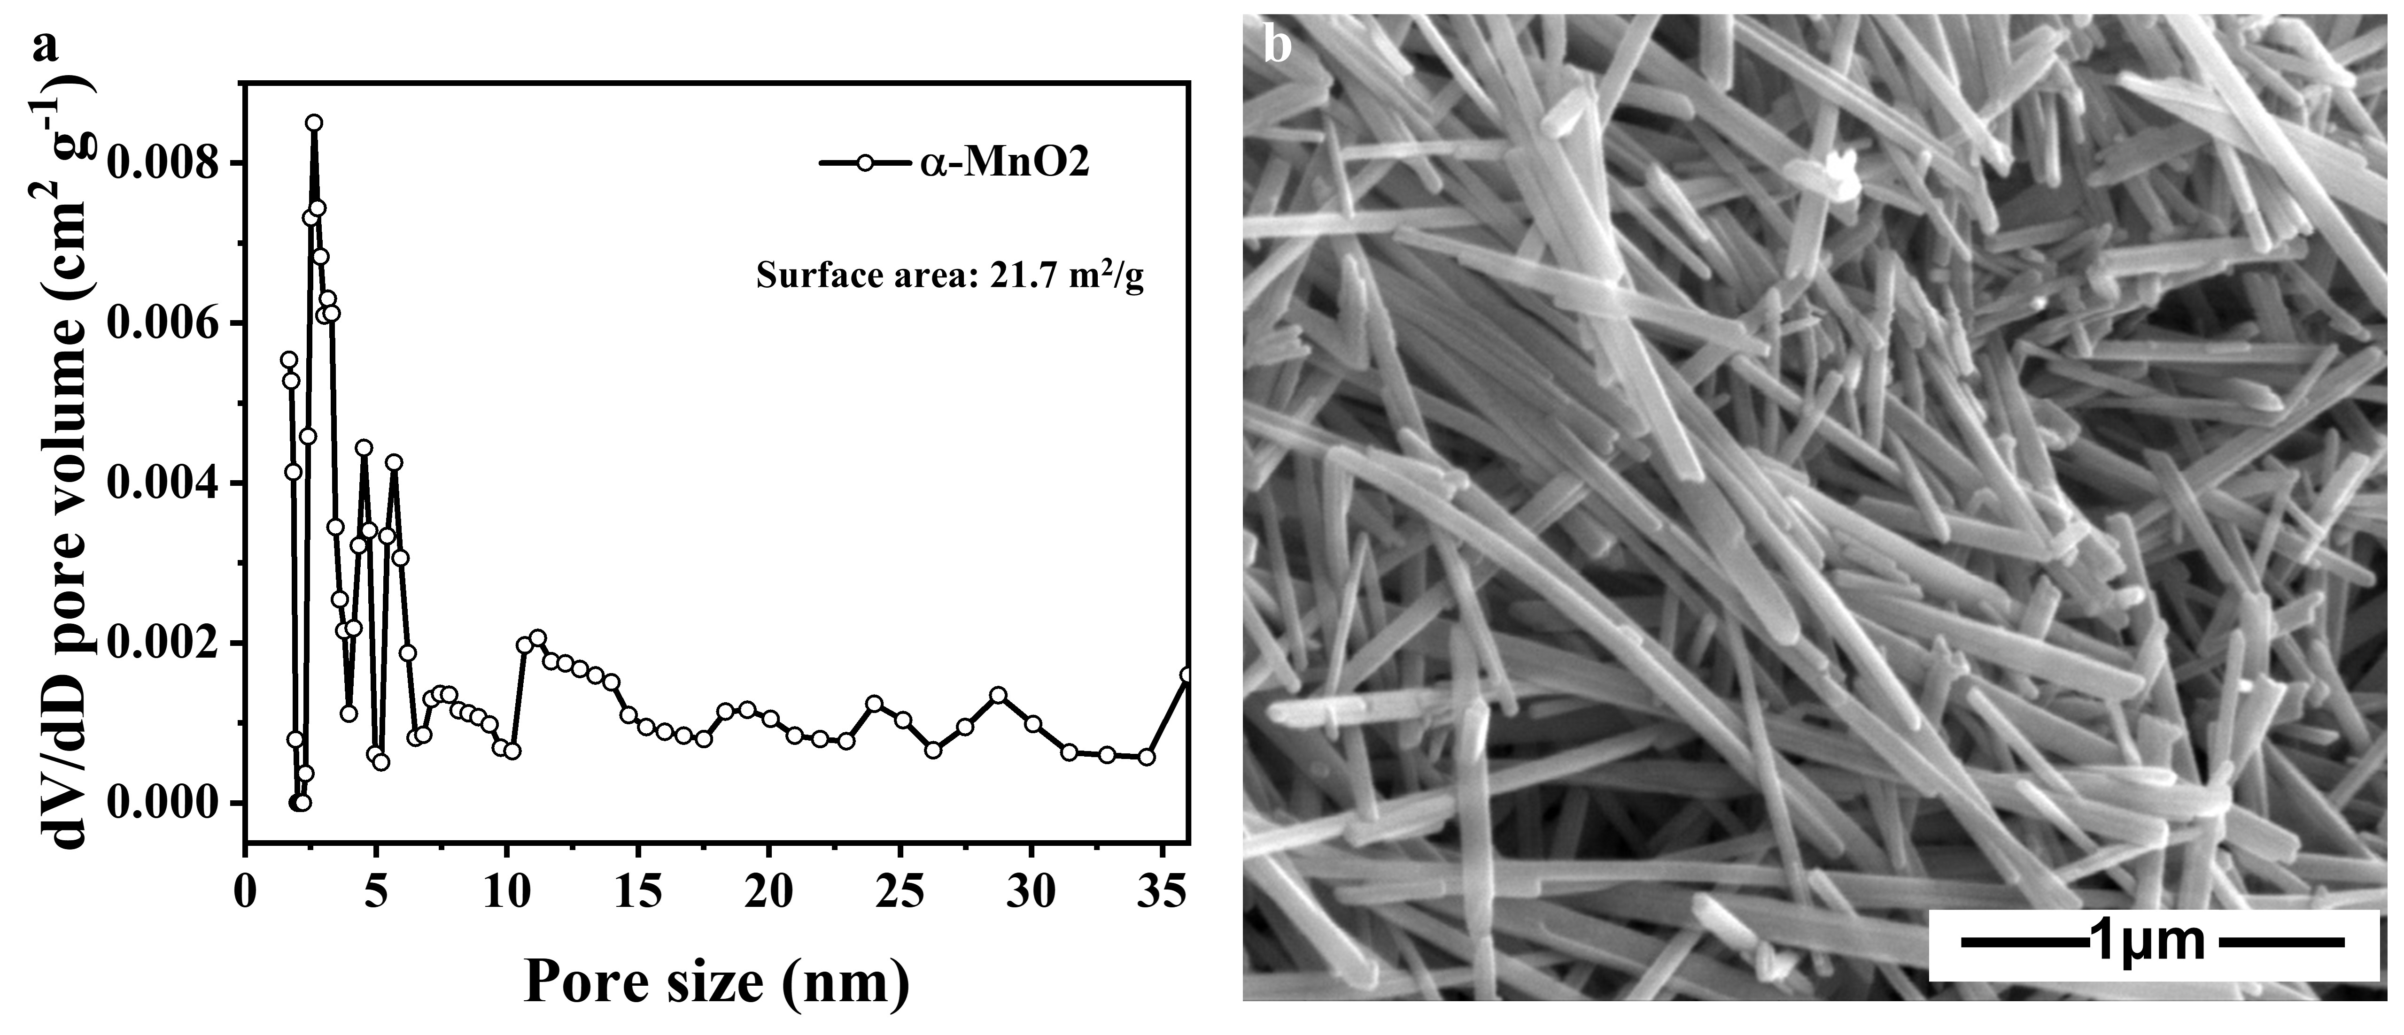
Fig. S11 Characterization of the synthesized α-MnO₂. a Pore size distribution derived from N₂ adsorption-desorption isotherms, with a measured surface area of 21.7m² g⁻¹. b Morphology observed by SEM
Fig. S12 Evolution of specific capacity during the capacity gaining process with different initial MnO₂ loadings
As the loading mass increases, the areal capacity increases accordingly whereas the specific capacity decreases. To balance cost-effectiveness and material utilization efficiency, a loading of 1.12 mg cm⁻² was ultimately chosen as the optimal condition for electrochemical performance characterization.
Fig. S13 Specific capacity evolution during the capacity gaining process for ACSs subjected to different soaking times
With prolonged soaking time, the gained capacity of structural battery within 10 cycles increases gradually, while the growth rate slows and eventually stabilizes. Based on a balance between electrochemical performance and experimental efficiency, a soaking time of 14 days was selected for all samples.
Fig. S14 CV curves of different groups using various separators at a scan rate of 1 mV s⁻¹
The redox peaks in the CV curves exhibit apparent shifts and distortions at higher scan rates, which can be attributed to severe polarization effects caused by the relatively high internal resistance of the ACSs.
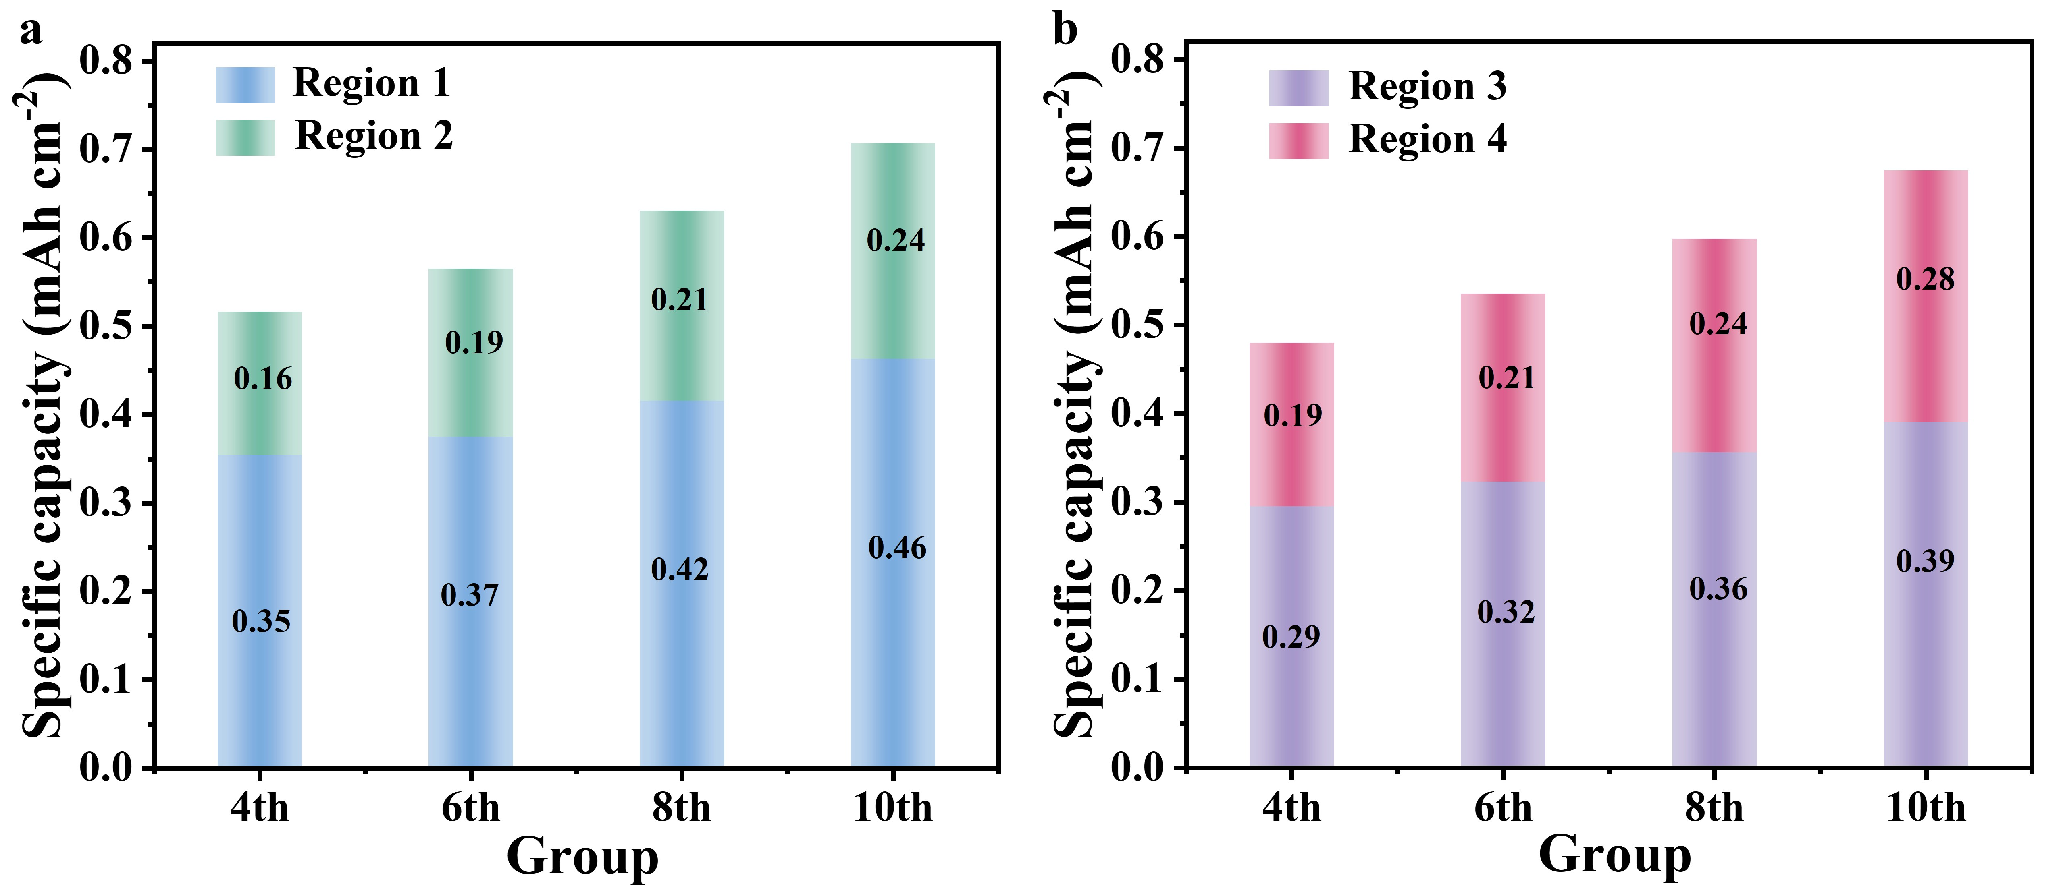
Fig. S15 Specific capacity contributions of different regions at various activation cycles during a the discharge stage and b the charge stage
Fig. S16 Comparison of charge/discharge curves of M20 group and CS group at the 10th cycle
Fig. S17 Nyquist profiles of structural Zn-Mn batteries with different MnSO₄ concentrations before activation
Fig. S18 Comparation of CV curves for CS group and M20 group at a scan rate of 0.1 mV s⁻¹

Fig. S19 Specific capacity of the M20 group with continuous cycling at 0.2 A g⁻¹
Fig. S20 Energy densities versus power densities for the M20 group

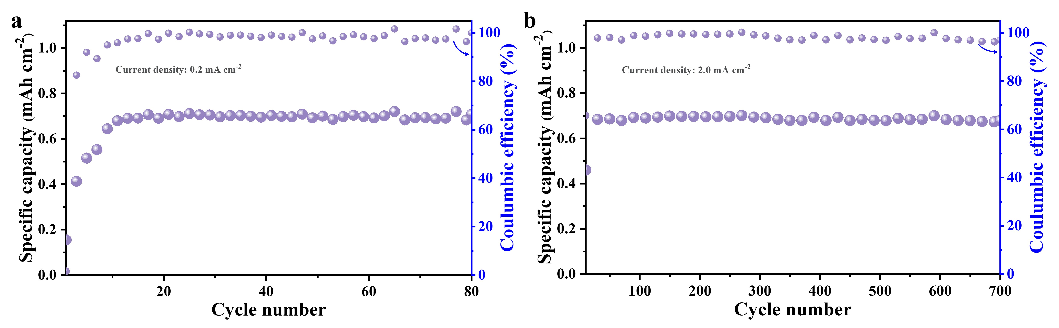
Fig. S21 Long-term cycling performance of M20 group at a 0.2 mA cm⁻² and at b 2 mA cm⁻²

Fig. S22 Polarization voltage during Zn plating/stripping at a current density of 1.0 mA cm⁻² and a capacity of 0.5 mAh cm⁻²
Fig. S23 LSV curves of the CS and M20 groups

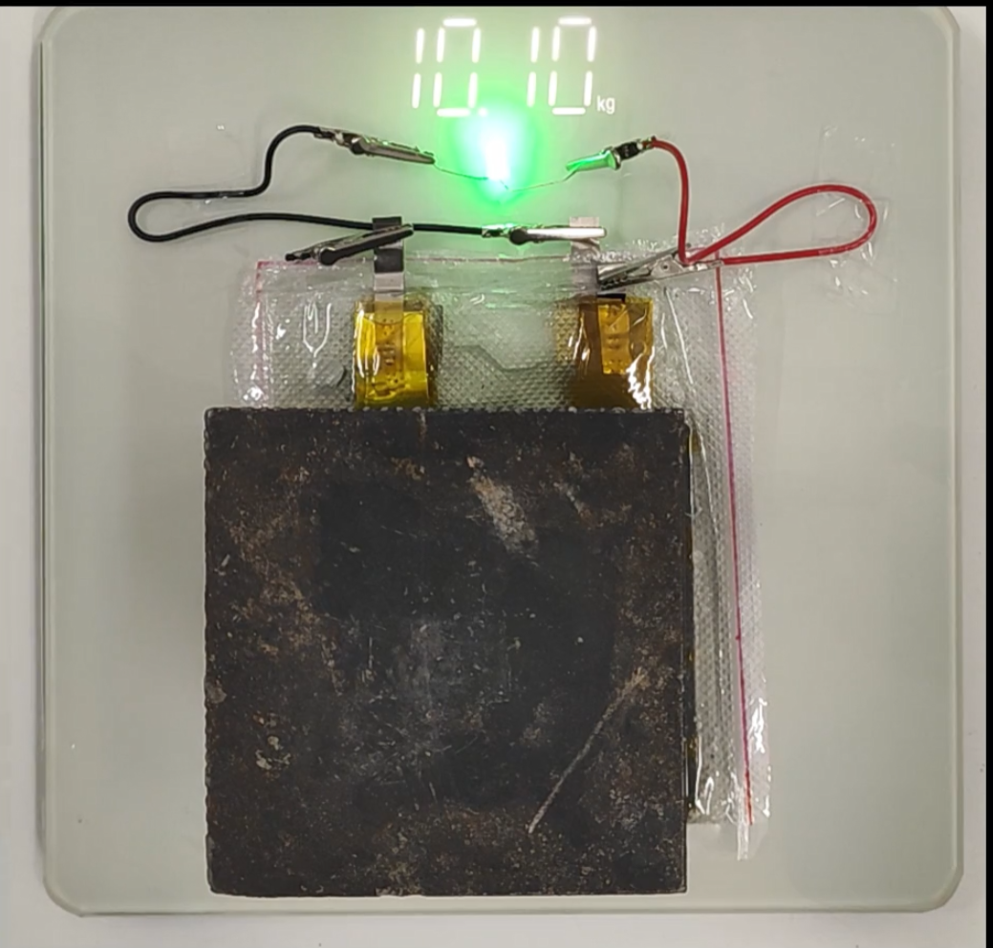
Fig. S24 Photograph of two tandemly connected 100 cm² devices illuminating a green light-emitting diode under compressive load

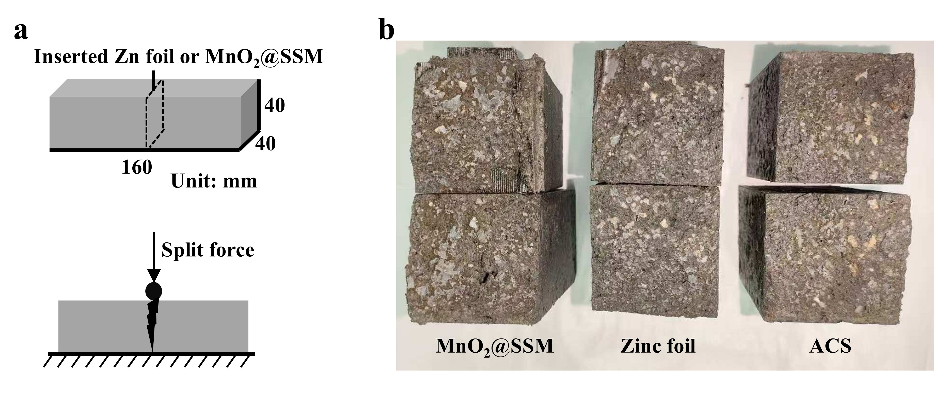
Fig. S25 a Schematic diagram of splitting test. b Schematic diagram of the specimens cross-section after splitting
Fig. S26 Splitting force of specimens containing different electrodes

Fig. S27 Photography of cathodes and ACMs after different activation cycles

Fig. S28 Fitted relationship between capacity and cathode mass obtained across different activation cycles
Fig. S29 Evolution of areal capacity of the M20 group with an SSM cathode during the activation process
Fig. S30 In-situ Raman spectra of the M20 group with an SSM cathode during the first charging process
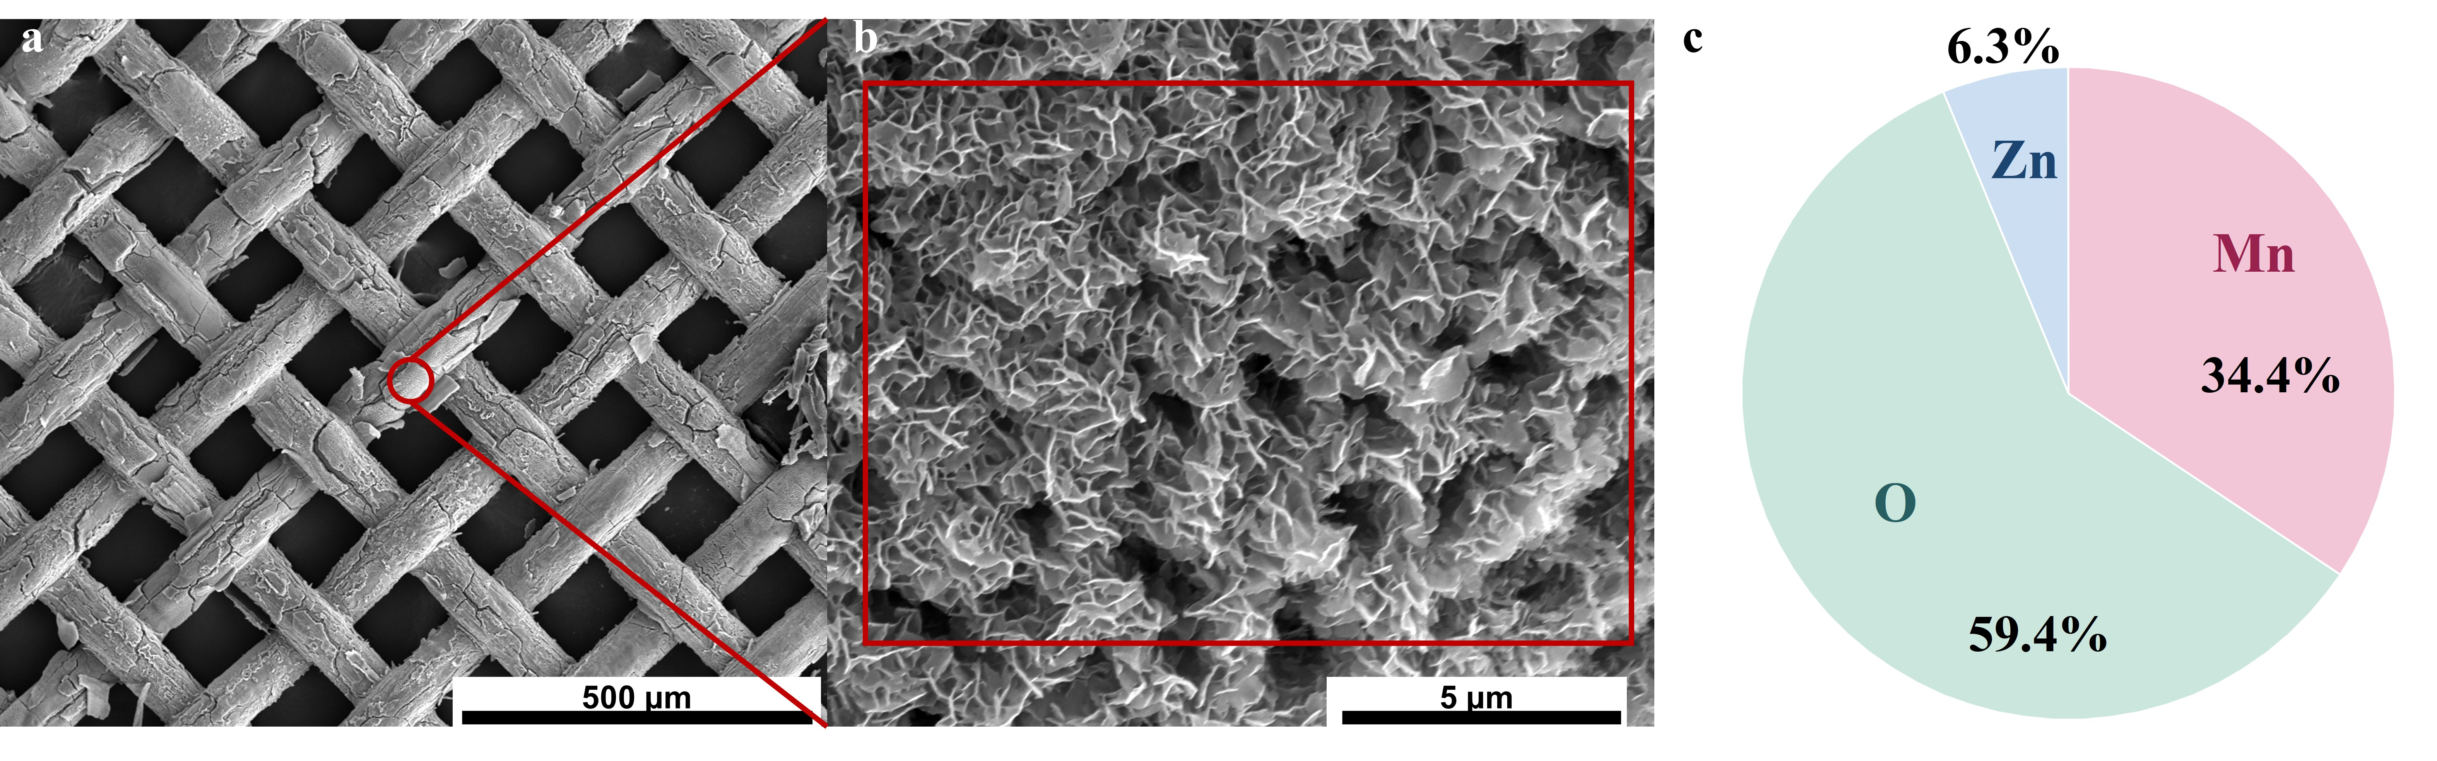
Fig. S31 SEM images of the SSM cathode from the M20 group after activation, at a 250×, and b 20000× magnifications. c Element composition of selected aera obtained from EDS mapping
Fig. S32 XRD pattern of the SSM cathode obtained from M20 group after activation

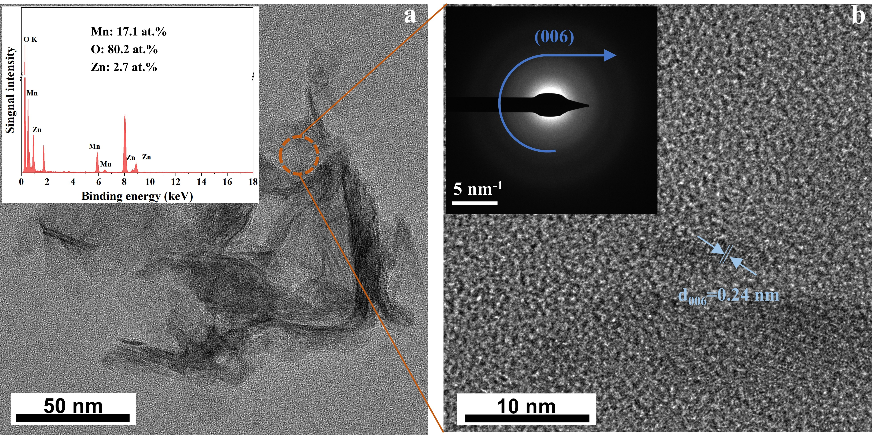
Fig. S33 a TEM image of the new phase on the surface of SSM cathode obtained from M20 group after activation, with corresponding EDS point-scan analysis. b High-resolution TEM image and the corresponding SEAD pattern

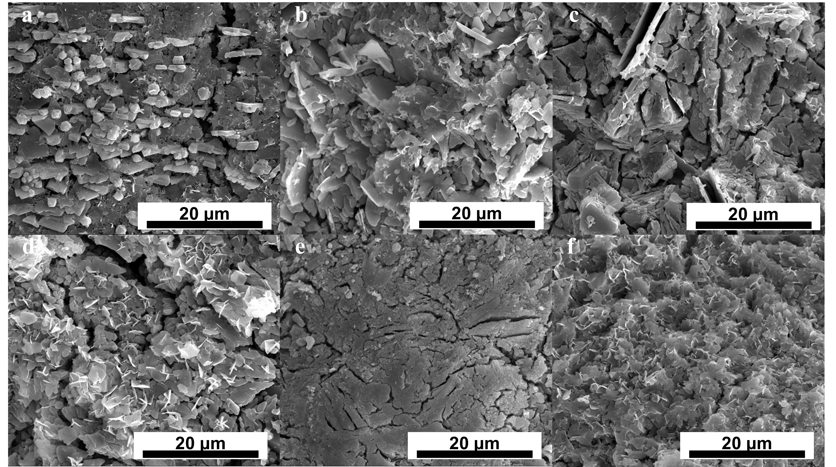
Fig. S34 SEM images of ACSs from the M20 group at different states: a pristine, b after the 1st full discharge, c after the 2nd full charge, d after the 2nd full discharge, e after the 5th full charge, f after the 5th full discharge
Fig. S35 SEM images of cathodes from the M20 group at different stages a-g during the charge-discharge process, as indicated in the corresponding schematic

Fig. S36 XRD patterns of cathodes from the M20 group at (a)-(g) stages

Fig. S37 LSV curves of CS and ACS group at a scan rate of 0.2 mV s⁻¹
Fig. S38 XRD patterns of cathodes from the M20 group at different activation cycles
Fig. S39 XRD patterns of the SSM cathode from the M20 group after activation at stages Ⅰ-Ⅵ
Fig. S40 Specific capacity evolution during capacity-gaining process for groups using CS, ACS, and CS with ACS placed away from the electrodes in the electrolyte

S3 Supplementary discussion

Note on the Charge/Discharge Mechanism in Fig. 5b, c
To further elucidate the specific charge/discharge mechanism of the birnessite-MnO₂, XRD patterns of the SSM cathode (without α-MnO₂) from the M20 group after activation were collected at stages Ⅰ-Ⅵ (same state in Fig. 5b). In this case, the precipitation of birnessite-MnO₂ still occurs, allowing its role to be specifically examined. Similar to the scenario where the cathode contains α-MnO₂, the formation of ZnMn₂O₄ confirms the intercalation/deintercalation of Zn²⁺ during the discharge/charge process when only birnessite-MnO₂ is present (Fig. S39). Moreover, the process is accompanied by the deposition and dissolution of ZSH, indicating that H⁺-involved reactions also take place in the cathode containing only birnessite-MnO₂.

