Supporting Information for
Polyphenol-Gated Composite Electrolytes with Enhanced Cross-Phase Lithium-Ion Transport for Solid-State Lithium Batteries
Xiaoxiao Li¹, Minqiang Jiang¹, Kai Chen¹, Zhixiang Cai¹, Yingxin Zhang¹, Jiamei Luo¹, Lei Hou², Yazhou Zhou³, Chao Zhang¹, Hui Zhang¹*, Feili Lai^{4,5}*, Yue-E Miao¹*, Tianxi Liu^{1,6} and Klaus Müllen^{3,7}
¹State Key Laboratory of Advanced Fiber Materials, College of Materials Science and Engineering, Donghua University, 2999 North Renmin Road, Shanghai 201620, P. R. China
²State Key Laboratory of Advanced Fiber Materials, College of Chemistry and Chemical Engineering, Donghua University, 2999 North Renmin Road, Shanghai 201620, P. R. China
³Nanotechnology Centre, Centre for Energy and Environmental Technologies, VŠB–Technical University of Ostrava, 17. listopadu 2172/15, Ostrava-Poruba 70800, Czech Republic
⁴Department of Chemistry, KU Leuven, Celestijnenlaan 200F, Leuven 3001, Belgium
⁵State Key Laboratory of Metal Matrix Composites, School of Materials Science and Engineering, Shanghai Jiao Tong University, Shanghai 200240, P. R. China
⁶Key Laboratory of Synthetic and Biological Colloids, Ministry of Education, School of Chemical and Material Engineering, Jiangnan University, Wuxi, 214122, P. R. China
⁷Department of Molecular Spectroscopy, Max Planck Institute for Polymer Research, Ackermannweg 10, Mainz 55128, Germany
*Corresponding authors. E-mail: zhanghui@dhu.edu.cn (Hui Zhang); feililai@sjtu.edu.cn (Feili Lai); yuee_miao@dhu.edu.cn (Yue-E Miao)
S1 Supplementary Figures and Tables
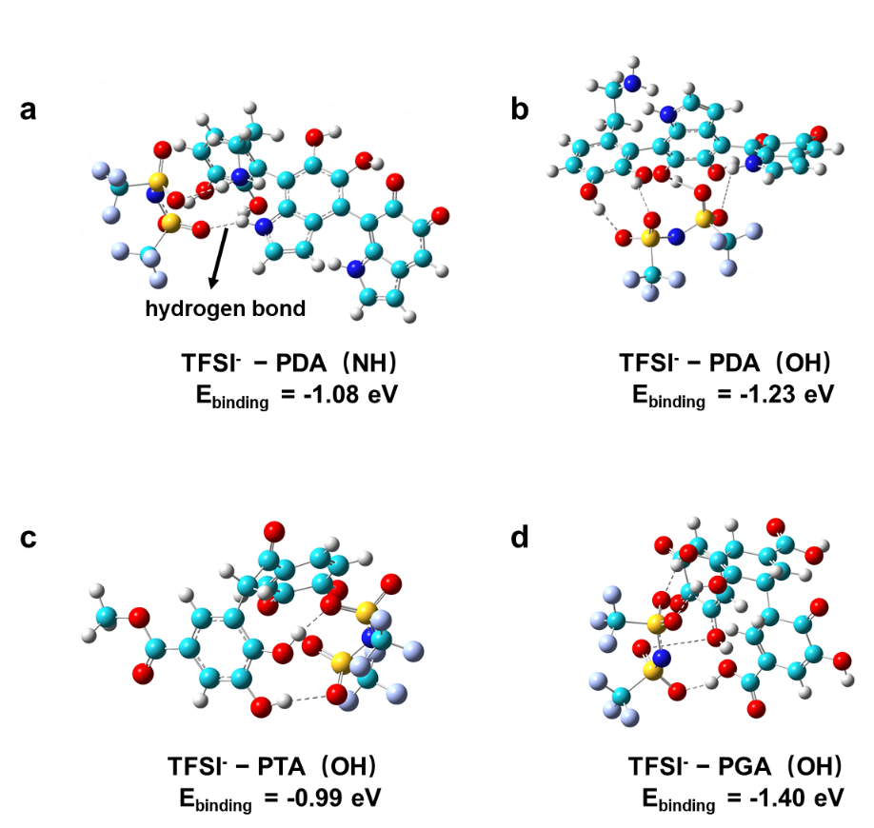
Fig. S1 DFT-calculated binding energies between TFSI⁻ anion and the polar groups in a, b PDA, c PTA and d PGA, respectively

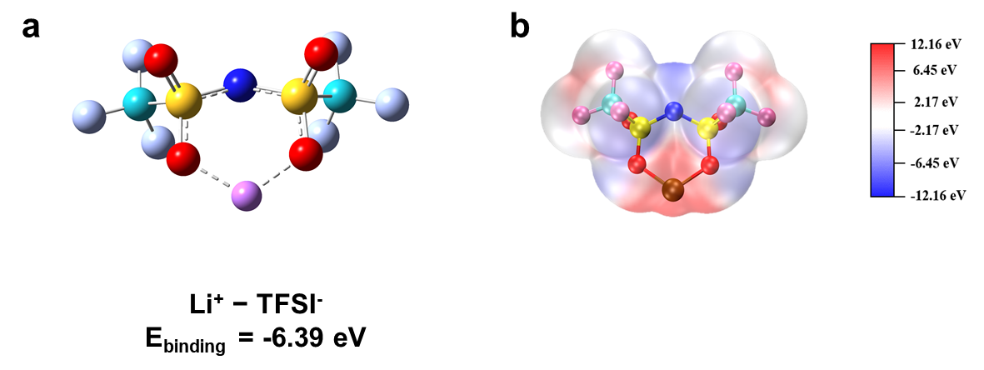
Fig. S2 a Optimized geometrical configurations and binding energies between Li⁺ and TFSI⁻ calculated by DFT. b ESP map of the Li⁺-TFSI⁻ solvation structure

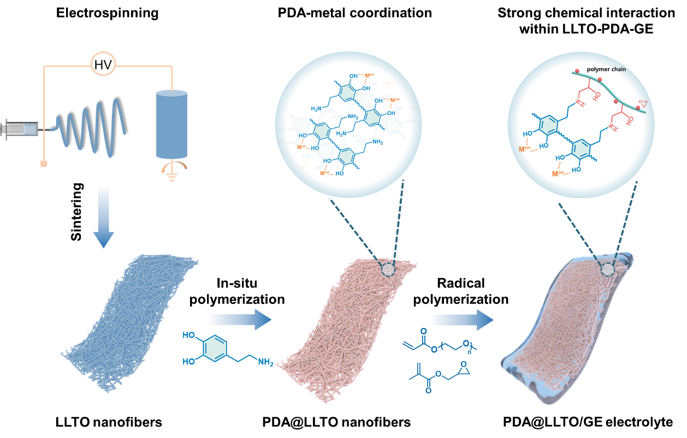
Fig. S3 Schematic illustration of the preparation process for the PDA@LLTO/GE electrolyte

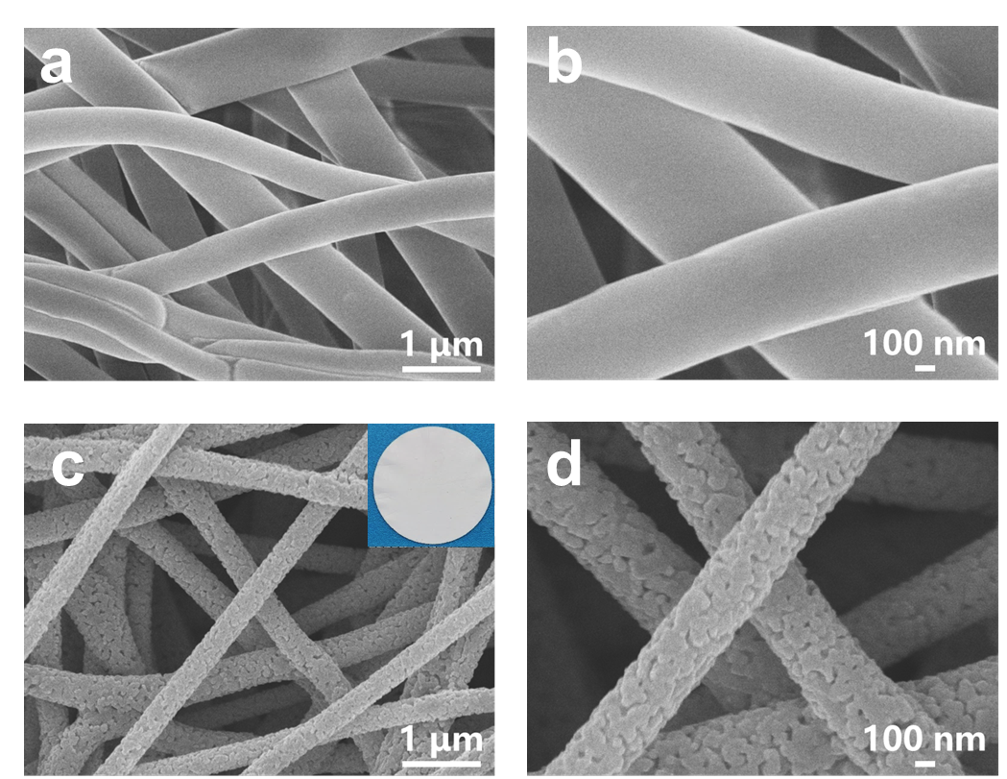
Fig. S4 SEM images of a, b p-LLTO nanofibers, and c, d LLTO nanofibers. The inset in c shows a digital photograph of the LLTO membrane
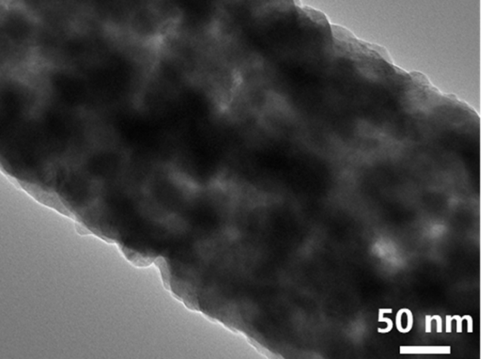
Fig. S5 TEM image of LLTO nanofiber

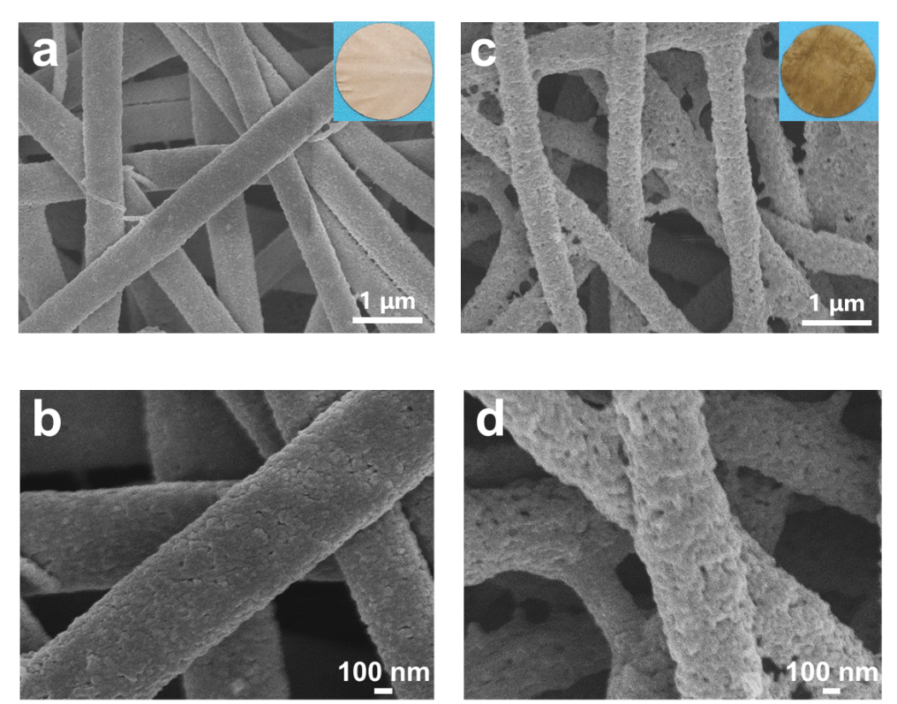
Fig. S6 SEM images of PDA_{x}@LLTO nanofibers with different DA concentrations of a, b 0.5 mg mL⁻¹ and c, d 4 mg mL⁻¹. The insets in a and c show the corresponding digital photographs

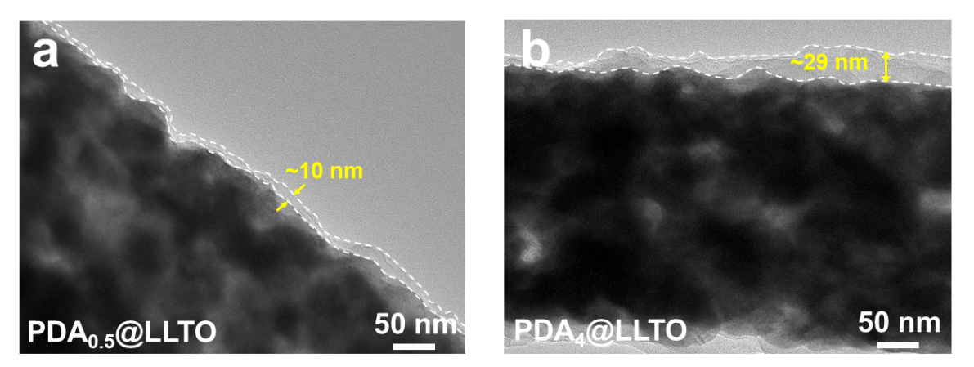
Fig. S7 TEM images of a PDA_{0.5}@LLTO, and b PDA₄@LLTO nanofibers
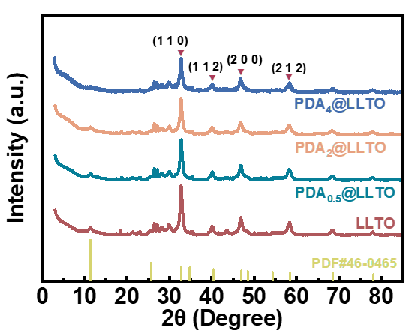
Fig. S8 XRD patterns of LLTO and PDA_{x}@LLTO membranes
Fig. S9 High-resolution La 3d XPS spectra of LLTO and PDA₂@LLTO membranes
Fig. S10 TGA curves of LLTO/GE and PDA_{x}@LLTO/GE electrolytes
Fig. S11 DSC curves of LLTO/GE and PDA_{x}@LLTO/GE electrolytes

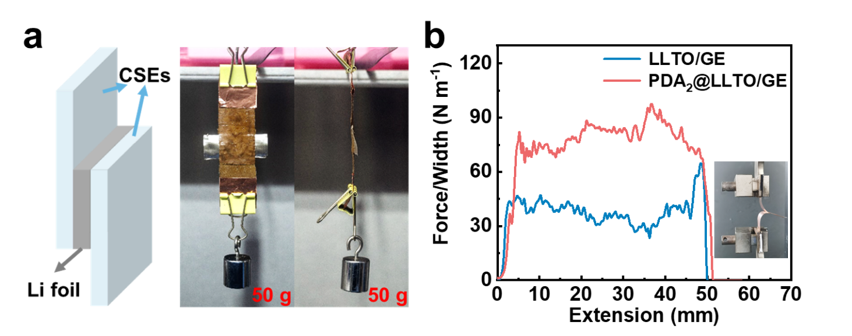
Fig. S12 a Digital photographs of the PDA₂@LLTO/GE electrolyte holding a 50 g weight while adhered to a Li metal foil. b The interfacial adhesion comparison between LLTO/GE and PDA₂@LLTO/GE electrolytes
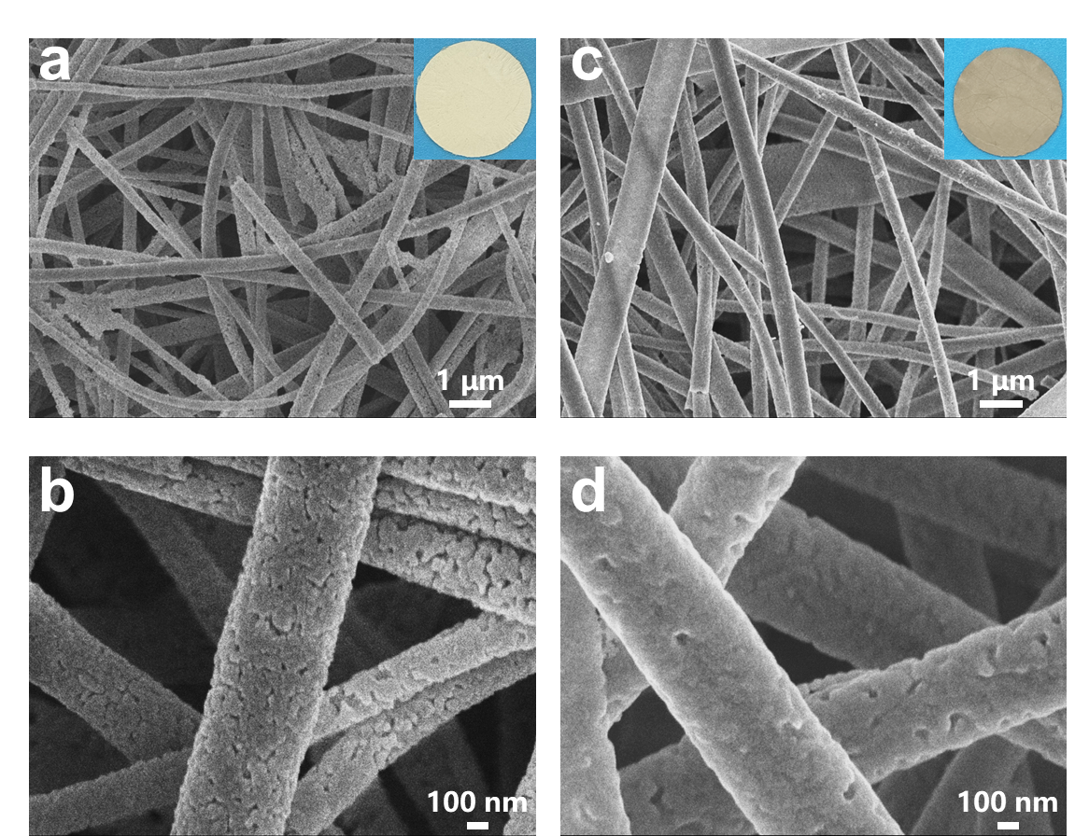
Fig. S13 SEM images of a, b PTA₂@LLTO and c, d PGA₂@LLTO nanofibers. The insets in a and c show the corresponding digital images
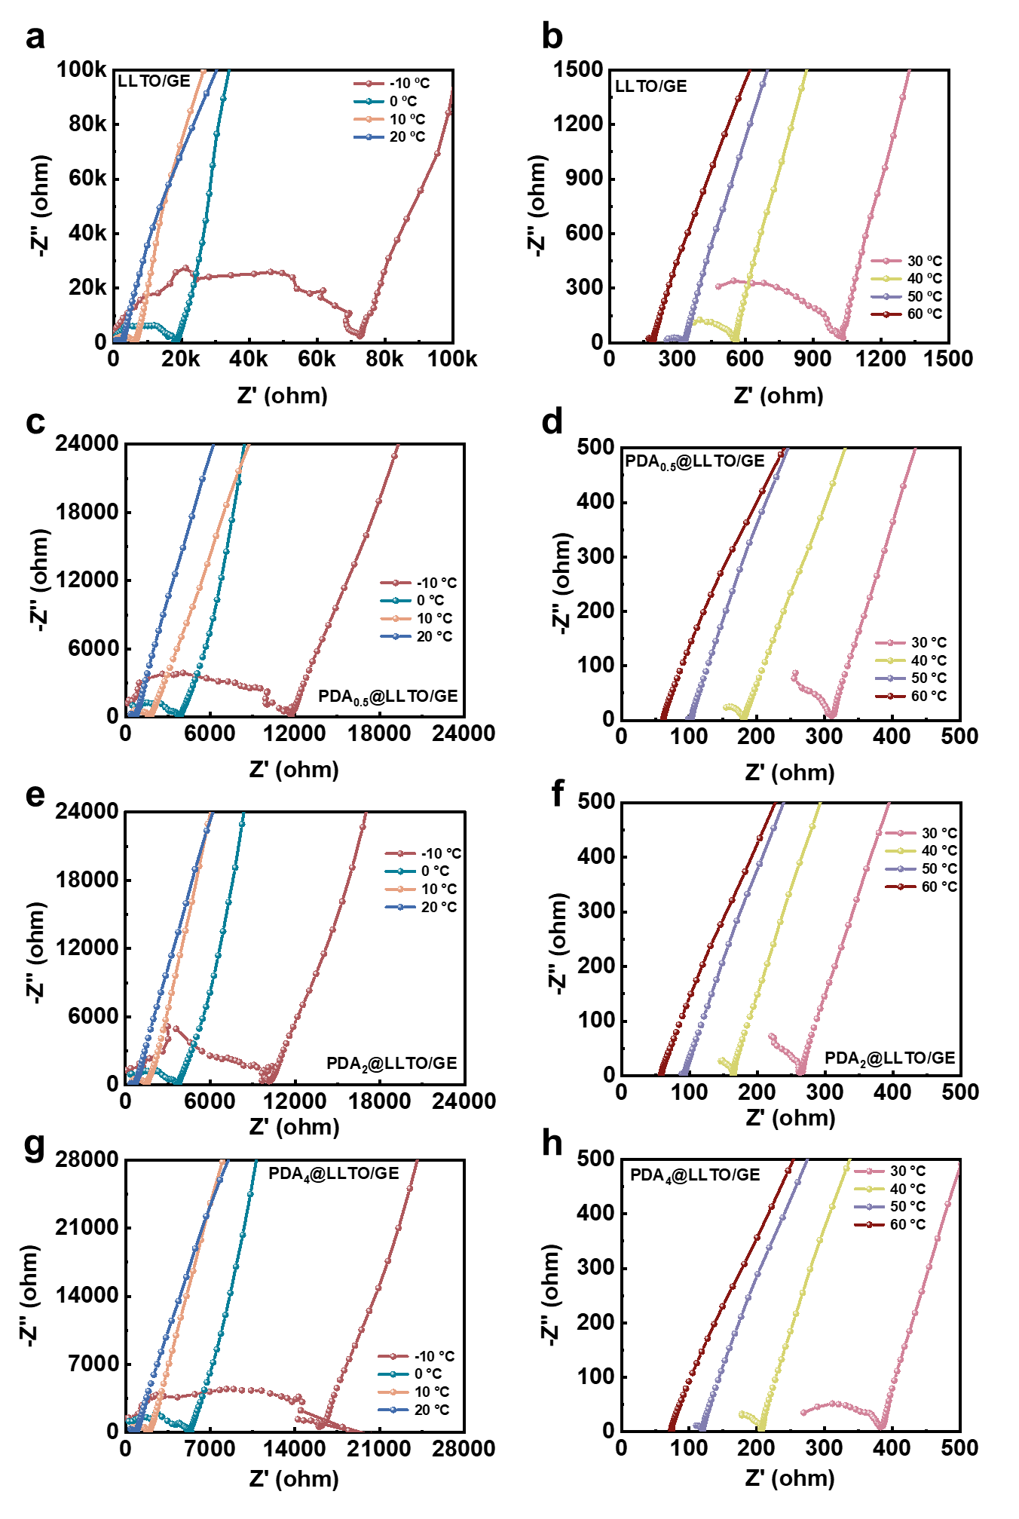
Fig. S14 EIS spectra of a, b LLTO/GE, and c-h PDA_{x}@LLTO/GE electrolytes at different temperature ranging from –10 to 60 ℃

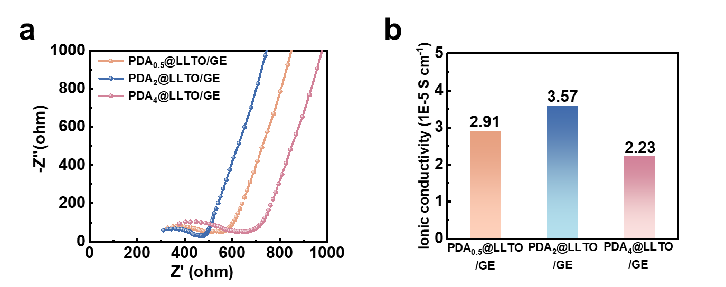
Fig. S15 a EIS spectra of PDA_{x}@LLTO/GE electrolytes at room temperature. b The corresponding ionic conductivities of the electrolytes
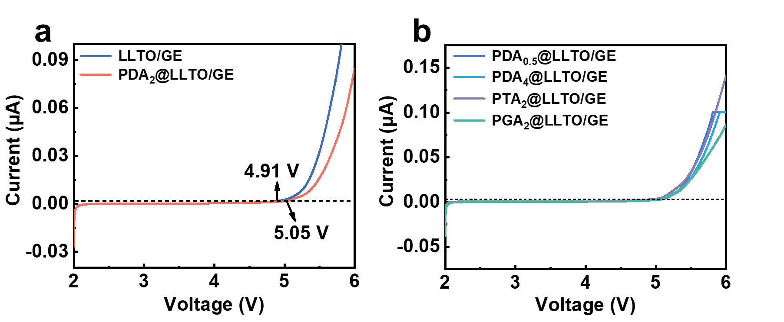
Fig. S16 LSV curves of different electrolytes
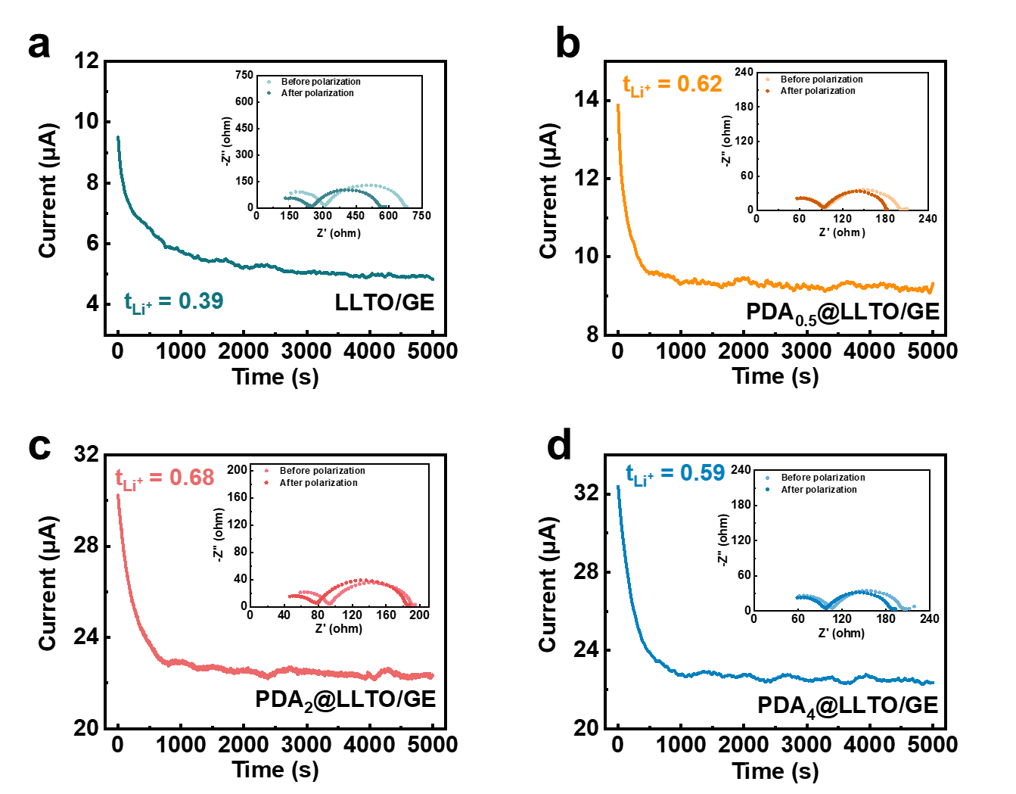
Fig. S17 Chronoamperometry curves of cells at 60 ℃ using a LLTO/GE, and b-d PDA_{x}@LLTO/GE electrolytes under a step voltage of 10 mV. Insets display the corresponding EIS plots before and after polarization
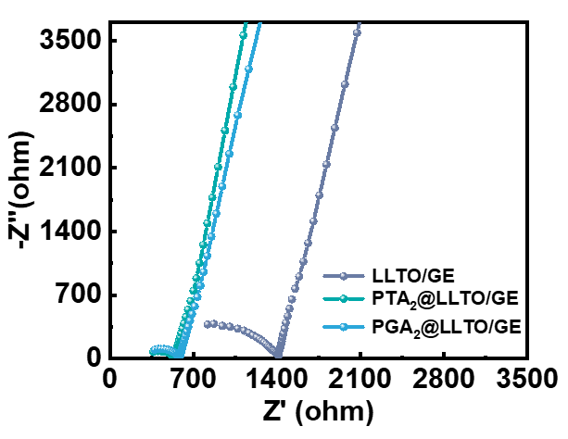
Fig. S18 EIS plots of different electrolytes at room temperature
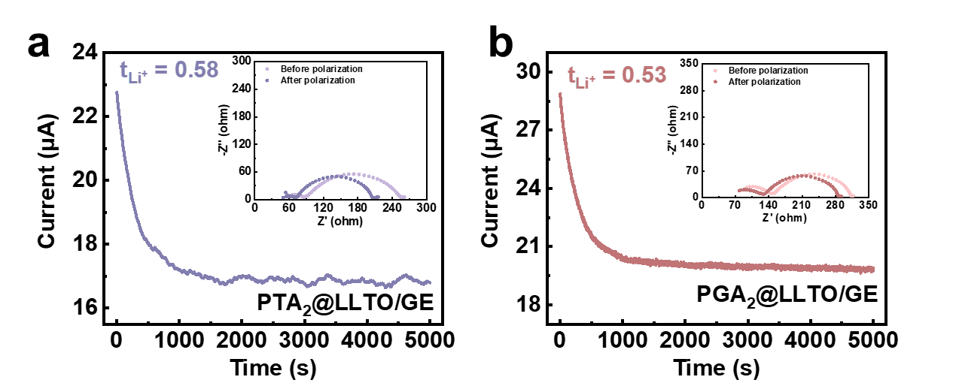
Fig. S19 Chronoamperometry curves of cells at 60 ℃ using a PTA₂@LLTO/GE, and b PGA₂@LLTO/GE under a step voltage of 10 mV. Insets display the corresponding EIS plots before and after polarization

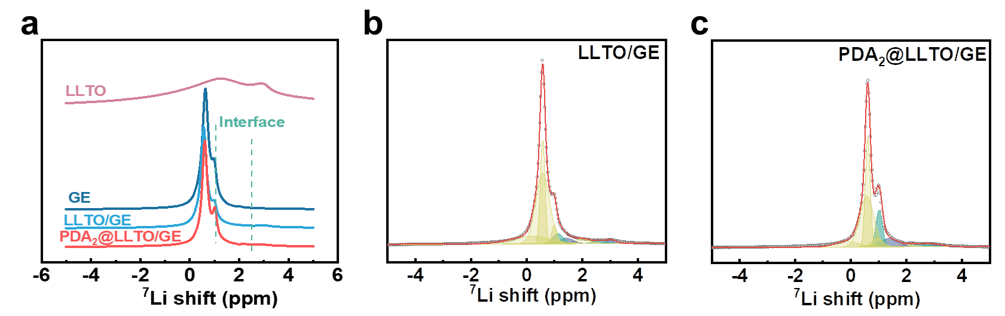
Fig. S20 a Solid-state ⁷Li NMR spectra of LLTO, GE, LLTO/GE and PDA₂@LLTO/GE electrolytes. Partially enlarged diagrams from the solid-state ⁷Li NMR spectra of b LLTO/GE, and c PDA₂@LLTO/GE electrolytes

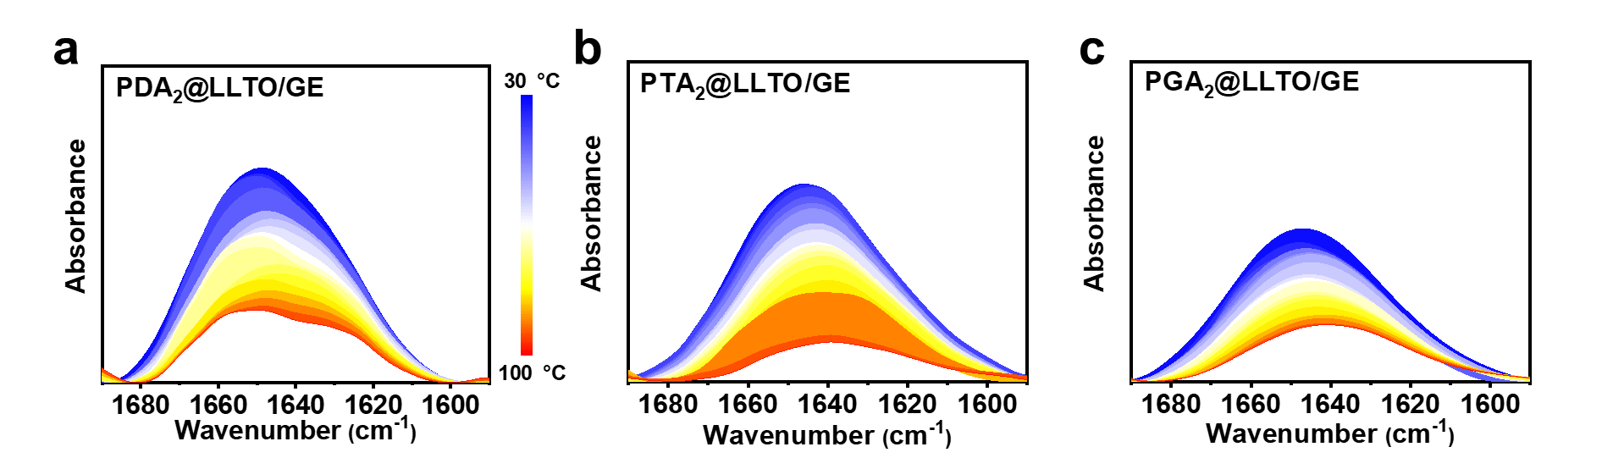
Fig S21 Temperature-variable FTIR spectra of a PDA₂@LLTO/GE, b PTA₂@LLTO/GE and c PGA₂@LLTO/GE recorded in the range of 1690 - 1590 cm⁻¹ during heating from 30 to 100 °C
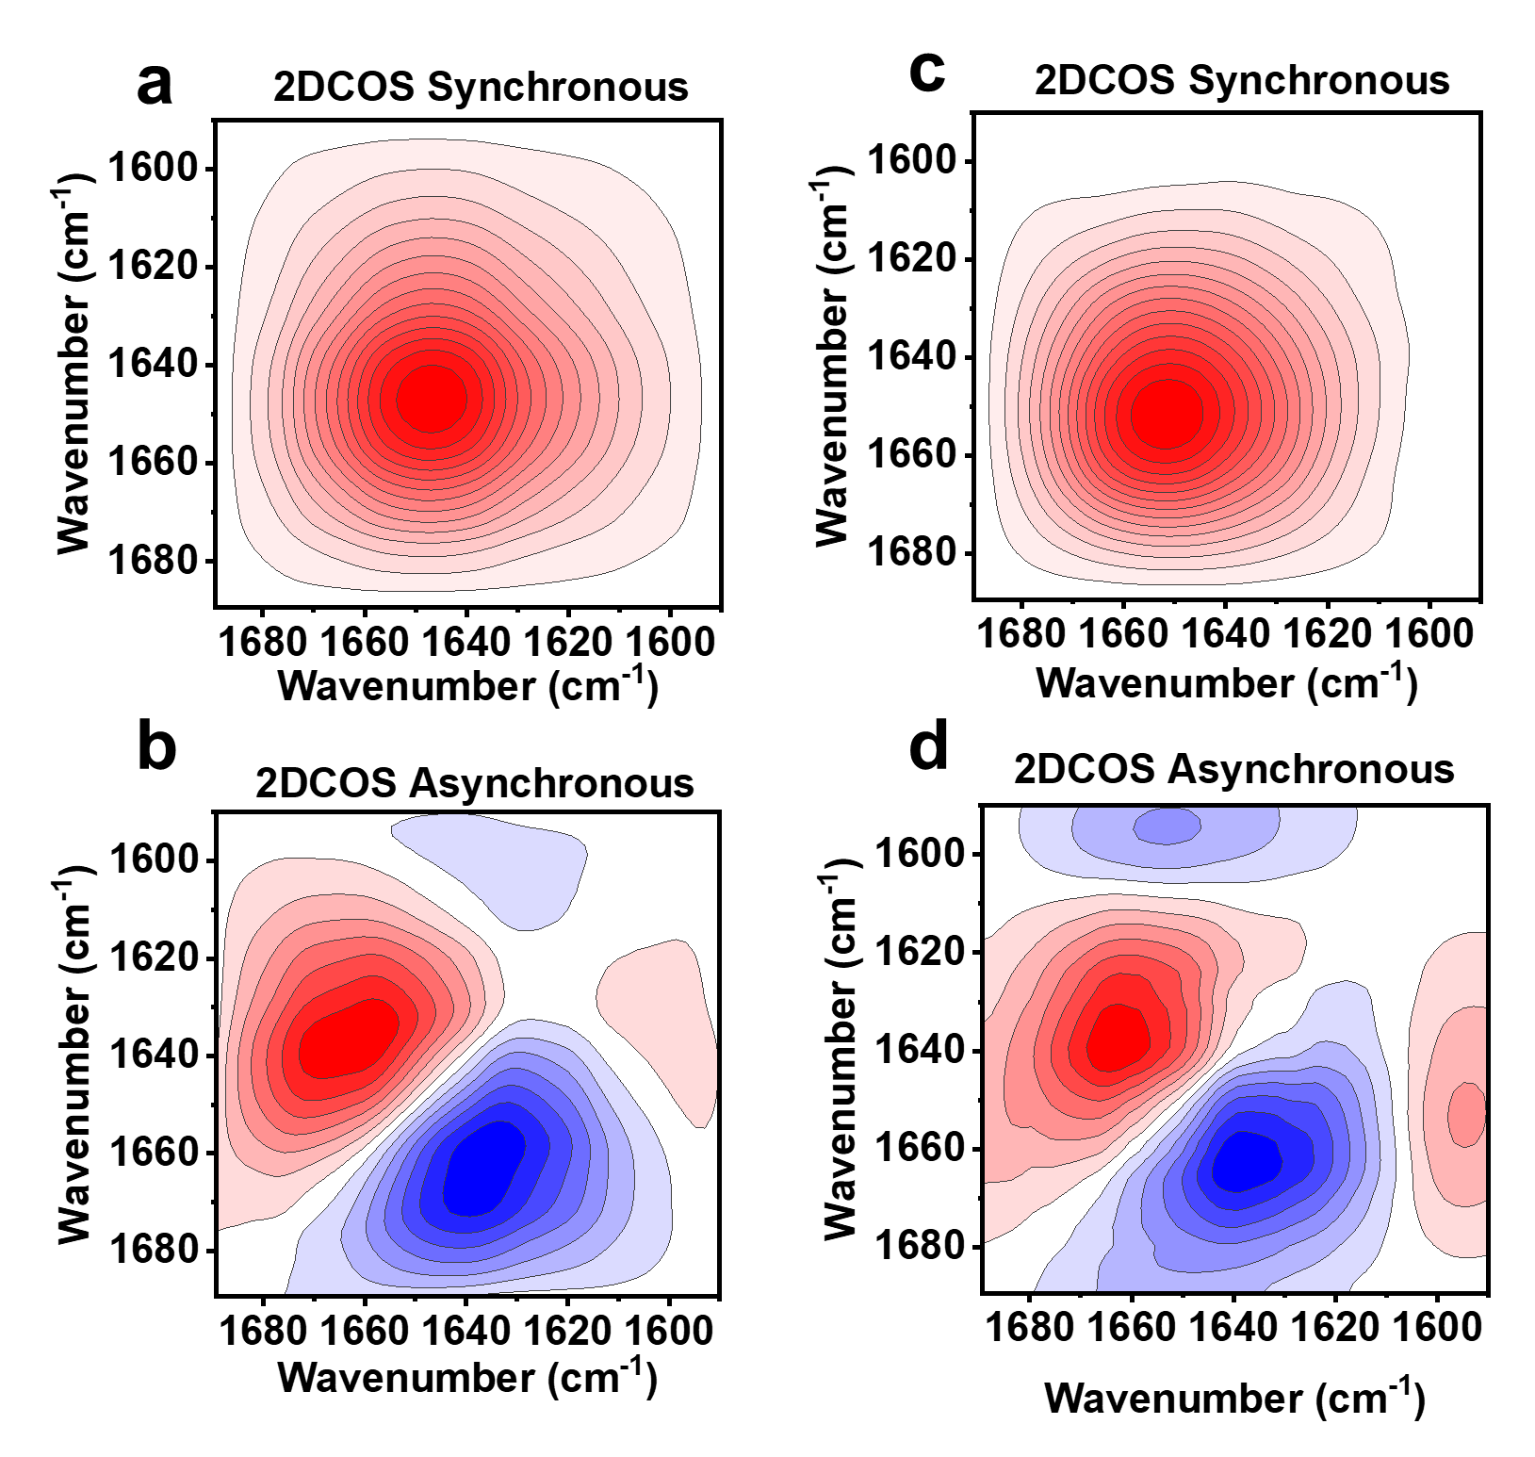
Fig. S22 2DCOS a, c synchronous and b, d asynchronous spectra of PTA₂@LLTO/GE and PGA₂@LLTO/GE electrolyte, respectively. Warm colors (red) represent positive intensities, while cold colors (blue) indicate negative intensities

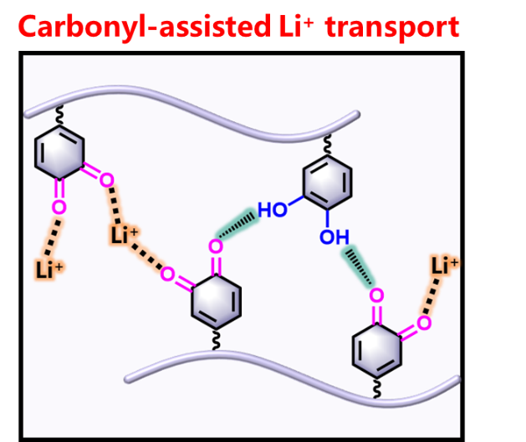
Fig. S23 Schematic diagrams of the carbonyl-assisted Li⁺ transport modes at the polyphenol interfaces

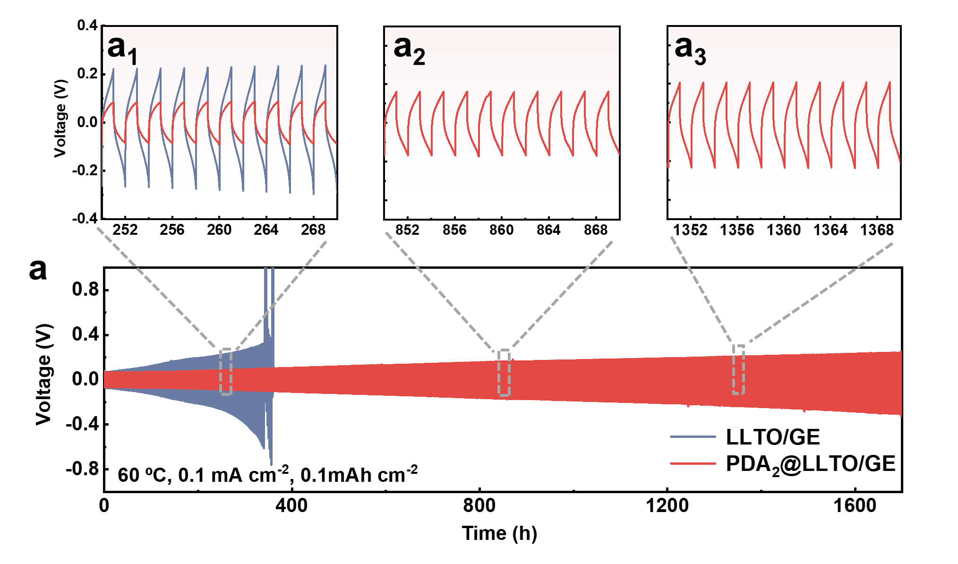
Fig. S24 Galvanostatic curves of symmetric cells assembled with LLTO/GE and PDA₂@LLTO/GE electrolytes at 0.1 mA cm⁻² and 60 ℃, (a₁–a₃) show enlarged view of the voltage–time curves during the periods of 250-270, 850-870 and 1350-1370 h, respectively
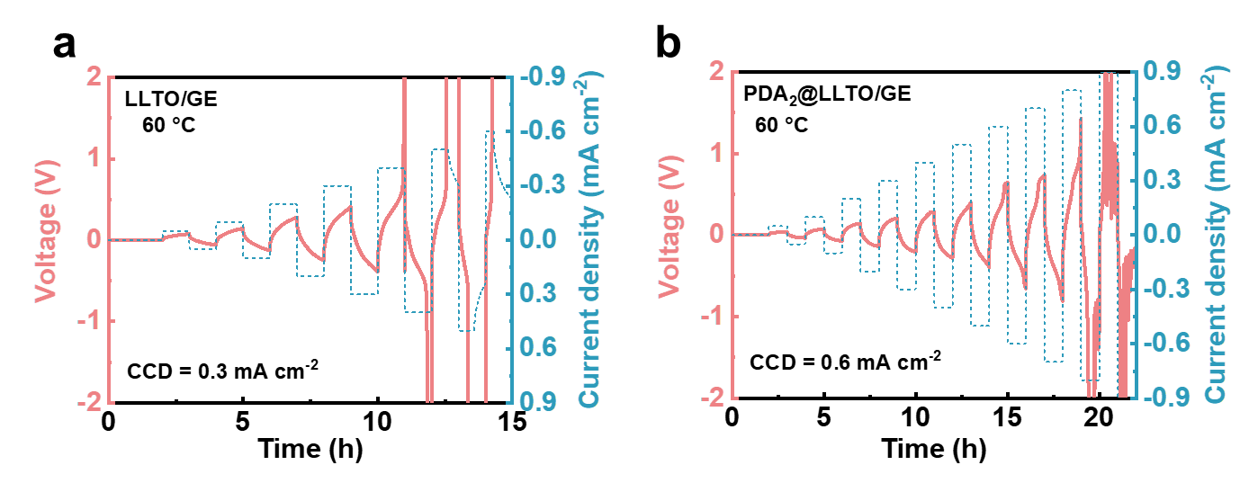
Fig. S25 CCD tests of a LLTO/GE and b PDA₂@LLTO/GE, respectively
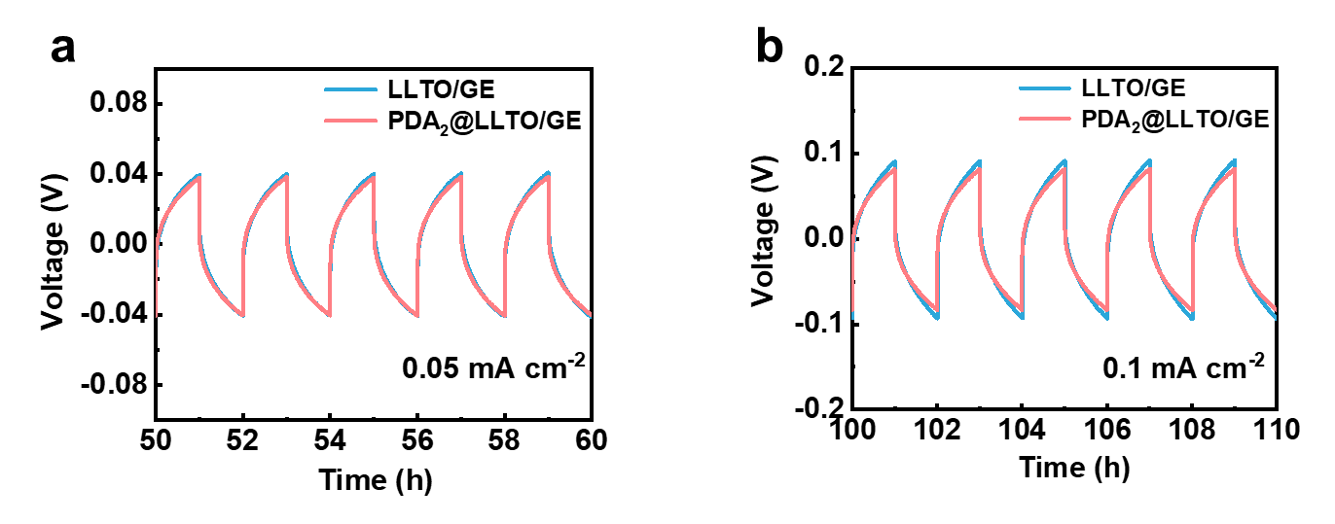
Fig. S26 The enlarged views of the voltage-time curves of LLTO/GE and PDA₂@LLTO/GE at different current density of a 0.05 mA cm⁻² and b 0.1 mA cm⁻², respectively
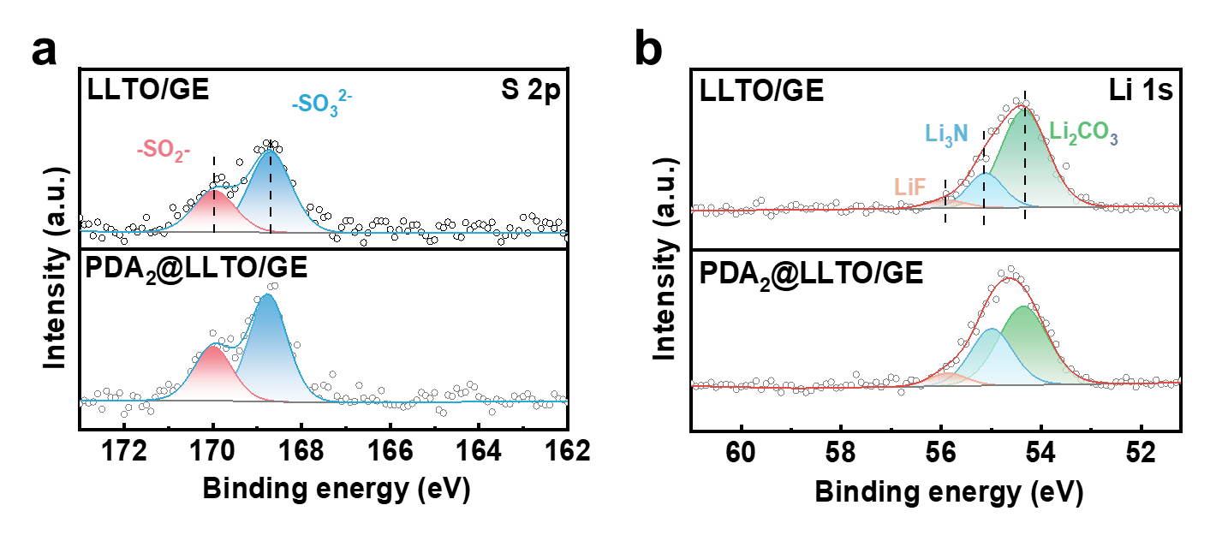
Fig. S27 XPS spectra of the lithium surface after 20 cycles with LLTO/GE and PDA₂@LLTO/GE electrolytes: a S 2p, b Li 1s

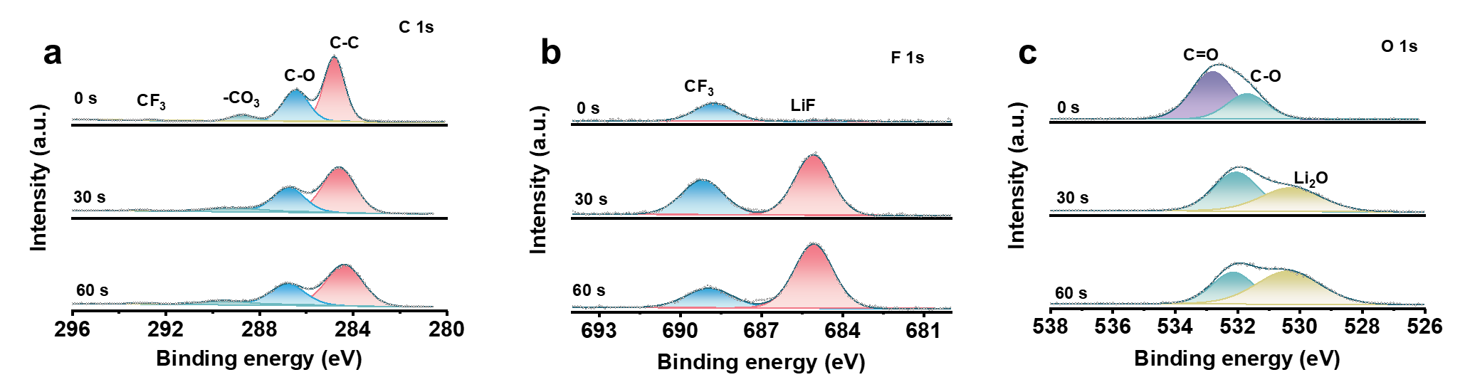
Fig. S28 Depth-profiling XPS spectra of a C 1s, b F 1s and c O 1s at different etching depths for the SEI layer on Li anodes disassembled from Li || Li cell assembled with PDA₂@LLTO/GE after 100 cycles at 0.2 mA cm⁻²

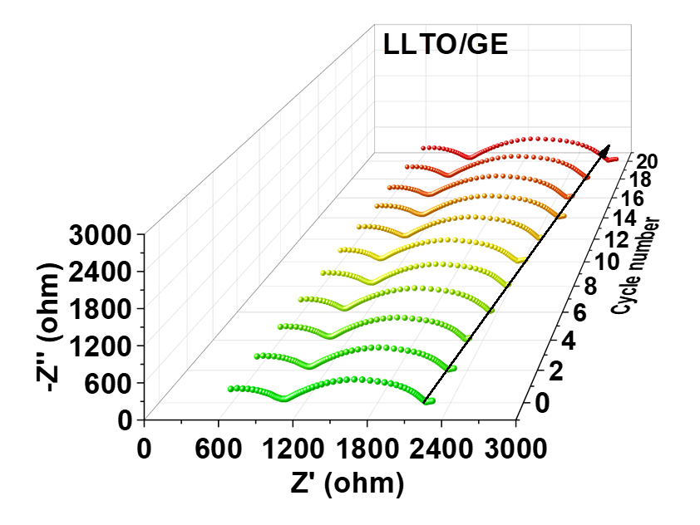
Fig. S29 EIS plots of Li | LLTO/GE | Li at different cycles
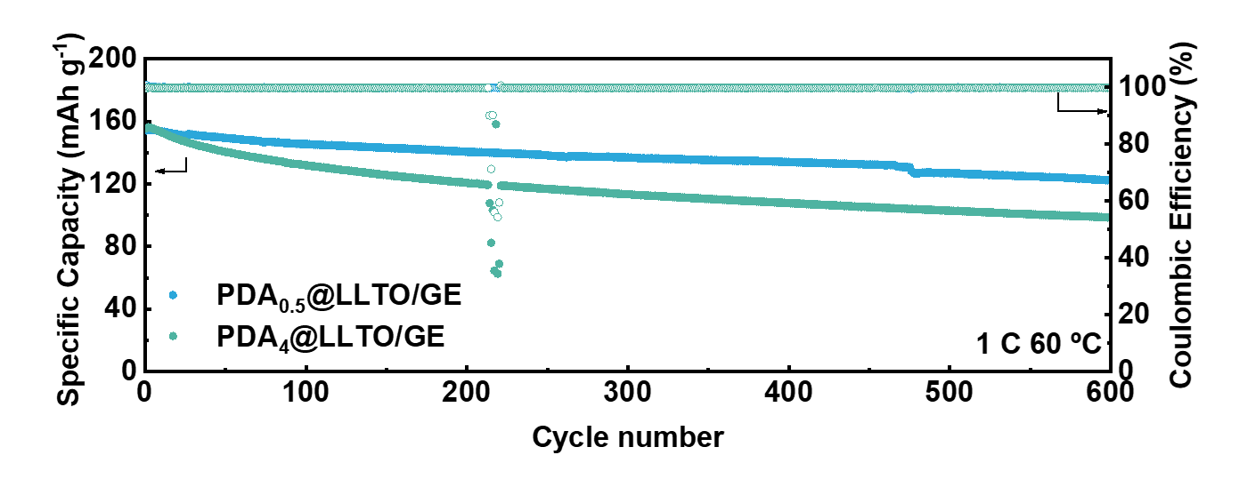
Fig. S30 Long-term cycling properties of LFP| PDA_{0.5}@LLTO/GE |Li and LFP| PDA₄@LLTO/GE |Li full batteries under 1 C at 60 ℃

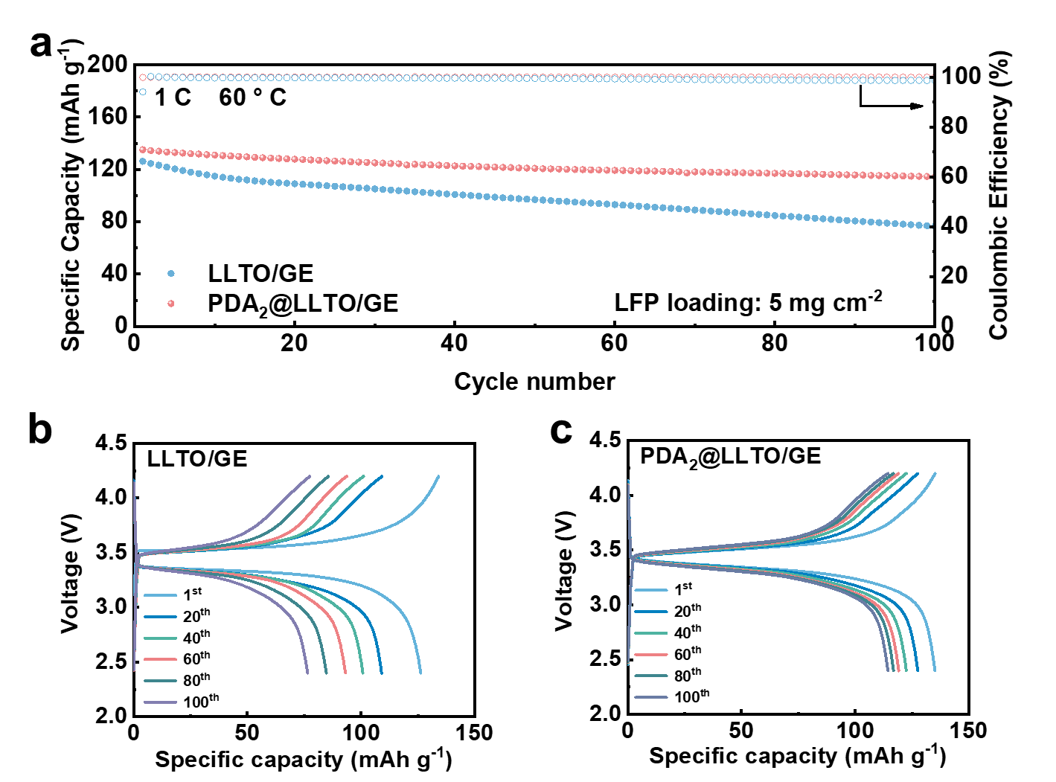
Fig. S31 a Cycling performance of LFP| LLTO/GE |Li and LFP| PDA₂@LLTO/GE |Li full batteries with a high LFP loading of 5 mg cm⁻² under 1 C at 60 ℃. The corresponding charge-discharge curves of b LLTO/GE and c PDA₂@LLTO/GE
Fig. S32 Charge/discharge profiles of the LFP| LLTO/GE |Li cell under the varying current density from 0.5 to 5 C at 60 ℃

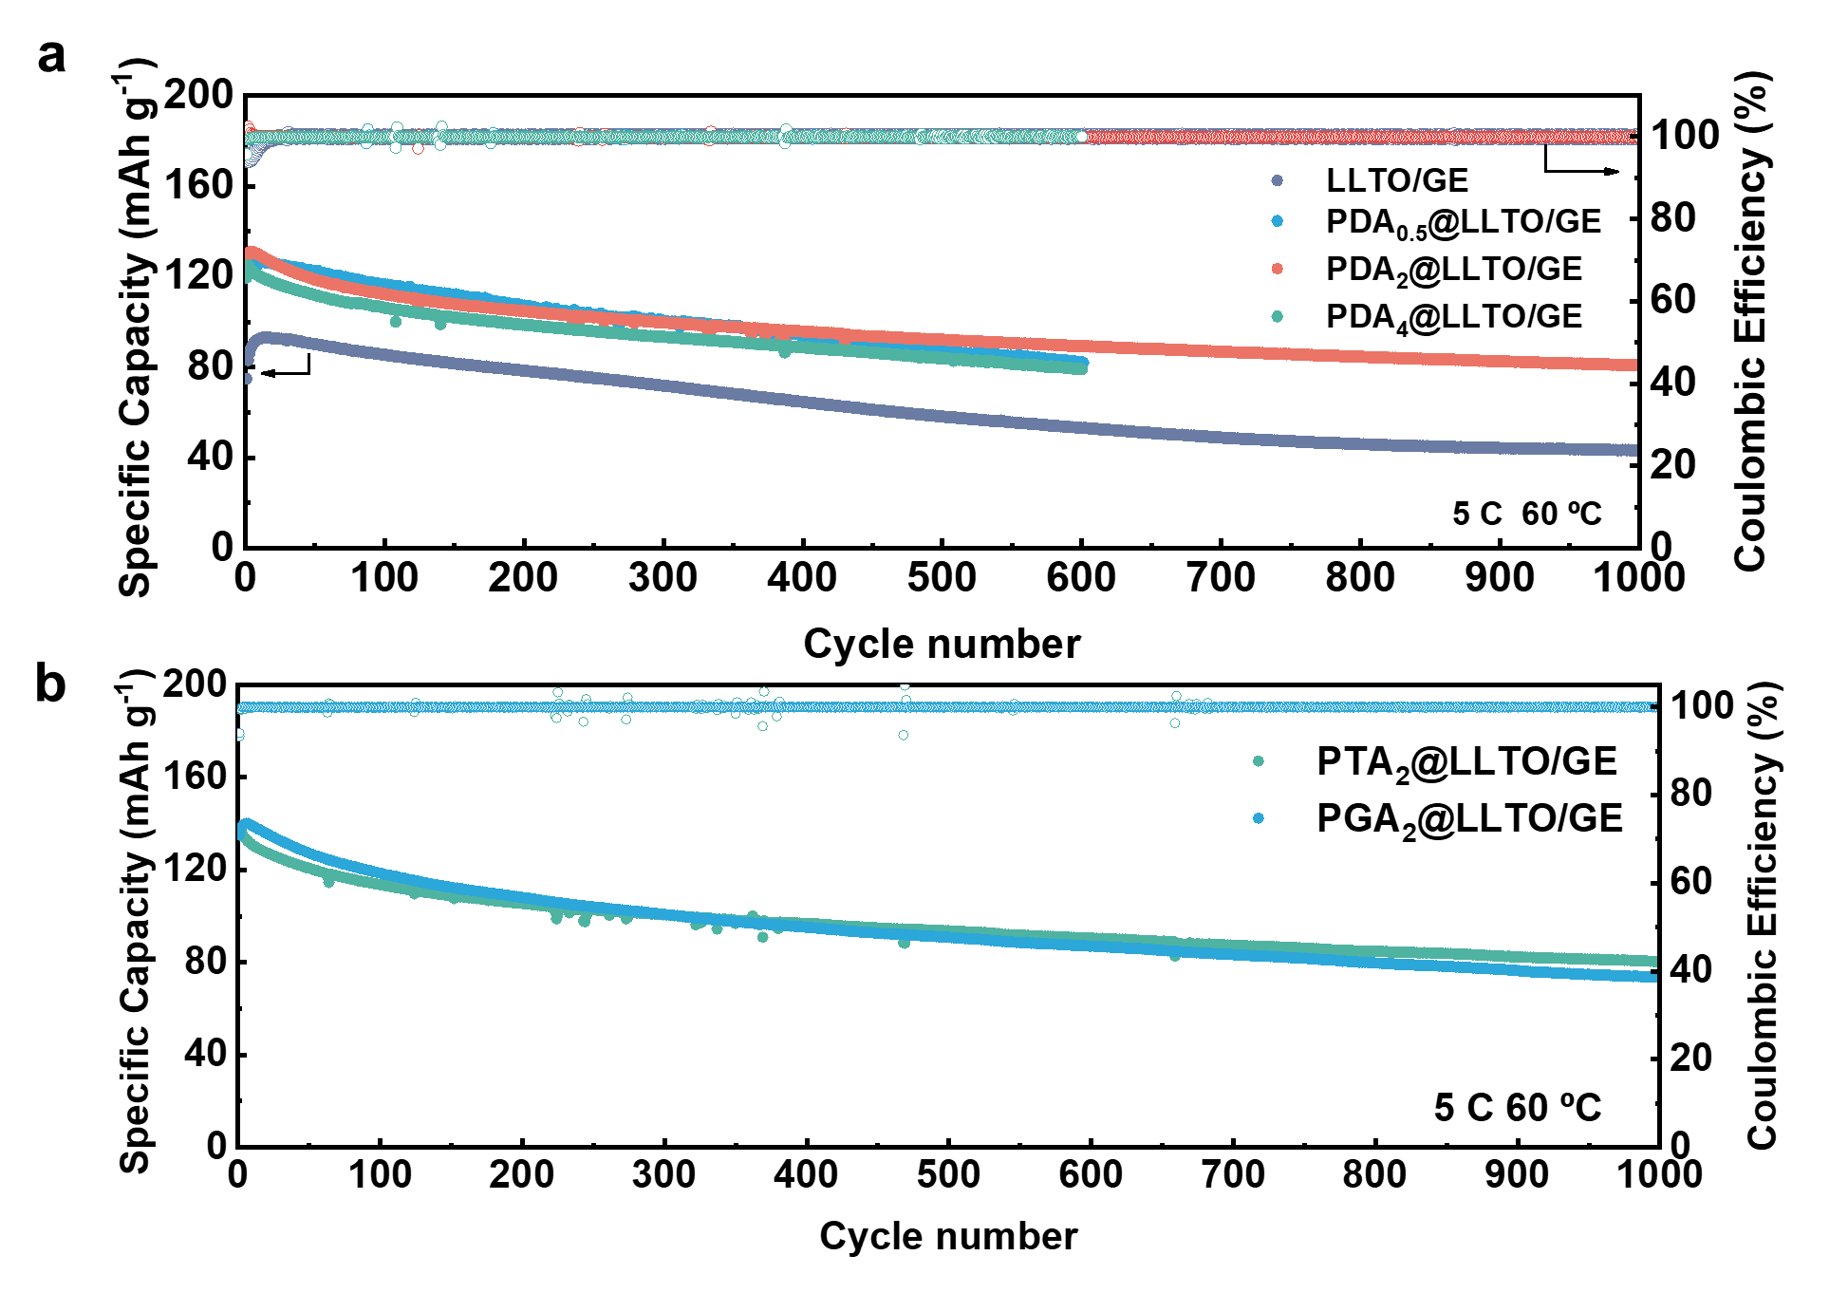
Figure S33. Long-term cycling properties of full batteries of a LFP| LLTO/GE |Li and LFP| PDA_{x}@LLTO/GE |Li and b LFP| PTA₂@LT/GE |Li and LFP| PGA₂@LLTO/GE |Li under 5 C at 60 ℃
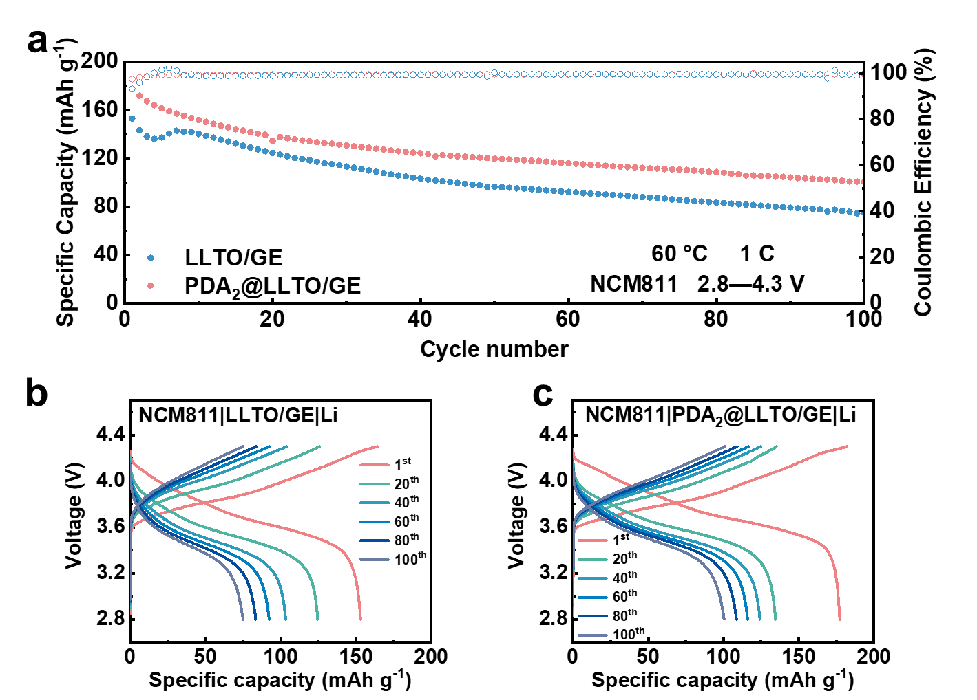
Fig. S34 a Cycling performance of the high voltage NCM811 full batteries assembled with LLTO/GE and PDA₂@LLTO/GE at 1 C at 60 ℃. The corresponding charge–discharge profiles for b LLTO/GE and c PDA₂@LLTO/GE, respectively

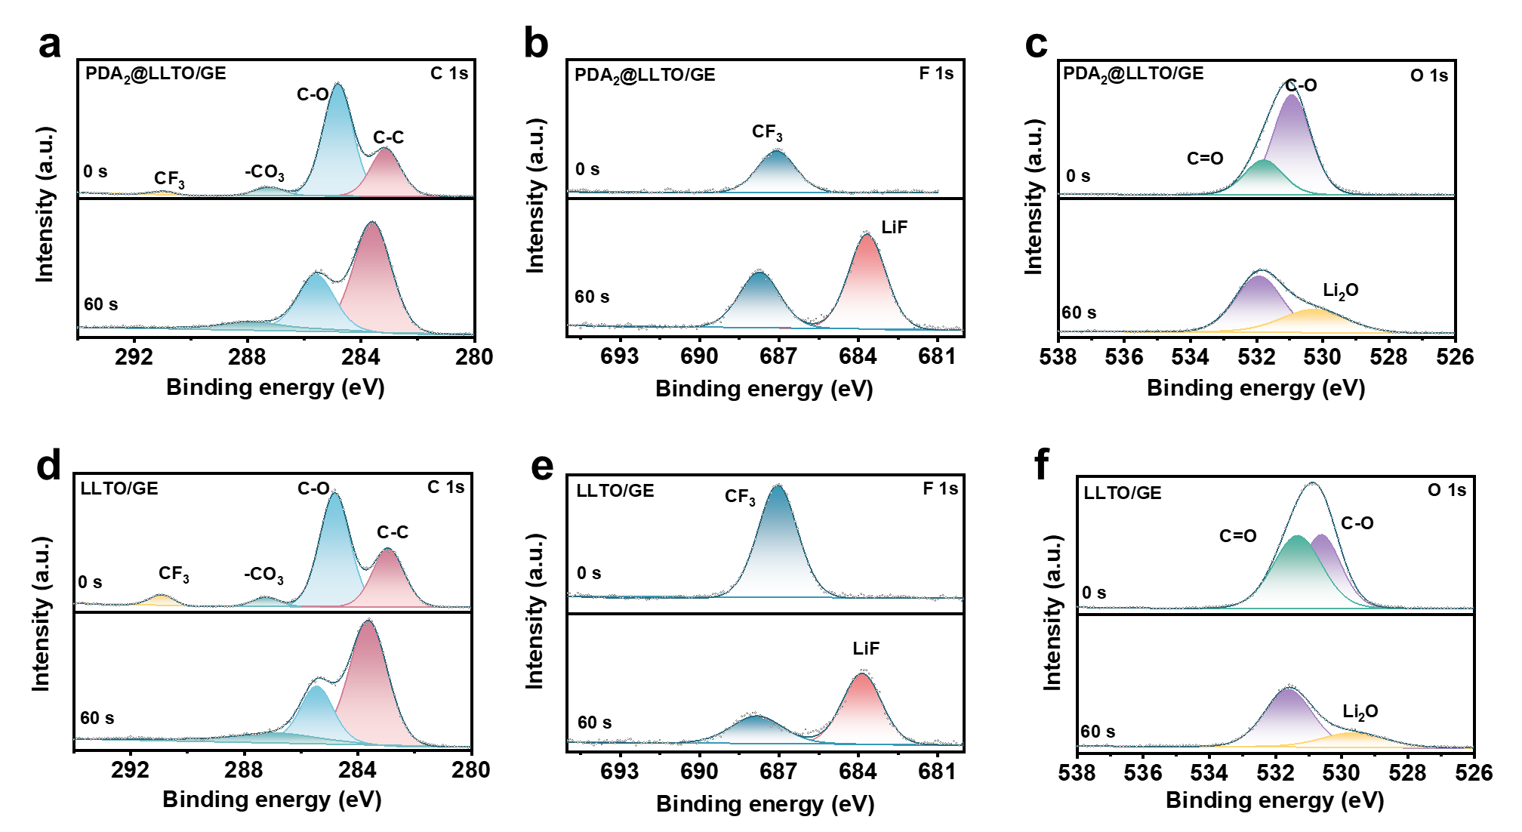
Fig. S35 XPS spectra of the CEI layers in the NCM811| PDA₂@LLTO/GE |Li and NCM811| LLTO/GE |Li cells: a, d C 1s, b, e F 1s, and c, f O 1s
Table S1 Signs of the main cross-peaks in 2DCOS synchronous and asynchronous spectra. Signs read in synchronous and asynchronous spectra (left: Syn; right: Asyn)
PDA₂@LLTO/GE
1629 | +,+ | +,+ | C=O…Li⁺
1648 | +,+ | C=O…H-X
1668 | C=O…C=O
 | 1668 | 1648 | 1629
PGA₂@LLTO/GE
1627 | +,+ | +,+ | C=O…Li⁺
1647 | +,+ | C=O…H-X
1664 | C=O…C=O
 | 1664 | 1647 | 1627
PTA₂@LLTO/GE
1621 | +,+ | +,+ | C=O…Li⁺
1646 | +,+ | C=O…H-X
1662 | C=O…C=O
 | 1662 | 1646 | 1621
C=O…Li⁺ > C=O…H-X > C=O…C=O

Based on Noda’s rule, the responsive order of different wavenumbers is determined to be: 1668 → 1648 → 1629 cm⁻¹, 1664 → 1647 → 1627 cm⁻¹, and 1662 → 1646 → 1621 cm⁻¹ for D@LT/GE, G@LT/GE and T@LT/GE electrolytes, respectively.

