Supporting Information for
Enhanced Spin-Engineering Photothermoelectric-Enzymatic Catalysis System via Lattice Mismatch-Induced Jahn-Teller Distortion for Tumor Therapy
Pengyu Zang¹, Meiqi Yang¹, Chenghao Yu¹, Rui Zhang¹, Avez Sharipov^{2,} *, Ruifang Shen³, Dan Yang^{1,} *, Shili Gai^{1,} *, and Piaoping Yang^{1,} *
¹Key Laboratory of Superlight Materials and Surface Technology, Ministry of Education, College of Materials Science and Chemical Engineering, Harbin Engineering University, Harbin 150001, P. R. China
²Tashkent Pharmaceutical Institute, Ministry of the Health of Uzbekistan, Tashkent 100015, Republic of Uzbekistan
³Laboratory for Space Environment and Physical Sciences, Harbin Institute of Technology, Harbin 150006, P. R. China
* Corresponding authors. E-mail: sharipov.avez@gmail.com (Avez Sharipov); yangdan@hrbeu.edu.cn (Dan Yang); gaishili@hrbeu.edu.cn (Shili Gai); yangpiaoping@hrbeu.edu.cn (Piaoping Yang)
S1 Experimental Sections
S1.1 Materials
Ferric chloride hexahydrate (FeCl₃·6H₂O, AR), sodium citrate (C₆H₅Na₃O₇, AR), sodium acetate (C₇H₆NNaO₂, AR), silver nitrate (Ag(NO)₃, AR), sodium sulfide nonahydrate (Na₂S·9H₂O, AR), ethylene glycol (C₂H₆O₂, AR), ammonia solution (H₅NO, AR, 25-28%) dihydrorhodamine 123 (DHR123, 95%), 5,5-dimethyl-1- pyrroline N-oxide (DMPO, 97%), sodium sulfate anhydrous (Na₂SO₄, 99%) and p-phthalic acid (TA, 99%) were purchased from Rhawn (Shanghai, China). Ethylenediaminetetraacetic acid disodium salt (C₁₀H₁₄N₂Na₂O₈, AR), 1,3-diphenylisobenzofuran (DPBF, 97%), 5',5'-dithiobis (2-nitrobenzoic acid) (DTNB, 95%) and 2,2′,6,6′-tetramethylpiperidine (TEMP, 95%), were purchased from Sigma-Aldrich (Shanghai, China). Glutathione (reduced, 98%), 3,3',5,5'- tetramethylbenzidine (TMB, >98%), 2,7-dichlorofluorescein diacetate (DCFH-DA, 99%), thiazolyl blue tetrazolium bromide (MTT, 98%), Calcein-AM (AM, 99%), and propidium iodide (PI, 94%) were obtained from Aladdin (Shanghai, China). Phosphate-buffered saline (PBS), trypsin cell digestive juices, and RPMI-1640 were obtained from Procell (Wuhan, China). The cell hypoxia detection kit Ru(dpp)₃Cl₂- red fluorescence, JC-1 staining kit, and Hoechst 33342 were obtained from Beyotime Inst. Biotech. (Haimen, China). Annexin V-FITC/PI apoptosis detection kit was taken from Tianjin Sungene Biotech Co., Ltd. (Tianjin, China). FITC-labeled Goat Anti-Rabbit IgG and HSP60 Rabbit Anti-mouse antibody were purchased from Shenyang Wanlei Biotechnology Co., Ltd. (Liaoning China). The TdT-mediated dUTP nick-end labeling (TUNEL) cell apoptosis detection kit was also bought from Dalian Meilun Biotechnology Co., Ltd. Female Balb/c mice (4 weeks old) were purchased from Liaoning Changsheng Biotechnology Co., Ltd. (Liaoning, China). All chemical agents were directly used without any further purification. The Animal experiment was conducted with the approval of ethics by the Ethics Committee of the Second Affiliated Hospital of Harbin Medical University. Animal experiments were performed according to the Guidelines for the Care and Use of Laboratory Animals of the Drug Safety Evaluation Center of Harbin Medical University. Female Balb/c mice were subcutaneously transplanted with 4T1 cancer cells (100 µL) at 5 weeks of age and used for subsequent experiments when the tumor volume approached 80 mm³. Animal Experiments Ethical Approval: All animal experiments were approved by the Ethics Committee of the Second Affiliated Hospital of Harbin Medical University (Harbin, China), and performed according to the Guidelines for Care and Use of Laboratory Animals of the Drug Safety Evaluation Center of Harbin Medical University.
S1.2 Experimental Apparatus
The transmission electron microscope (TEM) graph was obtained from the FEI Tecnai T20 transmission electron microscope. X-ray diffraction (XRD) was measured by a Rigaku DMAX-2400 X-ray diffractometer equipped with Cu Kα radiation (λ = 0.154 nm) at 40 kV and 40 mA. X-ray photoelectron spectroscopy (XPS) was measured by Thermo Fisher Scientific ESCALAB 250XI. inductively coupled plasma-optical emission spectrometry (ICP-OES) was measured by Agilent Technologies 725. UV–vis absorption spectrum was measured by UV1601 spectrophotometer. UV–visible–near-infrared absorption spectrum was tested by Shimadzu UV3600. Dissolved oxygen content analysis from portable dissolved oxygen analyzer (JPBJ-608, Anhui Leici Instrument Co. Ltd.) The ESR spectra were obtained with Bruker EMX1598 spectrometer. Thermal images were recorded using an Inf Rec R300SR-HD infrared thermal imager. The flow cytometry S3 assays were conducted on a BD Accuri C6 flow cytometer (USA). The PA images were obtained using the Vevo LAZR-X system. A confocal laser scanning microscope (CLSM, Leica TCS SP8) was used to obtain the fluorescence image. In vitro and in vivo CT imaging experiments were performed on a small animal X-ray CT imaging system (Quantum GX, PerkinElmer). X-ray absorption fine structure (XAFS) spectroscopy was carried out using the RapidXAFS 2M (Anhui Absorption Spectroscopy Analysis Instrument Co., Ltd.) by transmission mode at 15 kV and 20 mA, and the Ge (620) spherically bent crystal analyzer with a radius of curvature of 500 mm was used for Fe.
S1.3 Supplemental Notes
It should be noted that the observed catalytic enhancement in this study could not be attributed to a single factor alone. Interfacial charge separation at the heterojunction, lattice-strain–induced electronic structure modulation, and spin-related electronic effects were expected to act concurrently and synergistically in the Fe₃O₄-Ag₂S system. In this work, spin polarization was therefore not proposed as the sole origin of the enhanced catalytic activity, but rather as an important contributing factor that operates in concert with interfacial charge transfer and strain effects. Above all, the term “spin engineering” in this work was used to describe EPR-supported and lattice distortion–driven modulation of spin-related electronic structure, rather than a directly measured spin-state transition. The absence of Mössbauer spectroscopy and detailed magnetic measurements is explicitly acknowledged as a limitation, and such quantitative spin-state probes would be pursued in future studies.
The present DFT analysis, based on a bulk-derived (001) interface model, provides fundamental insights into the heterojunction-induced Jahn-Teller distortion and its electronic consequences. In practical nanoparticle systems, exposed faces and finite curvature can further modulate the interfacial lattice mismatch and strain distribution, potentially enhancing or spatially varying the degree of local distortion. Such nanoscale structural heterogeneity may introduce additional complexity to the lattice–electronic–spin coupling proposed herein. While a quantitative evaluation of the Jahn-Teller stabilization energy would offer a more rigorous metric for distortion strength, its reliable calculation for realistic, multi-faceted heterojunction nanoparticles requires extended models and remains a valuable direction for future theoretical work. Besides, the present DFT calculations were not intended to explicitly simulate thermoelectric carrier injection or non-equilibrium reaction energy barriers. The thermoelectric effect was intrinsically a non-equilibrium phenomenon driven by temperature gradients and carrier redistribution, whereas conventional ground-state DFT calculations were equilibrium methods that could not directly incorporate Seebeck-induce internal electric fields or thermally drive chemical potential gradients. Instead, the role of DFT in this work was to elucidate the intrinsic electronic-structure modulation induced by defect–interface coupling, including charge density redistribution, density-of-states evolution, and adsorption energetics, which established the necessary electronic-structure basis for carrier-mediated surface reactions. Consistent with prior studies on electric-field-assisted and thermoelectric-enhanced catalysis, the dynamic carrier-driven effects were primarily inferred from experimental evidence such as thermoelectrically induced voltage generation, enhanced carrier transport, and temperature/light-dependent catalytic enhancement rather than from explicit non-equilibrium reaction barrier calculations.
In the multimodal imaging section, beyond demonstrating the feasibility of CT and PA imaging individually, their complementary diagnostic value should be further highlighted. CT imaging provided high-resolution anatomical and density-based contrast, enabling accurate tumor localization and macroscopic assessment of nanoparticle accumulation, while PA imaging offered functional contrast based on optical absorption and photothermal conversion, allowing real-time monitoring of nanoparticle distribution and photothermal response under irradiation. By integrating CT and PA imaging, the system combined structural and functional information, facilitating accurate tumor targeting, confirmation of nanoparticle accumulation, and optimization of irradiation timing and region, thereby enabling more precise and reliable guidance for subsequent therapy.
As for the biodistribution analysis, Ag was selected as the quantitative tracer element for biodistribution analysis because its signal could be more accurately distinguished and quantified by ICP–OES due to the low background interference from endogenous biological elements.
In the in vivo therapeutic efficiency analysis section, the in vivo photothermal experiments demonstrated efficient temperature elevation throughout the tumor region. Even beyond macroscopic heating, localized photothermal conversion at the nanoparticle and cellular levels could generate steep micro- to nanoscale temperature gradients, which were sufficient to induce thermoelectric carrier redistribution and contributed to the observed catalytic and therapeutic effects.
S2 Supplementary Tables and Figures
Table S1 Quantitative EXAFS Fitting Parameters for Fe K-edge in Fe₃O₄ and Fe₃O₄–Ag₂S
Sample |  | Bond Type | R |  | N |  | σ² | ΔE₀
Fe₃O₄ |  | Fe-O Tat | 1.51 |  | 3.9 |  | 0.006 | -4.2
Fe₃O₄ |  | Fe-O Oct | 2.62 |  | 5.8 |  | 0.009 | -4.9
Fe₃O₄–Ag₂S |  | Fe-O Tat | 1.60 |  | 3.5 |  | 0.015 | -3.5
Fe₃O₄–Ag₂S |  | Fe-O Oct | 2.55 |  | 6.3 |  | 0.019 | -3.1
Table S2 The tumor growth inhibition rates (TGI) of other Fe-based nanomaterials
No. | Nanoplatform |  |  | TGI |  | Refs.
1 | TpyFe(II)-FF-AM-cRGD |  |  | 64.3% |  | Adv. Funct. Mater. 2025, 2505343
2 | GA-Fe-GOX-HA |  |  | 66.3% |  | Adv. Compos. Hybrid. Mater. 2025, 8, 338
3 | Fe-DMOS |  |  | 89.1 % |  | Adv. Mater. 2025, e10010
4 | HA/FeMo_{DA}-LPs |  |  | 93.7% |  | Angew. Chem. Int. Ed. 2025, 64, e202511471
5 | MAFe₃O₄ |  |  | 67% |  | ACS Nano 2025, 19, 21468–21483
6 | PDA–Fe(III)–FA |  |  | 86.6% |  | ACS Nano 2025, 19, 28554–28575
7 | Fe-TCPP(Cu)-HA |  |  | 76.65% |  | Adv. Funct. Mater. 2025, e02635
8 | NP_{siCD47}@Fe-TA |  |  | 74% |  | Adv. Funct. Mater. 2025, 35, 2417548
9 | MNRs@GOx/Cu/HSA |  |  | 97% |  | ACS Nano 2025, 19, 15040–15054
10 | FeS-CRISPR/Cas9 |  |  | 69% |  | ACS Nano 2025, 19, 18188–18202
11 | Fe–N₅ |  |  | 90% |  | J. Am. Chem. Soc. 2025, 147, 17372–17383
12 | FeCoCN |  |  | 94% |  | Adv. Funct. Mater. 2025, 35, 2423783
13 | Zr-Fe MOF@Ribociclib@Herceptin |  |  | 66.66% |  | Adv. Funct. Mater., 2025, 2508310
14 | ZnO₂@PDA-Fe |  |  | 98.92% |  | Adv. Mater. 2024, 36, 2412227.
15 | Fe₁Mn₁–NC_{e} |  |  | 95.74% |  | J. Am. Chem. Soc. 2024, 146, 10023–10031
16 | Fe₃O₄-αPD-L1 |  |  | 90% |  | J. Am. Chem. Soc. 2024, 146, 22455–22468
17 | Au–Fe₂C |  |  | ≈90% |  | Adv. Mater. 2024, 36, 2307006
18 | FeP@HCPT-HA |  |  | 80.5% |  | Adv. Funct. Mater. 2024, 34, 2313540

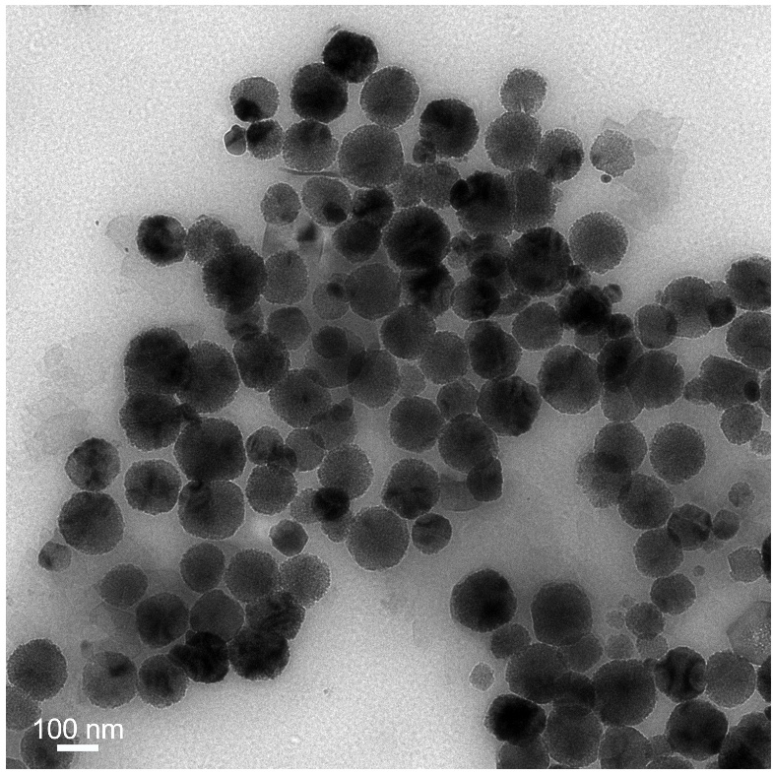
Fig. S1 TEM image of Fe₃O₄ nanoparticles

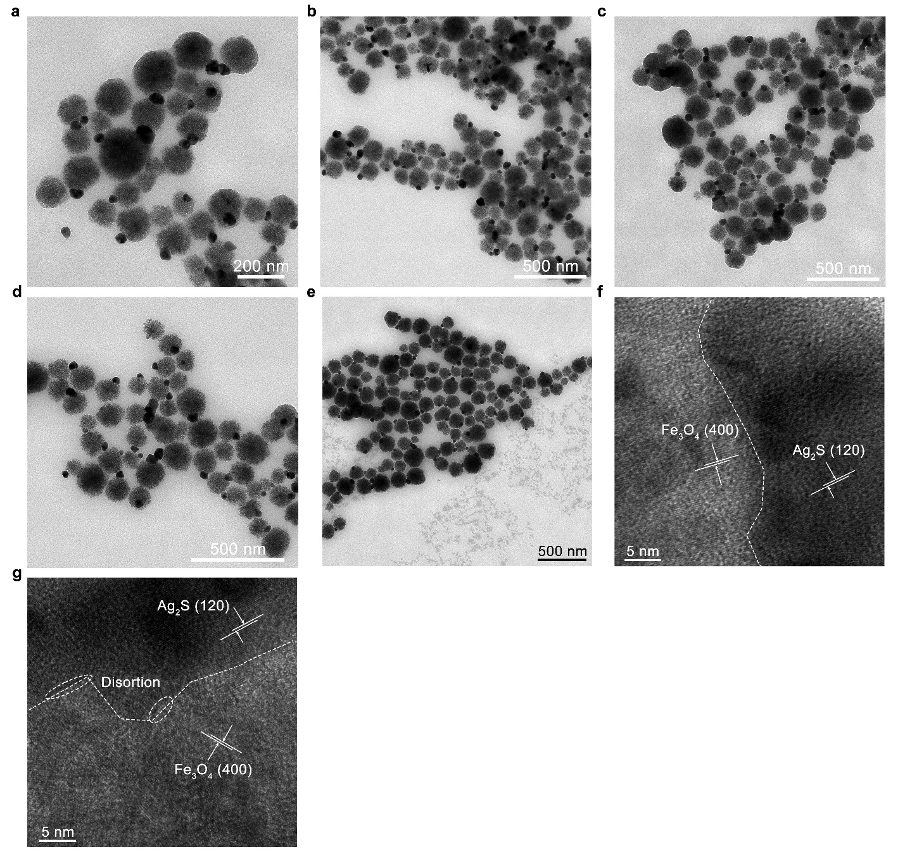
Fig. S2 TEM images of a-b Fe₃O₄-Ag and c-d Fe₃O₄-Ag₂S nanoparticles in various resolution. e TEM image of Fe₃O₄-Ag₂S nanoparticles contained in medium with serum. HRTEM images of Fe₃O₄-Ag₂S nanoparticles’ interfaces of Fe₃O₄ and Ag₂S, f in PBS and g medium with serum cultured after 48 h

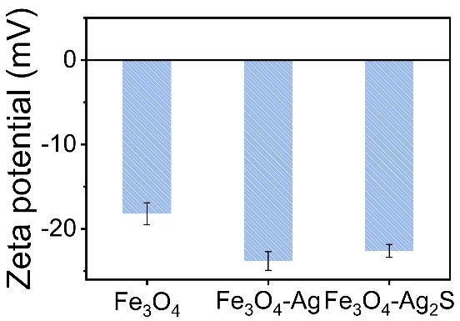
Fig. S3 Zeta potential of Fe₃O₄, Fe₃O₄-Ag, and Fe₃O₄-Ag₂S, data were presented as mean ± S.D. (n = 3)

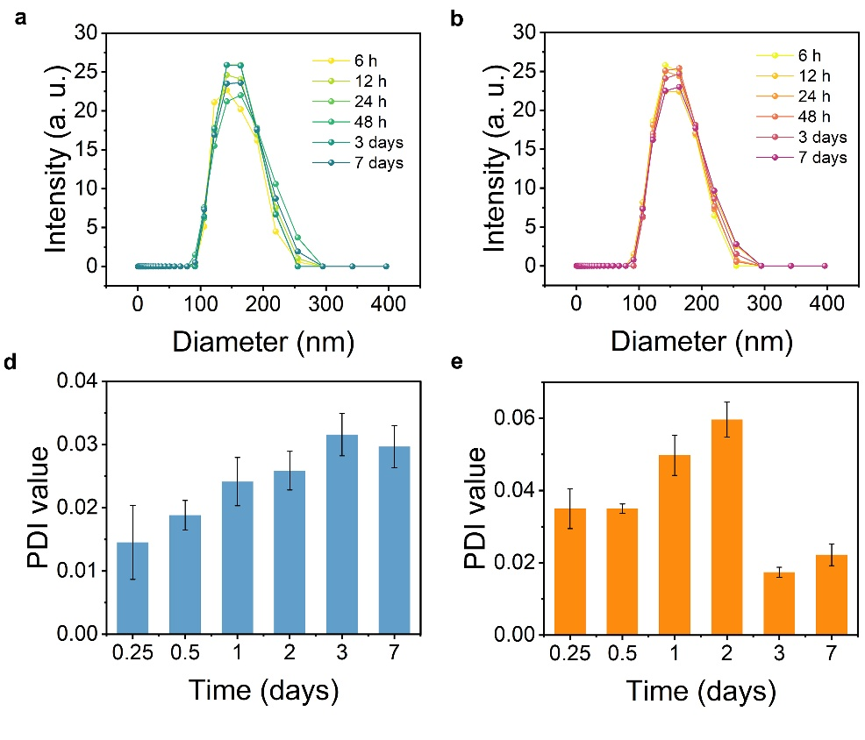
Fig. S4 Dynamic light scattering patterns of Fe₃O₄-Ag₂S over a 6, 12, 24, 48, 72, h and 7-days period in complete cell culture medium (containing 10% serum) in pH a, d 6 and b, e 7, data were presented as mean ± S.D. (n = 3)

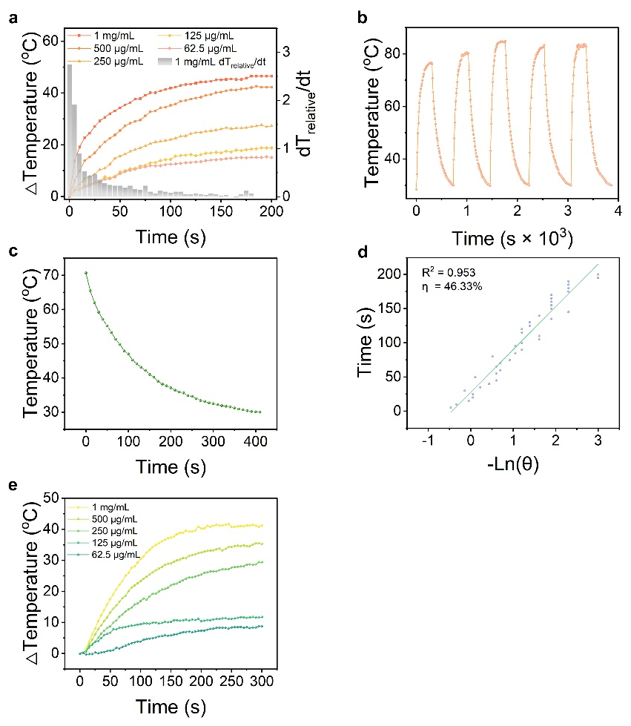
Fig. S5 a Time-dependent photothermal effect of Fe₃O₄-Ag₂S. b Photothermal stability curve. c Cooling period, and d photothermal conversion efficiency. e Photothermal effect of Fe₃O₄
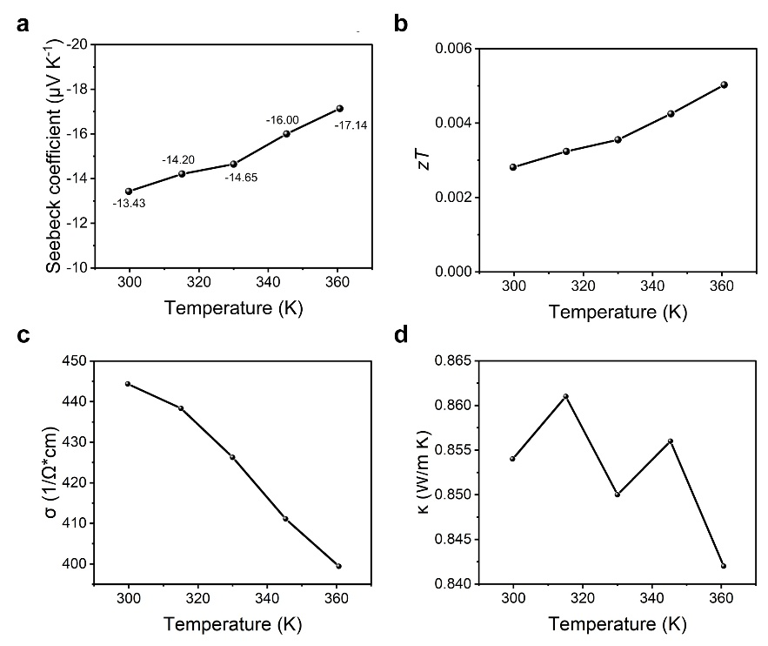
Fig. S6 Temperature dependent a Seebeck coefficient, b calculated zT, c electrical conductivity, and d thermal conductivity of Fe₃O₄-Ag₂S
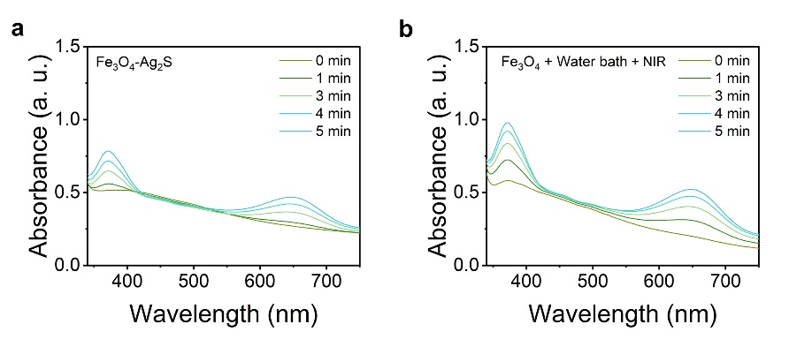
Fig. S7 TMB indicated •OH generation of a Fe₃O₄-Ag₂S and b Fe₃O₄ + Water bath + NIR
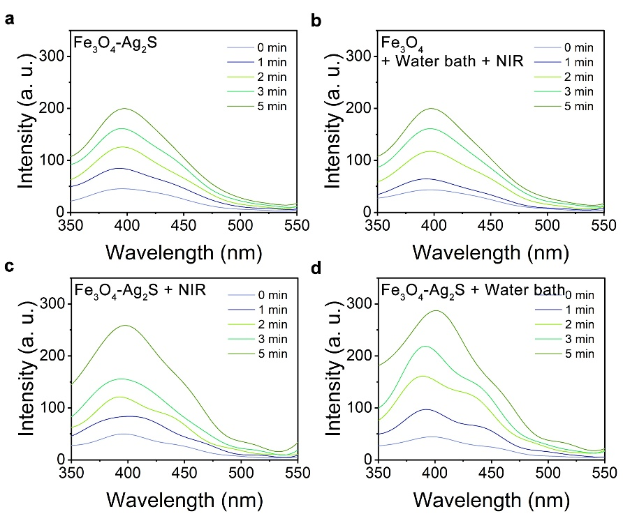
Fig. S8 TA indicated •OH generation of a Fe₃O₄-Ag₂S, b Fe₃O₄ + Water bath + NIR, c Fe₃O₄-Ag₂S + NIR, and d Fe₃O₄-Ag₂S + Water bath
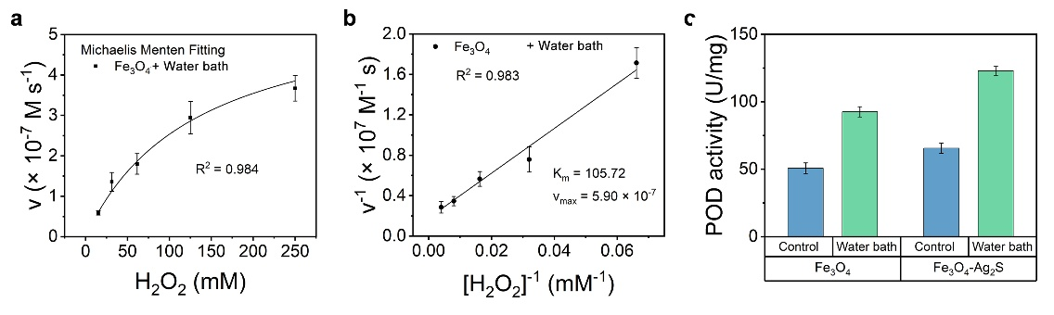
Fig. S9 a Michaelis-Menten kinetic analysis of Fe₃O₄ + Water bath and b Lineweaver-Burk plot, data were presented as mean ± S.D. (n = 3). c The enzymatic activities of Fe₃O₄ and Fe₃O₄-Ag₂S determined by guaiacol method under room temperature and water bath conditions, data were presented as mean ± S.D. (n = 3)
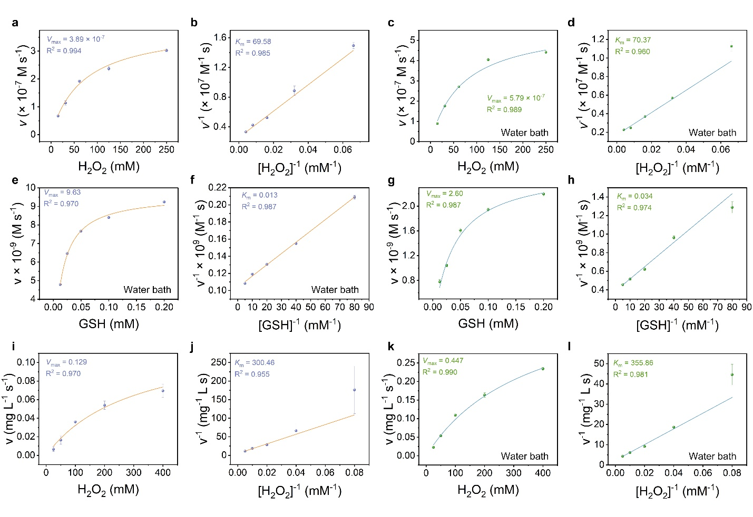
Fig. S10 a-d POD, e-h GSHox, and i-l CAT enzymatic activity of Fe₃O₄ + Ag₂S physical mixture under room temperature or 60℃ water bath

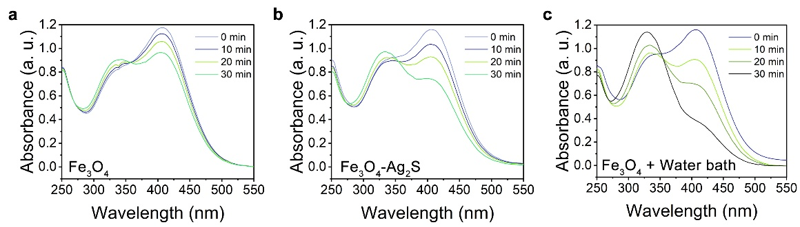
Fig. S11 DTNB indicated GSH consumption of a Fe₃O₄, b Fe₃O₄-Ag₂S, and c Fe₃O₄ + Water bath
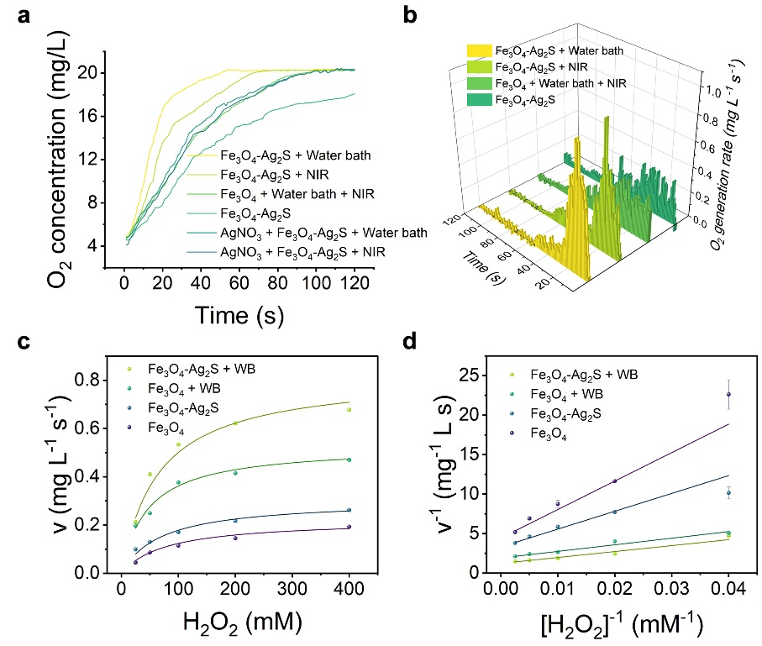
Fig. S12 a Time-dependent oxygen generation curves and b their differentiation under different conditions. c CAT enzyme analysis using Michaelis-Menten kinetic methods of Fe₃O₄ and Fe₃O₄-Ag₂S with or without water bath and d Lineweaver-Burk plot, data were presented as mean ± S.D. (n = 3)
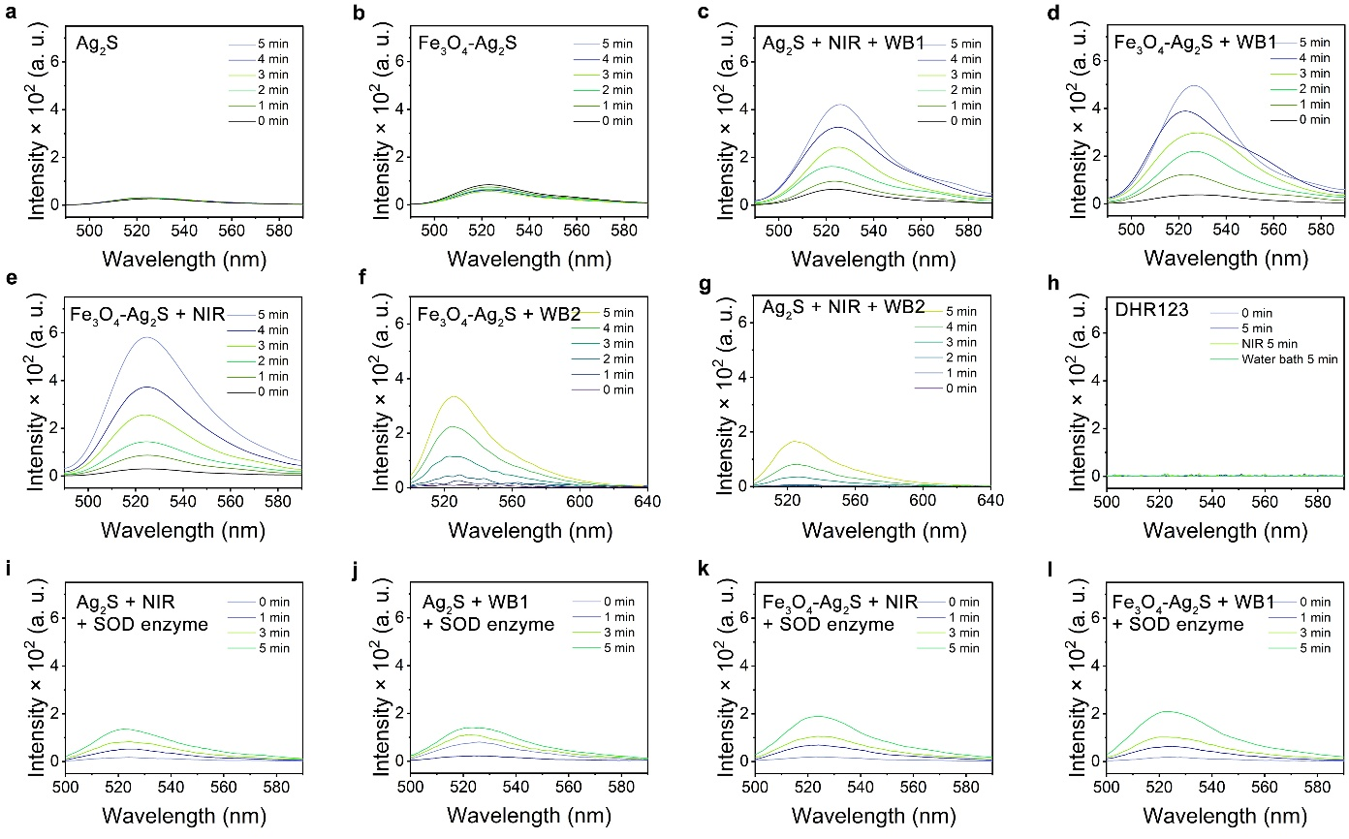
Fig. S13 DHR123 indicated O₂^{•−} generation at a Ag₂S, b Fe₃O₄-Ag₂S, c Ag₂S + NIR + Water bath (80/30ºC), d Fe₃O₄-Ag₂S + Water bath (80/30ºC), e Fe₃O₄-Ag₂S + NIR, f Fe₃O₄-Ag₂S + Water bath (60/30ºC), g Ag₂S + NIR + Water bath (60/30ºC), h control group of pure DHR123, i Ag₂S + NIR + SOD enzyme, j Ag₂S + Water bath (80/30ºC) + SOD enzyme, k Fe₃O₄-Ag₂S + NIR + SOD enzyme, and l Fe₃O₄-Ag₂S + Water bath (80/30ºC) + SOD enzyme.

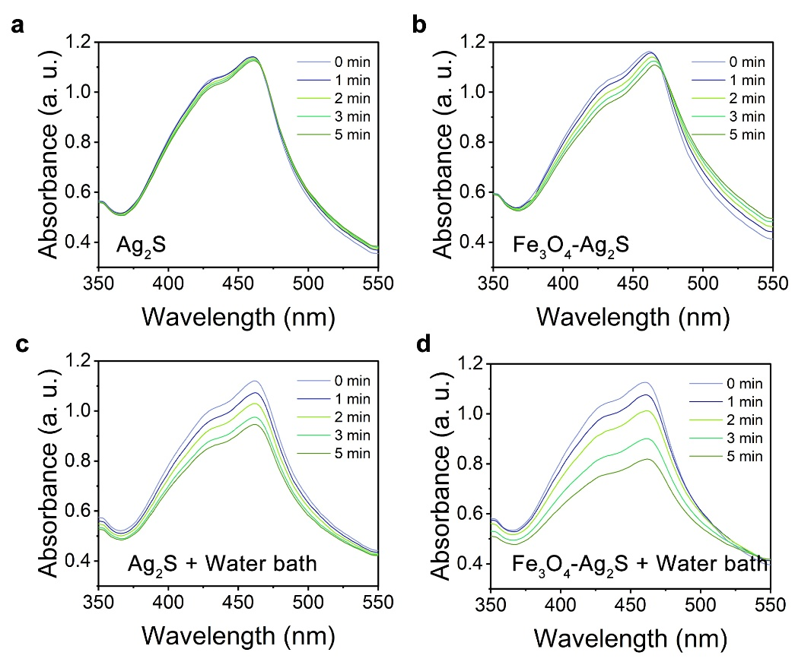
Fig. S14 DPBF indicated ¹O₂ generation of a, c Ag₂S and b, d Fe₃O₄-Ag₂S with or without water bath
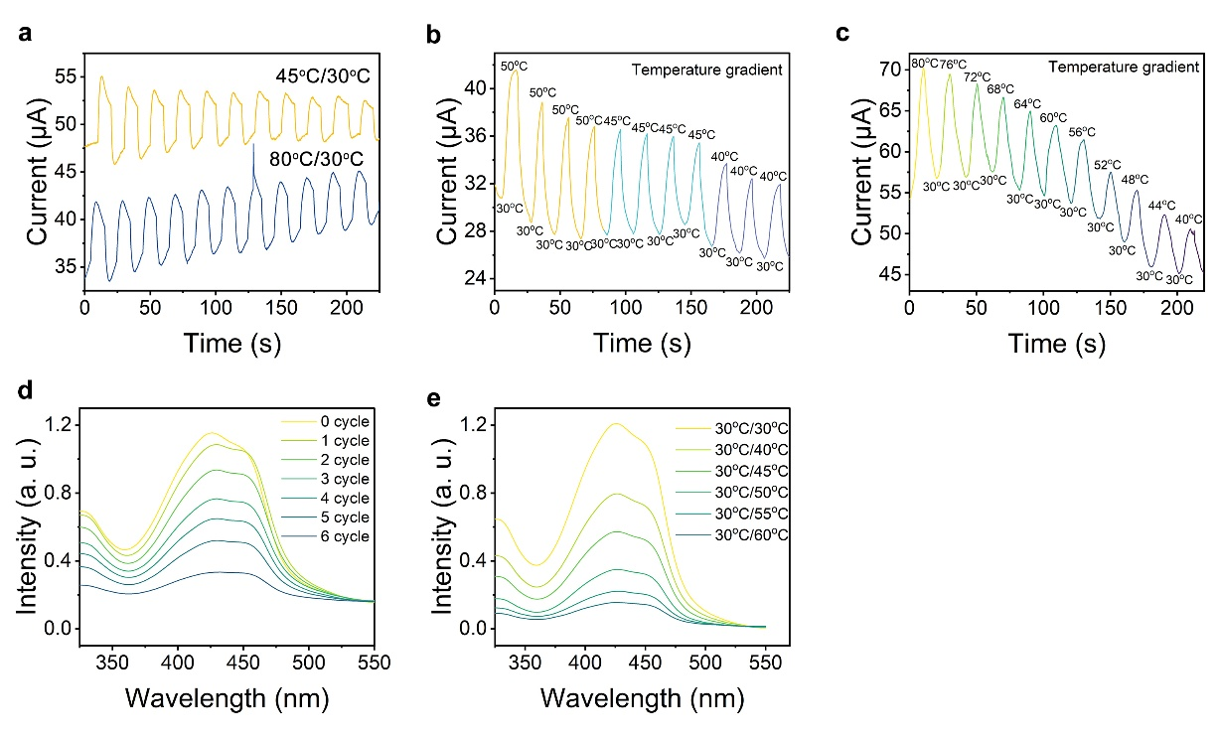
Fig. S15 Fe₃O₄-Ag₂S thermoelectric response. a Current response under 80/30ºC and 45/30ºC water bath. b Current response under a temperature difference of 20, 15, and 10ºC. c Current response under continuously changing temperature gradients. DPBF indicated ¹O₂ generation of Fe₃O₄-Ag₂S under d a 30ºC temperature gradient and e various temperature gradient

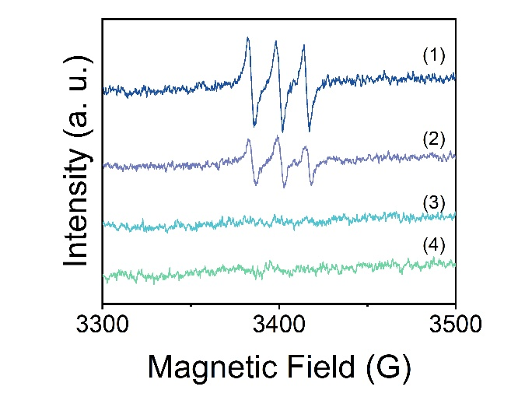
Fig. S16 ESR spectra of ¹O₂ under different conditions. (1) Fe₃O₄-Ag₂S + H₂O₂ + NIR in aqueous, (2) Fe₃O₄-Ag₂S + H₂O₂ + AgNO₃ + NIR in aqueous, (3) Fe₃O₄-Ag₂S + AgNO₃ + H₂O₂ + NIR in methanol and (4) Fe₃O₄-Ag₂S + AgNO₃ + NIR in methanol
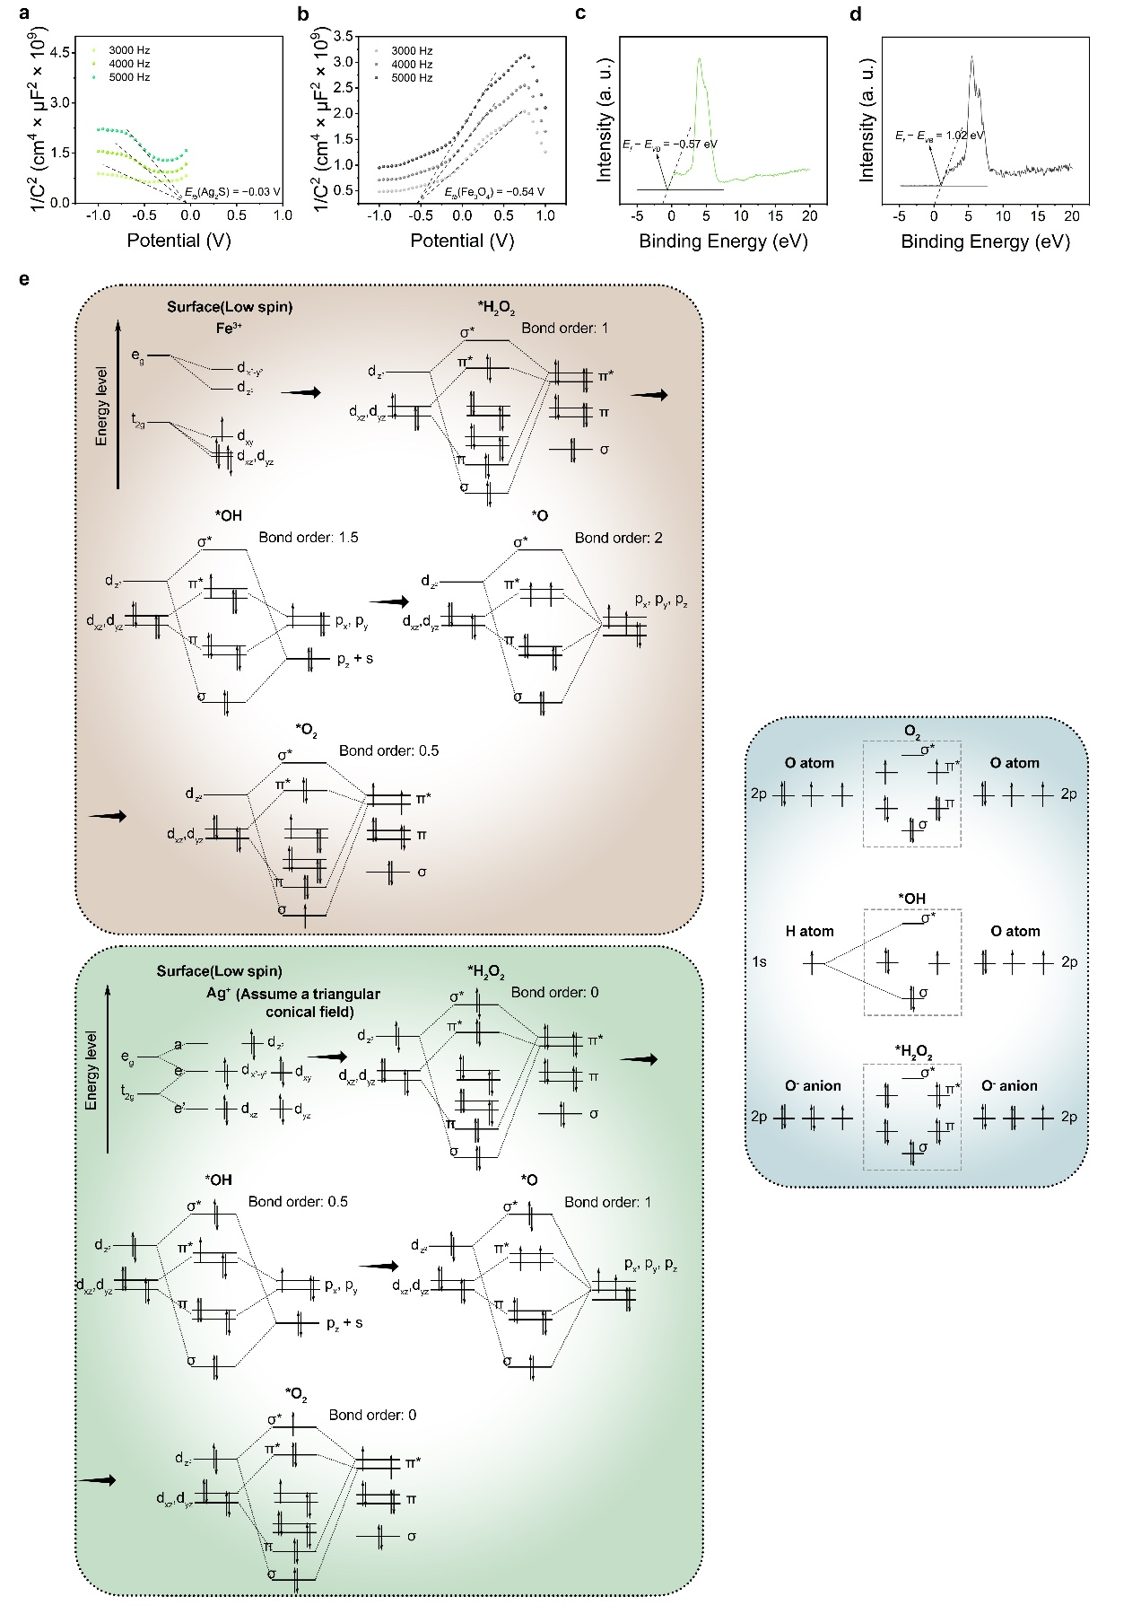
Fig. S17 Mott-Schottky curves and XPS valence band spectra of a, c Ag₂S and b, d Fe₃O₄. e Oxygen precipitation reaction history analyzed by molecular orbital theory of Fe³⁺ at the lowest spin state and Ag⁺

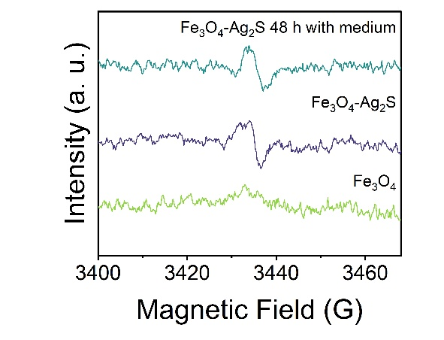
Fig. S18 EPR spectrum of Fe₃O₄-Ag₂S and Fe₃O₄. EPR spectrum of Fe₃O₄-Ag₂S cultured with medium after 48 h

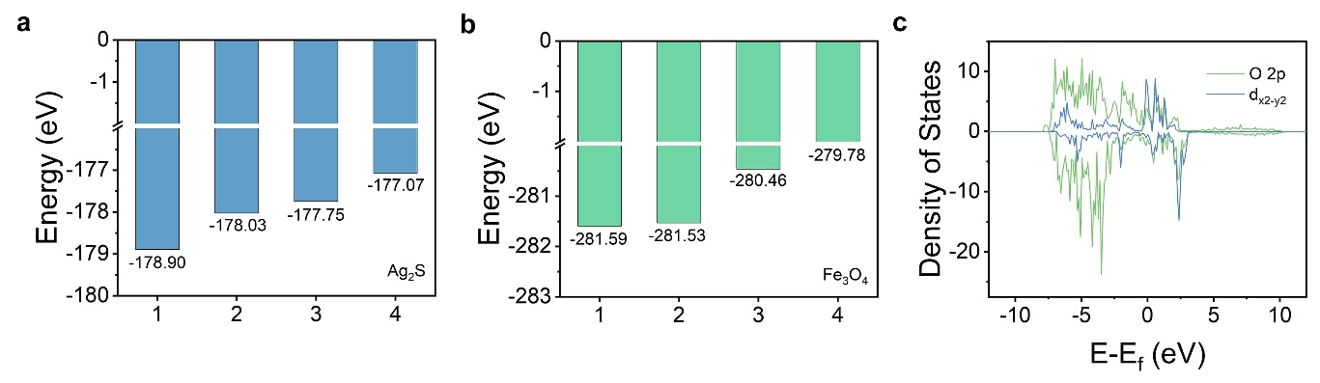
Fig. S19 The energies of different surface termination modes of a Ag₂S and b Fe₃O₄. c PDOS curves of O 2p and Fe d_{x}²_{-y}² orbitals

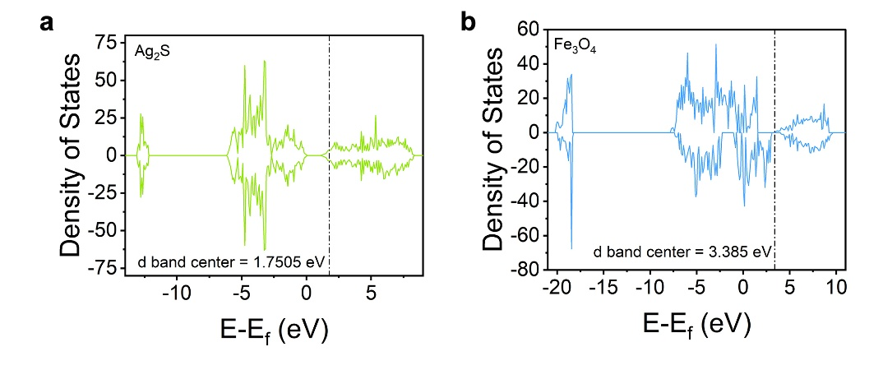
Fig. S20 DOS curves and d band center of a Ag₂S and b Fe₃O₄-Ag₂S

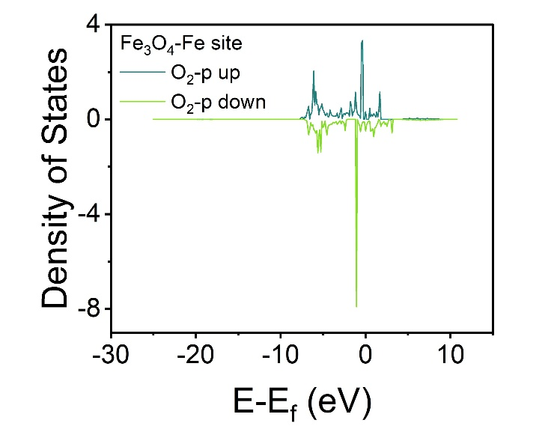
Fig. S21 The PDOS of the p orbital of O₂ adsorbed at the Fe site of Fe₃O₄

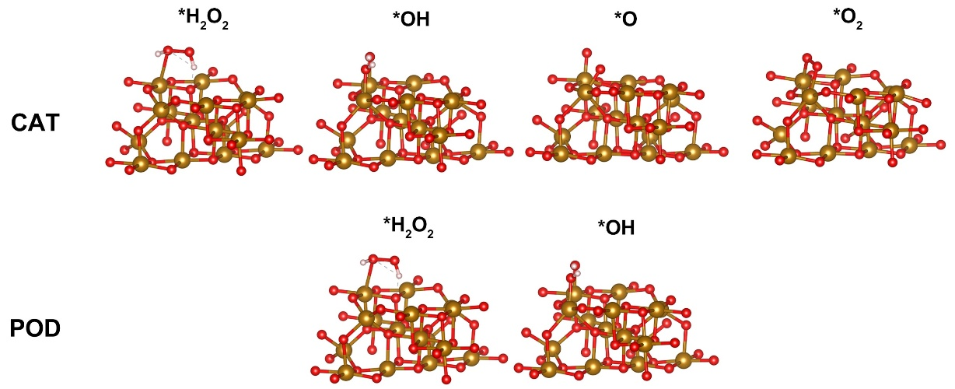
Fig. S22 Surface configurations of different modeled initial, transition, and final states at Fe₃O₄ for the simulated CAT-like and POD-like catalytic processes
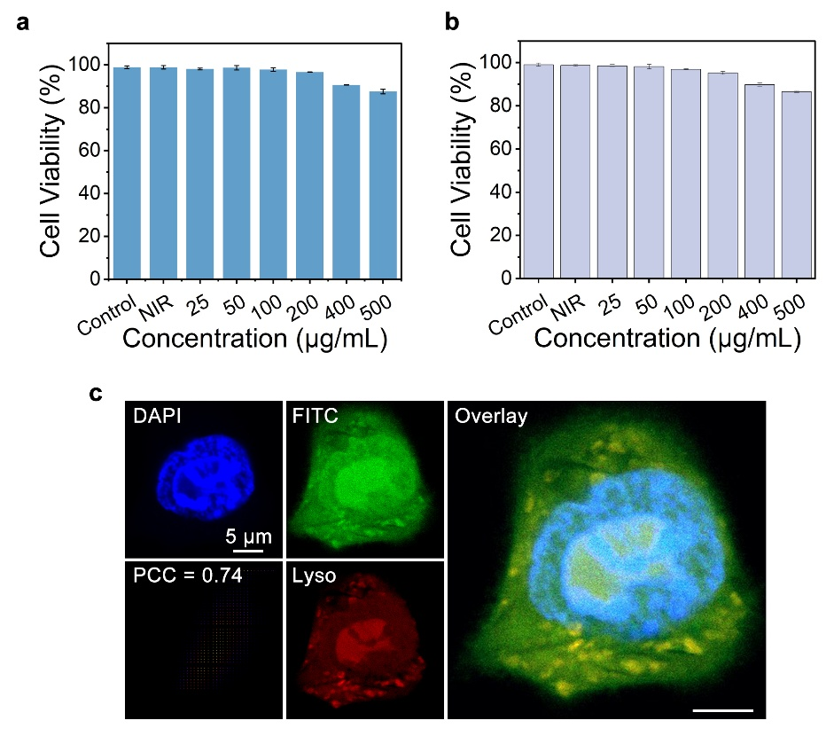
Fig. S23 Biocompatibility of different Fe₃O₄-Ag₂S concentrations with the a L929 fibroblast cell line and b mouse skeletal muscle myoblast cell line C2C12 in co-culture indication, data were presented as mean ± S.D. (n = 3). c Subcellular colocalization experiments of 4T1 cells and Fe₃O₄-Ag₂S after co-culture for 12 hours

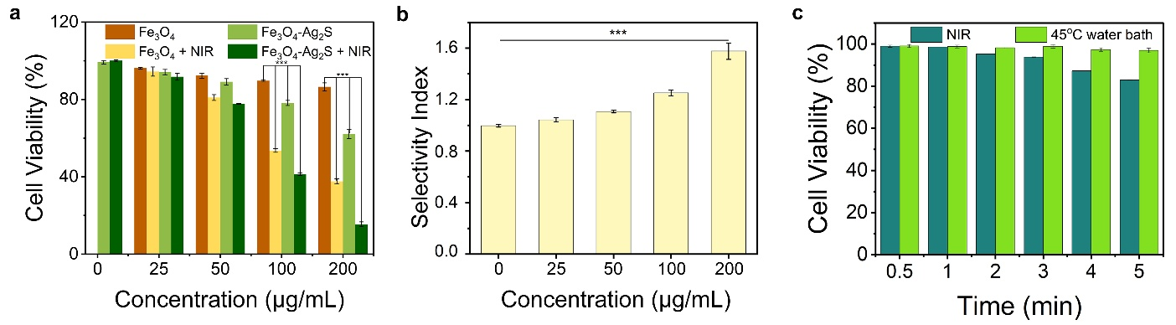
Fig. S24 a 4T1 cytotoxicity of different treatments as indicated by the MTT assay, data were presented as mean ± S.D. (n = 3), ***p < 0.001. b Selectivity Index of Fe₃O₄-Ag₂S in different concentrations. c 4T1 cell viability under NIR or 45ºC water bath

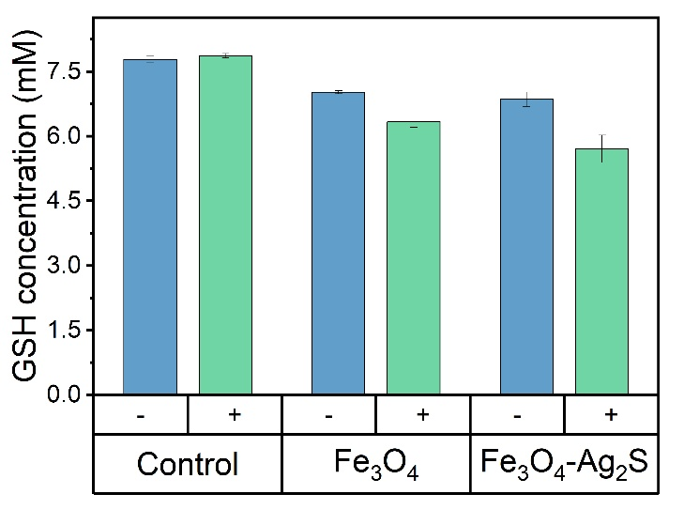
Fig. S25 GSH concentration in 4T1 tumor cells under different treatment (+ and – represent to NIR on and off, respectively), data were presented as mean ± S.D. (n = 3)

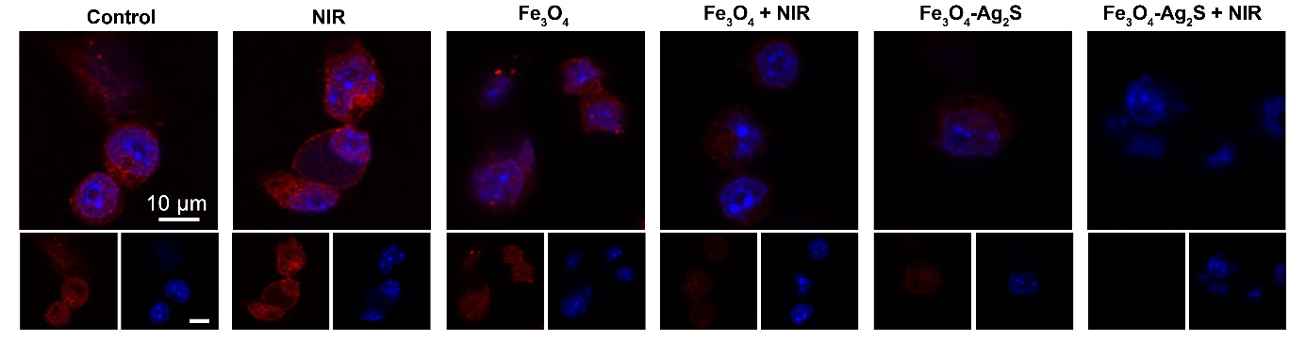
Fig. S26 GPX4 immunofluorescent CLSM images in 4T1 tumor cells under different treatment
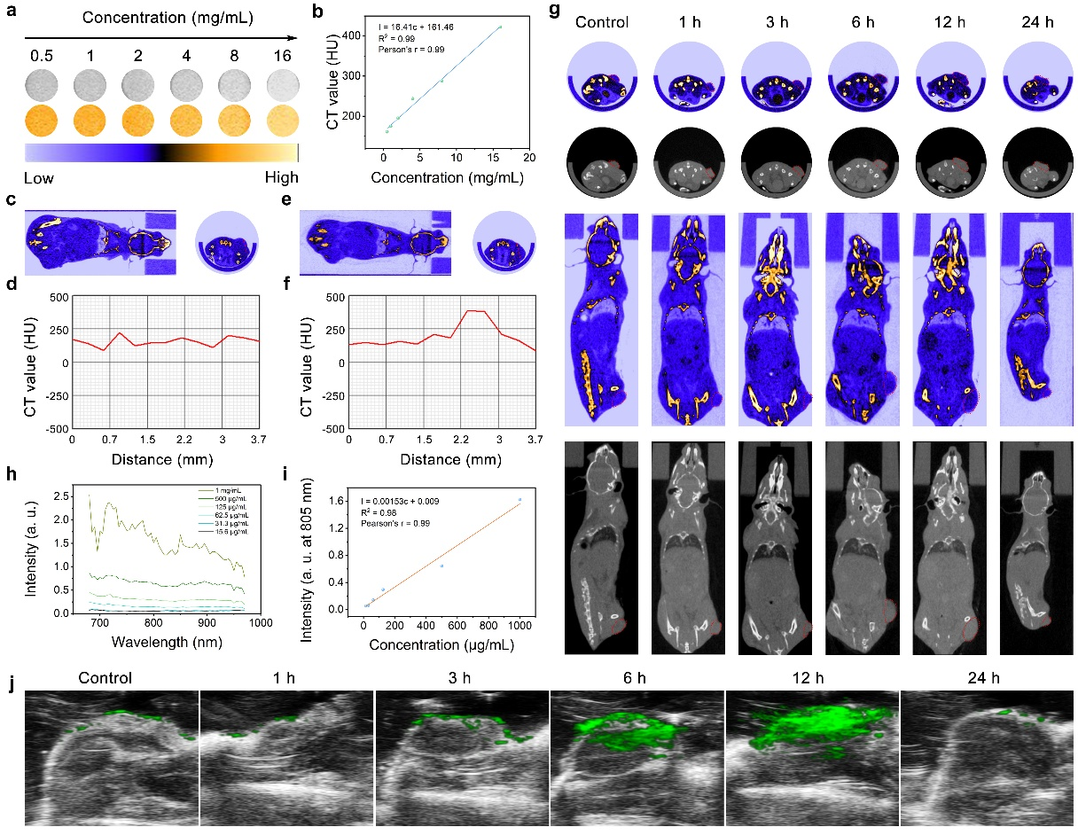
Fig. S27 In vitro and in vivo CT and PA Imaging. a In vitro CT images and pseudo-color images of Fe₃O₄-Ag₂S solutions with different concentrations in PBS. b CT value plots of Fe₃O₄-Ag₂S with the concentrations. In vivo CT images of tumor-bearing mice before c and after e i.t. injection of Fe₃O₄-Ag₂S (20 mg mL⁻¹), and d, f the corresponding cross-sectional compositional line profiles of CT value along the line. g In vivo CT images after i.v. injection of Fe₃O₄-Ag₂S solution at different times. h PA signal-excitation wavelength curves for various concentrations Fe₃O₄-Ag₂S. i PA signal intensity plots of Fe₃O₄-Ag₂S with the concentrations. j In vivo PA images after i.v. injection of Fe₃O₄-Ag₂S solution at different times
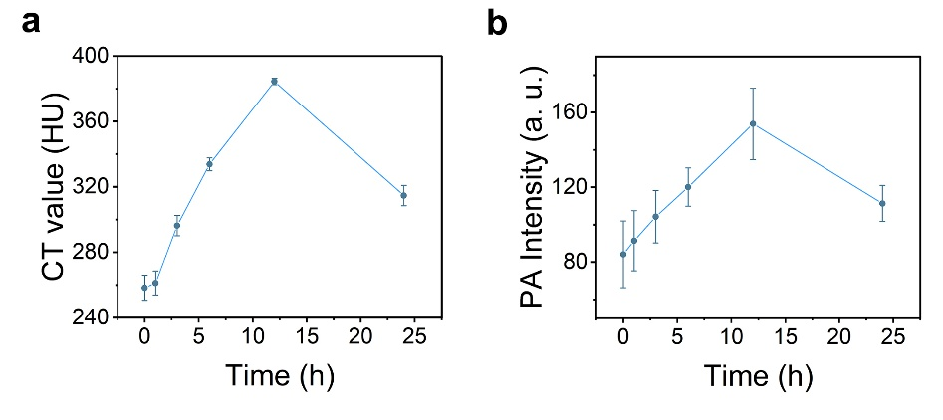
Fig. S28 In vivo a CT and b PA signal analysis, data were presented as mean ± S.D. (n = 3)
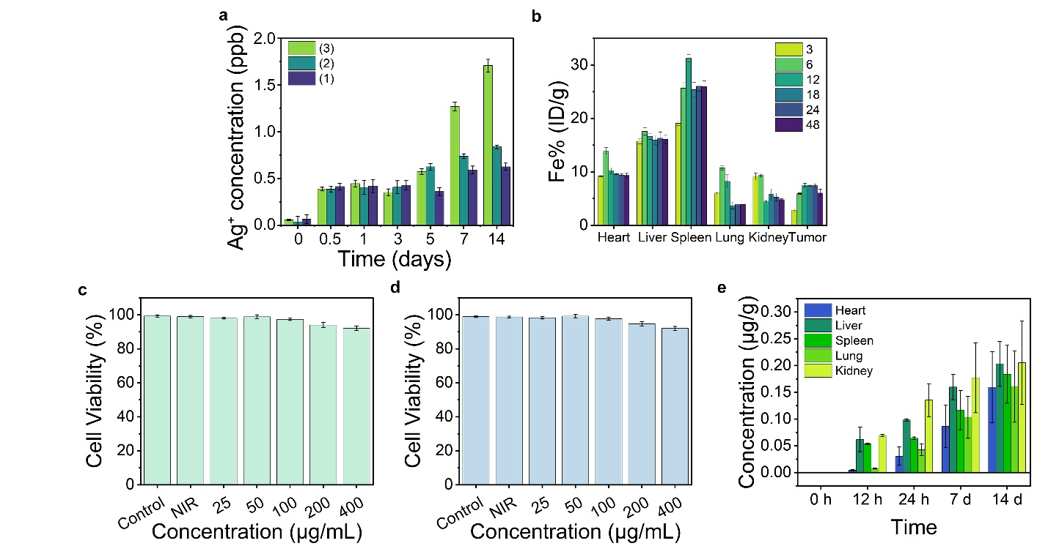
Fig. S29 a Ag⁺ release kinetic analysis using ICP-MS under different solvent: (1) Saline, pH 6.5, with 100 μM H₂O₂ and 100 μM GSH; (2) PBS, pH 6.5, with 100 μM H₂O₂ and 100 μM GSH; (3) Medium, pH 6.5, with 100 μM H₂O₂ and 100 μM GSH, during 0.5, 1, 3, 5, 7, and 14 days. b ICP-OES indicated drug distributions during during 3, 6, 12, 18, 24, and 48 h using Fe element distribution. MTT assay of c HL-7702 hepatocytes and d HK-2 renal proximal tubular cells. e The accumulation of Ag⁺ in various organs at different times after i.v. injection of Fe₃O₄-Ag₂S, data were presented as mean ± S.D. (n = 3)

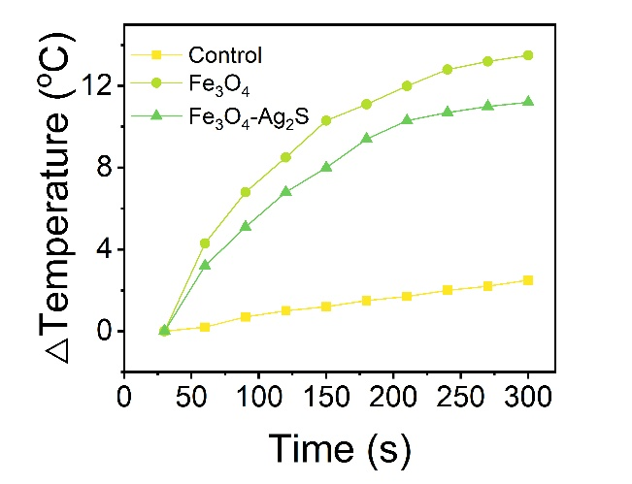
Fig. S30 In vivo photothermal property of PBS (Control), Fe₃O₄, and Fe₃O₄-Ag₂S

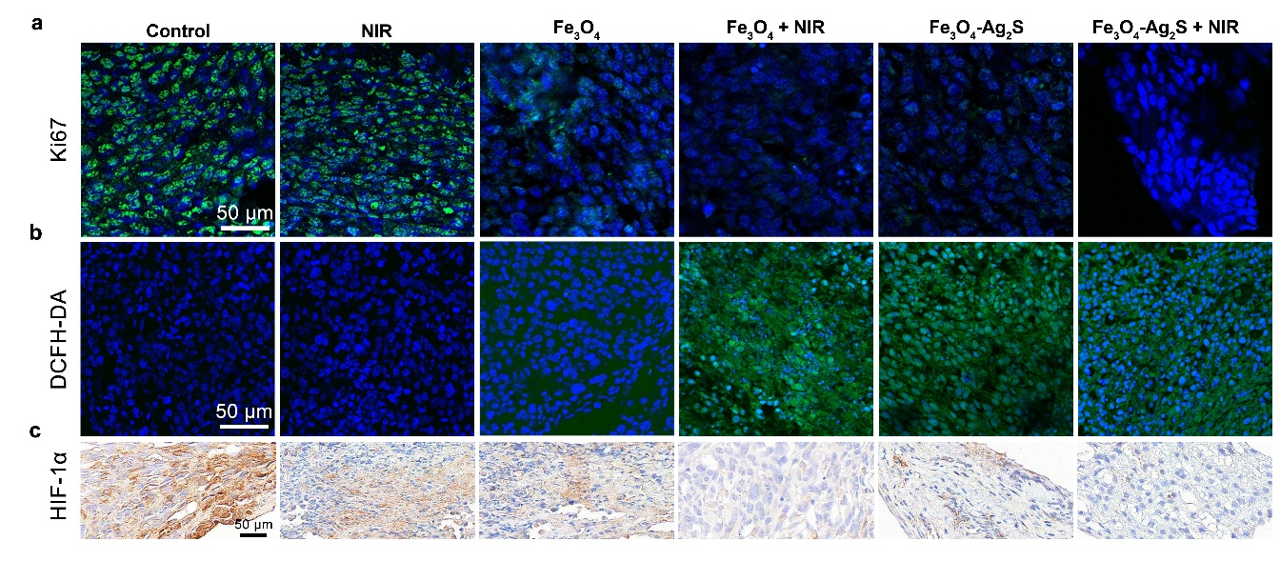
Fig. S31 a Ki67 staining. b Intratumoral ROS concentration indicated by DCFH-DA staining. c HIF-1α immunohistochemical staining

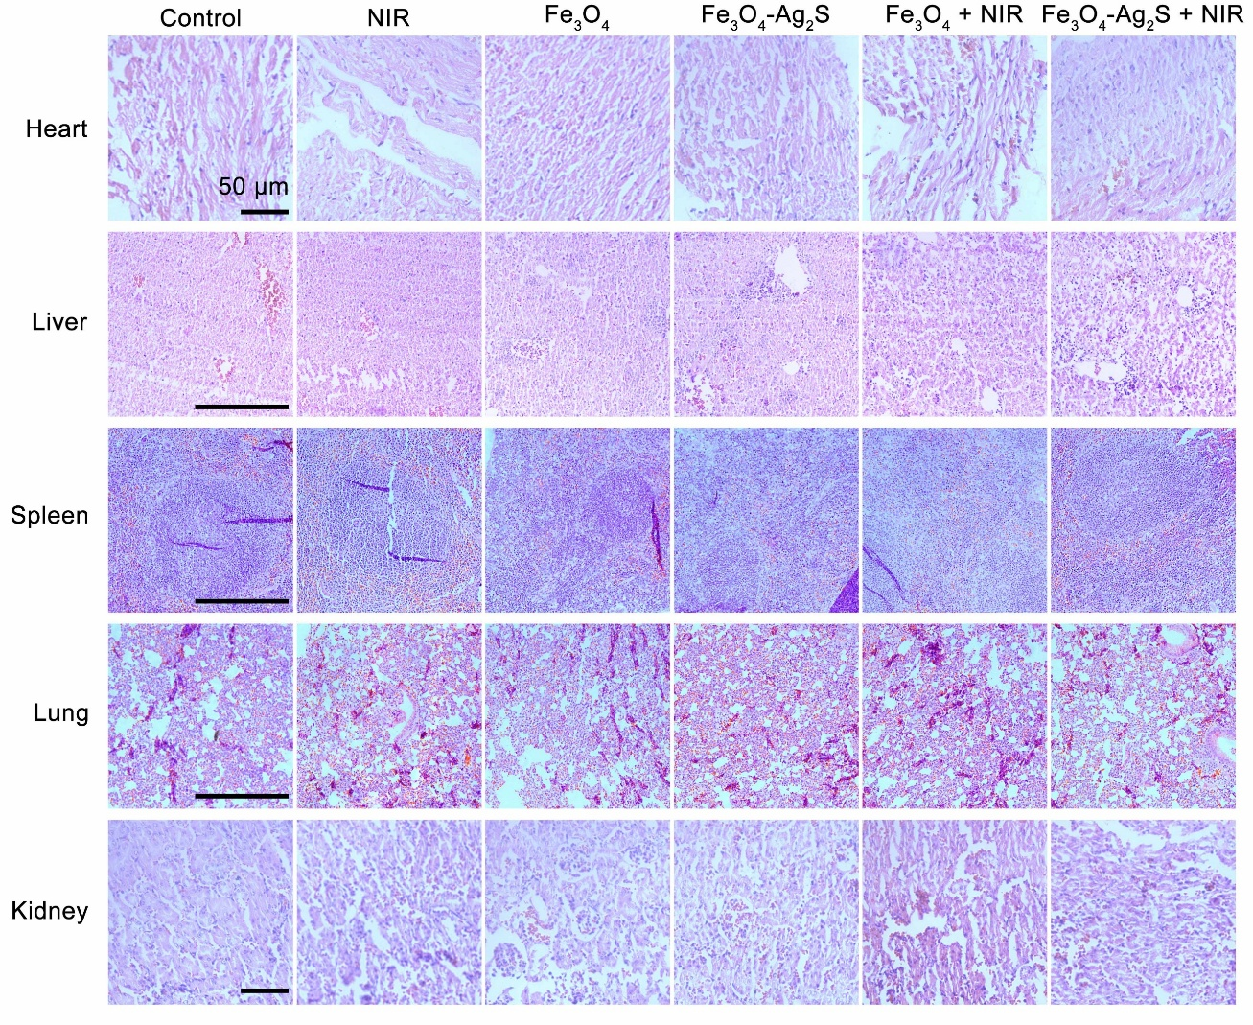
Fig. S32 H&E staining of heart, liver, spleen, lung, and kidney tissue sections
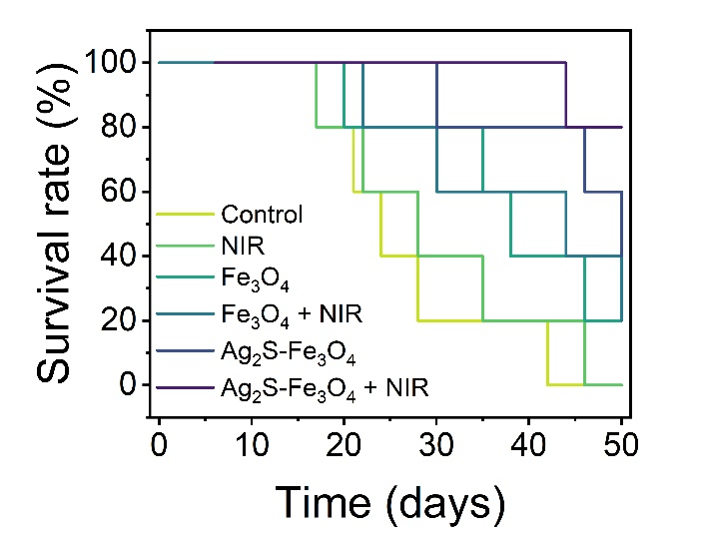
Fig. S33 The Kaplan-Meier survival curves of each treatment group

