Supporting Information for
Chirality-Dependent Supramolecular Biomaterials Remodeling of Scar Microenvironment via Integrin-Mediated Regulation for Hypertrophic Scars Therapy
Xueqian Wang^{1, 2, +}, Chengyao Han^{2, +}, Hongrui Shan^{3, +}, Jinjin Li⁴, Beibei Wu¹, Yixin Zhang^{2,} *, Ke Li^{2,} *, Chuanliang Feng^{1,} *
¹ State Key Lab of Metal Matrix Composites, Shanghai Key Laboratory for Molecular Engineering of Chiral Drugs, School of Materials Science and Engineering, Shanghai Jiao Tong University, Shanghai 200240, P. R. China
² Department of Plastic and Reconstructive Surgery, Shanghai Ninth People’s Hospital, Shanghai Jiao Tong University School of Medicine, Shanghai, P. R. China
³ Research Center of Precision Sensing and Control, Institute of Automation, Chinese Academy of Sciences, Beijing 100190, P. R. China
⁴ National Key Laboratory of Advanced Micro and Nano Manufacture Technology, Shanghai Jiao Tong University, Shanghai, 200240, P. R. China
⁺ Xueqian Wang, Chengyao Han, and Hongrui Shan contributed equally to this work.
*Corresponding authors. E-mail: clfeng@sjtu.edu.cn (Chuanliang Feng); zhangyixin6688@hotmail.com (Yixin Zhang); 18817821624@163.com (Ke Li )
S1 Supplementary Materials and Methods
S1.1 Materials
Pirfenidone and hyaluronic acid (HA, 10kDa) were bought from Aladdin Chemistry (Shanghai) Co., Ltd.; Terephthaloyl Chloride, D/L-Phenylalanine Methyl Ester Hydrochloride, were bought from Sigma-Aldrich Company; Ethanol (C₂H₅OH), Methanol (CH₃OH), Diethylene Glycol (C₄H₁₀O₃), Dichloromethane (CH₂Cl₂), Triethylamine (C₆H₁₅N) and Ammonia were purchased from Macklin Biochemical (Shanghai) Co., Ltd. All aqueous solutions were prepared using ultrapure water (18 MU) from a Milli-Q system (Millipore). Calcein-AM/propidium iodide (PI), Hoechst 33258, Cell Counting Kit-8 (CCK-8, Dojindo), Cell Cycle Analysis Kit (KeyGEN), AnnexinV/PI Apoptosis Kit (KeyGEN), EDU Kit (Invitrogen), Triton X-100, bovine serum albumin (BSA), and 4% paraformaldehyde and were acquired from Shanghai Shaoxin Biotechnology Co., Ltd.; Fetal bovine serum (FBS), Trypsin (0.25%), Dulbecco’s Modified Eagle Medium (DMEM), and normal saline were purchased from Thermo Fisher Scientific (China) Co., Ltd.; Phalloidin-iFluor 488 conjugate was bought from ATT Bioquest; Primary hypertrophic scar fibroblasts (HSFs) were isolated from human pathological hypertrophic scar tissues, provided by the Department of Plastic and Reconstructive Surgery in the Shanghai Ninth People’s Hospital, Shanghai, China. All of the chemicals were used as received without further purification.
S1.2 Synthesis of D/LP
Based on a previous synthetic approach, L/D-phenylalanine chiral gelator (L/DPFEG) was synthesized.¹ Terephthaloyl chloride (2.6 g, 13.0 mmol) was dissolved in DCM (20 mL) and slowly added to a mixture of 100 mL triethylamine (8.0 mL, 58.4 mmol) and L-phenylalanine methyl ester hydrochloride (6.0 g, 26.2 mmol) while being magnetically stirred. The mixture was agitated overnight to remove the excess solvent, and then concentrated using rotavapor. Following the ethanol-based dissolution of the remaining component in the flask, filtering, and drying, the insoluble materials p-Ph(L-Phe-OMe)₂ were produced. The intermediate product (5.1 g, 10.5 mmol, 85%) was dissolved in methanol and NaOH aqueous solution (15 mL) was added while being stirred for 24 hours to produce a transparent solution. In order to produce gel precipitation, the pH of the solution was then changed using HCl (3.0 M). The gel was next filtered, several times washed with DI water, and vacuum dried to get the p-Ph(L-Phe-OH)₂ (4.6 g, 9.9 mmol, 90%). Overall yield of LPF: 76.5%. Similarly, DPF was obtained as a white solid after freeze-drying (4.2 g, 82%).
After reacting at 130 °C for 3.5 hours, the cleaned solution was added to the frozen water, producing gel precipitation. After several filters and rinses with DI water, the sediment was finally baked to produce LPFEG gelator (4.2 g, 6.6 mmol, 91%), which was obtained. In the same way, DPFEG gelator (3.6 g, 5.6 mmol, 85%) was produced.
S1.3 In vitro cell migration experiment
The scratch assay was performed on the hypertrophic scar fibroblasts (HSFs) to assess cell migration. The relative Cell migration rate was calculated as following Equation (S1):
Cell migration rate = [(A0–An)/(A0)] × 100% (S1)
where A0 is the initial wound area (time = 0 h) and An is the wound area at each time point (24 h and 48 h). Data were presented as a mean with SD of three independent experiments.
S1.4 In vivo histological assay
For histological assays, scar tissues from rabbit ear were collected at day 30 and stained with Hematoxylin and Eosin (H&E). Based on H&E images, the scar elevation index (SEI) was quantified by Image J V. 1.52 and was calculated by the Equation (S2):
SEI = a / b (S2)
where a defines the maximum thickness of the scar tissue and brepresents the maximum thickness of the normal dermis surrounding the scar tissue. These values were determined by measuring the maximum thickness of the scar and normal tissues, respectively, from the top point of the epithelium to the surface of the cartilage.
S2 Supplementary Tables
Table S1 Skin irritation test of HA MNs, L-HA MNs, and D-HA MNs in rabbit ear skin
Group | Stimulus response | Time / h
Group | Stimulus response | 1 | 24 | 72
Control | erythema | 0 | 0 | 0
Control | edema | 0 | 0 | 0
HA MNs | erythema | 0 | 0 | 0
HA MNs | edema | 0 | 0 | 0
L-HA MNs | erythema | 0 | 0 | 0
L-HA MNs | edema | 0 | 0 | 0
D-HA MNs | erythema | 0 | 0 | 0
D-HA MNs | edema | 0 | 0 | 0

Table S2 Western blotting assay
Reagent | Company | Cat.ID
RIPA Lysis Buffer | Bryotime | P0013B
PMSF（100mM） | Biosharp | BL507A
Phosphorylated Protease Inhibitor | Bryotime | P1081
BCA protein assay kit | Bryotime | P0012
SDS-PAGE loading buffer (5×) | Bryotime | P0015
SDS-PAGE Gel Kit | Biosharp | BL508A
Protein Marker | YEASEN | 20350ES72
TRIS | BIOFROXX | 1115GR500
Glycine | BIOFROXX | 1275KG2P5
SDS | BIOFROXX | 3250GR500
PVDF membrane (0.45 μm)  PVDF membrane (0.22 μm)  BSA | Millipore  Millipore  Roche | IPVH00010  ISEQ00010  G5001
TWEEN 20 | Solarbio | T8220
ECL  Transfer buffer  Electrophoresis buffer  TBS buffer  PCNA | Biosharp  Boerfu  Boerfu  Boerfu  Proteintech | BL520A  BER0001  BER0002  BER0003  10205-2-AP
Cyclin D1 | Abcam | ab134175
CDK4 | Abcam | ab199728
p21 | Proteintech | 10355-1-AP
Intrgrinβ1 | Proteintech | 12594-1-AP
Vinculin | Proteintech | 66305-1-Ig
FAK  p-FAK  AKT  p-AKT  PI3K  p-PI3K  β-actin  GAPDH  β-catenin  p-Smad2  p-Smad3  TGF β1  GSK-3β | Affinity  Affinity  Proteintech  HUABIO  HUABIO  Affinity  Abclonal  HUABIO  CST  Bioss  Bioss  Proteintech  Bioss | AF6397  AF3398  60203-2-Ig  ET1612-73  ET1608-70  AF3241  AC026  ET1601-4  8480S  bs-3420R  bs-3425R  21898-1-AP  bs-0028R
HRP, Goat Anti-Rabbit IgG | Jackson | 111-035-003
HRP, Rabbit Anti-Goat IgG | Jackson | 305-035-003
HRP, Goat Anti-Mouse IgG | Jackson | 115-035-003
HRP, Goat Anti-Rat IgG | Jackson | 112-035-003

Table S3 Primers used for real-time PCR
Target gene | Primer sequences (5′-3′)
β-actin | Forward  Reverse | CTGGAACGGTGAAGGTGACA  TCAAAGTCCTCGGCCACATT
GSK-3β | Forward  Reverse | TGTCCTTCTTCGTGGTGAGC  CATCTCGGACGTCAGGTAGC
TGF-β | Forward  Reverse | CGGAGAGCAGCCGGAAAAT  AAGCTGTGGATTGCTTTGCG
p-Smad3 | Forward  Reverse | GTGAGAAGGCGGTCAAGAGC  AGGGATTCACGCAAACCTCA
p-Smad2 | Forward  Reverse | GTGTGAGAAGGCCGTGAAGA  TCAGTCCCCAAATTTCAGAGCA
β-catenin | Forward  Reverse | ATGACTCGAGCTCAGAGGGT  GTTAGTGGGATGAGCGGCAT
S3 Supplementary Figures
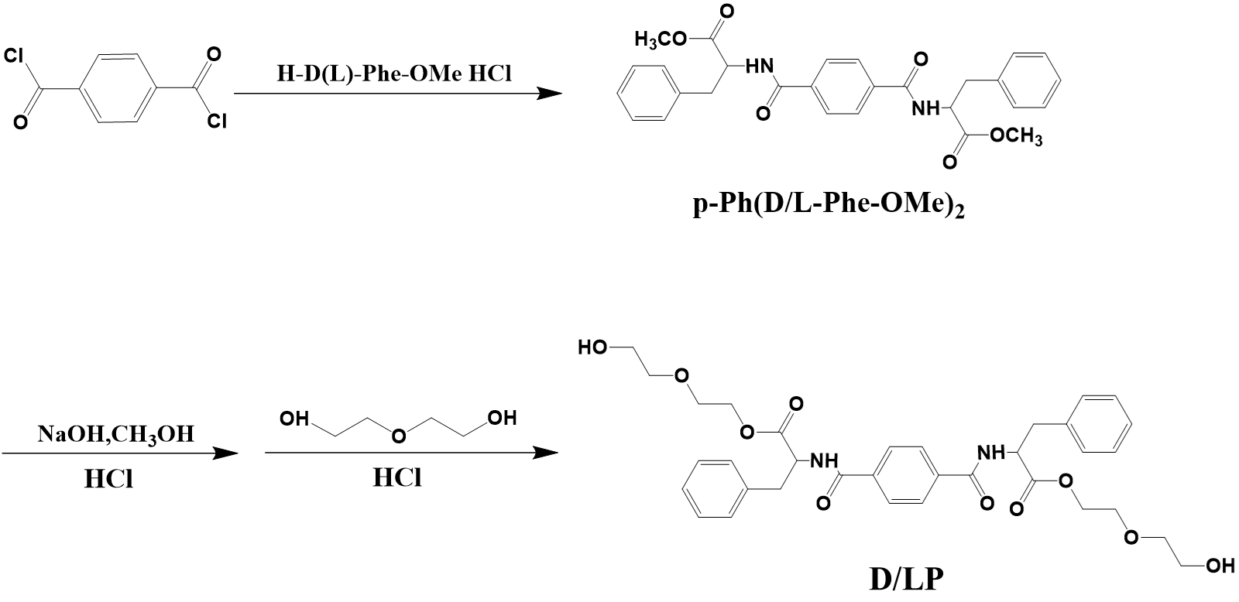
Fig. S1 Synthesis procedures of L/DP. L/DP was synthesized by H-L-Phe-OMe and H-D-Phe-OMe, respectively
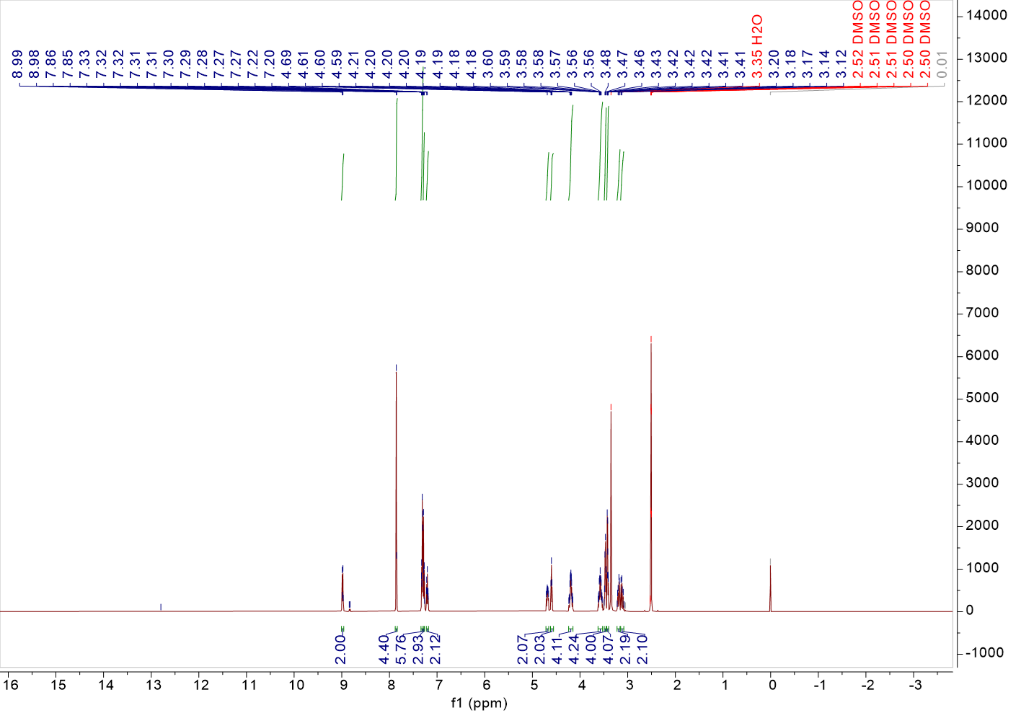
Fig. S2 ¹H-NMR spectrum of LP in DMSO-d6
¹H NMR (500 MHz, DMSO-d6) δ 8.98 (d, J = 7.8 Hz, 2H), 7.85 (d, J = 3.4 Hz, 4H), 7.34 – 7.29 (m, 6H), 7.28 (d, J = 7.8 Hz, 3H), 7.23 – 7.18 (m, 2H), 4.68 (ddd, J = 10.0, 7.8, 5.4 Hz, 2H), 4.60 (t, J = 5.4 Hz, 2H), 4.19 (qdd, J = 12.0, 5.9, 3.7 Hz, 4H), 3.58 (tdd, J = 11.5, 8.7, 4.8 Hz, 4H), 3.47 (q, J = 5.2 Hz, 4H), 3.42 (dd, J = 5.5, 4.0 Hz, 4H), 3.19 (dd, J = 13.9, 5.3 Hz, 2H), 3.12 (dd, J = 13.8, 10.0 Hz, 2H).
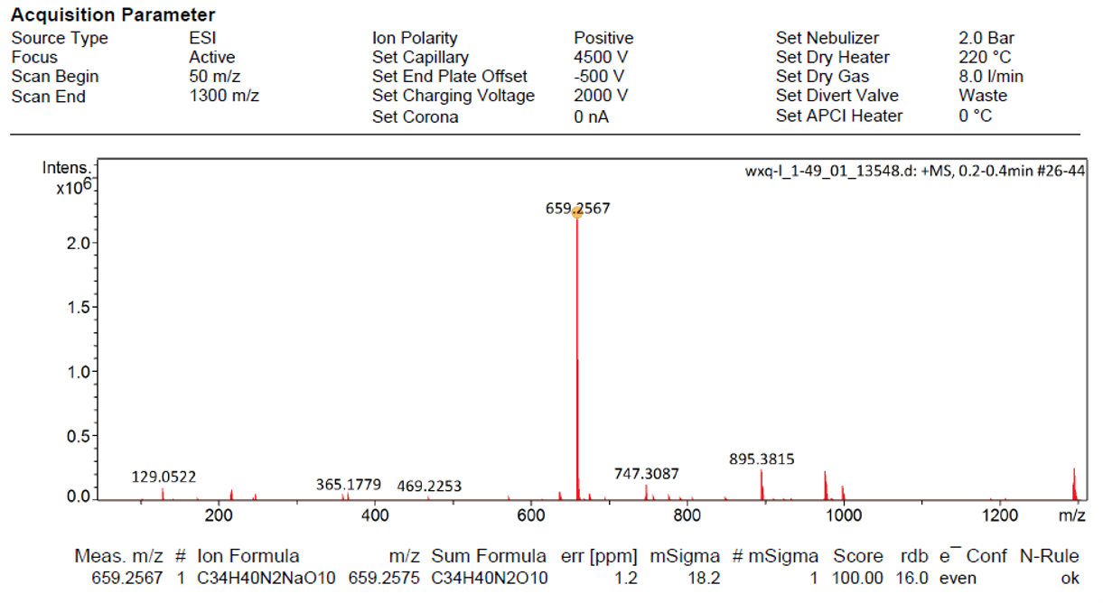
Fig. S3 EI-HRMS spectrum of LP

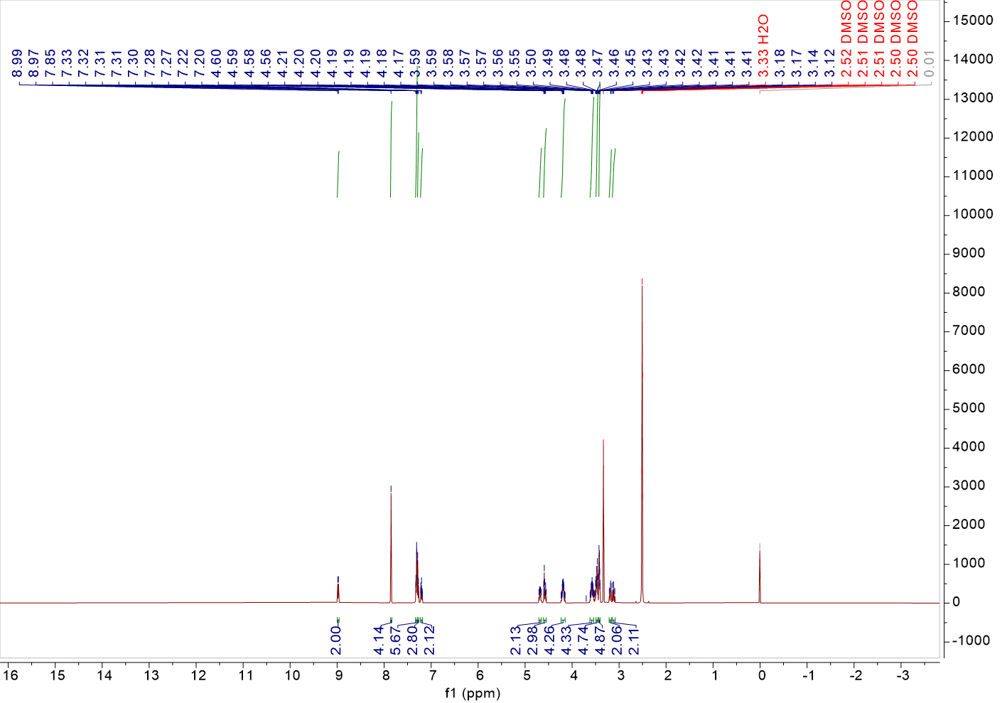
Fig. S4 ¹H-NMR spectrum of DP in DMSO-d6
¹H NMR (500 MHz, DMSO-d6) δ 8.98 (d, J = 7.8 Hz, 2H), 7.85 (s, 4H), 7.33 – 7.29 (m, 6H), 7.28 (d, J = 7.5 Hz, 3H), 7.23 – 7.18 (m, 2H), 4.68 (ddd, J = 10.1, 7.8, 5.3 Hz, 2H), 4.58 (dt, J = 14.2, 5.5 Hz, 3H), 4.19 (qdd, J = 11.9, 6.0, 3.7 Hz, 4H), 3.58 (qdt, J = 7.7, 5.8, 2.9 Hz, 4H), 3.49 – 3.45 (m, 5H), 3.43 – 3.40 (m, 5H), 3.19 (dd, J = 13.8, 5.3 Hz, 2H), 3.11 (dd, J = 13.8, 10.0 Hz, 2H).
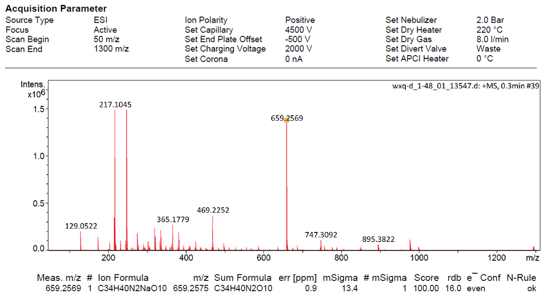
Fig. S5 EI-HRMS spectrum of DP

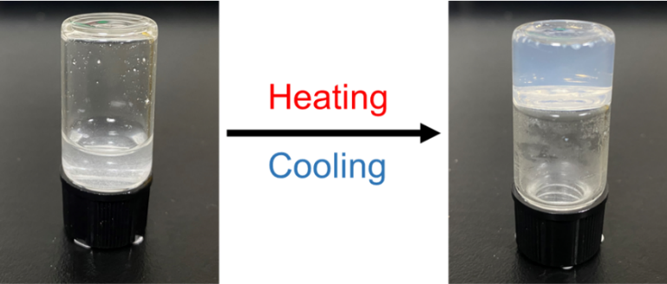
Fig. S6 Photographs of LP before and after a heating and cooling process
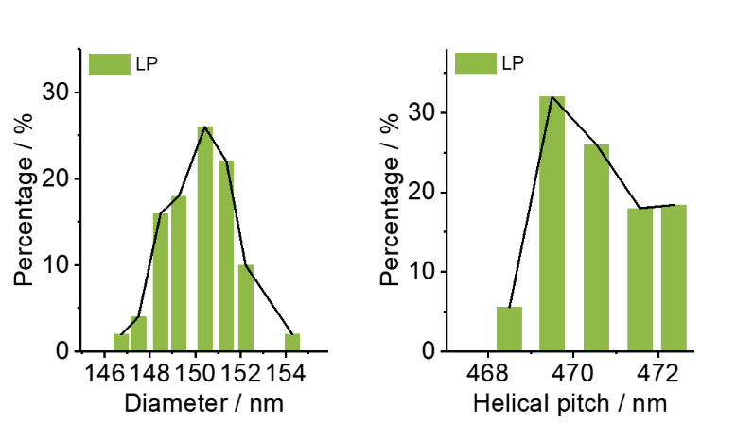
Fig. S7 SEM image of LP and the statistical data of diameter and helical pitch (n = 50). Scale bar: 500 nm

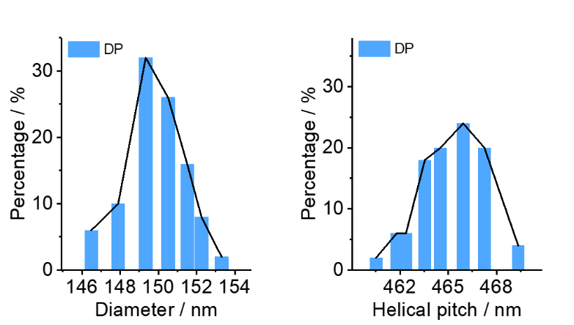
Fig. S8 SEM image of DP and the statistical data of diameter and helical pitch (n = 50). Scale bar: 500 nm
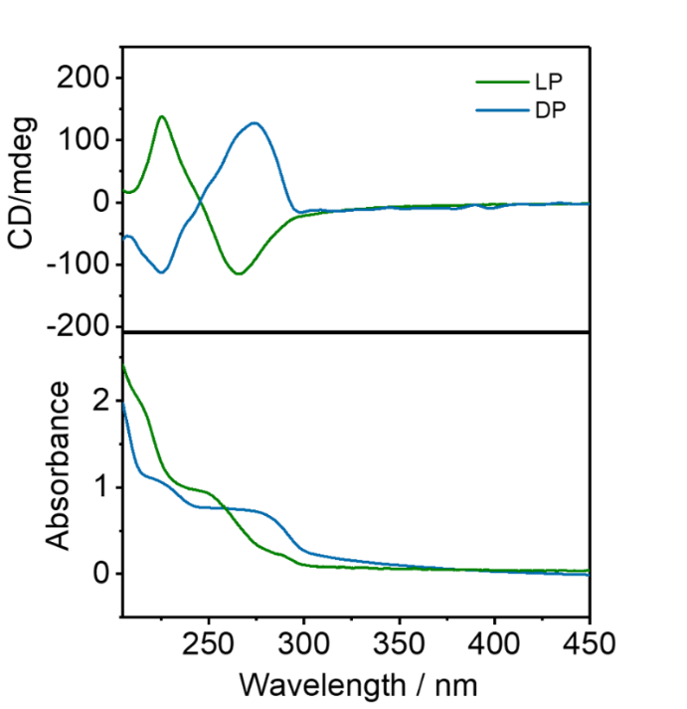
Fig. S9 CD and corresponding UV-vis spectra of LP and DP

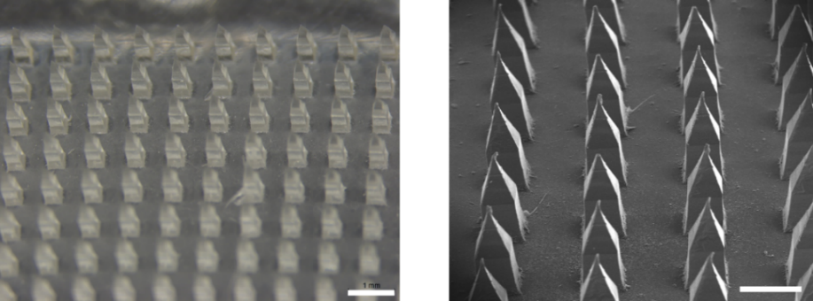
Fig. S10 Stereoscopic and SEM image of D-HA MNs. Scale bar (left): 1 mm and scale bar (right): 500 μm
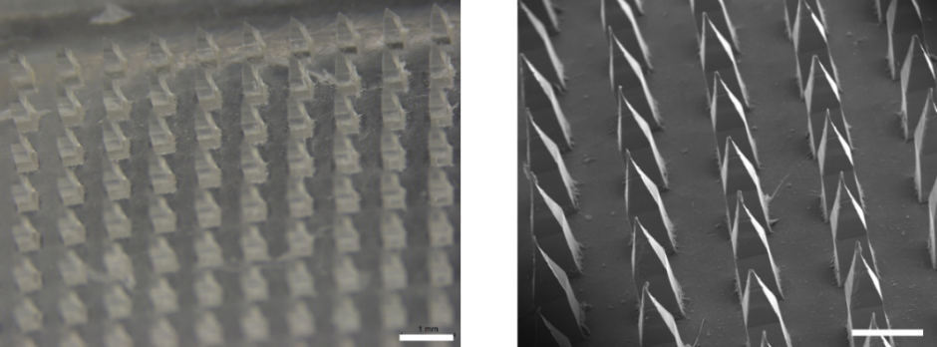
Fig. S11 Stereoscopic and SEM image of HA MNs. Scale bar (left): 1 mm and scale bar (right): 500 μm
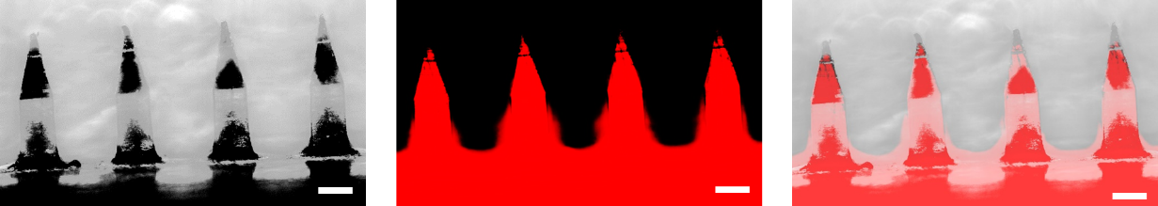
Fig. S12 Representative fluorescence images of the Rhodamine B labeled L-HA MNs. Scale bar, 200 μm
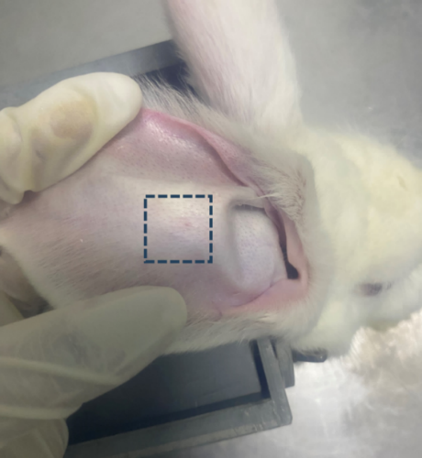
Fig. S13 Image of rabbit ear after microneedle treatment

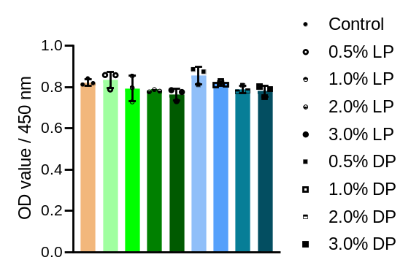
Fig. S14 Cell viability of NSFs with different concentrations of L/DP
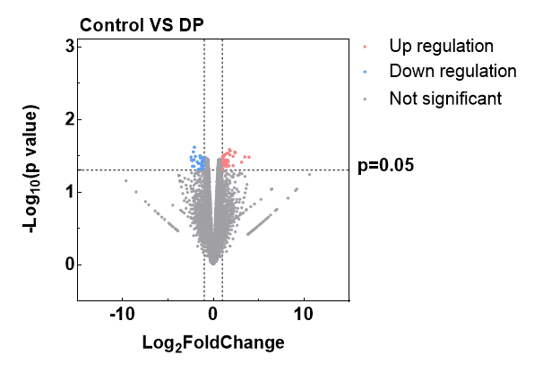
Fig. S15 Volcano plot of differentially expressed genes in control vs 3% DP

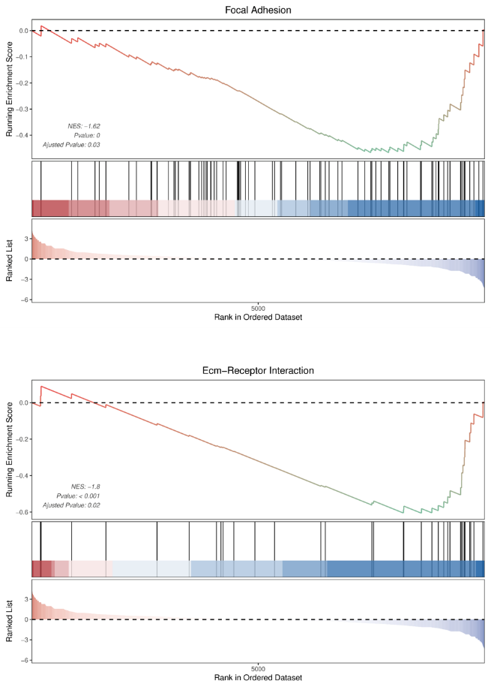
Fig. S16 Gene set enrichment analysis (GSEA) of focal adhesion and ECM-receptor interaction in control vs. LP
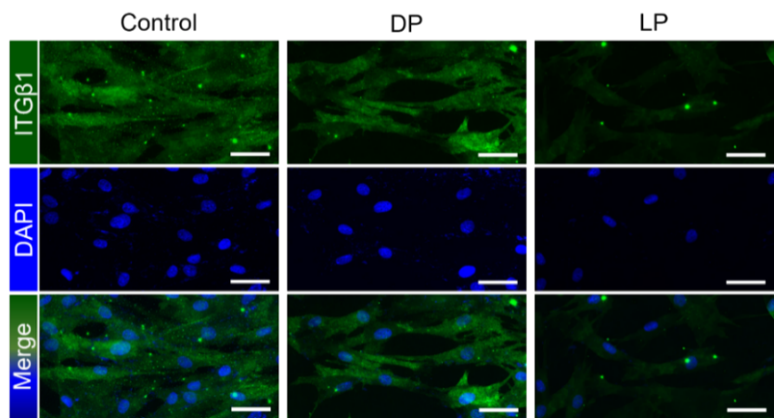
Fig. S17 Immunofluorescent staining images of ITGβ1 after DP and LP treatments. Green (ITGβ1) and blue (DAPI). Scale bar: 40 μm

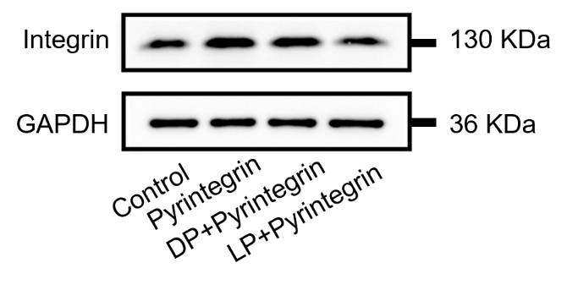
Fig. S18 The WB images of control, pyrintegrin, DP+pyrintegrin, and LP+pyrintegrin

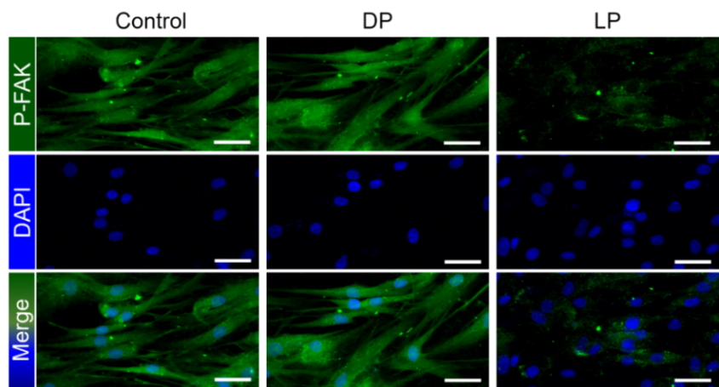
Fig. S19 Immunofluorescent staining images of p-FAK after DP and LP treatments. Green (p-FAK) and blue (DAPI). Scale bar: 40 μm
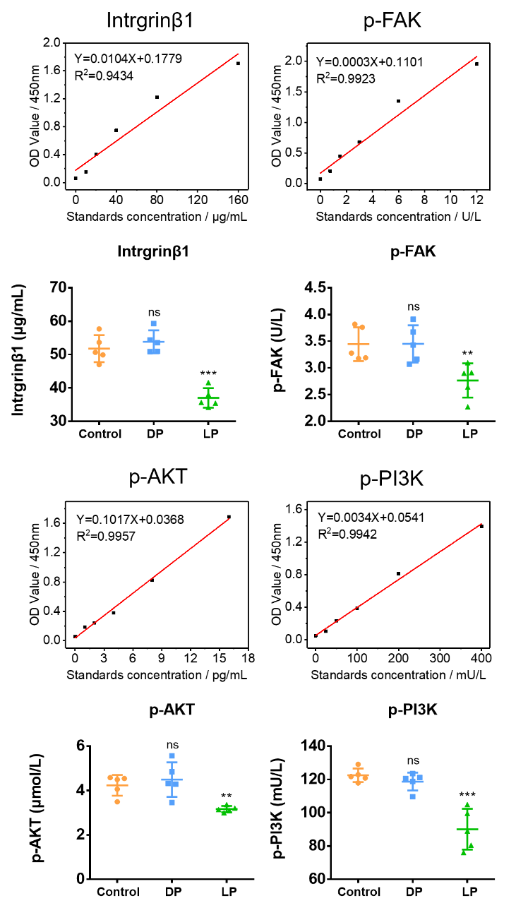
Fig. S20 The Elisa experiment results of ITGβ1 and p-FAK in control, 3% DP, and 3% LP (n=5 independent samples)
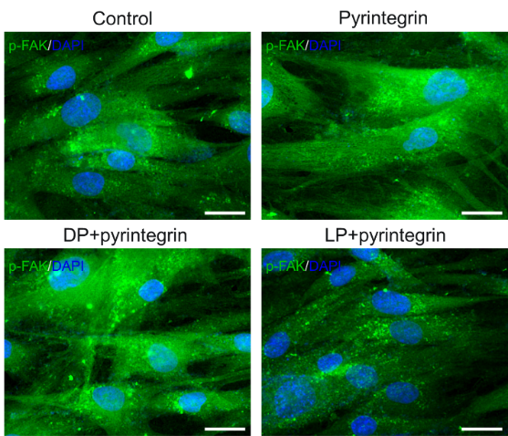
Fig. S21 Immunofluorescent staining images of p-FAK after various treatments. Green (p-FAK) and blue (DAPI). Scale bar: 40 μm
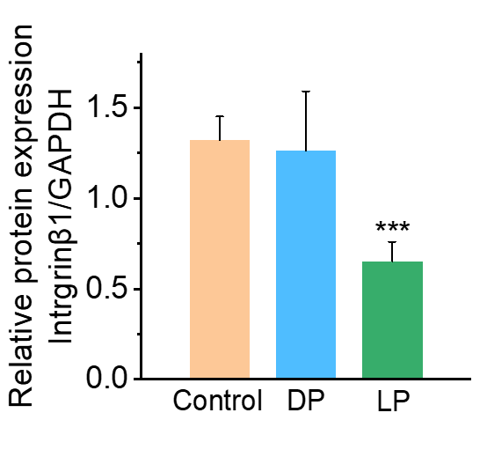
Fig. S22 Quantitative analyses of the protein expression levels of ITGβ1 in different groups (n=3 independent samples)
Fig. S23 The Elisa experiment results of p-AKT and p-PI3K in control, 3% DP, and 3% LP

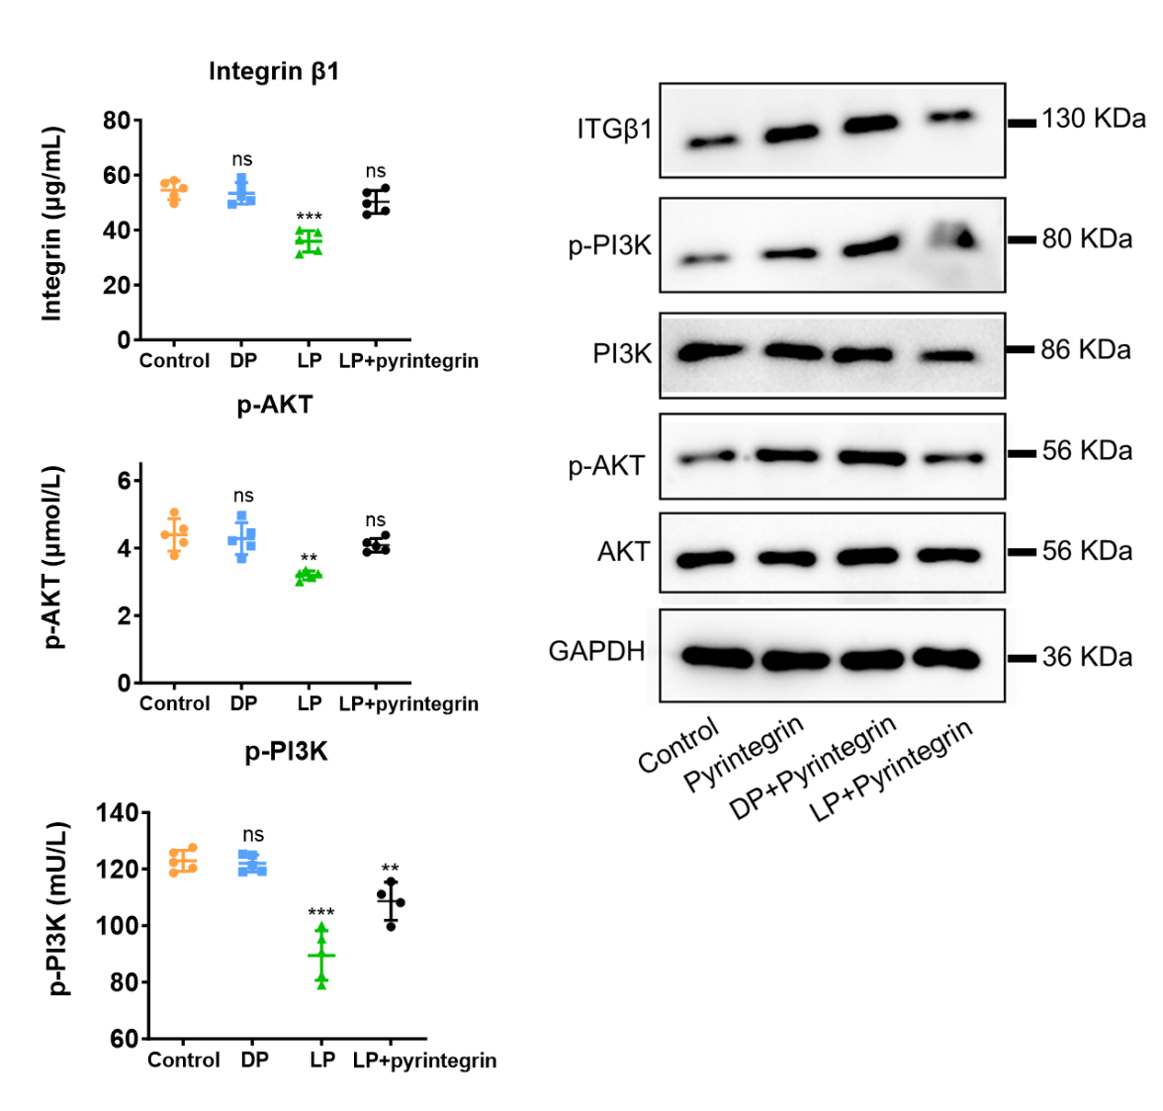
Fig. S24 The Elisa experiment and WB results of ITGβ1, p-AKT, and p-PI3K after various treatments (n=5 independent samples)
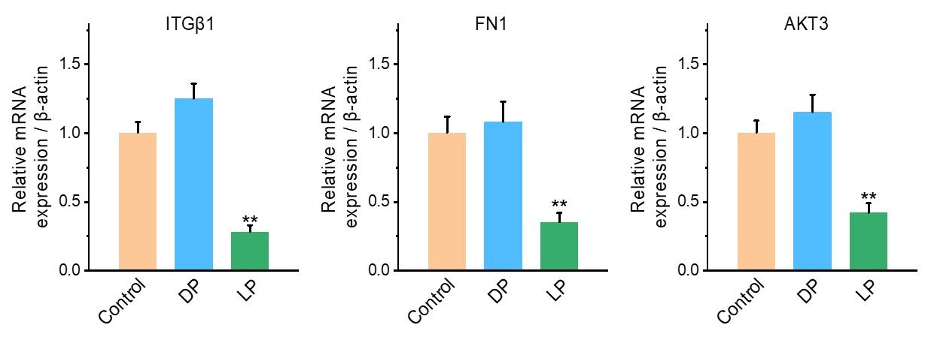
Fig. S25 Quantitative analyses of the relative mRNA expression levels of ITGβ1, FN1, and AKT3

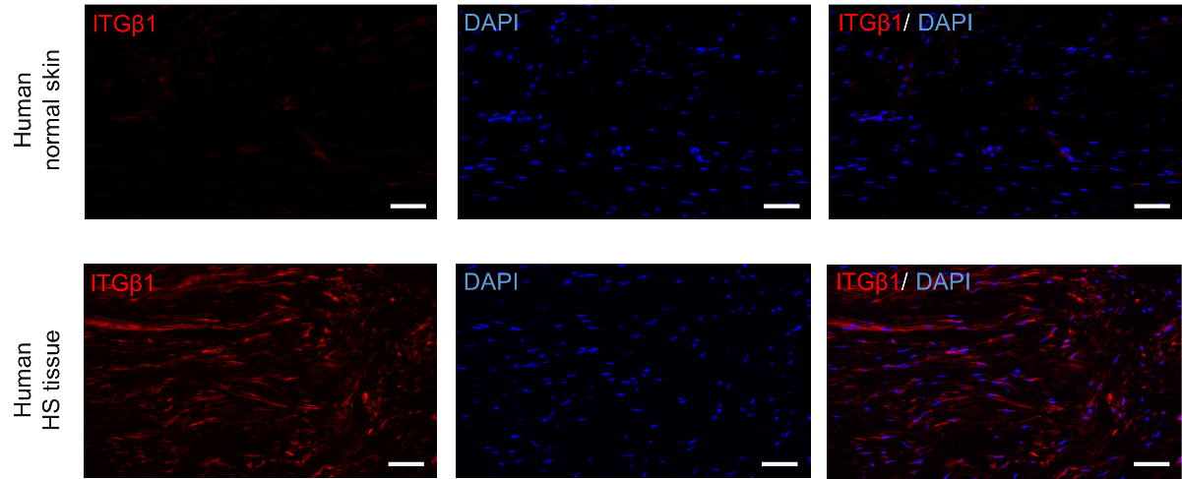
Fig. S26 Representative immunofluorescence staining of ITGβ1 in human normal skin and human HS tissue. Scale bar, 20 μm

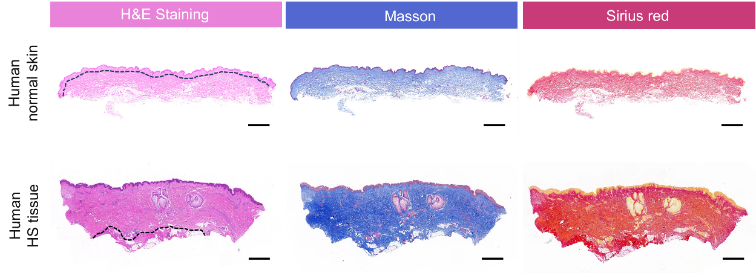
Fig. S27 Representative H&E staining, Masson staining, and Sirius red staining images of human normal skin and human HS tissue. Scale bar, 1000 μm
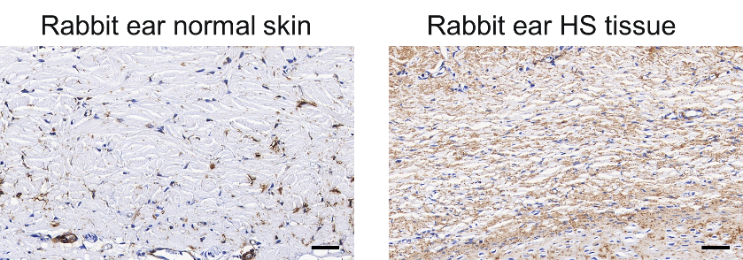
Fig. S28 Representative immunohistochemistry staining of ITGβ1 in rabbit ear normal skin and rabbit ear HS tissue. Scale bar, 1000 μm

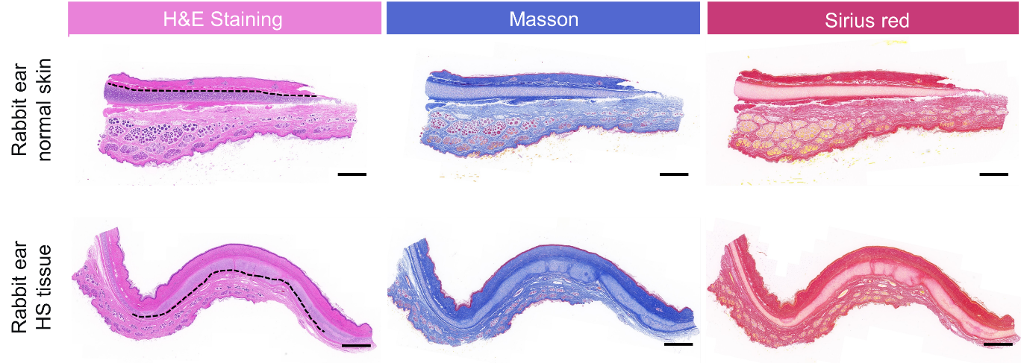
Fig. S29 Representative H&E staining, Masson staining, and Sirius red staining images of rabbit ear normal skin and rabbit ear HS tissue. Scale bar, 1000 μm

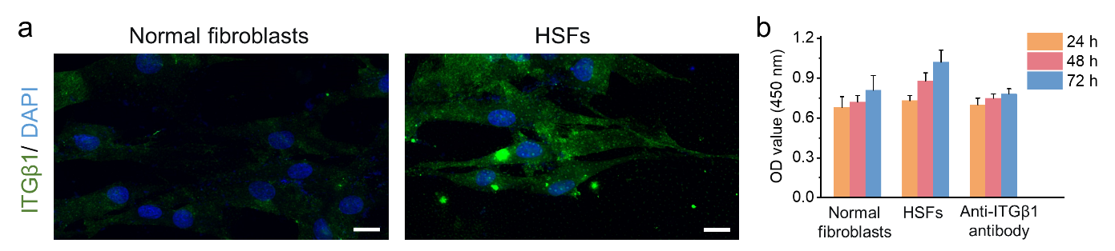
Fig. S30 a Representative immunofluorescence images of ITGβ1 (green) and DAPI (blue) in normal fibroblasts and HSFs. Scale bar, 50 μm. b The absorbance value at 450 nm in various groups for 24, 48, and 72 hours (n=3 independent samples)
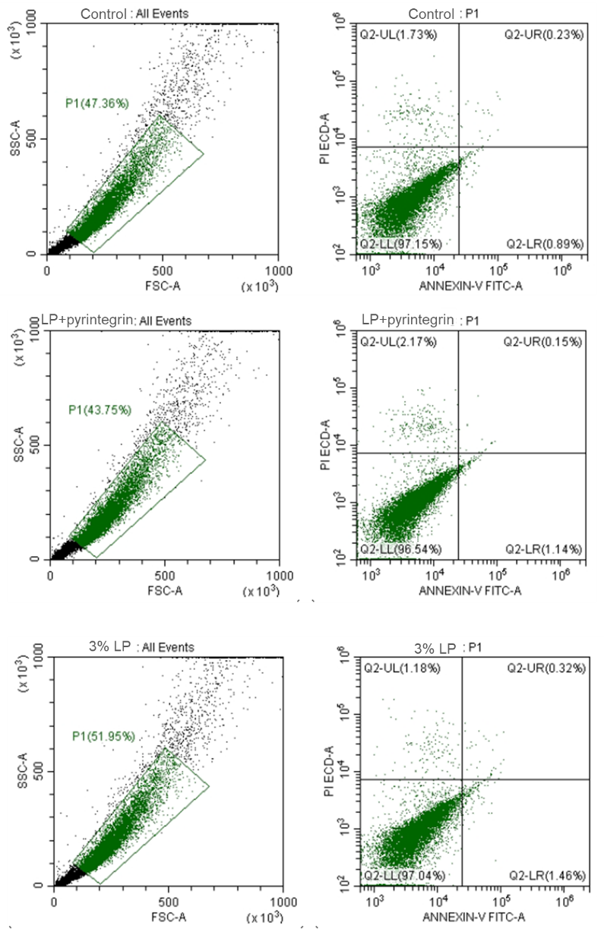
Fig. S31 The flow cytometry analysis after various treatments
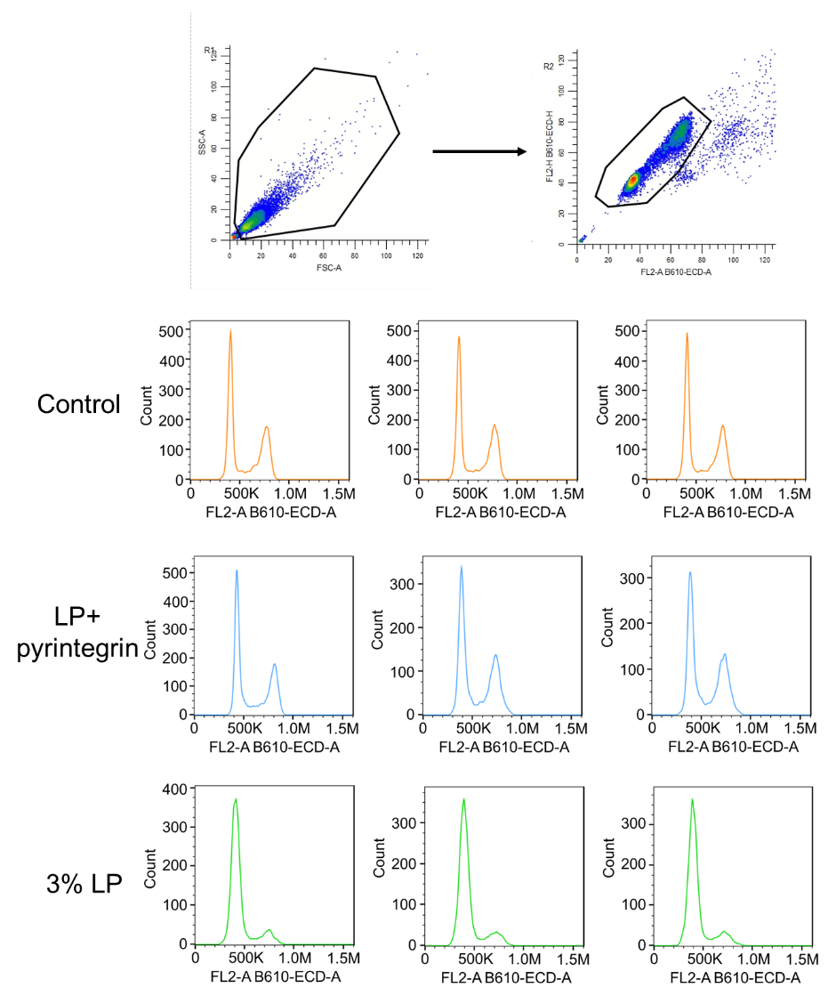
Fig. S32 The cell cycle analysis of different treatments
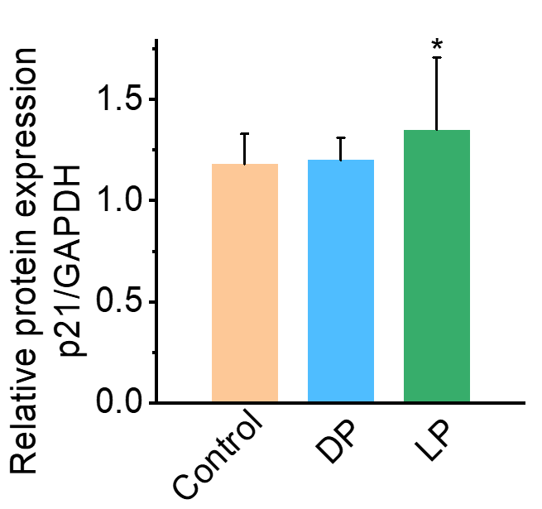
Fig. S33 Relative protein expression of p21 after various treatments (n=3 independent samples)

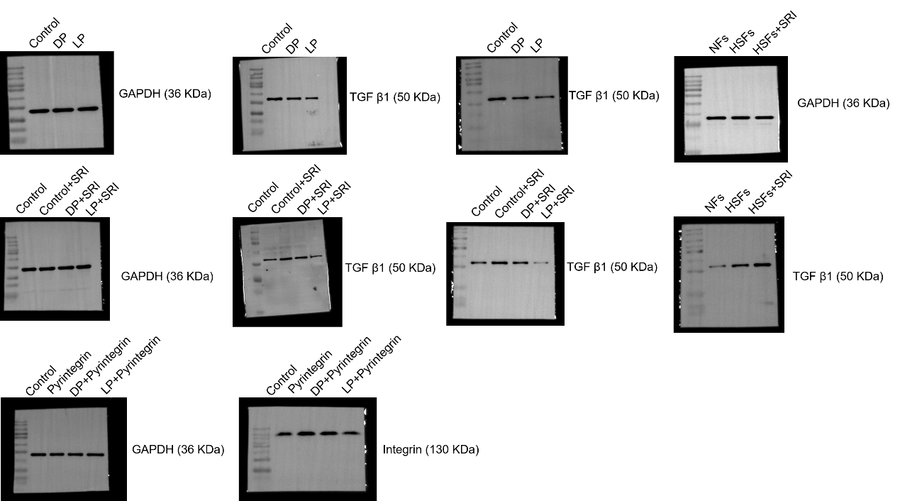
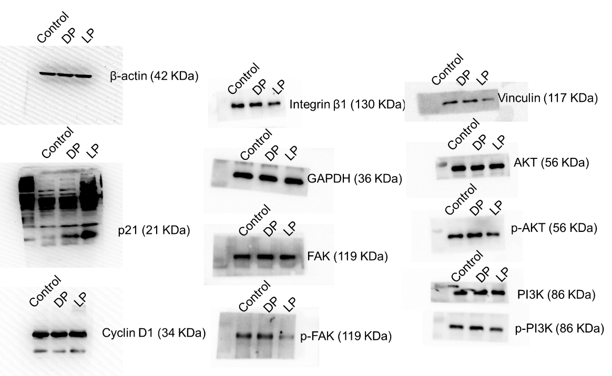
Fig. S34 The WB images of different treatments
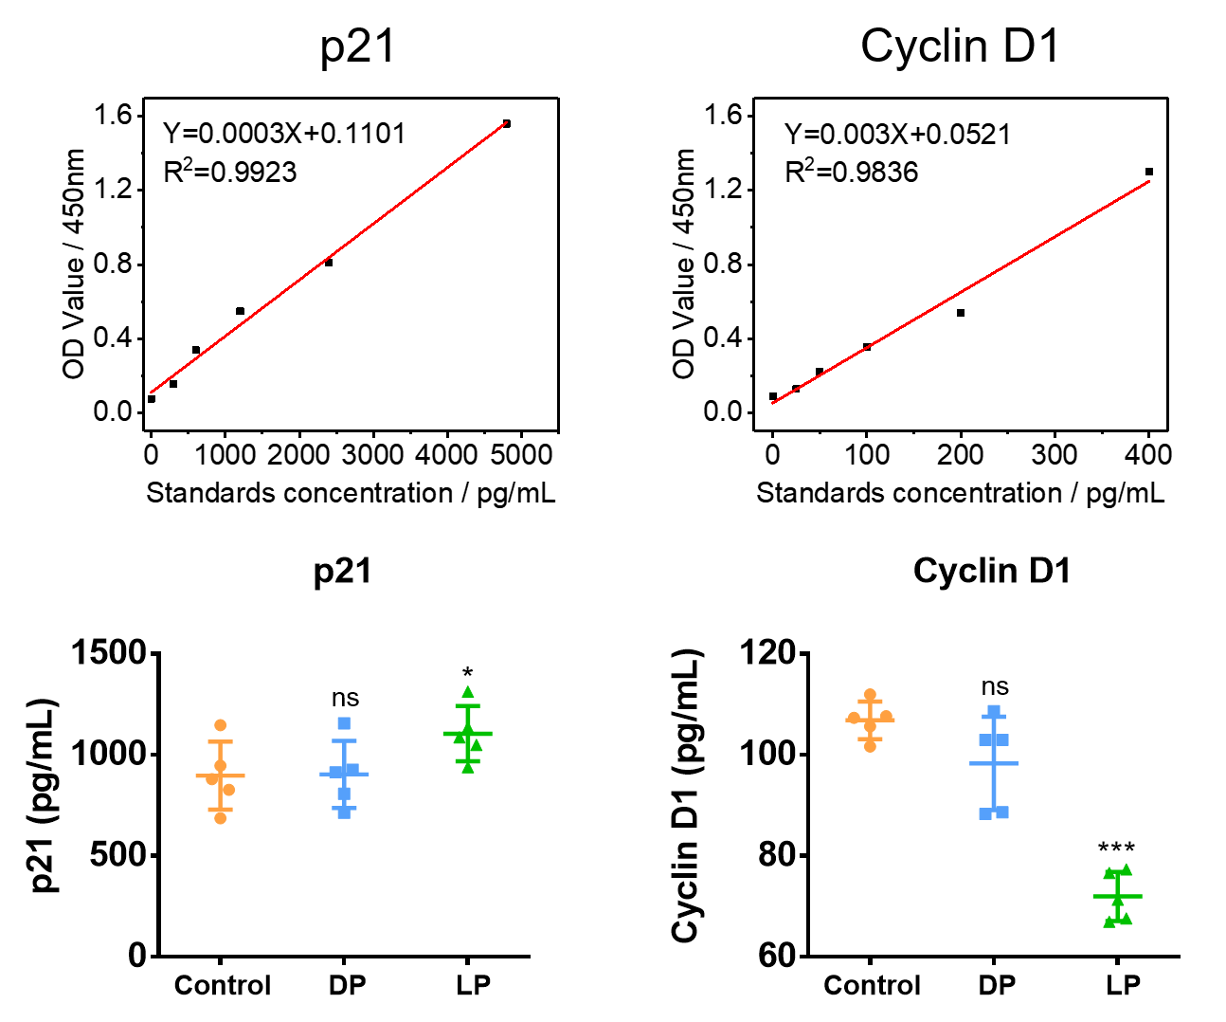

Fig. S35 The Elisa experiment results of p21 and cyclin D1 in control, DP, and LP (n=5 independent samples)

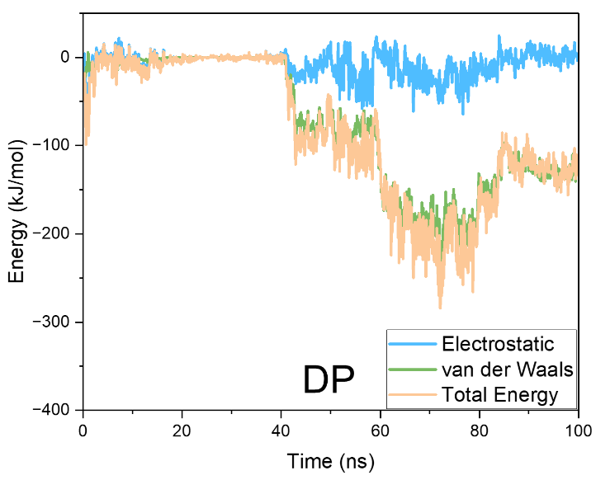
Fig. S36 The interaction energy between the protein and the substrate changes over the simulation time period
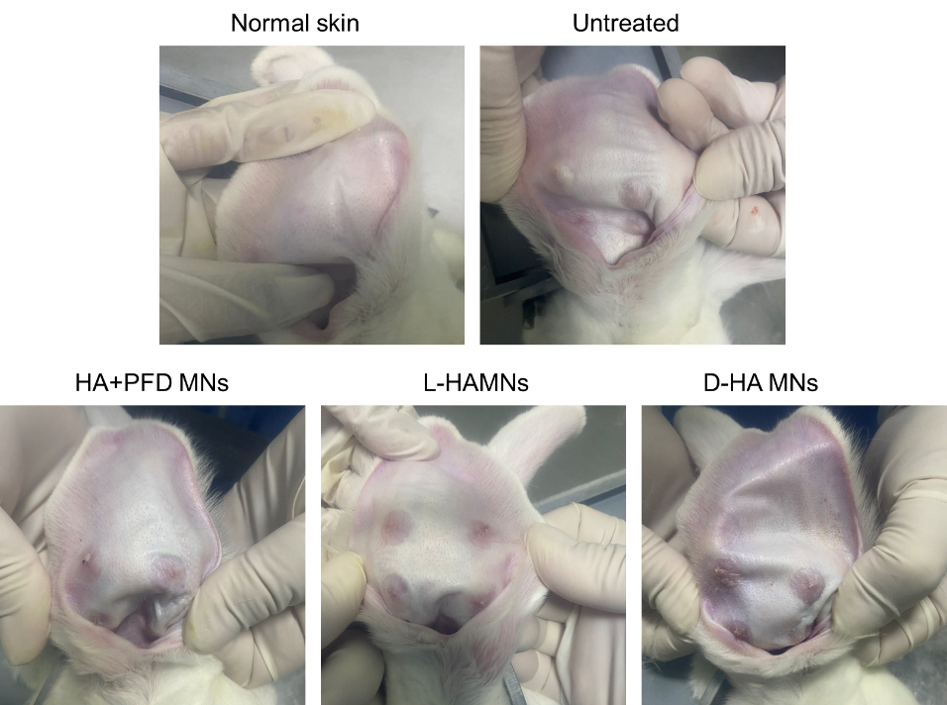
Fig. S37 Image of rabbit ear scar tissue with different treatments after 30 days

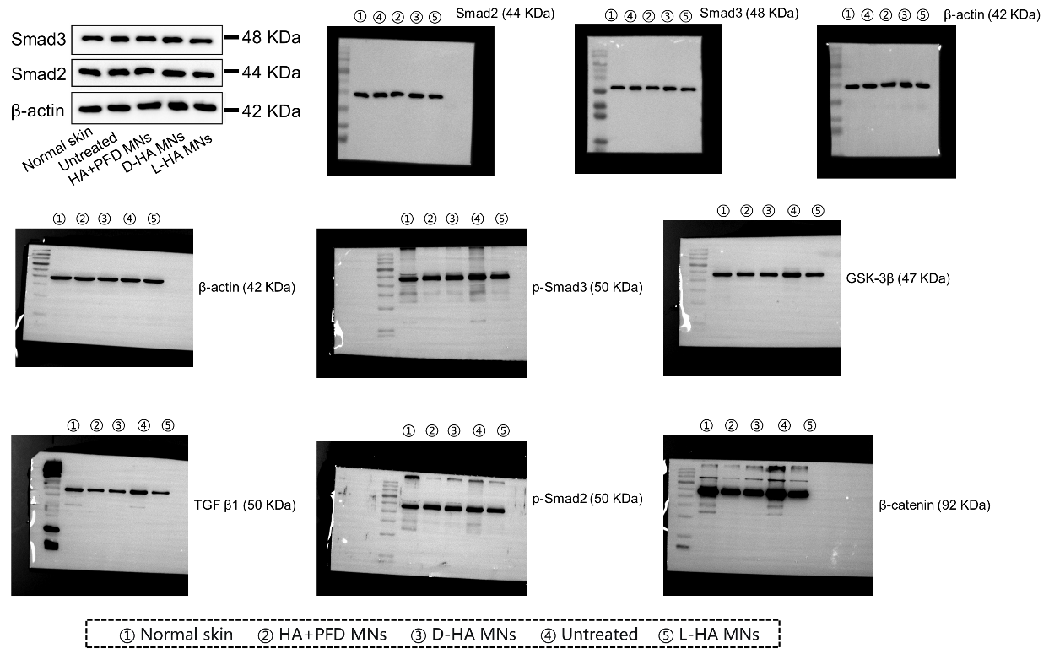
Fig. S38 Western blot analysis results of β-catenin, p-Smad2, p-Smad3, TGF β1, and GSK-3β with various treatments. β-actin was used as the protein loading control
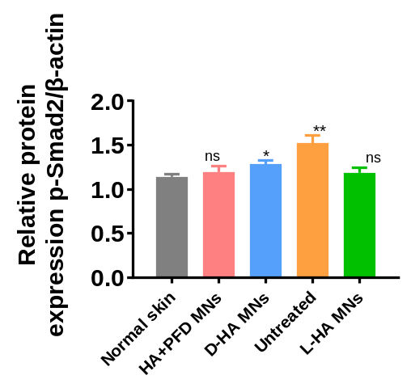
Fig. S39 Relative protein expression of p-Smad2 after various treatments (n=3 independent samples)

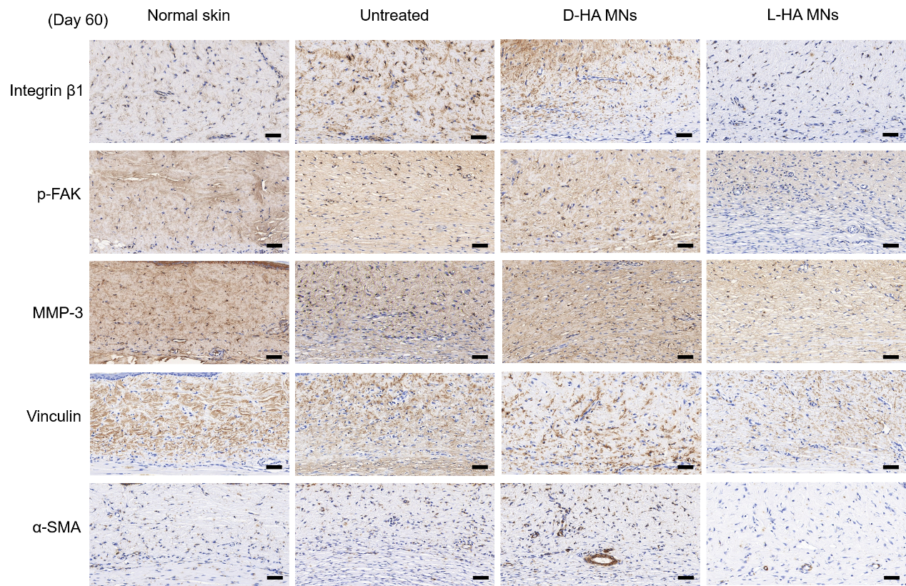
Fig. S40 Immunohistochemical images of scar tissues stained with p-FAK, MMP-3, Vinculin, and α-SMA in various groups. Scale bar, 100 μm

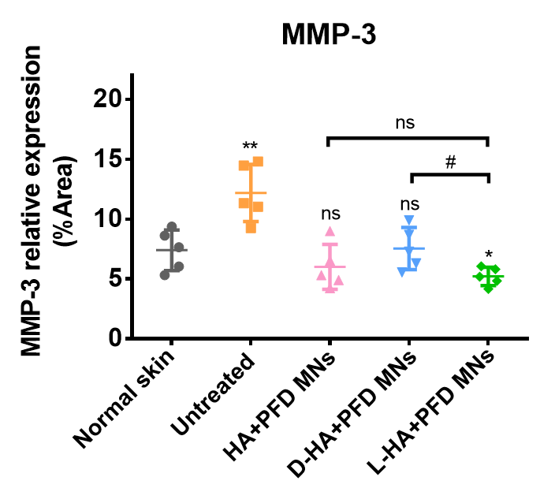
Fig. S41 Relative expression of MMP-3 after various treatments (n=3 independent samples)

