Supporting Information for
Multi-Responsive SEBS/MXene Janus Membranes Enabling Piezoelectric Energy Harvesting, Humidity Sensing, and Infrared Stealth
Weiwen Wang¹, Hong Ma¹, Lun Zhang², Jihai Zhang^{1,} *, Aimin Zhang^{1,} *
¹ State Key Laboratory of Advanced Polymer Materials, Polymer Research Institute, Sichuan University, Chengdu 610065, P. R. China
² Hubei Three Gorges Laboratory, Hubei,Yichang 443007, P. R. China
*Corresponding authors. Email: zhangjihai@scu.edu.cn (Jihai Zhang); zhangaimin@scu.edu.cn (Aimin Zhang)
Supplementary Figures and Videos
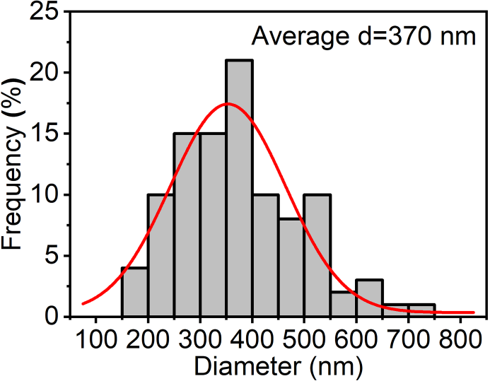
Fig. S1 The calculated fiber diameter distribution curve

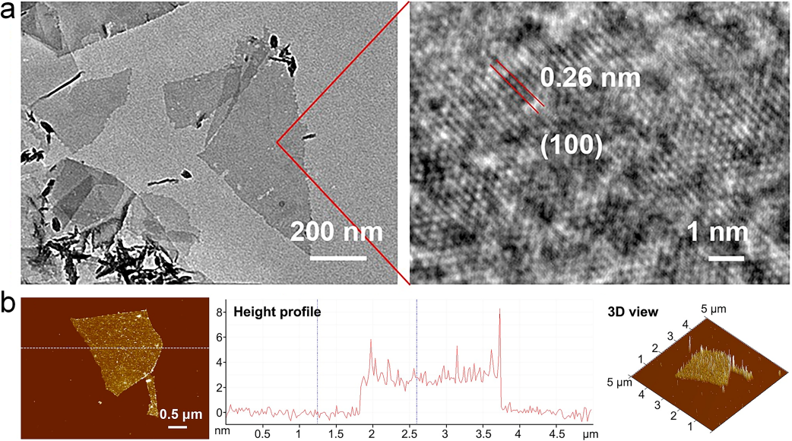
Fig. S2 a TEM image of Ti₃C₂T_{x} nanosheets with different magnifications. b AFM image of Ti₃C₂T_{x} nanosheets and corresponding height profile of crossed line

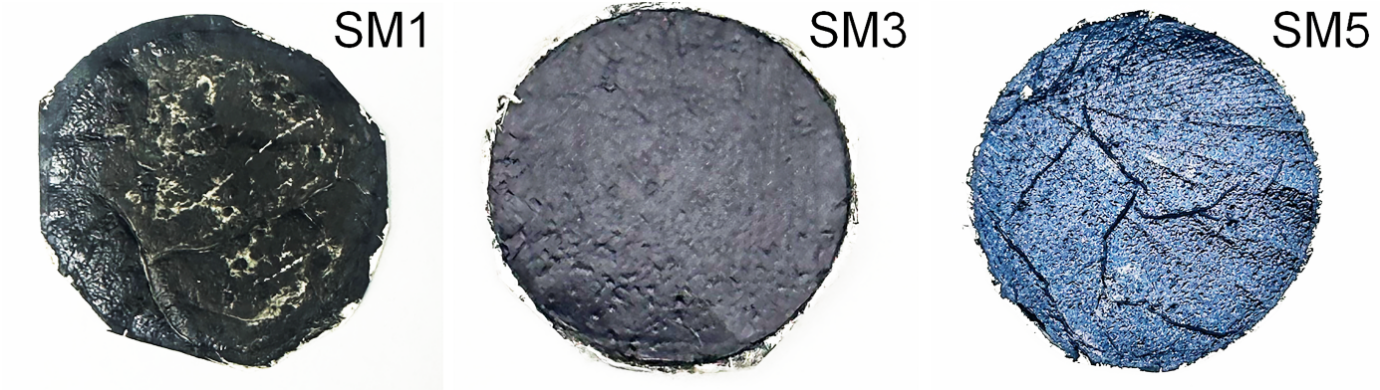
Fig. S3 Digital photos of SM1, SM3, and SM5

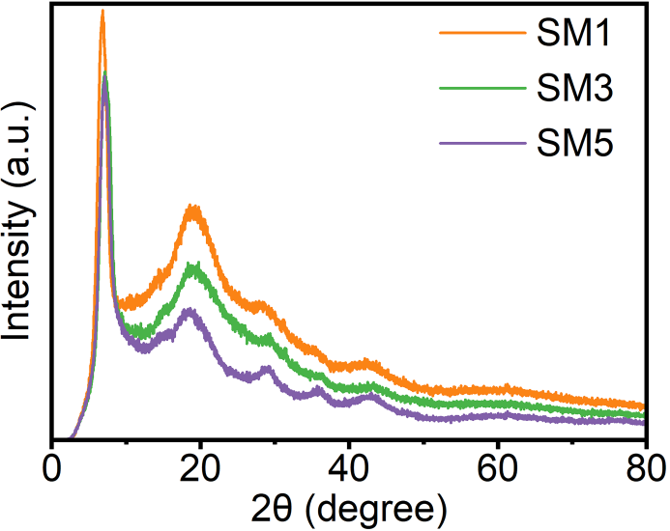
Fig. S4 XRD patterns of SM1, SM3, and SM5

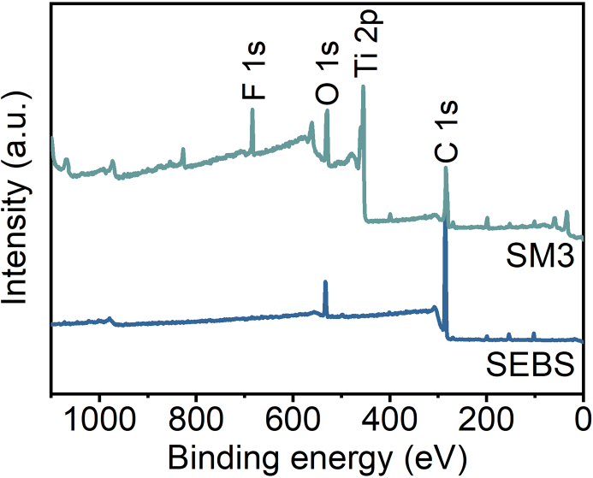
Fig. S5 The XPS survey spectrum of SEBS and SM3

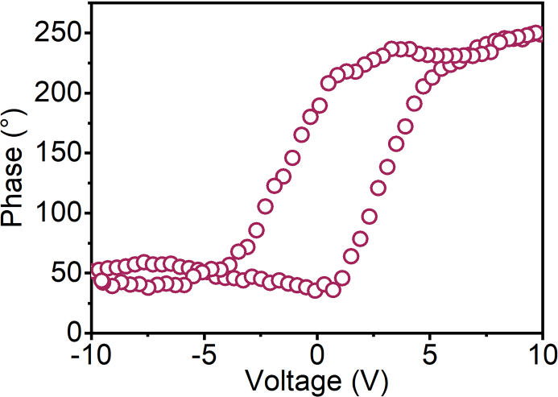
Fig. S6 Phase-voltage curve of SM3

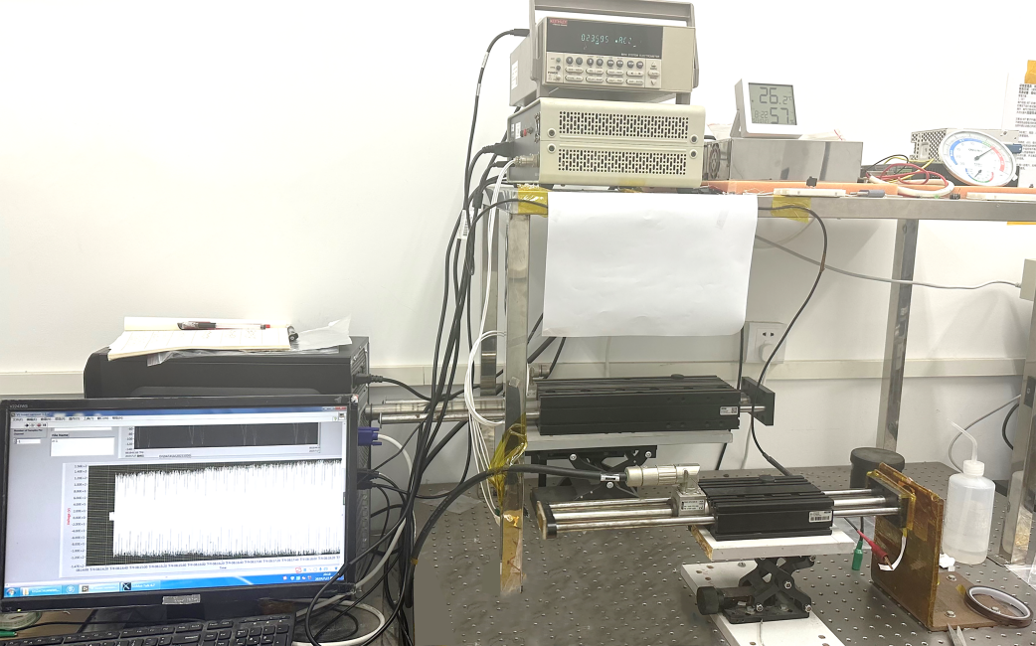
Fig. S7 Piezoelectric Performance Measurement Device

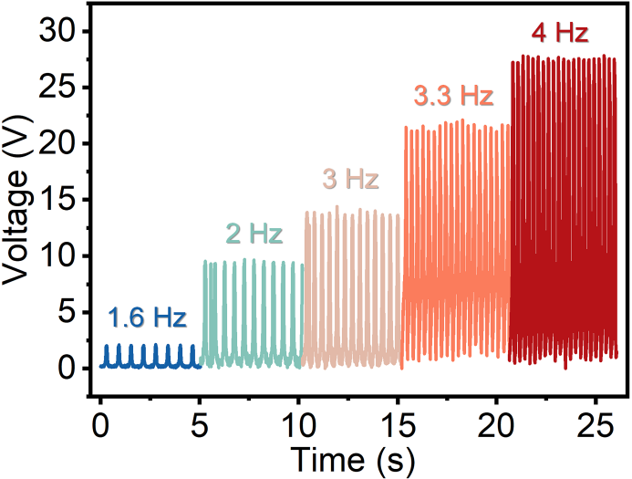
Fig. S8 Open-circuit voltage of the SM3-PENG across varying applied frequencies

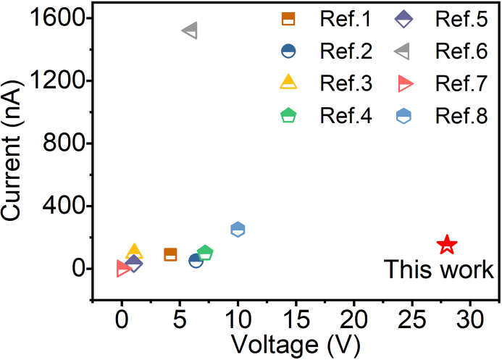
Fig. S9 Comparison of piezoelectric performance between SM and other materials

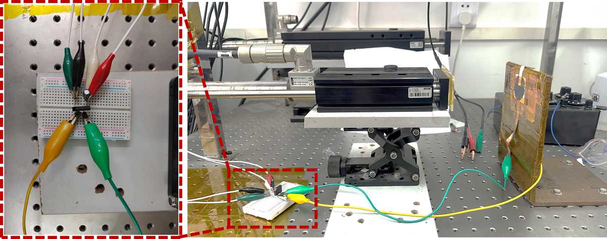
Fig. S10 Charging device for commercial capacitors

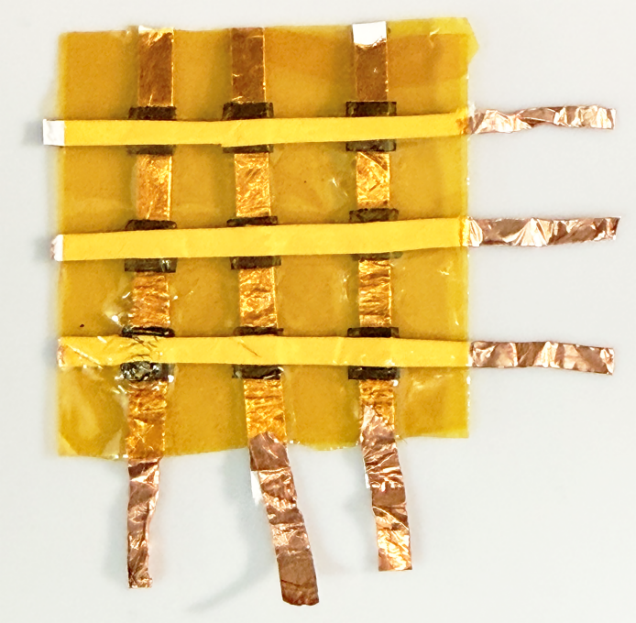
Fig. S11 3×3 Sensor Array Device for Pressure Position Detection

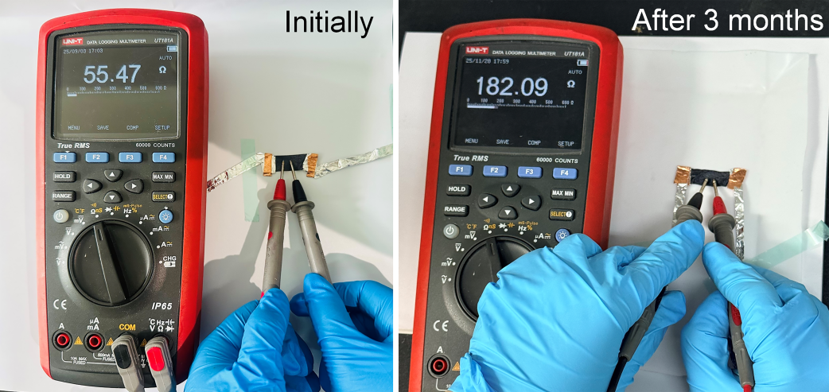
Fig. S12 Resistance response of SM3 before and after exposure to the environment for three months

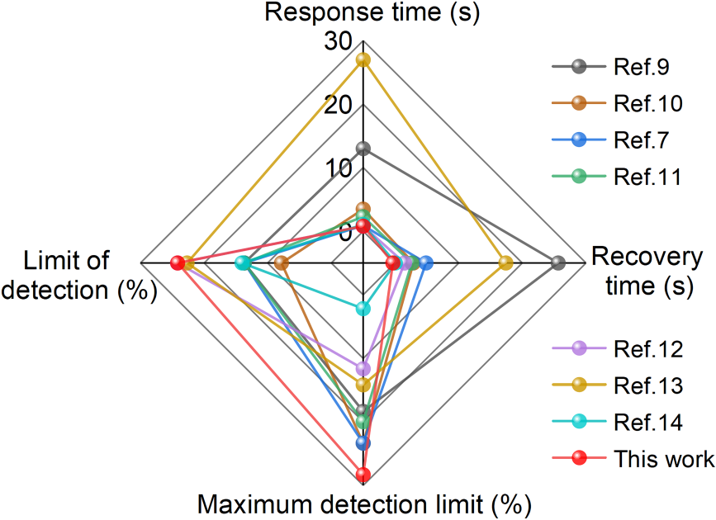
Fig. S13 Comparison of humidity sensing performance of SM with other materials

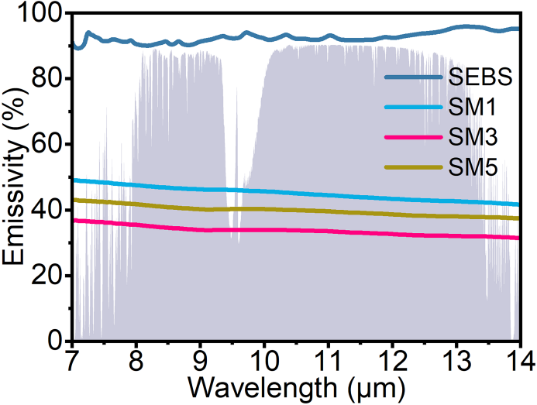
Fig. S14 Emissivity spectra in the mid-infrared range of SEBS, SM1, SM3, and SM5

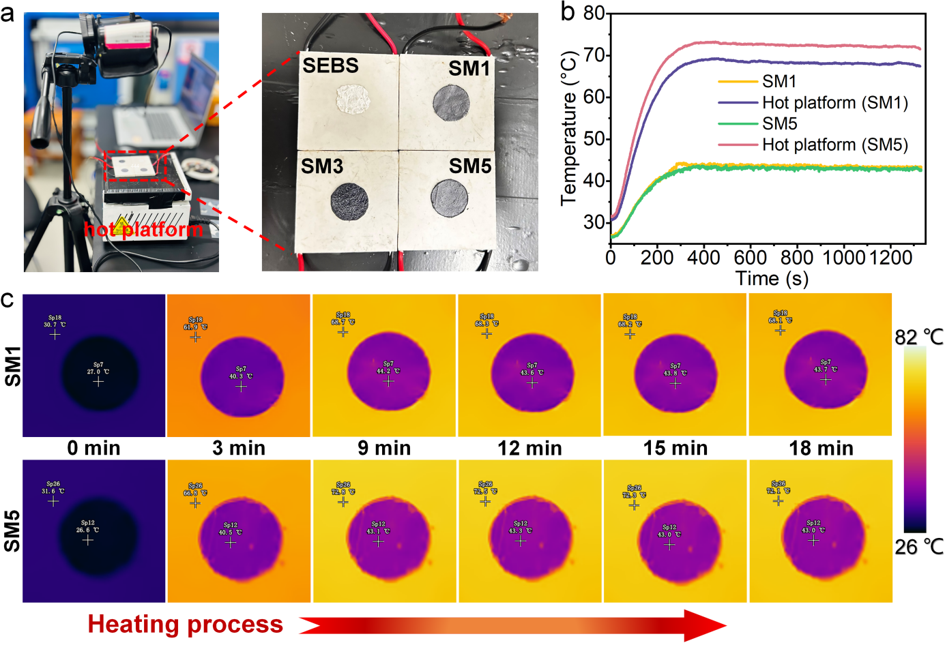
Fig. S15 a Experimental setup for testing the infrared stealth performance of SM on a hot platform. b Temperature-time curves of SM1 and SM5 obtained on an 80°C hot platform. c The corresponding infrared thermal images.

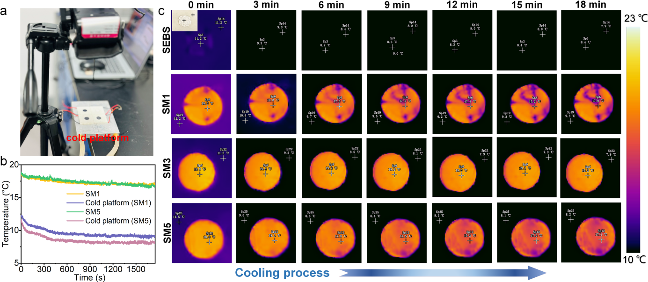
Fig. S16 a Experimental setup for testing the infrared stealth performance of SM on a cold platform. b Temperature-time curves of SM1 and SM5 obtained on an 8°C cold platform. c The corresponding infrared thermal images

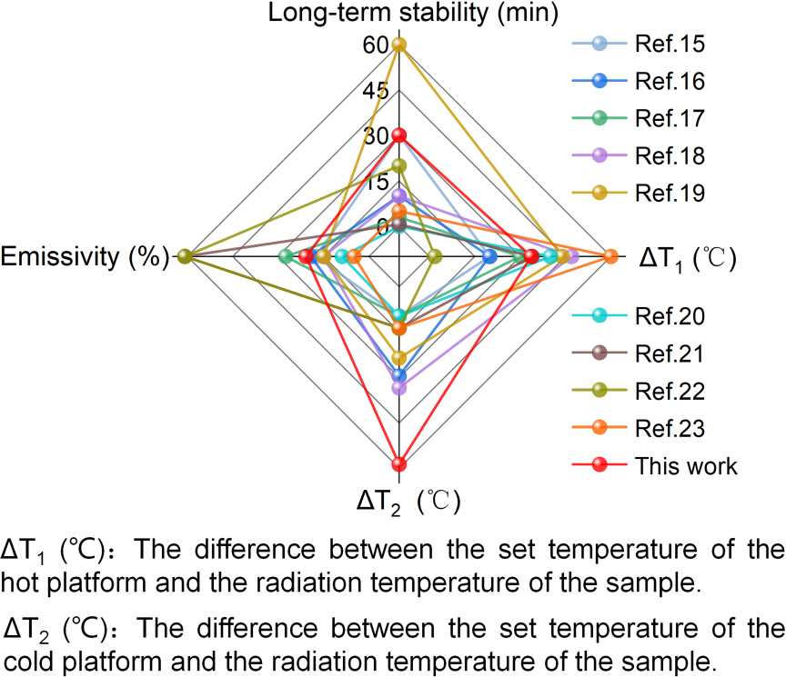
Fig. S17 Comparison of infrared stealth performance of SM with other materials
Supporting Movies
Video S1 Demonstration of piezoelectric device signal gener.
Video S2 Demonstration of SM3-PENG driving commercial LED illumination via linear motor impact.
Video S3 Testing of device sensing performance at different nebulizer spray frequencies.
Supplementary References
- Y. Zu, Y. Sun, C. Wang, Y. Ji, Y. Zhang et al., MXene-driven configurational remodeling of PVDF microstructures: a pathway to high piezoelectricity nanofibers for human motion recognition. Chem. Eng. J. 519, 164939 (2025). https://doi.org/10.1016/j.cej.2025.164939
- Y. Fu, J. Liu, J. Zou, S. Xu, Y. Wei et al., Electrospun PAN/BaTiO₃/MXene nanofibrous membrane with significantly improved piezoelectric property for self-powered wearable sensor. Chem. Eng. J. 489, 151495 (2024). https://doi.org/10.1016/j.cej.2024.151495
- S. Wang, W. Tong, Y. Li, P. Zhang, Y. Liu et al., Contributions of piezoelectricity and triboelectricity to a hydroxyapatite/PVDF–HFP fiber-film nanogenerator. Nano Energy 105, 108026 (2023). https://doi.org/10.1016/j.nanoen.2022.108026
- J.-X. Chen, J.-W. Li, Z.-J. Jiang, C.-W. Chiu, Polymer-assisted dispersion of reduced graphene oxide in electrospun polyvinylidene fluoride nanofibers for enhanced piezoelectric monitoring of human body movement. Chem. Eng. J. 498, 155244 (2024). https://doi.org/10.1016/j.cej.2024.155244
- Y. Wen, M. Xu, Y. Hu, J. Bao, Q. Yang et al., Flexible and oriented composite electrospun fiber membrane based on poly(L-lactic acid) for self-powered sensing. Chem. Eng. J. 510, 161795 (2025). https://doi.org/10.1016/j.cej.2025.161795
- X. Guan, B. Xu, J. Gong, Hierarchically architected polydopamine modified BaTiO₃@P(VDF-TrFE) nanocomposite fiber mats for flexible piezoelectric nanogenerators and self-powered sensors. Nano Energy 70, 104516 (2020). https://doi.org/10.1016/j.nanoen.2020.104516
- D. Wang, D. Zhang, P. Li, Z. Yang, Q. Mi et al., Electrospinning of flexible poly(vinyl alcohol)/MXene nanofiber-based humidity sensor self-powered by monolayer molybdenum diselenide piezoelectric nanogenerator. Nano-Micro Lett. 13(1), 57 (2021). https://doi.org/10.1007/s40820-020-00580-5
- J. Xiong, L. Wang, F. Liang, M. Li, Y. Yabuta et al., Flexible piezoelectric sensor based on two-dimensional topological network of PVDF/DA composite nanofiber membrane. Adv. Fiber Mater. 6(4), 1212–1228 (2024). https://doi.org/10.1007/s42765-024-00415-7
- T. Liu, D. Qu, L. Guo, G. Zhou, G. Zhang et al., MXene/TPU composite film for humidity sensing and human respiration monitoring. Adv. Sens. Res. 3(3), 2300014 (2024). https://doi.org/10.1002/adsr.202300014
- L. Ma, R. Wu, A. Patil, S. Zhu, Z. Meng et al., Full-textile wireless flexible humidity sensor for human physiological monitoring. Adv. Funct. Mater. 29(43), 1904549 (2019). https://doi.org/10.1002/adfm.201904549
- S. Ding, X. Jin, B. Wang, Z. Niu, J. Ma et al., Integrating Ti₃C₂T_{x} MXene nanosheets with thermoplastic polyurethane nanofibers as wearable humidity sensors for noninvasive sleep monitoring and noncontact sensing. ACS Appl. Nano Mater. 6(13), 11810–11821 (2023). https://doi.org/10.1021/acsanm.3c01732
- D. Lei, Q. Zhang, N. Liu, T. Su, L. Wang et al., Self-powered graphene oxide humidity sensor based on potentiometric humidity transduction mechanism. Adv. Funct. Mater. 32(10), 2107330 (2022). https://doi.org/10.1002/adfm.202107330
- Q. Zhao, Y. Jiang, Z. Duan, Z. Yuan, J. Zha et al., A Nb2CTx/sodium alginate-based composite film with neuron-like network for self-powered humidity sensing. Chem. Eng. J. 438, 135588 (2022). https://doi.org/10.1016/j.cej.2022.135588
- S. Li, Y. Zhang, X. Liang, H. Wang, H. Lu et al., Humidity-sensitive chemoelectric flexible sensors based on metal-air redox reaction for health management. Nat. Commun. 13(1), 5416 (2022). https://doi.org/10.1038/s41467-022-33133-y
- B.-X. Li, Z. Luo, H. Sun, Q. Quan, S. Zhou et al., Spectral-selective and adjustable patterned polydimethylsiloxane/MXene/nanoporous polytetrafluoroethylene metafabric for dynamic infrared camouflage and thermal regulation. Adv. Funct. Mater. 34(45), 2407644 (2024). https://doi.org/10.1002/adfm.202407644
- J. Mei, H. Liao, S. Yang, M. Liu, H. Tu et al., Multiband electromagnetic interference shielding composite with dynamic thermal management and passive infrared stealth performance. ACS Appl. Mater. Interfaces 17(30), 43839–43851 (2025). https://doi.org/10.1021/acsami.5c08956
- Y. Bai, B. Zhang, J. Ma, Y. Cheng, P. Cui et al., Adhesion strategy for cross-linking AgNWs/MXene Janus membrane: stretchable and self-healing electromagnetic shielding and infrared stealth capabilities. Small 21(5), e2408950 (2025). https://doi.org/10.1002/smll.202408950
- Q. Ji, X. Sheng, X. Li, S. Liu, Q. Chen et al., Camel skin-fat structure inspired MXene@PVA/PCC aerogel composite for efficient medium and low temperature infrared stealth. Chem. Eng. J. 476, 146671 (2023). https://doi.org/10.1016/j.cej.2023.146671
- J. Cui, J. Wu, A. Feng, Y. Yu, L. Mi et al., Low infrared emissivity and oxidation stability of Ti₃C₂T_{x} MXene-based composite with tannic acid. Chem. Eng. J. 493, 152289 (2024). https://doi.org/10.1016/j.cej.2024.152289
- N. Pang, X. Cheng, Y. Wang, X. Yin, X. Meng et al., Flexible multifunctional MXene/SWCNTs composite films with excellent infrared stealth, electromagnetic interference shielding and electrical heating properties. Carbon 238, 120303 (2025). https://doi.org/10.1016/j.carbon.2025.120303
- K. Sun, F. Meng, X. Zhang, H. Yan, H. Liu et al., Flexible MXene-functionalized composite phase change film with dual-mode of solar-thermal conversion and infrared stealth. Chem. Eng. J. 509, 161279 (2025). https://doi.org/10.1016/j.cej.2025.161279
- J. Yang, Y. Guo, X. Li, Y. Qiu, X. Wang et al., Fabry-Pérot matching lossy metasurface for coordinated, adaptive, and ultra-broadband visible-infrared-radar compatible camouflage. Adv. Mater. 38(6), e17422 (2026). https://doi.org/10.1002/adma.202517422
- N. Pang, X. Cheng, X. Yin, Y. Wang, W. Liu et al., Janus-structured ion-bridged MXene@PDA@PNF flexible composite films for synergistic infrared stealth, Joule thermal management, and EMI shielding. J. Mater. Sci. Technol. 259, 292–306 (2026). https://doi.org/10.1016/j.jmst.2025.10.007

