Supplementary Information for
Entropy-Modulated Oxide–Metal Catalyst Architectures for Direct Ammonia Protonic Ceramic Fuel Cells
Dongyeon Kim^{1,†}, Dong Jae Park^{2,†}, Incheol Jeong^{3,†}, Seeun Oh⁴, Hyeonggeun Kim⁴, Mincheol Lee⁴, Sang Won Lee², Kangyong Lee⁴, Daehan Chung⁴, Ki-Min Roh^{3*}, Joongmyeon Bae^{4*}, Tae Ho Shin^{2*}, Kang Taek Lee^{1,4,5*}
¹KAIST InnoCORE PRISM-AI Center, KAIST, Daejeon, Republic of Korea
²Hydrogen Energy Materials Center, Korea Institute of Ceramic Engineering and Technology (KICET), Jinju-Si, Gyeongsangnam-do, Republic of Korea
³Resources Utilization Research Center, Korea Institute of Geoscience and Mineral Resources (KIGAM), Daejeon, Republic of Korea
⁴Department of Mechanical Engineering, KAIST, Daejeon, Republic of Korea
⁵KAIST Graduate School of Green Growth & Sustainability, Daejeon, Republic of Korea
†Dongyeon Kim, Dong Jae Park, and Incheol Jeong contributed equally to this work.

* Corresponding authors. E-mail: kmroh@kigam.re.kr (Ki-Min Roh); jmbae@kaist.ac.kr (Joongmyeon Bae); ths@kicet.re.kr (Tae Ho Shin); leekt@kaist.ac.kr (Kang Taek Lee)
Supplementary Table and Figues
Table S1 Fitted Fe 2p XPS parameters for SFMMCCN in the pristine and reduced conditions
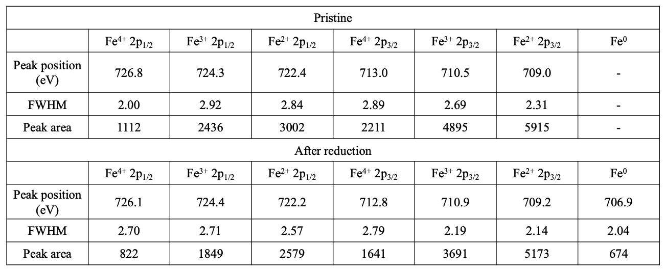

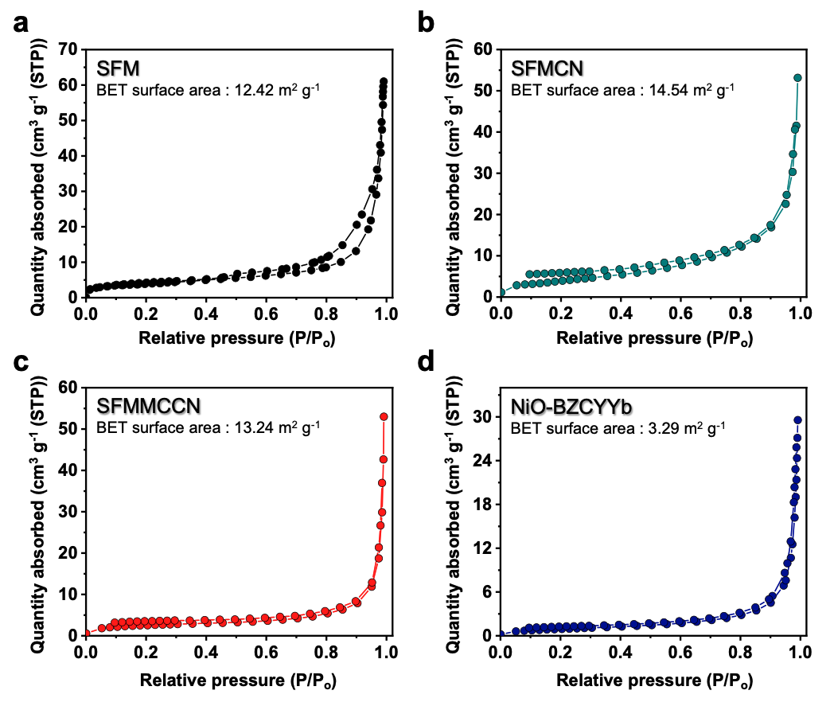
Fig. S1 BET specific surface areas of SFM, SFMCN, SFMMCCN, and NiO–BZCYYb

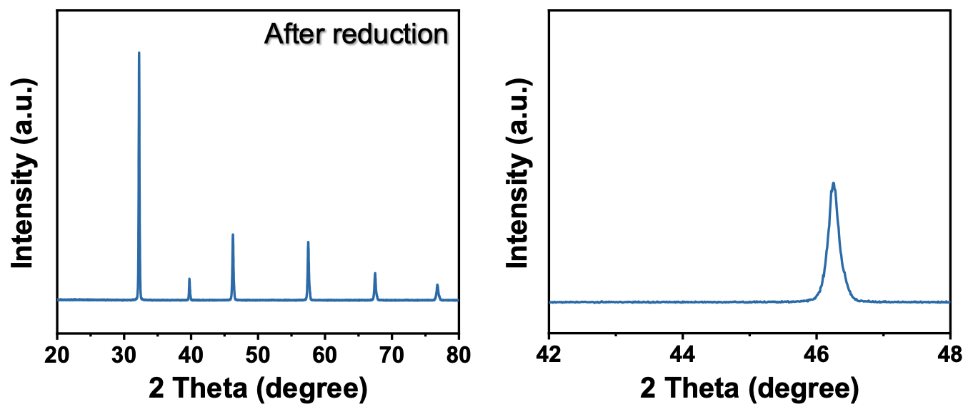
Fig. S2 XRD patterns of the SFM after heat treatment under a reducing atmosphere (100% H₂) at 700 ℃

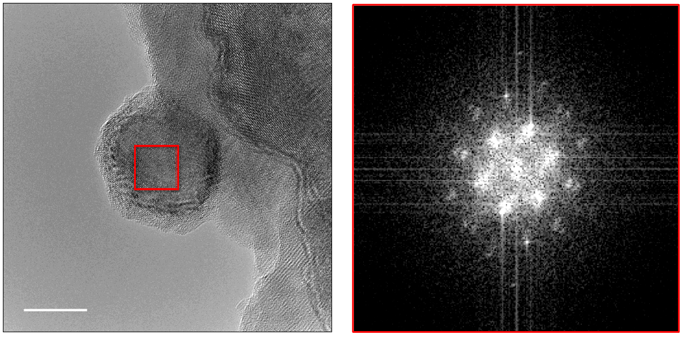
Fig. S3 HR-TEM image and fast fourier transform(FFT) pattern of exsolved nanoparticle

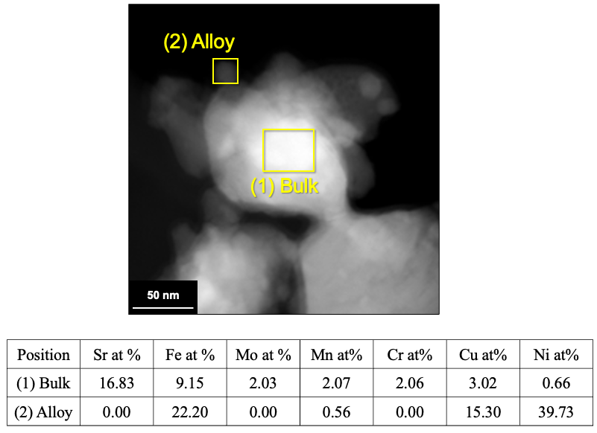
Fig. S4 STEM-EDS area analyses of the reduced SFMMCCN

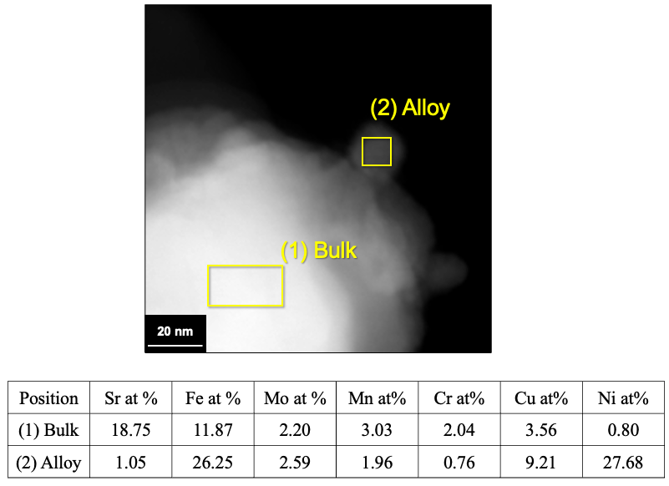
Fig. S5 STEM-EDS area analyses of the reduced SFMMCCN

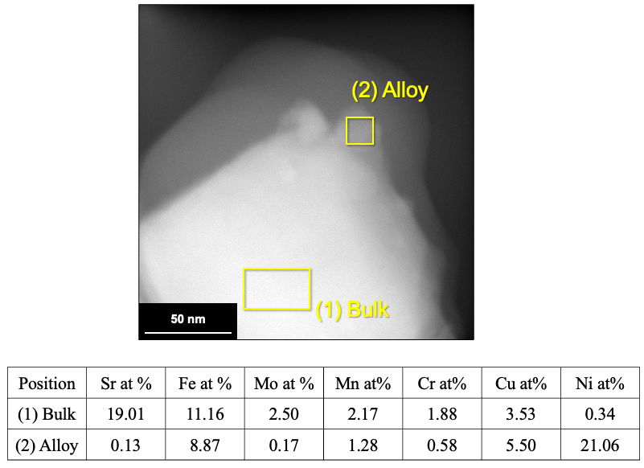
Fig. S6 STEM-EDS area analyses of the reduced SFMMCCN

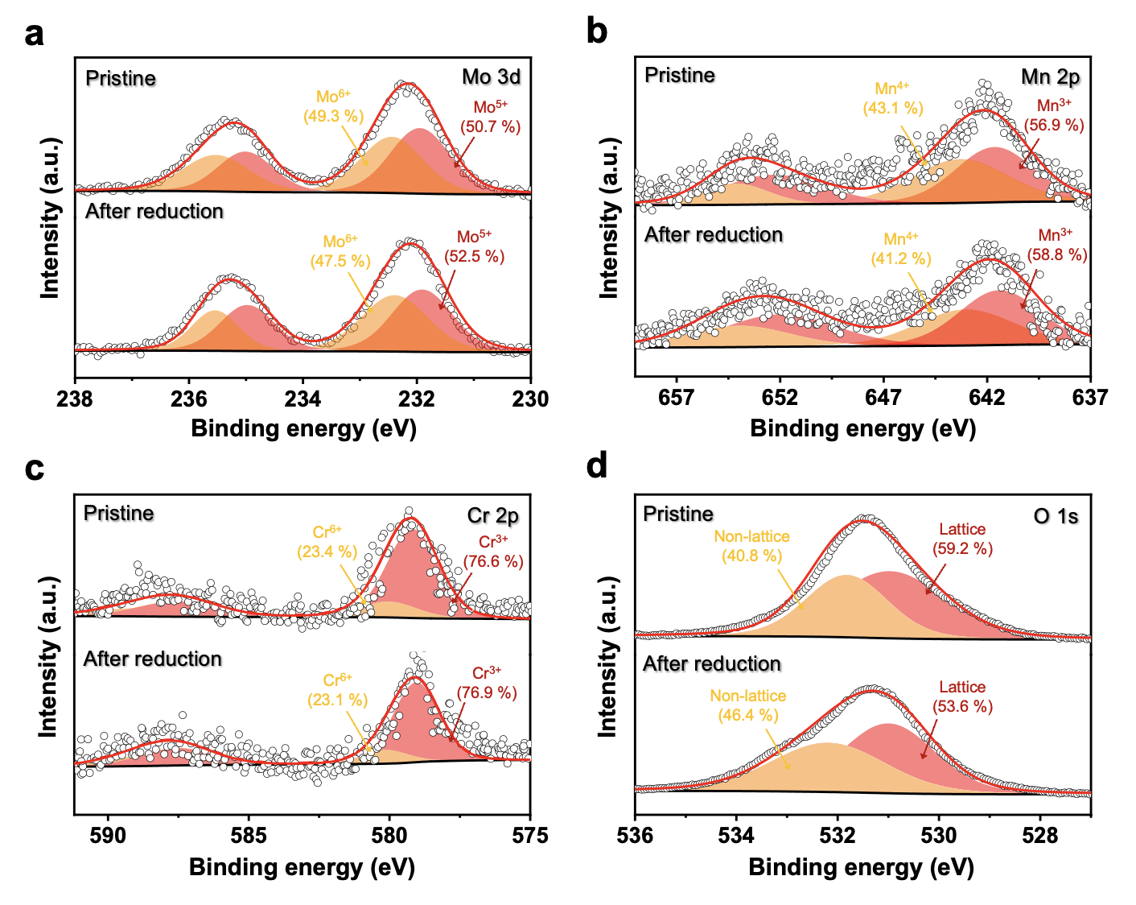
Fig. S7 XPS spectra of (a) Mo 3d, (b) Mn 2p, (c) Cr 2p, and (d) O 1s for SFMMCCN before and after reduction at 700 ℃ for 2h in a 100 % H₂ atmosphere
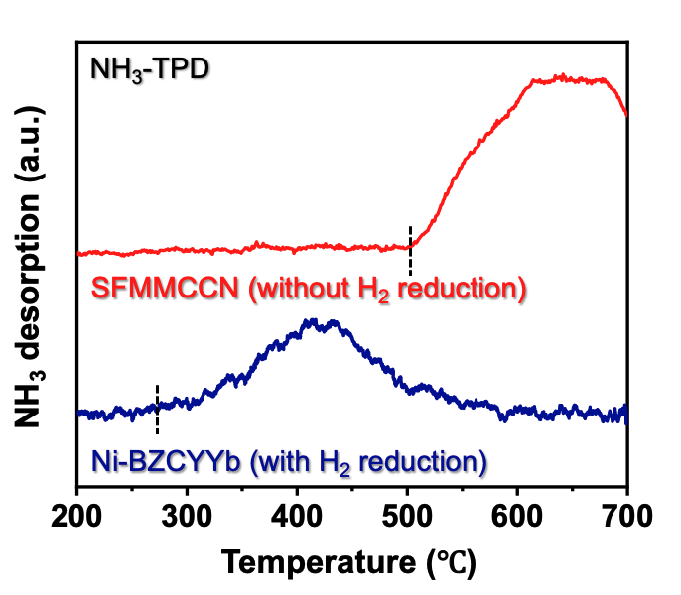
Fig. S8 NH₃-TPD profiles of Ni–BZCYYb (with prior H₂ reduction treatment) and SFMMCCN (without prior H₂ reduction treatment)

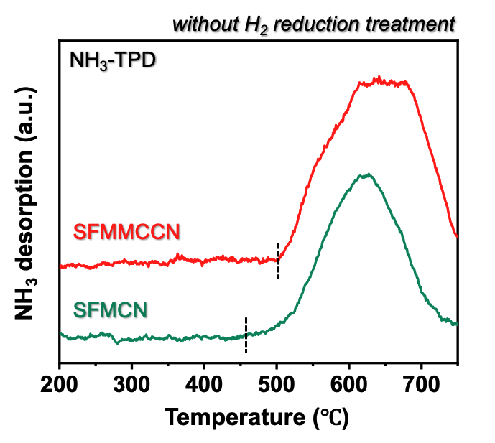
Fig. S9 NH₃-TPD profiles of SFMCN and SFMMCCN without prior H₂ reduction treatment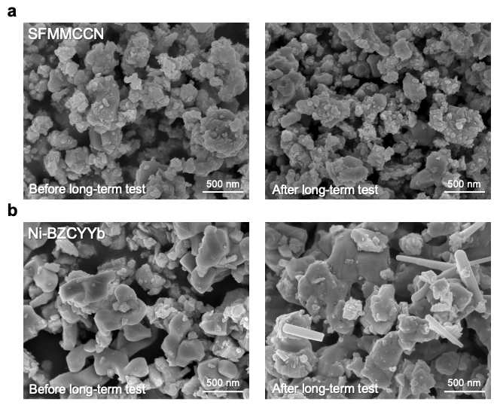
Fig. S10 SEM images of (a) SFMMCCN and (b) Ni-BZCYYb powders, obtained before and after long-term NH₃ conversion test
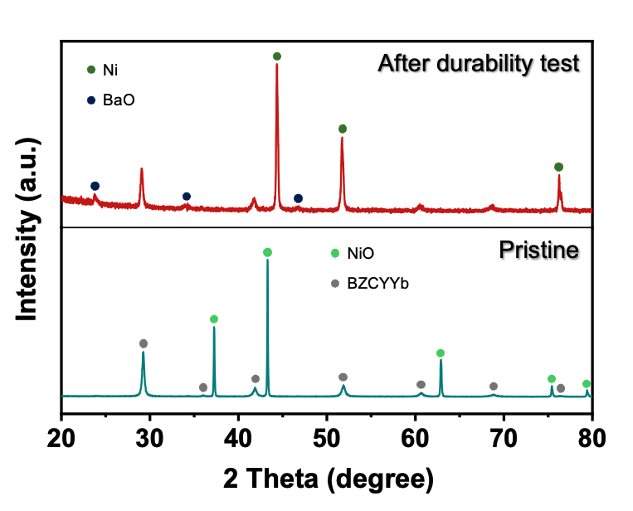
Fig. S11 XRD patterns of pristine Ni-BZCYYb and Ni-BZCYYb after the durability test under NH₃ gas conditions

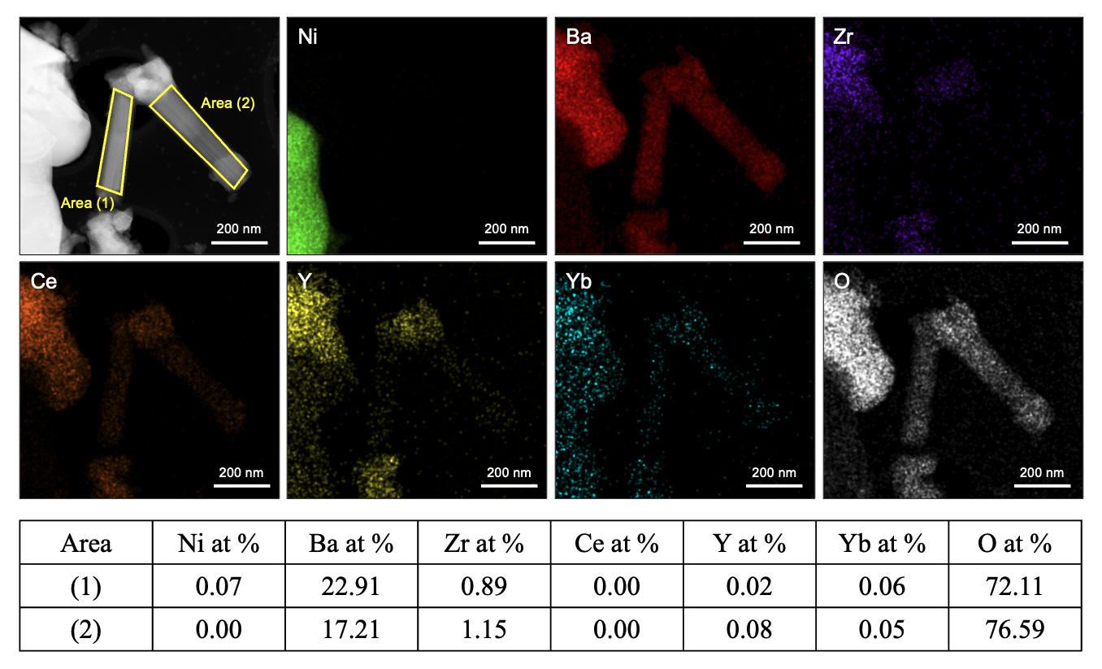
Fig. S12 XRD patterns of pristine Ni-BZCYYb and Ni-BZCYYb after the durability test under NH₃ gas conditions

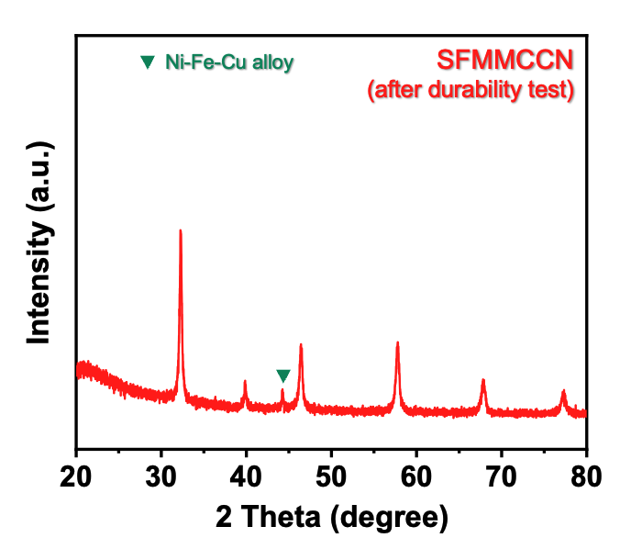
Fig. S13 XRD pattern of the SFMMCCN catalyst after the durability test under NH₃ gas conditions

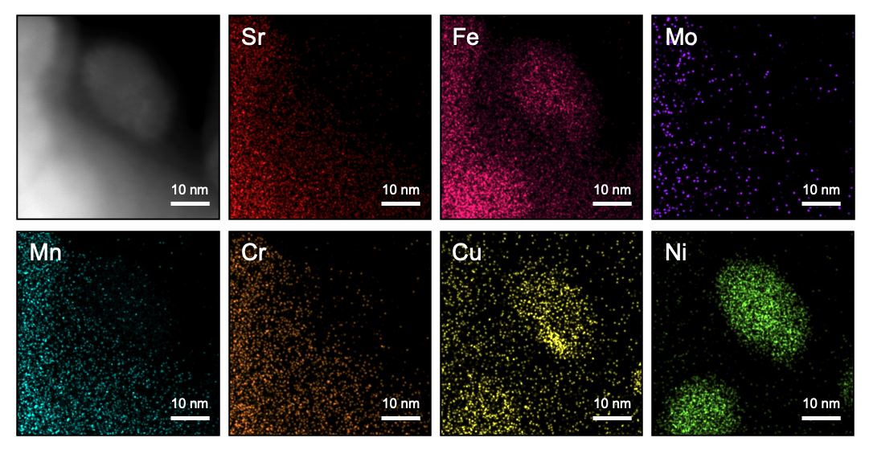
Fig. S14 STEM-EDS mapping images of the SFMMCCN after the durability test under NH₃ gas conditions

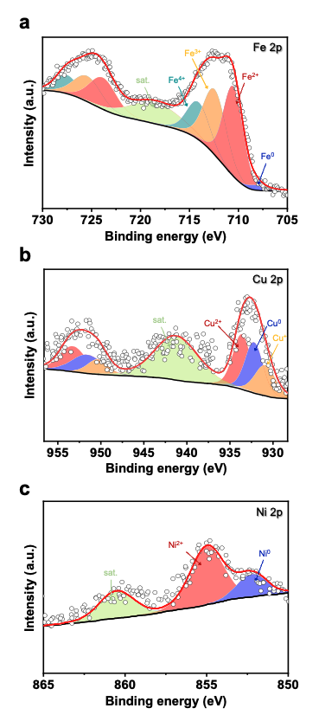
Fig. S15 STEM-EDS mapping images of the SFMMCCN after the durability test under NH₃ gas conditions

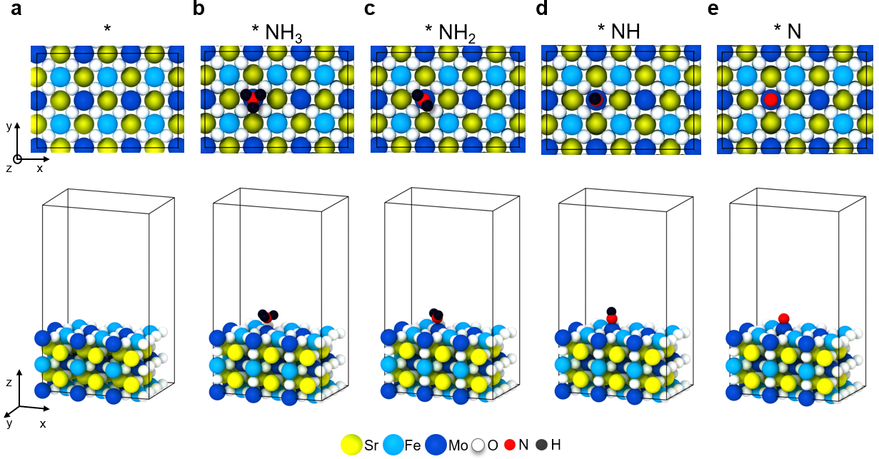
Fig. S16 Optimized SFM slab structure models including (a) pristine slab, slabs with adsorbed (b) NH₃, (c) NH₂, (d) NH, and (e) N species

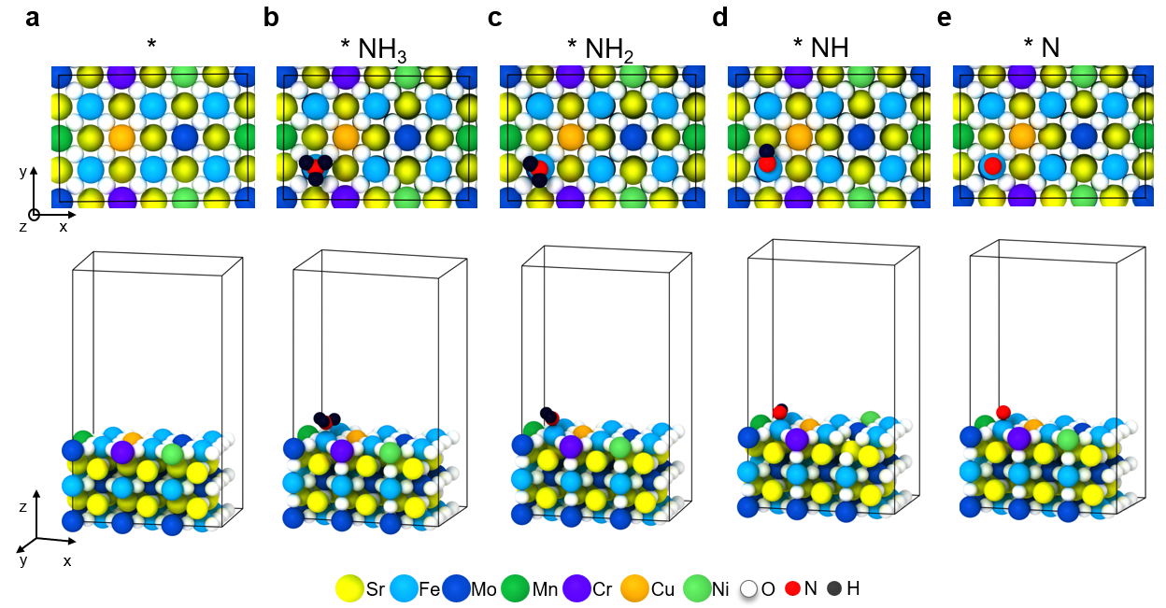
Fig. S17 Optimized SFMMCCN slab structure models including (a) pristine slab, slabs with adsorbed (b) NH₃, (c) NH₂, (d) NH, and (e) N species

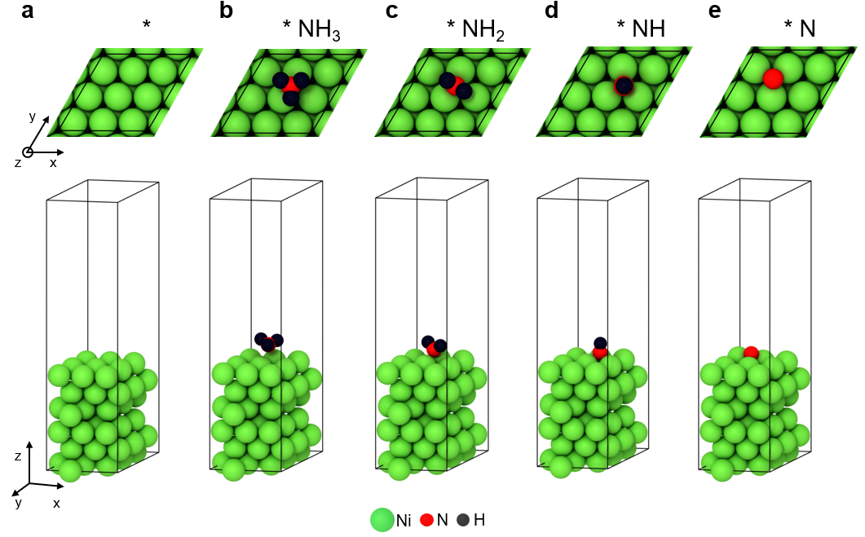
Fig. S18 Optimized SFMMCCN slab structure models including (a) pristine slab, slabs with adsorbed (b) NH₃, (c) NH₂, (d) NH, and (e) N species

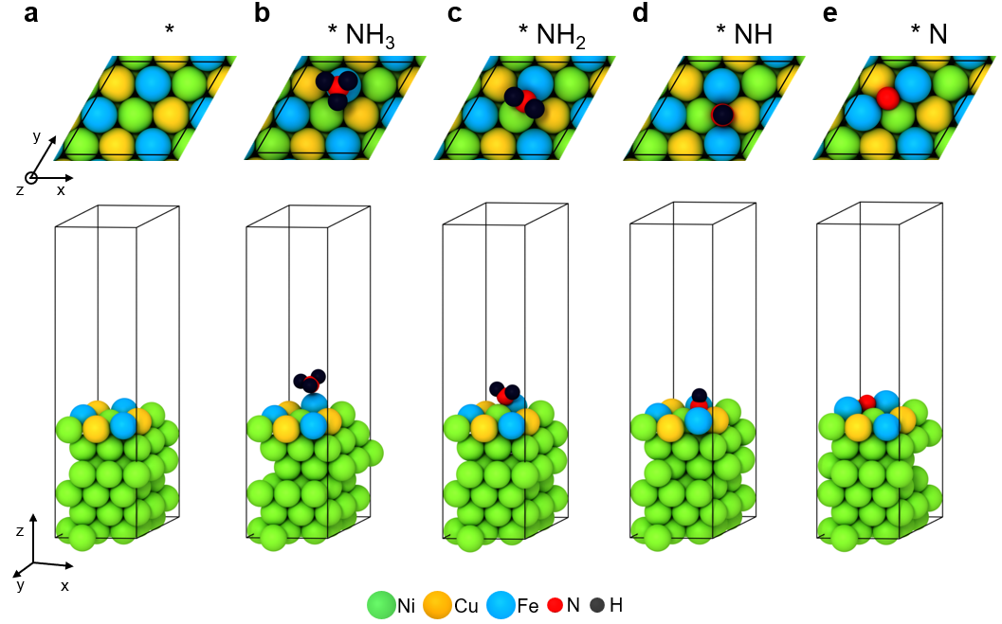
Fig. S19 Optimized Ni-Fe-Cu slab structure models including (a) pristine slab, slabs with adsorbed (b) NH₃, (c) NH₂, (d) NH, and (e) N species

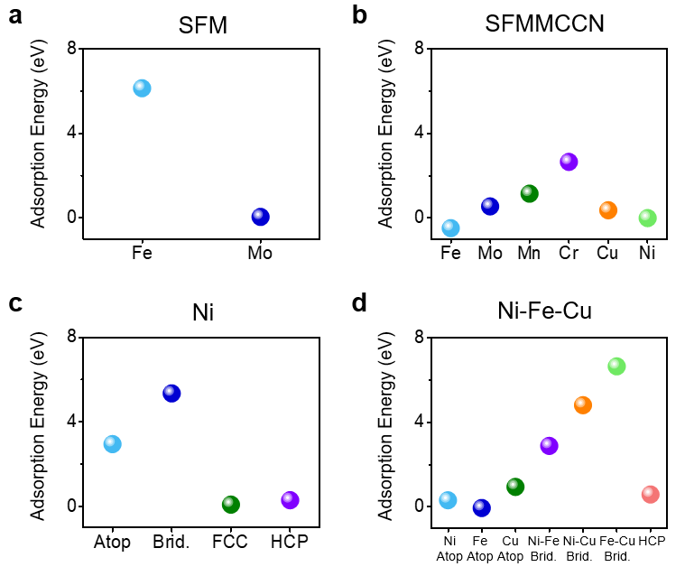
Fig. S20 Optimized Ni-Fe-Cu slab structure models including (a) pristine slab, slabs with adsorbed (b) NH₃, (c) NH₂, (d) NH, and (e) N species
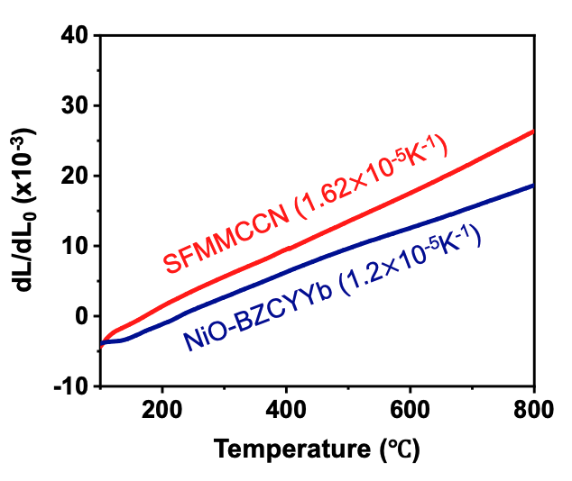
Fig. S21 Optimized Ni-Fe-Cu slab structure models including (a) pristine slab, slabs with adsorbed (b) NH₃, (c) NH₂, (d) NH, and (e) N species
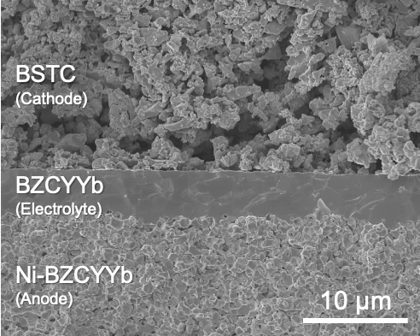
Fig. S22 Cross-sectional SEM image of bare cell

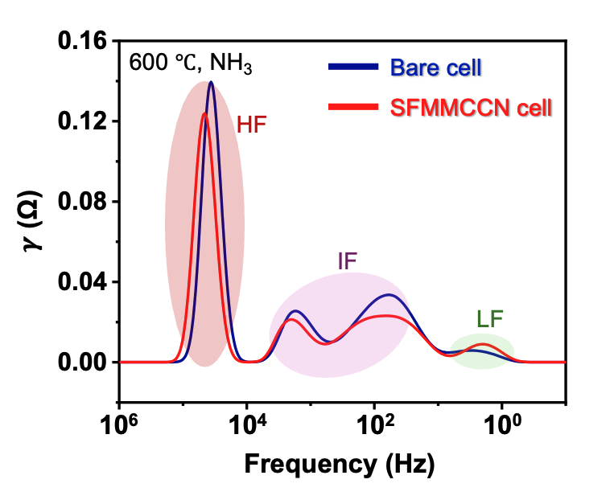
Fig. S23 Distribution of relaxation time (DRT) plots of the bare cell and the SFMMCCN cell at 600 ℃ under NH₃ gas conditions
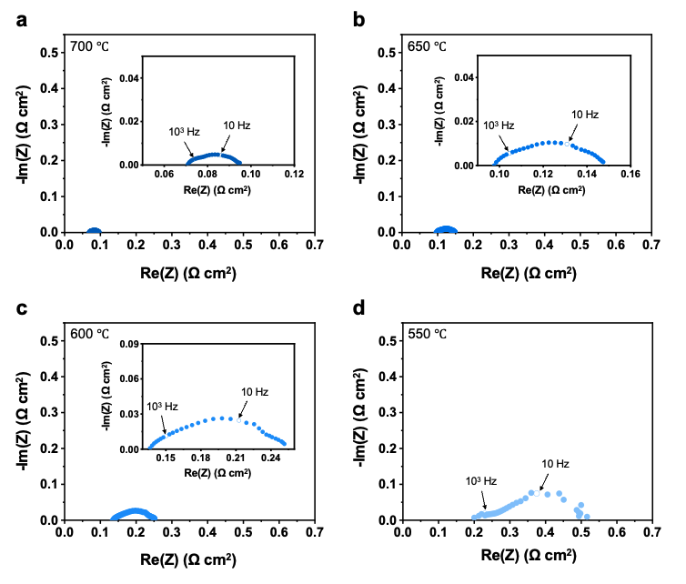
Fig. S24 Nyquist plots of the SFMMCCN cell measured at temperatures of (a) 700, (b) 650, (c) 600, and (d) 550 ℃
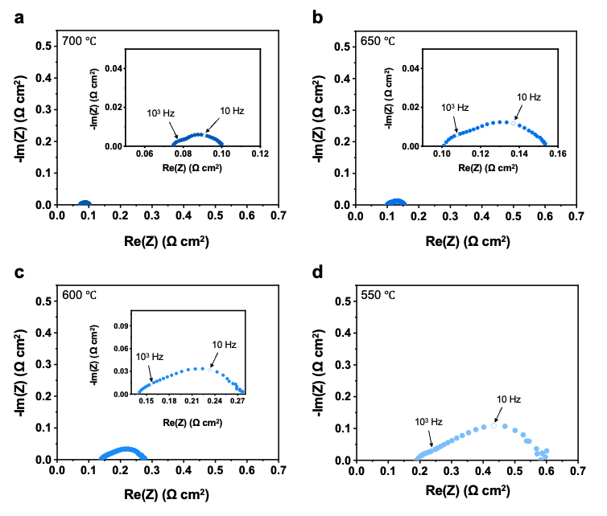
Fig. S25 Nyquist plots of the bare cell measured at temperatures of (a) 700, (b) 650, (c) 600, and (d) 550 ℃
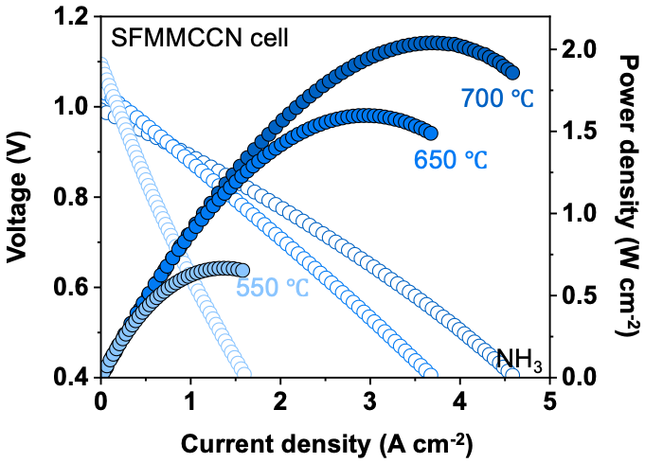
Fig. S26 I-V-P curves of the SFMMCCN cell measured over a temperature range from 700 to 550 ℃

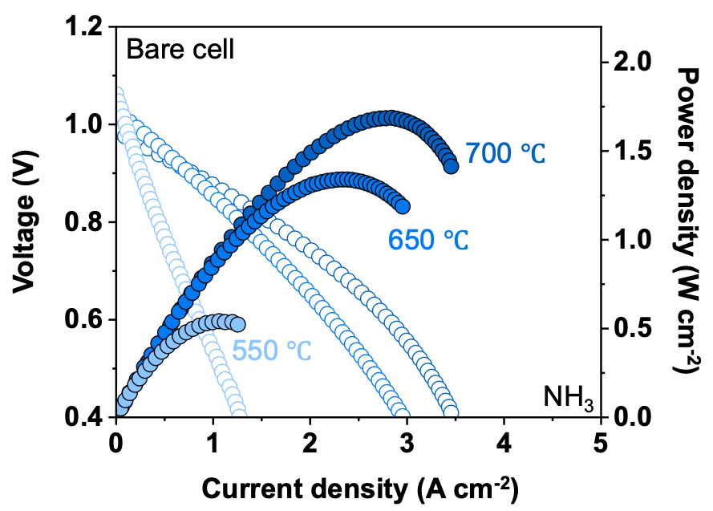
Fig. S27 I-V-P curves of the bare cell measured over a temperature range from 700 to 550 ℃

Fig. S28 Nyquist plot of the SFMMCCN cell measured at various time intervals during the long-term durability test
Fig. S29 Nyquist plot of the bare cell measured at various time intervals during the long-term durability test

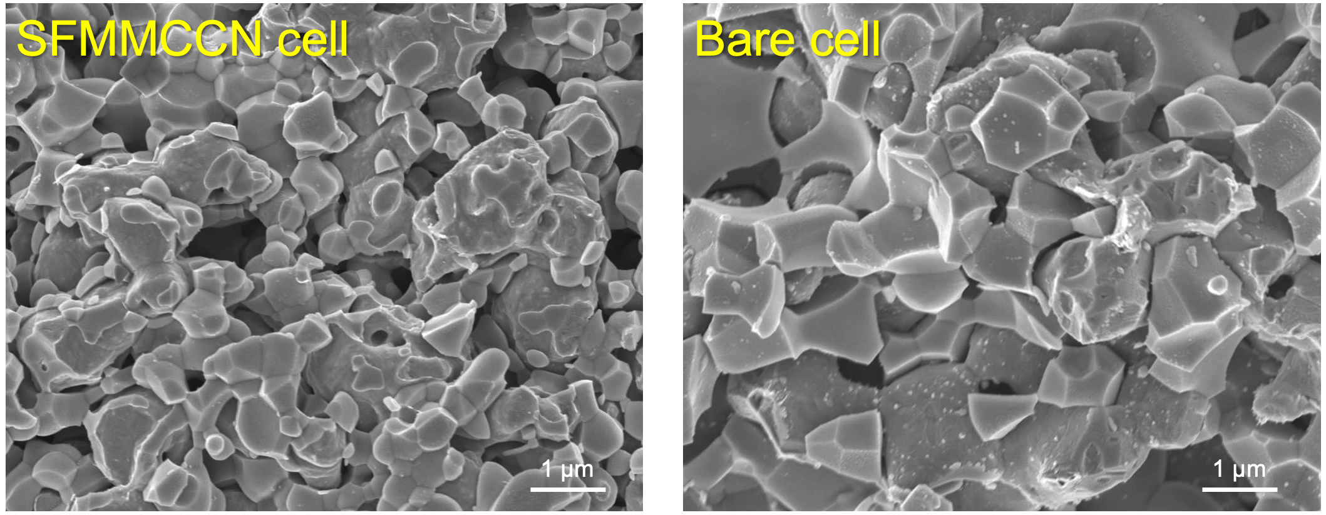
Fig. S30 SEM images of the anode in SFMMCCN cell and bare cell, obtained after long-term stability test under NH₃ fuel

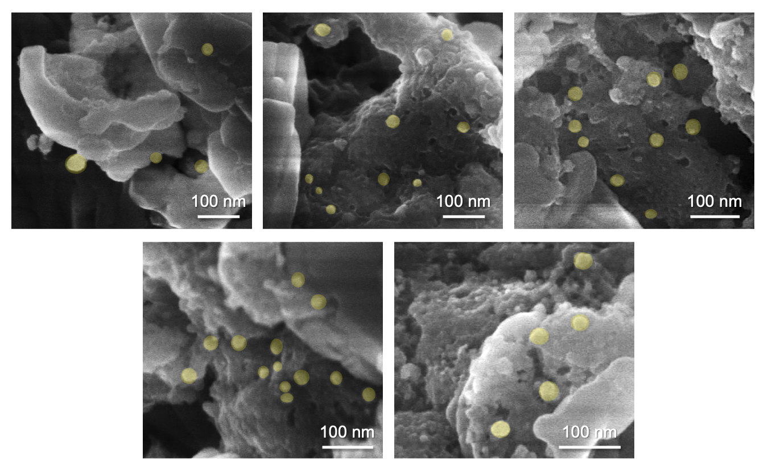
Fig. S31 SEM images of the SFMMCCN ACL after the durability test at 600 ℃

