Supporting Information for
Self-Separating Biphasic Electrolyte Enables High-Performance Aqueous Zinc-Ion Batteries via Electron-Enriched Interphase Engineering
Chengwu Yang¹, Pattaraporn Woottapanit^{2,3}, Qizhi Hou¹, Zhiqiang Dai¹, Wanwisa Limphirat⁴, Jiaqian Qin^{2,5,6*}, Xinyu Zhang^{1,2*}
¹State Key Laboratory of Metastable Materials Science and Technology, Yanshan University, Qinhuangdao 066004, P. R. China
²Department of Materials Science, Faculty of Science, Chulalongkorn University, Bangkok 10330, Thailand
³International Graduate Program of Nanoscience & Technology (Interdisciplinary), Graduate School, Chulalongkorn University, Bangkok, 10330, Thailand
⁴Synchrotron Light Research Institute (Public Organization), Nakhon Ratchasima 30000, Thailand
⁵Center of Excellence in Responsive Wearable Materials, Chulalongkorn University, Bangkok 10330, Thailand
⁶Energy Research Institute, Chulalongkorn University, Bangkok, 10330, Thailand
*Corresponding authors. E-mail: jiaqian.q@chula.ac.th (Jiaqian Qin); xyzhang@ysu.edu.cn (Xinyu Zhang)
Supplementary Figures and Tables
Fig. S1 The digital photos of PP in water.

Fig. S2 The digital photos of a DPPZ and b PPZ solutions.
Fig. S3 The digital photos of a DPPZ and b PPZ solutions after 24 h sedimentation with the corresponding supernatants and subnatants.
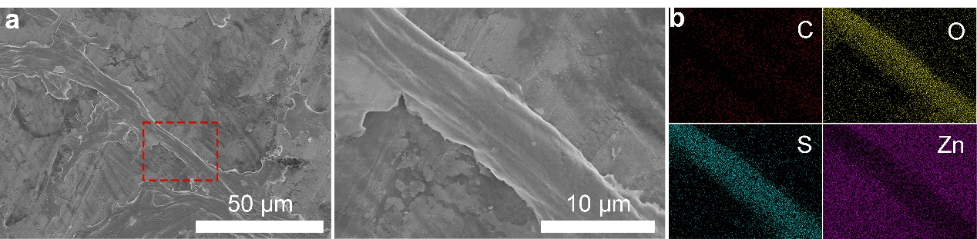
Fig. S4 a SEM images of PEDOT fiber on Zn substrate with b the corresponding EDS mapping of C, O S and Zn elements.
Fig. S5 The binding energy of PSS with Zn²⁺ ion and water molecule.
Fig. S6 XPS spectra of the ZSO and PPZ.
Fig. S7 UV-VIS absorption spectra of the samples. The UV-VIS absorption of supernatant of DPPZ is similar with that of ZSO. Subnatant of DPPZ also shows similar light absorption with DPPZ solution. These results indicates that PEDOT and PSS are not separated in the DPPZ solution.
Fig. S8 1H NMR spectra of PPZ1 and PPZ5 electrolytes.
Fig. S9 FTIR spectra of the ZSO and biphasic electrolytes.
Fig. S10 LSV curves of the ZSO and PPZ3 electrolytes.
Fig. S11 The structural models for ESP calculations. a PEDOT + PSS complex and b PEDOT + PSS complex combined with one Zn²⁺ ion.

Fig. S12 EIS plots of Zn||Zn symmetric cells with a the ZSO and b PPZ3 at various temperatures for the calculation of ionic desolvation energy. c The equivalent circuit of EIS plots.

Fig. S13 EIS plots of Zn||Zn symmetric cells with a the ZSO and b PPZ3 at various temperatures for the calculation of ionic conductivity.

Fig. S14 I-t curves and the corresponding EIS plots of the Zn symmetric cells with a, b the ZSO and c, d PPZ3 electrolytes. e The calculated Zn²⁺ transference number.
Fig. S15 CV curves of Zn||Zn symmetric cells with a the ZSO and b PPZ3 electrolytes at the scan rate range of 0.1 to 1 mV s⁻¹.
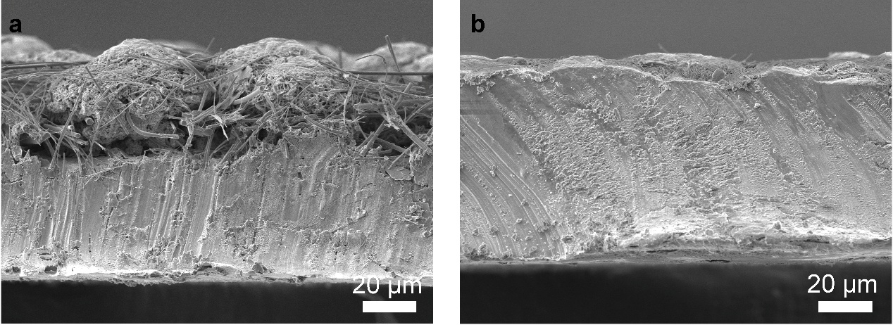
Fig. S16 SEM images of Cross-sectional view of Zn anodes after Zn deposition at the a ZSO and b PPZ3 electrolytes.
Fig. S17 The confocal images of Zn anode after deposition in the electrolytes of a ZSO and b PPZ3.

Fig. S18 XRD patterns and relative texture coefficients of Zn deposited on Ti foil with the corresponding digital photo. a ZSO and b PPZ3 electrolytes.

Fig. S19 The adsorption energy of PEDOT + PSS on Zn(002), Zn(100) and Zn(101).

Fig. S20 I-t curves of the Zn symmetric cells with different electrolyte tested at -150 mV.

Fig. S21 The initial configuration of Zn²⁺ migration on a ZSO and b PPZ3 electrolytes.
Fig. S22 The simulations of Zn²⁺ migration on the Zn surface with a one, b two, c three, d four, e five and f six water adsorptions.
Fig. S23 Tafel curves of the ZSO and PPZ3 electrolytes.
Fig. S24 In-situ XAS spectra of Zn anode with a ZSO and b PPZ3 electrolytes during Zn deposition.

Fig. S25 XRD patterns of Zn anodes after cycling.
Fig. S26 The S 2p XPS spectra of Zn anodes after cycling in the different electrolytes.
Fig. S27 a The cycling performance of Zn||Zn symmetric cells with ZSO and PPZ3 electrolytes at 10 mA cm⁻²/1 mAh cm⁻². The voltage-time profile of the symmetric cells at b 1-2, c 300-301, d 500-501 and e 599-600 h.

Fig. S28 Rate performance of Zn||Zn symmetric cells with the PPZ electrolytes.
Fig. S29 Rate performance of Zn||Zn symmetric cells with DPPZ electrolyte.

Fig. S30 CV curves of Zn||Cu asymmetric cell with different electrolytes.

Fig. S31 a The cycling performance of Zn||Cu asymmetric cells with ZSO and PPZ3 electrolytes at 5 mA cm⁻²/2.5 mAh cm⁻². The voltage-areal capacity profile of the asymmetric cells with b ZSO and c PPZ3.
Fig. S32 a The cycling performance of Zn||Cu asymmetric cells with ZSO and PPZ3 electrolytes at 10 mA cm⁻²/1 mAh cm⁻². The voltage-areal capacity profile of the asymmetric cells with b ZSO and c PPZ3.
Fig. S33 a The cycling performance of Zn||Cu asymmetric cells with ZSO and PPZ3 electrolytes at 20 mA cm⁻²/5 mAh cm⁻². The voltage-areal capacity profile of the asymmetric cells with b ZSO and c PPZ3.

Fig. S34 Schematical illustration of Zn||V₂O₅ full cell with the PPZ3 electrolyte.

Fig. S35 XRD pattern of V₂O₅ cathode material.

Fig. S36 a SEM image of V₂O₅ cathode material with the corresponding elemental mapping of b O and c V elements.

Fig. S37 The rate performance of Zn||V₂O₅ full cells with ZSO and PPZ3 electrolytes at the current density range from 0.3-5 A g⁻¹.
Fig. S38 Long-term cycling tests of ZSO and PPZ3 full cells at 0.5 A g⁻¹.
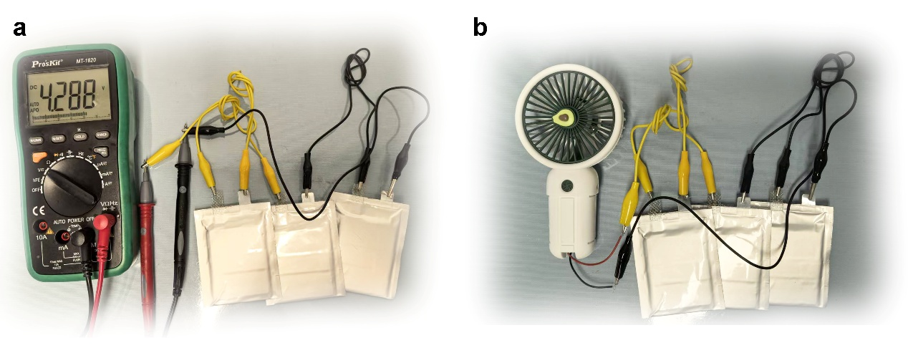
Fig. S39 The digital photos of a the voltage of cells and b fan powering by three cells in series.

Table S1 The cell size and atom count of Zn (slab) surface
 | Cell size |  |  | Atom count
 | a | b | c | Zn
Zn(002) | 13.133652 | 13.133652 | 35.207234 | 48
Zn(100) | 10.506922 | 15.621702 | 35.307902 | 48
Zn(101) | 11.664476 | 10.506922 | 34.516592 | 48
Zn(102) | 13.829595 | 10.506922 | 33.997151 | 48

Table S2 The mass of each component in pouch cell
Cell components | Size | Mass
Zn anode | 4.8 cm × 5.6 cm | 0.86 g
Cathode current | 4.8 cm × 5.6 cm | 0.42 g
Cathode | 4.8 cm × 5.6 cm | 0.85 g
Separator | 5.0 cm × 5.8 cm | 0.20 g
Electrolyte | 2 ml | 2.41 g
Al-plastic film | 8 cm × 12 cm | 1.10 g

