Supporting Information for
Taming Lattice Strain via Buried Interface Engineering for Reverse-Bias Resilient Perovskite Solar Cells
Niqian Du^{1,2}†, Shanshan Du^{1,2}†, Yaru Du¹†, Xiaobo Zhang²*, Xiaoyi Hou², Chi Feng¹, Rongdong Xiang¹, Xin Wu³, Heping Fu¹, Zhiyong Liu¹*, Tingwei He⁴, Kaikai Liu²*
¹ Henan Key Laboratory of Advanced Semiconductor & Functional Device Integration, School of Physic, Henan Normal University, Xinxiang 45007, P. R. China
² Henan Key Laboratory of Optoelectronic Energy Storage Material and Application, School of Physics and Engineering, Henan University of Science and Technology, Luoyang 471023, P. R. China
³ Department of Chemistry, City University of Hong Kong, Kowloon 999077, Hong Kong, P. R. China
⁴ College of Physics Science and Technology, Hebei University, Baoding 071002, P. R. China
† Niqian Du, Shanshan Du, and Yaru Du contributed equally to this work.
* Corresponding authors. E-mail: xiaobo@haust.edu.cn (Xiaobo Zhang); zyliu01@163.com (Zhiyong Liu); kkliu@haust.edu.cn (Kaikai Liu)

S1 Supplementary Equations and Tables
Equation S1
The following formula was used for SCLC analysis of pure hole devices (ITO/Mixed or Control SAMs/PVK/PTAA/Ag), and the defect density Nt was obtained.
$\begin{aligned}N_{t}=\frac{2ε_{r}ε_{0}V_{TFL}}{eL^{2}}\end{aligned}$ (S1)
Where $ε_{r}$, $ε_{0}$ and $L$ represent the relative perovskite dielectric constant, vacuum dielectric constant and film thickness, respectively, and e is the basic charge. $V_{TFL}$ was obtained by tangential method with readouts of 0.66 V and 0.83 V respectively.
Equation S2
The formula for calculating electrical conductivity (σ)
$\begin{aligned}σ=\frac{d}{AR}\end{aligned}$ (S2)
Where $d$, $A$ and $R$ are respectively the thickness, area and resistance of the hole layer.
Equation S3
The Mott-Schottky equation
$\begin{aligned}\frac{1}{c^{2}}=\frac{2(V_{bi}-V)}{A^{2}eϵϵ_{0}N_{A}}\end{aligned}$ (S3)
Where, $A$ is the active area, $c$ is the device capacitance, $V$ is the applied bias, and $N_{A}$ is the doping density.
Equation S4
Hysteresis calculation formula for perovskite solar cells
$HI=\frac{{PCE}_{reverse}-{PCE}_{forward}}{{PCE}_{reverse}}$ (S4)
Equation S5 and S6
The fitting formula and the calculation formula for the average carrier lifetime of TPC/TPV
$\begin{aligned}f\left(t\right)=A_{1}\exp\left(-\frac{t}{τ_{1}}\right)+A_{2}\exp\left(-\frac{t}{τ_{2}}\right)\end{aligned}$ (S5)
$\begin{aligned}τ_{ave}=\frac{A_{1}τ_{1}^{2}+A_{2}τ_{2}^{2}}{A_{1}τ_{1}+A_{2}τ_{2}}\end{aligned}$ (S6)
Where $A_{1}$ and $A_{2}$ are attenuation amplitudes,$τ_{1}$and $τ_{2}$ are attenuation times,$τ_{ave}$ average decay time.
Equation S7
The calculation formula of illumination ideal factor (n)
$\begin{aligned}n_{id}=\frac{q}{kT}×\frac{dV_{OC}}{dln\left(L\right)}\end{aligned}$ (S7)
Where $L$ is the normalized light intensity, $k$ is the Boltzmann constant, $T$ is the absolute temperature, and $q$ is the unit charge. The closer the $n$ value is to 1, the lower the carrier recombination caused by the defect.

Table S1 TRPL parameters of the Control and Target SAM films
Sample | A₁ (%) | τ₁ (ns) | A₂ (%) | τ₂ (ns) | Τ_{ave} (ns)
Control | 58.01 | 113.79 | 41.99 | 564.54 | 466.37
Target | 44.33 | 193.52 | 55.67 | 743.05 | 648.66

Table S2 Fitting parameters of the normalized GSB decays at 766 nm for the perovskite films deposited on the HTL/ITO substrate without and with 3F-2TC modification
Sample | A₁ (%) | τ₁ (ps) | A₂ (%) | τ₂ (ps) | Τ_{ave} (ns)
Control | 40.80 | 263.75 | 59.20 | 1842.13 | 1.70
Target | 41.19 | 177.57 | 58.81 | 1717.62 | 1.61

Table S3 EIS fitting parameters of the control and target devices
Sample | Rs (Ω) | Rrec (Ω)
Control | 1.47 | 963.05
Target | 0.78 | 1670.69

S2 Supplementary Figures
Fig. S1 The molecular structures of MeO-4PACz and 3F-2TC.
Fig. S2 J-V curves of devices with different volume ratios of MeO-4PACz to 3F-2TC.
Fig. S3 The PCE changes of control devices and target divices under different reverse bias.

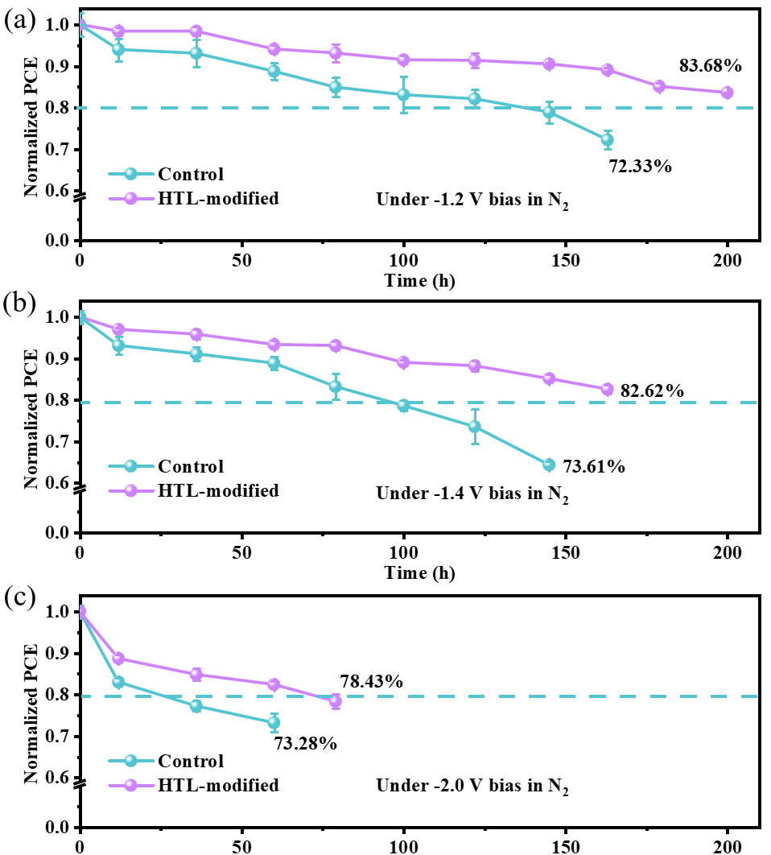
Fig. S4 Changes in PCE of control and HTL-modified devices under high magnitudes of bias stress for (a) -1.2 V, (b) -1.4 V, and (c) -2.0 V.

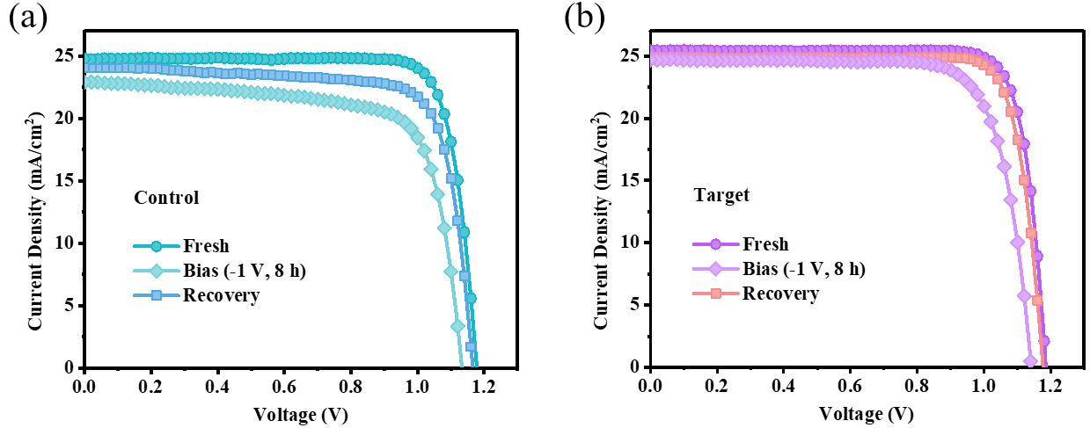
Fig. S5 J-V curves of (a) the control device and (b) the target device under different conditions of the fresh, bias (under -1 V for 8 h), and recovery (overnight dark storage).

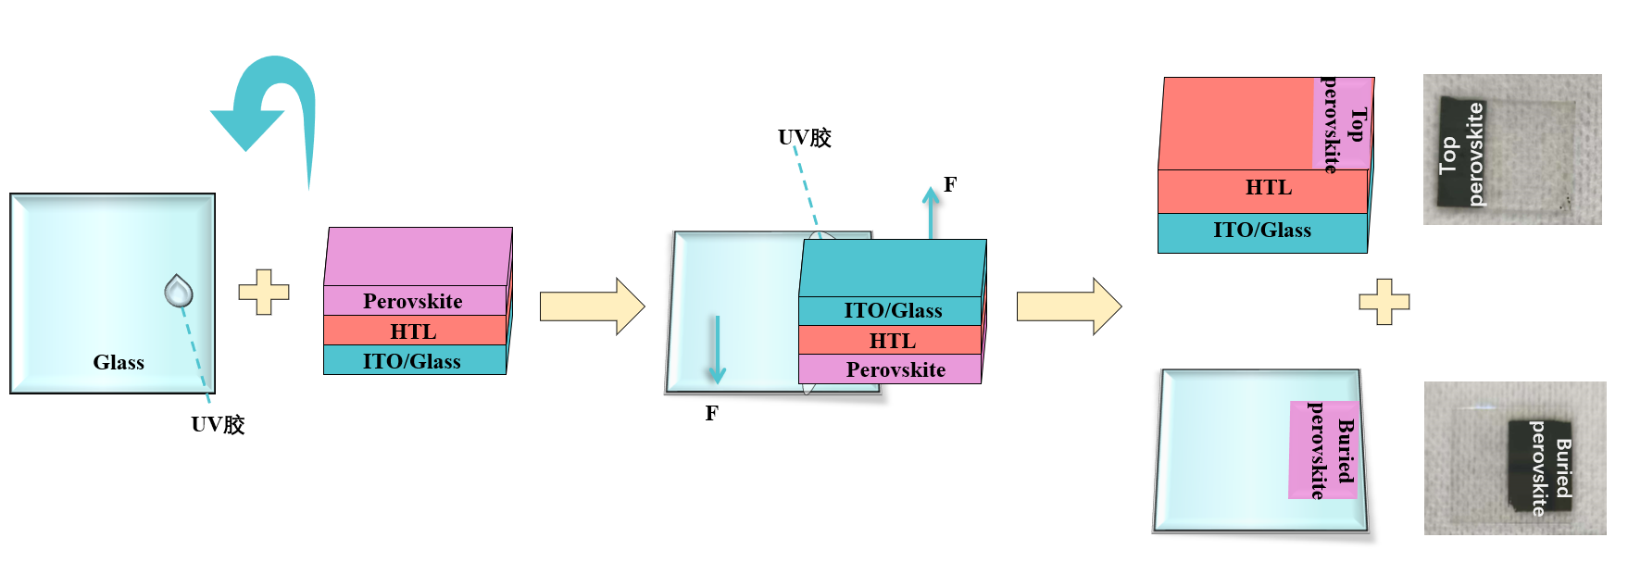
Fig. S6 Schematic illustration of preparation process to expose the buried interface.

Fig. S7 Temperature-dependent conductivity of the control and target device.
Fig. S8 FTIR spectra of FAI and FAI/3F-2TC mixture.

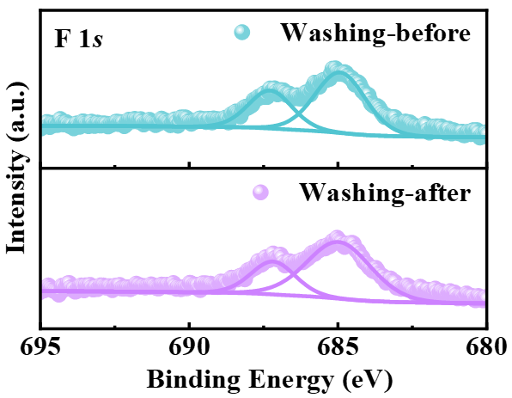
Fig. S9 F 1s signal in XPS spectra of the target HTL films before and after DMF/DMSO washing.

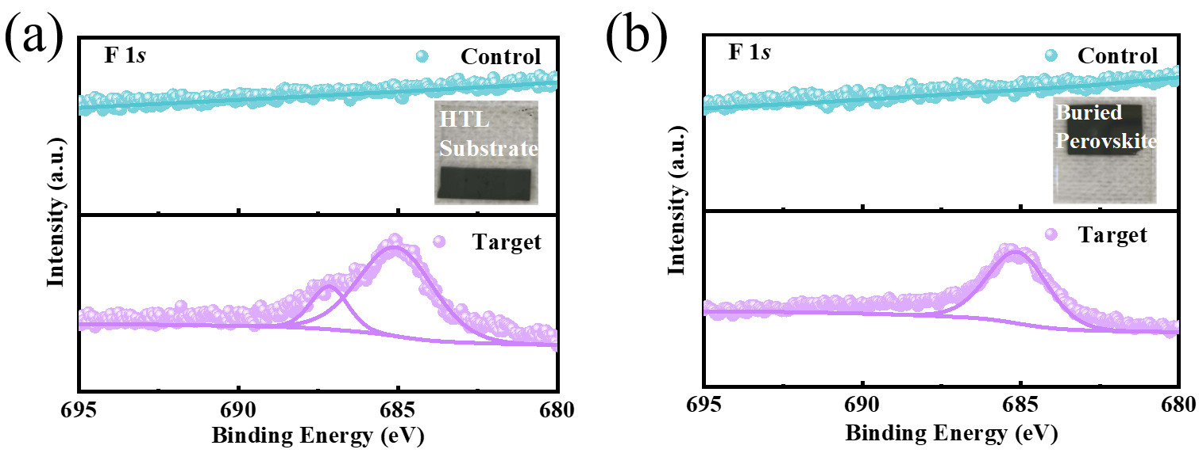
Fig. S10 F 1s signal in XPS spectra of (a) the HTL substrate (b) the buried perovskite films.
Fig. S11 I 3d signal in XPS spectra for the buried interface of the control and target perovskite films.

Fig. S12 SCLC analysis of hole-only devices based on the control and target perovskite film.

Fig. S13 AFM images of the top surface of the control and target perovskite film.

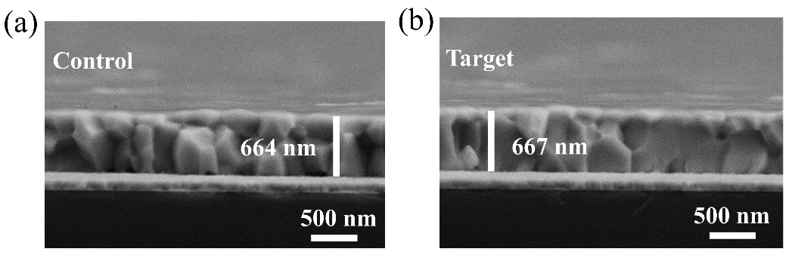
Fig. S14 Cross-sectional SEM images of the control and target perovskite film.

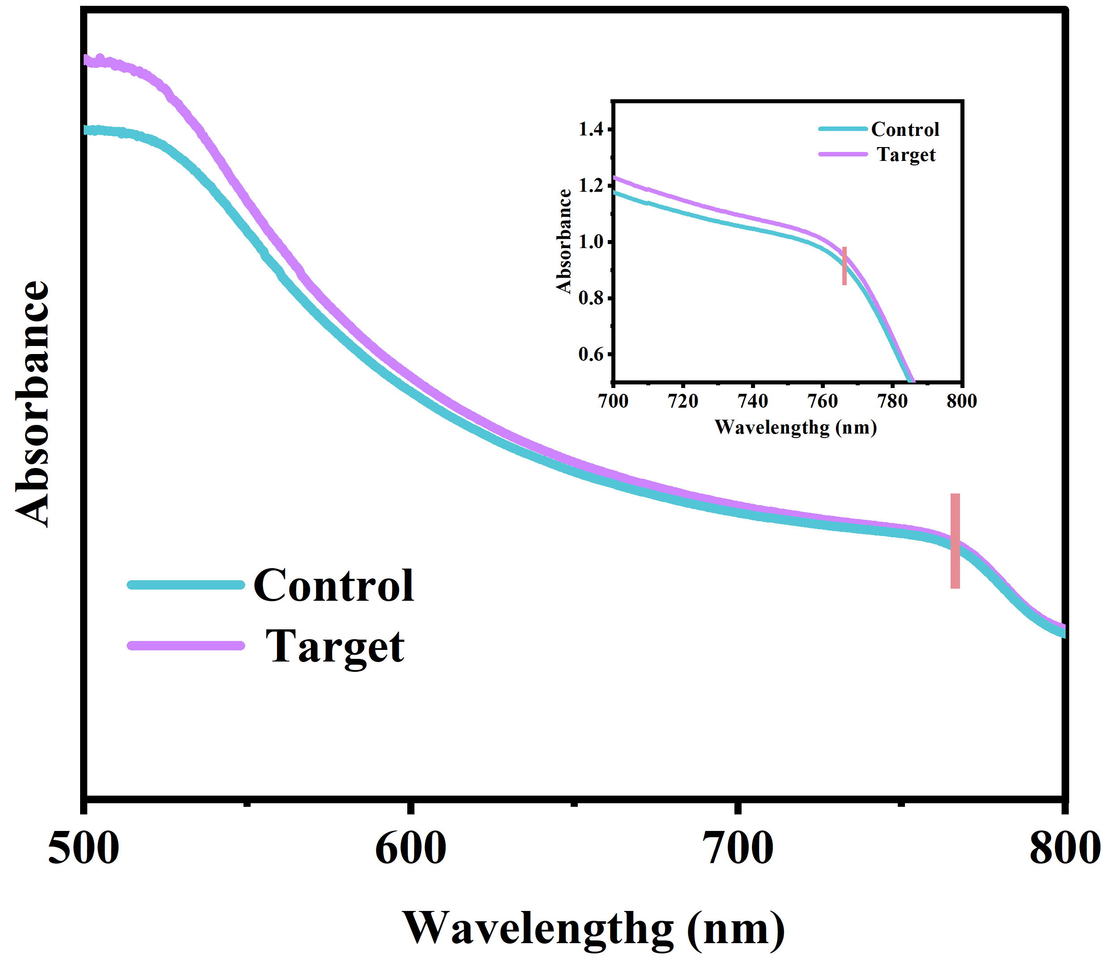
Fig. S15 Absorption of the control and target perovskite film.

Fig. S16 (a) P 2p and (b) In 3d in XPS spectra for the control HTL and target HTL.

Fig. S17 (a) Binding energy of the dimers and tetramers for MeO-4PACz molecules. (b) DFT-simulated conformations of MeO-4PACz dimers and tetramers (part Ι) and diagram of the control HTL (part Ⅱ).

Fig. S18 DLS measurements of the MeO-4PACz solutions without (control) and with (Target) 3F-2TC incorporation.

Fig. S19 Electrostatic surface potential (ESP) maps of the 3F-2TC molecule.
Fig. S20 DFT-simulated binding energy of the MeO-4PACz and 3F-2TC heterodimer.

Fig. S21 FTIR spectra of the MeO-4PACz powder and MeO-4PACz/3F-2TC mixed powder.

Fig. S22 Mechanism diagram and schematic illustration of depositing the target HTL (MeO-4PACz/3F-2TC) on ITO substrates.

Fig. S23 KPFM images of the control HTL and target HTL.

Fig. S24 UPS spectra for the (a, b) control HTL and (c, d) target HTL.

Fig. S25 Differential charge density of the interface for the control HTL and target HTL.
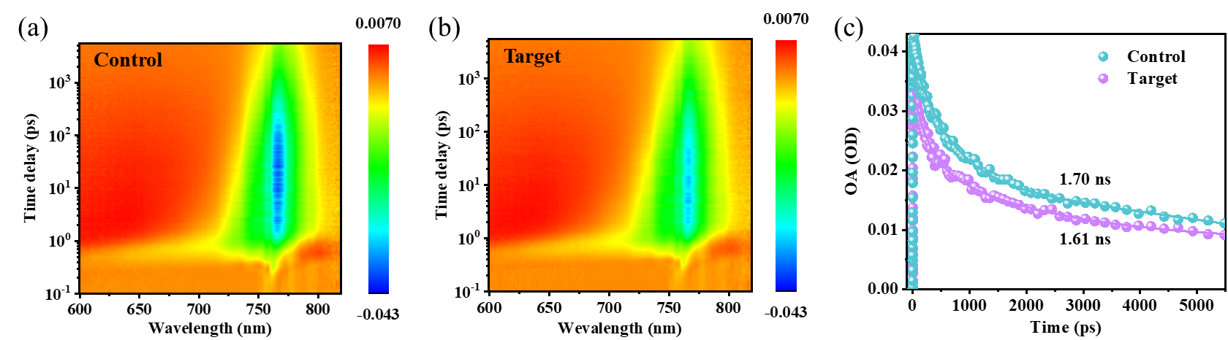
Fig. S26 (a, b) 2D pseudo-color plots of fs-TAS for the perovskite film deposited on HTL/ITO substrate without (control) and with (target) 3F-2TC modification; (c) Kinetic traces of the ground state bleaching (GSB) signal probed at 766 nm, normalized by the steady-state absorbance at 766 nm.

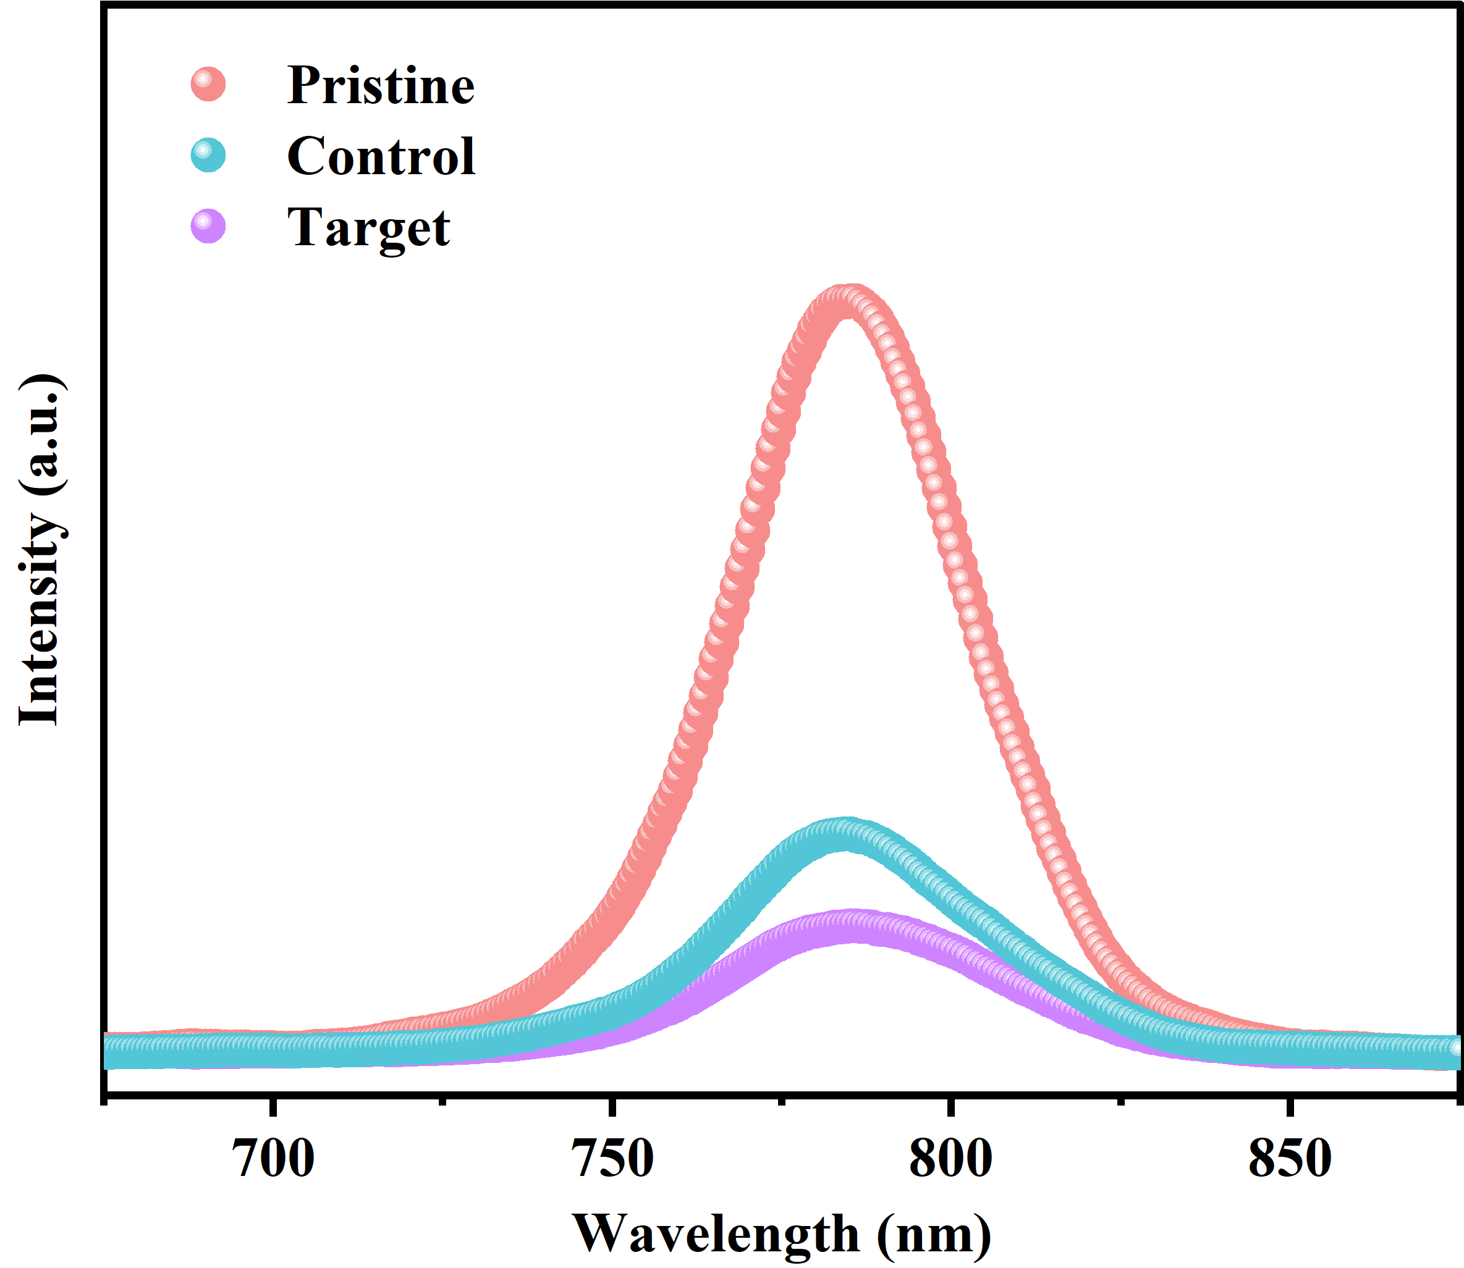
Fig. S27 Steady-state PL spectra of Glass/PVK (Pristine), Glass/ITO/MeO-4PACz/PVK (Control), and Glass/ITO/MeO-4PACz+3F-2TC/PVK (Target).

Fig. S28 Transmission spectra of the control HTL and target HTL.
Fig. S29 J-V curves of the control and target devices under the reverse and forward scanning modes.

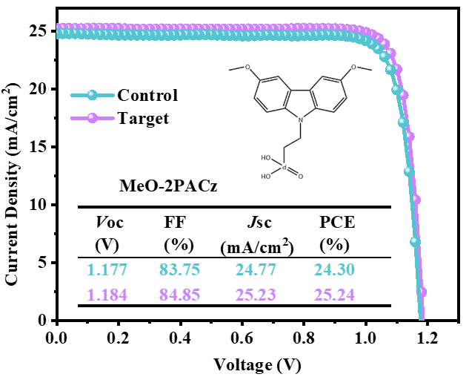
Fig. S30 J-V curves of the best-performing PSCs based on MeO-2PACzHTLs without (control) and with (target) 3F-2TC modifiction.

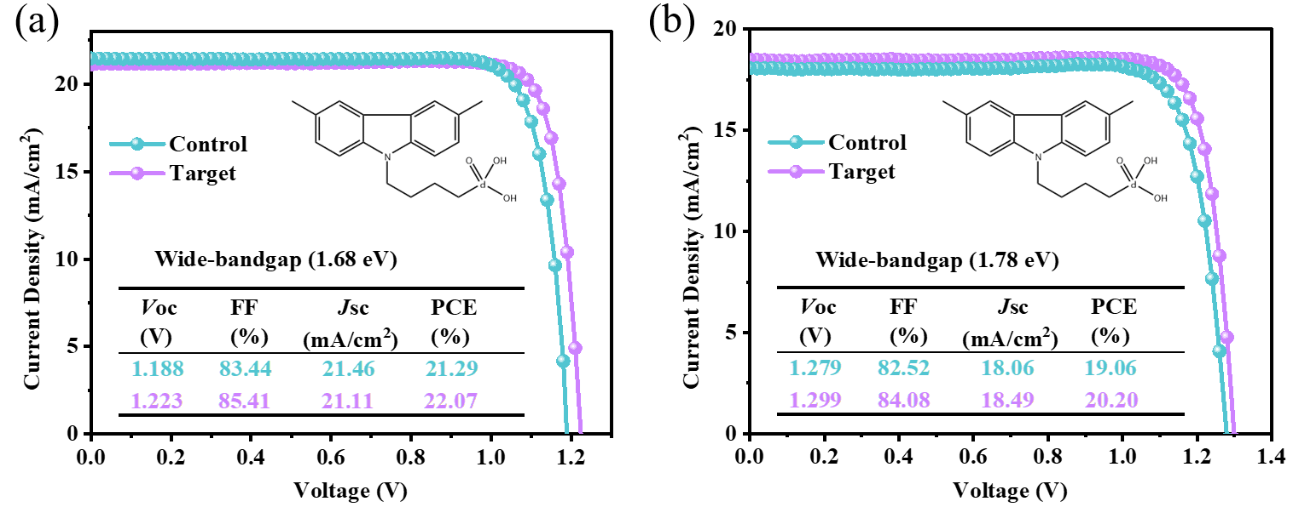
Fig. S31 J-V curves of the champion PSCs with different wide-band gaps based on Me-4PACz HTLs without (control) and with (target) 3F-2TC modification.
Fig. S32 TPV decay curves of the control and target device.
Fig. S33Voc dependence on light intensities for the control and target device.

Fig. S34 Jsc dependence of on light intensities for the control and targe device.
Fig. S35 TPC decay curves of the control and target device.

Fig. S36 Dark J-V curves for the control and target device.

Fig. S37 Water contact angle of the perovskite films deposited on the control HTL and target HTL.

