Supporting Information for
Ultra-Sodiophilic Mixed Conductor Interphase Enabling Uniform Top Deposition for Quasi-Solid-State Sodium Metal Batteries
Chunching Lu^{1, #}, Guangxiang Zhang^{1, #}, Yuxiang Niu², Yupeng Zhu², Siyuan Li², Hua Huo¹, Yulin Ma^{1,} *, Pengjian Zuo¹, Geping Yin¹, Yunzhi Gao¹, Liguang Wang^{3,} *, Chuankai Fu^{1,} *, and Wei Chen^{2,} *
¹State Key Laboratory of Space Power-Sources, School of Chemistry and Chemical Engineering, Harbin Institute of Technology, Harbin 150001, P. R. China
²Department of Chemistry, National University of Singapore, 3 Science Drive 3, 117543, Singapore
³College of Chemical and Biological Engineering, Zhejiang University, Hangzhou 310058, P. R. China
#Chunching Lu and Guangxiang Zhang contributed equally to this work.
*Corresponding authors. E-mail: phycw@nus.edu.sg (Wei Chen); chuankaifu@hit.edu.cn (Chuankai Fu); mayulin@hit.edu.cn (Yulin Ma); wanglg@zju.edu.cn (Liguang Wang)
Supplementary Figures and Tables

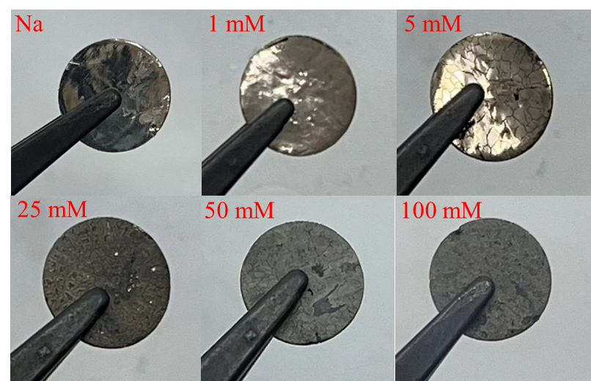
Fig. S1 Optical photos of the Na anode surface after treatment with different concentrations of SbF₃ in DME.
Optical photos indicate that the protective layer on the Na metal surface is most compact when the concentration of SbF₃ is 100 mM.

Fig. S2 Cycling performance of Na||Na symmetric cells with Na anode after chemical treatment in different SbF₃ concentrations at 0.1 mA cm⁻².
The cycling stability of Na metal treated with 100 mM SbF₃ solution is optimal.

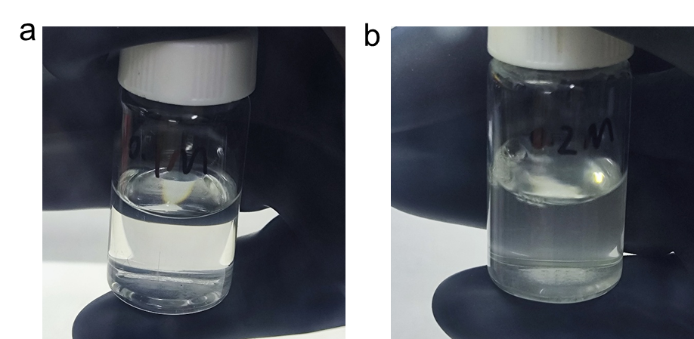
Fig. S3 Optical photos of a 0.1 M and b 0.2 M SbF₃ in DME.
The solution of 0.2 M SbF₃ in DME shows a turbid state, indicating that SbF₃ cannot be completely dissolved.

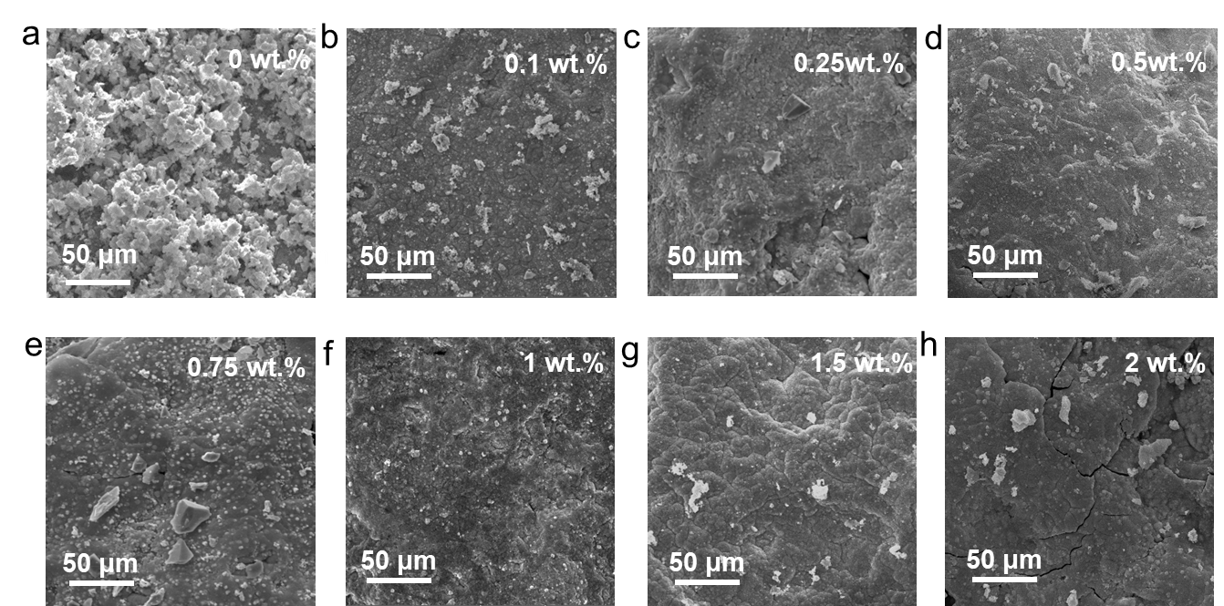
Fig. S4 The SEM images of the SFC-Na anode after treatment by SbF₃/DME solutions with different CMC concentrations.
When the CMC content in SbF₃/DME solution is 1 wt.%, the MCI layer is the densest and uniform.

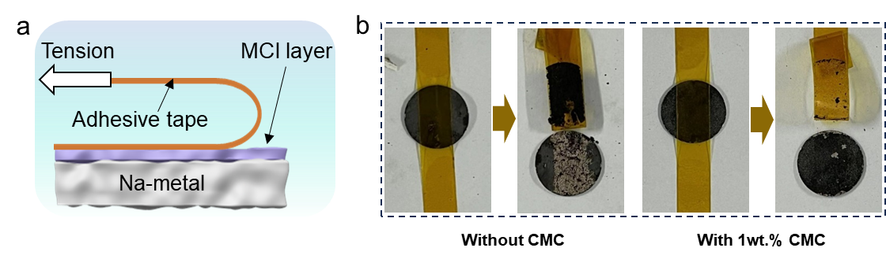
Fig. S5 a Schematic diagram of adhesion experiment, b adhesion experiment of MCI layer without or with 1 wt.% CMC.
Adhesion tests show that the addition of 1 wt.% CMC effectively promotes the adhesion between the MCI layer and the Na-metal substrate.
Fig. S6 XPS spectra of C 1s on the SFC-Na surface.
C=O-OR, C-O, and other organic components generated by DME solvent can improve the flexibility of the MCI layer.

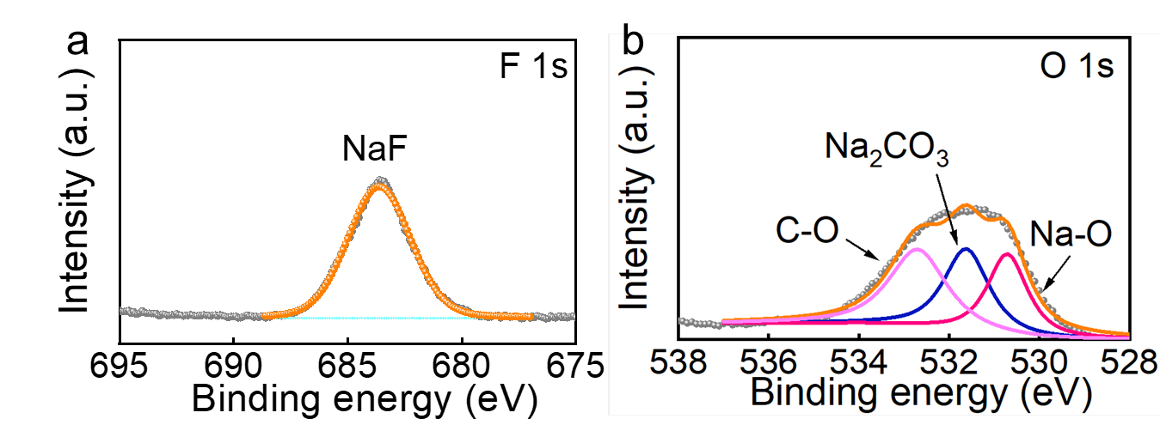
Fig. S7 XPS spectra of a F 1s and b O 1s on the F-Na surface.
Organic components and NaF are also detected on the surface of F-Na.

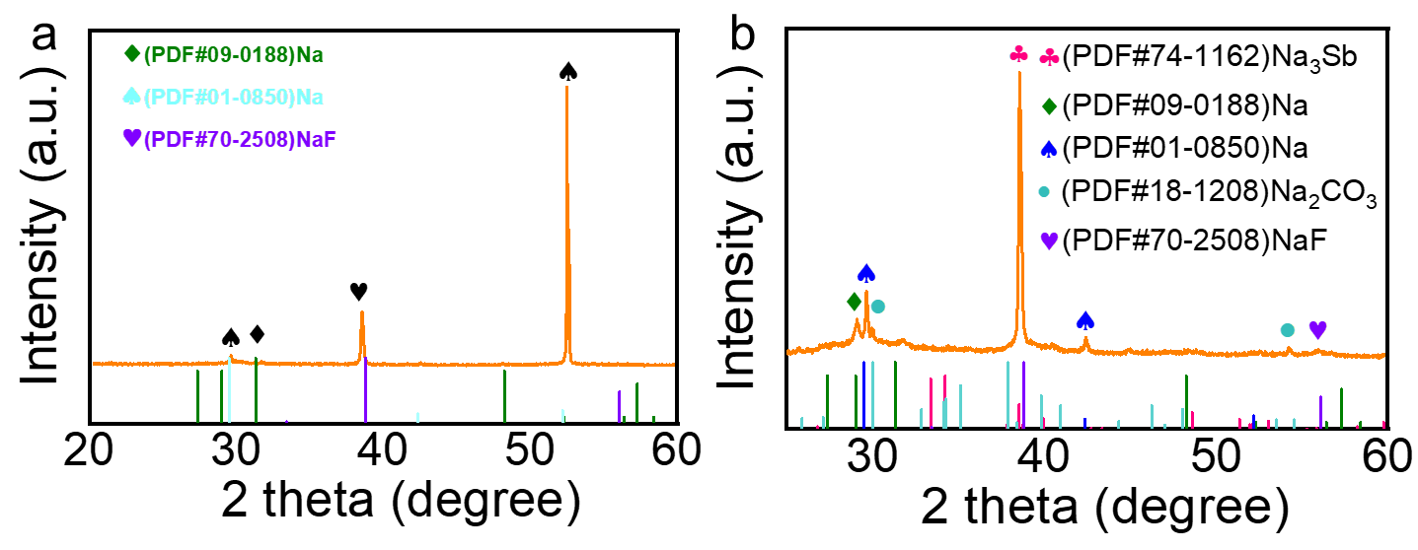
Fig. S8 XRD spectra of a F-Na and b SCF-Na.
XRD analysis further verifies the phase composition, with distinct diffraction peaks corresponding to NaF (PDF#70-2508) and Na₃Sb alloy (PDF#74-1162) in the surfaces of F-Na and SFC-Na anodes.

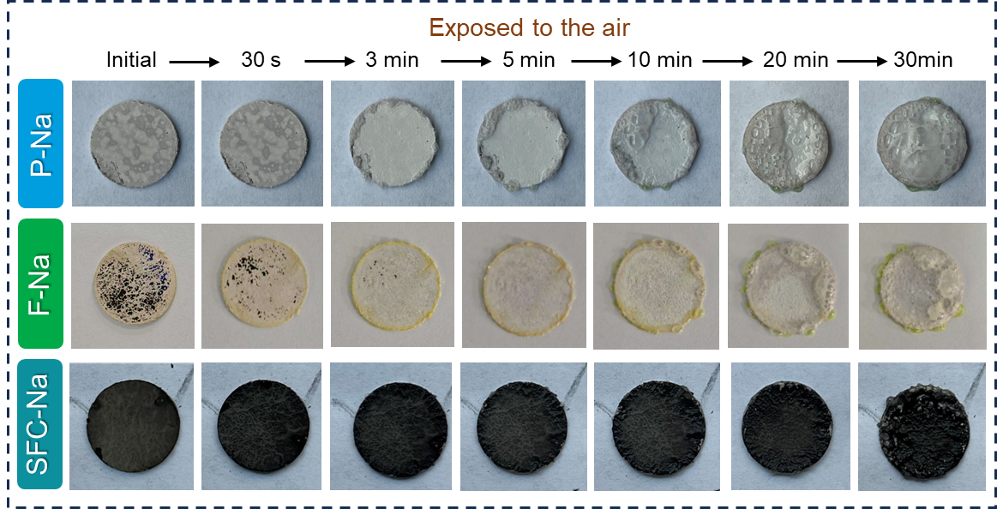
Fig. S9 The air stability of P-Na, F-Na, and SCF-Na.
Owing to the high compactness and excellent chemical stability of MCI, the SFC-Na anode can remain stable for 30 min in the air, which is superior to that of F-Na (3 min) and P-Na (5 min).

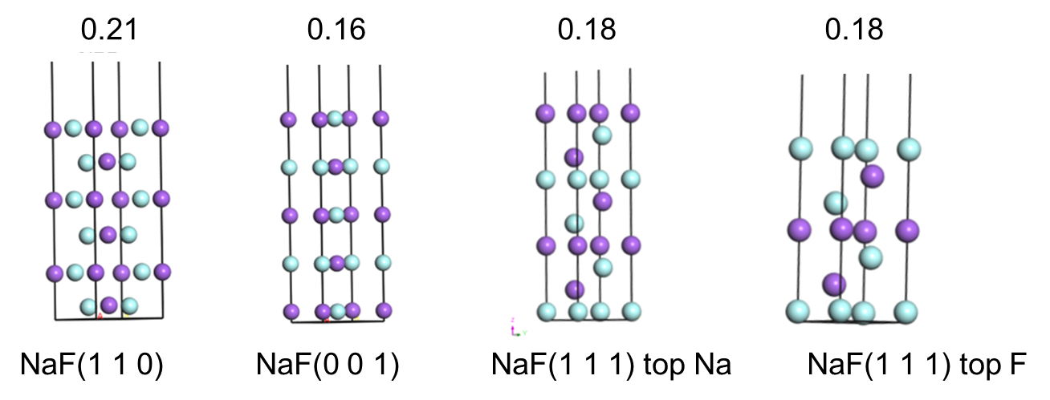
Fig. S10 Surface energies (eV/Å²) of NaF on the surface of SFC-Na.
The evolution mechanism of Na deposition on the MCI is elucidated by DFT, employing modeled NaF (001) surfaces with the lowest surface energies.

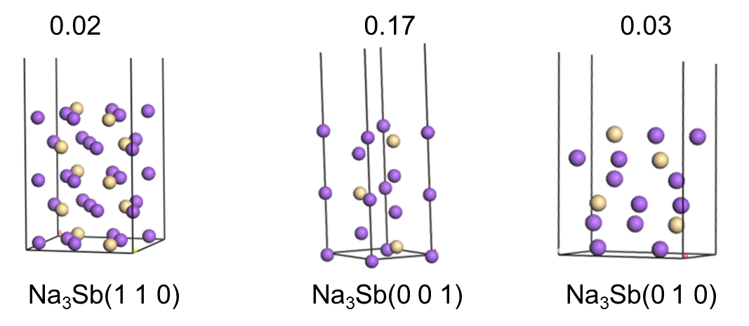
Fig. S11 Surface energies (eV/Å²) of Na₃Sb on the surface of SFC-Na.
The evolution mechanism of Na deposition on the MCI is elucidated by DFT, employing modeled Na₃Sb (110) surfaces with the lowest surface energies.
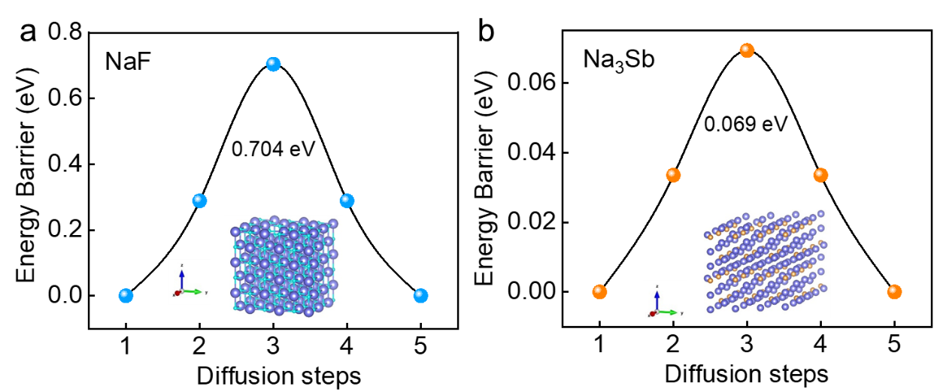
Fig. S12 DFT simulations of Na⁺ diffusion in NaF a and Na atom diffusion in Na₃Sb b.
The Na⁺ diffusion energy barrier in NaF is much higher than Na atom diffusion energy barrier in Na₃Sb, demonstrating the significant role of Na₃Sb in promoting electrochemical kinetics.
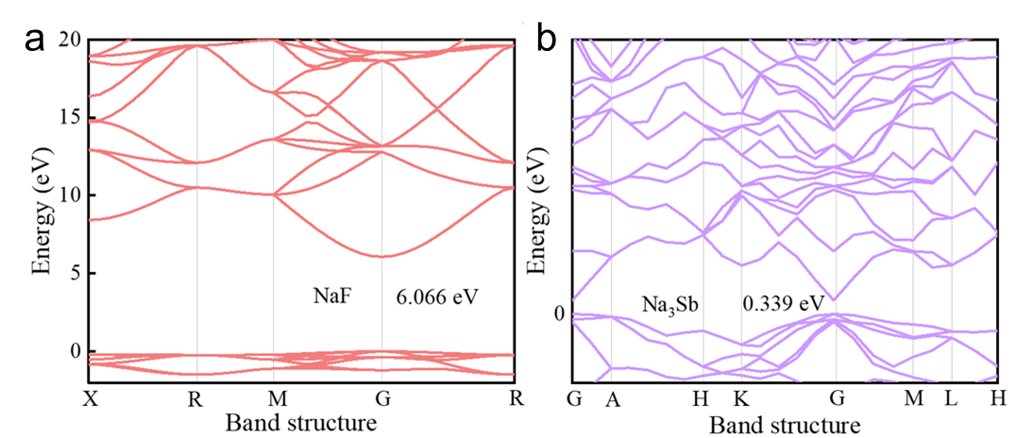
Fig. S13 The band gap of a NaF and b Na₃Sb.
NaF in MCL exhibits high electron blocking ability, which can effectively prevent electron tunneling, while Na₃Sb phase can improve electron conductivity, achieve rapid electron transfer, and avoid charge accumulation.

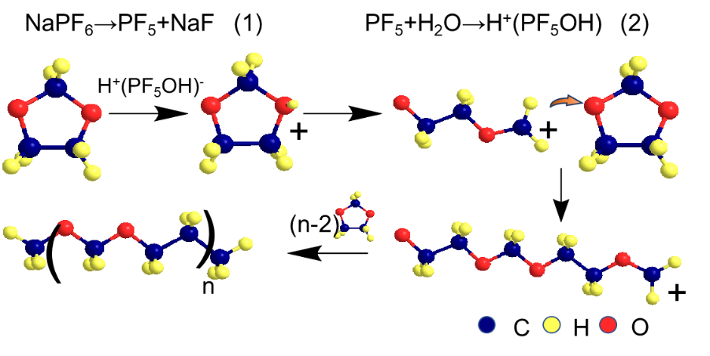
Fig. S14 Ring-opening polymerization mechanism of DOL.
The polymerization mechanism involves a Lewis acid PF₅– species derived from NaPF₆, which reacts with trace water to generate protons that initiate the ring-opening polymerization of DOL.
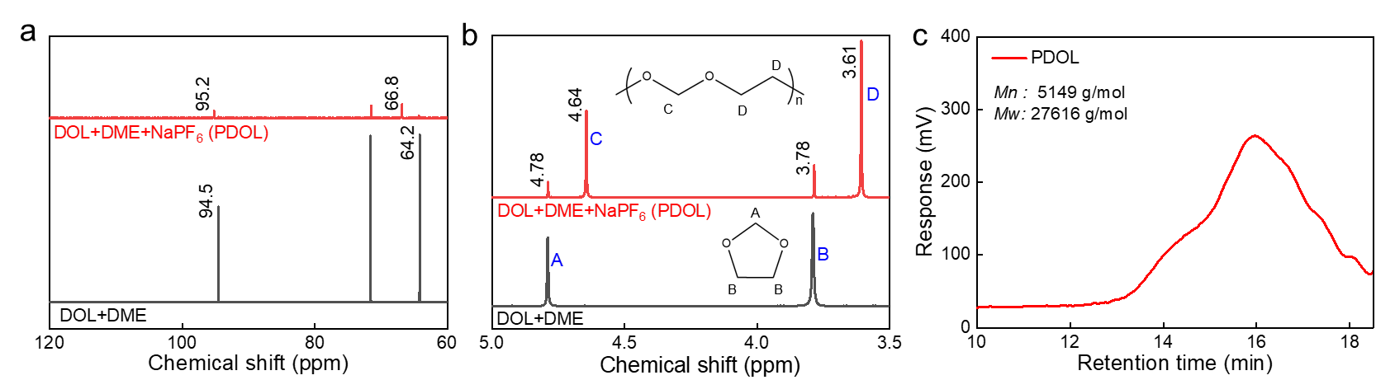
Fig. S15 a ¹³C NMR and b ¹H NMR spectra before and after DOL polymerization. c GPC spectrum of DGPE.
DOL was polymerized successfully, achieving a polymerization degree of 89.7% and number-average and weight-average molecular weight of 5,149 g mol⁻¹ and 27,616 g mol⁻¹, respectively.

Fig. S16 The impedance of Na||Na symmetric cells under different storage times before cycling.
After long-term storage, the impedance of Na||Na symmetric cells remain almost unchanged, proving the good compatibility between DGPE and SFC-Na.

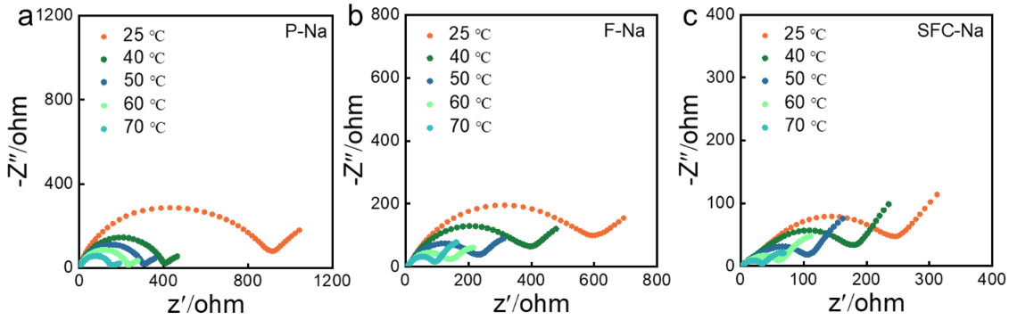
Fig. S17 Nyquist plots of a P-Na, b F-Na, and c SFC-Na in the Na||Na symmetric cells at different temperatures after 5 cycles.
The impedances of Na⁺ transport across the SEI (R_{SEI}) layer and charge-transfer (R_{ct}) at different temperatures are further measured by EIS to reflect the superiority of the MCI in inducing the construction of the stable and robust SEI layer and interfacial Na⁺ migration.

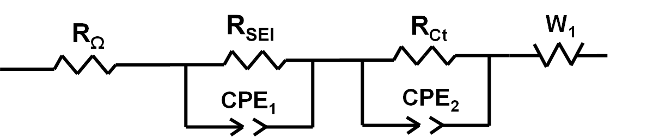
Fig. S18 Equivalent circuit of impedance fitting.
The EIS values are fitted by the corresponding equivalent circuit.

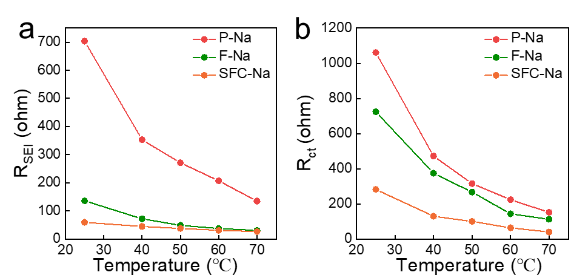
Fig. S19 Impedance values of a R_{SEI} and b R_{ct}.
The R_{SEI} and R_{ct} of quasi-solid-state symmetrical cells with SFC-Na anodes are markedly lower than those of cells with P-Na or F-Na anodes, demonstrating clear superiority.

Fig. S20 Galvanostatic long-term discharging performance of Na||Na symmetric cells with P-Na, F-Na, and SFC-Na anodes.
The cells with P-Na and SF-Na stabilized for only 2 h and 8 h, respectively, before short circuit, whereas the SFC-Na cell maintained a stable voltage plateau at 80 mV for 22 h, demonstrating effective suppression of Na dendrite growth.

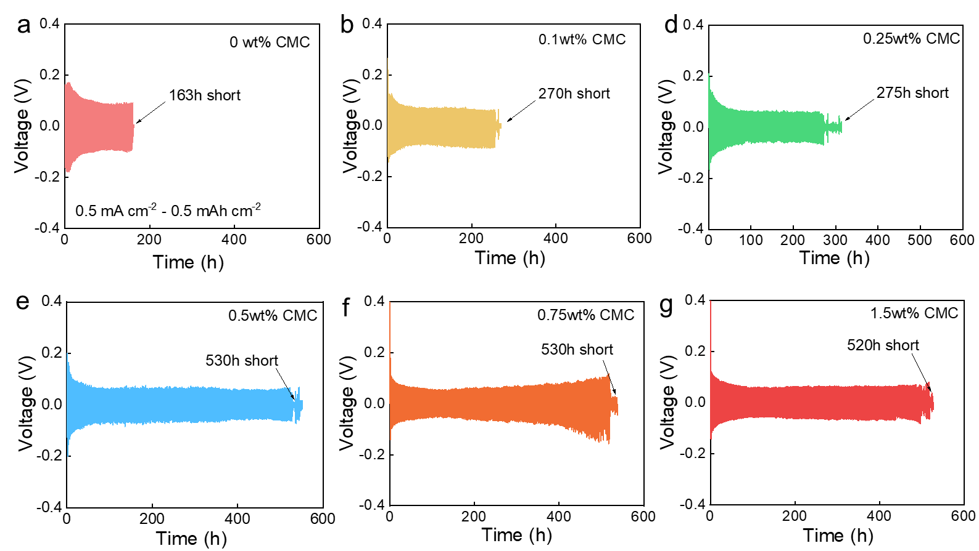
Fig. S21 Cycling performance of Na||Na symmetric cells with SFC-Na anode with different CMC contents at 0.5 mA cm⁻².
The Na||Na symmetric cells with an SFC-Na anode consisting of 1wt.% CMC exhibits the best cycling stability.

Fig. S22 Cycling performance of Na||Na symmetric cells with SFC-Na anode at 2.0 mA cm⁻².
Even at a higher current density of 2 mA cm⁻², the SFC-Na cells can stably cycle for 180 h without short circuit.

Fig. S23 Correlation between Z-real and ω^{-1/2} for P-Na, F-Na and SFC-Na anodes.
The construction of the MCI enhances the Na⁺ diffusion coefficient, thereby mitigating the concentration gradient across the corresponding SEI layer and promoting a more uniform distribution of Na⁺ during migration and stripping.
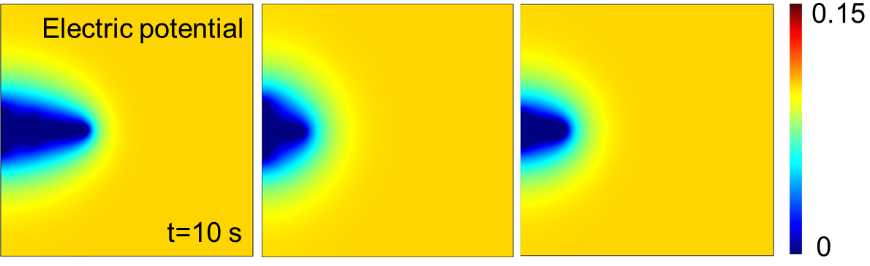
Fig. S24 The images of a P-Na, b F-Na, and c SFC-Na show the 2D distribution of the local electric field at t = 10 s.
The corresponding two-dimensional distributions of Na⁺ concentration and the local electric field reveal Na⁺ accumulation near the protrusion tip, where an intensified local electric field further accelerates dendritic growth.
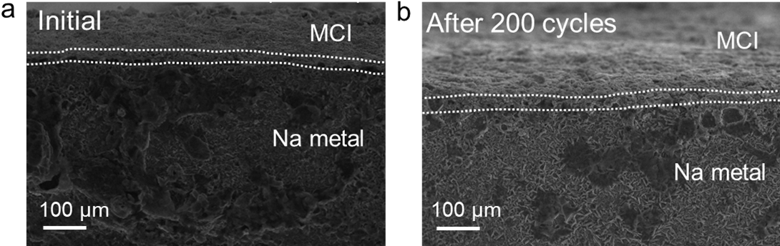
Fig. S25 Cross-sectional SEM images of SFC-Na anode: a initial state and b after 200 cycles.
After long-term cycling, the MCI layer remains firmly adhered to the Na metal surface.
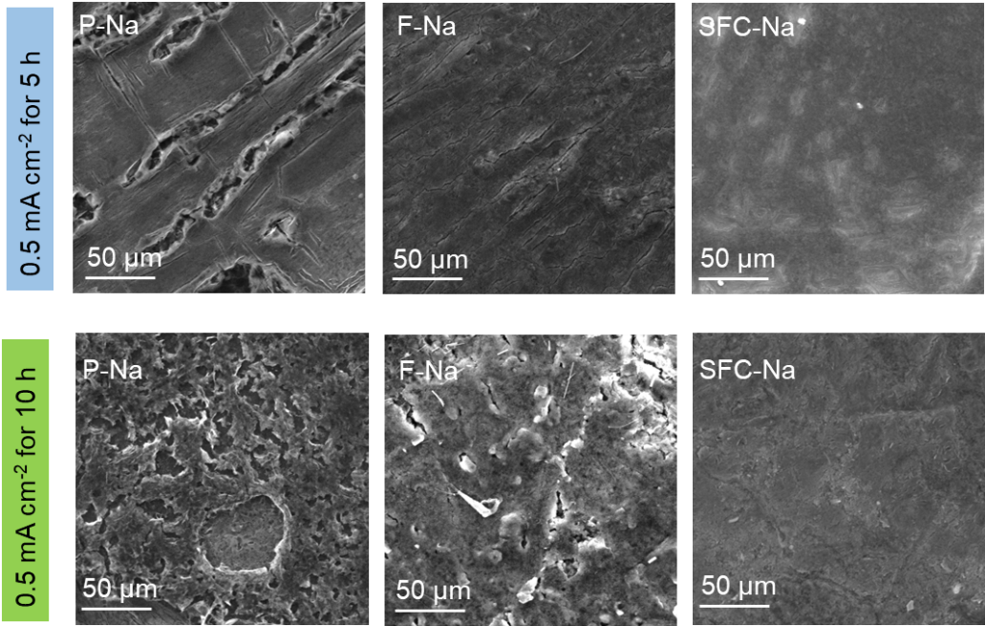
Fig. S26 The SME images of the deposited Na on the P-Na, F-Na, and SFC-Na surfaces at 0.5 mA cm⁻² for 5 h and 10 h.
Driven by the strong Na⁺ affinity of SFC-Na, the Na metal deposited on its surface exhibits a smoother morphology.
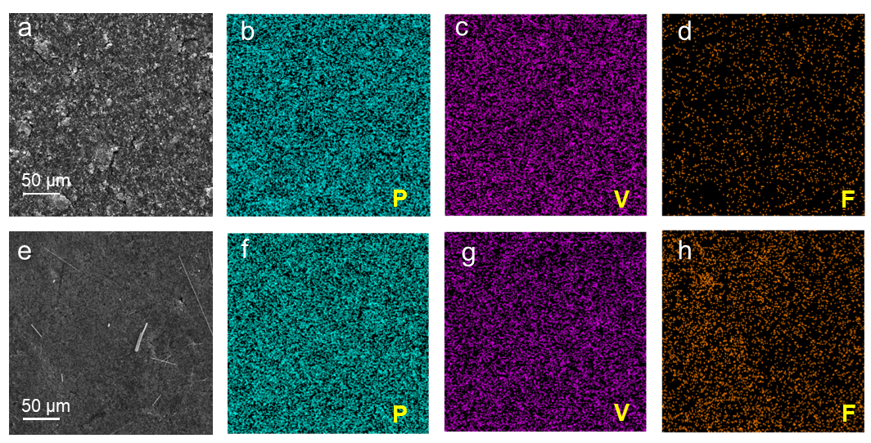
Fig. S27 Comparison of the morphology of Na₃V₂(PO₄)₃ (NVP) cathode before a and after gelation e, with corresponding surface EDX mappings shown in b-d, f-h, respectively.
SEM images and elemental mappings of the pristine NVP cathode reveal a granular morphology with uniformly distributed F and V elements, indicating a homogeneous distribution of the active material and electrolyte.
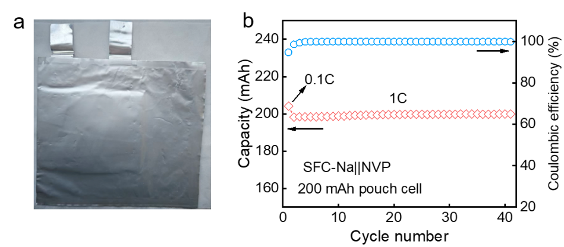
Fig. S28 Optical photo a and cycling performance b of SFC-Na||NVP pouch cell with a capacity of ~200 mAh.
The 200 mAh pouch cell based on SFC-Na anode and NVP cathode delivers stable capacity retention and high Coulombic efficiency over 40 cycles at 1C.

Table S1 Surface energy (eV Å⁻²) of different crystal surfaces of NaF and Na₃Sb
NaF |  | Na₃Sb
Surface | Surface energy (eV) | Surface | Surface energy (eV)
(001) | 0.016 | (001) | 0.052
(001) | 0.037 | (110) | 0.021
(111) top-F | 0.186 | (010) | 0.033
(111) top-Na | 0.186

Table S2 Comparison of the lifespan of the SFC-Na anode with the reported works
Artificial interphase | Electrolyte | Test conditions | Cycle life (hours) | Refs.
Al₂O₃-Na | 1 M NaClO₄-EC/DEC | 0.5 mA cm⁻²/1 mAh cm⁻² | 120 | [9]
Multilayer-MoS₂-Na | 1 M NaClO₄-EC/DEC | 0.5 mA cm⁻²/0.25 mAh cm⁻² | 100 | [33]
NaBr-Na | 1 M NaPF₆-EC/PC | 1 mA cm⁻²/1 mAh cm⁻² | 250 | [34]
Na_{x}Sn_{y}-Na | 1 M NaPF₆-EC/PC | 0.5 mA cm⁻²/0.25 mAh cm⁻² | 1000 | [35]
Na₃PS₄-Na | 1M NaPF₆-EC/PC | 1 mA cm⁻²/ 1 mAh cm⁻² | 275 | [36]
Na_{x}Sn_{y}-Na | 1 M NaPF₆-EC/DMC | 0.25 mA cm⁻²/0.125 mAh cm⁻² | 600 | [37]
NaCl-Na | 1 M NaClO₄-EC/DMC | 0.3 mA cm⁻²/ 0.3 mAh cm⁻² | 1000 | [38]
ZMOF-NSC@Na | 1M NaFSI-EC/PC | 0.5 mA cm⁻²/ 0.5 mAh cm⁻² | 900 | [39]
Na₃P-Na | 1 M NaClO₄-  EC/DEC/FEC | 1 mA cm⁻²/1 mAh cm⁻² | 500 | [40]
SFC-Na | 1M NaPF₆-  DOL/DME/FEC | 0.5 mA cm⁻²/0.5 mAh cm⁻² | 1000 | This work

Table S3 Surface energy (eV Å⁻²) of different crystal surfaces of NaF and Na₃Sb
Components of electrolytes | Test conditions | Cycle life | Capacity retention | Refs.
DOL/Al(OTf)₃/NaTFSI/FEC | NVP loading: 1.12 mg cm⁻²  Rate: 0.5C | 600 | 96.7% | [1]
TMPTA/NaPF₆/EC/DEC  /FEC | NVP loading: 13.01 mg cm⁻²  Rate: 1C | 1000 | ~80% | [3]
PEGMA/TEP/NaTFSI/FEC/  AIBN | NVP loading: - mg cm⁻²  Rate: 0.2C | 400 | 91% | [5]
PEGMA/TEP/NaTFSI/  PVDF-HFP/FEC | NVP loading: 1.2 mg cm⁻²  Rate: 1C | 500 | 91.7% | [46]
BA/NaPF₆/DEC/EC/AIBN | NVP loading: 1.5 mg cm⁻²  Rate: 1C | 300 | 83% | [47]
HMPP/ETPTA/NaClO₄/  PC/FEC | NVP loading: 1 mg cm⁻²  Rate: 5C | 1000 | 97% | [48]
EA/EDA/NaPF₆/SN/  PPO/FEC | NVP loading: 3 mg cm⁻²  Rate: 3C | 700 | 83.3% | [49]
PAN | NVP loading: 2.1mg cm⁻²  Rate: 1C | 1600 | 96.03% | [50]
PEGDA/PVDF-HFP/  NaTFSI/NaBOB/PC/EC | NVP loading: 1.8 mg cm⁻²  Rate: 2C | 500 | / | [51]
TMPTMA/HDDA/NaTFSI/  ABVN/FEC/DMC/PC | NVP loading: 0.891 mg cm⁻²  Rate: 2C/5C | 700/1000 | 95.58/95.31% | [52]
DOL/DME/NaPF₆/FEC | NVP loading: 2 mg cm⁻²  Rate: 2C/5C | 2000/1100 | 93.7%/94.3% | This work
Table S4 Electrochemical performance of full cells with various alloy anodes and SFC-Na
Cathode | Anode | Cycle life | Rate | Capacity retention | Anode reaction mechanism | Refs.
Na_{x}Fe[Fe(CN)₆] | Na-Au alloy | 300 cycles | 1C | 85.7% | Alloying | [53]
Na₄Fe₃(PO₄)₂ | Na-K/C alloy | 200 cycles | 1C | 94.6% | Alloying | [54]
Na₃V₂(PO₄)₃ | Na-Bi alloy | 1000 cycles | 5C | 90% | Alloying | [55]
Na₃V₂O₂(PO₄)₂F | Na-In/C alloy | 800 cycles | 1C | 87.6% | Alloying | [56]
Na₃V₂(PO₄)₃ | Sb/GO | 50 | 1.5C | 81.3% | Alloying | [57]
Na₃V₂(PO₄)₃ | Sb@HCF | 1000 | 1C | 84.1 | Alloying | [58]
Na₃V₂(PO₄)₃ | SFC-Na | 3000 cycles | 2C | 92.2% | Surface-induced “top” Na deposition | This work
Na₃V₂(PO₄)₃ | SFC-Na | 1100 cycles | 5C | 94.3% | Surface-induced “top” Na deposition | This work

