Supporting Information for
Multifunctional Conductive and Elastic Matrices–Engineered Si Nanocomposite Anodes for Liquid and Solid-State Lithium Batteries
Young-Han Lee^{1,2}, Je-Hyeon Han^{1,2}, Deok-Gyu Kim^{1,2}, Jung-Woon Yoo^{1,2}, Yoon-Cheol Ha^{3,4}*, Jae-Hun Kim⁵*, and Cheol-Min Park^{1,2}*
¹ Department of Advanced Materials Science and Engineering, Kumoh National Institute of Technology, Gumi, Gyeongbuk 39177, Republic of Korea
² Department of Energy Engineering Convergence, Kumoh National Institute of Technology, Gumi, Gyeongbuk 39177, Republic of Korea
³ Battery Research Division, Korea Electrotechnology Research Institute (KERI), Changwon, Gyeongnam 51543, Republic of Korea
⁴ Electric Energy Materials Engineering, KERI School, University of Science and Technology (UST), Daejeon 34113, Republic of Korea
⁵ School of Materials Science and Engineering, Kookmin University, Seoul 02707, Republic of Korea
*Corresponding authors. E-mail: cmpark@kumoh.ac.kr (Cheol-Min Park)； jaehunkim@kookmin.ac.kr (Jae-Hun Kim)；ycha@keri.re.kr (Yoon-Cheol Ha)

Supplementary Figures and Tables

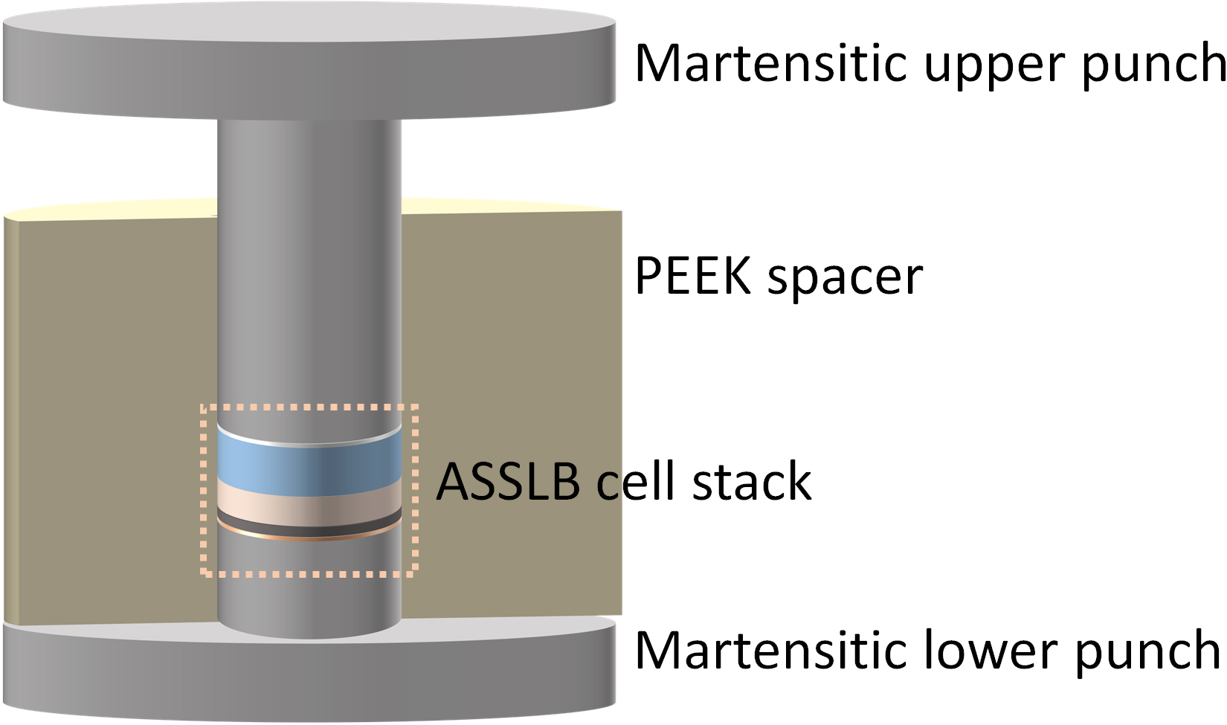
Fig. S1 Schematic illustration of the ASSLB cell configuration used for electrochemical testing
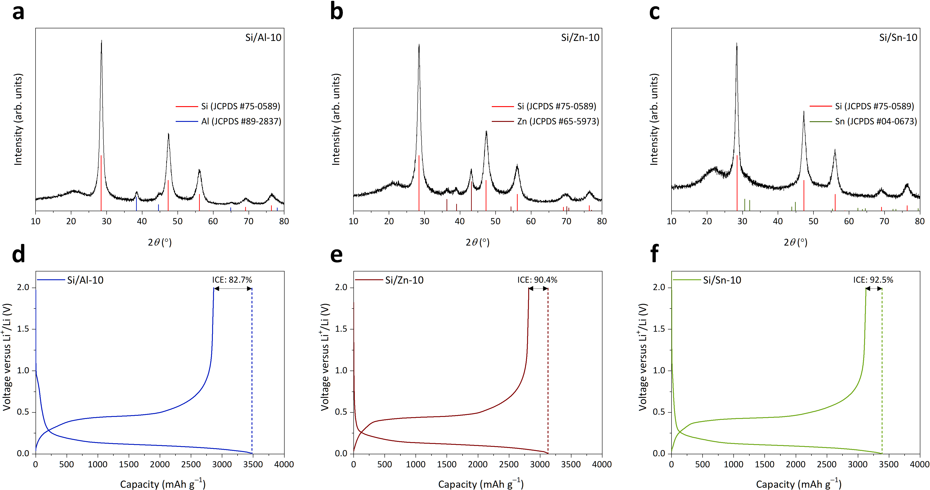
Fig. S2 Structural and electrochemical comparison of Si/M (M = Al, Zn, Sn) composites prepared under identical high-power MM conditions with 10 wt% metal incorporation. XRD patterns of a Si/Al-10, b Si/Zn-10, and c Si/Sn-10 composites. Voltage profiles of d Si/Al-10, e Si/Zn-10, and f Si/Sn-10 composites during the first cycle

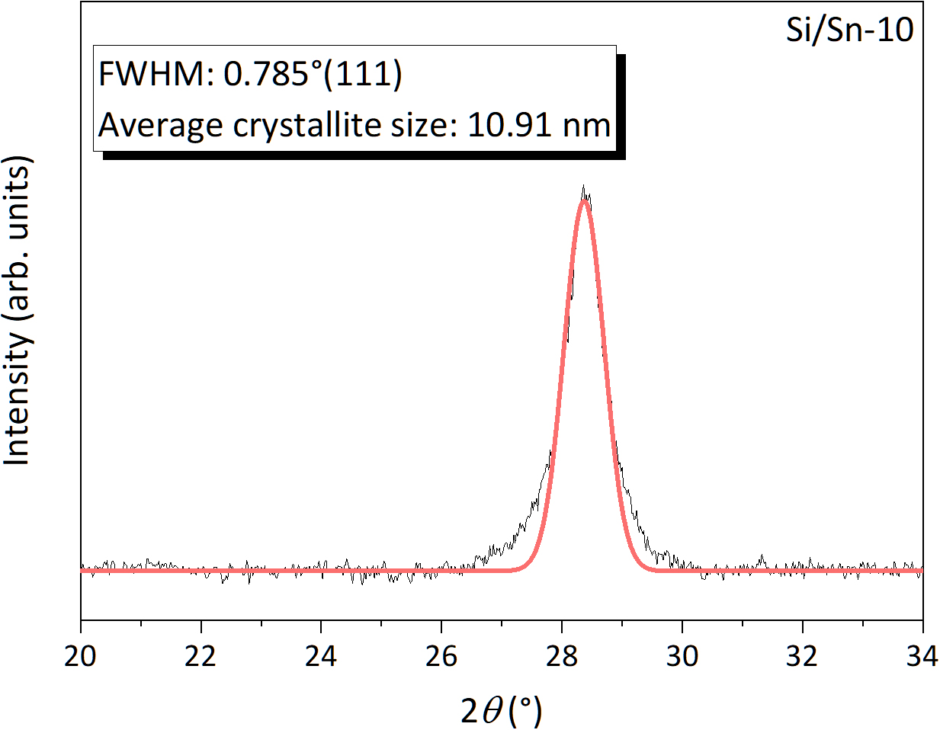
Fig. S3 Average size of Si crystallites in Si/Sn-10 composites calculated using the Scherrer equation
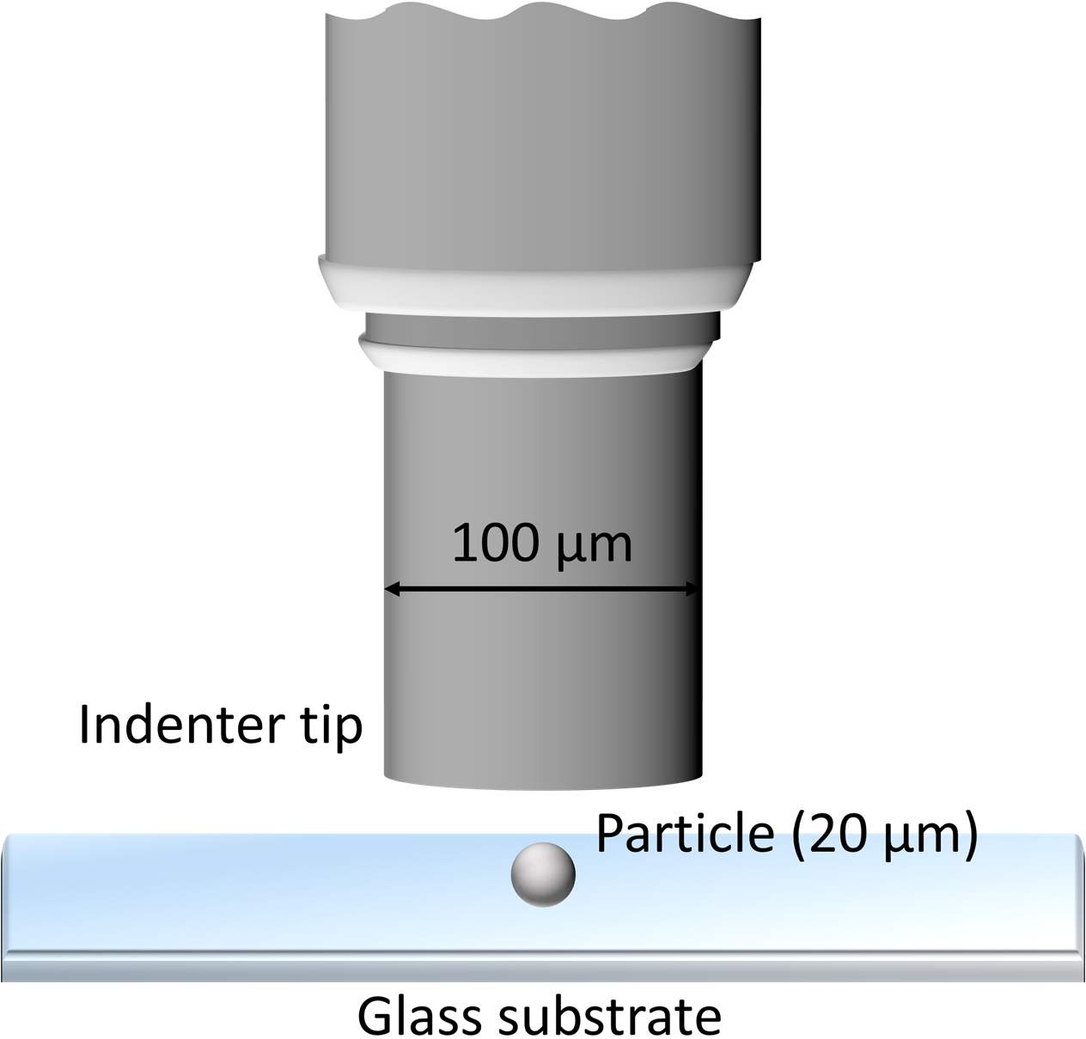
Fig. S4 Schematic illustration of the nanoindentation test setup
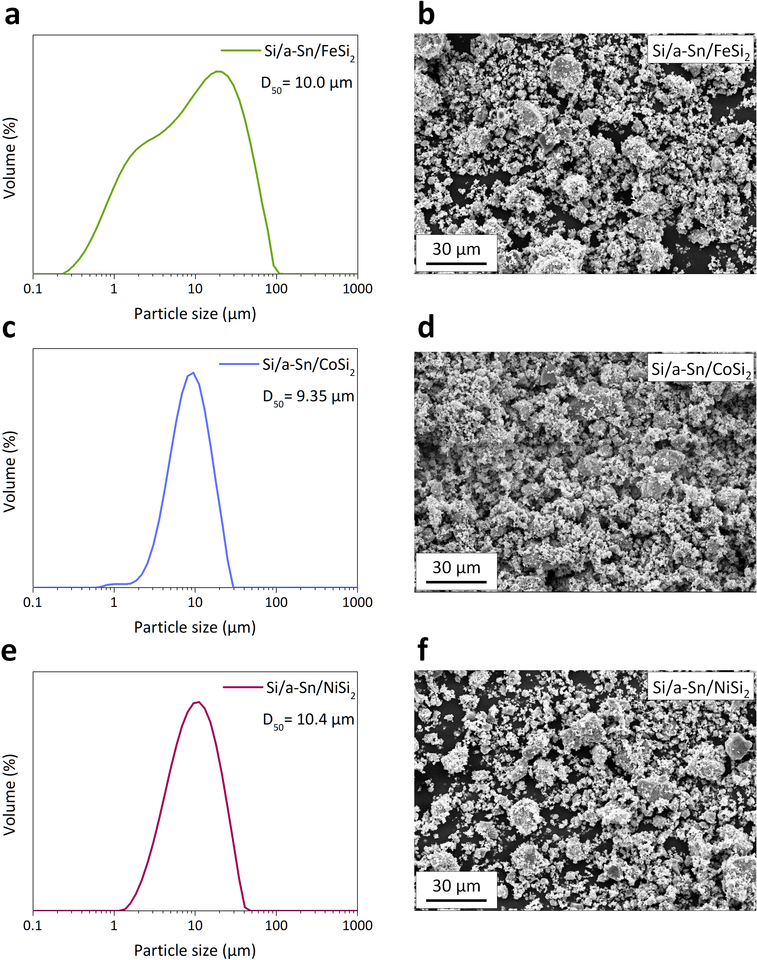
Fig. S5 Morphological characteristics of the Si/a-Sn/TMS composites. PSA results for a Si/a-Sn/FeSi₂, c Si/a-Sn/CoSi₂, and e Si/a-Sn/NiSi₂. SEM images of b Si/a-Sn/FeSi₂, d Si/a-Sn/CoSi₂, and f Si/a-Sn/NiSi₂
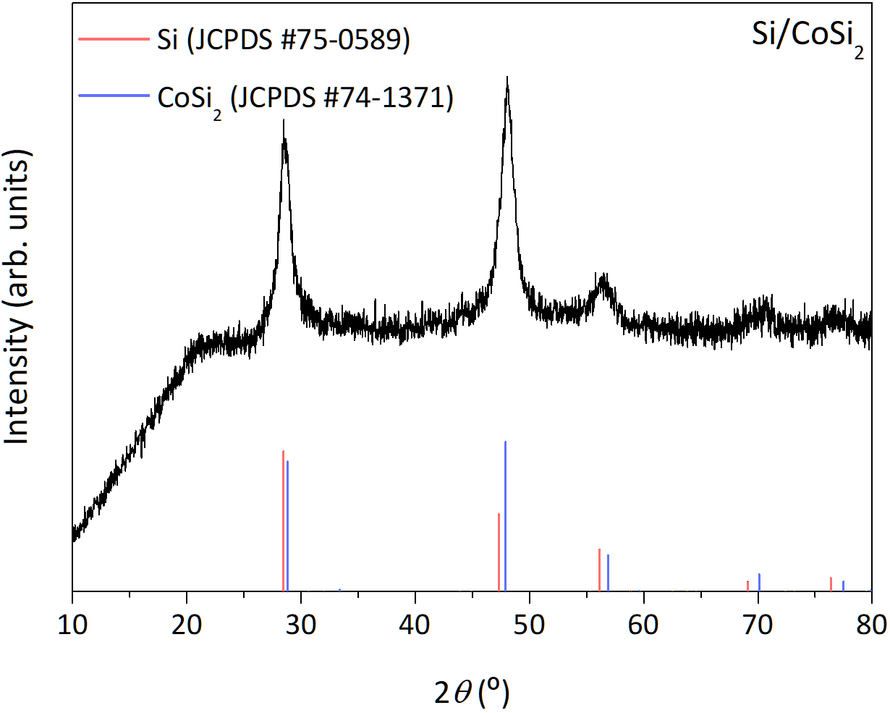
Fig. S6 XRD pattern of the Si/CoSi₂ composite synthesized via high-power MM

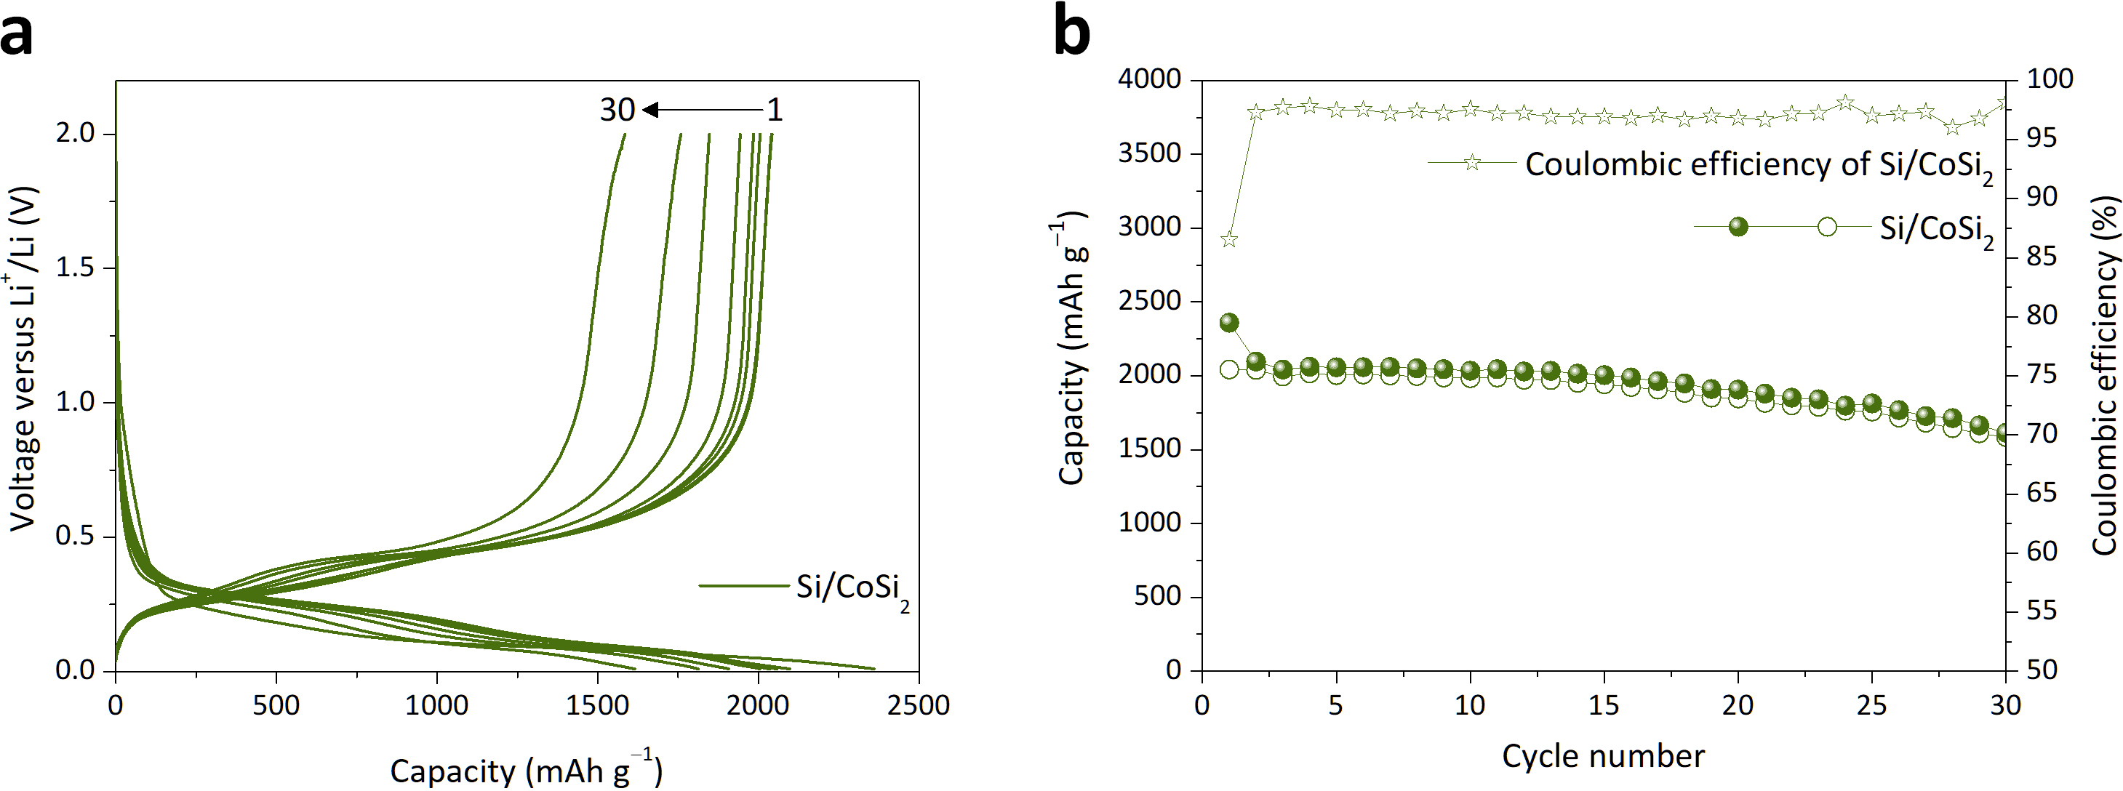
Fig. S7 Electrochemical performance results for the Si/CoSi₂ composite. a Galvanostatic voltage profiles of the Si/CoSi₂ composite anode. b Long-term cycling performance of the Si/CoSi₂ composite anode (current density: 300 mA g^{–1})
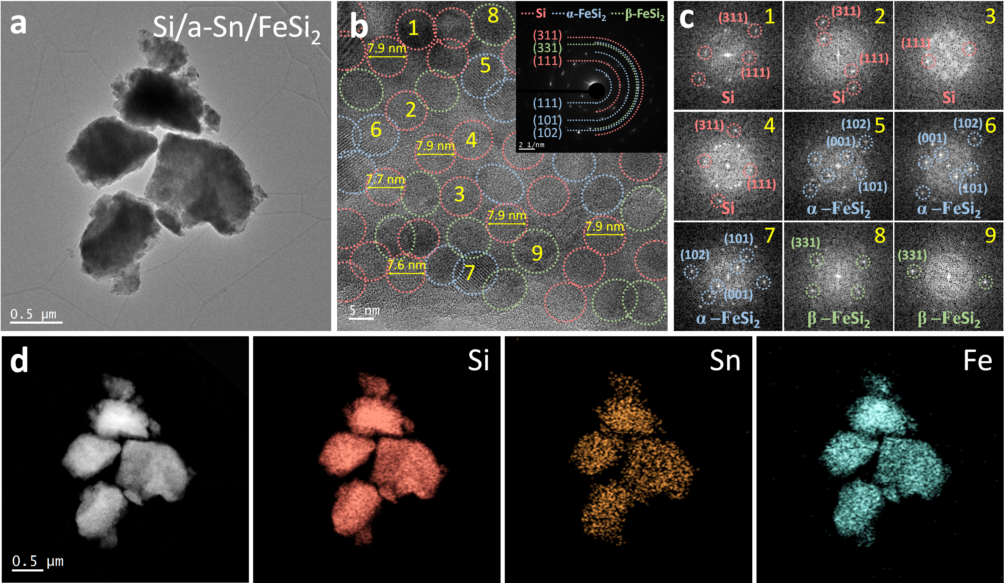
Fig. S8 Microstructural characteristics of the Si/a-Sn/FeSi₂ composite: a BFTEM image, b HRTEM image with SAED pattern, c FFT patterns for selected regions, and d STEM image with EDX elemental mappings
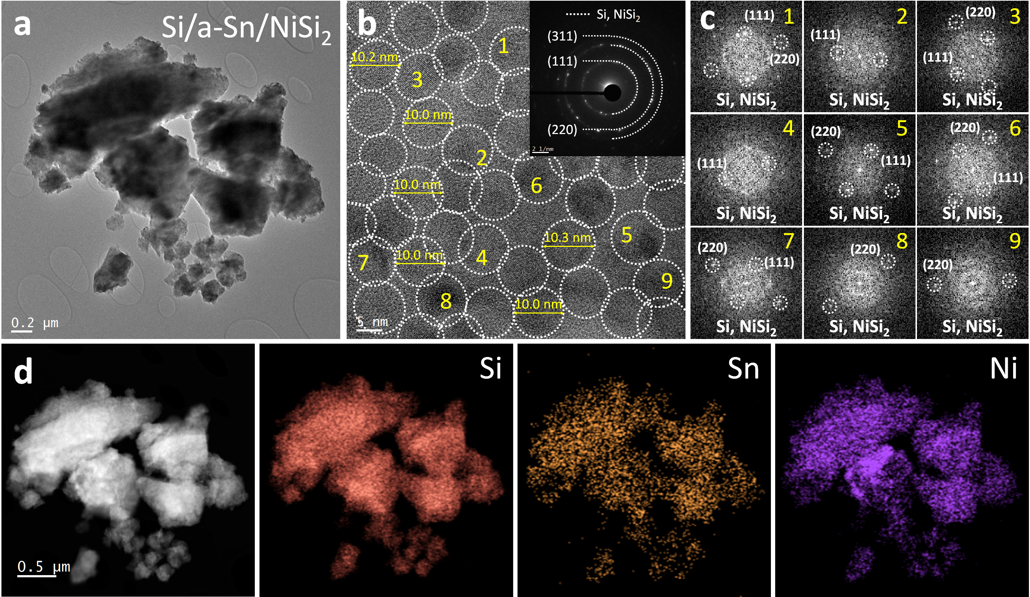
Fig. S9 Microstructural characteristics of the Si/a-Sn/NiSi₂ composite: a BFTEM image, b HRTEM image with SAED pattern, c FFT patterns for selected regions, and d STEM image with EDX elemental mappings
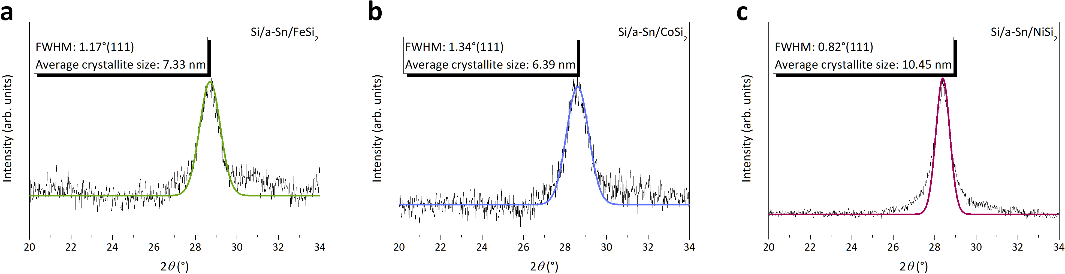
Fig. S10 Average sizes of Si crystallites in Si/a-Sn/TMS composites calculated using the Scherrer equation: a Si/a-Sn/FeSi₂, b Si/a-Sn/CoSi₂, and c Si/a-Sn/NiSi₂
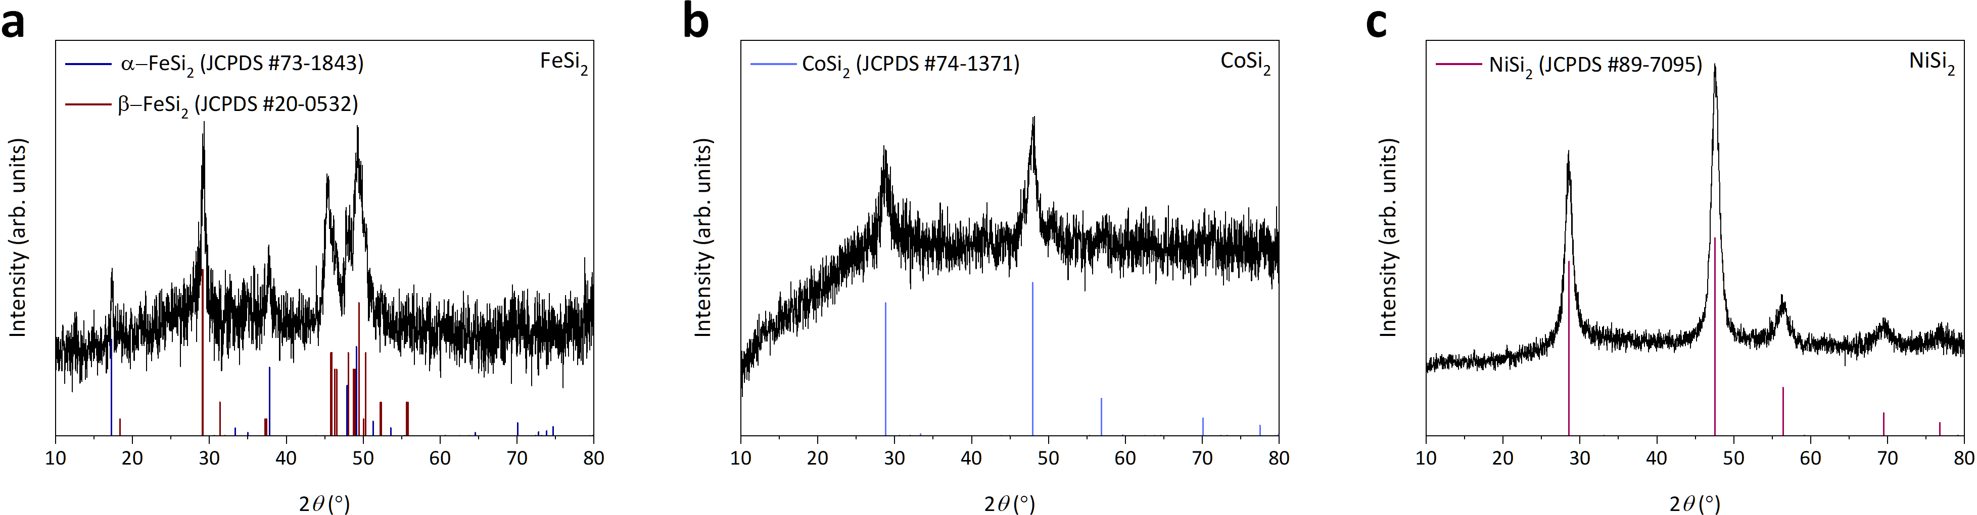
Fig. S11 Structural characteristics of the high-power MM-derived TMS phases. XRD patterns of high-power MM-derived a FeSi₂, b CoSi₂, and c NiSi₂
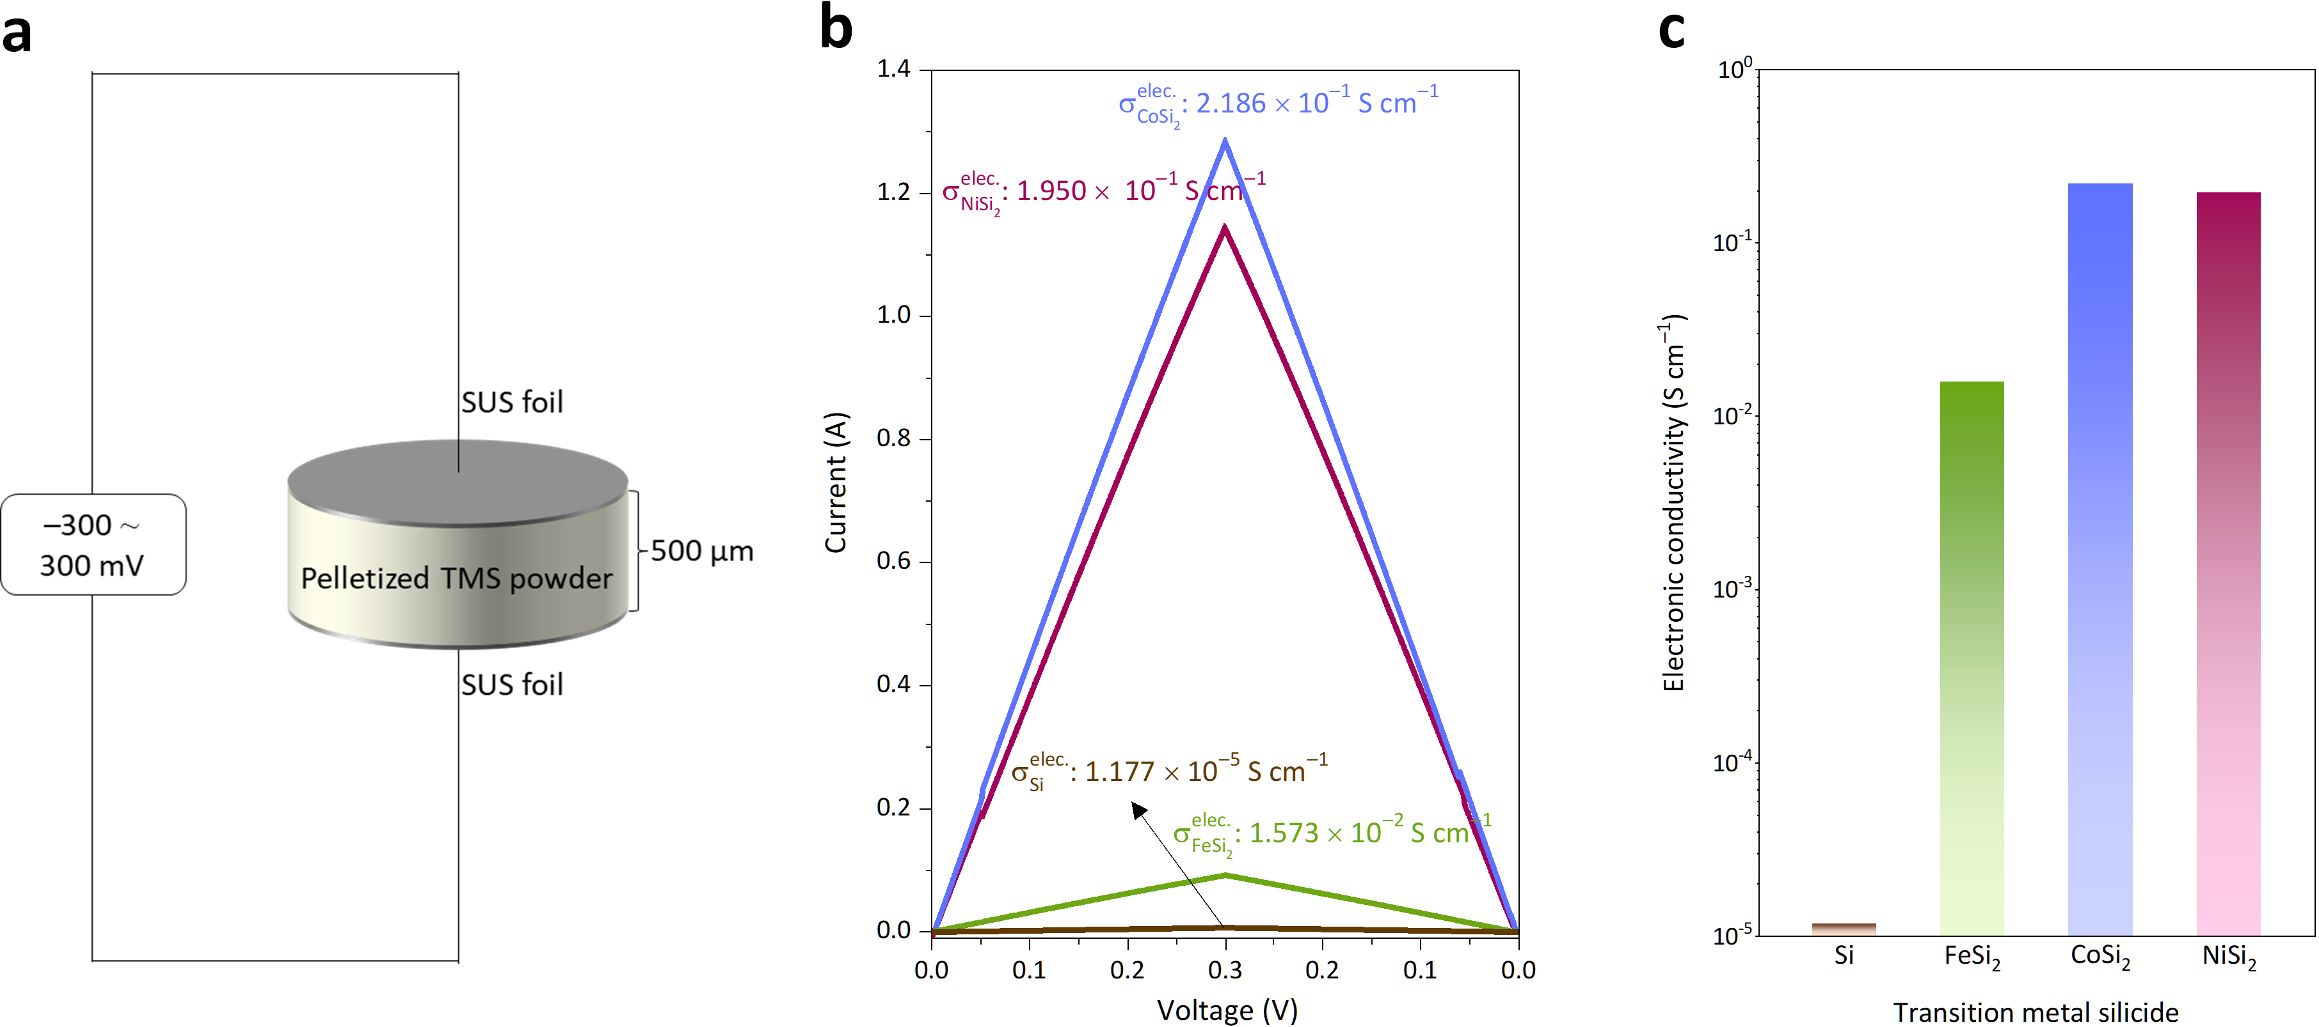
Fig. S12 Electronic conductivity measurements of high-power MM-derived TMS phases (FeSi₂, CoSi₂, and NiSi₂). a Schematic illustration of the SUS|TMS pellet|SUS symmetric cell configuration used to measure electronic conductivity. b I–V profiles of the TMS phases measured in the symmetric cell. c Electronic conductivities calculated from the slopes of the I–V curves
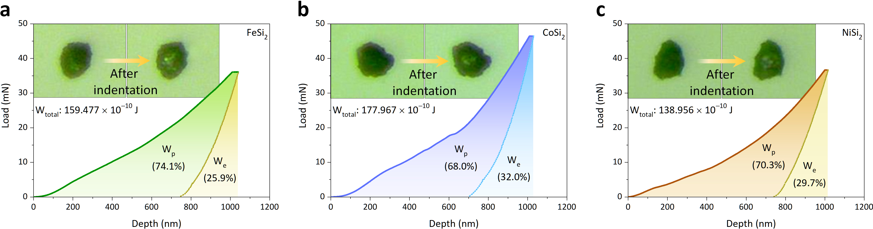
Fig. S13 Load–displacement profiles obtained from nanoindentation tests on the high-power MM-derived TMS particles: a FeSi₂, b CoSi₂, and c NiSi₂

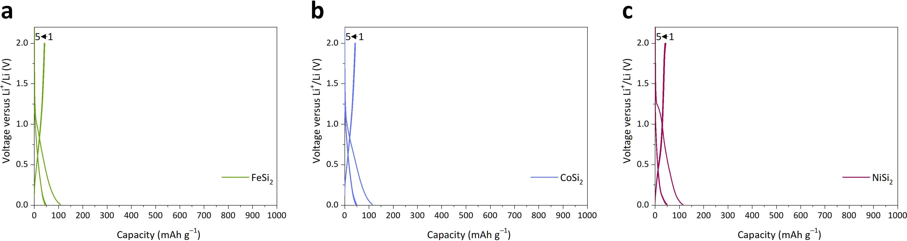
Fig. S14 Voltage profiles of TMS anodes measured at a current density of 100 mA g^{–1}. a FeSi₂, b CoSi₂, and c NiSi₂

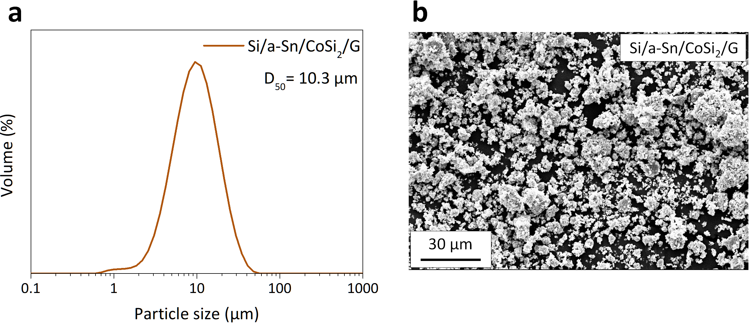
Fig. S15 Morphological characteristics of the Si/a-Sn/CoSi₂/G composite: a PSA result and b SEM image
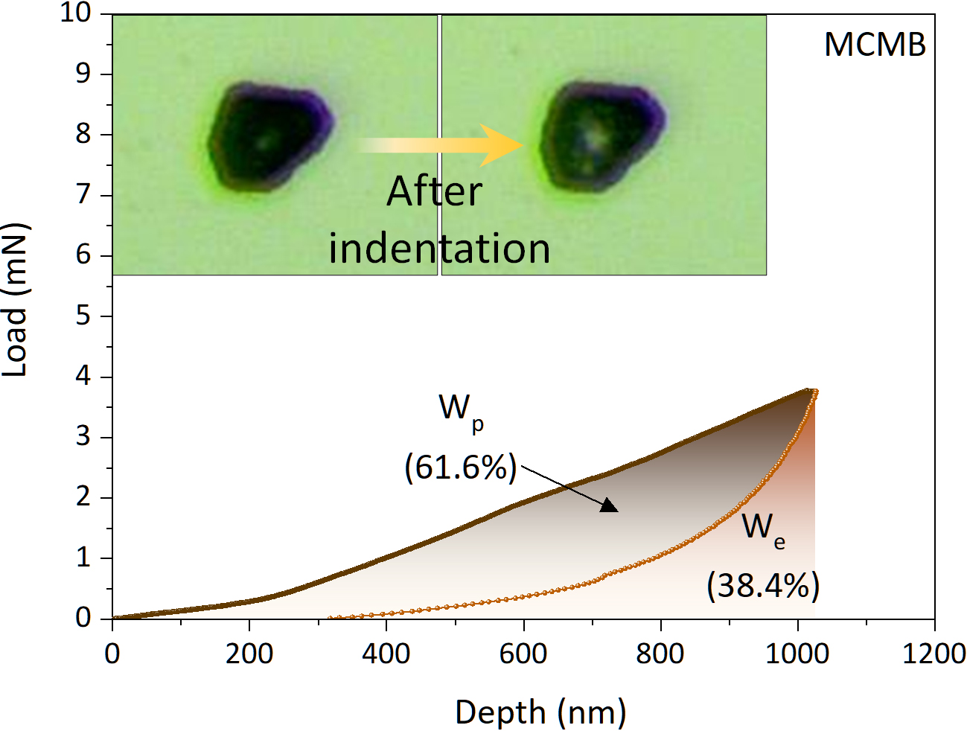
Fig. S16 Load–displacement profile obtained from a nanoindentation test on an MCMB graphite particle
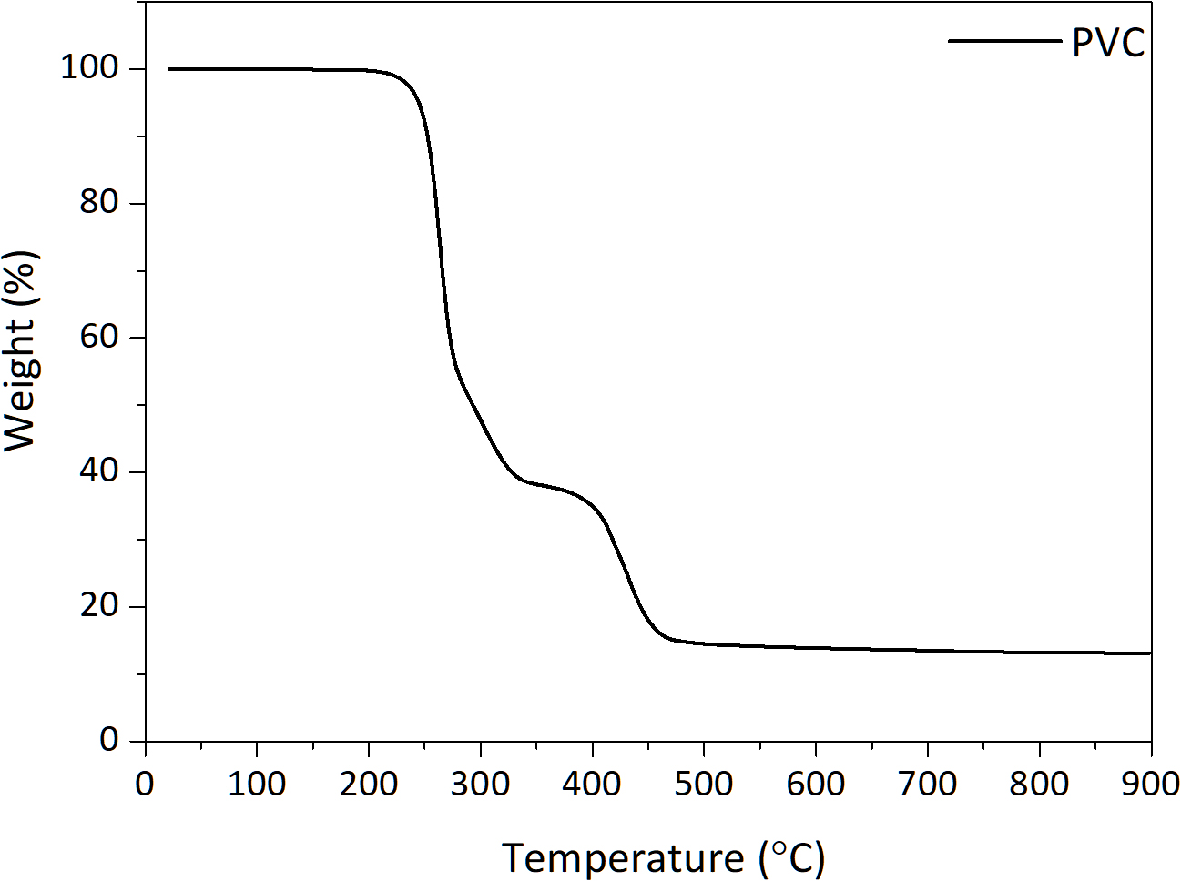
Fig. S17 TGA curve of PVC under an N₂ atmosphere
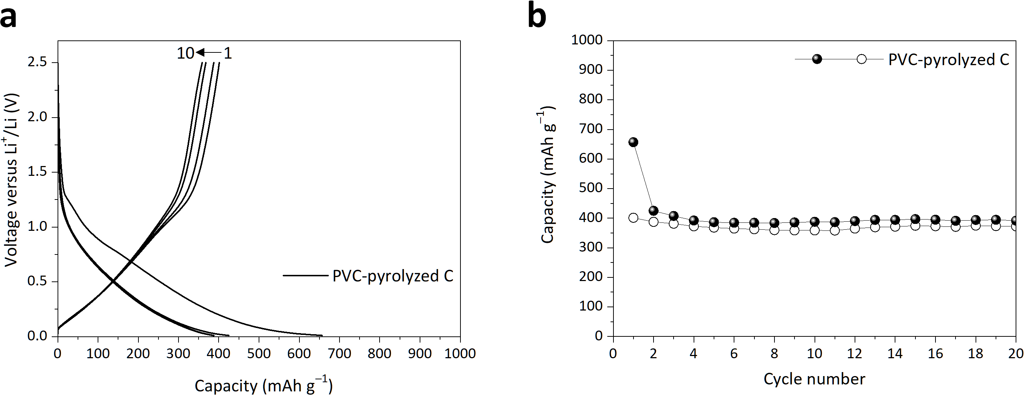
Fig. S18 Electrochemical performance results for the PVC-pyrolyzed carbon anode: a voltage profiles and b cycling performance of the PVC-pyrolyzed carbon anode tested at 100 mA g^{–1}
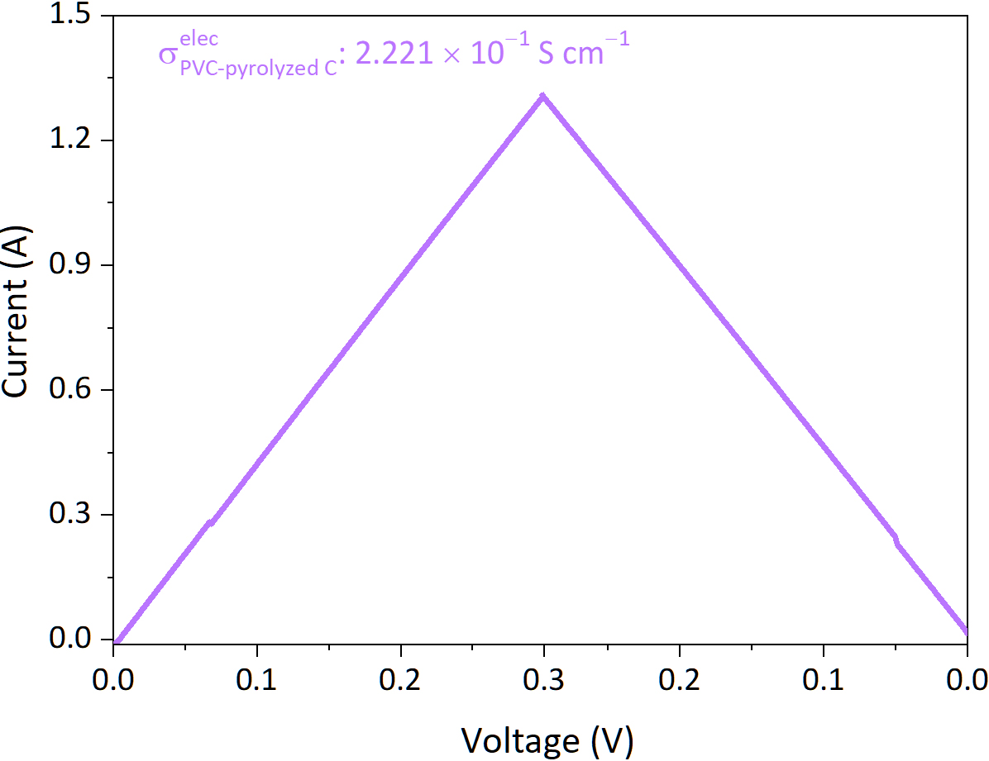
Fig. S19 I–V profile of the PVC-pyrolyzed C and the corresponding calculated electronic conductivity
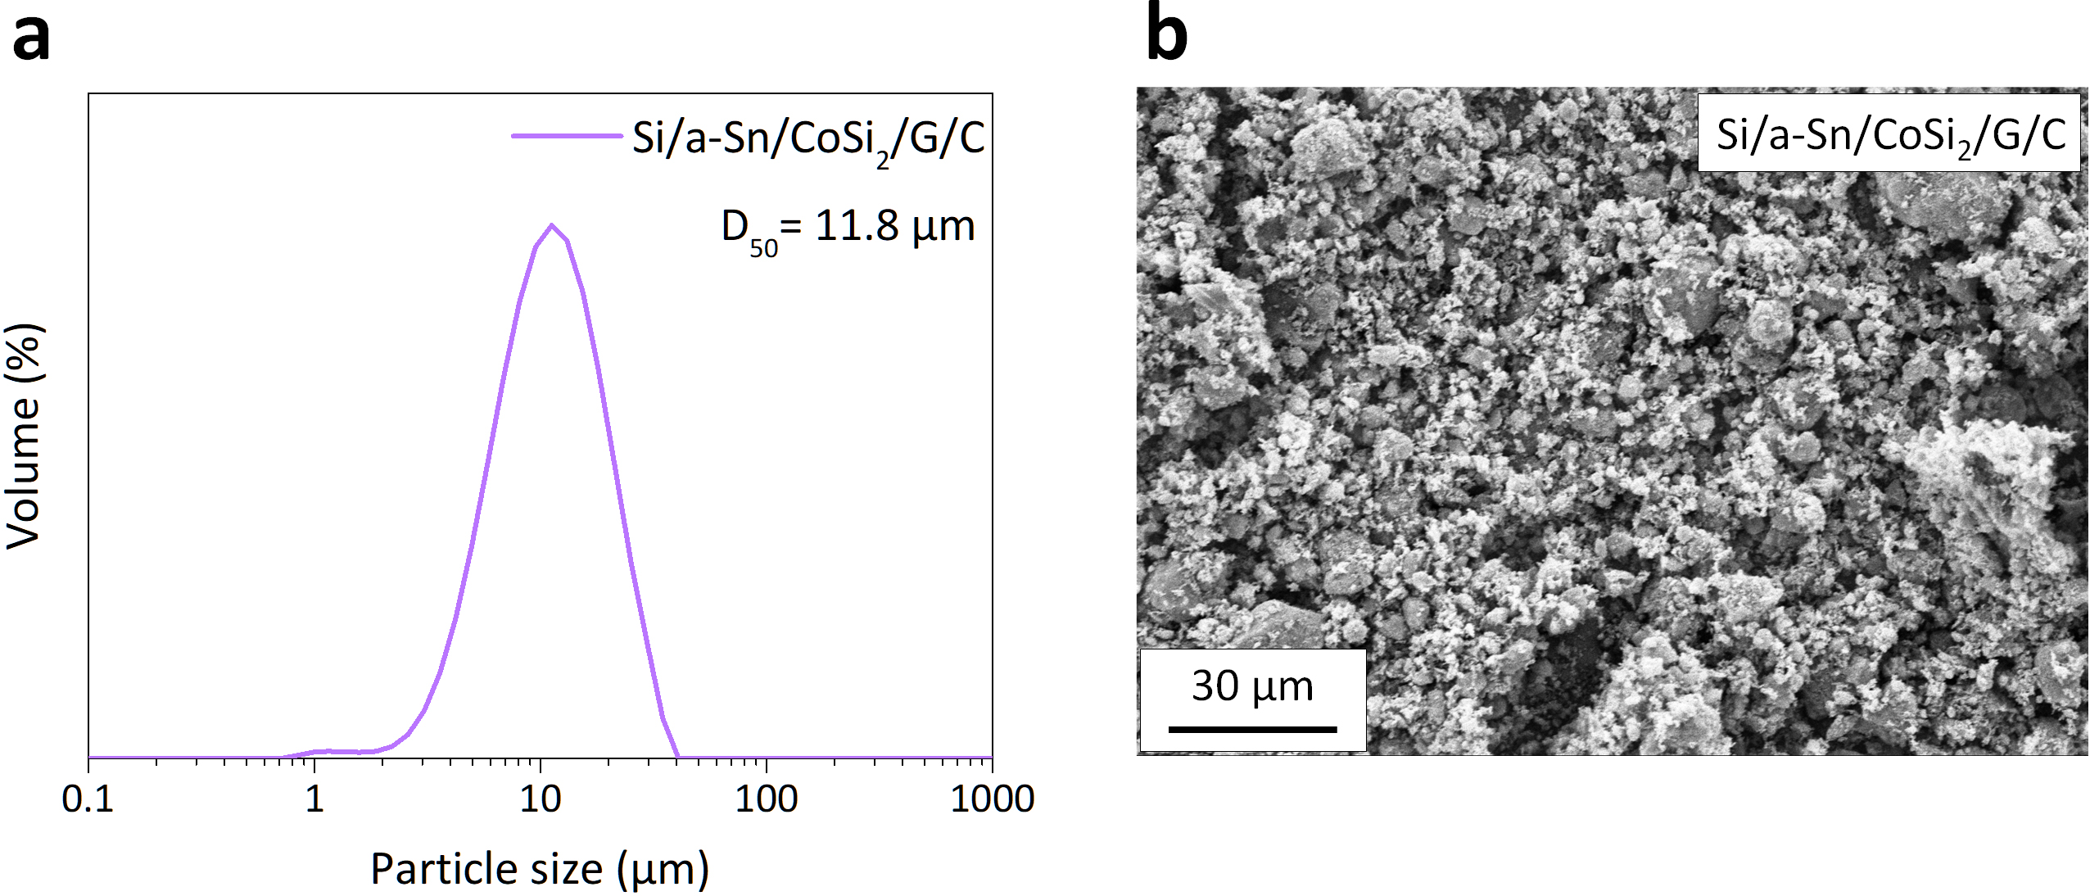
Fig. S20 Morphological characteristics of the Si/a-Sn/CoSi₂/G/C nanocomposite: a PSA result and b SEM image
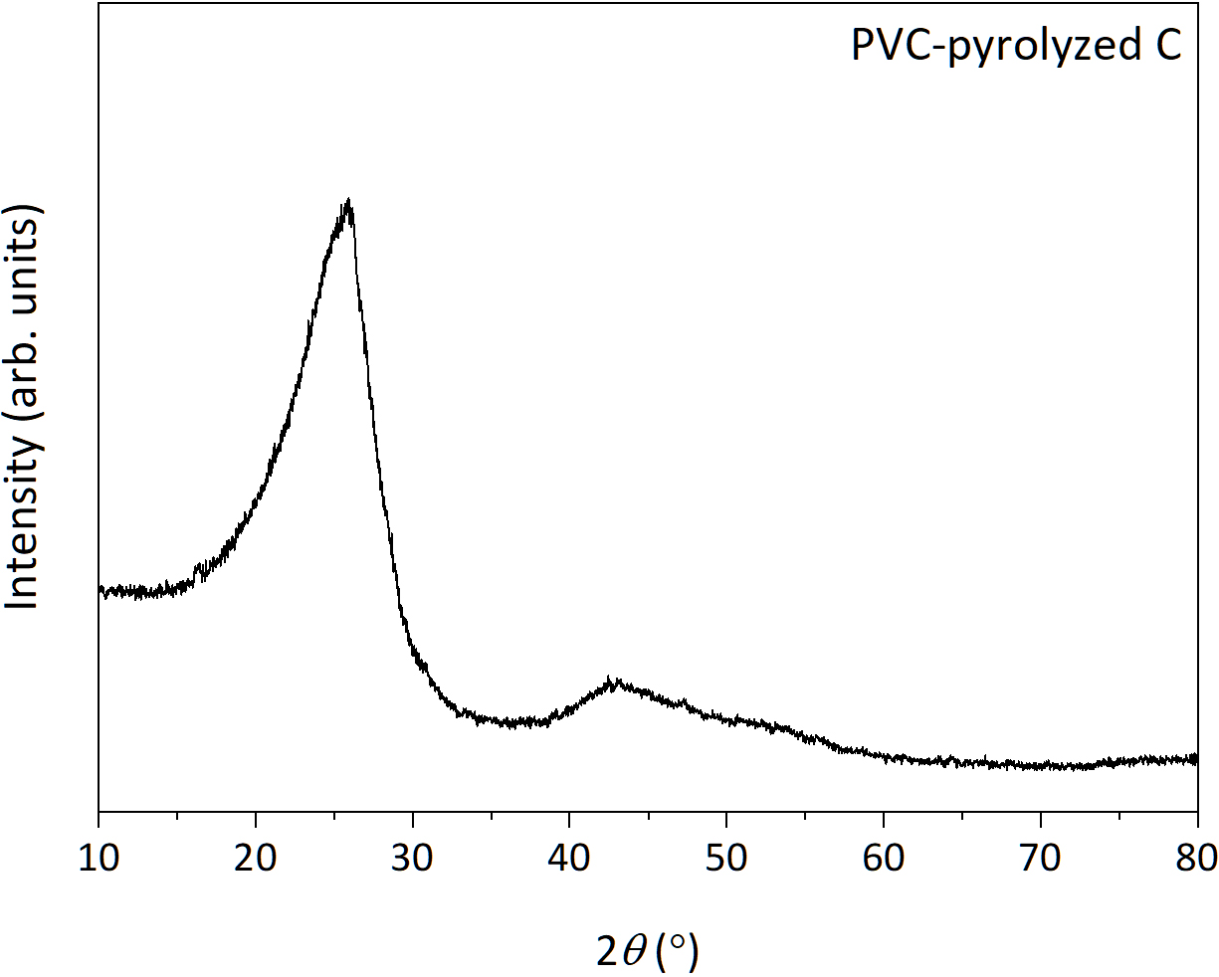
Fig. S21 XRD pattern of the PVC-pyrolyzed carbon obtained by thermal pyrolysis at 700 °C under an Ar atmosphere
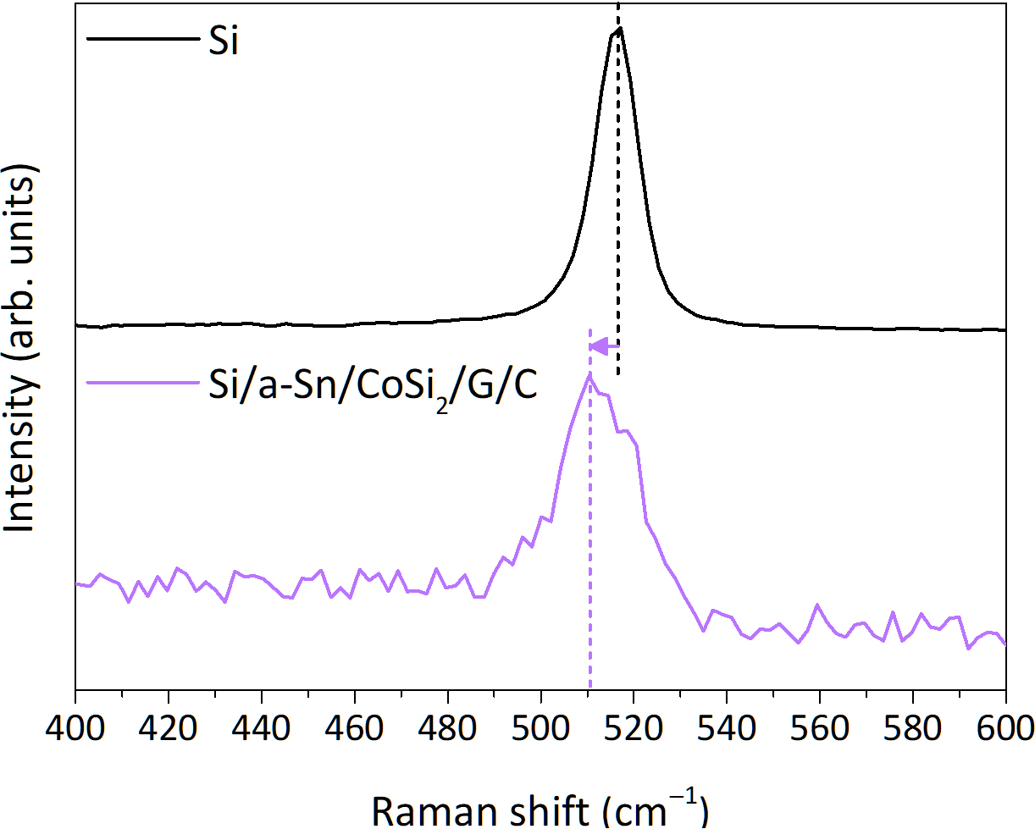
Fig. S22 Raman spectra of the pristine Si and Si/a-Sn/CoSi₂/G/C nanocomposite in the range of 400–600 cm^{–1}

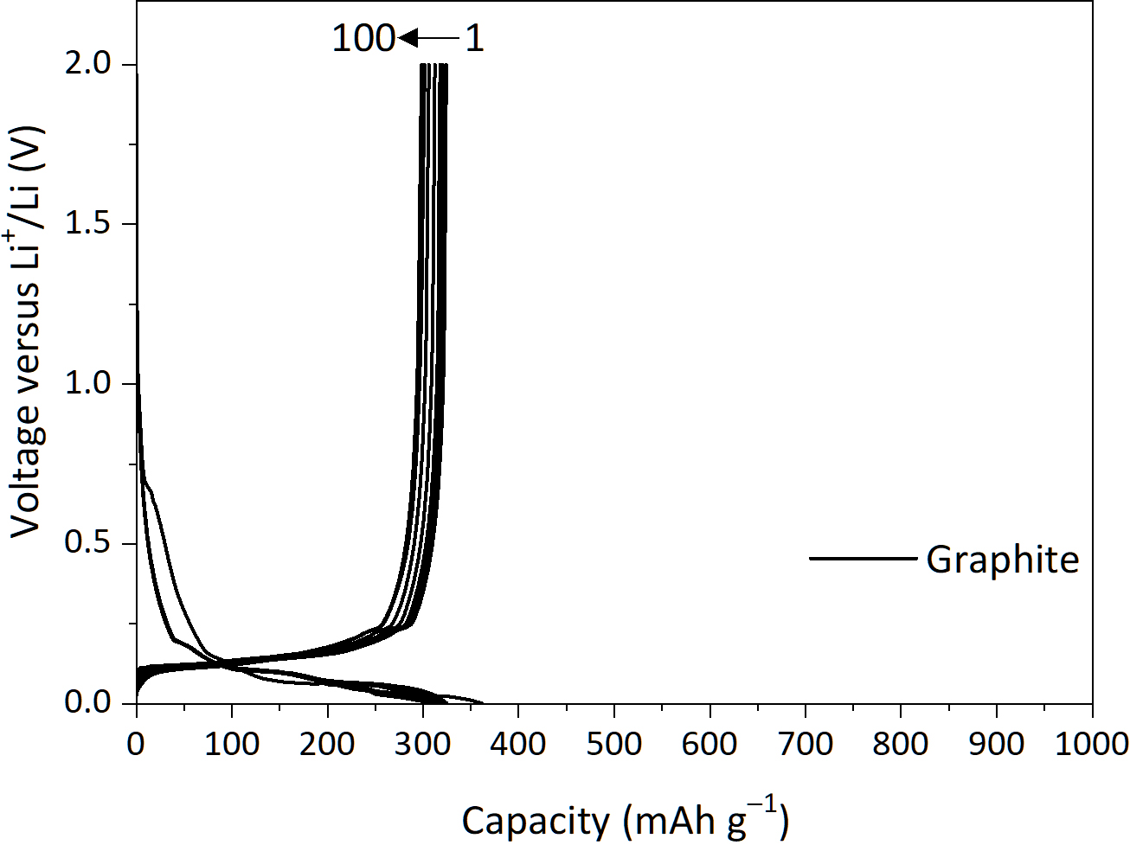
Fig. S23 Voltage profiles of the commercial graphite anode tested at 100 mA g^{–1}
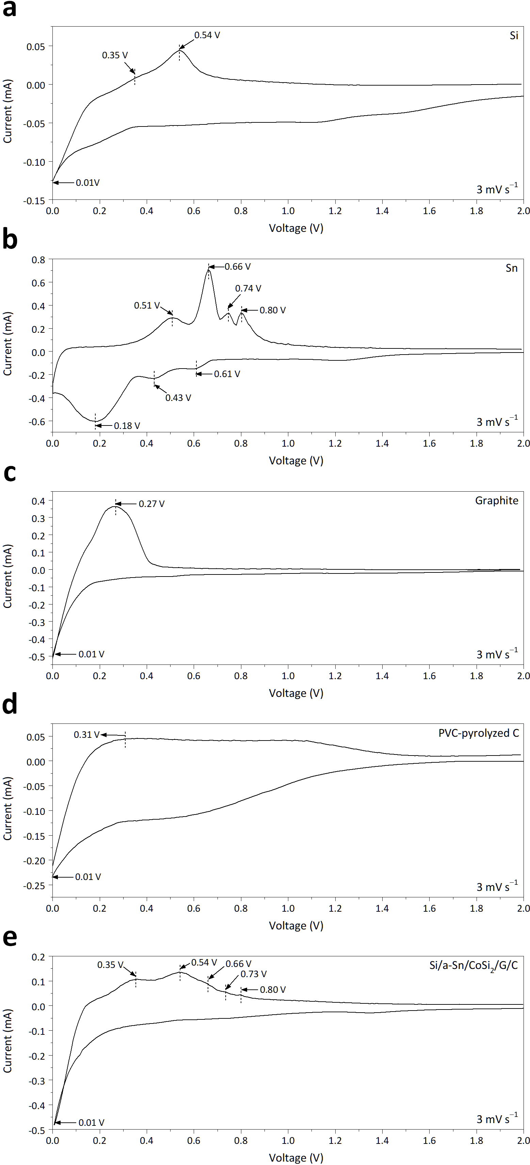
Fig. S24 CV profiles of Si, Sn, graphite, PVC-pyrolyzed amorphous carbon, and the Si/a-Sn/CoSi₂/G/C nanocomposite anode measured at a scan rate of 3 mV s^{–1} over a voltage range of 0.01–2.0 V (vs. Li⁺/Li)
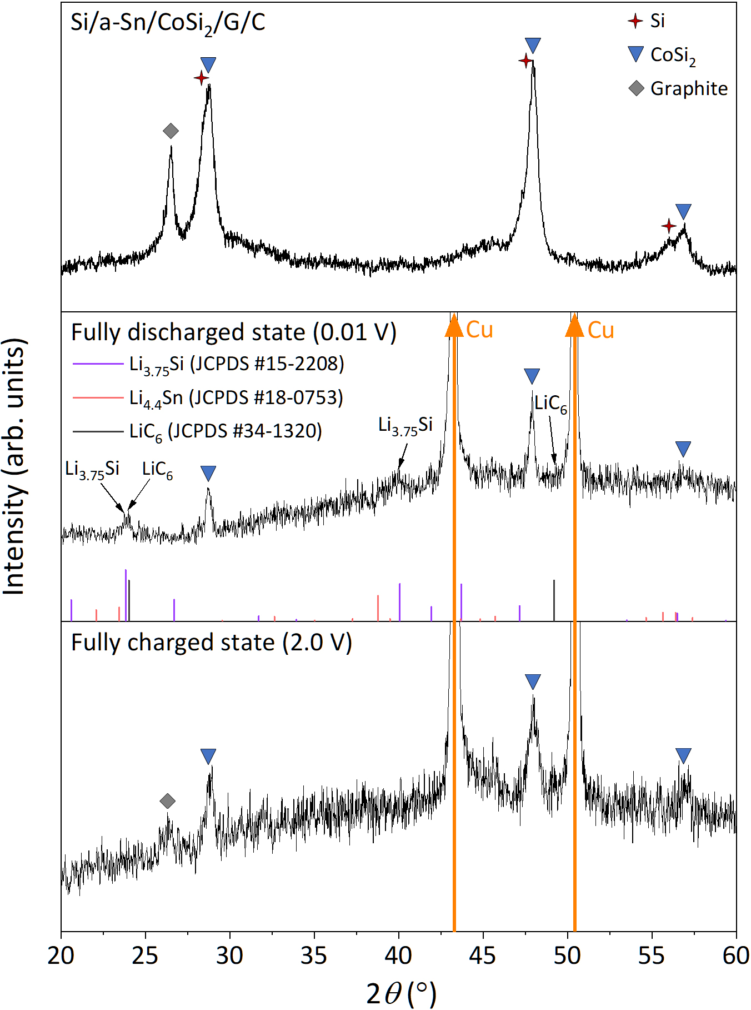
Fig. S25 Ex situ XRD patterns of the Si/a-Sn/CoSi₂/G/C anode at the pristine state, fully lithiated state (0.01 V), and delithiated state (2.0 V)

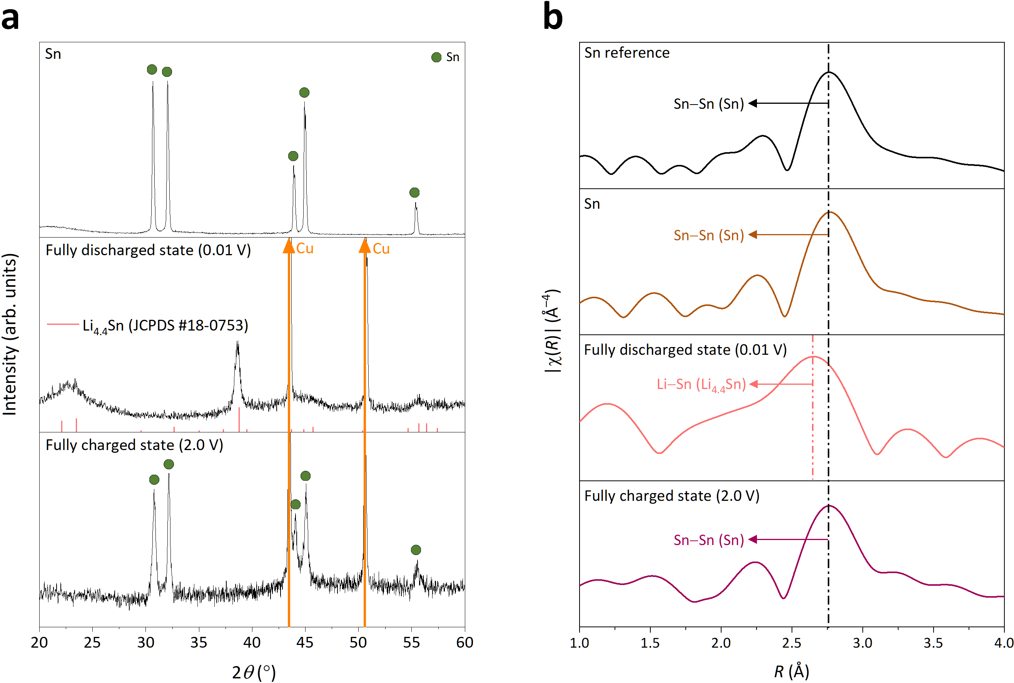
Fig. S26 Phase evolution of the Sn reference anode at the pristine state, fully lithiated state (0.01 V), and delithiated state (2.0 V). a Ex situ XRD patterns and b ex situ Sn K-edge EXAFS spectra
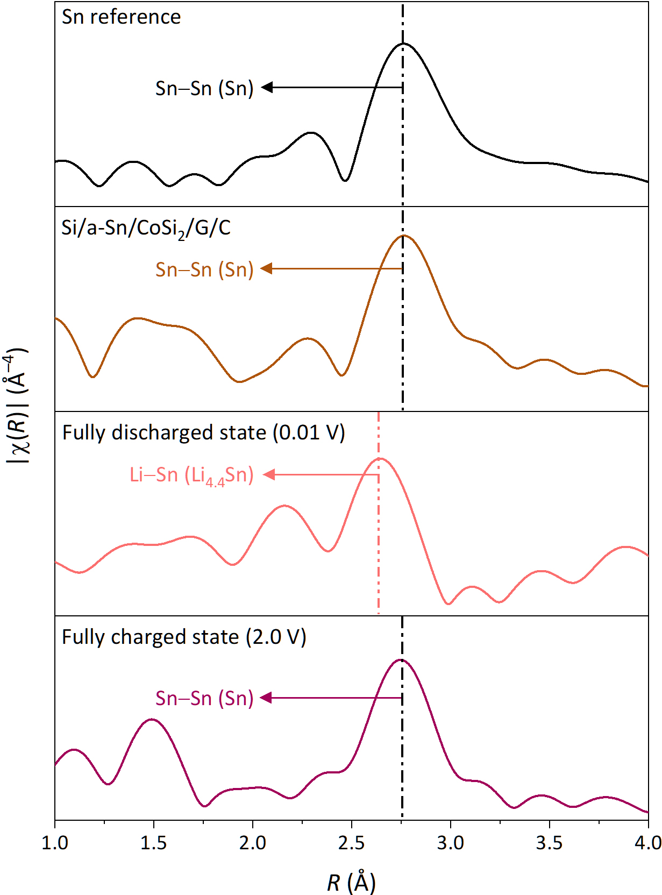
Fig. S27 Ex situ Sn K-edge EXAFS spectra of the Si/a-Sn/CoSi₂/G/C anode at the pristine state, fully lithiated state (0.01 V), and delithiated state (2.0 V)

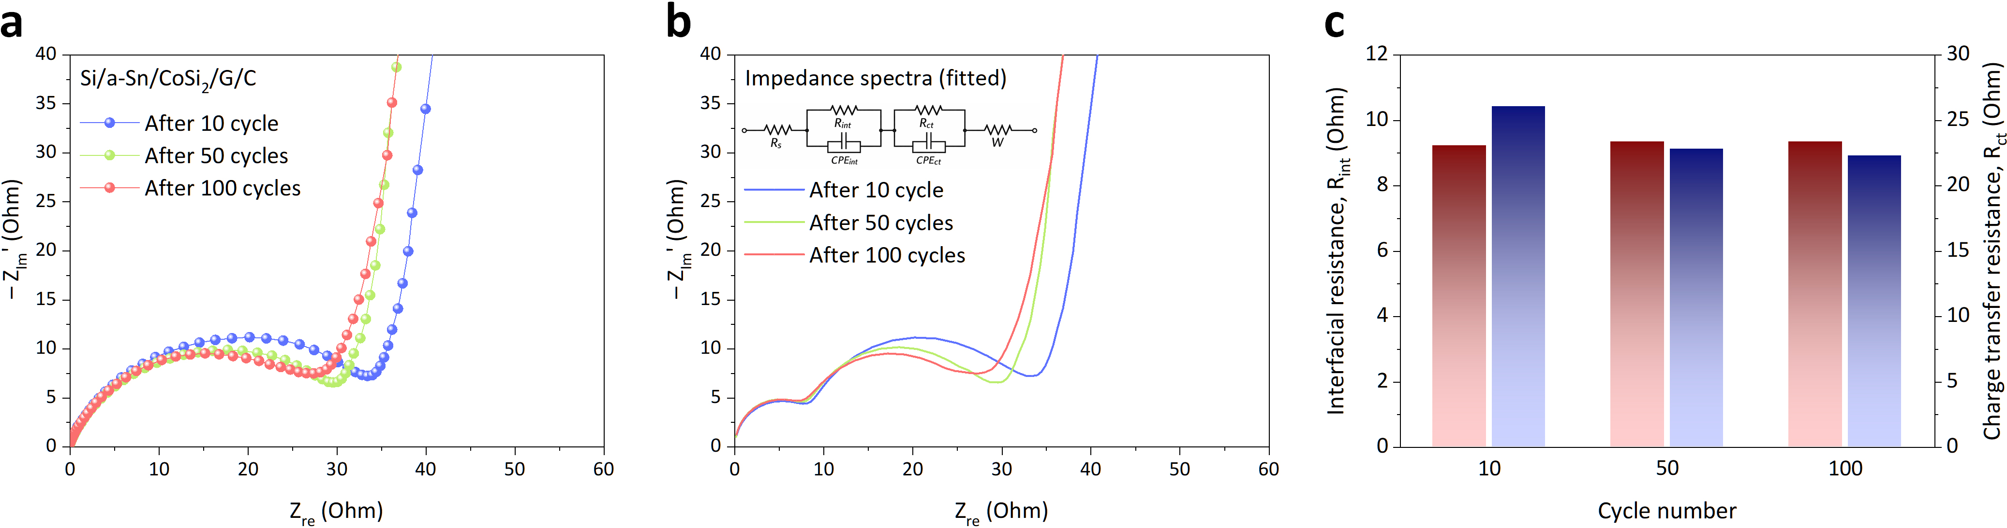
Fig. S28 Ex situ EIS analysis of the Si/a-Sn/CoSi₂/G/C anode after 10, 50, and 100 cycles. a Experimental Nyquist plots. b Equivalent circuit fitting of the impedance spectra using an R_{s}–(R_{int}||CPE_{int})–(R_{ct}||CPE_{ct})–W model. c Evolution of R_{int} and R_{ct} extracted from the fitting
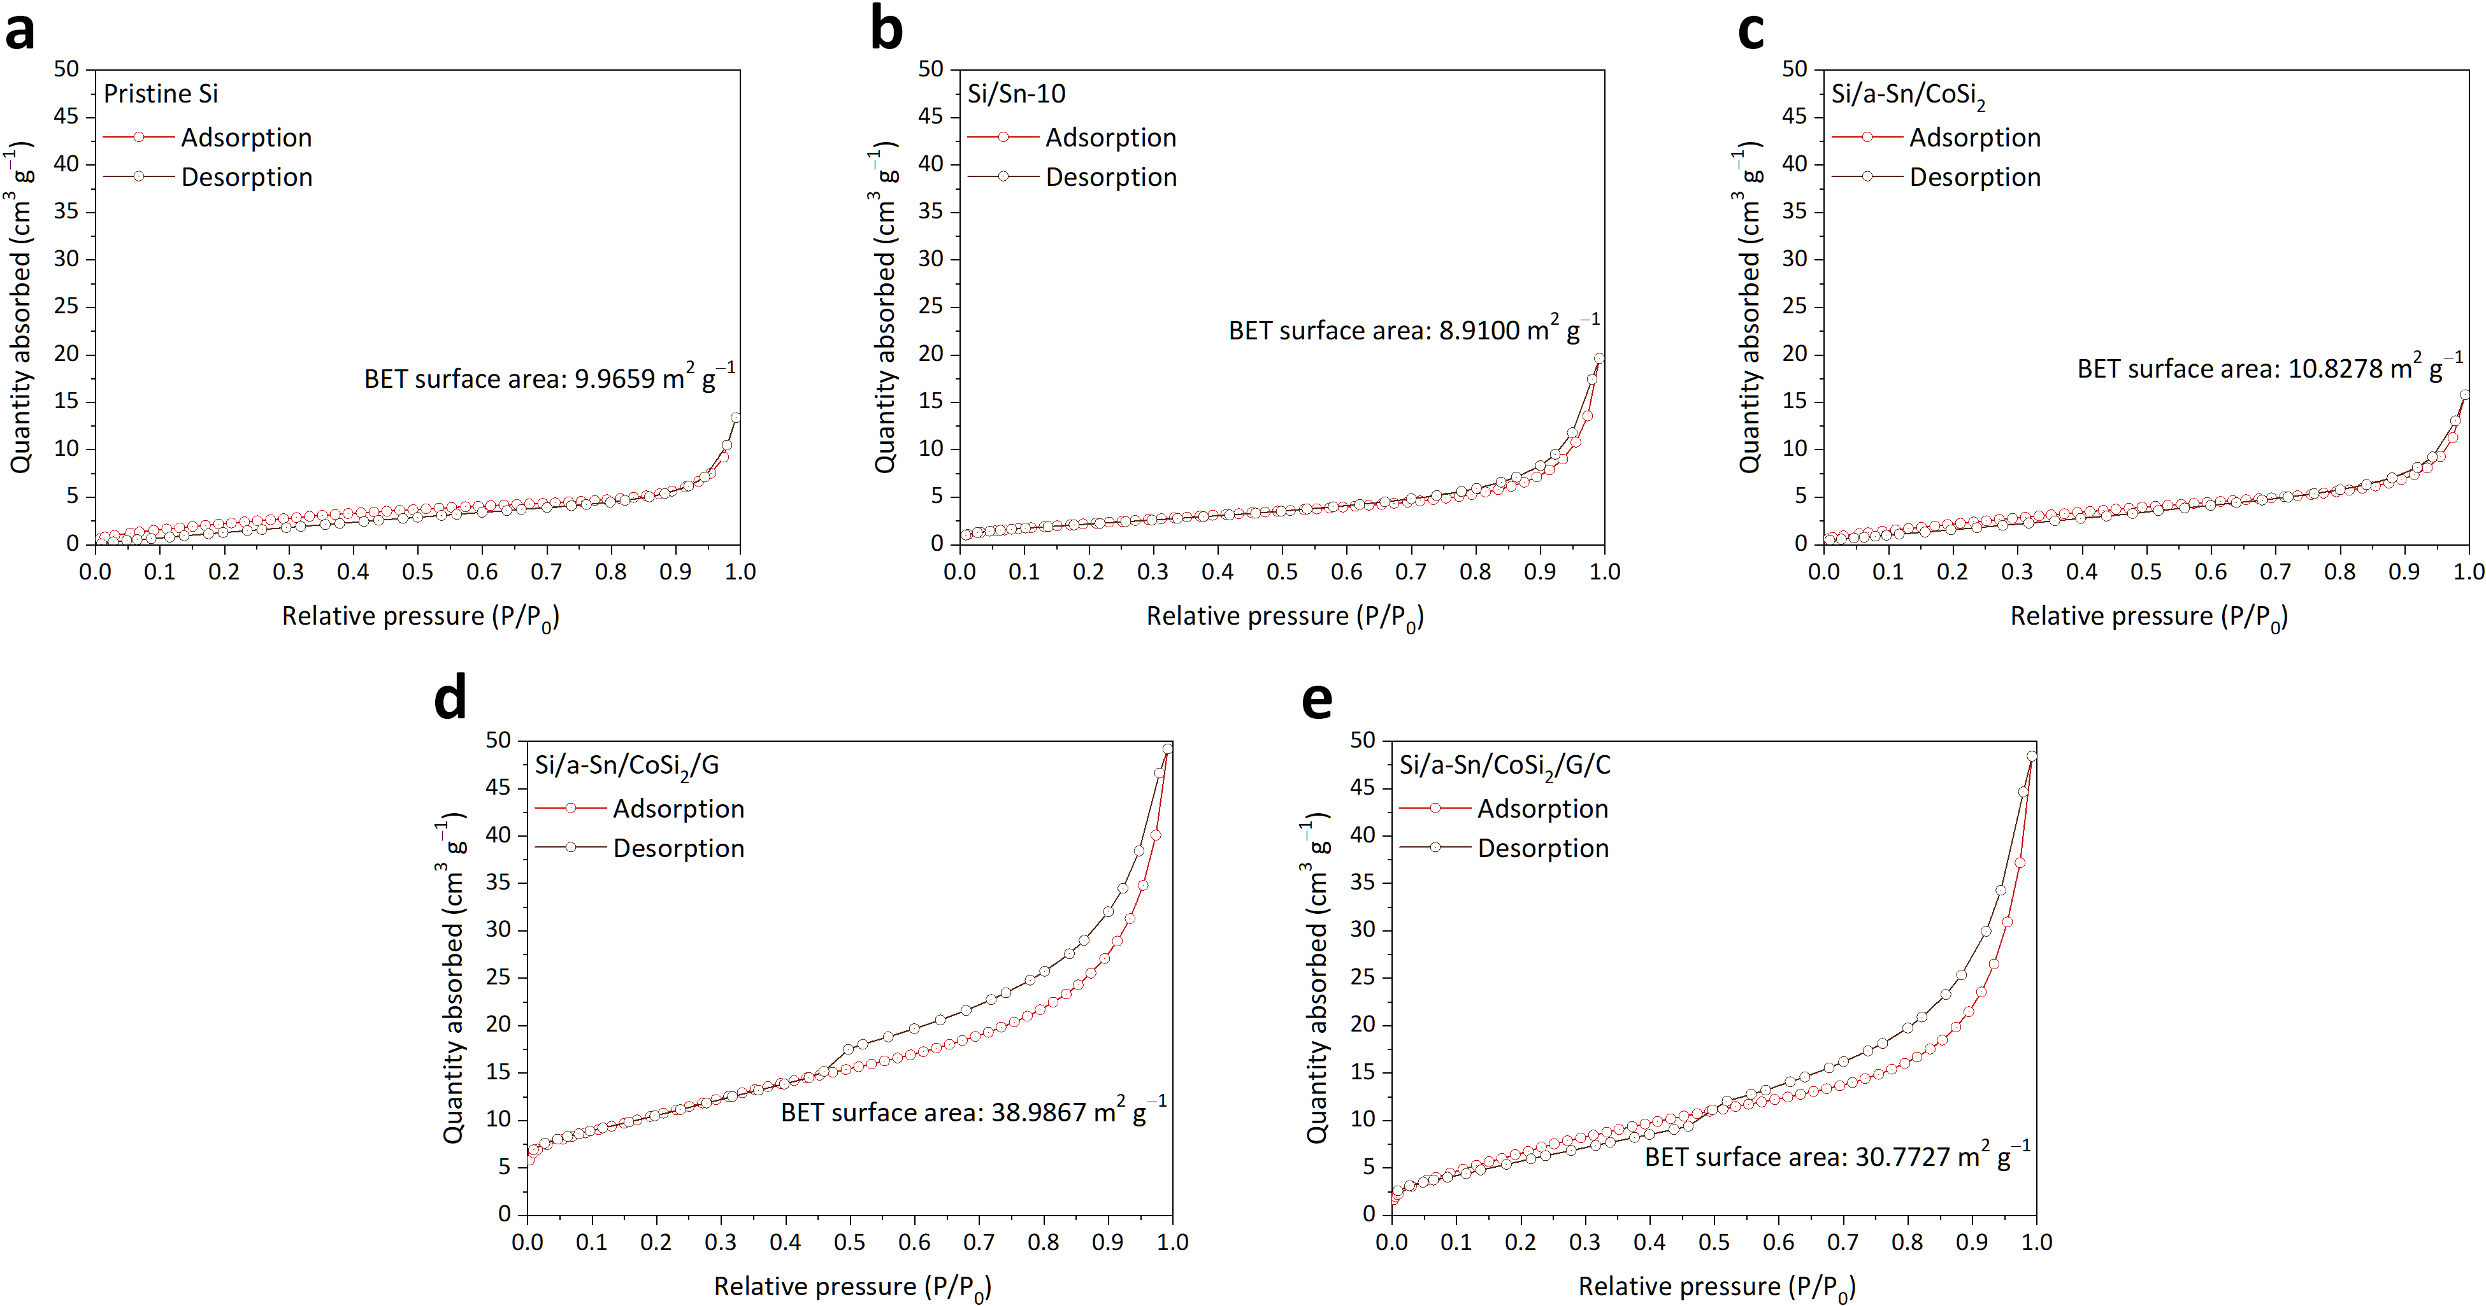
Fig. S29 N₂ adsorption–desorption isotherms of a pristine Si, b Si/Sn-10, c Si/a-Sn/CoSi₂, d Si/a-Sn/CoSi₂/G, and e Si/a-Sn/CoSi₂/G/C composites
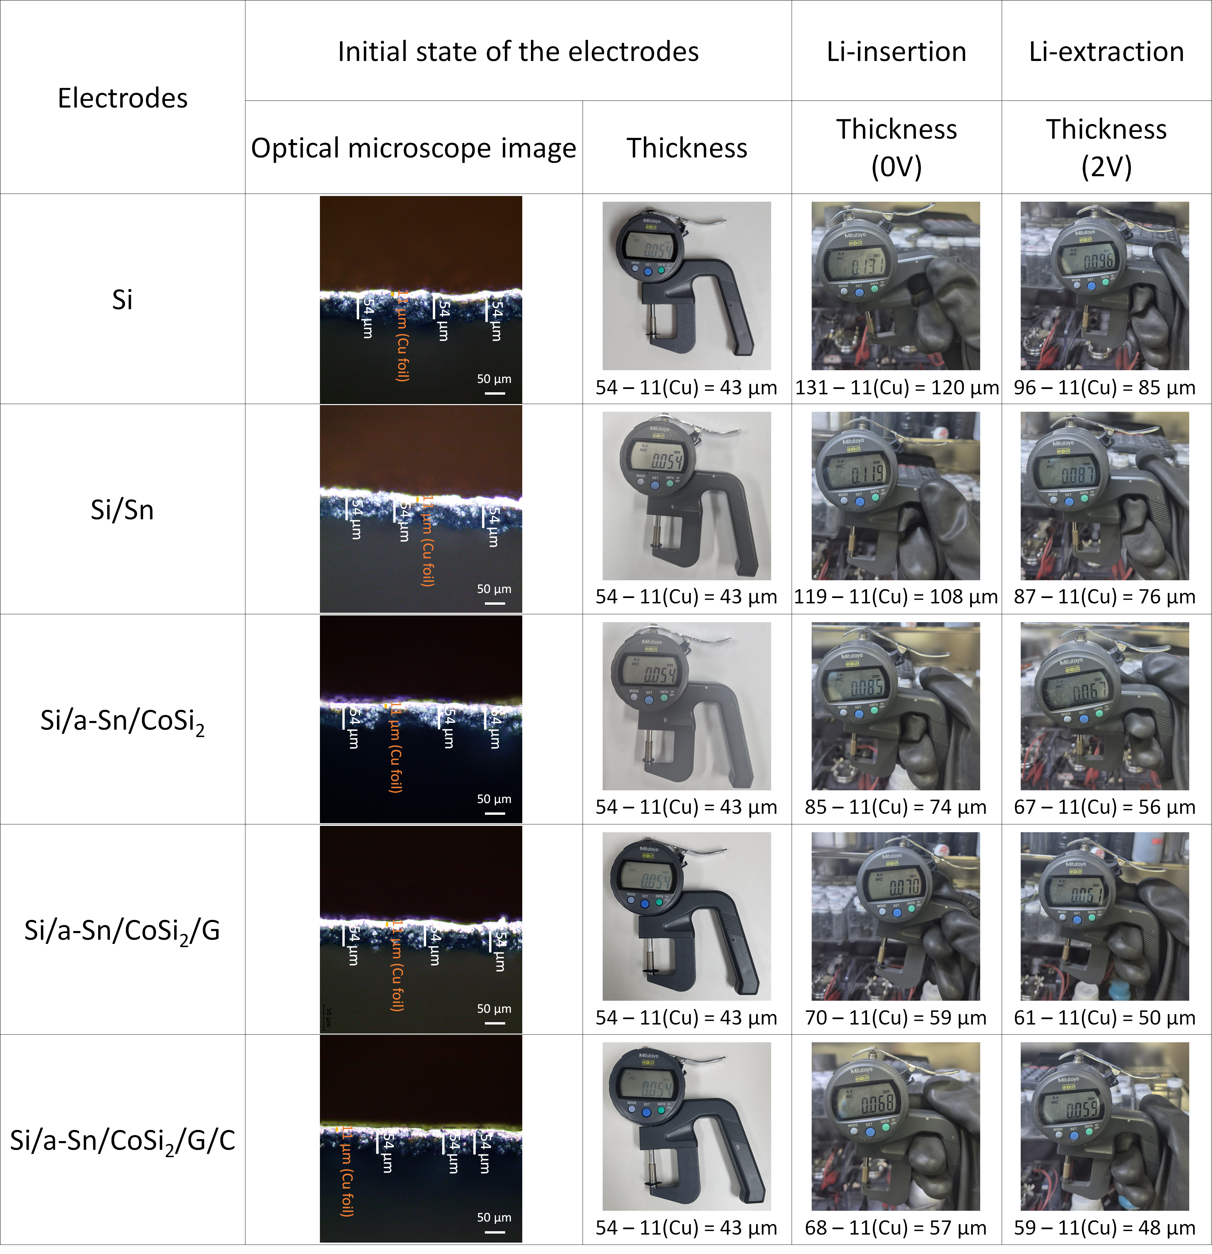
Fig. S30 OM images and photographs showing changes in the thicknesses of pristine Si, Si/Sn, Si/a-Sn/CoSi₂, Si/a-Sn/CoSi₂/G, and Si/a-Sn/CoSi₂/G/C anodes in the fully discharged (0 V vs. Li⁺/Li) and fully charged (2 V vs. Li⁺/Li) states
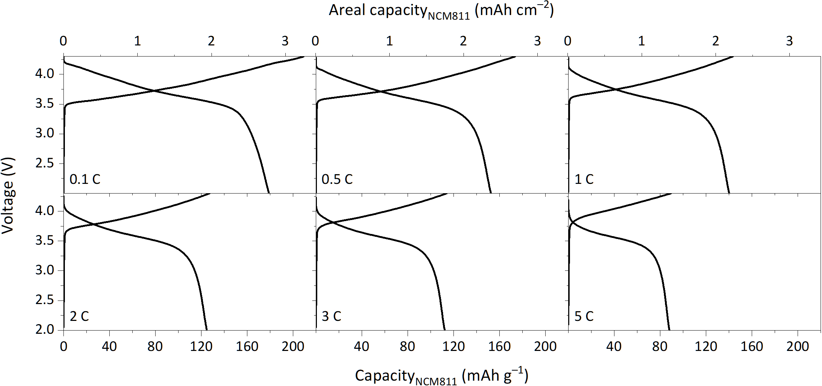
Fig. S31 Voltage profiles of the graphite|NCM811 full cell measured at various current densities from 0.1 to 5 C with a cathode loading of 15.5 mg cm^{–2}
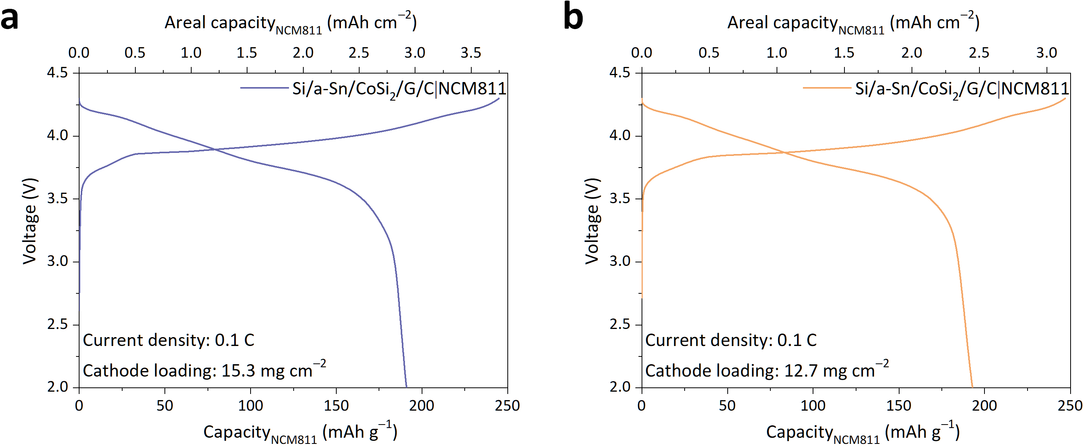
Fig. S32 Voltage profiles of the Si/a-Sn/CoSi₂/G/C|NCM811 full cells during the initial activation cycle at 0.1 C with cathode loadings of a 15.3 mg cm^{–2} and b 12.7 mg cm^{–2}
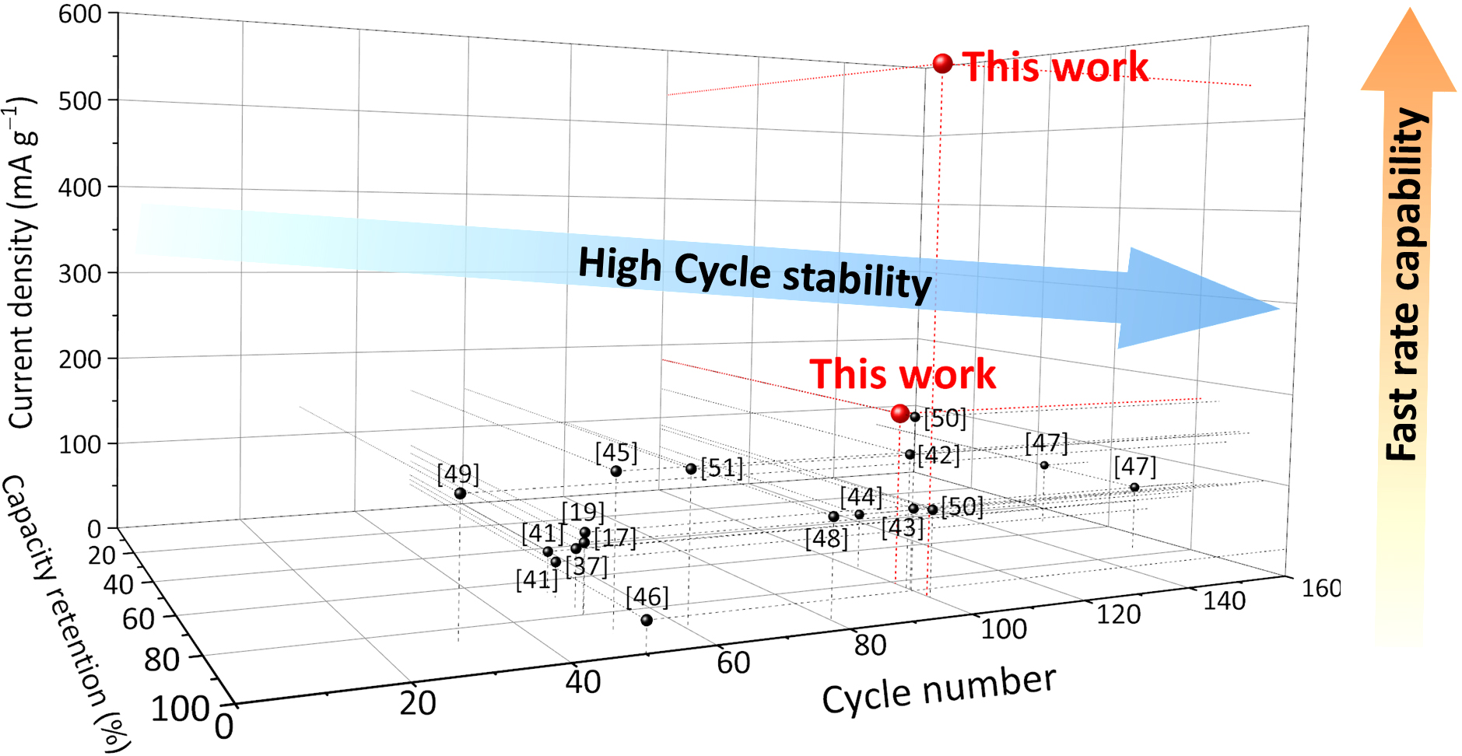
Fig. S33 Comparison of the electrochemical performance of the Si/a-Sn/CoSi₂/G/C|NCM811 full cell with those of previously reported Si-based full cells
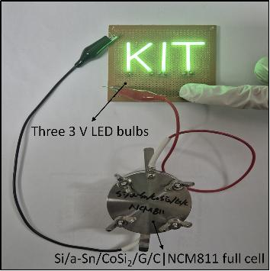
Fig. S34 Photograph of three commercial green LED bulbs (3 V) powered by the Si/a-Sn/CoSi₂/G/C|NCM811 full cell
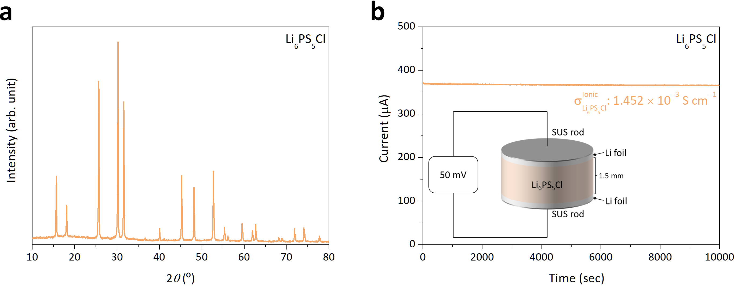
Fig. S35 Structural characteristics and ionic conductivity of argyrodite LPSC SE: a XRD pattern and b ionic conductivity measured by DC polarization in an electron-blocking symmetric cell (DC bias: 50 mV)
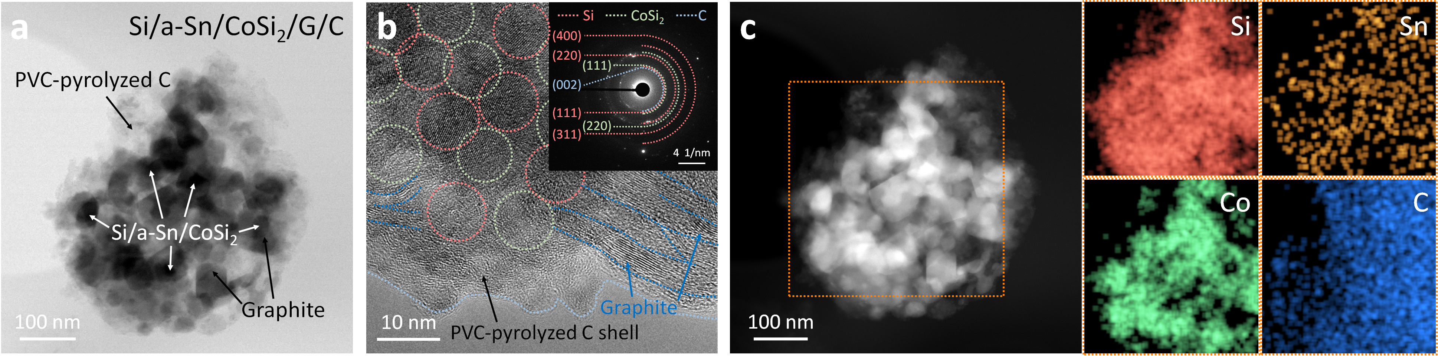
Fig. S36 Structural characterization of the Si/a-Sn/CoSi₂/G/C nanocomposite after pressing under 375 MPa for ASSLB assembly. a BFTEM image, b HRTEM image with the corresponding SAED pattern (inset), and c STEM image with the corresponding EDX elemental mappings of Si/a-Sn/CoSi₂/G/C
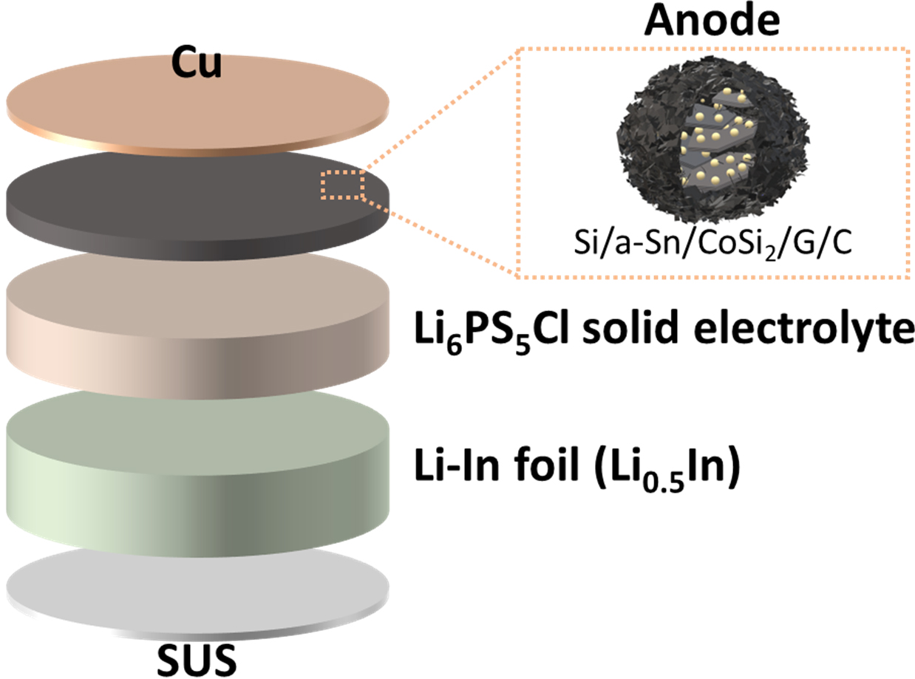
Fig. S37 Schematic illustration of the ASSLB half-cell configuration

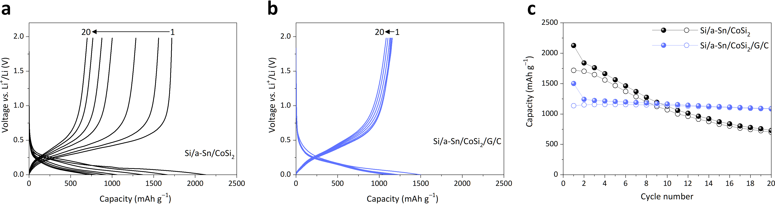
Fig. S38 Electrochemical comparison of Si/a-Sn/CoSi₂ and Si/a-Sn/CoSi₂/G/C anodes in sulfide-based ASSLB half cells. Voltage profiles of a Si/a-Sn/CoSi₂ and b Si/a-Sn/CoSi₂/G/C anodes. c Cycling performance of Si/a-Sn/CoSi₂ and Si/a-Sn/CoSi₂/G/C anodes at a current density of 300 mA g^{–1}
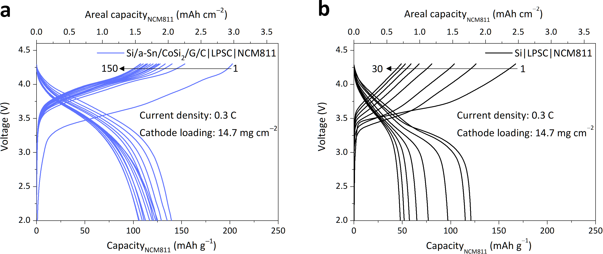
Fig. S39 Electrochemical performances of the Si|LPSC|NCM811 and Si/a-Sn/CoSi₂/G/C|LPSC|NCM811 full cells: a voltage profiles of the Si/a-Sn/CoSi₂/G/C|LPSC|NCM811 and b Si|LPSC|NCM811 full cells at a current density of 0.3 C (cathode loading: 14.7 mg cm^{–2}, temperature: 60 °C)
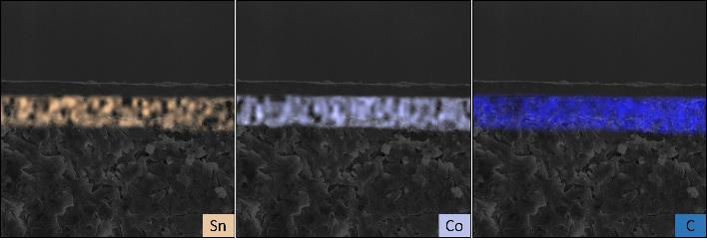
Fig. S40 EDX elemental mapping of the Si/a-Sn/CoSi₂/G/C anode before cycling in an ASSLB

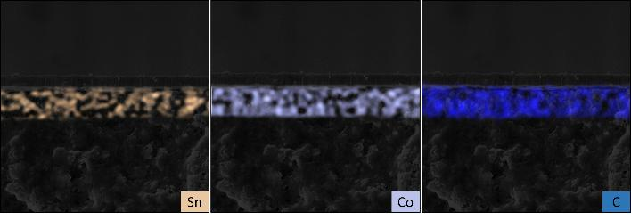
Fig. S41 EDX elemental mapping of the Si/a-Sn/CoSi₂/G/C anode after 100 cycles in an ASSLB

Table S1 Electrochemical performance of pristine Si and Si/Sn composite anodes with varying Sn contents
Materials | Initial discharge capacity  (mAh g^{–1}) | Initial charge capacity  (mAh g^{–1}) | Initial Coulombic efficiency  (%) | Capacity retention after 30 cycles  (%)
Pristine Si | 3916.2 | 3275.4 | 83.6 | 3.9
Si/Sn-5 | 3582.4 | 3167.9 | 88.4 | 25.0
Si/Sn-10 | 3384.3 | 3129.2 | 92.5 | 33.2
Si/Sn-15 | 3332.6 | 3049.8 | 91.5 | 33.8
Si/Sn-20 | 3262.1 | 2955.7 | 90.6 | 34.0

Table S2 Electrochemical performance of Si/a-Sn/TMS composite anodes
Materials | Initial discharge capacity  (mAh g^{–1}) | Initial charge capacity  (mAh g^{–1}) | Initial Coulombic efficiency  (%) | Capacity retention after 30 cycles  (%)
Si/a-Sn/FeSi₂ | 2024.0 | 1763.1 | 87.1 | 74.6
Si/a-Sn/CoSi₂ | 1961.7 | 1771.5 | 90.3 | 83.2
Si/a-Sn/NiSi₂ | 2051.6 | 1756.9 | 85.6 | 74.9

Table S3 Plastic and elastic deformation energies of Si and high-power MM-derived TMS particles derived from the load-displacement profiles
Materials | Plastic deformation energy  (10^{–10} J) | Elastic deformation energy  (10^{–10} J) | Total deformation energy  (10^{–10} J)
Si | 30.372 | - | 30.372
FeSi₂ | 118.099 | 41.378 | 159.477
CoSi₂ | 121.098 | 56.869 | 177.967
NiSi₂ | 97.710 | 41.246 | 138.956

Table S4 Comparison of the electrochemical performance of the Si/a-Sn/CoSi₂/G/C anode with previously reported Si/TMS-based anodes for LIBs
Materials | ICE  (%) | Current density  (mA g⁻¹) | Reversible capacity  after Xth cycle  (mAh g⁻¹) | Capacity retention  (%) | Electrolyte | Refs.
Si/TiSi₂ heterostructure | 59.4 | 1300 | 937  (X=100) | 79.3 | 1.0 M LiPF₆  (EC/DEC) | [18]
Si@TiSi₂@NC | 83 | 200 | 1553.3  (X=100) | 71.5 | 1.0 M LiPF₆  (EC/DEC+5wt%FEC) | [19]
Porous Si@TiSi₂ | 74.5 | 400 | 1180  (X=50) | 66.3 | 1.5 M LiPF₆  (EC/DEC+25vol%FEC) | [20]
Si/FeSi₂/CrSi₂ | 86 | 1000 | 841  (X=100) | 87.9 | 1.0 M LiPF₆  (EC/DEC+25vol%FEC) | [21]
Si-FeSi₂-G-C | 87.0 | 100 | 925  (X=80) | 88.5 | 1 M LiPF₆  (EC/DEC+10wt%FEC) | [22]
Si/FeSi₂@C NPs | 87.6 | 200 | 1375  (X=100) | 56.1 | 1.0 M LiPF₆  (EC/DEC/EMC+FEC) | [23]
Si/Co-CoSi₂/rGO | 77.9 | 100 | 921.8  (X=80) | 98.6 | 1.3 M LiPF₆  (EC/DMC) | [24]
Si@CoSi₂/Co-NPC@CNT | 76.1 | 200 | 1258  (X=100) | 74.6 | 1.0 M LiPF₆  (EC/DEC+5wt%FEC) | [25]
Si-NiSi₂-Al₂O₃@C | 74.3 | 200 | 680  (X=100) | 94.4 | 1 M LiPF₆  (EC/DEC+30vol%FEC) | [26]
Si/NiSi₂/C | 76.9 | 200 | 1827.7  (X=50) | 87.6 | 1 M LiPF₆  (EC/DMC+2wt%FEC) | [27]
Si/NiSi₂/C | 78 | 1000 | 1500  (X=100) | 79.8 | 1 M LiPF₆  (EC/DMC+2wt%FEC) | [27]
Cu-Si alloy nanotube | 42 | 840 | 1670  (X=100) | 77.6 | 1.0 M LiPF₆  (EC/DEC) | [35]
Cu-Si alloy nanotube | 37 | 1600 | 1380  (X=100) | 77.1 | 1.0 M LiPF₆  (EC/DEC) | [35]
Cu-Si alloy nanotube | 33 | 3200 | 1210  (X=100) | 76.2 | 1.0 M LiPF₆  (EC/DEC) | [35]
Cu₃Si/Si | 88.9 | 200 | 1675.4  (X=100) | 66.2 | 1.0 M LiPF₆  (EC/DMC/EMC+5vol%FEC) | [36]
Si/Cu₃Si/Al₂O₃ | 76 | 200 | 750  (X=100) | 89.2 | 1 M LiPF₆  (EC/DMC+5vol%FEC) | [37]
Si-Cu₃Si-CNT/G-C | 82.8 | 200 | 1084  (X=100) | 87.6 | 1.0 M LiPF₆  (EC/DEC+10wt%FEC) | [38]
Cu₉Si/Si NWs | 52.4 | 200 | 655.5  (X=100) | 55.6 | 1.0 M LiPF₆  (EC/DMC/EMC+5vol%FEC) | [39]
Si/TiFeSi₂ | 80 | 200 | 930  (X=100) | 93 | 1.3 M LiPF₆  (EC/DEC+2%FEC) | [40]
Si/a-Sn/CoSi₂/G/C | 80.7 | 300 | 1147.4  (X=100) | 91.4 | 1.3 M LiPF₆  (EC/DEC+10 wt%FEC) | This work

Table S5 Comparison of the energy densities of graphite|NCM811 and Si/a-Sn/CoSi₂/G/C|NCM811 full cells at various current densities
Anode material | Mass of anode  (mg) | Mass of  AAM  (mg) | Mass of separator (mg) | Mass of cathode  (mg) | Mass of NCM811  (mg) | Current density  (mA g^{–1}) | Specific capacity (mAh g^{–1}) | Average voltage  (V) | Energy  (Wh) | Energy density  (Wh kg^{–1})
Graphite | 8.61 | 6.89 | 1.76 | 15.23 | 12.18 | 18 | 179.0 | 3.63 | 0.00791 | 309.1
 |  |  |  |  |  | 90 | 152.5 | 3.56 | 0.00661 | 258.3
 |  |  |  |  |  | 180 | 140.2 | 3.54 | 0.00605 | 236.1
 |  |  |  |  |  | 360 | 124.8 | 3.52 | 0.00535 | 209.0
 |  |  |  |  |  | 540 | 112.2 | 3.50 | 0.00478 | 186.8
 |  |  |  |  |  | 900 | 88.1 | 3.46 | 0.00371 | 145.0
Si/a-Sn  /CoSi₂/G/C | 2.87 | 2.01 | 1.76 | 15.23 | 12.18 | 18 | 187.4 | 3.78 | 0.00863 | 434.4
 |  |  |  |  |  | 90 | 175.5 | 3.62 | 0.00774 | 389.6
 |  |  |  |  |  | 180 | 174.2 | 3.54 | 0.00751 | 378.2
 |  |  |  |  |  | 360 | 163.6 | 3.45 | 0.00687 | 346.2
 |  |  |  |  |  | 540 | 151.9 | 3.37 | 0.00623 | 313.9
 |  |  |  |  |  | 900 | 139.7 | 3.31 | 0.00563 | 283.6

Table S6 Comparison of the electrochemical performance of the Si/a-Sn/CoSi₂/G/C|NCM811 full cell with previously reported Si-based full cells
Anode | Cathode | Discharge capacity after Xth cycles  (mAh g^{–1}) | Current density  (mA g^{–1}) | Capacity retention  (%) | Refs
carbon-coated Si nanosheets | LCO | 111.3 (X=50) | 70 | 80 | [17]
Si@TiSi₂@NC | NCM622 | 143.9 (X=50) | 80 | 80.2 | [19]
Si-Cu₃Si-Al₂O₃ | LMO | 70 (X=50) | 60 | 77.2 | [37]
Amorphous Columnar Si | NCM622 | 125 (X=50) | 36 | 70 | [41]
Amorphous Columnar Si | NCM811 | 142 (X=50) | 42 | 67 | [41]
Si@N-ECGB | NCM811 | 140 (X=100) | 140 | 84 | [42]
Si submicroncube@C | LFP | 122 (X=100) | 85 | 85.3 | [43]
Si-graphite | NCM523 | 119.3 (X=100) | 60 | 71 | [44]
Si/SiO₂ | LCO | 149 (X=50) | 150 | 90 | [45]
Ag/ZnO-Si@C-PCNF | NCM513 | 135 (X=50) | 30 | 100 | [46]
Fe₁₄Si₈₆/C | NCM111 | 79 (X=150) | 75 | 54.1 | [47]
Fe₂₅Si₇₅ | NCM111 | 109 (X=150) | 75 | 77 | [47]
Si p-NS@TNS | LFP | 138 (X=80) | 100 | 95.2 | [48]
Si@graphene cage | LCO | 88 (X=30) | 135 | 87 | [49]
Si@C_{MR} | NCM622 | 151.3 (X=100) | 90 | 90 | [50]
Si@C_{MR} | NCM622 | 110.2 (X=100) | 180 | 85 | [50]
Si@C@MoS₂ | LCO | 136.1 (X=60) | 150 | 91.7 | [51]
Si/a-Sn/CoSi₂/G/C | NCM811 | 137.1 (X=100) | 180 | 81.2 | This work
Si/a-Sn/CoSi₂/G/C | NCM811 | 130.9 (X=100) | 540 | 89.2 | This work

Table S7 Energy density calculation of the Si/a-Sn/CoSi₂/G/C|LPSC|NCM811 ASSLB full cell
Mass of anode (mg) | 2.83
Mass of Si/a-Sn/CoSi₂/G/C (mg) | 1.98
Mass of 30 µm-thick LPSC SE (mg) | 4
Mass of cathode (mg) | 15.60
Mass of NCM811 (mg) | 12.01
Current density (mA g^{–1}) | 18
Specific capacity (mAh g^{–1}) | 162.1
Average voltage (V) | 3.47
Energy (Wh) | 0.00676
Energy density (Wh kg^{–1}) | 301.2

Table S8 Comparison of the electrochemical performance of the Si/a-Sn/CoSi₂/G/C|LPSC|NCM811 ASSLB full cell with previously reported Si-based ASSLB full cells
Anode | Cathode | Solid electrolyte | Cathode loading  (mg cm^{–2}) | Stack pressure  (MPa) | Operating temp.  (°C) | Current density  (mA cm^{–2}) | Areal capacity  (mAh cm^{–2}) | Refs.
μm-Si | NCM111 | Li₃PS₄ | 18.3 | 75 | 30 | 0.15 | 2.20 | [53]
 |  |  |  |  |  | 0.3 | 1.83 | [53]
 |  |  |  |  |  | 0.75 | 1.28 | [53]
 |  |  |  |  |  | 1.5 | 0.64 | [53]
 |  |  |  |  |  | 3.0 | 0.27 | [53]
 |  |  |  |  |  | 4.5 | 0.15 | [53]
 |  |  |  |  |  | 6.0 | 0.07 | [53]
Li₆PS₅Cl-infiltrated Si | LCO | Li₆PS₅Cl | 10.0 | 140 | 30 | 0.14 | 1.04 | [54]
 |  |  |  |  |  | 0.28 | 0.90 | [54]
Si-SE-CB | NCM811 | Li₆PS₅Cl | 7.93 | 50 | 25 | 0.08 | 1.49 | [55]
 |  |  |  |  |  | 0.16 | 1.41 | [55]
 |  |  |  |  |  | 0.32 | 1.28 | [55]
 |  |  |  |  |  | 0.79 | 1.13 | [55]
 |  |  |  |  |  | 1.58 | 1.03 | [55]
Si-SE-C | NCM811 | Li_{5.4}PS_{4.4}Cl_{1.6} | 14.88 | 150 | 25 | 0.15 | 1.99 | [56]
 |  |  |  |  |  | 0.30 | 1.74 | [56]
 |  |  |  |  |  | 0.60 | 1.46 | [56]
 |  |  |  |  |  | 1.49 | 1.01 | [56]
 |  |  |  |  |  | 2.98 | 0.67 | [56]
Si | NCM811 | Li₃PS₄ | 13.6 | 75 | 30 | 0.15 | 1.77 | [57]
 |  |  |  |  |  | 0.30 | 1.49 | [57]
 |  |  |  |  |  | 0.75 | 1.16 | [57]
 |  |  |  |  |  | 1.5 | 0.84 | [57]
 |  |  |  |  |  | 3.0 | 0.48 | [57]
 |  |  |  |  |  | 4.5 | 0.27 | [57]
 |  |  |  |  |  | 6.0 | 0.14 | [57]
Col-Si | N₉₀C₅M₅ | Li₆PS₅Cl | 12.9 | 3 N·m | 25 | 0.07 | 1.95 | [58]
 |  |  |  |  |  | 0.45 | 1.72 | [58]
 |  |  |  |  |  | 0.75 | 1.63 | [58]
 |  |  |  |  |  | 1.5 | 1.54 | [58]
Si@MOF | LFP | PVDF/PEO/  garnet | 15.4 | N/A | 60 | 0.1 | 2.20 | [59]
 |  |  |  |  |  | 0.2 | 1.40 | [59]
 |  |  |  |  |  | 0.5 | 0.80 | [59]
Si@MOF | LFP | PVDF/PEO/  garnet | 20.2 | N/A | 60 | 0.1 | 2.60 | [59]
 |  |  |  |  |  | 0.2 | 1.80 | [59]
 |  |  |  |  |  | 0.5 | 1.10 | [59]
C-Li₁Si-60 | NCM811 | Li₆PS₅Cl | 10.2 | 60 | 30 | 0.10 | 2.00 | [60]
 |  |  |  |  |  | 0.20 | 1.80 | [60]
 |  |  |  |  |  | 0.61 | 1.60 | [60]
 |  |  |  |  |  | 1.02 | 1.40 | [60]
 |  |  |  |  |  | 2.04 | 1.20 | [60]
 |  |  |  |  |  | 6.12 | 0.75 | [60]
In-Si | NCM90 | Li_{5.5}PS_{4.5}Cl_{1.5} | 8.75 | 50 | 55 | 1.23 | 1.08 | [61]
 |  |  |  |  |  | 4.92 | 0.94 | [61]
 |  |  |  |  |  | 7.38 | 0.86 | [61]
Li₂₁Si₅/  Si-Li₂₁Si₅ | LCO | Li₃InCl₆/  Li₆PS₅Cl | 23.4 | 0 | 45 | 0.6 | 2.32 | [62]
 |  |  |  |  |  | 1.3 | 1.85 | [62]
 |  |  |  |  |  | 2.5 | 1.46 | [62]
 |  |  |  |  |  | 3.8 | 1.23 | [62]
 |  |  |  |  |  | 5.0 | 1.01 | [62]
 |  |  |  |  |  | 6.3 | 0.79 | [62]
 |  |  |  |  |  | 7.6 | 0.57 | [62]
Si/a-Sn  /CoSi₂/G/C | NCM811 | Li₆PS₅Cl | 15.3 | 40 | 60 | 0.28 | 2.48 | This work
 |  |  |  |  |  | 0.55 | 2.32 | This work
 |  |  |  |  |  | 1.38 | 2.02 | This work
 |  |  |  |  |  | 1.93 | 1.82 | This work
 |  |  |  |  |  | 2.75 | 1.63 | This work
 |  |  |  |  |  | 5.50 | 1.38 | This work
 |  |  |  |  |  | 8.25 | 1.13 | This work

