Supporting Information for
Crystal Phase Engineering Accelerates Hydrogen Reverse Spillover for Efficient Alkaline Hydrogen Production
Jun Zhang^{†1}, Xiaoyu Chen^{†2}, Bin Wu^{†3,}*, Xiangyang Guo⁴, Xianlin Qu⁵, Qunzhi Ma¹, Ying Wang¹, Jiayi Li¹, Wei Liu¹, Xu Li¹, Liyun Cao¹, Yi Wang⁵, Jianfeng Huang^{1,}*, Jingxiang Zhao^{2,}*, Fuxiang Zhang^{4,}*, and Yongqiang Feng^{1,}*
¹ School of Materials Science and Engineering, Shaanxi Key Laboratory of Green Preparation and Functionalization for Inorganic Materials, Shaanxi University of Science and Technology, Xi’an 710021, P. R. China
² College of Chemistry and Chemical Engineering, Harbin Normal University, Harbin 150025, P. R. China
³ School of Materials Science and Engineering, Nanyang Technological University, Singapore 639798, Singapore
⁴ State Key Laboratory of Catalysis, Dalian Institute of Chemical Physics, Chinese Academy of Sciences, Dalian National Laboratory for Clean Energy, Dalian 116023, P. R. China
⁵ Center for Microscopy and Analysis, Nanjing University of Aeronautics and Astronautics, Nanjing 211106, P. R. China
† Jun Zhang, Xiaoyu Chen, and Bin Wu contribute equally to this work.
*Corresponding authors. E-mail: bin.wu@ntu.edu.sg (Bin Wu); huangjf@sust.edu.cn (Jianfeng Huang); zhaojingxiang@hrbnu.edu.cn (Jingxiang Zhao); fxzhang@dicp.ac.cn (Fuxiang Zhang); fengyq@sust.edu.cn (Yongqiang Feng)

Supplementary Figures and Tables
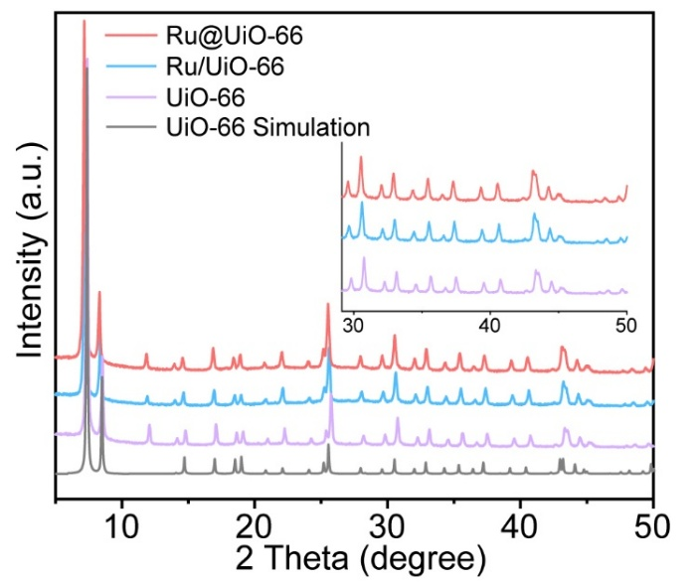

Fig. S1 XRD patterns of Ru@UiO-66, Ru/UiO-66 and UiO-66.
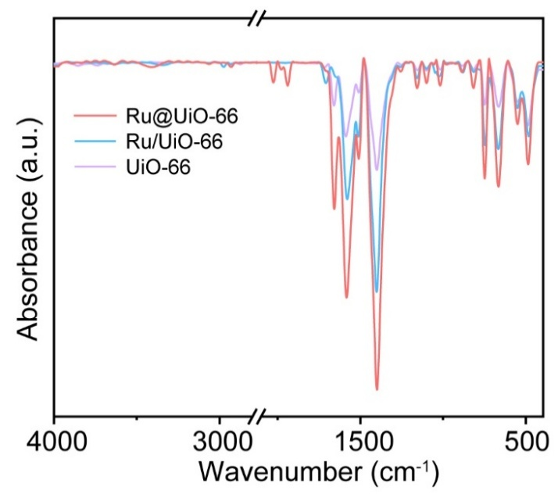

Fig. S2 FT-IR spectra of Ru@UiO-66, Ru/UiO-66 and UiO-66.

Fig. S3 N₂ isothermal adsorption/desorption curves of a Ru@UiO-66, Ru/UiO-66 and UiO-66, and b Ru@m-ZrO₂/C, Ru@t-ZrO₂/C and ZrO₂/C.
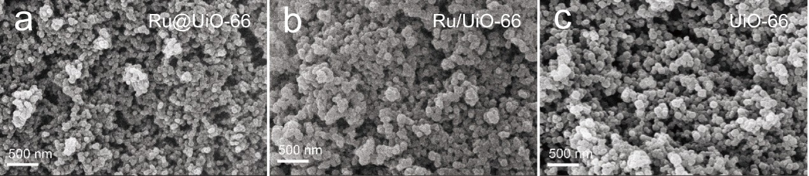

Fig. S4 SEM images of a Ru@UiO-66, b Ru/UiO-66 and c UiO-66.

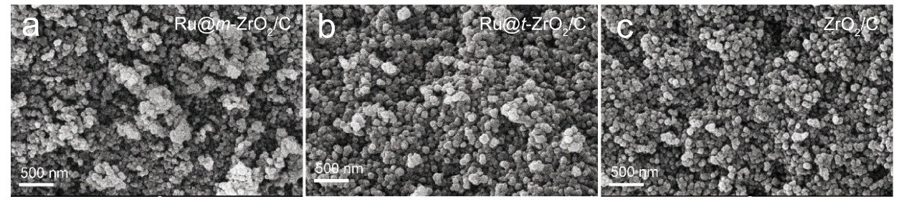

Fig. S5 SEM images of a Ru@m-ZrO₂/C, b Ru@t-ZrO₂/C and c ZrO₂/C.

Fig. S6 FT-IR spectra of Ru@m-ZrO₂/C, Ru@t-ZrO₂/C and ZrO₂/C.

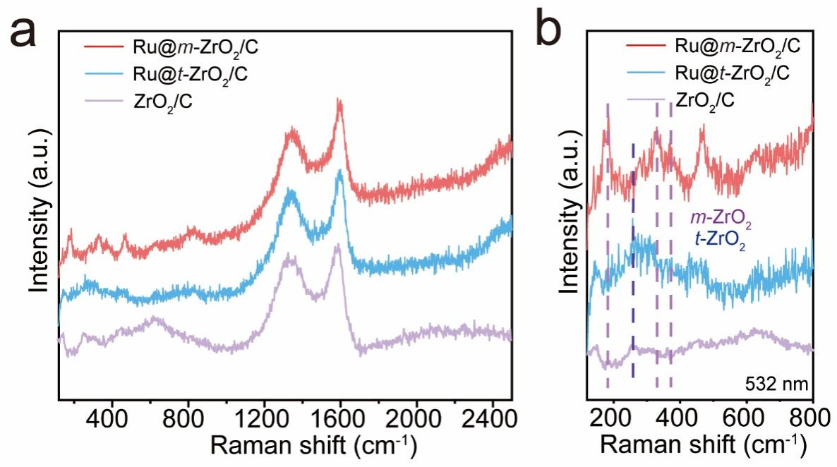

Fig. S7 Raman spectra of Ru@m-ZrO₂/C, Ru@t-ZrO₂/C and ZrO₂/C in the range of a 150~2500 cm⁻¹ and b 150~800 cm⁻¹.
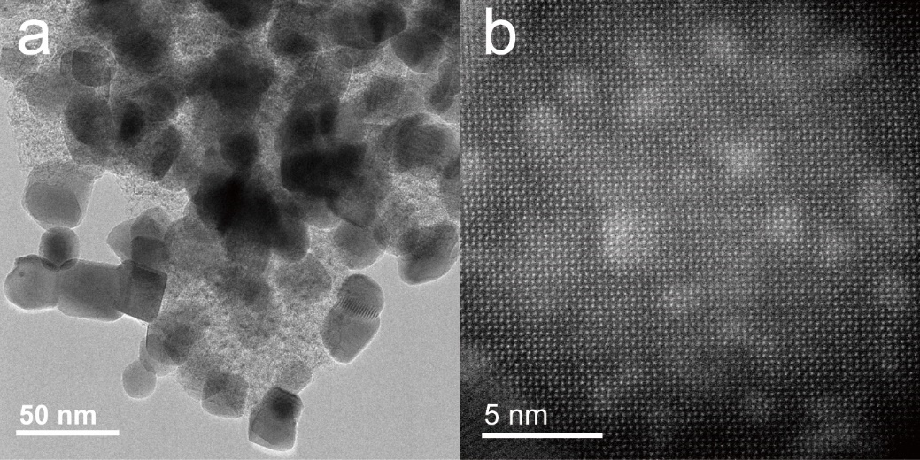

Fig. S8 a HRTEM and b HAADF-STEM image of Ru@m-ZrO₂/C.

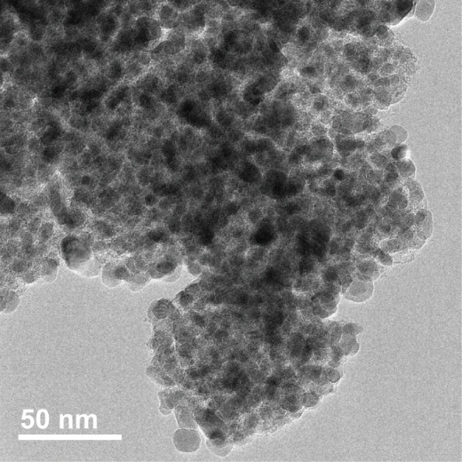

Fig. S9 HRTEM image of Ru@t-ZrO₂/C.
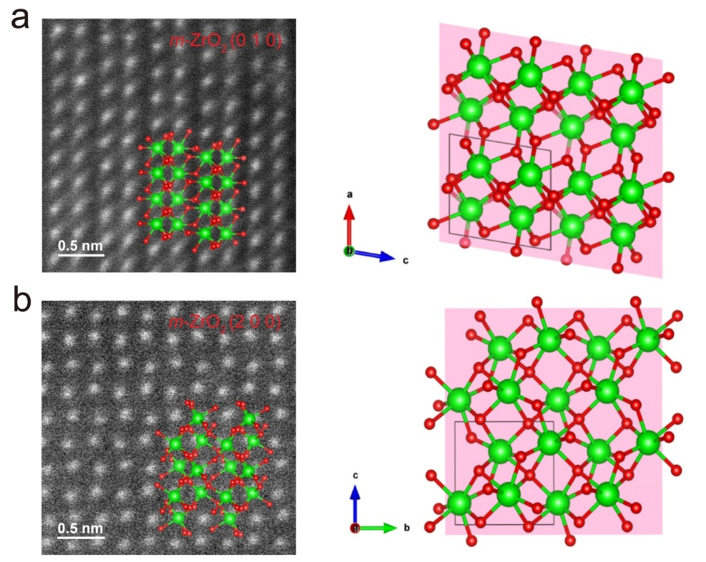

Fig. S10 HAADF-STEM image of Ru@m-ZrO₂/C and the corresponding structural model of m-ZrO₂ along a [010] and b [200] zone axis.

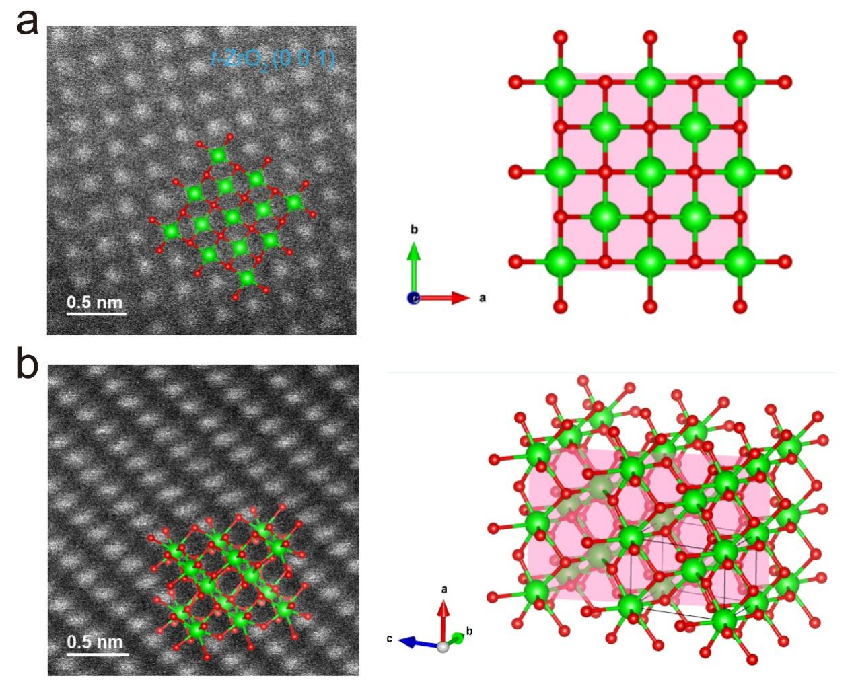

Fig. S11 HAADF-STEM image of Ru@t-ZrO₂/C and the corresponding structural model of t-ZrO₂.

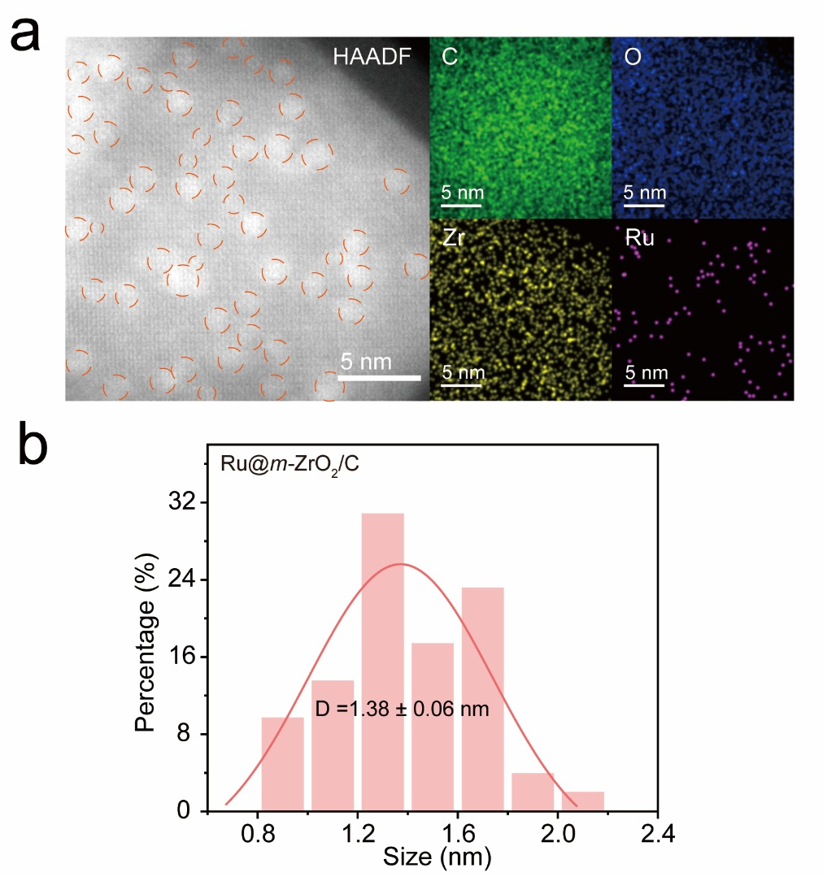

Fig. S12 a HAADF image of Ru@m-ZrO₂/C and the corresponding elemental mapping for C (green), O (blue), Zr (yellow) and Ru (purple). b size distribution histogram of Ru clusters in Ru@m-ZrO₂/C.

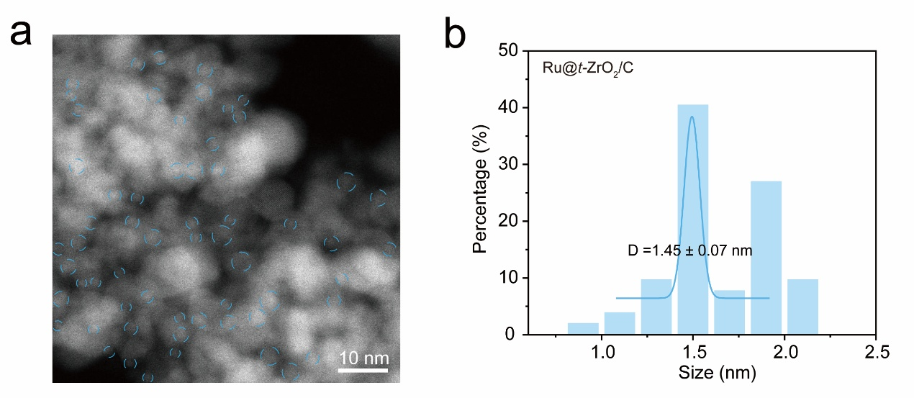

Fig. S13 a HRTEM image of Ru@t-ZrO₂/C and b size distribution histogram of Ru clusters in Ru@t-ZrO₂/C.

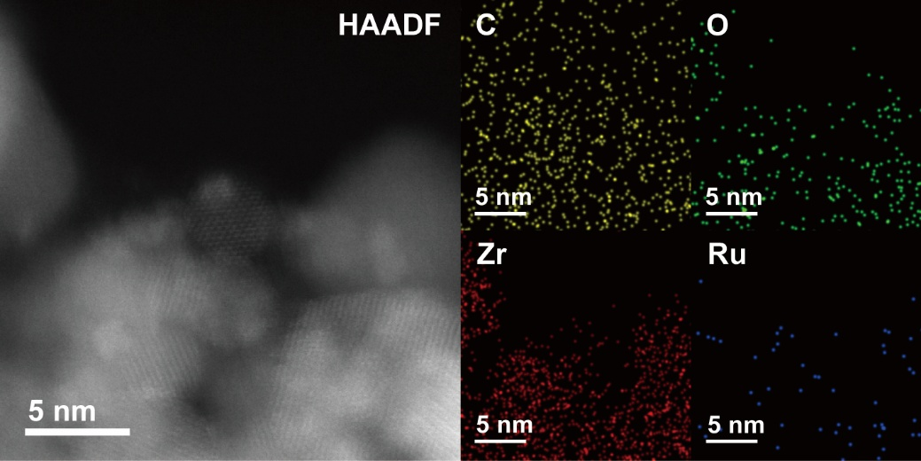

Fig. S14 HAADF image and the corresponding elemental mapping for C (yellow), O (green), Zr (red) and Ru (blue) in Ru@t-ZrO₂/C.

Fig. S15 The first derivative of Zr K-edge XANES for Ru@m-ZrO₂/C, Ru@t-ZrO₂/C and Zr foil.

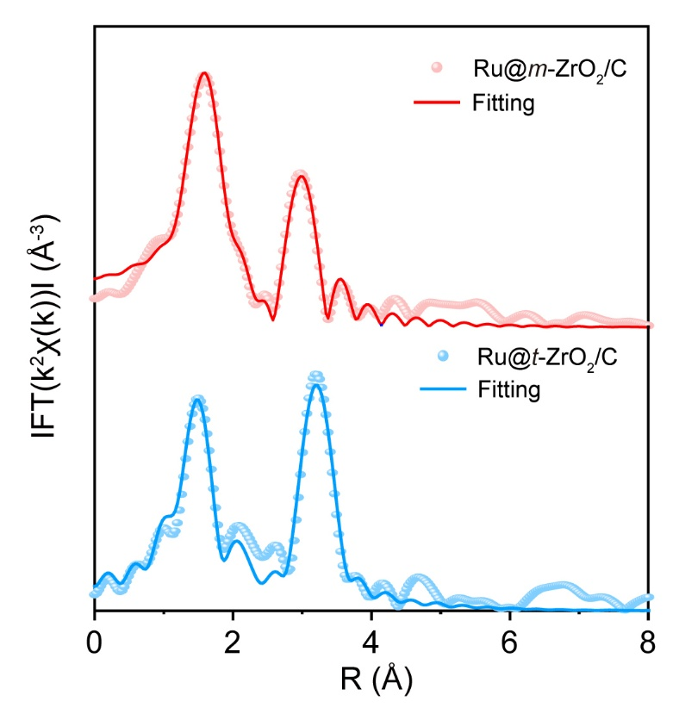

Fig. S16 Fitting curves of Zr K-edge EXAFS for Ru@m-ZrO₂/C and Ru@t-ZrO₂/C at R-space.

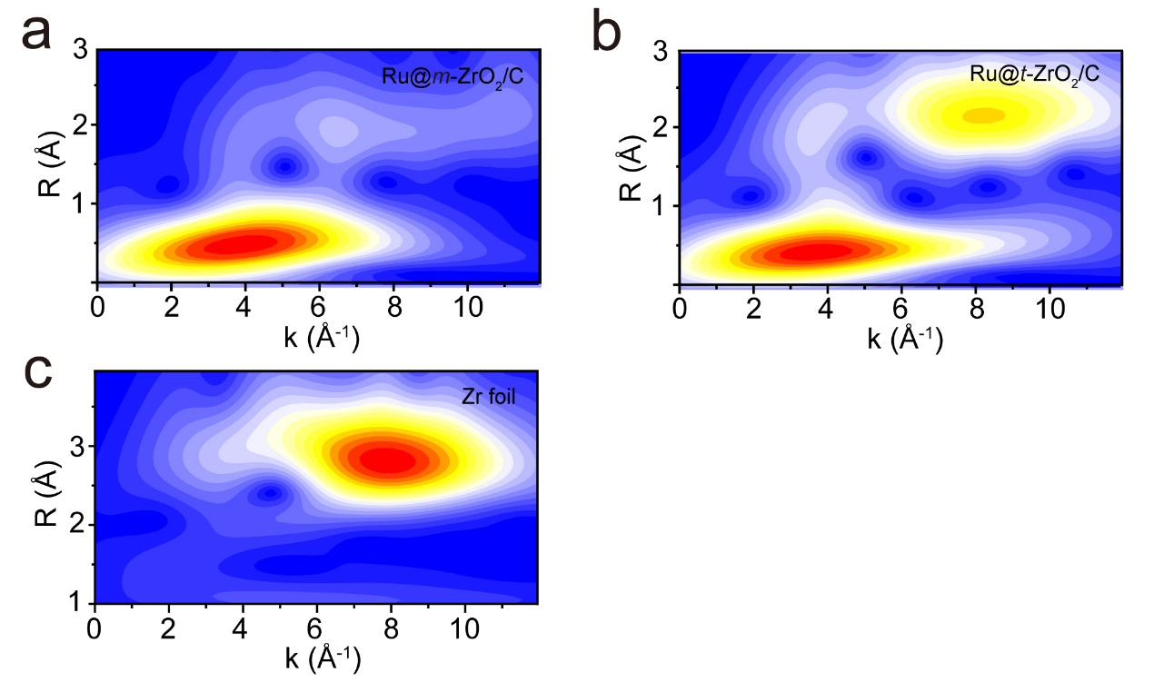

Fig. S17 Wavelet transforms of the EXAFS spectra at Zr K-edge for a Ru@m-ZrO₂/C, b Ru@t-ZrO₂/C and c Zr foil.

Fig. S18 The average oxidation state of Ru in Ru@m-ZrO₂/C and Ru@t-ZrO₂/C derived from the Ru K-edge XANES.

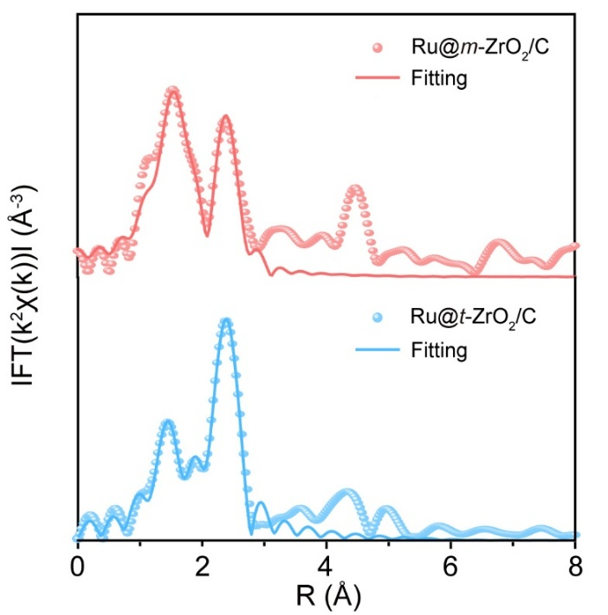

Fig. S19 Fitting curves of Ru K-edge EXAFS for Ru@m-ZrO₂/C and Ru@t-ZrO₂/C at R-space.

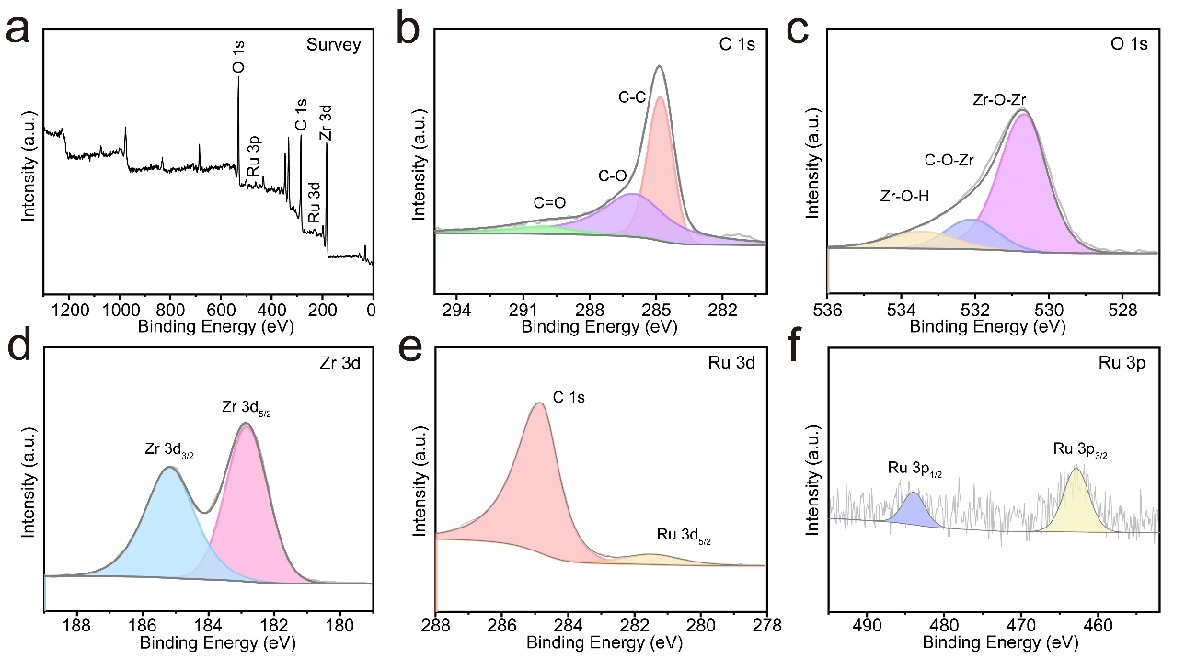

Fig. S20 XPS spectra of Ru@m-ZrO₂/C for a survey, b C 1s, c O 1s, d Zr 3d, e Ru 3d and f Ru 3p.

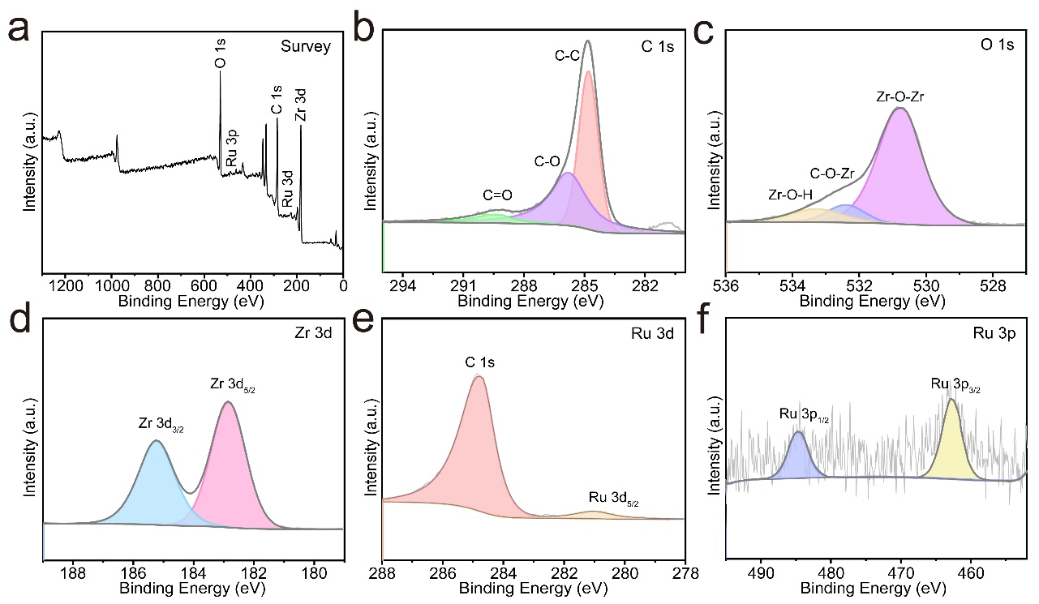

Fig. S21 XPS spectra of Ru@t-ZrO₂/C for a survey, b C 1s, c O 1s, d Zr 3d, e Ru 3d and f Ru 3p.

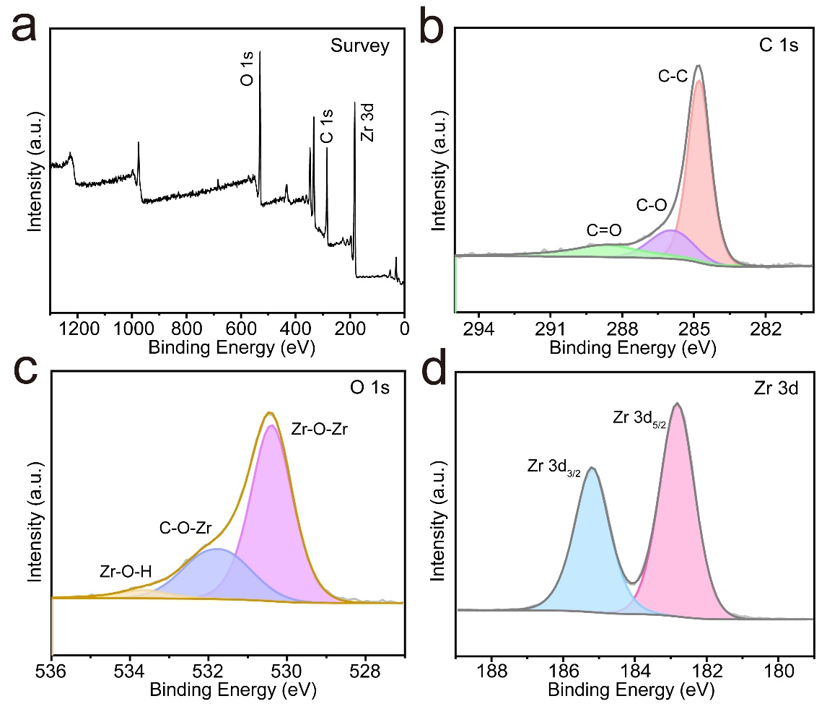

Fig. S22 XPS spectra of ZrO₂/C for a survey, b C 1s, c O 1s and d Zr 3d.

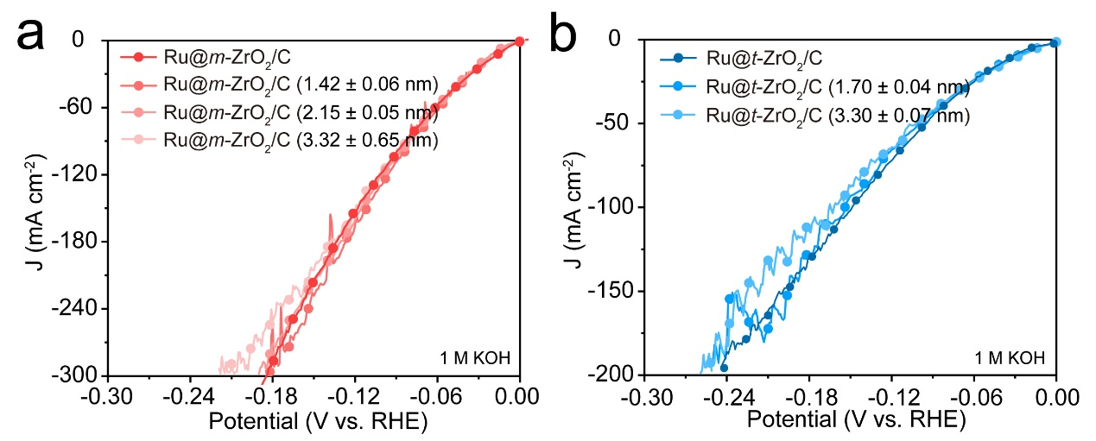

Fig. S23 LSV curves of a Ru@m-ZrO₂/C, Ru@m-ZrO₂/C (1.42 ± 0.06 nm), Ru@m-ZrO₂/C (2.15 ± 0.05 nm) and Ru@m-ZrO₂/C (3.32 ± 0.65 nm), b Ru@t-ZrO₂/C, Ru@t-ZrO₂/C (1.70 ± 0.04 nm) and Ru@t-ZrO₂/C (3.30 ± 0.07 nm) in 1 M KOH.

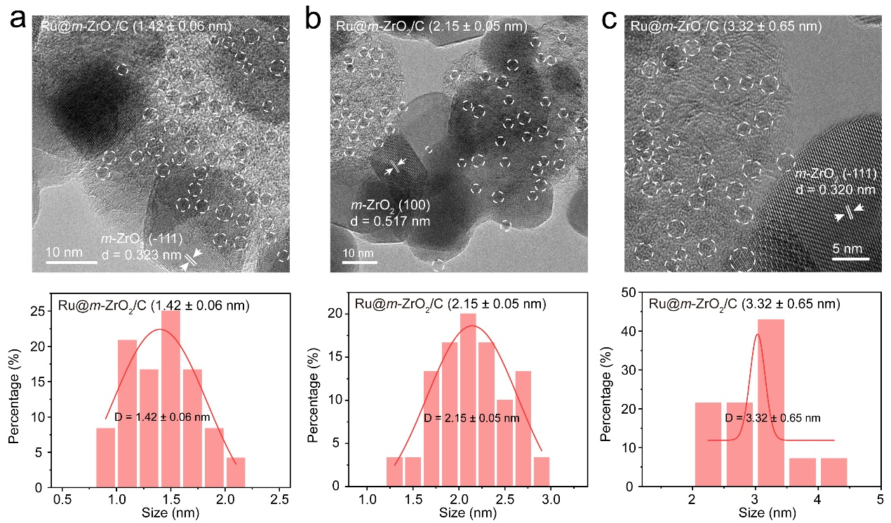

Fig. S24 HRTEM images and size distribution histogram of Ru clusters in a Ru@m-ZrO₂/C (1.42 ± 0.06 nm), b Ru@m-ZrO₂/C (2.15 ± 0.05 nm) and c Ru@m-ZrO₂/C (3.32 ± 0.65 nm).

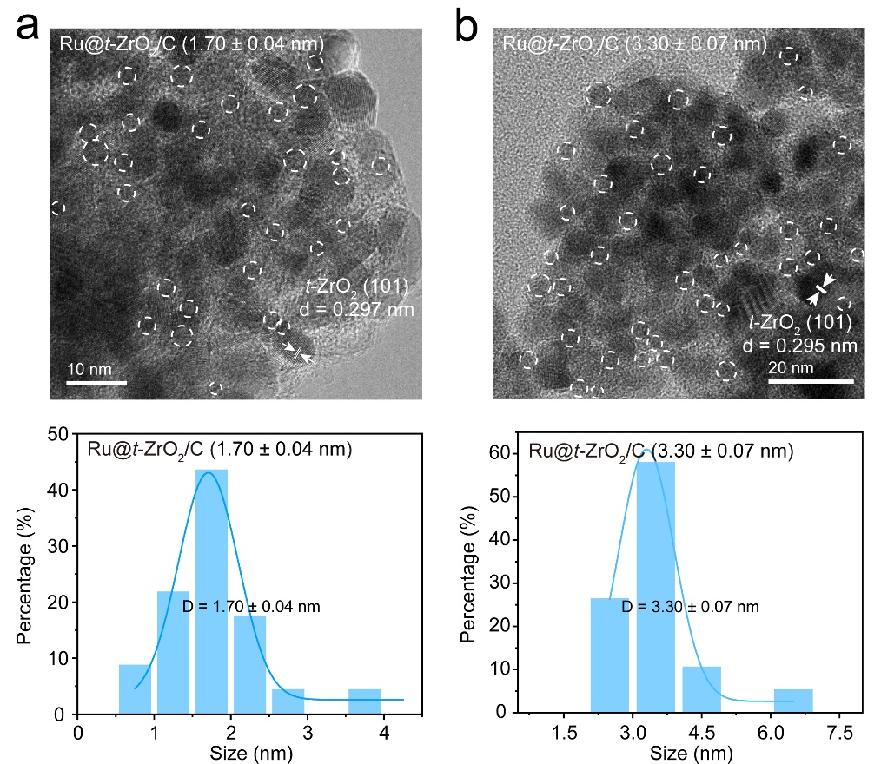

Fig. S25 HRTEM images and size distribution histogram of Ru clusters in a Ru@t-ZrO₂/C (1.70 ± 0.04 nm) and b Ru@t-ZrO₂/C (3.30 ± 0.07 nm).

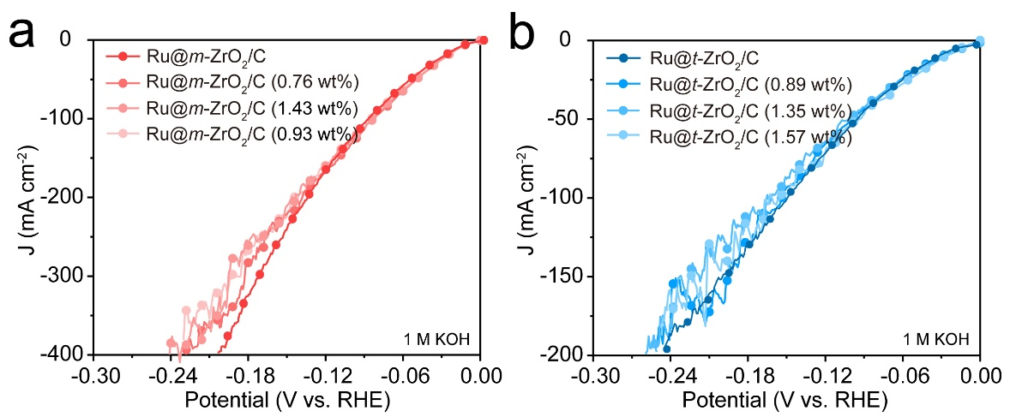

Fig. S26 LSV curves of a Ru@m-ZrO₂/C, Ru@m-ZrO₂/C (0.76 wt%), Ru@m-ZrO₂/C (1.43 wt%) and Ru@m-ZrO₂/C (0.93 wt%), b Ru@t-ZrO₂/C, Ru@t-ZrO₂/C (0.89 wt%), Ru@t-ZrO₂/C(1.35 wt%) and Ru@t-ZrO₂/C(1.57 wt%) in 1 M KOH.

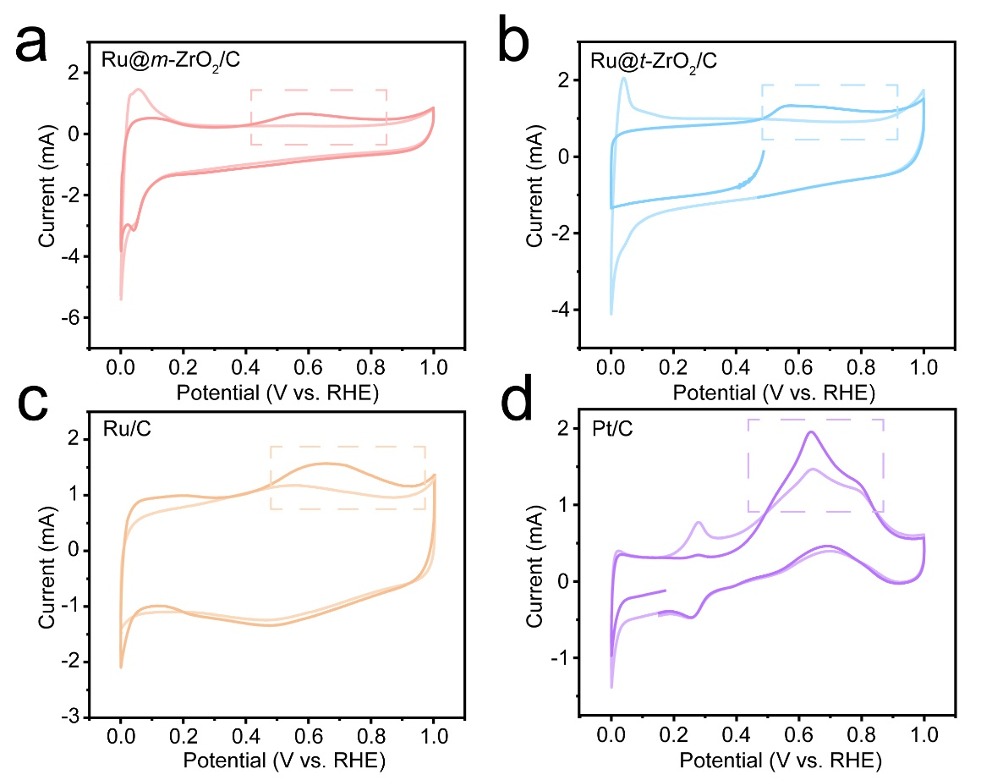

Fig. S27 CO-stripping curves of a Ru@m-ZrO₂/C, b Ru@t-ZrO₂/C, c Ru/C and d Pt/C in 1 M KOH.

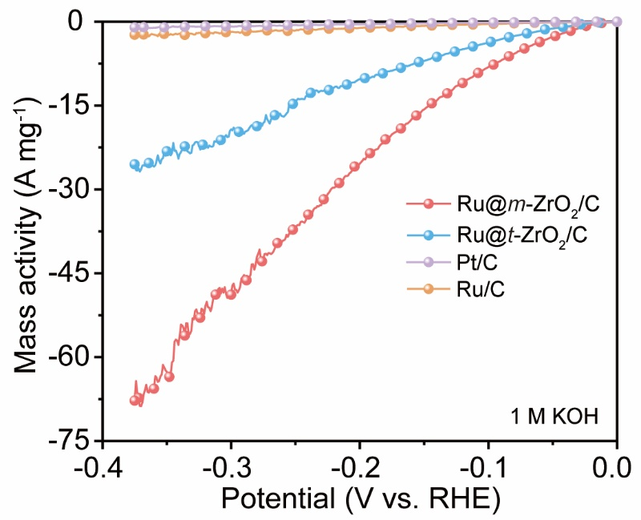

Fig. S28 Mass-normalized LSV curves of Ru@m-ZrO₂/C, Ru@t-ZrO₂/C, Pt/C and Ru/C in 1 M KOH.

Fig. S29. Electrochemical cyclic voltammetry recorded in the non-Faradaic region in 1 M KOH for a Ru@m-ZrO₂/C, b Ru@t-ZrO₂/C, c ZrO₂/C, d Pt/C and e Ru/C with scan rates of 2, 4, 6, 8, 10 and 12 mV s⁻¹. f The corresponding calculated current density difference against scan rate.

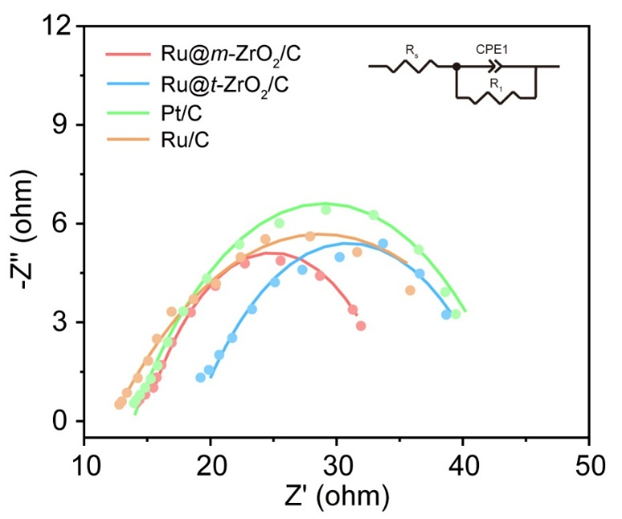

Fig. S30 Nyquist plots of Ru@m-ZrO₂/C, Ru@t-ZrO₂/C, Pt/C and Ru/C during HER test in 1 M KOH.

Fig. S31 LSV curves of a Ru@m-ZrO₂/C and b Ru@t-ZrO₂/C in 1 M KOH before and after addition of 10 mM of KSCN and 10 mM of EDTA, respectively.

Fig. S32 a LSV curves and b Tafel slopes of Ru@m-ZrO₂/C, Ru@t-ZrO₂/C, ZrO₂/C, Pt/C and Ru/C in 0.5 M H₂SO₄.

Fig. S33 Electrochemical cyclic voltammetry recorded in the non-Faradaic region in 0.5 M H₂SO₄ for a Ru@m-ZrO₂/C, b Ru@t-ZrO₂/C, c ZrO₂/C, d Pt/C and e Ru/C with scan rates of 2, 4, 6, 8, 10 and 12 mV s⁻¹. f The corresponding calculated current density difference against scan rate.

Fig. S34 XRD pattern of Ru@m-ZrO₂/C before and after i-t test in 1 M KOH.

Fig. S35 Raman spectra of Ru@m-ZrO₂/C before and after i-t test in 1 M KOH.

Fig. S36 XPS spectra of Ru@m-ZrO₂/C for a Zr 3d, b Ru 3d and c Ru 3p before and after i-t test in 1 M KOH.
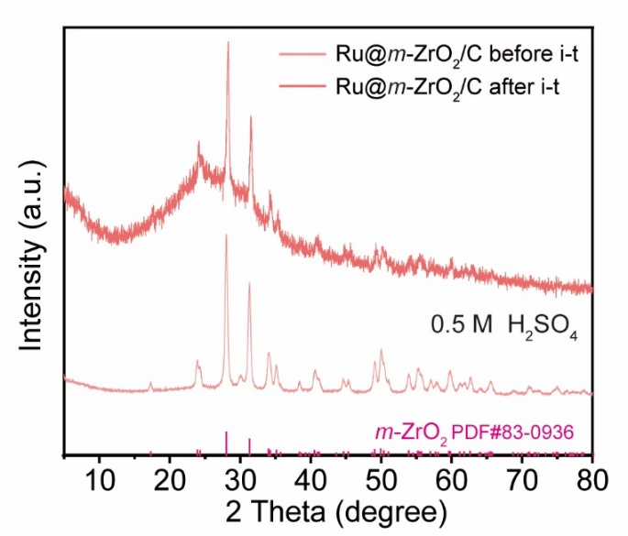

Fig. S37 XRD patterns of Ru@m-ZrO₂/C before and after i-t test in 0.5 M H₂SO₄.
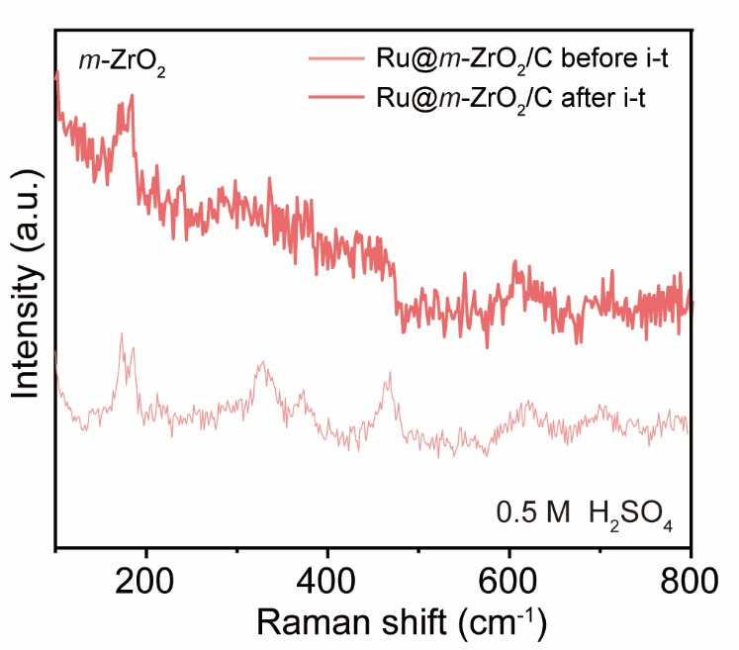

Fig. S38 Raman spectra of Ru@m-ZrO₂/C before and after i-t test in 0.5 M H₂SO₄.

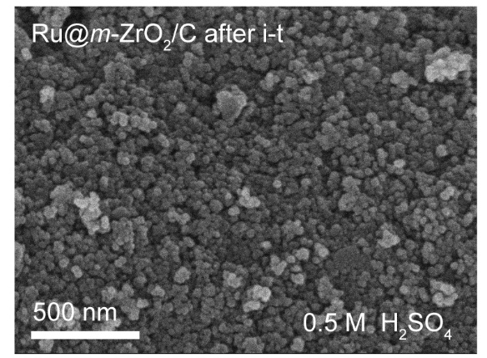

Fig. S39 SEM image of Ru@m-ZrO₂/C after i-t test in 0.5 M H₂SO₄.

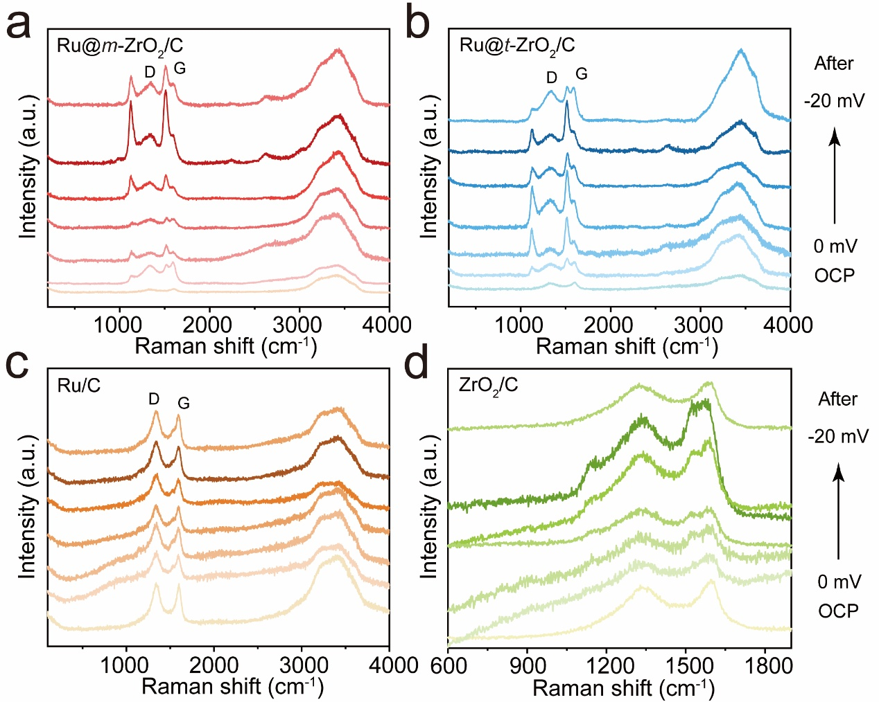

Fig. S40 In-situ Raman spectra of a Ru@m-ZrO₂/C, b Ru@t-ZrO₂/C, c Ru/C and d ZrO₂/C under applied potentials in 1 M KOH.

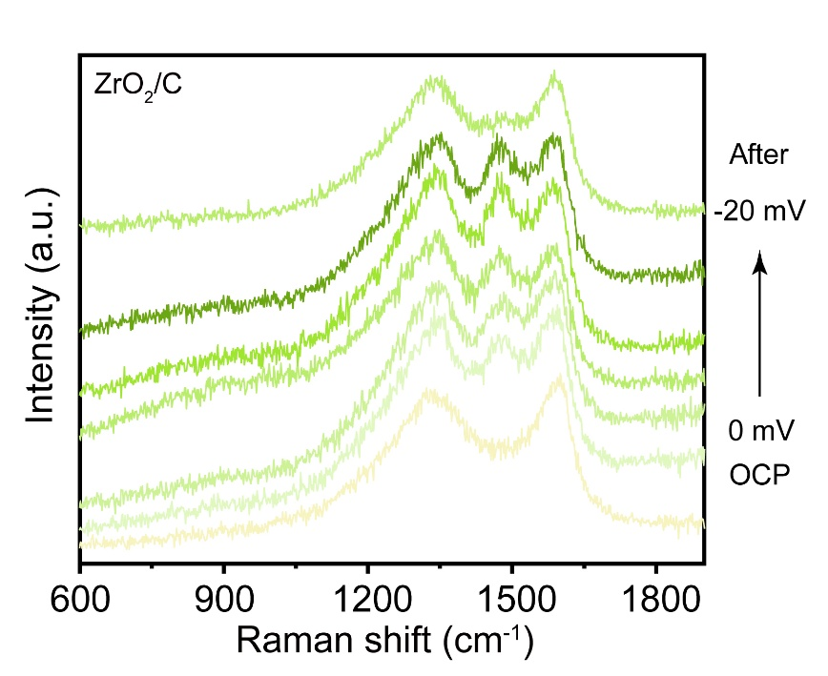

Fig. S41 In-situ Raman spectra of ZrO₂/C under applied potentials in 1 M KOD/D₂O.

Fig. S42 LSV curves of Ru@m-ZrO₂/C and Ru@t-ZrO₂/C in CO-saturated 1 M KOH.

Fig. S43 a In-situ Raman spectra of Ru@m-ZrO₂/C in the range of 2800~4000 cm⁻¹ in 1 M KOH. b The Stark slope and c population of 4-HB·H₂O, 2-HB·H₂O and free H₂O derived from Raman spectra at different applied potential in a.

Fig. S44 The proportions of free H₂O against applied potentials on Ru@m-ZrO₂/C and Ru@t-ZrO₂/C.
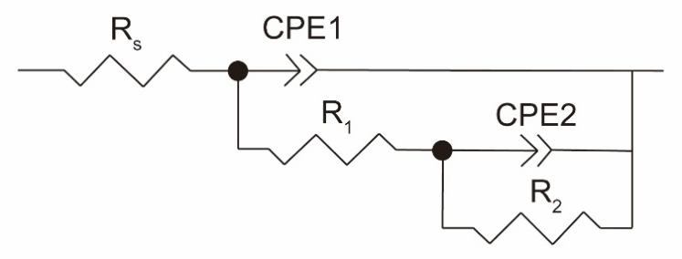

Fig. S45 Equivalent circuit model for fitting EIS data in 1 M KOH.

Fig. S46 In-situ EIS measurement of a, c Nyquist and b, d Bode plots for a, b Ru@m-ZrO₂/C and c, d Ru@t-ZrO₂/C in 1 M KOH.

Fig. S47 In-situ CV curves of a Ru@m-ZrO₂/C and b Ru@t-ZrO₂/C with the scan rate from 10 to 70 mV s⁻¹ in 1 M KOH.

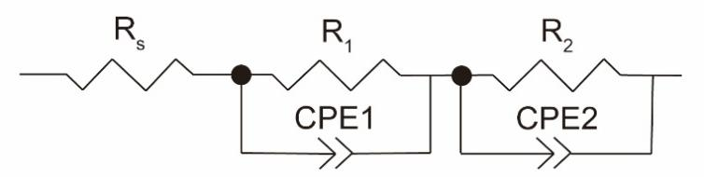

Fig. S48 Equivalent circuit model for fitting EIS data in 0.5 M H₂SO₄.

Fig. S49 In-situ EIS measurement of a, c Nyquist and b, d Bode plots for a, b Ru@m-ZrO₂/C and c, d Ru@t-ZrO₂/C in 0.5 M H₂SO₄.

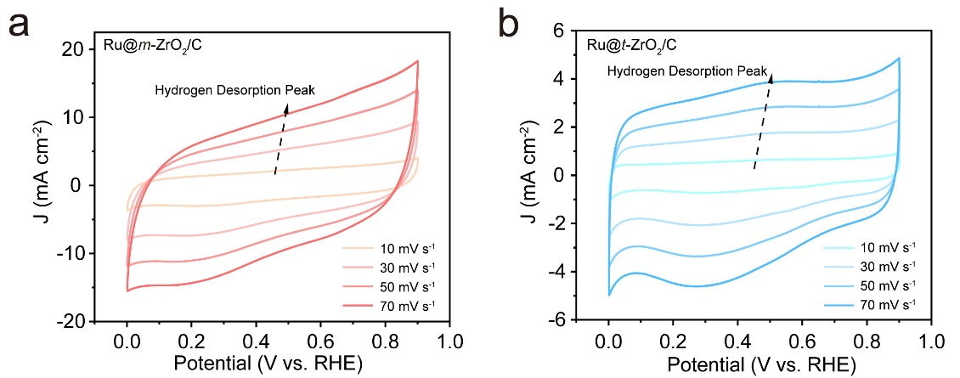

Fig. S50 In-situ CV curves of a Ru@m-ZrO₂/C and b Ru@t-ZrO₂/C with the scan rate from 10 to 70 mV s⁻¹ in 0.5 M H₂SO₄.

Fig. S51 Tafel slope of Ru@m-ZrO₂/C and Ru@t-ZrO₂/C estimated from R₂ in 0.5 M H₂SO₄.

Fig. S52 Optimized structures of a Ru₅/m-ZrO₂ and b Ru₅/t-ZrO₂.

Fig. S53 Binding energy of Ru₅ cluster on m-ZrO₂ and t-ZrO₂.

Fig. S54 PDOS profiles of Zr d orbital for Ru₅/m-ZrO₂ and Ru₅/t-ZrO₂.
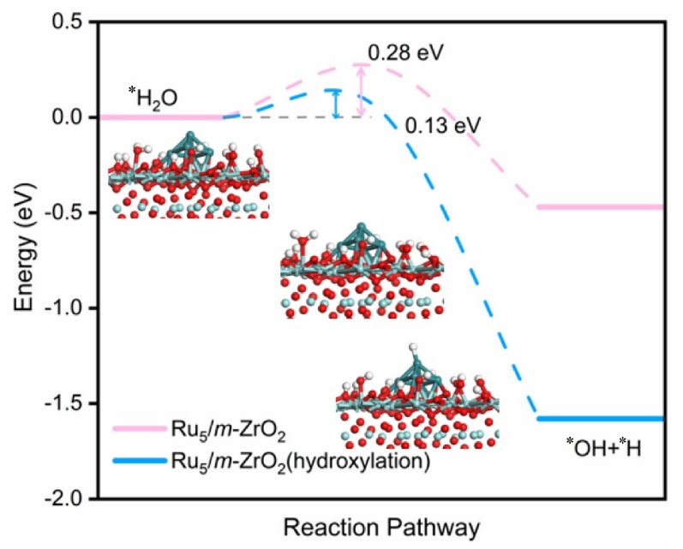

Fig. S55 Adsorption energy and energy barrier for surface hydroxylation of Ru₅/m-ZrO₂.

Fig. S56 Selected hydrogen adsorption sites on a Ru₅/m-ZrO₂ and b Ru₅/t-ZrO₂.

Fig. S57 Comparison of overpotential for Ru@m-ZrO₂/C, Ru@t-ZrO₂/C, Pt/C and Ru/C in 1 M KOH and 1 M KOH + 2 M NaCl.

Fig. S58 LSV curves of a Ru@m-ZrO₂/C, b Ru@t-ZrO₂/C, c Pt/C and d Ru/C in 1 M KOH + x M NaCl (x = 0, 0.5, 2).

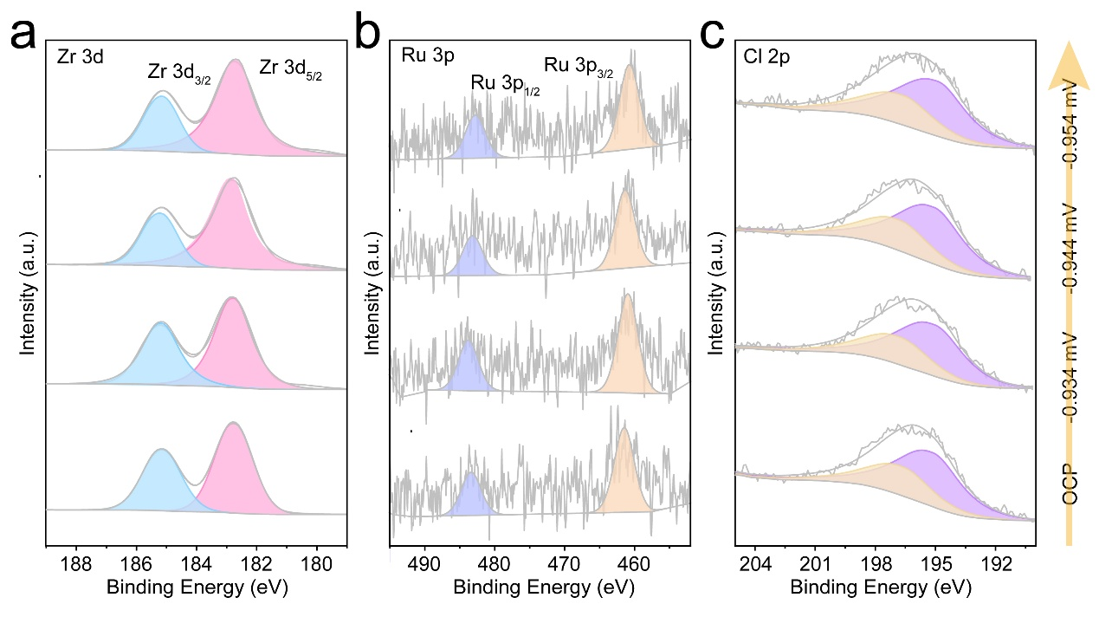

Fig. S59 XPS spectra of Ru@m-ZrO₂/C for a Zr 3d, b Ru 3p and c Cl 2p in 1 M KOH + 2 M NaCl.

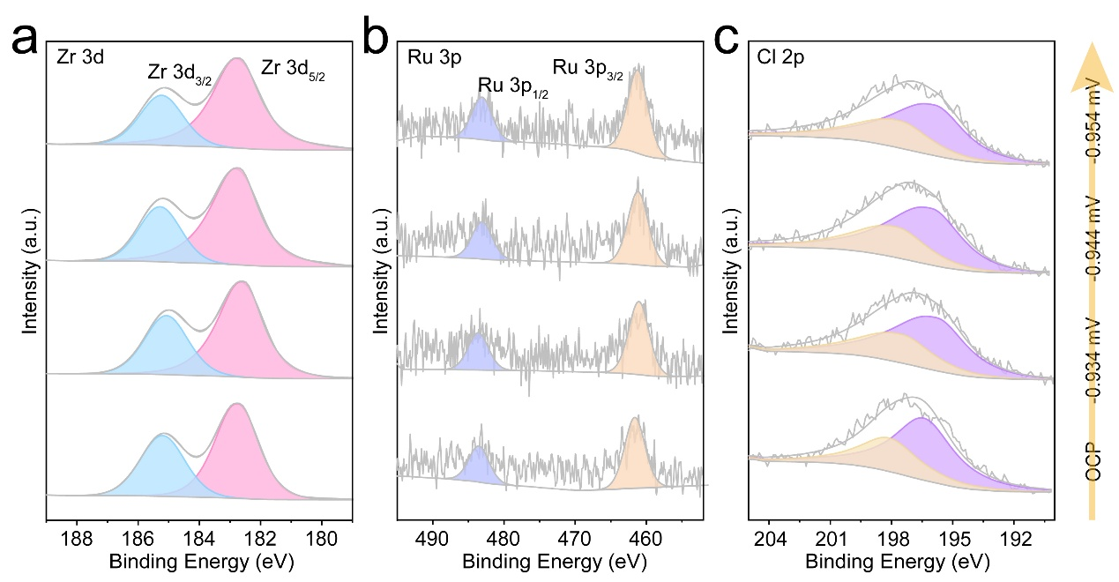
Fig. S60 XPS spectra of Ru@t-ZrO₂/C for a Zr 3d, b Ru 3p and c Cl 2p in 1 M KOH + 2 M NaCl.

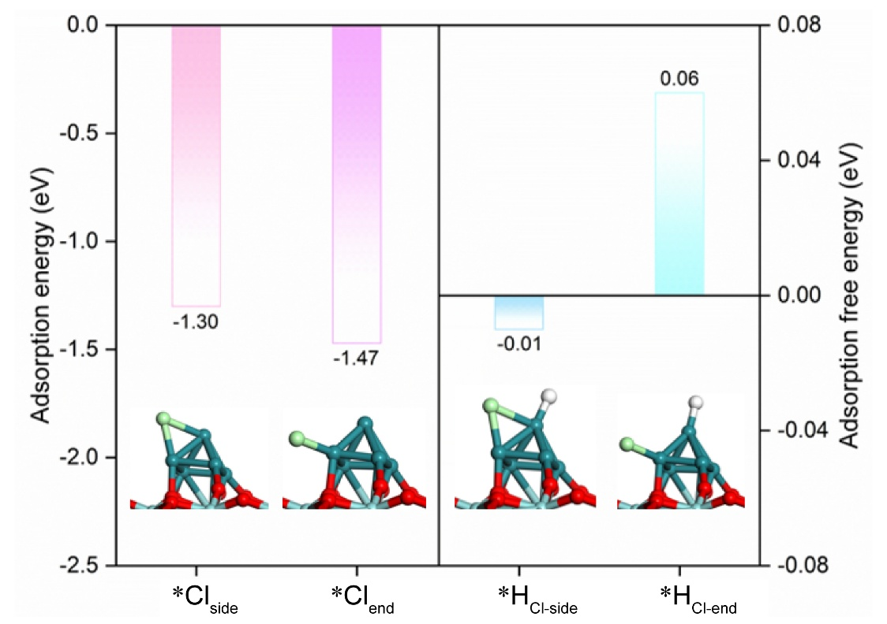

Fig. S61 Adsorption energy of Cl⁻ on Ru₅/m-ZrO₂.

Fig. S62 LSV curves of Ru@m-ZrO₂/C, Ru@t-ZrO₂/C, Pt/C and Ru/C in M KOH and 1 M KOH + simulated seawater.

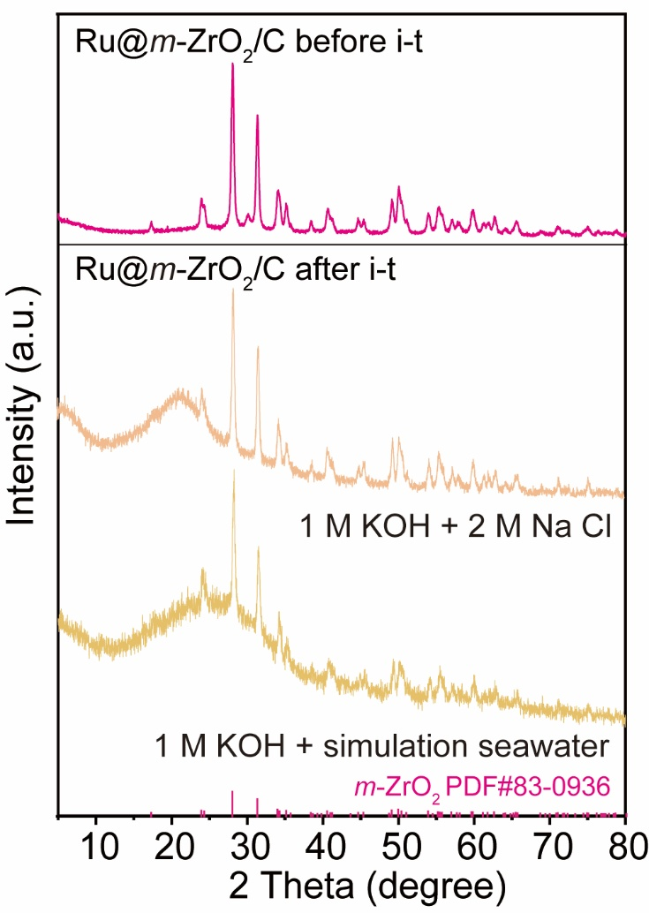

Fig. S63 XRD patterns of Ru@m-ZrO₂/C before and after i-t test in 1 M KOH + 2 M NaCl and 1 M KOH + simulated seawater, respectively.

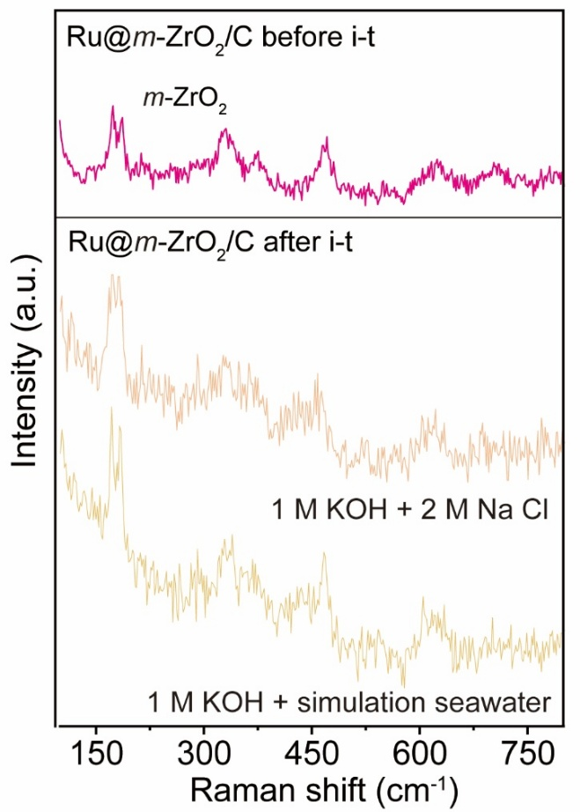

Fig. S64 Raman spectra of Ru@m-ZrO₂/C before and after i-t test in 1 M KOH + 2 M NaCl and 1 M KOH + simulated seawater, respectively.
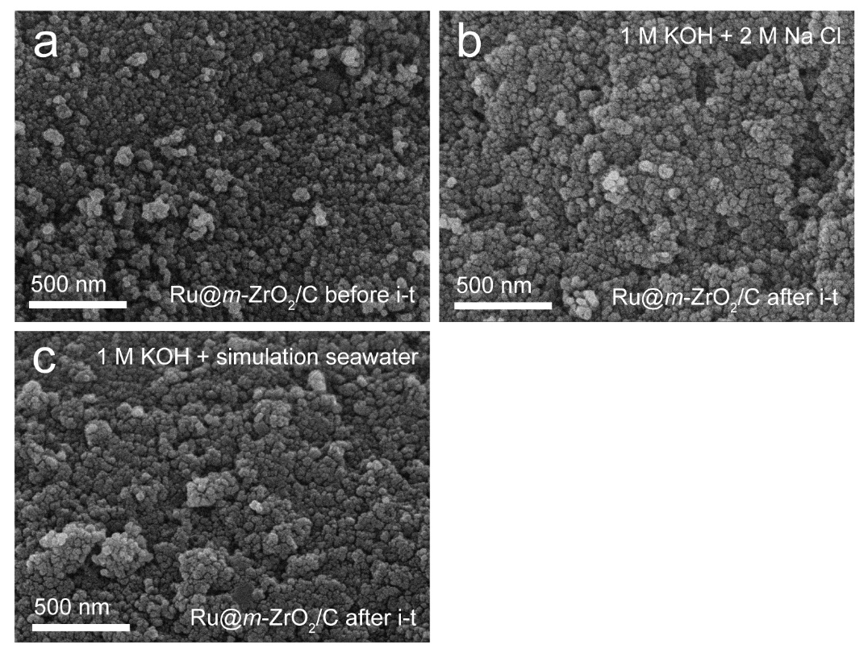

Fig. S65 SEM images of Ru@m-ZrO₂/C a before, b after i-t test in 1 M KOH + 2 M NaCl and c after i-t test in 1 M KOH + simulated seawater.
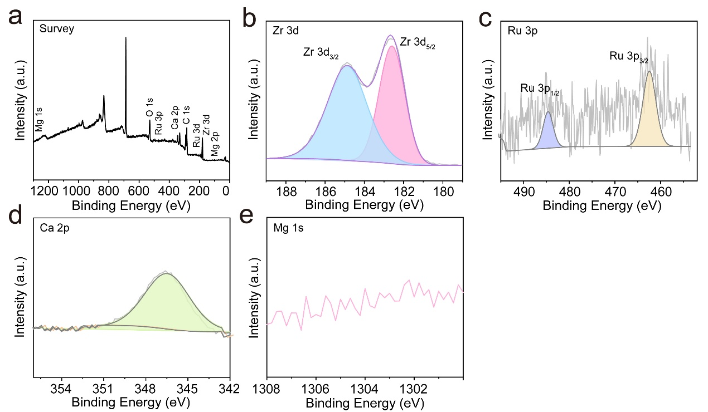

Fig. S66 XPS spectra of Ru@m-ZrO₂/C for a survey, b Zr 3d, c Ru 3p, d Ca 2p and e Mg 1s after i-t test in 1 M KOH + simulated seawater.

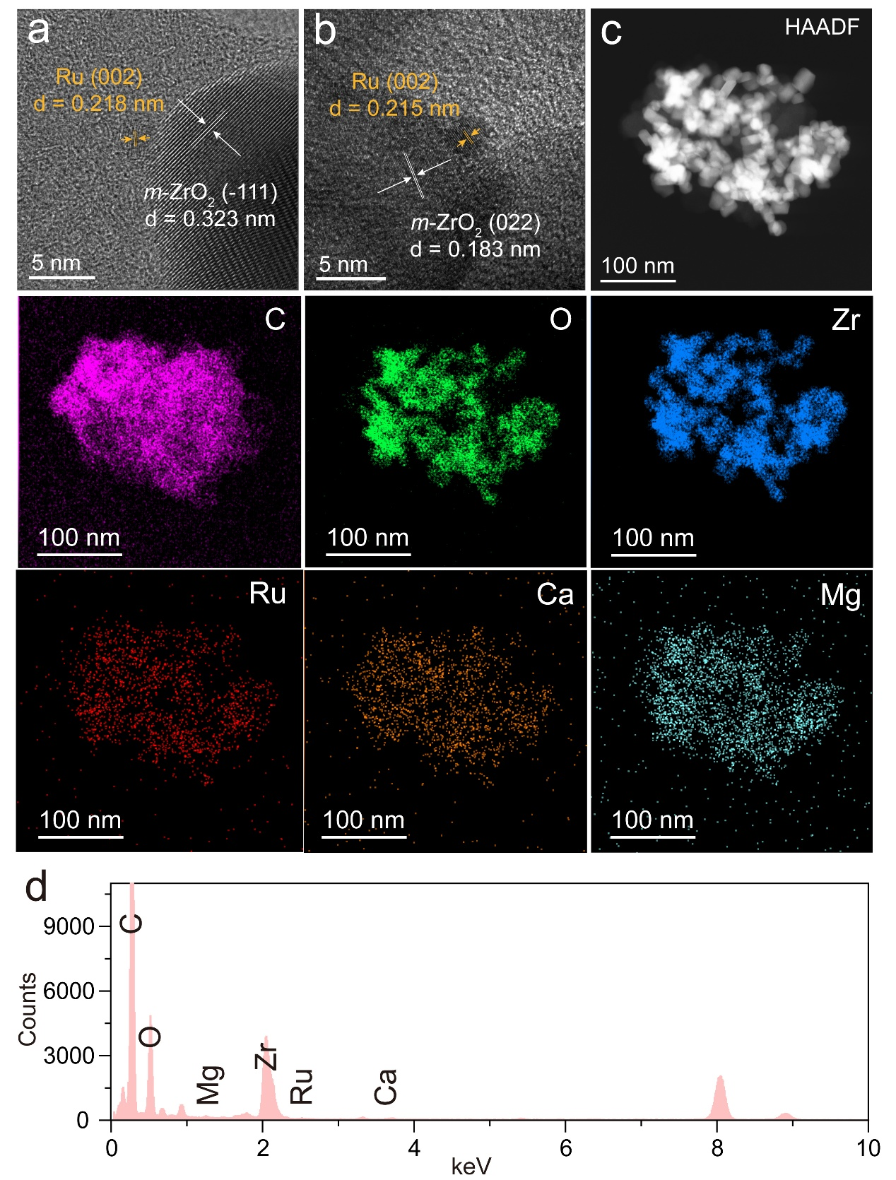

Fig. S67 a, b HRTEM images, c HAADF image and the corresponding elemental mapping for C (pink), O (green), Zr (blue), Ru (red), Ca (orange) and Mg (cyan), d EDS of Ru@m-ZrO₂/C after i-t test in 1 M KOH + simulated seawater.

Table S1 The content of Ru in Ru@m-ZrO₂/C and Ru@t-ZrO₂/C determined by ICP-AES
Sample | Ru content (%)
Ru@m-ZrO₂/C | 0.72
Ru@t-ZrO₂/C | 1.02

Table S2 EXAFS fitting parameters at the Zr K-edge for various samples
Sample | Coordination | CN | R(Å) | σ²(×1 0⁻³Å²) | ΔE(eV) | R-factor
Zr foil | Zr-Zr | 12 | 2.71 | -- | -- | --
Ru@m-ZrO₂/C | Zr-O | 8.1 | 2.15 | 9.3 | -4.5 | 1.60%
Ru@m-ZrO₂/C | Zr-Zr | 6.3 | 3.48 | 6.0 | -4.5 | 1.60%
Ru@t-ZrO₂/C | Zr-O | 4.4 | 2.09 | 3.0 | -5.5 | 0.64%
Ru@t-ZrO₂/C | Zr-O | 2.4 | 2.30 | 4.6 | -5.5 | 0.64%
Ru@t-ZrO₂/C | Zr- Zr | 12.3 | 3.62 | 7.3 | -5.5 | 0.64%
CN: coordination numbers, R: bond distance; σ²: Debye-Waller factors, ΔE₀: the inner potential correction. R factor reflects the goodness of fit.

Table S3 EXAFS fitting parameters at the Ru K-edge for various samples
Sample | Coordination | CN | R(Å) | σ²(×10⁻³Å²) | ΔE(eV) | R-factor
Ru foil | Ru-Ru | 12 | 2.71 | -- | -- | --
RuO₂ | Ru-O | 6 | 2.01 | -- | -- | --
Ru@m-ZrO₂/C | Ru-O | 2.7 | 1.94 | 4.3 | -0.4 | 0.91%
Ru@m-ZrO₂/C | Ru-Ru | 2.5 | 2.69 | 5.9 | -0.4 | 0.91%
Ru@t-ZrO₂/C | Ru-O | 1.9 | 1.97 | 4.8 | -3.4 | 0.65%
Ru@t-ZrO₂/C | Ru-Ru | 4.1 | 2.67 | 5.1 | -3.4 | 0.65%
CN: coordination numbers, R: bond distance; σ²: Debye-Waller factors, ΔE₀: the inner potential correction. R factor reflects the goodness of fit.

Table S4 A series of Ru@m-ZrO₂/C and Ru@t-ZrO₂/C catalysts with different Ru cluster sizes
the amount of RuCl₃ precursor (mmol) | Ru cluster sizes on the catalyst (nm)
0.30 | Ru@m-ZrO₂/C (1.38 ± 0.06)
0.28 | Ru@m-ZrO₂/C (1.42 ± 0.06)
0.31 | Ru@m-ZrO₂/C (2.15 ± 0.05)
0.34 | Ru@m-ZrO₂/C (3.32 ± 0.65)
0.30 | Ru@t-ZrO₂/C (1.45 ± 0.07)
0.31 | Ru@t-ZrO₂/C (1.70 ± 0.04)
0.34 | Ru@t-ZrO₂/C (3.30 ± 0.07)

Table S5 The content of a series of Ru@m-ZrO₂/C and Ru@t-ZrO₂/C catalysts determined by ICP-AES.
the amount of RuCl₃ precursor (mmol) | Ru content on the catalyst (wt%)
0.30 | Ru@m-ZrO₂/C (0.72)
0.27 | Ru@m-ZrO₂/C (0.76)
0.29 | Ru@m-ZrO₂/C (1.43)
0.32 | Ru@m-ZrO₂/C (0.93)
0.30 | Ru@t-ZrO₂/C (1.02)
0.27 | Ru@t-ZrO₂/C (0.89)
0.29 | Ru@t-ZrO₂/C (1.35)
0.32 | Ru@t-ZrO₂/C (1.57)

Table S6 Comparison of the TOF for Ru@m-ZrO₂/C, Ru@t-ZrO₂/C, Pt/C and Ru/C in 1 M KOH
TOF (H₂ s⁻¹) @ η | Ru@m-ZrO₂/C | Ru@t-ZrO₂/C | Pt/C | Ru/C
η₁₀₀ | 0.04086 | 0.0226 | 0.03919 | 0.00936
η₂₀₀ | 0.12776 | 0.06226 | 0.11327 | 0.02564
Η₃₀₀ | 0.24587 | 0.1169 | 0.20365 | 0.04267

Table S7 HER performance comparison on the η₁₀, Tafel slopes, mass activities, TOF and R_{ct} of Ru@m-ZrO₂/C, Ru@t-ZrO₂/C, Pt/C and Ru/C in 1 M KOH
 | Ru@m-ZrO₂/C | Ru@t-ZrO₂/C | Pt/C | Ru/C
η₁₀ (mV) | 28 | 35 | 36 | 48
Tafel slope (mV dec⁻¹) | 31.4 | 42.2 | 51.0 | 69.9
Mass activity (A mg⁻¹) @ η = 50 mV | 2.72 | 1.22 | 0.06 | 0.15
TOF (H₂ s⁻¹) @ η = 100 mV (CO-stripping) | 0.0409 | 0.0226 | 0.0392 | 0.0094
R_{ct} (Ω) | 20.4 | 24.6 | 30.4 | 33.1

Table S8 Comparison of the HER activity of the Ru@m-ZrO₂/C with other reported catalysts in 1 M KOH.
Catalysts | η₁₀ (mV) | Tafel slope (mV dec⁻¹) | Reference
Ru@m-ZrO₂/C | 28 | 31.4 | This work
Ru@t-ZrO₂/C | 35 | 42.2 | This work
20% Pt/C | 36 | 51 | This work
5% Ru/C | 48 | 69.9 | This work
Pt/C₆₀ | 25 | 55 | Nat. Commun., 2023, 14, 2460.
Ru/HMCs-500 | 26.93 | 41.26 | J. Mater. Chem. A, 2023, 11(7), 3524-3534.
RuNi-alloy@SC | 34 | 55 | Chem. Eng. J., 2021, 417, 129319.
MSOR_{x} | 43 | 63.1 | Adv. Funct. Mater., 2023, 33, 2210939.
Rh/NiFeRh-LDH | 58 | 81.3 | Nano Lett., 2020, 20, 136.
5% Ru-Ti₃C₂T_{x} | 46 | 37.6 | J. Alloy. Compd., 2023, 960, 170764.
Ru/Co-CAT/CC | 38 | 32.1 | Adv. Energy Mater., 2023, 13(20), 2204177.
Ru-CrN/NC | 53 | 59 | J. Mater. Chem. A, 2024, 12, 8291-8301.
Ru@TiO₂ | 62 | 70 | Chem. Front., 2023, 10, 3852-3859.
NiRu-OH | 38 | 39 | Appl. Catal. B Environ., 2020, 269, 118824.
CoMnP/NF | 53.9 | 63 | Int. J. Hydrogen Energy, 2022, 47(26), 12927-12936.
Pt@Mo-S-Ni-CNTs | 61.2 | 52.3 | Carbon, 2024, 224, 119061.
Pt₁/Ni(OH)₂/C | 55 | 52.1 | Energy Environ. Sci., 2023, 16, 1035-1048.
Ir/WO_{x}/rGO | 53 | 62 | Energy Environ. Mater., 2021, 4, 681-686.
Ru@1T-MoS₂ MXene | 44 | 47 | Adv. Funct. Mater., 2023, 33(13), 2212514.
Pt₁/NMHCS | 42 | 38 | Adv. Mater., 2021, 33, 2008599.
Ru SAs-NiP | 57 | 75 | Nano Energy, 2021, 80, 105467.
SA-Ru-MoS₂ | 76 | 21 | Small Methods, 2019, 3, 1900653.
Ru-Fe-P | 44 | 80 | Appl. Catal. B Environ., 2020, 263 118324.
MoP/CNT | 86 | 73 | Adv. Funct. Mater., 2018, 28, 1706523.
Ru-NPs/SAs@N-TC | 97 | 58 | Adv. Funct. Mater., 2020, 30, 2003007.

Table S9 Comparison of the HER activity of the Ru@m-ZrO₂/C with other reported catalysts in 0.5 M H₂SO₄.
Catalysts | η₁₀ (mV) | Tafel slope  (mV dec⁻¹) | Reference
Ru@m-ZrO₂/C | 56 | 49.4 | This work
Ru@t-ZrO₂/C | 67 | 62.0 | This work
20% Pt/C | 33 | 16.6 | This work
5% Ru/C | 82 | 81.9 | This work
Ru-MoO_{3-x}/Mo₂AlB₂ | 38 | 57.1 | Angew. Chem. Int. Ed., 2025, 64(24), e202504084
Co₅Ru₁@NCNT/PF | 45 | 64 | Adv. Sci., 2022, 9, 2200010.
Ru-CrN/NC | 53 | 59 | J. Mater. Chem. A, 2024, 12, 8291.
NCAG/Ru-3 | 65 | 68.8 | Chem. Eng. J, 2022, 442, 136337.
RuS_{x}/S-GO | 31 | 40 | Small, 2019, 15, 1904043.
s-RuS₂/S-rGO | 69 | 64 | ACS Appl. Mater. Interfaces, 2018, 10 (40), 34098-34107.
Cu@Cu₃P-Ru/CCG-500 | 102.5 | 63 | Appl. Catal. B Environ., 2023, 326, 122402.
CoRu/NC-700 | 6 | 21 | Chem. Eng. J., 2022, 450, 138026.
N-RuS₂/Ru | 120 | 53 | RSC Adv., 2020, 10 (30), 17862-17868.
RuIrO_{x} | 12 | 21 | Nat. Commun., 2019, 10, 4875.
SL-Ni-Ru-VS₂ | 20 | 34 | Small, 2024, 20, 2311217.
RuB₂ | 53 | 66.9 | ACS Energy Lett., 2020, 5(9), 2909-2915.
CoRu@NG-3 | 52 | 65 | Electrochim. Acta, 2021, 382, 138337.
0.04-Ru@CN-6 | 30 | 42 | J. Colloid Interface Sci., 2021, 604, 885.
RuSe₂/CNTs-650 | 64 | 42.04 | Nanoscale, 2022, 14 (3), 790-796.
RuCu NSs/C‐250 °C | 19 | 27.3 | Angew. Chem. Int. Ed., 2019, 58, 13983-13988.
Ru/NG-750 | 54 | 44 | ACS Appl. Mater. Inter., 2017, 9, 3785.
Co₅Ru₁@NCNT/PF | 45 | 64 | Adv. Sci., 2022, 9 (15), 2200010.
29.1 wt% Rh/SiNW | 110 | 24 | Nat. Commun., 2016, 7, 12272.
Ru/RuS₂-2 | 45 | 24.4 | Angew. Chem. Int. Ed., 2021, 60 (22), 12328-12334.

Table S10 Fitting parameters of the in-situ EIS curves for Ru@m-ZrO₂/C in 1 M KOH
E (mV) | R_{s} | CPE1-T | CPE1-P | R₁ | CPE2-T | CPE2-P | R₂
0 | 9.424 | 0.007280 | 0.67315 | 112.9 | 0.003697 | 1.056 | 3791
-5 | 9.541 | 0.007418 | 0.65769 | 119.5 | 0.004553 | 1.071 | 578.0
-10 | 9.703 | 0.005467 | 0.72207 | 59.58 | 0.008862 | 0.9477 | 179.5
-15 | 10.05 | 0.005271 | 0.72484 | 51.60 | 0.013146 | 1.011 | 56.09
-20 | 10.74 | 0.005288 | 0.71446 | 48.62 | 0.028468 | 1.147 | 15.64

Table S11 Fitting parameters of the in-situ EIS curves for Ru@t-ZrO₂/C in 1 M KOH.
E (mV) | R_{s} | CPE1-T | CPE1-P | R₁ | CPE2-T | CPE2-P | R₂
0 | 10.66 | 0.007368 | 0.63552 | 36.38 | 0.011858 | 1.015 | 6643
-5 | 10.42 | 0.010371 | 0.54921 | 50.17 | 0.012939 | 1.050 | 1161
-10 | 12.71 | 0.009088 | 0.51019 | 87.34 | 0.020134 | 1.130 | 120.2
-15 | 13.56 | 0.005805 | 0.60386 | 58.63 | 0.065626 | 0.884 | 44.74
-20 | 12.85 | 0.004999 | 0.62712 | 55.25 | 0.32741 | 1.075 | 14.29

Table S12 Fitting parameters of the in-situ EIS curves for Ru@m-ZrO₂/C in 0.5 M H₂SO₄.
E (mV) | R_{s} | CPE1-T | CPE1-P | R₁ | CPE2-T | CPE2-P | R₂
0 | 9.302 | 0.004856 | 0.77435 | 192.0 | 0.005734 | 0.93836 | 8446
-10 | 9.004 | 0.004476 | 1.1970 | 34.25 | 0.004817 | 0.70121 | 3952
-20 | 8.751 | 0.003344 | 1.1400 | 37.23 | 0.006732 | 0.63067 | 1471
-30 | 8.871 | 0.003202 | 1.1700 | 22.53 | 0.006343 | 0.61964 | 212.3
-40 | 8.542 | 0.034723 | 0.35279 | 23.08 | 0.002598 | 0.85975 | 71.99

Table S13 Fitting parameters of the in-situ EIS curves for Ru@t-ZrO₂/C in 0.5 M H₂SO₄.
E (mV) | R_{s} | CPE1-T | CPE1-P | R₁ | CPE2-T | CPE2-P | R₂
0 | 11.76 | 0.0066586 | 1.164 | 55.94 | 0.0043886 | 0.75457 | 16974
-10 | 11.28 | 0.0045404 | 1.117 | 73.52 | 0.0056266 | 0.70275 | 7953.8
-20 | 11.25 | 0.0034961 | 1.083 | 71.51 | 0.0079477 | 0.63686 | 1724.0
-30 | 11.36 | 0.0033525 | 1.117 | 43.82 | 0.0073954 | 0.63206 | 217.40
-40 | 9.114 | 0.0026221 | 0.86836 | 102.5 | 0.095085 | 0.12573 | 89.520

Table S14 Comparison of the HER activity of the Ru@m-ZrO₂/C with other reported catalysts in alkaline simulated seawater.
Catalysts | Electrolyte | Overpotential (mV) | Reference
Ru@m-ZrO₂/C | 1 M KOH + 2 M NaCl | 42@ 10 mA cm⁻²  129@ 100 mA cm⁻² | This work
Ru@t-ZrO₂/C | 1 M KOH + 2 M NaCl | 47@ 10 mA cm⁻²  159@ 100 mA cm⁻² | This work
20% Pt/C | 1 M KOH + 2 M NaCl | 53@ 10 mA cm⁻²  182@ 100 mA cm⁻² | This work
5% Ru/C | 1 M KOH + 2 M NaCl | 68@ 10 mA cm⁻²  239@ 100 mA cm⁻² | This work
Ru@MoC | 1 M KOH + 0.5 M NaCl | 58@ 10 mA cm⁻² | Angew. Chem. Int. Ed., 2025, 60(30), e202505031.
Ni@O-C/CNTs | 1 M KOH + 0.5 M NaCl | 47@ 10 mA cm⁻² | The Innovation Materials, 2025, 3(3), 100148.
Ti/TiO₂@NiBx (PEE) | 1 M KOH + 0.5 M NaCl | 91@ 10 mA cm⁻² | Chem. Eng. J. 2022, 430, 132881.
Ru@m-ZrO₂/C | 1 M KOH + simulate seawater | 158@ 100 mA cm⁻² | This work
Ru@t-ZrO₂/C | 1 M KOH + simulate seawater | 199@ 100 mA cm⁻² | This work
20% Pt/C | 1 M KOH + simulate seawater | 291@ 100 mA cm⁻² | This work
5% Ru/C | 1 M KOH + simulate seawater | 274@ 100 mA cm⁻² | This work
Co@RuCo-3 | 1 M KOH + seawater | 161@ 100 mA cm⁻² | Appl. Catal. B Environ., 2022, 315, 121554.
Ni₂P-Fe₂P/NF | 1 M KOH + seawater | 135@ 10 mA cm⁻² | Adv. Funct. Mater., 2020, 31, 2006484.
Co-MoSe₂ | 1 M KOH + seawater | 190@ 100 mA cm⁻² | ACS Appl. Mater. Interfaces, 2022, 14, 10246.
Ru/B-CoP | 1 M KOH + seawater | 82@ 10 mA cm⁻² | Chem. Eng. J., 2023, 452, 139175.
S-NiMoO₄@NiFe-  LDH/NF | 1 M KOH + seawater | 220@ 100 mA cm⁻² | J. Colloid Interface Sci., 2022, 613, 349–358
Ni₂P-Fe₂P | 1 M KOH + seawater | 252@ 100 mA cm⁻² | Adv. Funct. Mater., 2021, 31(1): 2006484.
Mn-MoWNi | 1 M KOH + seawater | 261@ 100 mA cm⁻² | Fuel, 2024, 372, 132281.
NC-Ni₃N21 | 1 M KOH + seawater | 290@ 100 mA cm⁻² | ACS Sustain. Chem. Eng., 2023, 11(17): 6556-6566.
NiCoHPi@Ni₃N/NF | 1 M KOH + seawater | 182@ 100 mA cm⁻² | ACS Appl. Mater. Interfaces, 2022, 14, 22061-22070.

Table S15 Comparison of the AEMWE device performance of Ru@m-ZrO₂/C || NiFe-LDH and recently-reported AEMWE devices in 1 M KOH.
AEMWE devices | Operation temperature (°C) | Cell voltage (V) | Reference
Ru@m-ZrO₂/C || NiFe-LDH//NF | 60 | 1.64@0.5 A cm⁻²  1.76@1 A cm⁻²  1.98@2 A cm⁻² | This work
Ru_{SA/NP}-PNCFs || NiFe-LDH | 20 | 1.77@0.5 A cm⁻² | Joule, 2024, 8, 1790-1803.
UP-RuNiSAs/C || NiFeO_{x} | 70 | 1.70@0.5 A cm⁻²  1.95@1 A cm⁻² | Nat. Commun., 2024, 15, 2218.
SL-Pt cluster || IrO₂ | / | 1.59@0.5 A cm⁻²  1.74@1 A cm⁻² | Adv. Funct. Mater., 2022, 33, 2212752.
Li_{3.0}RuSn_{0.8} NWs/C || NiFeO_{x}H_{y} | 80 | 1.689@1 A cm⁻² | J. Am. Chem. Soc., 2025, 147, 7711-7720.
Ru/Ni-N4C-300 || NiFe-LDH | 50 | 1.72@0.5 A cm⁻² | Adv. Funct. Mater., 2025, 35, 2416071.
Ru-YNC || NiFe-LDH | 80 | 1.78@0.5 A cm⁻²  1.87@1 A cm⁻² | Energy Environ. Sci., 2025, 18(12), 6141-6153.
Pt/C_{com} || NiFe-LDH | 80 | 1.90@0.5 A cm⁻² | Energy Environ. Sci., 2025, 18(12), 6141-6153.
Ru/C_{com} || NiFe-LDH | 80 | 2.03@0.5 A cm⁻² | Energy Environ. Sci., 2025, 18(12), 6141-6153.
Pt₁+n/Ni₃S₂ || RuO₂ | 80 | 2.00@0.5 A cm⁻² | Appl. Catal. B Environ., 2024, 354, 124074.
Pt/NiCoP@MXene || NiFe-LDH | 80 | 1.74@0.5 A cm⁻²  1.80@1 A cm⁻² | Angew. Chem., Int. Ed., 2024, 63, e202401819.
Fe₂P-Co₂P ǀǀ NPC NiFe(OH)_{x}-Ni₃S₂ | 60 | 1.73@1 A cm⁻² | ACS Nano, 2023, 17, 24070.
Mn-O-Ru || RuO₂ | 25 | 1.97@0.25 A cm⁻² 2.36@0.5 A cm⁻² | Adv. Mater., 2023, 35, 2303331.
NA-Ru₃Ni/C || NA-Ru₃Ni/C | 60 | 1.82@0.5 A cm⁻² 2.05@1 A cm⁻² | Energy Environ. Sci., 2023, 16, 285-294.
Ru-LC-Ni(OH)₂ || NiFe-LDH | 80 | 1.65@0.5 A cm⁻² 1.69@1 A cm⁻² | Angew. Chem., Int. Ed., 2024, 136(7), e202317220.
PtPd-HEA || NiFe-LDH | 80 | 1.81@1 A cm⁻² | ACS Catal., 2025, 15, 11022-11033.
Pt/CoMoO₄ || NiFe-LDH | R.T. | 1.63@1 A cm⁻² | Adv. Funct. Mater., 2025, 2423537.
PtRu/C || IrO₂ | 60 | 2.00@1.75 A cm⁻² | Electrochem. Soc., 2021, 168, 054522.
NiCu MMO || Ir | 50 | 2.00@1.85 A cm⁻² | Electrochim. Acta, 2021, 371, 137837.
Ru₁-Mo₂C ǀǀ NiFe LDH | 65 | 1.83@1.0 A cm⁻²  2.03@2.0 A cm⁻² | Energy Environ. Sci., 2024, 17, 1397.
CoNiS || CoNiS | 60 | 2.00@2.2 A cm⁻² | Nat. Commun., 2022, 13, 7956.

