Supporting Information for
Rheologically Engineered 3D-Printed Highly Loaded Magneto-Dielectric Absorbers for Device-Level Electromagnetic Compatibility
Yuheng Jiang^{1, †}, Zihao Chen^{1, †}, Xiao Sun^{1, 2,} *, Haotian Li¹, Jinlong Xie¹, Yueting Li¹, Xiaolei Nie¹, Feng Lan^{1, 3,} *, Yaxin Zhang^{1, 3} *, Qiye Wen^{1, 2, 3} *
¹ School of Electronic Science and Engineering, University of Electronic Science and Technology of China, Chengdu 611731, China
² Shenzhen Institute for Advanced Study, University of Electronic Science and Technology of China, Shenzhen 518110, China
³ Engineering Center of Integrated Optoelectronic & Radio Meta-chips, Chengdu, 611731, China
† Yuheng Jiang and Zihao Chen contributed equally to this work.
*Corresponding author. E-mail: qywen@uestc.edu.cn (Qiye Wen), langfeng@uestc.edu.cn (Feng Lan), xiaosun@uestc.edu.cn (Xiao Sun), zhangyaxin@uestc.edu.cn (Yaxin Zhang)
The content of supplementary material:
Total number of pages: 13
Total number of figures: 22
Total number of tables: 3
Supplementary Figures and Tables
Figure S1. (a) The relationship between τ_{y} and φ_{Gr} in Gr/PDMS ink, fitted by the Heymann model. (b) The relationship between τ_{y} and φ_{CIP} in CIP/PDMS ink, fitted by the Heymann model. (c) η of GC ink with endpoints from G₀C₅₀ to G₄C₀ at low shear rates (0.01 s⁻¹).
Figure S2. (a) Shear stress-shear rate curves and Herschel-Bulkley model fitting results. (b) τ_{y} obtained from the H-B model fitting as a function of GC ink composition. (c) Corresponding consistency coefficient K. (d) Rheological index n.
Figure S3. Rheological results from frequency sweeps of PDMS and GC inks: (a) storage modulus G' and (b) loss modulus G'' as functions of angular frequency (ω).
Compared with PDMS and G₀C₅₀, Gr-containing GC inks exhibit higher G' and G'' values with weaker frequency dependence, indicating the formation of a more stable physical network and a slower relaxation process.
Figure S4. Cross-sectional SEM images of representative GC samples: (a), (b) G₂C₂₅, (c) G₀C₅₀, and (d) G₄C₀.
G₀C₅₀ is dominated by spherical CIP particles dispersed in the PDMS matrix, while G₄C₀ shows a sheet-like Gr network. In G₂C₂₅, spherical CIP particles are spatially embedded among interconnected Gr sheets, confirming the formation of a representative multi-dimensional Gr/CIP network.
Figure S5. Top (a) and side (b) optical photographs of the corresponding GC series samples at different deposition times.
Figure S6. FTIR spectra of samples with different Gr/CIP ratios.
Figure S7. (a) XPS full spectrum of samples with different Gr/CIP ratios. (b)–(d) High-resolution XPS results for Fe 2p, C 1s and O 1s, respectively.
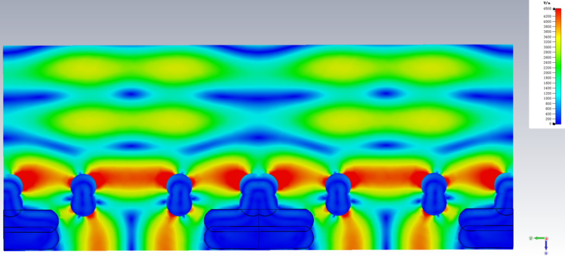
Figure S8. Electric field distribution of 3D-printed GCH absorber under 90 GHz.
Figure S9. (a)–(c) Relationship between the real part ε', imaginary part ε", and loss tangent tan δ_{ε} of planar samples with different GC formulations in the 0.2–1.2 THz band. (d) Cole-Cole plot of the representative G₂C₂₅ sample in the 0.2–1.2 THz band.
Figure S10. (a)-(c) Equivalent dielectric parameters ε', ε" and tan δ_{ε} of G₂C₂₅ formulation under different cellular gradient structures (H0–H4) and planar structures. (d) Normalized input impedance |Z_{in}/Z₀| of the corresponding structure as a function of frequency.
Figure S11. (a)–(d) RL curves of the honeycomb gradient structures (H0–H4) with different formulations (excluding G₂C₂₅) in the 0.2–1.2 THz.
Figure S12. (a)–(d) RL curves for gradient structures (H0–H4) with different formulations (excluding G₂C₂₅) in the 75–110 GHz. (e) Comparison of absorption performance of different formulations in the 75–110 GHz under a fixed H2 structure.
Figure S13. (a) RL response under different incident angles (0°–45°). (b) RL variation under different number of printed layers. (c) Comparison of RL in TE and TM polarization modes.
Figure S14. Electromagnetic parameters and Cole-Cole analysis of G₂C₂₅ in the 18–40 GHz frequency band: (a) ε' and ε'', (b) Cole-Cole plot, (c) μ' and μ'', (d) dielectric and magnetic loss tangents.
Figure S15. (a) Schematic diagram of the three-dimensional structure of the mesh matching layer. (b) Schematic diagram of the side view structure. (c) RL curves in the range of 18–40 GHz with different aperture widths (W).
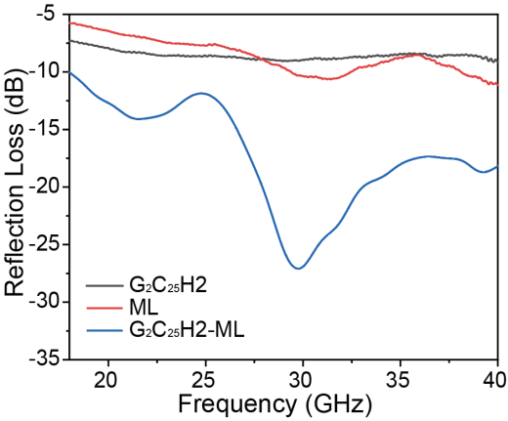
Figure S16. Comparison curves of RL for the G₂C₂₅H2 structure, matching layer (ML), and G₂C₂₅H2-ML composite structure in the 18–40 GHz band.
Figure S17. Supplementary RL curves of the G2C25H2 structure in the D/G bands (110–170 GHz, 170–220 GHz) and THz ranges: (a) 110–170 GHz, (b) 170–200 GHz, and (c) 1.2–4.0 THz.
Figure S18. Broadband electromagnetic stability of the GCH absorber after durability tests. (a) RL curves before and after 85 °C/85% RH aging for 168 h. (b) RL curves after repeated bending-releasing cycles at a bending radius (R) of 8.5 mm.
Figure S19. (a) Optical photograph of the fabricated THz RIS integrated with the 3D-printed GCH absorbing structure. (b) Photograph of the THz beam scanning test setup for the integrated RIS device.
Figure S20. (a)–(b) Comparison of antenna gain with scanning angle θ before and after introducing 3D printed RAM at 220 GHz under scanning angles of 30° and 35°, respectively. (c) Quantitative comparison of sidelobe suppression levels at different scanning angles. (d) Statistical results of specular reflection beamwidth.
Figure S21. Thermal conductivity and surface heat-transfer behavior of GC composite and pristine PDMS. (a) Schematic illustration of the infrared thermal-imaging test. The samples were first placed on a 100 °C hot stage for heating and then rapidly transferred to a room-temperature wooden substrate for cooling. (b) Surface temperature evolution of GC and PDMS during the heating–cooling process. (c) Thermal conductivity and thermal diffusivity of GC and PDMS measured at 70 °C.
Figure S22. Images illustrate the fighter jet model both without (a) and with (b) the GCH absorber affixed to its fuselage.

Component  Number | Gr/g | CIP/g | PDMS/g | Curing agent/g
G₀C₅₀ | 0.0 | 50.0 | 10.0 | 1.0
G₁C_{37.5} | 1.0 | 37.5 | 10.0 | 1.0
G₂C₂₅ | 2.0 | 25.0 | 10.0 | 1.0
G₃C_{12.5} | 3.0 | 12.5 | 10.0 | 1.0
G₄C₀ | 4.0 | 0.0 | 10.0 | 1.0
Table S1. The detailed compositions of GC functional inks.

Table S2. The detailed printing information.
X/Y Axis  movement speed (mm/s) | Z Axis  movement speed (mm/s) | X/Y axis movable limit  (mm) | Z axis movable limit  (mm) | Syringe volume  (mL)
15 | 5 | 300 | 40 | 50

Table S3. Comparison with previously reported absorbing materials.
Materials | Technique | Thickness  (mm) | EAB  (GHz) | RL_{min}  (dB) | EAB/t  (GHz·mm⁻¹) | Ref
mSiO₂ | Coating | 1.8 mm | 2300 GHz  (0.2-2.5 THz) | -29.8 | 1277.77 | [S1]
CIP/MXene | Coating | 1.5 mm | 2973.5 GHz  (26.5~3000 GHz) | -27.9 | 1486.75 | [S2]
3D Graphene | Foam | 4mm | 1045 GHz  (0.155-1.2 THz) | -19.0 | 261.25 | [S3]
Si₃N₄–SiC | Foam | 2.80 | 8.78 GHz  (9.20~17.98 GHz) | -51.6 | 3.16 | [S4]
MXene/GO | Foam | 4.00 | 1200 GHz  (0.2~2.0 THz) | -37.0 | 300.00 | [S5]
Gr/CF | Aerogel | 3.25 | 1208.72 GHz  (9.28-18 GHz/  0.3-1.5 THz) | -64.8 | 371.91 | [S6]
Gr/MWCNT | Aerogel | 8.00 | 25.7 GHz  (5.8~18 GHz/  26.5~40 GHz) | -39.7 | 3.21 | [S7]
Ag-Cu alloy | 3D-printing | 20.00 | 37 GHz  (3~40 GHz) | -24.5 | 1.85 | [S8]
RGO/CIP | 3D-printing | 3.20 | 3008.24 GHz  (8.99-17.23GHz/  0.5-3.5 THz) | -52.2 | 940.07 | [S9]
RGO | 3D printing | 6.40 | 35.5 GHz  (4.5-40 GHz) | -35.5 | 5.55 | [S10]
CIP/Gr | 3D printing | 4.25 | 3982 GHz  (18~4000 GHz) | -84.3 | 936.94 | This Work
CIP/Gr | 3D printing | 2.60 | 3933 GHz  (67~4000 GHz) | -84.3 | 1512.69 | This Work
(GF: Glass fiber, CF: Carbon Fiber, RGO: Reduced graphene oxide, Gr: Graphene, CNT: Carbon nanotube, MWCNT: Multi-walled carbon nanotube, CIP: Carbonyl iron powder, MXene: Ti₃C₂T_{x}).
Supplementary Reference
- Y. Guo, Z. Wang, S. Bi, Q. Sun, Y. Lu. Design and regulation of electromagnetic parameters of thz absorbing epoxy resin composite film for 6G electronic packaging. Mater. Today Phys. 51, 101655 (2025). https://doi.org/10.1016/j.mtphys.2025.101655
- Z. Chen, M. Luo, W. Jiao, Y. Jiang, J. Xie, et al. Multiscale magnetic-electric synergy in CIP/MXene/epoxy nano-micro composites for ultra-broadband absorption and enhanced thermal conductivity. Compos. Sci. Technol. 271, 111360 (2025). https://doi.org/10.1016/j.compscitech.2025.111360
- Z. Huang, H. Chen, Y. Huang, Z. Ge, Y. Zhou, et al. Ultra‐broadband wide‐angle terahertz absorption properties of 3D graphene foam. Adv. Funct. Mater. 28(2), 1704363 (2017). https://doi.org/10.1002/adfm.201704363
- Z. Xing, X. You, H. Ouyang, Q. Zhang, Y. Yang, et al. Porous and lightweight continuous sic fiber reinforced Si₃N₄–SiC composites for wide frequency electromagnetic wave absorption. Composites, Part B. 300, 112497 (2025). https://doi.org/10.1016/j.compositesb.2025.112497
- W. Ma, H. Chen, S. Hou, Z. Huang, Y. Huang, et al. Compressible highly stable 3d porous MXene/GO foam with a tunable high-performance stealth property in the terahertz band. ACS Appl. Mater. Interfaces. 11(28), 25369-25377 (2019). https://doi.org/10.1021/acsami.9b03406
- Y. Cao, Z. Cheng, R. Wang, X. Liu, T. Zhang, et al. Multifunctional graphene/carbon fiber aerogels toward compatible electromagnetic wave absorption and shielding in gigahertz and terahertz bands with optimized radar cross section. Carbon. 199, 333-346 (2022). https://doi.org/10.1016/j.carbon.2022.07.077
- Q. Zhang, Z. Du, M. Hou, Z. Ding, X. Huang, et al. Ultralight, anisotropic, and self-supported graphene/MWCNT aerogel with high-performance microwave absorption. Carbon. 188, 442-452 (2022). https://doi.org/10.1016/j.carbon.2021.11.047
- Z. Yang, Q. Liang, Y. Duan, P. Liu, X. Wang, D. Li. Electromagnetic characteristics and 3D-printing realization of a lightweight hierarchical wave-absorbing metastructure for low-frequency broadband absorption. J. Alloys Compd. 949, 169894 (2023). https://doi.org/10.1016/j.jallcom.2023.169894
- P. Liu, S. Shi, Y. Ni, K. Xu, Q. Gao, et al. Direct ink writing printed flexible double-layer staggered woodpile structure for multi-band compatible absorption of gigahertz and terahertz waves. Chem. Eng. J. 478, 147474 (2023). https://doi.org/10.1016/j.cej.2023.147474
- L. Yin, X. Tian, Z. Shang, D. Li. Ultra-broadband metamaterial absorber with graphene composites fabricated by 3D printing. Mater. Lett. 239, 132-135 (2019). https://doi.org/10.1016/j.matlet.2018.12.087

