Supporting Information for
From Screening to Site Control: Phytic-Acid Mediated P-Tuning of M-N Coordination to Balance Iodine Adsorption and Stability in Zn-I₂ Batteries
Yuxuan Jiang¹, Bingxin Sun¹, Mohsen Shakouri², Bin He³, Wang Zhang¹, Ran Wang^{1,4}, Tianxiao Sun⁵ and Huan Pang^{1,} *
¹School of Chemistry and Materials, Yangzhou University, Yangzhou 225002, P. R. China
²Canadian Light Source, University of Saskatchewan, Saskatoon, Saskatchewan, S7N 2V3, Canada
³Zhejiang Key Laboratory for Industrial Solid Waste Thermal Hydrolysis Technology and Intelligent Equipment, Department of Materials Engineering, Huzhou Normal University, Huzhou 313000, P. R. China
⁴Yangzhou Key Laboratory of Smart Materials and Clean Energy, Interdisciplinary Research Center for Advanced Energy, Yangzhou University, Yangzhou 225002, P. R. China
⁵Shanghai Synchrotron Radiation Facility, Shanghai Advanced, Research Institute, Chinese Academy of Sciences, Shanghai 201204, P. R. China
* Corresponding author. E-mail: huanpangchem@hotmail.com (Huan Pang)
S1 Supplementary Text
S1.1 Materials
The Powder X-ray diffraction (PXRD) patterns were performed by Bruker AXS D8 advance with Cu Kα radiation of 40 kV (λ=1.5418 Å). Scanning electron microscopy (SEM) images were obtained by Zeiss-Supra 55 microscope. Transmission electron microscopy (TEM) was recorded using Tecnai G2 F30 S-TWIN at an acceleration voltage of 300 kV. Raman spectroscopy was obtained by using Renishaw InVia Reflex (514 nm laser). Nitrogen sorption isotherms were carried out using a BELSORP-mini (BEL, Japan). The specific surface area (SSA) was analyzed by Multipoint Brunauer-Emmett-Teller (BET) technique. X-ray photoelectron spectroscopy (XPS) analysis was carried out using a Thermo Scientific ESCALAB 250Xi X-ray photoelectron spectrometer with Al Kα radiation of 1486.6 eV as the excitation source. The survey thickness is 2-3 nm. The concentration variations in these solutions were detected by the UV-vis spectroscopy. Synchrotron radiation-based soft X-ray absorption near-edge structure (XANES) characterizations were conducted at BL02B in the Shanghai Synchrotron Radiation Facility (SSRF).
S1.2 Battery assembling and test
The CR 2032-type coin cells were fabricated using the working electrode, zinc foil as anode electrode, glass fiber as the separator. The electrolyte is composed of 2M ZnSO₄ and (100 μL per cell). The GCD tests were estimated in the voltage window of 0.6-1.6 V. The rate capability was also tested by varying the current density from 0.1 A/g to 5 A/g on a battery measurement system (CT2001A, Wuhan Land, China) at room temperature. CV and EIS curves were measured on an electrochemical workstation (CHI660E, Chenhua, Shanghai, China). CV curves was performed from 1.6 V to 0.6 V at a scanning rate of 0.2 mV s⁻¹, and the frequency of EIS was performed form 100 kHz to 0.01 Hz at open-circuit potential. For In situ EIS measurements, Zn-iodine cells were discharged in galvanostatic mode at 0.1 A/g for 10 min, and then the cell was rest for 10 min to reach the quasi-open circuit voltage (QOCV). The EIS test is performed when the QOCV is slightly below the target voltage.
S1.3 Computation methods
All calculations were implemented with the CASTEP code. The Perdew-Burke-Ernzerhof (PBE) functional of the generalized gradient approximation (GGA) was used to calculate the exchange-correlation energy. The ultrasoft pseudopotential for every atom was adopted. The cutoff energy was 500 eV, the Γ-centered k-mesh was adopted as 3×3×1 for the geometry optimization of all structures. The convergence tolerances of energy change, maximum force, and maximum displacement were set as 2×10⁻⁶ eV/atom, 0.05 eV/Å, and 0.002 Å, respectively. To eliminate interactions between adjacent unit cells, a vacuum separation >15 Å was employed.
S2 Supporting Figures
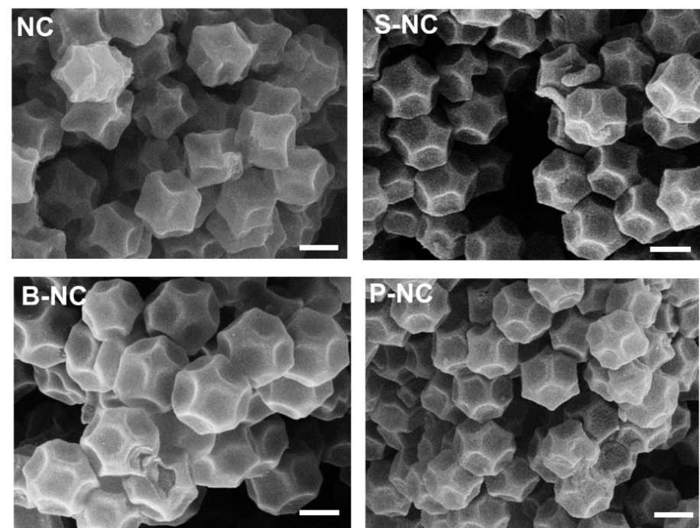

Fig. S1 SEM images of M₁-NC (the scale bars in the graphs are 400 nm).

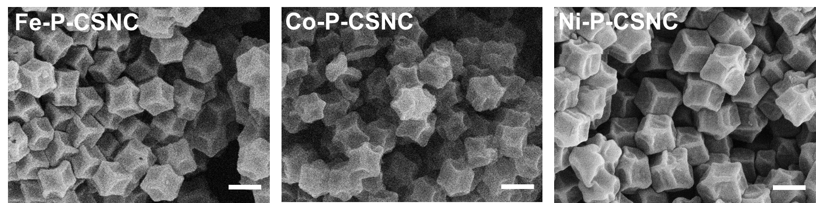

Fig. S2 SEM images of M₂-P-CSNC (the scale bars in the graphs are 400 nm).

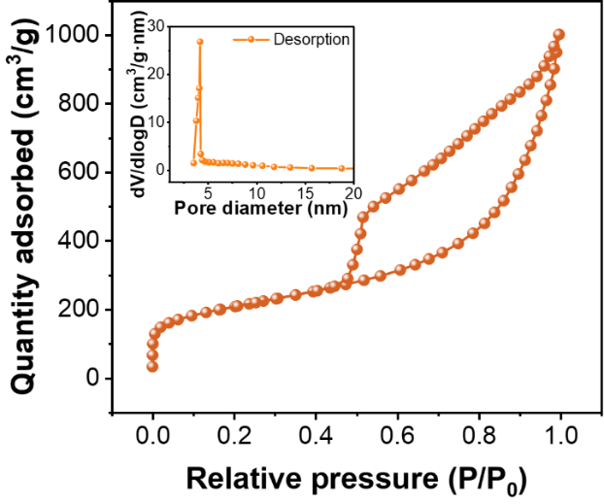

Fig. S3 Nitrogen adsorption isotherms and pore size distribution of Fe-P-CSNC.

Fig. S4 XRD patterns of different samples.

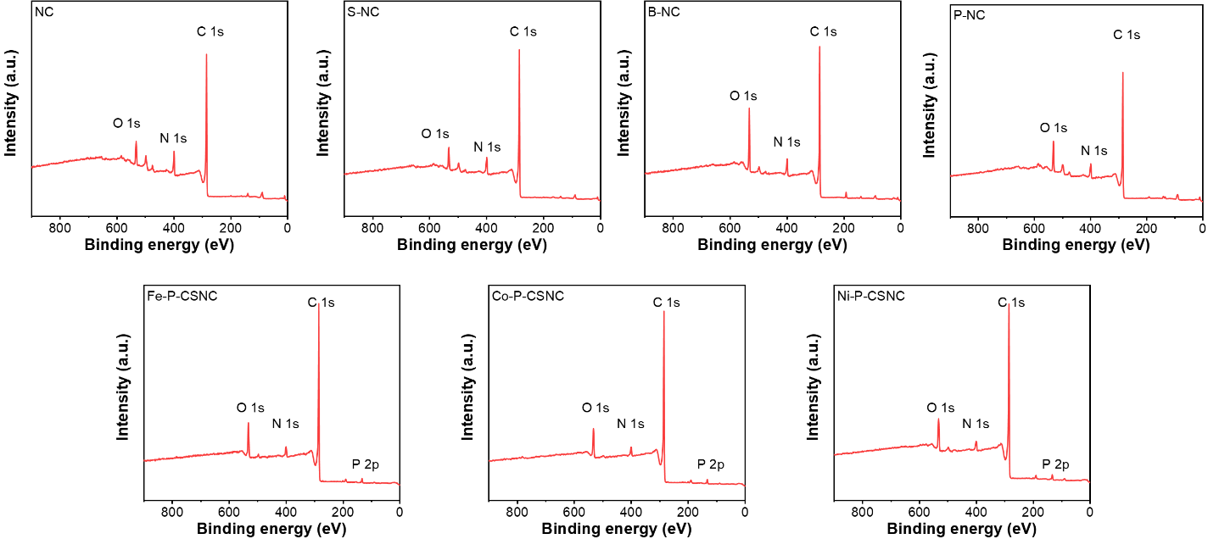

Fig. S5 Full XPS spectra of different samples.

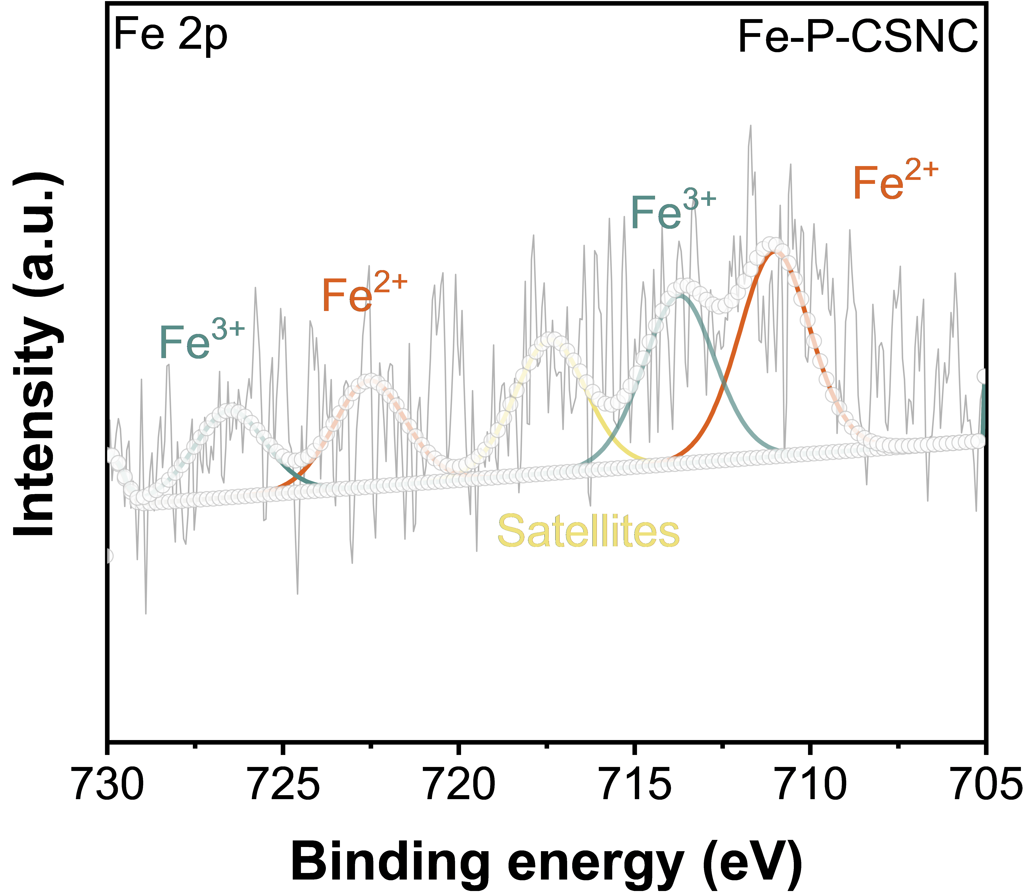

Fig. S6 XPS Fe 2p spectra of Fe-P-CSNC.

Fig. S7 CV curves at 0.2 mV s⁻¹.
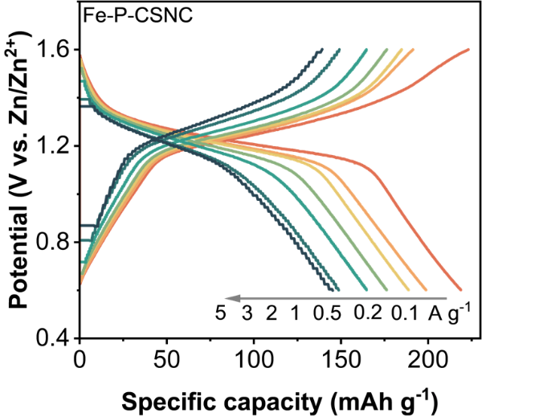

Fig. S8 GCD curves of Fe-P-CSNC at different rates.

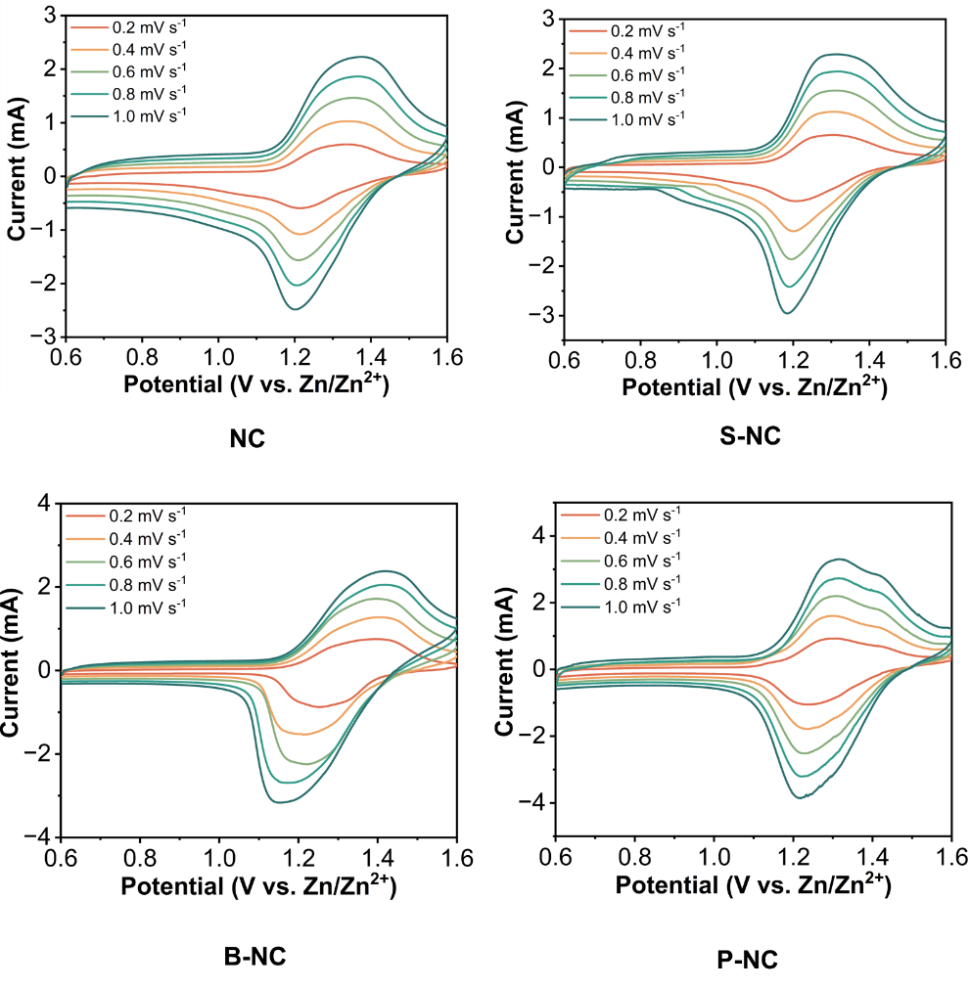
Fig. S9 CV curves of M₁-NC at different scan rate.
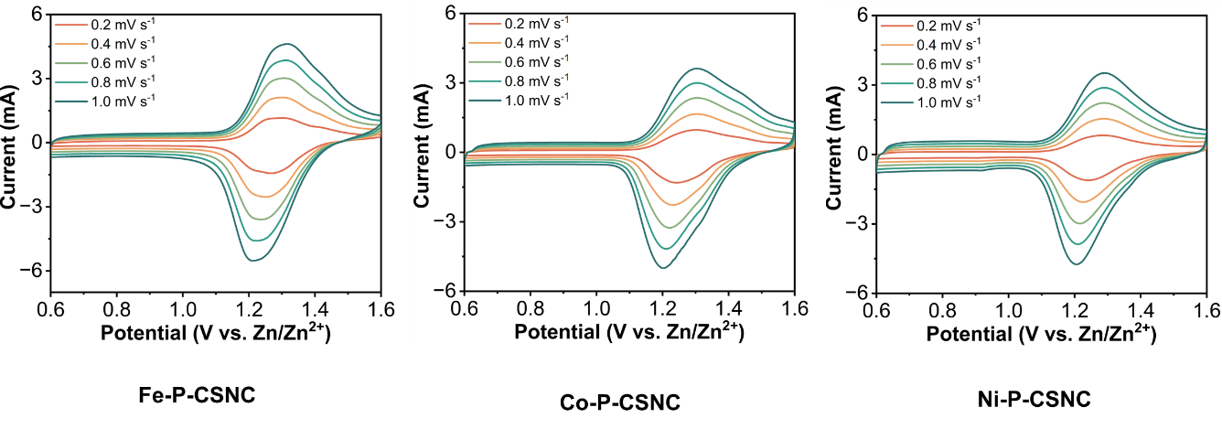Fig. S10 CV curves of M₂-P-CSNC at different scan rate.

Fig. S11 Linear fits of peak current with the square root of scanning speeds ranging from 0.2 to 1 mV s⁻¹.

Fig. S12 The capacitive contribution of NC at different scan rate.
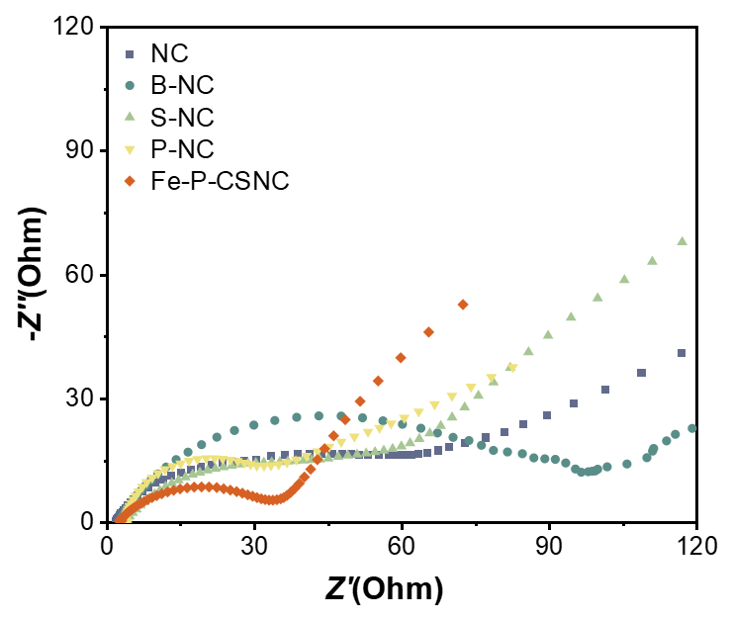

Fig. S13 EIS curves of all samples.

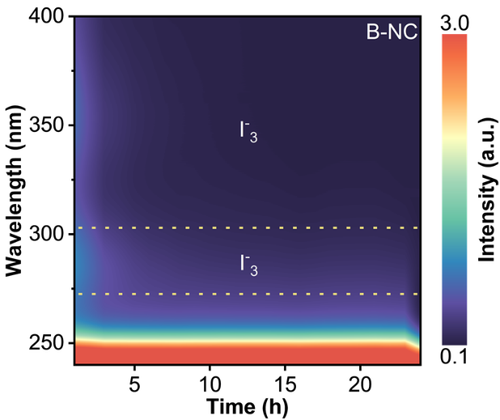

Fig. S14 In-situ monitoring of polyiodide solution adsorption on B-NC.

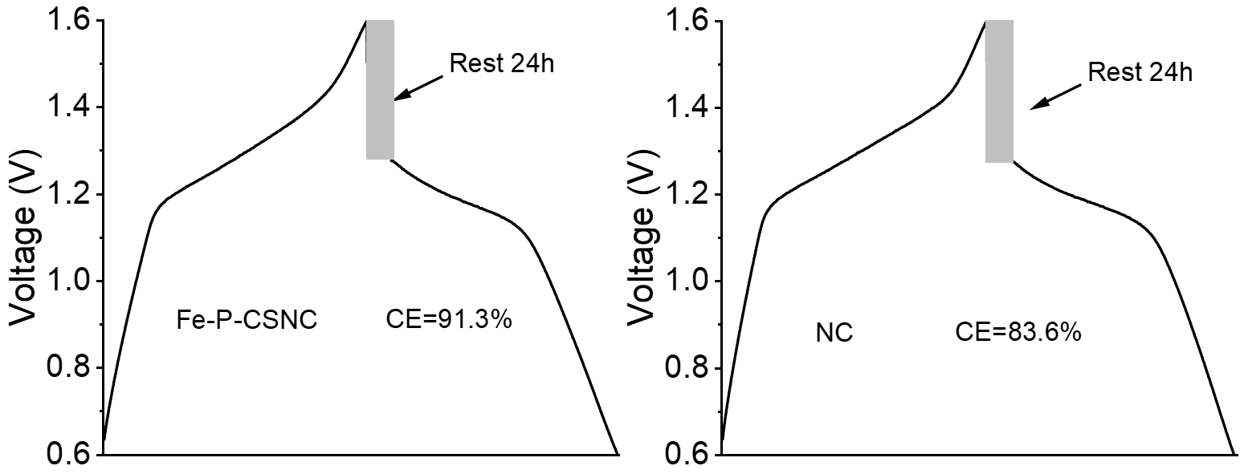

Fig. S15 The self-discharge capacity of the two typical cathodes after 24 h.
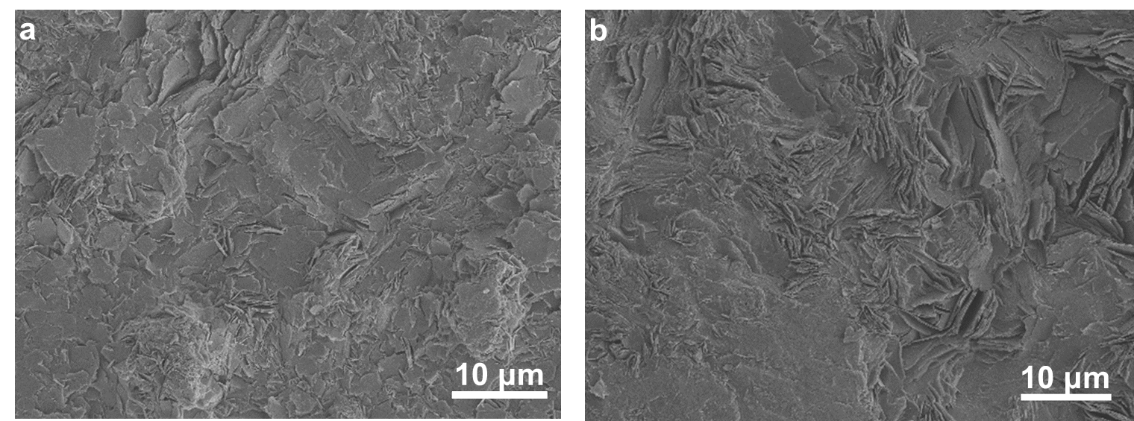

Fig. S16 SEM images of Zn, a Fe-P-CSNC as cathode and b NC as cathode.
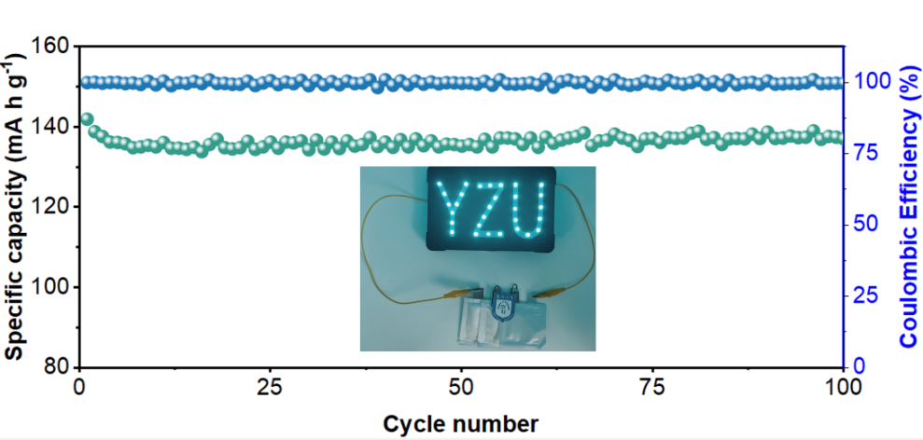

Fig. S17 The cycle performance of pouch cells based on Fe-P-CSNC.

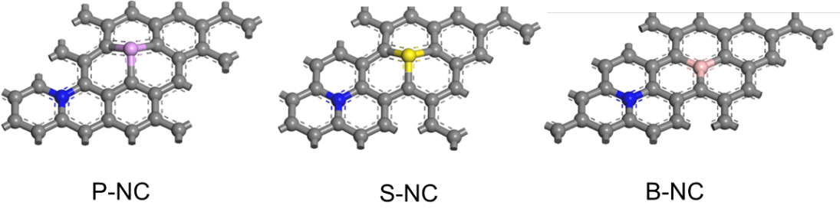

Fig. S18 The optimized geometry conformation models (M₁-NC).

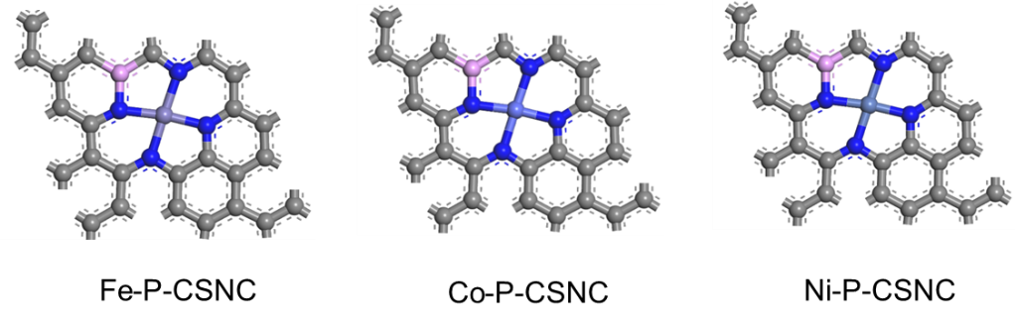
Fig. S19 The optimized geometry conformation models (M₂-P-CSNC).
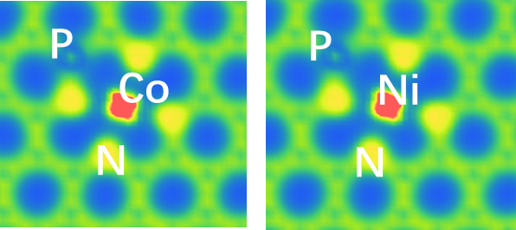
Fig. S20 The charge distribution of Co-P-CSNC and Ni-P-CSNC.

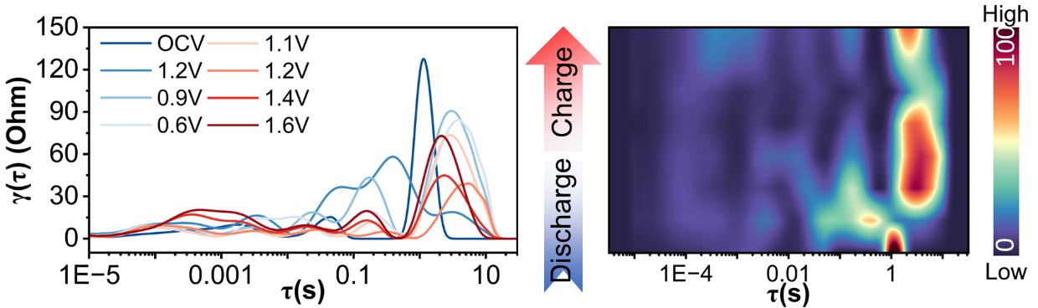

Fig. S21 DRT calculated from EIS measurements of NC at different voltages and corresponding contour plots.
Table S1 Elemental content of Fe element in Fe-P-CSNC measured by ICP-MS
Sample | Fe wt%
Fe-P-CSNC | 1.96
Table S2 Comparison of the Fe-P-CSNC/I₂ electrode with reported aqueous Zn–I₂ batteries
Sample | Capacity/mA h g^{–1} | Cycles | Current density/mA g^{–1} | References
NiSAs-HPC/I₂ | 179 | 1000 | 1100 | [S1]
Fe-NCF/I₂ | 169 | 1500 | 442 | [S2]
MPC/I₂ | 112 | 2000 | 1000 | [S3]
PANI-I₂ | 160 | 700 | 1500 | [S4]
PTCC900@I₂ | 100 | 3000 | 500 | [S5]
B-Fe-NC/I₂ | 158 | 10000 | 2210 | [S6]
NCCs/I₂ | 259 | 1000 | 100 | [S7]
PNC-1000-I₂ | 200 | 10000 | 1000 | [S8]
ZPC/I₂ | 99 | 1000 | 800 | [S9]
ODAI₂ | ~150 | 3500 | 1000 | [S10]
Fe-P-CSNC/I₂ | 163 | 20000 | 2000 | This work

Supplementary References
- L. Ma, Y. Ying, S. Chen, Z. Chen, H. Li et al., Electrocatalytic selenium redox reaction for high-mass-loading zinc-selenium batteries with improved kinetics and selenium utilization. Adv. Energy Mater. 12(26), 2201322 (2022). https://doi.org/10.1002/aenm.202201322
- S. Ding, Q. Chen, S. Chen, Y. Tian, J. Zhang, The dispersion of iron nitride among porous carbon fibers to enhance redox conversion for high-performance zinc-iodine batteries. Chin. Chemical Lett. 34(11), 108232 (2023). https://doi.org/10.1016/j.cclet.2023.108232
- Y. Hou, F. Kong, Z. Wang, M. Ren, C. Qiao et al., High performance rechargeable aqueous zinc-iodine batteries via a double iodine species fixation strategy with mesoporous carbon and modified separator. J. Colloid Interface Sci. 629, 279–287 (2023). https://doi.org/10.1016/j.jcis.2022.09.079
- X. Zeng, X. Meng, W. Jiang, J. Liu, M. Ling et al., Anchoring polyiodide to conductive polymers as cathode for high-performance aqueous zinc–iodine batteries. ACS Sustainable Chem. Eng. 8(38), 14280–14285 (2020). https://doi.org/10.1021/acssuschemeng.0c05283
- Y. Wu, Y. Qian, C. Huang, Y. Zhang, Y. Yang et al., A high-performance aqueous Zn-I₂ battery with polyacrylamide hydrogel electrolyte. Electrochim. Acta 460, 142593 (2023). https://doi.org/10.1016/j.electacta.2023.142593
- M. Liu, Q. Chen, X. Cao, D. Tan, J. Ma et al., Room temperature construction of vicinal amino alcohols via electroreductive cross-coupling of N-heteroarenes with aldehydes. J. Am. Chem. Soc. 144, 21683 (2022). https://doi.org/10.1021/jacs.2c11582
- W. Liu, P. Liu, Y. Lyu, J. Wen, R. Hao et al., Advanced Zn-I₂ battery with excellent cycling stability and good rate performance by a multifunctional iodine host. ACS Appl. Mater. Interfaces 14(7), 8955–8962 (2022). https://doi.org/10.1021/acsami.1c21026
- T. Liu, H. Wang, C. Lei, Y. Mao, H. Wang et al., Recognition of the catalytic activities of graphitic N for zinc-iodine batteries. Energy Storage Mater. 53, 544–551 (2022). https://doi.org/10.1016/j.ensm.2022.09.028
- J. Xu, J. Wang, L. Ge, J. Sun, W. Ma et al., ZIF-8 derived porous carbon to mitigate shuttle effect for high performance aqueous zinc–iodine batteries. J. Colloid Interface Sci. 610, 98–105 (2022). https://doi.org/10.1016/j.jcis.2021.12.043
- X. Li, S. Wang, T. Wang, Z. Duan, Z. Huang et al., Flexible zinc-iodine batteries with ultralong cycle life and high volumetric energy density. Nano Energy 98, 107287 (2022). https://doi.org/10.1016/j.nanoen.2022.107287

