Supporting Information for
Covalent Organic Framework-Anchored Carbon Nanotubes Enabling Ultra-Thin Robust Polyimide Films for High-Specific-Power Flexible GaAs Solar Cells
Bin Li¹, Zhejun Guo², Qin Wang³, Maoshu Yin², Xianglei Shi², Lu Yao⁵, Chongjing Lu⁴, Yanpeng Zhang¹, Wenwei Xu², Liying Jiang¹, Lijie Sun^{2, *}, Feng Shao^{5, *}, Xuan Liu^{3, *} and Nantao Hu^{4, *}
¹ Henan Key Laboratory of Information Functional Materials and Sensing Technology, Zhengzhou University of Light Industry, Zhengzhou 450002, P. R. China
² Research Center for Photovoltaics, Shanghai Institute of Space Power-Sources, Shanghai 200245, P. R. China
³ College of Engineering Science and Technology, Shanghai Ocean University, Shanghai 201306, P. R. China
⁴ Key Laboratory of Intelligent Creation for Extreme Energy Materials (Ministry of Education), Shanghai Jiao Tong University, Shanghai 200240, P. R. China
⁵ Faculty of Chemical Engineering and Energy Technology, Shanghai Institute of Technology, Shanghai 201418, P. R. China
*Corresponding authors. E-mail: sunlijielu@163.com (Lijie Sun); shaofeng@sit.edu.cn (Feng Shao); xliu@shou.edu.cn (Xuan Liu); hunantao@sjtu.edu.cn (Nantao Hu)
S1 Supplementary Text
Calculation of porosity
The quantitative porosity analysis can use the methods:
(i) Density-based calculation [S1-S3]:
The porosity was calculated using the equation:
$\text{Porosity}=(1-ρ_{\text{composite}}/ρ_{\text{theoretical}})×100\%$ (S1)
where $ρ_{\text{theoretical}}$ was determined using the rule of mixtures based on the mass fractions and true densities of the composite film ($ρ_{\text{composite}}=0.73{g/cm}^{3}$), PI ($ρ=1.35 {\text{g/cm}}^{3}$), MWCNTs ($ρ=2.0 {\text{g/cm}}^{3}$), and COF ($ρ=1.30 {\text{g/cm}}^{3}$). The calculation yields an approximate porosity of 46.7% for the 2 wt.% MWCNT-COF/PI composite film. Detailed calculations and results for other mixing ratios are provided in Table S1. This quantitative result confirms that the observed density reduction (from 1.31 g/cm³ to 0.73 g/cm³) is attributable to the highly porous structure introduced by the MWCNT-COF network.
(ii) SEM image analysis:
We further analyzed cross-sectional SEM images using ImageJ software to statistically determine the pore area fraction based on the Fig. S6(a-f). The results show a porosity of 41.1% for the 2 wt.% MWCNT-COF at different mixing ratios, which is consistent with the density-based calculation. This SEM image analysis method was employed to evaluate the cross-sectional SEM images and to compare the corresponding pore structures of different mixing ratios of MWCNT-COF. Additionally, the results for other mixing ratios and detailed calculations can be found in Table S2.
S2 Supporting Figures and Tables
Fig. S1 Schematic illustration of the fabrication process for MWCNT-COF and MWCNT-COF/PI composite films: a Synthesis of MWCNT-COF, b Fabricating of ultrathin porous MWCNT-COF/PI composite films

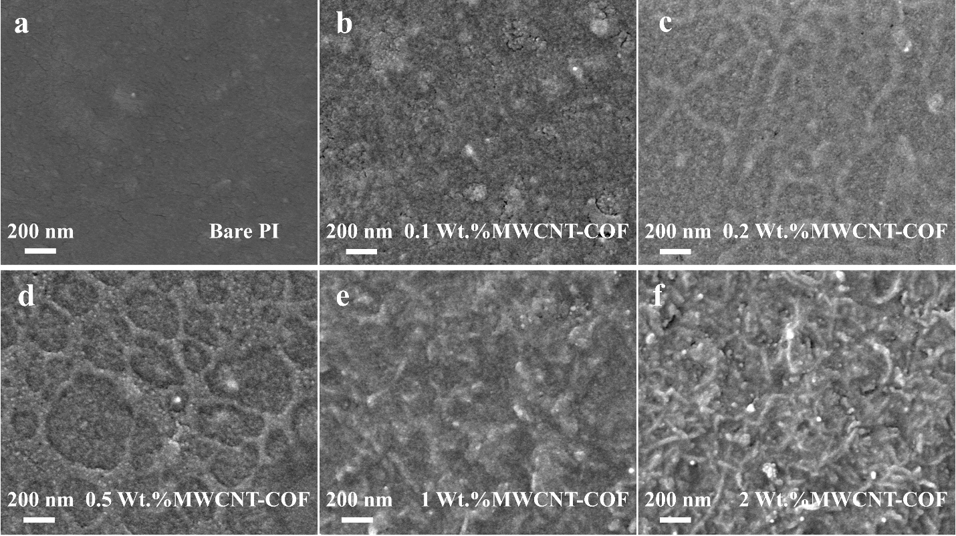
Fig. S2 SEM images of bare a PI and MWCNT-COF/PI composite films with b 0.1 Wt.%, c 0.2 Wt.%, d 0.5 Wt.%, e 1 Wt.% and f 2 Wt.% MWCNT-COF

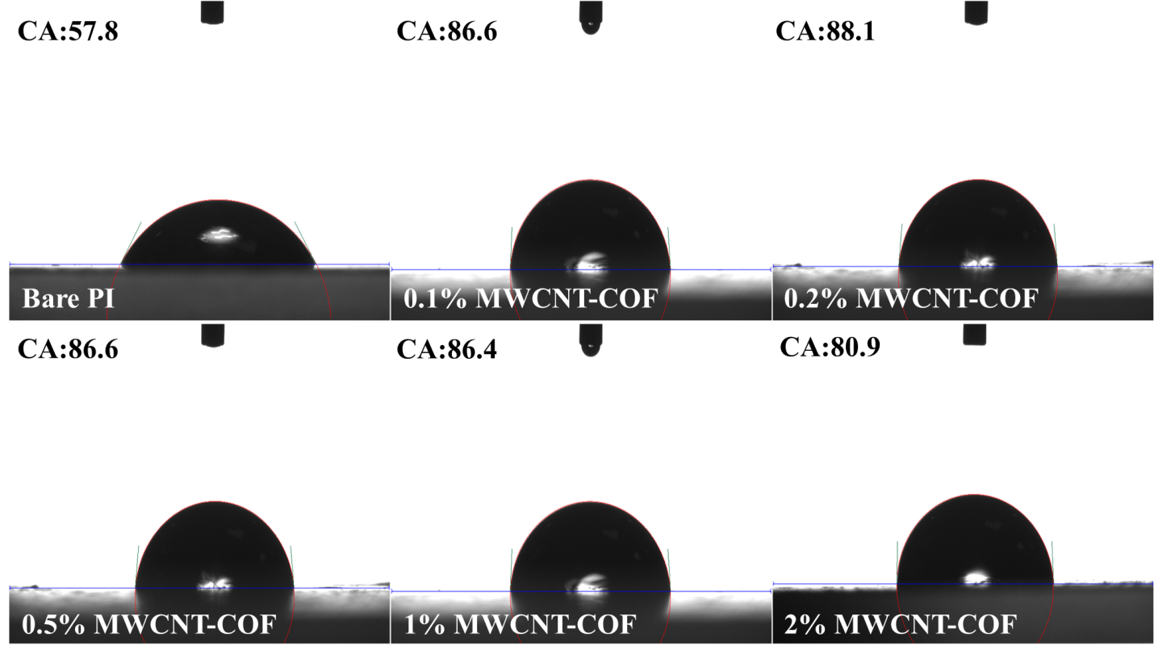
Fig. S3 Contact angles of bare PI and MWCNT-COF/PI composite films
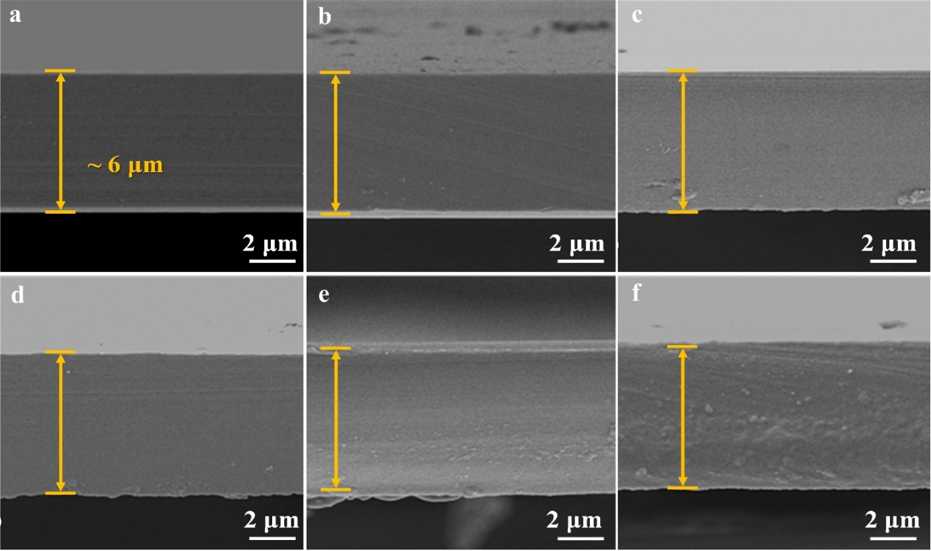
Fig. S4 SEM images of the cross-section morphology of a bare PI and COFs/PI films: a Bare PI, b 1 Wt.% COFs/PI, c 2 Wt.% COFs/PI, d 3 Wt.% COFs/PI, e 4 Wt.% COFs/PI and f 5 Wt.% COFs/PI
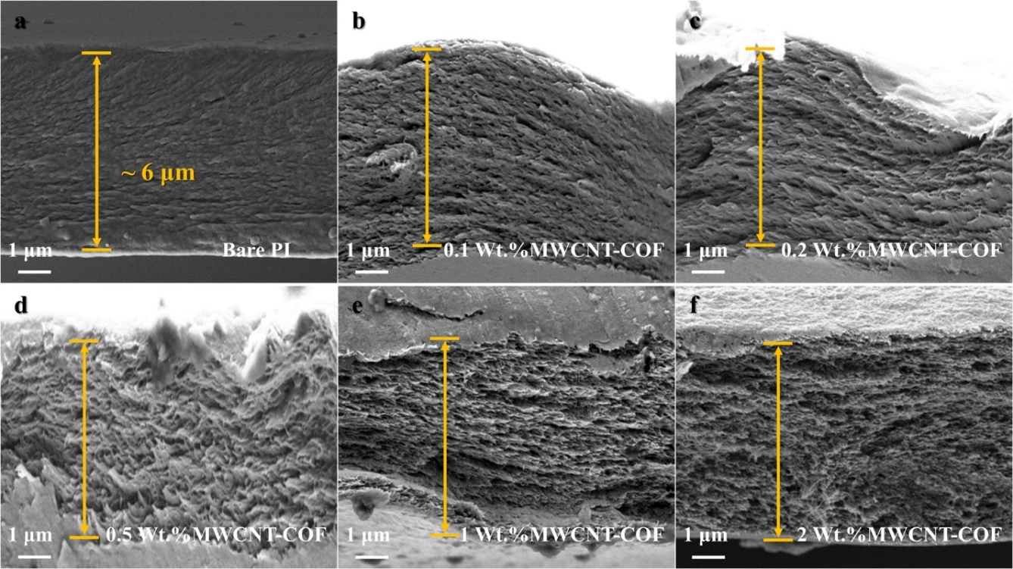
Fig. S5 Characterization results of bare PI and MWCNT-COF/PI composite films. SEM images of the cross-section morphology of a bare PI and composite films with different proportions of MWCNT-COF: b 0.1 Wt.%, c 0.2 Wt.%, d 0.5 Wt.%, e 1 Wt.% and f 2 Wt.%

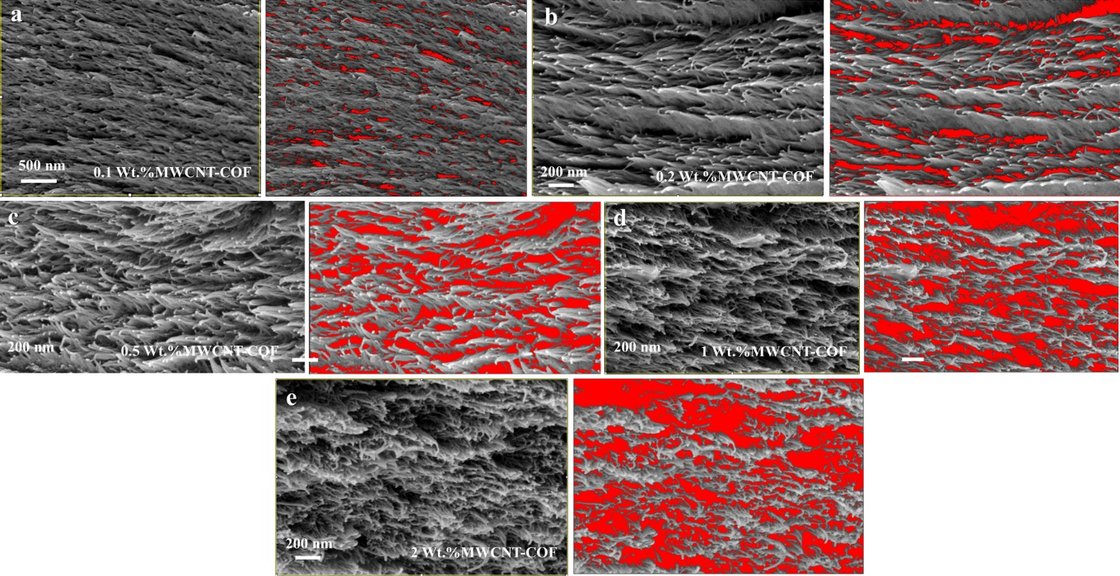
Fig. S6 Comparison diagrams of cross-sectional SEM images and corresponding pore structures based on SEM image analysis for different mixing ratios of MWCNT-COF: a 0.1 Wt.%, b 0.2 Wt.%, c 0.5 Wt.%, d 1 Wt.%, e 2 Wt.%

Fig. S7 a Stress-Strain curves of PI films and b Young's modulus of PI films
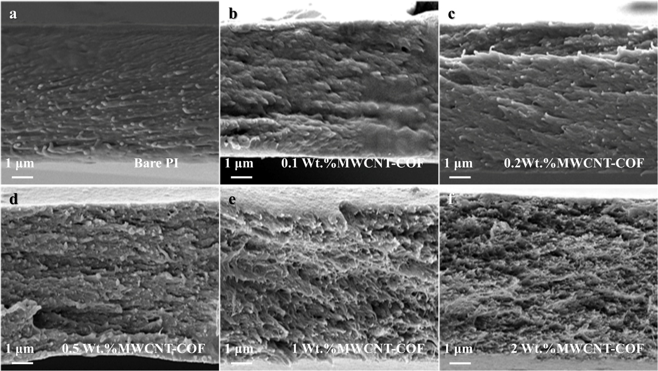
Fig. S8 SEM images of a bare PI and MWCNT-COF/PI composite films with different proportions: b 0.1 Wt.%, c 0.2 Wt.%, d 0.5 Wt.%, e 1 Wt.%, f 2 Wt.% after tensile fracture

Table S1 The porosity of PI substrates with different mixing ratios of MWCNT-COF
Sample | Density of film (g/cm³) | Porosity
0.1wt.% MWCNT-COF/PI | 1.31 | 4.4%
0.2 wt.% MWCNT-COF/PI | 1.18 | 13.9%
0.5 wt.% MWCNT-COF/PI | 0.91 | 33.6%
1 wt.% MWCNT-COF/PI | 0.81 | 40.9%
2 wt.% MWCNT-COF/PI | 0.73 | 46.7%

Table S2 The porosity of PI substrates with different mixing ratios of CNTs by SEM image analysis
Sample | Density of film (g/cm³) | Pore area  (nm²) | Total area  (nm²) | Porosity
0.1wt.% MWCNT-COF/PI | 1.31 | 487596.7 | 3549.9×2699.9 | 5.1%
0.2 wt.% MWCNT-COF/PI | 1.18 | 475358.0 | 2273.3×1540.0 | 13.5%
0.5 wt.% MWCNT-COF/PI | 0.91 | 854646.9 | 2164.4×1277.78 | 30.9%
1 wt.% MWCNT-COF/PI | 0.81 | 1246823.9 | 2258.3×1523.2 | 36.2%
2 wt.% MWCNT-COF/PI | 0.73 | 1420966.2 | 2264.9×1525.5 | 41.1%

Table S3 Parameters of GaAs solar cells with different types of substrates and MWCNT-COF/PI composite films
Sample | Photoelectric conversion efficiency (AM0) | Areal density (g/m²) | Specific-power (W/kg) | References
Triple-junction GaAs/Si solar cell (Silicon) | 30.3% | 200-500 | 820-2050 | [S4]
Triple-junction perovskite/perovskite/silicon solar cell (Silicon) | 26.1% | 3000-3300 | 107-118 | [S5]
Triple-junction GaAs solar cell (Bare Cu) | 33.47% | 230 | 1968 | [S6]
Four-junction GaAs solar cell (Bare PI) | 23.4% | 467 | 678 | [S7]
Dual-junction GaAs solar cell (Bare PI) | 24.9% | 50 | 6736 | [S8]
Triple-junction GaAs solar cell (Bare PI) | 30.2% | 132 | 3093 | [S9]
Dual-junction GaAs solar cell (MWCNT-COF/PI) | 26.6% | 40 | 8998 | This Work
Triple-junction GaAs solar cell (MWCNT-COF/PI) | 31.5% | 55 | 7749 | This Work
Supplementary References
- M.A. Silva, M.N.N. Miranda, Estimation of properties of ternary mixtures of solids using the mixing rule. Powder Technol. 134(1–2), 16–23 (2003). https://doi.org/10.1016/S0032-5910(03)00131-1
- H. Akbar, et al. Density and porosity calculation of composites refer to the rule of mixture (ROM). Procedia Struct. Integr., 27, 62-68 (2020). https://doi.org/10.1016/j.prostr.2020.07.009
- M. Ravikumar, R. Nail, Impact of nano sized SiC and Gr on mechanical properties of aerospace grade Al7075 composites. Frat. Ed Integrità Strutturale 16(62), 439–447 (2022). https://doi.org/10.3221/igf-esis.62.30
- R. Cariou, J. Benick, F. Feldmann, O. Höhn, H. Hauser et al., III–V-on-silicon solar cells reaching 33% photoconversion efficiency in two-terminal configuration. Nat. Energy 3(4), 326–333 (2018). https://doi.org/10.1038/s41560-018-0125-0
- F. Xu, E. Aydin, I. Yavuz, C. Deger, E. Ugur et al., Stabilized perovskite phases enabling efficient perovskite/perovskite/silicon triple-junction solar cells. Nat. Mater. 25(2), 259–266 (2026). https://doi.org/10.1038/s41563-025-02367-8
- M. Yu, J. Long, Q. Sun, Z. Chen, X. Wu et al., Achieving flexible higher efficiency GaInP/GaAs/InGaAs solar cells by 40-period quantum well superlattices. Nano Energy 136, 110718 (2025). https://doi.org/10.1016/j.nanoen.2025.110718
- X. Huang, J. Long, D. Wu, S. Ye, X. Li et al., Flexible four-junction inverted metamorphic AlGaInP/AlGaAs/In_{0.17}Ga_{0.83}As/In_{0.47}Ga_{0.53}As solar cell. Sol. Energy Mater. Sol. Cells 208, 110398 (2020). https://doi.org/10.1016/j.solmat.2020.110398
- T.S. Kim, H.J. Kim, D.-M. Geum, J.-H. Han, I.S. Kim et al., Ultra-lightweight, flexible InGaP/GaAs tandem solar cells with a dual-function encapsulation layer. ACS Appl. Mater. Interfaces 13(11), 13248–13253 (2021). https://doi.org/10.1021/acsami.1c00006
- J. Schön, G.M.M.W. Bissels, P. Mulder, R.H. van Leest, N. Gruginskie et al., Improvements in ultra-light and flexible epitaxial lift-off GaInP/GaAs/GaInAs solar cells for space applications. Prog. Photovolt. Res. Appl. 30(8), 1003–1011 (2022). https://doi.org/10.1002/pip.3542

