Supplementary material

Figure S1. Sample composition by country and sectors

Industry (percentages) | Services (percentages)
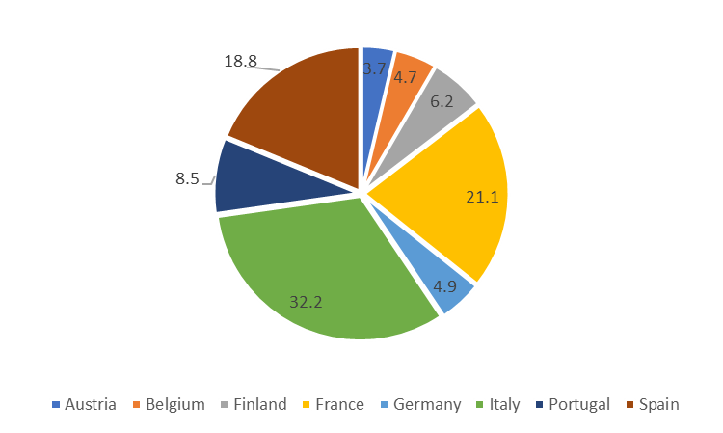 | 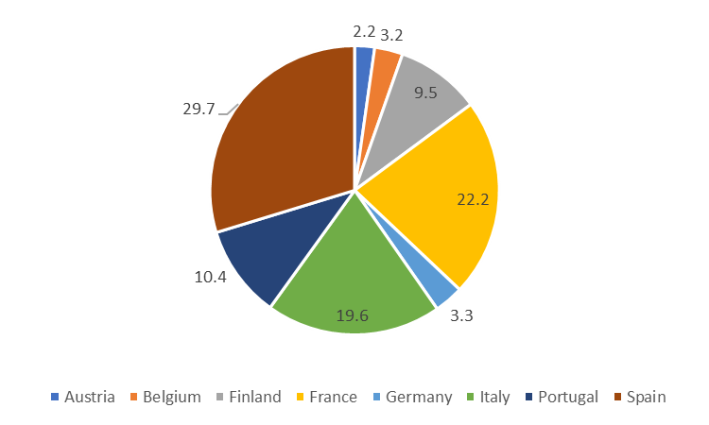
High Tech (percentages) | Low Tech (percentages)
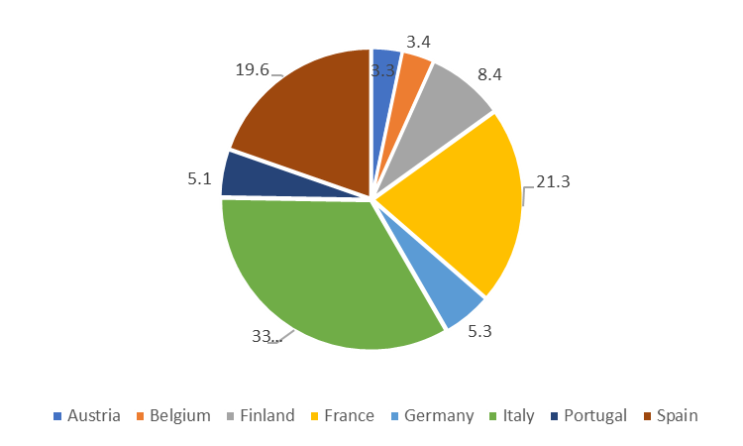 | 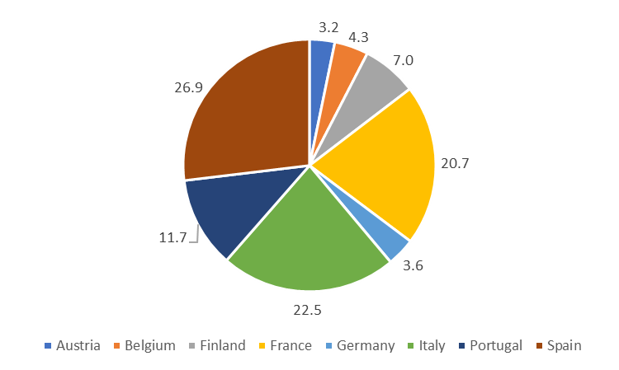

Source: our elaboration on data from SAFE & BvD AMADEUS.

Table S1. Estimation of profit functions and inefficiency equations for HT, MT and LT Industry sectors and for KIS and less-KIS - Specification with Cash Flow/Total Asset
 | INDUSTRY |  |  |  |  |  |  |  | SERVICES
 | HT |  | MT |  |  | LT |  | KIS |  |  |  | less-KIS
Profit frontier
Intercept | 3.7239 | *** |  | 2.4292 | *** |  | 2.2809 | *** | -0.1191 |  | -0.0880
Log(Operating revenues) | -0.1674 | ** |  | 0.0594 |  |  | 0.2376 | ** | 0.7225 | *** | 0.5842 |  | ***
Log(wl/wk) | 0.8462 | *** |  | 0.9002 | *** |  | 0.5648 | *** | 0.7802 | *** | 0.9432 |  | ***
Log(Operating revenues)² | 0.1059 | *** |  | 0.0784 | *** |  | 0.0227 | ** | 0.0219 | ** | -0.0058
Log(wl/wk)2 | 0.0772 | *** |  | 0.0706 | *** |  | 0.0233 | *** | 0.0628 | *** | -0.0096
Log(Operating revenues*wl/wk) | -0.0449 | *** |  | -0.0516 | *** |  | 0.0172 | *** | -0.0523 | *** | -0.0090 |  | **
Country/Size/Time Effect | Yes |  |  | Yes |  |  | Yes |  | Yes |  | Yes
Inefficiency equation
Cash flow/Total assets | -8.0724 | *** |  | -8.8443 | *** |  | -5.2470 | *** | -3.5406 | *** | -4.8488 |  | ***
Product Innovation | -0.3039 | *** |  | -0.0603 |  |  | -0.0320 |  | -0.2864 | ** | 0.3085 |  | ***
Profit up | -0.2246 | ** |  | -0.1187 |  |  | -0.0695 |  | -0.2482 | ^ | -0.1376 |  | **
Leverage up | -0.3064 | *** |  | -0.4334 | *** |  | -0.1494 |  | -0.3849 | ** | -0.6452 |  | ***
σ² | 0.9998 | *** |  | 0.8655 | *** |  | 0.8031 | *** | 1.0123 | *** | 1.1311 |  | ***
γ | 0.7638 | *** |  | 0.7206 | *** |  | 0.5744 | *** | 0.6130 | *** | 0.4584 |  | ***
Macroeconomic controls | Yes |  |  | Yes |  |  | Yes |  | Yes |  | Yes
N. obs | 3,001 |  |  | 2,133 |  |  | 1,931 |  | 1,674 |  | 5,945
Log-likelihood | -2880 |  |  | -1979 |  |  | -1996 |  | -1887 |  | -7634
Mean PE | 0.6575 |  |  | 0.6846 |  |  | 0.6822 |  | 0.6458 |  | 0.6477
AIC | 5824 |  |  | 4022 |  |  | 4056 |  | 3838 |  | 15332
BIC | 6016 |  |  | 4203 |  |  | 4234 |  | 4012 |  | 15546
Source: our elaboration on data from SAFE & BvD AMADEUS. Significance levels: ‘***’ 0.01, ‘**’ 0.05, ‘*’ 0.10 [^ 11%].
Legend: HT=High-tech industries; MT= Medium-Low technology industries; LT= Low-tech industries; KIS= Knowledge Intensive Services; less-KIS=less- Knowledge Intensive Services.

Table S2. Estimation of inefficiency equations for Micro and Small enterprises
 | INDUSTRY |  |  |  |  |  | SERVICES
 | (1) |  | (2) |  | (3) |  | (4) |  | (5) |  | (6)
Cash flow/Total assets | -6.8553 | *** |  |  |  |  | -3.5471 | ***
Problem of finance |  |  | -0.1611 | ** |  |  |  |  | -0.1976 | *
Finance obstacles |  |  |  |  | -0.0927 |  |  |  |  |  | -0.1850 | ^
Product Innovation | 0.0091 |  | -0.0563 |  | -0.0518 |  | -0.0540 |  | -0.1335 | * | -0.1352 | *
Profit up | -0.2321 | *** |  |  |  |  | -0.1985 | **
Profit margin |  |  | -3.1615 | *** | -2.8148 | *** |  |  | -2.2359 | *** | -1.6202 | ***
Leverage up | -0.3771 | *** | -0.1609 | ** | -0.0894 |  | -0.1834 | * | -0.1622 | * | -0.0545
σ² | 0.7134 | *** | 0.5729 | *** | 0.5513 | *** | 0.6616 | *** | 0.7178 | *** | 0.6114 | ***
γ | 0.7908 | *** | 0.7457 | *** | 0.7606 | *** | 0.4126 | *** | 0.5566 | *** | 0.4754 | ***
Macroeconomic ocntrols | Yes |  | Yes |  | Yes |  | Yes |  | Yes |  | Yes
N. obs | 2,876 |  | 2,820 |  | 2,172 |  | 3,626 |  | 3,512 |  | 2,537
Log-likelihood | -2251 |  | -2200 |  | -1643 |  | -3772 |  | -3582 |  | -2507
Mean PE | 0.6764 |  | 0.6581 |  | 0.6561 |  | 0.7195 |  | 0.6561 |  | 0.6836
AIC | 4561 |  | 4461 |  | 3346 |  | 7604 |  | 7225 |  | 5074
BIC | 4740 |  | 4639 |  | 3517 |  | 7790 |  | 7410 |  | 5249

Source: our elaboration on data from SAFE & BvD AMADEUS. Notes; For sake of brevity, we report here only the z-variables coefficients. Significance levels: ‘***’ 0.01, ‘**’ 0.05, ‘*’ 0.10 [^ 0.122].

Table S3. Estimation of inefficiency equations for Micro and Small enterprises
 | HIGH-TECH |  |  |  |  |  |  |  | LOW-TECH
 | (1) |  | (2) |  |  | (3) |  |  | (4) |  |  | (5) |  | (6)
Cash flow/Total assets | -4.4153 | *** |  |  |  |  |  |  | -4.9108 | ***
Problem of finance |  |  |  | 0.0209 |  |  |  |  |  |  | -0.17821 |  | **
Finance obstacles |  |  |  |  |  |  | -0.1075 |  |  |  |  |  |  |  | -0.2937 | ***
Product Innovation | -0.2989 | *** |  | -0.2705 | *** |  | -0.1714 | * | 0.0922 | * | 0.0318 |  |  |  | 0.0745 | ^
Profit up | -0.3724 | *** |  |  |  |  |  |  | -0.1359 | **
Profit margin |  |  |  | -2.9046 | *** |  | -2.2986 | *** |  |  | -3.0059 |  | *** |  | -2.5289 | ***
Leverage up | -0.2435 | * |  | -0.1445 |  |  | 0.0009 |  | -0.3019 | *** | -0.2162 |  | *** |  | -0.1165
σ² | 0.8523 | *** |  | 0.7609 | *** |  | 0.6435 | *** | 0.7541 | *** | 0.7451 |  | *** |  | 0.6348 | ***
γ | 0.7907 | *** |  | 0.7972 | *** |  | 0.7655 | *** | 0.5730 | *** | 0.6401 |  | *** |  | 0.5526 | ***
Macroeconomic controls | Yes |  |  | Yes |  |  | Yes |  | Yes |  | Yes |  |  |  | Yes
N. obs | 1,863 |  |  | 1,824 |  |  | 1,373 |  | 5,683 |  | 5,534 |  |  |  | 4,049
Log-likelihood | -1653 |  |  | -1602 |  |  | -1139 |  | -5735 |  | -5490 |  |  |  | -3915
Mean PE | 0.6409 |  |  | 0.6147 |  |  | 0.6345 |  | 0.6802 |  | 0.6340 |  |  |  | 0.6645
AIC | 3367 |  |  | 3263 |  |  | 2337 |  | 11531 |  | 11040 |  |  |  | 7889
BIC | 3533 |  |  | 3428 |  |  | 2494 |  | 11730 |  | 11239 |  |  |  | 8078
Source: our elaboration on data from SAFE & BvD AMADEUS. Notes; For sake of brevity, we report here only the z-variables coefficients. Significance levels: ‘***’ 0.01, ‘**’ 0.05, ‘*’ 0.10 [^ 0.155].
Note: High-tech includes high-technology industries and knowledge-intensive services; Low-tech includes medium-low and low-technology industries and less-knowledge intensive services.

