Tailoring Small-Molecule Acceptors through Asymmetric Side-Chain Substitution for Efficient Organic Solar Cells
Lan Xie ^{1,2 †}, Dingding Qiu ^{3,†}, Xianghao Zeng ², Chung Hang Kwok ², Yan Wang ², Jia Yao ², Kan Ding ⁴, Lu Chen ², Jicheng Yi ², Harald Ade ⁴, Zhixiang Wei ³, Wai- Yeung Wong ^{1, *}, He Yan ^{2, *}, Han Yu ^{1, 2, *}

¹Department of Applied Biology and Chemical Technology and Research Institute for Smart Energy, The Hong Kong Polytechnic University, Hung Hom, Hong Kong 999077, China.
² Department of Chemistry and Hong Kong Branch of Chinese National Engineering Research Center for Tissue Restoration and Reconstruction, Hong Kong University of Science and Technology, Clear Water Bay, Kowloon 999077, Hong Kong.
³ CAS Key Laboratory of Nanosystem and Hierarchical Fabrication National Center for Nanoscience and Technology Beijing 100190, China.
⁴ Department of Physics and Organic and Carbon Electronics Laboratories (ORaCEL), North Carolina State University Raleigh, NC 27695, USA.
Corresponding author (email: wai-yeung.wong@polyu.edu.hk; hyan@ust.hk; yuhan.yu@polyu.edu.hk)

- Materials and Synthesis.
Materials.
Toluene was refluxed and distilled from sodium with benzophenone as an indicator before use. N, N'-Dimethylformamide (DMF), n-Butyllithium (n-BuLi, 1.6 M in THF), and Pd₂(dba)₃ were purchased from Alfa Aesar or J&K Chemical or Derthon (Shenzhen China) Optoelectronic Materials Science Technology Co., Ltd. PM6 was purchased from Solarmer Materials Inc. The synthetic routes to the BT-ASY SMA were outlined in Scheme 1. Synthetic details of BT-ASY and target SMAs were shown as follows. All other reagents and chemicals were purchased from commercial sources and used without further purification¹H and ¹³C NMR spectra were obtained with a Bruker AV-400 MHz NMR spectrometer. Chemical shifts were reported in parts per million (ppm, δ)¹H, and ¹³C NMR spectra were referenced to tetramethylsilane (0 ppm) in CDCl₃. Mass spectra were collected on a MALDI Micro MX mass spectrometer, or an API QSTAR XL System.
Synthesis.
Compounds BT-ASY were developed according to the following procedures:
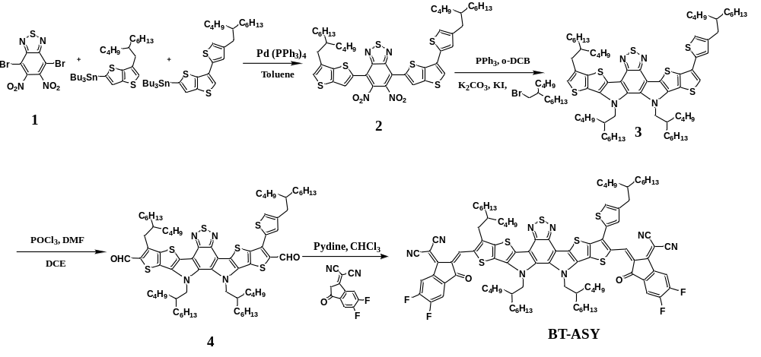
Scheme 1. Synthesis of BT-ASY.

Compound 2: In a dry 100 mL flask, Pd(PPh₃)₄ (36 mg, 0.031 mmol) was added to a solution of 1 (0.50 g, 1.30 mmol), tributyl (6-(2-butyloctyl) thieno [3,2-b] thiophen-2-yl) stannane (0.78 g, 1.30 mmol) and tributyl(6-(4-(2-butyloctyl)thiophen-2-yl)thieno[3,2-b]thiophen-2-yl) stannane (0.90 g 1.30 mmol) in 10 mL degassed toluene under argon and stirred vigorously at 110 ℃ for 12 hours. Then the mixture was poured into methanol (200 mL) and precipitation occurred. The obtained solid crude product was further purified by column chromatography on silica gel with petroleum ether/dichloromethane (PE/DCM, v/v = 4:1) as eluent to afford 2 as a dark red solid (0.80 g, 66%). ¹H NMR (400 MHz, CDCl₃, TMS), (ppm): δ 7.98 (s, 1H), 7.10 (s, 2H), 7.05 (s, 1H), 6.90 (s, 1H), 6.57 (s, 1H), 2.79-2.67 (d, 4H), 1.68 (t, 2H), 1.47-0.88 (m, 48H).
Compound 3: A solution of 2 (0.5 g, 0.54 mmol) in degassed 1,2-dichlorobenzene (o-DCB, 3 mL) was added to Triphenylphosphine (PPh₃, 3 mL) under the protection of argon. The reaction was then refluxed overnight at 180 ℃, cooled down to room temperature, and precipitated with cold methanol. The crude product was collected by filtration and then dried as a bright orange solid. After that, in a dry 100 mL flask, crude product, potassium carbonate (K₂CO₃, 0.75 g, 5.40 mmol), potassium iodide (KI, 1.79 g, 10.80 mmol), and 5-(bromomethyl) undecane (0.67 g, 2,70 mmol) were added to anhydrous N, N-dimethylformamide (DMF, 10 mL) under argon and stirred vigorously at 80 °C for 12 h. The reaction was quenched by water and extracted with DCM. The combined extracts were washed with brine, dried over anhydrous MgSO₄, and then filtered and collected solvent. The solvent was removed by rotary evaporation to give the crude product as an orange oil, which was purified by column chromatography on silica gel with PE/DCM (v/v, 6:1) as eluent to afford 3a as an orange viscous liquid (0.37 g, 58%). ¹H NMR (400 MHz, CDCl3, TMS), (ppm): δ 7.98 (s, 1H), 7.05 (s, 1H), 6.90 (s, 1H), 6.57 (s, 1H), 3.90 (d, 4H), 2.65 (d, 4H), 1.68 (t, 2H), 1.3 (t, 2H), 1.43-0.88 (m, 88H).

Compound 4: To a dry 100 mL two-necked round bottom flask, 10 ml anhydrous N, N-dimethylformamide (DMF) was added, and the solution was cooled to 0 ºC and stirred when 2 ml phosphorous oxychloride (POCl₃) was added by syringe under argon protection. The mixture was kept at 0 ºC for 2h, and then compound 5 (370 mg, 0.4 mmol) in dry 1, 2-dichloroethane (20 ml) was added. Then, the mixture solution was allowed to reflux overnight. After cooling to room temperature, 100 ml water was added to quench the reaction. The mixture was extracted with dichloromethane (DCM), and the organic layer was collected, washed with water, and dried with anhydrous Na₂SO₄. After removal of the solvent under reduced pressure, the residue was purified by column chromatography on silica gel using a mixture solvent as eluent (hexane/dichloromethane, v/v = 1/2) to give a yellow solid (352 mg, 90%). ¹H NMR (400 MHz, CDCl₃) δ 10.25 (s, 1H), 10.12 (s, 1H), 7.41 (d, J = 1.4 Hz, 1H), 7.19 (s, 1H), 4.65 (t, J = 6.6 Hz, 4H), 3.11 (d, J = 7.4 Hz, 2H), 2.67 (d, J = 6.8 Hz, 2H), 2.06 (h, J = 6.0 Hz, 3H), 1.70 (t, J = 6.4 Hz, 1H), 1.37 – 1.21 (m, 30H), 1.01 – 0.80 (m, 23H), 0.73 – 0.58 (m, 11H).
BT-ASY: To a 100 ml round bottom flask, compound 6 (103 mg, 0.10 mmol), IC-2F (115 mg, 0.5 mmol), and chloroform (15 ml) were added under argon protection and stirred for a while when pyridine (0.8 ml) was added. The mixture was kept stirring at 70 ºC for 6h. After the removal of the chloroform of the reaction mixture under reduced pressure, 50 ml methanol was added and the precipitate was collected by filtration. The residue was purified by column chromatography on silica gel using a mixture solvent as eluent (hexane/dichloromethane, v/v = 1/2) to give a blue-dark solid (131 mg, 90%).
¹H NMR (400 MHz, CDCl₃) δ 9.14 (s, 1H), 9.13 (s, 1H), 8.54 (ddd, J = 14.0, 9.9, 6.5 Hz, 2H), 7.70 (q, J = 7.2 Hz, 2H), 7.34 (q, J = 1.4 Hz, 2H), 4.78 (d, J = 7.9 Hz, 3H), 3.18 (d, J = 7.6 Hz, 2H), 2.71 (d, J = 6.7 Hz, 2H), 2.12 (s, 3H), 1.72 (s, 1H), 1.41 – 1.19 (m, 25H), 1.04 – 0.79 (m, 12H), 0.76 – 0.54 (m, 12H).

- Organic solar cell devices fabrication
Device Fabrication and Testing The OSCs with conventional structure were fabricated on glass/ITO (indium tin oxide)/PEDOT:PSS (poly(3,4-ethylenedioxythiophene):poly(styrene sulfonate))/active layer/PNDIT-F3N ([(9,9-bis(3'-(N,N-dimethylamino)propyl)-2,7-fluorene)-alt-5,5'-bis(2,2'-thiophene)-2, 6-naphthalene-1,4,5,8-tetracaboxylic-N,N'-di(2-ethylhexyl)imide])/Ag. The patterned ITO-coated glass substrates were cleaned in detergent, de-ionized water, acetone, and isopropanol sequentially by ultra-sonic bath for 30 minutes, respectively, and then dried in an even at 70 ℃ overnight. Further UV-Ozone treatment for 20 min was applied before use to improve its work function and clearance. Then the PEDOT:PSS (Heraeus Clevios P VP. AI 4083, filtered at 0.45 μm) was spin-coated onto the cleaned ITO-coated glass substrate at 5500 rpm for 30 s followed by annealing at 150 ℃ for 15 minutes in air to obtain ~30 nm thick film. The PEDOT:PSS-coated ITO substrates were then transferred into an N₂-filled glove box for further device fabrication. The donor: acceptor blends solution with a weight ratio of 1:1.2 was dissolved in the CF, in which the solid concentration is 14.2 mg/mL in total, with 1-chloronaphthalene (0.5% vol) as an additive. Then the blend solution was stirred under 40 ℃ for 1 hours to mix intensively in a nitrogen-filled glove box. The blend solution was spin-casted at 2500 rpm for 30 s onto the PEDOT:PSS films followed by a thermal annealing of 100 °C for 5 min. For all types of devices, a methanol with 0.5% vol acetic acid blend solution of PNDIT-F3N at a concentration of 0.5 mg mL⁻¹ was spin-coated onto the active layer at 2000 rpm for 30 s.The thickness was measured by a profilometer (KLA Tencor D-500).
The active layer thickness is ~110 nm measured by Bruker Dektak XT profilometer. A thin layer of PNDIT-F3N (~10 nm) was spin-coated onto the active layer, and Ag electrode (~100 nm) was deposited on top of the electron transfer layer in a thermal evaporator under vacuum of 1×10⁻⁵ Pa through a shadow mask. The current density-voltage (J-V) curves of all encapsulated devices were measured using a Keithley 2400 Source Meter under AM 1.5G (100 mW cm⁻²) using an Enlitech solar simulator. The light intensity was calibrated using a standard Si diode with KG5 filter to bring spectral mismatch to unity. Optical microscope (Olympus BX51) was used to define the device area (4.0 mm²). EQEs were measured using an Enlitech QE-S EQE system equipped with a standard Si diode. Monochromatic light was generated from an Enlitech 300W lamp source.

Characterization Methods
UV–visible (UV-Vis) absorption. UV-Vis absorption spectra of films were acquired on a Perkin Elmer Lambda 20 UV/VIS Spectrophotometer. The diluted solutions of BQx, BQx-CN, and BQx-2CN were kept at a low concentration of 10⁻⁵ M. All film samples were spin-cast on glass/ITO substrates.

Cyclic voltammetry (CV). Cyclic voltammetry was carried out on a CHI610E electrochemical workstation with the three electrode configuration, using Ag/AgCl as the reference electrode, a Pt plate as the counter electrode, and a glassy carbon as the working electrode. 0.1 mol L⁻¹ tetrabutylammonium hexafluorophosphate in anhydrous acetonitrile was used as the supporting electrolyte. The polymer and small molecules were drop-cast onto the glassy carbon electrode from chloroform solutions (5 mg/mL) to form thin films. Potentials were referenced to the ferrocenium/ferrocene couple by using ferrocene as external standards in acetonitrile solutions. The scan rate is 100 mV s⁻¹. The conversion of reduction/oxidation onsets and LUMO/HOMO energy levels can be described as:
equation (2): E_{LUMO} = - [e (E ^{red}–E ^{Fc/Fc+}) +4.8];
equation (3): E_{HOMO} = - [e (E ^{ox}–E ^{Fc/Fc+}) +4.8].

Atomic force microscopy (AFM). AFM measurements were performed by using a Scanning Probe MicroscopeDimension 3100 in tapping mode under atmosphere conditions at room temperature. All film samples were spin-cast on glass/ITO substrates.

Grazing Incidence Wide-Angle X-ray Scattering (GIWAXS): GIWAXS measurements were performed at beamline 7.3.3 at the Advanced Light Source.
(Samples were prepared on Si substrates using identical blend solutions as those used in devices. The 10 keV X-ray beam was incident at a grazing angle of 0.10°-0.14°, selected to maximize the scattering intensity from the samples. The scattered x-rays were detected using a Dectris Pilatus 2M photon counting detector.)

Charge Carrier Mobility Measurement.
Hole-only diode configuration: glass/ITO/PEDOT:PSS/active layer/MoO₃/Ag. Electron-only diode configuration: glass/ITO/ZnO/active layer/PNDIT-F3N/Ag. The mobility in active layers were determined by fitting the dark current hole/electron-only diodes to the space-charge limited current (SCLC) model. The mobility was determined by the equation:
𝐽 = 9𝜀₀𝜀_{𝑟}𝜇₀𝑉²/ 8𝑑³
where J is current density, μ₀ is the hole or electron mobility, ε_{r} is the dielectric permittivity of the active layer (generally assumed to be 3 for organic materials), ε0 is the dielectric permittivity of free space (ε₀ = 8.854×10⁻¹² F m⁻¹), d is the film thickness of active layers, and V is the voltage, which is defined as V = V_{appl} - V_{bi}, where V_{appl} is the applied voltage, V_{bi} is the built-in voltage.

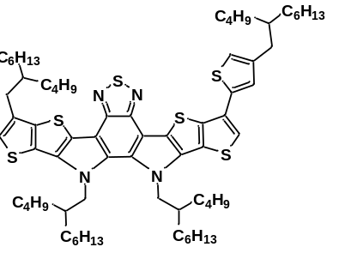
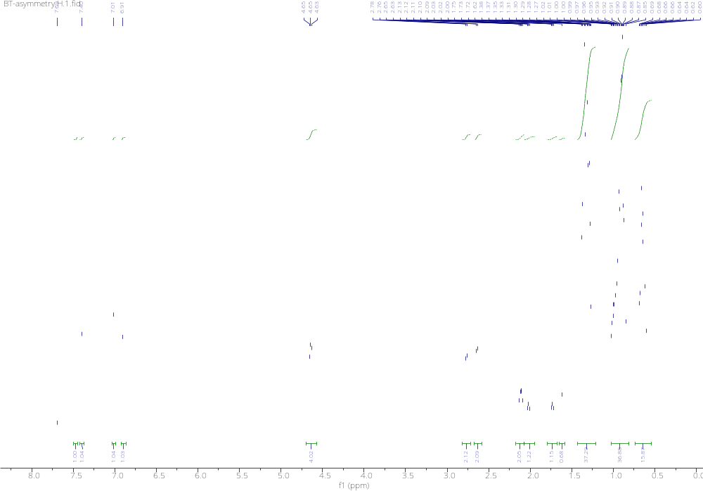
Figure S1. ¹H NMR image of 3.

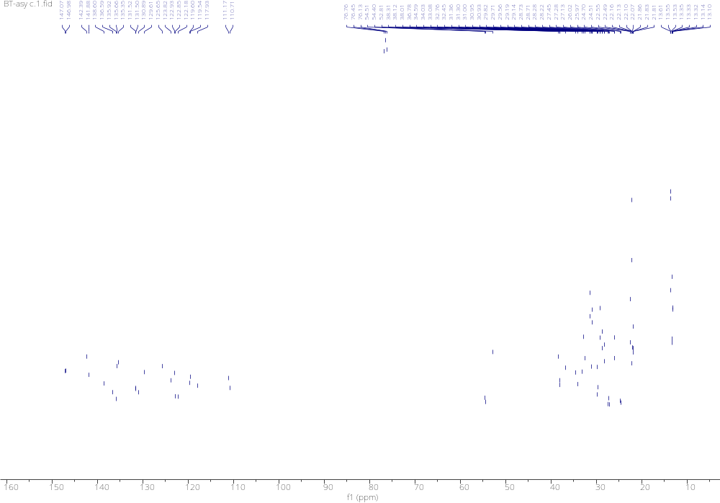
Figure S2. ¹³C NMR image of 3.
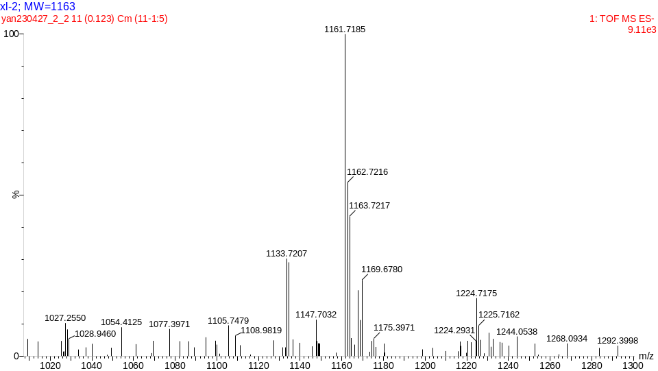
Figure S3. HRMS of compound 3.
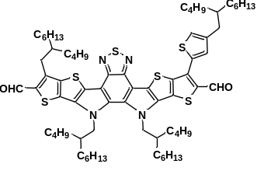
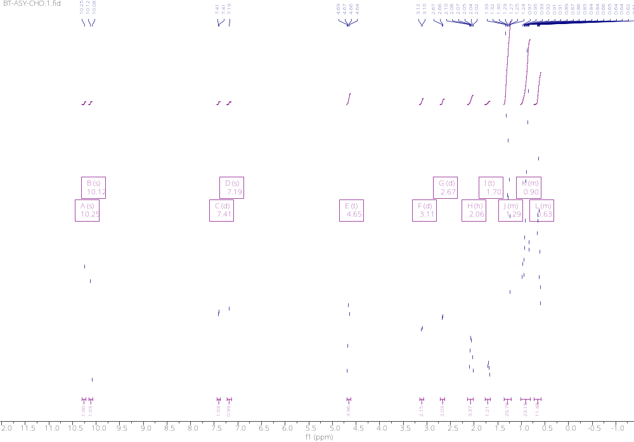
Figure S4. ¹H NMR image of 4.
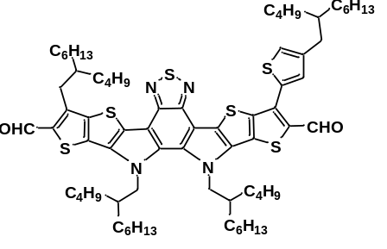
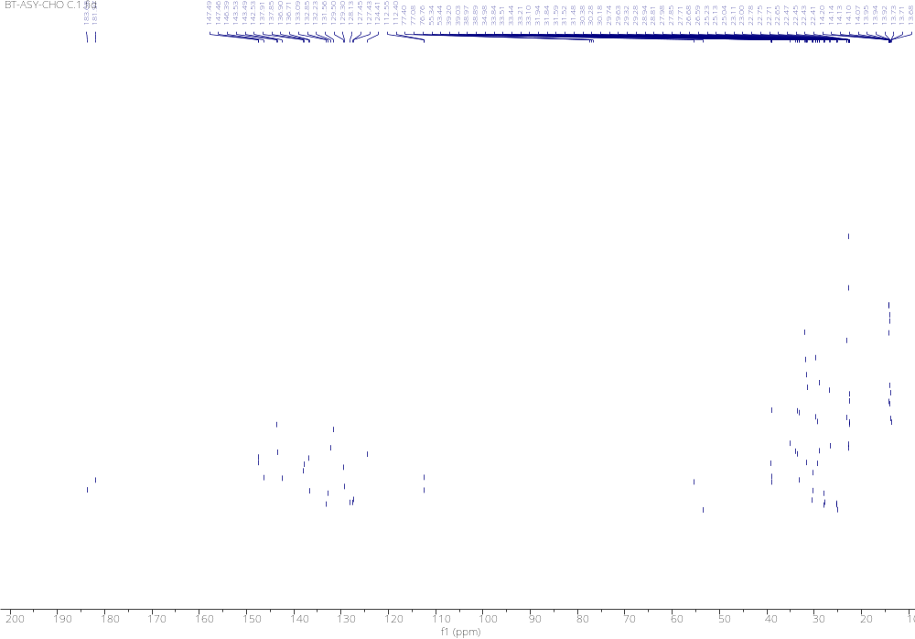
Figure S5. ¹³C NMR image of 4.
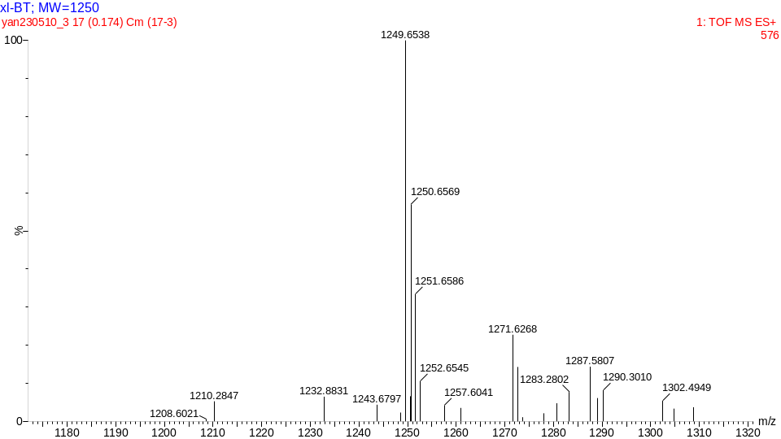
Figure S6. HRMS of compound 4.

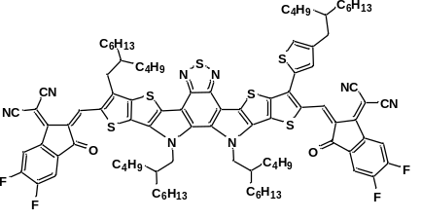
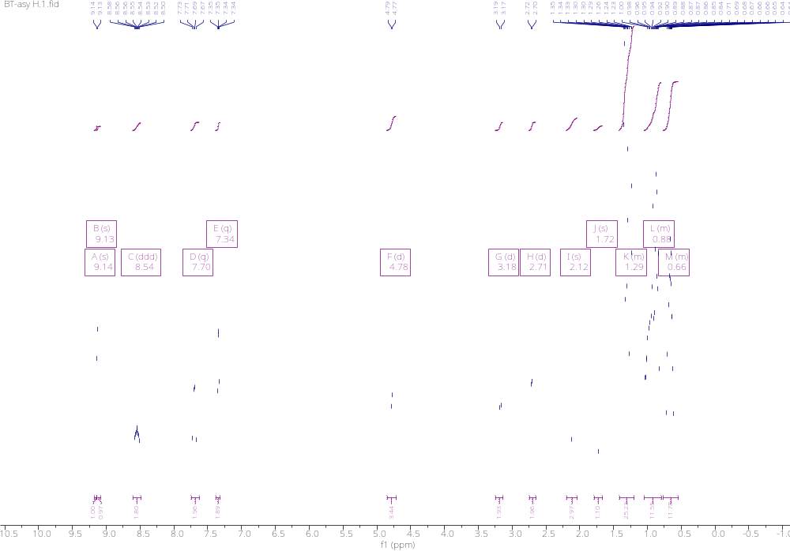
Figure S7. ¹H NMR image of BT-ASY.

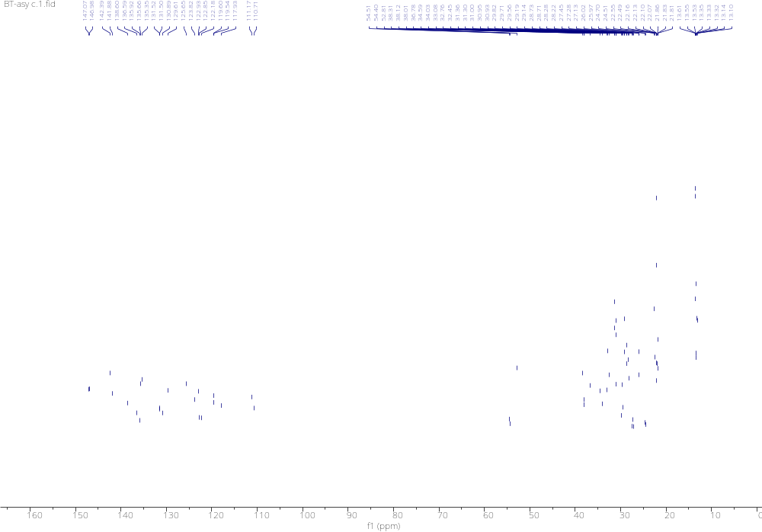
Figure S8. ¹³C NMR image of BT-ASY.
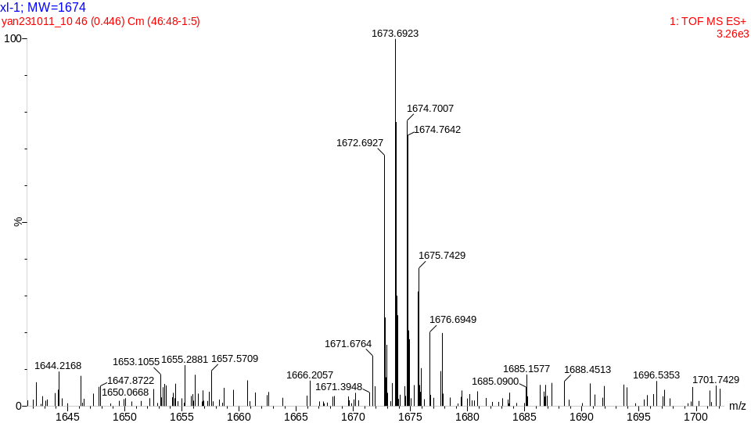
Figure S9. HRMS of compound BT-ASY.
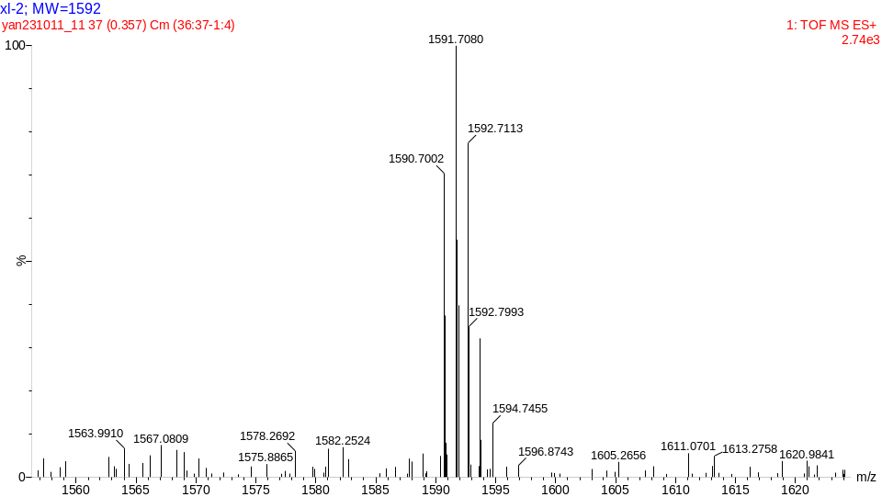
Figure S10. HRMS of compound BT-BO.
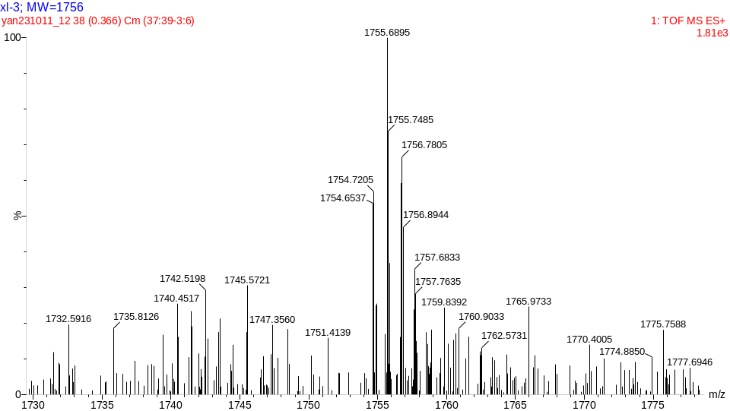
Figure S11. HRMS of compound BT-TBO.
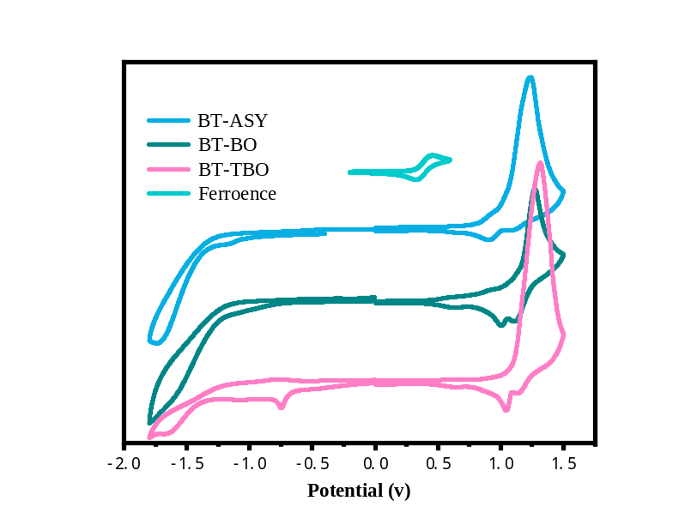
Figure S12. CV curves for BT-BO, BT-ASY, BT-TBO.

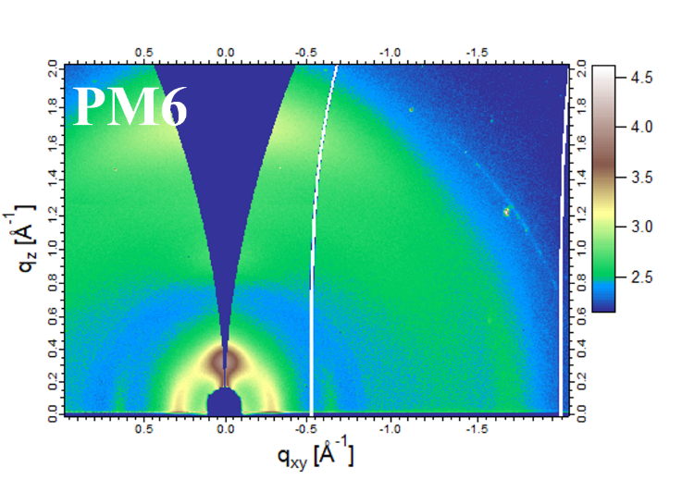
Figure S13. 2D GIWAXS pattern of PM6.

Table S1. The slope of J_{SC}/V_{OC} against different light intensities (P_{light}), and parameters of J_{sat} and J_{ph.}
PM6:NFA | J_{sat}^{a)}( mA/cm²) | J_{ph}^{&b)}(mA/cm²) | J_{ph}^{*c)} | J_{ph}&/J_{sat}(%) | J_{ph}*/J_{sat}(%) | Slope | n
BT-BO | 24.0 | 24.3 | 18.6 | 98.8 | 77.5 | 0.95 | 1.38
BT-ASY | 27.1 | 27.1 | 23.2 | 100.0 | 85.6 | 0.97 | 1.31
BT-TBO | 26.9 | 26.8 | 20.9 | 99.6 | 77.7 | 0.96 | 1.32
- The J_{ph} when V_{eff}=0.82 V; ^{b)} The J_{ph} under short current condition; ^{c)} The J_{ph} under maximum power output condition.

Table S2. Charge mobility parameters of the optimized PM6:BT-BO, PM6:BT-ASY and PM6:BT-TBO devices.
PM6: NFA | μ_{e}(cm² V⁻¹ s⁻¹) | μ_{h}(cm² V⁻¹ s⁻¹) | μ_{e} /μ_{h} | μ_{e}(cm² V⁻¹ s⁻¹)
BT-BO | 2.43 × 10⁻⁴ | 1.79 × 10⁻⁴ | 1.36 | 2.30 × 10⁻⁴
BT-ASY | 5.50 × 10⁻⁴ | 5.00 × 10⁻⁴ | 1.10 | 6.40 × 10⁻⁴
BT-TBO | 5.20 × 10⁻⁴ | 4.50 × 10⁻⁴ | 1.15 | 5.60 × 10⁻⁴
Electron-only mobility ITO/ZnO/active layer/ PNDI-F3N/Ag; Hole-only mobility
ITO/PEDOT:PSS/active layer/MnO₃/Ag; Electron-only mobility ITO/ZnO/acceptor/Ag.

Table S3. Morphology parameters are extracted from the GIWAXS measurements.
Film | q  (010, Å⁻¹) | d-space ª  (010, Å) | CCL ^{b} (010, Å) | FWHM  (010, Å⁻¹) | q  (100, Å-1) | d-space ª (100, Å) | CCL ^{b} (100, Å) | FWHM  (100, Å⁻¹)
BT-BO | 1.8 | 3.5 | 22.4 | 0.25 | 0.39 | 15.99 | 30.2 | 0.09
BT-ASY | 1.71 | 3.67 | 14.5 | 0.39 | 0.35 | 17.95 | 39.0 | 0.15
BT-TBO | 1.69 | 3.72 | 19.5 | 0.29 | 0.27 | 22.93 | 79.6 | 0.07
PM6 | 1.68 | 3.75 | 17.10 | 0.33 | 0.29 | 22.05 | 63.5 | 0.090
PM6:BT-BO | 1.71 | 3.68 | 25.8 | 0.22 | 0.30 | 20.67 | 91.2 | 0.06
PM6:BT-ASY | 1.80 | 3.48 | 38.7 | 0.15 | 0.29 | 22.05 | 40.39 | 0.02
PM6:BT-TBO | 1.70 | 3.70 | 24.4 | 0.23 | 0.30 | 21.23 | 95.8 | 0.06
ª Calculated from the equation: d-spacing = 2π/q. ^{b} Obtained from the Scherrer equation: CCL = 2πK/FWHM, where FWHM is the full-width at half-maximum and K is a shape factor (K = 0.9 here).

