Supplementary Table 1. Origin of the samples collected for Verticillium isolation in PDA culture medium from potato plants with symptoms associated with PED from commercial crops in Cundinamarca.
Code | Origin | Variety | Altitude (msnm)
S1 | Subachoque | Diacol Capiro | 2700
S2 | Subachoque | Diacol Capiro | 2700
S3 | Subachoque | Criolla | 2600
S4 | Subachoque | Diacol Capiro | 2600
Z1 | Zipaquirá | Diacol Capiro | 2500
Z2 | Zipaquirá | Diacol Capiro | 2600
Z3 | Zipaquirá | Diacol Capiro | 2500
Z4 | Zipaquirá | Diacol Capiro | 2500
M1 | Mosquera | Diacol Capiro | 2500
M2 | Mosquera | Diacol Capiro | 2500
C1 | Chocontá | Única | 2650
C2 | Chocontá | Diacol Capiro | 2650
F1 | Funza | Diacol Capiro | 2550
F2 | Funza | Diacol Capiro | 2550
Fa1 | Facatativá | Diacol Capiro | 2600
S: Subachoque; Z: Zipaquirá; M: Mosquera; C: Chocontá; F: Funza, Fa: Facatativá

Supplementary Table 2. DNA sequences of primers used for phylogenetic analysis.
Primers | Sequences (5’ 3’)
ITS1 | TCCGTAGGTGAACCTGCGG
ITS4 | TCCTCCGCTTATTGATATGC
Bt2a | GGTAACCAAATCGGTGCTGCTTTC
Bt2b | ACCCTCAGTGTAGTGACCCTTGGC

Supplementary Table 3. Macroscopic and microscopic description and frequency of 15 monosporic cultures of Verticillium spp. grouped into five morphotypes on PDA medium. Isolates were obtained from potato plants with PED symptoms in commercial crops in Cundinamarca.
Morphotype | Code | Frequency | Appearance | Description
1 | M1 | 6.6 | 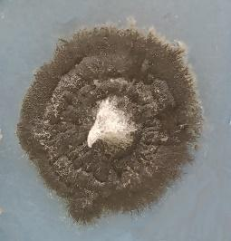 | Scant aerial mycelium, black color, with irregular edges.  Formation of microsclerotia.
2 | M2 | 6.6 | 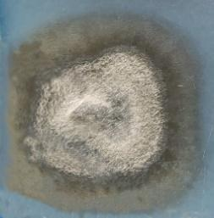 | Velvety white mycelium in the center, outer black ring, regular edge.  Formation of microsclerotia.
3 | S1, S2, S3, S4, Z1, C2, Fa1 | 46.9 | 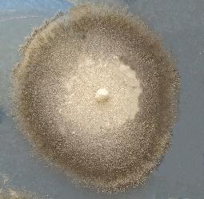 | Velvety mycelium, cream color in the center, gray rings, and more intense black on the colony's outer part.  Formation of melanized mycelium.
4 | A1, C1 | 6.6 | 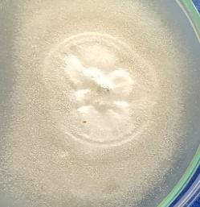 | Velvety mycelium, white or cream in color.  Formation of melanized mycelium and melanized base of conidiophores.
5 | F1, F2, Z2, Z3, Z4 | 33.3 | 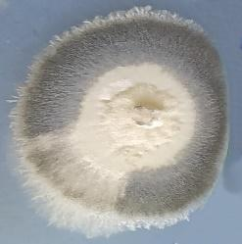 | Velvety appearance, white in the center, with black rings and a white edge.  Formation of melanized mycelium and melanized base of conidiophores.

