Appendix- A

Fig. A-1: Questionnaire of the study

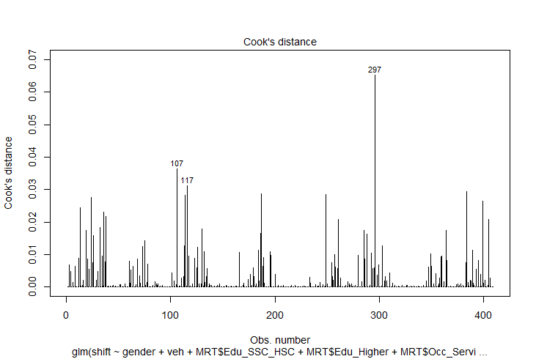
Figure A2: Residual vs leverage graph

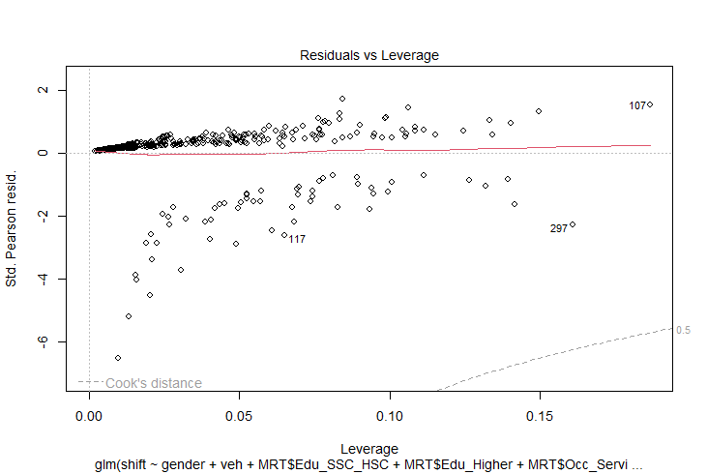
Fig. A2: Cook’s distance graph
Fig. A3: Residual vs leverage graph
Fig. A4: Scatterplot between trip time and log of odds
Fig. A5: Scatterplot between time to reach nearest station and log of odds

Appendix-B
Table B-1: Crosstabulation of the occupation and personal income of respondents

Table B-2: Statistics of the predictors after removing the observation with high cook’s distance

Coefficients:
Estimate Std. Error z value Pr(>|z|)
(Intercept) 3.300738 0.842585 3.917 8.95e-05 ***
Gender-Male 0.963722 0.430607 2.238 0.025217 *
Veh_Own-Yes -0.131757 0.404057 -0.326 0.044361 *
Edu_SSC-HSC 0.857574 0.526235 1.630 0.103178
Edu_Higher 1.901057 0.559159 3.400 0.000674 ***
Occu_Service 1.366695 0.467685 -2.922 0.003475 **
Occu_Buss -2.049102 0.557229 -3.677 0.000236 ***
Trip_time -0.006434 0.004661 -1.380 0.127448
Trip_freq_Regular 0.477840 0.349293 -1.368 0.071305 .
Origin_Non-aligning -0.826753 0.451440 -1.831 0.067046 .
Dest_Non-aligning -0.672364 0.556811 -1.208 0.027229 *
Access_mode_Private -2.906313 0.618725 -4.697 2.64e-06 ***
Access_mode_Public -1.450927 0.719365 -2.017 0.043700 *
Access_mode_Walking -1.856668 0.473015 -3.925 8.67e-05 ***
Time_nearest_station -0.006068 0.025461 -0.238 0.111625
---
Signif. codes: 0 ‘***’ 0.001 ‘**’ 0.01 ‘*’ 0.05 ‘.’ 0.1 ‘ ’ 1

Table B-3: VIF values of the model’s predictors

