Supplementary Materials

Co-offending and criminal experience
In our main analysis, the criminal experience at crime commission was operationalized by the total number of offenses committed prior to the considered one. To corroborate our findings on the relation between co-offending and criminal experience, we present results relying on an alternative measure of criminal experience, i.e. the sequential number of the crime in the offender’s criminal career. Due to the characteristics of the PMM data set, each offender may have multiple crimes recorded with the same crime number in their criminal career, since they may commit multiple offenses in the same year (and more detailed temporal information allowing to order crimes committed in the same year is not available). For this reason, while the PMM includes data on offenders who committed up to 300 crimes throughout their criminal career, their sequential crime number ranges from a minimum of 1 to a maximum of 30 (meaning that they have committed crimes in 30 different calendar years, at most), with an average value of 5.24 (SD=3.74).
Figure A1 charts the share of offense participations in co-offenses against the sequence number of the offense in the individual’s criminal career. The aggregate co-offending prevalence remains fairly constant as criminal experience increases. The curve shows a very moderate increase after criminal onset up until the 10th crime, and a subsequent gradual decrease lasting until the end of the criminal career (let aside for the sudden increase of offense 17 and offenses of order 20 or higher). Results are graphically comparable to those reported in Figure 2 of the main text, where criminal experience is measured as the number of previously committed offenses.
To investigate the trivariate relationship between co-offending, criminal experience, and career activity, Figure A2 plots the co-offending prevalence by crime number curves for careers with differing levels of activity. Even in this case, results are comparable to those presented in Figure 3 of the main text: the co-offending prevalence increases up until crime 3 or 4 and then starts decreasing for offenders with lower career activity, while it remains stable for high activity offenders. Furthermore, less prolific offenders experience a steeper decrease in the co-offending prevalence in the final stages of their careers compared to more prolific ones.

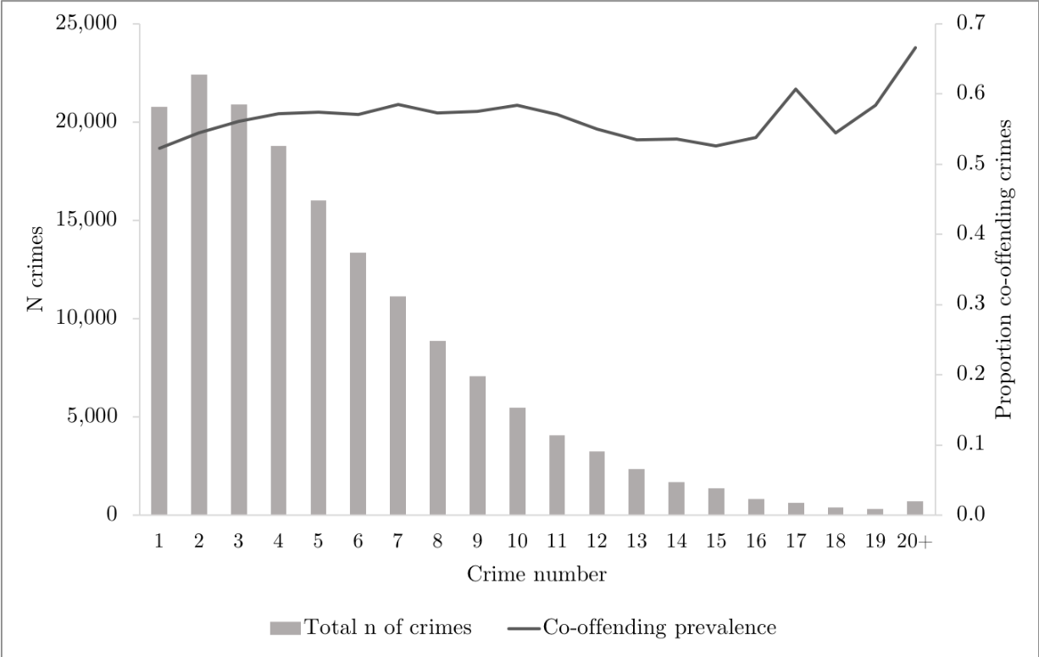
Figure A1. Co-offending prevalence and total number of crimes committed by crime number (n=160,262)

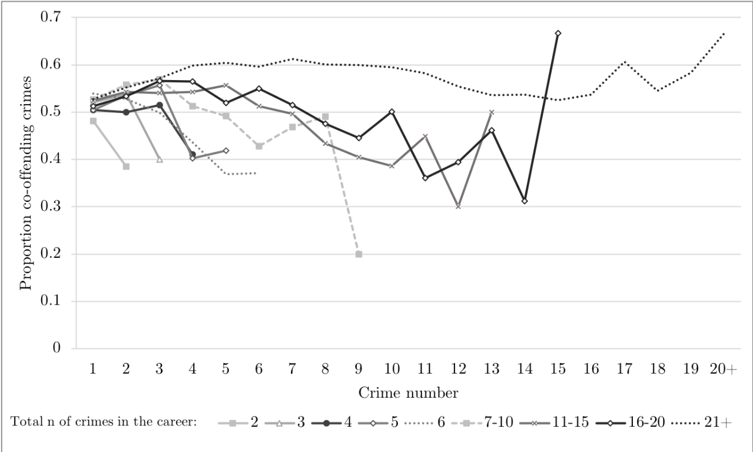
Figure A2. Co-offending prevalence by crime number and total career activity (n=160,262)
Note: Due to reduced sample sizes, careers of offenders who committed 7 or more crimes were combined in the aggregate 7-10, 11-15, 16-20, and 21+ classes.

