Supplementary material

Supplementary Table A. Relationship status by age (%)
 | Men |  |  |  | Women
Age | Single | Cohabiting | Married |  | Single | Cohabiting | Married
15 | 100 | 0 | 0 |  | 100 | 0 | 0
16 | 100 | 0 | 0 |  | 99.9 | 0.0 | 0.1
17 | 99.9 | 0.0 | 0.1 |  | 99.6 | 0.0 | 0.4
18 | 75.0 | 17.6 | 0.6 |  | 61.8 | 30.7 | 1.4
19 | 61.1 | 24.7 | 1.1 |  | 51.3 | 34.5 | 2.0
20 | 57.0 | 28.0 | 1.7 |  | 47.6 | 36.7 | 2.8
21 | 54.0 | 29.5 | 2.2 |  | 43.7 | 38.3 | 3.8
22 | 50.3 | 31.0 | 2.9 |  | 40.3 | 38.9 | 5.2
23 | 46.5 | 32.0 | 3.9 |  | 36.6 | 39.1 | 6.9
24 | 42.4 | 32.5 | 5.3 |  | 33.1 | 38.1 | 9.0
25 | 38.3 | 32.5 | 6.9 |  | 29.7 | 36.6 | 11.5
26 | 34.4 | 31.4 | 8.7 |  | 26.5 | 34.2 | 14.0
27 | 30.5 | 29.6 | 10.6 |  | 23.4 | 31.0 | 16.3
28 | 26.6 | 27.0 | 12.2 |  | 20.5 | 27.3 | 17.9
29 | 22.6 | 23.4 | 13.1 |  | 17.5 | 23.2 | 18.4
30 | 17.8 | 18.6 | 12.6 |  | 14.0 | 18.0 | 17.0
31 | 11.6 | 12.0 | 9.6 |  | 8.9 | 11.7 | 12.5

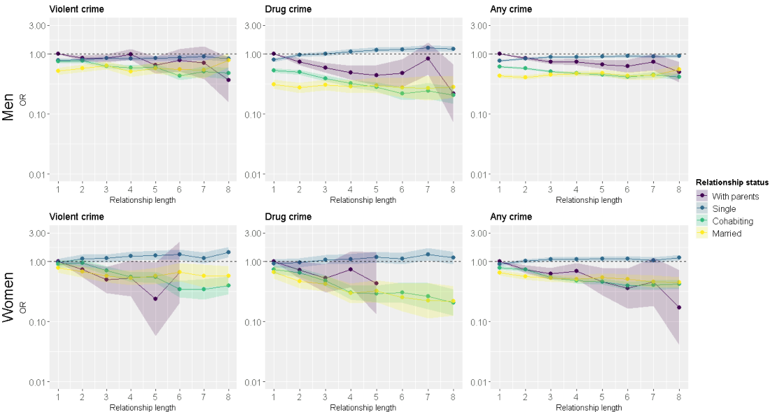
Supplementary Figure A. Between individual effects when participants living with their parents are included in the analyses.
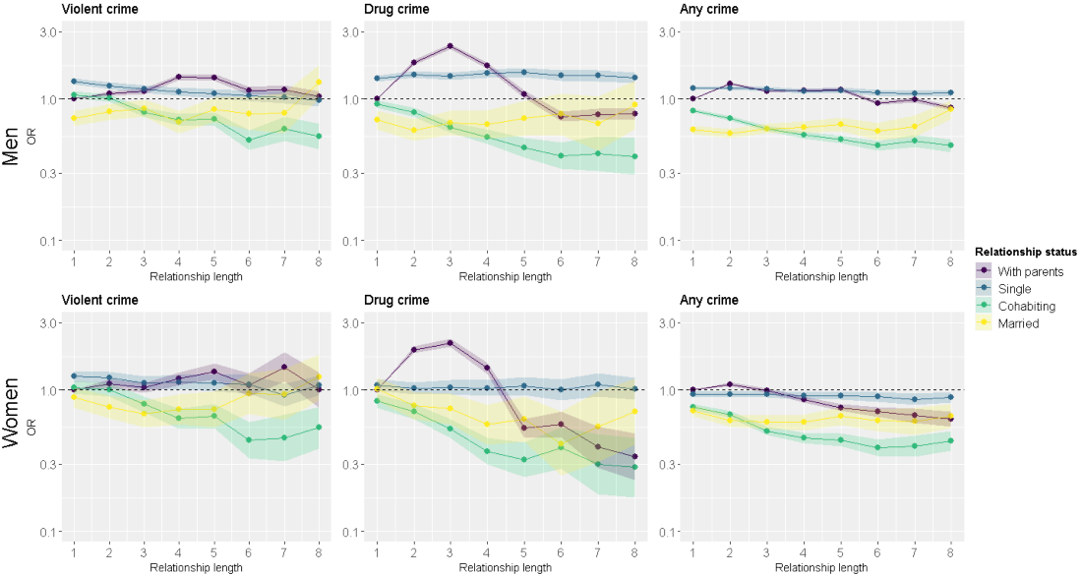
Supplementary Figure B. Within individual effects when participants living with their parents are included in the analyses.
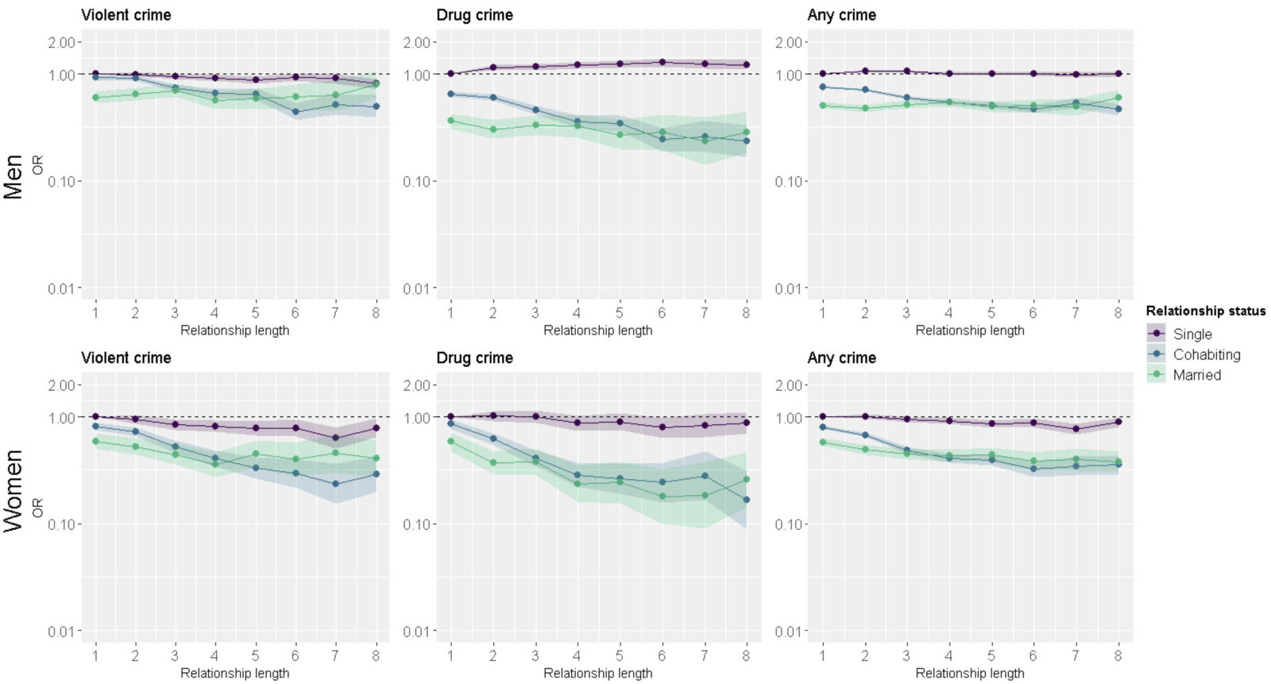
Supplementary Figure C. Between individual effects, age limited to 20+ years.

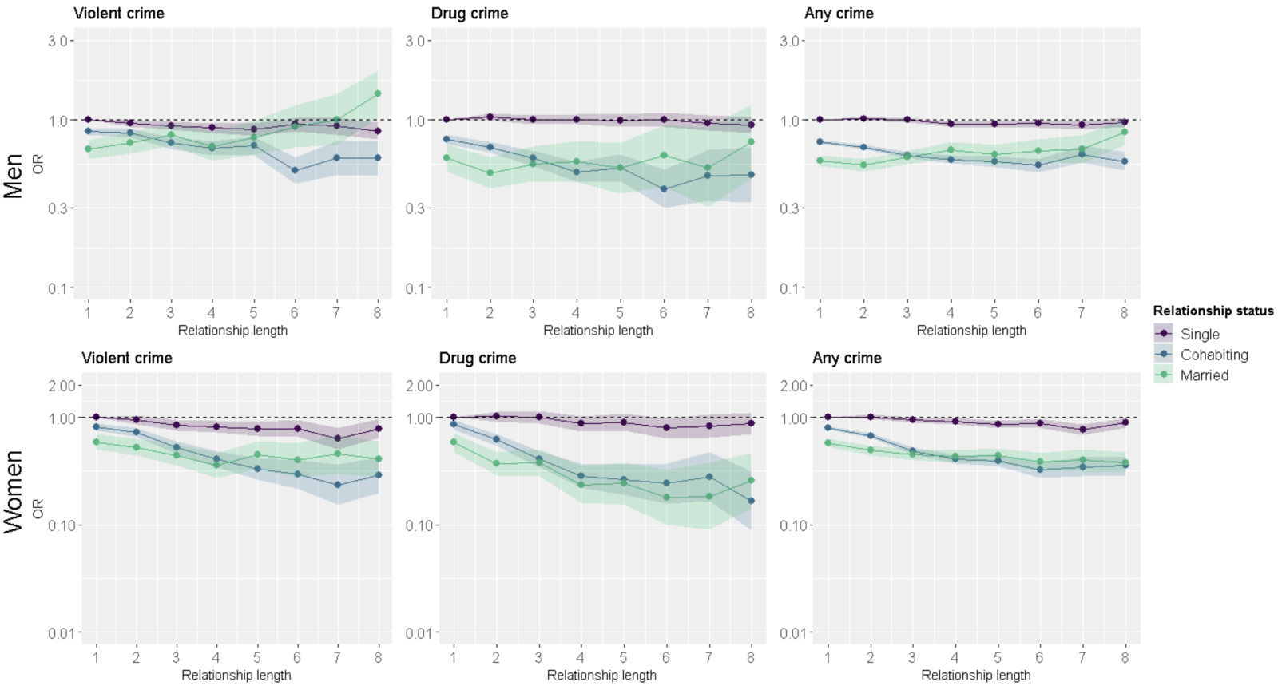
Supplementary Figure D. Within individual effects. Age limited to 20+ years.

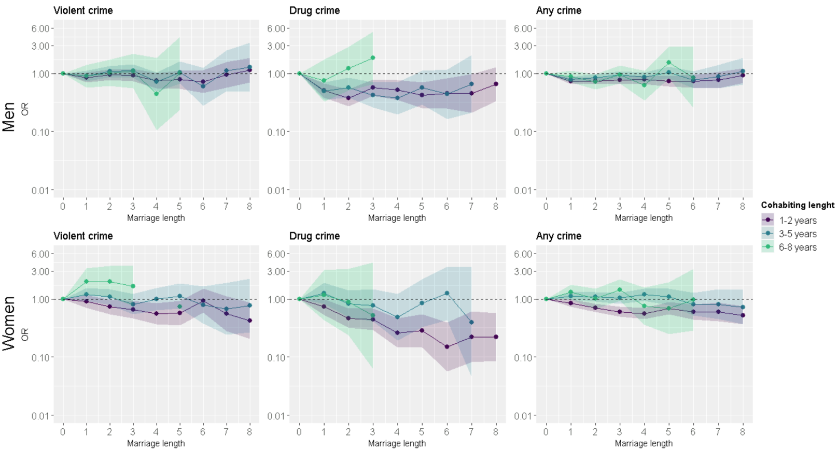
Supplementary Figure E. Between individual effects for analyses stratified by cohabiting relationship length. Marriage length “0” refers to cohabitation.
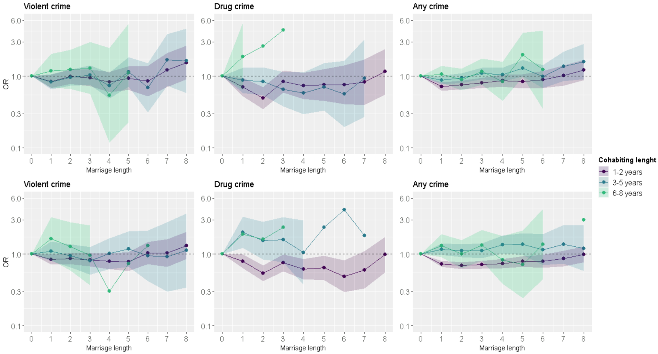
Supplementary Figure F. Within individual effects for analyses stratified by cohabiting relationship length. Marriage length “0” refers to cohabitation.

Supplementary Table B. Average predicted probabilities (%) for the three different criminal behaviors for men and women
 |  | Violent crime |  |  | Drug crime |  |  | Any crime
Men | Relationship length | Predicted risk % | 95% CI |  | Predicted risk % | 95% CI |  | Predicted risk % | 95% CI
Single | 1 | 1.52 | 1.48, 1.56 |  | 1.43 | 1.39, 1.48 |  | 6.51 | 6.42, 6.59
 | 2 | 1.58 | 1.54, 1.63 |  | 1.65 | 1.60, 1.70 |  | 6.94 | 6.85, 7.04
 | 3 | 1.58 | 1.53, 1.64 |  | 1.68 | 1.62, 1.73 |  | 7.13 | 7.02, 7.24
 | 4 | 1.57 | 1.50, 1.63 |  | 1.74 | 1.68, 1.81 |  | 6.97 | 6.84, 7.10
 | 5 | 1.58 | 1.50, 1.65 |  | 1.83 | 1.75, 1.90 |  | 7.13 | 6.98, 7.28
 | 6 | 1.60 | 1.51, 1.69 |  | 1.82 | 1.73, 1.91 |  | 7.05 | 6.88, 7.23
 | 7 | 1.63 | 1.52, 1.74 |  | 1.89 | 1.79, 2.00 |  | 7.05 | 6.83, 7.26
 | 8 | 1.55 | 1.46, 1.65 |  | 1.89 | 1.79, 1.98 |  | 7.16 | 6.97, 7.36
Cohabiting | 1 | 1.47 | 1.42, 1.51 |  | 1.07 | 1.03, 1.12 |  | 5.53 | 5.44, 5.62
 | 2 | 1.47 | 1.42, 1.52 |  | 1.01 | 0.96, 1.05 |  | 5.26 | 5.16, 5.35
 | 3 | 1.24 | 1.17, 1.30 |  | 0.83 | 0.78, 0.89 |  | 4.76 | 4.64, 4.87
 | 4 | 1.16 | 1.07, 1.24 |  | 0.70 | 0.63, 0.77 |  | 4.49 | 4.34, 4.63
 | 5 | 1.17 | 1.07, 1.28 |  | 0.63 | 0.54, 0.71 |  | 4.30 | 4.11, 4.49
 | 6 | 0.88 | 0.75, 1.00 |  | 0.51 | 0.41, 0.61 |  | 4.03 | 3.79, 4.27
 | 7 | 1.01 | 0.84, 1.19 |  | 0.55 | 0.41, 0.69 |  | 4.26 | 3.94, 4.59
 | 8 | 0.95 | 0.78, 1.12 |  | 0.48 | 0.35, 0.61 |  | 4.02 | 3.70, 4.35
Married | 1 | 1.02 | 0.92, 1.12 |  | 0.68 | 0.59, 0.77 |  | 4.15 | 3.96, 4.35
 | 2 | 1.11 | 0.99, 1.23 |  | 0.60 | 0.51, 0.69 |  | 3.98 | 3.76, 4.19
 | 3 | 1.21 | 1.07, 1.36 |  | 0.65 | 0.54, 0.76 |  | 4.27 | 4.01, 4.53
 | 4 | 0.98 | 0.83, 1.13 |  | 0.62 | 0.49, 0.74 |  | 4.35 | 4.04, 4.65
 | 5 | 1.10 | 0.91, 1.30 |  | 0.64 | 0.49, 0.80 |  | 4.45 | 4.07, 4.82
 | 6 | 1.06 | 0.82, 1.29 |  | 0.59 | 0.41, 0.77 |  | 4.03 | 3.59, 4.46
 | 7 | 1.05 | 0.75, 1.34 |  | 0.58 | 0.36, 0.81 |  | 4.14 | 3.59, 4.69
 | 8 | 1.43 | 1.11, 1.74 |  | 0.61 | 0.41, 0.81 |  | 4.90 | 4.36, 5.43
Women
Single | 1 | 0.46 | 0.44, 0.48 |  | 0.35 | 0.33, 0.37 |  | 1.86 | 1.82, 1.91
 | 2 | 0.52 | 0.49, 0.55 |  | 0.36 | 0.34, 0.38 |  | 2.03 | 1.98, 2.08
 | 3 | 0.50 | 0.47, 0.53 |  | 0.38 | 0.35, 0.41 |  | 2.08 | 2.02, 2.14
 | 4 | 0.52 | 0.48, 0.56 |  | 0.39 | 0.35, 0.42 |  | 2.07 | 1.99, 2.14
 | 5 | 0.52 | 0.47, 0.57 |  | 0.40 | 0.36, 0.44 |  | 2.04 | 1.95, 2.13
 | 6 | 0.51 | 0.45, 0.57 |  | 0.37 | 0.32, 0.41 |  | 1.96 | 1.86, 2.07
 | 7 | 0.44 | 0.38, 0.51 |  | 0.39 | 0.34, 0.45 |  | 1.92 | 1.79, 2.04
 | 8 | 0.54 | 0.48, 0.60 |  | 0.37 | 0.32, 0.41 |  | 2.03 | 1.91, 2.14
Cohabiting | 1 | 0.42 | 0.40, 0.45 |  | 0.29 | 0.27, 0.31 |  | 1.65 | 1.61, 1.69
 | 2 | 0.43 | 0.40, 0.45 |  | 0.26 | 0.24, 0.28 |  | 1.53 | 1.48, 1.57
 | 3 | 0.32 | 0.30, 0.35 |  | 0.20 | 0.18, 0.22 |  | 1.17 | 1.12, 1.23
 | 4 | 0.25 | 0.22, 0.28 |  | 0.13 | 0.11, 0.16 |  | 1.05 | 0.98, 1.11
 | 5 | 0.25 | 0.20, 0.29 |  | 0.12 | 0.09, 0.15 |  | 1.00 | 0.91, 1.08
 | 6 | 0.16 | 0.11, 0.20 |  | 0.13 | 0.09, 0.17 |  | 0.86 | 0.76, 0.96
 | 7 | 0.16 | 0.10, 0.21 |  | 0.11 | 0.06, 0.16 |  | 0.88 | 0.75, 1.01
 | 8 | 0.18 | 0.13, 0.23 |  | 0.09 | 0.05, 0.13 |  | 0.91 | 0.79, 1.04
Married | 1 | 0.34 | 0.30, 0.39 |  | 0.25 | 0.21, 0.29 |  | 1.33 | 1.25, 1.42
 | 2 | 0.30 | 0.25, 0.34 |  | 0.19 | 0.15, 0.22 |  | 1.17 | 1.08, 1.26
 | 3 | 0.25 | 0.21, 0.30 |  | 0.17 | 0.13, 0.21 |  | 1.10 | 1.00, 1.20
 | 4 | 0.24 | 0.18, 0.29 |  | 0.12 | 0.09, 0.16 |  | 1.07 | 0.95, 1.18
 | 5 | 0.25 | 0.18, 0.32 |  | 0.13 | 0.09, 0.18 |  | 1.12 | 0.98, 1.26
 | 6 | 0.29 | 0.20, 0.37 |  | 0.11 | 0.06, 0.16 |  | 1.05 | 0.89, 1.21
 | 7 | 0.26 | 0.16, 0.36 |  | 0.09 | 0.04, 0.15 |  | 0.98 | 0.79, 1.16
 | 8 | 0.25 | 0.16, 0.33 |  | 0.09 | 0.05, 0.14 |  | 0.93 | 0.77, 1.09

Supplementary Table C. Odds ratios from the fixed-effect models for the risk of criminal behavior for men and women
 |  | Violent crime |  |  | Drug crime |  |  | Any crime
Men | Relationship length | Predicted risk % | 95% CI |  | Predicted risk % | 95% CI |  | Predicted risk % | 95% CI
Single | 1 | 1 | - |  | 1 | - |  | 1 | -
 | 2 | 1.00 | 0.96, 1.05 |  | 1.11 | 1.06, 1.17 |  | 1.05 | 1.02, 1.08
 | 3 | 0.96 | 0.92, 1.01 |  | 1.05 | 0.99, 1.10 |  | 1.04 | 1.01, 1.07
 | 4 | 0.92 | 0.87, 0.98 |  | 1.03 | 0.97, 1.10 |  | 0.98 | 0.95, 1.01
 | 5 | 0.91 | 0.85, 0.98 |  | 1.04 | 0.97, 1.12 |  | 0.99 | 0.95, 1.03
 | 6 | 0.91 | 0.84, 0.98 |  | 0.99 | 0.92, 1.08 |  | 0.96 | 0.92, 1.00
 | 7 | 0.92 | 0.84, 1.01 |  | 1.01 | 0.92, 1.10 |  | 0.95 | 0.90, 1.00
 | 8 | 0.88 | 0.81, 0.97 |  | 0.97 | 0.88, 1.05 |  | 0.98 | 0.93, 1.03
Cohabiting | 1 | 0.87 | 0.82, 0.91 |  | 0.76 | 0.72, 0.81 |  | 0.76 | 0.74, 0.78
 | 2 | 0.84 | 0.80, 0.89 |  | 0.67 | 0.63, 0.72 |  | 0.69 | 0.67, 0.71
 | 3 | 0.71 | 0.66, 0.76 |  | 0.58 | 0.53, 0.64 |  | 0.62 | 0.60, 0.65
 | 4 | 0.67 | 0.61, 0.73 |  | 0.50 | 0.44, 0.57 |  | 0.59 | 0.56, 0.62
 | 5 | 0.69 | 0.61, 0.78 |  | 0.46 | 0.38, 0.54 |  | 0.56 | 0.53, 0.60
 | 6 | 0.50 | 0.42, 0.59 |  | 0.38 | 0.29, 0.48 |  | 0.53 | 0.48, 0.57
 | 7 | 0.60 | 0.49, 0.74 |  | 0.44 | 0.32, 0.61 |  | 0.58 | 0.52, 0.64
 | 8 | 0.57 | 0.46, 0.71 |  | 0.43 | 0.30, 0.60 |  | 0.55 | 0.49, 0.62
Married | 1 | 0.64 | 0.57, 0.73 |  | 0.57 | 0.48, 0.68 |  | 0.57 | 0.53, 0.61
 | 2 | 0.71 | 0.62, 0.82 |  | 0.48 | 0.39, 0.59 |  | 0.53 | 0.49, 0.58
 | 3 | 0.80 | 0.69, 0.93 |  | 0.54 | 0.43, 0.68 |  | 0.59 | 0.54, 0.65
 | 4 | 0.66 | 0.54, 0.80 |  | 0.52 | 0.40, 0.68 |  | 0.62 | 0.56, 0.69
 | 5 | 0.80 | 0.64, 1.00 |  | 0.60 | 0.43, 0.82 |  | 0.66 | 0.58, 0.75
 | 6 | 0.83 | 0.63, 1.09 |  | 0.60 | 0.40, 0.90 |  | 0.60 | 0.51, 0.69
 | 7 | 0.87 | 0.61, 1.23 |  | 0.63 | 0.38, 1.03 |  | 0.63 | 0.53, 0.77
 | 8 | 1.38 | 1.03, 1.86 |  | 0.79 | 0.49, 1.26 |  | 0.83 | 0.70, 0.98
Women
Single | 1 | 1 | - |  | 1 | - |  | 1 | -
 | 2 | 1.08 | 1.00, 1.16 |  | 0.92 | 0.85, 1.01 |  | 1.05 | 1.01, 1.09
 | 3 | 0.98 | 0.90, 1.07 |  | 0.92 | 0.83, 1.02 |  | 1.02 | 0.97, 1.07
 | 4 | 1.00 | 0.90, 1.11 |  | 0.89 | 0.79, 1.01 |  | 0.98 | 0.93, 1.04
 | 5 | 0.98 | 0.87, 1.11 |  | 0.92 | 0.80, 1.06 |  | 0.94 | 0.88, 1.01
 | 6 | 0.94 | 0.82, 1.09 |  | 0.82 | 0.69, 0.97 |  | 0.89 | 0.82, 0.96
 | 7 | 0.81 | 0.68, 0.97 |  | 0.88 | 0.72, 1.07 |  | 0.86 | 0.78, 0.94
 | 8 | 1.00 | 0.86, 1.17 |  | 0.85 | 0.71, 1.02 |  | 0.94 | 0.86, 1.02
Cohabiting | 1 | 0.88 | 0.82, 0.95 |  | 0.81 | 0.74, 0.90 |  | 0.85 | 0.82, 0.89
 | 2 | 0.88 | 0.81, 0.96 |  | 0.69 | 0.62, 0.77 |  | 0.77 | 0.73, 0.80
 | 3 | 0.72 | 0.64, 0.80 |  | 0.58 | 0.49, 0.67 |  | 0.61 | 0.57, 0.65
 | 4 | 0.59 | 0.50, 0.69 |  | 0.38 | 0.30, 0.48 |  | 0.56 | 0.51, 0.61
 | 5 | 0.62 | 0.51, 0.76 |  | 0.39 | 0.29, 0.52 |  | 0.56 | 0.50, 0.62
 | 6 | 0.42 | 0.31, 0.57 |  | 0.45 | 0.31, 0.66 |  | 0.50 | 0.43, 0.58
 | 7 | 0.47 | 0.32, 0.69 |  | 0.43 | 0.26, 0.71 |  | 0.54 | 0.45, 0.65
 | 8 | 0.60 | 0.43, 0.85 |  | 0.43 | 0.26, 0.73 |  | 0.62 | 0.52, 0.73
Married | 1 | 0.77 | 0.65, 0.90 |  | 0.93 | 0.75, 1.14 |  | 0.73 | 0.67, 0.80
 | 2 | 0.68 | 0.57, 0.82 |  | 0.67 | 0.53, 0.86 |  | 0.63 | 0.57, 0.70
 | 3 | 0.61 | 0.49, 0.77 |  | 0.66 | 0.49, 0.87 |  | 0.62 | 0.55, 0.69
 | 4 | 0.61 | 0.47, 0.80 |  | 0.50 | 0.34, 0.73 |  | 0.63 | 0.55, 0.72
 | 5 | 0.71 | 0.52, 0.96 |  | 0.60 | 0.39, 0.92 |  | 0.71 | 0.61, 0.83
 | 6 | 0.91 | 0.65, 1.29 |  | 0.49 | 0.28, 0.84 |  | 0.71 | 0.58, 0.86
 | 7 | 0.96 | 0.62, 1.47 |  | 0.48 | 0.24, 0.96 |  | 0.69 | 0.55, 0.88
 | 8 | 1.11 | 0.74, 1.65 |  | 0.79 | 0.42, 1.49 |  | 0.77 | 0.62, 0.96

Supplementary Table D. Predicted risks from the between-individual models for the three criminal behaviors for men and women
 |  | Violent crime |  |  | Drug crime |  |  | Any crime
 | Relationship length | Predicted risk % | 95% CI |  | Predicted risk % | 95% CI |  | Predicted risk % | 95% CI
Non-criminal partner
Cohabiting | 1 | 1.27 | 1.22, 1.31 |  | 0.82 | 0.79, 0.86 |  | 4.94 | 4.85, 5.03
 | 2 | 1.28 | 1.23, 1.33 |  | 0.76 | 0.72, 0.79 |  | 4.68 | 4.59, 4.77
 | 3 | 1.05 | 0.99, 1.11 |  | 0.60 | 0.56, 0.64 |  | 4.15 | 4.04, 4.26
 | 4 | 0.96 | 0.89, 1.03 |  | 0.50 | 0.45, 0.55 |  | 3.85 | 3.71, 3.99
 | 5 | 0.97 | 0.88, 1.06 |  | 0.45 | 0.39, 0.51 |  | 3.63 | 3.46, 3.80
 | 6 | 0.69 | 0.59, 0.79 |  | 0.37 | 0.29, 0.44 |  | 3.36 | 3.15, 3.58
 | 7 | 0.82 | 0.67, 0.97 |  | 0.39 | 0.29, 0.49 |  | 3.54 | 3.25, 3.83
 | 8 | 0.76 | 0.62, 0.91 |  | 0.34 | 0.24, 0.43 |  | 3.23 | 2.94, 3.51
Married | 1 | 0.81 | 0.73, 0.90 |  | 0.41 | 0.35, 0.47 |  | 3.44 | 3.26, 3.61
 | 2 | 0.91 | 0.80, 1.02 |  | 0.37 | 0.31, 0.44 |  | 3.28 | 3.09, 3.48
 | 3 | 0.97 | 0.85, 1.10 |  | 0.41 | 0.33, 0.49 |  | 3.53 | 3.29, 3.76
 | 4 | 0.79 | 0.65, 0.92 |  | 0.40 | 0.31, 0.49 |  | 3.49 | 3.22, 3.76
 | 5 | 0.86 | 0.69, 1.03 |  | 0.41 | 0.31, 0.52 |  | 3.59 | 3.27, 3.92
 | 6 | 0.82 | 0.62, 1.02 |  | 0.35 | 0.23, 0.47 |  | 3.17 | 2.79, 3.54
 | 7 | 0.79 | 0.54, 1.04 |  | 0.32 | 0.17, 0.46 |  | 3.26 | 2.79, 3.74
 | 8 | 1.09 | 0.82, 1.36 |  | 0.38 | 0.24, 0.52 |  | 3.79 | 3.33, 4.26
Criminal partner
Cohabiting | 1 | 16.89 | 15.21, 18.58 |  | 17.41 | 15.66, 19.16 |  | 46.67 | 44.49, 48.85
 | 2 | 13.50 | 11.87, 15.13 |  | 13.15 | 11.53, 14.78 |  | 38.32 | 36.09, 40.55
 | 3 | 10.12 | 8.05, 12.19 |  | 11.72 | 9.57, 13.88 |  | 33.39 | 30.40, 36.39
 | 4 | 10.08 | 7.28, 12.88 |  | 9.54 | 6.84, 12.24 |  | 33.61 | 29.61, 37.62
 | 5 | 8.69 | 5.15, 12.23 |  | 5.21 | 2.48, 7.95 |  | 32.38 | 27.09, 37.67
 | 6 | 9.81 | 4.51, 15.11 |  | 4.21 | 0.62, 7.81 |  | 29.14 | 22.01, 36.27
 | 7 | 6.19 | 0.00, 12.58 |  | 4.77 | 0.00, 10.48 |  | 20.18 | 10.49, 29.86
 | 8 | 7.55 | 1.24, 13.86 |  | 5.26 | 0.00, 10.63 |  | 30.69 | 20.87, 40.52
Married | 1 | 15.69 | 12.17, 19.21 |  | 14.64 | 11.37, 17.92 |  | 42.32 | 37.62, 47.02
 | 2 | 12.49 | 8.97, 16.00 |  | 10.33 | 7.32, 13.33 |  | 33.94 | 29.05, 38.83
 | 3 | 14.02 | 9.66, 18.38 |  | 10.02 | 6.51, 13.52 |  | 34.41 | 28.57, 40.25
 | 4 | 8.75 | 4.70, 12.79 |  | 6.54 | 3.31, 9.78 |  | 35.83 | 28.96, 42.70
 | 5 | 9.87 | 4.45, 15.29 |  | 8.03 | 3.54, 12.52 |  | 29.97 | 21.77, 38.18
 | 6 | 13.41 | 5.99, 20.83 |  | 9.88 | 4.03, 15.72 |  | 30.89 | 21.24, 40.54
 | 7 | 12.11 | 3.51, 20.71 |  | 10.93 | 3.61, 18.25 |  | 22.54 | 12.39, 32.70
 | 8 | 13.82 | 6.20, 21.44 |  | 3.62 | 0.00, 7.44 |  | 24.46 | 15.58, 33.35

Supplementary Table E. Odds ratios from the between-individual models for the three criminal behaviors for men and women
 |  | Violent crime |  |  | Drug crime |  |  | Any crime
 | Relationship length | Odds ratio | 95% CI |  | Odds ratio | 95% CI |  | Odds ratio | 95% CI
Non-criminal partner
Cohabiting | 1 | 1 |  |  | 1 | - |  | 1 | -
 | 2 | 0.98 | 0.93, 1.04 |  | 0.85 | 0.79, 0.92 |  | 0.91 | 0.89, 0.94
 | 3 | 0.86 | 0.80, 0.93 |  | 0.75 | 0.67, 0.84 |  | 0.85 | 0.82, 0.89
 | 4 | 0.83 | 0.75, 0.92 |  | 0.66 | 0.57, 0.77 |  | 0.82 | 0.78, 0.87
 | 5 | 0.87 | 0.77, 0.99 |  | 0.62 | 0.51, 0.76 |  | 0.8 | 0.74, 0.86
 | 6 | 0.62 | 0.51, 0.74 |  | 0.52 | 0.40, 0.69 |  | 0.76 | 0.69, 0.83
 | 7 | 0.78 | 0.62, 0.97 |  | 0.62 | 0.44, 0.87 |  | 0.83 | 0.74, 0.94
 | 8 | 0.76 | 0.60, 0.96 |  | 0.59 | 0.40, 0.86 |  | 0.79 | 0.70, 0.89
Married | 1 | 0.81 | 0.69, 0.94 |  | 0.62 | 0.49, 0.79 |  | 0.77 | 0.71, 0.84
 | 2 | 0.93 | 0.79, 1.09 |  | 0.58 | 0.44, 0.76 |  | 0.74 | 0.67, 0.81
 | 3 | 1.04 | 0.86, 1.24 |  | 0.65 | 0.49, 0.87 |  | 0.83 | 0.75, 0.92
 | 4 | 0.9 | 0.71, 1.12 |  | 0.67 | 0.48, 0.93 |  | 0.87 | 0.78, 0.98
 | 5 | 1.09 | 0.85, 1.42 |  | 0.79 | 0.54, 1.17 |  | 0.96 | 0.83, 1.10
 | 6 | 1.17 | 0.85, 1.60 |  | 0.71 | 0.44, 1.16 |  | 0.86 | 0.72, 1.02
 | 7 | 1.25 | 0.84, 1.85 |  | 0.69 | 0.38, 1.26 |  | 0.94 | 0.76, 1.15
 | 8 | 2.11 | 1.48, 3.00 |  | 1.06 | 0.60, 1.89 |  | 1.22 | 1.01, 1.47
Criminal partner
Cohabiting | 1 | 1 | - |  | 1 | - |  | 1 | 0
 | 2 | 0.73 | 0.59, 0.90 |  | 0.62 | 0.49, 0.78 |  | 0.57 | 0.48, 0.68
 | 3 | 0.51 | 0.37, 0.69 |  | 0.55 | 0.39, 0.77 |  | 0.43 | 0.34, 0.55
 | 4 | 0.5 | 0.34, 0.76 |  | 0.43 | 0.26, 0.69 |  | 0.46 | 0.33, 0.62
 | 5 | 0.46 | 0.26, 0.81 |  | 0.18 | 0.08, 0.39 |  | 0.46 | 0.30, 0.69
 | 6 | 0.54 | 0.25, 1.15 |  | 0.15 | 0.05, 0.47 |  | 0.35 | 0.20, 0.62
 | 7 | 0.31 | 0.08, 1.16 |  | 0.2 | 0.04, 1.09 |  | 0.18 | 0.07, 0.44
 | 8 | 0.44 | 0.14, 1.37 |  | 0.27 | 0.06, 1.23 |  | 0.48 | 0.22, 1.05
Married | 1 | 0.74 | 0.48, 1.14 |  | 0.73 | 0.43, 1.23 |  | 0.64 | 0.43, 0.93
 | 2 | 0.56 | 0.34, 0.91 |  | 0.39 | 0.22, 0.70 |  | 0.35 | 0.23, 0.53
 | 3 | 0.65 | 0.38, 1.11 |  | 0.39 | 0.20, 0.76 |  | 0.35 | 0.22, 0.58
 | 4 | 0.36 | 0.18, 0.72 |  | 0.22 | 0.10, 0.49 |  | 0.4 | 0.23, 0.71
 | 5 | 0.48 | 0.21, 1.08 |  | 0.34 | 0.13, 0.87 |  | 0.28 | 0.14, 0.58
 | 6 | 0.77 | 0.32, 1.85 |  | 0.49 | 0.17, 1.43 |  | 0.29 | 0.13, 0.66
 | 7 | 0.69 | 0.24, 2.03 |  | 0.59 | 0.17, 2.04 |  | 0.14 | 0.05, 0.39
 | 8 | 0.89 | 0.35 2.30 |  | 0.13 | 0.03 0.58 |  | 0.19 | 0.08 0.46

Supplementary Table F. Predicted probabilities from the between-individual models for the three criminal behaviors for women
 |  | Violent crime |  |  | Drug crime |  |  |  | Any crime
 | Relationship length | Predicted risk % | 95% CI |  | Predicted risk % | 95% CI |  |  |  | Predicted risk % | 95% CI
Non-criminal partner
Cohabiting | 1 | 0.29 | 0.27, 0.31 |  | 0.14 | 0.13, 0.16 |  |  |  | 1.15 | 1.11, 1.19
 | 2 | 0.32 | 0.30, 0.34 |  | 0.14 | 0.13, 0.16 |  |  |  | 1.13 | 1.09, 1.17
 | 3 | 0.23 | 0.21, 0.26 |  | 0.10 | 0.08, 0.12 |  |  |  | 0.83 | 0.78, 0.87
 | 4 | 0.17 | 0.14, 0.20 |  | 0.07 | 0.05, 0.09 |  |  |  | 0.71 | 0.66, 0.76
 | 5 | 0.17 | 0.13, 0.20 |  | 0.05 | 0.03, 0.07 |  |  |  | 0.66 | 0.59, 0.72
 | 6 | 0.12 | 0.08, 0.15 |  | 0.07 | 0.04, 0.09 |  |  |  | 0.59 | 0.51, 0.67
 | 7 | 0.11 | 0.07, 0.16 |  | 0.06 | 0.03, 0.09 |  |  |  | 0.60 | 0.50, 0.70
 | 8 | 0.13 | 0.09, 0.17 |  | 0.06 | 0.03, 0.08 |  |  |  | 0.62 | 0.53, 0.72
Married | 1 | 0.21 | 0.17, 0.24 |  | 0.08 | 0.06, 0.11 |  |  |  | 0.81 | 0.74, 0.88
 | 2 | 0.2 | 0.16, 0.24 |  | 0.07 | 0.04, 0.09 |  |  |  | 0.75 | 0.68, 0.83
 | 3 | 0.17 | 0.13, 0.21 |  | 0.05 | 0.03, 0.07 |  |  |  | 0.72 | 0.64, 0.80
 | 4 | 0.16 | 0.12, 0.21 |  | 0.04 | 0.02, 0.07 |  |  |  | 0.68 | 0.59, 0.78
 | 5 | 0.17 | 0.11, 0.22 |  | 0.05 | 0.02, 0.07 |  |  |  | 0.71 | 0.60, 0.82
 | 6 | 0.21 | 0.14, 0.28 |  | 0.03 | 0.01, 0.06 |  |  |  | 0.69 | 0.56, 0.81
 | 7 | 0.17 | 0.09, 0.24 |  | 0.02 | 0.01, 0.04 |  |  |  | 0.61 | 0.47, 0.75
 | 8 | 0.16 | 0.10, 0.22 |  | 0.02 | 0.00, 0.04 |  |  |  | 0.54 | 0.43, 0.66
Criminal partner
Cohabiting | 1 | 3.14 | 2.86, 3.42 |  | 3.47 | 3.17, 3.78 |  |  |  | 12.89 | 12.34, 13.43
 | 2 | 2.62 | 2.36, 2.89 |  | 2.51 | 2.24, 2.78 |  |  |  | 10.30 | 9.80, 10.81
 | 3 | 1.99 | 1.67, 2.31 |  | 1.95 | 1.63, 2.26 |  |  |  | 8.05 | 7.44, 8.66
 | 4 | 1.72 | 1.32, 2.12 |  | 1.20 | 0.87, 1.52 |  |  |  | 7.50 | 6.72, 8.28
 | 5 | 1.58 | 1.07, 2.09 |  | 1.42 | 0.96, 1.88 |  |  |  | 6.96 | 5.97, 7.96
 | 6 | 0.79 | 0.31, 1.27 |  | 1.07 | 0.52, 1.62 |  |  |  | 5.08 | 3.92, 6.24
 | 7 | 0.84 | 0.18, 1.50 |  | 1.21 | 0.42, 1.99 |  |  |  | 5.18 | 3.62, 6.74
 | 8 | 0.47 | 0.01, 0.93 |  | 0.84 | 0.22, 1.45 |  |  |  | 5.68 | 4.12, 7.23
Married | 1 | 3.43 | 2.80, 4.05 |  | 3.31 | 2.73, 3.89 |  |  |  | 12.50 | 11.41, 13.60
 | 2 | 2.69 | 2.07, 3.31 |  | 2.40 | 1.86, 2.94 |  |  |  | 10.26 | 9.16, 11.36
 | 3 | 1.92 | 1.30, 2.53 |  | 2.33 | 1.72, 2.94 |  |  |  | 8.72 | 7.54, 9.90
 | 4 | 1.96 | 1.22, 2.70 |  | 1.60 | 1.00, 2.21 |  |  |  | 8.82 | 7.42, 10.23
 | 5 | 2.08 | 1.16, 3.01 |  | 1.75 | 1.00, 2.50 |  |  |  | 9.09 | 7.39, 10.79
 | 6 | 1.48 | 0.48, 2.47 |  | 1.66 | 0.77, 2.54 |  |  |  | 7.80 | 5.82, 9.78
 | 7 | 2.46 | 0.84, 4.09 |  | 1.75 | 0.63, 2.88 |  |  |  | 8.14 | 5.66, 10.61
 | 8 | 1.37 | 0.19, 2.56 |  | 2.47 | 1.10, 3.83 |  |  |  | 8.17 | 5.74, 10.60

Supplementary Table G. Odds ratios from the between-individual models for the three criminal behaviors for men and women
 |  | Violent crime |  |  | Drug crime |  |  | Any crime
 | Relationship length | Odds ratio | 95% CI |  | Odds ratio | 95% CI |  | Odds ratio | 95% CI
Non-criminal partner
Cohabiting | 1 | 1 | - |  | 1 | - |  | 1 | -
 | 2 | 1.08 | 0.97, 1.19 |  | 0.98 | 0.84, 1.14 |  | 0.97 | 0.91, 1.02
 | 3 | 0.93 | 0.81, 1.07 |  | 0.88 | 0.70, 1.10 |  | 0.78 | 0.73, 0.85
 | 4 | 0.74 | 0.61, 0.90 |  | 0.72 | 0.52, 0.98 |  | 0.73 | 0.66, 0.80
 | 5 | 0.84 | 0.66, 1.06 |  | 0.51 | 0.32, 0.81 |  | 0.73 | 0.65, 0.83
 | 6 | 0.65 | 0.46, 0.91 |  | 0.80 | 0.49, 1.33 |  | 0.71 | 0.60, 0.84
 | 7 | 0.74 | 0.48, 1.14 |  | 0.80 | 0.42, 1.55 |  | 0.78 | 0.63, 0.95
 | 8 | 1.04 | 0.70, 1.55 |  | 1.05 | 0.54, 2.04 |  | 0.94 | 0.77,1 .15
Married | 1 | 0.82 | 0.65, 1.03 |  | 0.86 | 0.57, 1.29 |  | 0.78 | 0.69, 0.88
 | 2 | 0.85 | 0.65, 1.09 |  | 0.68 | 0.42, 1.09 |  | 0.74 | 0.64, 0.84
 | 3 | 0.78 | 0.58, 1.05 |  | 0.58 | 0.33, 1.02 |  | 0.74 | 0.63, 0.87
 | 4 | 0.81 | 0.57, 1.15 |  | 0.60 | 0.31, 1.16 |  | 0.79 | 0.66, 0.94
 | 5 | 0.94 | 0.63, 1.39 |  | 0.82 | 0.38, 1.77 |  | 0.91 | 0.74, 1.11
 | 6 | 1.35 | 0.89, 2.05 |  | 0.62 | 0.23, 1.64 |  | 0.96 | 0.75, 1.22
 | 7 | 1.24 | 0.72, 2.13 |  | 0.50 | 0.11, 2.27 |  | 0.93 | 0.69, 1.25
 | 8 | 1.54 | 0.92, 2.58 |  | 0.91 | 0.27, 3.11 |  | 0.98 | 0.74, 1.30
Criminal partner
Cohabiting | 1 | 1 | - |  | 1 | - |  | 1 | -
 | 2 | 0.84 | 0.72, 0.96 |  | 0.65 | 0.56, 0.77 |  | 0.72 | 0.66, 0.78
 | 3 | 0.67 | 0.55, 0.83 |  | 0.52 | 0.41, 0.66 |  | 0.54 | 0.48, 0.61
 | 4 | 0.64 | 0.48, 0.85 |  | 0.30 | 0.21, 0.43 |  | 0.52 | 0.44, 0.61
 | 5 | 0.61 | 0.42, 0.91 |  | 0.41 | 0.26, 0.64 |  | 0.5 | 0.40, 0.62
 | 6 | 0.34 | 0.25, 0.47 |  | 0.65 | 0.46, 0.91 |  | 0.34 | 0.25, 0.47
 | 7 | 0.38 | 0.25, 0.58 |  | 0.74 | 0.48, 1.14 |  | 0.38 | 0.25, 0.58
 | 8 | 0.49 | 0.33, 0.73 |  | 1.04 | 0.70, 1.55 |  | 0.49 | 0.33, 0.73
Married | 1 | 0.86 | 0.73, 1.02 |  | 0.82 | 0.65, 1.03 |  | 0.86 | 0.73, 1.02
 | 2 | 0.62 | 0.51, 0.76 |  | 0.85 | 0.65, 1.09 |  | 0.62 | 0.51, 0.76
 | 3 | 0.50 | 0.39, 0.63 |  | 0.78 | 0.58, 1.05 |  | 0.5 | 0.39, 0.63
 | 4 | 0.52 | 0.40, 0.68 |  | 0.81 | 0.57, 1.15 |  | 0.52 | 0.40, 0.68
 | 5 | 0.58 | 0.43, 0.79 |  | 0.94 | 0.63, 1.39 |  | 0.58 | 0.43, 0.79
 | 6 | 0.47 | 0.31, 0.70 |  | 1.35 | 0.89, 2.05 |  | 0.47 | 0.31, 0.70
 | 7 | 0.50 | 0.32, 0.81 |  | 1.24 | 0.72, 2.13 |  | 0.5 | 0.32, 0.81
 | 8 | 0.54 | 0.33, 0.87 |  | 1.54 | 0.92, 2.58 |  | 0.54 | 0.33 0.87

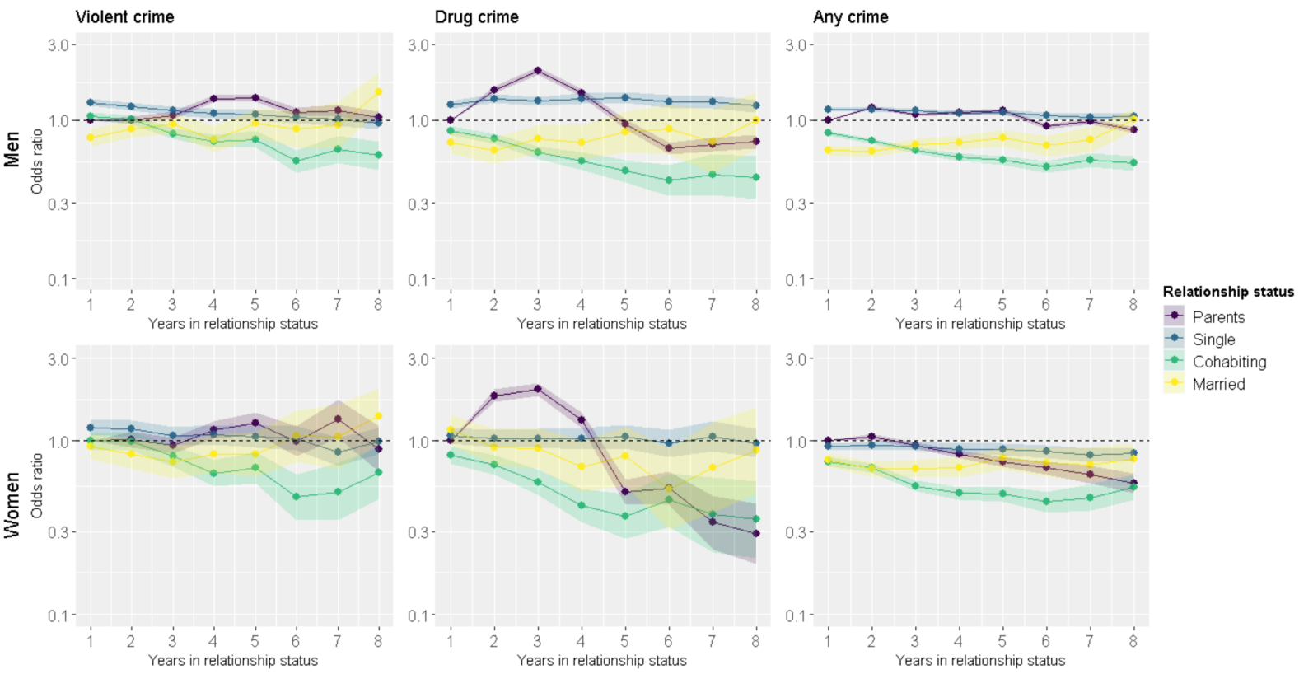
Figure G. Within-individual effects when participants living with their parents are included in the analyses, and models are further adjusted for participants income, immigration status and having children.

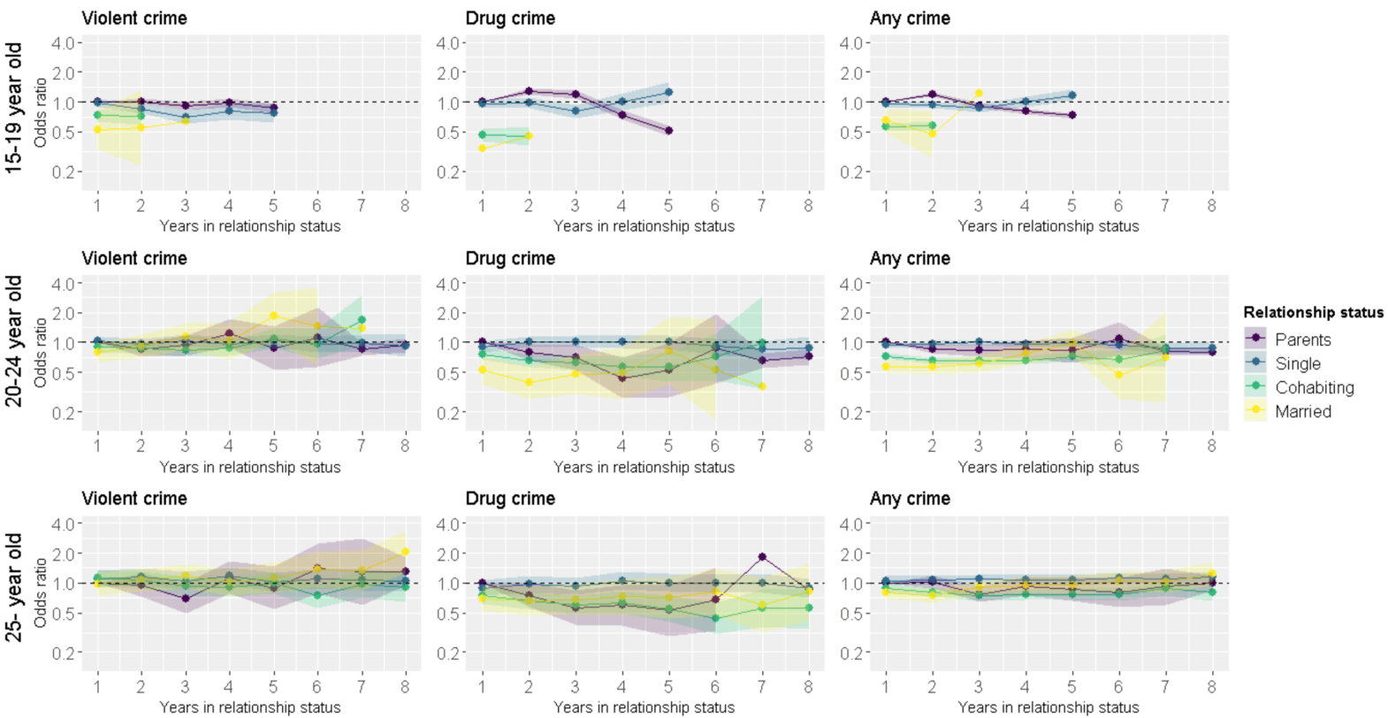
Figure H. Within-individual effects for men when participants living with their parents are included in the analyses stratified by age group.

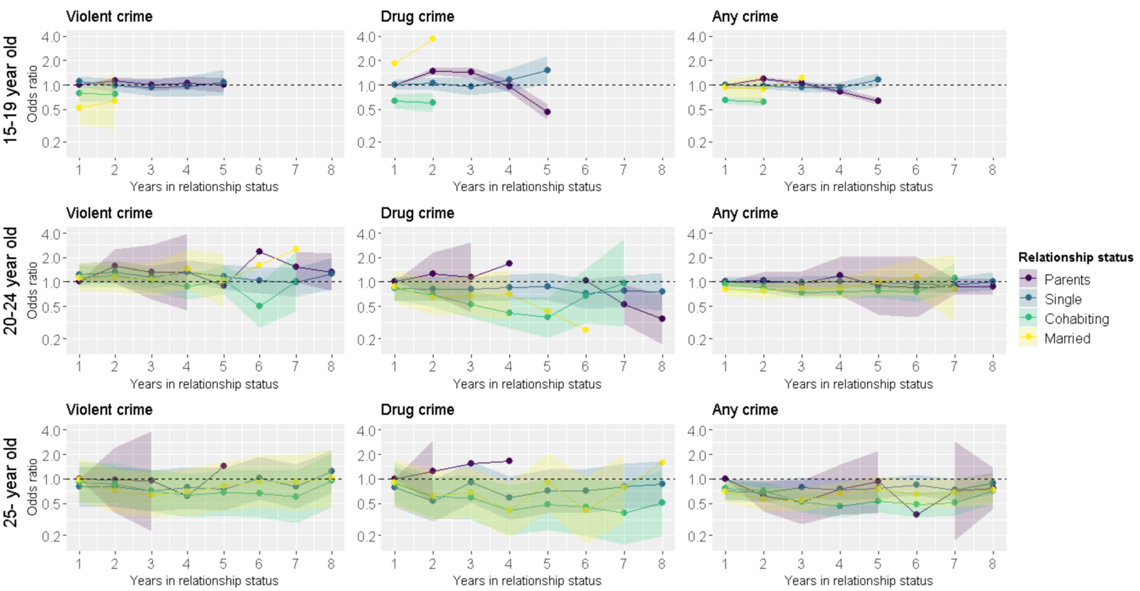
Figure I. Within-individual effects for women when participants living with their parents are included in the analyses stratified by age group.

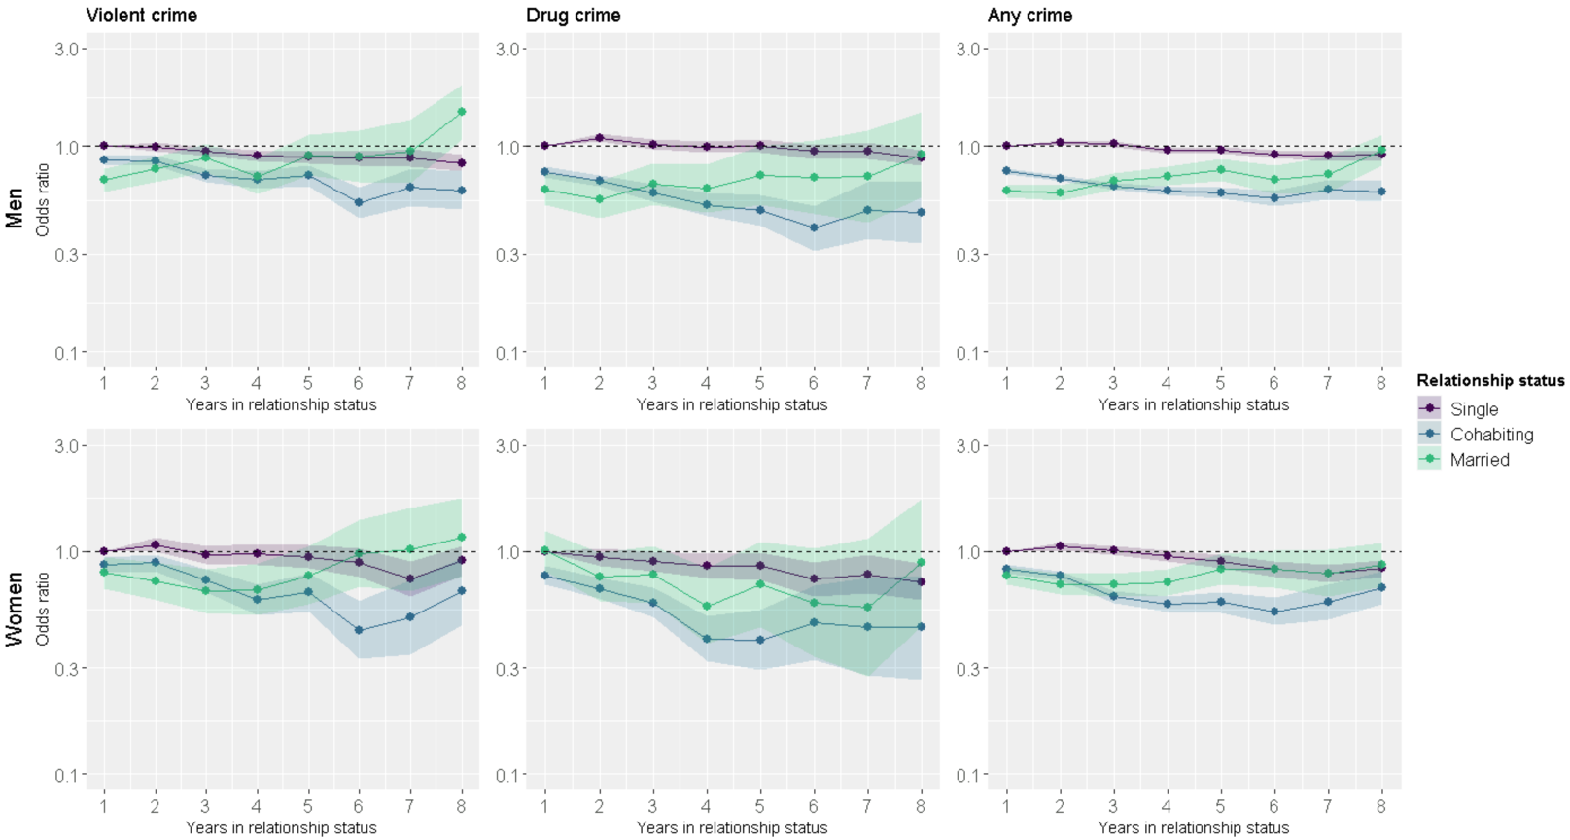
Figure J. Within-individual effects when participants living with their parents are excluded from the analyses, and models are further adjusted for participants income, immigration status and having children.

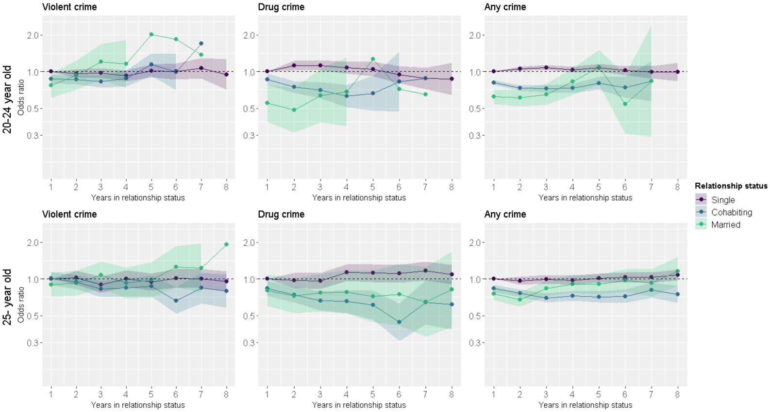
Figure K. Within-individual effects for men when participants living with their parents are excluded in the analyses stratified by age group.

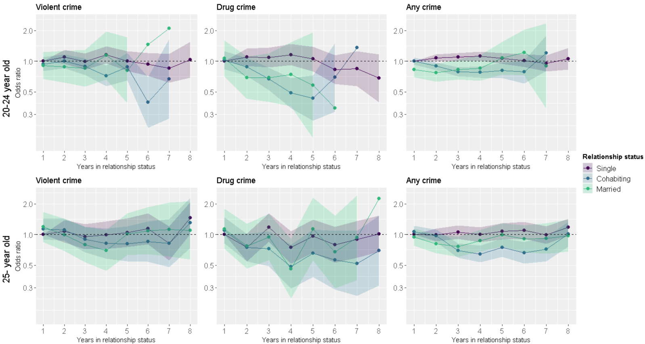
Figure L. Within-individual effects for women when participants living with their parents are excluded in the analyses stratified by age group.

Supplementary Table H. Odds ratios from the fixed-effect models for the risk of being suspected of crimes for men and women further controlled for income and having children
 |  | Violent crime |  |  | Drug crime |  |  | Any crime
Men | Relationship length | Odds ratio | 95% CI |  | Odds ratio | 95% CI |  | Odds ratio | 95% CI
Single | 1 | 1 | - |  | 1 | - |  | 1 | -
 | 2 | 0.99 | 0.95, 1.04 |  | 1.10 | 1.05, 1.16 |  | 1.04 | 1.02, 1.07
 | 3 | 0.95 | 0.90, 1.00 |  | 1.02 | 0.97, 1.08 |  | 1.03 | 1.00, 1.06
 | 4 | 0.90 | 0.84, 0.95 |  | 1.00 | 0.94, 1.06 |  | 0.95 | 0.92, 0.99
 | 5 | 0.88 | 0.82, 0.95 |  | 1.00 | 0.94, 1.08 |  | 0.96 | 0.92, 1.00
 | 6 | 0.87 | 0.81, 0.95 |  | 0.94 | 0.87, 1.02 |  | 0.92 | 0.88, 0.96
 | 7 | 0.88 | 0.80, 0.97 |  | 0.95 | 0.86, 1.04 |  | 0.90 | 0.85, 0.95
 | 8 | 0.83 | 0.76, 0.91 |  | 0.88 | 0.80, 0.96 |  | 0.91 | 0.86, 0.95
Cohabiting | 1 | 0.86 | 0.82, 0.90 |  | 0.75 | 0.71, 0.80 |  | 0.76 | 0.74, 0.78
 | 2 | 0.85 | 0.80, 0.90 |  | 0.68 | 0.64, 0.73 |  | 0.70 | 0.68, 0.72
 | 3 | 0.72 | 0.67, 0.78 |  | 0.59 | 0.54, 0.65 |  | 0.64 | 0.61, 0.66
 | 4 | 0.69 | 0.63, 0.76 |  | 0.52 | 0.46, 0.59 |  | 0.61 | 0.58, 0.64
 | 5 | 0.72 | 0.64, 0.81 |  | 0.49 | 0.41, 0.58 |  | 0.59 | 0.56, 0.63
 | 6 | 0.53 | 0.45, 0.63 |  | 0.40 | 0.31, 0.51 |  | 0.56 | 0.51, 0.61
 | 7 | 0.63 | 0.51, 0.78 |  | 0.49 | 0.36, 0.67 |  | 0.62 | 0.55, 0.69
 | 8 | 0.61 | 0.49, 0.76 |  | 0.48 | 0.34, 0.67 |  | 0.60 | 0.54, 0.68
Married | 1 | 0.68 | 0.60, 0.78 |  | 0.62 | 0.52, 0.74 |  | 0.61 | 0.56, 0.65
 | 2 | 0.77 | 0.67, 0.89 |  | 0.55 | 0.45, 0.68 |  | 0.59 | 0.55, 0.65
 | 3 | 0.88 | 0.75, 1.03 |  | 0.65 | 0.52, 0.82 |  | 0.68 | 0.62, 0.74
 | 4 | 0.72 | 0.59, 0.87 |  | 0.62 | 0.47, 0.82 |  | 0.72 | 0.64, 0.80
 | 5 | 0.91 | 0.72, 1.14 |  | 0.72 | 0.52, 1.00 |  | 0.77 | 0.68, 0.87
 | 6 | 0.89 | 0.67, 1.19 |  | 0.71 | 0.47, 1.07 |  | 0.69 | 0.59, 0.81
 | 7 | 0.95 | 0.66, 1.34 |  | 0.72 | 0.43, 1.20 |  | 0.73 | 0.60, 0.89
 | 8 | 1.47 | 1.09, 1.99 |  | 0.91 | 0.57, 1.47 |  | 0.96 | 0.81, 1.13
Women
Single | 1 | 1 | - |  | 1 | - |  | 1 | -
 | 2 | 1.07 | 1.00, 1.16 |  | 0.94 | 0.86, 1.03 |  | 1.05 | 1.01, 1.10
 | 3 | 0.97 | 0.89, 1.06 |  | 0.90 | 0.81, 1.00 |  | 1.01 | 0.96, 1.06
 | 4 | 0.97 | 0.88, 1.08 |  | 0.86 | 0.76, 0.98 |  | 0.96 | 0.90, 1.01
 | 5 | 0.95 | 0.84, 1.07 |  | 0.86 | 0.74, 0.99 |  | 0.90 | 0.84, 0.96
 | 6 | 0.89 | 0.77, 1.03 |  | 0.75 | 0.63, 0.89 |  | 0.83 | 0.77, 0.90
 | 7 | 0.75 | 0.63, 0.90 |  | 0.79 | 0.65, 0.96 |  | 0.79 | 0.72, 0.87
 | 8 | 0.91 | 0.78, 1.06 |  | 0.73 | 0.61, 0.88 |  | 0.84 | 0.77, 0.91
Cohabiting | 1 | 0.87 | 0.80, 0.94 |  | 0.78 | 0.71, 0.86 |  | 0.83 | 0.80, 0.87
 | 2 | 0.89 | 0.82, 0.97 |  | 0.68 | 0.61, 0.76 |  | 0.78 | 0.74, 0.81
 | 3 | 0.74 | 0.66, 0.83 |  | 0.59 | 0.50, 0.69 |  | 0.63 | 0.59, 0.67
 | 4 | 0.61 | 0.52, 0.71 |  | 0.40 | 0.32, 0.51 |  | 0.58 | 0.53, 0.63
 | 5 | 0.65 | 0.54, 0.80 |  | 0.40 | 0.29, 0.55 |  | 0.59 | 0.53, 0.66
 | 6 | 0.44 | 0.33, 0.60 |  | 0.48 | 0.33, 0.70 |  | 0.54 | 0.47, 0.62
 | 7 | 0.51 | 0.34, 0.75 |  | 0.46 | 0.28, 0.76 |  | 0.59 | 0.49, 0.71
 | 8 | 0.66 | 0.47, 0.93 |  | 0.46 | 0.27, 0.78 |  | 0.69 | 0.58, 0.82
Married | 1 | 0.80 | 0.68, 0.94 |  | 1.00 | 0.81, 1.24 |  | 0.78 | 0.71, 0.85
 | 2 | 0.74 | 0.61, 0.89 |  | 0.77 | 0.60, 0.99 |  | 0.71 | 0.64, 0.79
 | 3 | 0.66 | 0.53, 0.83 |  | 0.79 | 0.59, 1.05 |  | 0.71 | 0.63, 0.80
 | 4 | 0.67 | 0.52, 0.88 |  | 0.57 | 0.39, 0.84 |  | 0.73 | 0.63, 0.84
 | 5 | 0.78 | 0.58, 1.06 |  | 0.71 | 0.46, 1.11 |  | 0.83 | 0.71, 0.97
 | 6 | 0.98 | 0.69, 1.38 |  | 0.59 | 0.34, 1.03 |  | 0.84 | 0.69, 1.01
 | 7 | 1.02 | 0.66, 1.58 |  | 0.56 | 0.27, 1.14 |  | 0.80 | 0.63, 1.02
 | 8 | 1.16 | 0.77, 1.73 |  | 0.89 | 0.46, 1.71 |  | 0.87 | 0.70, 1.09

Supplementary Table I. Age-stratified odds ratios from the fixed-effect models for the risk of criminal behavior for men.
 |  | Violent crime |  |  |  | Drug crime |  |  |  |  | Any crime
20-24 years old | Relationship length | Odds ratio | 95% CI |  |  |  | Odds ratio | 95% CI |  |  |  | Odds ratio |  | 95% CI
Single | 1 | 1 | - |  |  |  | 1 | - |  |  |  | 1 |  | -
 | 2 | 0.96 | 0.89, 1.04 |  |  |  | 1.12 | 1.03, 1.22 |  |  |  | 1.06 |  | 1.01, 1.10
 | 3 | 0.97 | 0.89, 1.06 |  |  |  | 1.12 | 1.02, 1.24 |  |  |  | 1.08 |  | 1.03, 1.13
 | 4 | 0.92 | 0.83, 1.02 |  |  |  | 1.08 | 0.97, 1.21 |  |  |  | 1.03 |  | 0.98, 1.09
 | 5 | 1.01 | 0.89, 1.14 |  |  |  | 1.05 | 0.92, 1.20 |  |  |  | 1.07 |  | 1.00, 1.15
 | 6 | 1.00 | 0.86, 1.17 |  |  |  | 0.94 | 0.80, 1.10 |  |  |  | 1.02 |  | 0.94, 1.11
 | 7 | 1.07 | 0.88, 1.29 |  |  |  | 0.88 | 0.72, 1.08 |  |  |  | 0.99 |  | 0.88, 1.11
 | 8 | 0.95 | 0.71, 1.26 |  |  |  | 0.87 | 0.64, 1.18 |  |  |  | 0.99 |  | 0.84, 1.18
Cohabiting | 1 | 0.87 | 0.80, 0.95 |  |  |  | 0.86 | 0.78, 0.96 |  |  |  | 0.81 |  | 0.77, 0.85
 | 2 | 0.86 | 0.78, 0.94 |  |  |  | 0.75 | 0.67, 0.84 |  |  |  | 0.73 |  | 0.70, 0.77
 | 3 | 0.83 | 0.74, 0.93 |  |  |  | 0.70 | 0.61, 0.82 |  |  |  | 0.72 |  | 0.68, 0.77
 | 4 | 0.88 | 0.76, 1.03 |  |  |  | 0.63 | 0.51, 0.78 |  |  |  | 0.73 |  | 0.67, 0.79
 | 5 | 1.14 | 0.92, 1.41 |  |  |  | 0.66 | 0.48, 0.92 |  |  |  | 0.80 |  | 0.71, 0.90
 | 6 | 0.99 | 0.70, 1.40 |  |  |  | 0.83 | 0.47, 1.47 |  |  |  | 0.74 |  | 0.61, 0.90
 | 7 | 1.69 | 0.93, 3.07 |  |  |  | 0.88 | 0.25, 3.12 |  |  |  | 0.84 |  | 0.57, 1.22
 | 8 | - | - |  |  |  | - | - |  |  |  | - |  | -
Married | 1 | 0.77 | 0.61, 0.97 |  |  |  | 0.55 | 0.39, 0.78 |  |  |  | 0.62 |  | 0.54, 0.71
 | 2 | 0.93 | 0.71, 1.23 |  |  |  | 0.48 | 0.32, 0.74 |  |  |  | 0.61 |  | 0.52, 0.71
 | 3 | 1.20 | 0.86, 1.67 |  |  |  | 0.64 | 0.38, 1.06 |  |  |  | 0.65 |  | 0.53, 0.79
 | 4 | 1.15 | 0.73, 1.82 |  |  |  | 0.68 | 0.35, 1.30 |  |  |  | 0.83 |  | 0.64, 1.06
 | 5 | 2.01 | 1.11, 3.65 |  |  |  | 1.26 | 0.54, 2.94 |  |  |  | 1.08 |  | 0.78, 1.50
 | 6 | 1.84 | 0.71, 4.77 |  |  |  | 0.72 | 0.20, 2.55 |  |  |  | 0.54 |  | 0.31, 0.94
 | 7 | 1.37 | 0.23, 8.07 |  |  |  | 0.65 | 0.07, 6.00 |  |  |  | 0.84 |  | 0.29, 2.41
 | 8 | - | - |  |  |  | - | - |  |  |  | - |  | -
25 years and older
Single | 1 | 1 | - |  |  |  | 1 | - |  |  |  | 1 |  | -
 | 2 | 1.02 | 0.89, 1.17 |  |  |  | 0.97 | 0.85, 1.12 |  |  |  | 0.97 |  | 0.90, 1.04
 | 3 | 0.90 | 0.77, 1.04 |  |  |  | 0.96 | 0.83, 1.12 |  |  |  | 0.99 |  | 0.92, 1.08
 | 4 | 1.00 | 0.86, 1.17 |  |  |  | 1.13 | 0.96, 1.32 |  |  |  | 0.98 |  | 0.90, 1.06
 | 5 | 0.94 | 0.80, 1.11 |  |  |  | 1.11 | 0.95, 1.32 |  |  |  | 1.02 |  | 0.93, 1.11
 | 6 | 1.01 | 0.85, 1.20 |  |  |  | 1.10 | 0.93, 1.31 |  |  |  | 1.03 |  | 0.94, 1.13
 | 7 | 1.01 | 0.84, 1.21 |  |  |  | 1.16 | 0.97, 1.39 |  |  |  | 1.03 |  | 0.93, 1.13
 | 8 | 0.96 | 0.80, 1.15 |  |  |  | 1.08 | 0.90, 1.30 |  |  |  | 1.07 |  | 0.97, 1.19
Cohabiting | 1 | 1.01 | 0.89, 1.15 |  |  |  | 0.84 | 0.72, 0.97 |  |  |  | 0.83 |  | 0.78, 0.90
 | 2 | 0.94 | 0.83, 1.07 |  |  |  | 0.74 | 0.64, 0.86 |  |  |  | 0.76 |  | 0.71, 0.82
 | 3 | 0.83 | 0.71, 0.96 |  |  |  | 0.66 | 0.55, 0.79 |  |  |  | 0.70 |  | 0.64, 0.76
 | 4 | 0.84 | 0.71, 1.00 |  |  |  | 0.65 | 0.52, 0.81 |  |  |  | 0.72 |  | 0.66, 0.79
 | 5 | 0.87 | 0.72, 1.06 |  |  |  | 0.61 | 0.47, 0.80 |  |  |  | 0.71 |  | 0.64, 0.79
 | 6 | 0.66 | 0.52, 0.85 |  |  |  | 0.44 | 0.31, 0.63 |  |  |  | 0.72 |  | 0.64, 0.82
 | 7 | 0.84 | 0.63, 1.12 |  |  |  | 0.64 | 0.42, 0.97 |  |  |  | 0.81 |  | 0.70, 0.94
 | 8 | 0.80 | 0.58, 1.09 |  |  |  | 0.61 | 0.38, 0.98 |  |  |  | 0.75 |  | 0.64, 0.88
Married | 1 | 0.90 | 0.72, 1.12 |  |  |  | 0.81 | 0.60, 1.09 |  |  |  | 0.76 |  | 0.67, 0.86
 | 2 | 0.92 | 0.73, 1.17 |  |  |  | 0.73 | 0.52, 1.01 |  |  |  | 0.68 |  | 0.59, 0.78
 | 3 | 1.08 | 0.84, 1.39 |  |  |  | 0.77 | 0.54, 1.10 |  |  |  | 0.84 |  | 0.72, 0.97
 | 4 | 0.92 | 0.69, 1.24 |  |  |  | 0.78 | 0.52, 1.18 |  |  |  | 0.91 |  | 0.77, 1.07
 | 5 | 0.98 | 0.70, 1.37 |  |  |  | 0.72 | 0.44, 1.17 |  |  |  | 0.90 |  | 0.75, 1.09
 | 6 | 1.26 | 0.85, 1.86 |  |  |  | 0.74 | 0.42, 1.33 |  |  |  | 0.97 |  | 0.78, 1.21
 | 7 | 1.23 | 0.77, 1.96 |  |  |  | 0.65 | 0.34, 1.25 |  |  |  | 0.93 |  | 0.72, 1.20
 | 8 | 1.91 | 1.19, 3.06 |  |  |  | 0.82 | 0.40, 1.68 |  |  |  | 1.16 |  | 0.89, 1.51

Supplementary Table J. Age-stratified odds ratios from the fixed-effect models for the risk of criminal behavior for women.
 |  | Violent crime |  |  | Drug crime |  |  | Any crime
20-24 years old | Relationship length | Odds ratio | 95% CI |  | Odds ratio | 95% CI |  | Odds ratio | 95% CI
Single | 1 | 1 | - |  | 1 | - |  | 1 | -
 | 2 | 1.10 | 0.94, 1.29 |  | 1.09 | 0.90, 1.34 |  | 1.08 | 0.99, 1.17
 | 3 | 1.00 | 0.83, 1.19 |  | 1.08 | 0.87, 1.35 |  | 1.10 | 1.00, 1.21
 | 4 | 1.15 | 0.95, 1.40 |  | 1.16 | 0.91, 1.47 |  | 1.12 | 1.01, 1.25
 | 5 | 1.01 | 0.80, 1.26 |  | 1.05 | 0.80, 1.38 |  | 1.07 | 0.95, 1.21
 | 6 | 0.93 | 0.71, 1.21 |  | 0.82 | 0.59, 1.14 |  | 1.01 | 0.87, 1.17
 | 7 | 0.85 | 0.62, 1.18 |  | 0.85 | 0.57, 1.26 |  | 0.96 | 0.80, 1.15
 | 8 | 1.03 | 0.69, 1.54 |  | 0.68 | 0.40, 1.17 |  | 1.05 | 0.83, 1.35
Cohabiting | 1 | 0.94 | 0.80, 1.09 |  | 1.02 | 0.84, 1.25 |  | 1.00 | 0.92, 1.09
 | 2 | 1.00 | 0.86, 1.17 |  | 0.88 | 0.72, 1.07 |  | 0.89 | 0.82, 0.97
 | 3 | 0.89 | 0.74, 1.07 |  | 0.67 | 0.52, 0.86 |  | 0.79 | 0.71, 0.87
 | 4 | 0.72 | 0.57, 0.91 |  | 0.49 | 0.35, 0.68 |  | 0.78 | 0.69, 0.88
 | 5 | 0.88 | 0.65, 1.20 |  | 0.43 | 0.26, 0.72 |  | 0.81 | 0.68, 0.96
 | 6 | 0.39 | 0.22, 0.69 |  | 0.69 | 0.32, 1.50 |  | 0.78 | 0.60, 1.01
 | 7 | 0.67 | 0.27, 1.64 |  | 1.36 | 0.38, 4.92 |  | 1.20 | 0.80, 1.78
 | 8 | - | - |  | - | - |  | - | -
Married | 1 | 0.91 | 0.67, 1.23 |  | 1.06 | 0.71, 1.60 |  | 0.83 | 0.70, 0.98
 | 2 | 0.88 | 0.62, 1.26 |  | 0.69 | 0.43, 1.11 |  | 0.77 | 0.63, 0.94
 | 3 | 0.85 | 0.56, 1.29 |  | 0.69 | 0.40, 1.19 |  | 0.83 | 0.66, 1.04
 | 4 | 1.14 | 0.66, 1.96 |  | 0.74 | 0.36, 1.53 |  | 0.86 | 0.64, 1.14
 | 5 | 0.81 | 0.39, 1.72 |  | 0.58 | 0.17, 1.92 |  | 1.07 | 0.74, 1.56
 | 6 | 1.46 | 0.57, 3.73 |  | 0.35 | 0.05, 2.26 |  | 1.22 | 0.72, 2.05
 | 7 | 2.11 | 0.50, 8.96 |  | - | - |  | 0.90 | 0.34, 2.34
 | 8 | - | - |  | - | - |  | - | -
25 years and older
Single | 1 | 1 | - |  | 1 | - |  | 1 | -
 | 2 | 1.08 | 0.83, 1.39 |  | 0.75 | 0.55, 1.02 |  | 0.99 | 0.86, 1.14
 | 3 | 0.95 | 0.71, 1.27 |  | 1.17 | 0.85, 1.61 |  | 1.06 | 0.90, 1.23
 | 4 | 0.99 | 0.73, 1.35 |  | 0.75 | 0.52, 1.08 |  | 1.00 | 0.84, 1.18
 | 5 | 1.04 | 0.75, 1.45 |  | 0.96 | 0.66, 1.40 |  | 1.08 | 0.90, 1.29
 | 6 | 1.14 | 0.80, 1.62 |  | 0.79 | 0.53, 1.18 |  | 1.09 | 0.90, 1.32
 | 7 | 0.82 | 0.56, 1.20 |  | 0.89 | 0.59, 1.36 |  | 0.99 | 0.81, 1.21
 | 8 | 1.45 | 1.02, 2.07 |  | 1.02 | 0.68, 1.53 |  | 1.18 | 0.98, 1.44
Cohabiting | 1 | 1.13 | 0.89, 1.44 |  | 1.10 | 0.82, 1.48 |  | 1.06 | 0.93, 1.21
 | 2 | 1.11 | 0.87, 1.42 |  | 0.74 | 0.55, 1.01 |  | 0.97 | 0.85, 1.12
 | 3 | 0.89 | 0.67, 1.19 |  | 0.72 | 0.49, 1.08 |  | 0.69 | 0.59, 0.82
 | 4 | 0.82 | 0.58, 1.15 |  | 0.48 | 0.29, 0.79 |  | 0.64 | 0.53, 0.78
 | 5 | 0.81 | 0.55, 1.20 |  | 0.66 | 0.38, 1.12 |  | 0.74 | 0.60, 0.92
 | 6 | 0.85 | 0.54, 1.34 |  | 0.56 | 0.29, 1.09 |  | 0.66 | 0.52, 0.85
 | 7 | 0.82 | 0.48, 1.41 |  | 0.52 | 0.25, 1.08 |  | 0.72 | 0.55, 0.94
 | 8 | 1.30 | 0.74, 2.27 |  | 0.70 | 0.32, 1.54 |  | 1.01 | 0.76, 1.33
Married | 1 | 1.18 | 0.84, 1.66 |  | 1.14 | 0.72, 1.79 |  | 0.94 | 0.78, 1.15
 | 2 | 0.99 | 0.69, 1.43 |  | 0.77 | 0.46, 1.27 |  | 0.81 | 0.66, 1.00
 | 3 | 0.80 | 0.53, 1.19 |  | 0.95 | 0.56, 1.59 |  | 0.76 | 0.61, 0.95
 | 4 | 0.70 | 0.44, 1.11 |  | 0.46 | 0.23, 0.91 |  | 0.87 | 0.68, 1.11
 | 5 | 1.01 | 0.63, 1.61 |  | 1.13 | 0.56, 2.30 |  | 0.99 | 0.76, 1.29
 | 6 | 1.09 | 0.64, 1.85 |  | 0.67 | 0.30, 1.53 |  | 0.90 | 0.67, 1.22
 | 7 | 1.12 | 0.61, 2.07 |  | 0.93 | 0.36, 2.43 |  | 0.92 | 0.65, 1.29
 | 8 | 1.10 | 0.57, 2.13 |  | 2.25 | 0.74, 6.88 |  | 0.98 | 0.68, 1.40

