‘As time goes by’ The effectiveness of protection orders in reducing intimate partner violence recidivism

Supplementary material

Table A1: Sample description at committing crime. Recurrent events database.
Category | Variable | Mean / Col(%) | SD | Min | Max
Aggressor characteristics | Age at crime | 38,5 | 11,0 | 16,9 | 97,1
Aggressor characteristics | National origin | 60% | . | . | .
Aggressor characteristics | Foreign origin | 28% | . | . | .
Aggressor characteristics | Unknown origin | 10% | . | . | .
Crime characteristics | Physical violence | 55% | . | . | .
Crime characteristics | Days of sentence imposed (logged) | 4.5 | 0.59 | 3.7
Criminal history | Prior number of IPV crimes before the crime | 0.33 | 0.63 | 0,0 | 3,0
Criminal history | Prior number of other crimes | 0.73 | 1.8 | 0,0 | 32,0
Current sentencing status | Imprisoned | 0.1% | . | . | .
Current sentencing status | Supervised | 0,0 | . | . | .
Sentencing history | Prior imprisonment spells | 0.29 | 0.98 | 0,0 | 22,0
Sentencing history | Prior years imprisoned | 0.3 | 1.4 | 0,0 | 19,0
Sentencing history | Prior supervision spells | 0.18 | 0.47 | 0,0 | 4,0
Sentencing history | Prior years supervised | 0.22 | 0.79 | 0,0 | 12,0
Sentencing history | Prior PO spells | 0,10 | 0.45 | 0,0 | 4,0
Sentencing history | Prior years under a PO | 0.24 | 0.93 | 0,0 | 24,0

Figure A1: Results of a Cox Regression Models Predicting the Time of Holding a Protection Order after committing the first crime between 2010 and 2014.
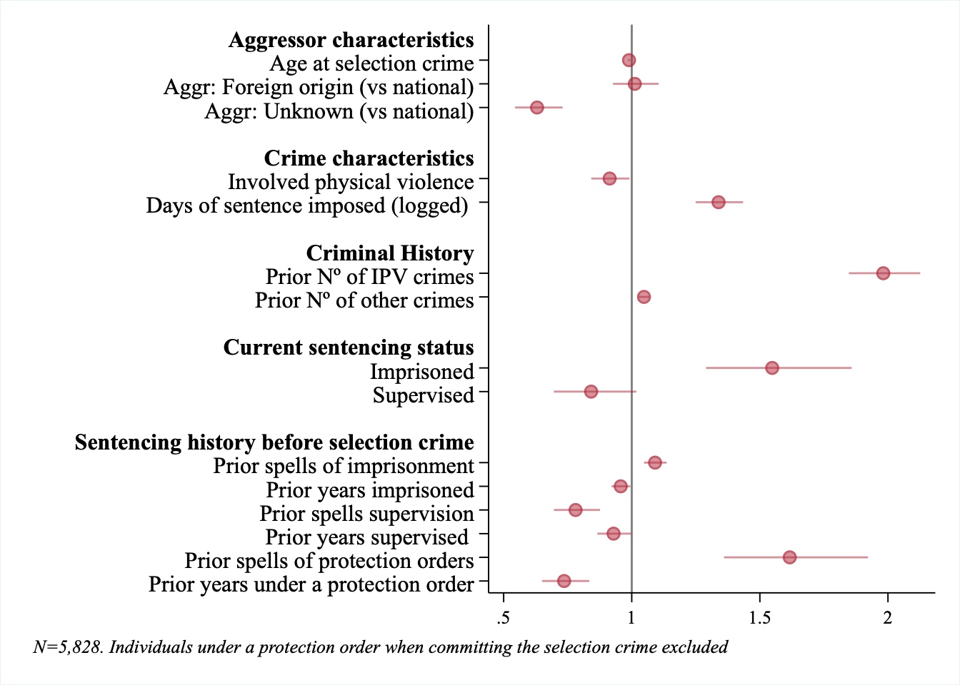
Table A2: Cox Regression Full Model Results for Time to First Recidivism, Including Time Interactions
 | Model 0 | Model 0+ | Model 1 | Model 1+ | Model 2a | Model 2a+ | Model 2 | Model 2+ | Model 3A | Model 3A+ | Model 4A | Model 4A+
Current PO (vs. not) | 2.01*** | 1.79*** | 1.29*** | 1.13 | 1.23** | 1.23** | 1.04 | 1.15 | 1.24* | 1.87*** | 1.33*** | 2.06***
Current PO (vs. not) | (0.11) | (0.12) | (0.09) | (0.10) | (0.08) | (0.08) | (0.10) | (0.12) | (0.13) | (0.21) | (0.11) | (0.19)
Aggressor characteristics: Age at crime |  |  |  |  | 0.97*** | 0.98*** | 0.97*** | 0.98*** | 0.97*** | 0.98*** | 0.97*** | 0.98***
Aggressor characteristics: Age at crime |  |  |  |  | (0.00) | (0.00) | (0.00) | (0.00) | (0.00) | (0.00) | (0.00) | (0.00)
Aggr. charac.: Foreign origin (vs. national) |  |  |  |  | 0.82** | 0.82** | 0.81** | 0.81** | 0.81** | 0.81** | 0.76*** | 0.85*
Aggr. charac.: Foreign origin (vs. national) |  |  |  |  | (0.05) | (0.05) | (0.05) | (0.05) | (0.05) | (0.05) | (0.04) | (0.06)
Aggr. charac.: Unknown or. (vs. national) |  |  |  |  | 0.61*** | 0.61*** | 0.64*** | 0.64*** | 0.64*** | 0.64*** | 0.56*** | 0.74*
Aggr. charac.: Unknown or. (vs. national) |  |  |  |  | (0.06) | (0.06) | (0.07) | (0.07) | (0.07) | (0.07) | (0.05) | (0.09)
SC crime characteristics: Involved physucal injury (vs. not) |  |  |  |  |  |  | 1.25*** | 1.25*** | 1.26*** | 1.26*** | 1.34*** | 1.34***
SC crime characteristics: Involved physucal injury (vs. not) |  |  |  |  |  |  | (0.08) | (0.08) | (0.08) | (0.08) | (0.07) | (0.07)
SC crime characteristics: Days of sentence imposed (logged) |  |  |  |  |  |  | 1.09 | 1.11 | 1.08 | 1.10 | 1.16*** | 1.16***
SC crime characteristics: Days of sentence imposed (logged) |  |  |  |  |  |  | (0.06) | (0.06) | (0.06) | (0.06) | (0.05) | (0.05)
Crim. hist.: Prior number of IPV crimes before SC crim |  |  |  |  |  |  | 1.37*** | 1.50*** | 1.21* | 1.23*
Crim. hist.: Prior number of IPV crimes before SC crim |  |  |  |  |  |  | (0.12) | (0.13) | (0.11) | (0.12)
Crim. hist.: Prior number of other crimes |  |  |  |  |  |  | 1.07*** | 1.05** | 1.07*** | 1.05** | 1.08*** | 1.07***
Crim. hist.: Prior number of other crimes |  |  |  |  |  |  | (0.01) | (0.02) | (0.01) | (0.02) | (0.01) | (0.01)
Curent sentencing status: Imprisoned (vs. not) |  |  |  |  |  |  | 0.16*** | 0.15*** | 0.16*** | 0.16*** | 0.13*** | 0.13***
Curent sentencing status: Imprisoned (vs. not) |  |  |  |  |  |  | (0.04) | (0.04) | (0.04) | (0.04) | (0.02) | (0.02)
Current sentencing status: Supervised (vs. not) |  |  |  |  |  |  | 1.13 | 0.82 | 1.13 | 0.81 | 1.22* | 0.79
Current sentencing status: Supervised (vs. not) |  |  |  |  |  |  | (0.12) | (0.13) | (0.12) | (0.13) | (0.10) | (0.10)
Sent. hist.: Prior imprisonment spells |  |  |  |  |  |  | 1.00 | 0.98 | 1.00 | 0.98 | 1.01 | 0.99
Sent. hist.: Prior imprisonment spells |  |  |  |  |  |  | (0.03) | (0.03) | (0.03) | (0.03) | (0.03) | (0.03)
Sent hist: Prior years imprisoned |  |  |  |  |  |  | 1.05* | 1.06* | 1.05* | 1.06* | 1.03 | 1.03
Sent hist: Prior years imprisoned |  |  |  |  |  |  | (0.02) | (0.02) | (0.02) | (0.02) | (0.02) | (0.02)
Sent hist: Prior supervision spells |  |  |  |  |  |  | 1.12 | 1.23** | 1.11 | 1.24** | 0.89* | 1.13
Sent hist: Prior supervision spells |  |  |  |  |  |  | (0.08) | (0.09) | (0.08) | (0.09) | (0.05) | (0.09)
Sent hist: Prior years supervised |  |  |  |  |  |  | 0.82*** | 0.70*** | 0.82*** | 0.72*** | 0.85*** | 0.76***
Sent hist: Prior years supervised |  |  |  |  |  |  | (0.04) | (0.06) | (0.04) | (0.06) | (0.03) | (0.05)
Sent. hist.: Prior PO spells |  |  |  |  |  |  | 1.52*** | 1.62*** | 1.50*** | 1.46*** | 1.37*** | 1.22***
Sent. hist.: Prior PO spells |  |  |  |  |  |  | (0.12) | (0.17) | (0.11) | (0.11) | (0.08) | (0.07)
Sent hist: Prior years under a PO |  |  |  |  |  |  | 0.80*** | 0.63***
Sent hist: Prior years under a PO |  |  |  |  |  |  | (0.04) | (0.05)
Sent hist: Prior number of days under a protection order BEFORE crime |  |  |  |  |  |  |  |  | 0.95 | 0.87* | 1.01 | 1.05
 |  |  |  |  |  |  |  |  | (0.05) | (0.06) | (0.04) | (0.03)
Sent hist: Prior number of days under a protection order AFTER crime |  |  |  |  |  |  |  |  | 0.67*** | 0.35*** | 0.71*** | 0.38***
 |  |  |  |  |  |  |  |  | (0.04) | (0.04) | (0.03) | (0.03)
Time interactions (Only with variables with p-values<0.05 at residual schoenfeld test)
Current PO x ln(t) |  | 1.00** |  | 1.00*
Current PO x ln(t) |  | (0.00) |  | (0.00)
Aggressor characteristics: Age at crime x ln(t) |  |  |  |  |  | 1.00* |  | 1.00* |  | 1.00* |  | 1.00***
Aggressor characteristics: Age at crime x ln(t) |  |  |  |  |  | (0.00) |  | (0.00) |  | (0.00) |  | (0.00)
Crim. hist.: Prior number of other crimes x ln(t) |  |  |  |  |  |  |  | 1.00** |  | 1.00** |  | 1.00
Crim. hist.: Prior number of other crimes x ln(t) |  |  |  |  |  |  |  | (0.00) |  | (0.00) |  | (0.00)
Current sentencing status: Supervised x ln(t) |  |  |  |  |  |  |  | 1.00** |  | 1.00** |  | 1.00***
Current sentencing status: Supervised x ln(t) |  |  |  |  |  |  |  | (0.00) |  | (0.00) |  | (0.00)
Sent hist: Prior supervision spells x ln(t) |  |  |  |  |  |  |  | 1.00 |  | 1.00 |  | 1.00*
Sent hist: Prior supervision spells x ln(t) |  |  |  |  |  |  |  | (0.00) |  | (0.00) |  | (0.00)
Sent hist: Prior years under a PO x ln(t) |  |  |  |  |  |  |  | 1.00
Sent hist: Prior years under a PO x ln(t) |  |  |  |  |  |  |  | (0.00)
Sent hist: Prior years under a PO x ln(t) |  |  |  |  |  |  |  | 1.00***
Sent hist: Prior years under a PO x ln(t) |  |  |  |  |  |  |  | (0.00)
Sent hist: Prior number of days under a protection order BEFORE crime x ln(t) |  |  |  |  |  |  |  |  |  | 1.00***
 |  |  |  |  |  |  |  |  |  | (0.00)
Sent hist: Prior number of days under a protection order AFTER crime x ln(t) |  |  |  |  |  |  |  |  |  | 1.00*** |  | 1.00***
 |  |  |  |  |  |  |  |  |  | (0.00) |  | (0.00)
Aggr. charac.: Foreign origin (vs. national) x ln(t) |  |  |  |  |  |  |  |  |  |  |  | 1.00*
Aggr. charac.: Foreign origin (vs. national) x ln(t) |  |  |  |  |  |  |  |  |  |  |  | (0.00)
Aggr. charac.: Foreign origin (vs. national) x ln(t) |  |  |  |  |  |  |  |  |  |  |  | 1.00**
Aggr. charac.: Foreign origin (vs. national) x ln(t) |  |  |  |  |  |  |  |  |  |  |  | (0.00)
Sent hist: Prior supervision spells x ln(t) |  |  |  |  |  |  |  |  |  |  |  | 1.00**
Sent hist: Prior supervision spells x ln(t) |  |  |  |  |  |  |  |  |  |  |  | (0.00)
Sent. hist.: Prior PO spells x ln(t) |  |  |  |  |  |  |  |  |  |  |  | 1.00***
Sent. hist.: Prior PO spells x ln(t) |  |  |  |  |  |  |  |  |  |  |  | (0.00)
N Individuals | 6046 | 6046 | 6046 | 6046 | 6046 | 6046 | 6046 | 6046 | 6046 | 6046 | 6046 | 6046
N Spells | 6046 | 6046 | 6046 | 6046 | 6046 | 6046 | 6046 | 6046 | 6046 | 6046 | 8073 | 8073
Dependent Variable | IPV + Breach | IPV + Breach | IPV | IPV | IPV | IPV | IPV | IPV | IPV | IPV | IPV | IPV
Model Type | Standard | Standard | Standard | Standard | Standard | Standard | Standard | Standard | Standard | Standard | REC. EVENTS | REC. EVENTS
Interaction with time | No | Yes | No | Yes | No | Yes | No | Yes | No | Yes | No | Yes
Note: Exponentiated coefficients. * p<0.05, ** p<0.01, *** p<0.001.

Table A3: Cox Regression Full Model Results for Time to First Recidivism, Including Time Interactions. Aggressors with a protection order imposed less than 90 days after the crime excluded.

 | Model 5 | Model 5+
Current PO | 1.25 | 1.67*
Current PO | (0.27) | (0.42)
Aggressor characteristics: Age at crime | 0.97*** | 0.98***
Aggressor characteristics: Age at crime | (0.00) | (0.00)
Aggr. charac.: Foreign origin (vs. national) | 0.79** | 0.79**
Aggr. charac.: Foreign origin (vs. national) | (0.07) | (0.07)
Aggr. charac.: Unknown or. (vs. national) | 0.66*** | 0.65***
Aggr. charac.: Unknown or. (vs. national) | (0.08) | (0.08)
SC crime characteristics: Physical violence | 1.23** | 1.24**
SC crime characteristics: Physical violence | (0.10) | (0.10)
SC crime characteristics: Days of sentence imposed (logged) | 1.05 | 1.08
SC crime characteristics: Days of sentence imposed (logged) | (0.07) | (0.08)
Crim. hist.: Prior number of IPV crimes before SC crim | 1.32* | 1.34*
Crim. hist.: Prior number of IPV crimes before SC crim | (0.16) | (0.17)
Crim. hist.: Prior number of other crimes | 1.10*** | 1.05*
Crim. hist.: Prior number of other crimes | (0.02) | (0.02)
Current sentencing status: Imprisoned | 0.15*** | 0.13***
Current sentencing status: Imprisoned | (0.06) | (0.05)
Current sentencing status: Supervised | 1.12 | 1.15
Current sentencing status: Supervised | (0.15) | (0.16)
Sent. hist.: Prior imprisonment spells | 1.01 | 0.99
Sent. hist.: Prior imprisonment spells | (0.04) | (0.04)
Sent hist: Prior years imprisoned | 1.01 | 1.03
Sent hist: Prior years imprisoned | (0.04) | (0.04)
Sent hist: Prior supervision spells | 1.03 | 1.23
Sent hist: Prior supervision spells | (0.09) | (0.16)
Sent hist: Prior years supervised | 0.86* | 0.66***
Sent hist: Prior years supervised | (0.05) | (0.07)
Sent. hist.: Prior PO spells | 1.53** | 1.48**
Sent. hist.: Prior PO spells | (0.21) | (0.20)
Sent hist: Prior number of days under a protection order BEFORE crime | 0.97 | 1.00
 | (0.06) | (0.06)
Sent hist: Prior number of days under a protection order AFTER crime | 0.59*** | 0.35***
 | (0.08) | (0.11)
Time interactions (Only with variables with p-values<0.05 at residual Schoenfeld test)
Aggressor characteristics: Age at crime x ln(t) |  | 1.00**
Aggressor characteristics: Age at crime x ln(t) |  | 1.00**
Crim. hist.: Prior number of other crimes x ln(t) |  | (0.00)
Crim. hist.: Prior number of other crimes x ln(t) |  | 1.00
Sent hist: Prior supervision spells x ln(t) |  | (0.00)
Sent hist: Prior supervision spells x ln(t) |  | 1.00***
Sent hist: Prior years supervised x ln(t) |  | (0.00)
Sent hist: Prior years supervised x ln(t) |  | 1.00
Sent hist: Prior number of days under a protection order AFTER crime x ln(t) |  | (0.00)
N Individuals | 4541 | 4541
N Spells | 4541 | 4541
Dependent Variable | IPV + Breach | IPV + Breach
Model Type | Standard | Standard
Interaction with time | No | Yes

