Supplementary Materials

Table A1. Total Mental Health index correlations

 | Total mental health index | Psychosis | Mood disorder | PTSD | Impulse Control disorder | Antisocial behavior | Disruptive behavior | Paranoid personality disorder | Schizoid personality disorder | Antisocial personality disorder | Narcissistic personality disorder | Borderline personality disorder | Substance abuse
Total mental health index | 1 | 0.3562 | 0.3284 | 0.1022 | 0.1579 | 0.1088 | 0.0797 | 0.0415 | 0.0419 | 0.5377 | 0.0261 | 0.1768 | 0.7125
Total mental health index |  | <.0001 | <.0001 | <.0001 | <.0001 | <.0001 | <.0001 | <.0001 | <.0001 | <.0001 | <.0001 | <.0001 | <.0001

Table A2 – Mental illness index correlations
 | Mental Illness Index | Psychosis | Mood disorder | PTSD | Impulse Control disorder | Antisocial behavior | Disruptive behavior
Mental Illness Index | 1 | 0.6506 | 0.6172 | 0.2218 | 0.2791 | 0.2462 | 0.1765
Mental Illness Index |  | < .0001 | < .0001 | < .0001 | < .0001 | < .0001 | < .0001

Table A3. Personality Disorders index correlations
 | Personality Disorder Index | Paranoid personality disorder | Schizoid personality disorder | Antisocial personality disorder | Narcissistic personality disorder | Borderline personality disorder
Personality Disorder Index | 1 | 0.0679 | 0.0550 | 0.9646 | 0.0582 | 0.3133
Personality Disorder Index |  | < .0001 | < .0001 | < .0001 | < .0001 | < .0001

Table A4. Social Risk index correlations
 | Social Risk index | High school | Employment or occupation (any) | Married | Gang Membership | Prior violent | Priors non- violent | Age at first conviction
Social Risk index | 1 | 0.59104 | 0.55781 | 0.27 | 0.13422 | 0.08271 | 0.54738 | 0.59104
Social Risk index |  | < .0001 | < .0001 | < .0001 | < .0001 | < .0001 | < .0001 | < .0001

Table A5. Fit indexes Akaike’s information criterion (AIC), Bayesian information criterion (BIC), and Log Likelihood Ratio (-2 Log Likelihood)

 | Main effects – New commitment |  | Moderation – New commitment |  | Main Effects – Technical violation |  | Moderation – Technical violation
 | Cox PH | AFT | Cox PH | AFT | Cox PH | AFT | Cox PH | AFT
-2 LOG L | 238,694.03 | 67,119.08 | 238,693.84 | 67,119.08 | 74,871.80 | 34,430.01 | 74,869.17 | 34,427.33
AIC | 238,716.03 | 67,145.08 | 238,717.84 | 67,147.08 | 74,893.80 | 34,456.01 | 74,893.17 | 34,455.33
BIC | 238,797.19 | 67,256.21 | 238,806.39 | 67,266.75 | 74,962.17 | 34,567.13 | 74,967.75 | 34,575.00

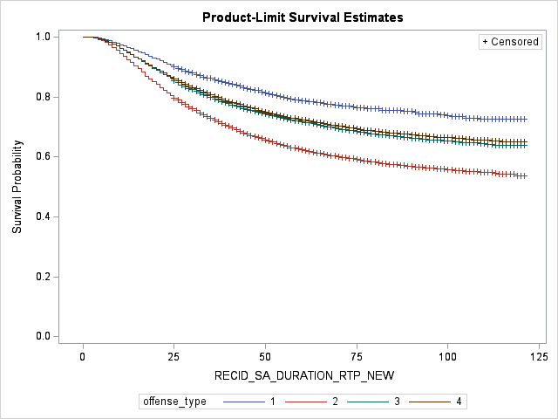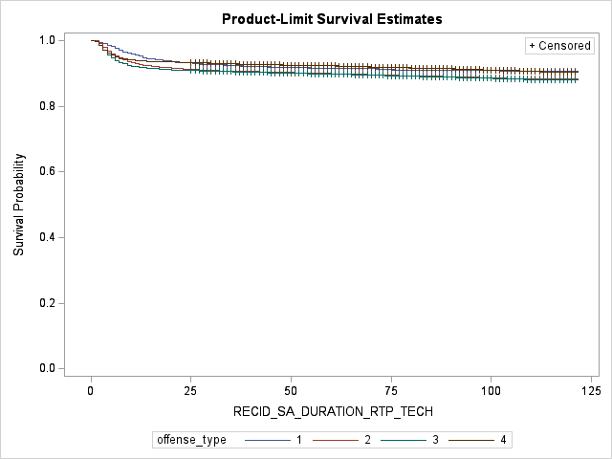

Figure 1. Test for homogeneity of survival curves fore reconviction for a new commitment (left) and for a technical violation (right)

Table A6 - Cox proportional hazard regression models with time variant covariates to test for proportionality assumption

 | Recidivism - new commitment |  | Recidivism - technical violation
 | Sig | Hazard Ratio | Sig | Hazard Ratio
Age | ** |  | ***
Age*log(time) | *** |  | ***
Race (ref. White) |  | <
Black |  |  | ***
Hispanic | ***
Race*log(time) | **
Primary offense (ref. homicide)
Robbery |  |  | ***
Aggravated Assault | ** | < | ***
Other violent | ** | < | ***
Offense*Log(time) | ** |  | *
Time served in prison | *** |  | ***
Time served*log(time) | ** |  | ***
Programming | *** |  | ***
Program*Log(time) | *** |  | **
Misconduct | * |  | *
Social Risk Index |  |  | ***
Social Risk Index*Log(time) | **
Mental Health Index (total) |  | < |  | >
Note: *p < .05; **p < .01; ***p < .001

