Supplementary figures and captions
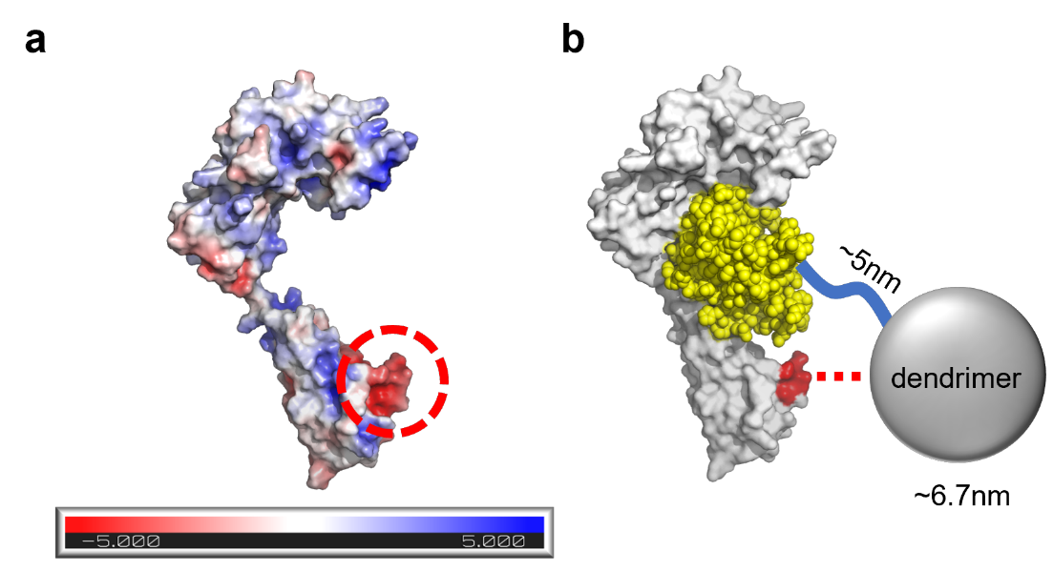
Supplementary Fig. 1. 3D model of IL-1R.
(a) Charge distribution of the IL-1R reveals the anionic patch outside of the binding site (red dashed circle).
(b) Cationic dendrimer is able to interact with the anionic patch of the IL-1R but does not hinder the IL-1RA – IL-1R binding (red dashed line).
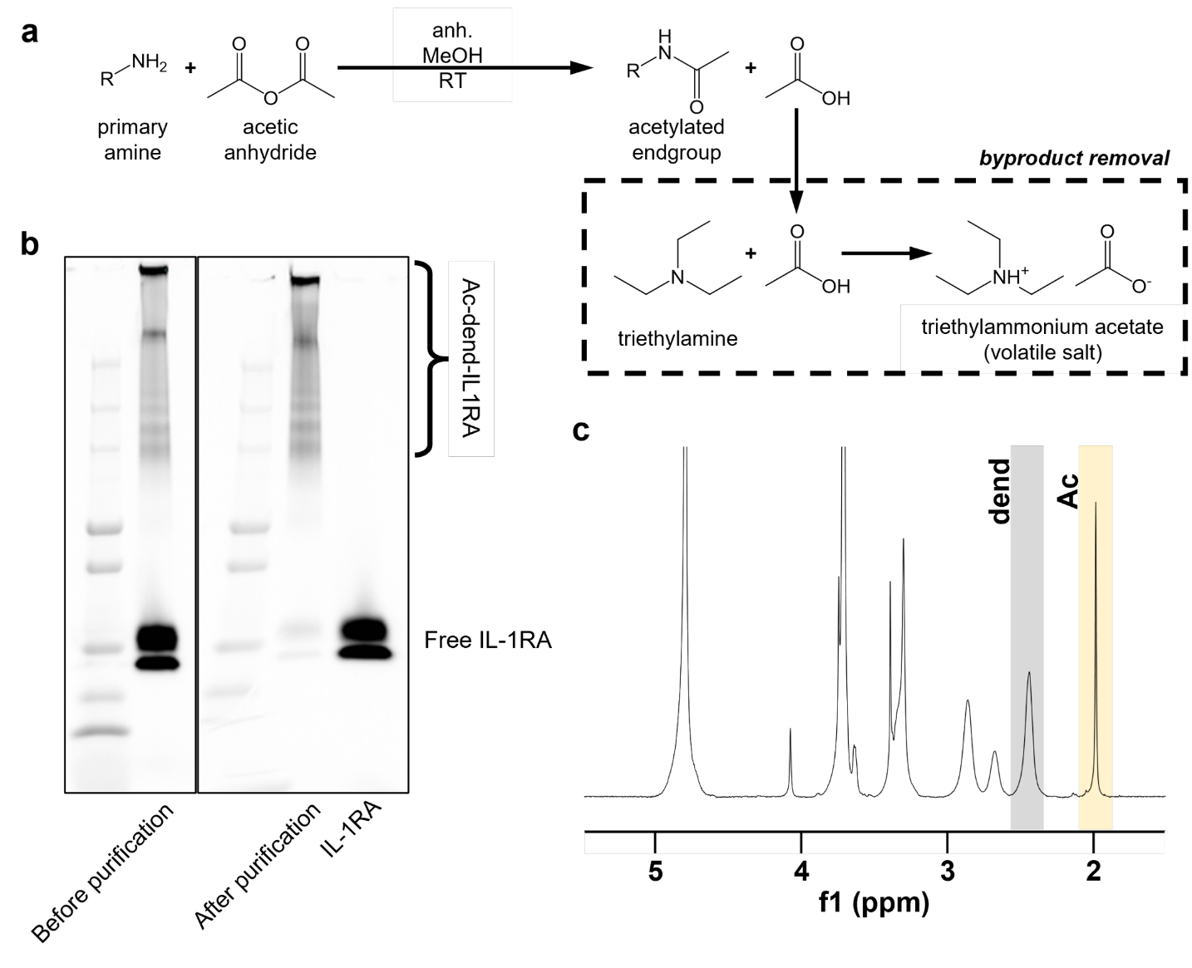
Supplementary Fig. 2. Synthesis and characterization of Ac-dend-IL1RA.
(a) Primary amine groups are acetylated by reacting with acetic anhydride under anhydrous condition in methanol at room temperature. The byproducts are reacted with triethylamine and removed by forming volatile salt.
(b) Purification of Ac-dend-IL1RA using 5x PBS and ultrafiltration is confirmed by SDS-PAGE.
(c) ¹H NMR spectrum of acetylated dendrimer shows successful acetylation. Dendrimer methylene (δ 2.39-2.44; gray peak), acetyl group (δ 1.90-2.10; yellow peak).
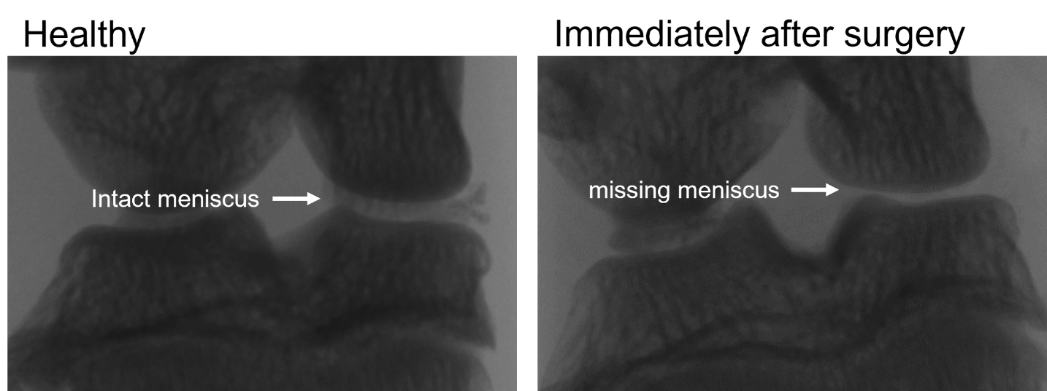
Supplementary Fig. 3. Removal of medial meniscus is confirmed by μCT.
μCT image taken after the surgery is missing medial meniscus while the healthy knee joint has intact medial meniscus.
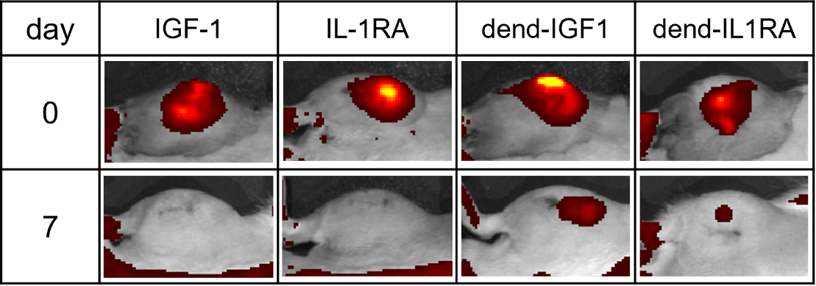
Supplementary Fig. 4. Confirmation of enhanced retention of the dendrimer formulation during the therapeutic efficacy study.
Fluorescence signals from both of the dendrimer formulations are detected after 7 days post-injection while the free proteins were cleared from the joint space.
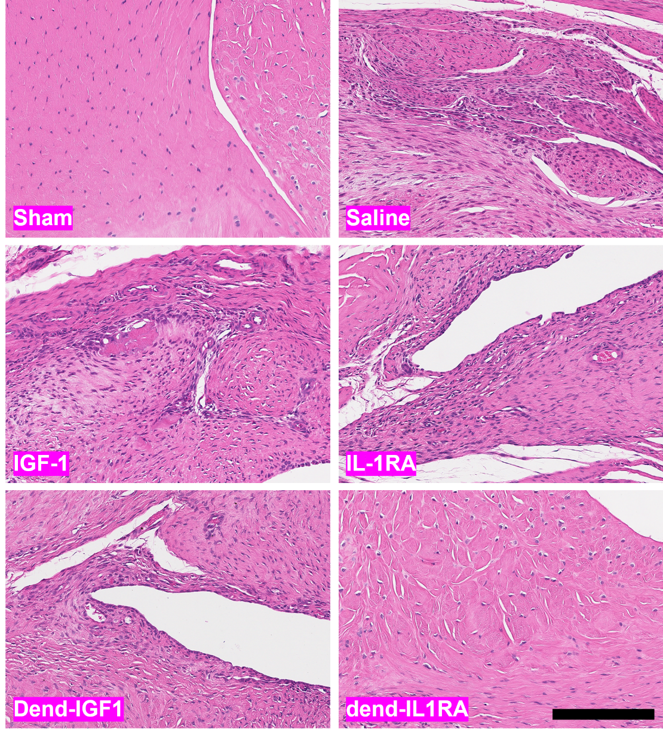
Supplementary Fig. 5. H&E staining confirms reduced synovitis in OA knee synovium when treated with dend-IL1RA.
Anti-inflammatory efficacy of dend-IL1RA is able to reduce inflammation in synovium of OA knee compared to other treatments. Scale bar, 200 μm.

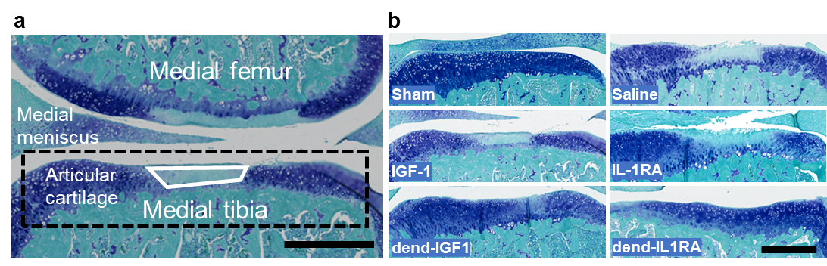
Supplementary Fig. 6. Histopathology of the tibial articular cartilage.
(a) The area of degeneration (white box) of the medial tibial articular cartilage (dashed box) is observed for evaluating the severity of the damaged as the result of OA progression. Scale bar, 500 μm.
(b) Representative toluidine blue/fast green images of medial tibial articular cartilage. The free protein treated groups showed severe damage to the cartilage. Scale bar, 500 μm.

