Supplemental Video Legends
Supplemental Data Video 1. Bi-directional Mitochondrial Transfer via Axons and Dendrites in Neighboring Neurons post MiNE NP Treatment. Video capture on an Android cell phone of live primary hippocampal neurons following two hours of MiNE NP treatment. Imaging is of 60X objective of a Keyence BZ-X710 microscope, live cell, real time. Cells were stained with Mitotracker™ Green prior to imaging. The green movement is of mitochondria trafficking between cells between axons and dendrites.

Supplemental Data Video 2. Intracellular Mitochondrial Movement Following MiNE NP Treatment. Video capture on an Android cell phone of live primary hippocampal neurons following two hours of MiNE NP treatment. Imaging is of 60X objective of a Keyence BZ-X710 microscope, live cell, real time. Cells were stained with Mitotracker™ Green prior to imaging. The green movement is of mitochondria moving withing a single neuronal cell body.

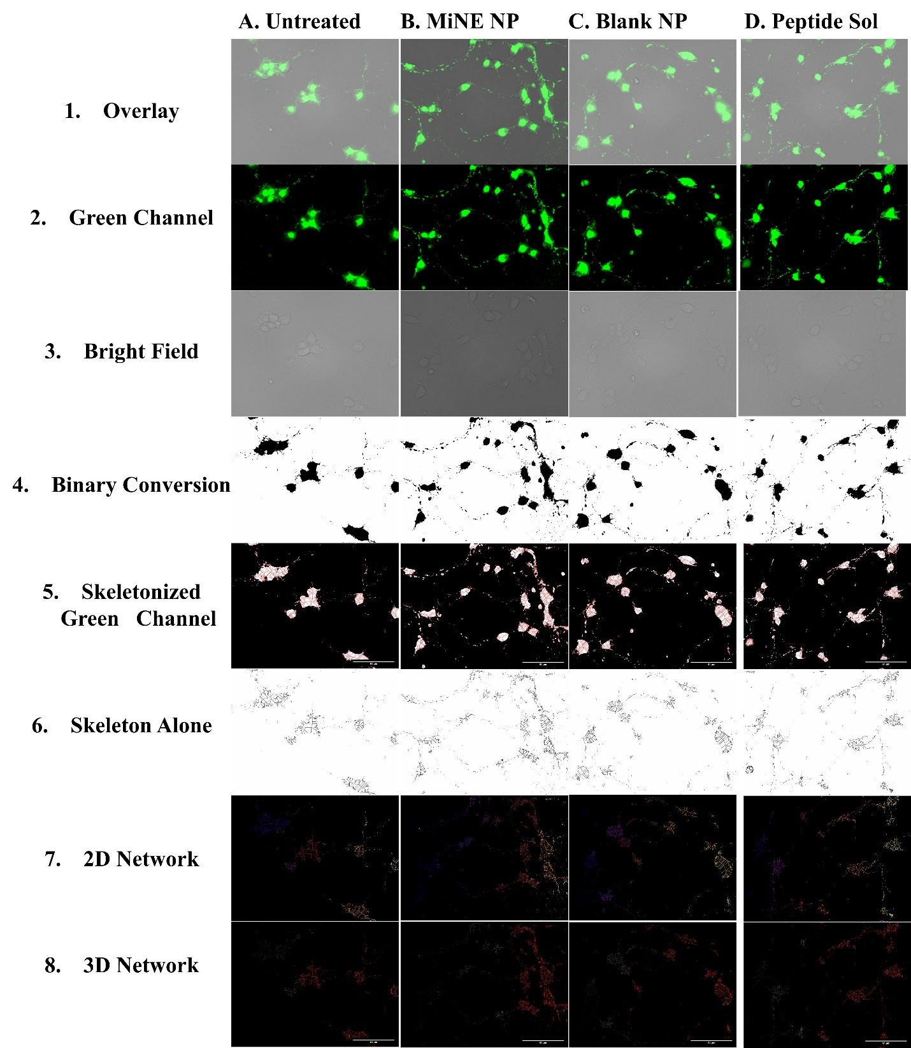
Supplemental Figure 1. Microscopy and Mitochondrial Network Analysis of Primary Hippocampal Neurons (Panel 2). Cells were stained with Mitotracker™ Green, fluorescent microscopy was performed using the 60X objective of a Keyence BZ-X710 microscope. Images were processed using mitochondrial network analysis (MiNA) software. Columns represent the different treatments: (A) Untreated, (B) MiNE NPs, (C) Blank NPs, (D) Pro-MFN2 Peptide in Solution. Rows represent the different image processing: (1) the fluorescent overlay on the brightfield channel, (2) the green fluorescent channel which represents mitochondrial staining with Mitotracker™ Green FM, (3) bright field, (4) the binary converted image of the green channel, (5) the skeletonized green fluorescent channel, (6) the skeleton alone, (7) the 2D rendering of the mitochondrial network generated from the skeleton, and (8) the 3D construction of the mitochondrial network based on the mitochondrial network morphology, branching pattern, and mathematical parameters in the MiNA software.
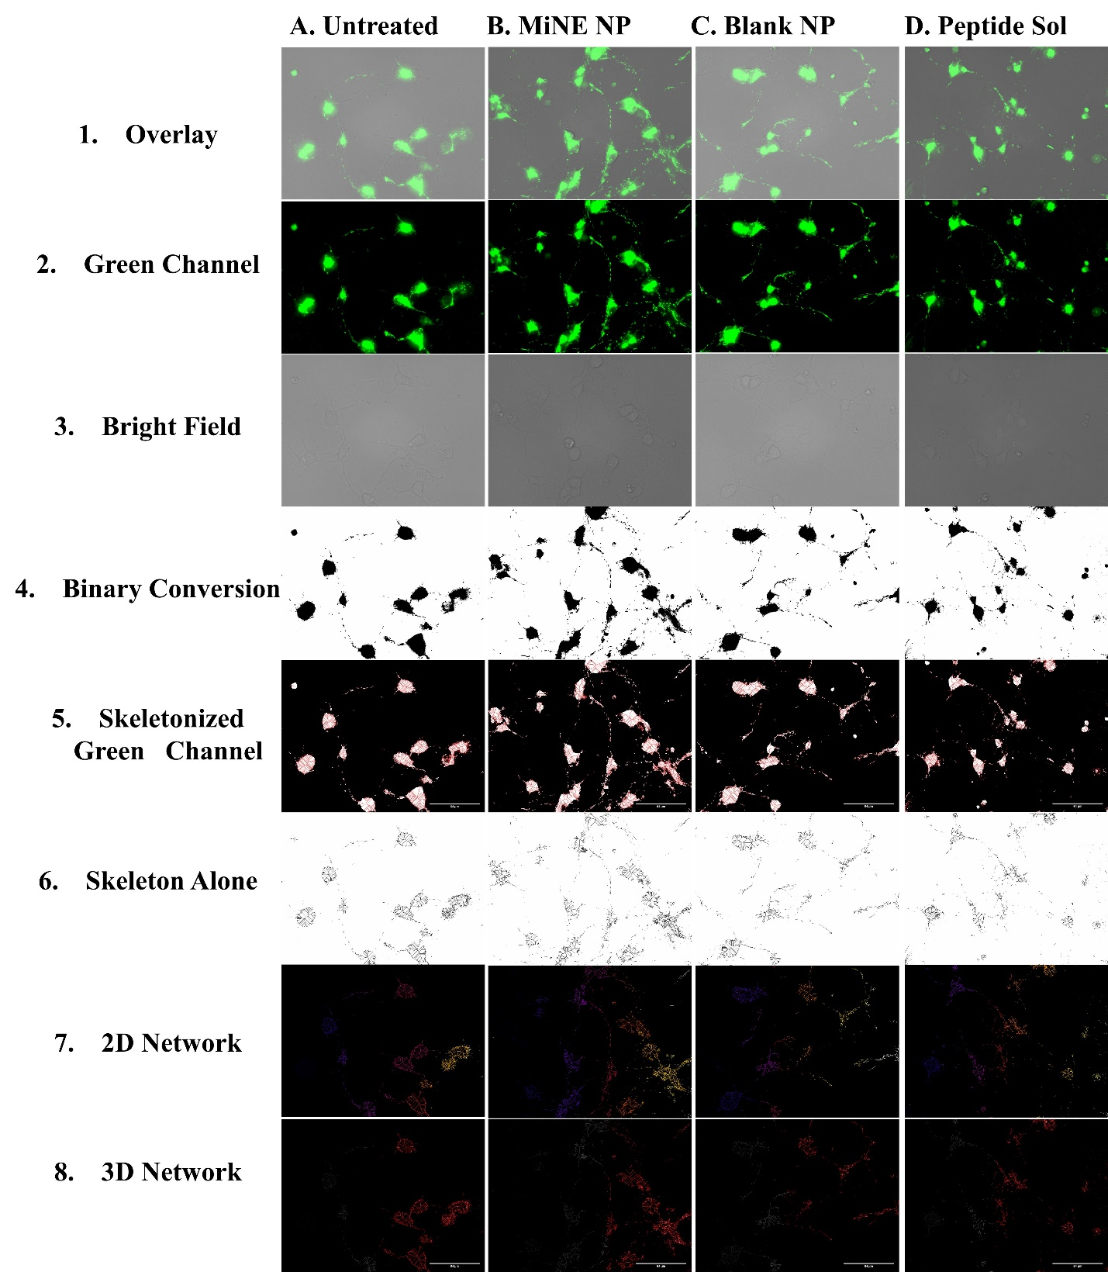
Supplemental Figure 2. Microscopy and Mitochondrial Network Analysis of Primary Hippocampal Neurons (Panel 3). Cells were stained with Mitotracker™ Green, fluorescent microscopy was performed using the 60X objective of a Keyence BZ-X710 microscope. Images were processed using mitochondrial network analysis (MiNA) software. Columns represent the different treatments: (A) Untreated, (B) MiNE NPs, (C) Blank NPs, (D) Pro-MFN2 Peptide in Solution. Rows represent the different image processing: (1) the fluorescent overlay on the brightfield channel, (2) the green fluorescent channel which represents mitochondrial staining with Mitotracker™ Green FM, (3) bright field, (4) the binary converted image of the green channel, (5) the skeletonized green fluorescent channel, (6) the skeleton alone, (7) the 2D rendering of the mitochondrial network generated from the skeleton, and (8) the 3D construction of the mitochondrial network based on the mitochondrial network morphology, branching pattern, and mathematical parameters in the MiNA software.

