Online Resource 3

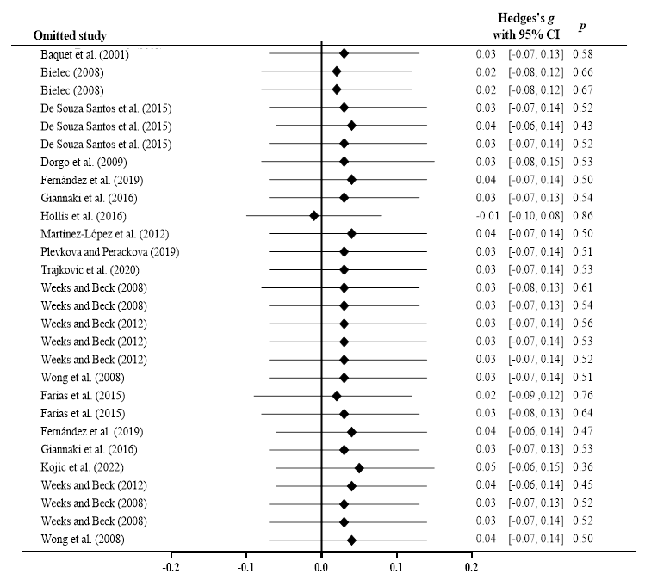
Control Group Sensitivity Analysis
Experimental Group Sensitivity Analysis

